Project: Family, Education, Land, Livestock, and Resident Information Management System (FELLRIMS)

nwustudent

Date: 02/09/2024Venue: IZITECHNOLOGY Research Centre Version: 0.3





**Design Phase**

**Table of content**

1. Problem statement.………………………………………………………..……….1
2. Use case diagram.………………………………………………………..……….1-4
3. Detailed use case………………………………………………………………….4-7
4. Overview of ERD……………………………………………………………………8
5. Detailed ERD………………………………………………………………………….8-11
6. Data flow Diagram………………………………………………………………….11-13

**Problem Statement**

Chief Bonke of the Zulu Kingdom has identified a critical need for an integrated data management system to effectively capture and manage comprehensive information about families, education, land holdings, livestock, and residents within his jurisdiction. The current lack of a centralized system results in inefficient data collection, disparate record-keeping practices, and a significant barrier to informed decision-making and resource allocation. Specifically, the challenges include:

**Use Case Diagram**

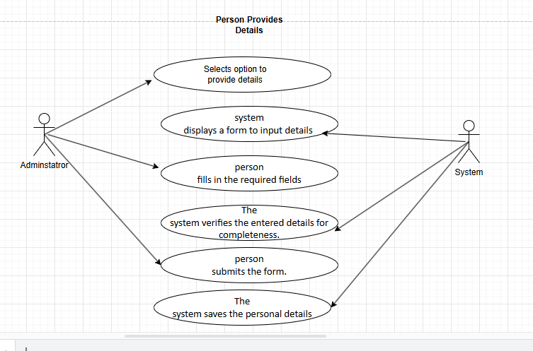

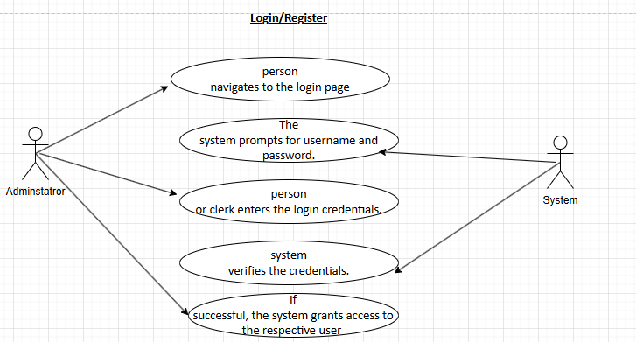

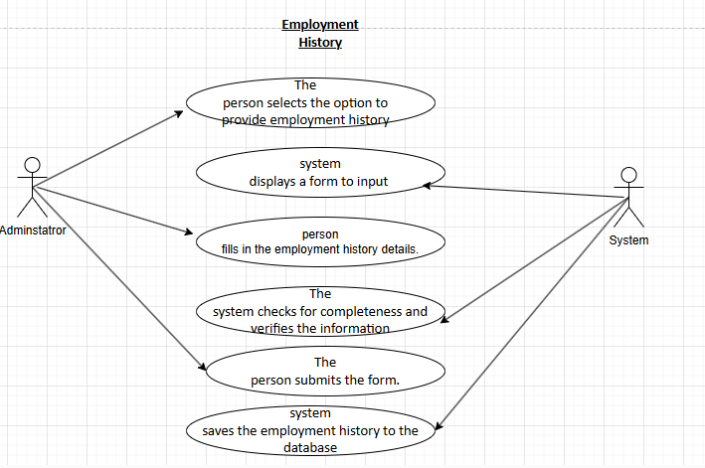

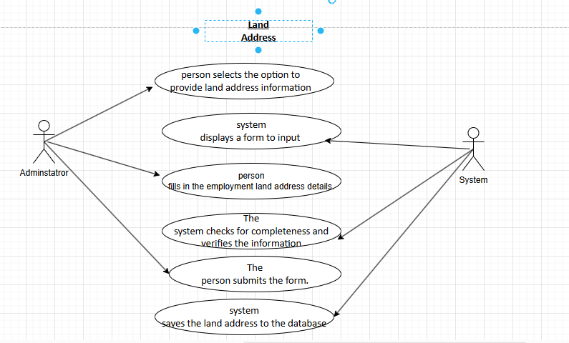

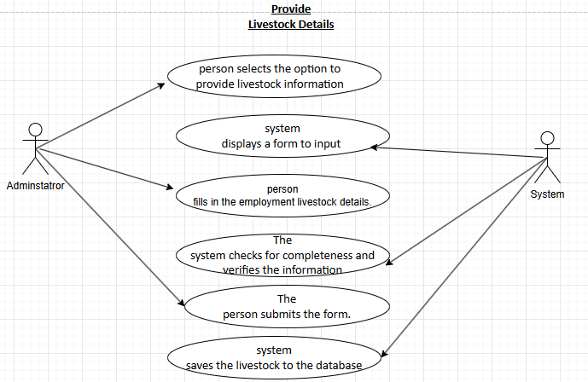

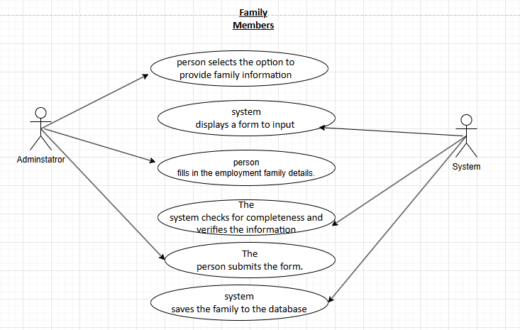

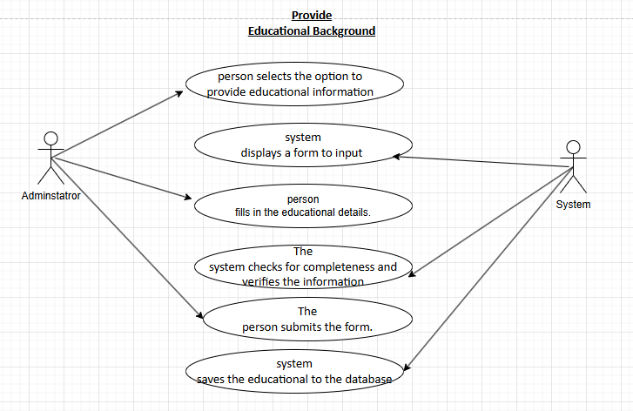

**Detailed Use Case**

To update the use case based on the provided image, we'll break down each process into detailed interactions. Here's how it can be done:

The algorithm corresponding to the use case processes

1. Provide Person Details

Actor: Administrator

Main Flow:

1. The person selects the option to provide personal details.

2. The system displays a form to input details like name, date of birth, gender, etc.

3. The person fills in the required fields.

4. The system verifies the entered details for completeness.

5. The person submits the form.

6. The system saves the personal details to the database.

2.Login/Register

Actors: Administrator

Main Flow:

1. The person or clerk navigates to the login page.

2. The system prompts for username and password.

3. The person or clerk enters the login credentials.

4. The system verifies the credentials.

5. If successful, the system grants access to the respective user (person or clerk)

3. Employment History

Actor: Administrator

Main Flow:

1. The person selects the option to provide employment history.

2. The system displays a form to input details such as past employers, job titles, durations, etc.

3. The person fills in the employment history details.

4. The system checks for completeness and verifies the information.

5. The person submits the form.

6. The system saves the employment history to the database.

4. Land Address

Actor: Administrator

Main Flow:

1. The person selects the option to provide land address information.

2. The system displays a form to input details such as property location, ownership status, etc.

3. The person fills in the land address details.

4. The system verifies the information for accuracy.

5. The person submits the form.

6. The system saves the land address information to the database.

5. Provide Livestock Details

Actor: Administrator

Main Flow:

1. The person selects the option to provide livestock details.

2. The system displays a form to input details such as livestock type, quantity, and other relevant information.

3. The person enters the livestock details.

4. The system verifies the information for accuracy.

5. The person submits the form.

6. The system saves the livestock details to the database.

6. Family Members

Actor: Administrator

Main Flow:

1. The person selects the option to provide family member details.

2. The system displays a form to input details such as family member names, relationship, and other relevant information.

3. The person fills in the family member details.

4. The system checks for completeness and verifies the information.

5. The person submits the form.

6. The system saves the family member details to the database.

7. Provide Educational Background

Actor: Administrator

Main Flow:

1. The person selects the option to provide educational background.

2. The system displays a form to input details such as highest level of education, institutions attended, etc.

3. The person fills in the educational background details.

4. The system verifies the entered information for completeness.

5. The person submits the form.

6. The system saves the educational background to the database.

8. Validation Form

Actors: System

Main Flow:

1. After entering all required information, the system presents a validation form to the person or clerk.

2. The form displays all entered information for review.

3. The person or clerk reviews the information.

4. If everything is correct, they confirm the details.

5. The system finalizes the entries and stores them securely.

6. If there are errors, the person or clerk can go back and correct them.

9. Update Resident Records

Actor: System

Main Flow:

1. The clerk selects the option to update resident records.

2. The system displays a list of existing residents.

3. The clerk selects a resident to update.

4. The system displays the resident's current details.

5. The clerk makes necessary updates to the resident's details.

6. The system verifies the updates and saves the changes to the database.

**Overview of ERD**

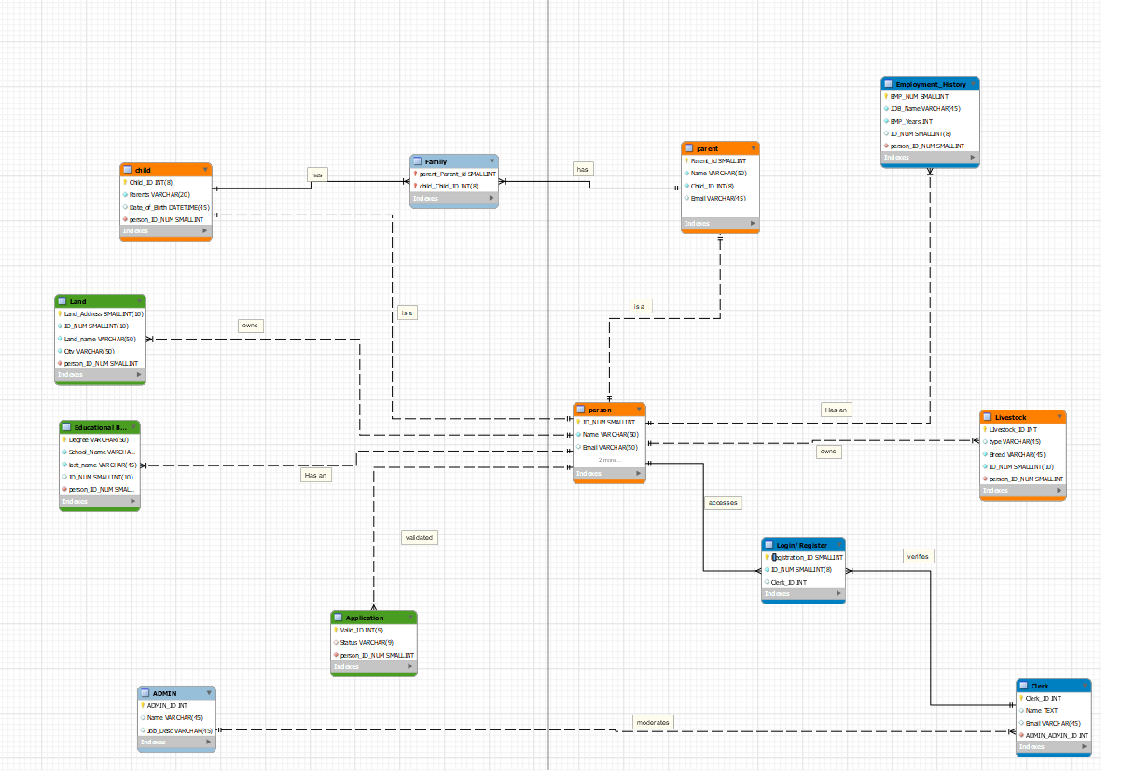

**Detailed ERD**

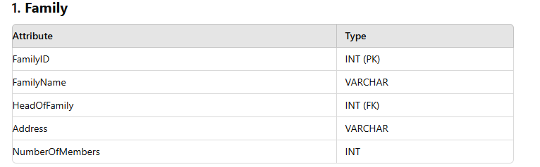

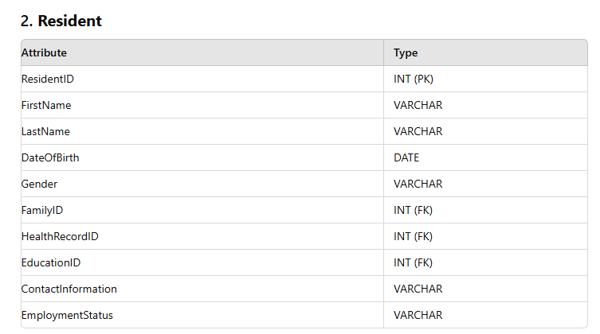

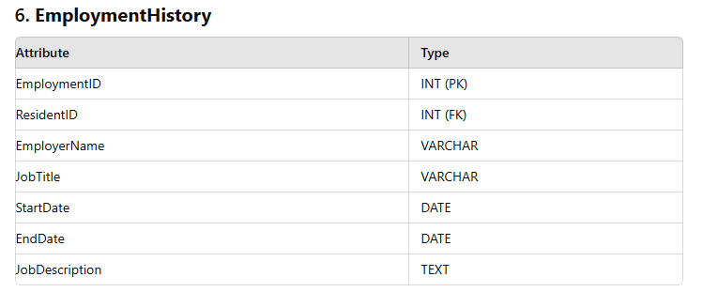

**Data flow diagram**

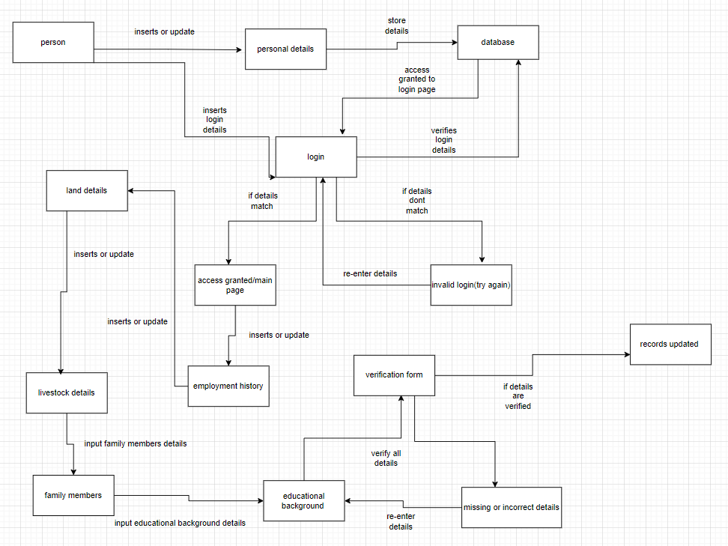

**Detailed Data Flow:**

Provide Person Details

- Input: User inputs personal details.

- Process: System verifies and saves details.

- Output: Details saved to the database.

Login/Register

- Input: User enters login credentials.

- Process: System verifies credentials.

- Output: Access granted or denied.

Provide Employment History

- Input: User inputs employment history.

- Process: System verifies and saves details.

- Output: History saved to the database.

Provide Land Address

- Input: User inputs land address details.

- Process: System verifies and saves details.

- Output: Address saved to the database.

Provide Livestock Details

- Input: User inputs livestock details.

- Process: System verifies and saves details.

- Output: Livestock details saved to the database.

Provide Family Members

- Input: User inputs family member details.

- Process: System verifies and saves details.

- Output: Family details saved to the database.

Provide Educational Background

- Input: User inputs educational background.

- Process: System verifies and saves details.

- Output: Educational details saved to the database.

Validation Form

- Input: System presents the validation form to the user.

- Process: User reviews and confirms details.

- Output: Finalized entries saved securely.

Update Resident Records

- Input: Clerk selects and updates resident records.

- Process: System verifies updates and saves changes.

- Output: Updated resident details saved to the database.