|  |  |
| --- | --- |
| A picture of a winding road and trees  FELLRIMS COMMUNITY SYSTEM | Fellrims Community system  **:Family, Education, Land, Livestock, and Resident Information Management System (FELLRIMS**  **python-docx**  Date:29/08/2024Venue: IZITECHNOLOGY Research Centre Version: 0.1 |

**Updated Workflow for FELLRIMS COMMUNIT SYSYEM**

## 1. Welcome Page

Initial landing page when the application is launched.  
Provides an overview of the application functionalities.

## 2. Login

• Username: Input field for the user to enter their username.  
• Password: Input field for the user to enter their password.  
• Login validation to ensure secure access to the application.

## 3. Search Box

Functionality to search for a person within the system.

## 4. Display a Person

Displays the details of a selected person from the search results.

## 5. Display Person Options

Options for managing the details of the selected person, including:  
• Option 1: Manage Children  
• Option 2: Manage Address  
• Option 3: Manage Livestock  
• Option 4: Manage Education

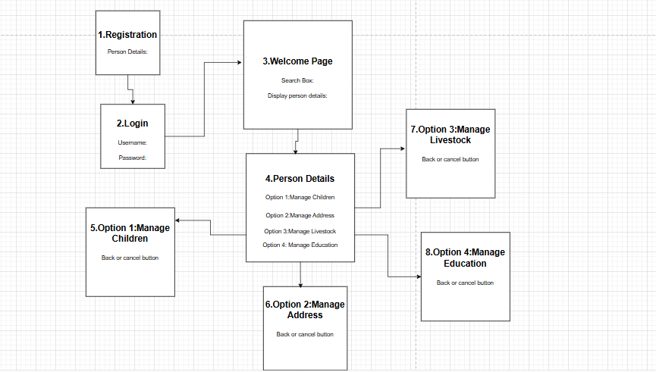

**Prototypes.**

**Welcome Page**

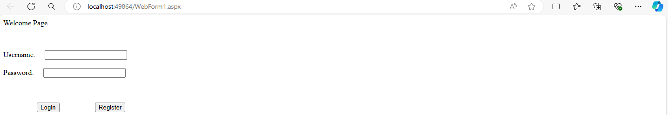

**Display person details**

**Display person**

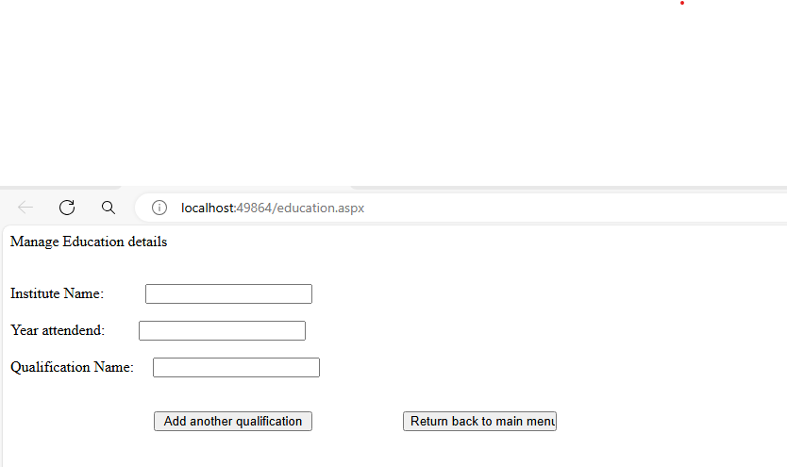

**Manage Livestock**

**Manage Land Address**

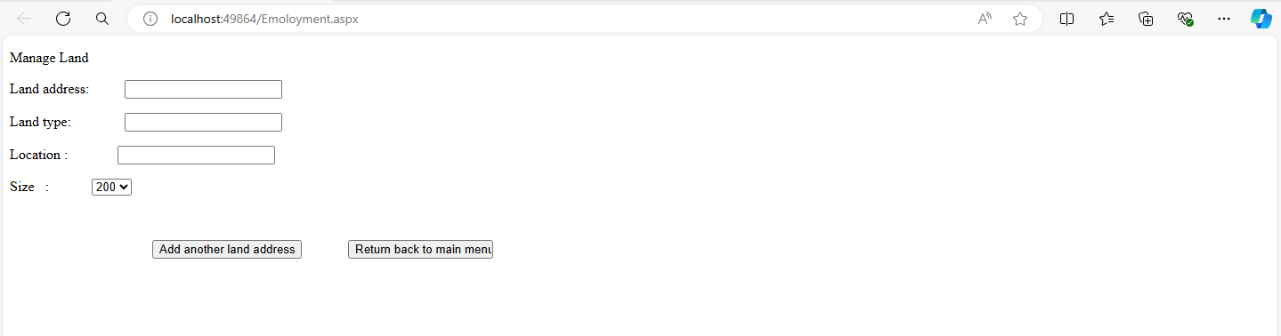

**Manage Children**

**Validation Form**

