EDITING THE GAME
- To change the url, open up the file build.min.js in a text editor (e.g. Notepad, definitely not MS Word!). Edit the url setting by changing the text in between the quotes, e.g:
url:"http://www.surrey.police.uk/piyn"
- To edit any of the questions, open the file data.json, and change the text in between the quotes:
"text" : "There's a horse loose on M25",
- Each answer has an associated numeric value – slightly different to the ones you originally allocated.
ALLOCATION KEY
1 - Fast-time response
2 - Slow-time response
0 - Partner Agency
3 - No action
- To change an answer, edit the answer’s numeric value:
"answer" : 1
- To change an image, simply replace the image in the img folder with a file that has the same name, dimensions, and file extension.
  - The easiest way to change the image is to take the existing file into Photoshop, add guidelines, then use it as your template for new content.
  - The buttons are separate files that are overlaid using code, so if redesigning the screens, make sure space is allowed for them to run
  - At the end of the game there is a slide which tells you your score. The main part of it is a jpg image, but the actual score sentence at the top is generated by code at the bottom of the Build.min.js file
- You can only preview the game when it is placed on a functioning server (not locally)
- Make sure the following MIME types are set of the server: (‘application/json’) and MP3 (‘audio/mpeg’)
  - This is often an issue If you have an IIS-based server

- In the Index.html file ensure the Google Analytics code is changed to your own analytics reference. This code is at the bottom of the page and looks like this:
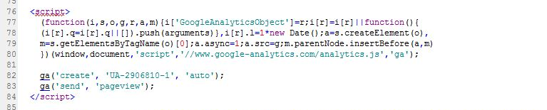
- In the Index.html file, make sure all meta data is changed to match your force, including the reference for the twitter:image:src
- In the index.html file ensure the <title> tag at the top is changed to what you would like to page to be called in the tab
- We use the term PIYN for our project, but this will not be the same for yourself, so in build.min.js you will find two links (they have utm_source… at the beginning), make sure you change the word piyn to something more specific to yourself (one word only)
- In build.min.js make sure the piece of code that sets the hashtag for sharing tweets is set to your tweet. The code is &hashtags=PolicingMatters where …PolicingMatters is the name of your hashtag. You can also do this with any mentions of PolicingMatters within Twitter based URLs (there is one straight after the above hashtag change)
- In build.min.js there is a Facebook sharing link with the term [title]=Surrey+Police+PolicingMatters+Game in it, you can change this title (keeping the + for spaces) for the title of your game
- In the top of the index.html file you will see reference to twitter:img:src and linking to a PIYN-Game-Screen-1.jpg – this is included in the …/img/ folder and just needs uploading to your website so you can get the link for it. Once uploaded, just swap the URL out with the location of your one on your site.

