DVAI Connect
Secure, Intelligent Video Conferencing
Powered by On-Device AI
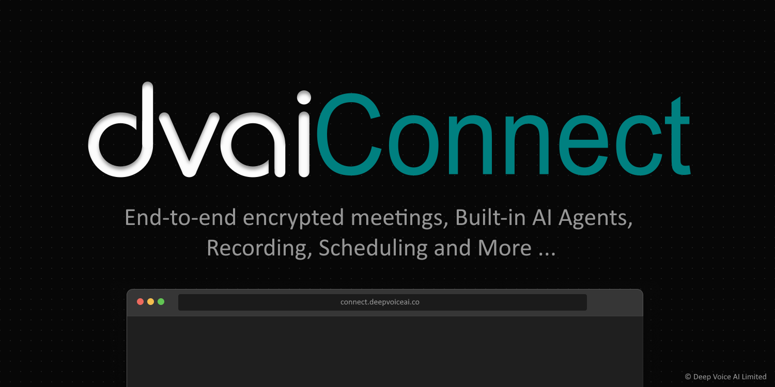

Deep Voice AI Limited
Confidential Product Documentation — 2025

Why DVAI Connect?

DVAI Connect is a next-generation video conferencing platform built from the ground up for organizations that refuse to compromise on privacy, security, or intelligence. Every call is protected by military-grade end-to-end encryption. Every meeting transcript, summary, and action item is generated entirely on-device — your data never leaves your hardware.

Whether you are a Fortune 500 company, a government agency, or a healthcare provider, DVAI Connect gives you the collaboration tools you need with zero cloud dependency for sensitive data.

Zero-Trust Security  Every byte of audio, video, and data is encrypted end-to-end using AES-GCM encryption. Not even our servers can see your content. | On-Device AI  Meeting summaries, action items, and intelligent search powered by DVAI-EDGE running entirely in your browser via WebGPU. No API calls. No cloud processing. | Enterprise Ready  Waiting rooms, admin controls, recording management, role-based permissions, and full audit trails. Built for regulated industries.

Military-Grade Encryption, Built In
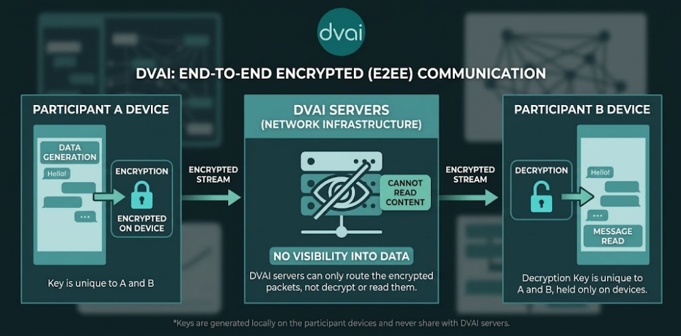
DVAI Connect uses AES-GCM (Advanced Encryption Standard in Galois/Counter Mode) to encrypt all audio, video, screen shares, chat messages, and data streams in real-time. Encryption keys are generated locally on each participant's device and are never transmitted to or stored on DVAI servers.

How It Works
When you create or join an encrypted meeting, a unique cryptographic passphrase is generated and shared exclusively through the meeting link's URL fragment (the part after the # symbol). URL fragments are never sent to servers by web browsers — they stay entirely on-device. This passphrase is used to derive AES-GCM encryption keys locally using the Web Crypto API. Every media frame is individually encrypted before transmission.

What Is Protected
- Audio and video streams from all participants
- Screen share content
- Chat messages and file transfers
- Real-time data channels (reactions, hand raises, transcription)

What This Means For You
Even if network traffic is intercepted, recorded, or subpoenaed from our infrastructure, the content is mathematically unreadable without the passphrase — which only meeting participants possess.

DVAI Connect servers act purely as encrypted relay nodes. We have zero access to your meeting content. This is not a policy — it is a mathematical guarantee.

AI That Never Leaves Your Device

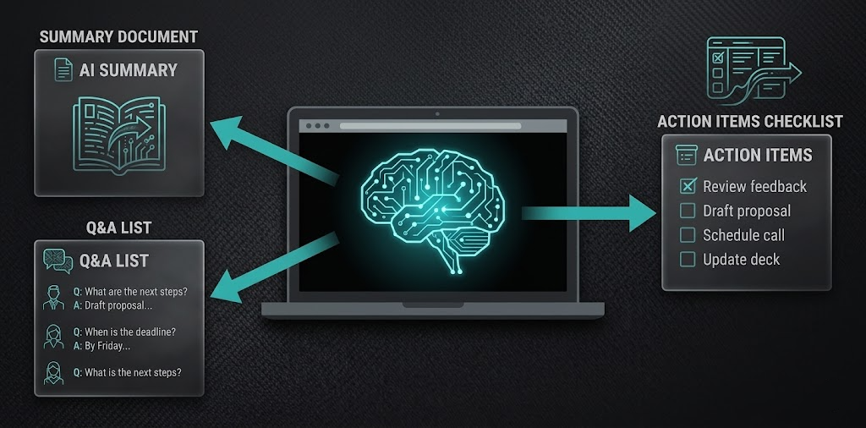DVAI Connect includes a full AI intelligence suite that runs entirely within your web browser using WebGPU acceleration. Local LLM and AI Agents (optimized for edge deployment) powered by DVAI-EDGE, the AI processes your meeting transcripts locally to extract actionable insights — without sending a single word to any external server.

Automatic Meeting Summaries  After your meeting ends, DVAI Connect automatically generates a comprehensive summary capturing all discussion topics, decisions made, and key takeaways. | Action Item Extraction  The AI identifies tasks, assignments, deadlines, and responsibilities mentioned during the meeting and presents them as a structured checklist.

Unanswered Questions  Identifies questions that were raised but not resolved during the meeting, ensuring nothing falls through the cracks. | Intelligent Meeting Search  Ask natural language questions about any past meeting. The AI retrieves relevant transcript excerpts and generates accurate, context-grounded answers.

All AI processing uses Local LLM and AI Agents, powered by DVAI-EDGE in your browser. Zero API calls. Zero cloud processing. Your meeting data stays on your hardware.

Everything You Need in a Meeting
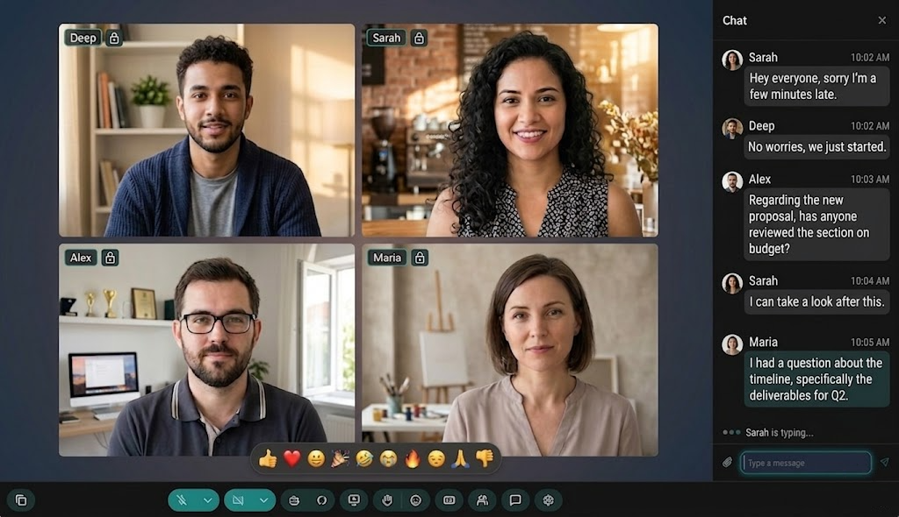

HD Video & Audio  Crystal-clear 1080p video and high-fidelity audio with adaptive bitrate that adjusts to your network conditions in real-time. | Screen Sharing  Share your entire screen, a specific window, or a browser tab with one click. Perfect for presentations and demos.

Smart Recording  Record meetings with a single click. Recordings are processed and stored securely, accessible from your personal recording library. | Live Transcription  Real-time captions powered by on-device speech recognition. Adjustable font sizes from small to extra-large for accessibility.

In-Meeting Chat  Rich messaging with text and file sharing. Files are securely uploaded and shared via encrypted links. Chat history is preserved for recorded meetings. | Emoji Reactions  Express yourself without interrupting. Send emoji reactions that appear on your video tile for all participants to see.

Hand Raise  Raise your hand to get the speaker's attention without unmuting. Visual indicators appear on your tile and in the participants panel. | Picture-in-Picture  Pop the meeting into a floating mini-window while you work in other applications. Full camera and mic controls stay accessible.

Enterprise-Grade Meeting Controls

Waiting Room
Every non-admin participant enters a secure waiting room. Admins review and admit each person individually, preventing unauthorized access to sensitive meetings.

Role-Based Permissions
Meeting creators and designated admins have full control: admit or deny participants, mute individuals, remove disruptive attendees, and pin important speakers.

Recording Permissions
Only admins or the person who initiated a recording can stop it, preventing accidental or unauthorized recording interruptions.

Secure Meeting Links
Meeting codes use cryptographically random identifiers. E2EE passphrases are embedded in URL fragments that never reach the server.

DVAI Meeting Agent
Deploy AI-powered agents directly into your meetings for real-time assistance, note-taking, or automated workflows — all operating under the same E2EE protection as human participants.

Invite System
Invite participants via email, WhatsApp or any other platform directly from the meeting interface. Invitations include secure meeting links and one-click join functionality.

Your Meeting, Your Library

Every recorded meeting is automatically saved to your personal recording library. Browse, search, share, and revisit any meeting with full AI-powered insights.

Recording Library
All your recordings in one place. Search by name, filter by date range, and sort by latest, oldest, or name. Switch between tile and table views.

Video Playback
Full video player with play/pause, seek, volume control, playback speed (0.5x to 2x), and fullscreen mode.

AI Insights on Recordings
When you open a recording, the AI pipeline automatically processes the transcript and generates summaries, action items, and questions — all running locally on your device.

Ask About This Meeting
Use the intelligent search to ask natural language questions about any recorded meeting. Get AI-generated answers grounded in the actual transcript with source citations.

Share Recordings
Share recording links via email, Telegram, WhatsApp, X (Twitter), or LinkedIn with a single click.

Built for Privacy by Design

Local-First Architecture
Transcripts, chat messages, AI insights, and embeddings are stored in your browser's local database. They never leave your device unless you explicitly share them.

On-Device Inference
The Large Language Model and embedding model run entirely via DVAI-EDGE in your browser. No data is sent to any AI provider.

Encrypted Relay
DVAI servers relay encrypted media streams between participants. We cannot decrypt, inspect, or store your meeting content.

Secure Storage
User accounts and recording metadata are managed through encrypted, SOC2-compliant infrastructure. Recording video files are stored in encrypted object storage.

Intelligent Chat Lifecycle
Chat messages are only preserved for recorded meetings. If a meeting is not recorded, all chat data and uploaded files are automatically purged when the meeting ends.

Built for Organizations That Demand Privacy

Government & Defense  Classified briefings, inter-agency coordination, and secure policy discussions. E2EE ensures content sovereignty — your data never leaves participant devices in readable form. | Healthcare & HIPAA  Patient consultations, clinical case reviews, and care coordination meetings. On-device AI processing means PHI is never exposed to third-party servers.
Legal & Financial  Attorney-client privilege, M&A discussions, and board meetings. Mathematical encryption guarantees that privileged communications remain private. | Enterprise & IP Protection  Product roadmap discussions, R&D reviews, and strategic planning. Keep your intellectual property safe with zero-cloud AI and end-to-end encryption.

Deep Voice AI Limited

Secure communication. Intelligent collaboration. Zero compromise.

[IMAGE] Generate a minimal, elegant graphic with shield+AI icon in teal. Dark background. 600x300

deepvoiceai.co
info@deepvoiceai.co

Copyright 2026 Deep Voice AI Limited. All rights reserved.
DVAI Connect, DVAI Edge, and the DVAI logo are trademarks of Deep Voice AI Limited.

