PESTALERT: AN AI-POWERED PEST DETECTION AND IDENTIFICATION
SYSTEM FOR CROP AGRICULTURE IN PALAWAN
A Capstone Project
Presented to the Faculty of
Department of Information Technology

FULLBRIGHT COLLEGE

In Partial Fulfillment
Of the Requirements for the Degree
Bachelor of Science in Information Technology

Charles Allen L. Abella
Jacob Israel A. Mabag
Jomari B. Recalde
Marvin Q, Saik

June 2, 2025

APPROVAL SHEET
In partial fulfillment of the requirements for the degree BACHELOR OF SCIENCE INFORMATION TECHNOLOGY, this Capstone project entitled “‘PESTALERT: AN AI-POWERED PEST DETECTION AND IDENTIFICATION SYSTEM FOR CROP AGRICULTURE IN PALAWAN.” has been prepared and submitted by Charles Allen L. Abella, Jacob Israel A. Mabag, Jomari B. Recalde, Marvin Q. Saik, who are hereby recommended for project presentation.
FRANCIS A. ALTERADO, DIT
Thesis Adviser
Approved by the Committee for Project presentation with a notation on June 02, 2025
FRANCIS A. ALTERADO, DIT
Chairman

TRISTAN REX A. SANTIAGO CHRISTINE JOY M. ACOSTA, MIT
Panel Member Panel Member

Accepted and approved of partial fulfillment of the requirements for the degree
BACHELOR OF SCIENCE IN INFORMATION TECHNOLOGY.

Date: June 2, 2025

DEDICATION
We dedicate this thesis to the following individuals, whose unwavering support and inspiration have guided me throughout my academic journey:
To our parents, whose belief in us and encouragement to pursue our dreams have been a constant source of strength.
To our advisor, Mr. Francis A. Alterado, whose guidance and mentorship have been instrumental in shaping my academic and professional growth. Your expertise has pushed the boundaries of my abilities, and I am grateful for the opportunities you have provided.
To our friends and colleagues, whose support and companionship have enriched my life. Your encouragement and intellectual discussions have made this academic endeavor more enjoyable, and we are thankful for our unwavering camaraderie.
Lastly, we dedicate this Capstone to all those who have faced adversity and overcome challenges in pursuit of their dreams. May this work stand as a testament to the power of resilience, determination, and the belief that anything is possible with hard work and perseverance.
To all those mentioned and to anyone else who has significantly contributed to our academic and personal growth, thank you for being part of our journey and for the profound impact you have had on my life. This Capstone is dedicated to each of you with deep gratitude and appreciation.

ACKNOWLEDGMENT
We would like to express our deepest gratitude and appreciation to all those who have supported and contributed to the completion of this thesis. Their guidance, encouragement, and assistance have been invaluable, and we are truly thankful for their presence throughout this journey.
First and foremost, we are immensely grateful to our Capstone Adviser, Mr. Francis Alterado, for his unwavering support and guidance. His expertise, patience, and insightful feedback have played a pivotal role in shaping the direction of this project. We are grateful for his constant encouragement and for pushing us to reach our full potential. We extend our heartfelt appreciation to the members of our thesis committee, Mr. Charles Allen L. Abella, Mr. Jacob Israel A. Mabag, Mr. Jomari B. Recalde, Mr. Marvin Q. Saik. Our valuable insights and constructive criticism have helped us refine our ideas and improve the overall quality of our work.
We sincerely appreciate the backyard farm owners of Barangay Luzviminda, Puerto Princesa City, Mario B. Barraquio and his invaluable resources, expertise, and support which were essential for our project's success. Especially thanks to them for their generosity in allowing us to utilize their backyard farm.
We are also grateful to the Department of Agriculture Puerto Princesa city for providing us practical insights and technical support. Their contributions significantly enriched the quality and applicability of our project.
We acknowledge our colleagues and friends, whose camaraderie and encouragement have inspired and motivated. Their willingness to engage in stimulating discussions and share their perspectives has enriched my understanding of the subject and has been a constant source of support. We would like to express our gratitude to our family for their unwavering love, encouragement, and belief in my abilities. Their unwavering support, understanding, and sacrifices have served as the bedrock of my academic journey.
We are thankful for their presence in our life. Finally, we would like to thank all of the Capstone participants and individuals who generously contributed their time and expertise. Their willingness to share their experiences and insights helped shape the findings of this thesis. We extend our heartfelt gratitude to everyone mentioned above, as well as anyone else who has contributed to this thesis in any way. Your contributions, large and small, have been significant in assisting us in reaching this milestone. Thank you for your unwavering encouragement, counsel, and faith in my abilities.

TABLE OF CONTENTS
APPROVAL SHEET i
DEDICATION ii
ACKNOWLEDGMENT iii
List of Figures iv
List of Tables v
List of Appendices vi
Abstract vii
CHAPTER I 1
1.INTRODUCTION 1
1.1 Project Context 1
1.2 Purpose and Description 4
1.3 Research Objectives 5
Specific Objective: 5
1.4 Scope and Limitation 5
Scope 5
Limitation 6
CHAPTER II 7
2.REVIEW OF RELATED LITERATURE AND STUDIES 7
2.1 Local Studies 7
2.2 Foreign Studies 8
2.3 Local Literature 12
2.4 Foreign Literature 13
2.5 System Gap 17
2.6 Insight 17
CHAPTER III 18
3.TECHNICAL BACKGROUND 18
3.1 Background of the Current Study 18
3.2 Proposed System 19
3.2.1 Software 19
3.3 Prototype 22
CHAPTER IV 27
4.METHODOLOGY 27
4.1 REQUIREMENT ANALYSIS 27
4.2 REQUIREMENT DOCUMENTATION 27
4.3 DESIGN SOFTWARE 28
4.4 DESIGN OF SYSTEM 30
4.5 GANTT CHART 31
Figure 4.3: Level 0 Data Flow Diagram (DFD) 36
Figure 4.4: Level 1 Data Flow Diagram (DFD) 37
USE CASE DIAGRAM 38
4.10 Development and Testing 39
SURVEY 44
CHAPTER V 49
5.RECOMMENDATIONS, SUMMARY AND REFERENCES 49
Recommendations for Implementation: 49
5.1 Summary 51
5.2 Conclusion 53
APPENDICES 54
APPENDIX A 55
APPENDIX B 57
APPENDIX C 59
CURRICULUM VITAE 65
REFERENCE 70

List of Figures
Figure No. | Title | Page No.
Figure 3.0 | Homepage of the PestAlert Mobile Application | 22
Figure 3.1 | Pest Category Display Page | 25
Figure 3.2 | Pest Identity Information Page | 26
Figure 3.3 | Pest Scanning Interface | 27
Figure 3.4 | Settings Page of the Application | 28
Figure 4.5.1 | Gantt Chart of Project Timeline | 32
Figure 4.5.2 | Detailed Project Timeline Breakdown | 34
Figure 4.6 | Context Diagram of the PestAlert Application | 35
Figure 4.7 | Level 0 Data Flow Diagram (DFD) | 36
Figure 4.8 | Level 1 Data Flow Diagram (DFD) | 37
Figure 4.9 | Use Case Diagram of PestAlert App | 38
Figure 4.10.1 | Coding Interface – Mobile Application Development | 40
Figure 4.10.2 | Coding Interface – Logic and Backend Setup | 40
Figure 4.11 | Testing Phase – Field Image Capture | 41
Figure 4.11.1 | Testing Phase – Sample Pest Detection Screenshot | 42

List of Tables
Table No. | Title | Page No.
Table 4.1 | Recommended Minimum Specifications for Mobile Devices | 29
Table 4.11.1 | Testing Schedule and Pest Identification Results | 43
Table 4.12 | Monthly Pest Occurrence Report by Farmers | 41
Table 4.12.1 | Monthly Frequency Count of Common Pests | 45
Table 4.12.2 | Pest Occurrence Trends and Interpretation | 46
Table 4.12.3 | Interpretation of Survey Results and Impact on System Development | 47

List of Appendices
Appendix No. | Title | Page No.
Appendix A | Participant Consent Letter and Project Introduction | 54
Appendix B | Survey Results, Monthly Pest Logs, and Demographic Information | 56
Appendix C | Code Snippets and Screenshots of Application Files | 58

Abstract

Agriculture makes it possible for most to survive, even if pest is an infestation to farmers, that often leading to losses of crop. PestAlert, is an Ai-based application system for pest identification and detection for a small and medium farmers in Palawan. Through the application the Ai and image recognition software, PestAlert help real-time identification of pest using smartphone. The system offers important information on pest species and suggested pest control methods, with the feature of translation to English-to-Tagalog and Text-to-speech. This research highlights the benefits of the technology, and challenges of building Ai in agricultural pest control.

CHAPTER I

INTRODUCTION

1.1 Project Context
Agriculture has been one of the fundamental foundations of human society for almost endless eras, providing raw materials for countless businesses and ensuring food security. However, a rapid rise of global population has, therefore, put on a mighty pressure on the production of agriculture via farmers and agribusiness. Among these, pest infestation is one of the most serious aspects, as it leads to total crop loss, great yield loss, and substantive financial losses and, in severe cases, results in food supply shortages. As a result, pest management has grown into an important component of modern agriculture. Classical pest management systems, like chemical pesticides and labor-intensive field monitoring, are coming under fire with respect to the added risks to human health and environmental damage, and their limited scalability. On the other hand, those same concerns have given impetus to the search for alternatives that detect and control pest problems in less damaging ways to the environment.
That is where AI and smartphones promise to be an effective form of response to this increasing pest management magnitude. AI can process massive amounts of data at high speed, becoming a game-changing technology in agriculture for pest identification and spotting. This speeds up pest recognition and allows problems to be taken on early when the pests are small. Early pest recognition will permit timely intervention and permissible crop damage and the prevention of widespread infestations. The deployment of AI-based pest-recognition algorithms in mobile applications allows a user-friendly and scalable approach, closer to some operators like smallholder farmers.
Smartphone solutions for pest recognition are particularly regarded as being advantageous to physical inspection settings. Such applications, supported by AI algorithms and image recognition capacities, will allow users to scan for pests or identify affected plants with their camera through the phone. After capturing the image, the app analyzes it and identifies the given pest species and provides control measures accordingly. This means targeted pest control, unlike indigenous practices of broad-spectrum pesticide applications being less environment-friendly and not cost-effective.
The smartphone-based systems for pest identification are useful for hands-on purposes for many reasons. One of its advantages is that it gives information on specific areas where problems may have suspicion in the fields. The typical smaller or larger scopes may have some aerial surveillance that may not resolve the pest identification accurately however, with smartphone applications, has attained high-resolution images close enough to be used for fine analysis. With this detail, it is easier to tell pests apart, even those that resemble each other a lot because they may be difficult to tell apart both by humans and by AI systems.
Besides spotting pests, these applications can act as comprehensive pest management tools by incorporating educational resources and real-time data analysis. Farmers can get advice on how to handle outbreaks, including which pesticide to use. This phase, the knowledge swap, is helpful in enabling farmers to make informed choices to push for long-lasting pest management processes.
However, phone-based pest spotting systems face some hurdles that need fixing to make the most of what they offer. One major limitation is the accuracy of current AI algorithms. Bugs that look alike or those in tricky field settings, like spots with changing light, can be hard to peg right. To boost how exact and trusty these formulas are, we'll need huge training sets that factor in all sorts of outdoor conditions and differences among pests.
Another challenge is the design of user-friendly interfaces which will be suitable for farmers with different levels of knowledge with technology. The applications should be designed and developed in such a way that they are easy to use and can be readily adopted. Hardware limitations, such as type of smartphone cameras and processing power, may hinder the processing of these applications. The collaborations between distributed groups of application developers and hardware manufacturers and agricultural expertise would benefit the pathway forward in lowering the costs of service and may control the existence of various pest-related problems within urban settings, such as mosquitoes and rodents, that can deteriorate public health and safety.
Although there are hurdles to overcome, the advantages of smartphone-based pest recognition systems far outweigh their limitations. These technologies, when used, can match and offer a neutral and affordable alternative to conventional methods by reducing the ecological and economic burden from pesticides. They can also bring about a better yield, improved food security, and enhanced farmer livelihoods by allowing spatially accessible and localized interventions. Their scalability and availability make them suitable for different types of agricultural and urban echelons.
In conclusion, AI-based smartphone apps for pest recognition development and use, can be viewed as a pillar for contemporary pest management. This has, however, to be looked through issues like algorithm accuracy and user accessibility. Nevertheless, this technology will surmount all hurdles of transformation to assure a huge gain for pest management in agriculture and public health. Smartphone-based pest detection systems open up the possibilities of enhancing the quality of finding, advancing targeted intervention, and placing sustainability in pest management protocols that are under a threshold of revolutionizing pest management, leading towards a more resilient and greener ever after.

1.2 Purpose and Description
PestAlert: An AI-Powered Pest Detection and Identification System. This system's aim is to deliver real-time pest information to farmers through their smartphones. The technology seeks to lift the spirits of agricultural specialists and the lacking information by overcoming delays inherent with other traditional communication methodologies like messenger group chats, which would remain unanswered for too long. The tough lifestyles of most farmers have rendered it very difficult for them to attend the Department of Agriculture's outreach mechanisms such as pest related seminars. Farmers will no longer have to attend seminars regularly about pest related topics or wait for sluggish responses on group chats. PestAlert allows them instantaneous access to the crucial pest information.
Farmers can directly scan the pest with their smartphone camera and receive complete information on the pest species, effects on crops, and proposed management methods, allowing for real-time decision-making. The technology allows farmers to act on time and take action against pests through legitimate information that results in increased yields and promotes sustainable farming. Furthermore, PestAlert takes pest management one step further by delivering the latest information to the mobile devices of farmers, significantly advancing the technologies in small and medium farm fields.

1.3 Research Objectives
The PestAlert system aims to provide an efficient and effective pest control management system through pest recognition and identification based on artificial intelligence in an agricultural landscape. The system is also expected to tackle issues with currently available pest monitoring systems through high-tech characteristics, such as a mobile application. The ultimate goal is to successfully provide a way for farmers and agricultural workers to find pests as long as they notice some suspicious pest activity and take action to minimize losses. In short, the project will attempt to answer such problems in this study:

Specific Objective:
- To spot pests through real time scanning coming from the mobile camera.
- To develop an open for all pest detection and identification mobile application.
- To provide the details of the pest such as the name of the pest, its description, damage it caused and also the preventive measures that can be taken.
These particular objectives concentrate on the essential stages involved in converting the idea of an AI-powered pest detection tool into a working device and an efficient one. They also underscore achievable and quantifiable results within the time frame defined in this research.

1.4 Scope and Limitation

Scope
PestAlert is an AI-based mobile application designed to assist small and medium scale farmers in Palawan, pest identification and management in various agriculture fields. The real-time image capturing, recognizes pests and provides pest management recommendations based on how it scans the affected area by the user. Over time, the algorithm learns from user data to build its accuracy. The application allows the user to translate all information from English to Tagalog. This could include pest information, crop damage, and pesticides treatment level recommended for control. PestAlert promotes environmentally friendly pest control, is easy to use. Future upgrades are expected to include lifecycle information, predictions of pest infestation.

Limitation
The accuracy of PestAlert: An AI-Powered Pest Detection and Identification System depends significantly on the quality of the images scanned by users. Grainy,poor light area, or low-resolution images can make pest identification more challenging. AI models struggle with identifying similar-looking pests leading to misdiagnosis. The system may not recognize rare pest species as it primarily focuses on common pests found in various agricultural fields. Environmental factors, such as background clutter and inconsistent lighting, can also impact the results. The application may only be applicable for the area with good internet connection. For optimal accuracy, users are encouraged to perform proper scanning with clear, well-lit images.

CHAPTER II

REVIEW OF RELATED LITERATURE AND STUDIES

2.1 Local Studies
“Smarter Pest Identification Technology (SPIDTECH)”
According to Guiam, A. C., Gutierrez, et al. (2021)¹ SPIDTECH architecture consists of an Android application, a web application, and a Firebase online database and storage bucket. The online database receives all data from the Android application while giving way to the web application to retrieve the data for validation and visualization. Firebase Realtime Database enables real-time synchronization of data while allowing offline availability using the application. The web application retrieves data from the online database using Django 3.1, plots the data points on the map, generates statistics on-the-fly, and provides users with a user interface. Enhancement of identification and libraries is the main purpose of the setup.
“Philippine Carabao Mango Pest Identification Using Convolutional Neural Network”
Based on Rocha et al. (2020)² the research entitled "Philippine Carabao Mango Pest Identification Using Convolutional Neural Network" relates to a precision agriculture solution relating to pest detection affecting mango trees in the Philippines. Through the medium of smartphone images, the system, using convolutional neural networks (CNNs), recognizes pests and specific methods of control. Using the dataset of 5,100 images, an 88.75% accuracy was achieved. By employing the Geographic Information Systems (GIS), the information on areas of pest infestation is mapped out, thus enabling mango farmers to make a decision concerning pest management. Built using Keras and TensorFlow, the application was evaluated according to the ISO 25010 Standards, obtaining high scores primarily in functionality, reliability, and usability from both IT experts and users. The system is aimed at heading off production losses caused by pest infestations and creating efficiency in agriculture.

2.2 Foreign Studies
“PlanteSaine: An Artificial Intelligent Empowered Mobile Application for Pests and Disease Management for Maize, Tomato, and Onion Farmers in Burkina Faso”
Appiah, O., Hackman, K. O., et al, (2024)³ PlanteSaine is an application for a smartphone that Burkina Faso farmers can use to identify the pests and diseases in their crops. The tool will make an accurate diagnosis using photos from smartphones, even at remote locations where the internet is spotty. It also has an alarm system for emergencies so that farmers will not be caught off guard with disease and pest outbreaks. It develops agricultural technology and also promotes the use of sustainable farming methods besides contributing to an increased food security because it performs better than the baseline models.
“An Efficient System for Real-time Mobile Smart Device-based Insect Detection”
According to Doan, T.-N., An Giang University, et al. (2022)⁴ Our real-time insect identification system blends mobile devices with the YOLOv5-S model for pest detection. A user can capture the insect images live, upload them from the internet, or use images from insect traps. An insect is identified by YOLOv5-S that gives detailed information regarding biological characteristics, distribution, and control strategies. The online and offline mode of the system: online mode employs server-based databases that provide updated information and allow data uploads to extend the data warehouse, while in offline mode, the SQLite library manages localized data, supporting areas with limited internet access. YOLOv5-S has been chosen by our group because of its compact size of 14.2 MB, GFLOPs: 17.1 speed, and excellent accuracy, which suits mobile phones with limited hardware. The pest detection dataset is composed of 2,335 images consisting of 10 types of pests, which were put into boxes manually by Labeling; it was divided into 70% training, 20% test, and 10% validation, thus obtaining conclusive results despite some problems posed by various insect stages.
“Machine learning-based identification of hazardous insects attacking cabbage”
According to Hossain, M. S., Al Shahid, A. et al. (2023)⁵ Among the major threats to cabbage crops through destructive insects such as aphid, whiteflies, and diamondback moths that negatively affect yields and agritechnology business performance, Hossain et al. (2023)⁵ discuss using machine learning or ML as a means of efficiently enhancing pest identification and management while reducing environmental impacts. The conventional pest control methods, for instance, pesticides are not environmentally friendly, and the approach is time and labor-consuming. Their research proposes a detection gap for harmful insects on cabbage by developing a dataset of four distinct insect classes and training a YOLOv5 detection model. The developed ML model enables the real-time detection of pests as part of an improved strategy in pest management and produces knowledge useful for future research on agriculture.

“Information needs of farmers: a systematic study based on farmer surveys”
According to Babu, S. C., & Glendenning, C. J. (2019)⁶ The communication gap between farmers and the extension workers regarding information needs and the lack of insight into information-seeking behavior is one of the reasons public extension programs fail quite often. Therefore, this case study investigated the information needs of farmers, their information-seeking behavior, the determinants for their search behavior, and their willingness to pay for information in the South Zone of India. Information-seeking behavior was categorized into four types: low, medium, semimedium, and high. For rice, critical information requirements included pest and disease management, pesticide use, seed variety, and seed treatment. Higher and medium-level seekers utilized more print and television media. Poor time and high untrustworthiness stood as the two uphill challenges to information accessibility. Farmers were less inclined to pay for audio mobile phone messaging but preferred face-to-face interactions and mobile phone information.
“An app that identifies plant diseases and diagnoses plant problems”
According to Agrio. (2022)⁷ Artificial neural networks form the backbone of state of the art image recognition. Samples of diseased plants, tagged by the specialists, are provided to the neural network as if it were a learning experience for the agronomy students. During the learning phase, the neural network keeps on adjusting until the performance score is maximized. The outcome is an application that recognizes plant diseases and keeps getting better with each additional sample. Agrio determines which treatment regimens work best based on producers' input and field observations. An ineffective therapy indicates a potential identification issue and adds further input to help the network get better.
“AI-powered banana diseases and pest detection.”
According to Selvaraj, M., et al. (2019)⁸ Their findings established that the DCNN is a robust and easy-to-implement method for the detection of pests and diseases in digital bananas. Through DTL on a pre-trained disease detection model, we were able to design a network that can generate accurate predictions. The model is a valuable early disease and pest detection tool due to its notable high success rate. This research can be extended to build a fully automated mobile application that will benefit millions of banana producers in poor countries.
“DubasAlert: AI-Powered Detection System for Dubas Infestation on Palm Leaves”
According to Y Nagaraju, Venkatesh, (2024)⁹ The dubas insects are a deadly threat to plants in the Middle East as they suck the sap of the fronds and leaflets of the date palm. The current study offers a new methodology for identifying the different stages of development of the Dubas insect. It is challenging to integrate edge devices as it has a high training weight and poor performance of the model. We use a pruned YOLOv7 model such that it is lighter and fewer parameters, reducing by 75% FLOPs in addressing the issues above. Pruned Yolov7 has an mAP@0.5 score of 80.1, more excellent than baseline models. The method proposed above indeed yields workable methods to fight Dubas insect infestations by permitting real-time detection and smooth integration into edge devices.
“Rapid detection and identification of major vegetable pests based on machine learning”
According to Zhang et al. (2022)¹⁰ emphasizes the knowledge of the kind and quantity of pests is crucial for creating strategies for controlling vegetable pests. In this study, machine vision and remote information processing technologies have been combined to create an automated pest monitoring system. In order to monitor four major pests—Phyllotretastriolata (F.), Frankliniella occidentalis (P.), Bemisiatabaci (G.), and Plutellaxylostella (L.)—a Vegetable Pest Counting Algorithm Based on Machine Learning (VPCA-ML) was proposed and put into practice in a vegetable field. The algorithm's bag-of-feature model was found to be feasible for representing pest features, and an improved SVM model was found to be suitable for pest classifications. The overall relative error produced by the VPCA-ML is less than 10% when compared to the manual counts. The VPCA-ML-based system operates steadily in a field setting and can rapidly and accurately identify the types and dynamic quantities of the most common vegetable pests.
“Research on the identification and detection of field pests in the complex background based on the rotation detection algorithm”
Based on Zhang et al., (2022)¹¹ The study surveyed 78 farmers in Edu Local Government Area of Kwara State to assess their agricultural information needs and challenges in accessing these resources. Findings revealed a strong demand for improved farming techniques, irrigation management, and pest control, while issues like poor communication systems, absence of libraries, and insufficient extension agents hinder access to information. Challenges such as inadequate credit facilities and insufficient knowledge on government policies further limit productivity. These results align with earlier studies highlighting barriers to effective agricultural information dissemination in developing regions.

2.3 Local Literature
“Rationalizing And Strengthening The Crop Pest Management Functions, Services, And Related Tasks Of The Department Of Agriculture”
According to the Department of Agriculture (2020)¹²The four elements considered essential by the 1996 World Food Summit in defining food security are availability, accessibility, utilization, and stability. Crop pests have emerged as a major cause of crop losses; plant diseases cost the global economy about $220 billion, and invasive insect pests constitute around $70 billion worth of losses. Climate change aggravates pest-related issues, with additional threats to crop yields. While faced with the task of feeding an ever-growing population, FAO has indicated that the agriculture sector needs to double its output by 2030. Recently, the United Nations General Assembly declared 2020 as the International Year of Plant Health and called for international cooperation on plant health policies.
“An intelligent monitoring system of diseases and pests on rice canopy”
According to Li, S., Feng, Z., et al. (2022)¹³ The real-time monitoring and detection accuracy of rice diseases and pest infestations in paddy regions are explored as developed models called YOLO-Disease and Pest Detection (YOLO-DPD). It is the improved detection network based on the original which incorporates the attention mechanism along with the residual feature augmentation method. In order to expand the depth and accuracy, give a convolutional BN block, use the Leaky_Relu activation function, and add a Res Unit and CSPResblock unit. In updating the model, enhancing the accuracy of pest and disease visualization finds application with rice.

2.4 Foreign Literature
“Smart Farming (Ai-Generated) as an Approach to Better Control Pest and Disease Detection in Agriculture:POV Agricultural”
According to Hashem et al. (2022)¹⁴ For gaining insights from a large sample size, the study relies on a quantitative method of data collection on AI in agriculture. The "Disruptive Innovation Theory" narrates how AI technologies have transformed the market and how it has changed the game from traditional approaches to pest and disease monitoring. Likert 5-point scale was used in designing a two-section questionnaire: demographics and sub-variables. The sample was allowed to access the online version of the questionnaire so that they could complete it on their own. The aim of the study is to understand how AI impacts agriculture.
“Cultivating a Greener Future: How AI Can Transform Agriculture for Food Security and Sustainability”
According to Hung, S., Siddiqi, y., (2024)¹⁵ Artificial intelligence is really transforming agriculture in a general sense by increasing resilience and efficiency, though the problem today is the urgent need to make an enterprise sustainable because of the increase in various climate changes with fewer natural resources available. According to analysts, the global market for AI in agriculture was pegged at about $138 million in 2022, but it is likely to be about $1.3 billion through a 25% annual growth rate by 2032. While researchers of AI say that this technology would be a potent ally in the fight against climate change and food insecurity, others contend that AI is the panacea for food security. It is based on these issues that the "AI for Climate Resilience in Rural Areas" Innovation Challenge is being held.
“Palm Leaf Health Management: A Hybrid Approach for Automated Disease Detection and Therapy Enhancement”
According to Imran, A., et al, (2024)¹⁶ The hybrid model proposed in this research article combines computer vision and deep learning approaches to identify diseases in the palm leaves, thereby obtaining higher training accuracy as well as accuracy in the diagnosis of the disease by combining the approaches of transfer learning with Efficient Channel Attention Network. It has demonstrated its exceptional capacity in agricultural technology by validating its performance to yield an accuracy of 98.67% along with a training accuracy of 99.54%.
“Smartphone-Based Citizen Science Tool for Plant Disease and Insect Pest Detection Using Artificial Intelligence”
According to Christakakis, P , Papadopoulou, G., et al. (2024)¹⁷ the cornerstone elements in the design of the REST API in Python with RabbitMQ for asynchronous communication, thus, are scalability, efficiency, and security. An AI model is integrated into the back-end of the system, which performs the pest or disease identification in agricultural fields based on the image and geographical details provided by users. The model analyzes the data so that the AI can provide a detailed diagnosis report about the disease or pest species, how the crops would be affected, and the possible preventive measures. RabbitMQ supports asynchronous processing of several requests, ensuring seamless and efficient communication crosswise services, which enhances the system performance and guarantees real-time results to users.
“Artificial Intelligence Techniques For The Pest Detection In Banana Field: A Systematic Review”
According to Rashid, M., et al, (2023)¹⁸ This review aims at the use of artificial intelligence (AI) and image processing techniques for pest detection and management in banana fields. Various methods like deep learning, machine learning, and image segmentation have been discussed for automating the identification and classification of diseases in banana crops such as Black Sigatoka, banana speckle, and Fusarium wilt. The many studies reviewed showed that models such as ResNet50, InceptionV2, and YOLOv3 achieved high accuracy with respect to banana disease detection under varying environmental conditions. The necessity of integrating IoT, UAVs, and mobile applications with tools powered by AI for real-time monitoring that could assist in early diagnosis and better management has also been emphasized. The findings emphasize the need for scalable, cost-effective solutions for the quickest and most effective detection of plant diseases, one that mitigates reliance on labor-intensive inspection.

“Role of Artificial Intelligence in Pest Management”
According to Rahman (2022)¹⁹ states Agricultural pests contribute to annual losses between 20-40% of the world's crop production, and overuse of pesticides creates huge problems. Smart agriculture is an alternative that incorporates artificial intelligence techniques with modern information and communication technology. The techniques of AI, which include Machine Learning, deep learning, and computer vision, are helpful in taxonomic studies, ecological studies, and pest management. Important applications from which Pest detection, monitoring, prediction and identification such as Plantix, Leaf-Byte, Bioleaf, Cotton Ace, and Apizoom are to emerge. Among the considered important AI applications include an AIoT-based system for a system for the detection of Tessaratoma papillosa mobile application in which one can detect insect pests on mobile application, automatic moth detection methods, autonomous robotic vehicles for recognizing pyralidae insects smart traps with remote monitoring, and AI models for banana disease and pest detection.
“A Smartphone-Based Application for Scale Pest Detection Using Multiple-Object Detection Methods”
According to Chen, J.-W., Lin, W.-J., et al. (2021)²⁰ the economy of Taiwan is heavily reliant on agricultural exports that are severely threatened by a slew of pests, ranging from mealybugs to Coccidae and Diaspididae insects. The employment of AI-based pest detection systems, most of which are based on deep learning, such as You Only Look Once v4 (YOLOv4), single-shot multibox detectors, and Faster R-CNNs, are recommended so as to assist in the resolution of this issue. The final output showed highly promising classification accuracy rates for the classes under review: 97% for Diaspididae, 89% for Coccidae, and 100% for mealybugs. It also produced a mobile application based on the trained model that assists farms in pest identification.

2.5 System Gap
Though there are a lot of mobile pest detection systems available, small and medium-sized farmers in Palawan face a significant gap in terms of affordability, usability, and accessibility. Many pest identification systems require relatively advanced gadgets or charge subscription fees, which makes them unfeasible for farmers with limited resources who typically do not own the newest mobile phones. Despite sometimes having highly sophisticated features, these commercial systems are rarely used because of their challenging user interfaces, poor language support, and locally relevant content. By creating a free AI-powered smartphone app just for Filipino farmers, PestAlert aims to close this gap. Real-time image scanning, multilingual support (Tagalog-English), and user-friendly navigation are all combined by PestAlert to enable even individuals with limited digital.

2.6 Insight
The literature study highlights how AI is revolutionizing agricultural pest identification and management. Studies conducted in the Philippines and abroad emphasize that AI applications such as machine learning, deep learning, and IOT improve the precision, effectiveness, and sustainability of pest control. Essential technologies, such as real-time data systems and mobile-based platforms, address problems like labor-intensive inspections and restricted internet access. While foreign systems such as “PlanteSaine” stress scalability and offline capabilities, local examples such as SPIDTECH reflect region-specific solutions. The research maximizes pesticide use, minimizes crop losses, and encourages environmentally friendly agriculture. To promote global food security, future initiatives should focus on enhancing data quality hybrid models, affordable, easily available AI technology.

CHAPTER III

TECHNICAL BACKGROUND
The project will entail development and testing using a laptop or desktop with either Windows 10 or Windows 11. The software tools that will be used are TypeScript, a strong-type language for creating the mobile application. Visual Studio Code will serve as the integrated development environment (IDE), providing increased functionality and ease of use to facilitate development.
The Machine Learning will be TensorFLow and Yolo(You-Only-Look-Once) for object detection. This machine learning enables the AI capabilities for image analysis directly from the mobile environment. Also the help of Expo Go for reviewing the developing application to see the changes when creating the application. From a hardware point of view, an application would rely on mobile phones that are already equipped with a camera. This camera is of utmost importance in obtaining detailed images of pests, which will later be subjected to computer vision and machine-learning models embedded in the application for image-processing and analysis. The models thus embedded allow for accurate identification and classification of the pest types, thus delivering actionable insights to the users.

3.1 Background of the Current Study
Efficient pest control in modern agriculture is essential in achieving high yield, quality crops, and sustainability. Conventional methods of insect pest inspection and identification greatly rely on traditional inspections by farmers and recommendation systems of agricultural extension offices. However, these processes are often long-lasting in nature with their delays being brought about by poor communication and low network signals in isolated areas. Delay may lead to
To meet this challenge, new technologies are helping pest management by providing operational efficiency, speed, and accuracy. For instance, the AI-powered pest detection systems operate on the machine learning principle for precise identification of pests, reducing the chances of misdiagnosis. Real-time mobile applications loaded with pest management tools help farmers in fast identification and solving of pest problems, allowing sustainable practice. This would also help save time and resources for agricultural practice, which gives room for environmental sustainability while enabling the farmers to optimize production.

3.2 Proposed System
This chapter talks about ancillary things regarding the project such as the toolsets, methods, and techniques for development. The software and the general workflow process of the application provide a comprehensive overview of the various technical specifications behind the successful implementation of "PestAlert." The specifications are discussed to aid the development process and ensure that the application performs as expected to meet the project objectives. The chapter will focus on the software requirements for the development of this innovative pest recognition and identification solution.

3.2.1 Software
The PestAlert system has software components that ensure operation and user interaction. These include the operating system, programming environments, and IDEs with which the device would be developed and controlled.
- Operating System (OS): The selected OS version for developing the device either Windows 11 or 10. It brings along support for Visual Studio Code, the main tool for developing the mobile app controlling the device. The wide acceptance of Windows 11 and the strong program support make this OS suitable for the project.
- Expo GO: Expo Go is a capable application meant for testing React Native projects built using the Expo framework. Available on both iOS and Android platforms, it allows developers to preview their applications without the need to build a full binary (APK/IPA). This proves especially handy for the development cycle and continuous iterations and tests.
- Visual Studio Code: Microsoft has developed a powerful open-source code editor called Visual Studio Code. This code editor is used for different programming languages and is preferred by developers for its flexibility, fast-paced performance, and extensive features. Visual Studio Code has strong support for working with TypeScript that makes it an excellent choice for TypeScript development.
- TensorFLow.Js: An open-source library by Google, allowing machine learning models to run in web browsers or Node.js environments directly. It's part of the Tensorflow ecosystem and is aimed toward JavaScript developers, enabling them to integrate machine learning capabilities into web and mobile apps.
- YOLO (You-Only-Look-Once): The algorithm employs a cutting-edge, real-time approach to detecting objects, and it is swift and accurate. Basically, it does not pass through an image multiple times like the traditional systems; instead, YOLO runs through the entire image in a single pass, making it quite efficient. It is now widely used in a number of applications, including surveillance, autonomous driving, and pest detection.
- Programming Languages:
  - TypeScript: TypeScript is a statistical supersequel of JavaScript that is widely used for android mobile app development. TypeScript's statically typed environment assures the organized coding and maintains quality code which is scalable. Along with its associated frameworks like React Native, a strong, feature-rich application can be developed using TypeScript for Android.
These pieces of software together provide a strong development background for PestAlert. Developers have the tools necessary to create and maintain the application properly, ensuring high performance, and scalability. This collection of tools and technologies would help ensure the successful implementation of Pest Detection and Identification System.

3.3 Prototype
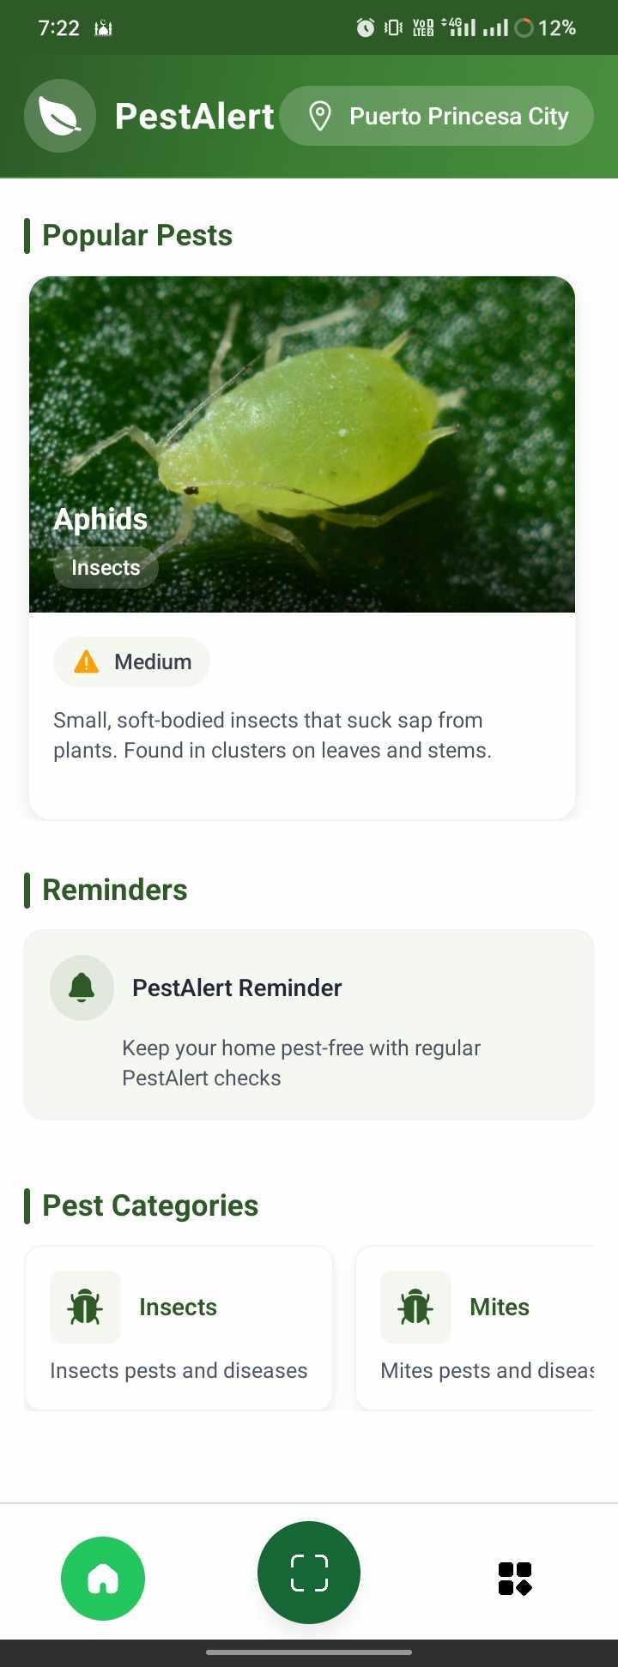

Figure 3.0 Home Page
Figure 3.1 The homepage will display the different types of pests and initially gives a prompt view of them. This homepage will show the related pest categories and other peoples, the search bar, the settings at the top-right corner of the homepage, and a button at the bottom-right corner of the homepage. The button will provide access to the camera that will allow the user to scan the pests.

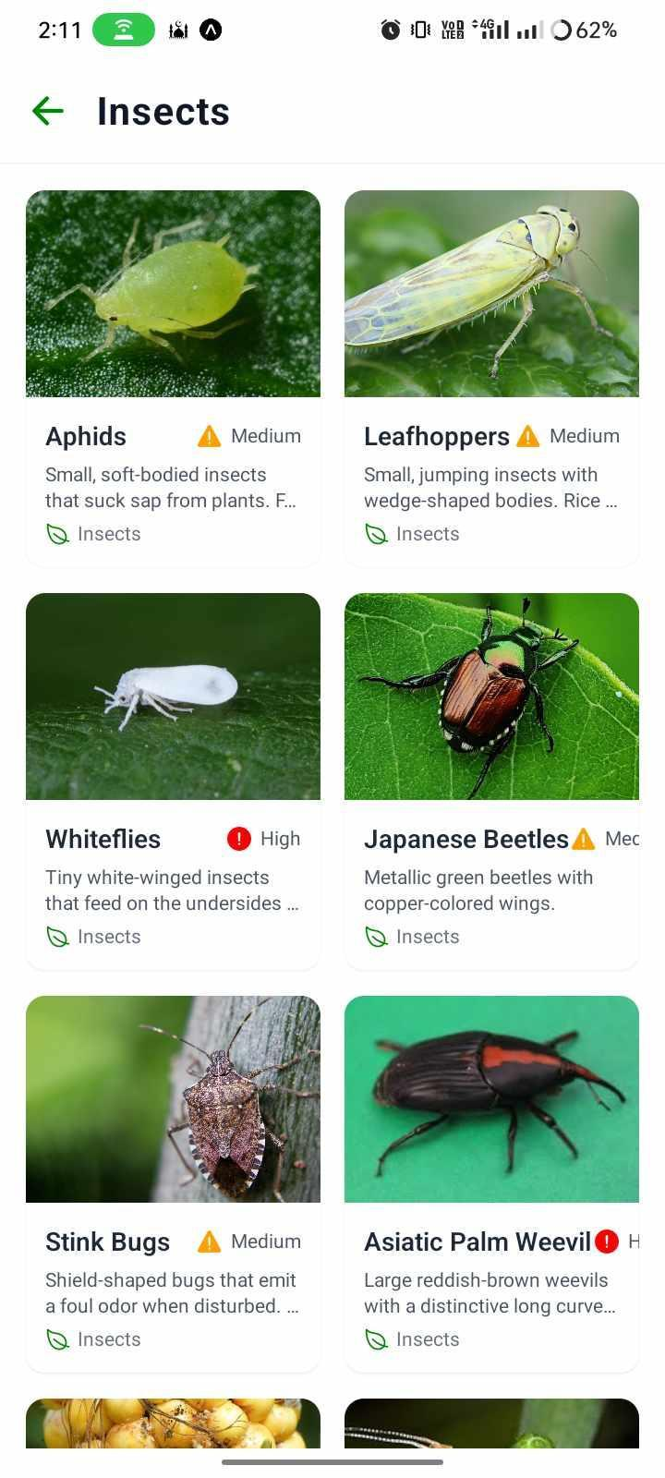

Figure 3.1 Category
Figure 3.2 It shows illustrated on this page the various types of pests according to the respective category. Also contains some information about the name of the pests and some information regarding them.

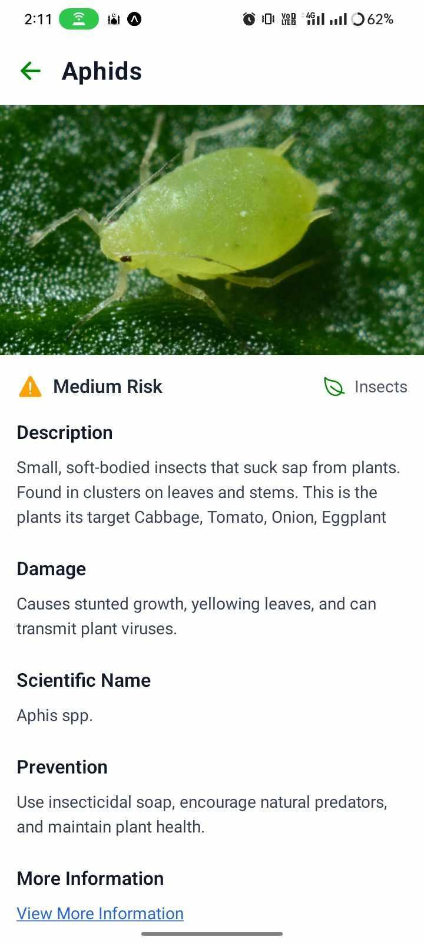

Figure 3.4 Identity Page
Figure 3.4 Information about pests, such as their identification and crop-damaging impacts.

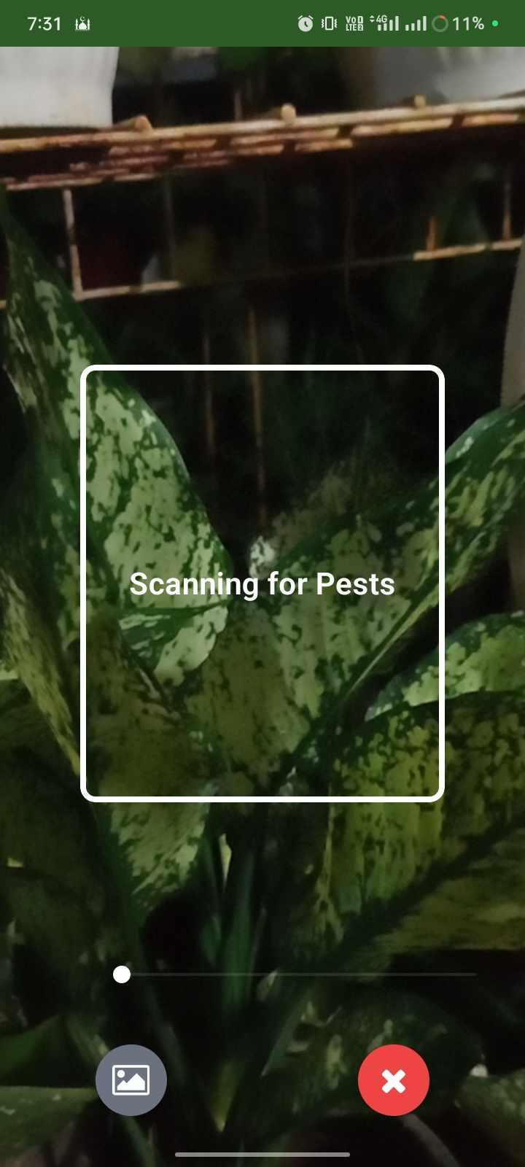

Figure 3.5 Scanning
Figure 3.5 Pest scanning is seen in Figure 3.5, where the pests are automatically detected when they are discovered.

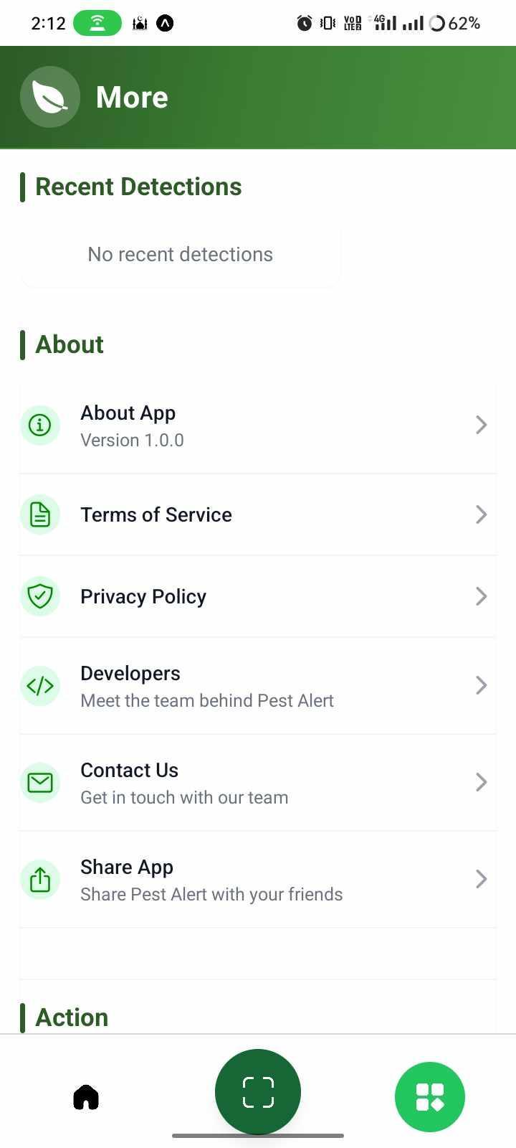

Figure 3.6 Settings
Figure 3.6 shows the settings page, which includes information about the app, terms and conditions, and the application's version.

‘

CHAPTER IV

METHODOLOGY

4.1 REQUIREMENT ANALYSIS
This chapter focuses on the procedures that will be used to conceptualize, develop, test, and implement the proposed project. The testing procedures go over Software Development Life Cycle (SDLC) methods used to evaluate the system, as well as the type of testing that was done. The implementation plan details the steps involved in deploying the system.

4.2 REQUIREMENT DOCUMENTATION
The development of the project involved a comprehensive data gathering process, to ensure the project objectives were met and the solution to the problem was both user-friendly and effective. Different methods were used to collect all the necessary data. Interviews were conducted with agricultural experts, farmers, and other potential end-users to better understand their needs, challenges, and expectations regarding insect pest control. The interview provided insights to the researchers in terms of practical aspects on insect pest management, and limitations of existing solutions. Identification of various insect and pest control methods.
The researchers also analyzed the current data related to the project. Pest control methods including the use of insecticides and their long-term effect on both human health and the environment are thoroughly reviewed. This involved examining research and case studies regarding the use of YOLOv (You Only Look Once) and mobile devices were also studied and examined to make sure that the applications were effective and sustainable.
Direct observations were also conducted by the researchers. It involved observing the insect pest identification and process of the YOLOv to the pest. The effectiveness of the device is thoroughly observed in different backyard plants, areas, time, and weather conditions both on pilot testing using the prototype application and the final applicaton. This process helped the researchers identify issues in real-world situations to address them immediately

4.3 DESIGN SOFTWARE
The design of software for the "Pestalert: An Ai-Powered Pest Detection and Identification System for Crop Agriculture in Palawan " device will be a mobile application designed for Android devices. The app will serve as the primary interface for users to interact with and control the device.
Key Features and Functionalities:
Mobile Application:
- User-Friendly Interface: Easy to use with intuitive navigation and clear instructions. Instructions: Detailed guidance on using the app and device, including step-by-step procedures.
- Online Modes: Connect the device via mobile network for identification process.
- Search Button: To search a specific pest for use.

Mobile Phone Minimum Requirements:
COMPONENTS | RECOMMENDED MINIMUM SPECIFICATION
OS Version | Android 8.0 (Oreo)
Ram | 2GB
Processor (CPU) | Octa-Core 1.4ghz
Internal | At least 8GB
Display | 720p HD
Battery | 2500mAh
Internet | 3G/4G connection or Wi-Fi connection
Table 4.1
The software will follow a structured development process:
- Architecture: The application will use a client-server model, with a mobile frontend communicating with a cloud-based backend.
- Database Design: The pest database will store images, descriptions, and recommended treatments.
- UI/UX Design: A simplified interface will ensure usability for farmers with varying levels of tech experience.

4.4 DESIGN OF SYSTEM
The project design was thoroughly studied by the researchers to achieve the optimal functionality of the device for it to properly perform and execute the project’s objectives.
The System Development Life Cycle (SDLC) approach used in our project follows the straightforward and structured methodology of the Waterfall model. This model is particularly suitable for our project due to its linear and sequential nature, ensuring each phase is completed before moving on to the next.
Requirement Gathering and Analysis
In the Requirement Gathering and Analysis phase, the researchers conducted a series of meetings to thoroughly discuss the entire scope and objectives of the project. During these discussions, we meticulously analyzed the existing systems related to our program to understand their strengths and weaknesses. This analysis helped us identify the specific requirements for our project. We compiled a comprehensive list of requirements, ensuring that all necessary functionalities and features were considered. This phase was crucial for laying a solid foundation for the subsequent stages of the project.
Design
The Design phase involved generating ideas and conceptualizing the mobile application and its associated devices. During this phase, the researchers created detailed design specifications for the entire system. We focused on user interface design, user experience, and the overall architecture of the mobile application. This phase resulted in a set of detailed design documents that guided the implementation phase.
Implementation
The Implementation phase began with the coding of the mobile application. The programmers took the finalized design documents and artifacts and started the actual development work. They ensured that the solution adhered to the design specifications established in the previous phase. As the coding of the mobile application neared completion, system integration commenced. Initial testing was conducted during this phase to identify and address any immediate issues.

4.5 GANTT CHART
A Gantt chart is a visual representation of a project schedule, displaying tasks, their durations, and dependencies over time. It helps project managers and teams track progress, allocate resources, and ensure timely completion. In the context of the "Pest Alert" project, a Gantt chart would outline the various phases and tasks involved in developing and implementing the insect control device. By visualizing the project timeline and task dependencies, the Gantt chart would enable the project team to effectively manage resources, identify potential bottlenecks, and ensure the successful and timely completion of the "Pest Alert" project.

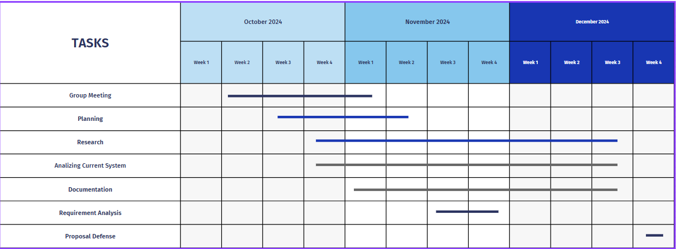

Figure 4.5.1: Gantt Chart of Project Timeline
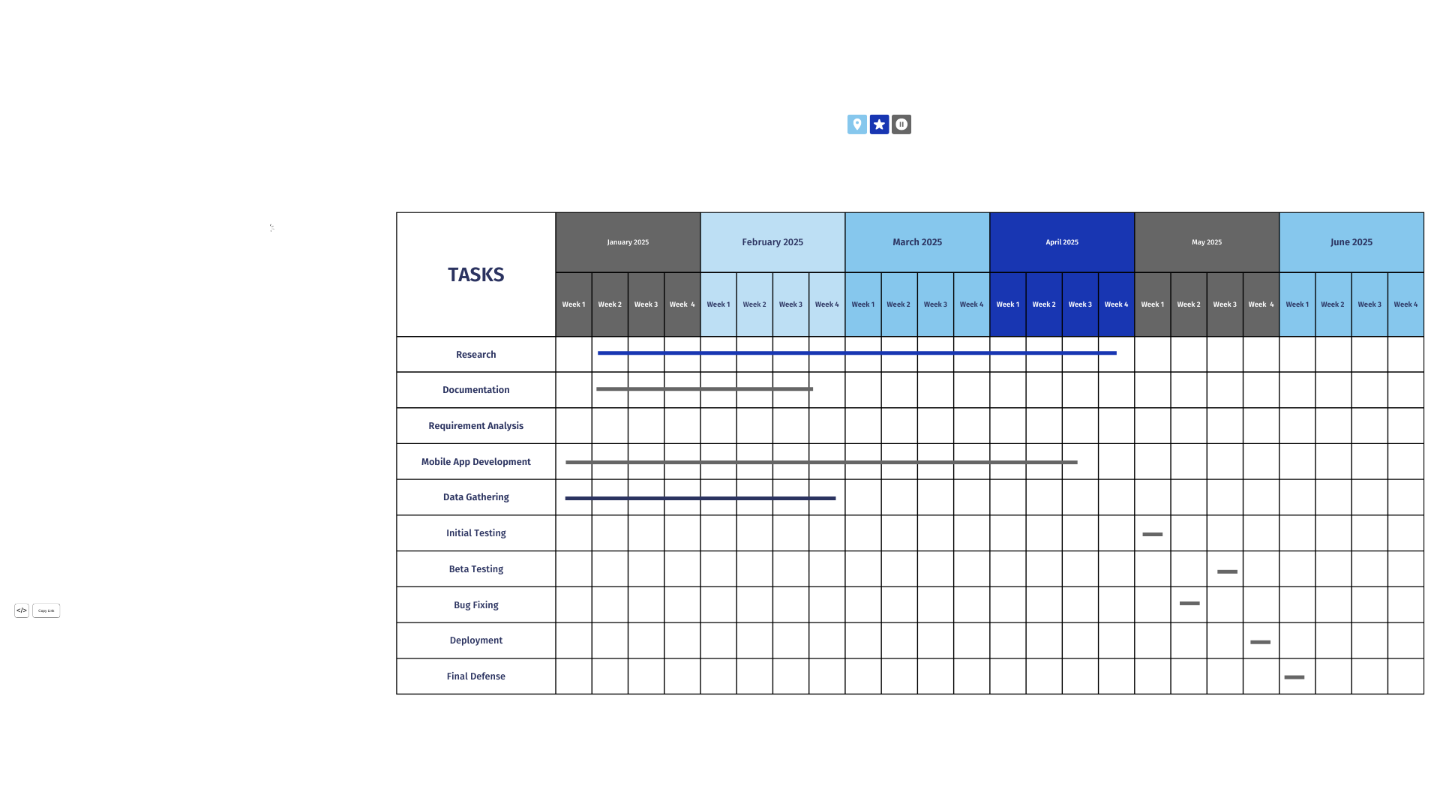

Figure 4.5.2
This figure presents the overall project timeline, outlining key phases such as requirement analysis, system design, software development, testing, and deployment. It provides a visual guide to ensure tasks are completed on schedule.
Phase 1: Requirement Gathering Phase
(October 11 – November 29, 2024)
- Group Meeting (October 14 – November 3, 2024) - Organized initial collaboration sessions to determine project scope, assign tasks, and set objectives.
- Planning (October 21 – November 15, 2024) - Formulated an actionable plan for system development with technology stacks, AI tools, and hardware planning.
- Analyzing Current System (October 28 – November 3, 2024) - Assessed conventional pest detection techniques to determine gaps PESTALERT has set out to address.
- Requirement Analysis (November 18 – November 29, 2024) - Executed stakeholder consultations (farmers, agriculturists) to collect extensive system requirements.

Phase 2: Research & Documentation Phase
(October 28, 2024 – April 27, 2025)
- Research (October 28, 2024 – April 27, 2025) - Current studies on pests prevalent in Palawan, applicable data sets, AI image processing algorithms, and crop culture.
- Documentation (November 4, 2024 – February 2, 2025) - Recorded system requirements, research results, architectural designs, and early project workflows.
Phase 3: Development Phase
(January 6 – April 20, 2025)
- Mobile App Development (January 6 – April 20, 2025) - Developed and deployed the PESTALERT mobile app with emphasis on UI/UX, image input functionality, and AI integration in the backend.
- Data Gathering (January 6 – February 23, 2025) - Sample images of pests were collected from farms, government databases, and research institutions for model training and testing.
Phase 4: Testing & Deployment Phase
(April 28 – May 20, 2025)
- Initial Testing (April 28 – May 4, 2025) - Performed system testing to ensure AI performance, correctness of pest identification, and UI functionality.
- Beta Testing (May 12 – May 18, 2025) - Provided a beta release to a test community of farmers and agricultural specialists in order to obtain user feedback.
- Bug Fixing (May 19 – May 25, 2025) - Fixed bugs reported by beta testers and implemented performance enhancements.
- Deployment (May 26 – May 27, 2025) - Released the final app version for real application to selected pilot farms in Palawan.
Phase 5: Finalization Phase
(June 2, 2025)
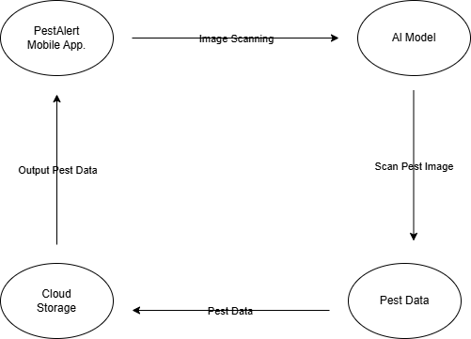
- Final Defense (June 2, 2025) - Formal project defense and presentation to the panel, showcasing system features, architecture, testing results, and impact assessment.

Figure 4.6: Context Diagram of PestAlert application
The Level 0 Data Flow Diagram, demonstrates a mobile app-based pest scanning, utilizing AI technology to scan images, detect pests, and provide actionable insights for agricultural management.
The main components of the device are:
- User: The user controls the system through a mobile device.
- Mobile Application: The mobile application sends scans and gives the information and preventive measurement of pests.
- Camera capturing: The application camera features real-time capturing.
The device works as follows:
- The user opens the mobile application and selects the camera button.
- The mobile application gives information about pests after scanning.
- The application scans the pests and executes it.
PestAlert is created to be user-friendly, safe, and very effective. It offers several in-built features to provide a secure and stable user experience, including automatic session management preventing extended use of the app without activity. The app is also very effective in detecting and offering precautionary measures against numerous agricultural pests based on image-based detection and smart an
Overall, the PestAlert app is a safe and effective solution for identifying and managing agricultural insect pests.

Figure 4.3: Level 0 Data Flow Diagram (DFD)
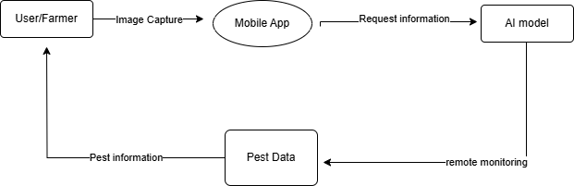
Figure 4.7: Level 0 Data Flow Diagram (DFD)

The Level 1 Data Flow Diagram defines a pest monitoring system with a mobile app and AI technology for monitoring and detecting pests efficiently. Farmers scan pest images of the fields through the app that are processed by an AI model. The AI performs remote monitoring, processing of data, and captures pest data. Feedback is sent back to the app, providing farmers with actionable data. Pest management with AI enhances the accuracy of pest detection by monitoring fields in real-time.

Figure 4.4: Level 1 Data Flow Diagram (DFD)
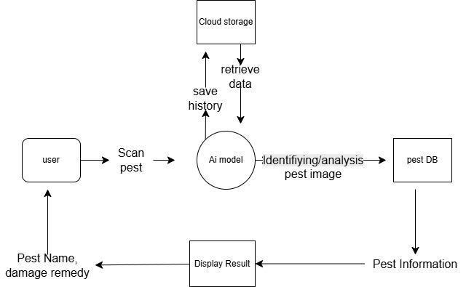
Figure 4.8: Level 1 Data Flow Diagram (DFD)
The Level 1 Data Flow Diagram for the Pest Alert application outlines a pest monitoring process where farmers scan pest images using a mobile app. The app scans images to an AI model, which detects pests, categorizes threats, triggers alerts, and provides management recommendations. This increases efficiency and accuracy, allowing farmers to respond quickly.

USE CASE DIAGRAM
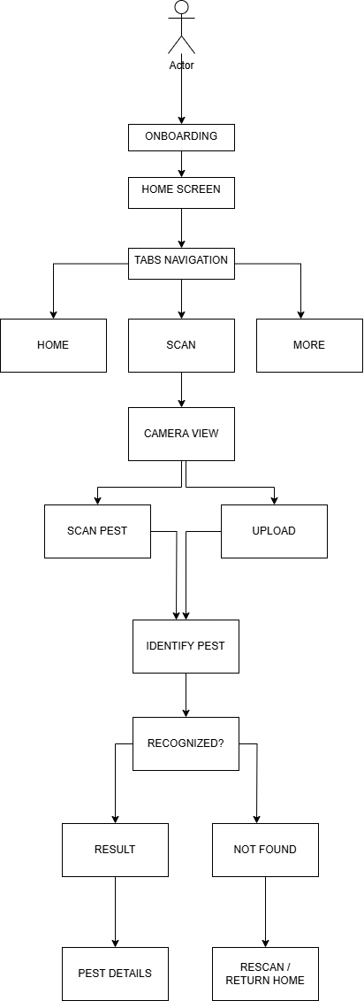

Figure 4.9 USE CASE

With this use case diagram, it is possible to represent the user flow of the mobile app, which was built specifically for pest identification through image scanning. A new user gets introduced to what the app can do through the onboarding screen of the app. The following screen is the home screen which eventually changes to the tabs navigation for the three primary sections of the app, namely Home, Scan and More The Scan option allows users to enter the camera view mode to scan a pest live or upload a previously captured picture. When an image is presented, the app performs pest identification and, depending on the identification outcome, displays a result screen with the option to view pest details if the pest is identified However, if the pest is not found the user can either rescan or go back home This is the flow, ensuring that the user experience is seamless and interactive and focused on the interpretation of the detected pest and the information retrieval path.

4.10 Development and Testing
The project was designed to cater to small to medium-scale farmers in Palawan by providing an intelligent, AI-based solution for checking for pests and controlling them. To demonstrate the operability and usability of the system, the researchers conducted extensive data gathering in the form of personal interviews from the farmers and consultation with the Department of Agriculture. Additionally, real-world testing and actual observation were conducted on backyard farms. These methods aided in deciding optimal conditions for pest infestation, which specific months or conditions are most common for infestations. Through this collaborative effort, the respondents and the researchers were able to validate and analyze the concept and functionalities of the PestAlert system ensuring that it met the project objectives of real-time detection, simplicity, and usability in the native agricultural setting.

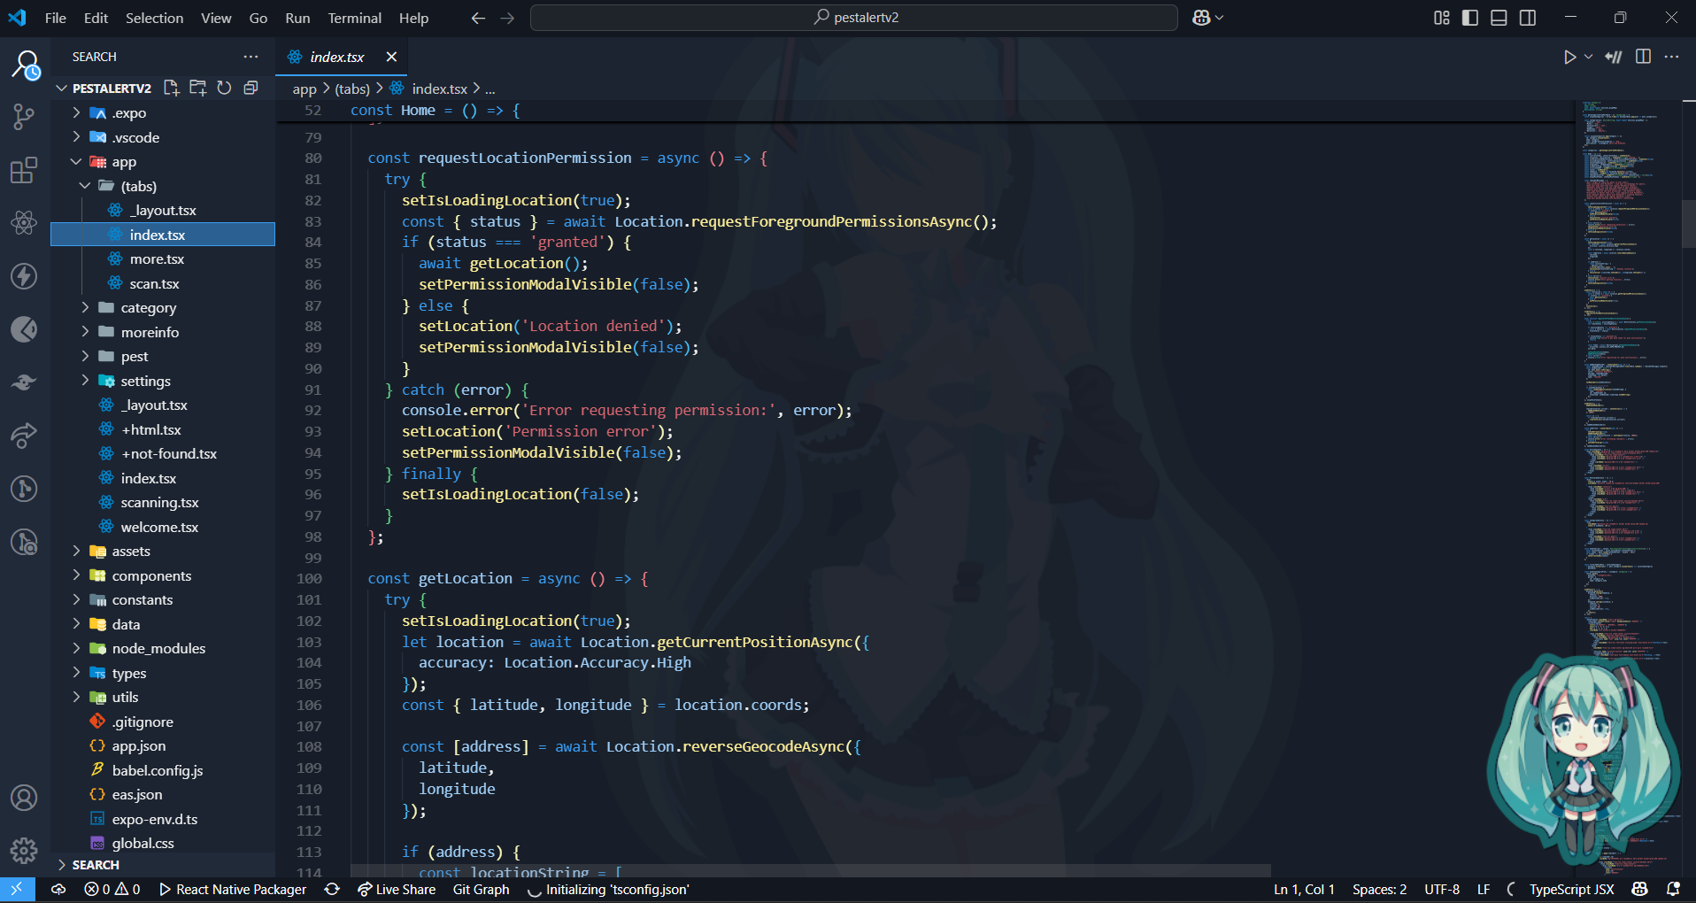
Figure 4.10.1 CODING INTERFACE
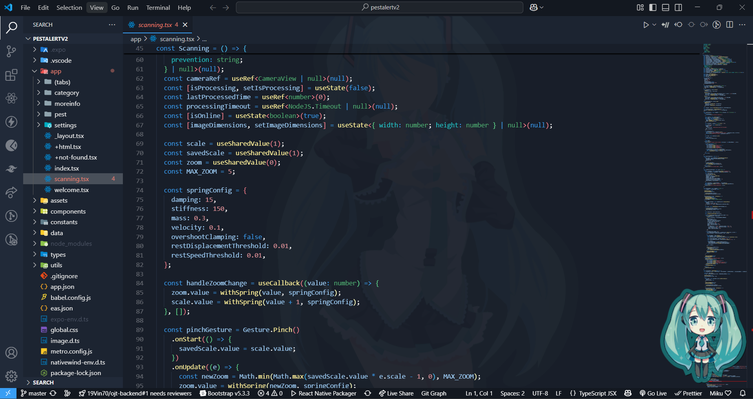
Figure 4.10.2 CODING INTERFACE
Figures 4.10.1 and 4.10.2 Show the coding Interface used in developing the mobile application. The researchers used Visual Studio as an Integrated Development Environment (IDE) for the entire development as it is so user-friendly and easy to navigate through.
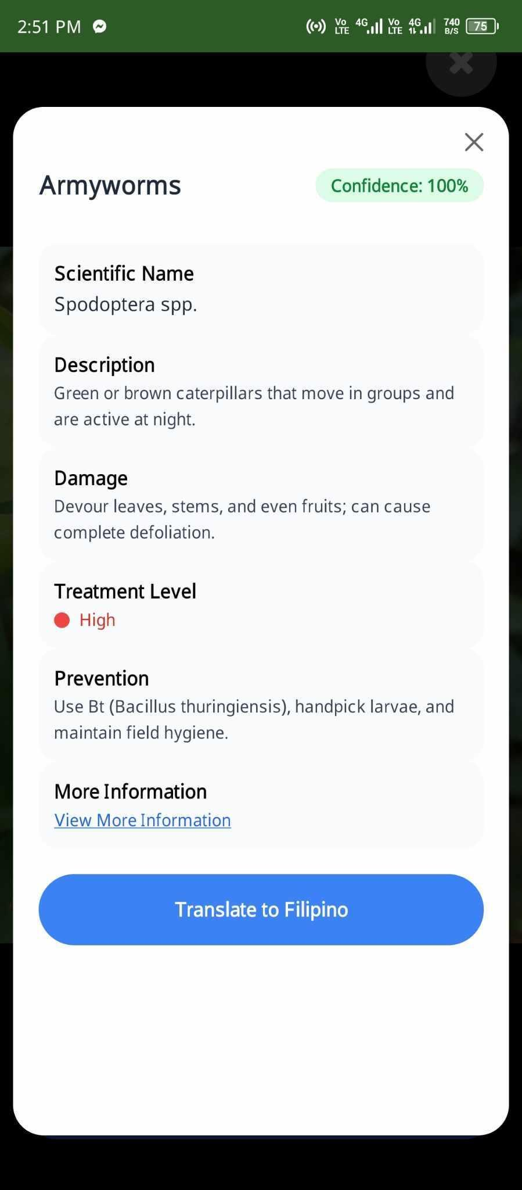
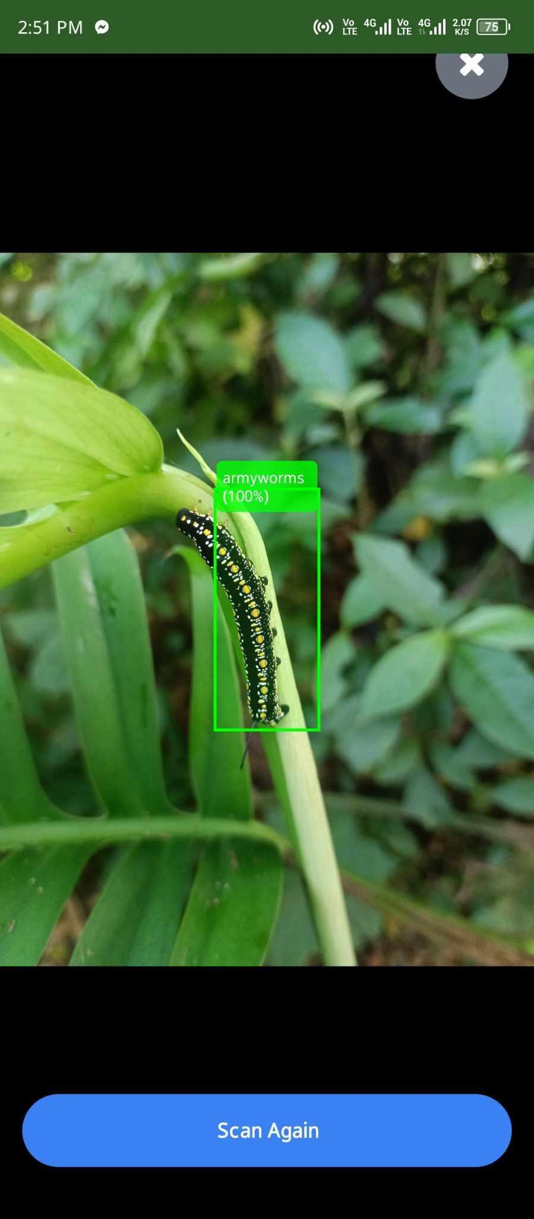

Figure 4.11 IMAGE DURING TESTING
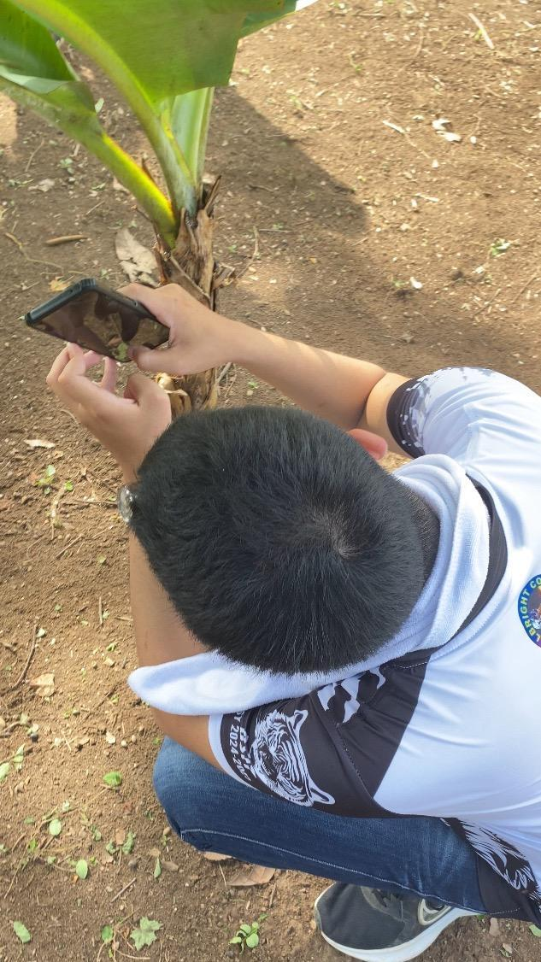

Figure 4.11.1 IMAGE DURING TESTING
Figure 4.11.1 Shows PestAlert application underwent accurate testing to ensure its functionality in real-world agricultural settings. The system was analyzed for accuracy, responsiveness, and stability, enhancing its effectiveness and support for sustainable agriculture in Palawan.
Testing May 23, 2025 – May 26, 2024
TESTING | DATE | PEST
testing 1 | May 23, 2025 | Stink Bug  Potato Beetle  Rice bug  Aphids  Tomato hornworm
testing 2 | May 24, 2025 | Armyworm  Aphids  Spider mites  Cabbage looper  Corn earworm  Corn borer
testing 3 | May 25 2025 | Cotton steiner  Stink bug  Lady beetle  Grasshopper  Cabbage hooper  Tomato hornworm
testing 4 | May 26, 2025 | Rice bug  Grasshopper  Stink bug  Grasshopper  Armyworm  Cotton Stainer
Table 4.11.1 Testing Result
Figure 4.1 provides a detailed schedule of insect testing conducted from May 23, 2025, to May 26, 2026. Each test includes specific dates, and the types of insects.
- Testing 1 (May 23, 2025): From 1:30 PM to 5:00 PM, the test identified Stink Bug, Potato Beetle, Rice Bug, Aphids, and Tomato Hornworm.
- Testing 2 (May 24, 2025): From 3:30 PM to 5:00 PM, the test identified Armyworm, Aphids, Spider Mites, Cabbage Looper, Corn Earworm, and Corn Borer.
- Testing 3 (May 25, 2025): From 3:30 PM to 5:00 PM, the test identified Cotton Stainer, Stink Bug, Lady Beetle, Grasshopper, Cabbage Looper, and Tomato Hornworm.
- Testing 4 (May 26, 2025) : From 2:30 PM to 4:00 PM, the test identified Rice Bug, Grasshopper, StinkBug, Grasshopper, Armyworm, Cotton Stainer.

SURVEY
Survey topic: This survey was designed to gather first-hand information about the monthly occurrence of common agricultural pests in the Palawan area. The information will be utilized to train the AI model of the PestAlert system and improve its predictive power. In contrast to formal Likert scale surveys, this instrument used a descriptive monthly pest listing to suit local farmers' preferences and facilitate easier responses. There were 4 local farmers involved in this survey.

The table below summarizes pests reported per month by the 4 participants:
MONTH | PEST REPORTED
January | Freshwater Snail,Cabbage Looper
February | Cabbage Looper
March | Freshwater Snail,Cabbage Looper
April | Armyworm,Stem-borer,Cabbage Looper
May | Rice Black Bug, Aphids, Yellow Bug, Rats,Cabbage Looper, Leaf Hispine Beetle
June | Stem-borer, Armyworm, Mites, Aphids, Looper
July | Aphids,Cabbage Looper
August | Aphids,Cabbage Looper
September | Aphids,Cabbage Looper
October | Aphids,Cabbage Looper
November | Aphids,Cabbage Looper
December | Freshwater Snail, Aphids,Cabbage Looper
Table 4.12 Survey Summary Result
Table 4.12 Provides the details of the pests reported per month, which is based on feedback collected from all 4 farmer participants. The table shows the pests found from January to December and will be used for the identification of seasonal pest trends and for creating the AI model on the PestAlert system.
PEST TYPE | FREQUENCY (NUMBER OF MONTHS REPORTED)
Cabbage Looper | 12
Aphids | 7
Freshwater Snail | 3
Armyworm | 2
Stem-borer | 2
Rice Black Bug | 1
Yellow Bug | 1
Mites | 1
Rats | 1
Leaf Hispine Beetle | 1
4.12.1 Monthly Frequency Count of Common Pests
Table 4.12.1 Provides a summary of the frequency of occurrence of each pest in terms of the number of months that they were reported by the 4 respondents. We can see from this table which of the pests occur most often during the year, e.g., pests such as Looper and Aphids as the most regular, which is why they are given the highest priority in the AI model and pest database of the PestAlert system.

RATING CRITERIA |  | INTERPRETATION
Pest present in ≥ 6 months | Looper, Aphids | Highly Seasonal / Common
Pest present in 3-5 months | Freshwater Snail | moderately Seasonal
Pest present in ≤ 2 months | Armyworm, Stem-borer, Rice bug, etc. | Rare / Outbreak-Based
Table 4.12.2 Pest Occurrence Trends and Interpretation
Table 4.12.2 provides the interpretation of pest occurrence trends by how often each pest was reported across the months. The pests are then labeled as Highly Seasonal/Common, Moderately Seasonal, or Rare/Outbreak-Based depending on their frequency. This classification directs the PestAlert system regarding the order of detection of pests, scheduling of alerts, and resource utilization in the mobile app.

OBSERVATION | SYSTEM DEVELOPMENT IMPACT
Looper and Aphids are the most recurring pests | These will be prioritized in the AI training dataset
May has most diverse pest activity (6 pest types) | System can trigger peak season alerts during this period
December, January, March show freshwater snail recurrence | Used for location-based and seasonal recommendations
Rice Black Bug outbreak observation only in may | Indicates potential for seasonal pest-specific alerts
Low incidence of rats and Sparrows | May be considered in future updates if reported more frequently

Table 4.12.3 Interpretation of Result
Table 4.12.3 Provides an interpretation of the overall pest occurrence data based on observed trends and their potential impact on system development. It maps major survey results against specific features of the PestAlert system, such as AI model training, peak season alerts, and seasonal recommendations. This enables the system to be developed according to actual field data, thus making it more accurate, responsive, and relevant to Palawan farmers' needs.

CHAPTER V

RECOMMENDATIONS, SUMMARY AND REFERENCES
This recommendation outlines the benefits and practical implementation of the “PESTALERT: An AI-Powered Pest Detection and Identification System for Crop Agriculture in Palawan” project, illustrating its power of transformation in crop pest management. PESTALERT marries high-tech artificial intelligence with smartphone usability to provide real-time pest detection, offering an innovative, green, and scalable alternative to conventional pesticide application. The initiative applies AI-powered image recognition (YOLO, TensorFlow), enabling farmers to scan and detect pests using a mobile application, which makes suitable treatment recommendations. This solution not only simplifies pest control but also strengthens decision-making, increases crop yield, and minimizes the harmful environmental and health effects of excessive pesticide usage.

Recommendations for Implementation:
To maximize the benefits of the PESTALERT system, the following recommendations are proposed:
Strategic Image Capture: Educate farmers to capture sharp, well-illuminated photographs of the pests in order to accurately detect them. Include visual instructions in the app on best practices for scanning and demonstrations of good and bad image quality.
Frequent Data Updates: Continuously enrich the pest database with additional species and user-provided images. Collaboration with agricultural institutions will enhance the system's accuracy and reliability in the future.
Enlarge Offline Capabilities: Implement local cache and offline scanning of pest information to support farmers with limited internet access in rural areas. Sync data once online.
Enhance Multilingual and Accessibility Features: Increase the app's text-to-speech and translation features by adding more Filipino dialects and voice choices. This will enhance the system's accessibility to a wider user population.
Smart Notifications: Include alert notifications to enhance user interaction and app stability. These are:
- Low-quality image warning
- Successful scan confirmation
- Pest not found alerts with tips for improved image capture
- Daily or seasonal pest danger alerts by location and trends
Advanced Training Modules: Instruct through hands-on workshops and in-app tutorials on how to operate the system. Incorporate modules for pest identification fundamentals, life cycle of pests, and organic treatment methods.
Cloud-Based Scan History and Analytics: Enable users to view their scan history and plot pest frequency and types against time. This will assist in the diagnosis of recurring problems and the optimization of pest control practices.
Integration with IPM Strategies: Promote the use of PESTALERT in conjunction with current Integrated Pest Management (IPM) practice. This combination approach supports sustainability and minimizes chemical dependence.
Security and Data Privacy Compliance: Ensure that all user information, such as images and scan history, is encrypted and secured in accordance with data privacy protocols to ensure user trust and confidentiality.
Public-Private Partnership: Coordinate with the Department of Agriculture, LGUs, and NGOs to disseminate the app, capacitate farmers, and subsidize mobile phones or data usage to maximize adoption, particularly in remote areas.

5.1 Summary
The capstone project "PESTALERT: An AI-Powered Pest Detection and Identification System for Crop Agriculture in Palawan" offers a groundbreaking and smart solution to contemporary pest control in agriculture. Through artificial intelligence and mobile technology, it detects and classifies pest infestations in real-time using smartphone cameras. The app employs AI models including YOLO (You Only Look Once) and TensorFlow to identify pests from photographs taken by farmers, offering real-time identification, pest details, and suggested control methods. The project provides a solution to the ever-present problem of farm pest control while minimizing reliance on dangerous and expensive chemical pesticides.
Agriculture continues to be an essential source of livelihood and food security, particularly in provinces such as Palawan. Yet pest infestations remain a threat to crop productivity, with farmers frequently resorting to excessive pesticide applications. These conventional approaches have evoked concerns regarding environmental degradation, health risks, and long-term ineffectiveness as a result of pest resistance. Responding to this, the PestAlert project was initiated to provide a smart, convenient, and environmentally friendly alternative that places actionable pest information in the farmers' hands in the form of their smartphones.
The PestAlert app enables image capturing of pests, multilingual interface support (including Tagalog), text-to-speech functionality for accessibility, and sustainable pest management recommendations that are environmentally friendly. PestAlert seeks to equip small to medium-sized farmers with technology-based decision-making capabilities to avoid loss of crops and improve yield. While there are some limitations, such as lower accuracy in low-light or poor-quality images, the advantages of rapid, targeted, and sustainable pest detection outweigh these limitations.
This project emphasizes precision agriculture through the convergence of mobile and AI technologies in order to close the knowledge and accessibility gaps in pest control. Through localized monitoring and control of pests independent of archaic or inaccessible agricultural support systems, PestAlert provides an efficient, scalable, and eco-friendly solution. It not only promotes sustainable agriculture but also enhances food security and agriculture industry in Palawan.

The primary goal of PestAlert is to improve pest detection capacity for farmers with minimal dependence on traditional pesticides. This is possible through image recognition models supported by AI deployed in a mobile app that detects pests through image capturing. The system also maintains scan history in cloud databases, gains experience from user feedback over time, and offers training materials for integrated pest management. With its easy interface and intelligent features, PestAlert revolutionizes the way pest-associated problems are managed among rural agricultural communities, ushering in a stronger and technology-based agricultural future.

5.2 Conclusion
The PESTALERT capstone project was able to create an AI-based mobile application that assists Palawan farmers to identify and detect crop pests in real-time using smartphone cameras. Through the incorporation of machine learning tools such as YOLO and TensorFlow, the system instantly provides pest details, control measures, and Tagalog translations to improve accessibility. Although there were some issues with image quality and identification of infrequent pests, the app worked well in field testing and provides a viable, sustainable alternative to conventional pesticide use. This project shows how technology can be used to enable local farmers, enhance agricultural practices, and encourage eco-friendly pest management.

APPENDICES

APPENDIX A
FULLBRIGHT COLLEGE
Mangga Street, Km.5, National Highway, Brgy. San Jose, Puerto Princesa City, Palawan
Bachelor of Science in Information Technology
Capstone Project Team – PESTALERT
Date: June 2, 2025

Dear Participant,
Greetings!
I am a Bachelor Science of Information Technology student from Fullbright College who is doing our capstone project now with the title "PESTALERT: An AI-Powered Pest Detection and Identification System for Crop Agriculture in Palawan."
The objective of our project is to create a mobile app that would be able to assist farmers in identifying and detecting crop pests through the use of artificial intelligence (AI) and phone cameras. In order to confirm the accuracy and applicability of the system, we are performing a phenomenological interview with you to learn about your own experiences with pest infestation during the year.
Your feedback will assist us as a participant in the following ways:
- Identify the most prevalent pests in your location
- Identify when the pests tend to show up
- Enhance the efficiency of our AI detection model
Please rest assured that:
- Your contribution is on a volunteer basis.
- Your responses will be treated as confidential and used exclusively for academic purposes.
- You can withdraw from the interview at any point without any cost.
We really appreciate your experience and knowledge. Your input will assist in developing a tool that will be useful for many farmers like you.

We appreciate your support!
Best regards,
The PESTALERT Capstone Team
BSIT-4A, Fullbright College
recaldejoms27@gmail.com

APPENDIX B
Purpose:
To investigate the actual experience of Palawan local farmers on the occurrence of pests in their crops and how they deal with pest infestation at present.

Research Method:
- Type: Phenomenological qualitative study
- Instrument: Printed Interview Questionnaire and Monthly Pest Log
- Respondents: Registered or practicing farmers from Narra and Puerto Princesa
- Sample Size: 4

Section 1: Demographic and Verification Information
Full Name | Address | Register in D.A. | Proof of Farming
ANGELO A. SARMINES | Brgy, Inagawan, Puerto Princesa City, Palawan | Yes | Brgy. Certification
Gina J. Anecito | Aborlan, Palawan | No | Brgy. Certification
Felimon Cabrastante Jr. | Tinagong Dagat, Narra, Palawan | Yes | RSBSA Stab, Brgy. Certification
June H. Lorenzo | Sta, Lucia, Puerto Princesa City, Palawan | Yes | RSBSA Stab

Section 2. Monthly Pest Occurrence Table
MONTH | FARMER 1 | FARMER 2 | FARMER 3 | FARMER 4
January | Rice Black Bug | Yellow Bugs | Leaf Hispine Beetle | Aphids
February | Armyworm | Cabbage Looper | Leaf Hispine Beetle | Stem-borer
March | Freshwater Snail | Yellow Bugs | Leaf Hispine Beetle | Stem-borer
April | Stem-borer | Yellow Bugs | Leaf Hispine Beetle | Aphids
May | Rice Black Bug | Yellow Bugs | Leaf Hispine Beetle | Armyworms
June | White Flies | Cabbage Looper | Leaf Hispine Beetle | Stem-borer
July | Mites | Cabbage Looper | Leaf Hispine Beetle | Armyworms
August | Rats | Yellow Bugs | Leaf Hispine Beetle | Aphids
September | Sparrow | Cabbage Looper | Leaf Hispine Beetle | Aphids
October | Armyworm | Cabbage Looper | Leaf Hispine Beetle | Armyworm
November | Freshwater Snail | Cabbage Looper | Leaf Hispine Beetle | Aphids
December | Stem-borer | Yellow Bugs | Leaf Hispine Beetle | Aphids

Section 3: Summary of Findings
- Leaf Hispine Beetle is a year-round pest with significant leaf damage, especially in Narra, Palawan,
- Aphids are more active in the cooler months and during the rainy season.
- Armyworms and Stem-borer are problematic during planting months (May-July).
- Farmers mainly rely on visual inspection and manual pest control, with no digital tools.
- Participants expressed interest in using a mobile app that can detect pests from images
Application in System Design
Data collected from these interviews directly supports:
- Training the AI model to focus on the most commonly reported pest.
- Creating a monthly alert system inside the app.
- Making the UI/UX more intuitive for farmers with farmers with little to no tech background.
- Building an AI system rooted in real local agricultural experiences.

APPENDIX C
CODE SNIPPET
PESTALERT: AN AI-POWERED PEST DETECTION AND IDENTIFICATION SYSTEM FOR CROP AGRICULTURE IN PALAWAN.
This is one the code of the application, this is the “App” branch of the application where all of the available files (screen, logic, and function) are connected and united here.
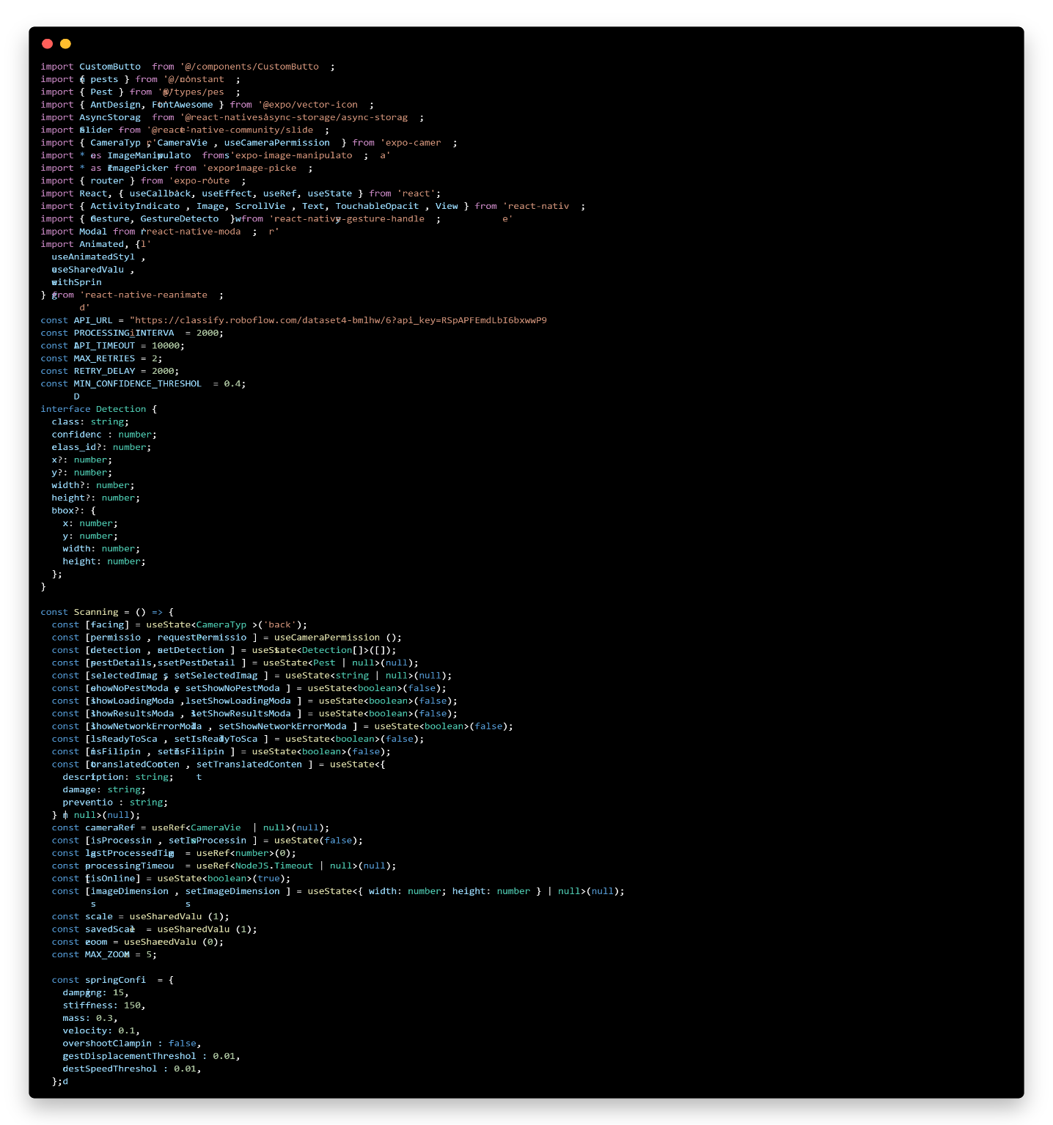
Scan File:
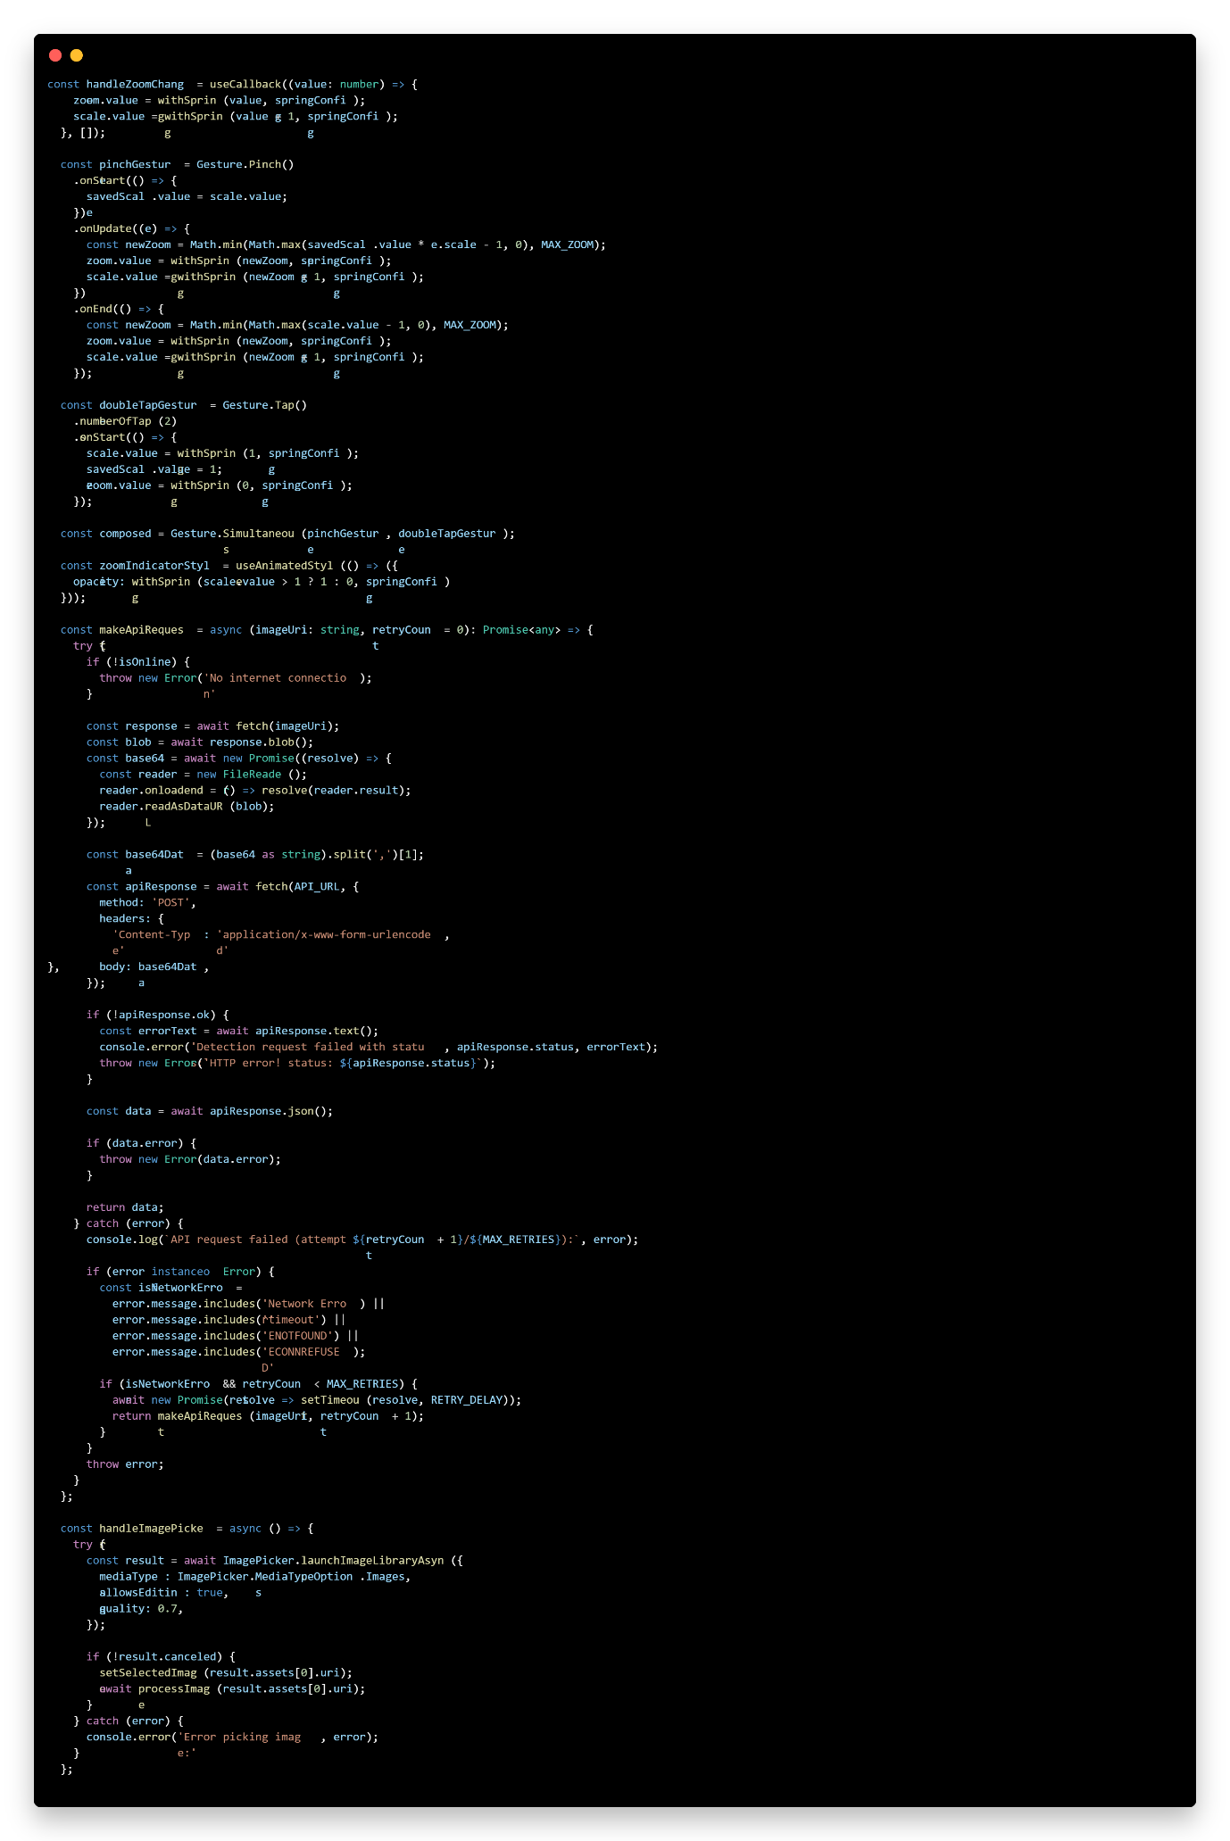
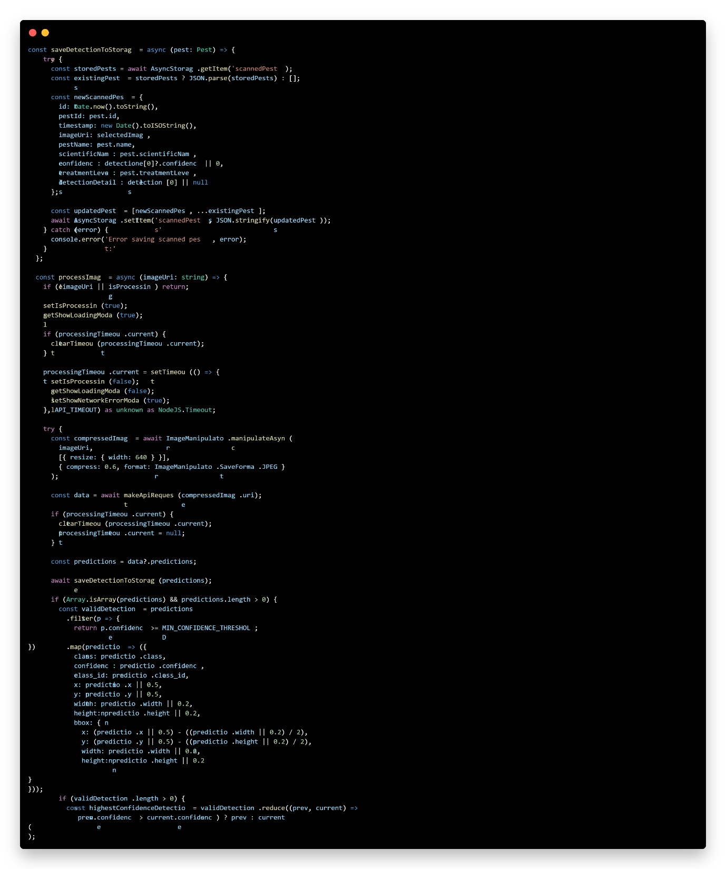

Data File:
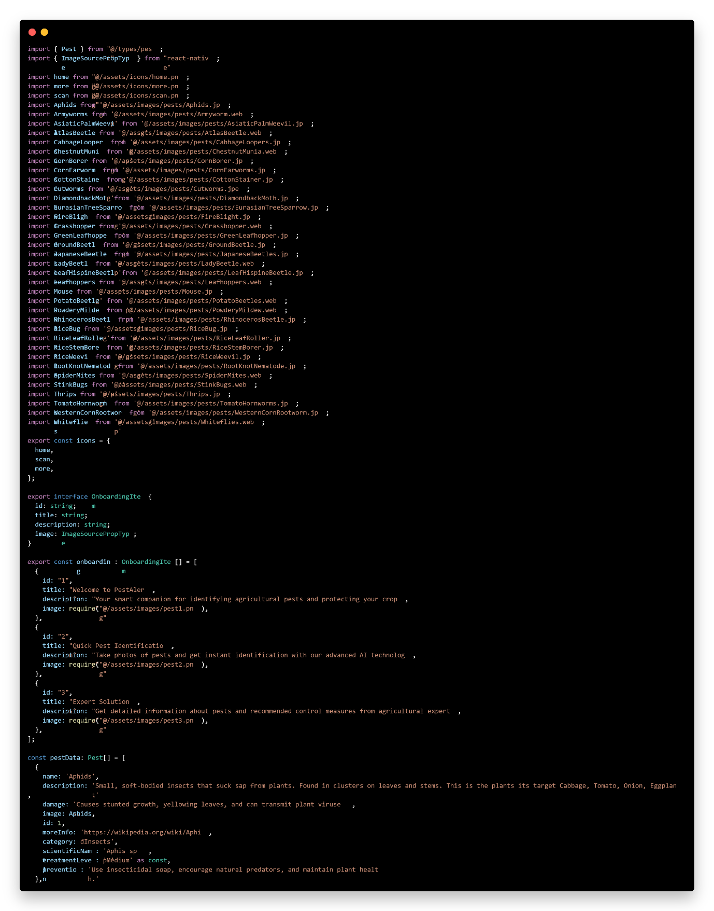

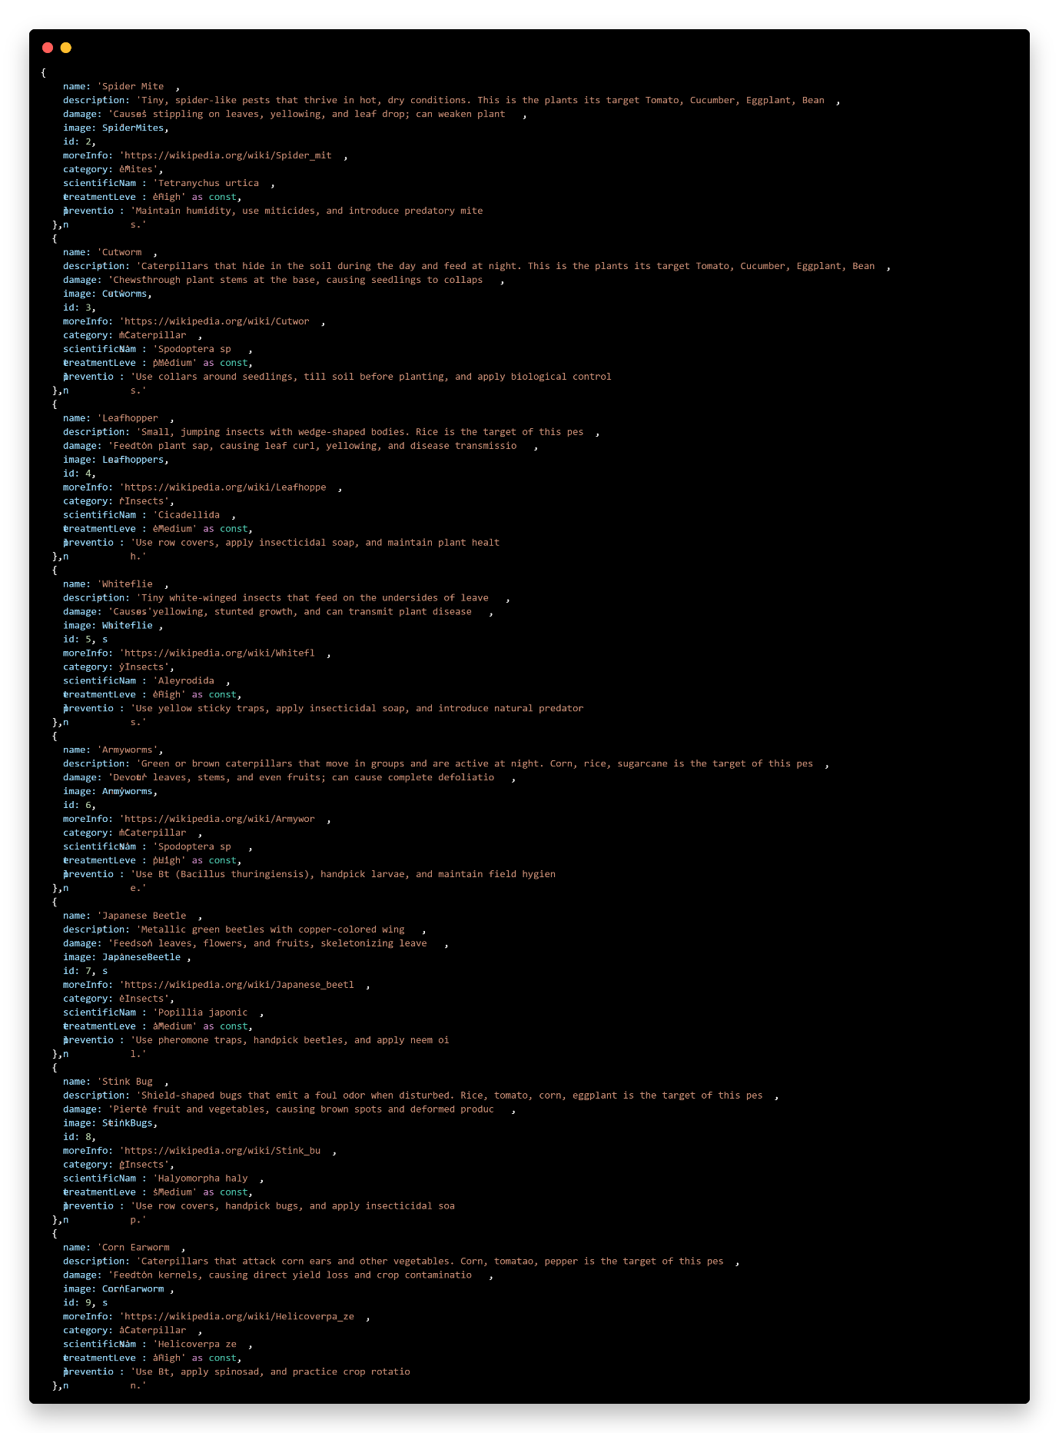

Welcome File:
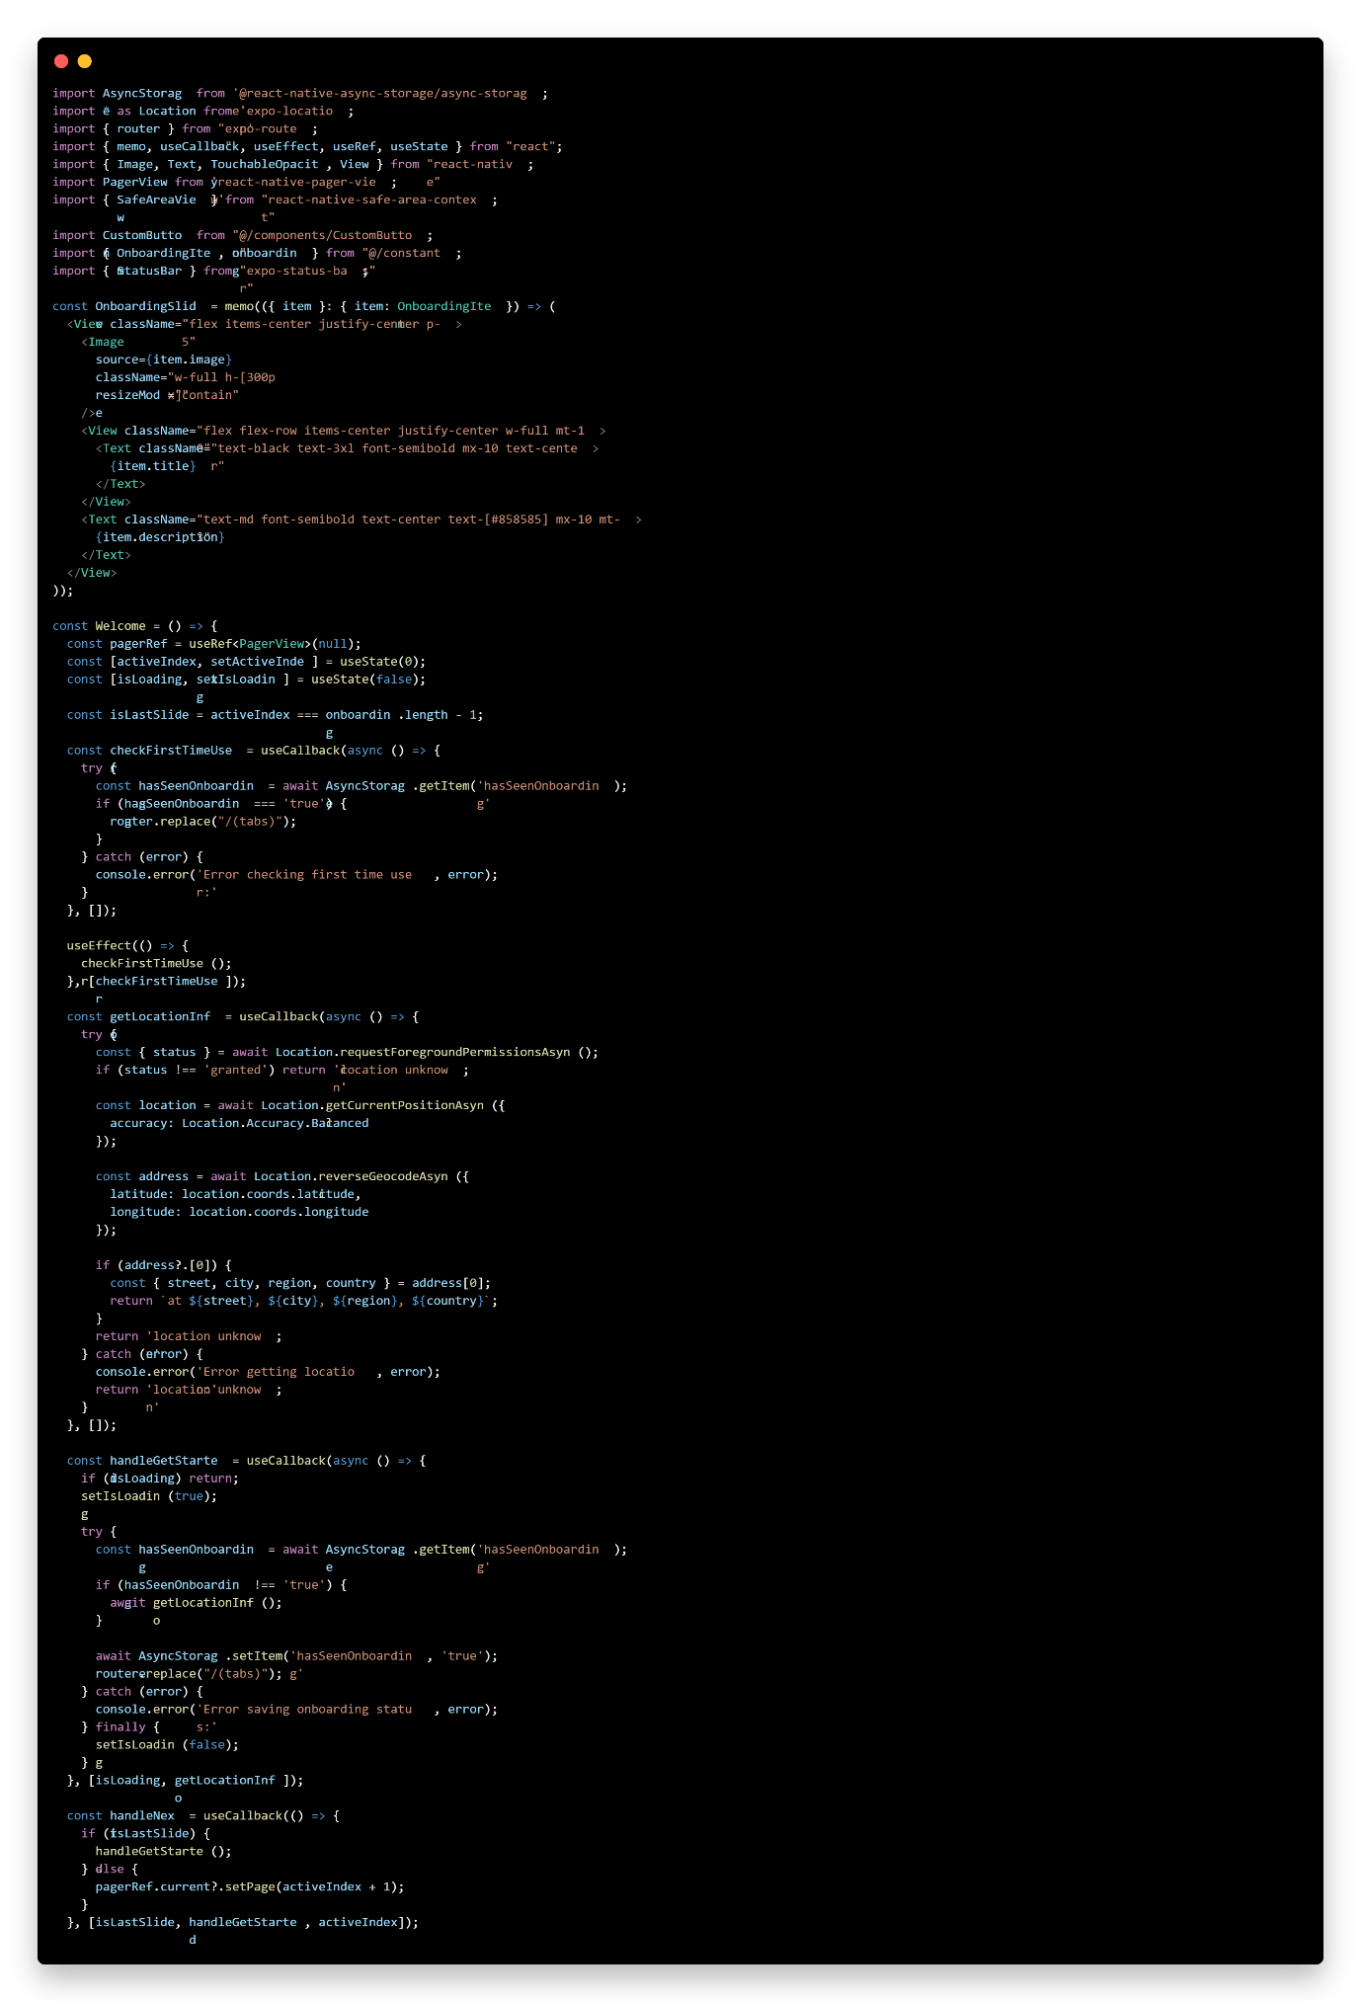

CURRICULUM VITAE

PERSONAL INFORMATION
Name: Charles Allen L. Abella
Address: Brgy. San Manuel, Puerto Princesa City, Palawan
Contact: 09818000354
Charlesallebella9@gmail.com
Date of Birth: June 25, 2001
Place of Birth: Puerto Princesa City, Palawan
Age: 23
Nationality: Filipino
Religion: Roman Catholic
Civil Status: Single
EDUCATION ATTAINMENT
Tertiary: Fullbright College Inc. - Bachelor of Science in Information Technology
Brgy, San Jose, Puerto Princesa City, Palawan
Secondary: Lorenzo S. Sarmiento Sr. National High School
Brgy, Poblacion, Mawab, Davao de Oro
Primary: Mawab Central Elementary School SPED Center
Brgy, Poblacion, Mawab, Davao de Oro
Training / Seminars Attended
Boy Scout of the Philippines training and seminars
Senior Scout of the Philippines training and seminars
Citizenship Advancement Training (CAT) Officer training and seminars
Computer System Servicing NCII
Work Experience
Counter Bagger at Gaisano Grand Mall of Tagum (2021)
Sales Assistant at JS Gaisano Mall of Tagum (2022)
Office Staff at Deliverya Inc (2023)

PERSONAL INFORMATION
Name: Jomari Barraquio Recalde
Address: Brgy. San Josel, Puerto Princesa City, Palawan
Contact: 09935030140
recaldejoms2729@gmail.com
Date of Birth: October 27, 2001
Place of Birth: Santa Rosa City, Laguna
Age: 23
Nationality: Filipino
Religion: Roman Catholic
Civil Status: Single
EDUCATION ATTAINMENT
Tertiary: Fullbright College Inc. - Bachelor of Science in Information Technology
Brgy, San Jose, Puerto Princesa City, Palawan
Secondary: San Jose. National High School
Brgy. San Jose,Puerto Princesa City Palawan
Primary: F,UBAY Memorial Elementary School
Brgy. San Jose,Puerto Princesa City Palawan

Work Experience
Office Staff at Deliverya Inc (2024)


PERSONAL INFORMATION
Name: Jacob Israel A. Mabag
Address: Brgy. San pedro, Libis, Puerto Princesa City, Palawan
Contact: 09154075891
Israelamay91@gmail.com
Date of Birth: September 26, 1992
Place of Birth: Puerto Princesa City, Palawan
Age: 32
Nationality: Filipino
Religion: Roman Catholic
Civil Status: Single
EDUCATION ATTAINMENT
Tertiary: Fullbright College Inc. - Bachelor of Science in Information Technology
Brgy, San Jose, Puerto Princesa City, Palawan
Secondary: Sicsican National High School
Purok mahogany brgy, Sicsican, Puerto princesa City, Palawan
Primary: Mateo Jagmis Elementary School
Barangay San Miguel, Puerto Princesa City, Palawan
Training / Seminars Attended
Computer Hardware NCII
Work Experience
I.T field Technician at 3Dtech IT solution. (2022)


PERSONAL INFORMATION
Name: Marvin Quillo Saik
Address: Brgy. Sicsican, Golden Valley, Puerto Princesa City, Palawan
Contact: 09917020169 marvinsaik43@gmail.com
Date of Birth: September 10, 1998
Place of Birth: Zamboanga City
Age: 26
Nationality: Filipino
Religion: ISLAM
Civil Status: Single
EDUCATION ATTAINMENT
Tertiary: Fullbright College Inc. - Bachelor of Science in Information Technology
Brgy, San Jose, Puerto Princesa City, Palawan
Secondary: Mangsee National High School
Mangsee Balabac Palawan
Primary: Mangsee Elementary School
Mangsee Balabac Palawan
Work Experience
Bagger at KCC Mall De Zamboanga Supermarket (2015)
Bagger at NCCC Supermarket (2019)
Secretary at Balabac Water Disctrict Construction (2020)
Supervisor at Balabac Water Disctrict Piping (2021)
Freelance (2022 - Present)

REFERENCE
- Guiam, A. C., Gutierrez, R. D., Gapasin, C. V. D., Matalog, R. P., & Ebuenga, M. D. (2021). Smarter pest identification technology (SPIDTECH): A mobile application for digital identification and remote monitoring of insect pests and diseases of major crops in the Philippines. Philippine Journal of Science, 150(6B), 1811–1821. https://philjournalsci.dost.gov.ph/images/pdf/pjs_pdf/vol150no6B/smarter_pest_identification_technology_.pdf
- Rocha, A. V., IV, Lagarteja, J. G., Isabela State University, Jones Campus, & Isabela State University, Echague Isabela. (2020). Philippine Carabao Mango Pest Identification Using Convolutional Neural Network. In INTERNATIONAL JOURNAL OF SCIENTIFIC & TECHNOLOGY RESEARCH (Vol. 9, Issue 03, pp. 3443–3444). https://www.ijstr.org/final-print/mar2020/Philippine-Carabao-Mango-Pest-Identification-Using-Convolutional-Neural-Network.pdf
- Appiah, O., Hackman, K. O., Diallo, B. a. A., Ogunjobi, K. O., Diakalia, S., Valentin, O., Abdoul-Karim, D., & Dabire, G. (2024). PlanteSaine: an artificial intelligent empowered mobile application for pests and disease management for maize, tomato, and onion farmers in Burkina Faso. Agriculture, 14(8), 1252. https://www.mdpi.com/2077-0472/14/8/1252
- Doan, T.-N. (2022). An Efficient System for Real-time Mobile Smart Device-based Insect Detection. International Journal of Advanced Computer Science and Applications, 13(6). https://thesai.org/Downloads/Volume13No6/Paper_5-An_Efficient_System_for_Real_time_Mobile_Smart_Device.pdf
- Hossain, M. S., Al Shahid, A., & Akter, A. (2023). Machine learning-based identification of hazardous insects attacking cabbage. In 2023 5th International Conference on Sustainable Technologies for Industry 5.0 (STI) (pp. 12-19). IEEE. https://www.researchgate.net/publication/379289180_AI-CABB_An_AI-Enabled_Integra
- Babu, S. C., & Glendenning, C. J. (2019, January 1). Information needs of farmers: a systematic study based on farmer surveys (S. C. Babu & P. K. Joshi, Eds.). ScienceDirect; Academic Press. https://www.sciencedirect.com/science/article/abs/pii/B9780128187524000060
- Agrio. (2022, June 15). An app that identifies plant diseases and diagnoses plant problems. Agrio. https://agrio.app/An-app-that-identifies-plant-diseases-and-pests/
- Selvaraj, M. G., Vergara, A., Ruiz, H., Safari, N., Elayabalan, S., Ocimati, W., & Blomme, G. (2019). AI-powered banana diseases and pest detection. Plant Methods, 15(1).https://link.springer.com/article/10.1186/s13007-019-0475-z
- Y Nagaraju, Venkatesh, (2024)¹⁹ “DubasAlert: AI-Powered Detection System for Dubas Infestation on Palm Leaves ”https://ieeexplore.ieee.org/document/10617323/authors#authors
- Zhang, W., Xia, X., Zhou, G., Du, J., Chen, T., Zhang, Z., & Ma, X. (2022b). Research on the identification and detection of field pests in the complex background based on the rotation detection algorithm. Frontiers in Plant Science, 13. https://www.inderscienceonline.com/doi/pdf/10.1504/IJWMC.2022.124813
- Zhang, W., Xia, X., Zhou, G., Du, J., Chen, T., Zhang, Z., & Ma, X. (2022b). Research on the identification and detection of field pests in the complex background based on the rotation detection algorithm. Frontiers in Plant Science, 13. https://www.inderscienceonline.com/doi/pdf/10.1504/IJWMC.2022.124813
- Department of Agriculture. (2020). Rationalizing And Strengthening The Crop Pest Management Functions, Services, And Related Tasks Of The Department Of Agriculturehttps://www.da.gov.ph/wp-content/uploads/2020/09/do09_s2020.pdf
- Li, S., Feng, Z., Yang, B., Li, H., Liao, F., Gao, Y., Liu, S., Tang, J., & Yao, Q. (2022). An intelligent monitoring system of diseases and pests on rice canopy. Frontiers in Plant Science, 13. https://www.frontiersin.org/journals/plant-science/articles/10.3389/fpls.2022.972286/full
- Hashem, T. et al., (2022) “Smart Farming (Ai-Generated) as an Approach to Better Control Pest and Disease Detection in Agriculture:POV Agricultural” Institutionshttps://www.researchgate.net/publication/377234485_Smart_Farming_Ai
- Hung, S., & Siddiqi, Y. (2024). Cultivating a greener future: How AI can transform agriculture for food security and sustainability. Asian Development Bank Blog. https://blogs.adb.org/blog/cultivating-greener-future-how-ai-can-transform-agriculture-food-security-and-sustainability
- Imran, M. A., Nobel, S. M. N., Zaman Bina, N., Kabir, M. M., Safran, M., Alfarhood, S., & Mridha, M. F. (2024). Palm leaf health management: A hybrid approach for automated disease detection and therapy enhancement. IEEE Xplore. https://ieeexplore.ieee.org/document/10385067/metrics#metrics
- Christakakis, P., Papadopoulou, G., Mikos, G., Kalogiannidis, N., Ioannidis, D., Tzovaras, D., & Pechlivani, E. M. (2024). Smartphone-Based Citizen Science Tool for Plant Disease and Insect Pest Detection Using Artificial Intelligence. Technologies, 12(7), 101. https://www.mdpi.com/2227-7080/12/7/101
- Rashid, M., Syed, S. A., Nasim, S., Brohi, I.,(2023.). Artificial intelligence techniques for the pest detection in banana fields: A systematic review. Pakistan Journal of Biological and Therapeutic Sciences. https://pjbt.org/index.php/pjbt/article/view/746/782
- Rahman, S. (2022) “Role of Artificial Intelligence in Pest Management” https://www.researchgate.net/publication/360652345_Role_of_Artificial_Intelligence_in_Pest_Management

- Chen, J.-W., Lin, W.-J., Cheng, H.-J., Hung, C.-L., Lin, C.-Y., & Chen, S.-P. (2021). A Smartphone-Based Application for Scale Pest Detection Using Multiple-Object Detection Methods. Electronics, 10(4), 372. https://www.researchgate.net/publication/349014502_A_Smartphone-Based_Application_for_Scale_Pest_Detection_Using_Multiple-Object_Detection_Methods

