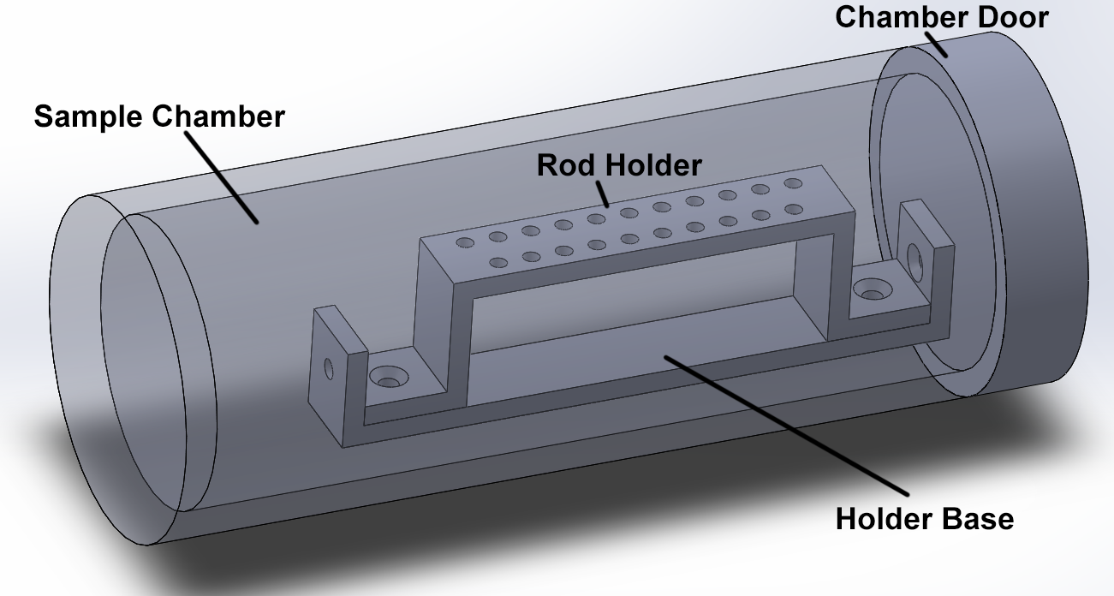
Sample Chamber V1

See following pages for dimensions and details

Pros:
Lots of space

Cons:
Holder Base seems superfluous
How does the actuator open the door and release the latch at the same time?

