Sample Chamber V1
Operation:
Actuator will pull on the handles of the over-center latch. The latch’s hooks will be attached to the hooks on either side of the chamber door, and will pull open the chamber door as the latch releases. Length extensions can be added to the hooks to enable a longer range of motion, allowing us to control how much the door opens.
Example of a suitable over-center latch: https://www.southco.com/en-us/97/97-30-160-12

Features:
Holds up to 21 rotorods. Lots of extra room inside.

Cons:
Holder Base seems superfluous

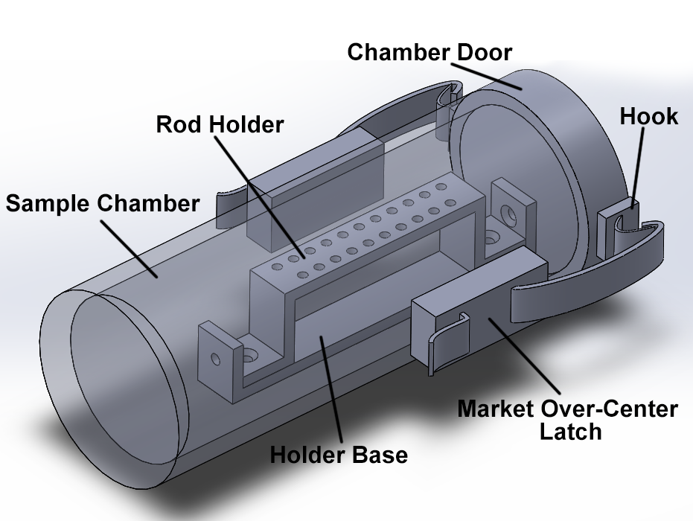
See following pages for dimensions and details

Top View:
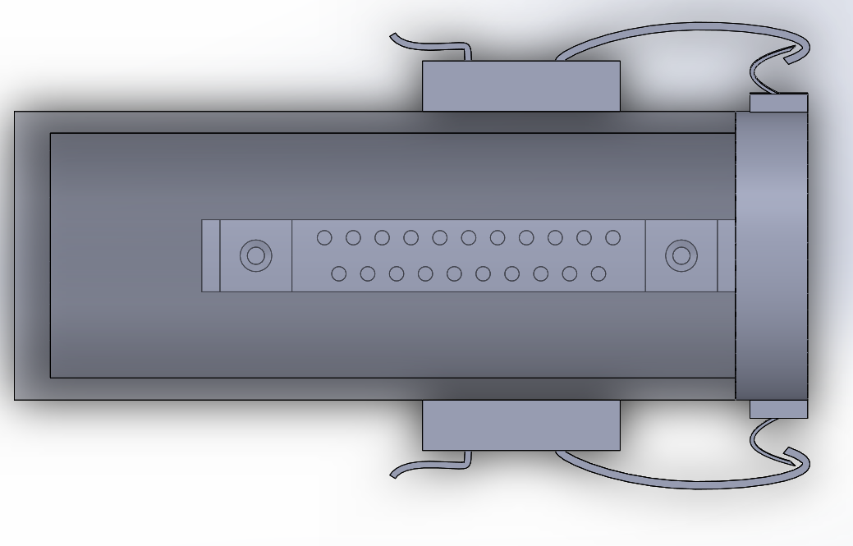
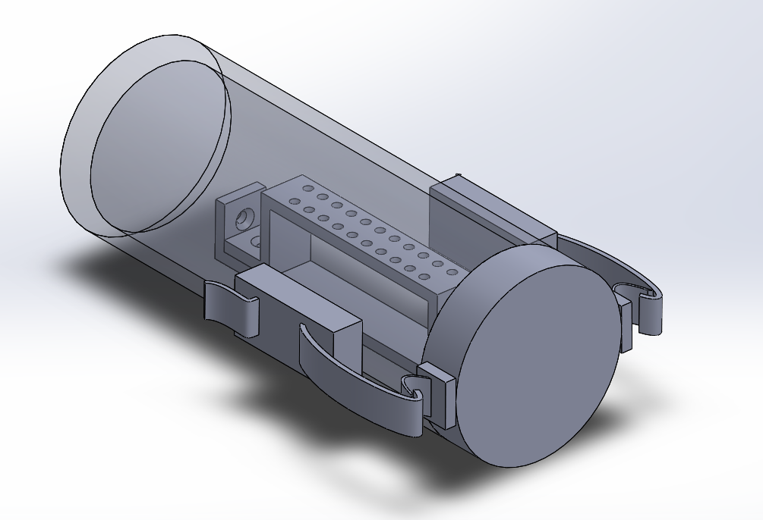
Front View:

