In-Flight Details

The following image shows an early plan for the layout of the payload. It was included in our PDR presentation but left out of the report. It shows the 7 sample chambers that will be opened by actuators during the flight and the one control chamber that will remain sealed. Table 10 of the PDR report lists the altitudes that we are targetting. One chamber will sample a single of these altitudes, as described on pg. 16 of the PDR report.
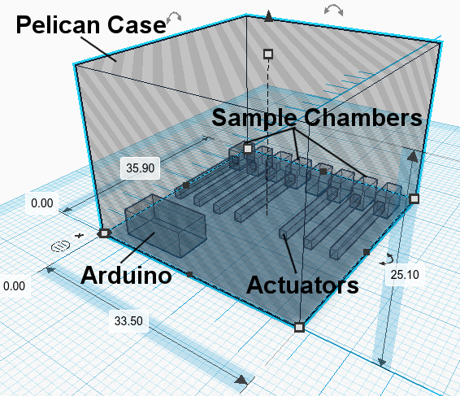

As mentioned, the GPS will be used to determine when the payload is at the correct altitude. Below is a sketch of a flight program, similar to the one included in our initial proposal:

sensors = ["bme", "position", "gps"]
MinimalSampleRegions = [0, 10, 20, 30] # km
IdealSampleRegions = [0, 5, 10, 15, 20, 25, 30] # km
altitudeRange = 1 # km
recordingTime = 30 # s

Loop: if most recent FlightLog entry includes data from all sensors:
Turn on Green indicator light (healthy payload)
else
Turn on Red light (unhealthy payload)

# use the GPS to determine when we open the sample chambers
if GPS entry is "good" and balloon is in ascent phase:
get altitude

sampleRegion = getRegion(altitude, altitudeRange) # index from 0-6

triggerLogging(recordingTime) # start camera to record for preset amount of time
openChamber(chamber[sampleRegion]) # opens the corresponding chamber
closeChambers(chamber[:sampleRegion], chamber[sampleRegion+1:]) # close all other chambers
else if GPS entry is "good" and balloon is in descent phase:
close all SampleChambers
else if GPS entry is "bad" over the last x minutes:
close all SampleChambers

# robust sample chamber logging for confirming integrity of data.
def triggerLogging(recordingTime):
start camera recording for time specified by `recordingTime`
log position reading of all actuators
log open/closing action of chamber, including timestamp
log filename of associated camera recording
Repeat Loop

