Westin Gjervold
ComSci 342 Homework 7
- (8 pt) [Type Checking]: Using the new type syntax from TypeLang, provide the type of the expression. If the expression fails to type check, provide a brief description as to why type checking would fail.
  - (lambda (x : num) (lambda (y : num) #t))
Inner lambda takes a num and returns #t, which is a bool. The outer lambda takes a num and returns the inner function, so the type is bool.
  - (lambda (x : num) (lambda (y : num) (if x #t #f)))
The if condition is x, but x is a num and the if condition must be a bool, therefore there is a Type error.
  - (lambda (x : num) (lambda (y : num) (if (> x y) #t y)))
The two branches of the if statement must have the same type. The then branch is a bool, but the else is a num. Therefore, this is a type error due to the mismatched branches on the if statement.
  - (let ((x : num 8) (y : bool #f)) (cons (cons x y) (list : (num , bool))))
x : num and y : bool so (cons x y) produces pair (num, bool)
(list : (num, bool)) is empty list of type List<(num, bool)>
Cons (cons x y) (list : (num, bool))) prepends a (num, bool) pair onto a List<(num, bool)>
Type is List<(num, bool)>

- (5 pt) [TypeLang Programming for Lists]: In HW4, you have written a function compList that takes a list and remove consecutive repetitive numbers. Rewrite the function in TypeLang.
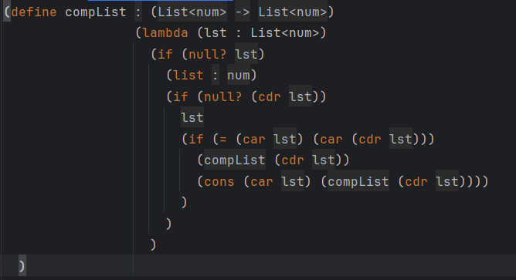

- (5 pt) [TypeLang Programming for Pairs]: A function to swap variable values can be defined by a lambda function that takes a single pair (a b) and returns a new pair (b a). Instead of taking in a pair of values, we can take in a pair holding references to where a and b are stored and the function updates the referenced values. Write a function swap in which you accept a pair of references and swaps the values referenced and returns the pair of references.
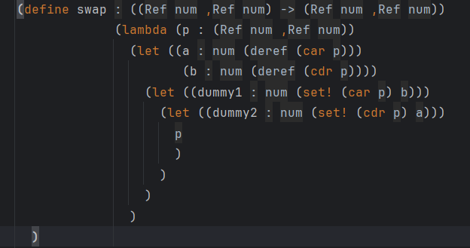
- (8 pt) [Memory Management]: Modify the TypeLang to change the internal implementation of the heap used to store the dynamic memory and handle dynamic memory allocation.
I removed the index-based allocation and replaced it with a loop that scans the heap for the first available (null) slot. This change allows freed memory locations to be reused instead of always allocating new ones sequentially.
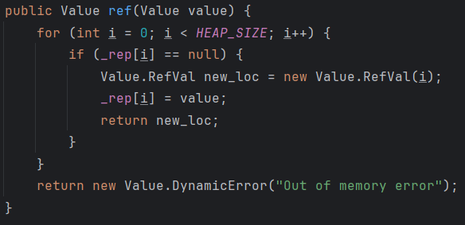

- (16 pt) [Memory Management, Type System]: The second modification you will make to TypeLang will add a new operator which checks if two expressions refer to the same memory address.
TypeLang.g4:
Added exp rules in TypeLang file with the new refeq rule:
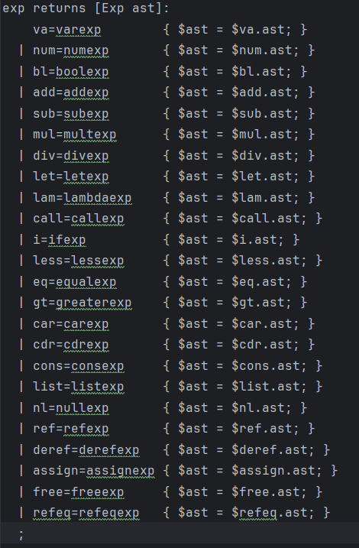
Added refeqexp returns:
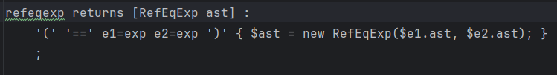

AST.java:
Added new RefEqExp class:
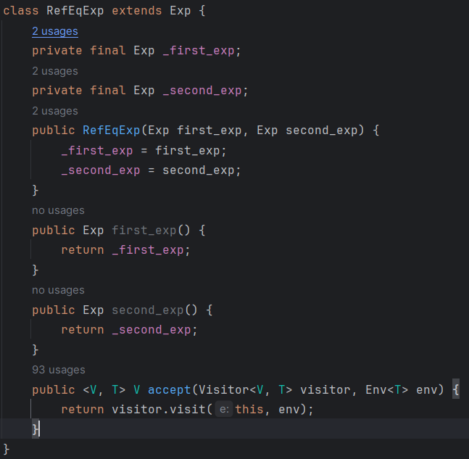
Added RefEqExp to the visitor interface:
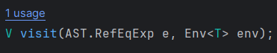

Evaluator.java:
Added the new RefEqExp visit method:
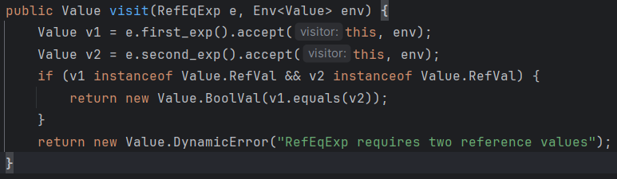

Printer.java:
Added visit method:
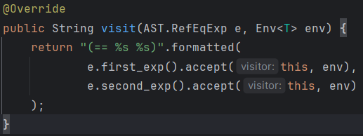

Checker.java:
Added new type checking visit method:
