Westin Gjervold
ComSci 342 Homework 8
- (8 pt) [Prolog for Numbers]
  - (4 pt) Write a Prolog program to compute the sequence of Fibonacci numbers given its length.
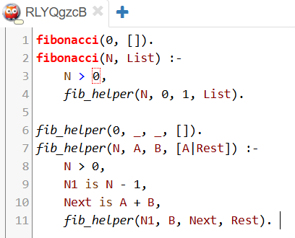
  - (4 pt) Write a Prolog program to check if a given integer i (0 < i < 1000) is a prime.
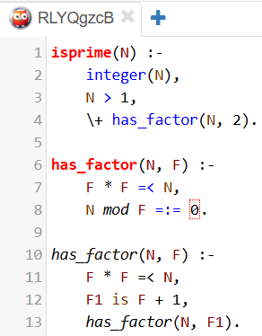
- (10 pt) [Prolog for List]
  - (5 pt) Write a Prolog program to filter a list containing a given number N
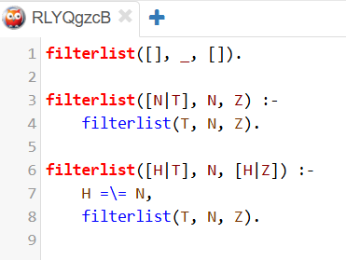
  - (5 pt) Write a Prolog program to sort a list of numbers in ascending order.
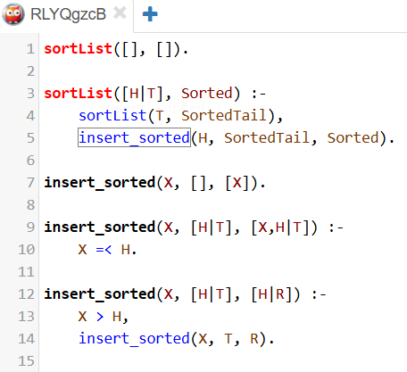

- (6 pt) [Prolog for Word Puzzle] Write a Prolog program to solve a word puzzle.
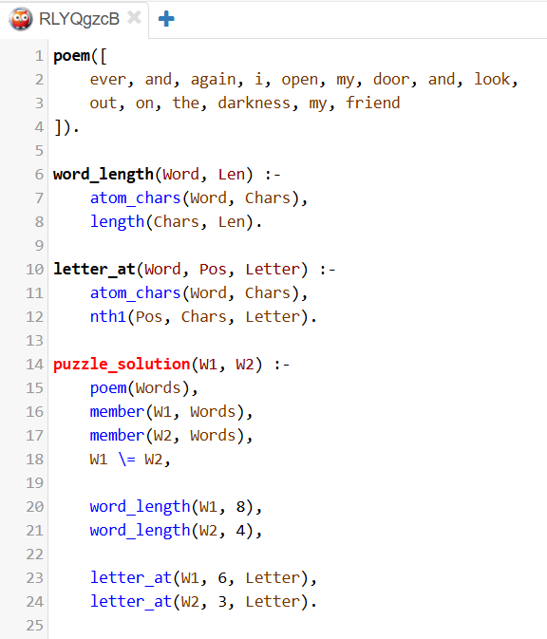
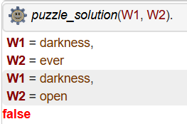
- (15 pt) [Prolog for Mini-Sudoku] Write a Prolog program to solve a given Mini-Sudoku instance, which is a simplified version of the popular Sudoku puzzles.
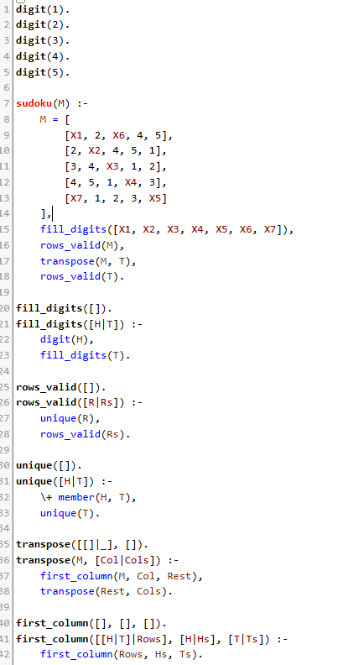
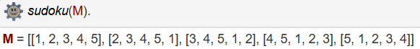
X1 = 1, X2 = 3, X3 = 5, X4 = 2, X5 = 4, X6 = 3, X7 = 5.
- (13 pt) [Prolog for Parsing]
  - (10 pt) Write a Prolog parser for the grammar for VarLang. This parser should be capable of deciding whether a given program belongs to the language.
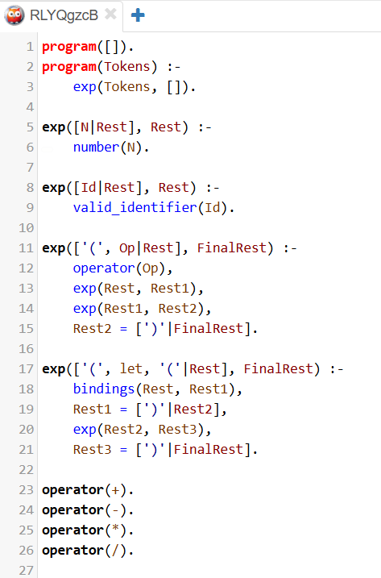
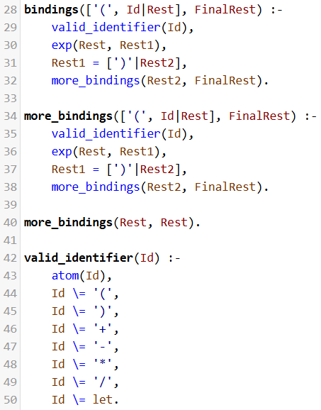
  - (3 pt) Write a Prolog query that determines whether a given program is syntactically correct in VarLang, pertaining to the grammar defined above. Include an example program in your query.
