Computer Security (CS 419)
Information Assurance Certification and Accreditation Process (DIACAP)

SECURITY DESIGN DOCUMENT
VERSION 1.0.0

FOR

SECURE WEB APPLICATION PROJECT



DISTRIBUTION IS LIMITED TO U.S. GOVERNMENT AGENCIES AND THEIR CONTRACTORS.
OTHER REQUESTS FOR THIS DOCUMENT MUST BE REFERRED TO: <CLIENT NAME>
Template developed by: I-Assure, LLC. http://www.i-assure.com.

This page intentionally blank

change log
This record shall be maintained throughout the life of the document. Each published update shall be recorded. Revisions are a complete re-issue of entire document. A revision shall be made whenever the cumulative changes reaches ten percent (10%) of this document’s content.
CHANGE / REVISION RECORD
Date | Page/Paragraph | Description of Change | Made By:

tABLE OF CONTENTS
1. Architecture Overview 2
1.1 System Architecture Diagram 3
1.2 Data Flow Diagrams 3
1.3 Component Descriptions 3
1.4 Technology Stack Justification 3
2. Threat Model 2
2.1 Asset Identification 3
2.2 Threat Enumeration 3
2.3 Vulnerabillity Assessment 3
2.4 Attack Scenarios 3
2.5 Risk Prioritization 3
3. Security Controls 2
3.1 Control Description 3
3.2 Implementation Approach 3
3.3 Testing Methodology 3
3.4 Known Limitations 3
3.5 Mitigation Strategies 3
4. Data Protection 3
4.1 Data Classification 3
4.2 Encryption Methods 3
4.3 Key Management 3
4.4 Secure Deletion Procedures 3

executive summary
The following table lists the DoDI 8500.2 IA Controls that are satisfied through this artifact.
IA Control Number | IA Control Name
DCSR-1, DCSR-2, DCSR-3 | Specified Robustness – Basic/Medium/High
DCSD-1 | IA Documentation
DCBP-1 | Best Security Practices
DCCS-1, DCCS-2 | Configuration Specifications
ECSC-1 | Security Configuration Compliance
EBBD-1, EBBD-2, EBBD-3 | Enclave Security Architecture
ECWN-1 | Wireless Computing and Networking
ECVI-1 | Voice over IP
ECIM-1 | Instant Messaging
EBVC-1 | VPN Controls
ECAD-1 | Affiliation Display
ECVP-1 | Virus Protection
DCFA-1 | Functional Architecture for AIS Applications
DCSP-1 | Security Support Structure Partitioning
DCNR-1 | NIST FIPS 140-2 Validated Cryptography
DCPD-1 | Public Domain Software Controls
DCPP-1 | Ports, Protocols, and Services
DCPA-1 | Partitioning the Application
DCSQ-1 | Software Quality
DCMC-1 | Mobile Code Assessment
DCSL-1 | System Library Management Controls
DCHW-1 | HW Baseline
DCSW-1 | SW Baseline
ECID-1 | Host Based Intrusion Detection
ECTM-1, ECTM-2 | Transmission Integrity Controls

Architecture Overview
<INSERT SYSTEM OVERVIEW>.
The Security Design Document (SDD) describes the <SYSTEM NAME> Information Assurance (IA) Program. This involves identifying and describing in detail the security safeguards that comprise the <SYSTEM NAME> Information System (IS) and application and explaining how these security safeguards collectively satisfy the protection objectives of the DoD IA Controls.

System Architecture Diagram
The information in this document provides Information Owners system managers, developers, and security certification officials with a baseline for measuring the effectiveness of the security design and managing design changes that impact security throughout the <SYSTEM NAME> IS lifecycle. This document explains how the <SYSTEM NAME> IA technical framework is translated into technical and administrative solutions that comprise the Defense-in-Depth approach to IS security. This document also describes the security safeguards associated with external system interfaces and/or remote access solutions that are considered an integral part of the <SYSTEM NAME> IS. The <SYSTEM NAME> IS includes all hardware and software components that comprise the DoD Information Assurance Certification and Accreditation Process (DIACAP) accreditation boundary. This includes security mechanisms involved in hardware, firmware, and software, all of which are involved in the successful operation of the <SYSTEM NAME> IS. The following diagram depicts the assets that are under this accreditation effort.
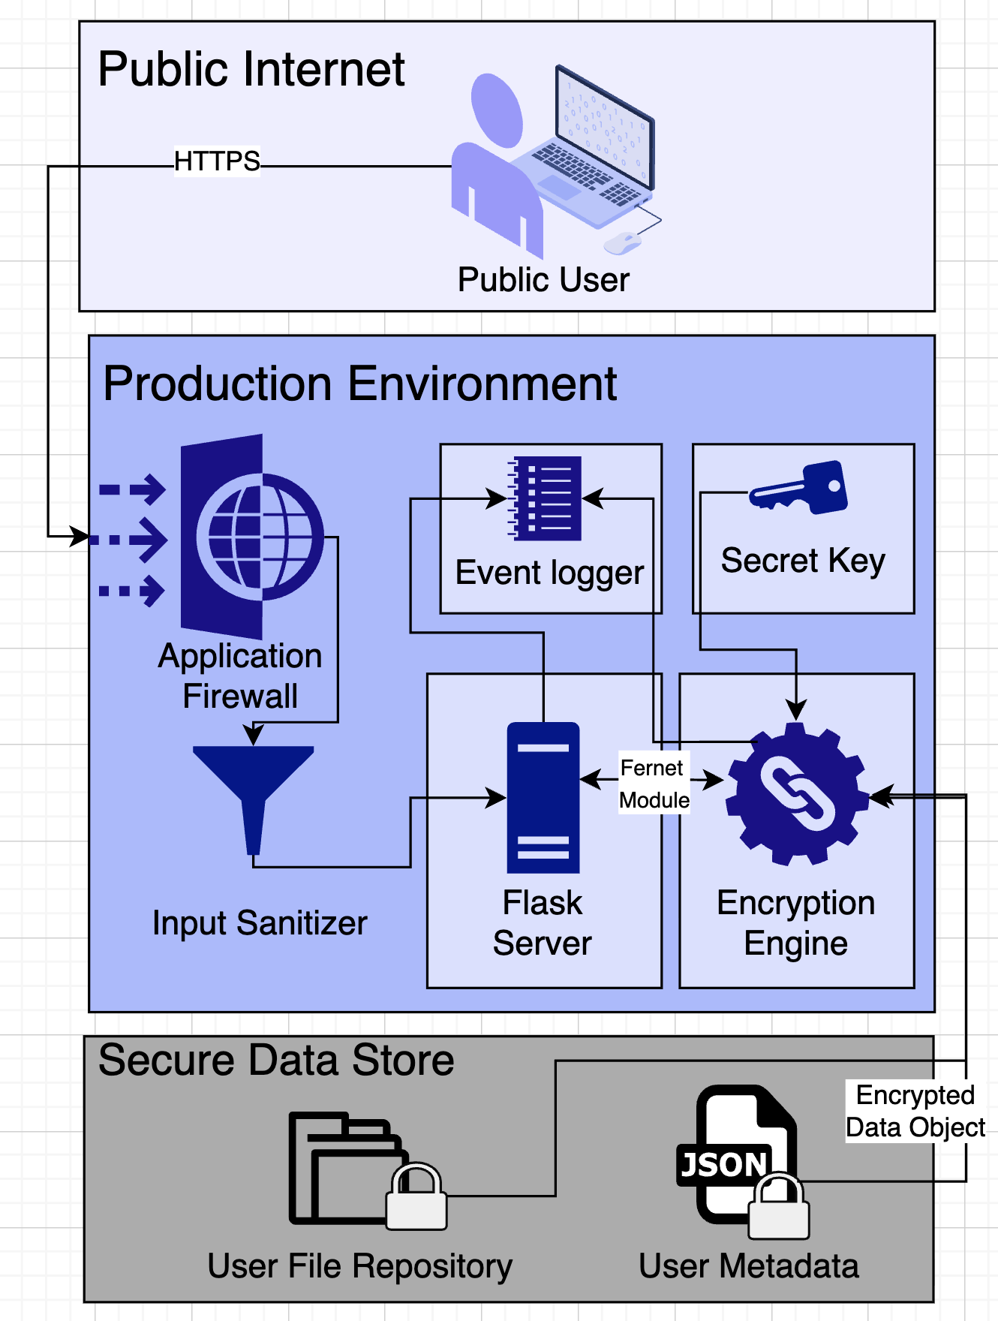

Data Flow Diagrams
sd

Component Descriptions
sd

Technology Stack Justification
sd

Threat Model
sd

Threat Enumeration
Component | STRIDE Category | Threat Description | Mitigation
Flask Server | Spoofing | Attacker impersonates an Admin using a stolen session token. | secrets.token_urlsafe(32) tokens + 30m timeout.
Input Sanitizer | Tampering | Attacker uses ../ in a filename to overwrite a system file. | Whitelist validation + os.path.basename() usage.
User Metadata | Information Disc. | An attacker reads the JSON file to see who is sharing what. | Fernet Encryption at-rest for sensitive fields.
Web Browser | Elevation of Privacy | A Guest user manually changes their Role in an API call. | Server-side Role Check (@require_role) on every request.

Vulnerability Assessment
sd

Attack Scenarios
sd

Risk Prioritization
sd

Security Controls
sd

Control Description
sd

Implementation Approach
sd

Testing Methodology
sd

Known Limitations
sd

Mitigation Strategies
sd

Data Protection
sd

Data Classification
sd

Encryption Methods
sd

Key Management
ds

Secure Deletion Procedures
ds

Specified Robustness – Basic/Medium/High (DCSR-1, DCSR-2, DCSR-3)
The following table lists the products used to satisfy the required robustness level and their current Common Criteria evaluation status.
Name | Manufacturer | Version | EAL Level | Validation Date

IA Principals

IA Documentation (DCSD-1)
The following table lists the IA roles and appointed personnel
Role | Name | Clearance | IT Designation | Trained?
DAA
CA
IAM

SECURITY ARCHITECTURE

Best Security Practices (DCBP-1)
<SYSTEM NAME> uses the following best security practices:

Strong (2 factor) Authentication for management/admin traffic (explain)
Management of network devices is through local console access. Remote access to network devices is not permitted. Authentication to network devices is provided by a Microsoft RADIUS Server, which enforces strong password requirements. DoD PKI is not available, as the system resides on the commercial internet.

Presence of a firewall (not firewall configuration settings) (explain)
<SYSTEM NAME> has implemented a <TYPE> firewall to provide boundary defense mechanisms and ensure adherence to DoD Ports and Protocols guidance.
Biometrics (explain)
<SYSTEM NAME> does not utilize Biometrics
Two person control (explain)
<SYSTEM NAME> is a Sensitive, Unclassified system, therefore two-person control is not required.
Non-Use of Unsupported Software (explain)
<SYSTEM NAME> utilizes the open-source Snare IIS agent to convert web logs to the centralized audit system and Osiris software to fulfill Windows Host-Based Intrusion Detection and File Integrity checking requirements.
Out of Band Management (explain)
Management of network devices is through local console access. Remote access to network devices is not permitted
Presence of ACLs (not the actual ACL settings) (explain)
The <SYSTEM NAME> router has been configured to comply with DISA Enclave and Network Security Technical Implementation Guides (STIGs). The ACLs are configured to Deny-by-Default and include the most up to date IP Block list.

Configuration Specifications (DCCS-1, DCCS-2, ECSC-1)
Security designs should follow appropriate security guidance and employ DOD Defense in depth techniques. (explain)
<SYSTEM NAME> has been configured to comply with the following DISA STIGs: Enclave, Network, DNS, Windows, Database, Web and Application Services.

Enclave Security Architecture (EBBD-1, EBBD-2, EBBD-3)
Firewall and IDS are in place at the enclave boundary (explain)
External Connection | Firewall | IDS | Controlled by Enclave

Architecture Components (ECWN-1, ECVI-1, ECIM-1, EBVC-1, ECAD-1
<SYSTEM NAME> uses the following architecture components:
Wireless Technology (explain)
<SYSTEM NAME> does not utilize wireless technologies.
Voice over IP (VOIP) (explain)
<SYSTEM NAME> does not utilize VOIP technologies.
Instant Messaging (explain)
<SYSTEM NAME> does not utilize instant messaging technologies.
Virtual Private Networks (VPN) (explain)
<SYSTEM NAME> does not utilize VPN technologies.
E-Mail. (explain)
<SYSTEM NAME> utilizes an external SMTP Gateway for outbound e-mail traffic. Inbound e-mail traffic is not permitted

Virus Protection (ECVP-1)
<SYSTEM NAME> servers utilize McAfee VirusScan as the antivirus product. McAfee has been configured in accordance with the DISA Desktop STIG. <SYSTEM NAME> subscribe to the JTF-GNO IAV mailing list, which provides notification of new antivirus definitions.

Host Intrusion Detection System (ECID-1)
<SYSTEM NAME> servers utilize two applications to provide host-level intrusion detection. Osiris provides file integrity monitoring on a nightly basis. Osiris utilizes SHA-1 checksums to verify file integrity on a nightly basis. If the checksum of a file changes, alerts are sent via Windows Event Log. Active host-based intrusion monitoring is provided by McAfee On-Access scan, which monitors processes, scripts, and file-accesses in real time to detect malware.

Functional Architecture for AIS Applications (DCFA-1)
<INSERT SYSTEM FUNCTIONALTY>.

Application Access Control
<DESCRIBE>.

External Interfaces (ECTM-1, ECTM-2)
<DESCRIBE>

<INSERT INTERFACE DIAGRAM>

The following table describes all external interfaces, the local and remote systems, and the information exchanged.
Source | Destination | Classification | Protocol | Port | Direction

The following mechanisms are in place to assure the integrity of all transmitted information (including labels and security parameters) and to detect or prevent the hijacking of a communication session (e.g., encrypted or covert communication channels):
- TripWire
- SSL Encryption

Internal Interfaces
The following diagram depicts all internal interfaces at a high level:
<INSERT DATA FLOW DIAGRAM>

The following table details internal functional communications and data flows:
Source | Destination | Classification | Protocol | Port | Direction

Security Support Structure Partitioning (DCSP-1)
The following table details internal security support and management communications and data flows:
Source | Destination | Classification | Protocol | Port | Direction

System State Changes (DCSS-1, DCSS-2)
When systems are in a state of transition, they may be susceptible to unauthorized access or to attack. The following means have been employed to ensure unauthorized changes to the system state are not allowed during transition. Common Criteria validated products that have met EAL 4+ ratings meet this requirement. The below table lists the software component and mitigations.
Software | Version | Common Criteria Validated | EAL Level | Other

Public Domain Software Controls (DCPD-1)
<SYSTEM NAME> utilizes the following open-source software components.

Software | Version | Location | Security Controls
Snare IIS Agent | 1.2 | Web Servers | Convert IIS Logs to SYSLOG messages
Osiris | 4.2.3 | All Servers | Provide HIDS and File Integrity Checking

Application Design

Partitioning the Application (DCPA-1)
The following table lists the application components and partitioning information.
Application | Architectural Role | Software Components | Partitioned? | Partition Method | Location

System Library Management Controls (DCSL-1)
Are privileged application programs are protected to prevent the introduction of unauthorized code by use of operating system STIGs?
No

Yes, Windows 2003 version 5.1.10

Does User Agreement address the download and/or installation of third party software?
No

Yes, User Agreements are on file.

Software Quality (DCSQ-1)
During software development, negative impacts on integrity or availability are minimized through specification of requirements and validation methods Is the application a software development effort?

No

Yes (fill in below table)
Software Name | COTS/GOTS | Evidence of COTS ISO/CMMI or GOTS SDLC
<SYSTEM NAME> Application | COTS | Strict CM controls in place. <CLIENT NAME> currently pursuing CMMI certification.

Mobile Code Assessment (DCMC-1)
Not applicable. <SYSTEM NAME> does not utilize mobile code.

Hardware and Software Baseline

HW Baseline (DCHW-1)
Backup copies of this inventory are stored using the following:
Offsite
Fire Rated Container

Server Name(s) | Manufacturer | Make/Model | Function | Location

SW Baseline (DCSW-1)
Backup copies of this inventory are stored using the following:
Offsite
Fire Rated Container

Software Name | Manufacturer | Version | Type | Manual Available?

