Computer Security (CS 419)
Information Assurance Certification and Accreditation Process (DIACAP)

SECURITY DESIGN DOCUMENT
VERSION 1.0.0

FOR

SECURE WEB APPLICATION PROJECT



DISTRIBUTION IS LIMITED TO RUTGERS UNIVERSITY AND THEIR EDUCATIONAL INSTITUTIONS.
OTHER REQUESTS FOR THIS DOCUMENT MUST BE REFERRED TO OLIVER KING
Document developed by: Oli King and Weston Lane

This page intentionally blANK

tABLE OF CONTENTS
1. Architecture Overview 1
1.1 System Architecture Diagram 1
1.2 Data Flow Diagrams 3
1.3 Component Descriptions 3
1.4 Technology Stack Justification 4
2. Threat Model 5
2.1 Threat Enumeration 5
2.2 Vulnerability Assessment 5
2.3 Attack Scenarios 5
2.4 Risk Prioritization 6
3. Security Controls 6
3.1 Control Description 6
4. Data Protection 8
4.1 Data Classification 8
4.2 Encryption Methods 8
4.3 Key Management 8
4.4 Secure Deletion Procedures 9

Architecture Overview
The Secure Document Sharing System is a multi-tiered web application built on the Flask micro-framework, designed to facilitate secure, authenticated, and encrypted file exchanges between military agencies and contractors. The system is engineered with a "Secure-by-Design" philosophy, utilizing a json file-based persistence layer to eliminate the entire class of SQL Injection vulnerabilities.
Core security components include a centralized Session Manager for high-entropy token tracking, a Role-Based Access Control (RBAC) engine for privilege enforcement, and a cryptographic Encryption Engine that ensures all sensitive data remains encrypted at-rest using AES-128 via the Fernet specification. This document outlines the technical boundaries and general architecture of our program.

System Architecture Diagram
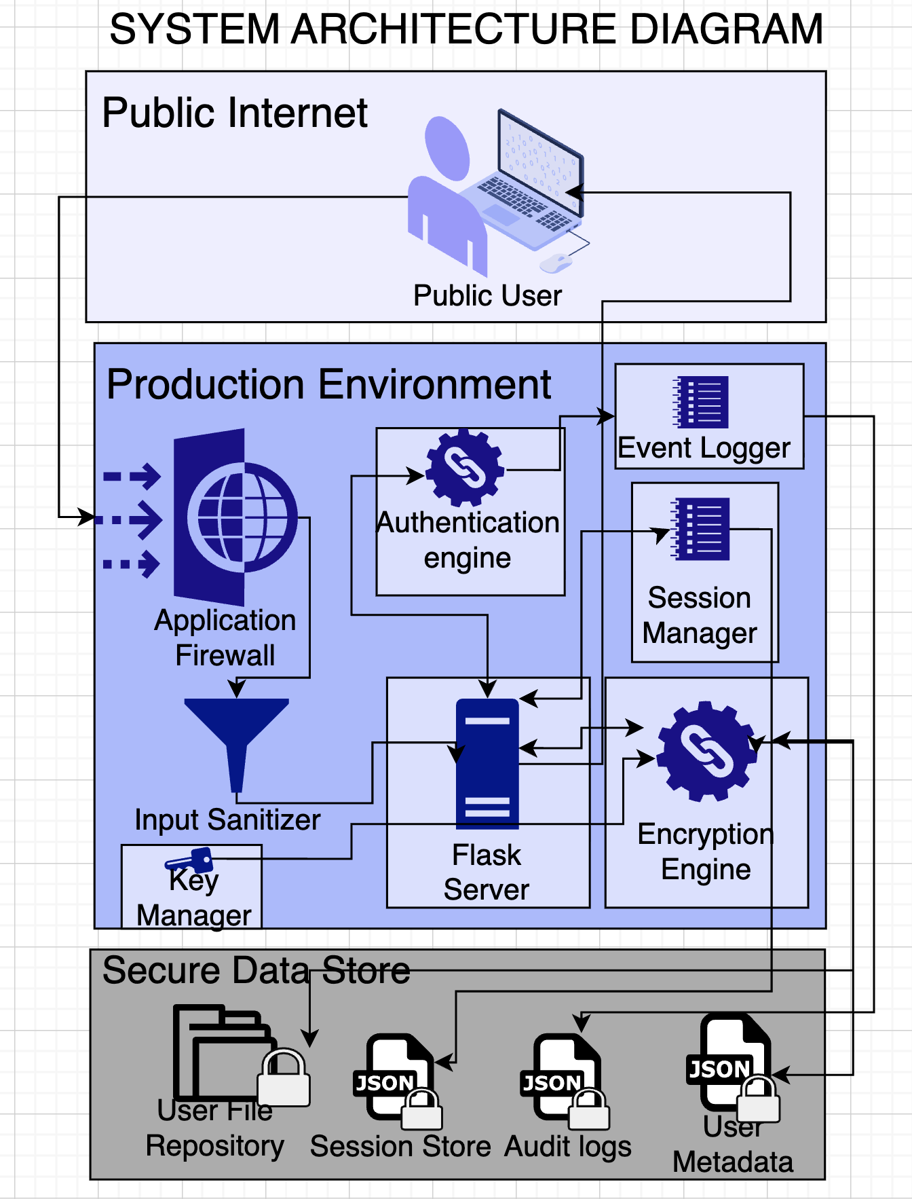

Data Flow Diagrams
Data flow begins at the Web Frontend, where user requests are received over TLS 1.3. Requests pass through the Input Sanitizer logic before reaching the Flask Server. The Flask routing mechanisms employ RBAC and Session Management before interacting with the Encryption Engine and JSON Metadata Store. Sensitive files are written to the File Repository only after encryption.
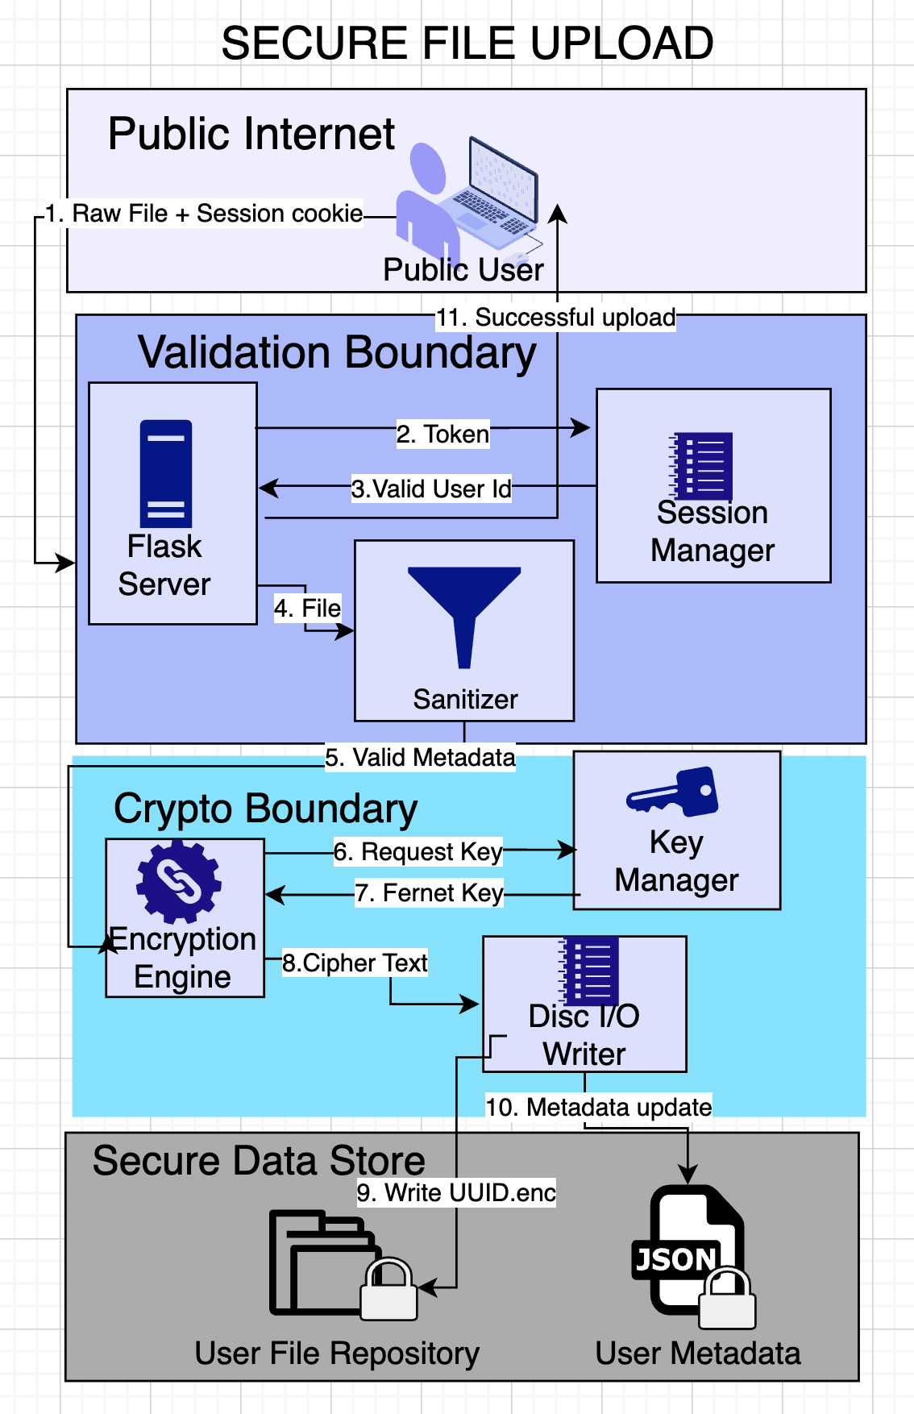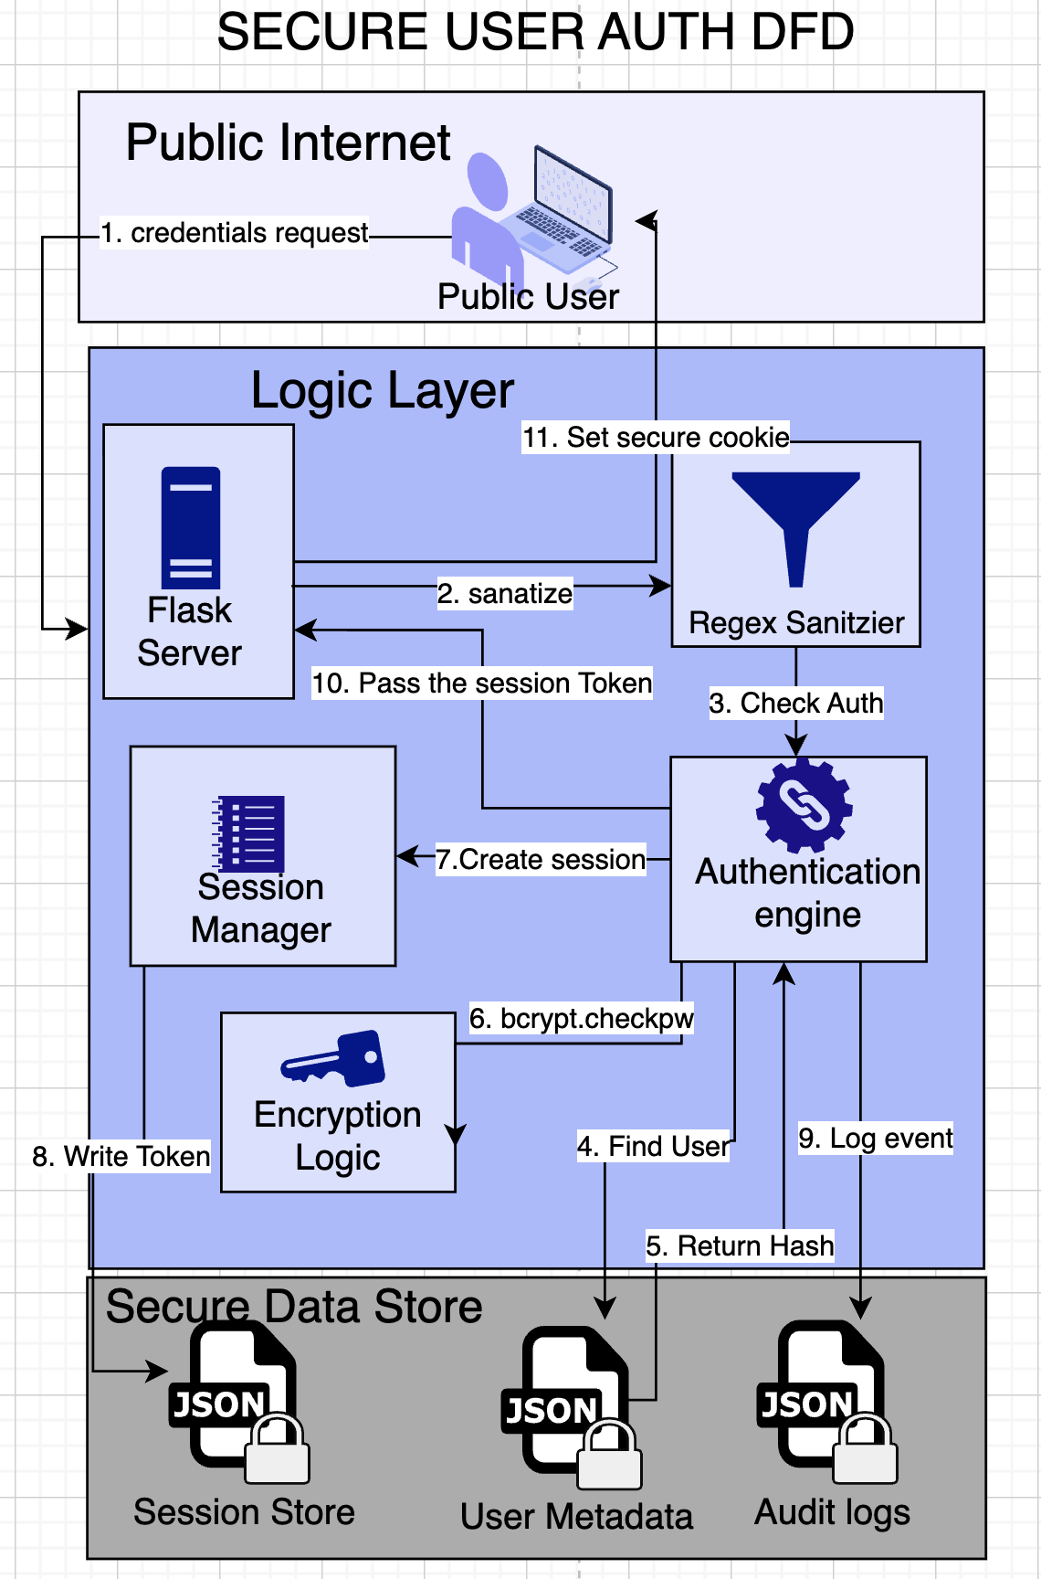

Component Descriptions
This section provides a detailed technical breakdown of the functional components within the Secure Document Sharing System, outlining their specific security responsibilities and data handling procedures.
Component | Tier | Primary Function | Mitigation
Web Frontend | Presentation | User Input Handling & Encoding | Cross-Site Scripting (XSS)
Application Firewall | Network | Ingress Filtering & SSL Termination | Man-in-the-Middle (MITM)
Input Sanitizer | Logic | Path Traversal & Whitelist Validation | Command Injection / Path Traversal
Flask Server | Logic | RBAC & Session Management | Unauthorized Access / Privilege Escalation
Encryption Engine | Logic | AES-128 Symmetric Encryption | Data-at-Rest Exposure
Secret Key Manager | Storage | Root-of-Trust (Key) Protection | Total System Compromise
Event Logger | Monitoring | Immutable Audit Trail Maintenance | Repudiation / Unseen Breach
JSON Metadata Store | Storage | Bcrypt Password Hashing | Credential Theft
File Repository | Storage | Physical File Isolation (UUID naming) | Information Disclosure

Technology Stack Justification
Python 3.x (Base Language)
- Security Rationale: Python was selected due to its highly mature ecosystem of security libraries (e.g., cryptography, bcrypt, PyJWT). Its clean syntax reduces the likelihood of logic errors, which are a primary source of many security vulnerabilities. Furthermore, Python’s memory management helps mitigate certain classes of low-level memory corruption attacks common in languages like C/C++.
Flask (Web Framework)
- Security Rationale: Flask is a "micro-framework" that provides a "secure-by-default" foundation without forcing the overhead or "black-box" security of larger frameworks. This allowed the development team to explicitly implement and verify every security header, authentication check, and authorization decorator, ensuring that no "magic" configurations could hide potential vulnerabilities.
JSON File-Based Data Persistence
- Security Rationale: To fulfill the project requirements while eliminating the risk of SQL Injection (SQLi)—one of the OWASP Top 10 vulnerabilities—a file-based JSON storage system was implemented. By avoiding a traditional relational database, the entire class of SQL-based injection attacks is eliminated by design. Data integrity is maintained through atomic file-write operations and manual validation schemas.
Cryptography (Fernet/AES-128)
- Security Rationale: The system utilizes the Fernet specification of the cryptography library. Fernet was chosen because it implements Authenticated Encryption, which ensures that the message cannot be read or tampered with without the key. It utilizes AES in CBC mode with HMAC for authentication, protecting the system against common cryptographic pitfalls such as bit-flipping or padding oracle attacks.
Bcrypt (Password Hashing)
- Security Rationale: For user authentication, Bcrypt was chosen over faster hashing algorithms like MD5 or SHA-256. Bcrypt is intentionally "slow" (computationally expensive) and utilizes a per-user salt. This makes the system highly resistant to brute-force attacks and hardware-accelerated cracking (e.g., using GPUs or ASICs), even if the metadata store is compromised.

Threat Model
This Threat Model evaluates the primary risks to the Secure Web Application, focusing on unauthorized access, data exposure, and integrity compromise. It utilizes the STRIDE methodology to formalize and categorize potential threats to the system components.

Threat Enumeration
Component | STRIDE Category | Threat Description | Mitigation
Flask Server | Spoofing | Attacker impersonates an Admin using a stolen session token. | secrets.token_urlsafe(32) tokens + 30m timeout.
Input Sanitizer | Tampering | Attacker uses ../ in a filename to overwrite a system file. | Whitelist validation + os.path.basename() usage.
User Metadata | Information Disc. | An attacker reads the JSON file to see who is sharing what. | Fernet Encryption at-rest for sensitive fields.
Web Browser | Elevation of Privacy | A Guest user manually changes their Role in an API call. | Server-side Role Check (@require_role) on every request.

Vulnerability Assessment
A vulnerability assessment was conducted on the core components. Findings confirm that the use of a JSON file-based database mitigates injection vulnerabilities intrinsically. However, session hijacking remains a residual risk if the client device itself is compromised.

Attack Scenarios
- Brute Force Authentication: An external actor automates login attempts. Mitigated by a 15-minute lockout after 5 failed attempts.
- Path Traversal: An attacker submits directory traversal payloads to access local OS files. Mitigated by rigorous backend input sanitization and regex whitelisting.
- Privilege Escalation: A basic user manipulates requests to access the admin dashboard. Mitigated by server-side @require_roles validation.

Risk Prioritization
Risks are prioritized based on likelihood and impact. High-priority risks include Authentication Bypasses and Data-at-Rest Exposure. Medium-level risks involve Rate Limiting (DOS) while low-level risks center around UI-based Spoofing.

Security Controls
The application enforces security through a Defense-in-Depth approach. The controls listed below represent the implementation of countermeasures against the enumerated threats.

Control Description
Control | Description | Implementation | Limitations | Limitations & Mitigation
Authentication | Manages user identity verification and credential protection. | Uses flask-bcrypt to generate salted hashes with a workload factor of 12. Authentication logic includes a "failed attempts" counter in the user metadata, triggering a 15-minute account lockout upon 5 consecutive failures. | Performed brute-force simulation using automated scripts to hit the /login endpoint. Verified that the locked_until field was correctly populated and effectively blocked subsequent valid login attempts. | Lim: Susceptible to session hijacking if the client device is local-compromised. Mit: Implemented IP-Binding checks to ensure the session IP matches the login IP.
Access Control | Enforced Role-Based Access (RBAC) across all system resources. | Implemented custom Python decorators (@require_role) wrapping Flask routes. These decorators query the session context to verify if the user’s role (Admin, User, Guest) matches the required permission level for the requested endpoint. | Conducted "Forced Browsing" tests where a Guest-level user account attempted to manually access the /admin/dashboard and /uploads/ paths. Confirmed that the system correctly returned a 403 Forbidden status code. | Lim: Complex to manage if granular permissions (per-file) are required in the future. Mit: Designed the database to support a shared_with list for future per-file access control.
Input Validation | Defensive layer to prevent code injection and path traversal. | Every user-provided string is passed through a validate_input() function that uses the werkzeug.secure_filename utility and a regex whitelist (^[a-zA-Z0-9_\.]+$) to strip any non-conforming characters or directory markers. | Executed injection payloads including Script Tags (<script>) and Path Traversal strings (../../config). Verified that the system neutralized the payloads and logged the attempt as a "High Severity" validation failure. | Lim: Does not prevent logic-based injection (e.g., valid but malicious filenames). Mit: Strict length limits (max 50 chars) are enforced on all inputs to minimize the attack surface.
Session Security | Protects the integrity and lifespan of user sessions. | Sessions are managed via server-side JSON storage. The corresponding client-side cookie is set with HTTP Only (preventing JS access), Secure (forcing HTTPS), and Same Site=Strict (preventing CSRF attacks). | Used Browser Developer Tools to inspect the Set-Cookie header. Verified that the HTTP Only flag was present and that the token was a high-entropy string generated via the secret’s library. | Lim: No "Logout from all devices" feature is currently implemented. Mit: Implemented a global session invalidation event that clears the sessions.json file upon password changes.

Data Protection

Data Classification
Classification | Examples | Storage Method | Access Restrction
Public | UI Assets (CSS/JS), Documentation | Plaintext (Static Files) | Unrestricted
Private | User Profiles, Dashboard Stats | Plaintext (JSON) | Authenticated Users Only
Confidential | Document Contents, Session Tokens | Encrypted (Fernet) | Owner / Admin Only
Secret | Password Hashes, Symmetric Keys | Bcrypt / Protected Env | System-Only Access

Encryption Methods
The system employs a multi-layered cryptographic approach to ensure data remains secure in every state (In-Transit and At-Rest).
- Encryption In-Transit: All communications between the client and server are encapsulated in TLS 1.3. This prevents packet sniffing and man-in-the-middle attacks on public networks.
- Encryption At-Rest (Files): The system uses AES-128 in CBC mode (via Fernet). Every file uploaded is converted into an authenticated ciphertext blob. This ensures that even if local file storage is compromised, the documents cannot be read or tampered with.
- Sensitive Metadata Hashing: Instead of encryption, user passwords are protected using the Bcrypt hashing algorithm. This ensures that even the system administrator cannot reverse the hashes to view plaintext passwords.

Key Management
Key Management is the "root of trust" for the entire application. The system follows industry-standard key isolation practices:
- Master Key Generation: Upon the first deployment, the system generates a high-entropy 32-byte symmetric key using cryptography.fernet.generate_key().
- Key Storage: The key is stored in a file named secret.key located in the root directory. To prevent accidental exposure, this file is explicitly excluded from version control via .gitignore.
- Access Control: The key file is restricted at the OS level (using chmod 600), ensuring that only the process running the Flask application has read access.

Secure Deletion Procedures
When a user requests the deletion of a document or an account, the system ensures no "data remnants" are left behind:
- Metadata Removal: The corresponding entry is immediately purged from the documents.json or users.json file to prevent any logical references to the data.
- File Linkage Destruction: The system utilizes os.remove() to un-link the encrypted file from the filesystem.
- Secure Overwriting (Future Enhancement): While standard os.remove() marks the disk space as available, the system architecture allows for a "Shredding" module that can overwrite the file with random bits before deletion to prevent forensic recovery.
- Session Invalidation: Upon account deletion, all active session tokens associated with that UID are wiped from sessions.json, immediately severing all existing access.

