| Course Name | ITD 2313 – Script Programming |
| --- | --- |
| Instructor | Mark Pranger |
| Student Name | Weston Albright |
| Due date | 05/27/2025 |
| Grade | 99.02% |
| Grading Comments | N/A |

Write a program in the file equilateral.py that accepts the lengths of three sides of a triangle as inputs. The program output should indicate whether or not the triangle is an equilateral triangle.

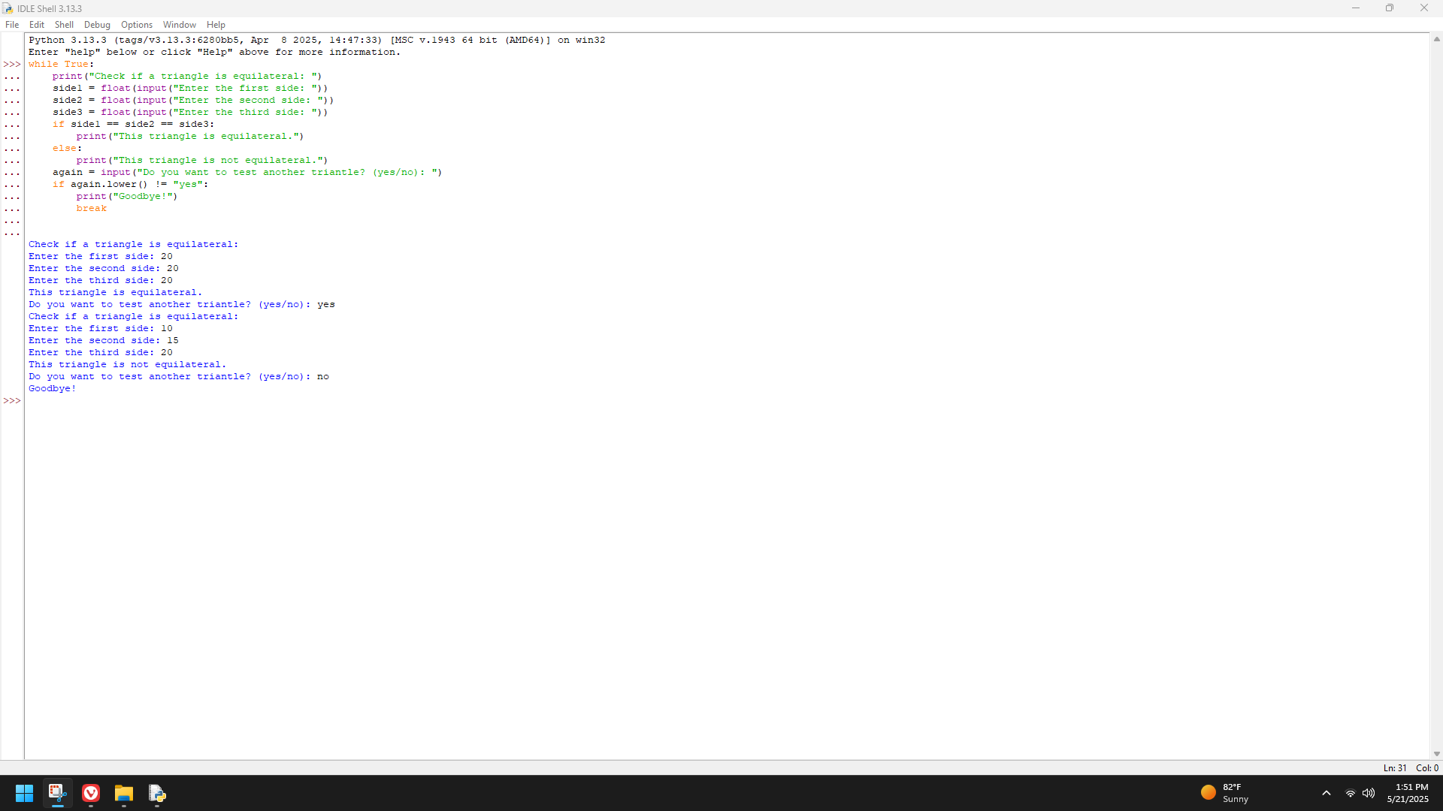

A standard science experiment is to drop a ball and see how high it bounces. Once the “bounciness” of the ball has been determined, the ratio gives a bounciness index. For example, if a ball dropped from a height of 10 feet bounces 6 feet high, the index is 0.6, and the total distance traveled by the ball is 16 feet after one bounce. If the ball were to continue bouncing, the distance after two bounces would be

10

ft

+

6

ft

+

6

ft

+

3.6

ft

=

25.6

ft

. Note that the distance traveled for each successive bounce is the distance to the floor plus 0.6 of that distance as the ball comes back up. Write a program in the file bouncy.py that lets the user enter the initial height from which the ball is dropped and the number of times the ball is allowed to continue bouncing. Output should be the total distance traveled by the ball.

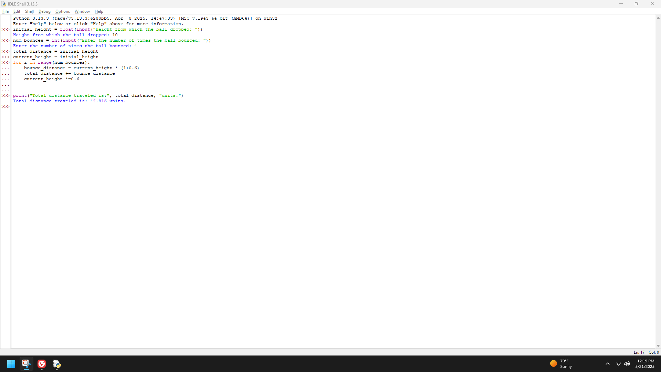

A local biologist needs a program to predict population growth. The inputs would be the initial number of organisms, the rate of growth (a real number greater than 0), the number of hours it takes to achieve this rate, and a number of hours during which the population grows. For example, one might start with a population of 500 organisms, a growth rate of 2, and a growth period to achieve this rate of 6 hours. Assuming that none of the organisms die, this would imply that this population would double in size every 6 hours. Thus, after allowing 6 hours for growth, we would have 1000 organisms, and after 12 hours, we would have 2000 organisms. Write a program in the file population.py that takes these inputs and displays a prediction of the total population.

