| Course Name | ITD 2313 – Script Programming |
| --- | --- |
| Instructor | Mark Pranger |
| Student Name | Weston Albright |
| Due date | 07/29/2025 |
| Grade | 95.57% |
| Grading Comments | N/A |

**Write a GUI-based program in the file taxformwithgui.py that implements the tax calculator program shown in Figure 9-2.**

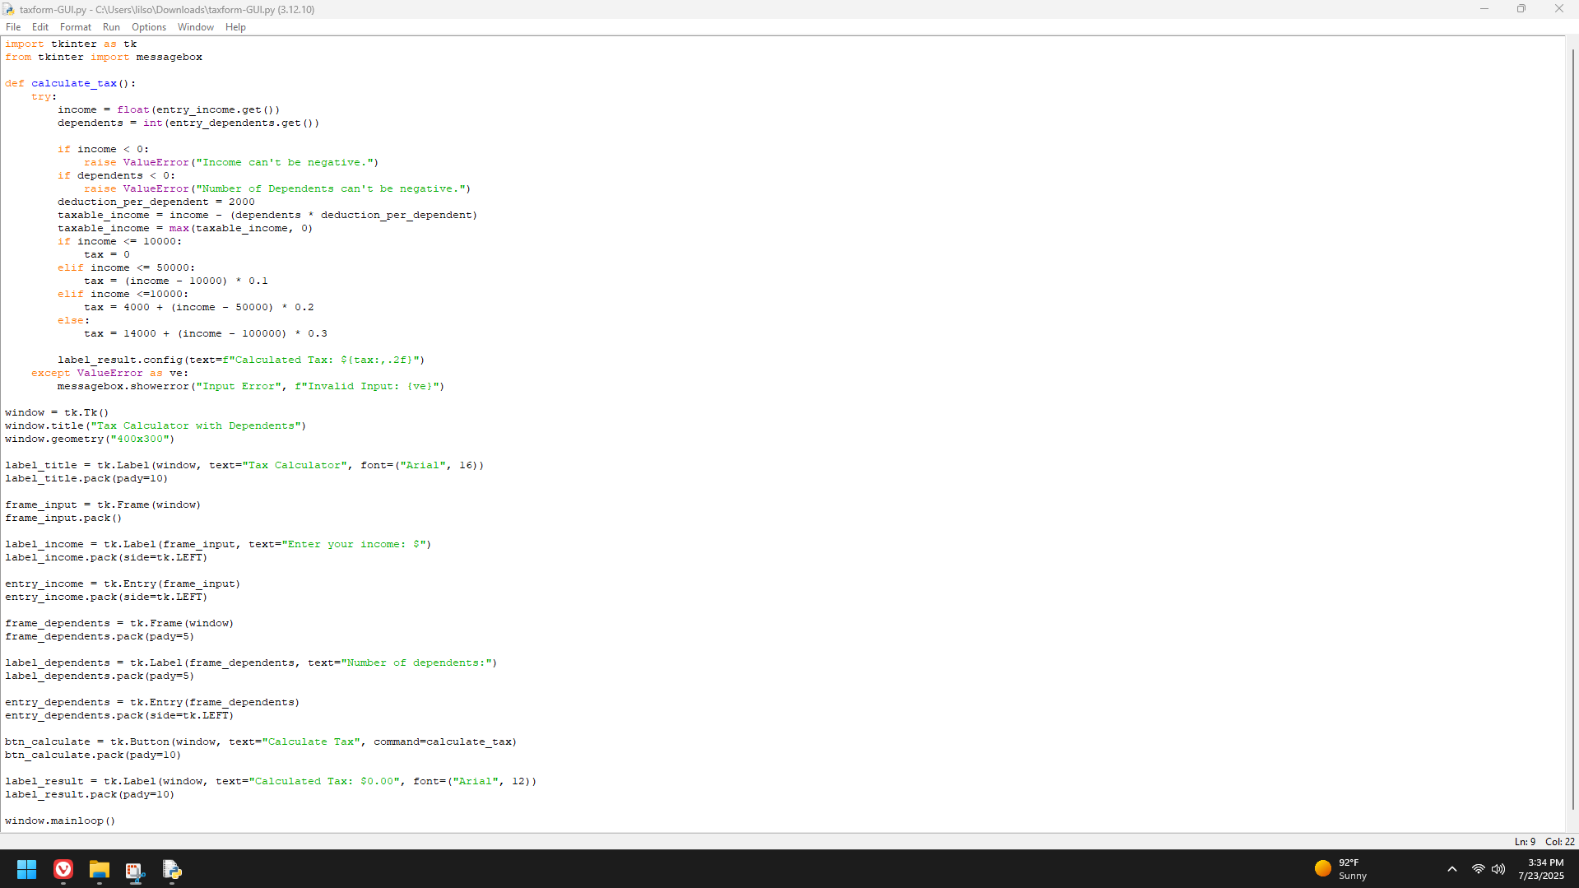

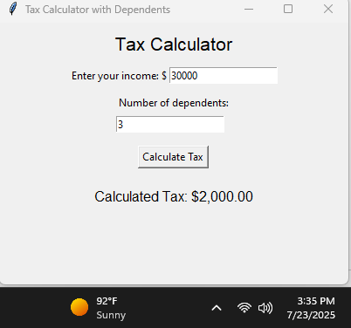

**Write a GUI-based program in the file temperatureconverter.py that allows the user to convert temperature values between degrees Fahrenheit and degrees Celsius. The interface should have labeled entry fields for these two values. These components should be arranged in a grid where the labels occupy the first row and the corresponding fields occupy the second row. At start-up, the Fahrenheit field should contain 32.0, and the Celsius field should contain 0.0. The third row in the window contains two command buttons, labeled >>>> and <<<<. When the user presses the first button, the program should use the data in the Fahrenheit field to compute the Celsius value, which should then be output to the Celsius field. The second button should perform the inverse function.**

