| Course Name | ITD 2313 – Script Programming |
| --- | --- |
| Instructor | Mark Pranger |
| Student Name | Weston Albright |
| Due date | 05/13/2025 |
| Grade | 95% |
| Grading Comments | N/A |

Page 33

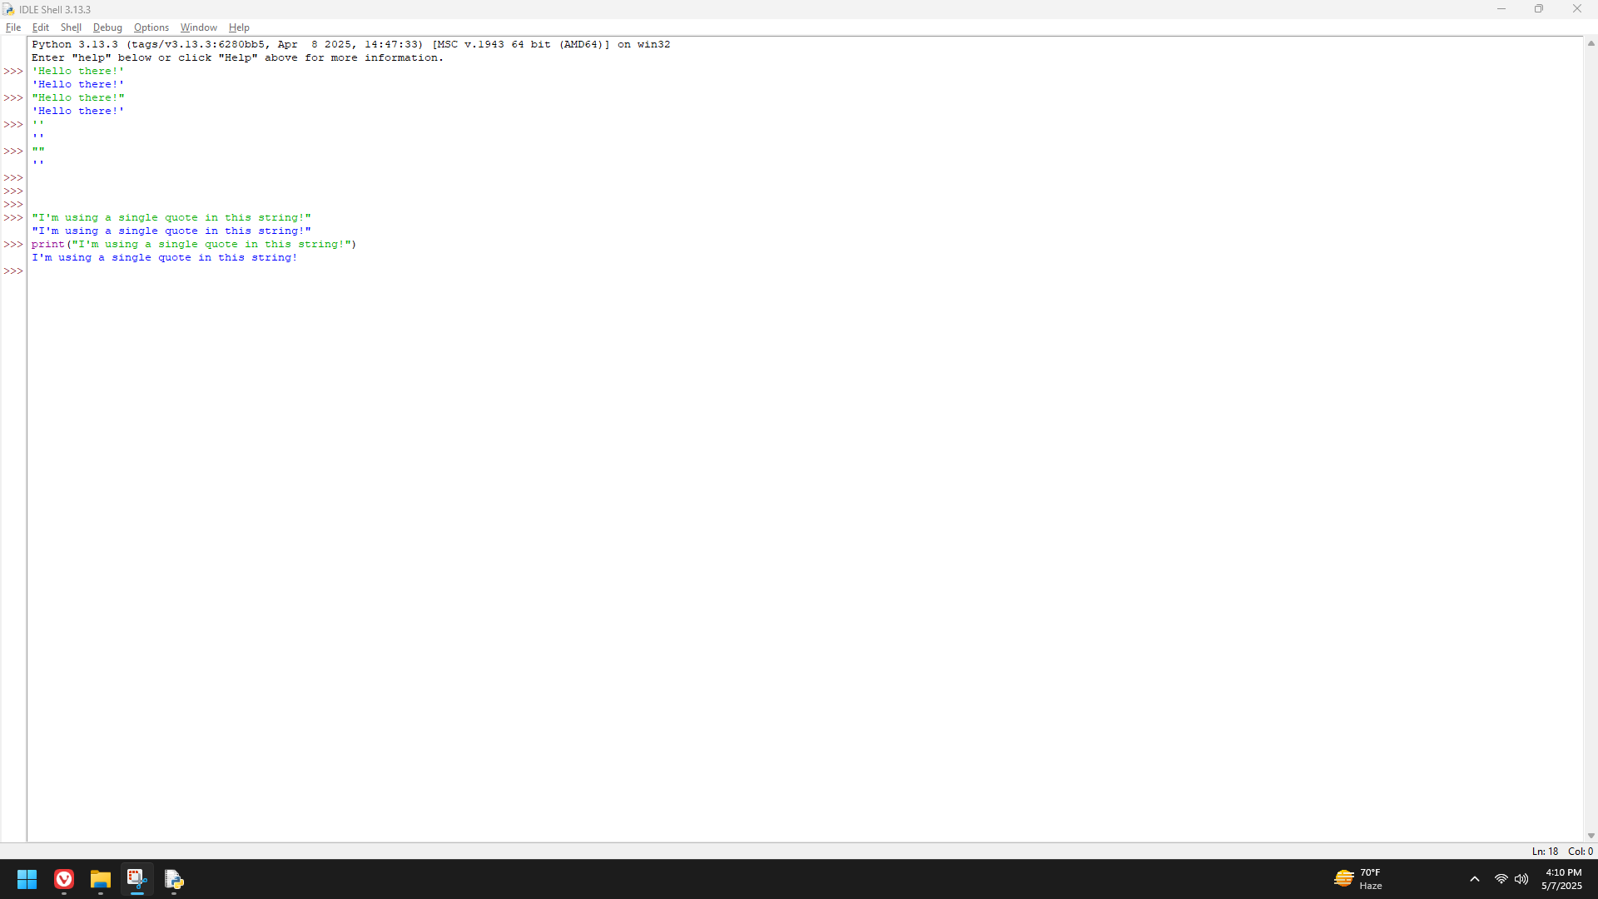

Page 34

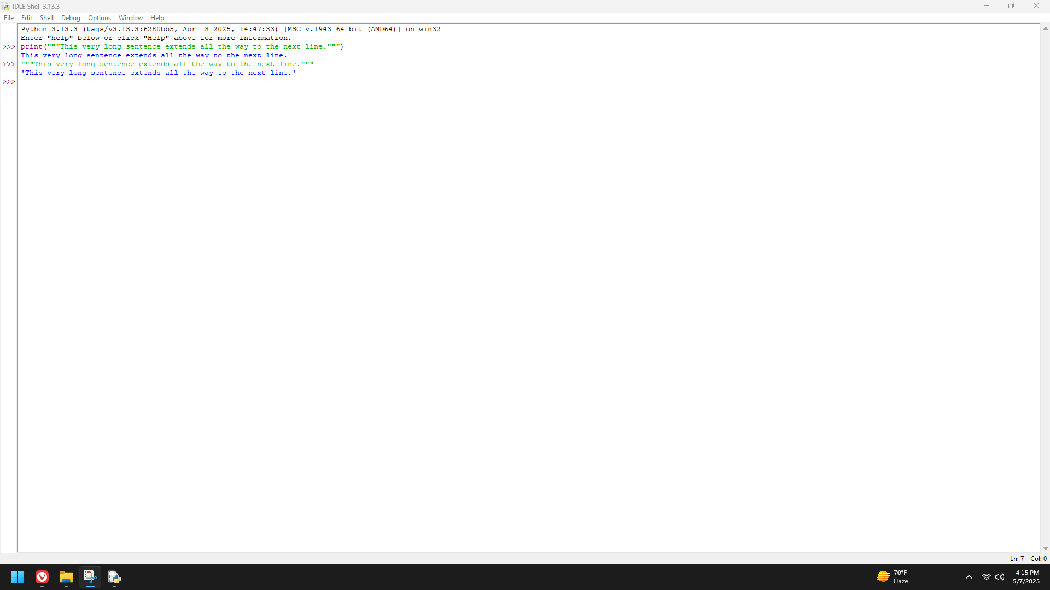

Page 35

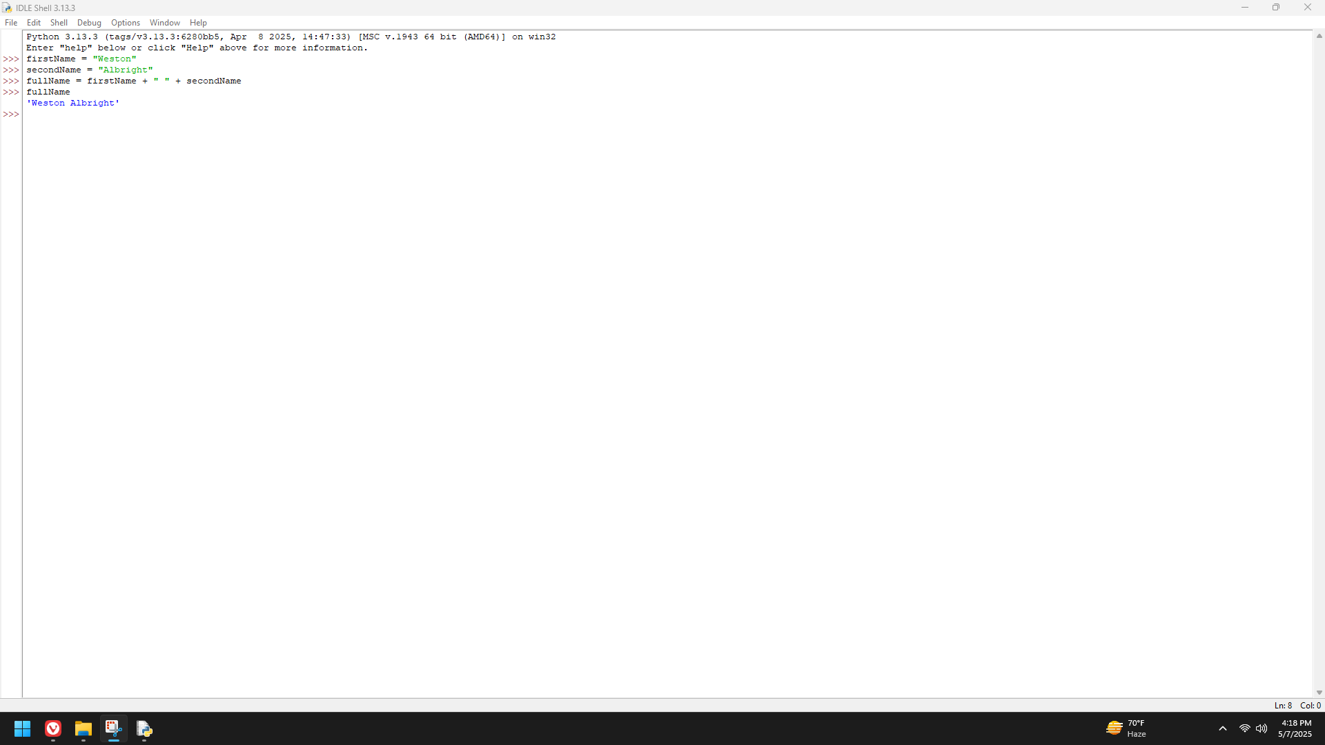

Page 39

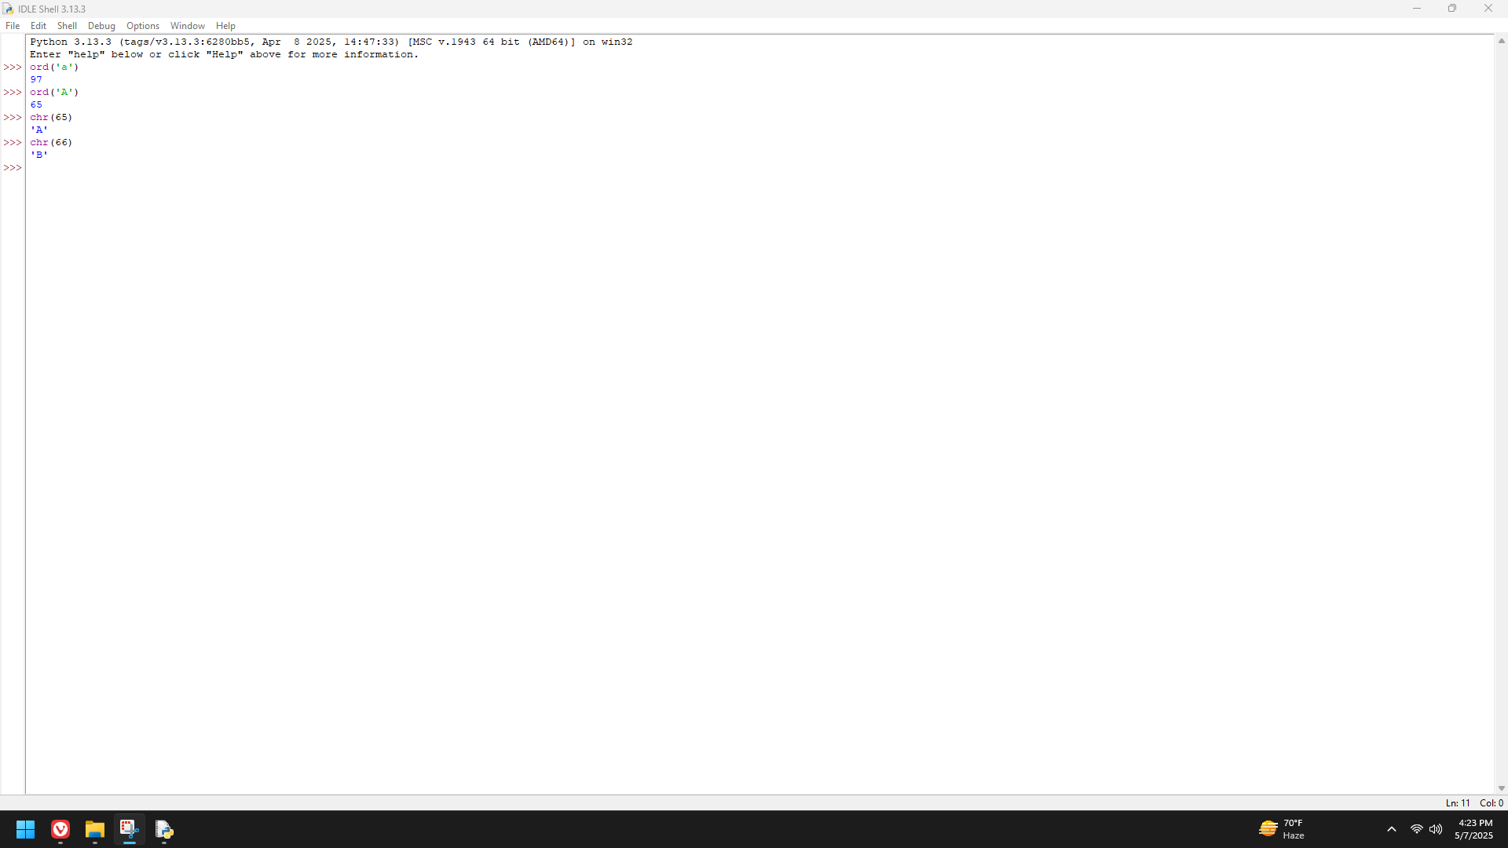

Page 40

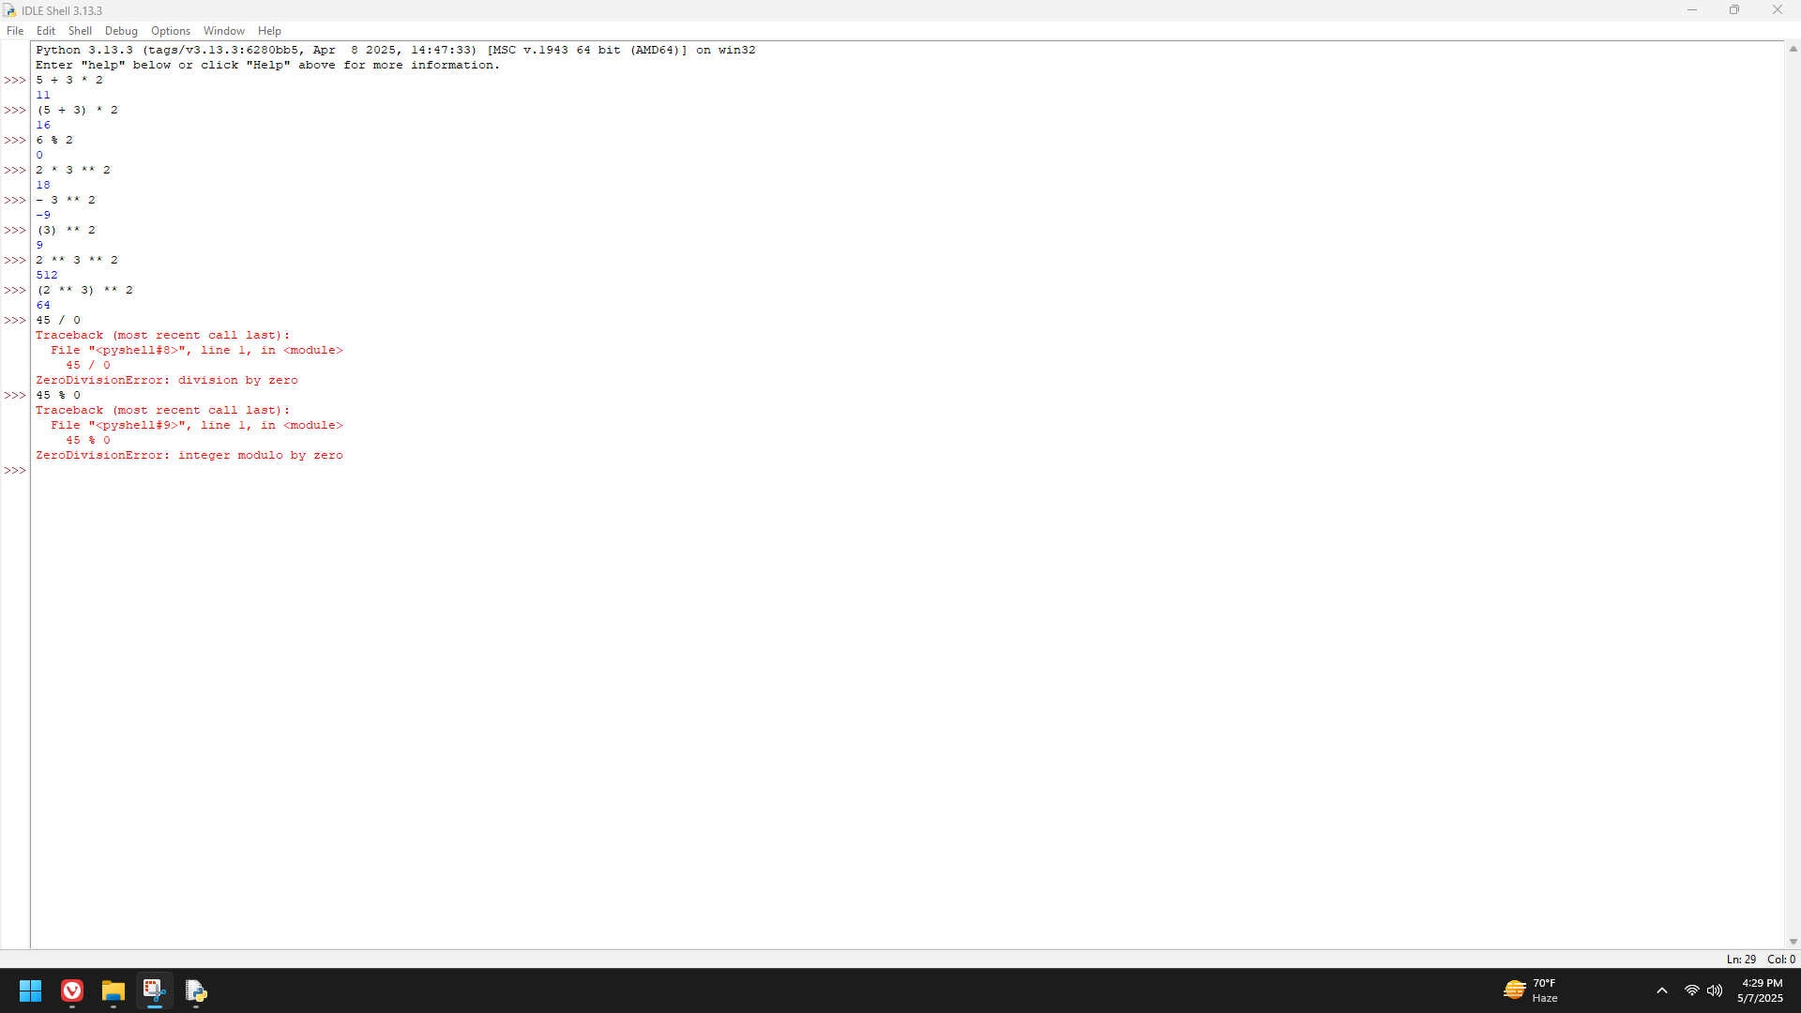

Page 41

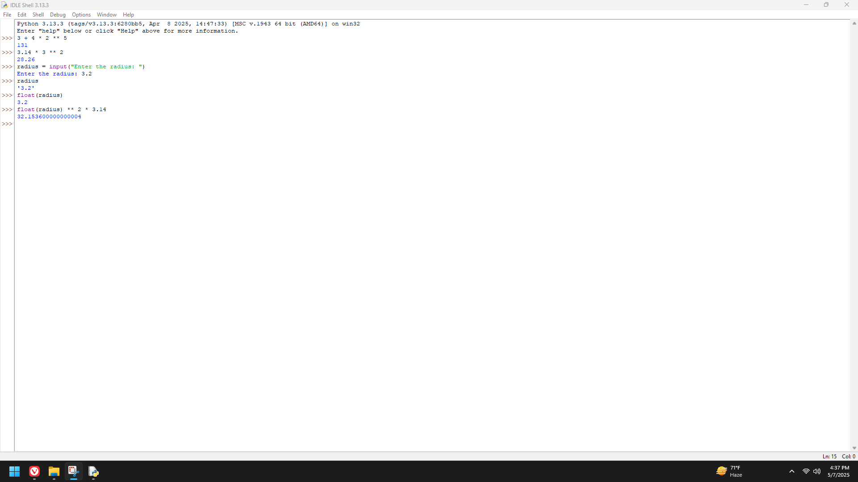

Page 42

