| Course Name | ITD 2313 – Script Programming |
| --- | --- |
| Instructor | Mark Pranger |
| Student Name | Weston Albright |
| Due date | 05/20/2025 |
| Grade | 99.32% |
| Grading Comments | N/A |

The tax calculator program of the case study outputs a floating-point number that might show more than two digits of precision. Use the round function to modify the program in the file taxform.py to display at most two digits of precision in the output number.

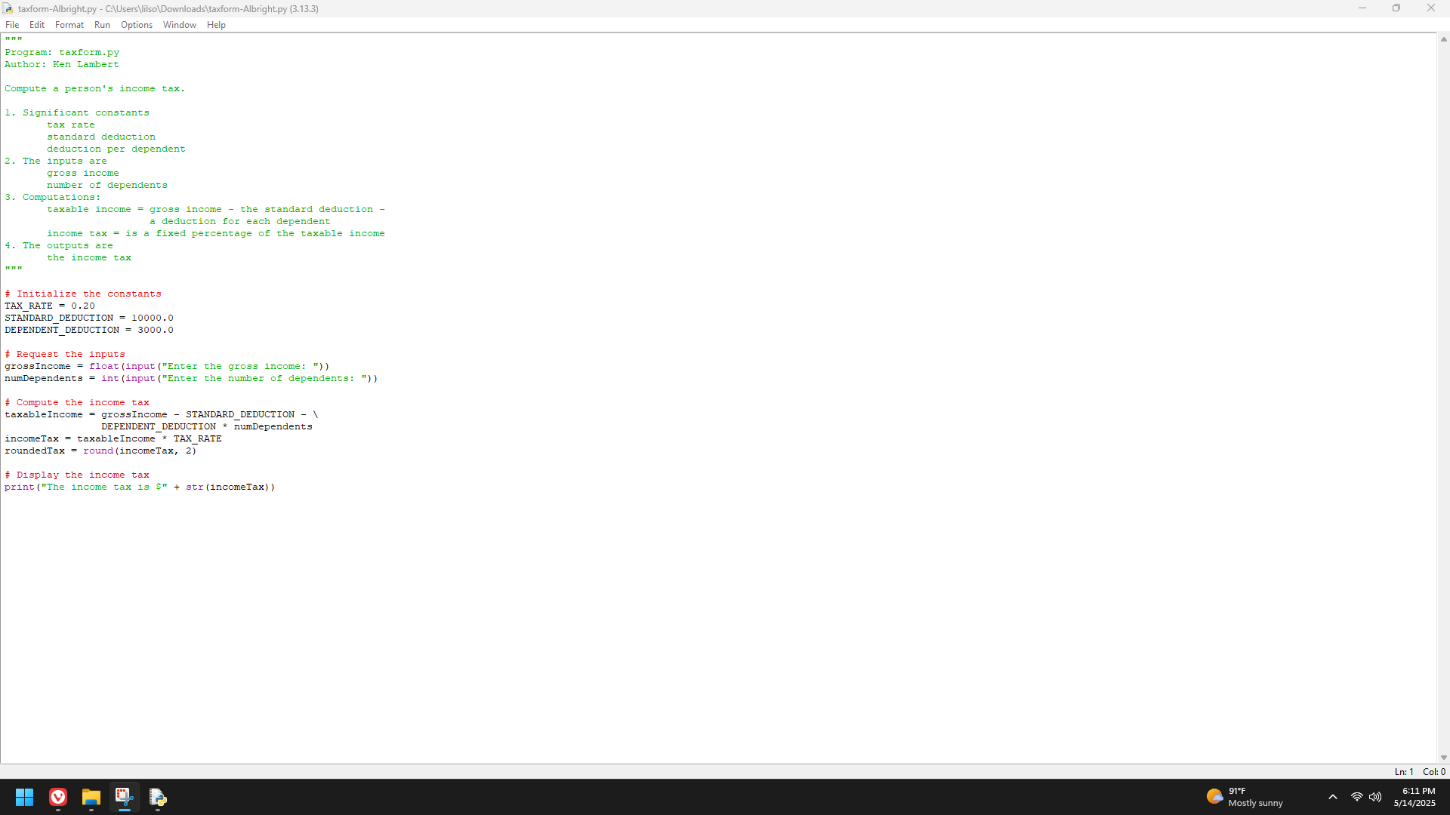

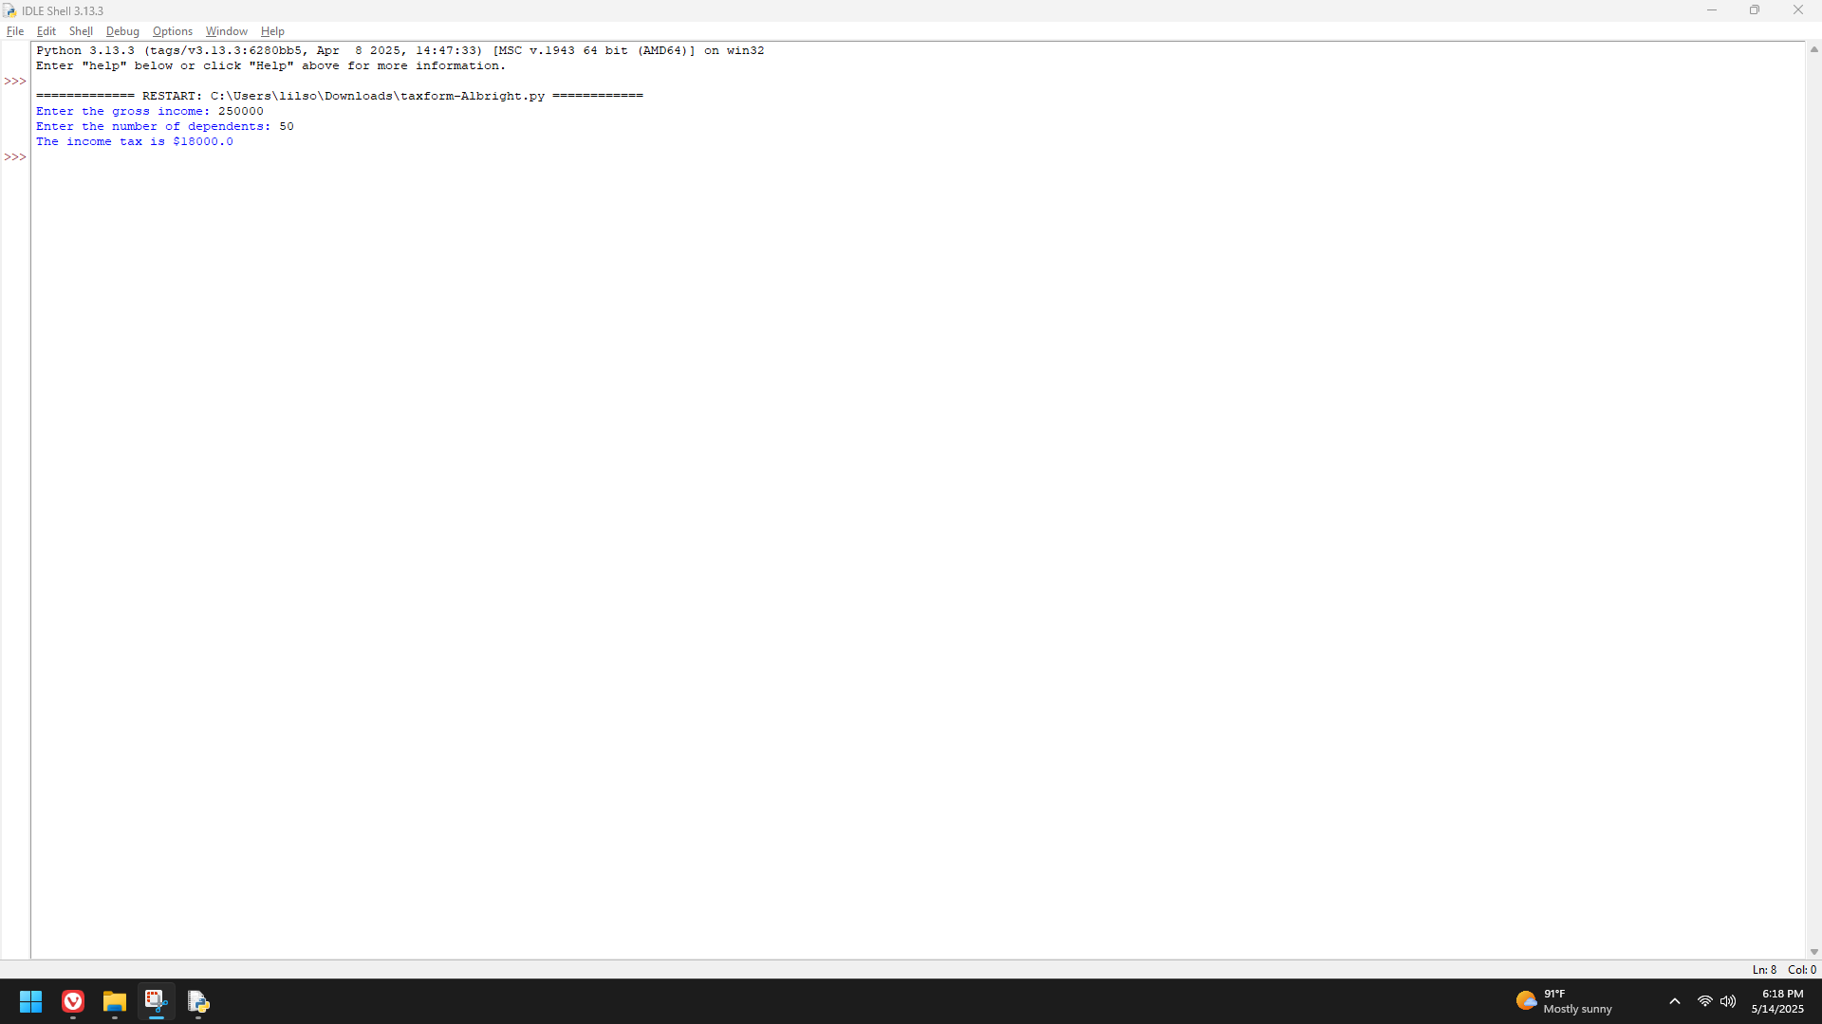

Write a program in the file minutes.py that takes as input a number of years and calculates and prints the number of minutes in that period of time.

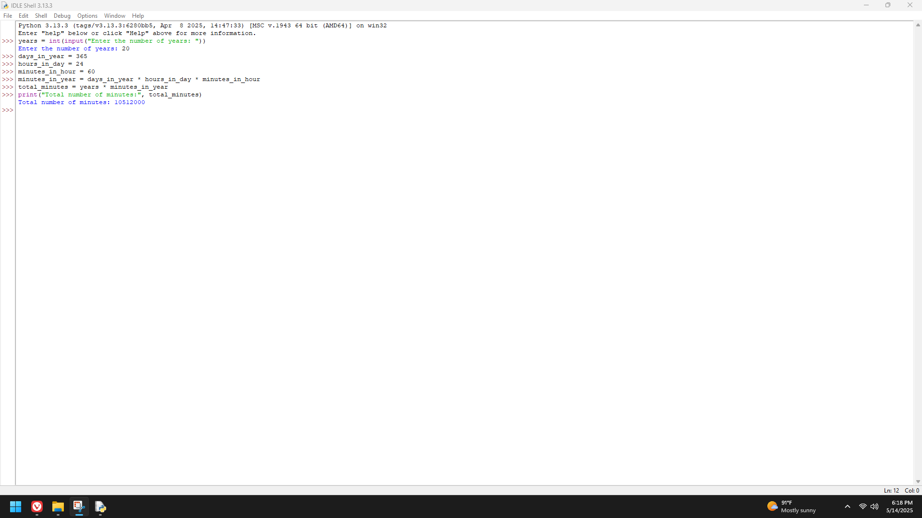

An employee’s total weekly pay equals the hourly wage multiplied by the total number of regular hours plus any overtime pay. Overtime pay equals the total overtime hours multiplied by 1.5 times the hourly wage. Write a program in the file employeepay.py that takes as inputs the hourly wage, total regular hours, and total overtime hours and displays an employee’s total weekly pay.

