| Course Name | ITD 2313 – Script Programming |
| --- | --- |
| Instructor | Mark Pranger |
| Student Name | Weston Albright |
| Due date | 06/10/2025 |
| Grade | 97.69% |
| Grading Comments | N/A |

Write a script in the file encrypt.py that inputs a line of plaintext and a distance value and outputs an encrypted text using a Caesar cipher. The script should work for any printable characters.

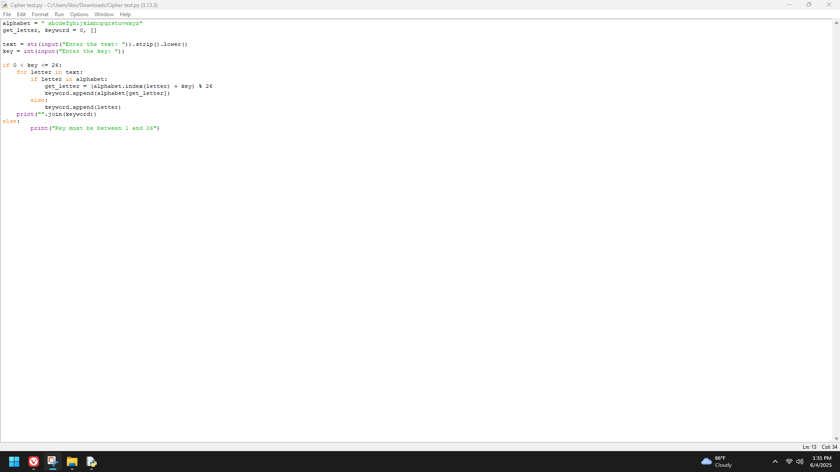

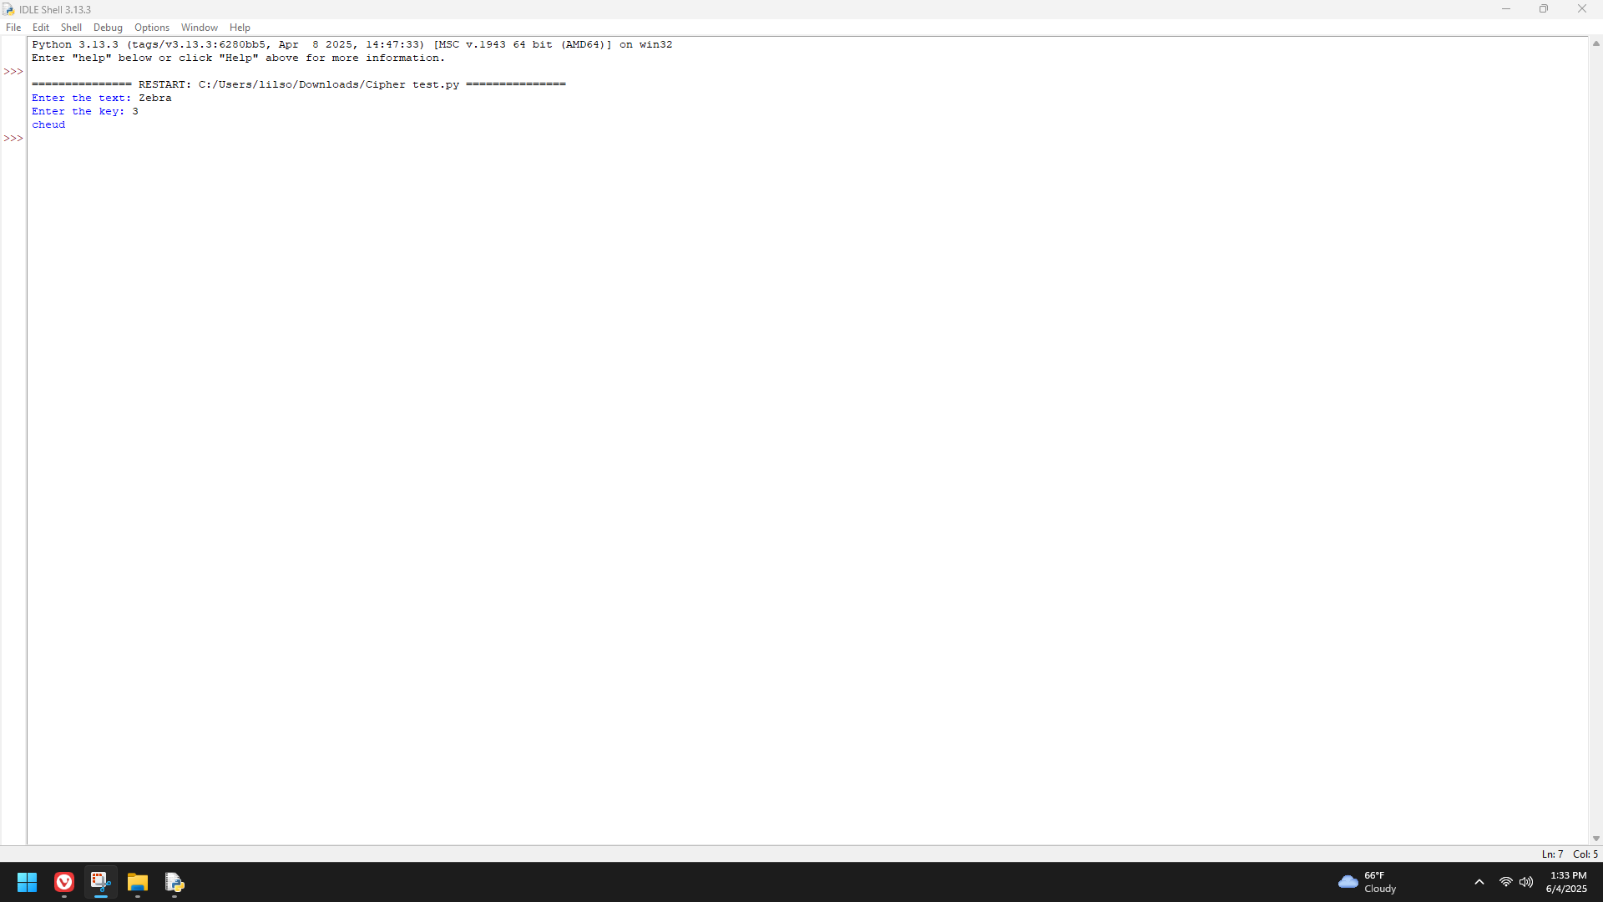

Write a script in the file decrypt.py that inputs a line of encrypted text and a distance value and outputs plaintext using a Caesar cipher. The script should work for any printable characters.

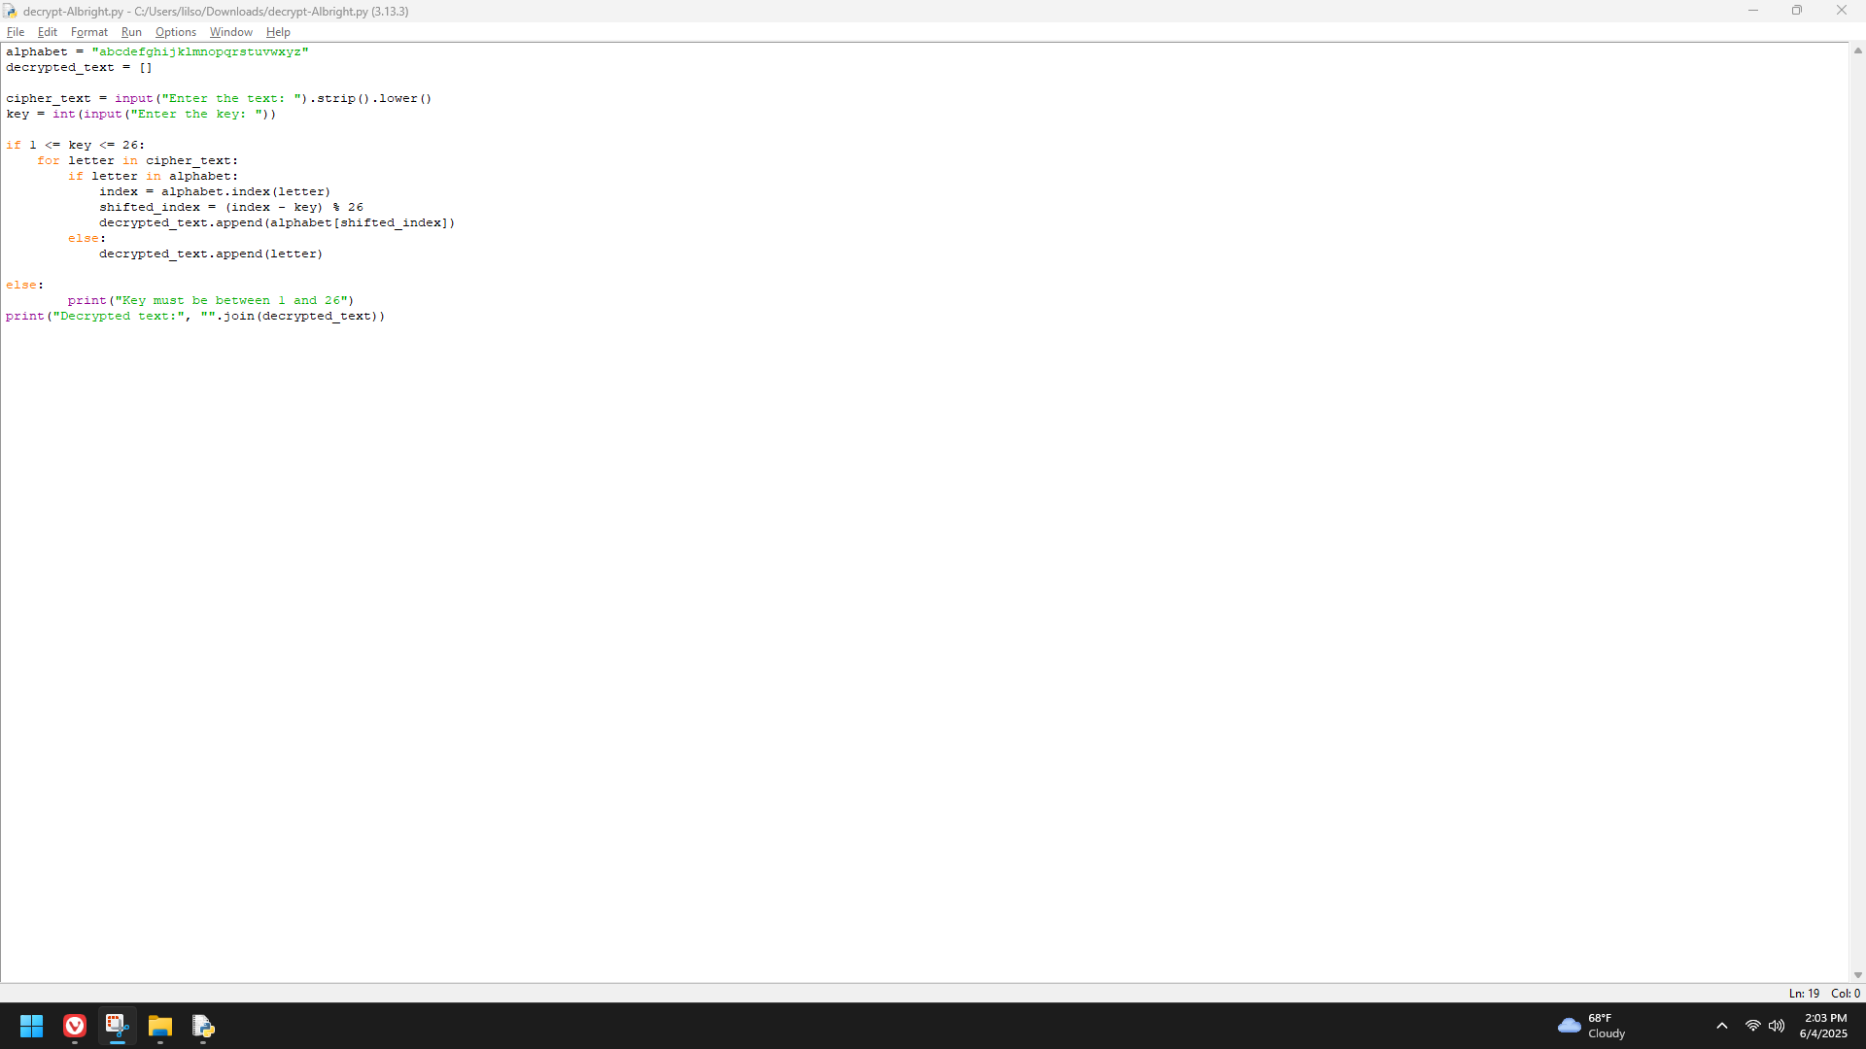

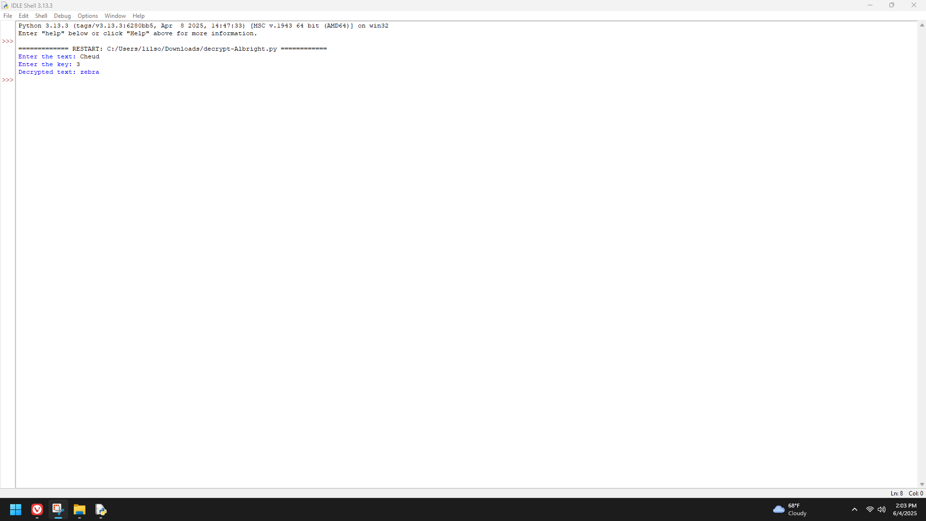

Write a script named copyfile.py . This script should prompt the user for the names of two text files. The contents of the first file should be input and written to the second file.

