| Course Name | ITD 2313 – Script Programming |
| --- | --- |
| Instructor | Mark Pranger |
| Student Name | Weston Albright |
| Due date | 06/17/2025 |
| Grade | 97.12% |
| Grading Comments | N/A |

**A group of statisticians at a local college has asked you to create a set of functions that compute the median and mode of a set of numbers, as defined in Section 5.3. Define these functions in a module named stats.py. Also include a function named mean , which computes the average of a set of numbers. Each function should expect a list of numbers as an argument and return a single number. Each function should return 0 if the list is empty. Include a main function that tests the three statistical functions with a given list.**

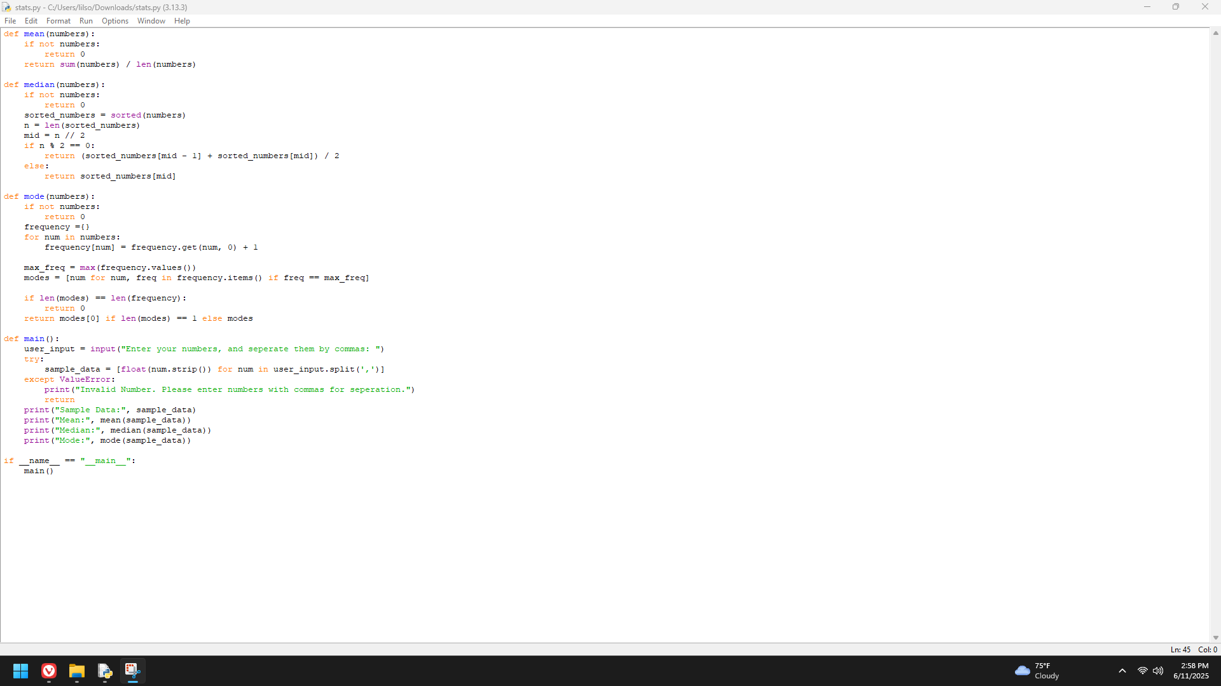

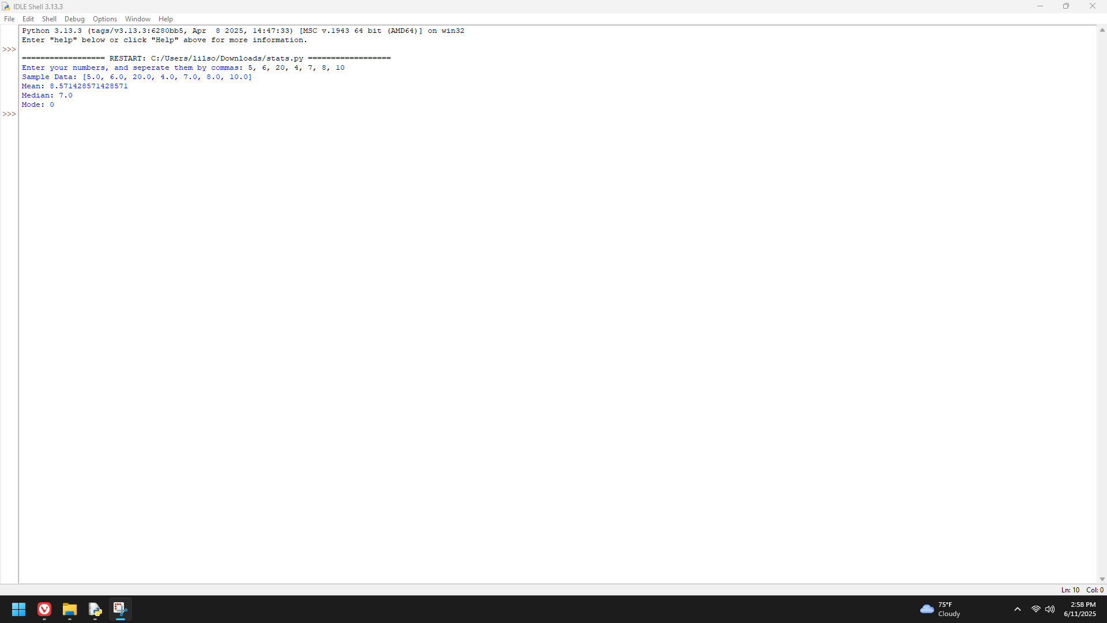

**Write a program in the file navigate.py that allows the user to navigate the lines of text in a file. The program should prompt the user for a filename and input the lines of text into a list. The program then enters a loop in which it prints the number of lines in the file and prompts the user for a line number. Actual line numbers range from 1 to the number of lines in the file. If the input is 0, the program quits. Otherwise, the program prints the line associated with that number.**

