| Course Name | ITD 2313 – Script Programming |
| --- | --- |
| Instructor | Mark Pranger |
| Student Name | Weston Albright |
| Due date | 06/17/2025 |
| Grade | 97.12% |
| Grading Comments | N/A |

**List Literals and Basic Operators (Page 116-117)**

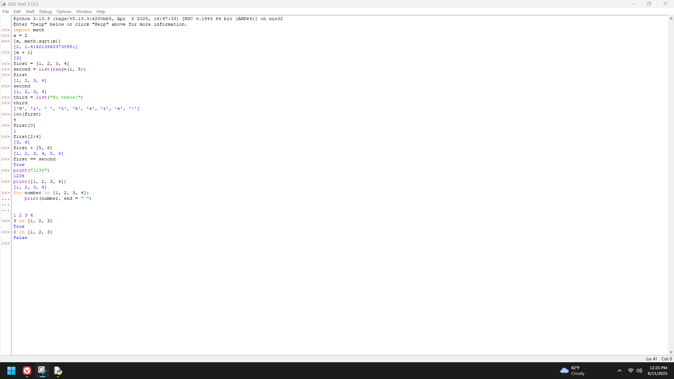

**Replacing an Element in a List (Page 118)**

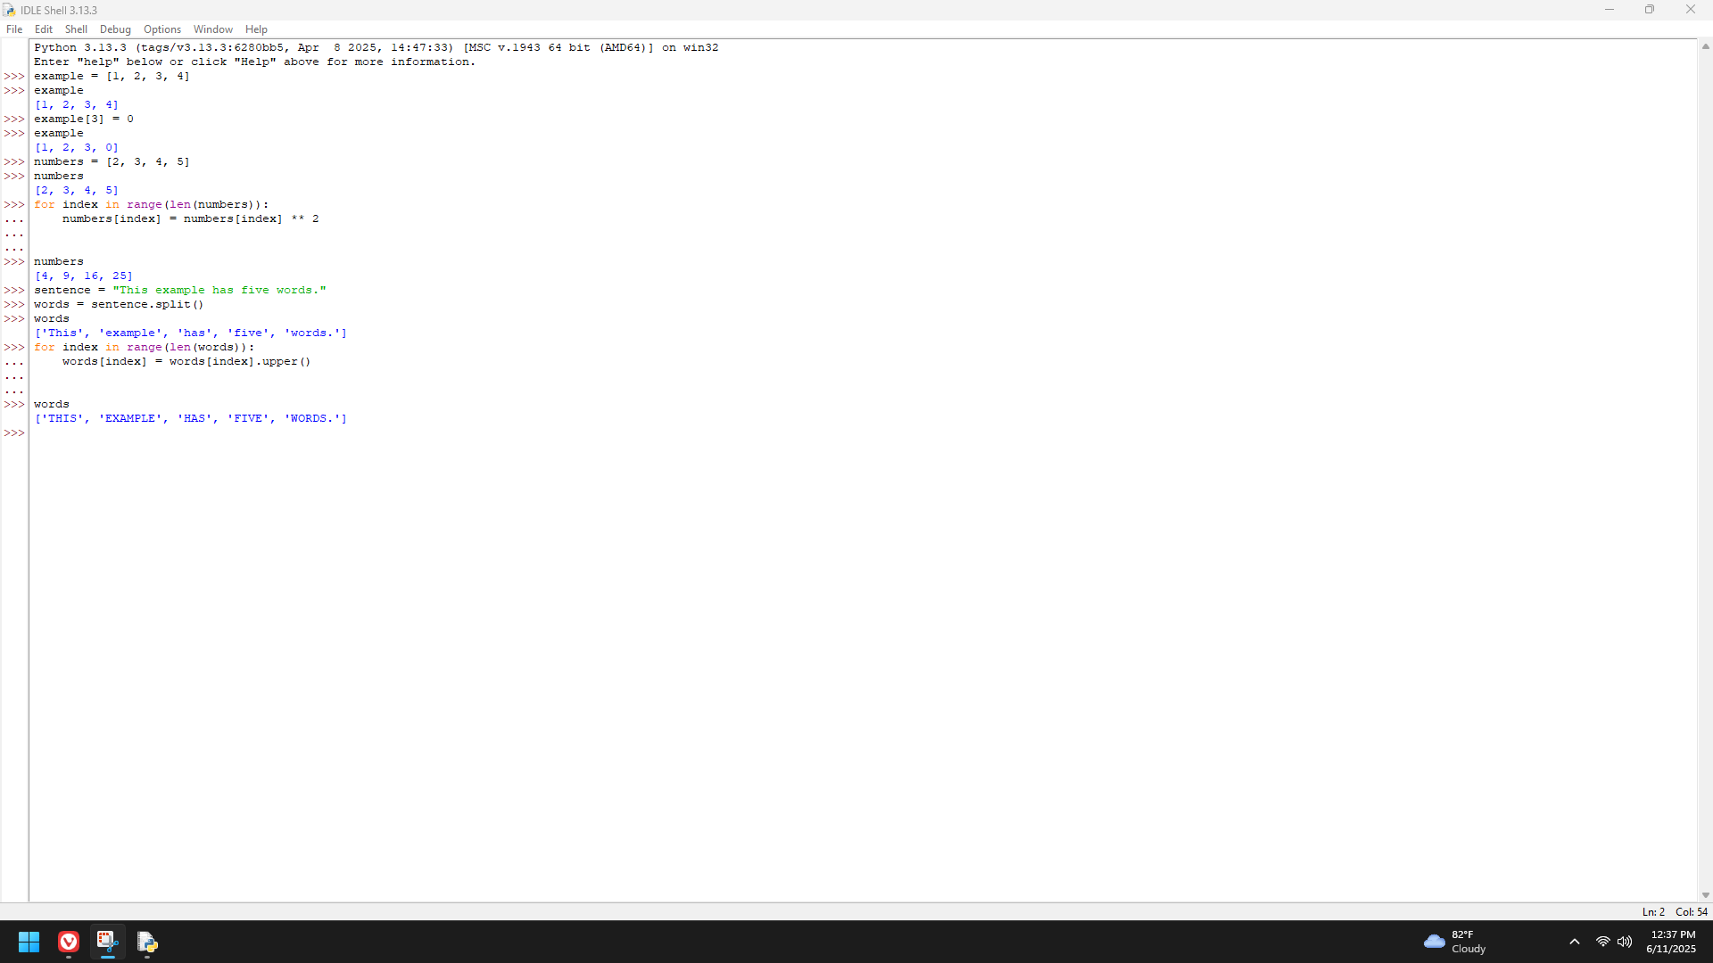

**List Methods for Inserting and Removing Elements (Page 119-120)**

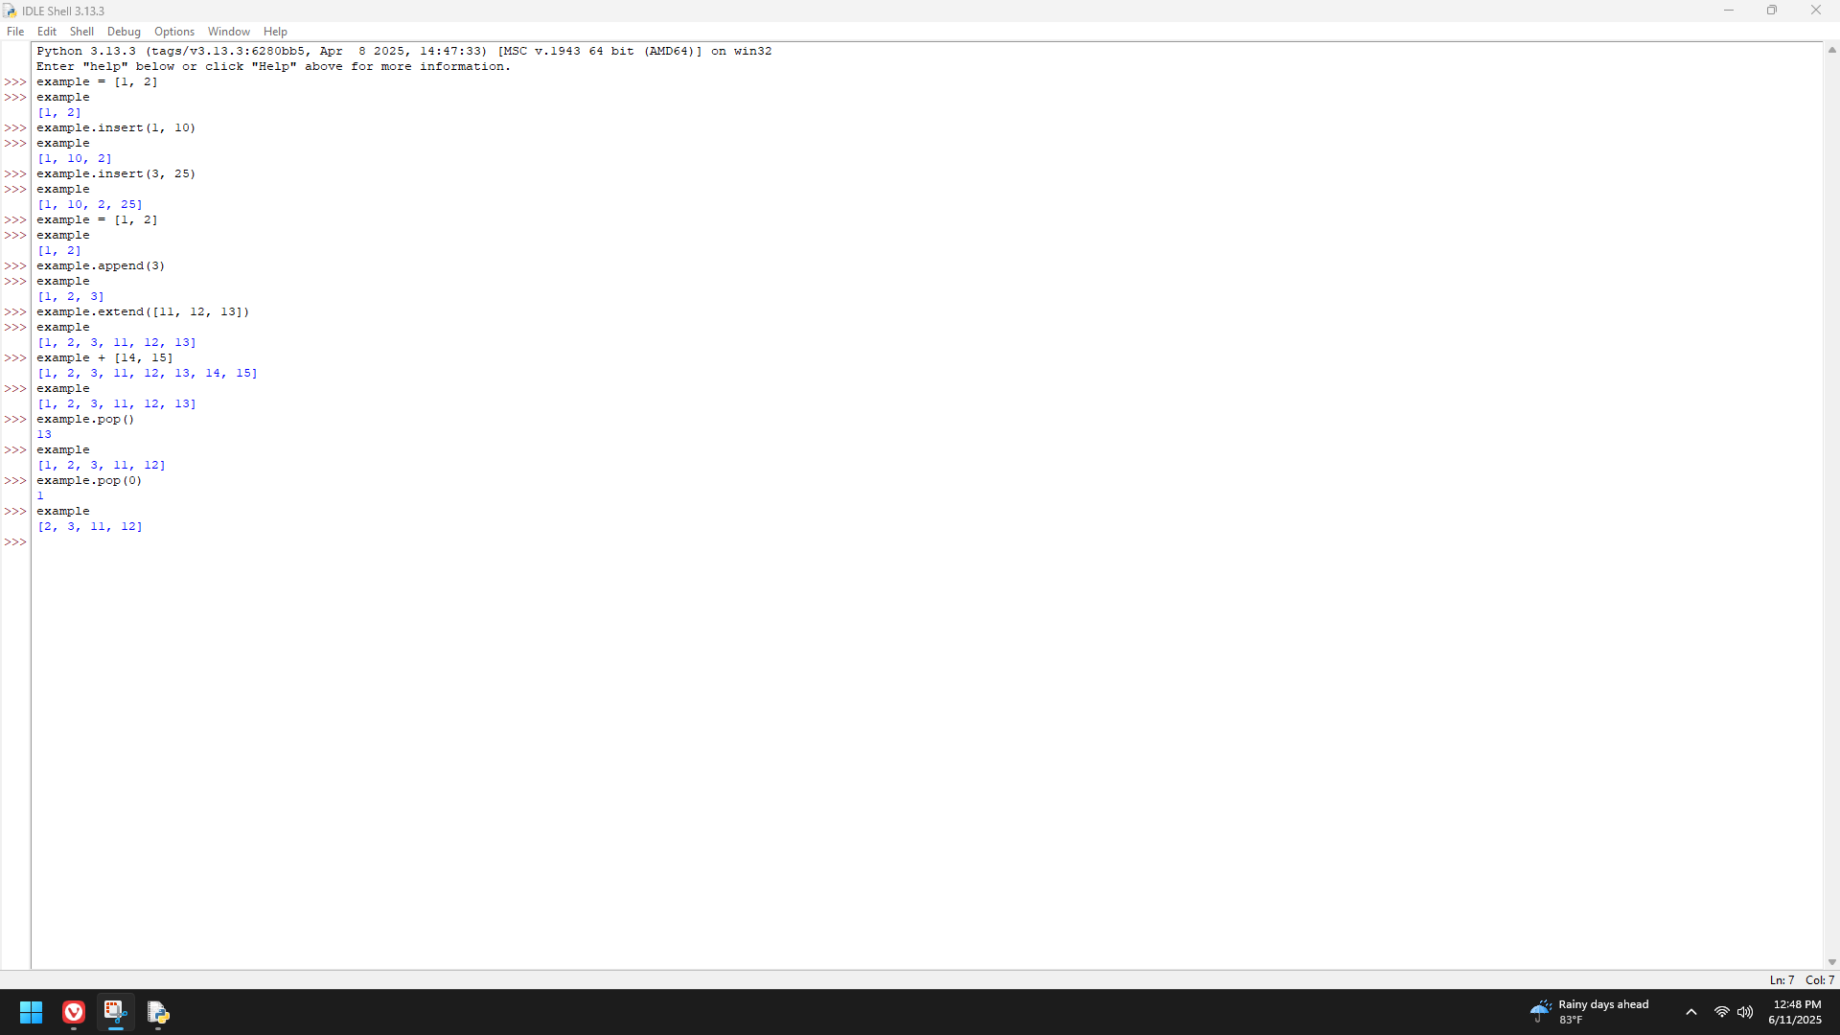

**Searching a list (Page 121)**

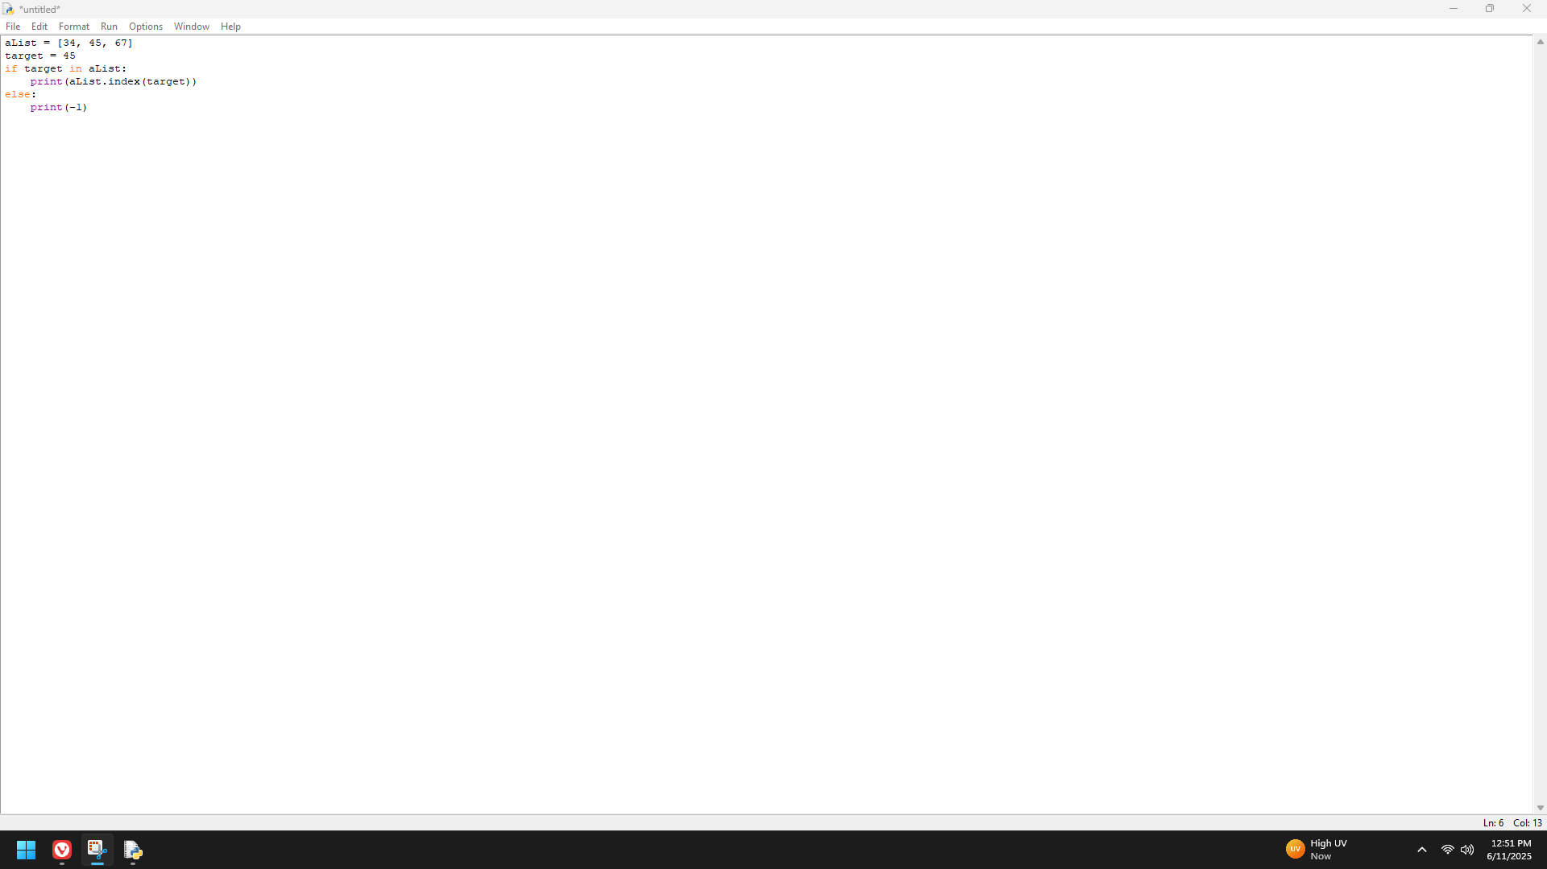

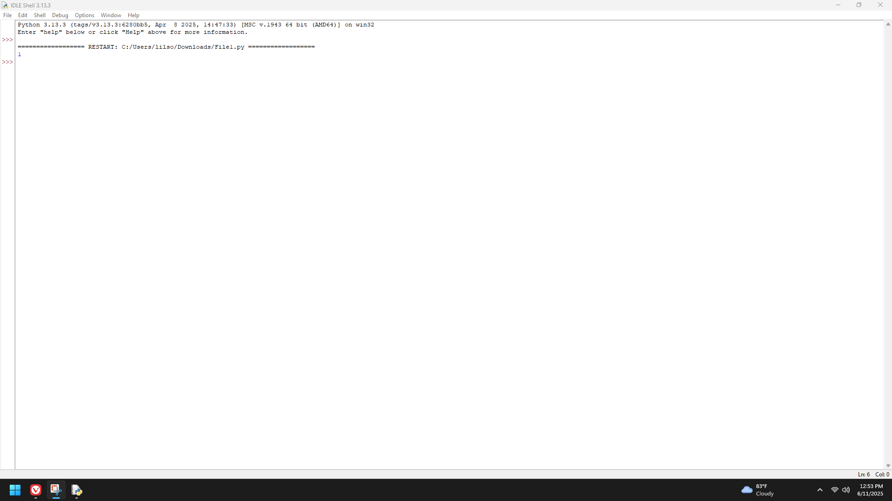

**Sorting a list (Page 121)**

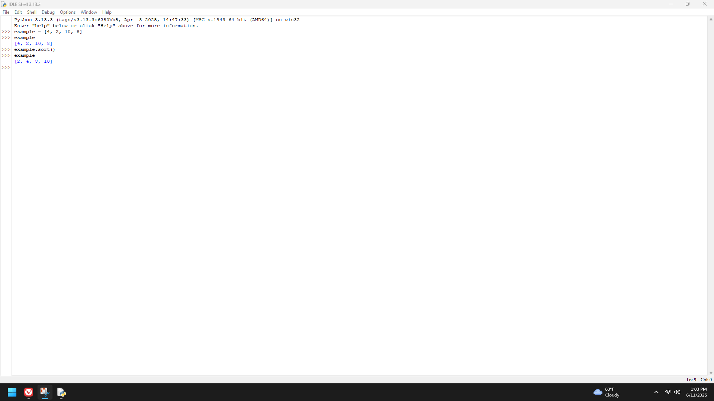

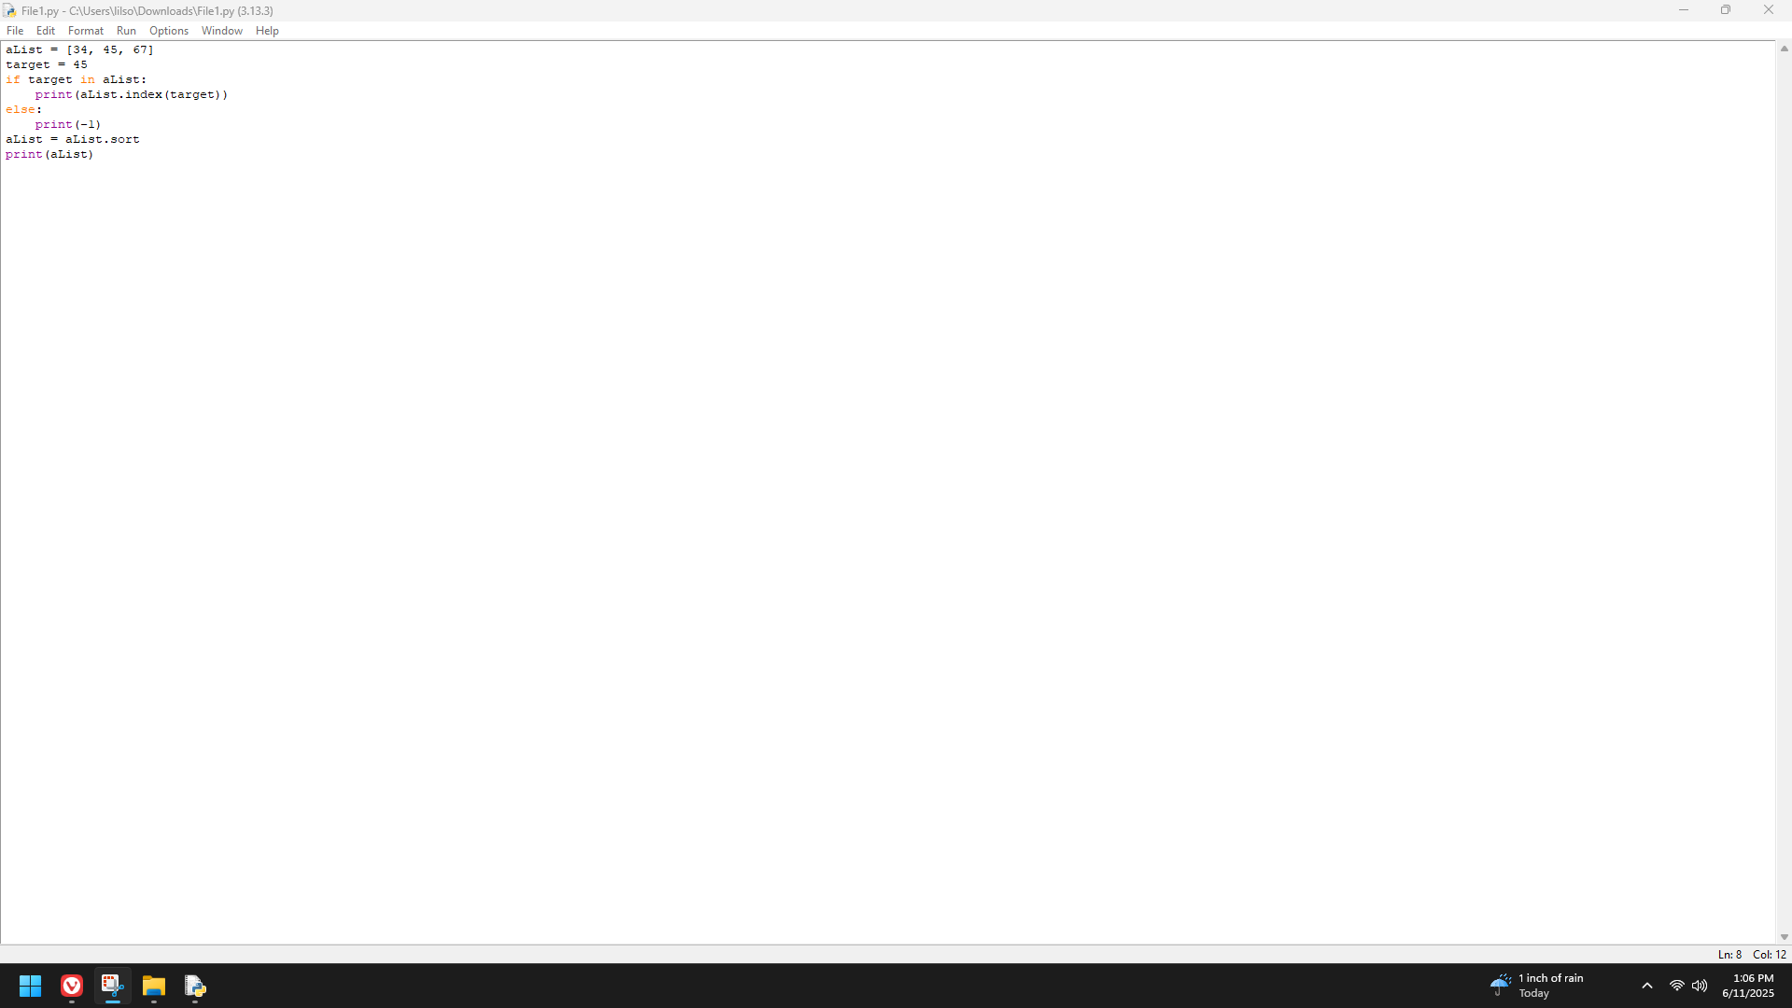

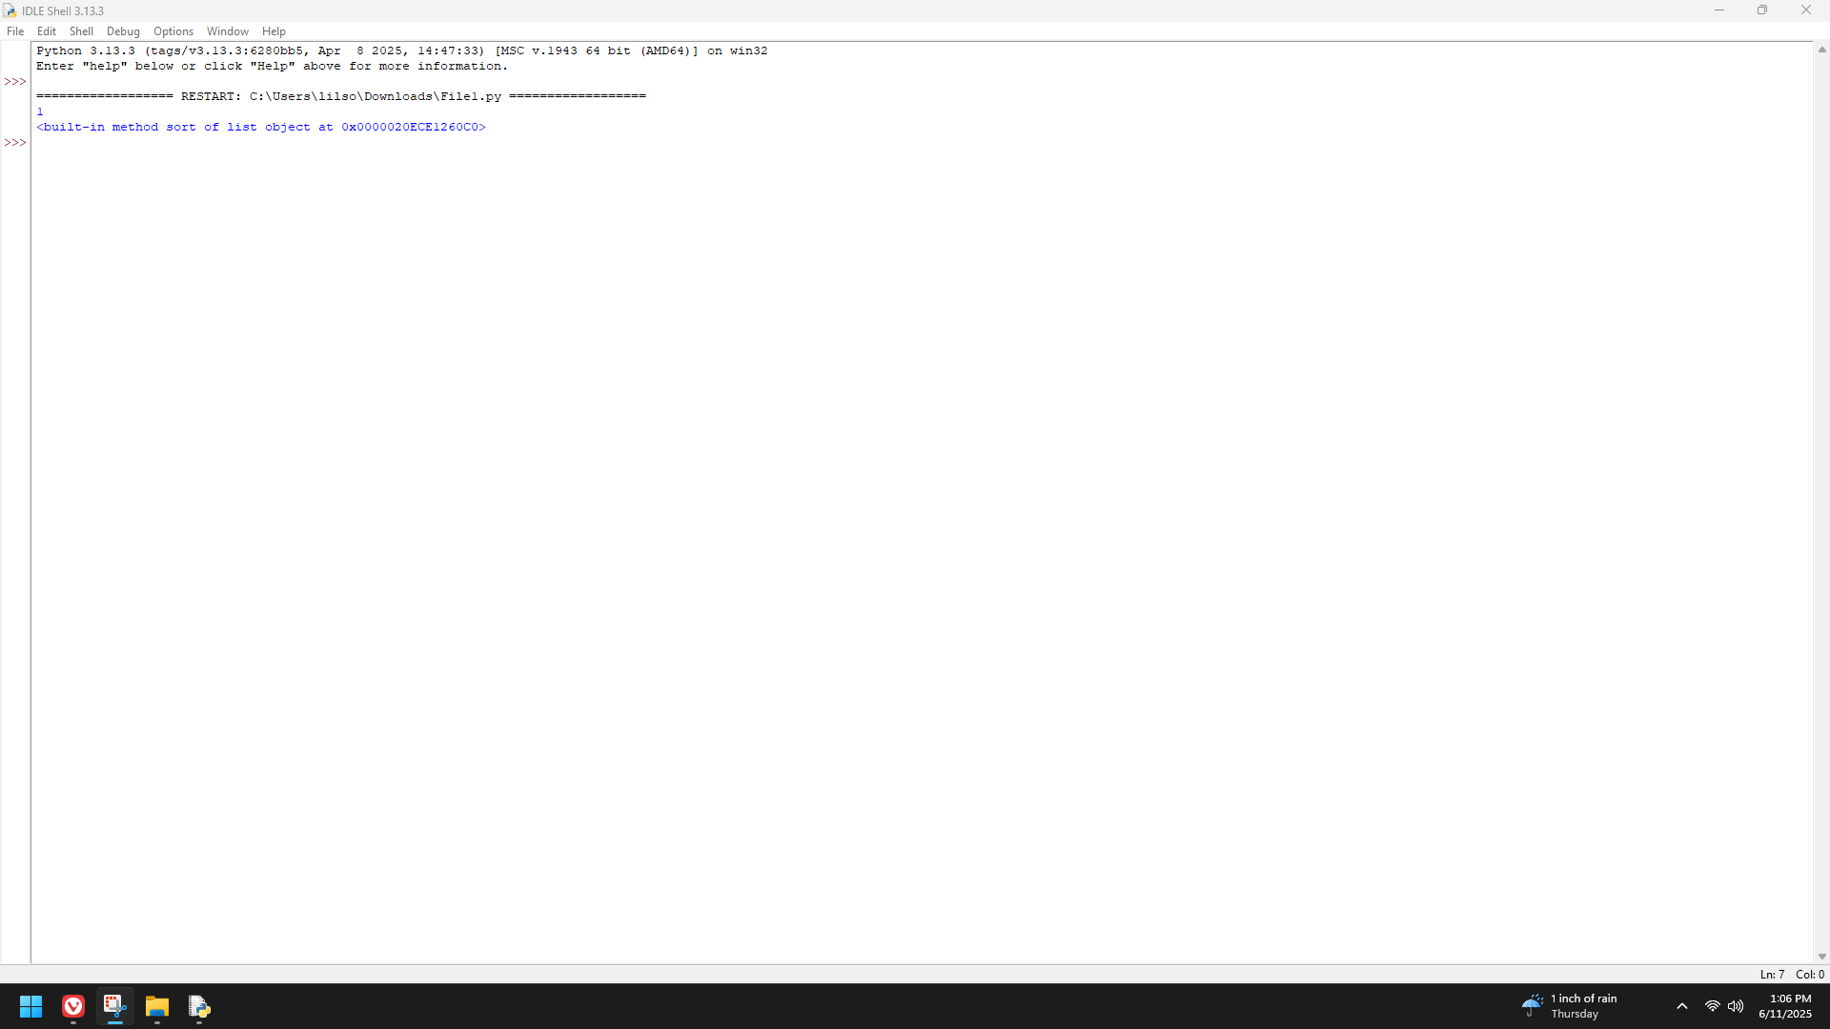

**Aliasing and Side effects (Page 122-123)**

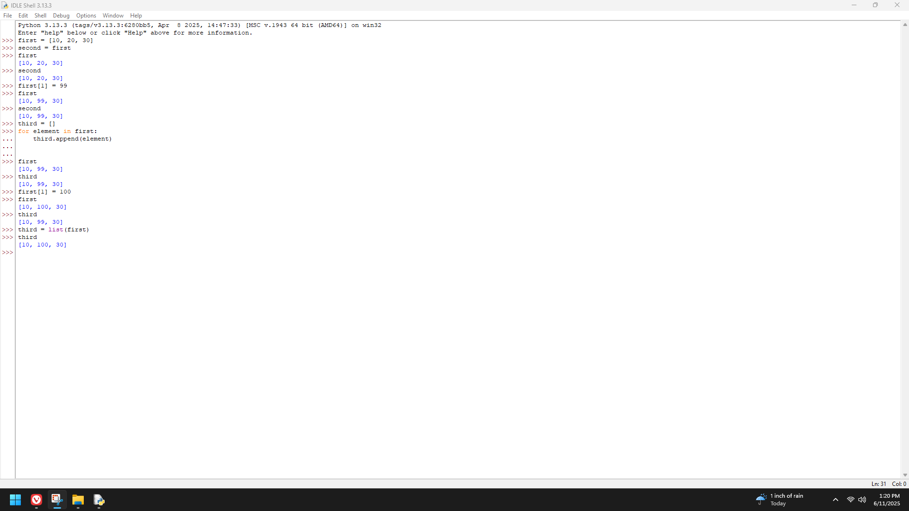

**Page 124**

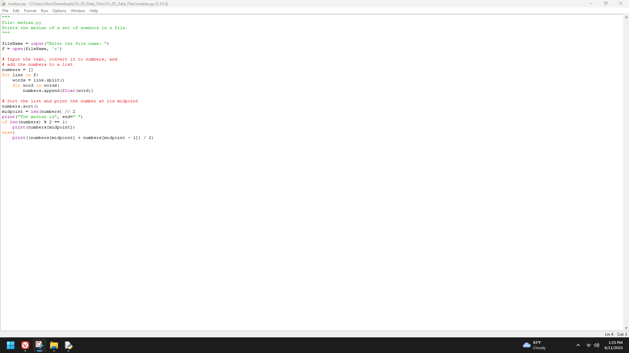

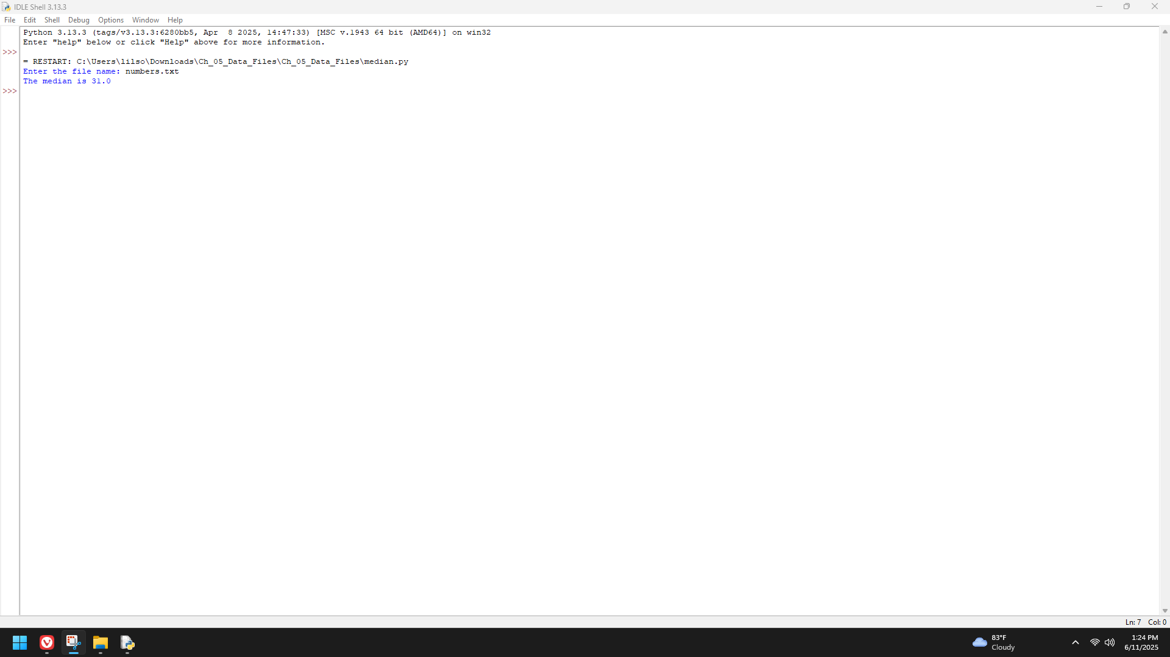

**Tuples (Page 124)**

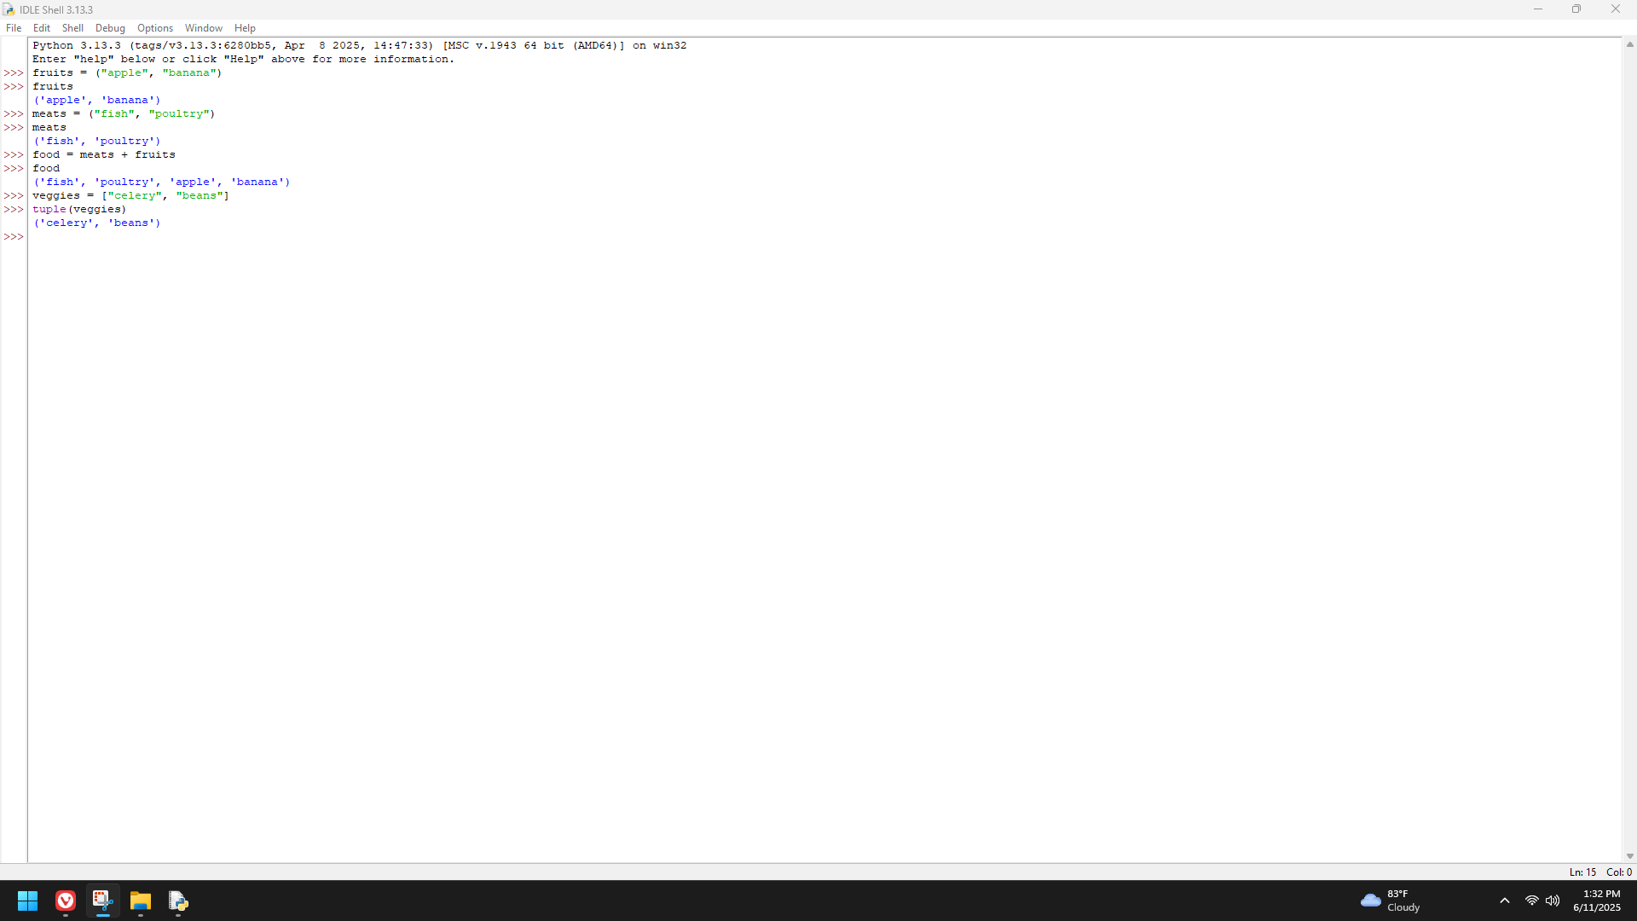

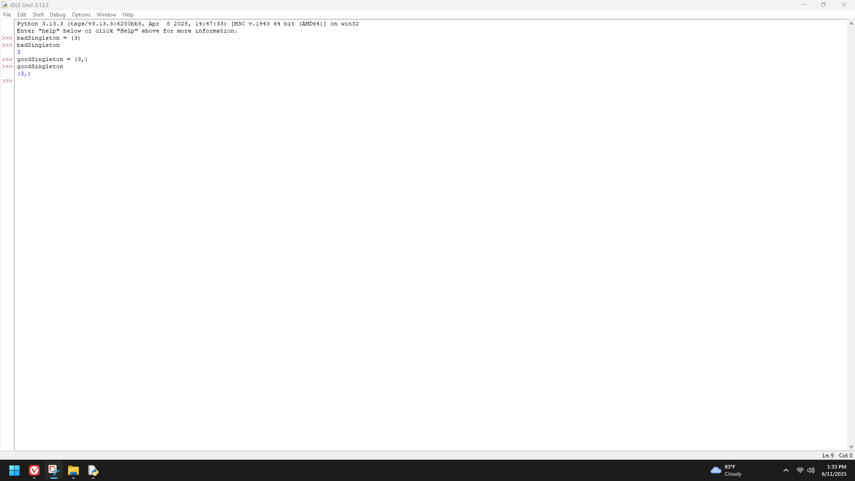

**The Syntax of Simple Function Definitions (Page 126)**

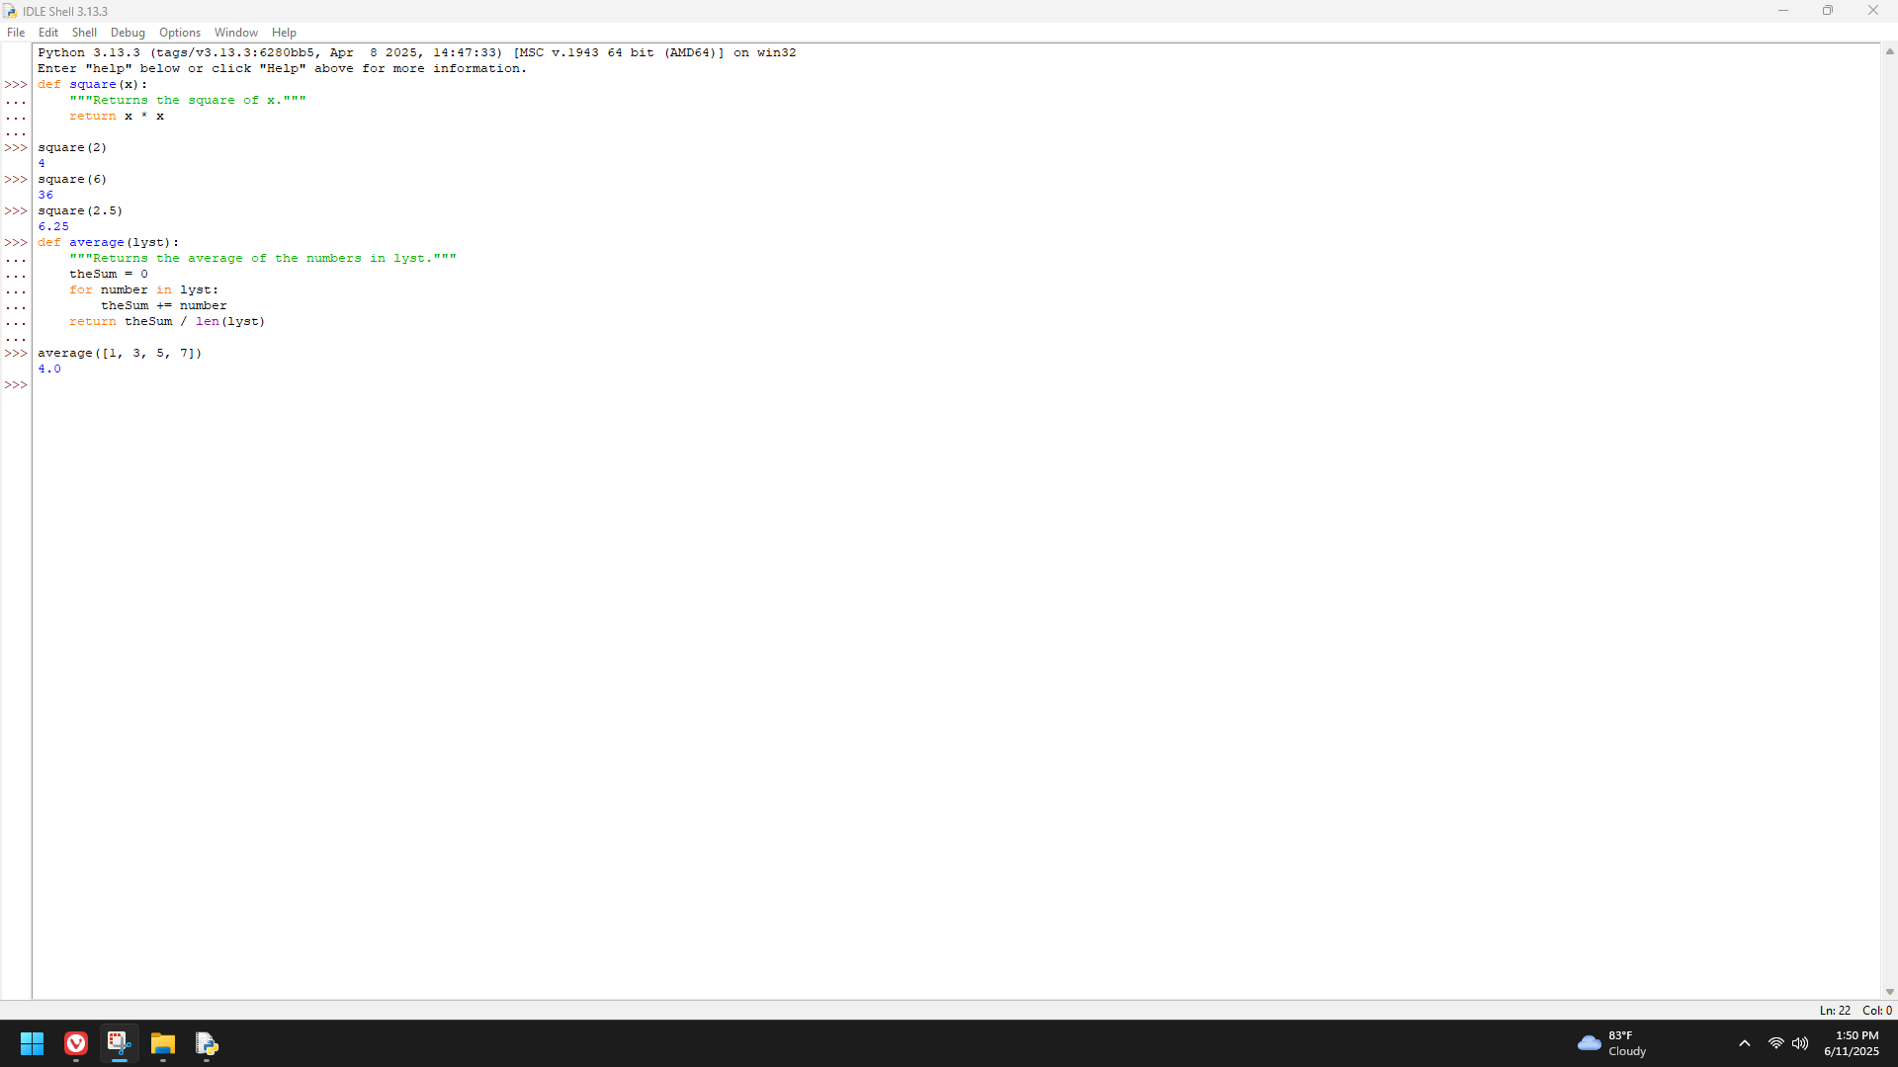

**Boolean Function (Page 127)**

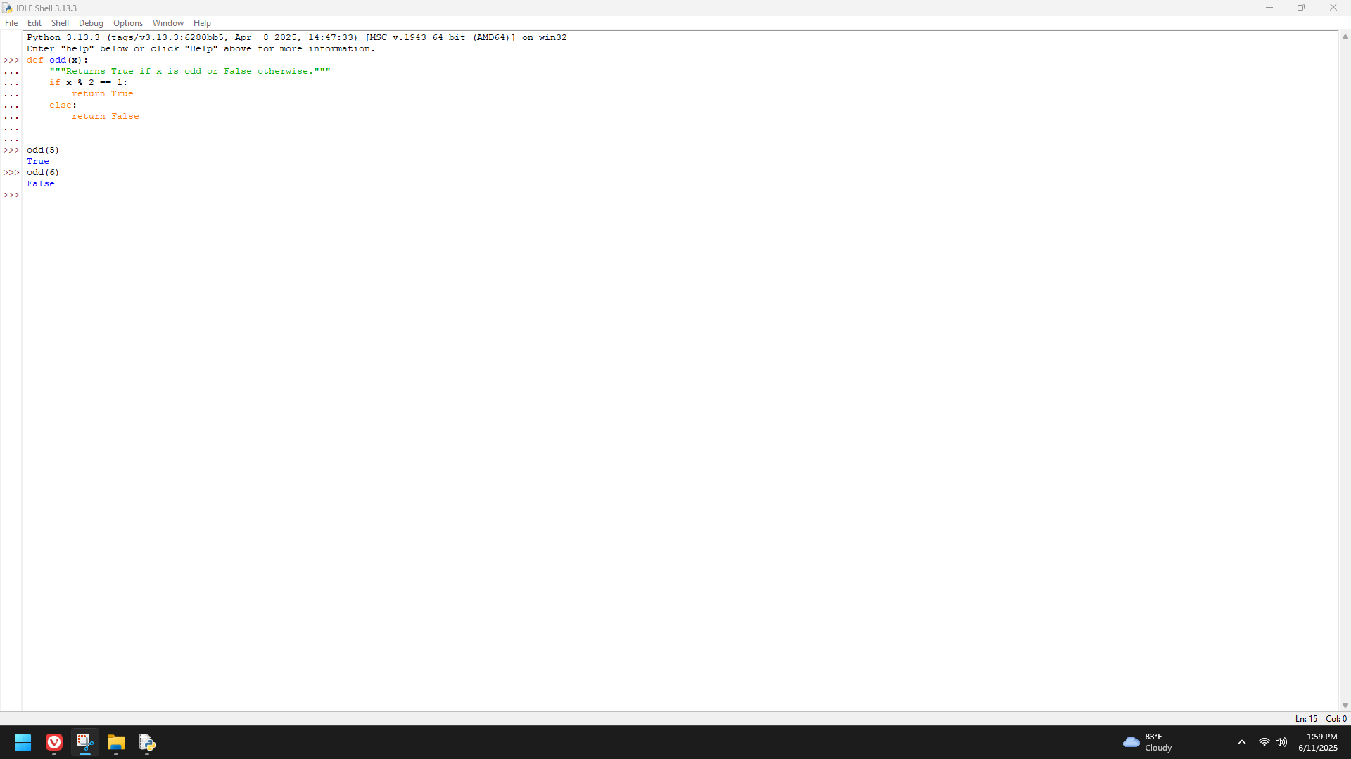

**Defining the Main function (Page 128)**

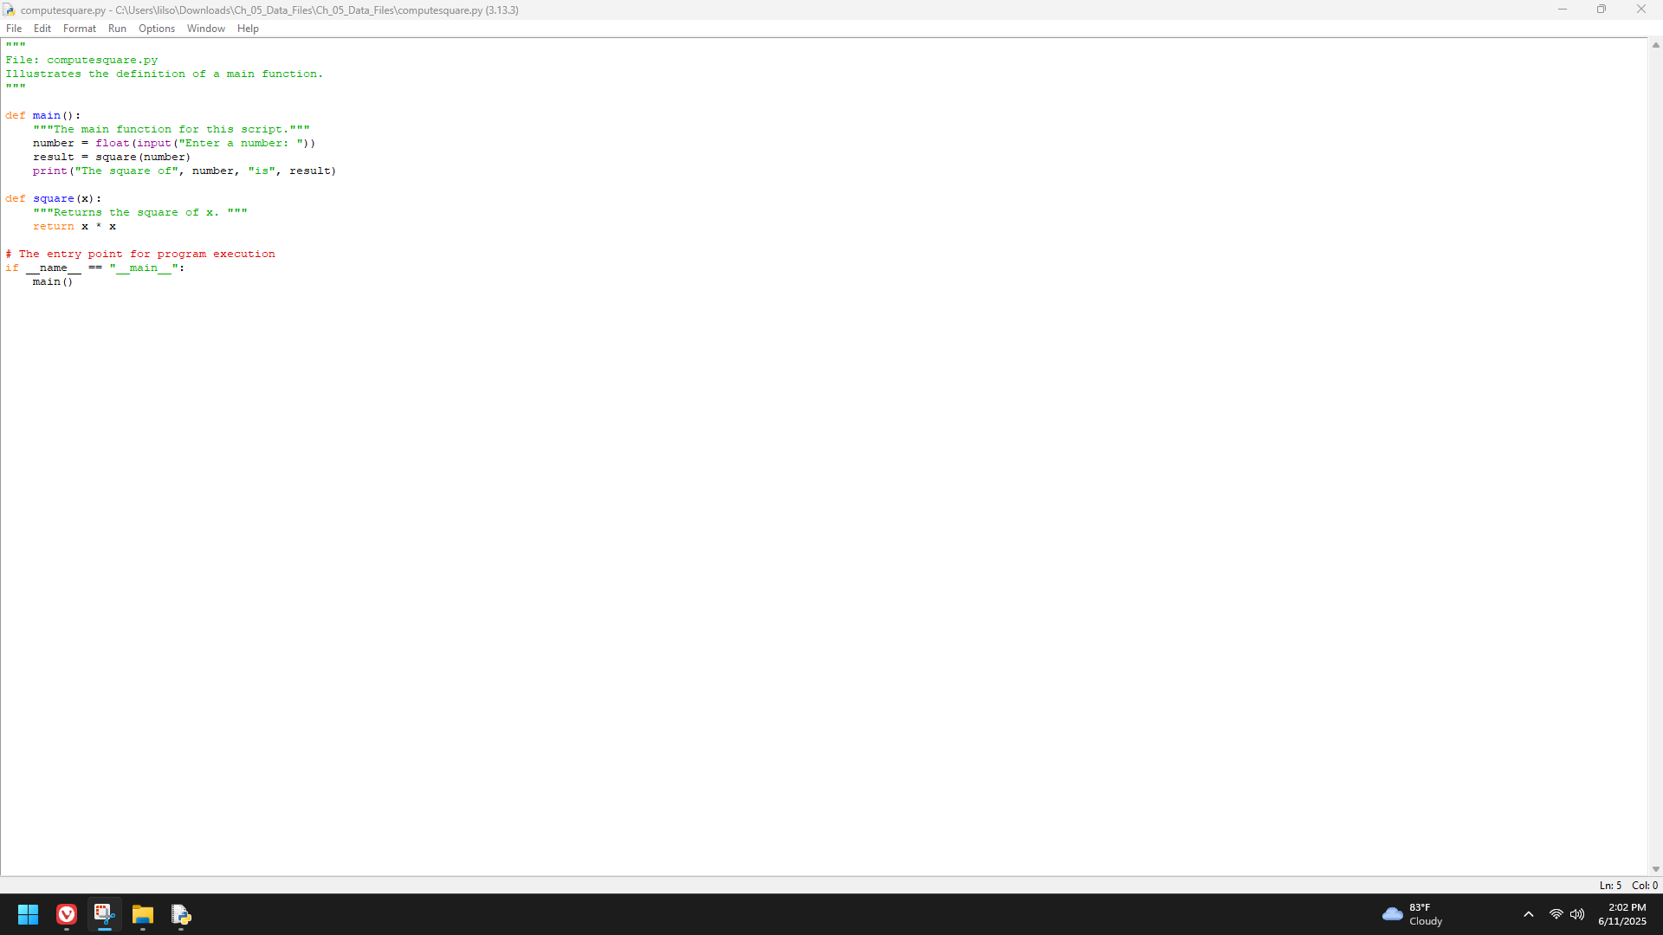

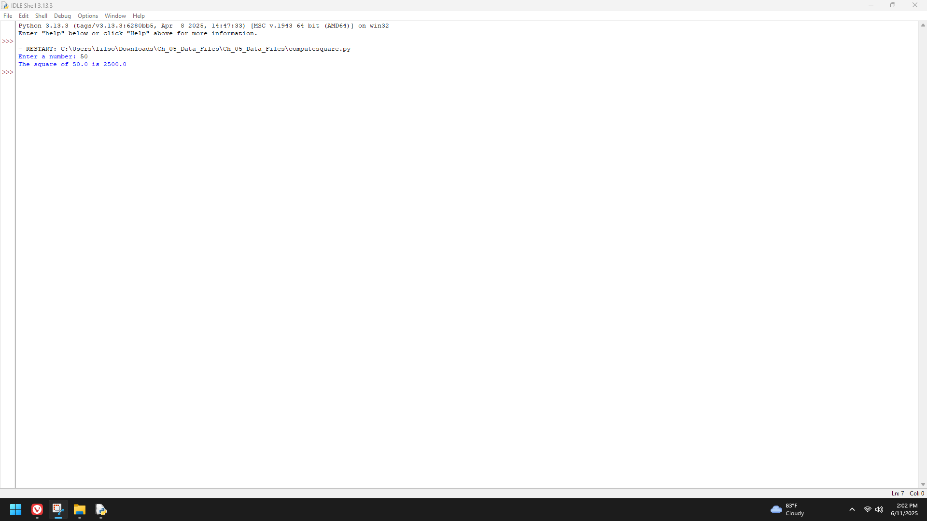

**Adding Keys and Replacing Values (Page 132)**

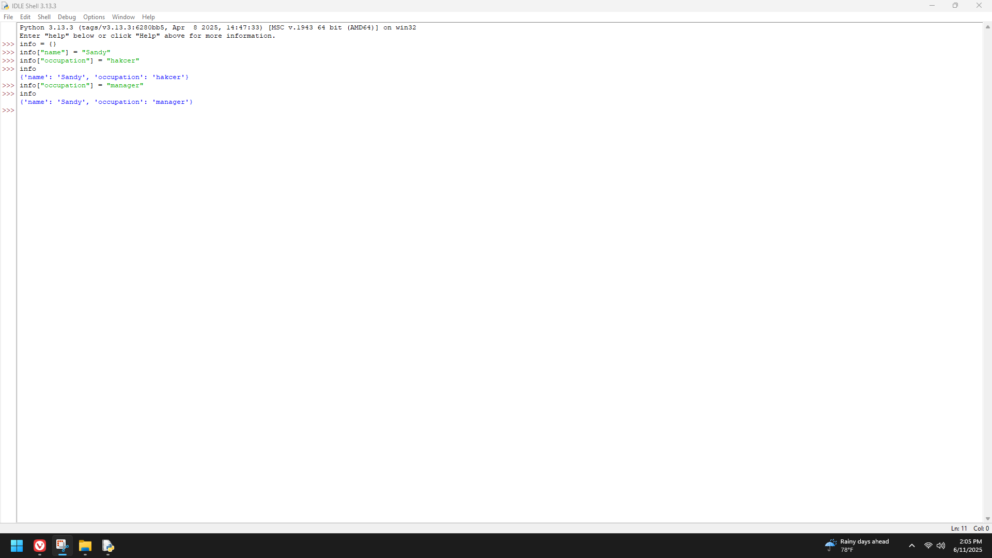

**Accessing Values (Page 133)**

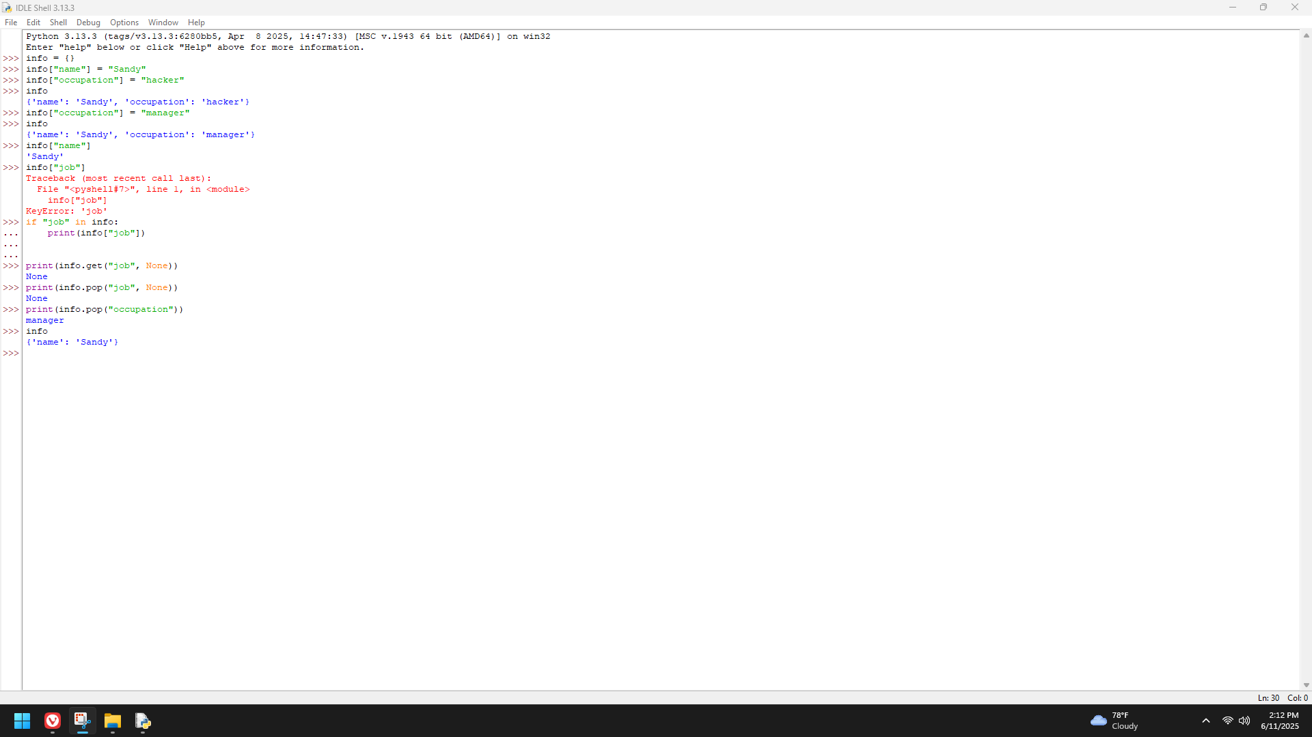

**The Hexadecimal system revisited (Page 134-135)**

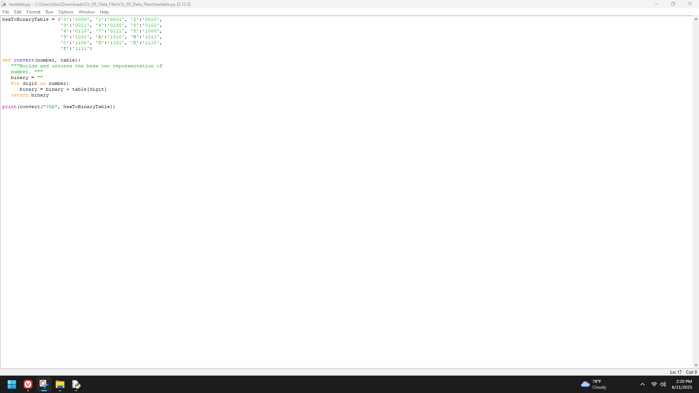

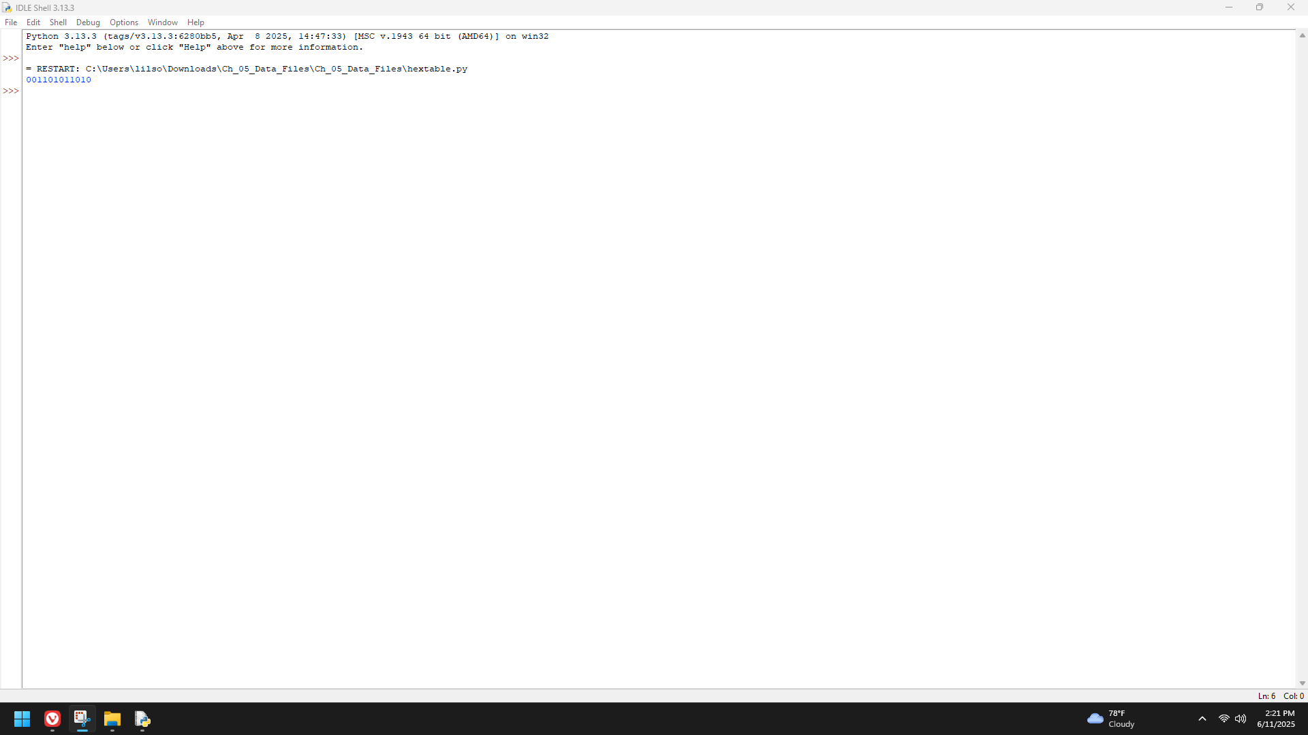

**Finding the Mode of a list of Values (Page 135)**

