| Course Name | ITD 2313 – Script Programming |
| --- | --- |
| Instructor | Mark Pranger |
| Student Name | Weston Albright |
| Due date | 07/15/2025 |
| Grade | 95.78% |
| Grading Comments | N/A |

**A list is sorted in ascending order if it is empty or each item except the last one is less than or equal to its successor. Define a predicate isSorted that expects a list as an argument and returns True if the list is sorted or returns False otherwise. (Hint: For a list of length 2 or greater, loop through the list and compare pairs of items, from left to right, and return False if the first item in a pair is greater.) Include the function in a short tester program in the file named** [**testsort.py**](http://testsort.py)**.**

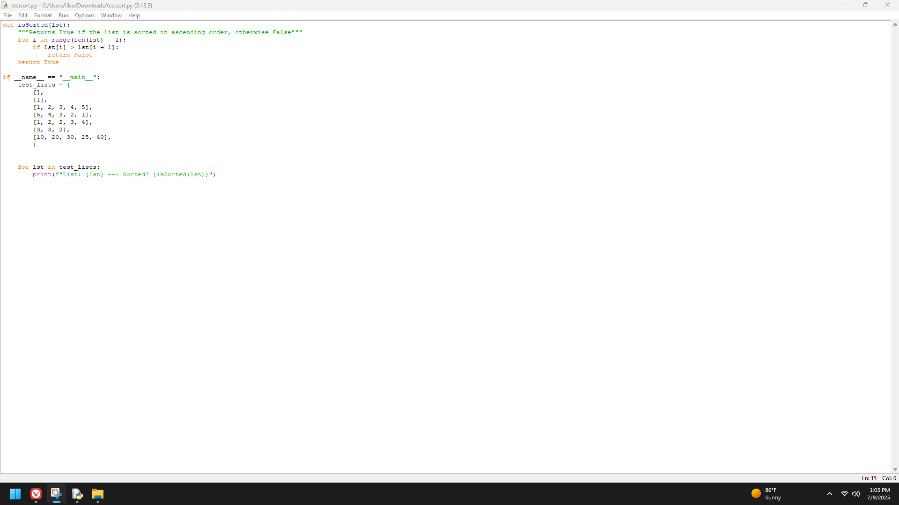

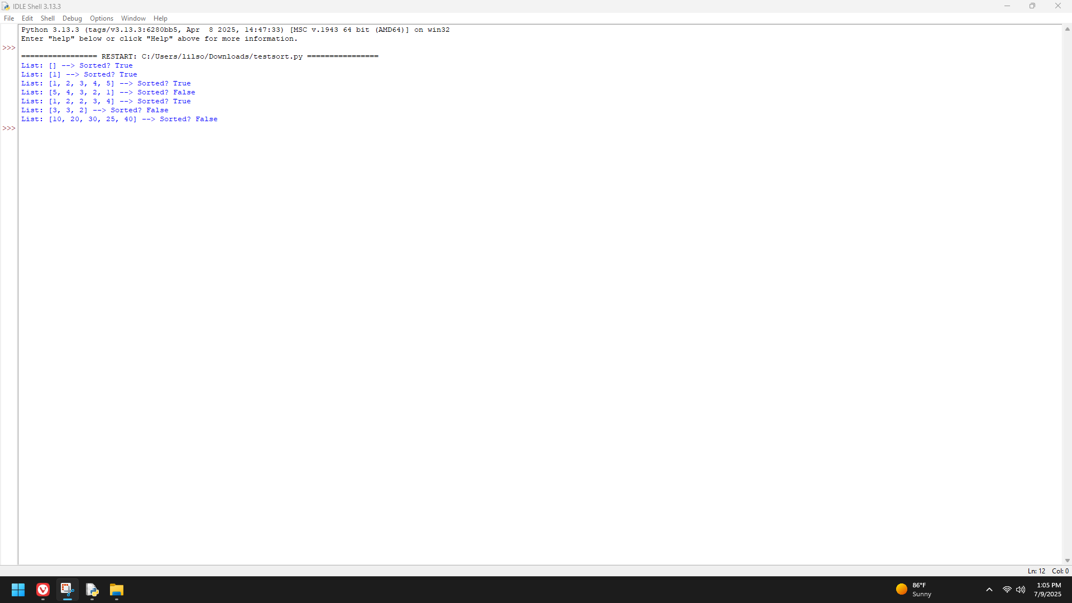

**Add a function named inputFloat to the module testinputfunctions (available in the file named testinputfunctions.py in the Data Files for this chapter). This function behaves like the function inputInt developed in this chapter but provides for the robust input of floating-point numbers. This function allows digits only or digits and a single decimal point in the input string. Test your new function in this module.**

**(Before edit)**

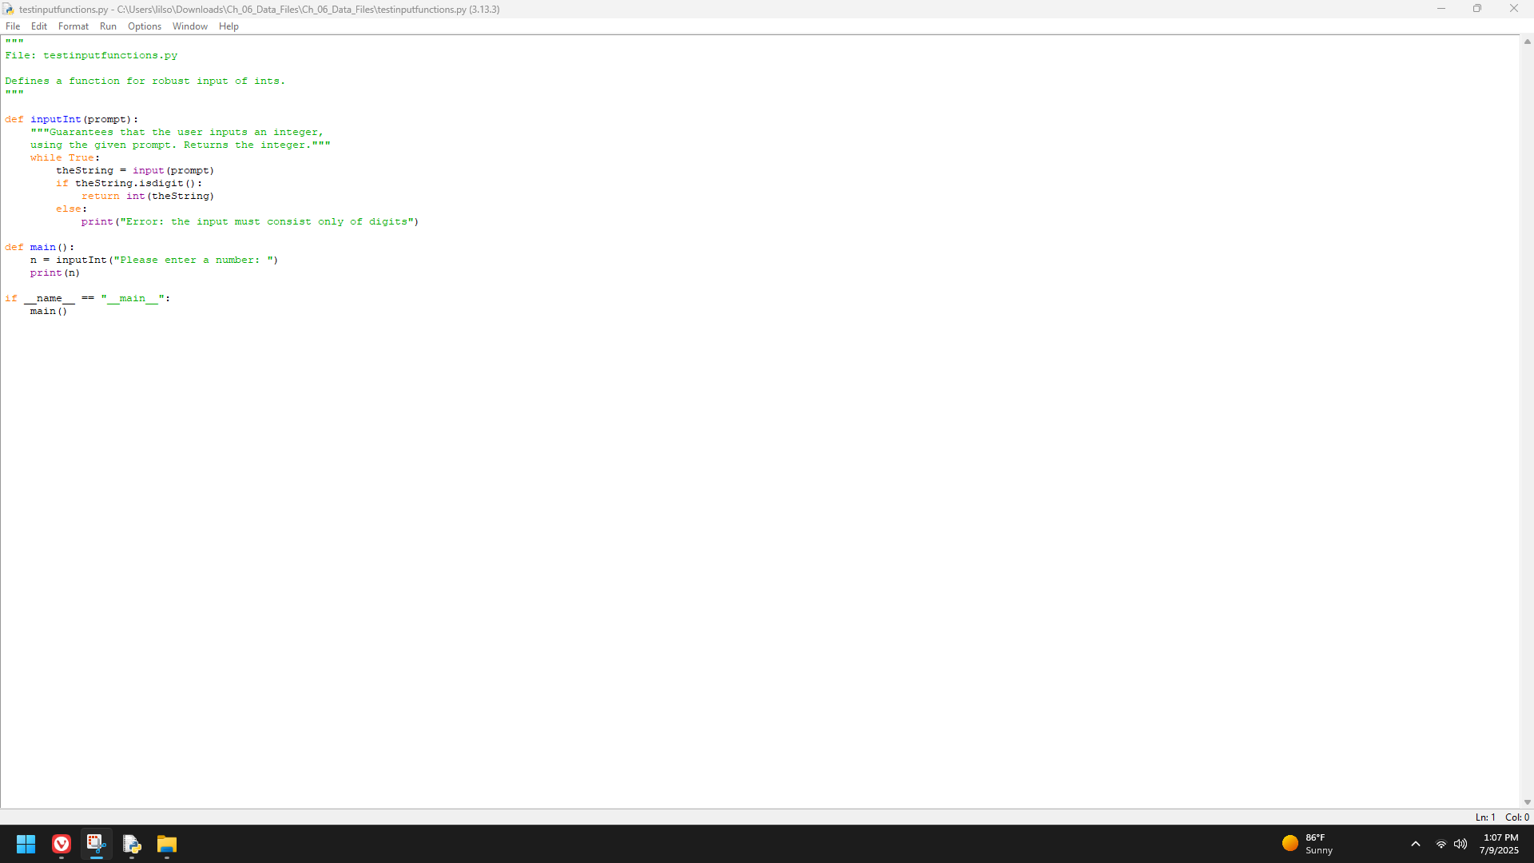

**(With edit)**

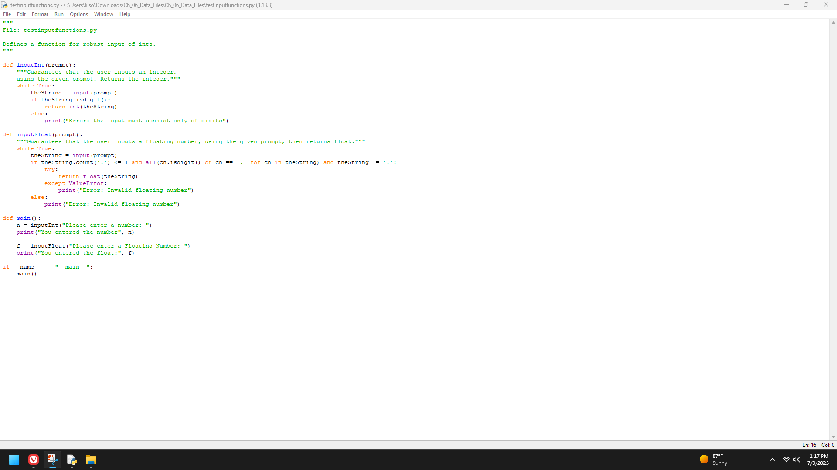

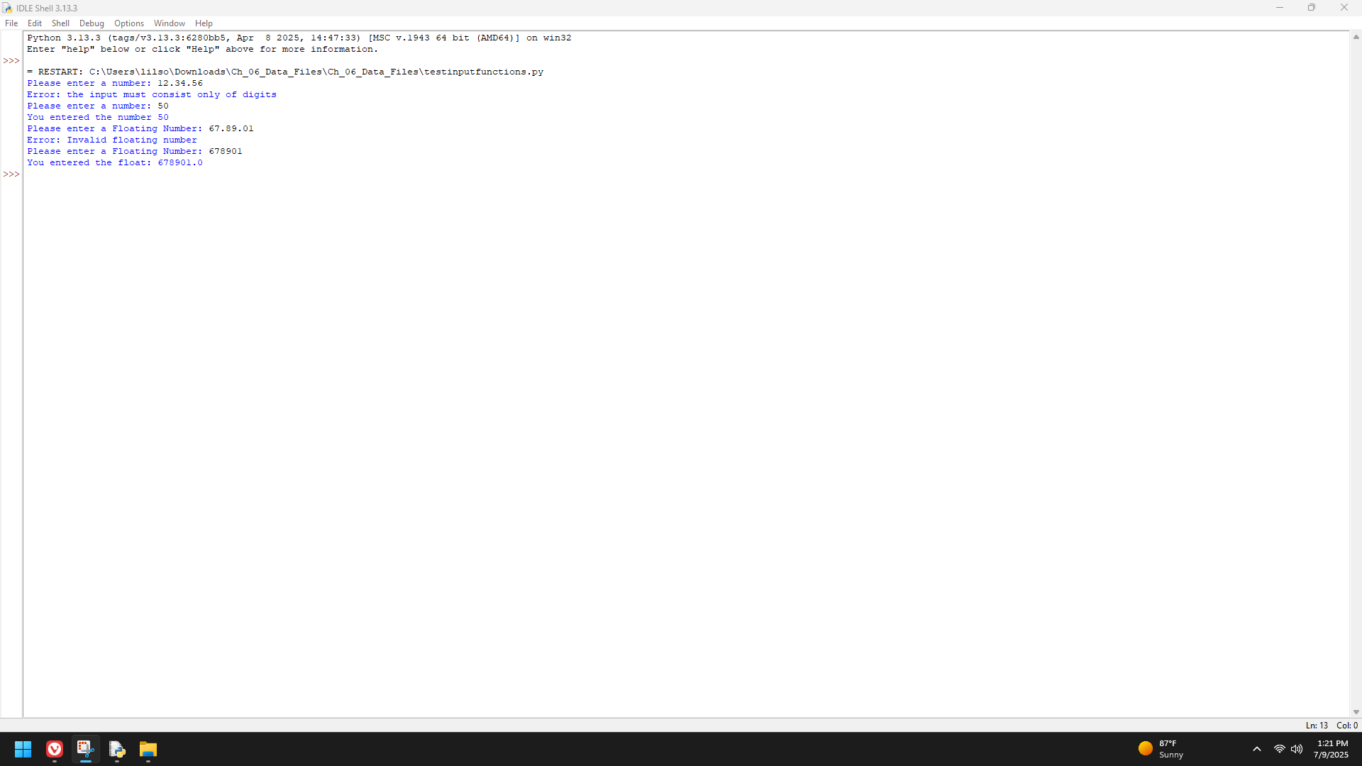

**Write a program (in the file average.py) that computes and prints the average of the numbers in a text file. You should make use of two higher-order functions to simplify the design.**

