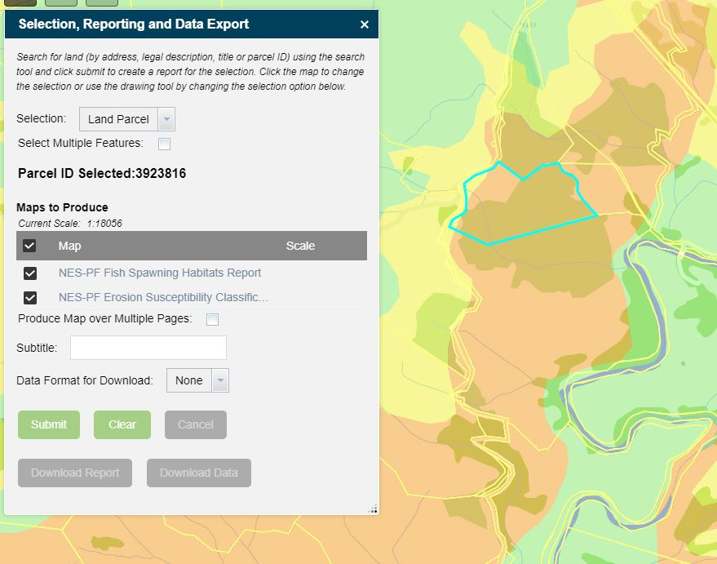

Report Widget for ArcGIS Web AppBuilder Guide

6 March 2018

Table of Contents

1 Background 4

2 Deployment 5

2.1 Requirements 5

2.2 Deployment Steps 6

2.2.1 Reporting Geoprocessing Service 6

2.2.2 Web AppBuilder for ArcGIS Widget 9

3 Configuration 12

3.1 Report Widget 12

3.1.1 Description 12

3.1.2 Reporting Geoprocessing Service 13

3.1.3 Enable Search to Report Integration 13

3.1.4 Selection Layers 14

3.1.5 Enable Drawing Tools 16

3.1.6 Maps Available 18

3.1.7 Show Multiple Page Map Option 20

3.1.8 Show Subtitle 21

3.1.9 Show Intersect Layers on Map 22

3.1.10 Download Data from Intersect Layers 22

3.1.11 Show Report Quality 23

3.1.12 Default Report Quality 23

3.2 Templates 24

3.2.1 A4 Map Portrait 24

3.2.2 A4 Report Portrait 24

Change Log

| Version | **Date** | **Author** | **Change** |
| --- | --- | --- | --- |
| 0.1 | 01/03/2018 | Shaun Weston | Initial draft |
| 1.0 | 06/03/2018 | Shaun Weston | Final version |

# Background

Web AppBuilder for ArcGIS is an intuitive what-you-see-is-what-you-get (WYSIWYG) application that allows you to easily build web apps. It includes powerful tools to configure fully featured HTML apps. Web AppBuilder (Developer Edition) provides an extensible framework for developers to create custom widgets and themes.

A report widget has been developed that enables the user to configure the widget to create several maps and reports for a selected feature or user drawn graphic. The report widget includes the Web AppBuilder for ArcGIS widget and a python script to be published as a geoprocessing service to ArcGIS Server. This report widget can be added to a Web AppBuilder for ArcGIS (Developer Edition) application or can be added as an item to an enterprise portal site and used within ArcGIS Enterprise.

The following documentation outlines how to deploy the report widget for Web AppBuilder and how to configure the tool to produce various maps and reports.

# Deployment

2. 1. Requirements

Web AppBuilder for ArcGIS is built with [ArcGIS API for JavaScript](https://developers.arcgis.com/javascript) and [Dojo](http://dojotoolkit.org). It allows you to customize and extend functionalities by creating your own widgets and themes. A widget is a set of text files that you can share, move, and deploy to a Web AppBuilder application.

A report geoprocessing service also needs to be published, which has been written in the python programming language. Python is a free, cross-platform, open-source programming language that is both powerful and easy to learn. Python has been accepted as the scripting language of choice for the ArcGIS software.

Requirements are:

* ArcMap 10.4 and above (Needed to publish the GP service).
* ArcGIS Server 10.4 and above (Needed for hosting the GP service).
* Python 2.7.10 (For ArcMap) and above (Needed to publish the GP service).
* ReportLab 2.6 for Python 2.7 - 32-bit (Needed to publish the GP service).
* ReportLab 2.6 for Python 2.7 - 64-bit (Needed on the ArcGIS Server machine).
* Web AppBuilder for ArcGIS 2.7 and above or ArcGIS Enterprise 10.5.1.
  + ArcGIS API for JavaScript 3.22 needs to be set.
  1. Deployment Steps

The report tool can be downloaded from GitHub here as a zip file - <https://github.com/WestonSF/ArcGISWebAppBuilderReportWidget>

This zip file includes all the files needed to deploy the tool:

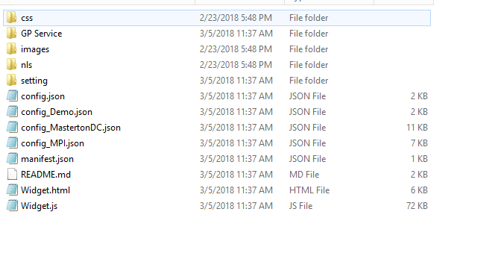

* + 1. Reporting Geoprocessing Service

Part of the web application includes a reporting widget, which creates a PDF report based on the user’s selection. This calls a geoprocessing service developed in python that has logic to create a PDF report and optionally allow the user to download data based on their selection. This report service works in a similar way to the Esri export web map service and has been published to ArcGIS Server.

ReportLab for python is a package the enables python to create rich PDF documents. This package needs to be installed with python for the report tool to run.

The windows install files are in the GP Service>Packages folder. The 32-bit version of the ReportLab package needs to be installed where ArcMap is installed to be able to publish the tool to ArcGIS Server. The 64-bit version of the ReportLab package needs to be installed where ArcGIS Server is running.

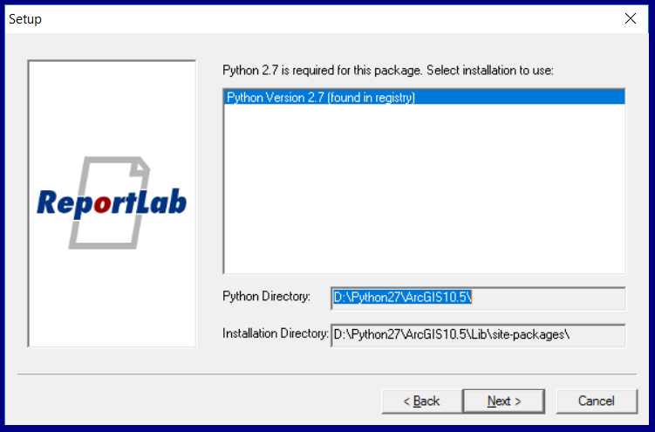

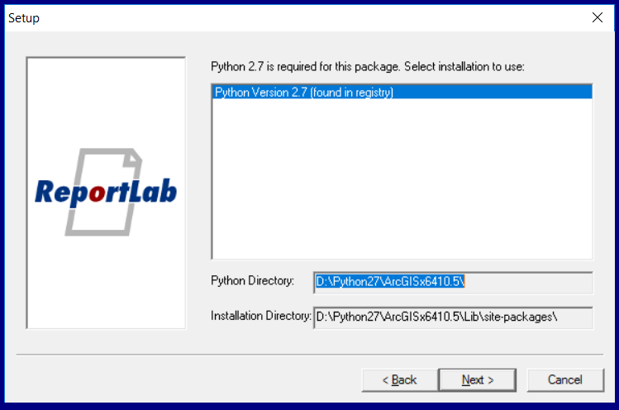

To publish the tool to ArcGIS Server, open the script tool from the toolbox and make sure the map template parameter is pointing correctly to the “A4 Map Portrait” MXD and the “A4 Report Portrait” MXD. The rest of the parameters can be left blank.

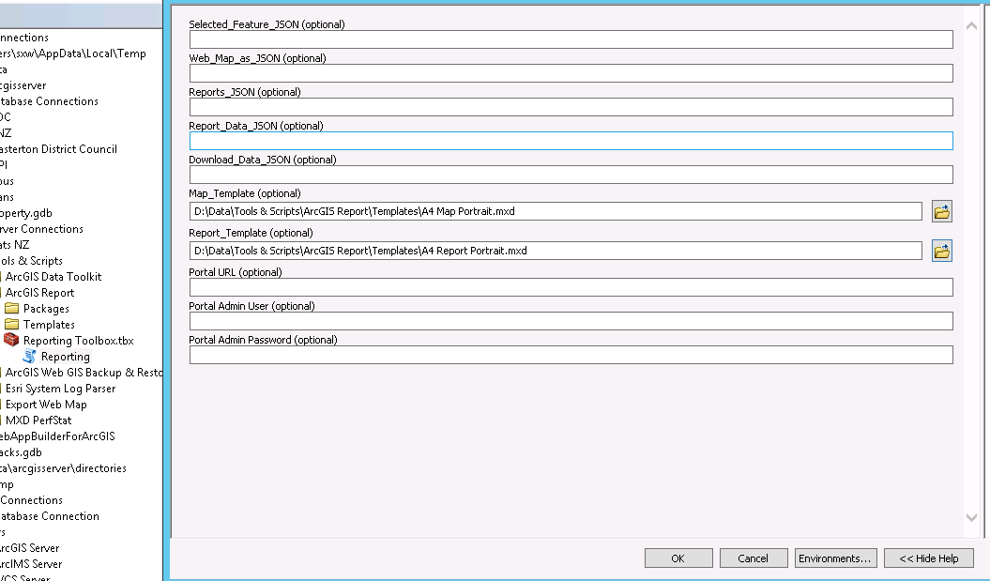

After running the tool, share this as a geoprocessing service and publish to the ArcGIS Server site where the 64-bit version of ReportLab has just been installed.

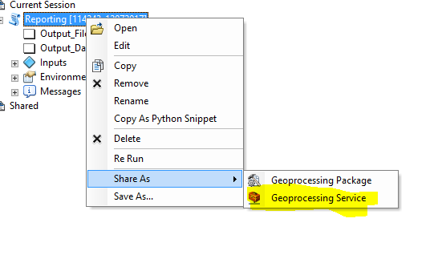

The configuration parameters can be left blank apart from the execution mode, which needs to be “Asynchronous”.

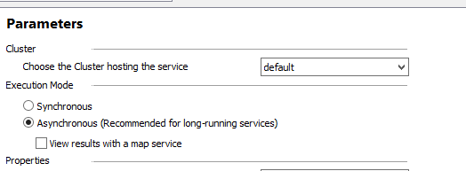

The report geoprocessing service will then have a URL like this:

* <https://SERVERURL/arcgis/rest/services/Tools/Reporting/GPServer>
  + 1. Web AppBuilder for ArcGIS Widget

The report widget can be added to a Web AppBuilder application in two ways – Web AppBuilder (Developer Edition) or an Enterprise portal site.

**Web AppBuilder for ArcGIS (Developer Edition)**

To add the widget to the developer edition of Web AppBuilder, copy the widget folder into the \client\stemapp\widgets directory and call the widget folder “Report”.

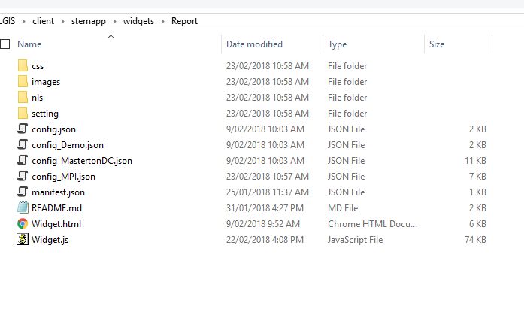

Start Web AppBuilder (Developer Edition) and the widget will now be available to be added to applications.

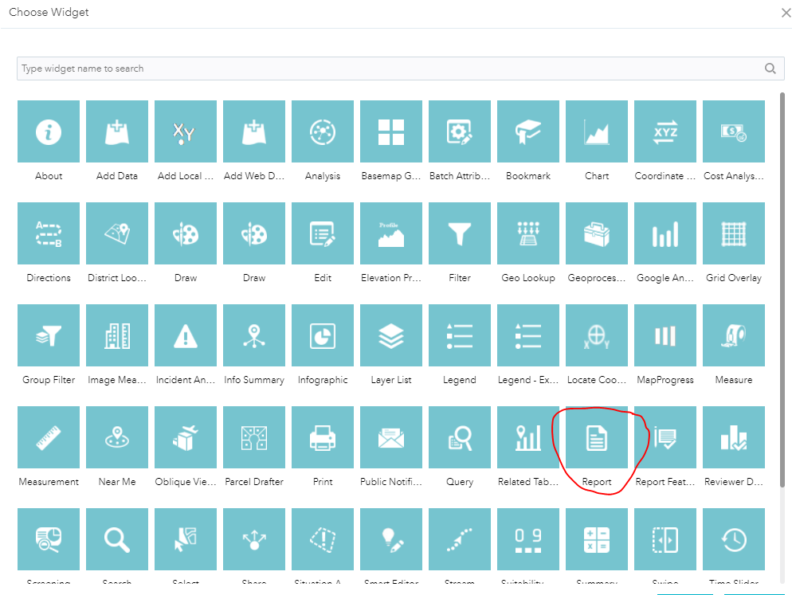

The widget can then be configured (See next section), downloaded from Web AppBuilder and then deployed to a web server.

**Enterprise Portal Site**

To add the widget to an enterprise portal site, copy the widget folder onto a web server into a virtual directory folder e.g. \inetpub\wwwroot\WebAppBuilderWidgets\Report.

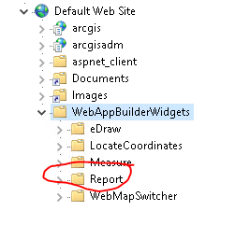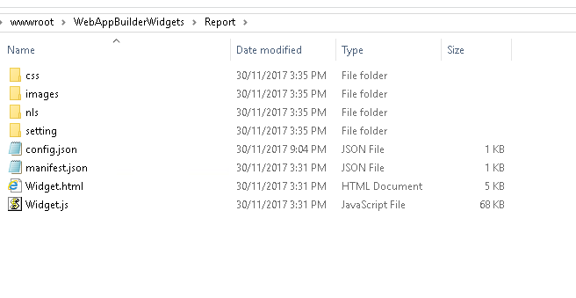

The widget URL then needs to be added to the enterprise portal site. Click Add Item>An Application and enter in the URL to the widget manifest.json file e.g.

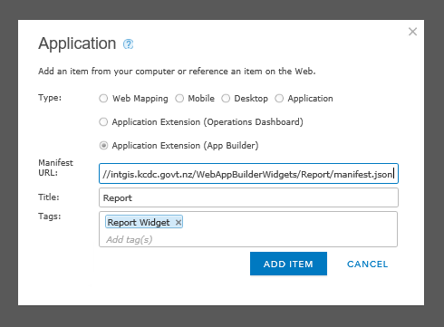

Click Add Item and a new item as added to portal with the “App Builder Extension” type.

The widget can then be added to a Web AppBuilder application in portal and configured (See next section).

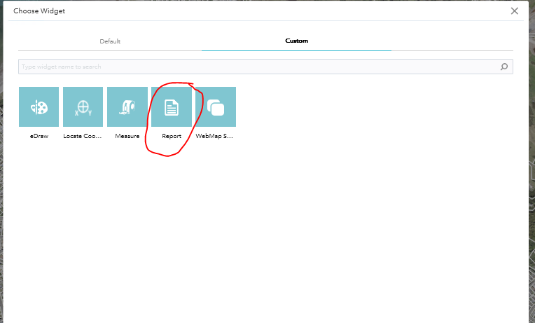

# Configuration

1. 1. Report Widget

There are several configuration parameters for the report widget, which will be discussed below.

* + 1. Description

The description parameter updates the description text in the first paragraph of the widget.



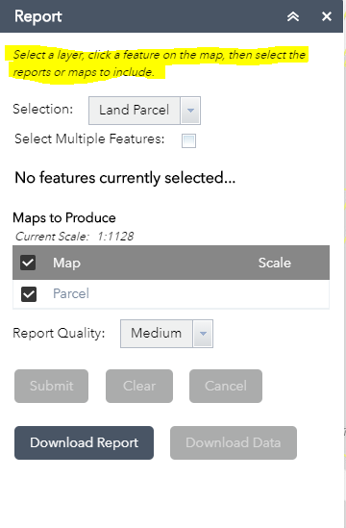

* + 1. Reporting Geoprocessing Service

The Reporting Geoprocessing Service parameter updates the GP service to be used by the widget. This needs to be the reporting GP service included with the widget files.



* + 1. Enable Search to Report Integration

This enables the search widget to integrate with the report widget. This will automatically select the result of the search. For example, if the following address is searched for using the search widget it will automatically select the feature in the report widget and enable the “Submit” button. The report widget will need to be open for the selection to be made.

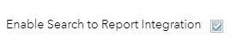

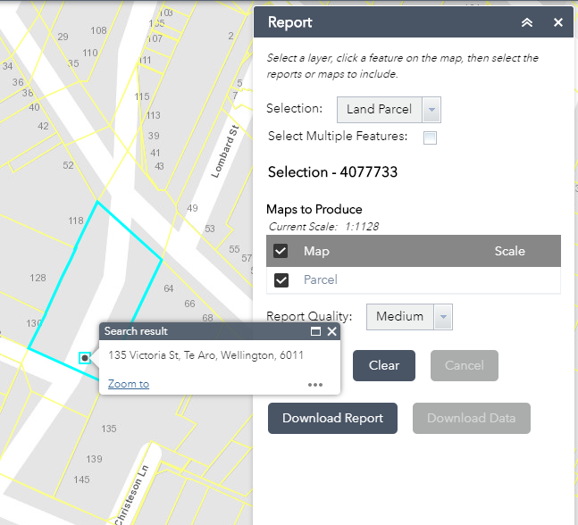

* + 1. Selection Layers

The selection layers are a list of layers that can be selected and used as input into the report. Either feature services or map service layers will need to be used for the service URL. When a selection option is changed that layer is automatically added to the map, the user can then click on the map to select a feature, which will highlight the feature and enable the “Submit” button.

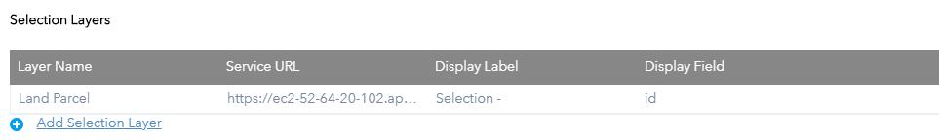

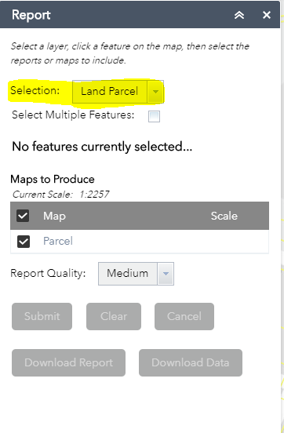

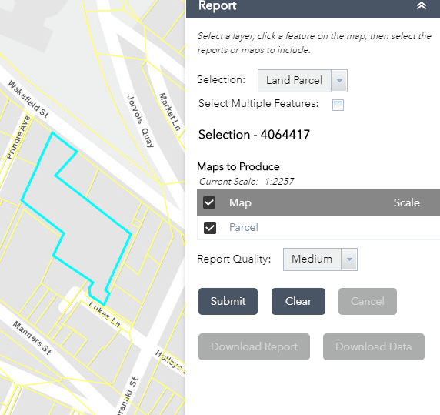

Selection Layer parameters:

* Layer Name – Layer name to appear in dropdown.



* Service URL – Feature service or map service layer
* Display Label – Text to be prefixed to selection.
* Display Field – Field used in layer for selection text.



A new selection can be added by clicking the “Add Selection Layer” button.

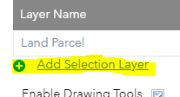

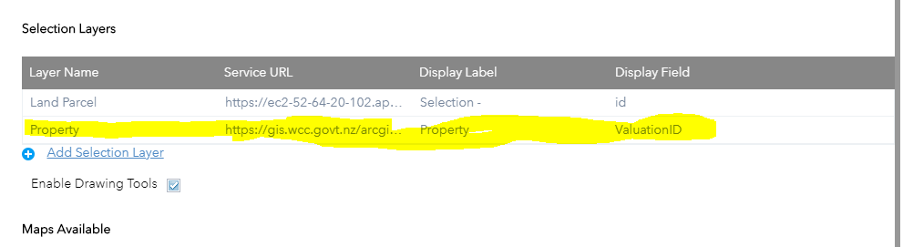A new entry will be added to the table, fill in all the parameters and click OK to submit the changes.

The new layer will be added into the Selection dropdown.

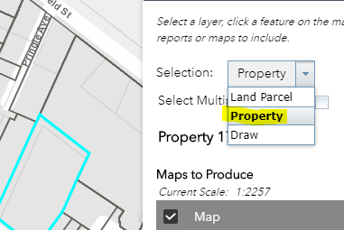

Layers can be deleted and moved up/down using the buttons on the right of each row.

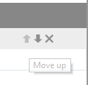

* + 1. Enable Drawing Tools

This will enable the drawing tools from the selection dropdown. Three polygon drawing tool buttons will be added to the widget, allowing the user to draw on the map. This graphic will then be used as input for the reporting tool.



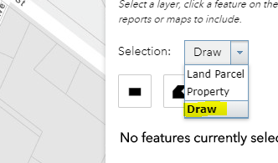

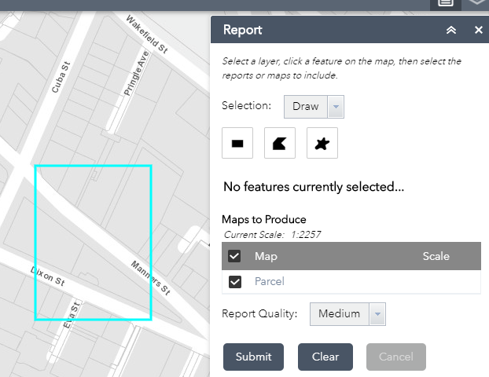

* + 1. Maps Available

The maps available are a list of maps or reports available for selection from the report widget. Maps/reports can be checked on or off and a fixed scale set by the user.

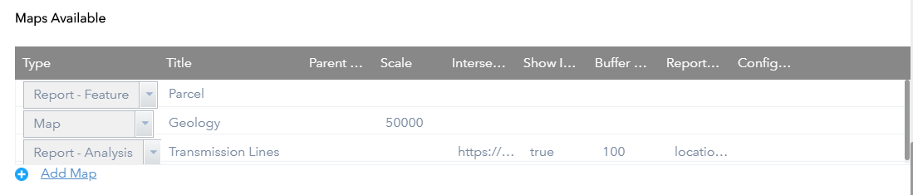

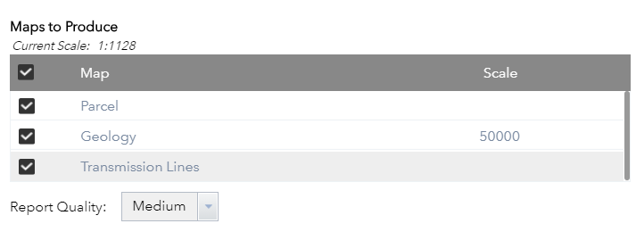

Maps Available parameters:

* Type – The map type can be one of the following:
  + Map - Just a map for the selected feature.
  + Report - Just a report for the selected feature.
  + Report - Feature - A map and report for the selected feature using an MXD template.
  + Report - Analysis - A map and a report for the selected feature.
* Title – Title to appear on the map or report.

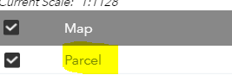

* Parent Map – Will combine the map or report with the parent map/report. Set the parent map parameter to be the title of the map/report to combine with. This will mean that several maps/reports can be included in the one map selected.
* Scale – Scale the map will be in. If left blank or set at 0, the map will go to the extent of the selected feature or drawing.

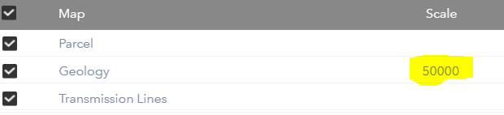

* Intersect Service – Feature service or map service URL to use as an intersect service i.e. The map will only be produced if it intersects with this service. If a map service is used, it will intersect with all map service layers in the map service. If blank, the map be produced every time. This parameter is required for the “Report – Analysis” type.
* Show Intersect Service – If set to true, the features that intersect the selection will be added to the map. The “Show Intersect Layers on Map” parameter will also need to be checked, for features to show on the map.
* Buffer Distance – The distance in metres to buffer the intersect layer i.e. A value of 100 will buffer the intersect layer 100 metres, so any feature selected or drawn within 100 metres, will produce a map/report.
* Report Fields – A text string of the fields from the intersect layer to show in the report. These need to be separated by a comma e.g. location,designvolt,status,description shows these four fields from the layer. Field alias will be used in the report if they are set on the service. Field Alias can also be set from the widget by adding a “>” e.g. location>Location,designvolt,status,description, will set the field alias for location to “Location”. A fixed value can also be set by using “=”. E.g. location>Location,designvolt,status,description,Test=51 will create a new field called “Test” with a value of 51.

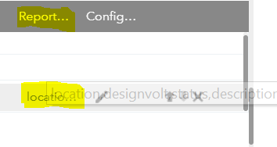

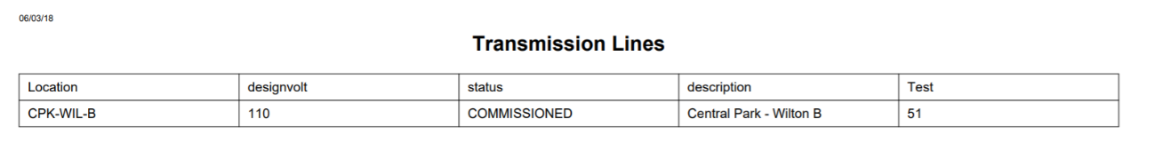

* Configure Operational Layers – Clicking the edit button will open the “Configure Operational Layers” window, this is where any number of layers can be added, removed or configured for the map or report.
  + Title – Title of the layer
  + Opacity – Opacity of the layer in the map/report e.g. 1.0 – 100% visibility, 0.5 – 50% visibility.
  + Service URL – Feature or map service URL.
  + Visible Layers – If a map service Is used, set the visible layers for the map service e.g. [0,2,3] will show layers 0,2 and 3 for the map service.
  + Secure – Set to true if the service is secure and token will be appended with the request.
  + Legend – Set to true to show the legend in the map or false, to not show the legend.
  + A new operational layer can be added by clicking the “Add Operational Layer” button.

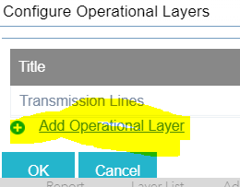

* New maps/reports can be added by clicking the “Add Map” button.

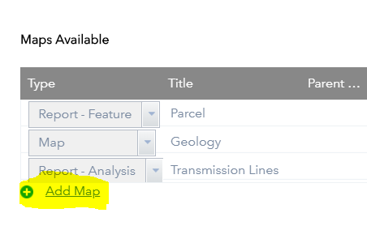

* + 1. Show Multiple Page Map Option

This enables the multiple page map option in the widget. When this option is selected, the maps will be produced over multiple pages rather than just a single page. This will enable the map to be closer into the features. The number of maps produced is determined by the size and shape of the selected or drawn feature.



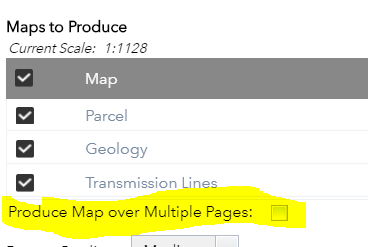

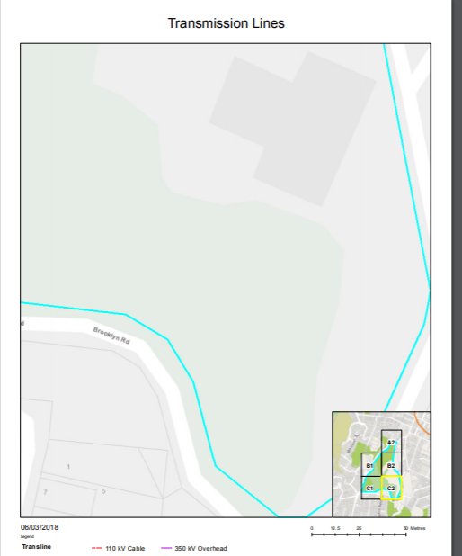

* + 1. Show Subtitle

This enables the subtitle text box in the widget. When enabled a subtitle is added to maps and reports. If the subtitle text box is left blank, the feature selected is used as the subtitle. If subtitle text is provided, then that text is used as the subtitle in the report.



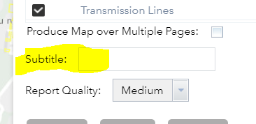

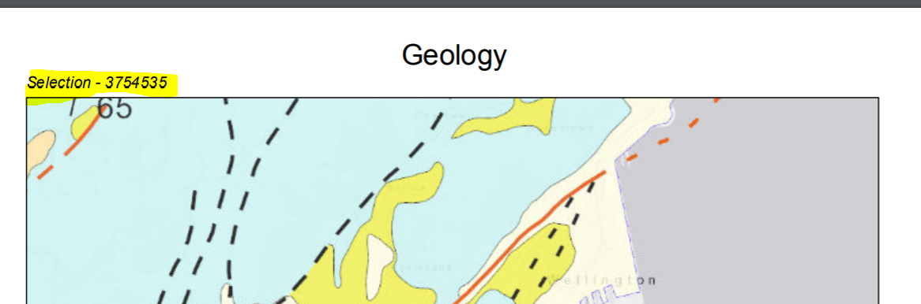

* + 1. Show Intersect Layers on Map

If checked, the features that intersect the selection will be added to the map. The “Show Intersect Service” parameter for the report will also need to be checked, for features to show on the map.



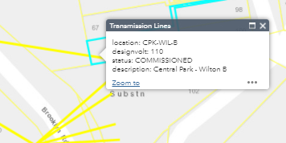

* + 1. Download Data from Intersect Layers

If checked, the option to download data for features that intersect the selection will be shown on the widget. The default is set to not download any features, but data can be downloaded in file geodatabase, CSV and shapefile by changing the selection. Data will be available in a zip file and can click the “Download Data” button to download the data.



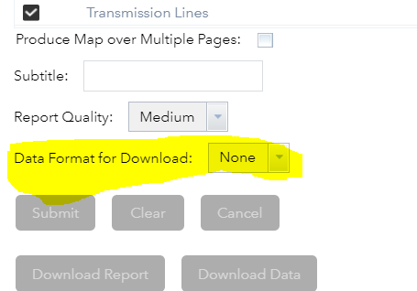

* + 1. Show Report Quality

If checked, Shows the report quality on the widget – Low (72 DPI), Medium (96 DPI) or High (180 DPI) options are available. Using a higher report quality will take longer to process the report.



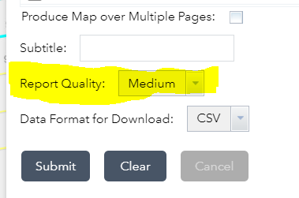

* + 1. Default Report Quality

Sets the default report quality for the widget – Low (72 DPI), Medium (96 DPI) or High (180 DPI).





* 1. Templates

There are two map templates used with the tool that are set when publishing the geoprocessing service. These templates can be updated with logos, texts, etc. If the location of the templates has been registered with ArcGIS Server, then the geoprocessing service will not need to be republished when changes are made to the template.

* + 1. A4 Map Portrait

The A4 map portrait template is used for “Map” and “Report – Analysis” types.

The MXD template includes several tags that will be replaced when the report tool is run.

* Map Title – Title of the map.
* Subtitle – Subtitle populated from subtitle textbox or user selection.
* Date – The current date.
* Page Number – The page number is added to all maps and reports.

The main data frame is the “Layers” data frame, which includes an “Index” layer, which is set when the tool is run. This is only used when the map is produced over multiple pages.

The overview data frame shows an overview map and includes a several layers that are set when the tool is run. These layers are only used when the map is produced over multiple pages. If the map is single page, then the overview data frame will be removed.

* + 1. A4 Report Portrait

The A4 report portrait template is used for “Report – Feature” analysis type. This template combines a report and map in the one template.

The MXD template includes several tags that will be replaced when the report tool is run.

* Map Title – Title of the map.
* Date – The current date.
* Page Number – The page number is added to all maps and reports.
* Data tags – Any field name from the selection data can be added as a tag to this template. For example, if in the selection data there is a field called “ValuationID”, this will automatically update the text tag in the MXD with the value of the field.