- 从键盘上输入字符，将小写字母转换成大写字母。输入“ctl + z” 结束 。
#include<stdio.h>
#include<stdlib.h>

int main()
{
char a;
while(scanf("%c",&a)!=EOF)//此处不可以用fflush,否则只能打印一个字母
{
if(a!='\n')
{
printf("%c",a-32);
}else
{
printf("\n");
}
}
system("pause");
return 0;
}
//运行结果

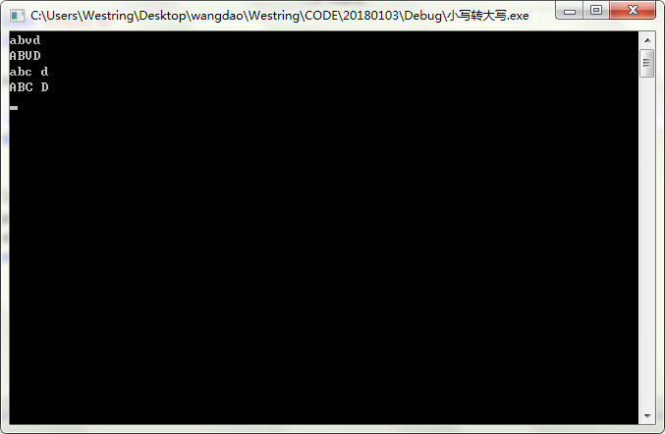

- 从键盘上输入字符，（1）分别统计一下其中字母，数字，其他字符的个数， （2）将统计的字母，数字，其他字符的个数以柱状图的形式打印。例如
#include<stdio.h>
#include<stdlib.h>

int main()
{
int alp=0,num=0,oth=0;//统计字母，数字，其他字符个数
int max,mid,min;//存储大中小三值
int i;//控制行
char c;
while(scanf("%c",&c)!=EOF)
{
if(c=='\n')
break;
else if(c>='a'&&c<='z'||c>='A'&&c<='Z')
alp++;
else if(c>='0'&&c<='9')
num++;
else
oth++;
}
//==============================================
max=(alp>num?alp:num)>oth?(alp>num?alp:num):oth;
min=(alp<num?alp:num)<oth?(alp<num?alp:num):oth;
mid=alp+num+oth-max-min;
printf(" %d\n",max);
for(i=1;i<=max-mid-1;i++)
{printf("*****\n");}
printf("***** %d\n",mid);
for(i=1;i<=mid-min-1;i++)
{printf("***** *****\n");}
printf("***** ***** %d\n",min);
for(i=1;i<=min;i++)
printf("***** ***** *****\n");
//==================================================
if(alp==max)
{
printf(" alp ");
}else if(num==max)
{
printf(" num ");
}
else
{
printf(" oth ");
}
//-------------------------------------------------------
if(alp==mid)
{
printf(" alp ");
}else if(num==mid)
{
printf(" num ");
}
else
{
printf(" oth ");
}
//-------------------------------------------------------
if(alp==min)
{
printf(" alp ");
}else if(num==min)
{
printf(" num ");
}
else
{
printf(" oth ");
}
printf("\n");
system("pause");
return 0;
}
//运行结果

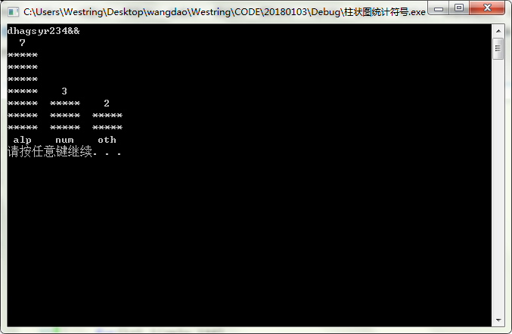

- 进制转换。
- 将十进制数转换成二进制数。输入十进制数输出对应的二进制数，输入“ctl + z”结束。
#include<stdio.h>
#include<stdlib.h>

int main()
{
int d,b,shang,i=0,num;//输入的十进制数，商，数组下标,二进制位数
int a[10]={0};
while(scanf("%d",&d)!=EOF)
{
num=0;
i=0;
for(shang=d;shang>0;)
{
a[i]=shang%2;
shang=shang/2;
i++;
}
for(num=i-1;num>=0;num--)
{
printf("%d",a[num]);
}

}

system("pause");
return 0;
}
//运行结果

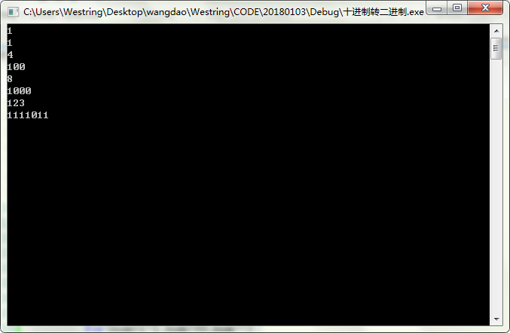

- 将二进制转换成十进制数。输入二进制数输出对应的十进制数，输入“ctl + z”结束。
#include<stdio.h>
#include<stdlib.h>

int main()
{
int a[]={0};
int b,sum=0,i=0,j;
while(scanf("%d",&b)!=EOF)
{
while(b!=0)
{a[i]=b%10;
i++;
b=b/10;
//printf("%d",a[i-1]);
}
for(j=i-1;j>=0;j--)
{
sum=sum+(a[j]<<j);
}
printf("%d",sum);
sum=0;
i=0;
}
}
//运行结果

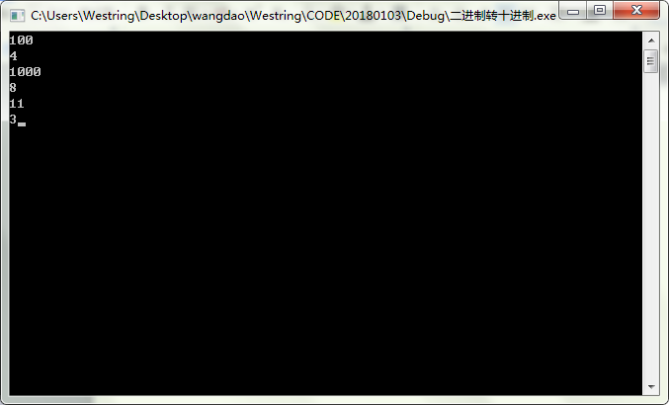

- 将十进制数转换成十六进制数。输入十进制数输出对应的十六进制数。输入“ctl + z” 结束。
#include<stdio.h>
#include<stdlib.h>

int main()
{
int d,yu;
int i=0,k;
int a[10]={0,0,0,0,0,0,0,0,0,0};
while(scanf("%d",&d)!=EOF)
{
while(d>=16)
{ yu=d%16;
d=d/16;
a[i]=yu;
i++;
//printf("%d ",yu);
}
a[i]=d;
//printf("%d\n",d);
for(k=i;k>=0;k--)
{
switch(a[k])
{
case 0:printf("0");break;
case 1:printf("1");break;
case 2:printf("2");break;
case 3:printf("3");break;
case 4:printf("4");break;
case 5:printf("5");break;
case 6:printf("6");break;
case 7:printf("7");break;
case 8:printf("8");break;
case 9:printf("9");break;
case 10:printf("A");break;
case 11:printf("B");break;
case 12:printf("C");break;
case 13:printf("D");break;
case 14:printf("E");break;
case 15:printf("F");break;
default:printf("Error");
}
a[k]=0;
}
i=0;
}
}

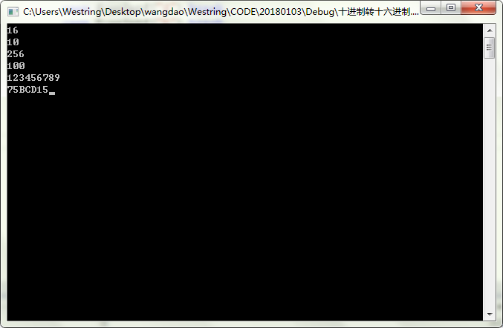

- 将十六进制数转换成十进制数。输入十六进制数输出对应的十进制数。输入“ctl + z” 结束。
#include<stdio.h>
#include<stdlib.h>
#include<string.h>
int main()
{

char in;
int i=0,sum=0,len=0;
char a[10]={0};
int b[10]={0};
lable:
printf("请输入:\n");
gets(a);
len=strlen(a);
//printf("%d\n",len);
//for(i=0;i<len;i++)
//{
// printf("%c",a[i]);
//}
//printf("\n");
for(i=0;i<len;i++)
{
if(a[i]>='a'&&a[i]<='f')
{
b[i]=a[i]-87;
}else if(a[i]>='A'&&a[i]<='F')
{
b[i]=a[i]-55;
}else if(a[i]>='0'&&a[i]<='9')
{
b[i]=a[i]-48;
}else if(a[i]!='\n')
{
goto lable;
}else
{
break;
}
//printf("%d ",b[i]);
}
for(i=0;i<len;i++)
{
sum=sum+(b[i]<<(len-i-1)*4);
}
printf("%d\n",sum);

system("pause");
return 0;
}
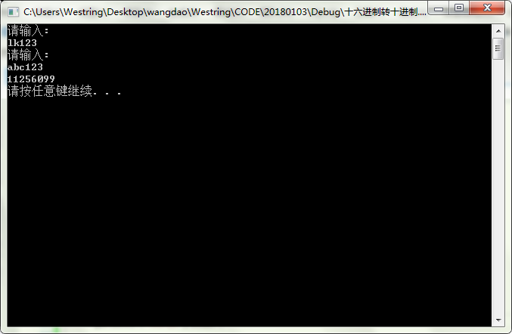

- 统计一个整数对应的二进制数的1的个数。输入一个整数（可正可负）， 输出该整数的二进制包含1的个数， “ctl+ z” 结束。
#include<stdio.h>
#include<stdlib.h>

int main()
{
int a,yu=0,sum=0;
while(fflush(stdin),scanf("%d",&a)!=EOF)
{
while(a)
{
yu=a%2;
a=a/2;
sum=sum+yu;
}
printf("%d ",sum);
sum=0;
}
}

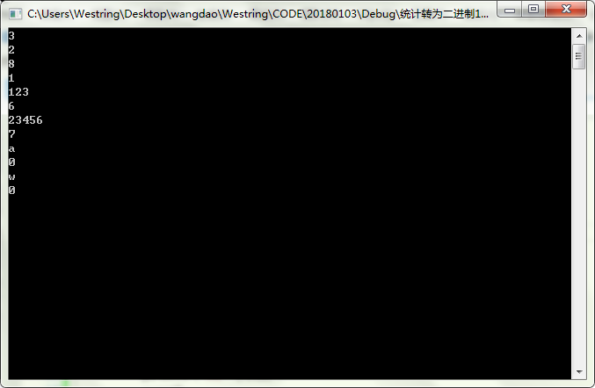

- （1）.有101个整数，其中有50个数出现了两次，1个数出现了一次， 找出出现了一次的那个数。
#include<stdio.h>
#include<stdlib.h>

int main()
{
int a[100]={0};
int b;
int num=0,i=0;
while(scanf("%d",&b)!=EOF)
{
for(i=0;i<=100;i++)
{
a[i]=b;
i++;
}
for(i=0;i<=100;i++)
{
num=num^a[i];
i++;
}
}
printf("%d",num);

system("pause");
return 0;
}
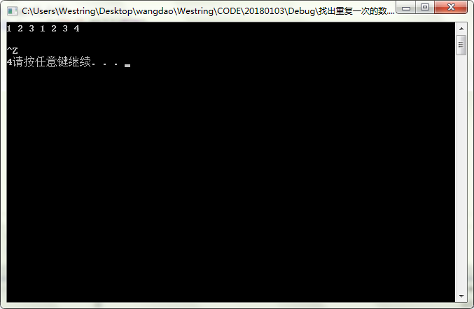
（2）有102个整数，其中有50个数出现了两次，2个数出现了一次， 找出出现了一次的那2个数。
（3）有103个整数，其中有50个数出现了两次，3个数出现了一次， 找出出现了一次的那3个数。

(做错了)
#include <stdio.h>
#include <stdlib.h>
#include <string.h>

int *array_in(int *a)
{
int b;
int *p;
p=a;
while(scanf("%d",&b)!=EOF)
{
*p=b;
p++;
}
return p-1;
}

void array_out(int *a)
{
int i=0;
while(a[i])
{
printf("%d ",a[i]);
i++;
}
}

void xg_quchong(int *a,int *m)
{
int *k;
int *p;
p=a;

while(*p)
{
k=m;
while(p<k)
{
if(*p==*k)
{
*k=*(k+1);
k--;
}else
{
k--;
}
}
p++;
k=m;
}
}

int main()
{
int i=0,b;
int a[100]={0};
int *m;
m=array_in(a);
// array_out(a);
// printf("\n");
xg_quchong(a,m);
array_out(a);
// printf("%d",sizeof(a));
system("pause");
return 0;
}
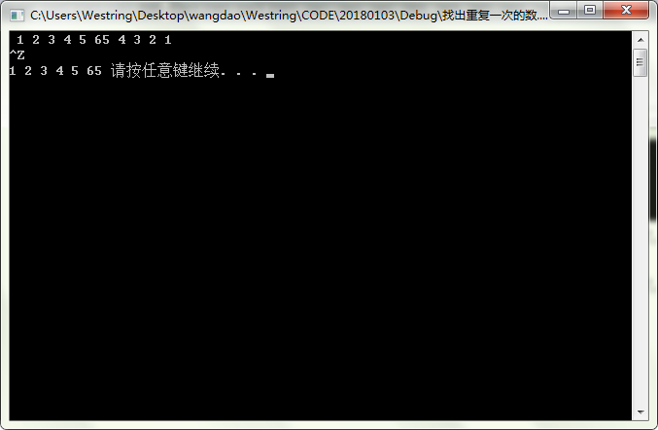

- （1）输入年月日，输出该日期是当年的第几天。
#include<stdio.h>
#include<stdlib.h>

int main()
{
int year,mon,day,sum=0,num=0;
int i;
while(scanf("%d%d%d",&year,&mon,&day)!=EOF)
{
for(i=1;i<mon;i++)
{
switch(i)
{
case 1:
case 3:
case 5:
case 7:
case 8:
case 10:
case 12:num=31;break;
case 2:num=28+(year%4==0&&year%100!=0||year%400==0);break;
case 4:
case 6:
case 9:
case 11:num=30;break;
default:printf("error\n");
}
sum=sum+num;
}
sum = sum +day;
printf("%d\n",sum);
sum=0;
}
system("pause");
return 0;
}

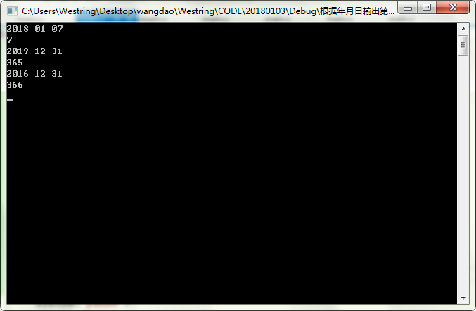

（2）输入两个日期（年 月 日 年 月 日）， 输出这两个日期之间差多少天。
sum = delt(year1 year2) - dayofyear(date1) + dayofyear(date2)
#include<stdio.h>
#include<stdlib.h>

//算某天是该年的第几天
int days(int year,int mon,int day)
{
int
sum=0,num=0;
int i;
//scanf("%d%d%d",&year,&mon,&day);
for(i=1;i<mon;i++)
{
switch(i)
{
case 1:
case 3:
case 5:
case 7:
case 8:
case 10:
case 12:num=31;break;
case 2:num=28+(year%4==0&&year%100!=0||year%400==0);break;
case 4:
case 6:
case 9:
case 11:num=30;break;
default:printf("error\n");
}
sum=sum+num;
}
sum = sum + day;
return sum;
}

int years(int year1,int year2)
{
int max,min;
int i,year=0;
if(year1<year2)
{
min=year1;
max=year2;
}
else
{
max=year1;
min=year2;
}
for(i=min;i<max;i++)
{
year=year+365+(i%4==0&&i%100!=0||i%400==0);
}
return year;
}

int main()
{
int year1,year2,mon1,mon2,day1,day2;
int cha_tian,cha_nian;
scanf("%d%d%d",&year1,&mon1,&day1);
scanf("%d%d%d",&year2,&mon2,&day2);
if(year1*10000+mon1*100+day1>=year2*10000+mon2*100+day2)
cha_tian=days(year2,mon2,day2)-days(year1,mon1,day1);
else
cha_tian=days(year1,mon1,day1)-days(year2,mon2,day2);
cha_nian=abs(years(year1,year2));
printf("%d",abs(cha_nian-cha_tian));
system("pause");
return 0;
}

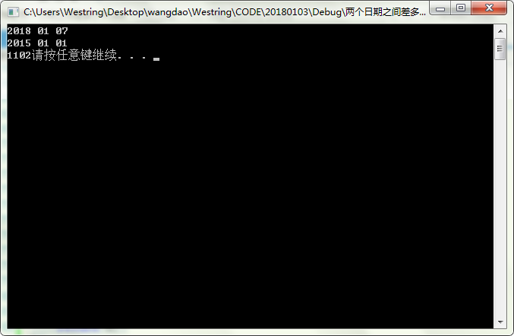
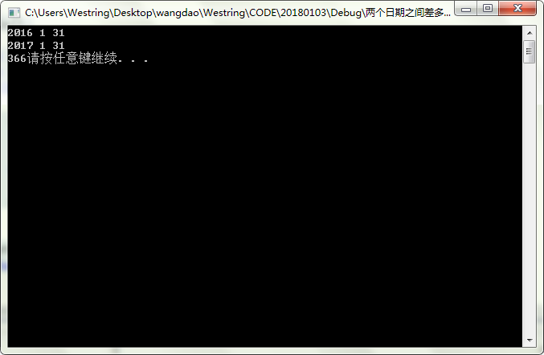

（3）输入一个日期，输出该日期是星期几。
a. delt % 7 b. (7 – delt % 7) % 7

#include<stdio.h>
#include<stdlib.h>

int days(int year,int mon,int day)
{
int
sum=0,num=0;
int i;
//scanf("%d%d%d",&year,&mon,&day);
for(i=1;i<mon;i++)
{
switch(i)
{
case 1:
case 3:
case 5:
case 7:
case 8:
case 10:
case 12:num=31;break;
case 2:num=28+(year%4==0&&year%100!=0||year%400==0);break;
case 4:
case 6:
case 9:
case 11:num=30;break;
default:printf("error\n");
}
sum=sum+num;
}
sum = sum +day;
return sum;
}

int years(int year1,int year2)
{
int max,min;
int i,year=0;
if(year1<year2)
{
min=year1;
max=year2;
}
else
{
max=year1;
min=year2;
}
for(i=min;i<max;i++)
{
year=year+365+(i%4==0&&i%100!=0||i%400==0);
}
return year;
}

int cha_days(int year1,int mon1,int day1,int year2,int mon2,int day2)
{
int cha_tian,cha_nian;
if(year1*10000+mon1*100+day1>=year2*10000+mon2*100+day2)
cha_tian=days(year2,mon2,day2)-days(year1,mon1,day1);
else
cha_tian=days(year1,mon1,day1)-days(year2,mon2,day2);
cha_nian=abs(years(year1,year2));
return abs(cha_nian-cha_tian);
}

int main()
{
int delt,week=0;
int year1,mon1,day1;
while(scanf("%d%d%d",&year1,&mon1,&day1)!=EOF)
{
delt=cha_days(year1,mon1,day1,2018,01,07);
if(year1*10000+mon1*100+day1>=20180107)
{week=delt%7;}
else
{week=(7-delt % 7) % 7;}
printf("%d",week);
}

system("pause");
return 0;
}
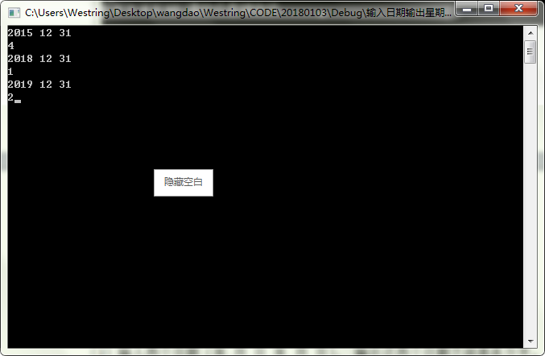

（4）输入 一个日期 和一个整数 n，输出从该日期起经过n天以后的日期。
-> date -> tomorrow of the date

#include<stdio.h>
#include<stdlib.h>

#define N1 31
#define N2 59
#define N3 90
#define N4 120
#define N5 151
#define N6 181
#define N7 212
#define N8 243
#define N9 273
#define N10 304
#define N11 334
#define N12 365

//计算某个日期是该年的第几天
int days(int year,int mon,int day)
{
int
sum=0,num=0;
int i;
//scanf("%d%d%d",&year,&mon,&day);
for(i=1;i<mon;i++)
{
switch(i)
{
case 1:
case 3:
case 5:
case 7:
case 8:
case 10:
case 12:num=31;break;
case 2:num=28+(year%4==0&&year%100!=0||year%400==0);break;
case 4:
case 6:
case 9:
case 11:num=30;break;
default:printf("error\n");
}
sum=sum+num;
}
sum = sum +day;
return sum;
}
//计算两个年份之间差多少天
int years(int year1,int year2)
{
int max,min;
int i,year=0;
if(year1<year2)
{
min=year1;
max=year2;
}
else
{
max=year1;
min=year2;
}
for(i=min;i<max;i++)
{
year=year+365+(i%4==0&&i%100!=0||i%400==0);
}
return year;
}
//计算两个日期之间差多少天
int cha_days(int year1,int mon1,int day1,int year2,int mon2,int day2)
{
int cha_tian,cha_nian;
if(year1*10000+mon1*100+day1>=year2*10000+mon2*100+day2)
cha_tian=days(year2,mon2,day2)-days(year1,mon1,day1);
else
cha_tian=days(year1,mon1,day1)-days(year2,mon2,day2);
cha_nian=abs(years(year1,year2));
return abs(cha_nian-cha_tian);
}

int ys_after_n(int year,int n)
{
int mon1,day1;
while(n>=365+(year%4==0&&year%100!=0||year%400==0))
{
n=n-365-(year%4==0&&year%100!=0||year%400==0);
year++;
}
if(n<N1)
{
mon1=1;
day1=n+1;
}else if(n<N2+(year%4==0&&year%100!=0||year%400==0))
{
mon1=2;
day1=n+1-N1;
}else if(n<N3+(year%4==0&&year%100!=0||year%400==0))
{
mon1=3;
day1=n+1-N2-(year%4==0&&year%100!=0||year%400==0);
}else if(n<N4+(year%4==0&&year%100!=0||year%400==0))
{
mon1=4;
day1=n+1-N3-(year%4==0&&year%100!=0||year%400==0);
}else if(n<N5+(year%4==0&&year%100!=0||year%400==0))
{
mon1=5;
day1=n+1-N4-(year%4==0&&year%100!=0||year%400==0);
}else if(n<N6+(year%4==0&&year%100!=0||year%400==0))
{
mon1=6;
day1=n+1-N5-(year%4==0&&year%100!=0||year%400==0);
}else if(n<N7+(year%4==0&&year%100!=0||year%400==0))
{
mon1=7;
day1=n+1-N6-(year%4==0&&year%100!=0||year%400==0);
}else if(n<N8+(year%4==0&&year%100!=0||year%400==0))
{
mon1=8;
day1=n+1-N7-(year%4==0&&year%100!=0||year%400==0);
}else if(n<N9+(year%4==0&&year%100!=0||year%400==0))
{
mon1=9;
day1=n+1-N8-(year%4==0&&year%100!=0||year%400==0);
}else if(n<N10+(year%4==0&&year%100!=0||year%400==0))
{
mon1=10;
day1=n+1-N9-(year%4==0&&year%100!=0||year%400==0);
}else if(n<N11+(year%4==0&&year%100!=0||year%400==0))
{
mon1=11;
day1=n+1-N10-(year%4==0&&year%100!=0||year%400==0);
}else if(n<N12+(year%4==0&&year%100!=0||year%400==0))
{
mon1=12;
day1=n+1-N11-(year%4==0&&year%100!=0||year%400==0);
}
//printf("%d %d\n",year,n);
printf("%d-%d-%d",year,mon1,day1);
}

int main()
{
int n;
int delt,week=0;
int year1,mon1,day1,year2;
while(scanf("%d%d%d%d",&year1,&mon1,&day1,&n))
{
n=n+cha_days(year1,mon1,day1,year1,1,1);
ys_after_n(year1,n);
}
system("pause");
return 0;
}

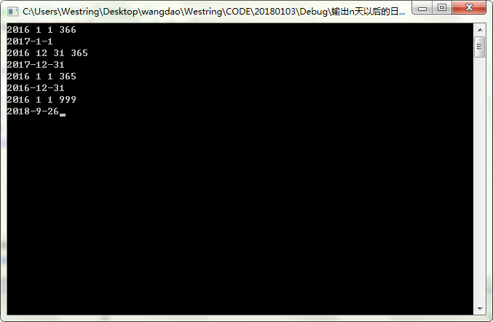

- 输入一个年份,月份，输出该月份的日历。

#include<stdio.h>
#include<stdlib.h>

//计算某日期是该年的第几天
int days(int year,int mon,int day)
{
int
sum=0,num=0;
int i;
//scanf("%d%d%d",&year,&mon,&day);
for(i=1;i<mon;i++)
{
switch(i)
{
case 1:
case 3:
case 5:
case 7:
case 8:
case 10:
case 12:num=31;break;
case 2:num=28+(year%4==0&&year%100!=0||year%400==0);break;
case 4:
case 6:
case 9:
case 11:num=30;break;
default:printf("error\n");
}
sum=sum+num;
}
sum = sum +day;
return sum;
}

//计算两个年份之间差多少天
int years(int year1,int year2)
{
int max,min;
int i,year=0;
if(year1<year2)
{
min=year1;
max=year2;
}
else
{
max=year1;
min=year2;
}
for(i=min;i<max;i++)
{
year=year+365+(i%4==0&&i%100!=0||i%400==0);
}
return year;
}

//计算两个日期之间相差多少天
int cha_days(int year1,int mon1,int day1,int year2,int mon2,int day2)
{
int cha_tian,cha_nian;
if(year1*10000+mon1*100+day1>=year2*10000+mon2*100+day2)
cha_tian=days(year2,mon2,day2)-days(year1,mon1,day1);
else
cha_tian=days(year1,mon1,day1)-days(year2,mon2,day2);
cha_nian=abs(years(year1,year2));
return abs(cha_nian-cha_tian);
}

//根据日期算出是星期几
int cal_week(int year1,int mon1,int day1)
{
int delt,week=0;
delt=cha_days(year1,mon1,day1,2018,01,07);
if(year1*10000+mon1*100+day1>=20180107)
{week=delt%7;}
else
{week=(7-delt % 7) % 7;}
return week;
}
//根据年、月得出本月有多少天
int mon_to_day(int year,int mon)
{
int num;
switch(mon)
{
case 1:
case 3:
case 5:
case 7:
case 8:
case 10:
case 12:num=31;break;
case 2:num=28+(year%4==0&&year%100!=0||year%400==0);break;
case 4:
case 6:
case 9:
case 11:num=30;break;
default:printf("error\n");
}
return num;
}

int main()
{
int year,mon,day=1;
int i;
printf("请输入年份和月份：\n");
while(scanf("%d%d",&year,&mon)!=EOF)
{
printf(" %2d SUM MON TUE WED THU FRI SAT\n",mon);
printf(" ");
for(i=0;i<cal_week(year,mon,1);i++)
{
printf(" ");
}
for(day=1;day<=mon_to_day(year,mon);day++)
{
if(6==cal_week(year,mon,day))
printf("%3d\n ",day);
else
printf("%3d ",day);
}
}
system("pause");
return 0;
}
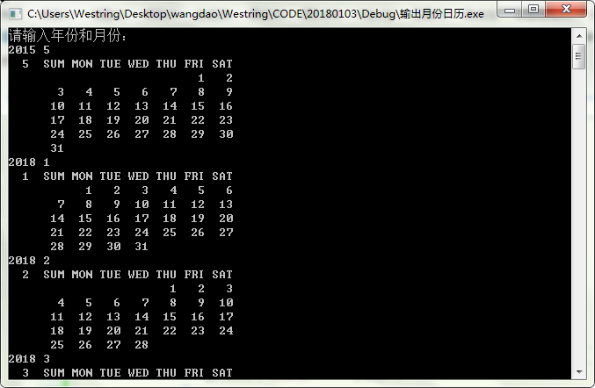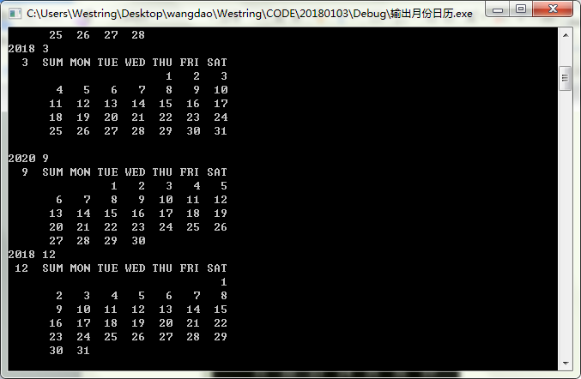

- 打印年历：

（最后一行还有些问题）
#include<stdio.h>
#include<stdlib.h>

//计算某日期是该年的第几天
int days(int year,int mon,int day)
{
int
sum=0,num=0;
int i;
//scanf("%d%d%d",&year,&mon,&day);
for(i=1;i<mon;i++)
{
switch(i)
{
case 1:
case 3:
case 5:
case 7:
case 8:
case 10:
case 12:num=31;break;
case 2:num=28+(year%4==0&&year%100!=0||year%400==0);break;
case 4:
case 6:
case 9:
case 11:num=30;break;
default:printf("error\n");
}
sum=sum+num;
}
sum = sum +day;
return sum;
}

//计算两个年份之间差多少天
int years(int year1,int year2)
{
int max,min;
int i,year=0;
if(year1<year2)
{
min=year1;
max=year2;
}
else
{
max=year1;
min=year2;
}
for(i=min;i<max;i++)
{
year=year+365+(i%4==0&&i%100!=0||i%400==0);
}
return year;
}

//计算两个日期之间相差多少天
int cha_days(int year1,int mon1,int day1,int year2,int mon2,int day2)
{
int cha_tian,cha_nian;
if(year1*10000+mon1*100+day1>=year2*10000+mon2*100+day2)
cha_tian=days(year2,mon2,day2)-days(year1,mon1,day1);
else
cha_tian=days(year1,mon1,day1)-days(year2,mon2,day2);
cha_nian=abs(years(year1,year2));
return abs(cha_nian-cha_tian);
}

//根据日期算出是星期几
int cal_week(int year1,int mon1,int day1)
{
int delt,week=0;
delt=cha_days(year1,mon1,day1,2018,01,07);
if(year1*10000+mon1*100+day1>=20180107)
{week=delt%7;}
else
{week=(7-delt % 7) % 7;}
return week;
}
//根据年、月得出本月有多少天
int mon_to_day(int year,int mon)
{
int num;
switch(mon)
{
case 1:
case 3:
case 5:
case 7:
case 8:
case 10:
case 12:num=31;break;
case 2:num=28+(year%4==0&&year%100!=0||year%400==0);break;
case 4:
case 6:
case 9:
case 11:num=30;break;
default:printf("error\n");
}
return num;
}

int main()
{
int year,mon,day1=1,day2=1;
int i,j;
printf("请输入年份和月份：\n");
while(scanf("%d%d",&year,&mon)!=EOF)
{
printf(" %2d SUM MON TUE WED THU FRI SAT %2d SUM MON TUE WED THU FRI SAT\n",mon,mon+6);
printf(" ");
for(i=0;i<cal_week(year,mon,1);i++)
{
printf(" ");
}
for(day1=1;day1<=mon_to_day(year,mon);day1++)
{
if(6==cal_week(year,mon,day1))
{
printf("%3d ",day1);/*^_^*/
for(i=0;i<cal_week(year,mon+6,1);i++)
{
printf(" ");
}
for(day2=1;day2<=mon_to_day(year,mon+6);day2++)
{
if(6==cal_week(year,mon+6,day2))
{
printf("%3d \n ",day2);/*^_^*/
/*for(i=0;i<cal_week(year,mon,1);i++)
{
printf(" ");
}*/
for(day1=day1+1;day1<=mon_to_day(year,mon);day1++)
{
if(6==cal_week(year,mon,day1))
{
printf("%3d ",day1);/*^_^*/
/*for(i=0;i<cal_week(year,mon+6,1);i++)
{
printf(" ");
}*/
for(day2=day2+1;day2<=mon_to_day(year,mon+6);day2++)
{
if(6==cal_week(year,mon+6,day2))
{
printf("%3d \n ",day2);/*^_^*/
/*for(i=0;i<cal_week(year,mon,1);i++)
{
printf(" ");
}*/
for(day1=day1+1;day1<=mon_to_day(year,mon);day1++)
{
if(6==cal_week(year,mon,day1))
{
printf("%3d ",day1);/*^_^*/
/*for(i=0;i<cal_week(year,mon+6,1);i++)
{
printf(" ");
}*/
for(day2=day2+1;day2<=mon_to_day(year,mon+6);day2++)
{
if(6==cal_week(year,mon+6,day2))
{
printf("%3d \n ",day2);/*^_^*/
/*for(i=0;i<cal_week(year,mon,1);i++)
{
printf(" ");
}*/
for(day1=day1+1;day1<=mon_to_day(year,mon);day1++)
{
if(6==cal_week(year,mon,day1))
{
printf("%3d ",day1);/*^_^*/
/*for(i=0;i<cal_week(year,mon+6,1);i++)
{
printf(" ");
}*/
for(day2=day2+1;day2<=mon_to_day(year,mon+6);day2++)
{
if(6==cal_week(year,mon+6,day2))
{
printf("%3d \n ",day2);/*^_^*/

/*for(i=0;i<cal_week(year,mon,1);i++)
{
printf(" ");
}*/
for(day1=day1+1;day1<=mon_to_day(year,mon);day1++)
{
if(6==cal_week(year,mon,day1))
{
printf("%3d ",day1);/*^_^*/
/*for(i=0;i<cal_week(year,mon+6,1);i++)
{
printf(" ");
}*/
for(day2=day2+1;day2<=mon_to_day(year,mon+6);day2++)
{
if(6==cal_week(year,mon+6,day2))
{
printf("%3d \n ",day2);/*^_^*/
/*for(i=0;i<cal_week(year,mon,1);i++)
{
printf(" ");
}*/
for(day1=day1+1;day1<=mon_to_day(year,mon);day1++)
{
if(6==cal_week(year,mon,day1))
{
printf("%3d ",day1);/*^_^*/
/*for(i=0;i<cal_week(year,mon+6,1);i++)
{
printf(" ");
}*/
for(day2=day2+1;day2<=mon_to_day(year,mon+6);day2++)
{
if(6==cal_week(year,mon+6,day2))
{
printf("%3d \n ",day2);/*^_^*/
/*for(i=0;i<cal_week(year,mon,1);i++)
{
printf(" ");
}*/
for(day1=day1+1;day1<=mon_to_day(year,mon);day1++)
{
if(6==cal_week(year,mon,day1))
{
printf("%3d ",day1);/*^_^*/
/*for(i=0;i<cal_week(year,mon+6,1);i++)
{
printf(" ");
}*/
for(day2=day2+1;day2<=mon_to_day(year,mon+6);day2++)
{
if(6==cal_week(year,mon+6,day2))
{
printf("%3d \n ",day2);/*^_^*/
/*for(i=0;i<cal_week(year,mon,1);i++)
{
printf(" ");
}*/
for(day1=day1+1;day1<=mon_to_day(year,mon);day1++)
{
if(6==cal_week(year,mon,day1))
{
printf("%3d ",day1);/*^_^*/
/*for(i=0;i<cal_week(year,mon+6,1);i++)
{
printf(" ");
}*/
for(day2=day2+1;day2<=mon_to_day(year,mon+6);day2++)
{
if(6==cal_week(year,mon+6,day2))
{
printf("%3d \n ",day2);/*^_^*/
}
else
printf("%3d ",day2);
}
}
else
printf("%3d ",day1);
}
}
else
printf("%3d ",day2);
}
}
else
printf("%3d ",day1);
}
}
else
printf("%3d ",day2);
}
}
else
printf("%3d ",day1);
}
}
else
printf("%3d ",day2);
}
}
else
printf("%3d ",day1);
}
}
else
{

if(day1==mon_to_day(year,mon)+1)
{
for(j=1;j<=35-mon_to_day(year,mon)-1;j++)
{printf(" ");}
printf(" ");
day1++;

}
printf("%3d ",day2);
if(day2==mon_to_day(year,mon)+1)
{
printf("\n");
}
}
}
}
else
printf("%3d ",day1);
}
}
else
printf("%3d ",day2);
}
}
else
printf("%3d ",day1);
}
}
else
printf("%3d ",day2);
}
}
else
printf("%3d ",day1);
}
}
else
printf("%3d ",day2);
}
}
else
printf("%3d ",day1);
}
}
system("pause");
return 0;
}

