- 将两个有序链表合并成一个有序链表。
func.h
#include<stdio.h>
#include<stdlib.h>

typedef struct student
{
int num;
struct student *pnext;
}STU,*PSTU;

//void list_head_insert(PSTU *,PSTU *,int);
void list_tail_insert(PSTU *,PSTU *,int);
void list_print(PSTU);

func.c
#include"func.h"
////头插法
//void list_head_insert(PSTU *pphead,PSTU *pptail,int i)
//{
// PSTU pnew;
// pnew=(PSTU)calloc(1,sizeof(STU));
// pnew->num=i;
// if(*pphead==NULL)
// {
// *pphead=pnew;
// *pptail=pnew;
// }else{
// pnew->pnext=*pphead;
// *pphead=pnew;
// }
//}

//尾插法
void list_tail_insert(PSTU* pphead,PSTU* pptail,int i)
{
PSTU pnew;
pnew=(PSTU)calloc(1,sizeof(STU));
pnew->num=i;
if(NULL==*pptail)
{
*pphead=pnew;
*pptail=pnew;
}else
{
(*pptail)->pnext=pnew;
*pptail=pnew;
}
}

//打印链表
void list_print(PSTU phead)
{
while(phead!=NULL)
{
printf("%3d",phead->num);
phead=phead->pnext;
}
}
main.c
#include"func.h"

int main()
{
PSTU a_phead=NULL,a_ptail=NULL,b_phead=NULL,b_ptail=NULL;
PSTU ppre,pcur;
PSTU pnew;
int i;
printf("please input a list:\n");
while (scanf("%d",&i)!=EOF)
{
list_tail_insert(&a_phead,&a_ptail,i);
}
printf("a list is:\n");
list_print(a_phead);
printf("\nplease input b list:\n");
while(scanf("%d",&i)!=EOF)
{
list_tail_insert(&b_phead,&b_ptail,i);
}
printf("b list is:\n");
list_print(b_phead);

pnew=b_phead;
ppre=a_phead;
pcur=a_phead;
while (b_phead!=NULL)
{
pnew=b_phead;
b_phead=b_phead->pnext;
pnew->pnext=NULL;
while(pnew->num>pcur->num)
{
ppre=pcur;
pcur=(pcur)->pnext;
if(pcur==NULL)
break;
}
if(pcur==a_phead)
{
pnew->pnext=pcur;
a_phead=pnew;
}else{
pnew->pnext=pcur;
ppre->pnext=pnew;
}
if(pcur==a_ptail)
{
a_ptail->pnext=pnew;
a_ptail=pnew;
pnew->pnext=b_phead;
a_ptail=b_ptail;
}
}
printf("\n合并后的有序链表是：\n");
list_print(a_phead);
system("pause");
}

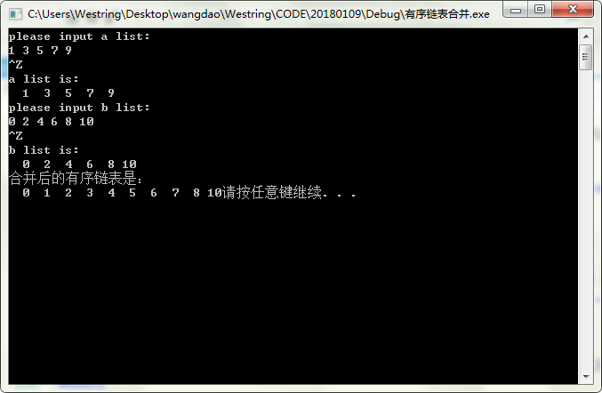

7. 将一个链表逆置。
如： 1->2 ->3 ->4 ->5 ->NULL， 输出: 5 -> 4 -> 3 ->2 ->1 -> NULL ；
func.h
#include<stdio.h>
#include<stdlib.h>

typedef struct student
{
int num;
struct student *pnext;
}STU,*PSTU;

//void list_head_insert(PSTU *,PSTU *,int);
void list_tail_insert(PSTU *,PSTU *,int);
void list_print(PSTU);
func.c
#include"func.h"
//头插法
//void list_head_insert(PSTU *pphead,PSTU *pptail,int i)
//{
// PSTU pnew;
// pnew=(PSTU)calloc(1,sizeof(STU));
// pnew->num=i;
// if(*pphead==NULL)
// {
// *pphead=pnew;
// *pptail=pnew;
// }else{
// pnew->pnext=*pphead;
// *pphead=pnew;
// }
//}

//尾插法
void list_tail_insert(PSTU* pphead,PSTU* pptail,int i)
{
PSTU pnew;
pnew=(PSTU)calloc(1,sizeof(STU));
pnew->num=i;
if(NULL==*pptail)
{
*pphead=pnew;
*pptail=pnew;
}else
{
(*pptail)->pnext=pnew;
*pptail=pnew;
}
}

//打印链表
void list_print(PSTU phead)
{
while(phead!=NULL)
{
printf("%3d",phead->num);
phead=phead->pnext;
}
}
main.c
#include"func.h"

int main()
{
PSTU a_phead=NULL,a_ptail=NULL,b_phead=NULL,b_ptail=NULL;
PSTU ppre,pcur;
PSTU pnew;
int i;
printf("please input a list:\n");
while (scanf("%d",&i)!=EOF)
{
list_tail_insert(&a_phead,&a_ptail,i);
}
printf("逆置后的链表为:\n");
ppre=a_phead;
pcur=a_phead->pnext;
while(pcur!=NULL)
{
pnew=pcur;
ppre->pnext=pcur->pnext;
pcur=pcur->pnext;
pnew->pnext=NULL;
pnew->pnext=a_phead;
a_phead=pnew;
}
list_print(a_phead);
system("pause");
}

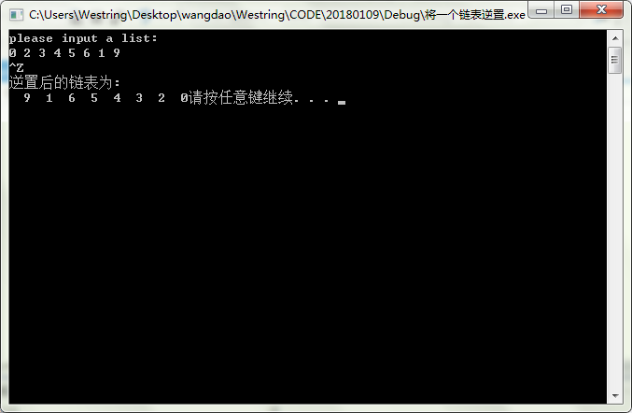

- 找出链表的倒数第四个节点
Func.h
#include<stdio.h>
#include<stdlib.h>

typedef struct student
{
int num;
struct student *pnext;
}STU,*PSTU;

//void list_head_insert(PSTU *,PSTU *,int);
void list_tail_insert(PSTU *,PSTU *,int);
void list_print(PSTU);
Func.c

#include"func.h"
//尾插法
void list_tail_insert(PSTU* pphead,PSTU* pptail,int i)
{
PSTU pnew;
pnew=(PSTU)calloc(1,sizeof(STU));
pnew->num=i;
if(NULL==*pptail)
{
*pphead=pnew;
*pptail=pnew;
}else
{
(*pptail)->pnext=pnew;
*pptail=pnew;
}
}

//打印链表
void list_print(PSTU phead)
{
while(phead!=NULL)
{
printf("%3d",phead->num);
phead=phead->pnext;
}
}
Main.c
#include"func.h"

int main()
{
PSTU a_phead=NULL,a_ptail=NULL,b_phead=NULL,b_ptail=NULL;
PSTU ppre,pcur;
PSTU pnew;
int i;

printf("please input a list:\n");
while (scanf("%d",&i)!=EOF)
{
list_tail_insert(&a_phead,&a_ptail,i);
}
ppre=a_phead;
pcur=a_phead->pnext;
pcur=pcur->pnext;
pcur=pcur->pnext;

while(NULL!=pcur->pnext)
{
ppre=ppre->pnext;
pcur=pcur->pnext;
}
printf("%d",ppre->num);
system("pause");
}
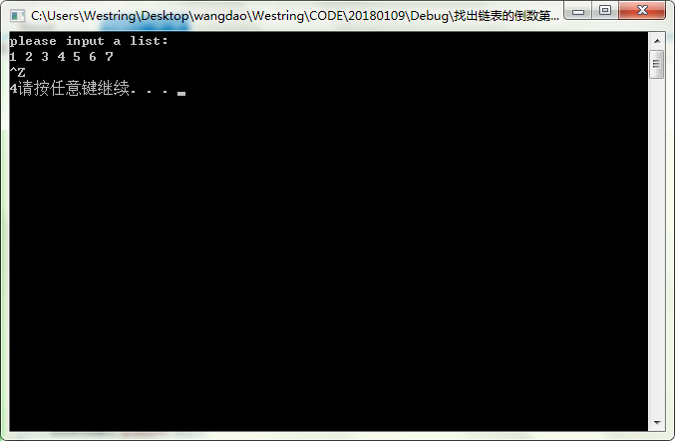
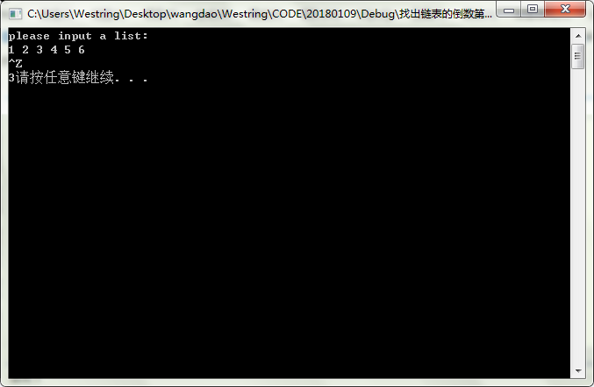

9. 找出链表的中间节点
func.h
#include<stdio.h>
#include<stdlib.h>

typedef struct student
{
int num;
struct student *pnext;
}STU,*PSTU;

//void list_head_insert(PSTU *,PSTU *,int);
void list_tail_insert(PSTU *,PSTU *,int);
void list_print(PSTU);
Func.c
#include"func.h"
//尾插法
void list_tail_insert(PSTU* pphead,PSTU* pptail,int i)
{
PSTU pnew;
pnew=(PSTU)calloc(1,sizeof(STU));
pnew->num=i;
if(NULL==*pptail)
{
*pphead=pnew;
*pptail=pnew;
}else
{
(*pptail)->pnext=pnew;
*pptail=pnew;
}
}

//打印链表
void list_print(PSTU phead)
{
while(phead!=NULL)
{
printf("%3d",phead->num);
phead=phead->pnext;
}
}
Main.c
#include"func.h"

int main()
{
PSTU a_phead=NULL,a_ptail=NULL,b_phead=NULL,b_ptail=NULL;
PSTU ppre,pcur,pbeh;
PSTU pnew;
int i;

printf("please input a list:\n");
while (scanf("%d",&i)!=EOF)
{
list_tail_insert(&a_phead,&a_ptail,i);
}
ppre=a_phead;
pcur=a_phead;
pbeh=pcur->pnext;
while(NULL!=pcur->pnext)
{
ppre=ppre->pnext;
pcur=pcur->pnext;
if(pcur->pnext==NULL)
{printf("没找到中间节点\n");
goto lable;
}
pcur=pcur->pnext;
}
printf("%d\n",ppre->num);
lable:
system("pause");
}

