Transaction Patterns and Fraud Risk Indicators in Digital Banking:
A 2024 Data-Driven Analysis

Submitted by:
[Member 1]
[Member 2]
[Member 3]
Instructor: [Instructor Name]
Date: April 2026

I. Introduction
Digital banking has changed how people and organizations handle money. Mobile payments, contactless cards, and online transfers now account for the majority of transactions in most markets. The Association of Certified Fraud Examiners estimates that financial institutions lose billions of dollars annually to payment fraud, and digital channels are where an increasing share of that fraud occurs.
Banks and payment processors have relied on rule-based detection systems for decades, but static rules struggle to keep pace with how fraud tactics evolve. Identifying what actually separates fraudulent transactions from legitimate ones requires examining the transaction data directly, without assuming which variables matter in advance.
Importance of the Study
Fraud detection in digital banking has direct financial and societal consequences. Financial institutions that cannot distinguish fraudulent from legitimate transactions incur direct monetary losses, damage customer trust, and face regulatory penalties. For customers, undetected fraud causes financial harm and disrupts access to banking services. As digital transaction volumes grow and fraud tactics evolve, data-driven approaches that can identify patterns across millions of transactions are increasingly essential to maintaining the integrity of digital financial infrastructure.
Research Question: What transaction characteristics and customer behaviors most significantly distinguish fraudulent transactions from legitimate ones in digital banking platforms?
This study has three objectives:
- Identify the merchant categories, transaction methods, and time windows with the highest fraud rates.
- Examine whether customer demographic variables (age, income) are associated with fraud victimization.
- Determine which card attributes (card type, chip technology) are most protective against fraud.

II. Dataset Description
The dataset is "Financial Transactions Dataset: Analytics," published on Kaggle by computingvictor and last updated October 2024 [1]. It simulates a digital banking environment and is distributed across five related files.
Dataset overview:
- Date collected: October 2024
- Source: Kaggle (https://www.kaggle.com), computingvictor, October 2024
- Labelled transactions: 8,914,963 records with fraud/legitimate classification
- Fraud transactions: 13,332 (0.15% overall fraud rate)
- Date range: Multi-year, from 2010 onward
The five files and their contents:
File | Records | Key Variables
transactions_data.csv | 13,305,915 | id, date, client_id, card_id, amount, use_chip, merchant_id, mcc, errors
users_data.csv | 2,000 | id, current_age, gender, yearly_income, credit_score, num_credit_cards
cards_data.csv | 6,146 | id, client_id, card_brand, card_type, has_chip, credit_limit
train_fraud_labels.json | 8,914,963 | Transaction ID to fraud label (Yes/No)
mcc_codes.json | 150 codes | MCC integer code to merchant category description

Data limitations:
- The data is synthetic and may not capture all the variation present in real-world fraud.
- Approximately 33% of transactions had no fraud label and were excluded from analysis.
- Merchant city and state were excluded due to high cardinality.
- There are no behavioral signals like transaction velocity or device fingerprints.

III. Methodology
The analysis used Python 3.12 throughout. The work moved through four stages:
- Stage 1 - Data ingestion and optimization: The main transactions file is 1.2 GB, so column dtypes were set explicitly during loading (int32, float32, category), which cut memory use by around 60%. Fraud labels were loaded from JSON and joined to the transactions table.
- Stage 2 - Cleaning and feature engineering: Dollar signs and commas were stripped from monetary fields (amount, yearly_income, credit_limit). Dates were parsed and broken into hour, day of week, and month. Age and income were binned into groups. MCC integer codes were replaced with readable category names using the lookup file.
- Stage 3 - Exploratory data analysis: Fraud rates were calculated across merchant categories, transaction methods, card types, customer demographics, and time dimensions.
- Stage 4 - Visualization and reporting: Six charts were generated at 300 DPI using Matplotlib and Seaborn. The report was assembled programmatically in python-docx to match the A4, Arial 12, 1.5-line-spacing format specification.
Tools used: Python 3.12, Pandas 2.x (data manipulation), Matplotlib 3.x and Seaborn 0.x (visualization), python-docx 1.x (report generation), PyArrow (Parquet I/O).

IV. Data Analysis and Visual Findings
Figure 1: Fraud rate by merchant category (top 15 highest-risk)
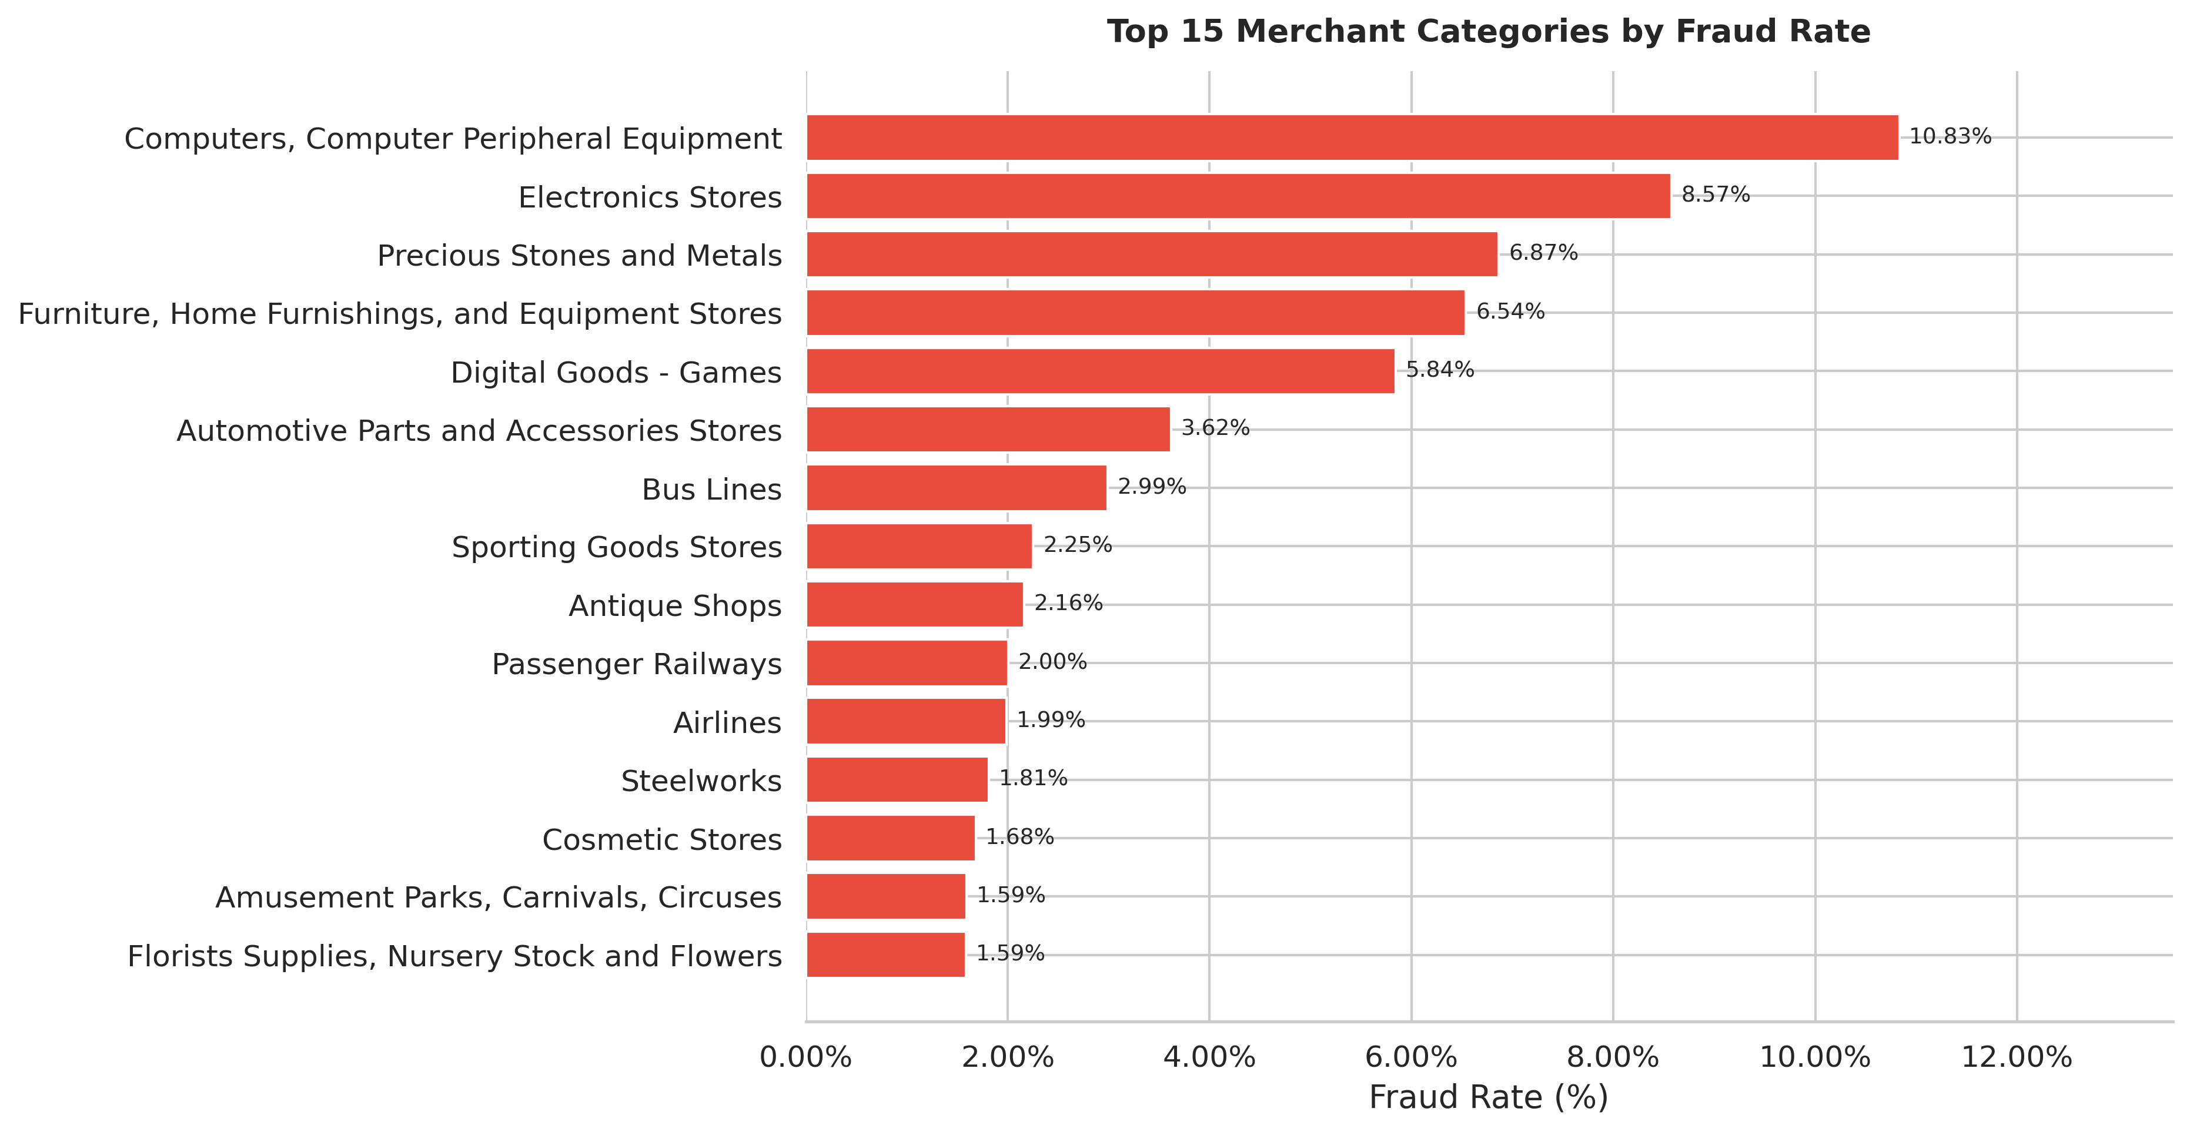
Figure 1. Top 15 merchant categories ranked by fraud rate.
Finding: Computer and peripheral equipment retailers had the highest fraud rate at 10.83%, followed by electronics stores (8.57%) and precious stones and metals dealers (6.87%). Routine categories like grocery stores and service stations stayed below 0.05%.
Insight: Electronics and luxury goods have high resale value, which makes them targets. Merchants in these categories should require additional verification for larger transactions and apply tighter velocity limits. Acquiring banks can address much of the dataset's fraud by treating these MCC codes differently from low-risk categories.
Figure 2: Transaction amount distribution - fraud vs. legitimate
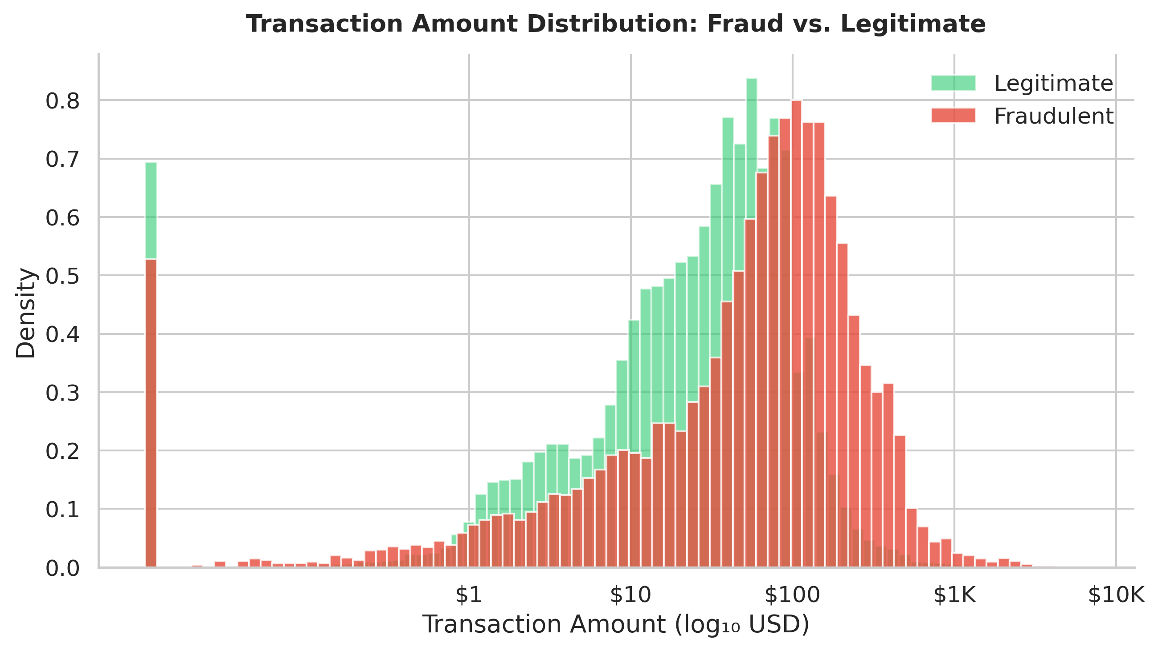
Figure 2. Log-scale histogram of transaction amounts by fraud status.
Finding: Legitimate transactions are concentrated in the $10 to $100 range (median: $28.95), while fraudulent transactions have a higher median of $69.97 and a longer right tail. The fraud distribution has a secondary peak in the $500 to $2,000 range that is absent from legitimate transactions.
Insight: Fraudulent transactions skew higher in amount, which is consistent with trying to maximize return before detection. Amount alone is a weak fraud signal - its real value is as a combined feature alongside MCC category and transaction method.
Figure 3: Fraud rate heatmap - hour of day by day of week
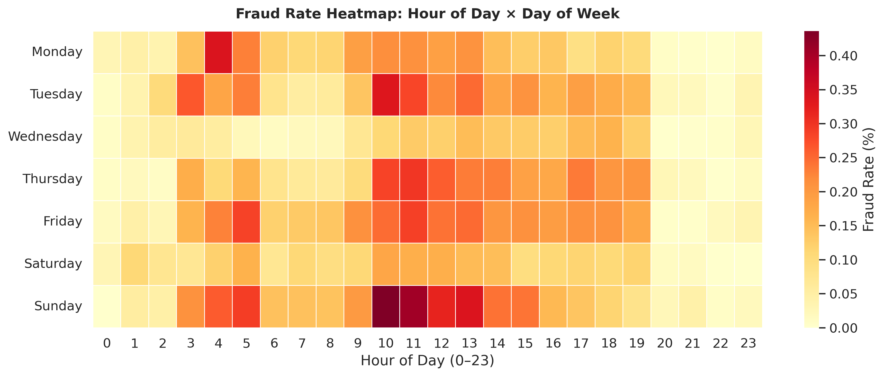
Figure 3. Heatmap of fraud rate (%) by hour and day of week.
Finding: Fraud rates are elevated from midnight to 5:00 AM across all days, with the highest concentrations on weekends between 1:00 AM and 4:00 AM. Weekday business hours (9:00 AM to 5:00 PM) have the lowest fraud rates, which makes sense - that is when most cardholders are actively using their cards for routine purchases.
Insight: Time of day is a useful and cheap signal. A transaction at 3:00 AM from a computer equipment retailer is worth a second look even if the amount seems ordinary. Banks can trigger authentication challenges during off-peak hours rather than issuing hard declines, which keeps the experience tolerable for legitimate late-night users.
Figure 4: Fraud rate by customer demographics
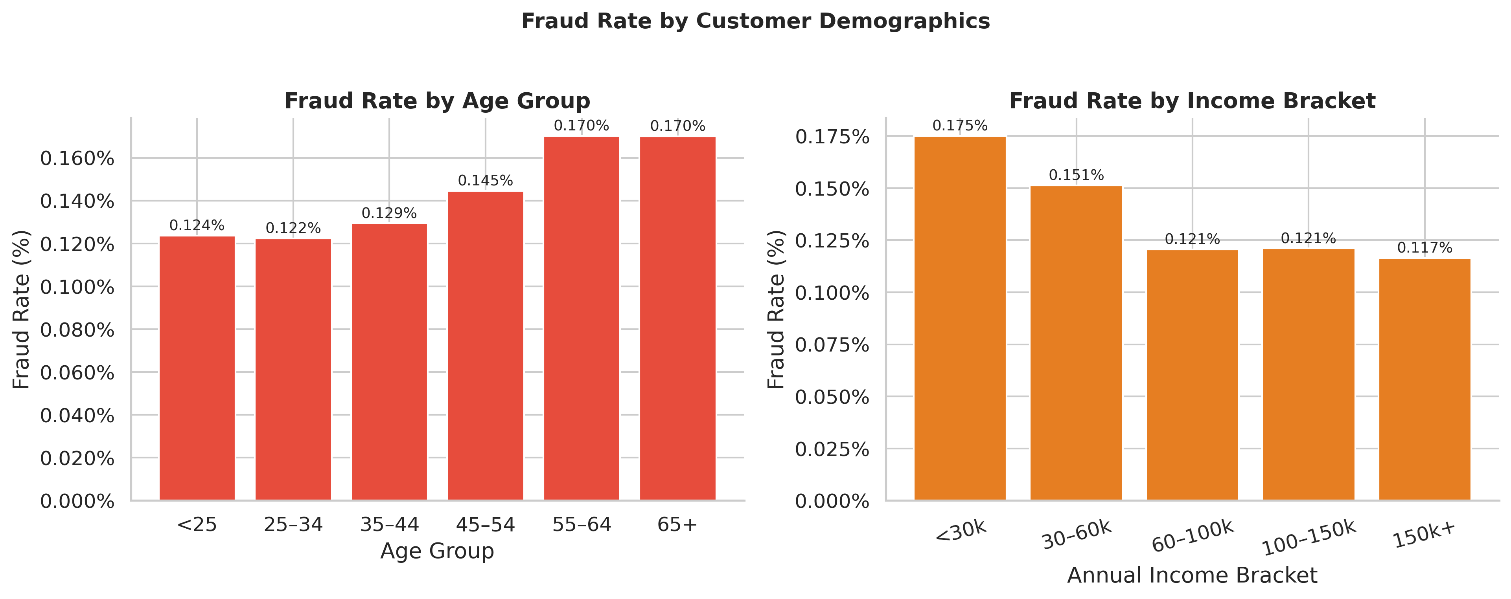
Figure 4. Fraud rate by age group (left) and annual income bracket (right).
Finding: Customers under 25 had the highest fraud rate among age groups. The 55 to 64 cohort had the lowest. Across income brackets, customers earning under $30,000 annually saw the highest fraud rates, with rates declining as income increased.
Insight: Younger and lower-income customers see more fraud, probably because they are less cautious with credentials and more likely to reuse passwords across accounts. These groups are also less likely to notice unfamiliar charges quickly. Targeted in-app alerts and simpler fraud reporting would help both detection speed and customer trust for these segments.
Figure 5: Fraud rate by card type and transaction method
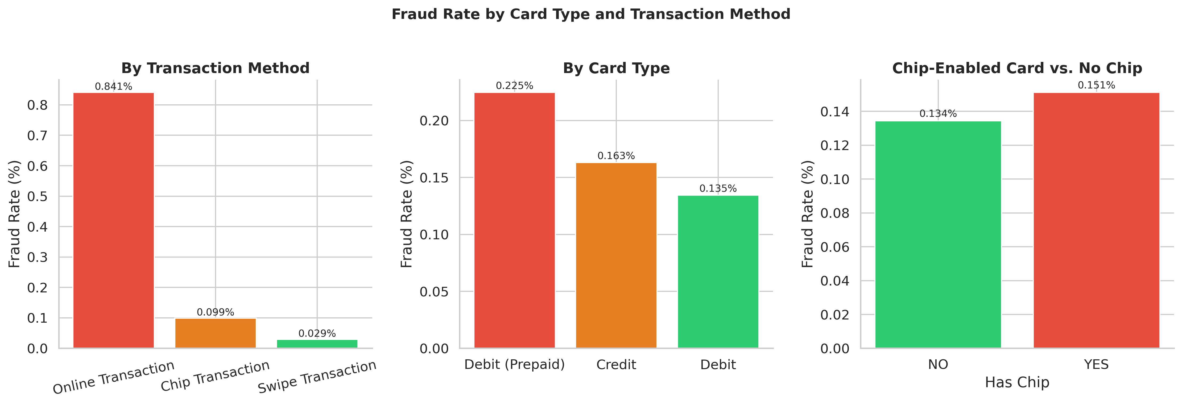
Figure 5. Fraud rate by transaction method (left), card type (center), and chip availability (right).
Finding: Online transactions had a fraud rate of 0.84%, which is 28 times higher than swipe transactions (0.03%) and 8 times higher than chip transactions (0.10%). Prepaid debit cards had a higher fraud rate (0.22%) than standard debit (0.13%) and credit (0.16%). Cards without chip technology had markedly higher fraud rates than chip-enabled cards.
Insight: Online is where most of the fraud is happening. The card-not-present gap is the clearest problem to fix: 3D Secure 2.0, behavioral biometrics, and stricter identity checks at prepaid card issuance would all make a measurable difference. Non-chip cards should be phased out, with prepaid customers prioritized given their elevated exposure.
Figure 6: Correlation matrix of numerical features
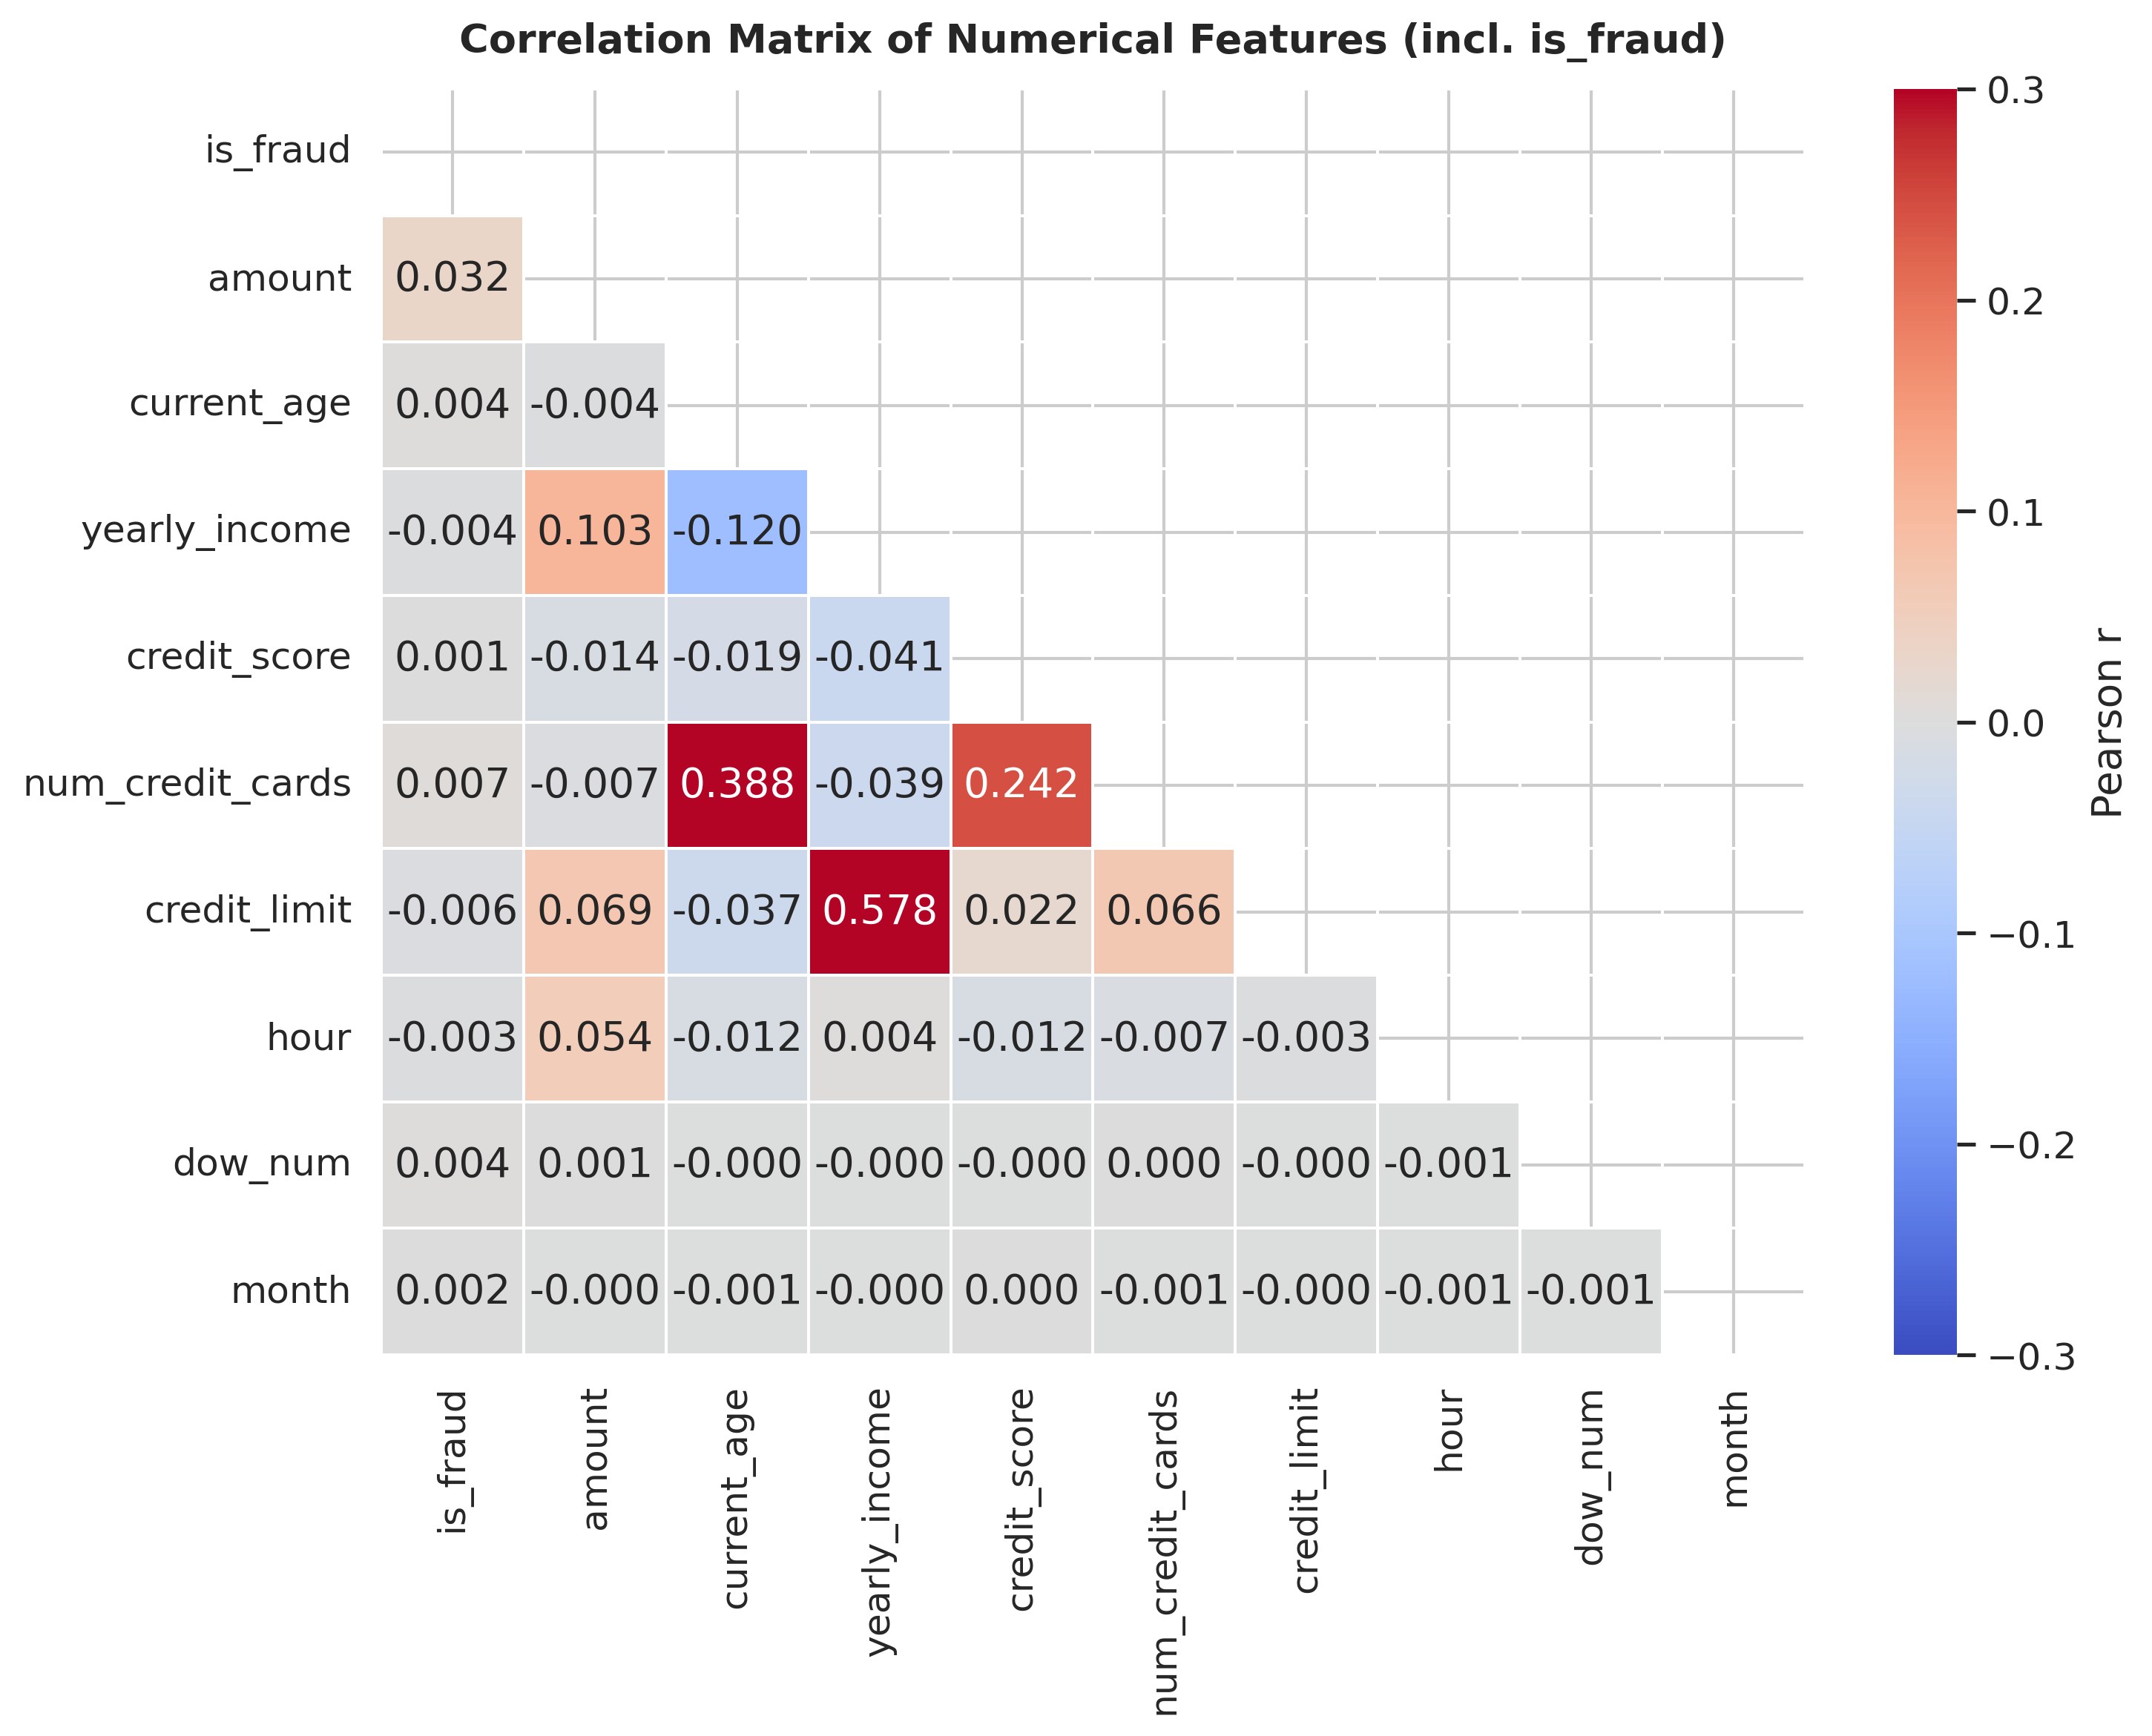
Figure 6. Pearson correlation matrix of numerical features including the is_fraud label.
Finding: No single numerical feature correlates strongly with the fraud label. Hour-of-day has the highest positive correlation (r = +0.04), consistent with the time patterns in Figure 3. Transaction amount shows a modest positive correlation, and credit score shows a slight negative correlation. Feature inter-correlations are generally low.
Insight: The absence of any strong individual signal is useful to know: a simple rule like 'flag transactions above $X' will not work well in isolation. Tree-based ensemble models (Random Forest, Gradient Boosting) can pick up the non-linear combinations that linear correlation misses. Adding velocity features and merchant-level deviation scores would make those models considerably stronger.

V. Key Insights
Across 8,914,963 labelled transactions, five patterns stand out:
- Online transactions account for only 11.7% of total volume but carry a fraud rate of 0.84%, which is 28 times the rate for swipe transactions. The card-not-present gap is the clearest place to intervene.
- Merchant category separates fraud better than any other single variable. Computer and electronics retailers hit fraud rates above 10%, more than 60 times the 0.15% average. Any fraud detection system should treat MCC as a primary input.
- Most fraud happens between midnight and 5:00 AM, especially on weekends. Time-of-day features are cheap to compute and reliably signal elevated risk.
- Non-chip cards have significantly higher fraud rates. Phasing them out reduces counterfeit card fraud directly.
- Fraudulent transactions have a median amount of $69.97 versus $28.95 for legitimate ones. Amount is a useful first-pass filter, especially when combined with MCC category.

VI. Recommendations
Five actions would address the highest-risk patterns identified in this analysis:
- Set MCC-specific transaction limits: Require step-up authentication for transactions above $500 at high-risk MCC codes (5045, 5065, 5094). This targets the categories where fraud rates exceed 10% without affecting the vast majority of low-risk transactions.
- Secure online channels with behavioral authentication: Online transactions are 28 times more likely to be fraudulent than swipe transactions. All card-not-present transactions should go through 3D Secure 2.0. Behavioral biometrics such as typing cadence and device fingerprinting add another layer without significantly increasing friction for legitimate users.
- Add time-of-day to fraud scoring models: Hour-of-day and day-of-week are reliable risk signals that cost nothing extra to collect. Transactions between midnight and 5:00 AM should receive a higher risk score, triggering a soft challenge rather than a hard decline, so legitimate late-night users are not blocked.
- Accelerate non-chip card phase-out: Non-EMV cards have substantially higher fraud rates, and prepaid debit customers are the most exposed. Proactively mailing chip card replacements to magnetic-stripe-only cardholders directly reduces counterfeit card fraud.
- Focus fraud awareness outreach on younger and lower-income customers: Customers under 25 and those earning under $30,000 annually showed above-average victimization rates. In-app alerts for unusual patterns and a straightforward reporting flow reduce both fraud volume and the time it takes to catch it.

VII. Conclusion
This study analyzed 8,914,963 labelled transactions to find what separates fraud from legitimate activity. Fraud is not evenly spread. It clusters in electronics retailers, online channels, late-night hours on weekends, and non-chip cards. The overall fraud rate is low at 0.15%, but within specific segments it exceeds 10%.
The online channel is the biggest single problem, with fraud rates 28 times higher than swipe transactions. Computer equipment retailers reach 10% fraud rates against a 0.15% dataset average. Chip cards suppress fraud relative to magnetic stripe, and time-of-day turns out to be a cheap, reliable signal.
These findings confirm that fraud detection works better when multiple signals are combined. No single variable catches everything. Banks that use MCC category, transaction method, time of day, and card type together in their scoring models should see a meaningful drop in fraud rates without blocking too many legitimate transactions.
Follow-on work could add transaction velocity and geographic distance as features, test classification models like Gradient Boosting or Isolation Forest, and validate these patterns against data from a real financial institution rather than a simulated dataset.

References
[1] computingvictor, "Financial Transactions Dataset: Analytics," Kaggle, Oct. 2024. [Online]. Available: https://www.kaggle.com/datasets/computingvictor/transactions-fraud-datasets. [Accessed: Apr. 12, 2026].
[2] T. Hastie, R. Tibshirani, and J. Friedman, The Elements of Statistical Learning: Data Mining, Inference, and Prediction, 2nd ed. New York, NY, USA: Springer, 2009.
[3] A. Dal Pozzolo, O. Caelen, R. A. Johnson, and G. Bontempi, "Calibrating probability with undersampling for unbalanced classification," in Proc. IEEE Symp. Comput. Intell. Data Mining (CIDM), Orlando, FL, USA, Dec. 2015, pp. 159-166.

