**Applied Data Science Capstone by IBM / Coursera**

**Starbucks Locations Worldwide**

**1. Introduction**

Starbucks Corporation is an American multinational chain of coffeehouses and roastery reserves headquartered in Seattle, Washington. As the world's largest coffeehouse chain, Starbucks is seen to be the main representation of the United States' third wave of coffee culture. Starbucks started as a roaster and retailer of whole bean and ground coffee, tea and spices with a single store in Seattle’s Pike Place Market in 1971. The company now operates more than 24,000 retail stores in 70 countries. And as of September 2020, the company had 32,660 stores in 83 countries, including 16,637 company operated stores and 16,023 licensed stores. Of these 32,660 stores, 18,354 were in the United States, Canada, and Latin America. Explore more about about Starbucks will give us more insight to this industry and economy.

Those who want to open a chained coffeehouse, or those who want to open a company which has similar target customers with Starbucks will be particularly interested in this project. Also those who are willing to explore the relation between economy and coffee, coffeehouse may also interested in this project.

**2.Data**

**2.1 Data Sources**

The data set used in this project is from Kaggle: <https://www.kaggle.com/starbucks/store-locations>

This data set includes a record for every Starbucks or subsidiary store location currently in operation as of February 2017.

**2.2 Data Cleaning**

This data set is a relatively clean data set. Only very few entries are missing coordination data, fill them with the data we get from google map.

For those entries with location information missing, collect them using Foursquare.

**3.Methodology**

In first step we have collected the required Starbucks data: coordination, location and other information we need from Internet.

Second step in our analysis will be descriptive statistical analysis. We will count the countries with the most Starbucks and the cities with the most Starbucks.

In third and final step we will display the Starbucks stores using Folium. To see how Starbucks distributed worldwide and in China. We also tried to visualize Starbucks stores according to their set up time.

**4. Results**

**4.1 Starbucks worldwide**

**4.1.1 Top 15 countries with most Starbucks**

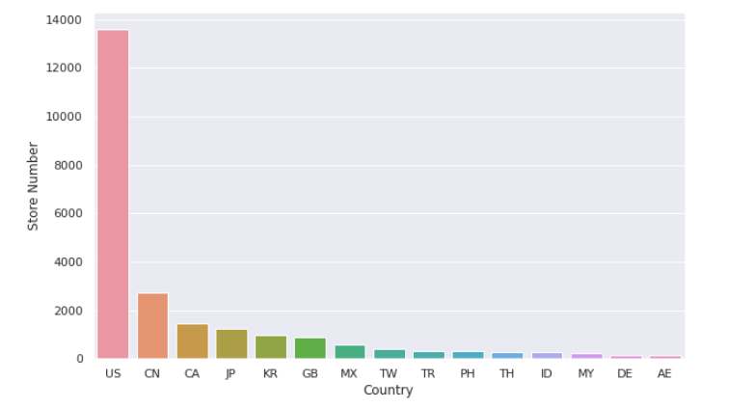

**Figure 1 Top 15 countries with most Starbucks**

The countries with most Starbucks are United States, China, Canada, Japan, Korean, United Kingdom.

While at the same time United States has ten thousands more Starbucks than China.

**4.1.2 Top 15 cities with most Starbucks**

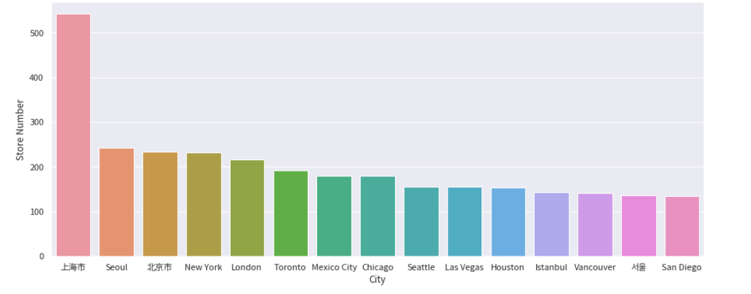

**Figure 2 Top 15 cities with most Starbucks**

The cities with most Starbucks are : Shanghai, Seoul, Beijing, New York. London, Toronto, Mexico City, Chicago, Seattle. Top 3 cities are all Asian cities, New York, Chicago, Seattle are 4th, 8th , 9th respectively. It’s an interesting fact that although America has most Starbucks in total, the city with

more than 500 Starbucks is in China.

**4.2 Starbucks in China**

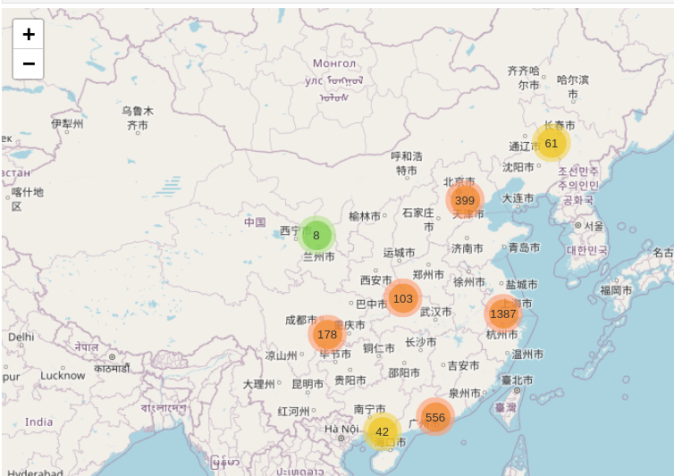

**Figure 3 Starbucks Distribution in China**

Starbucks in China are mostly concentrated in the economically developed areas along the southeast coast, while other Starbucks are mainly distributed near municipalities such as Beijing and Chongqing. There are very few Starbucks in the Northwest and other economically underdeveloped areas. From Figure 4 we can find that the top 4 cities’ Starbucks consists half of Starbucks in China.

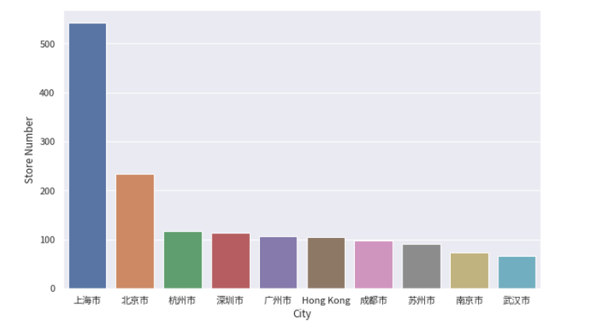

**Figure 4 Top 10 cities with most Starbucks in China**

**4.3 Starbucks in Shanghai**

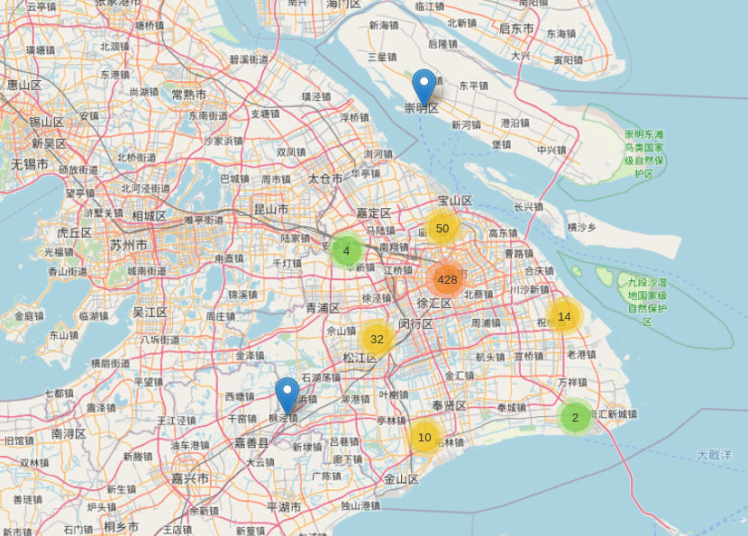

**Figure 5 Starbucks in Shanghai**

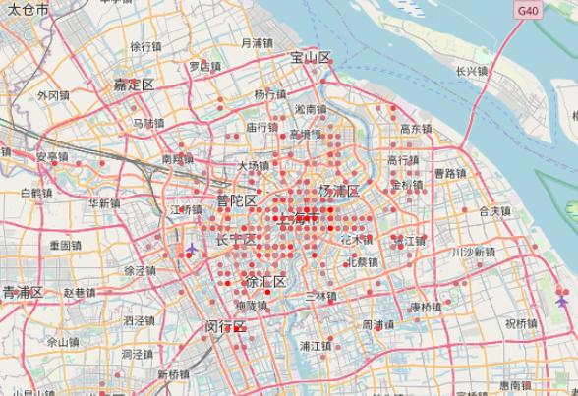

**Figure 6 Starbucks Expansion History in Shanghai**

Figure 5 shows how Starbucks are distributed in Shanghai. Starbucks in Shanghai mostly located at the very center of the city while only a small amount of Starbucks at the peripheral area.

Figure 6 plot the expansion history of Starbucks. According to their stores’ number, we can figure out when the store is set up. The color more close to red means the store is older, the color more close to light blue means the store is younger. Starbucks in Shanghai also started from the very center of the city and expanded to other areas.

**5. Conclusion**

In this project, I analyzed how Starbucks are distributed worldwide and in China. Conclusion1 is Starbucks are usually opened in the most prosperous countries and cities in the world. It shows that Starbucks opens mostly at US, UK, Canada etc, mostly in the big city or capital like Shanghai, Seoul, Beijing, New York, London etc.

Conclusion two is China's economic development is very unbalanced. Most of Starbucks opens at the southeastern coastline at the developed cities while most of the city in China have very few Starbucks especially at the northwestern side.

**6.Future Direction**

For unknown reason, Folium library can not display more than five thousands data points. So when if this problem is solved I can explore more about the Starbucks in US. And try to find out more and compare it with Chinese data.

Another thing is there are relatively little information of the stores attributes such as income, customer numbers etc. If more information is found, together with cities other information. We can deploy some machine learning algorithms and try to find out more insights.