1. Does a.n automatically calculated? If a vector is defined, does it automatically calculate normal and tangent components? Or using Macros a.n will be substituted by: sum a.x*n.x?
2. Embed is cut cell. Multigrid for a channel?

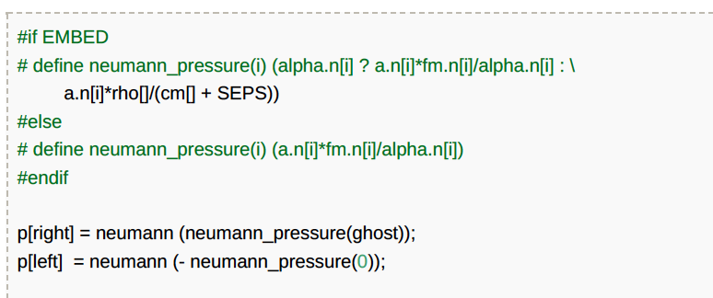

1.2) different viscosity??? Attribute??? (it depends on how I set double or scalar)

1. Note also that using these pre-defined expressions is necessary to obtain automatic homogeneous boundary

conditions, which is important if scalar a is the solution of a Poisson problem.

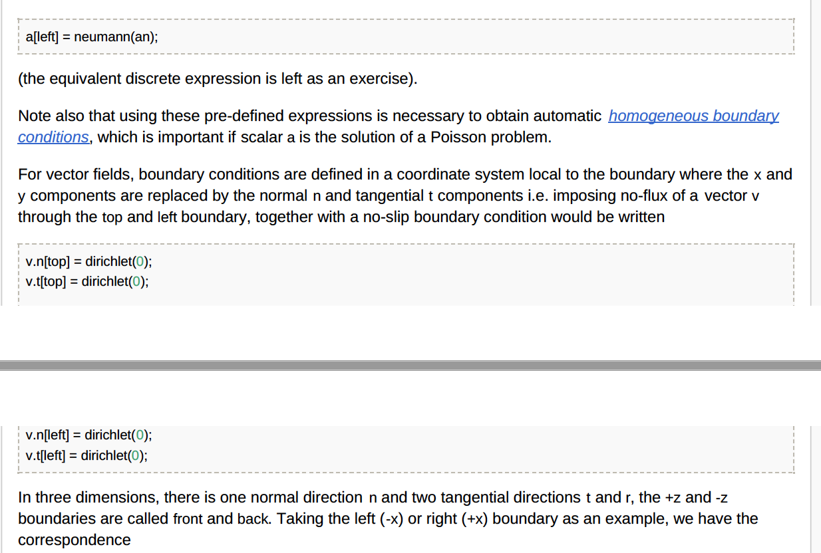

1. 2 Events with the same name. Will be overwritten? No
2. scalar * list1 = {a,v,t}; vector * list2 = {v,t}; Will it be unwrapped? List1={a,v.x,v.y,v.z,t.x.x,t,x,y, ….}
3. boundary_flux ({u}); why?
4. VOV’s approach for embedded BC
5. Attribute is added for all scalars? It is like adding field into a struct?Yes.

Attribute add to all scalars, it is cheaper to keep pointer, allocate memory in somewhere else, and associate them together. scalar df, scalar df[].

1. (const) face vector mu = zerof, a = zerof, alpha = unityf; (const) scalar rho = unity;

face vector alphav[];

scalar rhov[];

event defaults (i = 0) {

alpha = alphav;

rho = rhov;

If the viscosity is non-zero, we need to allocate the face-centered viscosity field.

if (mu1 || mu2)

mu = new face vector;

if (alpha.x.i == unityf.x.i) {

alpha = fm;

rho = cm;

}

else if (!is_constant(alpha.x)) {

face vector alphav = alpha;

foreach_face()

alphav.x[] = fm.x[];

boundary ((scalar *){alpha});

**как работают unityf, .i is_constant?**

1. 2phase_mask does not work ordinary vtk output.
2. Error in *.pvtu
3. **I refined grid and used mask, what happened with data does it eliminate points which are inside of mask? Yes, Refined => Circle mask.**
4. **Metric reason? Why it is so helpful. Axi.h, navier-stokes/centered.h**
5. Embedded boundary. Do points inside a solid deleted from array?
6. Requirements for solver, numerical scheme
7. Contact.h
8. Surface-tension+contact.h. It does not work with embedded boundary
9. Conservative formulation of surface tension force
10. Abu popinet 2018 new formulation of surface tension effects
11. Phase change Cecile Lalanne & Jose-Marina Fullana
12. Embedded boundaries would ensure more precise conditions Alexander Limare, Christophe Josserand
13. Interpretation/visualization of VOF? How 1 cells?
14. Three phase-flow? How does it work?
15. OpenMp, which parameters is good, how many points per processors are good?
16. When and what will be in the new version of Embedded Boundary module? Which limitations will be still?
17. Why not c++
18. Paraview. Oystean output_vtu_bin_foreach
19. Prinston, APS or XIANTO July
20. W.Aniszewski, S.Zaleski film formation. 3D simulations. Contact angles? Airknif? No solid. No mask. Application? Paper Planar Jet Stripping of Liquid Coating Numerical Studies. Arxiv.
21. Evgeniya Korsukova, Stratified Flow in a Horizontal Channel, University of Nottingham, Turbulance Damping is bad for wavy film. TDF factor. Gas/liquid
22. Sergio Chibarro, DNS of turbulent bubbly flows, specters etc. 3D simulation of
23. **Rui Wang**, Chunyu Zhang, University of Science and Technology of China   
    Simulation of fluid–structure interaction with **moving** contact line.

**Diffuse-interface-Immersed-Boundary-Method,** Liu &Ding JCP 2015, 2017

**Cahn-Hillard 6 points in interface**

1. Emily Lane, [NIWA](http://niwa.co.nz/) Christchurch, New Zealand   
   A two-layer model for submarine landslide generated tsunamis. Do we know inundation map?Emily/two-layer.h
2. [Radu Cimpeanu](https://www.maths.ox.ac.uk/people/radu.cimpeanu), [Mathematical Institute](https://www.maths.ox.ac.uk/), University of Oxford, United Kingdom   
   *Gerris/Basilisk in an industrial context: (drop) impact in aeronautics. Aircraft through the cloud. Drop->solid->blow-off. Flow goes up after collision of 2 spheres. 2 drops is not a drop and solid. Contact angles does it implemented?*
3. [Muhammad Saeed Saleem](http://icam.xjtu.edu.cn/info/1008/1161.htm), [International Center for Applied Mechanics (ICAM)](http://icam.xjtu.edu.cn/), Xi’an Jiaotong University (XJTU), China   
   *Drop impact formed vortex ring.*
4. Øystein Lande, DNV GL, Norway   
   Basilisk from an industrial perspective: Wave loading on offshore structures. Differences AMR and Octree/Wavelets?Which method give you the best results?
5. Saouchi toufik

[saouchi.toufik@gmail.com](mailto:saouchi.toufik@gmail.com)

toufik.saouchi@dalembert.upmc.fr

Best practices:

1. kinetic energy for liquid and gas(normalised)?
2. Averaging of results?
3. Export performance curve
4. Part of problem in 2D(difficult part), other part in 3D(easy part)

55

Limitations:

Cartetsion mesh-> adaptive. 6x6 NO. because BC