Jonathan Kimbell

Problem 8

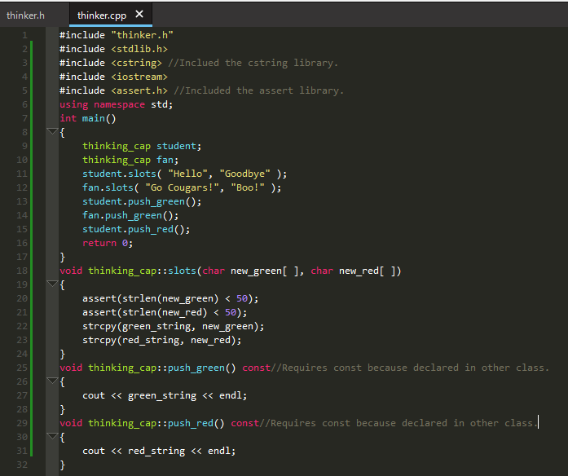

The correct libraries had to be added otherwise the program doesn’t know how to handle the assert syntax or strlen and strcpy.

As well had to change push_green and push_red to constants because they were declared as such in the other class.