

Safety Plan Lane Assistance

**Document Version: [Version]**

**Template Version 1.0, Released on 2017-06-21**



# Document history

|  |  |  |  |
| --- | --- | --- | --- |
| Date | Version | Editor | Description |
| 2018.06.06 | 1.0 | Frank . W | First version |
|  |  |  |  |
|  |  |  |  |
|  |  |  |  |
|  |  |  |  |

# 

# Table of Contents

Document history

Table of Contents

Introduction

Purpose of the Safety Plan

Scope of the Project

Deliverables of the Project

Item Definition

Goals and Measures

Goals

Measures

Safety Culture

Safety Lifecycle Tailoring

Roles

Development Interface Agreement

Confirmation Measures

# Introduction

## Purpose of the Safety Plan

The purpose of safety plan is to provide an overall framework for functional safety and to assign roles and responsibilities for functional safety of this item.

## Scope of the Project

For the lane assistance project, the following safety lifecycle phases are in scope:

Concept phase

Product Development at the System Level

Product Development at the Software Level

The following phases are out of scope:

Product Development at the Hardware Level

Production and Operation

## Deliverables of the Project

The deliverables of the project are:

Safety Plan

Hazard Analysis and Risk Assessment

Functional Safety Concept

Technical Safety Concept

Software Safety Requirements and Architecture

# 

# Item Definition

The lane assistance item is used to help drivers to keep vehicles in a certain lane. The system uses a camera to identify the lane boundaries. When the system detects a small distance between vehicles and lane lines unintentionally, it will alert the driver and try to keep vehicles in current lane.

The Lane Assistance System will have two functions:

1. Lane departure warning

When camera detects a small distance between vehicles and lane lines, this function shall apply an oscillating steering torque to provide the driver a haptic feedback.

1. Lane keeping assistance

When camera detects a small distance between vehicles and lane lines, this function shall apply the steering torque when active in order to stay in ego lane.

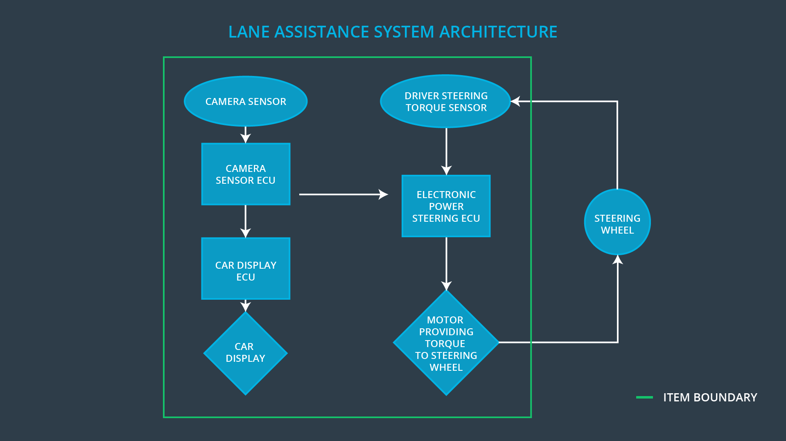

We can see from the above picture that the item boundary was drawn to include three sub-systems:

(1) Camera system;

(2) Electronic Power Steering system;

(3) Car Display system.

When the camera senses that the vehicle is leaving the lane, the camera sends a signal to the electronic power steering system asking to turn and vibrate the steering wheel.

The camera sensor will also request that a warning light turn on in the car display dashboard. That way the driver knows that the lane assistance system is active.

# Goals and Measures

## Goals

The goal of the project is that according to ISO26262 standard, finding the possible risk of the lane assistance item, and assessing the ASIL level of the risk, then taking the system engineering measures to reduce the risk to the acceptable level.

## Measures

|  |  |  |
| --- | --- | --- |
| Measures and Activities | Responsibility | Timeline |
| Follow safety processes | All Team Members | Constantly |
| Create and sustain a safety culture | All Team Members | Constantly |
| Coordinate and document the planned safety activities | Safety Manager | Constantly |
| Allocate resources with adequate functional safety competency | Project Manager | Within 2 weeks of start of project |
| Tailor the safety lifecycle | Safety Manager | Within 4 weeks of start of project |
| Plan the safety activities of the safety lifecycle | Safety Manager | Within 4 weeks of start of project |
| Perform regular functional safety audits | Safety Auditor | Once every 2 months |
| Perform functional safety pre-assessment prior to audit by external functional safety assessor | Safety Manager | 3 months prior to main assessment |
| Perform functional safety assessment | Safety Assessor | Conclusion of functional safety activities |

# Safety Culture

High priority:

Safety has the highest priority among competing constraints like cost and productivity;

Accountability:

Processes ensure accountability such that design decisions are traceable back to the people and teams who made the decisions;

Rewards:

The organization motivates and supports the achievement of functional safety;

Penalties:

The organization penalizes shortcuts that jeopardize safety or quality;

Independence:

Teams who design and develop a product should be independent from the teams who audit the work;

Well defined processes:

Company design and management processes should be clearly defined;

Resources:

Projects have necessary resources including people with appropriate skills;

Diversity:

Intellectual diversity is sought after, valued and integrated into processes;

Communication:

Communication channels encourage disclosure of problems.

# 

# Safety Lifecycle Tailoring

According to requirement of the project, the ISO 26262 standard process has been tailored.

The following phases are in scope:

1. Concept phase;
2. Product Development at the System Level;
3. Product Development at the Software Level.

The following phases are out of scope:

(1) Product Development at the Hardware Level;

(2) Production and Operation.

# 

# Roles

|  |  |
| --- | --- |
| Role | Org |
| Functional Safety Manager- Item Level | OEM |
| Functional Safety Engineer- Item Level | OEM |
| Project Manager - Item Level | OEM |
| Functional Safety Manager- Component Level | Tier-1 |
| Functional Safety Engineer- Component Level | Tier-1 |
| Functional Safety Auditor | OEM or external |
| Functional Safety Assessor | OEM or external |

# 

# Development Interface Agreement

A DIA (development interface agreement) defines the roles and responsibilities between companies involved in developing a product. All involved parties need to agree on the contents of the DIA before the project begins.

The DIA also specifies what evidence and work products each party will provide to prove that work was done according to the agreement.

The ultimate goal is to ensure that all parties are developing safe vehicles in compliance with ISO 26262.

In this project, the responsibilities of the OEM are listed as the following:

1. appointing a safety manager;
2. supplying the functional requirements to Tier-1;
3. supplying the hazards and risks analysis to Tier-1;
4. tailoring of the safety lifecycle with Tier-1;
5. arranging safety audits;
6. arranging final safety assessment.

The responsibilities for the Tier-1 are listed as the following:

(1) appointing a safety manager;

(2) tailoring of the safety lifecycle with OEM;

(3) analyzing and implementing the functional requirements;

(4) analyzing and implementing the functional safety requirements;

(5) supplying the final product to OEM on schedule.

# 

# Confirmation Measures

Confirmation measures serve two purposes:

1. ensure that a functional safety project conforms to ISO 26262;
2. ensure that project really does make the vehicle safer.

### Confirmation Measures Definitions

##### Confirmation review

Ensures that the project complies with ISO 26262. As the product is designed and developed, an independent person would review the work to make sure ISO 26262 is being followed.

##### Functional safety audit

Checking to make sure that the actual implementation of the project conforms to the safety plan is called a functional safety audit.

##### Functional safety assessment

Confirming that plans, designs and developed products actually achieve functional safety is called a functional safety assessment.

A safety plan could have other sections that we are not including here. For example, a safety plan would probably contain a complete project schedule.

There might also be a "Supporting Process Management" section that would cover "Part 8: Supporting Processes" of the ISO 26262 functional safety standard. This would include descriptions of how the company handles requirements management, change management, configuration management, documentation management, and software tool usage and confidence.

Similarly, a confirmation measures section would go into more detail about how each confirmation will be carried out.