

Technical Safety Concept Lane Assistance

**Document Version: [Version]**

**Template Version 1.0, Released on 2017-06-21**



# Document history

|  |  |  |  |
| --- | --- | --- | --- |
| Date | Version | Editor | Description |
| 2018/06/10 | 1.0 | Frank . W | First Version |
|  |  |  |  |
|  |  |  |  |
|  |  |  |  |
|  |  |  |  |

# 

# Table of Contents

Document history

Table of Contents

Purpose of the Technical Safety Concept

Inputs to the Technical Safety Concept

Functional Safety Requirements

Refined System Architecture from Functional Safety Concept

Functional overview of architecture elements

Technical Safety Concept

Technical Safety Requirements

Refinement of the System Architecture

Allocation of Technical Safety Requirements to Architecture Elements

Warning and Degradation Concept

# Purpose of the Technical Safety Concept

Given the functional safety requirements, deriving technical safety requirements based on system architecture, determining the property of technical safety requirements such as ASIL, fault tolerant time interval, and safe state as well as verification and validation acceptance criteria, then refining the system architecture and allocating requirements, finally, defining warning and degradation concept.

# Inputs to the Technical Safety Concept

## Functional Safety Requirements

|  |  |  |  |  |
| --- | --- | --- | --- | --- |
| **ID** | **Functional Safety Requirement** | **ASIL** | **Fault Tolerant Time Interval** | **Safe State** |
| Functional  Safety  Requirement  01-01 | The electronic power steering ECU shall ensure that the lane departure oscillating torque amplitude is below“Max_Torque_Amplitude” | C | 50ms | Set vibration torque amplitude to 0 |
| Functional  Safety  Requirement  01-02 | The electronic power steering ECU shall ensure that the lane departure oscillating torque frequency is below “Max_Torque_Frequency” | C | 50ms | Set vibration torque frequency to 0 |
| Functional  Safety  Requirement  02-01 | The electronic power steering ECU shall ensure that the lane keeping assistance torque is applied for only Max_Duration. | B | 500ms | Set lane keeping assistance torque to 0 |

## Refined System Architecture from Functional Safety Concept

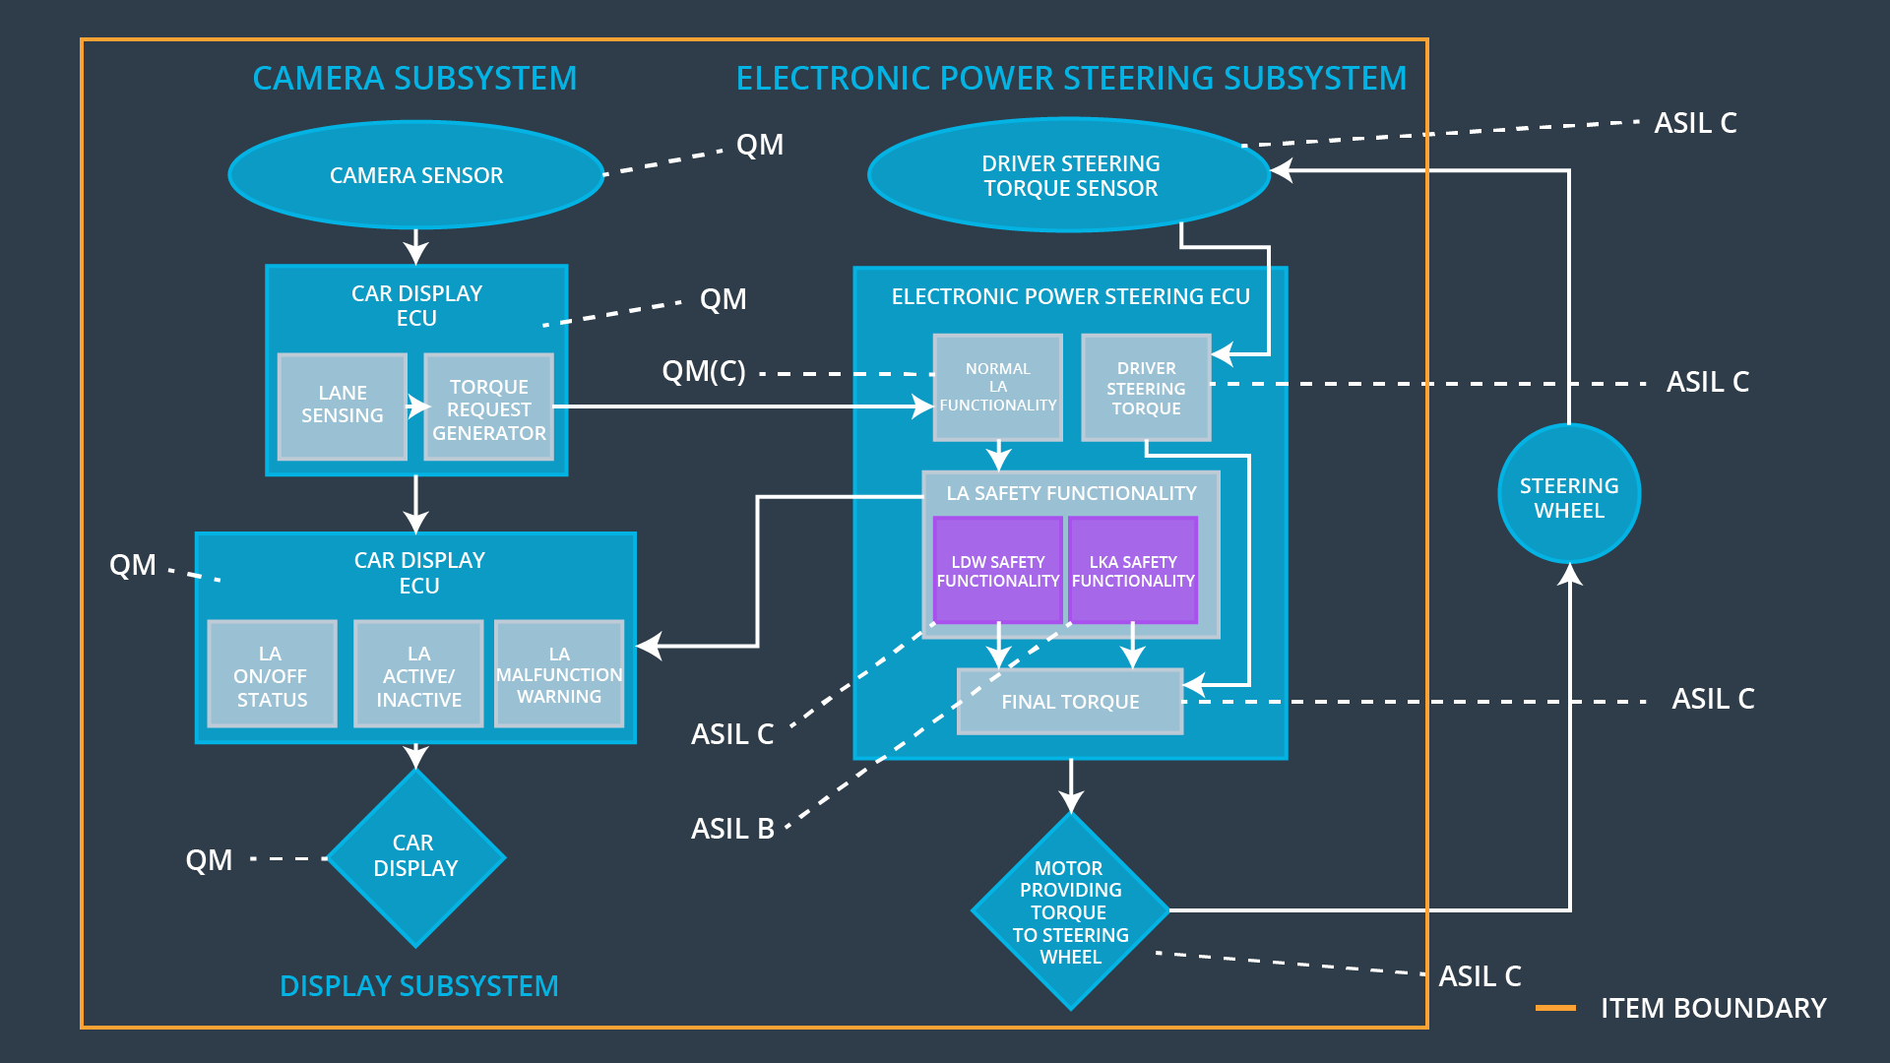

### Functional overview of architecture elements

|  |  |
| --- | --- |
| **Element** | **Description** |
| Camera Sensor | Transform ambient information into digital images and send them to Camera Sensor ECU. |
| Camera Sensor ECU - Lane Sensing | Detect lane line from digital images send by Camera Sensor. |
| Camera Sensor ECU - Torque request generator | Calculate the vehicle position in lane, and generate torque request to EPS. |
| Car Display | Transform the information sent by Car Display ECU into visual signals |
| Car Display ECU - Lane Assistance On/Off Status | Collect Lane Assistance On/Off status information and show the information to the driver by controlling Car Display. |
| Car Display ECU - Lane Assistant Active/Inactive | Collect Lane Assistance Active/Inactive status information and show the information to the driver by controlling Car Display. |
| Car Display ECU - Lane Assistance malfunction warning | Collect Lane Assistance malfunction warning information and show the information to the driver by controlling Car Display. |
| Driver Steering Torque Sensor | Transform the Steering Torque into electrical signal |
| Electronic Power Steering (EPS) ECU - Driver Steering Torque | Calculate the turning direction and torque of the motor according to the steering direction and torque size sent by the Driver Steering Torque Sensor. |
| EPS ECU - Normal Lane Assistance Functionality | Apply an oscillating steering torque to provide the driver a haptic feedback, and apply the steering torque when active in order to stay in ego lane. |
| EPS ECU - Lane Departure Warning Safety Functionality | Ensure that the lane departure oscillating torque amplitude is below“Max_Torque_Amplitude” and ensure that the lane departure oscillating torque frequency is below “Max_Torque_Frequency” |
| EPS ECU - Lane Keeping Assistant Safety Functionality | Ensure that the lane keeping assistance torque is applied for only Max_Duration. |
| EPS ECU - Final Torque | Synthesis difference input and calculate final torque output. |
| Motor | Generate corresponding steering torque according to the instruction from Electronic Power Steering ECU. |

# Technical Safety Concept

## Technical Safety Requirements

**Lane Departure Warning (LDW) Requirements:**

Functional Safety Requirement 01-01 with its associated system elements

(derived in the functional safety concept)

|  |  |  |  |  |
| --- | --- | --- | --- | --- |
| **ID** | **Functional Safety Requirement** | **Electronic Power Steering ECU** | **Camera ECU** | **Car Display ECU** |
| Functional  Safety  Requirement  01-01 | The lane keeping item shall ensure that the lane departure oscillating torque amplitude is below Max_Torque_Amplitude | X |  |  |

Technical Safety Requirements related to Functional Safety Requirement 01-01 are:

|  |  |  |  |  |  |
| --- | --- | --- | --- | --- | --- |
| **ID** | **Technical Safety Requirement** | **ASIL** | **Fault Tolerant Time Interval** | **Architecture Allocation** | **Safe State** |
| Technical  Safety  Requirement  01 | The LDW safety component shall ensure that the amplitude of the 'LDW_Torque_Request' sent to the 'Final electronic power steering Torque' component is below 'Max_Torque_Amplitude. | C | 50 ms | LDW safety software component | the lane departure warning talk request amplitude shall be set to zero |
| Technical  Safety  Requirement  02 | As soon as the LDW function deactivates the LDW feature, the 'LDW Safety' software block shall send a signal to the car display ECU to turn on a warning light. | C | 50 ms | LDW safety software component | the lane departure warning talk request amplitude shall be set to zero |
| Technical  Safety  Requirement  03 | As soon as a failure is detected by the LDW function, it shall deactivate the LDW feature and the 'LDW_Torque_Request' shall be set to zero. | C | 50 ms | LDW safety software component | the lane departure warning talk request amplitude shall be set to zero |
| Technical  Safety  Requirement  04 | The validity and integrity of the data transmission for 'LDW_Torque_Request' signal shall be ensured. | C | 50 ms | Data Transmission Integrity Check | N/A |
| Technical  Safety  Requirement  05 | Memory test shall be conducted at start up of the EPS ECU to check for any faults in memory. | A | ignition cycle | Memory Test | the lane departure warning talk request amplitude shall be set to zero |

Functional Safety Requirement 01-2 with its associated system elements

(derived in the functional safety concept)

|  |  |  |  |  |
| --- | --- | --- | --- | --- |
| **ID** | **Functional Safety Requirement** | **Electronic Power Steering ECU** | **Camera ECU** | **Car Display ECU** |
| Functional  Safety  Requirement  01-02 | The lane keeping item shall ensure that the lane departure oscillating torque frequency is below Max_Torque_Frequency | X |  |  |

Technical Safety Requirements related to Functional Safety Requirement 01-02 are:

|  |  |  |  |  |  |
| --- | --- | --- | --- | --- | --- |
| **ID** | **Technical Safety Requirement** | **ASIL** | **Fault Tolerant Time Interval** | **Architecture Allocation** | **Safe State** |
| Technical  Safety  Requirement  01 | The LDW safety component shall ensure that the frequency of the 'LDW_Torque_Request' sent to the 'Final electronic power steering Torque' component is below ' Max_Torque_Frequency'. | C | 50 ms | LDW safety software component | the lane departure warning talk request amplitude shall be set to zero |
| Technical  Safety  Requirement  02 | As soon as the LDW function deactivates the LDW feature, the 'LDW Safety' software block shall send a signal to the car display ECU to turn on a warning light. | C | 50 ms | LDW safety software component | the lane departure warning talk request amplitude shall be set to zero |
| Technical  Safety  Requirement  03 | As soon as a failure is detected by the LDW function, it shall deactivate the LDW feature and the 'LDW_Torque_Request' shall be set to zero. | C | 50 ms | LDW safety software component | the lane departure warning talk request amplitude shall be set to zero |
| Technical  Safety  Requirement  04 | The validity and integrity of the data transmission for 'LDW_Torque_Request' signal shall be ensured. | C | 50 ms | Data Transmission Integrity Check | N/A |
| Technical  Safety  Requirement  05 | Memory test shall be conducted at start up of the EPS ECU to check for any faults in memory. | A | ignition cycle | Memory Test | the lane departure warning talk request amplitude shall be set to zero |

**Lane Keeping Assistance (LKA) Requirements:**

Functional Safety Requirement 02-1 with its associated system elements

(derived in the functional safety concept)

|  |  |  |  |  |
| --- | --- | --- | --- | --- |
| **ID** | **Functional Safety Requirement** | **Electronic Power Steering ECU** | **Camera ECU** | **Car Display ECU** |
| Functional  Safety  Requirement  02-01 | The lane keeping item shall ensure that the lane keeping assistance torque is applied for only Max_Duration | X |  |  |

Technical Safety Requirements related to Functional Safety Requirement 02-01 are:

|  |  |  |  |  |  |
| --- | --- | --- | --- | --- | --- |
| **ID** | **Technical Safety Requirement** | **ASIL** | **Fault Tolerant Time Interval** | **Allocation to Architecture** | **Safe State** |
| Technical  Safety  Requirement  01 | The LKA safety component shall ensure that the torque of the 'LKA_Torque_Request' sent to the 'Final electronic power steering Torque' component is applied for only 'Max_Duration '. | B | 500 ms | LKA safety software component | Set lane keeping assistance torque to 0 |
| Technical  Safety  Requirement  02 | As soon as the LKA function deactivates the LKA feature, the LKA Safety' software block shall send a signal to the car display ECU to turn on a warning light. | B | 500 ms | LKA safety software component | Set lane keeping assistance torque to 0 |
| Technical  Safety  Requirement  03 | As soon as a failure is detected by the LKA function, it shall deactivate the LKA feature and the LKA _Torque_Request' shall be set to zero. | B | 500 ms | LKA safety software component | t Set lane keeping assistance torque to 0 |
| Technical  Safety  Requirement  04 | The validity and integrity of the data transmission for LKA _Torque_Request' signal shall be ensured. | B | 500 ms | Data Transmission Integrity Check | N/A |
| Technical  Safety  Requirement  05 | Memory test shall be conducted at start up of the EPS ECU to check for any faults in memory. | A | ignition cycle | Memory Test | Set lane keeping assistance torque to 0 |

## Refinement of the System Architecture

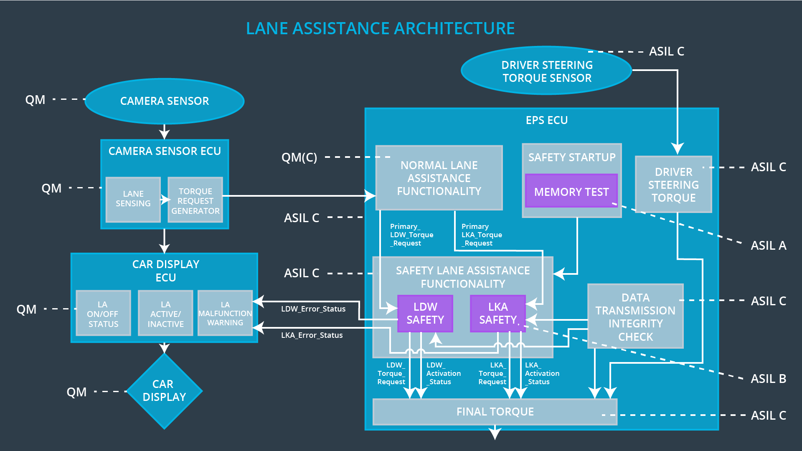

## Allocation of Technical Safety Requirements to Architecture Elements

All technical safety requirements are allocated to the Electronic Power Steering ECU.

## Warning and Degradation Concept

|  |  |  |  |  |
| --- | --- | --- | --- | --- |
| **ID** | **Degradation Mode** | **Trigger for Degradation Mode** | **Safe State invoked?** | **Driver Warning** |
| WDC-01 | Turn off LDW  function. | Functional Safety Requirement 01-01 /  Functional Safety Requirement 01-02 | Yes | Blink light on car display |
| WDC-02 | Turn off LKA  function. | Functional Safety Requirement 02-01 | Yes | Blink light on car display |