**Part 1:**

1. From the left to right column in the picture below, the first column in the processors tab contains all the running programs and applications running on the computer.
   1. The third column counting from the left in the processors tab shows how much memory is used. The 71% shown above the memory column is the total physical memory used by active processors. The yellow cells under the memory column show how much memory each application is using. Memory tab under the performance tab shows the memory usage which is related to Random Access Memory (RAM). RAM is the fastest way to store temporary data and to retrieve it if required. RAM is not permanent and will be lost as soon as the computer is shut down. RAM is part of memory and if it’s full, the computer will turn to disk and will respond slower than usual as disk is located further away from CPU compared to RAM. Disk is hard drive memory.
   2. The second column counting from the left in the processors tab shows the CPU usage. The 43% shown above the CPU column is the total processor utilisation across all the 8 cores this laptop has. The yellow cells under the CPU column show the percentage of processor activity falls under each application. The CPU tab under the performance tab shows CPU utilisation percentage. When an application is just starting to run, the CPU usage would be high, the graph shown in that tab will increase and peak then decrease as it will initially use more processors temporarily to start the application as shown in the sixth cell under the CPU column when I screenshotted the screen when I opened the application. Processors will retrieve and use certain information and data stored in RAM to execute specific programs so if more programs are opened, processor activity will rise and memory usage will increase due to more information and data being stored in RAM.
2. I did not expect to find Client Session Agent to be running as a background processor. Client Session Agent is part of Trend Micro Anti-Malware Solution Platform which is under an application I have installed called Trend Micro Maximum Security which is an antivirus software that also provides protection for my computer against evolving malware infections and threats. Trend Micro Maximum Security protects my computer from ransomware and potentially harmful websites by blocking access to some suspicious and unsecured websites. Of course if I really want to access these specific websites, I can as there is an option to allow me to do so. Trend Micro Maximum Security will not show any pop-ups notifications on my screen unless it detects suspicious activity from me. Trend Micro Maximum Security also performs regular security scanning on my computer and the files present in the computer to ensure that my computer is malware and threats free. The application will also inform me 5 minutes before their regular scanning to inform the user beforehand but the scanning will not affect the user from using their device. Hence, to perform what the application was designed to do, the application will always be running in the background as soon as the computer is on.
3. Operating systems can easily locate the files for the user in the computer system, so it's user-friendly and the files under the operating system would also need to obey certain rules and reach a certain security threshold for the computer to interact with the specific application. If it was the application itself managing their files themselves, malware attacks could happen anytime and infect the user’s computer which will then expose the user's files and personal information like bank account information.

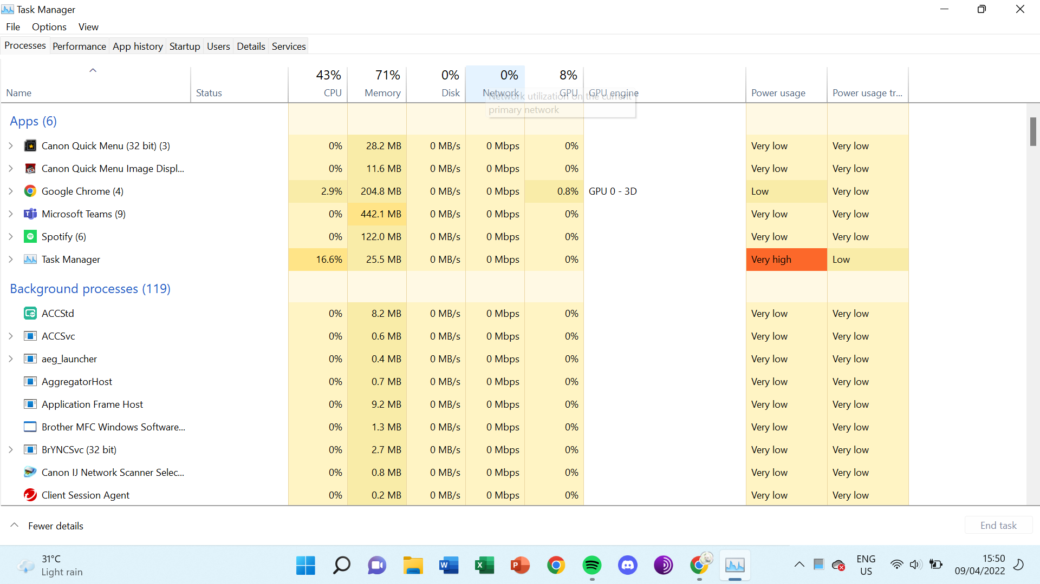

**Part 2:**

Test Case for Task 2.2:

1. String = fOokAiYaN! 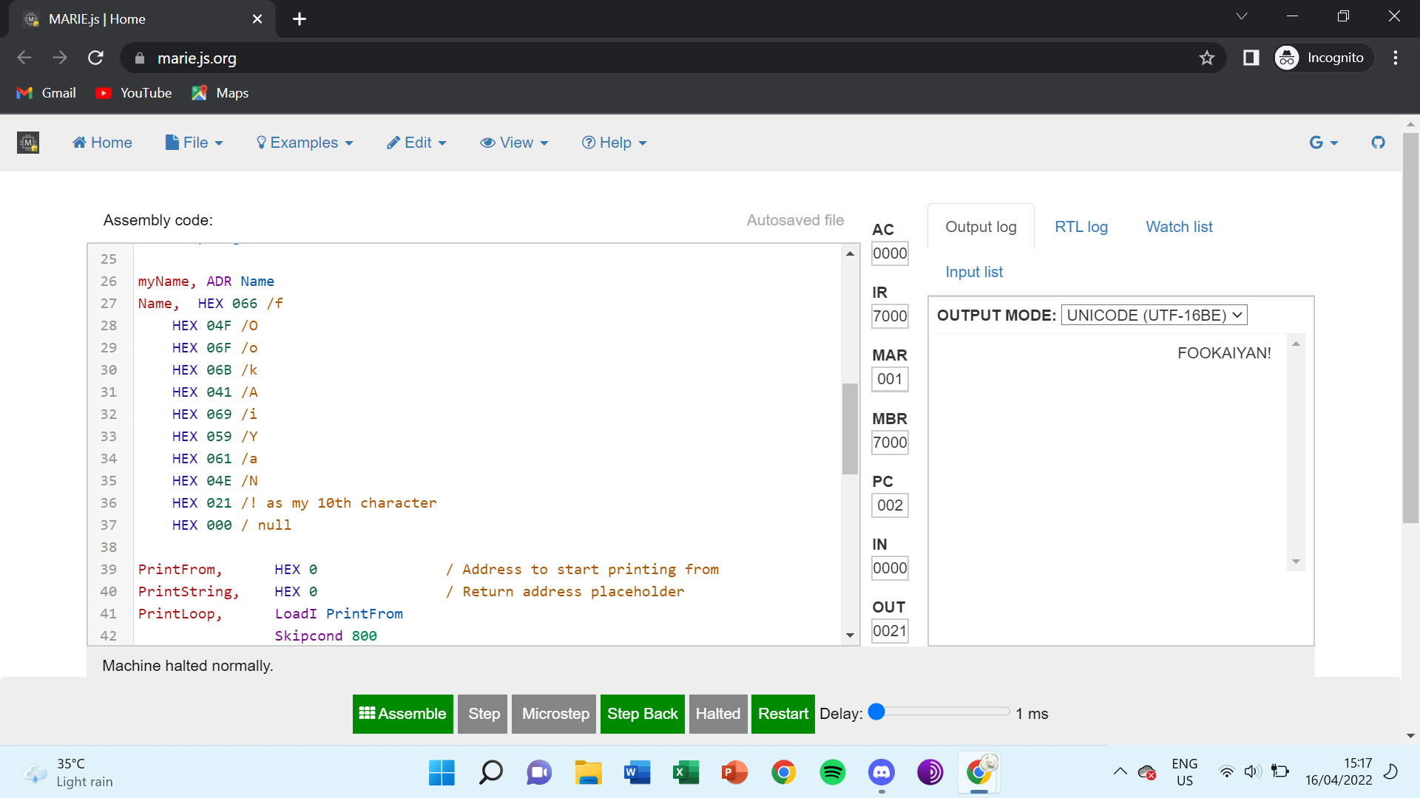

This string tests the Check subroutine on the position of the upper and lower case of characters.

2. String = foOKaIyAn*

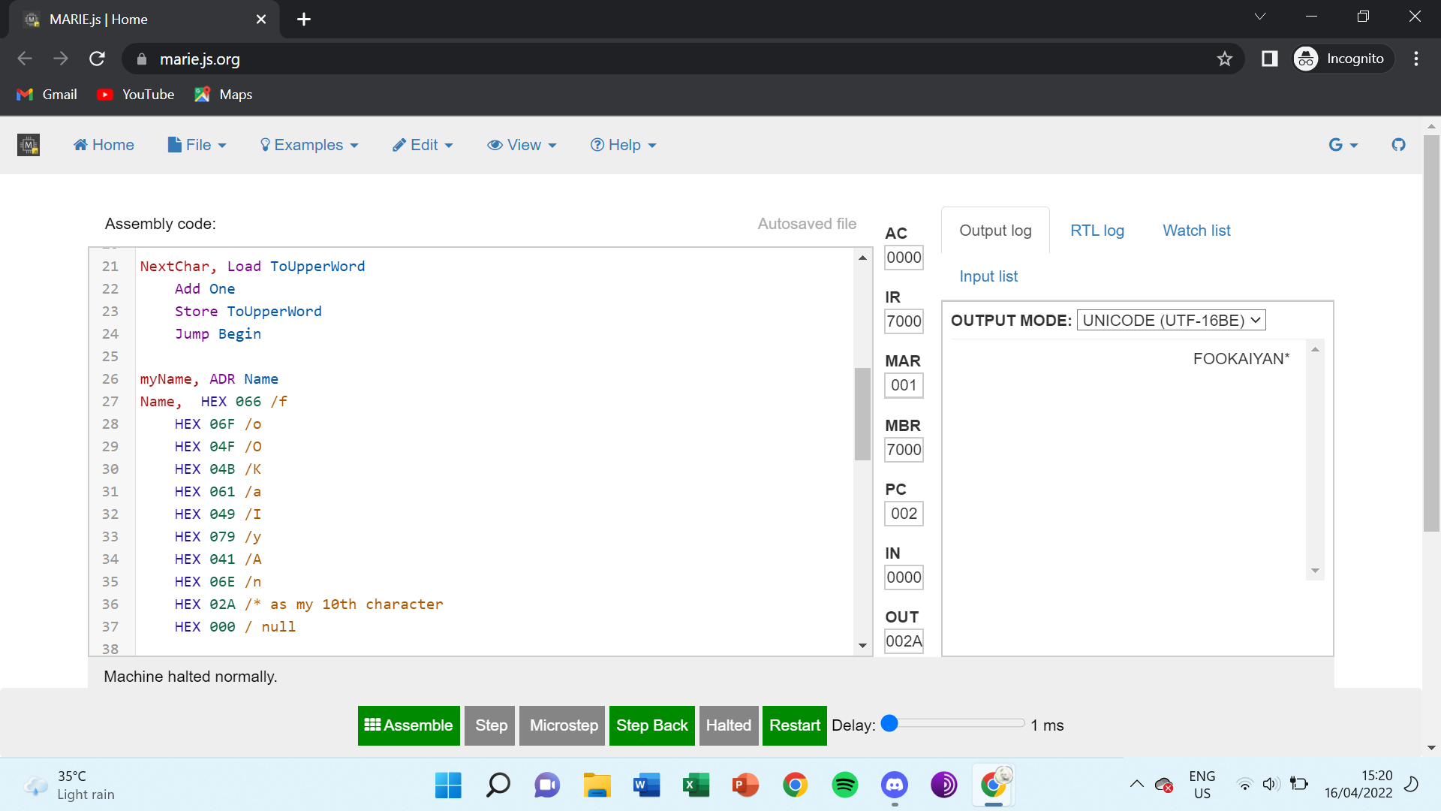

This string tests the Check subroutine on the position of the upper and lower case of characters.

3. String = fOOkAIyAn^

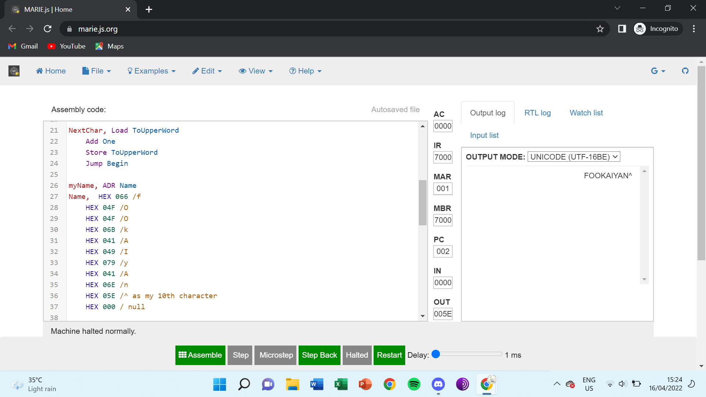

This string tests the Check subroutine on the position of the upper and lower case of characters.

Test Case for Task 2.3:

1. String = blackBear ; Character to be found = B

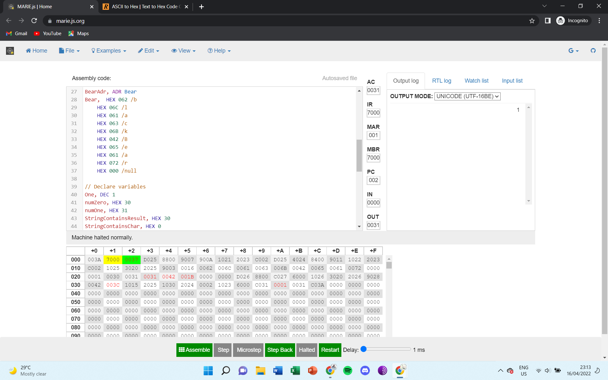

This string tests to see if the lowercase of the character is detected as present or absent and if it will continue on to loop through the characters present in the string to detect the uppercase B.

2. String = Ready? ; Character to be found = r

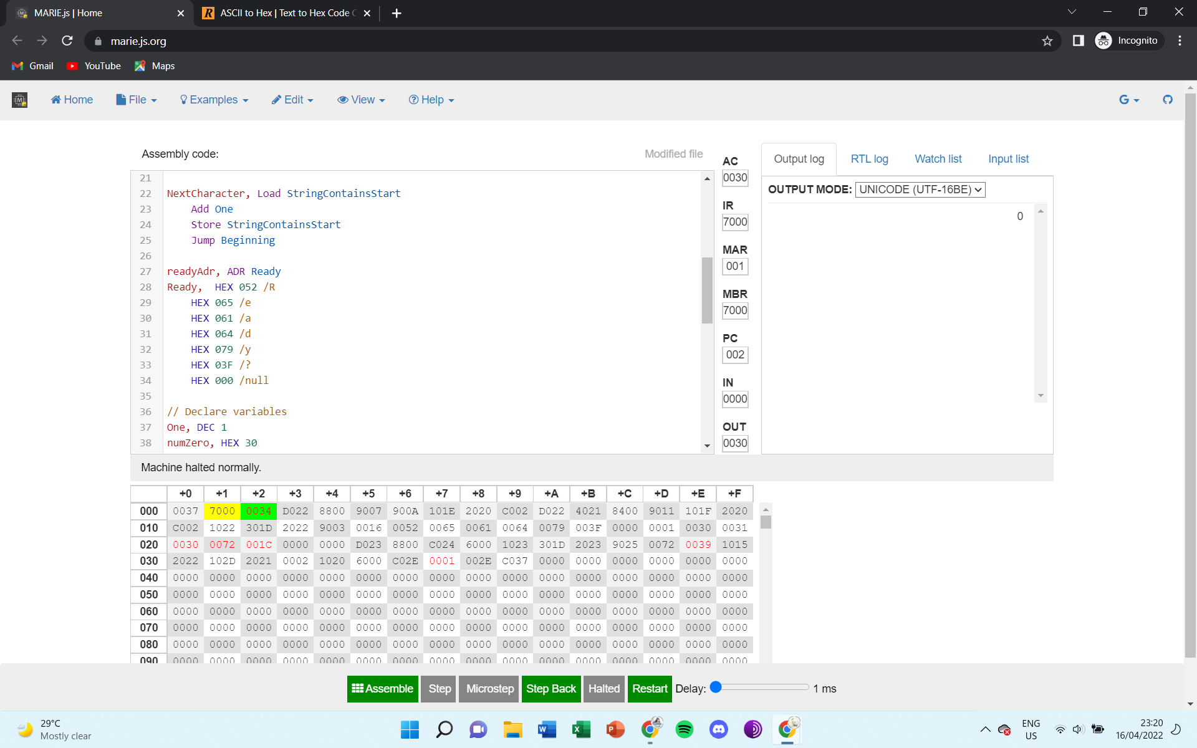

This string tests to see if the uppercase of the character is detected as present or absent.

3. String = OolongTea ; Character to be found = O

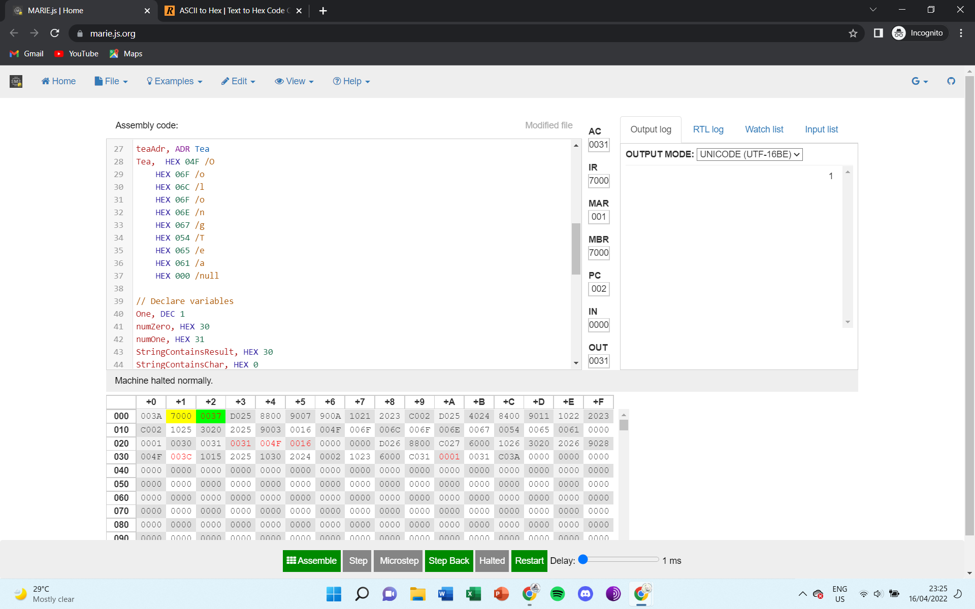

This string tests to see if the character is detected as present or absent and if it will continue on to loop through the characters present in the string.

4. String = Meow ; Character to be found = a

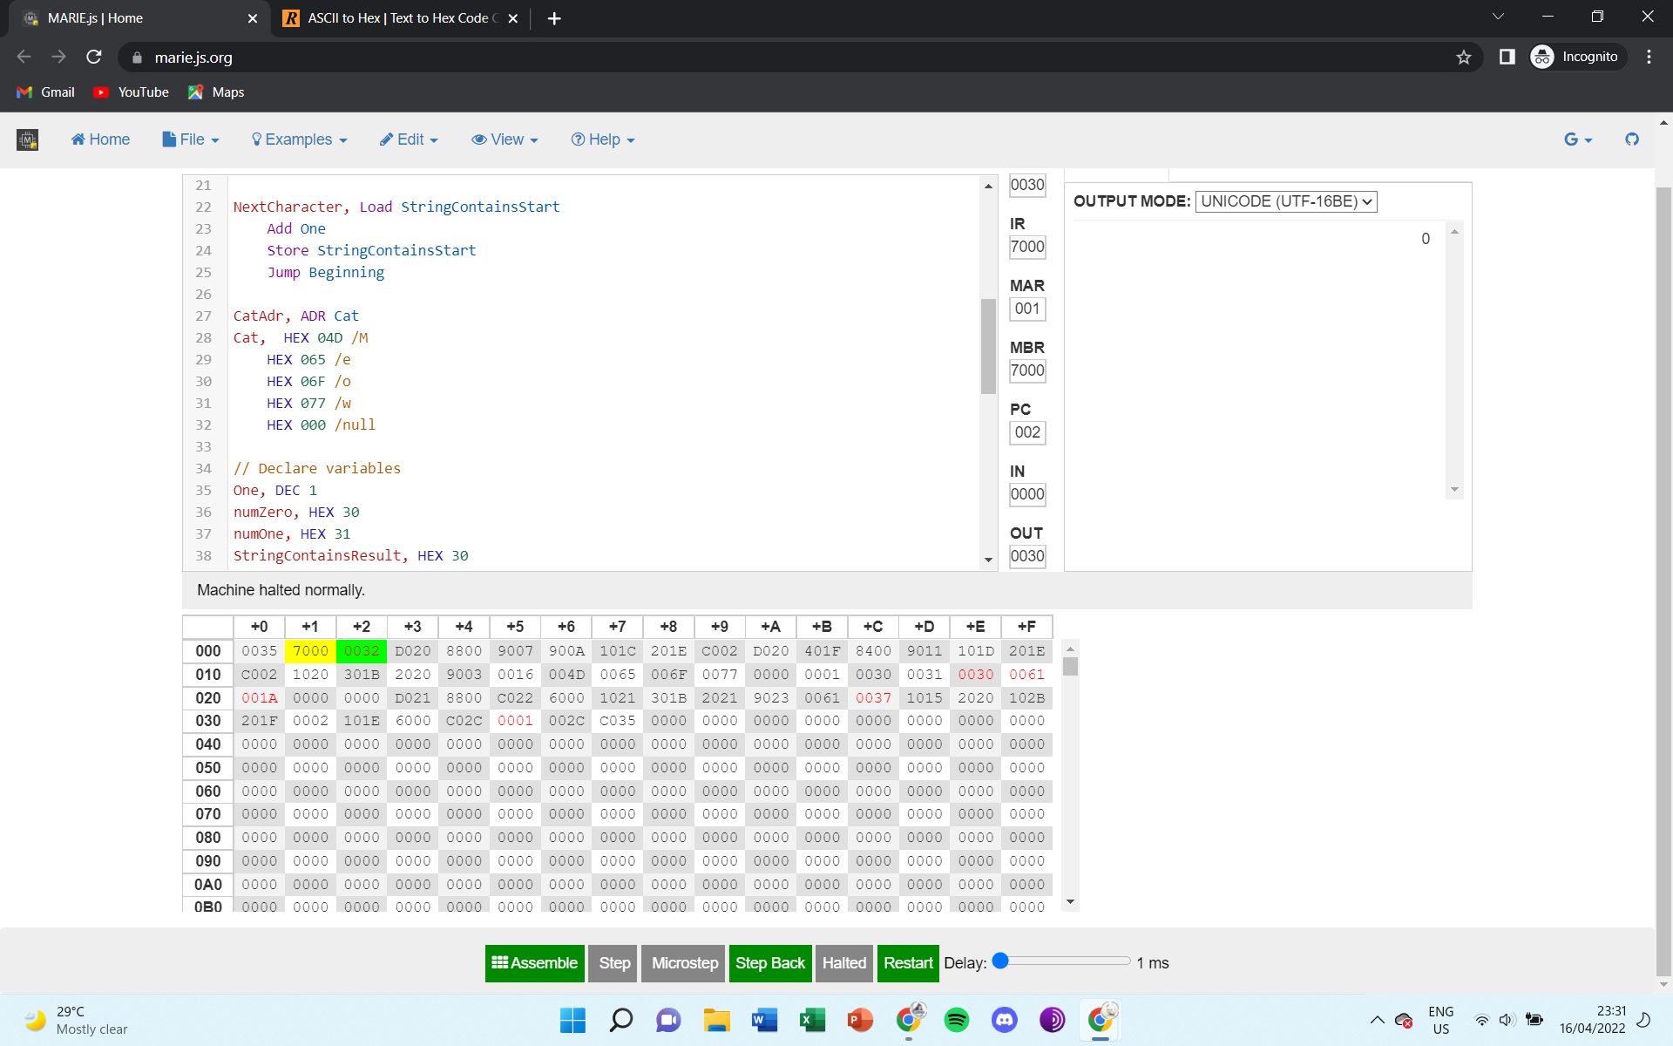

This string tests to see if the checking subroutine can detect a character not found in the string.

Test Case for Task 2.4:

1. Guessed_Word = Cat ; Selected_Word = Words

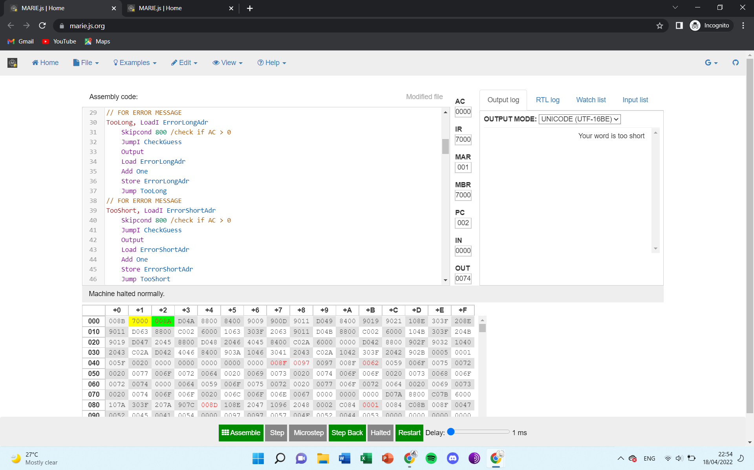

If guessed word shorter than selected work then output “Your word is too short”

2. Guessed_Word = Kitten ; Selected_Word = Words

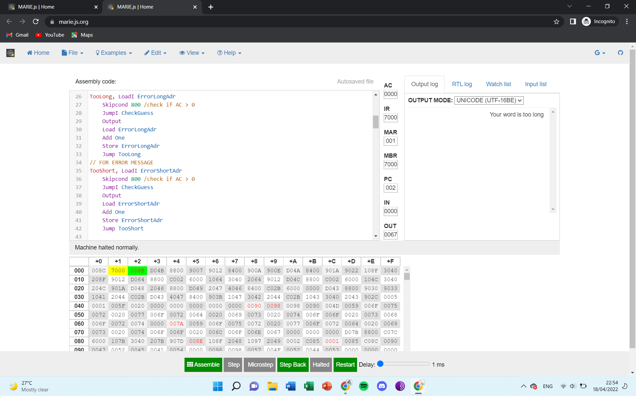

If guessed word longer than selected work then output “Your word is too long”

3. Guessed_Word = Kitten ; Selected_Word = Cat

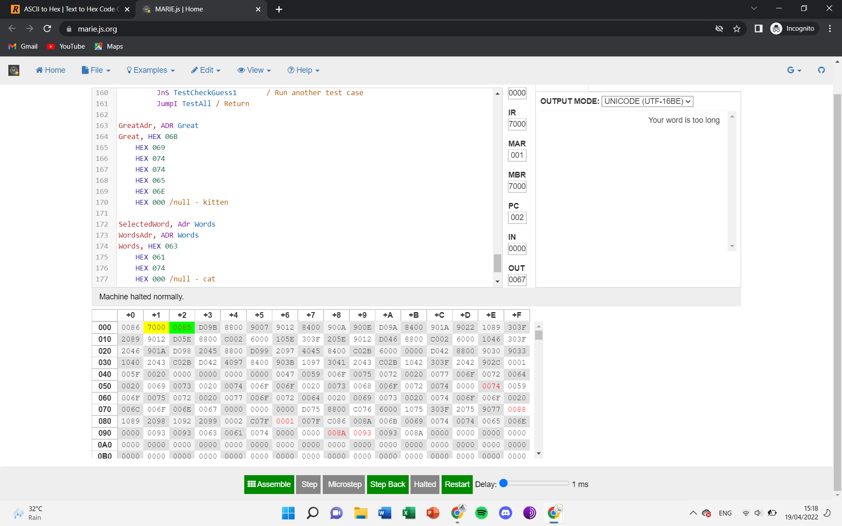

If guessed word longer than selected work then output “Your word is too long”

4. Guessed_Word = Cat ; Selected_Word = Kitten

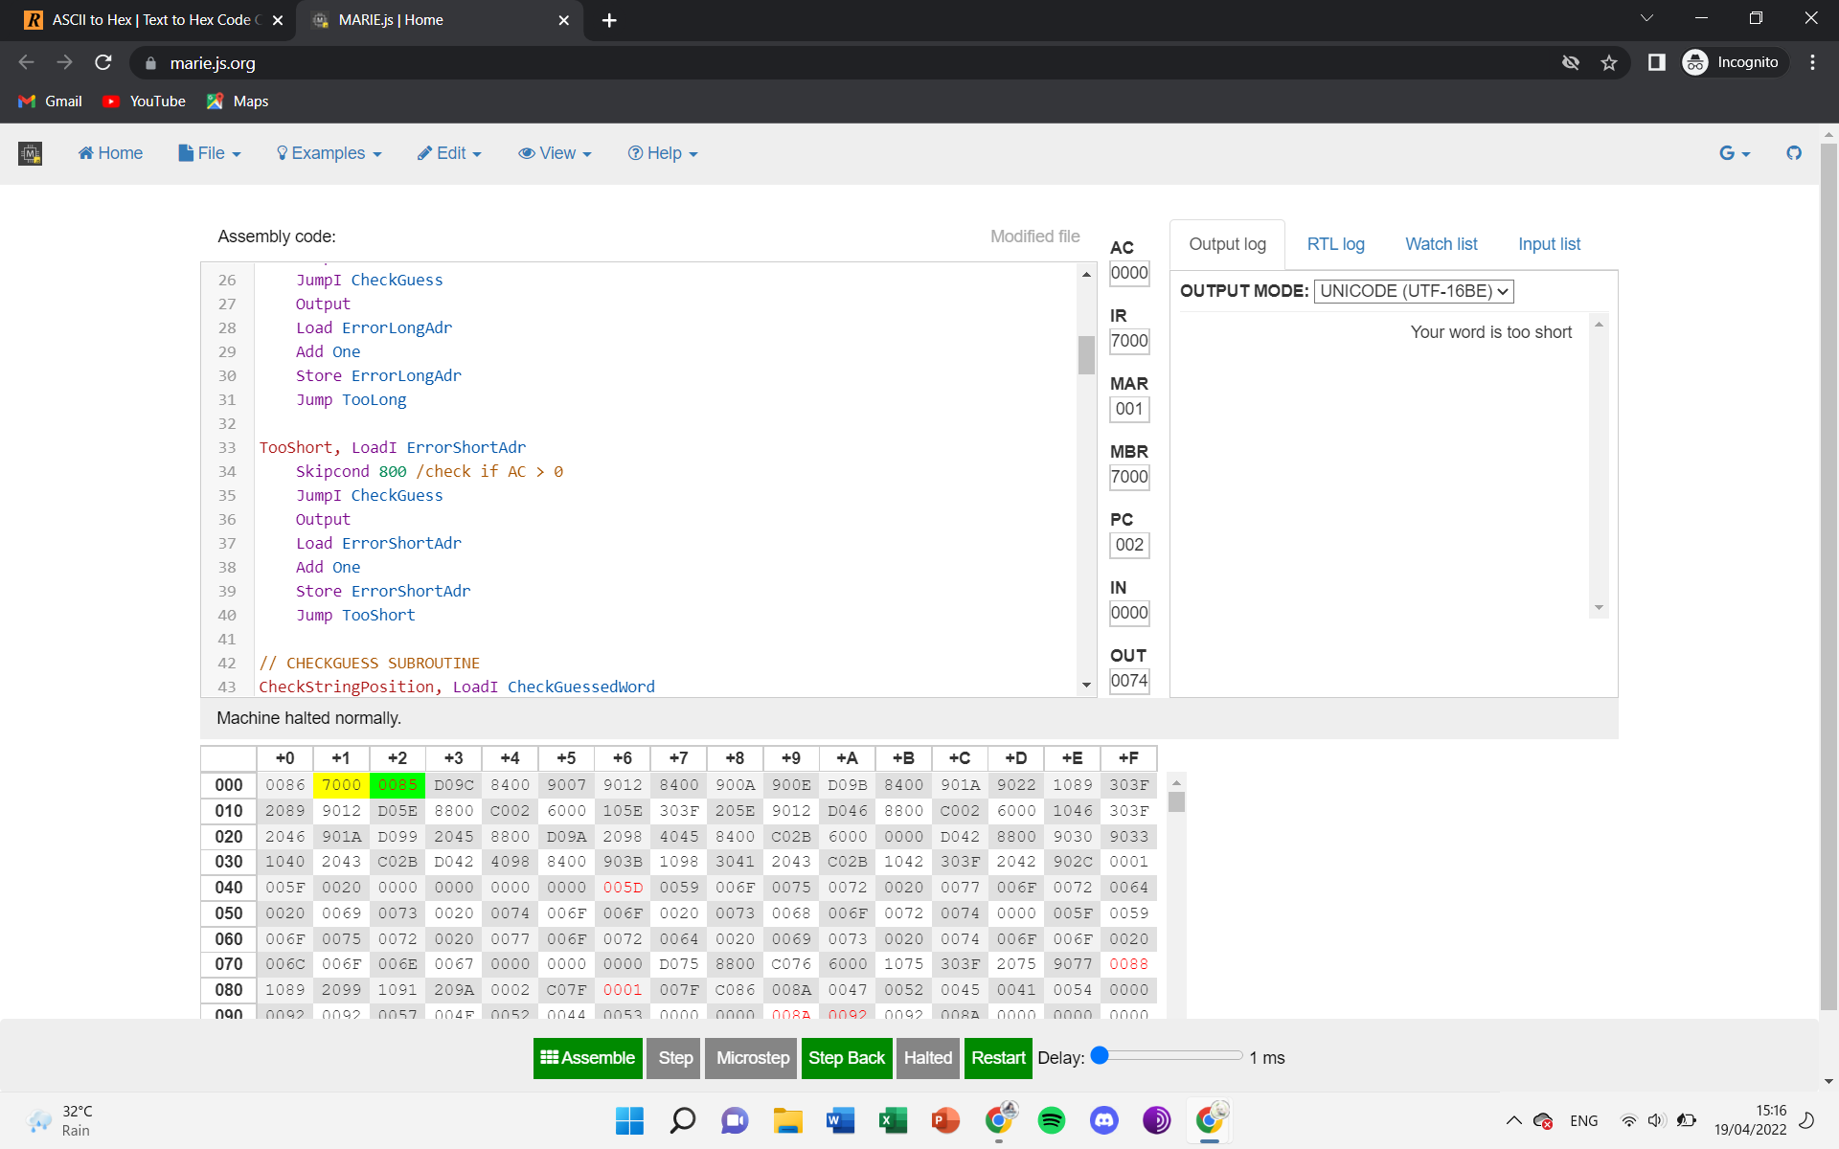

If guessed word shorter than selected work then output “Your word is too short”

5. Guessed_Word = Words ; Selected_Word = Words

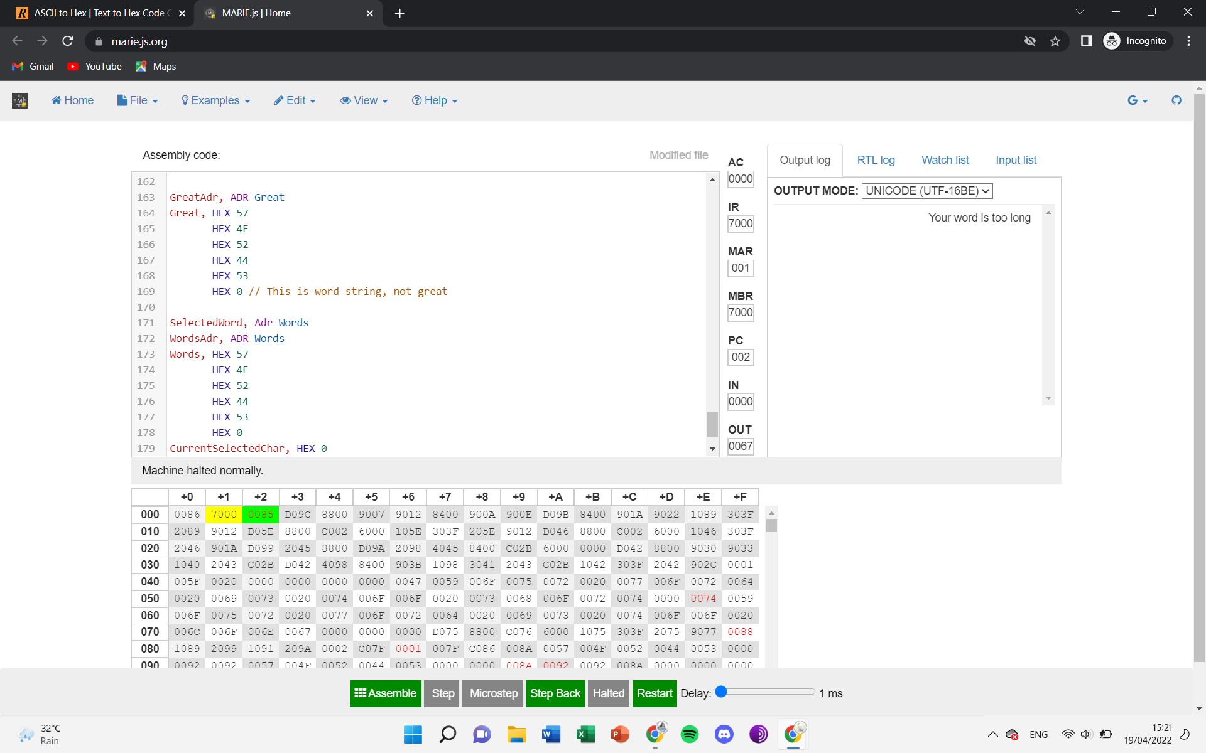

There is something wrong with my 2.4 code where it can only print too long error messages or too short error messages even though both selected-word and guessed-word are the same.

Test Case for Task 2.5:

1. Input_Guessed_Word = Samoyed ; Selected_Word = Words

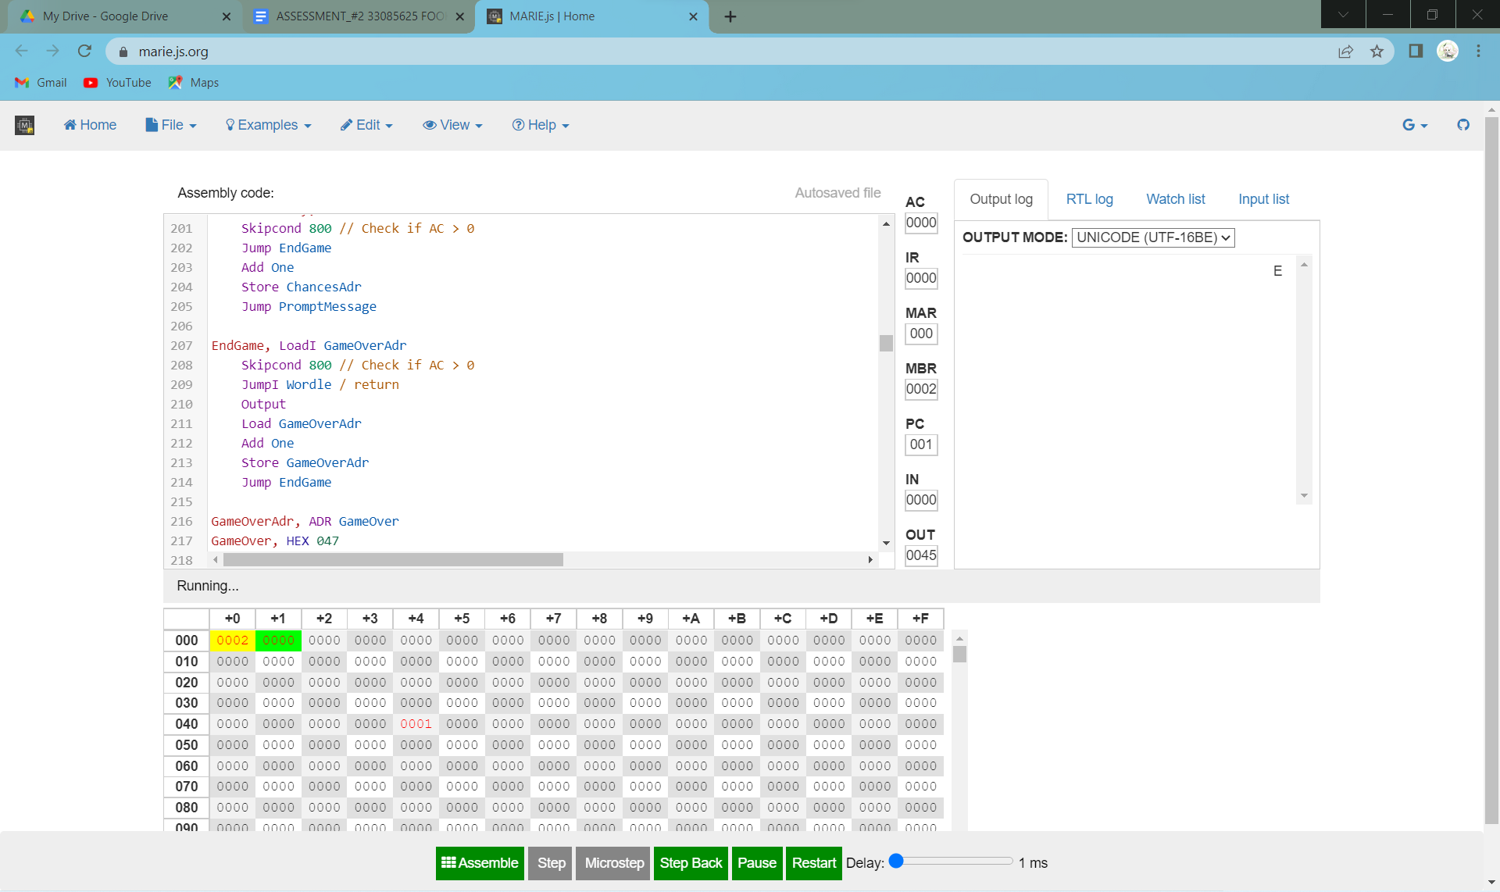

The guessed word is longer than the selected word so, it is supposed to output “Your word is too long” but I did something wrong in 2.4 which only gives me the output of either “Your word is too long” or “Your word is too short”. But this time in 2.5, no matter what I input, all my output is “E”.

2. Input_Guessed_Word = Pup ; Selected_Word = Words



The guessed word is shorter than the selected word so, it is supposed to output “Your word is too short” but I did something wrong in 2.4 which only gives me the output of either “Your word is too long” or “Your word is too short”. But this time in 2.5, no matter what I input, all my output is “E”.

3. Input_Guessed_Word = Doggies ; Selected_Word = Words



The guessed word is longer than the selected word so, it is supposed to output “Your word is too long” but I did something wrong in 2.4 which only gives me the output of either “Your word is too long” or “Your word is too short”. But this time in 2.5, no matter what I input, all my output is “E”.

4. Input_Guessed_Word = Golden ; Selected_Word = Words



The guessed word is longer than the selected word so, it is supposed to output “Your word is too long” but I did something wrong in 2.4 which only gives me the output of either “Your word is too long” or “Your word is too short”. But this time in 2.5, no matter what I input, all my output is “E”.

5. Input_Guessed_Word = Words ; Selected_Word = Words



There is something wrong with my 2.4 code where it can only print too long error messages or too short error messages even though both selected-word and guessed-word are the same. But I did something wrong in 2.4 which only gives me the output of either “Your word is too long” or “Your word is too short”. But this time in 2.5, no matter what I input, all my output is “E”.