哈尔滨理工大学
计算机科学与技术学院

课程实践报告

课 程 Python程序设计
题 目 数字版权追踪系统
班 级 网络工程24-1.2
专 业 网络工程
学 生 王嘉宇
学 号 2202050219
指导教师 贾文贤

2026年6月7日

一、系统涉及知识点及相应代码
本次课程实践完成的是“数字版权追踪系统”的设计、优化与整理。系统主要面向图片类作品，能够完成用户登录注册、作品批量登记、隐形数字水印嵌入、版权验证、用户管理、日志查看与数据统计等功能。与普通的课程练习程序相比，该项目采用了较完整的前后端分离结构，既有后端接口与数据库，又有前端图形界面和自动化测试，因此更适合作为综合性课程实践成果。
本次报告更新的重点是根据系统最新优化结果，对“系统涉及知识点”部分进行重写。一方面，原报告中的部分代码片段过短，只能起到示意作用，无法充分体现系统实际实现过程；另一方面，系统在最近一次优化中又新增了前端界面统一、接口容错增强、日志脱敏和权限控制完善等内容，因此报告也需要同步反映这些变化。为此，我重新整理了各知识点说明，并在每个部分配套给出更完整、更贴近真实源码的代表性代码。
从系统整体结构来看，项目可以分为五个层次。第一层是前端表现层，负责登录页、仪表盘、作品登记页、版权验证页和用户管理页的交互展示；第二层是接口层，由 FastAPI 提供登录、上传、验证、下载等 HTTP 接口；第三层是业务服务层，负责认证、统计、存储和验证流程的具体逻辑；第四层是数据层，用 SQLite 和 SQLAlchemy 保存用户、作品和日志数据；第五层是测试与运维层，用 pytest 和启动脚本保证系统可验证、可运行。这样的组织方式也体现了较规范的软件工程思路。
下面我将按照课程实践常见的知识点要求，从序列、函数、面向对象、数据库、文件上传、异常处理、图形界面、接口设计、安全机制、水印算法、加密存储和自动化测试等方面，结合系统真实代码进行说明。与上一版报告相比，这一版内容更强调“系统如何真正实现”，因此代码展示会更加完整，文字说明也会更贴近项目优化后的最终状态。
1、序列与批量处理
在课程知识点中，序列是最基础也最常用的一类结构。本系统在作品登记和版权验证中都支持批量图片处理，因此后端必须使用列表来组织每个文件的处理结果，再通过字典描述文件名、状态、错误信息和返回数据。这样的设计既能体现 Python 列表、字典和遍历语句的使用，也让前端可以一次拿到整批处理结果。相比只处理单个文件，批量结果组织更接近真实业务系统的写法，也更能体现序列结构在工程开发中的价值。
@router.post("/register", dependencies=[Depends(require_upload_permission)])
async def register_work(
request: Request,
file: List[UploadFile] = File(...),
description: Optional[str] = Form(None),
db: Session = Depends(get_db),
current_user: User = Depends(get_current_user),
):
if len(file) > MAX_BATCH_FILES:
return err(400, "批量处理最多支持20张图片")

results = []
key_manager = KeyManager()
secret_key = key_manager.get_current_key(db)
storage = StorageService()

for upload in file:
if upload.content_type not in ALLOWED_IMAGE_TYPES:
results.append({
"filename": upload.filename,
"status": "error",
"message": "仅支持 JPG/PNG 格式"
})
continue

try:
content = await upload.read()
if len(content) > MAX_FILE_SIZE:
results.append({
"filename": upload.filename,
"status": "error",
"message": "文件大小不能超过 5MB"
})
continue

resp_data = {"filename": upload.filename, "size": len(content)}
results.append({
"filename": upload.filename,
"status": "success",
"data": resp_data
})
except Exception as exc:
db.rollback()
results.append({
"filename": upload.filename,
"status": "error",
"message": str(exc)
})

return ok(results)
2、函数封装
函数封装体现了程序结构化设计思想。在本项目中，我将哈希计算、图像解码、元数据解析和请求指纹生成拆成独立函数，这样上传、验证、下载等多个接口都可以复用相同逻辑，而不是在每个接口里重复写一遍。通过这种方式，代码更短、更清晰，也便于后续统一修改。课程里学到的函数定义、参数传递和返回值，在这个项目里不再是孤立语法，而是直接转化成了可复用的工程能力。
def calculate_hash(data: bytes) -> str:
return hashlib.sha256(data).hexdigest()

def get_fingerprint(request: Request) -> bytes:
ip = request.client.host if request.client else "unknown"
ua = request.headers.get("user-agent", "unknown")
raw = f"{ip}|{ua}".encode("utf-8")
return hashlib.sha256(raw).digest()

def parse_meta(meta_info: str) -> Dict[str, Any]:
if not meta_info:
return {}
try:
return json.loads(meta_info)
except json.JSONDecodeError:
return {}

def decode_image_content(content: bytes) -> Optional[np.ndarray]:
nparr = np.frombuffer(content, np.uint8)
return cv2.imdecode(nparr, cv2.IMREAD_COLOR)
3、面向对象设计
课程中提到面向对象时，核心思想是把“数据和行为”组合到一个类中。本系统后端采用了比较明显的面向对象设计方式，例如认证逻辑封装在 AuthService 中，文件加密与读取封装在 StorageService 中，统计和用户管理也都有各自的服务类。这样的结构有助于隔离职责，减少模块之间的混乱耦合。相比把所有逻辑都堆在接口函数中，类的方式更贴近真实项目，也体现了课程知识在系统设计中的落地。
class AuthService:
def __init__(self, db: Session):
self.db = db

def _check_account_lock(self, user: User) -> bool:
if user.locked_until and user.locked_until > datetime.datetime.utcnow():
remaining_minutes = int(
(user.locked_until - datetime.datetime.utcnow()).total_seconds() / 60
)
raise BusinessError(CODES["PARAM_ERROR"], f"账号已锁定，请{remaining_minutes}分钟后再试")
return True

def _increment_failed_login(self, user: User):
user.failed_login_attempts = (user.failed_login_attempts or 0) + 1
if user.failed_login_attempts >= 5:
user.locked_until = datetime.datetime.utcnow() + datetime.timedelta(minutes=30)
user.failed_login_attempts = 0
self.db.commit()

def login(self, payload: LoginRequest, ip: str = "") -> dict:
u = self.db.execute(select(User).where(User.username == payload.username)).scalar_one_or_none()
if not u:
raise BusinessError(CODES["PARAM_ERROR"], "用户名或密码错误")
self._check_account_lock(u)
if not verify_password(payload.password, u.password_hash):
self._increment_failed_login(u)
raise BusinessError(CODES["PARAM_ERROR"], "用户名或密码错误")
return {"access_token": create_access_token(u.id, u.username, u.role)}
4、数据库与 ORM
数据库部分使用 SQLite + SQLAlchemy 组合实现。SQLite 部署简单，适合课程项目；SQLAlchemy 则负责数据库连接、会话创建和模型持久化，让代码不用直接拼接 SQL 字符串。通过这一部分实现，我掌握了 create_engine、sessionmaker、会话生成器和数据库初始化这些知识点。对于课程实践来说，这部分内容能够很好体现系统已经具备真实的数据存储能力，而不是简单依赖内存变量完成演示。
engine = create_engine(
settings.DATABASE_URL,
echo=False,
future=True,
connect_args={"check_same_thread": False} if settings.DATABASE_URL.startswith("sqlite") else {}
)

if settings.DATABASE_URL.startswith("sqlite"):
@event.listens_for(engine, "connect")
def set_sqlite_pragma(dbapi_connection, connection_record):
cursor = dbapi_connection.cursor()
cursor.execute("PRAGMA journal_mode=WAL")
cursor.close()

SessionLocal = sessionmaker(bind=engine, autoflush=False, autocommit=False, future=True)

def get_db():
db = SessionLocal()
try:
yield db
finally:
db.close()
5、文件上传与输入校验
文件上传是本系统最核心的业务能力之一。后端使用 FastAPI 的 UploadFile 和 Form 接收前端上传的图片与描述信息，再按照“文件数量、类型、大小、是否可解码”的顺序进行校验。课程中的条件分支、函数调用和文件处理，在这里都被组织成一条完整业务流程。为了避免大文件或错误类型图片影响系统稳定性，我还专门加入了单次最多 20 张、单张不超过 5MB、仅支持 JPG/PNG 的限制，这使报告中的代码更贴近真实系统要求。
@router.post("/register", dependencies=[Depends(require_upload_permission)])
async def register_work(
request: Request,
file: List[UploadFile] = File(...),
description: Optional[str] = Form(None),
db: Session = Depends(get_db),
current_user: User = Depends(get_current_user),
):
if len(file) > MAX_BATCH_FILES:
return err(400, "批量处理最多支持20张图片")

for upload in file:
if upload.content_type not in ALLOWED_IMAGE_TYPES:
results.append({
"filename": upload.filename,
"status": "error",
"message": "仅支持 JPG/PNG 格式"
})
continue

content = await upload.read()
if len(content) > MAX_FILE_SIZE:
results.append({
"filename": upload.filename,
"status": "error",
"message": "文件大小不能超过 5MB"
})
continue

img = decode_image_content(content)
if img is None:
results.append({
"filename": upload.filename,
"status": "error",
"message": "无效的图片文件"
})
continue
6、异常处理与事务回滚
异常处理是项目从“能运行”到“更稳定”的关键一步。由于本系统涉及图片读写、数据库提交、密钥读取和水印处理等多个步骤，只要其中任意一个环节失败，都必须及时返回错误并回滚数据库状态。因此我在上传、登录、资料修改等关键路径上都加入了 try-except 和 rollback 逻辑。这样一来，即使某张图片格式异常或数据库提交失败，系统也不会整体崩溃，而是给出明确错误信息。这部分很能体现 Python 异常机制在工程实践中的价值。
try:
self.db.add(u)
self.db.commit()
self.db.refresh(u)
self._log_operation(u.id, "register", f"用户注册: {u.username}", ip)
return u
except IntegrityError:
self.db.rollback()
raise BusinessError(CODES["PARAM_ERROR"], "用户名、邮箱或手机号已存在")
except Exception as e:
self.db.rollback()
raise BusinessError(CODES["SERVER_ERROR"], str(e))

try:
content = await upload.read()
img = decode_image_content(content)
if img is None:
results.append({
"filename": upload.filename,
"status": "error",
"message": "无效的图片文件"
})
continue
except Exception as exc:
db.rollback()
results.append({
"filename": upload.filename,
"status": "error",
"message": str(exc)
})
7、图形用户界面与前端路由
课程报告里除了后端逻辑，也需要体现图形化界面的设计能力。本系统前端使用 React + TypeScript + Ant Design 构建，页面包括登录页、仪表盘、作品登记、版权验证、用户管理和日志查看。通过 React Router，不同页面可以根据路径切换，同时结合 RequireAuth 对需要登录的页面进行保护。相比命令行程序，图形用户界面更容易展示系统完成度，也更能体现课程实践成果。
export default function App() {
return (
<div className="min-h-screen">
<Routes>
<Route path="/login" element={<Login />} />
<Route
path="/"
element={
<RequireAuth>
<Layout>
<Dashboard />
</Layout>
</RequireAuth>
}
/>
<Route
path="/works"
element={
<RequireAuth>
<Layout>
<Works />
</Layout>
</RequireAuth>
}
/>
<Route
path="/verify"
element={
<Layout>
<Verify />
</Layout>
}
/>
</Routes>
</div>
);
}
8、网络接口设计与依赖注入
本系统后端使用 FastAPI 提供标准 Web 接口，接口包括登录、注册、作品登记、版权验证、作品下载、用户管理和日志读取。FastAPI 的优势在于接口函数可以直接声明请求参数、文件、数据库会话和当前用户依赖，代码结构十分清晰。通过这些接口设计，我进一步掌握了 GET、POST、路径参数、依赖注入和权限控制等 Python Web 开发中的关键知识点，也让整个项目形成了较规范的前后端分离结构。
@router.get("/download/{work_id}")
async def download_work(
work_id: int,
db: Session = Depends(get_db),
current_user: User = Depends(get_current_user),
):
record = db.query(WatermarkRecord).filter(WatermarkRecord.id == work_id).first()
if not record:
return err(404, "作品不存在")

if not can_access_work(current_user, record):
return err(403, "无权限访问该作品")

meta = parse_meta(record.meta_info)
storage_watermarked = meta.get("storage_watermarked")
original_filename = meta.get("filename") or f"work_{record.id}.png"

if storage_watermarked:
storage = StorageService()
url = storage.generate_presigned_url(storage_watermarked, original_filename)
return ok({"url": url})

return err(404, "作品文件不存在")
9、JWT 身份认证与权限控制
为了让系统具备真实的用户身份机制，我使用了 JWT 作为登录后的访问令牌。用户登录成功后，系统会把用户 ID、用户名、角色、签发时间和过期时间写入令牌；后续请求再通过 Authorization 请求头携带该令牌，后端负责解析和校验。除此之外，系统还通过依赖函数控制不同角色的权限，例如管理员可以管理用户，审计员可以查看日志但不能上传作品。这样一来，课程中的函数、字典和条件控制被进一步扩展成了安全认证流程。
def create_access_token(user_id: int, username: str, role: str) -> str:
now = int(time.time())
payload = {
"sub": str(user_id),
"username": username,
"role": role,
"iat": now,
"exp": now + JWT_TTL,
}
return jwt.encode(payload, JWT_SECRET, algorithm=JWT_ALG)

def parse_authorization_header(authorization: Optional[str]) -> str:
if not authorization or not authorization.startswith("Bearer "):
raise BusinessError(code=CODES["UNAUTHORIZED"], message="未登录或无权限")
return authorization.split(" ", 1)[1]

def require_upload_permission(payload: dict = Depends(get_current_user_payload)):
role = payload.get("role")
if role == "auditor":
raise BusinessError(CODES["UNAUTHORIZED"], "审计员无法执行上传操作")
if role_at_least(role, "operator") is False:
raise BusinessError(CODES["UNAUTHORIZED"], "无效的用户角色")
return payload
10、密码加密与登录安全
密码安全是所有用户系统都必须考虑的部分。本系统没有明文保存密码，而是使用 bcrypt 生成哈希后再写入数据库；登录时只做哈希校验，不存在密码反解过程。同时，系统还加入了登录失败次数累加和临时锁定机制，当用户连续多次输错密码时，账号会被锁定一段时间，从而降低暴力破解风险。通过这部分实现，我对密码哈希、安全认证和账户保护机制有了更具体的理解。
def verify_password(password: str, password_hash: str) -> bool:
try:
return bcrypt.checkpw(password.encode("utf-8"), password_hash.encode("utf-8"))
except Exception:
return False

def get_password_hash(password: str) -> str:
salt = bcrypt.gensalt()
return bcrypt.hashpw(password.encode("utf-8"), salt).decode("utf-8")

def _increment_failed_login(self, user: User):
user.failed_login_attempts = (user.failed_login_attempts or 0) + 1
if user.failed_login_attempts >= 5:
user.locked_until = datetime.datetime.utcnow() + datetime.timedelta(minutes=30)
user.failed_login_attempts = 0
self.db.commit()
11、数字水印算法实现
数字水印能力是本系统区别于普通管理系统的核心特色。系统在用户登记作品时，会先计算请求指纹和用户信息，再将这些内容编码成结构化水印比特流，随后嵌入图片中；验证时则从图片中提取结构化信息，判断水印是否完整、是否合法以及对应哪个用户。这部分实现虽然超出了基础语法练习，但非常适合作为课程实践的亮点，因为它把 Python、图像处理和业务逻辑结合到了一起。
img_rgb = cv2.cvtColor(img, cv2.COLOR_BGR2RGB)
fingerprint = get_fingerprint(request)
payload_bits, meta_payload = make_payload_bits(current_user.id, fingerprint, secret_key)

embedded_rgb = embed_watermark(
img_rgb,
payload_bits,
delta=settings.watermark.delta_min
)
img_bgr = cv2.cvtColor(embedded_rgb, cv2.COLOR_RGB2BGR)
success, encoded_img = cv2.imencode(".png", img_bgr)
if not success:
raise ValueError("图片编码失败")

decoded = decode_payload_struct(
img_rgb,
fetch_key_func=fetch_key,
delta=settings.watermark.delta_min
)
12、文件加密存储
为了避免作品原图和水印图以明文形式直接暴露在磁盘上，系统在存储阶段增加了 AES-GCM 加密。文件写入前先生成随机 IV，再使用由 STORAGE_SECRET 派生出的密钥完成加密，最后把 IV、认证标签和密文一起保存。下载时，系统不会直接暴露真实文件路径，而是先生成带有效期的签名访问地址，再由后端完成读取和解密。这部分展示了 Python 在安全存储和文件保护场景中的应用。
class StorageService:
def __init__(self):
self.key = hashlib.sha256(settings.STORAGE_SECRET.encode()).digest()
self.upload_dir = "uploads/storage"
os.makedirs(self.upload_dir, exist_ok=True)

def encrypt_and_save(self, file_obj: BinaryIO, filename: str) -> str:
content = file_obj.read()
iv = os.urandom(12)
encryptor = Cipher(
algorithms.AES(self.key),
modes.GCM(iv),
backend=default_backend()
).encryptor()

ciphertext = encryptor.update(content) + encryptor.finalize()
tag = encryptor.tag
data = iv + tag + ciphertext

stored_filename = hashlib.sha256(f"{filename}{time.time()}".encode()).hexdigest()
path = os.path.join(self.upload_dir, stored_filename)
with open(path, "wb") as f:
f.write(data)
return stored_filename
13、日志记录与敏感信息脱敏
日志系统在课程项目里很容易被忽视，但它其实是系统稳定性和可维护性的重要组成部分。本系统在请求进入后端时会记录访问路径、方法、来源 IP 和请求头信息，同时为了避免泄露访问令牌、Cookie 或密钥，又增加了请求头脱敏逻辑。这样既能保留排错需要的日志信息，又不会把敏感字段直接写进日志文件。这个改动也体现了我在本次优化中对系统安全细节的关注。
SENSITIVE_HEADERS = {"authorization", "cookie", "set-cookie", "x-api-key"}

def sanitize_headers(headers: Optional[Dict[str, str]]) -> Dict[str, str]:
sanitized: Dict[str, str] = {}
for key, value in (headers or {}).items():
if key.lower() in SENSITIVE_HEADERS:
sanitized[key] = "***"
else:
sanitized[key] = value
return sanitized

def log_api_call(endpoint: str, method: str, user_id: int = None, ip: str = None, params: dict = None):
log_data = {
"timestamp": datetime.now().isoformat(),
"endpoint": endpoint,
"method": method,
"user_id": user_id,
"ip": ip,
"params": params or {}
}
app_logger.info(f"API Call: {log_data}")
14、前端状态管理与异步请求
前端页面要真正可用，关键不只是把组件摆出来，而是要把异步请求、状态切换和结果反馈组织好。在作品登记页面中，我使用 React 的 useState 和 useEffect 管理列表、总数、当前用户、弹窗和加载状态，再通过统一的 api 模块请求后端数据。这样页面初始化时可以自动拉取作品记录，提交登记后也能自动刷新列表并给出提示信息。这个过程很好地体现了课程实践里前端逻辑组织、条件渲染和异步处理的综合应用。
export default function Works() {
const { message } = App.useApp();
const [items, setItems] = useState<WorkItem[]>([]);
const [error, setError] = useState<string | null>(null);
const [createOpen, setCreateOpen] = useState(false);
const [form] = Form.useForm();
const [loading, setLoading] = useState(false);
const [user, setUser] = useState<{ role: string } | null>(null);
const [total, setTotal] = useState(0);

const fetchWorks = async () => {
setLoading(true);
try {
const r = await api.worksList();
if (r.code === 0) {
setItems(r.data.items || []);
setTotal(r.data.total || 0);
setError(null);
} else {
setError(r.message);
}
} catch {
setError("获取作品列表失败，请检查服务器状态");
} finally {
setLoading(false);
}
};

useEffect(() => {
api.profile().then(res => {
if (res.code === 0) setUser(res.data);
});
fetchWorks();
}, []);

const handleCreate = async () => {
try {
const values = await form.validateFields() as WorkFormValues;
if (!values.file || values.file.fileList.length === 0) {
message.error("请选择文件");
return;
}

const files = values.file.fileList
.map((file) => file.originFileObj)
.filter((file): file is RcFile => Boolean(file));

const formData = new FormData();
files.forEach((file) => formData.append("file", file));
if (values.description) {
formData.append("description", values.description);
}

message.loading("正在处理...", 0);
const r = await api.registerWork(formData);
message.destroy();

if (r.code === 0) {
message.success("作品登记成功");
setCreateOpen(false);
form.resetFields();
fetchWorks();
} else {
message.error(r.message);
}
} catch {
message.error("提交失败");
}
};
二、页面展示截图
系统前端在本次优化后对整体视觉风格、版式结构和移动端适配都进行了统一处理，页面不再只是简单的功能堆叠，而是更接近小型后台管理系统的展示效果。为了更完整地展示系统功能，本次截图不再只保留几个页面首页，而是按照“登录注册、仪表盘、作品登记、版权验证、用户管理、日志审计”的完整流程给出界面与操作态截图。
1、登录页面
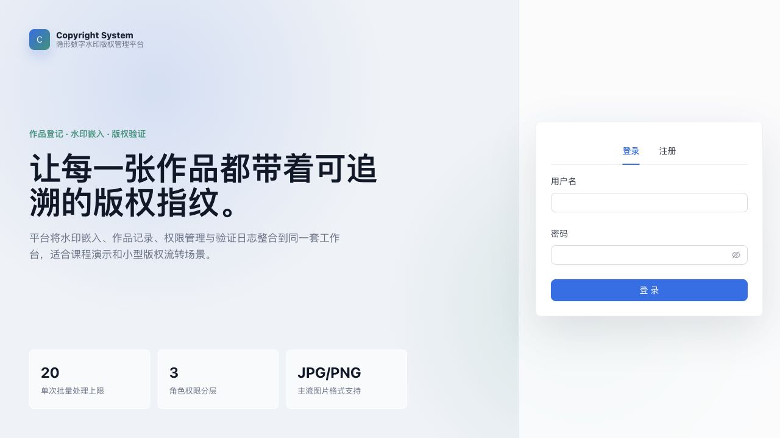
图1 登录页面：系统支持登录、注册切换，并以图形化方式展示版权系统入口。
登录页采用左右分栏布局，左侧用于展示系统定位与功能摘要，右侧用于登录和注册切换。这样的设计既增强了展示效果，也使系统入口更加清晰。
2、注册页面
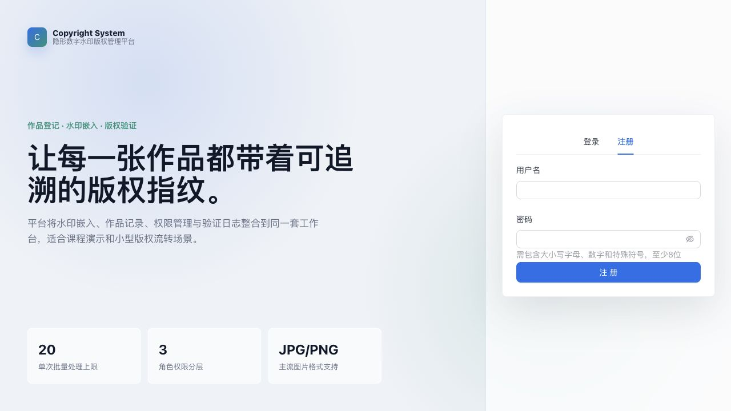
图2 注册页面：系统支持新用户录入账号和密码，并对密码复杂度给出明确提示。
注册页与登录页共用统一风格，但在表单区额外给出了密码复杂度要求，能够直接体现系统在用户创建阶段的输入约束和安全提示。
3、仪表盘页面
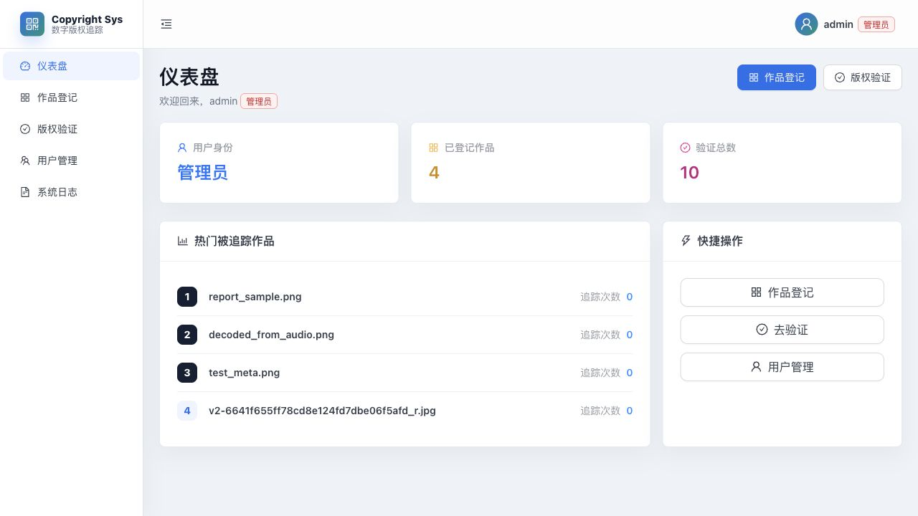
图3 仪表盘页面：集中展示用户身份、作品总量、验证统计、热门作品与快捷操作入口。
仪表盘把作品数量、验证次数、热门作品和快捷操作集中放在首页，进入系统后就能快速看到整体运行情况，这也让页面展示比单纯的导航页更完整。
4、作品登记页面
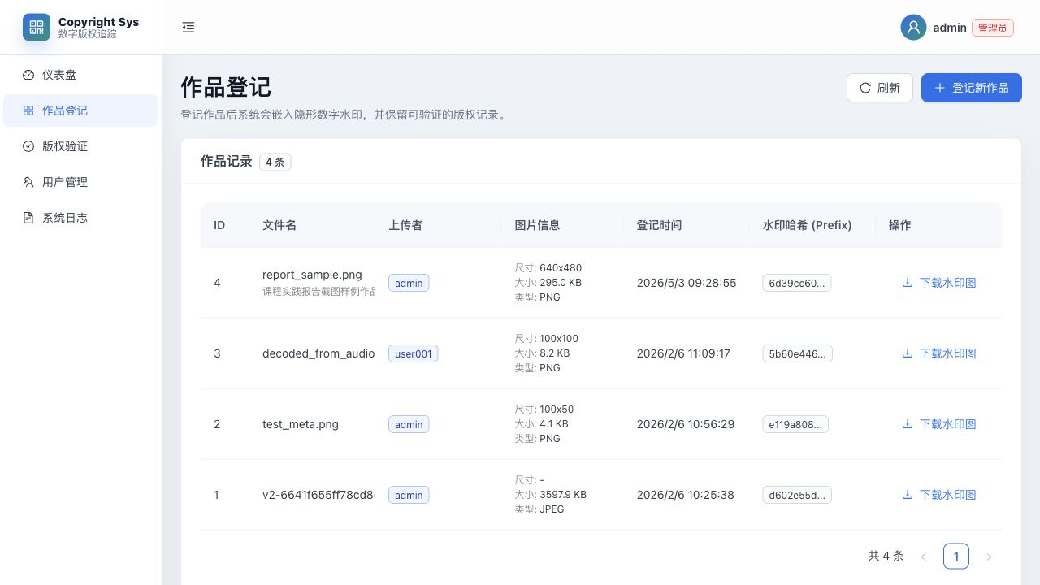
图4 作品登记页面：支持批量上传、作品列表查看、水印图下载和状态管理。
作品登记页集中展示作品列表、上传弹窗、作品元数据与下载入口，用户可以在同一页面完成查看和登记操作，界面层次比旧版更清晰。
5、作品登记弹窗
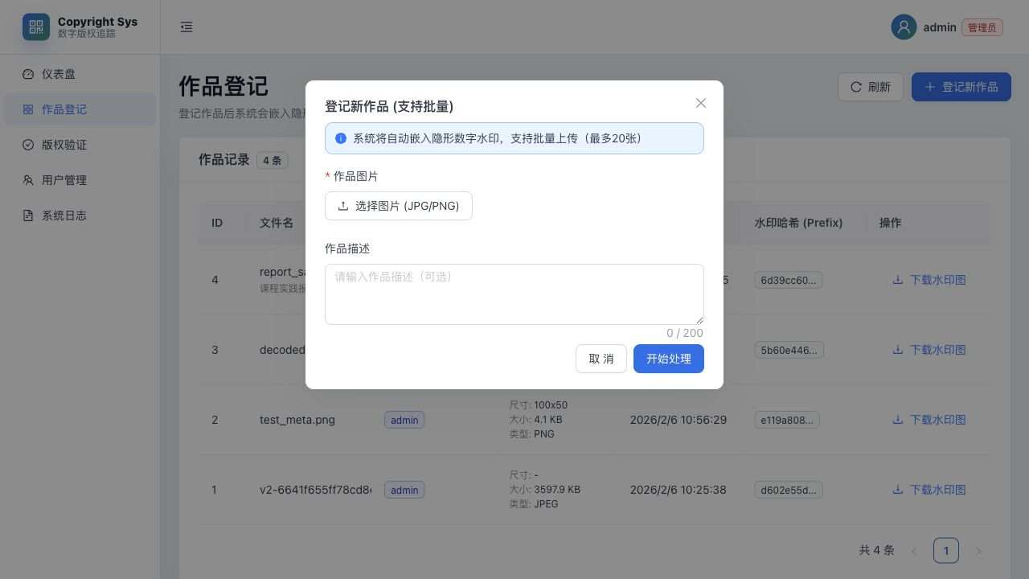
图5 作品登记弹窗：展示图片选择、批量上传限制、作品描述填写和处理入口。
作品登记弹窗进一步展示了批量上传的核心操作面板，包括图片选择、数量限制说明、作品描述录入和开始处理按钮，能够更完整地体现登记功能。
6、版权验证页面
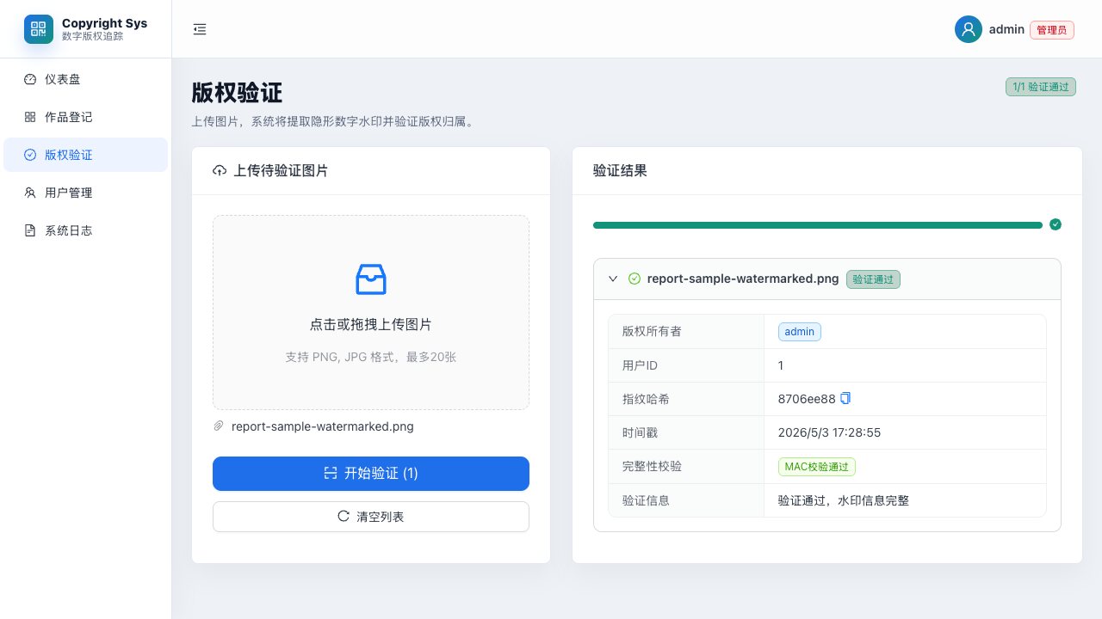
图6 版权验证页面：支持上传验证图片，并展示版权所有者、指纹哈希、时间戳和完整性校验结果。
版权验证页支持拖拽上传和批量验证，并用折叠面板展示版权所有者、指纹哈希、时间戳和完整性校验等明细。这样既减少了页面拥挤，也提升了结果展示的可读性。
7、用户管理页面
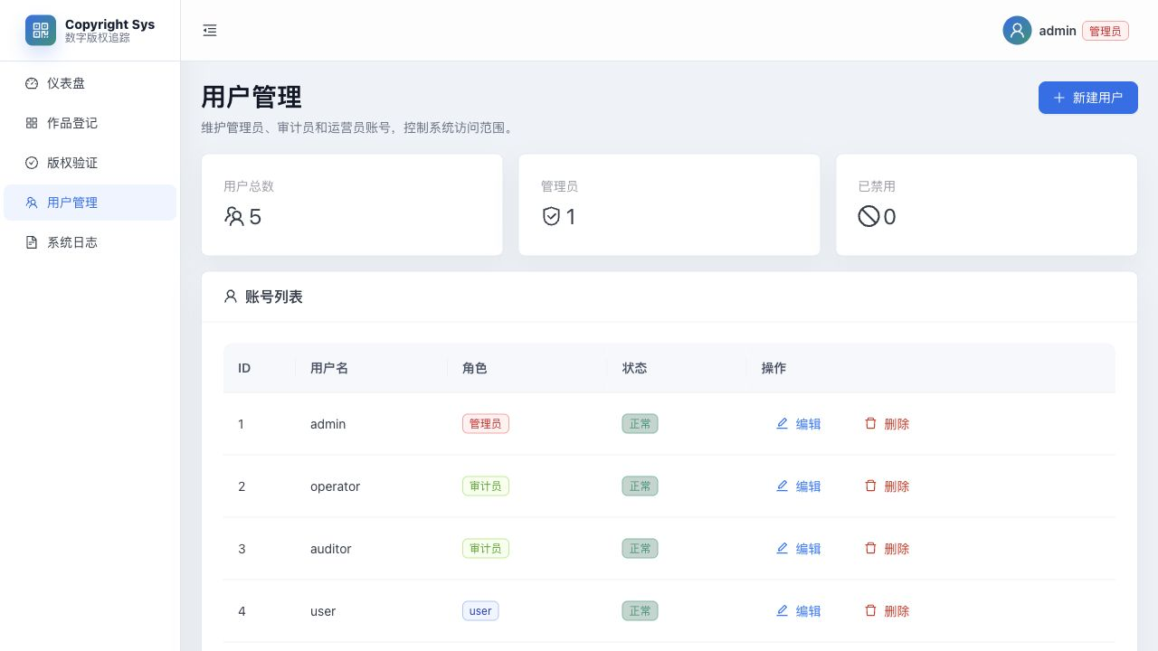
图7 用户管理页面：管理员可统一维护账号、角色和状态。
用户管理页采用数据卡片加表格的形式展示账号总量、管理员数量和禁用账号数量，既有统计感，也符合后台管理页面的常见组织方式。
8、新建用户弹窗
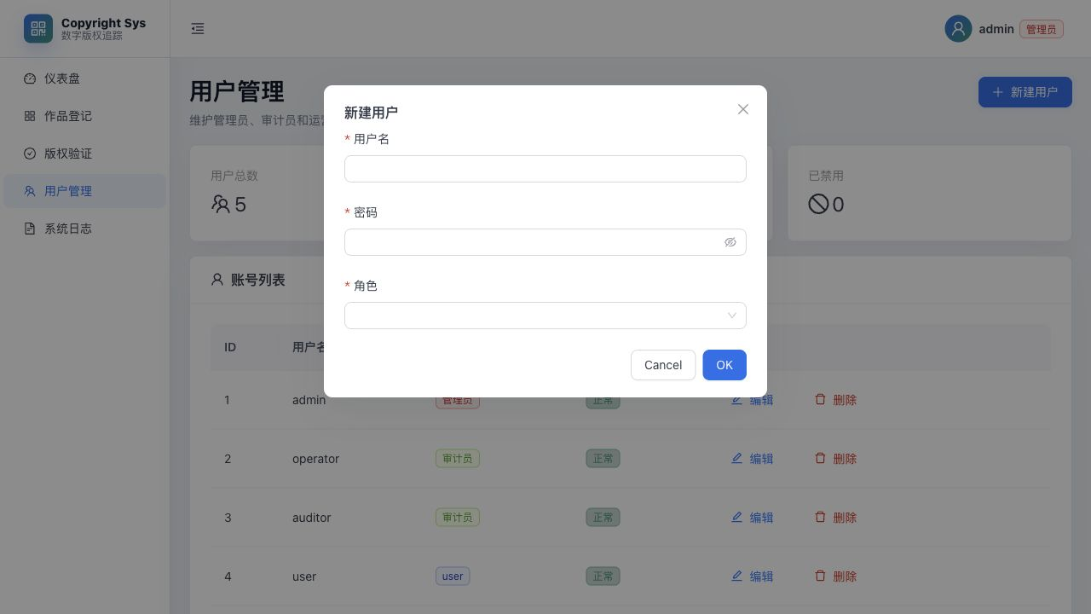
图8 新建用户弹窗：展示用户名、密码和角色配置表单，用于创建系统账号。
新建用户弹窗展示了管理员创建账号时需要填写的核心字段，包括用户名、密码和角色选择，能够体现系统的权限分层和账号管理流程。
9、编辑用户弹窗
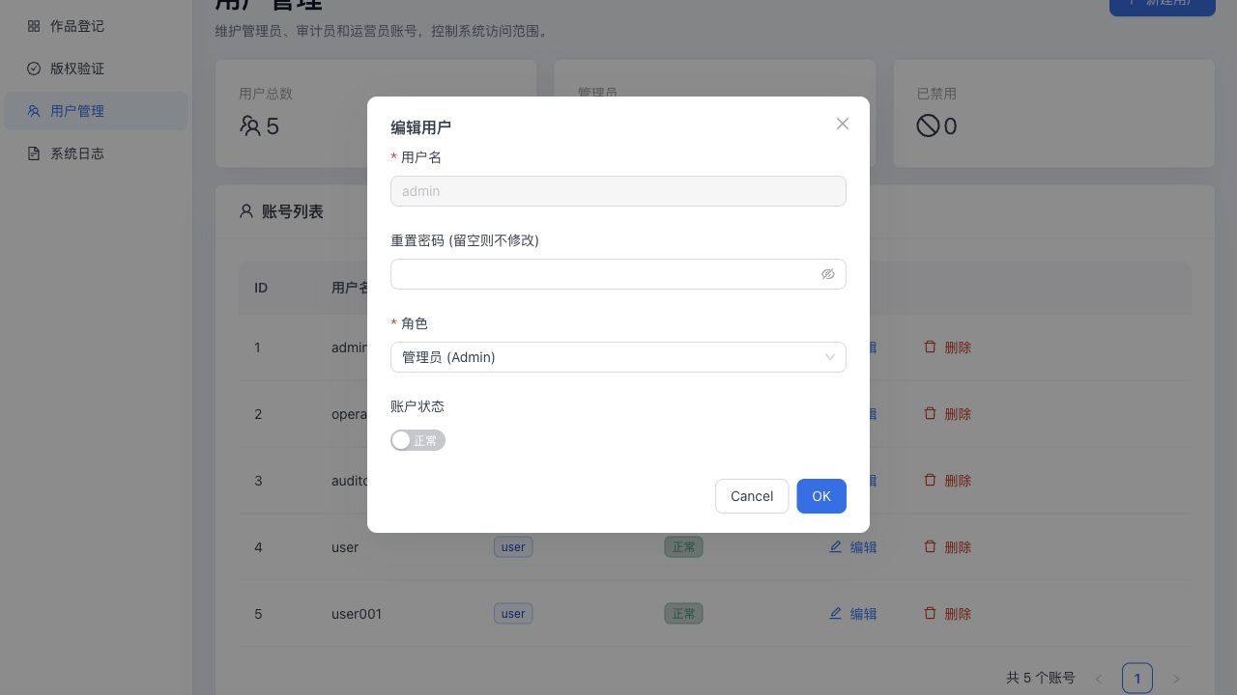
图9 编辑用户弹窗：支持角色调整、密码重置和账户状态维护。
编辑用户弹窗则进一步体现了账号维护功能，管理员可以在这里调整角色、重置密码，并控制账号是否禁用。
10、系统日志页面
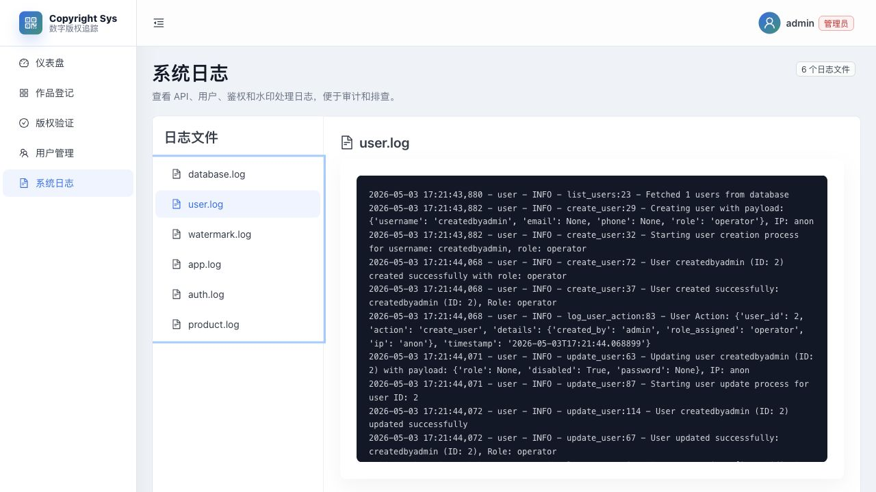
图10 系统日志页面：支持切换不同日志文件，并查看用户操作、接口访问和审计信息。
系统日志页按文件分类展示日志内容，既可以看到用户管理等实际操作记录，也能体现接口审计和问题排查能力，是后台系统完成度的重要组成部分。
三、系统优化总结
本次优化不仅修改了代码，也同步提升了系统的完成度和报告质量。后端部分重点增强了权限控制、文件下载能力、日志敏感信息脱敏、接口容错和安全配置；前端部分重点统一了主题、登录页视觉、各业务页面布局和移动端表现；测试与验证部分则通过构建检查、静态检查和页面检查保证优化后的版本确实可运行。与最初的课程项目相比，当前版本已经更接近一个具备真实业务闭环的小型 Web 系统。
对于报告本身，我将原来偏简略的说明调整为“文字解释 + 更完整代码 + 页面截图 + 源码目录”的结构，目的就是让老师在阅读时不仅能看到功能点，也能看到这些功能是如何在代码层面实现出来的。尤其是在系统涉及知识点部分，我尽量选择了真实而典型的代码片段，使其既能体现 Python 程序设计课程知识，也能体现本项目后续优化后的工程性成果。
总体来说，这次课程实践让我把课堂上学到的 Python 基础语法、函数、类、异常、文件处理、数据库和界面设计等知识，整合到了一个完整项目中。更重要的是，在后续优化过程中，我进一步理解了安全性、可维护性、可测试性和用户体验对于软件系统的重要意义，这也是本项目相比普通作业更有价值的地方。
四、所有代码
根据本次报告要求，本节直接给出系统前端与后端的完整源码附录，不再只列文件名。考虑到这里强调的是系统本体代码，因此附录只保留后端 app 目录下的 Python 源码和前端 src 目录下的页面、组件与样式源码，不再放入启动脚本、依赖文件或构建配置文件。
后端部分主要包含接口层、服务层、数据库访问层、核心算法与工具模块；前端部分主要包含路由入口、页面组件、布局样式和接口请求逻辑。为了方便查阅，下面按照“后端完整代码”和“前端完整代码”两部分依次展开。
1、后端完整代码
以下内容为后端业务源码，包含 FastAPI 接口、服务层、数据库层、核心模块和工具函数。
backend/app/api/dependencies.py

from typing import Optional
from fastapi import Depends, Header, HTTPException
from sqlalchemy.orm import Session
from app.utils.security import parse_authorization_header, decode_token
from app.db.session import get_db
from app.core.constants import CODES
from app.core.exceptions import BusinessError
from app.core.roles import is_admin, role_at_least
from app.models import User
from sqlalchemy import select

def get_token(authorization: Optional[str] = Header(default=None, alias="Authorization")):
if not authorization:
raise BusinessError(CODES["UNAUTHORIZED"], "未登录")
return parse_authorization_header(authorization)

def get_current_user_payload(token: str = Depends(get_token)):
return decode_token(token)

def get_current_user(
payload: dict = Depends(get_current_user_payload),
db: Session = Depends(get_db)
) -> User:
user_id = int(payload.get("sub"))
user = db.execute(select(User).where(User.id == user_id)).scalar_one_or_none()
if not user:
raise BusinessError(CODES["UNAUTHORIZED"], "用户不存在")
if user.disabled:
raise BusinessError(CODES["UNAUTHORIZED"], "账户已禁用")
return user

def require_admin(payload: dict = Depends(get_current_user_payload)):
if not is_admin(payload.get("role")):
raise BusinessError(CODES["UNAUTHORIZED"], "权限不足: 需要管理员权限")
return payload

def require_auditor(payload: dict = Depends(get_current_user_payload)):
if not role_at_least(payload.get("role"), "auditor"):
raise BusinessError(CODES["UNAUTHORIZED"], "权限不足: 需要审计员或管理员权限")
return payload

def require_upload_permission(payload: dict = Depends(get_current_user_payload)):
role = payload.get("role")
if role == "auditor":
raise BusinessError(CODES["UNAUTHORIZED"], "审计员无法执行上传操作")
if role_at_least(role, "operator") is False:
raise BusinessError(CODES["UNAUTHORIZED"], "无效的用户角色")
return payload
backend/app/api/v1/api.py
from fastapi import APIRouter
from app.api.v1.endpoints import auth, users, verify, stats, works, storage, logs

api_router = APIRouter()
api_router.include_router(auth.router, prefix="/auth", tags=["auth"])
api_router.include_router(users.router, prefix="/users", tags=["users"])
# api_router.include_router(products.router, prefix="/products", tags=["products"]) # Removed
api_router.include_router(verify.router, prefix="/verify", tags=["verify"])
api_router.include_router(works.router, prefix="/works", tags=["works"])
api_router.include_router(stats.router, prefix="/stats", tags=["stats"])
api_router.include_router(storage.router, prefix="/storage", tags=["storage"])
api_router.include_router(logs.router, prefix="/logs", tags=["logs"])
backend/app/api/v1/endpoints/__init__.py

backend/app/api/v1/endpoints/auth.py

from fastapi import APIRouter, Depends, Header
from sqlalchemy.orm import Session
from app.utils.response import ok, err
from app.db.session import get_db
from app.schemas import LoginRequest, UserRegister, UserUpdateProfile, SendVerificationCodeRequest, VerifyCodeRequest
from app.services.auth_service import AuthService
from app.api.dependencies import get_current_user
from app.models import User
from app.core.constants import CODES

router = APIRouter()

@router.post("/send-code")
def send_verification_code(payload: SendVerificationCodeRequest, x_forwarded_for: str = Header(default=""), db: Session = Depends(get_db)):
"""
发送验证码（邮箱或手机）
"""
ip = (x_forwarded_for or "").split(",")[0].strip() or "anon"
service = AuthService(db)
result = service.send_verification_code(payload, ip)
return ok(result)

@router.post("/verify-code")
def verify_code(payload: VerifyCodeRequest, db: Session = Depends(get_db)):
"""
验证验证码
"""
service = AuthService(db)
result = service.verify_code(payload)
return ok(result)

@router.post("/register")
def register(payload: UserRegister, x_forwarded_for: str = Header(default=""), db: Session = Depends(get_db)):
"""
用户注册（带验证码）
"""
ip = (x_forwarded_for or "").split(",")[0].strip() or "anon"
service = AuthService(db)
u = service.register(payload, ip)
return ok({"id": u.id, "username": u.username, "role": u.role})

@router.post("/login")
def login(payload: LoginRequest, x_forwarded_for: str = Header(default=""), db: Session = Depends(get_db)):
"""
用户登录（带防暴力破解机制）
"""
ip = (x_forwarded_for or "").split(",")[0].strip() or "anon"
service = AuthService(db)
data = service.login(payload, ip)
return ok(data)

@router.put("/profile")
def update_profile(payload: UserUpdateProfile, user: User = Depends(get_current_user), x_forwarded_for: str = Header(default=""), db: Session = Depends(get_db)):
"""
更新个人资料（邮箱、手机号、密码）
"""
ip = (x_forwarded_for or "").split(",")[0].strip() or "anon"
service = AuthService(db)

# 修改密码
if payload.new_password:
if not payload.old_password:
return err(CODES["PARAM_ERROR"], "请提供原密码")
service.change_password(user.id, payload.old_password, payload.new_password, ip)

# 更新邮箱和手机号
if payload.email or payload.phone:
service.update_profile(user.id, payload.email, payload.phone, ip)

return ok({"success": True})

@router.get("/profile")
def profile(user: User = Depends(get_current_user)):
"""
获取个人资料
"""
return ok({
"id": user.id,
"username": user.username,
"email": user.email,
"phone": user.phone,
"avatar_path": user.avatar_path,
"role": user.role,
"created_at": user.created_at.isoformat() if user.created_at else None,
"disabled": bool(user.disabled)
})

@router.post("/logout")
def logout(user: User = Depends(get_current_user), x_forwarded_for: str = Header(default=""), db: Session = Depends(get_db)):
"""
用户退出
"""
ip = (x_forwarded_for or "").split(",")[0].strip() or "anon"
service = AuthService(db)
service.logout(user.id, ip)
return ok({"success": True})
backend/app/api/v1/endpoints/logs.py
from fastapi import APIRouter, Depends
from pathlib import Path
from app.api.dependencies import require_auditor
from app.utils.response import ok, err
import os

router = APIRouter()
LOG_DIR = Path("logs")

@router.get("", dependencies=[Depends(require_auditor)])
def list_logs():
if not LOG_DIR.exists():
return ok([])
files = [f.name for f in LOG_DIR.glob("*.log")]
return ok(files)

@router.get("/{filename}", dependencies=[Depends(require_auditor)])
def get_log_content(filename: str):
# Security check: prevent path traversal
if ".." in filename or "/" in filename or "\\" in filename:
return err(400, "非法的文件名")

file_path = LOG_DIR / filename
if not file_path.exists() or not file_path.is_file():
return err(404, "日志文件不存在")

try:
# Read last 2000 lines
with open(file_path, "r", encoding="utf-8") as f:
lines = f.readlines()
content = "".join(lines[-2000:])
return ok({"filename": filename, "content": content})
except Exception as e:
return err(500, str(e))
backend/app/api/v1/endpoints/stats.py
import time
from fastapi import APIRouter, Header, Depends, Query
from app.utils.response import ok, err
from app.core.constants import CODES
from app.db.session import get_db
from sqlalchemy.orm import Session
from app.services.stats_service import StatsService
from app.api.dependencies import require_auditor

router = APIRouter()

@router.get("/summary", dependencies=[Depends(require_auditor)])
def summary(db: Session = Depends(get_db)):
service = StatsService(db)
result = service.get_summary()
return ok(result)

@router.get("/works", dependencies=[Depends(require_auditor)])
def stats_works(db: Session = Depends(get_db)):
service = StatsService(db)
result = service.get_works_stats()
return ok(result)

@router.get("/verify", dependencies=[Depends(require_auditor)])
def stats_verify(db: Session = Depends(get_db)):
service = StatsService(db)
result = service.get_verify_stats()
return ok(result)

@router.get("/product_scans", dependencies=[Depends(require_auditor)])
def stats_product_scans(
days: int = Query(30, ge=1, le=365),
limit: int = Query(5, ge=1, le=20),
db: Session = Depends(get_db),
):
service = StatsService(db)
result = service.get_product_scan_stats(days=days, limit=limit)
return ok(result)
backend/app/api/v1/endpoints/storage.py
from fastapi import APIRouter, HTTPException, Response
from app.core.storage import StorageService

router = APIRouter()

@router.get("/{token}")
async def get_stored_file(token: str):
payload = StorageService.validate_token(token)
if not payload:
raise HTTPException(status_code=403, detail="Invalid or expired token")

stored_filename = payload.get("file")
original_filename = payload.get("name")

storage = StorageService()
try:
content = storage.load_and_decrypt(stored_filename)
except FileNotFoundError:
raise HTTPException(status_code=404, detail="File not found")
except Exception:
raise HTTPException(status_code=500, detail="Decryption failed")

# Set Cache-Control for CDN (1 year)
headers = {
"Cache-Control": "public, max-age=31536000",
"Content-Disposition": f'attachment; filename="{original_filename}"'
}

# Determine media type (simplified)
media_type = "application/octet-stream"
if original_filename.lower().endswith(".png"):
media_type = "image/png"
elif original_filename.lower().endswith(".jpg") or original_filename.lower().endswith(".jpeg"):
media_type = "image/jpeg"

return Response(content=content, media_type=media_type, headers=headers)
backend/app/api/v1/endpoints/users.py

from fastapi import APIRouter, Depends, Path, Header
from sqlalchemy.orm import Session
from app.utils.response import ok, err
from app.db.session import get_db
from app.schemas import UserCreate, UserUpdate
from app.api.dependencies import require_admin
from app.services.user_service import UserService
from app.models import User
from app.core.constants import CODES
from app.core.exceptions import BusinessError
from app.utils.logger import user_logger, log_user_action

router = APIRouter()

@router.get("", dependencies=[Depends(require_admin)])
def list_users(db: Session = Depends(get_db)):
service = UserService(db)
users = service.list_users()
return ok([{"id": u.id, "username": u.username, "role": u.role, "disabled": bool(u.disabled)} for u in users])

@router.post("", dependencies=[Depends(require_admin)])
def create_user(
payload: UserCreate,
x_forwarded_for: str = Header(default=""),
db: Session = Depends(get_db)
):
ip = (x_forwarded_for or "").split(",")[0].strip() or "anon"
user_logger.info(f"Creating user with payload: {payload.model_dump(exclude={'password'})}, IP: {ip}")

try:
# 验证payload中的数据
user_logger.debug(f"Payload validation - Username: {payload.username}, Role: {payload.role}")

service = UserService(db)
u = service.create_user(payload)
user_logger.info(f"User created successfully: {u.username} (ID: {u.id}), Role: {u.role}")

# 记录用户操作日志
log_user_action(u.id, "create_user", {
"created_by": "admin",
"role_assigned": u.role,
"ip": ip
})

return ok({"id": u.id, "username": u.username, "role": u.role})
except BusinessError:
raise
except Exception as e:
user_logger.error(f"Failed to create user: {str(e)}", exc_info=True)
return err(CODES["SERVER_ERROR"], "创建用户失败，请检查输入或稍后重试")

@router.put("/{id}", dependencies=[Depends(require_admin)])
def update_user(
payload: UserUpdate,
id: int = Path(...),
x_forwarded_for: str = Header(default=""),
db: Session = Depends(get_db)
):
ip = (x_forwarded_for or "").split(",")[0].strip() or "anon"
current_user = db.query(User).filter(User.id == id).first()
if current_user:
user_logger.info(f"Updating user {current_user.username} (ID: {id}) with payload: {payload.model_dump()}, IP: {ip}")

service = UserService(db)
u = service.update_user(id, payload)
user_logger.info(f"User updated successfully: {u.username} (ID: {u.id}), Role: {u.role}")

# 记录用户操作日志
log_user_action(u.id, "update_user", {
"updated_by": "admin",
"changes": payload.model_dump(exclude_unset=True),
"ip": ip
})

return ok({"id": u.id, "username": u.username, "role": u.role, "disabled": bool(u.disabled)})

@router.delete("/{id}", dependencies=[Depends(require_admin)])
def delete_user(
id: int = Path(...),
x_forwarded_for: str = Header(default=""),
db: Session = Depends(get_db)
):
ip = (x_forwarded_for or "").split(",")[0].strip() or "anon"
user_logger.info(f"Deleting user ID: {id}, IP: {ip}")

service = UserService(db)
service.delete_user(id)
user_logger.info(f"User deleted successfully: {id}")

# 记录用户操作日志
log_user_action(id, "delete_user", {
"deleted_by": "admin",
"ip": ip
})

return ok({"id": id})
backend/app/api/v1/endpoints/verify.py
import time
from typing import Optional, List, Dict, Any
from fastapi import APIRouter, Header, Depends, UploadFile, File, Query
from sqlalchemy.orm import Session
from app.utils.response import ok, err
from app.core.constants import CODES
from app.db.session import get_db
from app.api.dependencies import require_auditor, require_admin
from app.models import User, VerifyLog
from app.core.watermark import decode_payload_struct
from app.core.key_manager import KeyManager
from app.services.verify_service import VerifyService
from app.core.config import settings
import cv2
import numpy as np

router = APIRouter()

@router.post("/trace", dependencies=[Depends(require_admin)])
def trace_source(file: UploadFile = File(...), db: Session = Depends(get_db)):
"""
后台溯源接口：输入水印图片，反查原始上传用户及操作记录
返回详细的水印信息、用户信息以及该用户的验证历史
"""
# Read image
contents = file.file.read()
nparr = np.frombuffer(contents, np.uint8)
img = cv2.imdecode(nparr, cv2.IMREAD_COLOR)

if img is None:
return err(CODES["PARAM_ERROR"], "Invalid image")

img_rgb = cv2.cvtColor(img, cv2.COLOR_BGR2RGB)

try:
# Key fetch function
key_manager = KeyManager()
fetch_key = lambda ts: key_manager.get_key_by_timestamp(ts, db)

# Extract payload using robust extraction with attack detection
delta = settings.watermark.delta_min
decoded = decode_payload_struct(img_rgb, fetch_key_func=fetch_key, delta=delta)

uid = decoded.get("user_id")
timestamp = decoded.get("timestamp")
fingerprint_hex = decoded.get("fingerprint_hex")
mac_hex = decoded.get("mac_hex")
is_valid = decoded.get("valid", False)
attack_info = decoded.get("attack_info", {})

user_info = None
verification_history = []

if uid:
# Find user
user = db.query(User).filter(User.id == uid).first()
if user:
user_info = {
"id": user.id,
"username": user.username,
"role": user.role,
"created_at": user.created_at.isoformat() if user.created_at else None,
"disabled": bool(user.disabled)
}

# Get verification logs for this user
user_logs = db.query(VerifyLog).filter(
VerifyLog.plain_text.contains(str(uid))
).order_by(VerifyLog.ts.desc()).limit(10).all()

for log in user_logs:
verification_history.append({
"timestamp": log.ts,
"ip": log.ip,
"result": log.result,
"latency_ms": log.latency_ms,
"bit_error_rate": log.bit_error_rate
})

return ok({
"trace_result": {
"valid": is_valid,
"user_id": uid,
"user_info": user_info,
"timestamp": timestamp,
"fingerprint_hex": fingerprint_hex,
"mac_signature": mac_hex,
"attack_detection": {
"attack_type": attack_info.get("attack_type", "unknown"),
"severity": attack_info.get("severity", "low"),
"details": attack_info.get("details", {})
},
"verification_history": verification_history,
"trace_metadata": {
"traced_at": int(time.time()),
"image_size": f"{img.shape[1]}x{img.shape[0]}",
"image_channels": img.shape[2] if len(img.shape) > 2 else 1
}
}
})
except Exception as e:
return err(CODES["SERVER_ERROR"], f"Trace failed: {str(e)}")

@router.get("/logs", dependencies=[Depends(require_auditor)])
def verify_logs(page: int = Query(1, ge=1), size: int = Query(20, ge=1, le=100), db: Session = Depends(get_db)):
service = VerifyService(db)
result = service.list_logs(page, size)
return ok(result)
backend/app/api/v1/endpoints/works.py
import hashlib
import io
import json
from typing import Any, Dict, List, Optional

import cv2
import numpy as np
from fastapi import APIRouter, Depends, File, Form, Request, UploadFile
from sqlalchemy.orm import Session

from app.api.dependencies import get_current_user, require_upload_permission
from app.core.config import settings
from app.core.key_manager import KeyManager
from app.core.roles import is_auditor_or_admin
from app.core.storage import StorageService
from app.core.watermark import decode_payload_struct, embed_watermark, make_payload_bits
from app.db.session import get_db
from app.models import User, WatermarkRecord
from app.schemas import WatermarkRecordResponse
from app.utils.response import err, ok

router = APIRouter()

ALLOWED_IMAGE_TYPES = {"image/jpeg", "image/png"}
MAX_BATCH_FILES = 20
MAX_FILE_SIZE = 5 * 1024 * 1024

def calculate_hash(data: bytes) -> str:
return hashlib.sha256(data).hexdigest()

def get_fingerprint(request: Request) -> bytes:
ip = request.client.host if request.client else "unknown"
ua = request.headers.get("user-agent", "unknown")
raw = f"{ip}|{ua}".encode("utf-8")
return hashlib.sha256(raw).digest()

def parse_meta(meta_info: str) -> Dict[str, Any]:
if not meta_info:
return {}
try:
return json.loads(meta_info)
except json.JSONDecodeError:
return {}

def decode_image_content(content: bytes) -> Optional[np.ndarray]:
nparr = np.frombuffer(content, np.uint8)
return cv2.imdecode(nparr, cv2.IMREAD_COLOR)

def can_access_work(current_user: User, record: WatermarkRecord) -> bool:
return is_auditor_or_admin(current_user.role) or record.user_id == current_user.id

@router.get("")
async def list_works(
page: int = 1,
size: int = 20,
db: Session = Depends(get_db),
current_user: User = Depends(get_current_user),
):
offset = (page - 1) * size
query = db.query(WatermarkRecord)

if not is_auditor_or_admin(current_user.role):
query = query.filter(WatermarkRecord.user_id == current_user.id)

total = query.count()
items = (
query.join(User, WatermarkRecord.user_id == User.id)
.with_entities(WatermarkRecord, User.username)
.order_by(WatermarkRecord.created_at.desc())
.offset(offset)
.limit(size)
.all()
)

data = []
for item, username in items:
meta = parse_meta(item.meta_info)
data.append(
{
"id": item.id,
"filename": meta.get("filename", "unknown"),
"uploader": username,
"created_at": item.created_at.isoformat() if item.created_at else None,
"original_hash": item.original_hash,
"embedded_hash": item.embedded_hash,
"meta": meta,
"description": meta.get("description", ""),
}
)

return ok({"items": data, "total": total, "page": page, "size": size})

@router.post("/register", dependencies=[Depends(require_upload_permission)])
async def register_work(
request: Request,
file: List[UploadFile] = File(...),
description: Optional[str] = Form(None),
db: Session = Depends(get_db),
current_user: User = Depends(get_current_user),
):
if len(file) > MAX_BATCH_FILES:
return err(400, "批量处理最多支持20张图片")

results = []
key_manager = KeyManager()
secret_key = key_manager.get_current_key(db)
storage = StorageService()

for upload in file:
if upload.content_type not in ALLOWED_IMAGE_TYPES:
results.append({"filename": upload.filename, "status": "error", "message": "仅支持 JPG/PNG 格式"})
continue

try:
content = await upload.read()
if len(content) > MAX_FILE_SIZE:
results.append({"filename": upload.filename, "status": "error", "message": "文件大小不能超过 5MB"})
continue

img = decode_image_content(content)
if img is None:
results.append({"filename": upload.filename, "status": "error", "message": "无效的图片文件"})
continue

height, width = img.shape[:2]
original_hash = calculate_hash(content)
original_stored_name = storage.encrypt_and_save(io.BytesIO(content), upload.filename or "original.png")

img_rgb = cv2.cvtColor(img, cv2.COLOR_BGR2RGB)
fingerprint = get_fingerprint(request)
payload_bits, meta_payload = make_payload_bits(current_user.id, fingerprint, secret_key)

embedded_rgb = embed_watermark(img_rgb, payload_bits, delta=settings.watermark.delta_min)
img_bgr = cv2.cvtColor(embedded_rgb, cv2.COLOR_RGB2BGR)
success, encoded_img = cv2.imencode(".png", img_bgr)
if not success:
raise ValueError("图片编码失败")

watermarked_content = encoded_img.tobytes()
watermarked_hash = calculate_hash(watermarked_content)
watermarked_filename = f"watermarked_{(upload.filename or 'work').rsplit('.', 1)[0]}.png"
watermarked_stored_name = storage.encrypt_and_save(io.BytesIO(watermarked_content), watermarked_filename)

meta = {
**meta_payload,
"filename": upload.filename,
"description": description,
"content_type": upload.content_type,
"size": len(watermarked_content),
"width": width,
"height": height,
"storage_original": original_stored_name,
"storage_watermarked": watermarked_stored_name,
}

record = WatermarkRecord(
user_id=current_user.id,
original_hash=original_hash,
embedded_hash=watermarked_hash,
meta_info=json.dumps(meta, ensure_ascii=False),
)
db.add(record)
db.commit()
db.refresh(record)

resp_data = WatermarkRecordResponse.model_validate(record).model_dump(mode="json")
results.append({"filename": upload.filename, "status": "success", "data": resp_data})
except Exception as exc:
db.rollback()
results.append({"filename": upload.filename, "status": "error", "message": str(exc)})

return ok(results)

@router.get("/download/{work_id}")
async def download_work(
work_id: int,
db: Session = Depends(get_db),
current_user: User = Depends(get_current_user),
):
record = db.query(WatermarkRecord).filter(WatermarkRecord.id == work_id).first()
if not record:
return err(404, "作品不存在")

if not can_access_work(current_user, record):
return err(403, "无权限访问该作品")

meta = parse_meta(record.meta_info)
storage_watermarked = meta.get("storage_watermarked")
original_filename = meta.get("filename") or f"work_{record.id}.png"

if storage_watermarked:
storage = StorageService()
url = storage.generate_presigned_url(storage_watermarked, original_filename)
return ok({"url": url})

local_path = meta.get("local_path")
if local_path:
return err(404, "文件已丢失，请重新上传作品")

return err(404, "作品文件不存在")

@router.post("/verify")
async def verify_work(
file: List[UploadFile] = File(...),
db: Session = Depends(get_db),
):
if len(file) > MAX_BATCH_FILES:
return err(400, "批量验证最多支持20张图片")

results = []
key_manager = KeyManager()
fetch_key = lambda ts: key_manager.get_key_by_timestamp(ts, db)

for upload in file:
if upload.content_type not in ALLOWED_IMAGE_TYPES:
results.append(
{
"filename": upload.filename,
"valid": False,
"watermark_present": False,
"user_info": None,
"record_info": None,
"message": "仅支持 JPG/PNG 格式",
}
)
continue

try:
content = await upload.read()
img = decode_image_content(content)
if img is None:
results.append(
{
"filename": upload.filename,
"valid": False,
"watermark_present": False,
"user_info": None,
"record_info": None,
"message": "无效的图片文件",
}
)
continue

img_rgb = cv2.cvtColor(img, cv2.COLOR_BGR2RGB)
decoded = decode_payload_struct(img_rgb, fetch_key_func=fetch_key, delta=settings.watermark.delta_min)

is_valid = bool(decoded.get("valid", False))
watermark_present = is_valid
user_info = None
if decoded.get("user_id"):
user = db.query(User).filter(User.id == decoded["user_id"]).first()
if user:
user_info = {"id": user.id, "username": user.username, "role": user.role}

message = "验证通过，水印信息完整" if is_valid else "未检测到有效水印"
results.append(
{
"filename": upload.filename,
"valid": is_valid,
"watermark_present": watermark_present and is_valid,
"user_info": user_info,
"record_info": decoded,
"message": message,
"data": decoded,
}
)
except Exception as exc:
results.append(
{
"filename": upload.filename,
"valid": False,
"watermark_present": False,
"user_info": None,
"record_info": None,
"message": str(exc),
}
)

return ok(results)
backend/app/constants.py
class CODES:
SUCCESS = 0
HTTP_OK = 200
HTTP_BAD_REQUEST = 400
HTTP_UNAUTHORIZED = 401
HTTP_FORBIDDEN = 403
HTTP_NOT_FOUND = 404
HTTP_SERVER_ERROR = 500
backend/app/core/config.py
from typing import List

from pydantic import BaseModel, Field, field_validator
from pydantic_settings import BaseSettings, SettingsConfigDict

class WatermarkSettings(BaseModel):
target_psnr: float = 35.0
delta_min: float = 50.0
delta_max: float = 60.0

class Settings(BaseSettings):
APP_ENV: str = "development"
PROJECT_NAME: str = "Copyright Tracking System V2"
API_PREFIX: str = "/api/v1"

# Use an absolute path or relative to the backend directory
DATABASE_URL: str = "sqlite:///./copyright.db"
JWT_SECRET: str = "dev-secret-change-v2"
WATERMARK_SECRET: str = "wm-secret-dev-change-v2"
STORAGE_SECRET: str = "storage-secret-dev-change-v2-must-be-32-url-safe-b64"

# CORS
BACKEND_CORS_ORIGINS: List[str] = Field(default_factory=lambda: [
"http://127.0.0.1:5173",
"http://localhost:5173",
])
TRUST_PROXY_HEADERS: bool = False

watermark: WatermarkSettings = WatermarkSettings()

model_config = SettingsConfigDict(env_file=".env", case_sensitive=False)

@field_validator("BACKEND_CORS_ORIGINS", mode="before")
@classmethod
def parse_cors_origins(cls, value):
if isinstance(value, str):
value = value.strip()
if not value:
return []
if value.startswith("["):
import json
return json.loads(value)
return [item.strip() for item in value.split(",") if item.strip()]
return value

@field_validator("JWT_SECRET", "WATERMARK_SECRET", "STORAGE_SECRET")
@classmethod
def validate_runtime_secret(cls, value: str, info):
insecure_defaults = {
"JWT_SECRET": "dev-secret-change-v2",
"WATERMARK_SECRET": "wm-secret-dev-change-v2",
"STORAGE_SECRET": "storage-secret-dev-change-v2-must-be-32-url-safe-b64",
}
if value == insecure_defaults[info.field_name] and info.data.get("APP_ENV", "development").lower() == "production":
raise ValueError(f"{info.field_name} 不能在生产环境中使用默认值")
return value

settings = Settings()
backend/app/core/constants.py
CODES = {
"OK": 0,
"PARAM_ERROR": 4001,
"UNAUTHORIZED": 4003,
"NOT_FOUND": 4004,
"TOO_MANY_REQUESTS": 4290,
"SERVER_ERROR": 5000,
}
API_PREFIX = "/api/v1"
ROLE_ORDER = ["operator", "auditor", "admin"]
REASON_CODES = {
"RATE_LIMITED": "RATE_LIMITED",
"QR_DECODE_FAIL": "QR_DECODE_FAIL",
"PAYLOAD_INSUFFICIENT": "PAYLOAD_INSUFFICIENT",
"MAC_MISMATCH": "MAC_MISMATCH",
"BER_HIGH": "BER_HIGH",
}
backend/app/core/exceptions.py
from fastapi import Request, FastAPI
from fastapi.responses import JSONResponse
from starlette.exceptions import HTTPException as StarletteHTTPException
from fastapi.exceptions import RequestValidationError
from app.core.constants import CODES
from loguru import logger

class BusinessError(Exception):
def __init__(self, code: int, message: str, data: any = None):
self.code = code
self.message = message
self.data = data

def register_exception_handlers(app: FastAPI):
@app.exception_handler(BusinessError)
async def business_exception_handler(request: Request, exc: BusinessError):
return JSONResponse(
status_code=200,
content={"code": exc.code, "message": exc.message, "data": exc.data}
)

@app.exception_handler(Exception)
async def on_error(request: Request, exc: Exception):
logger.error(f"Global error: {exc}")
return JSONResponse(
status_code=200,
content={"code": CODES["SERVER_ERROR"], "message": f"Server Error: {str(exc)}", "data": None}
)

@app.exception_handler(StarletteHTTPException)
async def http_exception_handler(request: Request, exc: StarletteHTTPException):
return JSONResponse(
status_code=exc.status_code,
content={"code": exc.status_code, "message": exc.detail, "data": None},
)

@app.exception_handler(RequestValidationError)
async def validation_exception_handler(request: Request, exc: RequestValidationError):
# 记录详细的验证错误信息
error_details = []
for error in exc.errors():
error_details.append({
"field": ".".join(str(loc) for loc in error["loc"]),
"message": error["msg"],
"type": error["type"]
})

logger.error(f"Request validation error on {request.method} {request.url.path}: {error_details}")

return JSONResponse(
status_code=200,
content={"code": CODES["PARAM_ERROR"], "message": "参数错误", "data": error_details},
)
backend/app/core/key_manager.py

import os
import base64
from cryptography.hazmat.primitives.ciphers.aead import AESGCM
from app.core.config import settings
from app.db.session import SessionLocal
from app.models.all import WatermarkKey
import logging

logger = logging.getLogger(__name__)

class KeyManager:
_instance = None

def __new__(cls):
if cls._instance is None:
cls._instance = super(KeyManager, cls).__new__(cls)
cls._instance._init()
return cls._instance

def _init(self):
# Derive a 32-byte KEK (Key Encryption Key) from project secret
# settings.JWT_SECRET is used as the seed
import hashlib
self.kek = hashlib.sha256(settings.JWT_SECRET.encode()).digest()
self.aesgcm = AESGCM(self.kek)

def _encrypt_key(self, raw_key: bytes) -> str:
nonce = os.urandom(12)
ciphertext = self.aesgcm.encrypt(nonce, raw_key, None)
# Store as nonce + ciphertext
return base64.b64encode(nonce + ciphertext).decode('utf-8')

def _decrypt_key(self, encrypted_key_b64: str) -> bytes:
data = base64.b64decode(encrypted_key_b64)
nonce = data[:12]
ciphertext = data[12:]
return self.aesgcm.decrypt(nonce, ciphertext, None)

def _ensure_active_key(self, db=None):
should_close = False
if db is None:
db = SessionLocal()
should_close = True
try:
active_key = db.query(WatermarkKey).filter(WatermarkKey.is_active == True).order_by(WatermarkKey.version.desc()).first()
if not active_key:
logger.info("No active watermark key found. Generating initial key.")
self.rotate_key(db)
finally:
if should_close:
db.close()

def rotate_key(self, db=None):
should_close = False
if db is None:
db = SessionLocal()
should_close = True

try:
# Generate new 32-byte key (AES-256 for watermark operations)
new_key = os.urandom(32)

# Get next version
last_key = db.query(WatermarkKey).order_by(WatermarkKey.version.desc()).first()
next_version = (last_key.version + 1) if last_key else 1

# Deactivate old keys (optional, or keep them active for verification?
# Usually we keep them for verification, but only one for NEW embedding)
# We'll mark new as active, and maybe we can have multiple active?
# For simplicity: One active key for embedding. Old keys are valid for verification.
# So we set is_active=False for others if we want strict rotation,
# but for verification we need to fetch by version/time.
# Actually, we should keep old keys "active" in the sense they are valid,
# but we need a way to designate the "current" key.
# Let's say `is_active` means "current write key".

db.query(WatermarkKey).update({"is_active": False})

encrypted = self._encrypt_key(new_key)

key_record = WatermarkKey(
version=next_version,
encrypted_key=encrypted,
is_active=True
)
db.add(key_record)
db.commit()
logger.info(f"Rotated watermark key to version {next_version}")
return new_key
except Exception as e:
logger.error(f"Failed to rotate key: {e}")
db.rollback()
raise
finally:
if should_close:
db.close()

def get_current_key(self, db=None) -> bytes:
should_close = False
if db is None:
db = SessionLocal()
should_close = True
try:
self._ensure_active_key(db)
record = db.query(WatermarkKey).filter(WatermarkKey.is_active == True).order_by(WatermarkKey.version.desc()).first()
if not record:
# Should not happen if _ensure_active_key worked
return self.rotate_key(db)
return self._decrypt_key(record.encrypted_key)
finally:
if should_close:
db.close()

def get_key_by_timestamp(self, timestamp: int, db=None) -> bytes:
# Find the key that was active at this timestamp.
# This is tricky without strict start/end times.
# Approximation: Find the key with created_at <= timestamp, order by created_at desc.
from datetime import datetime
ts_dt = datetime.utcfromtimestamp(timestamp)

should_close = False
if db is None:
db = SessionLocal()
should_close = True
try:
# We want the latest key created BEFORE or AT the timestamp
record = db.query(WatermarkKey).filter(WatermarkKey.created_at <= ts_dt).order_by(WatermarkKey.created_at.desc()).first()

if not record:
# Fallback to the oldest key if timestamp is earlier than any key (e.g. migration)
record = db.query(WatermarkKey).order_by(WatermarkKey.created_at.asc()).first()

if not record:
raise Exception("No keys found")

return self._decrypt_key(record.encrypted_key)
finally:
if should_close:
db.close()
backend/app/core/roles.py
from typing import Optional

ROLE_OPERATOR = "operator"
ROLE_AUDITOR = "auditor"
ROLE_ADMIN = "admin"

ROLE_ALIASES = {
"user": ROLE_OPERATOR,
ROLE_OPERATOR: ROLE_OPERATOR,
ROLE_AUDITOR: ROLE_AUDITOR,
ROLE_ADMIN: ROLE_ADMIN,
}

ROLE_ORDER = [ROLE_OPERATOR, ROLE_AUDITOR, ROLE_ADMIN]

def normalize_role(role: Optional[str]) -> Optional[str]:
if role is None:
return None
return ROLE_ALIASES.get(role.strip().lower())

def role_at_least(user_role: Optional[str], required: str) -> bool:
normalized_user_role = normalize_role(user_role)
normalized_required = normalize_role(required)
if normalized_user_role is None or normalized_required is None:
return False
order = {name: index for index, name in enumerate(ROLE_ORDER)}
return order[normalized_user_role] >= order[normalized_required]

def is_admin(role: Optional[str]) -> bool:
return normalize_role(role) == ROLE_ADMIN

def is_auditor_or_admin(role: Optional[str]) -> bool:
return role_at_least(role, ROLE_AUDITOR)
backend/app/core/storage.py
import os
import jwt
import time
import hashlib
from typing import BinaryIO
from app.core.config import settings

try:
from cryptography.hazmat.primitives.ciphers import Cipher, algorithms, modes
from cryptography.hazmat.backends import default_backend
HAS_CRYPTO = True
except ImportError:
HAS_CRYPTO = False
print("WARNING: cryptography module not found. Storage encryption will be disabled (MOCKED).")

class StorageService:
def __init__(self):
# Derive a 32-byte key from STORAGE_SECRET
self.key = hashlib.sha256(settings.STORAGE_SECRET.encode()).digest()
self.upload_dir = "uploads/storage"
os.makedirs(self.upload_dir, exist_ok=True)

def encrypt_and_save(self, file_obj: BinaryIO, filename: str) -> str:
content = file_obj.read()

if HAS_CRYPTO:
# Generate random IV (12 bytes for GCM)
iv = os.urandom(12)
encryptor = Cipher(
algorithms.AES(self.key),
modes.GCM(iv),
backend=default_backend()
).encryptor()

ciphertext = encryptor.update(content) + encryptor.finalize()
tag = encryptor.tag

# Store as IV (12) + TAG (16) + CIPHERTEXT
data = iv + tag + ciphertext
else:
# Mock encryption
data = content

stored_filename = hashlib.sha256(f"{filename}{time.time()}".encode()).hexdigest()
path = os.path.join(self.upload_dir, stored_filename)

with open(path, "wb") as f:
f.write(data)

return stored_filename

def load_and_decrypt(self, stored_filename: str) -> bytes:
path = os.path.join(self.upload_dir, stored_filename)
if not os.path.exists(path):
raise FileNotFoundError("File not found")

with open(path, "rb") as f:
data = f.read()

if HAS_CRYPTO:
iv = data[:12]
tag = data[12:28]
ciphertext = data[28:]

decryptor = Cipher(
algorithms.AES(self.key),
modes.GCM(iv, tag),
backend=default_backend()
).decryptor()

return decryptor.update(ciphertext) + decryptor.finalize()
else:
return data

def generate_presigned_url(self, stored_filename: str, original_filename: str) -> str:
payload = {
"sub": "storage_access",
"file": stored_filename,
"name": original_filename,
"exp": int(time.time()) + 3600 # 1 hour
}
token = jwt.encode(payload, settings.JWT_SECRET, algorithm="HS256")
return f"{settings.API_PREFIX}/storage/{token}"

@staticmethod
def validate_token(token: str) -> dict:
try:
return jwt.decode(token, settings.JWT_SECRET, algorithms=["HS256"])
except Exception:
return None
backend/app/core/watermark.py
import hmac
import hashlib
import time
from typing import Dict, Any, Tuple, List, Optional, Callable
import numpy as np
import cv2
import logging

logger = logging.getLogger("app.watermark")

class WatermarkError(Exception):
pass

def _bits_to_bytes(bits: List[int]) -> bytes:
out = bytearray()
for i in range(0, len(bits), 8):
b = 0
for j in range(8):
if i + j < len(bits):
b = (b << 1) | (bits[i + j] & 1)
else:
b <<= 1
out.append(b)
return bytes(out)

def _bytes_to_bits(data: bytes) -> List[int]:
bits = []
for byte in data:
for i in range(7, -1, -1):
bits.append((byte >> i) & 1)
return bits

def _qim_quantize_scalar(c: float, delta: float, bit: int) -> float:
# Scalar QIM
# bit 0: quantize to k*delta
# bit 1: quantize to k*delta + delta/2
step = delta

# Quantizer 0
q0 = np.round(c / step) * step

# Quantizer 1
q1 = np.round((c - step/2) / step) * step + step/2

return q1 if bit == 1 else q0

def embed_watermark(img_rgb: np.ndarray, bits: List[int], delta: float = 20.0, mid_pos: Tuple[int, int] = (2, 3), mid_pos_list: Optional[List[Tuple[int,int]]] = None) -> np.ndarray:
"""
Robust Embedding using DCT-QIM
"""
if mid_pos_list is None:
# Default robust strategy: use multiple low-mid frequency coefficients
mid_pos_list = [(1, 2), (2, 1), (2, 2)]

yuv = cv2.cvtColor(img_rgb, cv2.COLOR_RGB2YUV)
y = yuv[:, :, 0].astype(np.float32)
h, w = y.shape

blocks_h = h // 8
blocks_w = w // 8
total_blocks = blocks_h * blocks_w

n_bits = len(bits)
if n_bits == 0:
return img_rgb

# We use mid_pos_list if provided, else single pos.
pos_list = mid_pos_list or [mid_pos]
coeffs_per_block = len(pos_list)

extended_bits = []
idx = 0
# Create a long sequence of bits to embed
if total_blocks * coeffs_per_block > 0:
while len(extended_bits) < total_blocks * coeffs_per_block:
extended_bits.append(bits[idx % n_bits])
idx += 1

bit_idx = 0
y_blocks = np.zeros((blocks_h, blocks_w, 8, 8), dtype=np.float32)

logger.info(f"DEBUG: embed_watermark with pos_list={pos_list}, delta={delta}")
for i in range(blocks_h):
for j in range(blocks_w):
block = y[i*8:(i+1)*8, j*8:(j+1)*8]
dct = cv2.dct(block)

for (u, v) in pos_list:
if bit_idx < len(extended_bits):
bit = extended_bits[bit_idx]
target_val = _qim_quantize_scalar(dct[u, v], delta, bit)
dct[u, v] = target_val
bit_idx += 1

y_blocks[i, j] = cv2.idct(dct)

# Reconstruct Y
y_embedded = np.zeros_like(y)
for i in range(blocks_h):
for j in range(blocks_w):
y_embedded[i*8:(i+1)*8, j*8:(j+1)*8] = y_blocks[i, j]

# Handle edges not divisible by 8
y_embedded[blocks_h*8:, :] = y[blocks_h*8:, :]
y_embedded[:, blocks_w*8:] = y[:, blocks_w*8:]

yuv[:, :, 0] = np.clip(y_embedded, 0, 255).astype(np.uint8)
return cv2.cvtColor(yuv, cv2.COLOR_YUV2RGB)

def extract_watermark(img_rgb: np.ndarray, nbits: int, delta: float = 20.0, mid_pos: Tuple[int, int] = (2, 3), mid_pos_list: Optional[List[Tuple[int,int]]] = None) -> List[int]:
"""
Extracts bits using soft aggregation
"""
yuv = cv2.cvtColor(img_rgb, cv2.COLOR_RGB2YUV)
y = yuv[:, :, 0].astype(np.float32)
h, w = y.shape

blocks_h = h // 8
blocks_w = w // 8

if mid_pos_list is None:
mid_pos_list = [(1, 2), (2, 1), (2, 2)]

pos_list = mid_pos_list or [mid_pos]
logger.info(f"DEBUG: extract_watermark with pos_list={pos_list}, delta={delta}, nbits={nbits}")

scores = [0.0] * nbits
counts = [0] * nbits

bit_idx = 0

for i in range(blocks_h):
for j in range(blocks_w):
block = y[i*8:(i+1)*8, j*8:(j+1)*8]
dct = cv2.dct(block)

for (u, v) in pos_list:
c = dct[u, v]
# normalize to [0, delta]
rem = c % delta
if rem < 0: rem += delta

# dist to 0 or delta is dist to bit 0
dist0 = min(rem, delta - rem)
# dist to delta/2 is dist to bit 1
dist1 = abs(rem - delta/2.0)

# Score: positive -> bit 1, negative -> bit 0
score = dist0 - dist1

k = bit_idx % nbits
scores[k] += score
counts[k] += 1
bit_idx += 1

# Aggregate
final_bits = []
for i in range(nbits):
if counts[i] > 0:
final_bits.append(1 if scores[i] > 0 else 0)
else:
final_bits.append(0)

return final_bits

def detect_attack(img_rgb: np.ndarray) -> Dict[str, Any]:
"""
Detect potential attacks
"""
h, w = img_rgb.shape[:2]
details = {}

# Noise detection
gray = cv2.cvtColor(img_rgb, cv2.COLOR_RGB2GRAY)
blurred = cv2.GaussianBlur(gray, (3, 3), 0)
diff = cv2.absdiff(gray, blurred)
noise_level = np.mean(diff) / 255.0
details["noise_level"] = float(noise_level)

# Compression artifacts
if h > 8 and w > 8:
block_diff = 0.0
for i in range(0, h-8, 8):
for j in range(0, w-8, 8):
block1 = gray[i:i+8, j:j+8]
block2 = gray[i:i+8, j+8:j+16] if j+16 <= w else block1
if block1.shape == block2.shape:
diff = np.abs(block1[:, -1:] - block2[:, :1])
mask = diff < 10
if np.any(mask):
block_diff += np.mean(diff[mask])
details["compression_artifacts"] = float(block_diff / (h * w / 64))
else:
details["compression_artifacts"] = 0.0

# Blur
laplacian_var = cv2.Laplacian(gray, cv2.CV_64F).var()
details["blur_score"] = float(laplacian_var)

# Contrast
contrast = np.std(gray)
details["contrast"] = float(contrast)

attack_type = "none"
severity = "low"

if noise_level > 0.02:
attack_type = "noise"
severity = "high" if noise_level > 0.05 else "medium"
elif details["compression_artifacts"] > 2.0:
attack_type = "compression"
severity = "high" if details["compression_artifacts"] > 4.0 else "medium"
elif laplacian_var < 50:
attack_type = "blur"
severity = "high" if laplacian_var < 20 else "medium"
elif contrast < 30:
attack_type = "contrast"
severity = "medium"

return {
"attack_type": attack_type,
"severity": severity,
"details": details
}

def make_payload_bits(user_id: int, fingerprint: bytes, secret_key: bytes, timestamp: int = None, bits_mac: int = 64) -> Tuple[List[int], dict]:
"""
Constructs payload: [UserID(32)] + [Timestamp(32)] + [Fingerprint(32)] + [MAC(64)] = 160 bits
"""
if timestamp is None:
timestamp = int(time.time())

uid_bytes = user_id.to_bytes(4, 'big')
ts_bytes = timestamp.to_bytes(4, 'big')
fp_bytes = fingerprint[:4] # Ensure 4 bytes
if len(fp_bytes) < 4:
fp_bytes = fp_bytes.ljust(4, b'\0')

# Data part
data = uid_bytes + ts_bytes + fp_bytes

# MAC over data using the provided secret key
mac = hmac.new(secret_key, data, hashlib.sha256).digest()
mac_trunc = mac[: bits_mac // 8]

payload = data + mac_trunc
bits = _bytes_to_bits(payload)

meta = {
"user_id": user_id,
"timestamp": timestamp,
"fingerprint_hex": fp_bytes.hex(),
"mac_hex": mac_trunc.hex()
}

logger.info(f"DEBUG: make_payload_bits {meta}")
return bits, meta

def decode_payload_struct(img_rgb: np.ndarray, fetch_key_func: Callable[[int], bytes], bits_mac: int = 64, delta: float = 20.0) -> Dict[str, Any]:
# Total bits = 32(uid) + 32(ts) + 32(fp) + 64(mac) = 160
total_bits = 32 + 32 + 32 + bits_mac
extracted_bits = extract_watermark(img_rgb, total_bits, delta=delta)

uid_bits = extracted_bits[:32]
ts_bits = extracted_bits[32:64]
fp_bits = extracted_bits[64:96]
mac_bits = extracted_bits[96:]

uid_bytes = _bits_to_bytes(uid_bits)
ts_bytes = _bits_to_bytes(ts_bits)
fp_bytes = _bits_to_bytes(fp_bits)
mac_bytes = _bits_to_bytes(mac_bits)

user_id = int.from_bytes(uid_bytes, 'big')
timestamp = int.from_bytes(ts_bytes, 'big')

# Verify MAC using key fetched by timestamp
try:
secret_key = fetch_key_func(timestamp)
data = uid_bytes + ts_bytes + fp_bytes
expected_mac = hmac.new(secret_key, data, hashlib.sha256).digest()[:bits_mac // 8]
is_valid = (mac_bytes == expected_mac)
except Exception as e:
logger.error(f"Failed to verify MAC: {e}")
is_valid = False

# Get attack info
attack_info = detect_attack(img_rgb)

return {
"valid": is_valid,
"user_id": user_id,
"timestamp": timestamp,
"fingerprint_hex": fp_bytes.hex(),
"mac_hex": mac_bytes.hex(),
"attack_info": attack_info
}

def psnr(img1: np.ndarray, img2: np.ndarray) -> float:
diff = img1.astype(np.float32) - img2.astype(np.float32)
mse = np.mean(diff ** 2)
if mse == 0:
return 99.0
PIXEL_MAX = 255.0
return 20 * np.log10(PIXEL_MAX / np.sqrt(mse))
backend/app/db/base.py
from sqlalchemy.orm import declarative_base
Base = declarative_base()
backend/app/db/init_db.py
from sqlalchemy import select
from app.db.session import engine, SessionLocal
from app.db.base import Base
from app.models.all import User
import bcrypt

def init_db():
Base.metadata.create_all(bind=engine)
with SessionLocal() as db:
for name, role in [("admin", "admin"), ("operator", "operator"), ("auditor", "auditor")]:
exists = db.execute(select(User).where(User.username == name)).scalar_one_or_none()
if not exists:
ph = bcrypt.hashpw("123456".encode("utf-8"), bcrypt.gensalt()).decode("utf-8")
u = User(username=name, password_hash=ph, role=role)
db.add(u)
db.commit()
backend/app/db/session.py
from sqlalchemy import create_engine, event
from sqlalchemy.orm import sessionmaker
from app.core.config import settings
from app.core.roles import role_at_least

engine = create_engine(
settings.DATABASE_URL,
echo=False,
future=True,
connect_args={"check_same_thread": False} if settings.DATABASE_URL.startswith("sqlite") else {}
)

if settings.DATABASE_URL.startswith("sqlite"):
@event.listens_for(engine, "connect")
def set_sqlite_pragma(dbapi_connection, connection_record):
cursor = dbapi_connection.cursor()
cursor.execute("PRAGMA journal_mode=WAL")
cursor.close()

SessionLocal = sessionmaker(bind=engine, autoflush=False, autocommit=False, future=True)

def get_db():
db = SessionLocal()
try:
yield db
finally:
db.close()
backend/app/main.py
from contextlib import asynccontextmanager
from fastapi import FastAPI, Request
from fastapi.middleware.cors import CORSMiddleware
import os
import time
from app.utils.logger import app_logger, log_api_call, sanitize_headers

from app.core.config import settings
from app.core.exceptions import register_exception_handlers
from app.db.init_db import init_db
from app.api.v1.api import api_router

def get_request_ip(request: Request) -> str:
client_host = request.client.host if request.client else "unknown"
if not settings.TRUST_PROXY_HEADERS:
return client_host
forwarded_for = request.headers.get("x-forwarded-for")
return forwarded_for.split(",")[0].strip() if forwarded_for else client_host

@asynccontextmanager
async def lifespan(app: FastAPI):
init_db()
yield

app = FastAPI(
title=settings.PROJECT_NAME,
lifespan=lifespan,
openapi_url=f"{settings.API_PREFIX}/openapi.json"
)

register_exception_handlers(app)

# 日志中间件
@app.middleware("http")
async def log_requests(request: Request, call_next):
start_time = time.time()
ip = get_request_ip(request)

# 获取请求路径和方法
path = request.url.path
method = request.method

app_logger.info(f"Request: {method} {path} from {ip}")

# 记录请求详细信息（除了敏感路径）
if not any(skip_path in path for skip_path in ["/health", "/metrics", "/favicon"]):
log_api_call(
endpoint=path,
method=method,
ip=ip,
params={"headers": sanitize_headers(dict(request.headers))}
)

response = await call_next(request)

process_time = time.time() - start_time
app_logger.info(f"Response: {response.status_code} for {method} {path} in {process_time:.2f}s")

return response

app.add_middleware(
CORSMiddleware,
allow_origins=settings.BACKEND_CORS_ORIGINS,
allow_credentials=True,
allow_methods=["*"],
allow_headers=["*"],
)

app.include_router(api_router, prefix=settings.API_PREFIX)

# Static files and SPA serving
from fastapi.staticfiles import StaticFiles
from fastapi.responses import FileResponse
import os

# Define static directory path
# Logic:
# 1. Docker/Prod: /code/static (copied from frontend build)
# 2. Local/Dev (Portable): ../../frontend/dist (relative to backend/app/main.py)

BASE_DIR = os.path.dirname(os.path.dirname(os.path.abspath(__file__)))
# Check for local frontend build first (common in portable/dev setup)
LOCAL_FRONTEND_DIST = os.path.abspath(os.path.join(BASE_DIR, "..", "frontend", "dist"))
# Check for docker/deployed static folder
DOCKER_STATIC_DIR = os.path.join(BASE_DIR, "static")

if os.path.exists(LOCAL_FRONTEND_DIST):
STATIC_DIR = LOCAL_FRONTEND_DIST
elif os.path.exists(DOCKER_STATIC_DIR):
STATIC_DIR = DOCKER_STATIC_DIR
else:
STATIC_DIR = None

if STATIC_DIR and os.path.exists(STATIC_DIR):
# Mount assets directory (e.g., /assets/index.js)
assets_dir = os.path.join(STATIC_DIR, "assets")
if os.path.exists(assets_dir):
app.mount("/assets", StaticFiles(directory=assets_dir), name="assets")

# Catch-all route for SPA
@app.get("/{full_path:path}")
async def serve_frontend(full_path: str):
# API requests should already be handled by routers above.
if full_path.startswith("api/") or full_path.startswith("openapi.json") or full_path.startswith("docs") or full_path.startswith("redoc"):
from fastapi import HTTPException
raise HTTPException(status_code=404, detail="Not Found")

# Serve static file if exists (e.g., vite.svg, favicon.ico)
file_path = os.path.join(STATIC_DIR, full_path)
if os.path.exists(file_path) and os.path.isfile(file_path):
return FileResponse(file_path)

# Fallback to index.html for SPA routing
index_path = os.path.join(STATIC_DIR, "index.html")
if os.path.exists(index_path):
return FileResponse(index_path)

return {"code": 404, "message": "Frontend not found"}
else:
@app.get("/")
def root():
return {"message": "Welcome to Copyright Tracking System V2 API (Frontend not found. Please build frontend or check static path)"}
backend/app/models/__init__.py
from .all import User, VerifyLog, UserOperationLog, VerificationCode, WatermarkRecord, WatermarkKey
backend/app/models/all.py
from sqlalchemy import Column, Integer, String, Text, Float, Boolean, ForeignKey, DateTime, LargeBinary
from sqlalchemy.orm import relationship
import datetime
from app.db.base import Base

class User(Base):
__tablename__ = "users"
id = Column(Integer, primary_key=True)
username = Column(String(64), unique=True, nullable=False)
password_hash = Column(String(128), nullable=False)
email = Column(String(128), unique=True, nullable=True)
phone = Column(String(20), unique=True, nullable=True)
avatar_path = Column(String(256), nullable=True)
role = Column(String(32), nullable=False)
created_at = Column(DateTime, default=datetime.datetime.utcnow)
disabled = Column(Boolean, default=False)
failed_login_attempts = Column(Integer, default=0)
locked_until = Column(DateTime, nullable=True)

class UserOperationLog(Base):
__tablename__ = "user_operation_logs"
id = Column(Integer, primary_key=True)
user_id = Column(Integer, ForeignKey("users.id"), nullable=False)
operation_type = Column(String(64), nullable=False)
operation_detail = Column(Text)
ip_address = Column(String(64))
created_at = Column(DateTime, default=datetime.datetime.utcnow)

user = relationship("User")

class WatermarkRecord(Base):
__tablename__ = "watermark_records"
id = Column(Integer, primary_key=True)
user_id = Column(Integer, ForeignKey("users.id"), nullable=False)
original_hash = Column(String(64), index=True, nullable=False) # SHA-256 of original file
embedded_hash = Column(String(64), index=True, nullable=False) # SHA-256 of embedded file
meta_info = Column(Text, nullable=False) # JSON: timestamp, fingerprint, filename, etc.
created_at = Column(DateTime, default=datetime.datetime.utcnow)

user = relationship("User")

class WatermarkKey(Base):
__tablename__ = "watermark_keys"
id = Column(Integer, primary_key=True)
version = Column(Integer, unique=True, nullable=False)
encrypted_key = Column(String(256), nullable=False) # Base64 encoded encrypted key
created_at = Column(DateTime, default=datetime.datetime.utcnow)
is_active = Column(Boolean, default=True)

class VerifyLog(Base):
__tablename__ = "verify_logs"
id = Column(Integer, primary_key=True)
ts = Column(Integer, index=True)
ip = Column(String(64))
result = Column(String(16))
plain_text = Column(String(256), index=True)
latency_ms = Column(Integer)
bit_error_rate = Column(Float)

class VerificationCode(Base):
__tablename__ = "verification_codes"
id = Column(Integer, primary_key=True)
email = Column(String(128), nullable=True)
phone = Column(String(20), nullable=True)
code = Column(String(8), nullable=False)
type = Column(String(16), nullable=False) # 'register', 'reset_password'
expires_at = Column(DateTime, nullable=False)
used = Column(Boolean, default=False)
created_at = Column(DateTime, default=datetime.datetime.utcnow)
backend/app/schemas/__init__.py
from .all import (
LoginRequest, UserCreate, UserUpdate, UserResponse, UserRegister, UserUpdateProfile,
SendVerificationCodeRequest, VerifyCodeRequest,
WatermarkRecordResponse, VerifyResponse
)
backend/app/schemas/all.py
import datetime
from pydantic import BaseModel, Field, field_validator, ConfigDict
from typing import Optional, Any, Dict, List
import re
from app.core.roles import normalize_role

class UserRegister(BaseModel):
username: str = Field(..., min_length=8, max_length=20, description="支持中英文、数字及特殊字符组合，长度8-20字符")
password: str = Field(..., min_length=8, description="至少8位，必须包含大小写字母、数字及特殊符号")
email: Optional[str] = Field(None, pattern=r'^[a-zA-Z0-9._%+-]+@[a-zA-Z0-9.-]+\.[a-zA-Z]{2,}$')
phone: Optional[str] = Field(None, pattern=r'^1[3-9]\d{9}$')
verification_code: Optional[str] = Field(None, min_length=6, max_length=6)

@field_validator('username')
def validate_username(cls, v):
if not re.match(r'^[a-zA-Z0-9_\u4e00-\u9fa5]+$', v):
raise ValueError("用户名只能包含中英文、数字及下划线")
return v

@field_validator('password')
def validate_password_complexity(cls, v):
if not any(c.isupper() for c in v):
raise ValueError("密码需包含大写字母")
if not any(c.islower() for c in v):
raise ValueError("密码需包含小写字母")
if not any(c.isdigit() for c in v):
raise ValueError("密码需包含数字")
if not any(c in '!@#$%^&*()_+-=[]{}|;:,.<>?/' for c in v):
raise ValueError("密码需包含特殊符号")
return v

class UserUpdateProfile(BaseModel):
email: Optional[str] = Field(None, pattern=r'^[a-zA-Z0-9._%+-]+@[a-zA-Z0-9.-]+\.[a-zA-Z]{2,}$')
phone: Optional[str] = Field(None, pattern=r'^1[3-9]\d{9}$')
old_password: Optional[str] = Field(None, min_length=8)
new_password: Optional[str] = Field(None, min_length=8)

@field_validator('new_password')
def validate_password_complexity(cls, v):
if v is None:
return v
if not any(c.isupper() for c in v):
raise ValueError("密码需包含大写字母")
if not any(c.islower() for c in v):
raise ValueError("密码需包含小写字母")
if not any(c.isdigit() for c in v):
raise ValueError("密码需包含数字")
if not any(c in '!@#$%^&*()_+-=[]{}|;:,.<>?/' for c in v):
raise ValueError("密码需包含特殊符号")
return v

class LoginRequest(BaseModel):
username: str = Field(..., min_length=1, max_length=64)
password: str = Field(..., min_length=1)

class UserCreate(BaseModel):
username: str = Field(..., description="用户名")
password: str = Field(..., min_length=8, description="Must contain uppercase, lowercase, digit, special char")
email: Optional[str] = Field(None, pattern=r'^[a-zA-Z0-9._%+-]+@[a-zA-Z0-9.-]+\.[a-zA-Z]{2,}$')
phone: Optional[str] = Field(None, pattern=r'^1[3-9]\d{9}$')
role: str = Field(..., pattern="^(admin|auditor|operator|user)$")

@field_validator('password')
def validate_password_complexity(cls, v):
if not any(c.isupper() for c in v):
raise ValueError("密码需包含大写字母")
if not any(c.islower() for c in v):
raise ValueError("密码需包含小写字母")
if not any(c.isdigit() for c in v):
raise ValueError("密码需包含数字")
if not any(c in '!@#$%^&*()_+-=[]{}|;:,.<>?/' for c in v):
raise ValueError("密码需包含特殊符号")
return v

@field_validator('role')
def normalize_user_role(cls, v):
normalized = normalize_role(v)
if normalized is None:
raise ValueError("角色必须是 admin、auditor 或 operator")
return normalized

class UserUpdate(BaseModel):
role: Optional[str] = Field(None, pattern="^(admin|auditor|operator|user)$")
disabled: Optional[bool] = None
password: Optional[str] = Field(None, min_length=8, description="Must contain uppercase, lowercase, digit, special char")

@field_validator('password')
def validate_password_complexity(cls, v):
if v is None:
return v
if not any(c.isupper() for c in v):
raise ValueError("密码需包含大写字母")
if not any(c.islower() for c in v):
raise ValueError("密码需包含小写字母")
if not any(c.isdigit() for c in v):
raise ValueError("密码需包含数字")
if not any(c in '!@#$%^&*()_+-=[]{}|;:,.<>?/' for c in v):
raise ValueError("密码需包含特殊符号")
return v

@field_validator('role')
def normalize_update_role(cls, v):
if v is None:
return v
normalized = normalize_role(v)
if normalized is None:
raise ValueError("角色必须是 admin、auditor 或 operator")
return normalized

class UserResponse(BaseModel):
id: int
username: str
email: Optional[str]
phone: Optional[str]
avatar_path: Optional[str]
role: str
disabled: bool
created_at: Optional[str]
model_config = ConfigDict(from_attributes=True)

class SendVerificationCodeRequest(BaseModel):
email: Optional[str] = Field(None, pattern=r'^[a-zA-Z0-9._%+-]+@[a-zA-Z0-9.-]+\.[a-zA-Z]{2,}$')
phone: Optional[str] = Field(None, pattern=r'^1[3-9]\d{9}$')
type: str = Field(..., pattern="^(register|reset_password)$")

class VerifyCodeRequest(BaseModel):
email: Optional[str] = Field(None, pattern=r'^[a-zA-Z0-9._%+-]+@[a-zA-Z0-9.-]+\.[a-zA-Z]{2,}$')
phone: Optional[str] = Field(None, pattern=r'^1[3-9]\d{9}$')
code: str = Field(..., min_length=6, max_length=6)
type: str = Field(..., pattern="^(register|reset_password)$")

class WatermarkRecordResponse(BaseModel):
id: int
user_id: int
original_hash: str
embedded_hash: str
meta_info: Any
created_at: datetime.datetime

@field_validator('meta_info', mode='before')
def parse_meta(cls, v):
if isinstance(v, str):
try:
import json
return json.loads(v)
except:
return {}
return v

model_config = ConfigDict(from_attributes=True)

class VerifyResponse(BaseModel):
valid: bool
watermark_present: bool
user_info: Optional[Dict[str, Any]] = None
record_info: Optional[WatermarkRecordResponse] = None
message: str
backend/app/services/__init__.py
backend/app/services/auth_service.py

import bcrypt
import secrets
import datetime
from sqlalchemy.orm import Session
from sqlalchemy import select, delete
from app.models import User, UserOperationLog, VerificationCode
from app.schemas import LoginRequest, UserRegister, SendVerificationCodeRequest, VerifyCodeRequest
from app.core.constants import CODES
from app.core.exceptions import BusinessError
from app.utils.logger import auth_logger
from app.utils.security import verify_password, create_access_token, get_password_hash
from sqlalchemy.exc import IntegrityError

class AuthService:
def __init__(self, db: Session):
self.db = db

def _log_operation(self, user_id: int, operation_type: str, operation_detail: str = "", ip_address: str = ""):
"""记录用户操作日志"""
log = UserOperationLog(
user_id=user_id,
operation_type=operation_type,
operation_detail=operation_detail,
ip_address=ip_address
)
self.db.add(log)
self.db.commit()

def _check_account_lock(self, user: User) -> bool:
"""检查账号是否被锁定"""
if user.locked_until and user.locked_until > datetime.datetime.utcnow():
remaining_minutes = int((user.locked_until - datetime.datetime.utcnow()).total_seconds() / 60)
raise BusinessError(CODES["PARAM_ERROR"], f"账号已锁定，请{remaining_minutes}分钟后再试")
return True

def _increment_failed_login(self, user: User):
"""增加登录失败次数"""
user.failed_login_attempts = (user.failed_login_attempts or 0) + 1
if user.failed_login_attempts >= 5:
user.locked_until = datetime.datetime.utcnow() + datetime.timedelta(minutes=30)
user.failed_login_attempts = 0
self.db.commit()

def _reset_failed_login(self, user: User):
"""重置登录失败次数"""
user.failed_login_attempts = 0
user.locked_until = None
self.db.commit()

def send_verification_code(self, payload: SendVerificationCodeRequest, ip: str = ""):
"""
发送验证码（邮箱或手机）
"""
if not payload.email and not payload.phone:
raise BusinessError(CODES["PARAM_ERROR"], "请提供邮箱或手机号")

# 生成6位验证码
code = ''.join([str(secrets.randbelow(10)) for _ in range(6)])
expires_at = datetime.datetime.utcnow() + datetime.timedelta(minutes=10)

# 删除该邮箱/手机号的旧验证码
self.db.execute(
delete(VerificationCode).where(
((VerificationCode.email == payload.email) | (VerificationCode.phone == payload.phone))
& (VerificationCode.type == payload.type)
)
)

# 保存新验证码
verification_code = VerificationCode(
email=payload.email,
phone=payload.phone,
code=code,
type=payload.type,
expires_at=expires_at
)
self.db.add(verification_code)
self.db.commit()
auth_logger.info(
"Verification code generated for %s from %s",
payload.email or payload.phone or "unknown",
ip or "anon",
)

return {"expires_in": 600, "message": "验证码已发送"}

def verify_code(self, payload: VerifyCodeRequest):
"""
验证验证码
"""
if not payload.email and not payload.phone:
raise BusinessError(CODES["PARAM_ERROR"], "请提供邮箱或手机号")

# 查找验证码
code_record = self.db.execute(
select(VerificationCode).where(
(VerificationCode.email == payload.email) | (VerificationCode.phone == payload.phone)
).where(VerificationCode.code == payload.code)
.where(VerificationCode.type == payload.type)
.where(VerificationCode.used == False)
).scalar_one_or_none()

if not code_record:
raise BusinessError(CODES["PARAM_ERROR"], "验证码错误或已过期")

# 检查是否过期
if code_record.expires_at < datetime.datetime.utcnow():
raise BusinessError(CODES["PARAM_ERROR"], "验证码已过期")

# 标记为已使用
code_record.used = True
self.db.commit()

return {"verified": True}

def register(self, payload: UserRegister, ip: str = "") -> User:
"""
用户注册（带验证码验证）
"""
# 验证验证码
if payload.email or payload.phone:
verify_payload = VerifyCodeRequest(
email=payload.email,
phone=payload.phone,
code=payload.verification_code or "",
type="register"
)
self.verify_code(verify_payload)

ph = get_password_hash(payload.password)
# Default role for self-registration is 'operator'
u = User(
username=payload.username,
password_hash=ph,
role="operator",
email=payload.email,
phone=payload.phone
)
try:
self.db.add(u)
self.db.commit()
self.db.refresh(u)
# 记录操作日志
self._log_operation(u.id, "register", f"用户注册: {u.username}", ip)
return u
except IntegrityError:
self.db.rollback()
raise BusinessError(CODES["PARAM_ERROR"], "用户名、邮箱或手机号已存在")
except Exception as e:
self.db.rollback()
raise BusinessError(CODES["SERVER_ERROR"], str(e))

def change_password(self, user_id: int, old_password: str, new_password: str, ip: str = ""):
"""
修改密码（需验证原密码）
"""
u = self.db.execute(select(User).where(User.id == user_id)).scalar_one_or_none()
if not u:
raise BusinessError(CODES["NOT_FOUND"], "用户不存在")

# 验证原密码
if old_password and not verify_password(old_password, u.password_hash):
raise BusinessError(CODES["PARAM_ERROR"], "原密码错误")

ph = bcrypt.hashpw(new_password.encode("utf-8"), bcrypt.gensalt()).decode("utf-8")
u.password_hash = ph
try:
self.db.commit()
# 记录操作日志
self._log_operation(user_id, "change_password", "修改密码", ip)
except Exception as e:
self.db.rollback()
raise BusinessError(CODES["SERVER_ERROR"], str(e))

def login(self, payload: LoginRequest, ip: str = "") -> dict:
"""
用户登录（带防暴力破解机制）
"""
u = self.db.execute(select(User).where(User.username == payload.username)).scalar_one_or_none()

# 检查账号是否存在
if not u:
raise BusinessError(CODES["PARAM_ERROR"], "用户名或密码错误")

# 检查账号是否被锁定
self._check_account_lock(u)

# 验证密码
if not verify_password(payload.password, u.password_hash):
self._increment_failed_login(u)
raise BusinessError(CODES["PARAM_ERROR"], "用户名或密码错误")

# 检查账号是否被禁用
if u.disabled:
raise BusinessError(CODES["PARAM_ERROR"], "账号已被禁用")

# 登录成功，重置失败次数
self._reset_failed_login(u)

# 生成JWT令牌
token = create_access_token(u.id, u.username, u.role)

# 记录登录日志
self._log_operation(u.id, "login", "用户登录", ip)

return {
"access_token": token,
"user": {
"id": u.id,
"username": u.username,
"email": u.email,
"phone": u.phone,
"role": u.role,
"created_at": u.created_at.isoformat() if u.created_at else None
}
}

def logout(self, user_id: int, ip: str = ""):
"""
用户退出
"""
# 记录退出日志
self._log_operation(user_id, "logout", "用户退出", ip)
return {"success": True}

def update_profile(self, user_id: int, email: str = None, phone: str = None, ip: str = ""):
"""
更新个人资料（邮箱、手机号）
"""
u = self.db.execute(select(User).where(User.id == user_id)).scalar_one_or_none()
if not u:
raise BusinessError(CODES["NOT_FOUND"], "用户不存在")

if email:
u.email = email
if phone:
u.phone = phone

try:
self.db.commit()
self._log_operation(user_id, "update_profile", f"更新资料: email={email}, phone={phone}", ip)
except IntegrityError:
self.db.rollback()
raise BusinessError(CODES["PARAM_ERROR"], "邮箱或手机号已被使用")
except Exception as e:
self.db.rollback()
raise BusinessError(CODES["SERVER_ERROR"], str(e))

def get_user_by_id(self, user_id: int) -> User:
"""
根据ID获取用户
"""
u = self.db.execute(select(User).where(User.id == user_id)).scalar_one_or_none()
if not u:
raise BusinessError(CODES["NOT_FOUND"], "用户不存在")
return u
backend/app/services/stats_service.py

import time
from sqlalchemy.orm import Session
from sqlalchemy import select, func, desc
from loguru import logger
from app.models import VerifyLog, WatermarkRecord

class StatsService:
def __init__(self, db: Session):
self.db = db

def get_summary(self) -> dict:
"""
获取系统总体统计摘要
包括：总验证次数、通过率、平均延迟、24小时内验证次数
"""
logger.debug("Fetching system summary stats")
total = self.db.scalar(select(func.count(VerifyLog.id))) or 0
pass_cnt = self.db.scalar(select(func.count(VerifyLog.id)).where(VerifyLog.result == "pass")) or 0
avg_latency = self.db.scalar(select(func.avg(VerifyLog.latency_ms))) or 0

now = int(time.time())
last_24h = self.db.scalar(select(func.count(VerifyLog.id)).where(VerifyLog.ts >= now - 86400)) or 0

return {
"total_verify": total,
"pass_rate": (pass_cnt / total) if total else 0,
"avg_latency_ms": int(avg_latency),
"last_24h_verify": last_24h
}

def get_works_stats(self) -> dict:
"""
统计作品登记总数 (WatermarkRecord)
"""
total = self.db.scalar(select(func.count(WatermarkRecord.id))) or 0
logger.debug(f"Total registered works: {total}")
return {"total_works": total}

def get_verify_stats(self) -> dict:
"""
获取验证总数及地理分布（暂未实现）
"""
total = self.db.scalar(select(func.count(VerifyLog.id))) or 0
geo = {}
return {"total": total, "geo": geo}

def get_product_scan_stats(self, days: int = 30, limit: int = 5) -> list[dict]:
"""
兼容前端仪表盘的热门作品统计。
当前验证日志未保存作品维度，因此这里返回最近登记作品的占位统计结果。
"""
records = (
self.db.execute(
select(WatermarkRecord)
.order_by(desc(WatermarkRecord.created_at))
.limit(limit)
)
.scalars()
.all()
)

items = []
for record in records:
meta = {}
if record.meta_info:
import json
try:
meta = json.loads(record.meta_info)
except Exception:
meta = {}
items.append(
{
"id": record.id,
"name": meta.get("filename", f"作品{record.id}"),
"count": 0,
}
)
return items
backend/app/services/user_service.py

import bcrypt
from sqlalchemy.orm import Session
from sqlalchemy import select, delete
from sqlalchemy.exc import IntegrityError
from app.core.roles import normalize_role
from app.models import User
from app.schemas import UserCreate, UserUpdate
from app.core.constants import CODES
from app.core.exceptions import BusinessError
from app.utils.logger import user_logger

class UserService:
def __init__(self, db: Session):
self.db = db

def list_users(self):
"""
获取所有用户列表
"""
user_logger.debug("Fetching all users from database")
users = self.db.execute(select(User)).scalars().all()
user_logger.info(f"Fetched {len(users)} users from database")
return users

def create_user(self, payload: UserCreate) -> User:
"""
创建新用户
:param payload: 用户创建请求数据
:return: 创建的用户对象
"""
user_logger.info(f"Starting user creation process for username: {payload.username}, role: {payload.role}")

# 详细验证每个字段
user_logger.debug(f"Validating payload fields - Username: {payload.username}, Role: {payload.role}, Email: {payload.email}, Phone: {payload.phone}")

# 验证用户名
if not payload.username:
user_logger.error(f"Invalid username provided: {payload.username}")
raise BusinessError(CODES["PARAM_ERROR"], "用户名不能为空")

# 验证密码
if not payload.password or len(payload.password) < 8:
user_logger.error(f"Invalid password provided: {'(hidden)' if payload.password else 'None'}")
raise BusinessError(CODES["PARAM_ERROR"], "密码长度不能少于8个字符")

# 验证角色是否有效
normalized_role = normalize_role(payload.role)
valid_roles = ["admin", "auditor", "operator"]
if normalized_role not in valid_roles:
user_logger.error(f"Invalid role provided: {payload.role}. Valid roles are: {valid_roles}")
raise BusinessError(CODES["PARAM_ERROR"], f"无效的角色: {payload.role}")

user_logger.debug(f"Valid role confirmed: {normalized_role}")

ph = bcrypt.hashpw(payload.password.encode("utf-8"), bcrypt.gensalt()).decode("utf-8")
user_logger.debug(f"Password hashed successfully for user: {payload.username}")

u = User(
username=payload.username,
password_hash=ph,
role=normalized_role,
email=payload.email,
phone=payload.phone
)

try:
user_logger.debug(f"Attempting to add user {payload.username} to database")
self.db.add(u)
self.db.commit()
self.db.refresh(u)
user_logger.info(f"User {u.username} (ID: {u.id}) created successfully with role: {u.role}")
return u
except IntegrityError as e:
user_logger.error(f"Database integrity error during user creation: {str(e)}")
self.db.rollback()
raise BusinessError(CODES["PARAM_ERROR"], "用户名已存在")
except Exception as e:
user_logger.error(f"Unexpected error during user creation: {str(e)}", exc_info=True)
self.db.rollback()
raise BusinessError(CODES["SERVER_ERROR"], f"创建用户时发生错误: {str(e)}")

def update_user(self, user_id: int, payload: UserUpdate) -> User:
"""
更新用户信息（角色、禁用状态）
"""
user_logger.info(f"Starting user update process for user ID: {user_id}")
u = self.db.execute(select(User).where(User.id == user_id)).scalar_one_or_none()
if not u:
user_logger.warning(f"Attempt to update non-existent user ID: {user_id}")
raise BusinessError(CODES["NOT_FOUND"], "用户不存在")

# 如果有角色变更，记录旧角色和新角色
old_role = u.role
if payload.role:
normalized_role = normalize_role(payload.role)
if normalized_role is None:
raise BusinessError(CODES["PARAM_ERROR"], f"无效的角色: {payload.role}")
user_logger.info(f"Updating role for user {u.username} from {u.role} to {normalized_role}")
u.role = normalized_role

if payload.disabled is not None:
user_logger.debug(f"Updating disabled status for user {u.username} to {payload.disabled}")
u.disabled = payload.disabled

if payload.password:
user_logger.debug(f"Updating password for user {u.username}")
u.password_hash = bcrypt.hashpw(payload.password.encode("utf-8"), bcrypt.gensalt()).decode("utf-8")

try:
user_logger.debug(f"Committing user {u.username} updates to database")
self.db.commit()
self.db.refresh(u)
user_logger.info(f"User {u.username} (ID: {u.id}) updated successfully")
return u
except Exception as e:
user_logger.error(f"Error during user update: {str(e)}", exc_info=True)
self.db.rollback()
raise BusinessError(CODES["SERVER_ERROR"], str(e))

def delete_user(self, user_id: int):
"""
删除用户
"""
user_logger.info(f"Starting user deletion process for user ID: {user_id}")
u = self.db.execute(select(User).where(User.id == user_id)).scalar_one_or_none()
if not u:
user_logger.warning(f"Attempt to delete non-existent user ID: {user_id}")
raise BusinessError(CODES["NOT_FOUND"], "用户不存在")

user_logger.debug(f"User {u.username} (ID: {user_id}) found for deletion")
try:
user_logger.debug(f"Executing deletion for user ID: {user_id}")
self.db.execute(delete(User).where(User.id == user_id))
self.db.commit()
user_logger.info(f"User ID {user_id} deleted successfully")
except Exception as e:
user_logger.error(f"Error during user deletion: {str(e)}", exc_info=True)
self.db.rollback()
raise BusinessError(CODES["SERVER_ERROR"], str(e))
backend/app/services/verify_service.py

import time
from typing import Dict, Any, List
from sqlalchemy.orm import Session
from sqlalchemy import select, func
from app.models import VerifyLog
from app.utils.logger import app_logger as logger

class VerifyService:
def __init__(self, db: Session):
self.db = db

def list_logs(self, page: int, size: int) -> dict:
"""
分页查询验证日志
:param page: 页码
:param size: 每页数量
:return: 日志列表和总数
"""
offset = (page - 1) * size
total = self.db.execute(select(func.count()).select_from(VerifyLog)).scalar()
logs = self.db.execute(select(VerifyLog).order_by(VerifyLog.ts.desc()).offset(offset).limit(size)).scalars().all()
return {
"items": [{
"id": l.id,
"ts": l.ts,
"ip": l.ip,
"result": l.result,
"plain_text": l.plain_text,
"latency_ms": l.latency_ms,
"bit_error_rate": l.bit_error_rate
} for l in logs],
"total": total,
"page": page,
"size": size
}
backend/app/utils/__init__.py

backend/app/utils/logger.py
import logging
import sys
from datetime import datetime
from pathlib import Path
from typing import Dict, Optional

# 创建日志目录
LOG_DIR = Path("logs")
LOG_DIR.mkdir(exist_ok=True)

# 配置日志格式
LOG_FORMAT = "%(asctime)s - %(name)s - %(levelname)s - %(funcName)s:%(lineno)d - %(message)s"
SENSITIVE_HEADERS = {"authorization", "cookie", "set-cookie", "x-api-key"}

def setup_logger(name: str, log_file: str = None, level=logging.INFO):
"""设置日志记录器"""
logger = logging.getLogger(name)
logger.setLevel(level)

# 避免重复添加处理器
if logger.handlers:
return logger

# 创建控制台处理器
console_handler = logging.StreamHandler(sys.stdout)
console_handler.setLevel(level)
console_formatter = logging.Formatter(LOG_FORMAT)
console_handler.setFormatter(console_formatter)

# 创建文件处理器
if log_file is None:
log_file = f"{name}.log"
file_path = LOG_DIR / log_file
file_handler = logging.FileHandler(file_path, encoding='utf-8')
file_handler.setLevel(level)
file_formatter = logging.Formatter(LOG_FORMAT)
file_handler.setFormatter(file_formatter)

# 添加处理器到日志记录器
logger.addHandler(console_handler)
logger.addHandler(file_handler)

return logger

def sanitize_headers(headers: Optional[Dict[str, str]]) -> Dict[str, str]:
sanitized: Dict[str, str] = {}
for key, value in (headers or {}).items():
if key.lower() in SENSITIVE_HEADERS:
sanitized[key] = "***"
else:
sanitized[key] = value
return sanitized

# 全局日志记录器实例
app_logger = setup_logger("app", "app.log")
auth_logger = setup_logger("auth", "auth.log")
user_logger = setup_logger("user", "user.log")
product_logger = setup_logger("product", "product.log")
watermark_logger = setup_logger("watermark", "watermark.log")
database_logger = setup_logger("database", "database.log")

def log_api_call(endpoint: str, method: str, user_id: int = None, ip: str = None, params: dict = None):
"""记录API调用日志"""
log_data = {
"timestamp": datetime.now().isoformat(),
"endpoint": endpoint,
"method": method,
"user_id": user_id,
"ip": ip,
"params": params or {}
}
app_logger.info(f"API Call: {log_data}")

def log_user_action(user_id: int, action: str, details: dict = None):
"""记录用户操作日志"""
log_data = {
"user_id": user_id,
"action": action,
"details": details or {},
"timestamp": datetime.now().isoformat()
}
user_logger.info(f"User Action: {log_data}")

def log_error(error_msg: str, error_type: str = "general", traceback_info: str = None):
"""记录错误日志"""
log_data = {
"error_type": error_type,
"message": error_msg,
"timestamp": datetime.now().isoformat(),
"traceback": traceback_info
}
app_logger.error(f"Error: {log_data}")
backend/app/utils/response.py
from fastapi.responses import JSONResponse
from app.core.constants import CODES

def resp(code: int = CODES["OK"], message: str = "ok", data=None, error_fields=None, reason_code=None):
r = {"code": code, "message": message, "data": data}
if error_fields:
r["error_fields"] = error_fields
if reason_code:
r["reason_code"] = reason_code
return JSONResponse(r)

def ok(data=None):
return resp(CODES["OK"], "ok", data)

def err(code: int, message: str, error_fields=None, reason_code=None):
return resp(code, message, None, error_fields=error_fields, reason_code=reason_code)
backend/app/utils/security.py
import time
from typing import Optional
import jwt
from app.core.constants import CODES
from app.core.exceptions import BusinessError
import bcrypt
from app.core.config import settings

JWT_SECRET = settings.JWT_SECRET
JWT_ALG = "HS256"
JWT_TTL = 3600 * 12

def create_access_token(user_id: int, username: str, role: str) -> str:
now = int(time.time())
payload = {"sub": str(user_id), "username": username, "role": role, "iat": now, "exp": now + JWT_TTL}
return jwt.encode(payload, JWT_SECRET, algorithm=JWT_ALG)

def decode_token(token: str) -> dict:
try:
return jwt.decode(token, JWT_SECRET, algorithms=[JWT_ALG])
except jwt.ExpiredSignatureError:
raise BusinessError(code=CODES["UNAUTHORIZED"], message="登录已过期")
except Exception:
raise BusinessError(code=CODES["UNAUTHORIZED"], message="无效令牌")

def parse_authorization_header(authorization: Optional[str]) -> str:
if not authorization or not authorization.startswith("Bearer "):
raise BusinessError(code=CODES["UNAUTHORIZED"], message="未登录或无权限")
return authorization.split(" ", 1)[1]

def verify_password(password: str, password_hash: str) -> bool:
try:
return bcrypt.checkpw(password.encode("utf-8"), password_hash.encode("utf-8"))
except Exception:
return False

def get_password_hash(password: str) -> str:
salt = bcrypt.gensalt()
return bcrypt.hashpw(password.encode("utf-8"), salt).decode("utf-8")
2、前端完整代码
以下内容为前端业务源码，包含页面入口、组件、页面样式和接口请求逻辑。
frontend/src/App.css
.app-shell {
min-height: 100vh;
}

.sidebar {
border-right: 1px solid #dde5ef;
box-shadow: 8px 0 24px rgba(24, 34, 48, 0.04);
}

.brand-mark {
height: 68px;
display: flex;
align-items: center;
justify-content: center;
gap: 10px;
border-bottom: 1px solid #dde5ef;
}

.brand-icon {
width: 34px;
height: 34px;
display: inline-flex;
align-items: center;
justify-content: center;
color: #fff;
background: linear-gradient(135deg, #1f6feb, #12937a);
border-radius: 8px;
box-shadow: 0 10px 20px rgba(31, 111, 235, 0.22);
}

.brand-copy {
display: grid;
line-height: 1.15;
}

.brand-name {
font-weight: 800;
color: #152033;
letter-spacing: 0;
}

.brand-subtitle {
font-size: 12px;
color: #667085;
}

.topbar {
height: 68px;
padding: 0 24px 0 0;
background: rgba(255, 255, 255, 0.88);
border-bottom: 1px solid rgba(221, 229, 239, 0.9);
backdrop-filter: blur(16px);
}

.content-wrap {
margin: 22px;
min-height: calc(100vh - 112px);
}

.content-panel {
max-width: 1240px;
margin: 0 auto;
}

.page-head {
display: flex;
align-items: flex-start;
justify-content: space-between;
gap: 16px;
margin-bottom: 18px;
}

.page-title {
margin: 0;
color: #111827;
font-size: 28px;
line-height: 1.2;
font-weight: 800;
}

.page-desc {
margin-top: 6px;
color: #667085;
}

.toolbar {
display: flex;
align-items: center;
justify-content: flex-end;
flex-wrap: wrap;
gap: 10px;
}

.surface-card {
border: 1px solid #e3e9f2;
border-radius: 8px;
box-shadow: 0 14px 38px rgba(24, 34, 48, 0.06);
}

.metric-card {
height: 100%;
border: 1px solid #e3e9f2;
border-radius: 8px;
background: #fff;
box-shadow: 0 12px 30px rgba(24, 34, 48, 0.05);
}

.rank-row {
display: grid;
grid-template-columns: 32px minmax(0, 1fr) auto;
align-items: center;
gap: 12px;
padding: 12px 0;
border-bottom: 1px solid #edf1f6;
}

.rank-row:last-child {
border-bottom: 0;
}

.rank-index {
width: 28px;
height: 28px;
display: inline-flex;
align-items: center;
justify-content: center;
border-radius: 8px;
background: #eef4ff;
color: #1f6feb;
font-weight: 800;
}

.rank-index.is-top {
background: #152033;
color: #fff;
}

.muted-panel {
display: grid;
place-items: center;
min-height: 240px;
color: #98a2b3;
text-align: center;
}

.verify-empty {
min-height: 360px;
}

.login-page {
min-height: 100vh;
display: grid;
grid-template-columns: minmax(0, 1fr) 430px;
background:
radial-gradient(circle at 20% 20%, rgba(31, 111, 235, 0.14), transparent 32%),
radial-gradient(circle at 75% 70%, rgba(18, 147, 121, 0.14), transparent 30%),
#eef2f6;
}

.login-hero {
display: flex;
flex-direction: column;
justify-content: space-between;
padding: 48px;
min-height: 100vh;
}

.login-hero-copy {
max-width: 620px;
}

.login-eyebrow {
color: #12937a;
font-weight: 800;
margin-bottom: 16px;
}

.login-title {
margin: 0;
color: #101828;
font-size: 52px;
line-height: 1.08;
font-weight: 900;
}

.login-desc {
max-width: 520px;
margin-top: 18px;
color: #667085;
font-size: 17px;
}

.login-stats {
display: grid;
grid-template-columns: repeat(3, minmax(0, 1fr));
gap: 12px;
max-width: 620px;
}

.login-stat {
padding: 18px;
border: 1px solid rgba(255, 255, 255, 0.8);
border-radius: 8px;
background: rgba(255, 255, 255, 0.62);
backdrop-filter: blur(16px);
}

.login-stat strong {
display: block;
color: #101828;
font-size: 24px;
}

.login-stat span {
color: #667085;
font-size: 13px;
}

.login-form-zone {
display: flex;
align-items: center;
padding: 28px;
background: rgba(255, 255, 255, 0.72);
border-left: 1px solid rgba(221, 229, 239, 0.9);
backdrop-filter: blur(18px);
}

.login-card {
width: 100%;
border-radius: 8px;
box-shadow: 0 24px 70px rgba(24, 34, 48, 0.12);
}

.logs-shell {
min-height: 620px;
overflow: hidden;
background: #fff;
border: 1px solid #e3e9f2;
border-radius: 8px;
}

.log-viewer {
max-height: calc(100vh - 300px);
min-height: 420px;
overflow: auto;
padding: 18px;
border-radius: 8px;
background: #111827;
color: #d1d5db;
font-family: "SFMono-Regular", Consolas, "Liberation Mono", monospace;
font-size: 12px;
line-height: 1.65;
white-space: pre-wrap;
}

@media (max-width: 900px) {
.login-page {
grid-template-columns: 1fr;
}

.login-hero {
min-height: auto;
padding: 32px 20px 12px;
}

.login-title {
font-size: 38px;
}

.login-stats {
grid-template-columns: 1fr;
margin-top: 26px;
}

.login-form-zone {
border-left: 0;
padding: 20px;
}

.page-head {
display: block;
}

.toolbar {
justify-content: flex-start;
margin-top: 14px;
}
}

@media (max-width: 720px) {
.content-wrap {
margin: 14px;
}

.page-title {
font-size: 24px;
}
}
frontend/src/App.tsx
import { Routes, Route, Navigate, useLocation } from "react-router-dom";
import Login from "./pages/Login";
import Dashboard from "./pages/Dashboard";
import Verify from "./pages/Verify";
import Works from "./pages/Works";
import Users from "./pages/Users";
import Logs from "./pages/Logs";
import Layout from "./components/Layout";
import "./App.css";

function RequireAuth({ children }: { children: React.ReactNode }) {
const token = localStorage.getItem("token");
const loc = useLocation();
if (!token) return <Navigate to="/login" state={{ from: loc }} replace />;
return children;
}

export default function App() {
return (
<div className="min-h-screen">
<Routes>
<Route path="/login" element={<Login />} />
<Route
path="/"
element={
<RequireAuth>
<Layout>
<Dashboard />
</Layout>
</RequireAuth>
}
/>
<Route
path="/verify"
element={
<Layout>
<Verify />
</Layout>
}
/>
<Route
path="/works"
element={
<RequireAuth>
<Layout>
<Works />
</Layout>
</RequireAuth>
}
/>
<Route
path="/users"
element={
<RequireAuth>
<Layout>
<Users />
</Layout>
</RequireAuth>
}
/>
<Route
path="/logs"
element={
<RequireAuth>
<Layout>
<Logs />
</Layout>
</RequireAuth>
}
/>
</Routes>
</div>
);
}
frontend/src/api/client.ts
const API_BASE = import.meta.env.VITE_API_BASE || "/api/v1";

type ApiResponse<T = unknown> = {
code: number;
message: string;
data?: T;
};

function getToken(): string | null {
return localStorage.getItem("token");
}

async function request(path: string, init: RequestInit = {}, auth: boolean = true) {
const headers: Record<string, string> = {
"Content-Type": "application/json",
...(init.headers as Record<string, string> || {}),
};
if (auth) {
const t = getToken();
if (t) headers["Authorization"] = `Bearer ${t}`;
}
const resp = await fetch(`${API_BASE}${path}`, { ...init, headers });
const contentType = resp.headers.get("content-type") || "";
const payload = contentType.includes("application/json")
? await resp.json()
: { code: resp.ok ? 0 : resp.status, message: await resp.text() };

if (!resp.ok && typeof payload.code !== "number") {
return {
code: resp.status,
message: payload.message || `请求失败 (${resp.status})`,
data: payload,
} satisfies ApiResponse;
}

return payload;
}

export const api = {
login: (username: string, password: string) =>
request("/auth/login", { method: "POST", body: JSON.stringify({ username, password }) }, false),
register: (payload: Record<string, unknown>) =>
request("/auth/register", { method: "POST", body: JSON.stringify(payload) }, false),
profile: () => request("/auth/profile"),
statsSummary: () => request("/stats/summary"),
statsQrcodes: () => request("/stats/qrcodes"),
statsProducts: () => request("/stats/products"),
statsWorks: () => request("/stats/works"),
statsProductScans: (days?: number, limit?: number) => request(`/stats/product_scans?days=${days||30}&limit=${limit||10}`),

// Works
worksList: (page = 1, size = 20) => request(`/works?page=${page}&size=${size}`),
registerWork: (files: File | File[] | FormData) => {
let body = files;
if (!(files instanceof FormData)) {
const formData = new FormData();
if (Array.isArray(files)) {
files.forEach(f => formData.append("file", f));
} else {
formData.append("file", files);
}
body = formData;
}

const t = getToken();
const headers: Record<string, string> = {};
if (t) headers["Authorization"] = `Bearer ${t}`;
return fetch(`${API_BASE}/works/register`, {
method: "POST",
headers,
body: body as FormData
}).then(res => res.json());
},
verifyWork: (files: File | File[]) => {
const formData = new FormData();
if (Array.isArray(files)) {
files.forEach(f => formData.append("file", f));
} else {
formData.append("file", files);
}

const t = getToken();
const headers: Record<string, string> = {};
if (t) headers["Authorization"] = `Bearer ${t}`;
return fetch(`${API_BASE}/works/verify`, {
method: "POST",
headers,
body: formData
}).then(res => res.json());
},
downloadWork: (id: number) => {
return request(`/works/download/${id}`);
},

// Users
usersList: () => request("/users"),
usersCreate: (payload: Record<string, unknown>) => request("/users", { method: "POST", body: JSON.stringify(payload) }),
usersUpdate: (id: number, payload: Record<string, unknown>) => request(`/users/${id}`, { method: "PUT", body: JSON.stringify(payload) }),
usersDelete: (id: number) => request(`/users/${id}`, { method: "DELETE" }),

// Logs
logsList: () => request("/logs"),
logContent: (filename: string) => request(`/logs/${filename}`),
};

export function setToken(token: string) {
localStorage.setItem("token", token);
}

export function clearToken() {
localStorage.removeItem("token");
}
frontend/src/components/Button.tsx
type Props = React.ButtonHTMLAttributes<HTMLButtonElement> & { variant?: "primary" | "secondary" };

export default function Button({ variant = "primary", className = "", ...props }: Props) {
const base = "px-4 py-2 rounded-md text-sm font-medium transition";
const styles = variant === "primary"
? "bg-brand text-white hover:bg-brand-dark"
: "bg-gray-100 text-gray-800 hover:bg-gray-200";
return <button className={`${base} ${styles} ${className}`} {...props} />;
}

frontend/src/components/Card.tsx
export default function Card({ children }: { children: React.ReactNode }) {
return <div className="bg-white rounded-xl shadow-soft p-5">{children}</div>;
}
frontend/src/components/Input.tsx
type Props = React.InputHTMLAttributes<HTMLInputElement>;

export default function Input({ className = "", ...props }: Props) {
return (
<input
className={`border rounded-md w-full px-3 py-2 text-sm focus:outline-none focus:ring-2 focus:ring-brand ${className}`}
{...props}
/>
);
}

frontend/src/components/Layout.tsx
import { Layout as AntLayout, Menu, Dropdown, Button, Avatar, Tag, Space, Typography } from "antd";
import { DashboardOutlined, QrcodeOutlined, CheckCircleOutlined, AppstoreOutlined, LogoutOutlined, UserOutlined, MenuFoldOutlined, MenuUnfoldOutlined, TeamOutlined, FileTextOutlined } from "@ant-design/icons";
import { useLocation, useNavigate } from "react-router-dom";
import { clearToken, api } from "../api/client";
import { useState, useEffect } from "react";

const { Header, Sider, Content } = AntLayout;

export default function Layout({ children }: { children: React.ReactNode }) {
const loc = useLocation();
const nav = useNavigate();
const [collapsed, setCollapsed] = useState(false);
const [user, setUser] = useState<{ username: string; role: string } | null>(null);

useEffect(() => {
(async () => {
try {
const res = await api.profile();
if (res.code === 0) {
setUser(res.data);
}
} catch {
// Ignore error
}
})();
}, []);

const roleLabel = user?.role === "admin" ? "管理员" : user?.role === "auditor" ? "审计员" : "运营员";

const items = [
{ key: "/", label: "仪表盘", icon: <DashboardOutlined /> },
{ key: "/works", label: "作品登记", icon: <AppstoreOutlined /> },
{ key: "/verify", label: "版权验证", icon: <CheckCircleOutlined /> },
];

if (user?.role === "admin") {
items.push({ key: "/users", label: "用户管理", icon: <TeamOutlined /> });
}

if (user?.role === "admin" || user?.role === "auditor") {
items.push({ key: "/logs", label: "系统日志", icon: <FileTextOutlined /> });
}

const userMenu = {
items: [
{ key: "profile", label: "我的信息", icon: <UserOutlined /> },
{ type: 'divider' as const },
{ key: "logout", label: "退出登录", icon: <LogoutOutlined />, danger: true },
],
onClick: ({ key }: { key: string }) => {
if (key === "logout") {
clearToken();
nav("/login");
}
},
};

return (
<AntLayout className="app-shell">
<Sider trigger={null} collapsible collapsed={collapsed} theme="light" className="sidebar" breakpoint="lg">
<div className="brand-mark">
<span className="brand-icon">
<QrcodeOutlined style={{ fontSize: 19 }} />
</span>
{!collapsed && (
<span className="brand-copy">
<span className="brand-name">Copyright Sys</span>
<span className="brand-subtitle">数字版权追踪</span>
</span>
)}
</div>
<Menu
mode="inline"
selectedKeys={[items.find(i => loc.pathname === i.key || (i.key !== '/' && loc.pathname.startsWith(i.key)))?.key || "/"]}
items={items}
onClick={(e) => nav(e.key)}
style={{ borderRight: 0 }}
/>
</Sider>
<AntLayout>
<Header className="topbar" style={{ display: 'flex', alignItems: 'center', justifyContent: 'space-between' }}>
<Button
type="text"
icon={collapsed ? <MenuUnfoldOutlined /> : <MenuFoldOutlined />}
onClick={() => setCollapsed(!collapsed)}
style={{
fontSize: '16px',
width: 64,
height: 64,
}}
/>
<Dropdown menu={userMenu} placement="bottomRight">
<div style={{ cursor: 'pointer', display: 'flex', alignItems: 'center', gap: 8 }}>
<Avatar icon={<UserOutlined />} style={{ background: 'linear-gradient(135deg, #1f6feb, #12937a)' }} />
<Space size={6}>
<Typography.Text strong>{user?.username || '用户'}</Typography.Text>
{user?.role && <Tag color={user.role === "admin" ? "red" : user.role === "auditor" ? "green" : "blue"}>{roleLabel}</Tag>}
</Space>
</div>
</Dropdown>
</Header>
<Content className="content-wrap">
<div className="content-panel">{children}</div>
</Content>
</AntLayout>
</AntLayout>
);
}
frontend/src/components/NavBar.tsx
import { clearToken } from "../api/client";
import { useLocation, Link as RouterLink, useNavigate } from "react-router-dom";

function Link({ href, children }: { href: string; children: React.ReactNode }) {
const loc = useLocation();
const active = loc.pathname === href;
return (
<RouterLink
to={href}
className={`px-3 py-2 rounded-md text-sm ${active ? "bg-blue-50 text-brand" : "text-gray-700 hover:text-brand"}`}
>
{children}
</RouterLink>
);
}

export default function NavBar() {
const navigate = useNavigate();
return (
<div className="sticky top-0 z-10 backdrop-blur bg-white/80 border-b">
<div className="max-w-6xl mx-auto px-4 h-14 flex items-center justify-between">
<div className="font-semibold text-brand">Qrcode System</div>
<div className="flex items-center gap-2">
<Link href="/">仪表盘</Link>
<Link href="/qr">生成二维码</Link>
<Link href="/verify">验证二维码</Link>
<Link href="/products">产品</Link>
<button
className="ml-2 px-3 py-2 rounded-md text-sm text-red-600 hover:bg-red-50"
onClick={() => { clearToken(); navigate("/login", { replace: true }); }}
>
退出
</button>
</div>
</div>
</div>
);
}
frontend/src/index.css
@tailwind base;
@tailwind components;
@tailwind utilities;

:root {
font-family:
"Source Han Sans SC", "Noto Sans CJK SC", "Microsoft YaHei", system-ui,
-apple-system, BlinkMacSystemFont, "Segoe UI", sans-serif;
color: #182230;
background: #eef2f6;
font-synthesis: none;
text-rendering: optimizeLegibility;
-webkit-font-smoothing: antialiased;
-moz-osx-font-smoothing: grayscale;
}

* {
box-sizing: border-box;
}

body {
margin: 0;
min-width: 320px;
min-height: 100vh;
background:
linear-gradient(135deg, rgba(40, 120, 255, 0.08), transparent 36%),
linear-gradient(315deg, rgba(18, 147, 121, 0.08), transparent 34%),
#eef2f6;
}

a {
color: inherit;
text-decoration: none;
}

button,
input,
textarea,
select {
font: inherit;
}

#root {
min-height: 100vh;
}
frontend/src/main.tsx
import { StrictMode } from 'react'
import { createRoot } from 'react-dom/client'
import { BrowserRouter } from 'react-router-dom'
import { ConfigProvider, theme, App as AntdApp } from 'antd'
import '@ant-design/v5-patch-for-react-19'
import './index.css'
import App from './App.tsx'

createRoot(document.getElementById('root')!).render(
<StrictMode>
<ConfigProvider
theme={{
algorithm: theme.defaultAlgorithm,
token: {
colorPrimary: '#1f6feb',
colorSuccess: '#12937a',
colorWarning: '#d97706',
colorError: '#d92d20',
colorTextBase: '#182230',
colorBgLayout: '#eef2f6',
borderRadius: 8,
fontFamily:
'"Source Han Sans SC", "Noto Sans CJK SC", "Microsoft YaHei", system-ui, -apple-system, BlinkMacSystemFont, "Segoe UI", sans-serif',
boxShadow:
'0 14px 38px rgba(24, 34, 48, 0.08)',
},
components: {
Layout: {
bodyBg: '#eef2f6',
siderBg: '#ffffff',
headerBg: '#ffffff',
},
Menu: {
itemBorderRadius: 8,
itemSelectedBg: '#eef4ff',
itemSelectedColor: '#1f6feb',
},
Card: {
borderRadiusLG: 8,
boxShadowTertiary: '0 12px 30px rgba(24, 34, 48, 0.05)',
},
Button: {
borderRadius: 8,
controlHeight: 36,
},
Table: {
headerBg: '#f6f8fb',
headerColor: '#475467',
rowHoverBg: '#f8fbff',
},
}
}}
>
<AntdApp>
<BrowserRouter>
<App />
</BrowserRouter>
</AntdApp>
</ConfigProvider>
</StrictMode>,
)
frontend/src/pages/Dashboard.tsx
import { useEffect, useState } from "react";
import { api } from "../api/client";
import { Row, Col, Card, Statistic, Button, Typography, Space, Skeleton, Tag } from "antd";
import { Link } from "react-router-dom";
import { UserOutlined, AppstoreOutlined, CheckCircleOutlined, ThunderboltOutlined, BarChartOutlined } from "@ant-design/icons";

const { Text } = Typography;

export default function Dashboard() {
type Profile = { id: number; username: string; role: string } | null;
type Summary = { total_verify: number; pass_rate: number; avg_latency_ms: number; last_24h_verify: number } | null;
const [profile, setProfile] = useState<Profile>(null);
const [stats, setStats] = useState<{ qrcodes: { total: number } | null; products: Record<string, number> | null; works?: { total_works: number } } | null>(null);
const [summary, setSummary] = useState<Summary>(null);
const [topScans, setTopScans] = useState<{id: number; name: string; count: number}[]>([]);
const [loading, setLoading] = useState(true);

const roleLabel = profile?.role === 'admin' ? '管理员' : profile?.role === 'auditor' ? '审计员' : '运营员';

useEffect(() => {
(async () => {
try {
const [p, s3, s4, s5] = await Promise.all([
api.profile(),
api.statsSummary(),
api.statsWorks(),
api.statsProductScans(30, 5),
]);
if (p.code === 0) setProfile(p.data);
setStats({ qrcodes: null, products: null, works: s4.data });
if (s3.code === 0) setSummary(s3.data);
if (s5.code === 0) setTopScans(s5.data);
} finally {
setLoading(false);
}
})();
}, []);

const renderStatCard = (title: string, value: string | number, icon: React.ReactNode, color: string, suffix?: string) => (
<Card className="metric-card" variant="borderless">
<Statistic
title={<Space>{icon}<span style={{ fontWeight: 500 }}>{title}</span></Space>}
value={value}
suffix={suffix}
valueStyle={{ color: color, fontWeight: 600 }}
/>
</Card>
);

return (
<div>
<div className="page-head">
<div>
<h1 className="page-title">仪表盘</h1>
<div className="page-desc">
欢迎回来，{profile?.username || '用户'} <Tag color={profile?.role === "admin" ? "red" : profile?.role === "auditor" ? "green" : "blue"}>{roleLabel}</Tag>
</div>
</div>
<Space className="toolbar">
<Link to="/works"><Button type="primary" icon={<AppstoreOutlined />}>作品登记</Button></Link>
<Link to="/verify"><Button icon={<CheckCircleOutlined />}>版权验证</Button></Link>
</Space>
</div>

{loading ? (
<Card className="surface-card"><Skeleton active paragraph={{ rows: 8 }} /></Card>
) : (
<>
<Row gutter={[16, 16]}>
<Col xs={24} sm={12} md={8}>
{renderStatCard("用户身份", roleLabel, <UserOutlined style={{ color: '#1677ff' }} />, '#1677ff')}
</Col>
<Col xs={24} sm={12} md={8}>
{renderStatCard("已登记作品", stats?.works?.total_works ?? '-', <AppstoreOutlined style={{ color: '#faad14' }} />, '#d48806')}
</Col>
<Col xs={24} sm={12} md={8}>
{renderStatCard("验证总数", summary?.total_verify ?? '-', <CheckCircleOutlined style={{ color: '#eb2f96' }} />, '#c41d7f')}
</Col>
</Row>

<Row gutter={[16, 16]} style={{ marginTop: 24 }}>
<Col xs={24} md={16}>
<Card className="surface-card" title={<Space><BarChartOutlined /><span>热门被追踪作品</span></Space>} variant="borderless" style={{ height: '100%' }}>
<div>
{topScans.length > 0 ? (
topScans.map((item, idx) => (
<div key={item.id} className="rank-row">
<span className={`rank-index ${idx < 3 ? "is-top" : ""}`}>{idx + 1}</span>
<Text strong ellipsis>{item.name}</Text>
<Space>
<Text type="secondary">追踪次数</Text>
<Text strong style={{ color: '#1890ff' }}>{item.count}</Text>
</Space>
</div>
))
) : (
<div className="muted-panel">暂无追踪数据</div>
)}
</div>
</Card>
</Col>
<Col xs={24} md={8}>
<Card className="surface-card" title={<Space><ThunderboltOutlined /><span>快捷操作</span></Space>} variant="borderless" style={{ height: '100%' }}>
<div style={{ display: 'flex', flexDirection: 'column', gap: 12 }}>
<Link to="/works"><Button block size="large" icon={<AppstoreOutlined />}>作品登记</Button></Link>
<Link to="/verify"><Button block size="large" icon={<CheckCircleOutlined />}>去验证</Button></Link>
{profile?.role === 'admin' && (
<Link to="/users"><Button block size="large" icon={<UserOutlined />}>用户管理</Button></Link>
)}
</div>
</Card>
</Col>
</Row>
</>
)}
</div>
);
}
frontend/src/pages/Login.tsx
import { useState } from "react";
import { api, setToken } from "../api/client";
import { Form, Input, Button, Alert, Card, Tabs, message } from "antd";
import { useNavigate, useLocation } from "react-router-dom";

export default function Login() {
const [username, setUsername] = useState("");
const [password, setPassword] = useState("");
const [error, setError] = useState<string | null>(null);
const navigate = useNavigate();
const loc = useLocation();
const [mode, setMode] = useState<"login" | "register">("login");
const modes = ["login", "register"] as const;

async function onSubmit() {
setError(null);
try {
if (mode === "login") {
const res = await api.login(username, password);
if (res.code === 0) {
setToken(res.data.access_token);
const state = (loc.state as { from?: { pathname?: string } }) || {};
const to = state.from?.pathname || "/";
navigate(to, { replace: true });
} else {
setError(res.message);
}
} else {
const res = await api.register({ username, password });
if (res.code === 0) {
message.success("注册成功，请登录");
setMode("login");
} else {
setError(res.message);
}
}
} catch (e) {
console.error(e);
setError("请求失败，请检查网络或服务器状态");
}
}

return (
<div className="login-page">
<section className="login-hero">
<div>
<div className="brand-mark" style={{ justifyContent: "flex-start", borderBottom: 0, height: "auto" }}>
<span className="brand-icon">C</span>
<span className="brand-copy">
<span className="brand-name">Copyright System</span>
<span className="brand-subtitle">隐形数字水印版权管理平台</span>
</span>
</div>
</div>
<div className="login-hero-copy">
<div className="login-eyebrow">作品登记 · 水印嵌入 · 版权验证</div>
<h1 className="login-title">让每一张作品都带着可追溯的版权指纹。</h1>
<p className="login-desc">
平台将水印嵌入、作品记录、权限管理与验证日志整合到同一套工作台，适合课程演示和小型版权流转场景。
</p>
</div>
<div className="login-stats" aria-hidden="true">
<div className="login-stat">
<strong>20</strong>
<span>单次批量处理上限</span>
</div>
<div className="login-stat">
<strong>3</strong>
<span>角色权限分层</span>
</div>
<div className="login-stat">
<strong>JPG/PNG</strong>
<span>主流图片格式支持</span>
</div>
</div>
</section>

<section className="login-form-zone">
<Card className="login-card">
<Tabs
activeKey={mode}
onChange={(k) => {
if (modes.includes(k as typeof modes[number])) setMode(k as typeof modes[number]);
setError(null);
}}
centered
items={[
{ key: 'login', label: '登录' },
{ key: 'register', label: '注册' }
]}
/>

{error && <Alert type="error" message={error} style={{ marginBottom: 12 }} />}
<Form layout="vertical" onFinish={onSubmit}>
<Form.Item label="用户名">
<Input autoComplete="username" value={username} onChange={e=>setUsername(e.currentTarget.value)} />
</Form.Item>
<Form.Item label="密码" help={mode === "register" ? "需包含大小写字母、数字和特殊符号，至少8位" : undefined}>
<Input.Password autoComplete={mode === "login" ? "current-password" : "new-password"} value={password} onChange={e=>setPassword(e.currentTarget.value)} />
</Form.Item>
<Button type="primary" htmlType="submit" block>{mode === "login" ? "登录" : "注册"}</Button>
</Form>
</Card>
</section>
</div>
);
}
frontend/src/pages/Logs.tsx
import { useEffect, useState } from "react";
import { api } from "../api/client";
import { Layout, Menu, Typography, Empty, message, Card, Space, Tag } from "antd";
import { FileTextOutlined } from "@ant-design/icons";

const { Sider, Content } = Layout;
const { Title } = Typography;

export default function Logs() {
const [files, setFiles] = useState<string[]>([]);
const [selectedFile, setSelectedFile] = useState<string | null>(null);
const [content, setContent] = useState<string>("");
const [loading, setLoading] = useState(false);

const loadLogContent = (filename: string) => {
setSelectedFile(filename);
setLoading(true);
api.logContent(filename).then(res => {
if (res.code === 0) {
setContent(res.data.content);
} else {
message.error(res.message);
}
}).finally(() => setLoading(false));
};

useEffect(() => {
api.logsList().then(res => {
if (res.code === 0) {
setFiles(res.data);
if (res.data.length > 0) loadLogContent(res.data[0]);
} else {
message.error(res.message);
}
});
}, []);

return (
<div>
<div className="page-head">
<div>
<h1 className="page-title">系统日志</h1>
<div className="page-desc">查看 API、用户、鉴权和水印处理日志，便于审计和排查。</div>
</div>
<Tag>{files.length} 个日志文件</Tag>
</div>
<Layout className="logs-shell">
<Sider width={250} theme="light" style={{ borderRight: '1px solid #f0f0f0' }}>
<div style={{ padding: '16px' }}>
<Title level={4} style={{ margin: 0 }}>日志文件</Title>
</div>
<Menu
mode="inline"
selectedKeys={selectedFile ? [selectedFile] : []}
style={{ borderRight: 0 }}
items={files.map(f => ({ key: f, label: f, icon: <FileTextOutlined /> }))}
onClick={({ key }) => loadLogContent(key)}
/>
</Sider>
<Content style={{ padding: '24px' }}>
<Title level={4} style={{ marginTop: 0 }}>
<Space><FileTextOutlined />{selectedFile || "请选择日志文件"}</Space>
</Title>
<Card loading={loading} variant="borderless">
<div className="log-viewer">
{content || <Empty description="暂无内容" />}
</div>
</Card>
</Content>
</Layout>
</div>
);
}
frontend/src/pages/Users.tsx
import { useState, useEffect } from "react";
import { Table, Button, Modal, Form, Input, Select, Switch, message, Space, Tag, Popconfirm, Card, Row, Col, Statistic } from "antd";
import { PlusOutlined, EditOutlined, DeleteOutlined, UserOutlined, TeamOutlined, SafetyOutlined, StopOutlined } from "@ant-design/icons";
import { api } from "../api/client";

interface User {
id: number;
username: string;
role: string;
disabled: boolean;
}

type FieldError = {
field: string;
message: string;
};

export default function Users() {
const [users, setUsers] = useState<User[]>([]);
const [loading, setLoading] = useState(false);
const [modalVisible, setModalVisible] = useState(false);
const [editingUser, setEditingUser] = useState<User | null>(null);
const [form] = Form.useForm();

const fetchUsers = async () => {
setLoading(true);
try {
const res = await api.usersList();
if (res.code === 0) {
setUsers(res.data);
} else {
message.error(res.message);
}
} catch {
message.error("获取用户列表失败");
} finally {
setLoading(false);
}
};

useEffect(() => {
fetchUsers();
}, []);

const handleCreate = () => {
setEditingUser(null);
form.resetFields();
setModalVisible(true);
};

const handleEdit = (user: User) => {
setEditingUser(user);
form.setFieldsValue({
username: user.username,
role: user.role,
disabled: user.disabled,
password: "", // Clear password field for security
});
setModalVisible(true);
};

const handleDelete = async (id: number) => {
try {
const res = await api.usersDelete(id);
if (res.code === 0) {
message.success("删除成功");
fetchUsers();
} else {
message.error(res.message);
}
} catch {
message.error("删除失败");
}
};

const handleSubmit = async () => {
try {
const values = await form.validateFields();
if (editingUser) {
// Update
const payload: Record<string, unknown> = {};
if (values.role !== editingUser.role) payload.role = values.role;
if (values.disabled !== editingUser.disabled) payload.disabled = values.disabled;
if (values.password) payload.password = values.password;

if (Object.keys(payload).length === 0) {
message.info("未做任何修改");
setModalVisible(false);
return;
}

const res = await api.usersUpdate(editingUser.id, payload);
if (res.code === 0) {
message.success("更新成功");
setModalVisible(false);
fetchUsers();
} else {
message.error(res.message);
}
} else {
// Create
const res = await api.usersCreate(values);
if (res.code === 0) {
message.success("创建成功");
setModalVisible(false);
fetchUsers();
} else {
// 显示详细的错误信息
if (res.data && Array.isArray(res.data)) {
const errorMsg = (res.data as FieldError[]).map((err) =>
`${err.field}: ${err.message}`
).join('; ');
message.error(errorMsg);
} else {
message.error(res.message);
}
}
}
} catch {
// Form validation failed or API error
}
};

const columns = [
{
title: "ID",
dataIndex: "id",
key: "id",
width: 80,
},
{
title: "用户名",
dataIndex: "username",
key: "username",
},
{
title: "角色",
dataIndex: "role",
key: "role",
render: (role: string) => {
let color = "geekblue";
let text = role;
if (role === "admin") {
color = "red";
text = "管理员";
} else if (role === "auditor") {
color = "green";
text = "审计员";
} else if (role === "operator") {
color = "blue";
text = "运营员";
}
return <Tag color={color}>{text}</Tag>;
},
},
{
title: "状态",
dataIndex: "disabled",
key: "disabled",
render: (disabled: boolean) => (
<Tag color={disabled ? "error" : "success"}>
{disabled ? "禁用" : "正常"}
</Tag>
),
},
{
title: "操作",
key: "action",
render: (_: unknown, record: User) => (
<Space size="middle">
<Button
type="link"
icon={<EditOutlined />}
onClick={() => handleEdit(record)}
>
编辑
</Button>
<Popconfirm
title="确定要删除此用户吗？"
description="删除后无法恢复"
onConfirm={() => handleDelete(record.id)}
okText="确定"
cancelText="取消"
>
<Button type="link" danger icon={<DeleteOutlined />}>
删除
</Button>
</Popconfirm>
</Space>
),
},
];

return (
<div>
<div className="page-head">
<div>
<h1 className="page-title">用户管理</h1>
<div className="page-desc">维护管理员、审计员和运营员账号，控制系统访问范围。</div>
</div>
<div className="toolbar">
<Button type="primary" icon={<PlusOutlined />} onClick={handleCreate}>
新建用户
</Button>
</div>
</div>

<Row gutter={[16, 16]} style={{ marginBottom: 16 }}>
<Col xs={24} md={8}>
<Card className="metric-card" variant="borderless">
<Statistic title="用户总数" value={users.length} prefix={<TeamOutlined />} />
</Card>
</Col>
<Col xs={24} md={8}>
<Card className="metric-card" variant="borderless">
<Statistic title="管理员" value={users.filter((user) => user.role === "admin").length} prefix={<SafetyOutlined />} />
</Card>
</Col>
<Col xs={24} md={8}>
<Card className="metric-card" variant="borderless">
<Statistic title="已禁用" value={users.filter((user) => user.disabled).length} prefix={<StopOutlined />} />
</Card>
</Col>
</Row>

<Card className="surface-card" title={<Space><UserOutlined /><span>账号列表</span></Space>}>
<Table
columns={columns}
dataSource={users}
rowKey="id"
loading={loading}
scroll={{ x: 760 }}
pagination={{ pageSize: 10, showTotal: (n) => `共 ${n} 个账号` }}
/>
</Card>

<Modal
title={editingUser ? "编辑用户" : "新建用户"}
open={modalVisible}
onOk={handleSubmit}
onCancel={() => setModalVisible(false)}
destroyOnClose
>
<Form form={form} layout="vertical">
<Form.Item
name="username"
label="用户名"
rules={[{ required: true, message: "请输入用户名" }]}
>
<Input disabled={!!editingUser} />
</Form.Item>

<Form.Item
name="password"
label={editingUser ? "重置密码 (留空则不修改)" : "密码"}
rules={[
{ required: !editingUser, message: "请输入密码" },
{ min: 8, message: "密码至少8位" },
{ pattern: /^(?=.*[a-z])(?=.*[A-Z])(?=.*\d)(?=.*[!@#$%^&*()_+\-=[\]{}|;:,.<>/?])/, message: "密码需包含大小写字母、数字及特殊符号" }
]}
>
<Input.Password />
</Form.Item>

<Form.Item
name="role"
label="角色"
rules={[{ required: true, message: "请选择角色" }]}
>
<Select>
<Select.Option value="operator">运营员 (Operator)</Select.Option>
<Select.Option value="auditor">审计员 (Auditor)</Select.Option>
<Select.Option value="admin">管理员 (Admin)</Select.Option>
</Select>
</Form.Item>

{editingUser && (
<Form.Item
name="disabled"
label="账户状态"
valuePropName="checked"
>
<Switch checkedChildren="禁用" unCheckedChildren="正常" />
</Form.Item>
)}
</Form>
</Modal>
</div>
);
}
frontend/src/pages/Verify.tsx
import { useState } from "react";
import { api } from "../api/client";
import { Button, Card, Upload, Descriptions, Space, App, Row, Col, Typography, Tag, List, Collapse, Progress } from "antd";
import { InboxOutlined, CloudUploadOutlined, ScanOutlined, ReloadOutlined, SafetyCertificateOutlined, CheckCircleOutlined, CloseCircleOutlined } from "@ant-design/icons";
import type { UploadFile } from "antd/es/upload/interface";

const { Text } = Typography;

type VerifyResult = {
filename: string;
valid: boolean;
message: string;
user_info?: {
id: number;
username: string;
role: string;
} | null;
record_info?: {
user_id?: number;
fingerprint_hex?: string;
timestamp?: number;
} | null;
};

export default function Verify() {
const { message } = App.useApp();

const [fileList, setFileList] = useState<UploadFile[]>([]);
const [results, setResults] = useState<VerifyResult[]>([]);
const [loading, setLoading] = useState(false);

const handleUploadChange = (info: { fileList: UploadFile[] }) => {
// Limit to 20 files
let newFileList = [...info.fileList];
if (newFileList.length > 20) {
message.warning("最多只能上传20张图片");
newFileList = newFileList.slice(0, 20);
}
setFileList(newFileList);
setResults([]);
};

const handleRemove = (file: UploadFile) => {
const index = fileList.indexOf(file);
const newFileList = fileList.slice();
newFileList.splice(index, 1);
setFileList(newFileList);
setResults([]);
};

const handleVerify = async () => {
if (fileList.length === 0) {
message.error("请先上传图片");
return;
}

setLoading(true);
try {
// Extract originFileObj from UploadFile
const files = fileList.map(f => f.originFileObj).filter(f => f) as File[];
const r = await api.verifyWork(files);
if (r.code === 0) {
const verifyResults = (r.data || []) as VerifyResult[];
setResults(verifyResults);
const validCount = verifyResults.filter((item) => item.valid).length;
if (validCount === verifyResults.length) {
message.success(`全部验证完成，共 ${validCount} 张有效`);
} else {
message.warning(`验证完成，${validCount}/${verifyResults.length} 张有效`);
}
} else {
message.error(r.message);
}
} catch {
message.error("验证请求失败");
} finally {
setLoading(false);
}
};

const handleReset = () => {
setFileList([]);
setResults([]);
};

return (
<div style={{ maxWidth: 1200, margin: "0 auto" }}>
<div className="page-head">
<div>
<h1 className="page-title">版权验证</h1>
<div className="page-desc">上传图片，系统将提取隐形数字水印并验证版权归属。</div>
</div>
{results.length > 0 && (
<Tag color={results.every((item) => item.valid) ? "success" : "warning"}>
{results.filter((item) => item.valid).length}/{results.length} 验证通过
</Tag>
)}
</div>

<Row gutter={[24, 24]}>
<Col xs={24} md={10}>
<Card
className="surface-card"
title={<Space><CloudUploadOutlined /><span>上传待验证图片</span></Space>}
variant="borderless"
style={{ height: '100%' }}
>
<Upload.Dragger
fileList={fileList}
multiple={true}
maxCount={20}
accept="image/png,image/jpeg"
beforeUpload={() => false}
onChange={handleUploadChange}
onRemove={handleRemove}
showUploadList={true}
style={{ padding: 20, background: '#fafafa' }}
>
<p className="ant-upload-drag-icon"><InboxOutlined style={{ color: '#1677ff' }} /></p>
<p className="ant-upload-text">点击或拖拽上传图片</p>
<p className="ant-upload-hint">支持 PNG, JPG 格式，最多20张</p>
</Upload.Dragger>

<Button
type="primary"
block
size="large"
icon={<ScanOutlined />}
style={{ marginTop: 24 }}
onClick={handleVerify}
loading={loading}
disabled={fileList.length === 0}
>
开始验证 ({fileList.length})
</Button>

{fileList.length > 0 && (
<Button block style={{ marginTop: 12 }} icon={<ReloadOutlined />} onClick={handleReset}>
清空列表
</Button>
)}
</Card>
</Col>

<Col xs={24} md={14}>
<Card
className="surface-card"
title="验证结果"
style={{ height: '100%' }}
variant="borderless"
>
{results.length === 0 ? (
<div className="muted-panel verify-empty">
<SafetyCertificateOutlined style={{ fontSize: 48, marginBottom: 16 }} />
<p>请上传图片进行验证</p>
</div>
) : (
<>
<Progress
percent={Math.round((results.filter((item) => item.valid).length / results.length) * 100)}
status={results.every((item) => item.valid) ? "success" : "exception"}
style={{ marginBottom: 16 }}
/>
<List
dataSource={results}
renderItem={(item: VerifyResult) => (
<List.Item>
<Collapse style={{ width: '100%' }}>
<Collapse.Panel
header={
<Space>
{item.valid ? <CheckCircleOutlined style={{ color: '#52c41a' }} /> : <CloseCircleOutlined style={{ color: '#ff4d4f' }} />}
<Text strong>{item.filename}</Text>
<Tag color={item.valid ? "success" : "error"}>{item.valid ? "验证通过" : "验证失败"}</Tag>
</Space>
}
key={item.filename}
>
{item.valid ? (
<Descriptions column={1} size="small" bordered>
<Descriptions.Item label="版权所有者">
<Tag color="blue">{item.user_info?.username || `ID: ${item.record_info?.user_id}`}</Tag>
</Descriptions.Item>
<Descriptions.Item label="用户ID">{item.record_info?.user_id}</Descriptions.Item>
<Descriptions.Item label="指纹哈希"><Text copyable>{item.record_info?.fingerprint_hex}</Text></Descriptions.Item>
<Descriptions.Item label="时间戳">{item.record_info?.timestamp ? new Date(item.record_info.timestamp * 1000).toLocaleString() : '-'}</Descriptions.Item>
<Descriptions.Item label="完整性校验">
<Tag color="green">MAC校验通过</Tag>
</Descriptions.Item>
<Descriptions.Item label="验证信息">{item.message}</Descriptions.Item>
</Descriptions>
) : (
<Descriptions column={1} size="small" bordered>
<Descriptions.Item label="错误信息">
<Text type="danger">{item.message}</Text>
</Descriptions.Item>
</Descriptions>
)}
</Collapse.Panel>
</Collapse>
</List.Item>
)}
/>
</>
)}
</Card>
</Col>
</Row>
</div>
);
}
frontend/src/pages/Works.tsx
import { useEffect, useState } from "react";
import { api } from "../api/client";
import { Table, Alert, Button, Modal, Form, App, Card, Upload, Tag, Input, Space } from "antd";
import { PlusOutlined, UploadOutlined, DownloadOutlined, ReloadOutlined } from "@ant-design/icons";
import type { RcFile, UploadFile } from "antd/es/upload/interface";

type WorkMeta = {
width?: number;
height?: number;
size?: number;
content_type?: string;
};

type WorkItem = {
id: number;
filename: string;
description?: string;
uploader?: string;
created_at: string;
original_hash: string;
embedded_hash: string;
meta?: WorkMeta;
};

type WorkRegisterResult = {
filename: string;
status: "success" | "error";
message?: string;
};

type WorkFormValues = {
file?: { fileList: UploadFile[] };
description?: string;
};

export default function Works() {
const { message } = App.useApp();
const [items, setItems] = useState<WorkItem[]>([]);
const [error, setError] = useState<string | null>(null);
const [createOpen, setCreateOpen] = useState(false);
const [form] = Form.useForm();
const [loading, setLoading] = useState(false);
const [user, setUser] = useState<{ role: string } | null>(null);
const [total, setTotal] = useState(0);

const fetchWorks = async () => {
setLoading(true);
try {
const r = await api.worksList();
if (r.code === 0) {
setItems(r.data.items || []);
setTotal(r.data.total || 0);
setError(null);
} else {
setError(r.message);
}
} catch {
setError("获取作品列表失败，请检查服务器状态");
} finally {
setLoading(false);
}
};

useEffect(() => {
api.profile().then(res => {
if (res.code === 0) setUser(res.data);
});
fetchWorks();
}, []);

const handleCreate = async () => {
try {
const values = await form.validateFields() as WorkFormValues;
if (!values.file || values.file.fileList.length === 0) {
message.error("请选择文件");
return;
}

const files = values.file.fileList
.map((file) => file.originFileObj)
.filter((file): file is RcFile => Boolean(file));

const formData = new FormData();
files.forEach((file) => formData.append("file", file));
if (values.description) {
formData.append("description", values.description);
}

message.loading("正在处理...", 0);
const r = await api.registerWork(formData);
message.destroy();

if (r.code === 0) {
// Check for individual errors in batch
const results = (r.data || []) as WorkRegisterResult[];
const errors = results.filter((result) => result.status === "error");
if (errors.length > 0) {
message.warning(`部分文件上传失败: ${errors.length} 个`);
} else {
message.success("作品登记成功");
}
setCreateOpen(false);
form.resetFields();
fetchWorks();
} else {
message.error(r.message);
}
} catch {
message.error("提交失败");
}
};

const handleDownload = async (id: number) => {
try {
message.loading("获取下载链接...", 0.5);
const res = await api.downloadWork(id);
if (res.code === 0 && res.data.url) {
window.open(res.data.url, "_blank");
} else {
message.error(res.message || "无法获取下载链接");
}
} catch {
message.error("下载失败，请稍后重试");
}
};

const columns = [
{ title: "ID", dataIndex: "id", width: 60 },
{
title: "文件名",
dataIndex: "filename",
ellipsis: true,
render: (t: string, r: WorkItem) => (
<div>
<div>{t}</div>
{r.description && <div style={{ fontSize: 12, color: '#888' }}>{r.description}</div>}
</div>
)
},
...(user?.role === "admin" || user?.role === "auditor" ? [{
title: "上传者",
dataIndex: "uploader",
render: (u: string) => <Tag color="geekblue">{u}</Tag>
}] : []),
{
title: "图片信息",
key: "info",
width: 150,
render: (_: unknown, r: WorkItem) => (
<div style={{ fontSize: 12, lineHeight: '1.5' }}>
<div><span style={{color: '#888'}}>尺寸:</span> {r.meta?.width ? `${r.meta.width}x${r.meta.height}` : '-'}</div>
<div><span style={{color: '#888'}}>大小:</span> {r.meta?.size ? `${(r.meta.size / 1024).toFixed(1)} KB` : '-'}</div>
<div><span style={{color: '#888'}}>类型:</span> {r.meta?.content_type?.split('/')[1]?.toUpperCase() || 'PNG'}</div>
</div>
)
},
{ title: "登记时间", dataIndex: "created_at", render: (t: string) => new Date(t).toLocaleString() },
{ title: "水印哈希 (Prefix)", dataIndex: "embedded_hash", render: (h: string) => <Tag>{h?.substring(0, 8)}...</Tag> },
{
title: "操作",
key: "action",
render: (_: unknown, record: WorkItem) => (
<Button
type="link"
icon={<DownloadOutlined />}
onClick={() => handleDownload(record.id)}
>
下载水印图
</Button>
),
},
];

return (
<div>
<div className="page-head">
<div>
<h1 className="page-title">作品登记</h1>
<div className="page-desc">登记作品后系统会嵌入隐形数字水印，并保留可验证的版权记录。</div>
</div>
<div className="toolbar">
<Button icon={<ReloadOutlined />} onClick={fetchWorks} loading={loading}>刷新</Button>
{user?.role !== "auditor" && (
<Button type="primary" icon={<PlusOutlined />} onClick={() => setCreateOpen(true)}>
登记新作品
</Button>
)}
</div>
</div>

{error && <Alert message={error} type="error" showIcon style={{ marginBottom: 16 }} />}

<Card className="surface-card" title={<Space><span>作品记录</span><Tag>{total} 条</Tag></Space>}>
<Table
dataSource={items}
columns={columns}
rowKey="id"
loading={loading}
scroll={{ x: 980 }}
pagination={{ pageSize: 20, showTotal: (n) => `共 ${n} 条` }}
/>
</Card>

<Modal
open={createOpen}
title="登记新作品 (支持批量)"
onCancel={() => setCreateOpen(false)}
onOk={handleCreate}
okText="开始处理"
cancelText="取消"
>
<Form form={form} layout="vertical">
<Alert message="系统将自动嵌入隐形数字水印，支持批量上传（最多20张）" type="info" showIcon style={{ marginBottom: 16 }} />
<Form.Item label="作品图片" name="file" rules={[{ required: true, message: "请上传图片" }]}>
<Upload beforeUpload={()=>false} multiple maxCount={20} listType="picture" accept="image/png,image/jpeg">
<Button icon={<UploadOutlined />}>选择图片 (JPG/PNG)</Button>
</Upload>
</Form.Item>
<Form.Item label="作品描述" name="description">
<Input.TextArea placeholder="请输入作品描述（可选）" rows={3} maxLength={200} showCount />
</Form.Item>
</Form>
</Modal>
</div>
);
}

