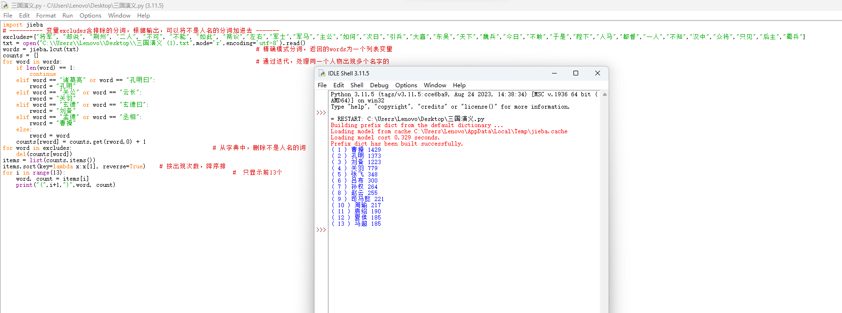
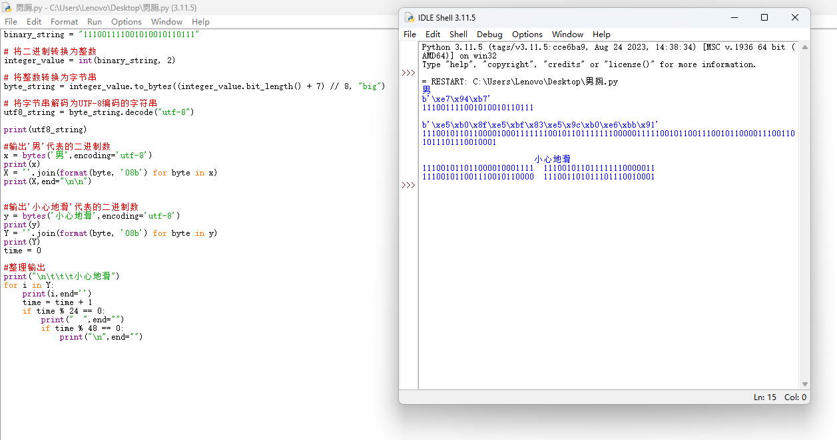
三国演义代码：
import jieba
# ---------- 变量excludes含排除的分词，根据输出，可以将不是人名的分词加进去 -------
excludes={"将军", "却说", "荆州", "二人", "不可", "不能", "如此", "商议","左右","军士","军马","主公","如何","次日","引兵","大喜","东吴","天下","魏兵","今日","不敢","于是","陛下","人马","都督","一人","不知","汉中","众将","只见","后主","蜀兵"}
txt = open("C:\\Users\\Lenovo\\Desktop\\三国演义 (1).txt",mode='r',encoding='utf-8').read()
words = jieba.lcut(txt) # 精确模式分词，返回的words为一个列表变量
counts = {}
for word in words: # 通过迭代，处理同一个人物出现多个名字的
if len(word) == 1:
continue
elif word == "诸葛亮" or word == "孔明曰":
rword = "孔明"
elif word == "关公" or word == "云长":
rword = "关羽"
elif word == "玄德" or word == "玄德曰":
rword = "刘备"
elif word == "孟德" or word == "丞相":
rword = "曹操"
else:
rword = word
counts[rword] = counts.get(rword,0) + 1
for word in excludes: # 从字典中，删除不是人名的词
del(counts[word])
items = list(counts.items())
items.sort(key=lambda x:x[1], reverse=True) # 按出现次数，降序排
for i in range(13): # 只显示前13个
word, count = items[i]
print("(",i+1,")",word, count)

Utf-8代码：
binary_string = "111001111001010010110111"

# 将二进制转换为整数
integer_value = int(binary_string, 2)

# 将整数转换为字节串
byte_string = integer_value.to_bytes((integer_value.bit_length() + 7) // 8, "big")

# 将字节串解码为UTF-8编码的字符串
utf8_string = byte_string.decode("utf-8")

print(utf8_string)

#输出'男'代表的二进制数
x = bytes('男',encoding='utf-8')
print(x)
X = ''.join(format(byte, '08b') for byte in x)
print(X,end="\n\n")

#输出'小心地滑'代表的二进制数
y = bytes('小心地滑',encoding='utf-8')
print(y)
Y = ''.join(format(byte, '08b') for byte in y)
print(Y)
time = 0

#整理输出
print("\n\t\t\t小心地滑")
for i in Y:
print(i,end='')
time = time + 1
if time % 24 == 0:
print(" ",end="")
if time % 48 == 0:
print("\n",end="")

