Shipwright's Countdown:
Civilizations Future
  - Repairing vehicles for a brighter future
Contents
1. Executive Overview & Technical Setup 2
1.1. Project Summary 2
1.2. Tech Stack & Target Specifications 2
2. Core Gameplay Architecture 3
2.1. Daily Gameplay Loop 4
2.2. Time & Day System 4
3. System Deep-Dive 4
3.1. Overworld & Navigation 4
3.2. Vehicle Difficulty & Part Scaling System 4
3.3. Minigame Architecture 5
4. UI Architecture & Canvas Rendering Strategy 5
4.1. System Architecture Split 5
5. Narrative Story 5
6. Data Persistence & Save Schema 6
6.1. Save Scheme 6
7. Future Roadmap 6

Executive Overview & Technical Setup

Project Summary
Shipwright's Countdown: Civilization's Future is a 2D top-down vehicle repair cozy simulator management game built for web browsers. Players take on the role of a mechanic (name TBA) over a 7-day period, diagnosing and repairing broken vehicles, navigating a top-down overworld to complete repair minigames, and fixing as many vehicles as possible before the daily shift ends. The game features three distinct endings depending on the number of vehicles the player manages to repair during the 7-day period.

Tech Stack & Target Specifications
- Core Languages: Vanilla JavaScript (ES6+), HTML5, CSS3
- Rendering Engine: HTML5 <canvas> API (2D context) for overworld and minigames, HTML/CSS DOM overlays for menus and global UI
- Audio Engine: Custom audio pipeline (using custom made assets via Bosca Ceoil – TBA)
- Data Persistence: Browser localStorage API
- Target Resolution & Platform: Base resolution of 1280 by 720 pixels (16:9 ratio) targeted for desktop browsers, with scaling support for mobile port (WIP)

Core Gameplay Architecture
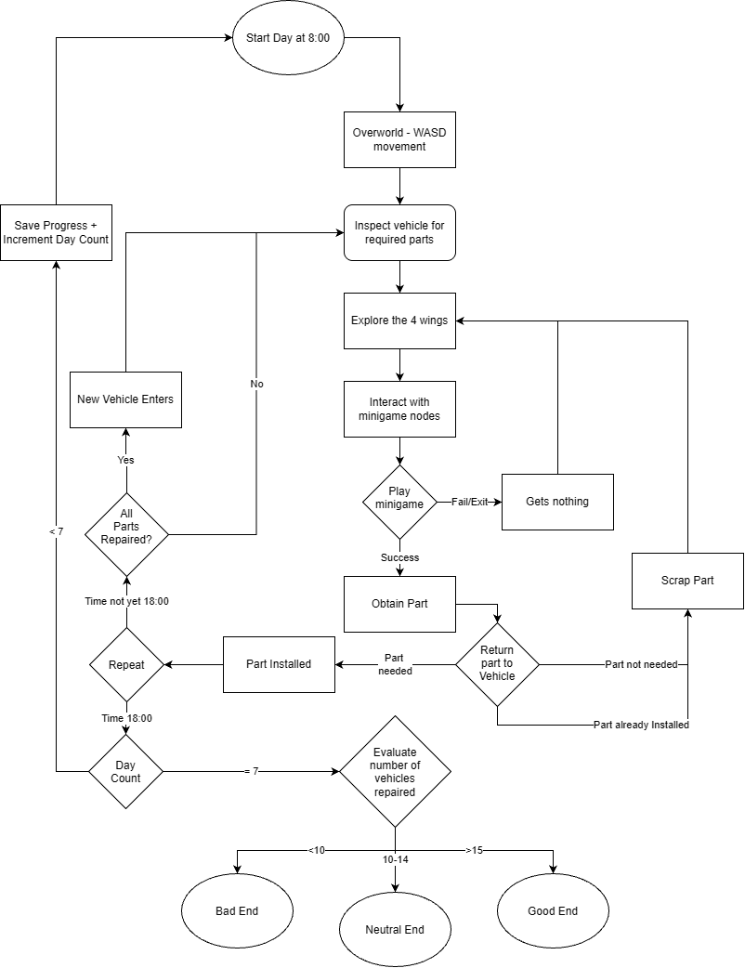

Daily Gameplay Loop
- Day Start Player Spawns at their house at 8:00 AM
- Diagnosis Player goes to the broken vehicle and interacts [E] with the vehicles to see the missing/required parts
- Scavenging Player roams the overworld map of the four wings to find the specific minigame nodes to obtain each part
- Assembly Player returns to the vehicle to apply the part
- Repeat Repeat process 3 and 4 until the vehicle is fully fixed
- Repeat New vehicles enter after previous one, repeat step 2-5
- Day End The Day automatically ends when the clock reaches 6:00 PM ( 10 real life minutes). Currently carried parts do not transfer over to the next day.

Time & Day System
- Time Scale : 1 real-world second = 1 in-game minute
- Shift Duration: : 8:00 AM to 6:00 PM (10 in-game hours = 10 real-world minutes per day)
- Total Duration : 7 Days ( ~70 minutes for a complete playthrough pre cutscenes)
- Day Progression : Time ticks down continuously even in minigames, only pauses in pause screen and cutscenes

System Deep-Dive

Overworld & Navigation
- Movement : Top-down navigation movement using WASD
- Interact : E key enables interaction of objects scattered throughout the world
- Map Overlay : M key toggles a map overlay with the 5 core sections (Main Hub, North Wing, South Wing, East Wing, West Wing)

Vehicle Difficulty & Part Scaling System
Vehicles spawn in a continuous queue, with its difficulty raising depending on the total number of vehicles repaired:
Vehicle Range | Missing Part Count | Structural Notes
Vehicle 1 | 3 Parts
Vehicles 2 – 5 | 4 – 6 parts
Vehicles 6 – 9 | 5 – 8 parts
Vehicle 10 | 8 parts | Reaches Neutral Ending Threshold
Vehicles 11 - 14 | 8-10
Vehicle 15 | 10 | Reaches Good Ending Threshold
Vehicles 16 – 19 | 10-11 parts
Vehicles 20 | 10 – 12 parts | Reaches Achievement
Vehicles 20+ | Randomized with some linearly increasing difficulty | Depends on number vehicles done and current day passed, is mostly unlockable in endless mode

Minigame Architecture
- Target Scope : 12 Minigames (1 per part)
- State Management : Interacting with a minigame node overlays the overworld with the minigame, pauses player movement unless told otherwise by each respective minigame. Returns a success flag if complete and awards the corresponding part. Players can choose to close the minigame early by pressing the ESCAPE key
- Active Minigames :
  - Wire Connection : Interactive wire-matching puzzle with randomized spawn locations for each node
  - Minigames 2 – 12 : WIP / TBA

UI Architecture & Canvas Rendering Strategy

System Architecture Split
- DOM Layer (HTML / CSS)
  - Main Menu & Settings
  - Pause Menu Overlay
  - Map Overlay
- Canvas Layer (JavaScript)
  - Overworld Map & Player Character
  - Vehicle Sprites & Parts
  - Minigame Nodes
  - Collision Detection
  - Movement and Interact functionalities
  - Camera Boundaries and Screen transitions

Narrative Story
Game end conditions will automatically be checked after the 7th day has passed
Ending Type | Condition (Vehicles Fixed) | Narrative Outcome
Bad Ending | 1 – 9 Vehicles | The distrust feeds the discourse planted by the Familia (antagonist) and your shop gets taken down and you are on the streets failed to fight the system arrogantly
Neutral Ending | 10 – 14 Vehicles | The Familia (antagonist) get demoted and kept in check and you continue with royal pardons and guarantees but even if that corrupt family gets overturned the fundamental issue remains
Good Ending | 15+ Vehicles | The trial recognizes you have gone above and beyond being even better than your perfect rates which invites the clientele who feel so blessed they risk their own standings to rally in court and push for your dream to be put forth in place of the convicted Familia (antagonist) so now it doesn’t just create a power vacuum for some new possibly good possibly bad group to take control but instead entrusts you to make the future better

Data Persistence & Save Schema
Progress is saved automatically at the end of each in-game day (6:00 PM fade to black transition)

Save Scheme
{
"playerX": 640,
"playerY": 400,
"roomId": 'hub',
"vehicle":
{
"currentVehicleIdx": 0,
"repairCount": 0,
"activeVehicle": null
},

"timer":
{
"currDay": 1,
"elapsedSec": 0
}
}
- Position Tracking : Saves playerX, playerY, and roomId so the player will spawn the same place they left off in
- Vehicle State : Preserves the current state and queue of the vehicle
- Time Progression : Tracks the current day and elapsed seconds so loading in will be at the same time as saved

Future Roadmap
Though the items listed above serve enough for the core mechanics, there are a few key features either still in a WIP state where they aren’t fully fleshed out yet, or are simply not yet incorporated:
- Audio Integration : Import custom BGM and SFX created via Bosca Ceoil using Web API controllers
- Map Overlay : Currently only displays a yellow translucent background, plan to incorporate proper map rendering and display of each sections’ items
- Minigame Expansion : Incorporate the remaining 11 minigames and potentially add more for each parts’ minigame pool if have time
- Mobile Ports : Currently not yet fully supported, only partly
- Assets and Sprites : Currently the game is made of only squares, planned to make sprites and art for each character using Pixelorama
- Cutscenes : Planned cutscenes for later
- Translations : Planned to properly incorporate translations between English and Chinese

