**Exam Photonics January 10 2023**

**In answering the following questions:** l **Be concise and to the point**

* **Explain everything as if the reader is an electrical engineer or a physicist who has NOT taken the Photonics course**
* **Write your name on every page**

**If a question is not fully clear, ask for clarification.**

**All questions have equal weight. The exam is open book.**

-----

1. Explain why a very thin oil film on water (with thickness of at most a few micrometers) looks colored and explain why the colors are very different from rainbow colors.

1. Two monochromatic laser beams (same frequency, same amplitude, circular polarisation) illuminate a certain volume whereby they are incident from orthogonal directions. Discuss the resulting interference pattern (in particular: what is the ratio of maximum to minimum intensity in the interference pattern).

1. Consider a simple symmetric slab waveguide. Describe how the group velocity and the group index of the lowest order TE mode behave as a function of wavelength in such a waveguide. Neglect the effect of the material dispersion of the materials involved.

1. Consider a thin layer of air in between two semi-infinite plates of silicon (n=3.5, no absorption). A plane wave with a (vacuum) wavelength of 1 micrometer is incident from the silicon under normal incidence. Make an approximate sketch of the power transmissivity as a function of the thickness of the air layer (over the range from 0 till 5 micrometer). For which thicknesses will there be a maximum or a minimum. Consider both s- and p-polarisation. Do the same for light incident under 45 degrees.

1. Why does one want to build ever larger telescopes? Give at least two good reasons.

1. Write down the system matrix of the plano-convex lens (in air) shown below. Assume the refractive index of the lens is 𝑛!, the radius of the spherical surface is *R*, and the thickness of the lens is 𝑇". Draw the two principal planes of the lens in the figure.

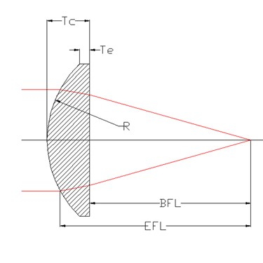

1. In the figure you can find a 3D illusion box with two identical parabolic mirrors. The focal point of the top mirror is on the bottom mirror. If you put a small frog toy on the bottom parabolic mirror, you will see a frog in the hole of the top mirror. Is the frog in the hole a real image or a virtual image? If you space the mirrors further apart, will the image become larger or smaller? Explain your answers.

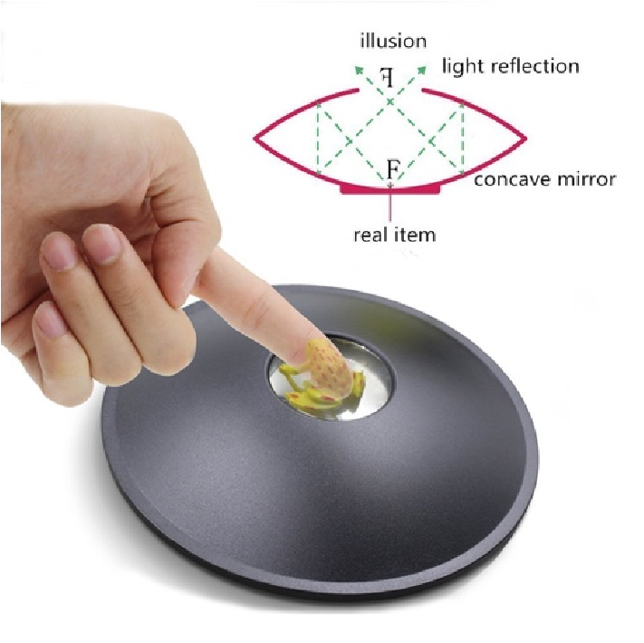

1. Assume the length of the cavity of a mode-locked laser is 300 microns with a (wavelength-independent) effective index of 3. To achieve a 0.1 ps pulsed laser, what is the minimal bandwidth (in wavelength) of the material gain? How many longitudinal modes are mode-locking in that case? Central wavelength = 1053nm.