Federal HRIT Productization — UIAO Substrate Alignment with OPM HRIT Modernization
  - How the open UIAO canon governs inbound HR provisioning from federal HR systems of record into Entra ID under the Spec 2 HR-agnostic architecture
Michael Stratton
2026-06-01
Table of contents

Federal HRIT Productization

How the open UIAO canon governs inbound HR provisioning into Entra ID under the Spec 2 HR-agnostic architecture
 Problem, solution, ask
Problem. Agencies do not own their identity-proofing event — it happens in the HR system of record months before an Entra account exists. Bespoke, vendor-specific, ConMon-opaque HR-to-directory pipelines mean AC-2, IA-4, and IA-5 cannot be continuously verified, and Federal HR 2.0 is now consolidating 100+ Core HCM systems onto Oracle Fusion Cloud HCM, retiring the very feed shapes agencies are integrating against.
Solution. UIAO’s Spec 2 architecture (UIAO_136; HR-agnostic by ADR-003): any HR source → a per-source adapter → one canonical schema → one middleware → one SCIM 2.0 binding into Entra ID, with Joiner/Mover/Leaver workflows, OrgPath population, drift detection, and FedRAMP-grade evidence produced as a byproduct. Spec2-D6.1 records the federal-civilian instance.
Ask. Build against the pattern, not the named systems: treat every current HR feed as an adapter that will change when Core HCM Wave 2 lands (FY2027) and hold the canonical schema and evidence chain constant across that change. Engage on Spec2-D6.1 now, while it is still Draft v0.2 and the federal instance is being refined.

Executive summary
Federal civilian and DoD-civilian agencies do not own their identity- proofing event. That event happens at the HR system of record — NFC EmpowHR, Treasury HR Connect, DCPDS, DOI IBC — typically months before the employee’s first Entra ID account exists. The HR system holds the authoritative personnel record under the Privacy Act (5 U.S.C. §552a) and the corresponding agency SORN; Entra ID is a downstream consumer.
The implication is structural: an agency’s Entra ID identity plane is only as trustworthy as the inbound HR provisioning pipeline that populates it. If the pipeline is bespoke per agency, evidence drifts between HR system and directory between the SF-50 event and the auditor’s review. If the pipeline is HR-vendor-specific, the agency is locked into whichever Workday / Oracle HCM / SAP SuccessFactors / NFC EmpowHR adapter it inherited. If the pipeline is opaque to FedRAMP continuous-monitoring, the controls that depend on accurate principal state (NIST 800-53 AC-2, IA-4, IA-5, NIST 800-63 IAL/AAL) cannot be continuously verified.
UIAO’s Spec 2 architecture (UIAO_136) governs this layer. It is HR-system-agnostic by canon decision (ADR-003): any HR source plugs into a single canonical schema via a per-source adapter, then flows through a single middleware to a single SCIM 2.0 binding into Entra ID. The federal-civilian instance of that architecture is recorded in Spec2-D6.1, which names the canonical federal HR / personnel / credential systems the substrate integrates with and maps each to its role in the pipeline.
This whitepaper is the customer-facing companion to that runbook. It is not a replacement for the agency’s authority over identity-proofing, PIV issuance, or HR data ownership; it is the open framework that records how the substrate routes those authoritative events into Entra ID and produces FedRAMP-grade evidence of the routing.
Program currency — Federal HR 2.0
The OPM HRIT program has moved further than “pre-award landscape” now suggests. The December 10, 2025 OMB/OPM memo Creating “Federal HR 2.0” by Consolidating Core Human Capital Management Across the Federal Government consolidates 100+ agency Core HCM systems onto one government-wide platform, and the June 11, 2026 Core HCM award went to Oracle Fusion Cloud HCM — Wave 2 (the wave that includes this paper’s reference agency) is scheduled to complete in FY2027, and the memo’s own announced schedule targets FY2028 for government-wide adoption, at which point eOPF and EHRI become redundant and are decommissioned. Vol I Book 04 states the consequence plainly: “anything built against the EHRI/eOPF feed shapes is building against systems the program has already scheduled for retirement.”
That changes what §2’s system catalog below actually is. NFC EmpowHR, Treasury HR Connect, DCPDS, and DOI IBC HR do not appear anywhere in Book 04’s current program picture — the memo’s framing is one consolidated platform absorbing agency HR systems, not four systems each earning a durable per-agency adapter. Treat every named system below as illustrative of the pattern (Pattern A: an HR system of record feeds a per-source adapter into the canonical schema), not as a durable integration target list — the Spec 2 architecture is HR-agnostic by canon decision (ADR-003) specifically so that when the named source changes, the adapter changes and the pipeline pattern does not. Book 04 itself hedges the 2027–2028 dates as the program’s announced schedule, not a certainty — treat them the same way here. Separately: this paper’s primary canon source, Spec2-D6.1, is itself Draft v0.2 and still under refinement (see Conclusion) — treat the specific system/pattern detail below as subject to change on that basis as well.

The companion AD → Entra ID story (Federal SSOT Alignment whitepaper) covers the directory migration dimension — moving the legacy AD tree to Entra ID as a governance event. This whitepaper covers the inbound provisioning dimension — keeping the migrated tenant continuously populated from authoritative HR sources. The two are complementary; both are required for a federal-civilian deployment with a trustworthy identity plane.

1. The HRIT mandate landscape
Federal HR data exchange is governed by an explicit, multi-statute regime that pre-dates the cloud era and that the substrate must respect.
Mandate | Scope | Relevance to substrate
5 U.S.C. §552a (Privacy Act) | Defines what counts as a “system of records” containing personnel data; agency-specific SORNs publish the routine uses | The HR system of record is the Privacy Act SoR; substrate is a routine-use consumer, not a SoR. ssot-mutation: never is the canon-level instantiation of this constraint
OPM SORN GOVT-1 | Government-wide HR system records | NFC EmpowHR / FPPS / DCPDS / DOI IBC operate under this and their agency-issued SORNs
OPM SORN GOVT-1 | EHRI government-wide data warehouse (OPM/GOVT-1, General Personnel Records, expressly covers EHRI and the Central Employee Record; OPM/GOVT-7 is applicant demographic data and does not apply) | EHRI is a downstream consumer per Spec2-D6.1 §2
HSPD-12 / FIPS 201-3 | PIV credential issuance | USAccess is the substrate’s trust-anchor terminator (ADR-052); identity proofing for PIV is upstream of Entra ID
OMB M-22-09 (Federal Zero Trust) | Continuous identity verification; phishing-resistant MFA | Drives the substrate’s AAL recording per principal + DRIFT-AUTHZ surface
OMB M-19-17 | Enterprise identity, credentialing, and access management | Frames the OPM Entra / OPM eAuthentication federation pattern
5 U.S.C. §3301 et seq. | OPM authority for federal hiring | USA Staffing / USAJobs operate under this; Spec2-D2.7 covers the pre-hire window
5 U.S.C. §8901 et seq. | Federal benefits enrollment | GRB Platform downstream consumer
5 C.F.R. part 293 + Federal Records Act | Personnel file retention | eOPF is the substrate’s downstream archival consumer
HRIT Solicitation 24322626R0007 | OPM’s HRIT-platform procurement reference | Substrate’s federal-instance shape (Spec2-D6.1) anchors against this solicitation’s requirements (Req #66 SOAP RPI; §5.1.1 federation; Q&A #146 eOPF ICDs)
The companion cross-walk at A.9 NIST + FICAM Cross-Walk maps the substrate to NIST IR 8011, NIST SP 800-157 (derived PIV), NIST SP 800-63 series (IAL/AAL/FAL), and FICAM Architecture v3. The HRIT pipeline is the operational form of NIST SP 800-63A (enrollment + identity proofing) — identity proofing happens at the HR system; the substrate records the AAL the HR-issued credential terminates at, and emits drift findings when continuous verification fails.

2. The federal HR / personnel ecosystem the substrate names
The federal-civilian HRIT integration runbook (Spec2-D6.1) catalogues eleven federal HR / personnel / credential systems plus the Entra ID target. The substrate is HR-agnostic by canon decision (ADR-003) — any HR source plugs in via a per-source adapter conforming to the canonical schema. The federal instance names which sources the substrate has integration patterns for.
System | Operator | Role | Substrate pattern
NFC EmpowHR / FPPS | USDA National Finance Center | HR SoR for many civilian agencies (USDA, DOJ, DOC, DHS components, Treasury OCC, SSA, …) | Pattern A — native HR adapter
Treasury HR Connect | Treasury | HR SoR for Treasury bureaus | Pattern A — native HR adapter
DCPDS | DCPAS / DoD | HR SoR for DoD civilian employees | Pattern A — native HR adapter
DOI IBC HR | DOI Interior Business Center | HR / payroll for smaller civilian agencies | Pattern A — native HR adapter
USA Staffing | OPM | Hire request / vacancy / new-hire data (SOAP RPI to HR systems) | Pattern B — OPM lifecycle, Joiner (Spec2-D2.1) trigger source
GRB Platform | OPM | Federal benefits enrollment (FEHB, FEGLI, FSAFEDS, retirement) | Pattern B — downstream consumer of provisioning
USAJobs | OPM | Federal job applicant identity (pre-hire) | Pre-hire window source (Spec2-D2.7)
eOPF | OPM | Long-term personnel record archive | Pattern B — downstream consumer; Federal Records Act archive
EHRI | OPM | Government-wide HR / payroll / training data warehouse | Pattern B — downstream consumer; Privacy Act routine-use disclosures
USAccess | GSA Managed Service | PIV credential issuance under HSPD-12 / FIPS 201-3 | Pattern C — trust-anchor; UIAO_129 binding #4
OPM eAuthentication / OPM Entra | OPM | Federal-IdP for HRIT-platform consumers | Pattern C — federation IdP (SAML 2.0 per ADR-051)
Microsoft Entra Government Cloud | Microsoft / OPM-tenant-operated | IAM target of the provisioning pipeline | IAM binding (UIAO_129 binding #3) — receives SCIM 2.0 inbound provisioning

3. The three federal integration patterns
Per the canon (Spec2-D6.1 §3), every federal HRIT integration follows one of three patterns. The substrate’s adapter shape is the same; the data flow shape differs by pattern.
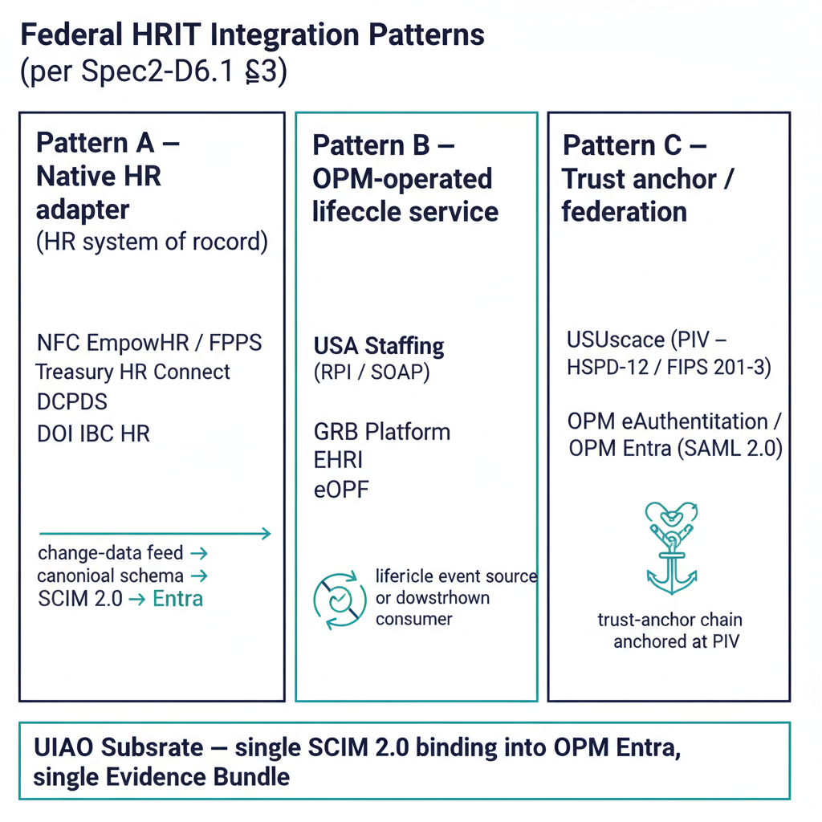
Figure 1: Three federal HRIT integration patterns side-by-side: native HR adapter, OPM-operated lifecycle service, trust anchor / federation

3.1 Pattern A — Native HR adapter
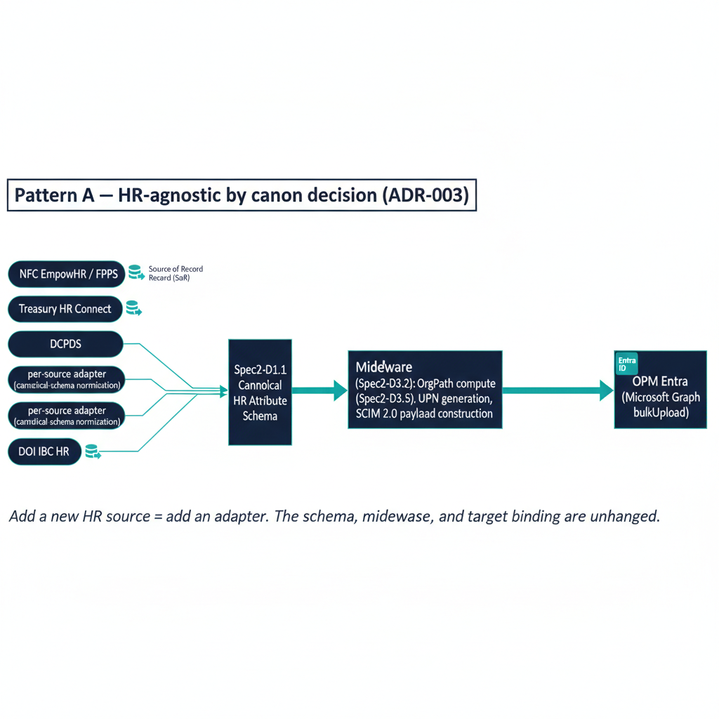
Figure 2: Pattern A inbound provisioning pipeline: per-source HR adapters normalize to canonical schema, middleware computes OrgPath, SCIM 2.0 bulkUpload into Entra
For HR systems of record (NFC EmpowHR, Treasury HR Connect, DCPDS, DOI IBC):
- Per-source adapter consumes the HR system’s published change-data feed (SOAP, REST, or batch file per system).
- Adapter normalizes records to the canonical schema (Spec2-D1.1).
- The middleware (Spec2-D3.2) computes OrgPath (Spec2-D3.5), generates the UPN, and constructs the SCIM 2.0 payload.
- Microsoft Graph bulkUpload endpoint applies the payload to OPM Entra (per the attribute mapping at Spec2-D1.3).
- Joiner / Mover / Leaver workflows (Spec2-D2.1 / D2.2 / D2.3) operate on the resulting Entra records.
Each per-source adapter is a candidate for its own activation ADR (modeled on ADR-035) when an engagement requires it.

3.2 Pattern B — OPM-operated lifecycle service
For OPM-operated services that exchange data with the HR system of record on lifecycle events (USA Staffing, GRB, EHRI, eOPF):
- USA Staffing → HR SoR: Request Processing Interconnection (RPI, SOAP per HRIT Req #66) sends new-hire data upstream into the HR system, which then triggers Spec2-D2.1.
- GRB Platform: consumes HR attributes downstream for benefits enrollment workflows; reads from Entra (post-provisioning) or from the HR system directly.
- EHRI: government-wide data warehouse; ingests HR / payroll / training data via the Guide to Human Resources Reporting feeds.
- eOPF: long-term personnel record archive; ingests SF-50 events, benefits documentation, onboarding records via the eOPF ICDs (per HRIT Solicitation Q&A #146).
These are integration points, not provisioning sources — the substrate records them as Pattern B for evidence-bundle attribution and routine-use disclosure purposes. Since the elevation of OrgLink as the substrate’s external-interconnection pillar (ADR-134), each of these agency-to-counterparty exchanges is also Link-object territory: UIAO_145 defines the Link as the governed record of one interconnection — interface, agreement artifact, and regime overlay, with a federal-agency counterparty class and CA-3 / CA-9 / SA-9 / AC-20 control bindings. The Pattern B records here are the natural seed inventory for that registry; see the OrgLink narrative for the doctrine.

3.3 Pattern C — Trust anchor / federation
For credential and federation services (USAccess, OPM Entra):
- USAccess terminates PIV credential issuance per HSPD-12 / FIPS 201-3. The substrate’s certificate-anchored: true invariant binds adapter operations to PIV-derived credentials per ADR-052; PIV issuance itself is upstream of the substrate.
- OPM Entra is the federation IdP for the entire HRIT platform. Consuming-agency tenants authenticate via SAML 2.0 (per ADR-051) to OPM Entra; the substrate records the trust-anchor chain at each authentication event. The full chain is PIV credential at USAccess → SAML assertion to OPM Entra → consuming-agency tenant.

4. Substrate mechanics — canonical schema, attribute mapping, JML
The substrate’s HR-agnostic claim rests on four canon artifacts:
Artifact | Role
Spec2-D1.1 Canonical HR Attribute Schema | The single internal representation every HR source normalizes to. Per-source adapters convert from NFC / HR Connect / DCPDS / DOI IBC native formats into this schema; no downstream component depends on the source format
Spec2-D1.3 HR → Entra Attribute Mapping Matrix | The single canonical-schema-to-Entra mapping. ISO-3166 alpha-2 country → Entra usageLocation, etc. Changes are canon-change-protocol-governed
Spec2-D2.1 Joiner Workflow (+ D2.2 Mover, D2.3 Leaver) | The lifecycle workflows that operate on the Entra record once it lands. Each workflow has explicit triggers, idempotence guarantees, and a remediation contract
Spec2-D3.5 OrgPath Population Pipeline | The pipeline that resolves the canonical schema’s organizational fields to an OrgPath value and writes it to the Entra extension attribute. This is the bridge between HRIT and the rest of the substrate’s OrgPath-driven governance (Purview Adaptive Scopes, Fabric Domains, Intune compliance per the UIAO OrgPath)
Drift between HR system and Entra ID is governed by Spec2-D5.5 Provisioning Drift Detection Rules, which operationalizes the drift-class contracts that Spec2-D3.5 §8 maps onto the six-class drift taxonomy in Doc 16. DRIFT-IDENTITY and DRIFT-AUTHZ are the load-bearing classes for HRIT — the same two that load-bear the AD → Entra ID story per the drift standard’s §7 Federal SSOT Context.

5. Federal mandate alignment
The substrate’s HRIT pipeline alignment is mechanical, not aspirational. Each federal mandate maps to a specific substrate capability that exists in canon.
Federal mandate | Substrate capability | Canon anchor
Privacy Act (5 U.S.C. §552a) — HR SoR ownership | ssot-mutation: never invariant; substrate is a routine-use consumer, not a SoR | adapter-registry.yaml, modernization-registry.yaml
HSPD-12 / FIPS 201-3 — PIV issuance | Trust-anchor binding to USAccess; PIV-derived credentials govern adapter operations | ADR-052
OMB M-22-09 — Federal Zero Trust | Continuous AAL verification per principal; DRIFT-AUTHZ findings | Spec2-D5.5 + Doc 16 §2
OMB M-19-17 — Federal ICAM | OPM Entra federation; SAML 2.0 trust anchor | ADR-051
NIST SP 800-63A — enrollment + identity proofing | HR-event-triggered provisioning; IAL recording per principal | A.9 NIST + FICAM Cross-Walk §4
NIST SP 800-53 AC-2 / IA-4 / IA-5 — account management + identifier management | Joiner / Mover / Leaver workflows; canonical-schema attribute mapping | Spec2-D2.1, D2.2, D2.3
FedRAMP 20x continuous monitoring | Provisioning drift findings emit into the Evidence Bundle as a byproduct of pipeline operation | Spec2-D3.5 §8 + D5.5 + ADR-043
Single-ATO reciprocity | One canon, multiple consuming tenants; substrate’s evidence is reciprocity-ready | ADR-054
HRIT Solicitation 24322626R0007 §5.1.1 #3 — federal-IdP for consumers | OPM Entra federation IdP routing | ADR-053
HRIT Solicitation Req #66 — RPI from USA Staffing | Pattern B Joiner trigger source | Spec2-D2.1, D6.1 §3.2
Federal Records Act + 5 C.F.R. part 293 | eOPF downstream consumption of provisioning events | Spec2-D6.1 §3.2

6. Complementarity with the AD → Entra ID story
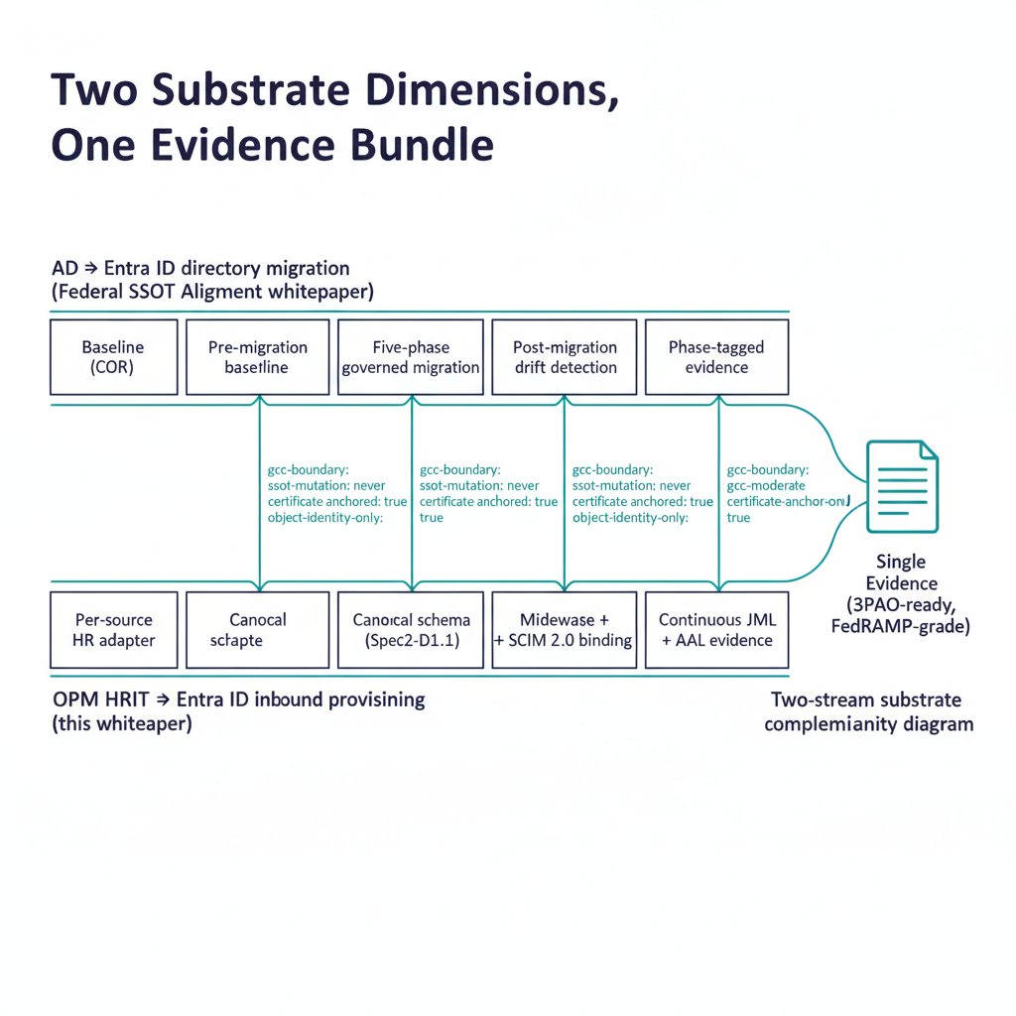
Figure 3: Two parallel substrate dimensions — AD-migration and HRIT provisioning — converging on one Evidence Bundle
UIAO’s Federal SSOT alignment whitepaper covers the directory migration dimension — moving the legacy AD tree to Entra ID as a governance event, with COR baselines, drift detection, and phase-tagged evidence bundles. This whitepaper covers the inbound provisioning dimension — keeping the migrated tenant continuously populated from authoritative HR sources.
The two are complementary. A federal-civilian deployment with a trustworthy identity plane needs both:
Concern | AD → Entra ID (PR #390 et al.) | OPM HRIT → Entra ID (this whitepaper)
What’s moving | The directory (identity store) | Nothing — HRIT is the upstream authoritative source
Substrate role | Govern the migration event end-to-end (5-phase, drift-detected) | Govern the inbound provisioning pipeline (continuous, drift-detected)
Canon home | src/uiao/modernization/directory-migration/ (8 adapters + DM_090 SQL Server) | src/uiao/canon/specs/Spec2-*.md (34 specs, UIAO_136 family)
Identity owner before | The agency’s AD (legacy) | The HR system of record (always)
Identity owner after | The agency’s Entra ID (migrated) | The HR system of record (unchanged)
Required UIAO invariants | gcc-boundary: gcc-moderate, ssot-mutation: never, certificate-anchored: true, object-identity-only: true | Same four
An agency running both substrate dimensions in parallel produces a single Evidence Bundle that an authorizing official can hand to a 3PAO: the AD-migration story carries the pre/post-migration SPN inventories, drift findings, and adapter operations; the HRIT story carries the ongoing provisioning evidence, AAL recordings, and JML transitions. Together they trace from the HR-event in the SoR through the directory migration into a continuously-verified Entra ID identity plane.

7. What this substrate dimension is NOT
- Not a replacement for the agency’s HR system of record. NFC, HR Connect, DCPDS, DOI IBC remain the Privacy Act systems of record; the substrate is a routine-use consumer per the agency’s SORN.
- Not a PIV issuance authority. USAccess remains the PIV issuance authority under HSPD-12 / FIPS 201-3; the substrate is a downstream trust-anchor consumer per ADR-052.
- Not a federation IdP. OPM Entra remains the HRIT-platform federation IdP; the substrate records the trust chain, it does not replace the IdP per ADR-051 / ADR-053.
- Not a benefits-enrollment system. GRB remains the federal benefits enrollment authority; the substrate emits provisioning events GRB can consume downstream.
- Not a SCIM provider implementation. The substrate uses Microsoft Graph bulkUpload (Pattern A step 4) as the SCIM 2.0 binding into OPM Entra; it does not re-implement SCIM.
- Not in scope for state-level HR systems. Per Spec2-D6.1 §1.1, state-agency hires fall outside this reference instance.

Conclusion
Federal HRIT is governed by a clearer mandate landscape than most substrate dimensions — Privacy Act SORNs, HSPD-12 / FIPS 201-3 for PIV, OMB M-22-09 / M-19-17 for ICAM, NIST SP 800-63A for enrollment, the HRIT solicitation for OPM-platform integration. What agencies have lacked is an open framework that records how the substrate routes authoritative HR events into Entra ID under those mandates, and that produces FedRAMP-grade evidence of the routing as a byproduct of normal operations.
UIAO’s Spec 2 architecture is that framework. It is HR-agnostic by canon decision (ADR-003), recorded for the federal-civilian instance in Spec2-D6.1 (the runbook is Draft v0.2 — governed canon, still under refinement), and operationalized through 34 canon deliverables spanning the canonical schema, attribute mapping, Joiner / Mover / Leaver workflows, OrgPath population, drift detection, and the federation trust chain to OPM Entra. Together with the AD → Entra ID story it produces a federal-civilian identity plane that is continuously trustworthy from the HR event through the directory migration into the Azure SSOT stack the chapter 07a — UIAO Beneath the Azure SSOT Stack positions.
For the canon-level operational mechanics, see Spec2-D6.1 and the 33 sibling Spec2 deliverables under src/uiao/canon/specs/. For the customer-facing program-level frame, see Doc 22 — HRIT Productization. For the federal-mandate cross-walk that frames the substrate against NIST and FICAM standards, see A.9 NIST + FICAM Cross-Walk.

