Federal SSOT Alignment — UIAO as the Identity Governance Substrate for AD → Entra ID Migration
  - How the open UIAO canon composes Evidence Act, M-25-05, CDO, DAMA-DMBOK, Zero Trust, TIC 3.0, NIST 800-63 and FedRAMP 20x obligations over the identity layer — SSOT as the architectural response, not a mandate
Michael Stratton
2026-06-01
Table of contents

Federal SSOT Alignment

How the open UIAO canon governs the identity layer beneath federal data governance mandates
 Problem, solution, ask
Problem. Agencies carry Evidence Act, OPEN Government Data Act, and M-25-05 data-governance obligations and an AD → Entra ID migration imperative, and run them as two unrelated programs. No statute mandates Single Source of Truth — but a credible data inventory cannot be maintained from sources that disagree, and the identity layer beneath every one of those decisions is exactly what the migration is about to change.
Solution. Treat the identity namespace as the root of the SSOT hierarchy and the migration as a governance event. The open UIAO canon encodes SSOT designations, the drift taxonomy, and a provenance chain so that FedRAMP-grade evidence is a byproduct of the migration rather than assembled afterward — beneath Entra ID, Purview, Fabric, Defender, and Sentinel, not in place of them.
Ask. Run the two programs as one. Adopt the phased posture (assess → govern → migrate → validate → operate) with governance in place before any identity object moves, and give the Chief Data Officer and the identity team a single, shared SSOT designation register.

Executive summary
Federal civilian agencies carry a set of data-governance obligations — through the Foundations for Evidence-Based Policymaking Act, the OPEN Government Data Act, and OMB’s implementation guidance, currently M-25-05 (Phase 2, January 2025) — to maintain comprehensive data inventories, designate Chief Data Officers, and publish open-by-default in machine-readable form.
None of those authorities mandates Single Source of Truth, and this paper does not claim otherwise. There is no federal SSOT mandate, no statutory requirement to designate authoritative systems of record, and no OMB CDO directive imposing one. The Federal Data Strategy was a strategy rather than a mandate, and its action plans ended with the 2021 edition.
SSOT is the architectural response a great many agencies adopt in order to satisfy those obligations. You cannot maintain a credible data inventory across fragmented operational environments without deciding which system is authoritative for a given fact, and you cannot publish open-by-default from sources that disagree. That is an engineering conclusion, not a legal one — and stating it that way is what makes the rest of this paper survive a reader who knows the statutes. A paper that asserts a mandate its cited authority does not impose has handed that reader the fastest possible reason to stop reading. At the same time, those same agencies face a migration imperative: retiring on-premises Active Directory infrastructure in favor of Microsoft Entra ID, while remaining coherent with Zero Trust, TIC 3.0, NIST 800-63, and FedRAMP 20x.
These two mandates are almost universally treated as separate programs. They should not be.
UIAO is an open, FedRAMP-Moderate-focused governance substrate that addresses both — treating the identity namespace as the root of the SSOT hierarchy, and the AD → Entra ID migration as a governance event rather than a technical transition. UIAO does not displace Microsoft Entra ID, Microsoft Purview, Microsoft Fabric, Microsoft Defender, or Microsoft Sentinel. It is the open canon that describes how those capabilities compose, at the identity layer, into a substrate that survives an audit and survives the migration boundary the entire Azure SSOT stack is built on.
The Azure SSOT stack alignment — UIAO’s positioning beneath Microsoft Purview and OneLake — is developed in its own chapter (07a — UIAO Beneath the Azure SSOT Stack) of the UIAO OrgPath series. This whitepaper establishes the federal mandate alignment that makes that chapter necessary.
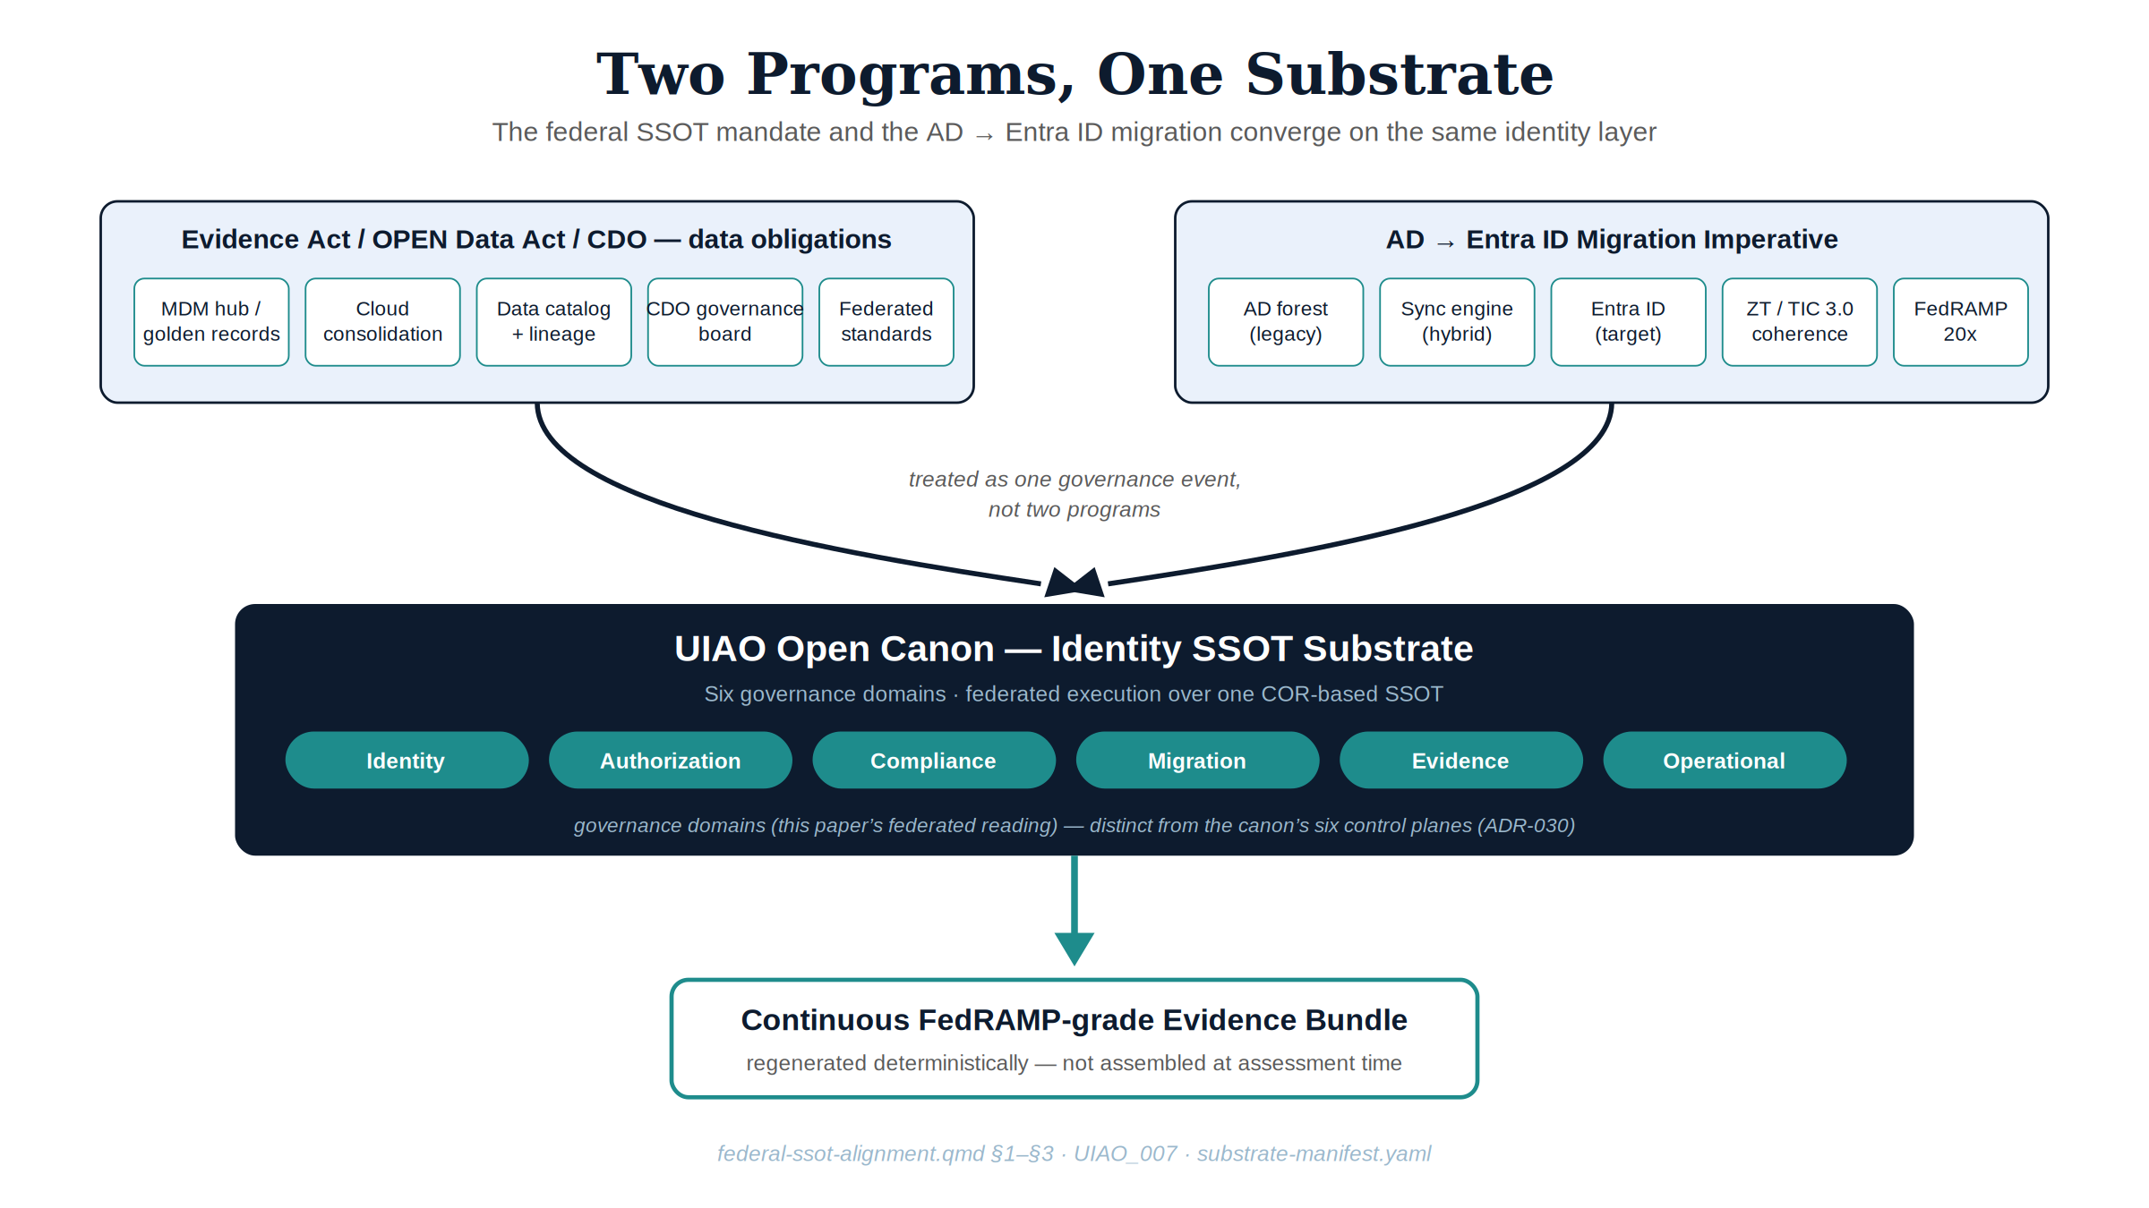
Figure 1: Two federal program tracks converging into the UIAO open canon as a single identity SSOT substrate

1. The federal SSOT problem — what agencies already know
Federal data governance guidance is explicit: silos, regional office sprawl, and overlapping SQL Server instances undermine mission effectiveness. The recommended counter-measures are well-established:
- Master Data Management (MDM) to define “golden records” and authoritative sources
- Cloud consolidation (Azure Government, AWS GovCloud) to eliminate redundant on-premises copies
- Data catalogs and lineage tools to enforce visibility and provenance
- Chief Data Officers and Data Governance Boards to assign ownership and accountability
- Federated governance models that balance central control with operational autonomy
These are the right mechanisms. The gap is that none of them are designed for the identity layer — and identity is not just another data domain. Identity is the namespace from which all other enterprise data is governed: who owns a record, who can modify it, who last changed it, and whether the current state of that record is trusted.
When the identity infrastructure is in transition — as it is in every AD → Entra ID migration — the SSOT frameworks built on top of it are structurally at risk. Agency CDO offices have inherited a data governance mandate that assumes the identity layer is stable. The identity layer is not stable. It is moving.

2. Why AD → Entra ID is a governance event, not a migration
A conventional AD → Entra ID migration project moves users. A governance-aware migration moves the entire identity namespace — and every dependency attached to it.
Domain | AD artifact | Migration risk
Identity | User accounts, SPNs, service accounts | Orphaned accounts, broken dependencies
Network | DNS, DHCP, DFS namespaces | Namespace drift, split-horizon DNS
Security | PKI, RADIUS/NPS, certificate templates | Broken authentication chains
Policy | GPOs, conditional access equivalents | Policy gap between AD and Entra ID
Applications | LDAP-dependent apps, legacy SSO | Silent auth failures
Devices | Domain-joined endpoints, SCCM/Intune hybrid | Device trust drift
Conventional migration engagements manage this complexity manually. The reason is structural: there is no shared, tamper-evident record of the pre-migration state, the migration events, or the post-migration compliance posture that survives the engagement. Each engagement starts from scratch. Findings are not reusable. Evidence for FedRAMP continuity is assembled retrospectively.
This is exactly the class of SSOT failure that federal data governance programs exist to prevent — applied to the one domain those programs have historically excluded: directory and identity infrastructure.
UIAO’s ad-dependency-inventory.md enumerates eleven AD object types that must be governed through the migration event, each with a named adapter contract in migration-adapter-registry.yaml. The inventory exists as canon so that successive engagements consume it rather than rediscover it.

3. UIAO architecture: SSOT enforcement as a canon property
UIAO treats the identity namespace as a governance substrate, not a migration target. Its core architectural mechanisms map directly to the federal SSOT mechanisms described in agency data governance frameworks.
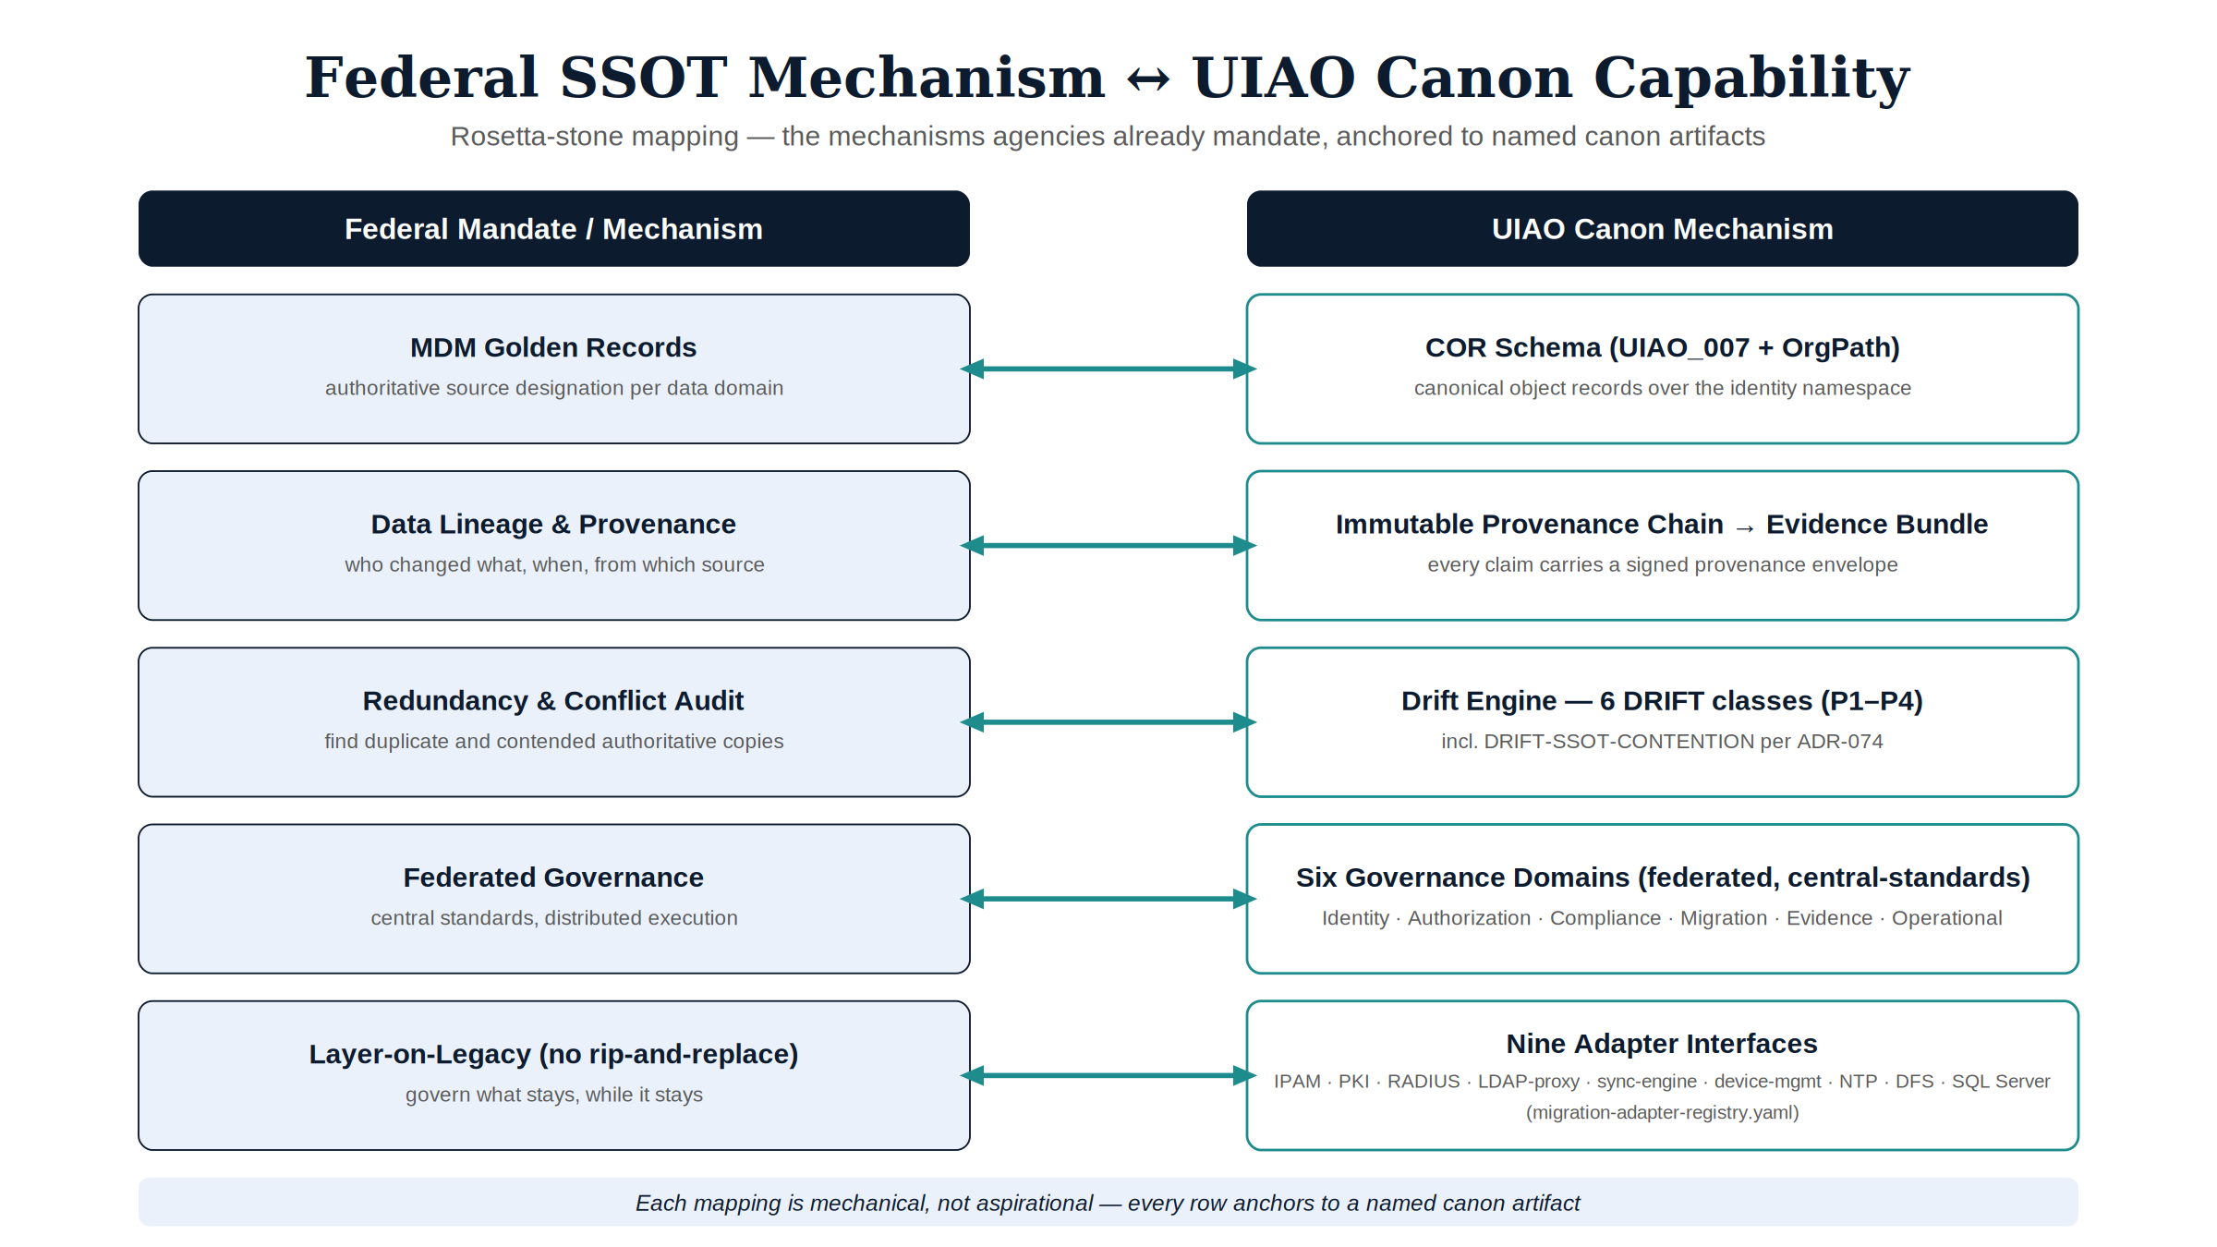
Figure 2: Rosetta-stone mapping of federal SSOT mechanisms to UIAO canon capabilities

3.1 COR schema → golden record / MDM hub
UIAO’s Canonical Object Record (COR) schema functions as the identity MDM hub. Every principal — user, service account, device, group — has a single authoritative representation. Downstream systems reference or synchronize to the COR; they do not maintain independent copies. This mirrors the federal MDM pattern exactly: a central hub with governed pipelines, not duplicated instances.
The OrgTree registry and the OrgPath extension attribute documented in UIAO_007 are the canonical form of this hub for the user and device planes. The UIAO OrgPath develops the substrate end-to-end across every Microsoft surface that consumes the attribute.

3.2 Provenance chain → data lineage and audit
Every change to a COR entry is recorded in an immutable provenance chain — who made the change, from what source, at what time, under which policy authority. This is the identity-layer equivalent of data catalog lineage tools, but embedded natively in the substrate rather than bolted on externally.
For FedRAMP Moderate environments, the provenance chain is the Evidence Bundle: a continuous, tamper-evident audit trail that survives the migration boundary. The substrate manifest at src/uiao/canon/substrate-manifest.yaml declares the modules whose changes feed it.

3.3 Drift Engine → automated redundancy and conflict detection
The UIAO drift taxonomy, formalized in 16_DriftDetectionStandard, defines six drift classes — DRIFT-SCHEMA, DRIFT-SEMANTIC, DRIFT-PROVENANCE, DRIFT-AUTHZ, DRIFT-IDENTITY, and DRIFT-SSOT-CONTENTION (ADR-074) — each with severity classification (P1–P4) and a remediation contract. DRIFT-IDENTITY and DRIFT-AUTHZ flag the conditions that compromise identity SSOT in real time:
- Service accounts that exist in AD but have no COR representation (shadow principals)
- Entra ID objects that diverge from their migrated COR baseline (post-migration drift)
- Authorization policies in Entra Conditional Access that conflict with the NIST 800-63 AAL requirements encoded in the COR
This is the automated equivalent of the redundancy auditing an agency has to perform to keep a data inventory honest — a practice the inventory obligation implies rather than a phrase any statute uses — applied in real time to the identity layer, with the drift class and severity carried as schema rather than narrative.

3.4 Six governance domains → federated governance with central standards
To be explicit up front, because the count is easy to conflate: this paper reads UIAO’s substrate through six governance domains — Identity, Authorization, Compliance, Migration, Evidence, and Operational. These are not a competing or independent six-part taxonomy. They are this paper’s governance-ownership reading of the canon’s own six control planes — Identity, Addressing, Overlay, Telemetry, Management, Governance, defined in ADR-030 — asking one question of each plane: who owns accountability for it? The control planes describe what the substrate acts on; the governance domains describe who governs that action, framed for the federated governance model federal agencies already run (centralized standards, federated execution across CDO, ISSO, and program-office ownership).
The correspondence is not one-to-one, and presenting it as a clean 1:1 table would overstate it. Identity is a direct match on both sides. Everywhere else, a governance domain typically draws its accountability from more than one control plane, or a control plane’s accountability splits across more than one domain:
UIAO governance domain | Federal governance equivalent | Draws accountability primarily from (ADR-030 control plane)
Identity domain | CDO-designated identity SSOT | Identity
Authorization domain | Data access policy standards | Governance, with Identity supplying the assurance context it enforces against
Compliance domain | FedRAMP / NIST continuous monitoring | Governance, with Telemetry supplying the monitoring signal it evaluates
Migration domain | Transition governance and rollback authority | Identity, Addressing, and Overlay jointly — migration is the event where all three change state together
Evidence domain | Audit, lineage, and reporting | Telemetry for emission, Management for bundle assembly and OSCAL regeneration
Operational domain | Regional / silo operational continuity | Management, with Addressing and Overlay for the legacy infrastructure that domain keeps running
Put plainly: Authorization and Compliance both lean primarily on the Governance plane rather than each owning a distinct plane of their own; Migration and Operational are each an accountability reading spread across three planes rather than one. That is expected, not a flaw in the overlay — a governance-ownership reading is not obligated to partition the same six things the control planes partition; it exists to answer a different question (who is accountable) over the same six-plane substrate. Each domain is governed independently but references the same COR-based SSOT. This is the “hybrid governance” model: centralized standards, federated execution.

3.5 No rip-and-replace — legacy infrastructure stays operational
UIAO does not require agencies to eliminate existing operational directory instances. AD domain controllers, LDAP-dependent applications, and regional authentication infrastructure can remain operational during and after migration. UIAO layers governance on top — exactly as federal guidance recommends layering MDM and cloud consolidation on top of legacy SQL instances rather than replacing them wholesale. The nine adapter interfaces under src/uiao/modernization/directory-migration/adapters/ (IPAM, PKI, RADIUS, LDAP-proxy, sync-engine, device-management, NTP, DFS, SQL Server) are the explicit governance surface for the legacy infrastructure that stays.

4. The M365 GCC Moderate compliance boundary problem
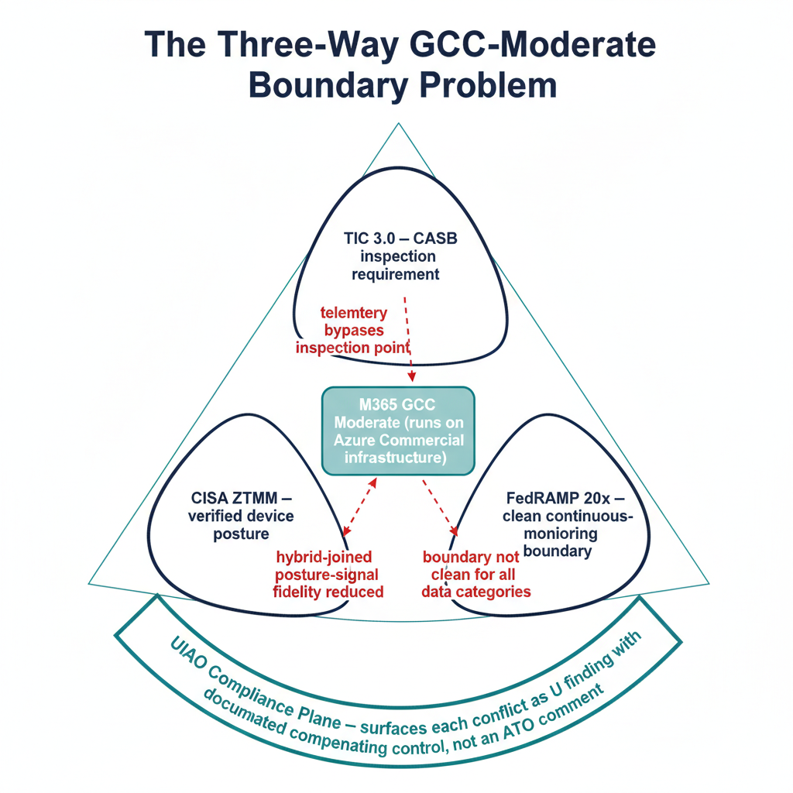
Figure 3: GCC-Moderate three-way compliance conflict triangle: TIC 3.0, CISA ZTMM, FedRAMP 20x
There is a structural compliance problem that the open UIAO canon is positioned to make explicit, and that is significantly underdocumented in federal architecture guidance.
M365 GCC Moderate runs on Azure Commercial infrastructure. This means:
- Telemetry and diagnostic data flow to Azure Commercial endpoints
- Microsoft Entra ID tenant control planes are shared with non-GovCloud tenants
- Location signal of the fidelity TIC 3.0’s inspection model assumes is not available at the GCC Moderate boundary
This creates a three-way compliance conflict:
- TIC 3.0 positions the agency’s TIC to inspect cloud service traffic — but GCC Moderate telemetry bypasses the inspection point. TIC 3.0 is guidance and prescribes no product class, so this is a capability gap against its Security Capabilities Catalog, not an agency failing a directive; stated as a directive violation it would not survive review
- CISA Zero Trust Maturity Model requires verified device posture — but hybrid-joined devices in a GCC Moderate tenant have reduced posture signal fidelity
- FedRAMP 20x continuous monitoring requirements assume a clean cloud boundary — which GCC Moderate does not provide for all data categories
Agencies migrating from AD to Entra ID into a GCC Moderate tenant are structurally inheriting this boundary without a clear compliance remediation path. The canon GCC Moderate boundary model at B1-gcc-moderate-boundary-model documents the structural shape, and its dedicated leaf B1-1 — the GCC-Moderate three-way conflict formalizes this section’s conflict as the standing finding GCC-BOUNDARY-3WAY-001. UIAO’s Compliance governance domain is the substrate where these boundary conditions are surfaced as compliance findings with documented compensating controls, rather than left as ATO comments discovered during 3PAO review.
The boundary problem is precisely the kind of finding that vendor documentation cannot honestly surface and that customer-side compliance teams need an open framework to articulate.

5. Alignment to federal mandates
The substrate’s alignment is mechanical, not aspirational. Each federal obligation maps to a specific UIAO capability that exists in canon. Read the left column as what the agency owes and the middle as how this substrate discharges it — not as a claim that the authority prescribes the mechanism. Only the Zero Trust and FedRAMP rows carry directive force with their own clocks; the data-governance rows are obligations whose method is the agency’s to choose.
Federal obligation | UIAO capability | Canon anchor
Evidence Act — Data Asset Inventories | COR schema as authoritative identity inventory | UIAO_007, substrate-manifest.yaml
M-25-05 — Open Data Plans, machine-readable publication | Identity namespace as root SSOT; no parallel copies. SSOT is UIAO’s architectural answer to this obligation, not a requirement the memo imposes | UIAO OrgPath §1–4
CDO Data Governance Board requirements | Six governance domains with ownership and accountability assignments | substrate-manifest.yaml
DAMA-DMBOK — Quality, Lineage, Metadata | Provenance Chain + COR schema metadata layer | 16_DriftDetectionStandard §4
Zero Trust Executive Order | Continuous identity verification via drift taxonomy | 16_DriftDetectionStandard §2
FedRAMP Moderate Continuous Monitoring | Evidence Bundle schema, tamper-evident audit trail | substrate-manifest.yaml, OSCAL exports
TIC 3.0 | Compliance governance domain models GCC boundary constraints | B1-gcc-moderate-boundary-model
NIST 800-63 AAL requirements | COR schema encodes authenticator assurance levels per principal | UIAO_007, DRIFT-IDENTITY

6. The shape of the current engagement model
Federal AD → Entra ID migration today follows a recognizable shape regardless of which system integrator delivers the work:
- Manual discovery of the AD environment
- Migration runbooks specific to that engagement
- Execution with point-in-time tooling (ADMT, Microsoft Identity Manager, Entra Connect)
- Hand-off documentation that describes what was done — not a living, governed, auditable record of the current state
The result is that every re-engagement starts from scratch. Drift is invisible until it becomes an incident. FedRAMP evidence is assembled retrospectively. The SSOT exists in a project binder, not a governed system.
The open UIAO canon makes explicit what current engagements do tacitly, and produces FedRAMP-grade evidence as a byproduct of normal operations rather than as a deliverable assembled at the end. The canon is freely available; its value to a system integrator engagement is that the engagement consumes existing canon rather than rebuilding it, and the evidence that survives the engagement is structured for the next FedRAMP cycle.

7. Implementation posture: phased, no rip-and-replace
Consistent with federal data governance practice (assess → design → pilot → scale → optimize), UIAO deployments follow a phased posture:
- Assess — COR schema populated from existing AD; drift taxonomy establishes the pre-migration baseline
- Govern — Governance domains activated; SSOT designations encoded; Evidence Bundle begins accumulating
- Migrate — Identity objects migrated under governance; provenance chain records every transition event
- Validate — Post-migration drift detection confirms Entra ID state matches the COR baseline
- Operate — Continuous monitoring; adapter interfaces for IPAM, PKI, RADIUS, LDAP-proxy, DFS remain connected
At no phase is the existing operational environment disrupted before governance is in place. This is the federal “think big, start small” principle applied to identity infrastructure.

Conclusion
Federal agencies are not lacking for governance frameworks, CDO mandates, or modernization directives. What they lack is an open framework that applies those frameworks to the identity layer — the one domain that underlies every other data governance decision — and does so in a way that survives the AD → Entra ID transition with a continuous, tamper-evident, FedRAMP-grade SSOT.
UIAO is that framework. It is not a migration tool that adds governance features. It is an open governance substrate that describes how migrations are executed as governed events, and how the identity foundation of the Azure SSOT stack is continuously verified once that migration is complete. The canon is the deliverable; the implementation references are reference implementations that adopters extend, fork, or replace as their environments require.
For the explicit alignment between this canon and the Microsoft Fabric + OneLake + Purview Azure SSOT stack — including the Fabric Domain bridge that extends OrgPath into the data plane — see Chapter 07a of the UIAO OrgPath.

