Snowflake Key-Pair Conversion — the UIAO and OrgPath Reading
  - How a governance substrate would run the password→key-pair migration Snowflake is forcing, and why the key pair is the bridge, not the destination
Michael Stratton
2026-06-01
Table of contents

Snowflake Key-Pair Conversion — the UIAO and OrgPath Reading
 Status — illustrative architecture comparison, not a shipped adapter
This whitepaper reads Snowflake’s authentication migration through the UIAO and OrgPath governance doctrine. It is an architecture comparison, not a claim that UIAO ships a Snowflake adapter today. Snowflake is a Commercial-cloud SaaS platform outside the current GCC-Moderate deployment boundary and is not one of the named Commercial exceptions (Amazon Connect, SailPoint); for a federal deployment, real Snowflake coverage would require a gating boundary ADR in the pattern of ADR-059 / ADR-033. (For non-federal engagements the registration path now exists without a new enum value: ADR-129 added the commercial-general boundary and ADR-133 added state-local.) Treat the patterns here as how the substrate would govern this class of problem, not as accepted normative coverage of Snowflake. The Snowflake product facts are cited to Snowflake’s own documentation; the UIAO/OrgPath positions are cited to canon.

Problem, solution, ask
Problem. Snowflake is switching passwords off on a published schedule, and service accounts, pipelines, and dbt jobs have to land somewhere. The usual answer — key-pair authentication — gets treated as the finish line, and warehouse-role grants stay hand-authored in a ticket queue, so nothing computes who should reach which role.
Solution. Three altitudes of one migration: Snowflake forces the credential change; UIAO governs what the credential becomes (password eliminated → stored key pair as a dated, rotated, compensated bridge → IdP federation with no long-lived secret, per ADR-004); OrgPath governs who the credential is for, rendering access from facet predicates and turning a stray grant into a DRIFT-AUTHZ finding. This is an illustrative reading: UIAO ships no Snowflake adapter, and Snowflake sits outside the GCC-Moderate boundary.
Ask. Three steps that need no adapter: classify every Snowflake principal by hand today, rotate stored key pairs on a defined cadence and track it as a compliance signal, and settle the boundary question (a gating ADR in the ADR-059/ADR-033 pattern, or commercial-general per ADR-129) before the automation question. See the Call to Action.

 Before the doctrine discussion — three things you can do today
This paper spends most of its length on how UIAO and OrgPath doctrine would extend to Snowflake if a boundary decision ever authorizes it. None of that is required to act. Classify every principal by hand (DESCRIBE USER plus login history), treat any stored key pair as the bridge it is, not the destination (rotate it on a defined cadence now), and settle the GCC-Moderate boundary question before the automation question (the ADR-059/ADR-033 pattern, or commercial-general per ADR-129 for non-federal work). All three are manual, adapter-independent, and executable with no UIAO product in place — the full Call to Action, with citations, is at the end of this document.

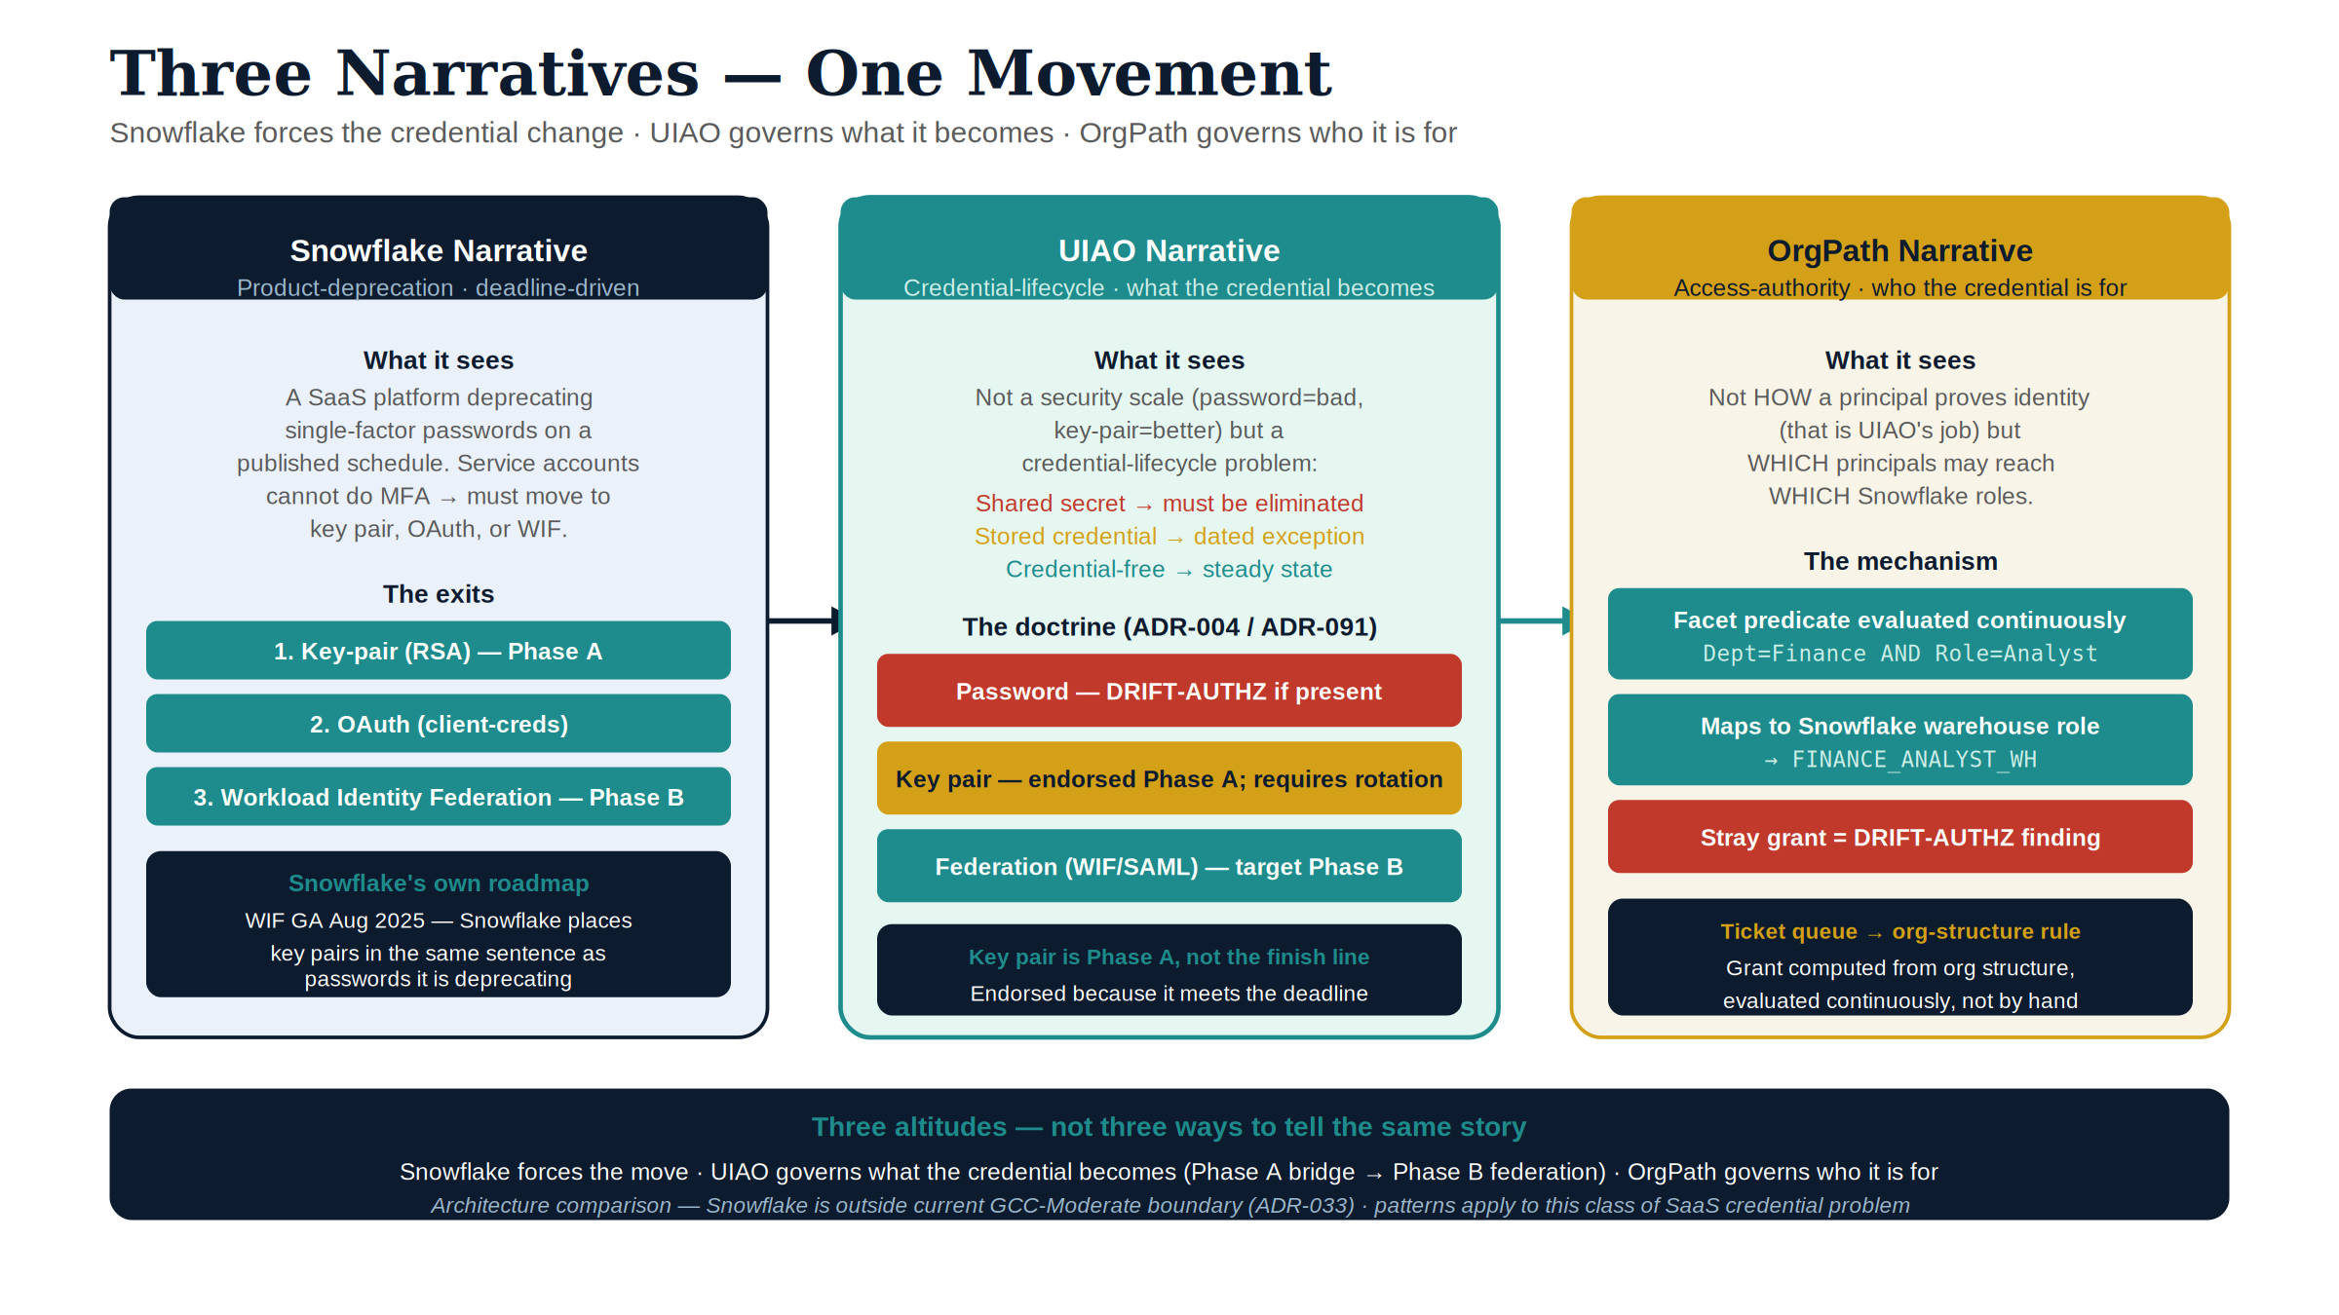
Figure 1: Three narratives — one movement: credential journey across Snowflake, UIAO, and OrgPath lenses
There are three narratives in this document, and the whole point is that they are not the same story told three ways — they are three different altitudes of the same migration.
The Snowflake narrative is a product-deprecation narrative: passwords are being switched off on a published schedule, and every account has to land somewhere else before the lights go out. Snowflake’s recommended landing spot for the accounts that cannot do interactive multi-factor authentication — the service accounts, the pipelines, the dbt jobs — is key-pair authentication. The “key-pair conversion” is the project that gets you off the password and onto an RSA key before the deadline.
The UIAO narrative is a credential-lifecycle narrative. UIAO does not see a password and a key pair as two points on a security scale where the key pair is simply “more secure.” It sees a shared secret that must be eliminated (the password) and a stored credential that should be a dated, compensated exception (the raw key pair) on the way to a credential-free steady state (federation to the identity provider, where no long-lived secret is stored anywhere). The key-pair conversion is endorsed — but as Phase A of a longer move, not as the finish line.
The OrgPath narrative is an access-authority narrative. It is not about how a principal proves who they are (that is the authentication question UIAO answers); it is about which principals may reach which Snowflake roles, and whether that grant is computed from the organization’s own structure or maintained by hand in a ticket queue. OrgPath is the coordinate system that turns “who should have access to the finance warehouse” into a rule the substrate evaluates continuously, and turns a stray grant into a drift event.
Read together, the three describe one movement: Snowflake forces the credential change; UIAO governs what the credential becomes; OrgPath governs who the credential is for. This document takes each in turn, then puts them side-by-side.
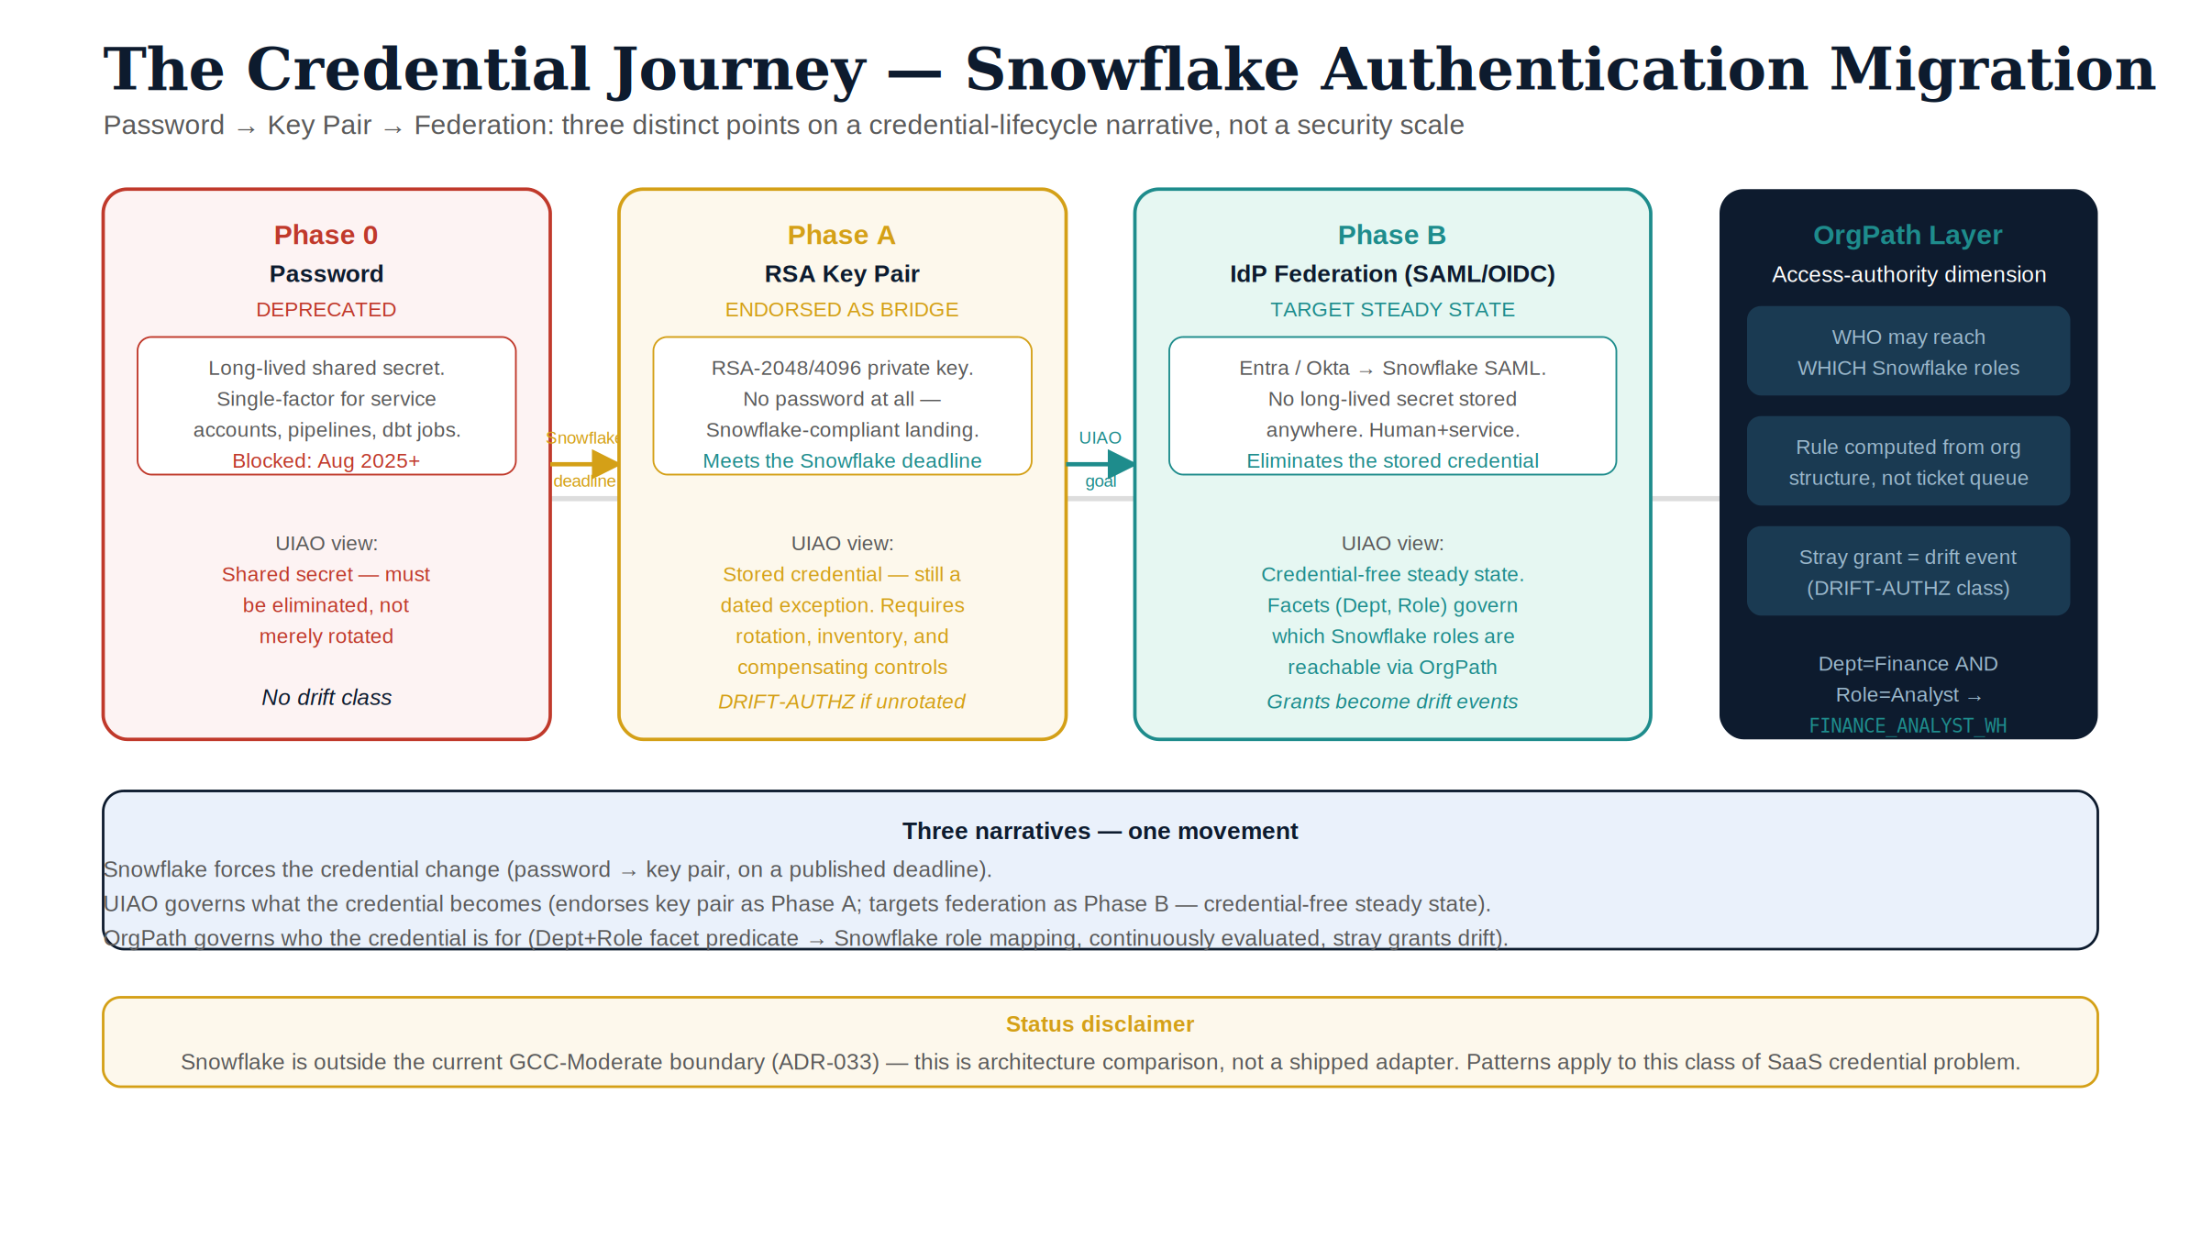
Figure 2: Credential journey — Password to Key Pair to Federation across three narratives

Part 1 — The Snowflake narrative

Why the conversion is happening at all
Snowflake is retiring single-factor password sign-ins on a published, phased schedule. Human users on accounts without a custom authentication policy were required to enroll in MFA the next time they signed in with a password (beginning April 2025); MFA became mandatory for all password-based human sign-ins regardless of policy (August 2025); and single-factor password sign-in attempts are blocked outright thereafter, with the final enforcement phase scheduled across 2026 (Snowflake — Planning for the deprecation of single-factor password sign-ins). The driver is the credential-theft reality of a SaaS data platform: a password is a reusable secret, and a reused secret is the entire attack.
The deprecation has a structural consequence that the human-MFA story tends to bury. MFA is not available to a non-interactive account. A nightly ELT job, a dbt run, an ingestion pipeline, a BI service connection — none of these can answer a push prompt. So the password deprecation splits the estate in two: human users move to MFA (or SSO), and service users must move off passwords to a non-interactive credential. Snowflake names exactly which credentials remain acceptable: the deprecation “doesn’t apply to customers using key-pair authentication or single sign-on users using … SAML or OAuth” (Snowflake — security-mfa-rollout). That sentence is the whole map. There are three exits from the password, and the “key-pair conversion” is the first of them.

What the key-pair conversion actually is
Snowflake key-pair authentication assigns an RSA public key to a user with ALTER USER <u> SET RSA_PUBLIC_KEY='…'; the client holds the matching private key and authenticates by signing a JWT that Snowflake verifies against the stored public key. The method requires a 2048-bit RSA key pair as a minimum, and supports make-before-break rotation by allowing two active public keys at once via the RSA_PUBLIC_KEY and RSA_PUBLIC_KEY_2 parameters: generate a new pair, set the unused slot, cut the client over, then remove the old key (Snowflake — Key-pair authentication and key-pair rotation).
For service workloads, the modern target is TYPE = SERVICE users, which cannot hold passwords or do MFA and authenticate with key pair, OAuth, or workload identity. The conversion project, in practice, is: inventory the password-bearing service accounts, generate a key pair for each, register the public key, store the private key where the workload can read it, and disable the password.

Where the Snowflake narrative quietly points next
Snowflake’s own documentation does not stop at the key pair. In August 2025 it made workload identity federation (WIF) generally available, and it describes WIF in terms that matter to this whole discussion: WIF lets workloads authenticate “using their cloud provider’s native identity system, such as AWS IAM roles, Microsoft Entra ID, and Google Cloud service accounts,” and — in Snowflake’s own words — “removes the need to manage and store long-lived credentials such as passwords, API keys, key pairs, and programmatic access tokens” (Snowflake — Workload identity federation; GA announcement, 2025-08-14).
Read that list again: Snowflake places key pairs in the same sentence as the passwords it is deprecating — both are long-lived credentials WIF exists to eliminate. The vendor’s own roadmap therefore already contains the UIAO thesis. The key-pair conversion is the move you make under deadline pressure; federation is the move the platform tells you is the destination. The rest of this document is about making that distinction governable rather than incidental.

Part 2 — How the doctrine would extend
UIAO already has a doctrine for this exact problem shape — written for SQL Server and for Kerberos/NTLM — and it transfers because the object classes are the same everywhere: a shared secret, a stored credential, and a federated identity. Reading the Snowflake conversion through that doctrine compresses to four moves.
The password is a type-S login; it must end, not rotate. ADR-091’s verdict on SQL Server passwords — “produces no Entra ID sign-in events and is invisible to Conditional Access and Defender for Identity; it is not an acceptable steady-state credential” — transfers to a Snowflake password unmodified. UIAO and Snowflake’s own deprecation schedule agree completely here; the conversion is endorsed without qualification.
The raw key pair is the interim posture, not the destination. Following the pattern ADR-068 sets for Kerberos/NTLM and ADR-091 §4 carries forward, a Snowflake RSA key pair is replay-resistant and public-key based (pointing at IA-5(2) and IA-2(8)) — but authentication still terminates at Snowflake, so Conditional Access never evaluates it. That makes it an exception-register entry: an inability-to-federate reason, a compensating control, and a sunset date, per the same ADR-068/ADR-091 §4 exception process.
The stored private key is a credential UIAO already rejected. A Snowflake .p8 private key is exportable software key material — the same stored bootstrap credential ADR-004 (ACCEPTED) prohibits for new integrations, permitting certificate-based auth “only when the external platform lacks OIDC issuer capability.” Mapped onto Snowflake, the password is the prohibited client secret, the RSA key pair is the certificate-based fallback, and WIF is the default. The “key-pair conversion” relocates risk from password-in-config to key-in-PEM; it does not leave the stored-credential class UIAO already named and rejected.
The destination is federation — no long-lived secret anywhere. ADR-002 makes the Managed Identity the credential-free destination and ADR-004 makes WIF the default for external-platform integrations. On Snowflake that means human users land on Entra SSO (Conditional Access applies, per ADR-008 / OMB M-22-09) and service users land on Snowflake’s own workload identity federation — an Azure Managed Identity exchanged for a short-lived token, with no RSA private key at rest. This is the Snowflake analogue of “Managed Identity, not service-principal-with-secret,” and it’s the same move Snowflake’s own WIF documentation describes.
Closure follows ADR-091’s continuous-verification standard: a reappearing password or an over-age key is a live finding, not an annual-review note — which is exactly where OrgPath picks up the thread.

Part 3 — How OrgPath would extend
Part 2 governs the credential; OrgPath governs the orthogonal axis — which principals reach which Snowflake roles, and whether that mapping is computed or hand-maintained. A key-pair conversion that modernizes the credential while leaving role membership in a spreadsheet has solved only half the problem.
The mechanism reuses the seam the SQL Server transformation already consumes: OrgPath’s vendor-neutral facet schema (ADR-078, bound to the Codebook under ADR-035/UIAO_151) drives Entra dynamic security groups (ADR-036) instead of hand-authored membership; those groups federate into Snowflake through the same SSO/SCIM path Part 2 stands up for authentication, mapping to Snowflake roles. A principal holds a role because their HR-driven OrgPath facts say they belong there, and loses it automatically when those facts change — a mover/leaver event re-renders the group and the grant follows, no ticket required. Delegation rides the same structure: an Administrative Unit (ADR-037) scoped to an OrgPath branch bounds who may edit those access groups.
The drift engine (ADR-040, UIAO_163) is what makes the closure claim above operational rather than aspirational: it compares observed Snowflake state — password-enabled users, key age, role membership — against the OrgPath-computed desired state, and treats a reappeared password, an unrotated key, or an out-of-rule grant as a typed DRIFT-IDENTITY, DRIFT-AUTHZ, or DRIFT-PROVENANCE finding, not a question for the next quarterly review.

The three narratives, side by side
The Snowflake narrative is correct about the destination for humans (SSO) and correct that key-pair is a valid exit; UIAO and OrgPath add the altitude that turns a deadline-driven credential swap into a governed end-state.
Dimension | Snowflake narrative | UIAO + OrgPath reading
Password | Deprecated on a schedule | Eliminated (ADR-091), not rotated
Key pair | Accepted, exempt service-account exit | Authorized interim posture — exception-register entry with sunset (ADR-068, ADR-091 §4); a stored credential ADR-004 rejects as a target
Steady state | Key pair, OAuth, or WIF | WIF / Managed Identity, no stored secret (ADR-004, ADR-002); role membership computed from OrgPath facets (ADR-036, ADR-078)
Who gets which role | Manual GRANT ROLE, or SCIM | Computed continuously from per-facet predicates, SCIM-federated
Closure | Deadline passes; project closed | Continuously verified; drift engine emits typed findings (ADR-040, UIAO_163)
For a single password-bearing service account, the governed sequence compresses to three moves: classify it (OrgPath surfaces it as a DRIFT-IDENTITY finding), convert to key pair under the exception register as an interim bridge, and federate to retire the exception permanently — with role membership computed from OrgPath facets throughout, never falling back to a manual grant. A pure Snowflake project stops at the conversion step and calls it done; the UIAO/OrgPath reading treats it as a bridge and keeps closure continuous.

Where this would sit in the substrate
This section is a placement sketch, not an authorization to build.
Snowflake is Commercial-cloud SaaS, outside the current GCC-Moderate deployment boundary, and it is not one of the named Commercial exceptions (Amazon Connect, SailPoint). Before any Snowflake adapter could exist, the boundary question is a gating ADR decision. For a GCC-Moderate federal deployment, a Snowflake exception would need its own gcc-boundary enum value added in lockstep with an authorizing ADR — the pattern ADR-059 set for SailPoint and ADR-033 defines for boundary drift. Since this paper was first drafted, the enum has also gained commercial-general (ADR-129) and state-local (ADR-133); a non-federal Snowflake engagement would register under commercial-general rather than minting a new value, but the authorizing-ADR requirement stands either way. Nothing in this whitepaper authorizes that step.
If authorized, the natural shape follows the existing adapter taxonomy (UIAO_003): a modernization / identity adapter that reads the Snowflake user inventory and each user’s TYPE and authentication policy, classifies every principal as password / keypair / federated, plans the conversion, and (dry-run by default, like every OrgPath writer) applies the ALTER USER changes. A read-only conformance-axis counterpart would assess posture without writing. The drift surface, the KSI family (key-rotation cadence + password elimination, shaped like the existing KSI families), and the evidence binding to IA-5(2), IA-2(8), and IA-2 / AC-17 (the OMB M-22-09 zero-trust anchor) would all reuse machinery the substrate already has.

What this document does not claim
For the avoidance of doubt, and in keeping with the substrate’s provenance discipline:
- It does not claim UIAO ships a Snowflake adapter or governs a Snowflake estate today. This is an architecture comparison.
- It does not claim Snowflake is inside the GCC-Moderate boundary or is an authorized exception. Bringing it in-boundary is a gating-ADR decision (ADR-059 / ADR-033 pattern) this document does not make.
- It does not claim key-pair authentication is insecure or wrong. It is a correct, replay-resistant, public-key credential and a legitimate interim posture; the only claim is that a stored key pair is a bridge, not the credential-free destination ADR-004 makes the default.
- It does not prescribe hand-authored Snowflake GRANT statements as the way to assign access. The governed path renders access from OrgPath facets (ADR-036) and federates it via SCIM.

Companion canon
For the normative decisions this whitepaper reads Snowflake against:
- ADR-004 — Workload Identity Federation as Default for External Integrations (ACCEPTED); the credential-free destination and the prohibition on stored secrets for new integrations.
- ADR-091 — SQL Server Engine Authentication Transformation; type-S elimination, interim posture, and continuous closure (the platform-analogous template; PROPOSED).
- ADR-068 — Kerberos / NTLM Elimination; the interim-posture pattern and exception register.
- ADR-002 — the credential-free Managed Identity destination.
- ADR-008 — Zero-Trust Identity (Conditional Access; OMB M-22-09 anchor).
- ADR-036 — Dynamic Group Provisioning (OrgPath-driven Entra access groups).
- ADR-037 — Administrative Unit Provisioning (the delegation surface).
- ADR-078 — OrgPath 15-facet Attribute Schema; ADR-035 / UIAO_151 — the Codebook binding.
- ADR-040 / UIAO_163 — the drift engine that makes a re-introduced password or an out-of-rule grant a compliance signal.
- ADR-059 / ADR-033 — the Commercial-exception boundary pattern any real Snowflake coverage would have to follow.

Companion series
- SQL Server Identity Transformation — the same authentication-transformation doctrine worked end-to-end on a different platform; the closest structural sibling to this whitepaper.
- UIAO OrgPath — the substrate this document’s Part 3 consumes.
- OrgPath × SQL Server — The Integration Bridge — the seam model this whitepaper reuses for Snowflake.

Sources (Snowflake product facts)
External facts about Snowflake’s behavior are cited directly to Snowflake’s documentation, current as of June 2026; verify against the live pages before relying on specific dates or parameter names, as vendor schedules move.
- Planning for the deprecation of single-factor password sign-ins
- Key-pair authentication and key-pair rotation
- Workload identity federation and its GA announcement (2025-08-14)
- Overview of Snowflake authentication

Call to Action
This paper is a reading, not a roadmap — nothing here is blocked on UIAO shipping a Snowflake adapter. The classify/convert/federate discipline in Parts 2-3 can be applied by hand today; only its automation depends on the boundary decision below.
Three steps that don’t require a new adapter
- Classify every Snowflake principal today, manually. DESCRIBE USER and the account-level login-history views answer the password / keypair / federated classification Part 2 would otherwise automate — the same inventory step the platform-analogous SQL Server transformation (ADR-091) starts with.
- Treat a stored key pair as the bridge it is, not the destination. Rotate on a defined cadence and track rotation as a compliance signal now, even without a drift engine watching it — key-pair auth is correct and replay-resistant, but ADR-004’s credential-free destination is still the target.
- Answer the boundary question before the automation question. If Snowflake is in scope for a GCC-Moderate deployment, the first real decision is not “build the adapter” — it’s the gating-ADR conversation (ADR-059/ADR-033 pattern) that would classify it under a gcc-boundary value, or under commercial-general (ADR-129) for a non-federal engagement. That conversation can start independently of any engineering work.

If and when that boundary decision authorizes it, the adapter shape in Part 2 and the OrgPath-rendered access model in Part 3 are already worked out — this document is the design sketch waiting on that decision, not a blocker to today’s manual discipline.

