Ticket-to-Machine, Not Ticket-to-Human: Why Changing State Isn’t Compliance Evidence
  - Azure, AWS, and VMware’s own tools remediate; ServiceNow — with SailPoint ISC Governance feeding it for access governance — supplies the owner, the clock, and the evidence NIST, CISA, and FedRAMP actually require
Michael Stratton
2026-07-01
Table of contents

Ticket-to-Machine, Not Ticket-to-Human: Why Changing State Isn’t Compliance Evidence
 Problem, solution, ask
Problem. Azure Policy, AWS Config, and vSphere Configuration Profiles genuinely remediate; none can answer the four questions an assessor asks about a finding — who owns it, by when, under whose approval, with what evidence. CM-6 is Tool-attestable: No on every platform surveyed. And raising a ticket does not fix that if a human still logs into the console because the ticket told them to.
Solution. A coordination layer — ServiceNow, with SailPoint ISC Governance feeding it for the access-governance domain — in front of the native tools, where the ticket authorizes a machine to execute under a service identity and the human’s role stops at approval. Where no machine actuator exists yet (VMware/vCenter), the closure is a declared exception through a recorded CyberArk PSM session, not a silent one. The OrgComp Day-2 kit is the working reference implementation.
Ask. §14: confirm, row by row, whether the agency’s ServiceNow contract entitles the IntegrationHub spokes each platform needs — Entra ID, Azure, AWS, VMware — and where it does not, license the integration or book a declared exception with a named compensating control. Never route the gap through a human at the console.

1. Executive Summary
The question this paper answers: if the agency already has Azure Portal, the AWS Console, vCenter/CPS, and a ServiceNow + SailPoint stack, why not just let the native tools handle compliance directly?
The short answer is that native cloud and virtualization consoles are excellent at one job — changing state — and structurally incapable of a second, different job: producing the evidence an assessor can trace. Azure Policy, AWS Config, and VMware’s vSphere Configuration Profiles all genuinely remediate. None of them, on their own, can answer the four questions a FedRAMP assessor or an authorizing official actually asks about a finding: who owns it, by when, under whose approval, and with what evidence. That is not a criticism of the native tools — it is a recognition that “the console shows green” and “the authorization package has a traceable, owned, evidenced record” are different claims, and only one of them is what NIST SP 800-53, CISA directives, and FedRAMP require.
A ticket alone does not close that gap either — this is the point this paper exists to make. The default shape of change management in most estates today is ticket → a human opens the console (or runs a script) because the ticket told them to → replies “done.” Adding a ServiceNow ticket in front of that does not change who is at the keyboard. §4 states this plainly: the ticket has to authorize a machine to execute, not a person to click through the same console the ticket was raised about — that distinction, not merely “have a ticketing system,” is what this paper is actually recommending.
Key Finding
Across every platform examined in this paper — Microsoft 365, Azure, AWS, and VMware — the OrgComp series’ own control-closure tables mark CM-6 (Configuration Settings) as Tool-attestable: No, without exception, regardless of vendor; the three IaaS/hybrid platforms (Azure, AWS, VMware) additionally carry RA-5 (Vulnerability Monitoring and Scanning) and SI-2 (Flaw Remediation) with the same verdict — M365 is Microsoft-managed SaaS and never reaches a control-closure table for those two at all. This is not an oversight or a gap waiting to be closed by the next product release — it is the structural finding of this paper: no native console, by itself, produces the ownership/clock/approval/evidence record FedRAMP evidence requires. That record comes from a coordination layer — ServiceNow, with SailPoint ISC Governance feeding it detection findings for the adjacent access-governance domain — sitting in front of the native tools, not replacing them.

2. The Question, Precisely
“Does the native cloud portal already do this?” is really three separate questions that get collapsed into one:
- Can the native tool detect drift and change state? Yes — this paper does not dispute that Azure Policy, AWS Config, and vSphere Configuration Profiles genuinely remediate.
- Can the native tool’s own dashboard show current compliance posture? Yes, for its own boundary — Defender for Cloud, Security Hub, and VCF Operations all show a live posture picture.
- Can the native tool’s dashboard, by itself, serve as the evidence artifact an assessor relies on for an ATO decision? No. This is the question this paper is actually about, and the answer is the same across every platform surveyed.
The reason the answer is uniformly “no” is not a per-vendor product gap; it is structural. A console shows current state. An evidence record has to show who owns the finding, the clock they are working against, the approval trail for any exception, and a re-test that proves closure — a governance wrapper, not a dashboard, and none of the three platforms’ native consoles are built to be a system of record for ownership and approval across an organization’s workflow.

3. One Coordination Pattern, Four Platforms
The OrgComp series documents this pattern once and applies it identically across Microsoft 365 (Vol VII Book 02), Azure (Book 03), AWS (Book 06), and VMware (Book 07) — the same five-step loop over each platform’s native control engines:
Test → Detect drift → Raise a typed task against the reconciled CI → Actuate on the native surface → Close with evidence.
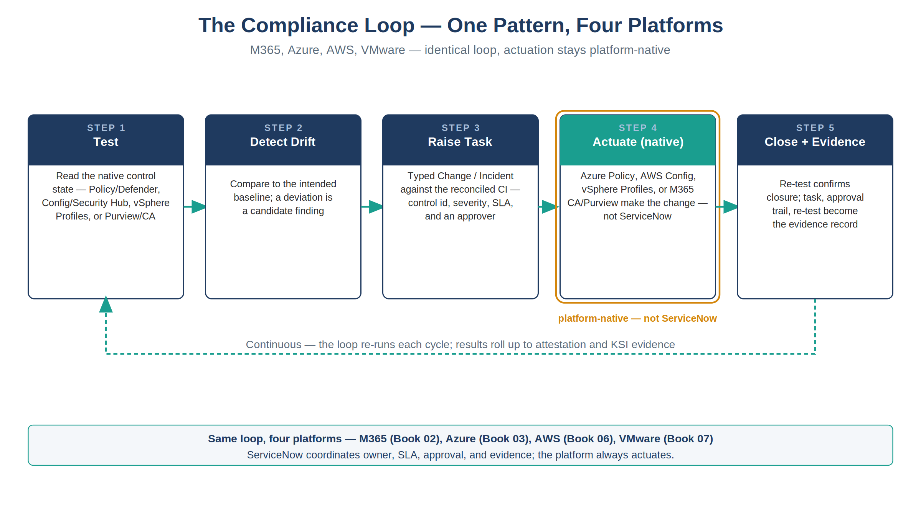
Figure 1: The compliance loop, identical across M365, Azure, AWS, and VMware — actuation always stays platform-native
Actuation always stays platform-native. ServiceNow’s role is never to write the configuration, apply the patch, or fix the firewall rule — it is to make sure every drift becomes an owned, clocked, approved, evidenced piece of work, whichever native engine ultimately does the actuating.
Platform | Native engines (actuate) | Controls covered | What the console alone cannot show
Microsoft 365 | Conditional Access, Purview | CM-6 | Owner, SLA, approval trail, exception review
Azure | Azure Policy, Defender for Cloud, MDVM, Update Manager (+ Arc for hybrid) | CM-6, RA-5, SI-2 | Same
AWS | AWS Config, Security Hub CSPM (+ GuardDuty, Inspector), Systems Manager Patch Manager | CM-2/CM-6, CM-6/RA-5, SI-2 | Same
VMware | vSphere Configuration Profiles, VCF Operations + NSX Distributed Firewall, vSphere Lifecycle Manager (vLCM) | CM-2/CM-6, CM-6/RA-5, SI-2 | Same
M365’s row is shorter than the other three for a structural reason, not an omission: it is Microsoft-managed SaaS, so there is no customer-facing vulnerability-scanning or patch-management surface the way the IaaS/hybrid platforms have (Defender for Cloud + MDVM + Update Manager, Security Hub + GuardDuty + Inspector + Patch Manager, VCF Operations + NSX + vLCM) — Microsoft owns that layer, so RA-5 and SI-2 never reach the tenant’s own control-closure table in the first place. Vol VII Book 02’s own generated Authorities Closed Here table has exactly three rows — AC-2, CA-7, CM-6 — confirming this, not asserting it.
VMware is worth calling out specifically, because it breaks the pattern people expect: unlike M365, Azure, and AWS — boundaries reached over a cloud provider’s API — VMware is the agency’s own on-premises or agency-operated virtualization estate, racked and patched directly. The same evidence gap exists anyway. Owning the hardware does not produce an owner, a clock, or an approval trail any more than renting a CSP subscription does; vCenter’s own console shows green on exactly the same terms Azure’s and AWS’s consoles do.

4. Who Actuates: Ticket-to-Machine, Not Ticket-to-Human
The gap described above has an obvious-looking fix that is itself a trap: raise a ServiceNow ticket for every finding and call the gap closed. It isn’t, if what happens next is still a human logging into the Azure Portal, the AWS Console, or vCenter — or running a script by hand — because the ticket told them to. That is the default shape of change management in most estates today: ticket → a human opens a console or runs a script → replies “done.” This paper’s coordination-layer argument does not automatically fix that pattern; it can look fixed while execution stays exactly where it always was, at a keyboard. Closing that gap — not merely adding a ticketing system in front of the same manual process — is this paper’s central recommendation.
Recommendation
The ticket should authorize a machine, not a person, wherever a machine can reach the surface. A human approves the change in ServiceNow; Azure Policy, AWS Config, vSphere Configuration Profiles, an orchestration runbook, or the ServiceNow MID Server itself executes it under a service identity. The human’s role stops at approval — the platform, not the person, is the actuator. This is the same “actuation always stays platform-native” claim from §3, stated as a rule about who touches the keyboard, not only about which console shows the change.

Why a machine actuator, specifically. Running a change through an orchestrator produces, automatically, everything a 3PAO or authorizing official actually checks for: the change traces to a prior approval, the artifact that ran is version-controlled and access-restricted, the execution is logged and attributable to the task rather than to a person’s memory, and the result is a re-testable, reproducible record rather than a “trust me” reply. A human at a console produces none of that unless every one of those properties is separately, manually reconstructed — a real cost, paid every time, that a machine actuator pays once, in the orchestrator’s own design.
This is a strong recommendation, not a citable prohibition — and this paper says so plainly rather than overstating it. No NIST SP 800-53 control bars a human from executing an approved change, and FedRAMP’s own KSI-CMT-RMV (redeploy version-controlled resources rather than modify directly) is itself qualified “wherever reasonable” — an engineering preference with a documented-exception path, not a ban. Vol VII Book 07 works the full derivation and citations — CM-3/CM-3(2)/CM-5/CM-7/CM-11/CM-14, AU-2/AU-12/AC-6(9), KSI-CMT-RMV/VTD/RVP, and the specific FedRAMP Rev 5 Moderate baseline enhancements that actually mandate automation (CM-3(2), CM-5(1), CM-6(1), SI-2(2)), each checked directly against FedRAMP’s own published baseline profile rather than asserted. That check was run a second time against an independently-authored citation review that also proposed CM-3(5), AU-12(3), and mischaracterized glosses of AC-6(9) and IA-5(2) for this argument — none of which held up against the same primary sources, and none of which are cited here; Book 07 documents why, so the rejected citations don’t quietly resurface later. This paper states the conclusion once, for the reader who wants the claim without the control-by-control case.
The anti-pattern gets worse, not better, when detection is automated. SailPoint flags an over-privileged entitlement, or a posture engine flags a drifted setting — and instead of opening the ServiceNow task this paper’s whole architecture depends on, the finding goes out as an email with a script attached, and a human runs it directly against the console. That path never touches ServiceNow at all: no owner, no clock, no approval trail, no re-test evidence — the exact console-only failure mode §10 describes, just reached by a different door. A notification email, if one exists, announces that work is needed; it is never the approval and never the record.
Where no machine actuator exists yet, the fallback is a declared exception, not a silent one. VMware/vCenter is the recurring case in this series: no confirmed orchestrator today runs a signed script against vCenter under a service identity. The compensating control is a CyberArk Privileged Session Manager (PSM) session — approved first in ServiceNow, then time-boxed, proxied, and recorded — with the recording itself as the evidence artifact. That closure is booked honestly as a documented-process closure, not represented as automated validation it cannot provide.
A working reference implementation exists for this pattern — it is not only a design recommendation — with one leg still catching up to its own design intent. The OrgComp Day-2 Automation Kit (docs/customer-documents/orgcomp-series/servicenow-day2/), a deployable ServiceNow scoped application rather than a design document, is designed to implement ticket-to-machine actuation for the AD/Entra joiner-mover-leaver and credential-lifecycle surface — and does so on the cloud-only Graph leg. The AD leg carries the identical design intent but not yet the identical guarantees; see the callout immediately below. AdHybridClient.js is intended to dispatch every synced-object AD write (New-ADUser, Disable-ADAccount, Set-ADAccountPassword, Add-ADGroupMember) through a domain-joined, in-boundary MID Server under a delegated, least-privilege service account — “NEVER Domain Admin,” per the script’s own header — never through an operator’s interactive session; that delegation claim is asserted in comments and has not itself been verified (an effective-permissions dump is still an open item). The kit’s ServiceNow-side actuator states the same doctrine in its own words, written independently of this paper: “ServiceNow raises, routes and evidences; it NEVER writes to the estate” (Day2NativeActuator.js) — a statement scoped to that script include specifically (it writes only ServiceNow’s own workflow records); the Graph and AD clients in the same app, including AdHybridClient above, are the ones that actuate the tenant, always under a delegated service identity, never as “ServiceNow” acting with standing tenant access. The admin-initiated password-reset path is explicitly commented as “the approver-gated fallback” behind self-service reset, and the daily morning sync-health check — RDP-to-the-sync-host in the series’ own documented “as-found” anti-pattern (OrgComp_Operator_Runbook_Day2_Compliant.qmd, Task 6) — is already closed in this kit as a read-only automated reconciliation job.
 Verified, then remediated — the AD leg’s P0s are closed
An external adversarial security review (2026-07-29) read the same two files this assessment sampled — AdHybridClient.js and Day2NativeActuator.js — plus the orchestrator, the gate, and the SAM inbound endpoint, and found the AD leg unsafe to run against a live directory. Four findings, verified directly against the shipped code at the time: parameter names (not just values) reached a rendered PowerShell command unescaped, so a hostile attribute key could drive arbitrary cmdlet execution on the MID Server (AdHybridClient.js, _render); a caller-supplied attribute bag could override the approved write target through merge precedence (_merge); a temporary password transited the platform’s ecc_queue table in cleartext (setPasswordAd); and the AD leg had no post-state read-back at all — a write was recorded as closed the moment the asynchronous dispatch was queued, never having observed AD. None of this was exercised by the kit’s own ATF suite: test_mode short-circuited every method before the vulnerable code path ran, so all 12 specs passed while the injection path had never executed.
All four P0s are fixed, as of commit 7d2423c74 (2026-07-30) — the day after the review. _render()’s string interpolation is gone; _dispatch() now emits a structured JSON payload the MID Server binds via splatting, so nothing caller-supplied is ever concatenated into executable text (P0-1). Reserved parameters are rejected outright rather than merged from caller input (P0-2). setPasswordAd() no longer accepts or transports a password at all — the MID Server generates it and ecc_queue never holds secret material (P0-3). Read-back methods (getUserAd, getGroupMembersAd, isGroupMemberAd) now exist, and a write returns {ok, dispatched, ecc_sys_id} without ever asserting post-state (P0-4). test_mode now refuses outright on a production instance rather than silently short-circuiting the vulnerable path (P0-5) — the gap that let the injection path go unexercised is itself closed, and a dedicated negative test (atf-negative-ad-parameter-injection.xml, “hostile AD parameter names and reserved keys are refused”) now exercises exactly the path the original review found untested. The AD leg is safe to run against a live directory on this basis; Appendix A describes the current, remediated code, not the reviewed snapshot.
What is still open, honestly: the header’s own “NEVER Domain Admin” delegation claim is asserted in comments and has not itself been independently verified — an effective-permissions dump against the service account remains an open item, unchanged by this remediation. The kit is AD/Entra-scoped and does not touch vCenter, so it also does not exercise this section’s own PSM exception path above; that path remains a documented recommendation without a sampled reference implementation as of this writing.

5. Closure Necessity — the Argument, in the Vendors’ Own Terms
Each platform book states the same finding, in the same words, changing only the vendor name. Quoting all three side by side makes the structural (not vendor-specific) nature of the claim concrete:
 Azure
“Azure Policy remediates, Defender recommends, Update Manager patches — the native stack is genuinely sufficient to change state. What it does not supply is the governance wrapper: who owns this finding, by when, under whose approval, with what evidence. Strip the coordination layer and Azure’s own consoles show green while the authorization package has no owned-and-evidenced record an assessor can trace.” — Vol VII Book 03

AWS
“AWS Config remediates, Security Hub CSPM surfaces, Patch Manager patches — the native stack is genuinely sufficient to change state. What it does not supply is the governance wrapper… Strip the coordination layer and AWS’s own consoles show green while the authorization package has no owned-and-evidenced record an assessor can trace.” — Vol VII Book 06

VMware
“vSphere Configuration Profiles remediates, VCF Operations and NSX DFW surface, vLCM patches — the native stack is genuinely sufficient to change state, on the agency’s own hardware exactly as it is on a hyperscaler’s. What it does not supply is the governance wrapper… Strip the coordination layer and vCenter’s own console shows green while the authorization package has no owned-and-evidenced record an assessor can trace.” — Vol VII Book 07

In each case: CM-6, SI-2, and RA-5 are closed by the platform; they are operated — owned, clocked, evidenced — by the coordination layer.

5.1 The Argument, Made Concrete — the Day-2 Kit as a Working Reference Implementation
The ServiceNow Day-2 Automation Kit (Volume IX of this series) is buildable ServiceNow source — Script Includes, ATF test specs, build-time gates — implementing this paper’s same five-step Closure Necessity loop for a different control family: AC-2/AC-3/AC-6 identity lifecycle, rather than CM-6/RA-5/SI-2 configuration drift. Its MacdrOrchestrator.js Script Include runs every governed identity request through five ordered MACD-R clauses; all five are now enforced, including clause 1 (Origin) — _clauseOrigin() resolves the origin record and refuses when it cannot, closing the gap an external adversarial security review (2026-07-29, disclosed above in §4) found and that a dedicated negative test (atf-negative-no-origin.xml) now exercises. The Graph/cloud leg re-reads post-state before closing a task; the AD leg now does too, per §4’s remediation record.
The full code walkthrough — the clause-by-clause table, the ATF test_mode gap that leaves the AD leg’s vulnerable code path unexercised, and the build-time gates — is reproduced in Appendix A — Day-2 Kit Code Review, including the same disclosed security findings §4 states above. Read against Appendix B’s extension into access governance, the kit is where that domain’s coordination loop is not only argued but actually implemented and testable end to end.

6. The Rollup — Every Platform, Same Verdict
The table below consolidates the Tool-attestable? column verbatim from each book’s generated “Authorities Closed Here” table (source: orgcomp-compliance-spine.yml), plus the attestation-stage controls from Book 04. Every row reads No — not because the tooling is immature, but because “tool-attestable” and “evidence the platform console alone can produce” are the same test, applied consistently.
Control | Title | Platforms it recurs across | Tool-attestable?
CM-2 / CM-6 | Baseline Configuration / Configuration Settings | M365, Azure, AWS, VMware | No
RA-5 | Vulnerability Monitoring and Scanning | Azure, AWS, VMware | No
SI-2 | Flaw Remediation | Azure, AWS, VMware | No
CA-2 | Control Assessments | Attestation layer (Book 04), fed by all four platforms | No
CA-5 | Plan of Action and Milestones | Attestation layer (Book 04) | No
CA-7 | Continuous Monitoring | Attestation layer (Book 04) | No

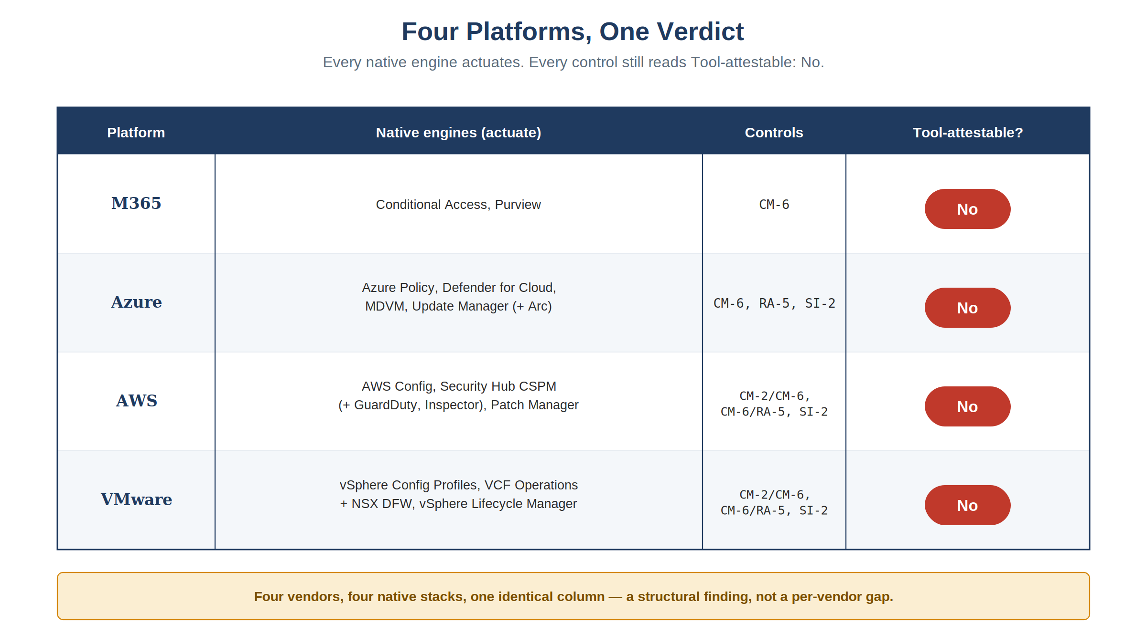
Figure 2: Four platforms, one verdict — every native engine actuates, every control still reads Tool-attestable: No
Four different vendors, four different native stacks, one identical column of verdicts. That consistency demonstrates the corpus doesn’t contradict itself across four platform books — a single-source-of-truth check, not four independent confirmations of the underlying structural claim. §11’s external validation — now Appendix D — is the actual independent corroboration for that claim.

7. The Front Door: What ServiceNow Actually Supplies
Books 02, 03, 06, and 07 all reconcile into the identical ServiceNow-side pattern, deployable today as the scoped app x_fed_compliance (Vol VII Book 05):
- ComplianceIngest reads each platform’s native control state (Graph/SCuBA/Purview for M365; Resource Graph/Defender/Update Manager for Azure; Config/Security Hub/Patch Manager for AWS; equivalent VMware APIs) through an in-boundary MID Server — read-only against the ATO boundary.
- ComplianceReconcile matches every finding to the authoritative CMDB CI before a task is raised, so nothing routes to an orphaned or unowned asset.
- ComplianceGate re-reads the native surface after actuation and stamps the re-test evidence on the task — the mechanism that makes “closed” mean “verified,” not “claimed.”
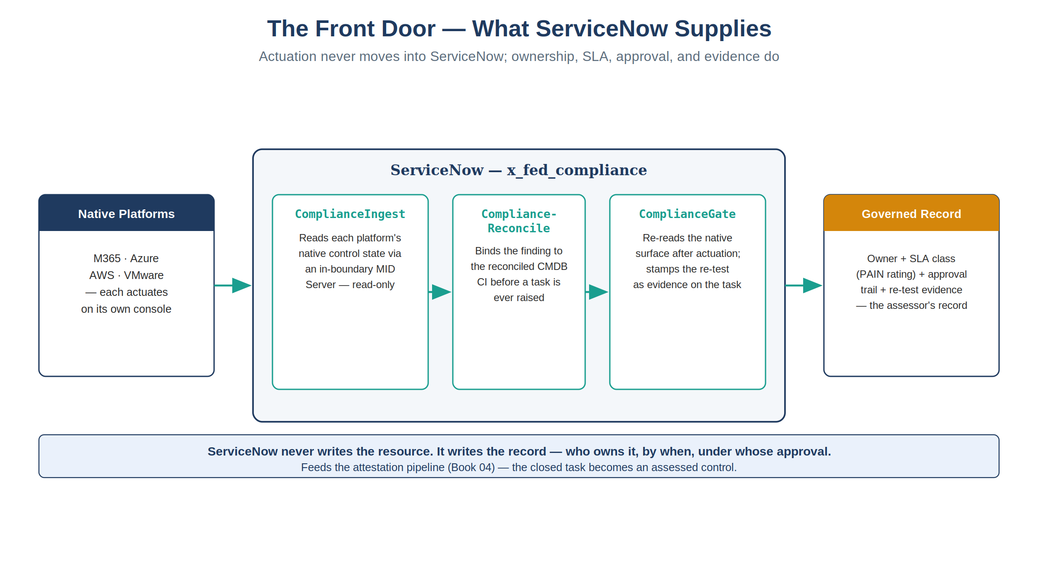
Figure 3: The ServiceNow front door — Ingest, Reconcile, and Gate sit between the native platforms and the governed record; actuation never moves into ServiceNow
Actuation never moves into ServiceNow. The native platform still remediates; ServiceNow’s entire job is the four things a console cannot do — assign an owner, attach a clock (the FedRAMP PAIN-rating SLA table, keyed to exploitability and internet-reachability, drives the SLA class), require an approval on anything that changes state or grants an exception, and capture the re-test as the evidence record.
From there, Vol VII Book 04 lifts the closed task stream into an assessed control: a scheduled IRM/GRC control test reads the actioned posture and renders pass/fail/partial with evidence attached (CA-2); any fail becomes an owned POA&M item (CA-5); the roll-up is emitted as OSCAL assessment-results and FedRAMP 20x KSI evidence (CA-7) into the authorization package.
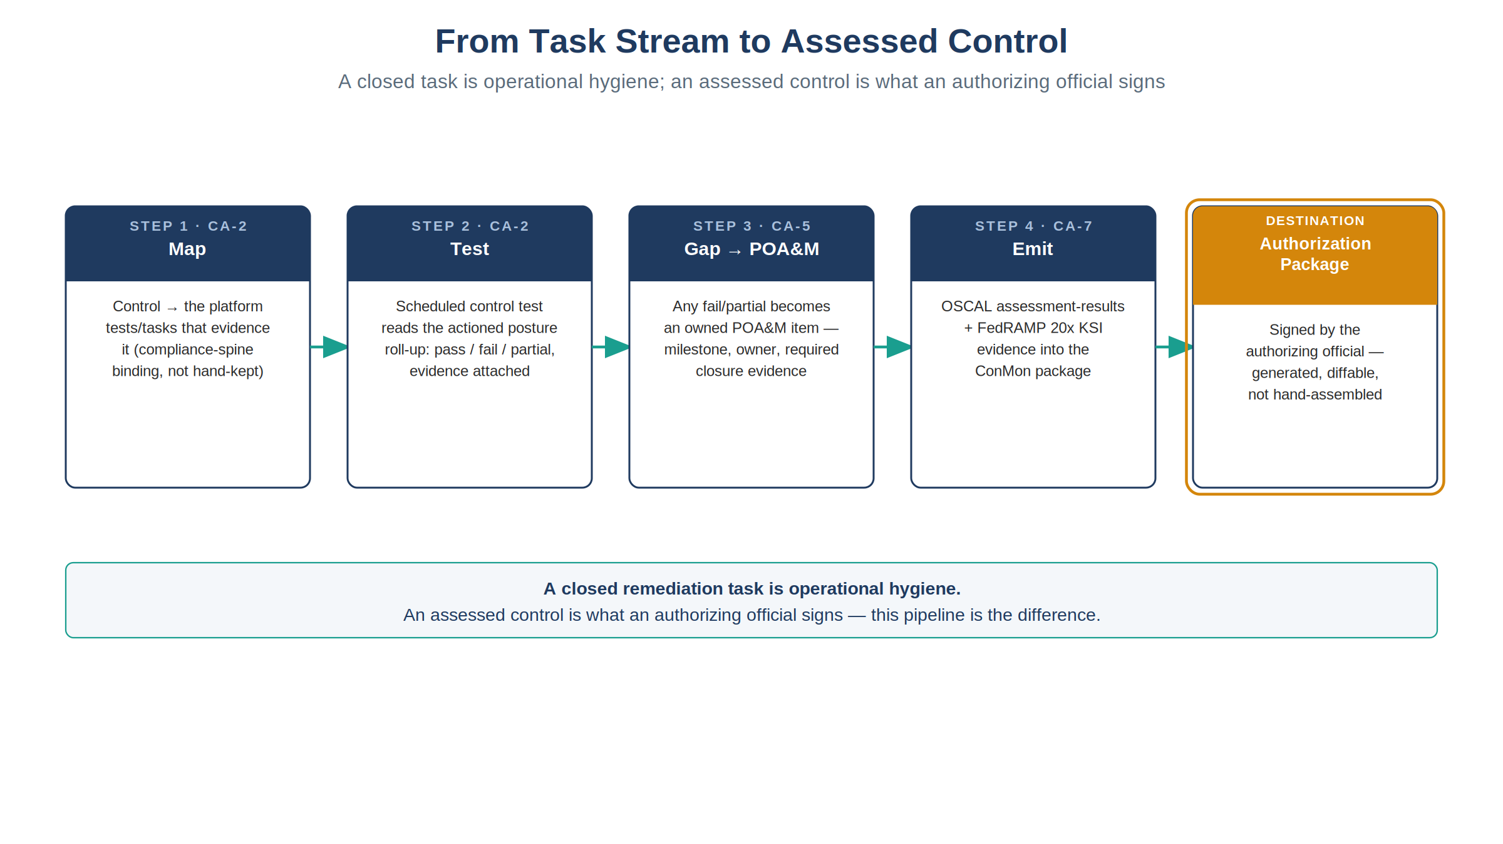
Figure 4: From task stream to assessed control — Map, Test, Gap to POA&M, Emit — feeding the authorization package
A closed remediation task is operational hygiene; an assessed control is what an authorizing official signs — the distinction Book 04 exists to close.

8. The Adjacent Domain: Access Governance and SailPoint ISC Governance
Everything above concerns configuration, vulnerability, and patch controls (CM-6, RA-5, SI-2) — the domain the ServiceNow-fronting pattern is built and deployed for today. The same structural argument extends to a second domain, access governance (AC-2, AC-3, AC-6): a native IAM console can inspect and even remediate Azure RBAC or AWS IAM policy, but a role binding is not, by itself, a record of who requested it, who approved it, and when it was last reviewed. SailPoint ISC Governance (the CIEM add-on) supplies that detection function natively across Azure, AWS, and GCP; ADR-135 and Vol VII Book 08 ratify this and close AC-2/AC-3/AC-6 using the same test → detect → raise → actuate-native → close-with-evidence loop as Books 03/06/07 — one front door, not a second SailPoint-fronted coordination layer. VMware/vCenter identity governance remains a genuinely open gap: no evidence was found that SailPoint’s CIEM add-on reaches vCenter permissions.
Two SailPoint products, not one. The agency also runs SAM (Systems Access Management) — its internal brand for a SailPoint IdentityIQ deployment, and the access-request and certification front end its users actually see. SAM is not ISC under another name, and the distinction is load-bearing: IdentityIQ is customer-hosted on agency infrastructure with a versioned on-premises integration surface (SCIM 2.0 plus a core REST API tied to the installed release), while ISC is SailPoint-hosted SaaS on a continuously-versioned cloud REST API. Canon holds them in separate slots for exactly that reason — sailpoint-isc-governance per ADR-135 and sailpoint-iiq-governance per ADR-136 — and the deployment model, not the vendor, sets the boundary cost: ISC had to buy its slot with a Commercial exception, whereas IdentityIQ needs none because it already sits inside the GCC-Moderate boundary. They also enter the front door from opposite directions. ISC pushes detection findings in, as one more engine alongside Security Hub and Defender; SAM pushes an approved access request in, correlated to a RITM, with closure written back. Two products, two directions, one front door — this paper’s claim survives the distinction, and collapsing them would bind SAM work to the wrong product, the wrong contract, and the wrong boundary value. The side-by-side comparison is in Appendix B.
The full discussion — the ADR-135/Book 08 closure narrative and the honest VMware/vCenter limit — is reproduced in Appendix B — Access Governance and SailPoint ISC.

9. The Certificates Exception — Why PKI Doesn’t Take the Same Path
Certificates are a large share of the actual operational work in this estate, which makes it tempting to assume they belong on the same ServiceNow-fronted path as everything else in this paper. They don’t — not for the routine lifecycle, and the reason is a deliberate, already-documented doctrine call, not an oversight. Vol I Book 03 closes IA-5(2)/SC-12/SC-17 with protocol-enforced automation instead — ACME/SCEP/EST issuance gates, CAA records, and short-lived certificates with non-renewal replacing revocation — because the volume (thousands of issuance/renewal events a week) rules out ticket-per-event without making the ServiceNow queue meaningless. Exceptions and anomalies — a new CA, a non-standard certificate lifetime, a trust-anchor change, or a drift finding from the certificate inventory — still route through the same front door as everything else in this paper; routine issuance within policy does not.
The full derivation, the Book 03 doctrine quote, and the recommended tooling (CyberArk Certificate Manager vs. Keyfactor for Government CLAaaS) are reproduced in Appendix C — The Certificates Exception.

10. What “Just Use the Console” Actually Costs
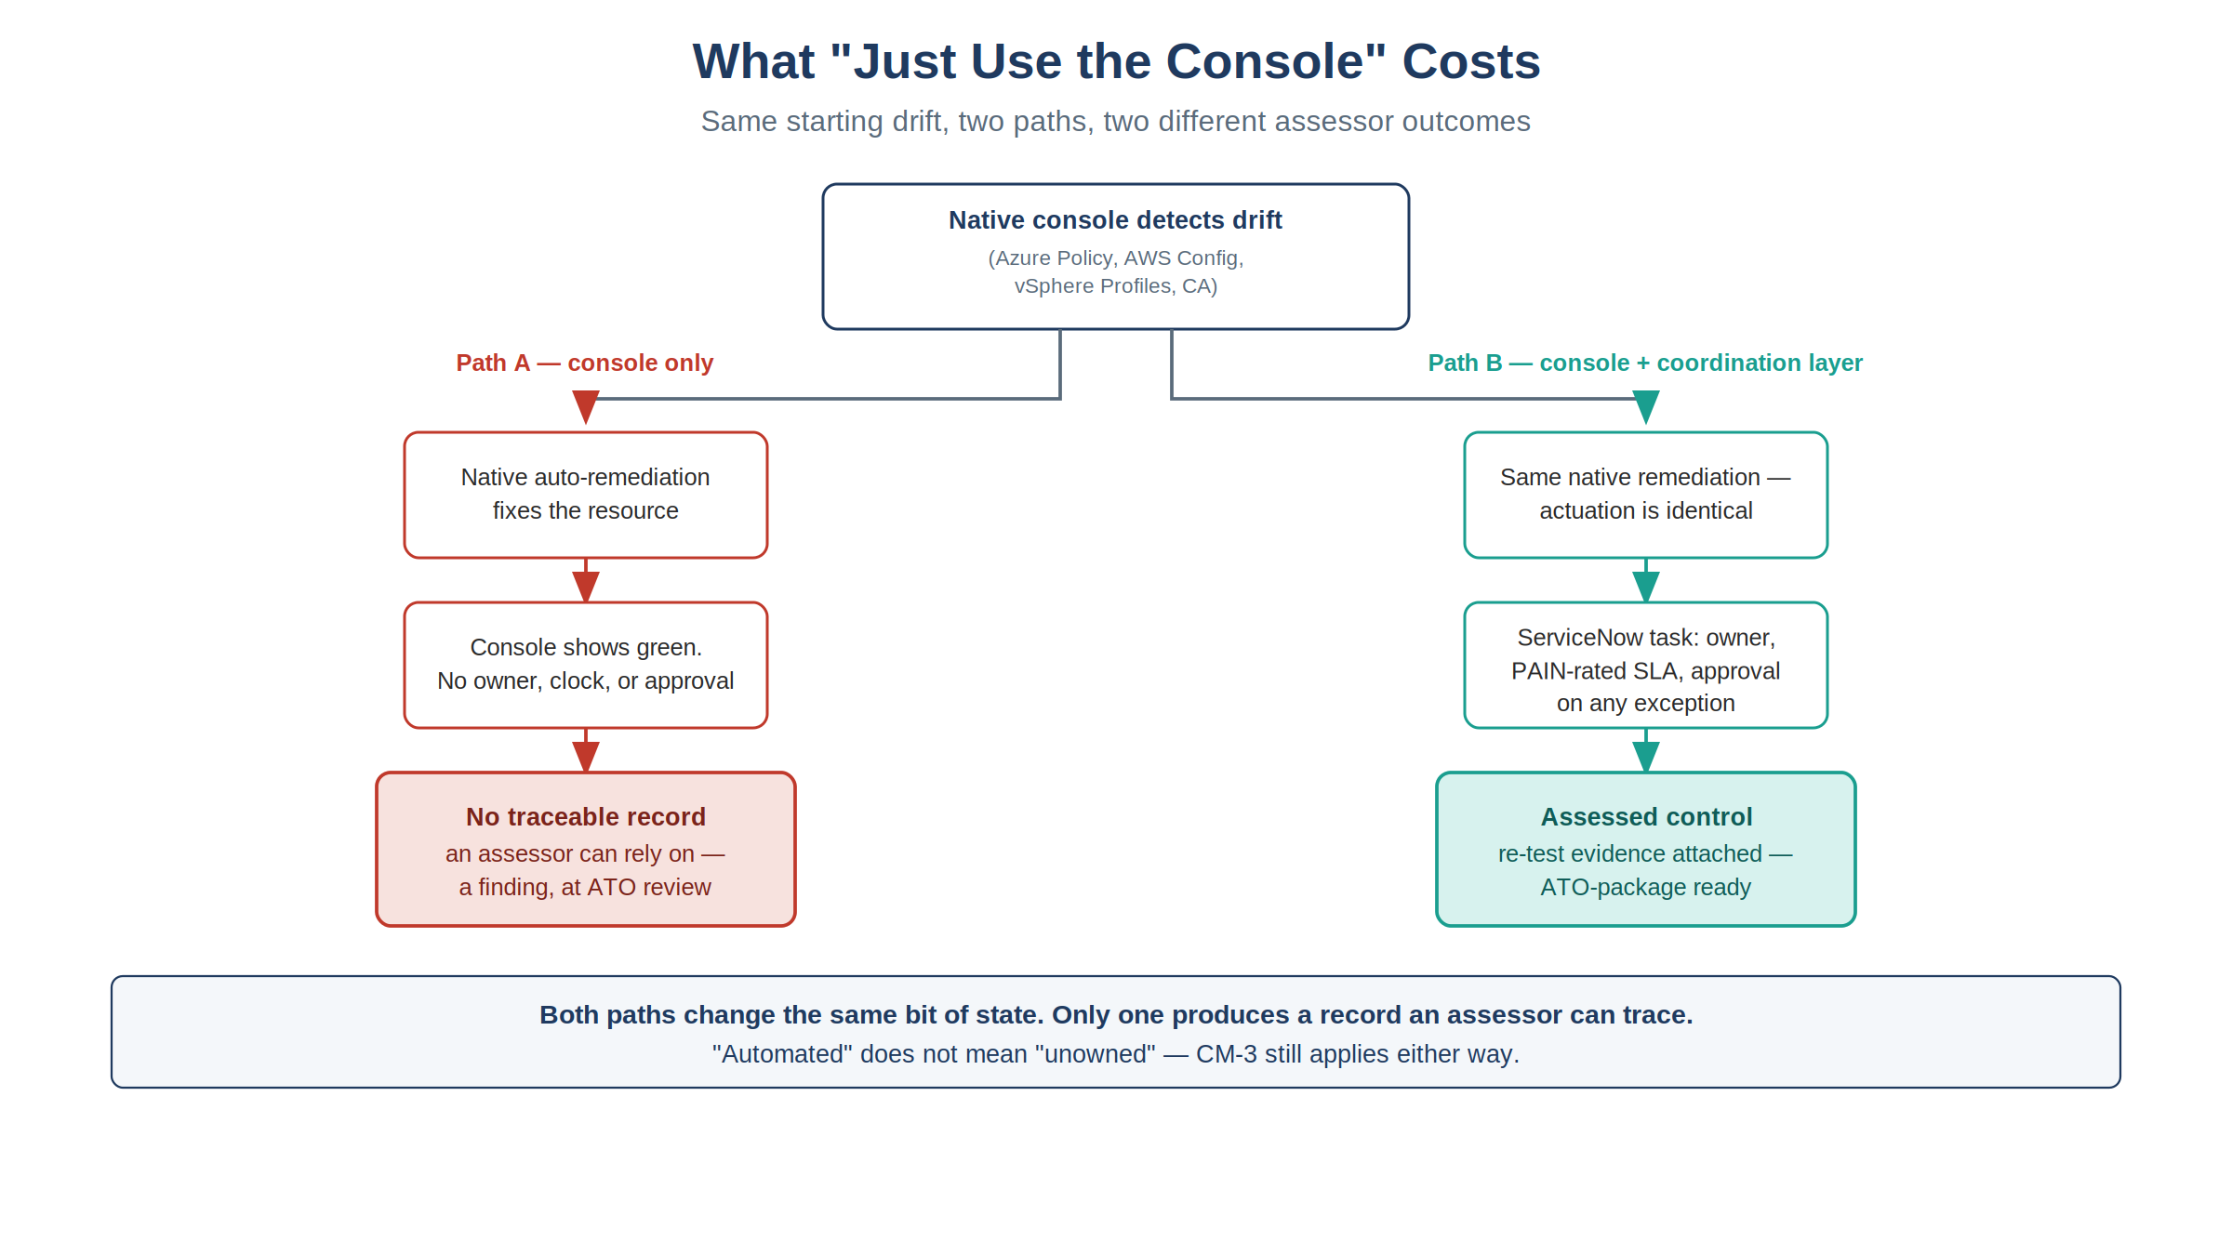
Figure 5: Same starting drift, two paths, two different assessor outcomes — only one produces a record an assessor can trace
For a customer or assessor weighing whether to skip the coordination layer and rely on native tools alone:
- The finding is real, but the record is not. Azure Policy, AWS Config, and vSphere Configuration Profiles will detect and often auto-remediate drift with no ServiceNow involvement at all. What disappears without the coordination layer is the durable, owned, approved, evidenced record of that event — the thing a 3PAO or an authorizing official is actually assessing.
- “Automated” does not mean “unowned.” Native auto-remediation (Azure’s deployIfNotExists, an AWS Config remediation action, a VMware Configuration Profiles remediation run) still requires a change record under CM-3 — automation changes who the actuator is, not whether change control applies.
- SLA-by-exposure is a specific published table, not a vague policy. FedRAMP’s Vulnerability Detection and Response ruleset (VDR-TFR-PVR) sets exact remediation timeframes by PAIN rating crossed with exploitability and reachability (4 to 192 days), plus KEV-catalog-driven due dates regardless of PAIN rating. A native console has no mechanism to enforce that clock against an owner; ServiceNow’s SLA-class task is where that enforcement actually lives.
- One coordination pattern, not one per cloud. Because the loop is identical across M365, Azure, AWS, and VMware, an organization does not need a separate governance story per platform — the evidence and the assessor-facing narrative are uniform regardless of where a given workload runs.

11. External Validation and Build-vs-Buy (2026-07-28)
This paper’s core claim — that a native console cannot be the evidence system of record — is not just an OrgComp position. Independent research outside this repo, done the same week this paper was drafted, backs it directly: the market agrees on the structural claim (Continuum GRC; Knox Systems, 2026), and the research updates two of the paper’s own assumptions — ServiceNow↔VMware integration is not greenfield (VMware Aria’s Management Pack, the VCF Automation ITSM plugin), and a commercial FedRAMP 20x KSI product, C1Secure SmartRAMP 20x, already competes with Book 05’s custom x_fed_compliance app for the KSI-attestation slice. It also confirms §8’s SailPoint framing (findings route into ServiceNow, not around it) and surfaces the alternative architectures a critical reviewer will raise — Wiz’s native VMware CNAPP coverage, and the OSCAL-first Vanta/RegScale/Paramify bet that bypasses ServiceNow/SailPoint coordination altogether.
The full vendor-by-vendor findings, the build-vs-buy analysis, and the sourcing are reproduced in Appendix D — Vendor Landscape and Build-vs-Buy, which also carries this paper’s Vendor Currency Doctrine caveat for the dated vendor claims (see the Provenance section below).

12. Honest Limits
- §4’s “machine, not human” recommendation is a derived design principle, not a citable rule — see §4 itself for the honest framing. No 800-53 control bars a human from executing an approved change, and FedRAMP’s own KSI-CMT-RMV is qualified “wherever reasonable.” Vol VII Book 07 carries the full derivation, citations, and the vCenter/PSM exception path in detail; this paper states the conclusion in its main body rather than only here.
- This paper’s CM-6/RA-5/SI-2 argument is well-established across four platform books and their generated control-closure tables; the AC-2/AC-3/AC-6 extension (§8, full discussion in Appendix B) is now likewise a documented OrgComp closure (Vol VII Book 08, ADR-135) — but VMware/vCenter identity governance remains genuinely open within it, per §8’s caution.
- Native-tool assessment latency (Azure Policy/Defender, AWS Config/Security Hub, VMware Configuration Profiles/VCF Operations) means “closed” in ServiceNow can lag the native platform’s own evaluation cycle by one cycle; evidence timestamps record the cycle, not the instant.
- Two of the four cited platform books (AWS, VMware) are current-dated Draft Proposals, not yet reviewed or approved by agency leadership — this paper inherits that draft status and should be read accordingly.
- This paper does not evaluate whether ServiceNow’s own native product modules (Configuration Compliance, Vulnerability Response/USEM, GRC: Continuous Authorization and Monitoring) already ship equivalent coordination out of the box versus requiring the custom x_fed_compliance app — that is a separate build-vs-buy question, orthogonal to this paper’s claim that some coordination layer, not the native console alone, is what produces the evidence.

13. Cross-References
- Vol VII Book 02 — M365 Control Compliance Automation — the first platform book in the series; the loop this paper describes originates here.
- Vol VII Book 03 — Azure Control Compliance Automation
- Vol VII Book 04 — Control Attestation, Evidence & KSI — how a closed task becomes an assessed control.
- Vol VII Book 05 — The ServiceNow Compliance App — the deployable artifact implementing the coordination loop.
- Vol IX Book 00 — ServiceNow Day-2 Operations — §5.1’s working reference implementation of the loop for identity lifecycle (AC-2/AC-3/AC-6) rather than configuration drift; full code review in Appendix A.
- Vol VII Book 06 — AWS Control Compliance Automation
- Vol VII Book 07 — VMware Control Compliance Automation
- Vol III Book 07 — Multi-Cloud Evidence Fabric — where the coordination layer’s output joins the cross-environment evidence fabric.
- Vol I Book 03 — Certificates, Tokens & Cryptographic Identity — the deliberate exception (§9): why routine PKI lifecycle closes through protocol automation, not a ServiceNow task; full discussion in Appendix C.
- Ticket-to-Machine Appendices — Appendix A (Day-2 Kit Code Review), Appendix B (Access Governance and SailPoint ISC), Appendix C (The Certificates Exception), and Appendix D (Vendor Landscape and Build-vs-Buy): the technical detail split out of §§5.1, 8, 9, and 11 so this paper stays a single-document read.
- Vol III Book 01 — Privileged Access Management — the CyberArk PSM session-recording capability §4’s vCenter compensating control relies on.
- OrgComp Day-2 Automation Kit — §4’s working reference implementation of ticket-to-machine actuation for the AD/Entra surface.

14. The Ask — Spoke Coverage Under the Agency Contract
This section was written for the agency’s internal ServiceNow team and was previously carried only by the standalone edition. It is folded in here so the ask survives in the paper that remains.
The architecture in §§3–8 only works if ServiceNow can actually reach each native surface under a service identity. §4 is explicit that the ticket must authorize a machine, not a person; a ServiceNow that can raise a task but cannot reach the platform is exactly the ticket-to-human anti-pattern that section describes. On the ServiceNow side, that reach is an IntegrationHub spoke — and because spokes are a licensed entitlement, this is a contract question before it is an engineering one.
The request: for each row below, confirm whether the agency’s current ServiceNow contract entitles the integration, and where it does not, say so explicitly so the gap can be booked rather than discovered during implementation.
Platform | What this paper needs ServiceNow to reach | Integration to confirm | Status to confirm
Entra ID (AC-2/AC-3/AC-6 identity lifecycle; the SAM approval front end) | User, group, license, service-principal, password, and device actions under a delegated service account | Microsoft Entra ID Spoke (formerly the Microsoft Azure Active Directory Spoke) | Documented by ServiceNow — confirm it is entitled, and confirm the delegated account’s scope
Azure (CM-6, RA-5, SI-2) | Read Azure Policy, Defender for Cloud, and Update Manager state; raise and close typed tasks against the reconciled CI | Microsoft Azure spokes — the Virtual Machine and Virtual Network spokes are documented; which spoke, if any, covers Policy / Defender / Update Manager is the open question | Confirm both coverage and entitlement
AWS (CM-2/CM-6, RA-5, SI-2) | Read AWS Config, Security Hub, and Inspector findings and Systems Manager Patch Manager state | AWS IAM Spoke is documented; the ServiceNow AWS Integration for Security Exposure Management store app covers Inspector + Security Hub | Confirm entitlement for both, and whether Config and Patch Manager are covered
VMware (CM-2/CM-6, RA-5, SI-2) | Read vSphere Configuration Profiles / VCF Operations / vLCM state, and actuate under a service identity | No vCenter IntegrationHub spoke was found. The documented connectors are the VMware Aria Operations Management Pack for ServiceNow and the VCF Automation ITSM plugin | Confirm what the contract covers; until a machine actuator exists, the PSM exception in §4 applies
Two notes on how to read the table. The VMware row is the one this paper already flags as genuinely open (§4, §8): it is not an oversight in the table but the same gap stated in contract terms, and the honest answer may be “no spoke exists,” in which case the CyberArk PSM compensating control in §4 is the closure path rather than a workaround. And where a spoke turns out not to be entitled, the answer is not to route the work through a human at the console — that is precisely the anti-pattern §4 rejects. It is either to license the integration, or to book the gap as a declared exception with a named compensating control.
Spoke names and packaging move between ServiceNow releases, and IntegrationHub entitlement is set by subscription terms rather than by the platform; treat every product name above as a starting point for that confirmation, not as a statement of what the agency already owns. The vendor-currency caveat below applies here in full.

15. Authority Mapping and Non-Compliance Exposure
This paper argues from control families throughout; the specific guidelines behind those claims, and the exposure an agency carries when they go unmet, are collected in one place rather than scattered.
The three authorities this paper answers to
Authority | What it obligates here | Where the loop meets it
NIST SP 800-53 Rev 5, FedRAMP Moderate baseline | CM-6, RA-5, SI-2 (configuration, vulnerability, patch); AC-2/AC-3/AC-6 (access governance); CA-2/CA-5/CA-7 (assessment, POA&M, ConMon); IA-5(2)/SC-17 (the PKI exception) | Every row is Tool-attestable: No — the native engine actuates, the coordination layer makes it assessable
FedRAMP 20x | Continuous KSI evidence (KSI-CMT, KSI-MLA, KSI-IAM, KSI-SVC); KSI-CMT-RMV/VTD/RVP; the VDR-TFR-PVR remediation-timeframe table (4–192 days by PAIN rating, plus KEV due dates) | CA-7 emit of OSCAL assessment-results plus KSI evidence; the SLA clock enforced against a named owner
CISA BOD 25-01 | Five obligations; four are administrative, the fifth — remediate deviations from the SCuBA baselines — is open-ended and architectural | Row 5 is this paper’s loop: detect natively, own and clock in ServiceNow, actuate natively, close with evidence
A note on attribution. Binding Operational Directives are issued by CISA, not OPM — OPM issues memoranda and HR-domain guidance. The directive governing the M365/SCuBA scope this paper touches is CISA BOD 25-01, Implementing Secure Practices for Cloud Services.
What non-compliance actually costs. None of these authorities carries a fine. The exposure is an authorization that can be conditioned, shortened, or withdrawn by the Authorizing Official; audit findings that persist across FISMA reporting cycles and compound; and a deviation list that grows, which is itself the documentary evidence that the remediation obligation went unmet. The last is the one that bites: an assessment tool running faithfully against an unremediated estate produces an accurate, lengthening record of non-closure. And the operational risk is unchanged by any of it — the misconfiguration remains exploitable regardless of how well it is reported.
The full control-by-control mapping, the BOD 25-01 obligation table, the forward-looking BOD 26-04 deadline, and the per-authority exposure breakdown are in Appendix E.

Provenance
This paper is a synthesis, not a new closure claim: every control-closure row and quoted Closure Necessity passage is reproduced from the four cited Vol VII books, which are in turn generated against orgcomp-compliance-spine.yml. It carries no independent Authorities Closed Here table of its own — reopening or re-deriving those closures is out of scope; this paper exists to state their shared argument once, for a reader who wants the claim without reading all four platform books end to end.
Vendor currency caveat — read before building a Project Plan on this paper
This paper’s dated vendor claims — SmartRAMP 20x, the VMware Aria/ServiceNow connectors, SailPoint CIEM’s cloud coverage, Wiz, Vanta, CyberArk/Keyfactor — now live primarily in the vendor-landscape appendix, and this market moves in weeks, not review cycles. Per the OrgComp series’ Vendor Currency Doctrine, every vendor claim in this paper and its appendices is a dated snapshot, not a standing commitment. Read the full caveat in Appendix D, and confirm current roadmaps directly with ServiceNow, SailPoint, VMware/Broadcom, and each CSP before any claim here becomes the basis of an implementation Project Plan, procurement action, or acquisition decision.

References
Claim | Source
CM-6/RA-5/SI-2 Tool-attestable: No across M365/Azure/AWS/VMware | orgcomp-compliance-spine.yml, rendered per-book by render_authorities_table.py
Closure Necessity argument (Azure/AWS/VMware) | Vol VII Books 03, 06, 07 (this repo)
Attestation pipeline (CA-2/CA-5/CA-7, OSCAL/KSI emit) | Vol VII Book 04 (this repo)
ServiceNow Compliance App record model (x_fed_compliance) | Vol VII Book 05 (this repo)
§4’s “working reference implementation” claims — MID-Server-dispatched AD writes under a delegated service account, “ServiceNow … NEVER writes to the estate,” the approver-gated password-reset fallback, the automated morning-check reconciliation | docs/customer-documents/orgcomp-series/servicenow-day2/script-includes/AdHybridClient.js, Day2NativeActuator.js, CURRENT-STATE-OPERATOR-USAGE.md (this repo) — sampled, not exhaustively audited; the sampling surfaced exploitable AD-leg defects, now remediated, see the callout above and Appendix A
§4/Appendix A AD-leg security findings (2026-07-29) — unescaped parameter names in _render (command injection), target substitution via _merge precedence, cleartext password in ecc_queue, no AD post-state read-back, clause 1 (Origin) unenforced — all remediated 2026-07-30 | External adversarial security review, 2026-07-29 (this repo’s inbox review process); remediation verified directly against the current AdHybridClient.js, MacdrOrchestrator.js, EntraHelpdeskGate.js, sam_inbound_ritm.js, SamCorrelationClient.js (this repo, commit 7d2423c74)
The morning-check RDP anti-pattern the Day-2 kit’s automated reconciliation replaces | docs/customer-documents/orgcomp-series/OrgComp_Operator_Runbook_Day2_Compliant.qmd, Task 6
§4’s CM-3(2)/CM-5(1)/CM-6(1)/SI-2(2) Moderate-baseline citations, and the rejection of CM-3(5)/AU-12(3)/mischaracterized AC-6(9)/IA-5(2) proposed by an independent citation review | Vol VII Book 07 (this series), Approval/Execution Split section and its References
MACD-R five-clause orchestration (Origin/Authorize/Elevate/Actuate/Evidence), the Appendix A code-level reference implementation — all five clauses now enforced, including Origin | docs/customer-documents/orgcomp-series/servicenow-day2/script-includes/MacdrOrchestrator.js (this repo)
PAIN-rating remediation timeframes (VDR-TFR-PVR) | FedRAMP — https://www.fedramp.gov/2026/reference/vulnerability-detection-and-response/
Risk-based remediation prioritization (KEV catalog) | CISA — https://www.cisa.gov/known-exploited-vulnerabilities-catalog
SAM (SailPoint IGA) canon status — distinct from reserved sailpoint-nerm slot (ADR-059) | docs/customer-documents/orgcomp-series/servicenow-day2/START-HERE.md
“CSPM complements GRC — findings need owners and closure proof”; no single tool covers a FedRAMP boundary alone | Continuum GRC — https://continuumgrc.com/audit-compliance-solutions-fedramp/
Coordinated-stack requirement; ticketing/SLA ownership as a FedRAMP necessity | Knox Systems — https://knoxsystems.com/resources/continuous-compliance-fedramp
C1Secure SmartRAMP 20x — ServiceNow-native FedRAMP 20x KSI platform (build-vs-buy context for Book 05) | PR Newswire — https://www.prnewswire.com/news-releases/c1secure-launches-smartramp-20x-a-servicenow-native-platform-built-for-the-fedramp-20x-model-302824168.html
VMware Aria Operations Management Pack for ServiceNow (native connector, corrects Book 07’s “unbuilt” framing) | Broadcom TechDocs — https://techdocs.broadcom.com/us/en/vmware-cis/aria/aria-operations-for-integrations/9-0/management-pack-for-servicenow-9-0/management-pack-for-servicenow.html
VCF Automation ITSM plugin for ServiceNow | ServiceNow Store — https://store.servicenow.com/store/app/0349abae1be06a50a85b16db234bcbbb
ServiceNow AWS Integration for Security Exposure Management (Inspector + Security Hub) | ServiceNow Store — https://store.servicenow.com/store/app/fc71081b47804f90040ae738436d43e0
SailPoint CIEM — native AWS/Azure/GCP cloud IAM entitlement governance | SailPoint — https://www.sailpoint.com/products/identity-security-cloud/atlas/add-ons/cloud-infrastructure-entitlement-management
SailPoint routes findings into ServiceNow’s Service Desk for ticketing/audit tracking | SailPoint — https://www.sailpoint.com/products/connectivity-and-integrations/catalog/servicenow
Wiz native multi-cloud + VMware vSphere coverage (alternative single-engine architecture) | Reintech — https://reintech.io/blog/wiz-vs-orca-vs-prisma-cloud-comparison-2026
Vanta FedRAMP 20x Moderate Authorization; OSCAL/KSI self-generation (alternative architecture) | Vanta — https://www.vanta.com/products/fedramp-20x
Certificates as the deliberate volume-driven exception (“no owner is named… because none needs to be”) | docs/customer-documents/orgcomp-series/Vol_I_Book_03_OrgComp_Certificates_Tokens_Cryptographic_Identity.qmd, Theme D
Keyfactor for Government CLAaaS — FedRAMP Moderate authorization (May 2026) | Keyfactor — https://www.keyfactor.com/press-releases/keyfactor-attains-fedramp-moderate-authorization/
CyberArk Certificate Manager (Venafi) — CA-agnostic discovery/orchestration, ServiceNow integration | CyberArk — https://www.cyberark.com/products/certificate-manager/
Keyfactor/DigiCert/AppViewX native ServiceNow CMDB and ITOM integrations for certificate lifecycle | Keyfactor — https://www.keyfactor.com/blog/keyfactor-simplifies-enterprise-pki-certificate-management-with-new-servicenow-integrations/; DigiCert — https://docs.digicert.com/en/trust-lifecycle-manager/build-your-inventory-and-ecosystem/connectors/it-service-management/link-to-servicenow.html; ServiceNow — https://www.servicenow.com/products/certificate-management.html
Ticket-to-Machine, Not Ticket-to-Human: Why Changing State Isn’t Compliance Evidence | Draft | July 2026

