Zero Trust Governance — Whitepaper
  - Implementing CISA Zero Trust maturity through UIAO’s governance model
Michael Stratton
2026-06-01
Table of contents

Zero Trust Governance

Implementing CISA Zero Trust maturity through UIAO’s governance model
 Problem, solution, ask
Problem. Agency Zero Trust programs assemble point solutions per ZTMM pillar and discover late that they are structurally unable to reach Advanced or Optimal, because the substrate the pillars sit on cannot produce continuous, canonical, drift-detected, cross-pillar evidence.
Solution. UIAO does not replace pillar tooling; it supplies the shared canonical fabric beneath all five pillars — identity as the root namespace (ADR-008), a provenance envelope on every claim, the drift taxonomy as continuous verification, OSCAL-native evidence, and an explicit boundary-impact model for GCC-Moderate.
Ask. Four steps this quarter (§8): inventory which pillar evidence is reproducible without operator coordination, bring one adapter under the canonical taxonomy, run uiao substrate walk in CI, and — if the agency operates in GCC-Moderate — instantiate the boundary impact model so platform feature gaps become governed findings.

Executive summary
CISA’s Zero Trust Maturity Model (ZTMM) defines five pillars (Identity, Devices, Networks, Applications & Workloads, Data) and four maturity stages (Traditional → Initial → Advanced → Optimal). Most federal agency Zero Trust programs spend their first two years assembling point solutions per pillar and discover, late, that the program is structurally unable to reach Advanced or Optimal because the substrate the pillars sit on cannot produce continuous, canonical, drift-detected evidence.
UIAO closes that structural gap. This whitepaper explains how the Governance OS maps onto the five ZTMM pillars, why Advanced/Optimal maturity requires a substrate (not just better tools), and what an agency can ship today versus what remains target-state.

1. Why Zero Trust programs stall at Initial maturity
Federal Zero Trust programs stall for the same structural reason, independent of which pillar tools an agency has bought: pillars get administered per-tool instead of governed against a shared canonical truth, so the cross-pillar correlation, continuous evidence, and automated policy evaluation the ZTMM’s Advanced and Optimal stages require are structurally out of reach. The full argument — three named failure patterns, each grounded in a specific documented incident (Storm-0558, the ESXiArgs and ESXi AD-integration CVEs) rather than asserted in the abstract — is made in Zero Trust Governance Principles §1; this paper does not repeat it and instead moves directly to UIAO’s contribution.
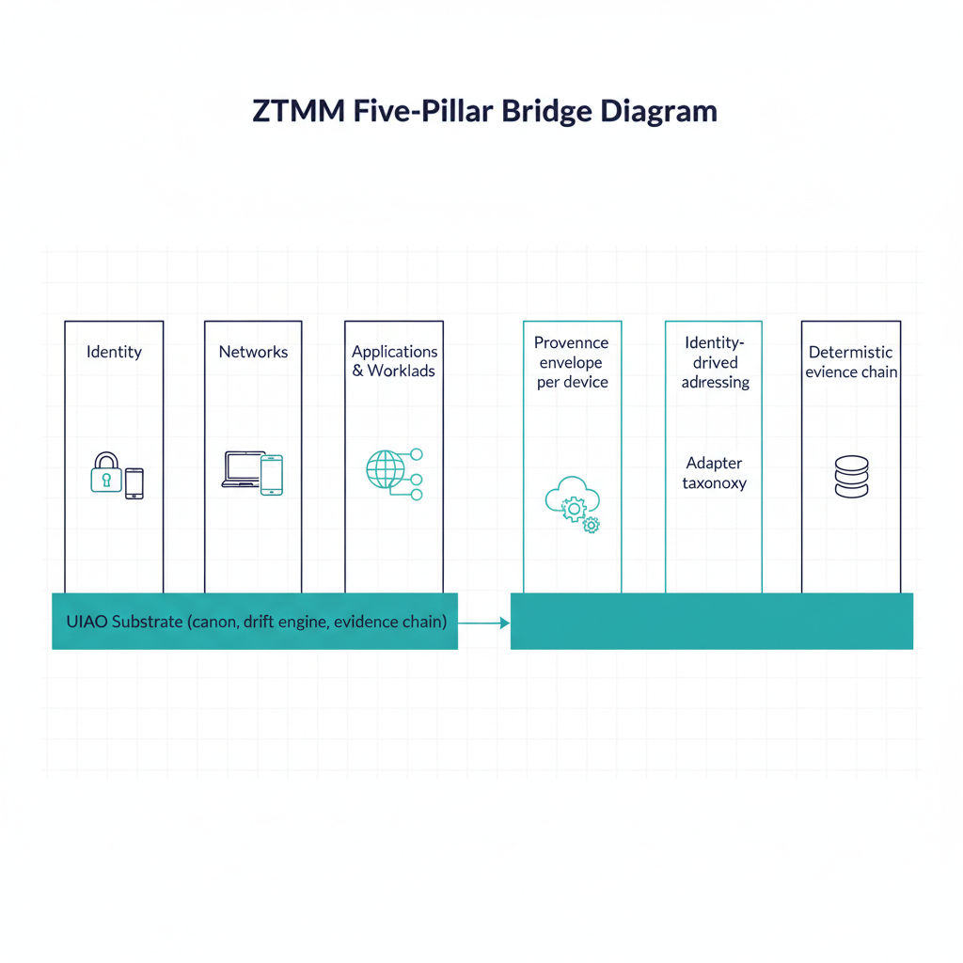
Figure 1: ZTMM five-pillar bridge diagram

2. The substrate’s contribution to each pillar
UIAO does not replace per-pillar tooling. It provides the shared canonical fabric that ties pillars together. Per-pillar contribution:
ZTMM pillar | UIAO contribution | Canon anchor
Identity | Identity-plane SSOT; identity-as-root-namespace per ADR-008 | adr-008-zero-trust-identity.md
Devices | Device claims normalized into the provenance envelope; drift findings per device | 15_ProvenanceProfile.qmd
Networks | Identity-derived addressing; addressing plane is computed from identity, not parallel-administered | 01_UnifiedArchitecture.qmd
Applications & Workloads | Adapter taxonomy maps workload controls onto canonical KSI rules | adapter-registry.yaml, modernization-registry.yaml
Data | Provenance envelope on every claim; deterministic evidence chain per ADR-006 / ADR-016 | 15_ProvenanceProfile.qmd, ADR-006, ADR-016
The substrate’s contribution is uniform across pillars: SSOT, provenance envelope, drift taxonomy, and OSCAL-native evidence. Each pillar still keeps its tool-level capability; the substrate is what makes those tools’ output reproducibly verifiable in one assessor-readable form.
What the table’s canon anchors produce concretely, per pillar:
Identity, in practice. An agency onboards a new SaaS integration that authenticates through Entra ID. Per ADR-008, the integration’s device and workload objects do not get a separate identity system stood up for the integration — device claims and workload access decisions key off the same Entra object ID the identity plane already governs. A control like KSI-IA-02 (phishing-resistant MFA, src/uiao/rules/ksi/iam/ — a UIAO-internal rule id named after NIST IA-2, not the FedRAMP 20x indicator, which is KSI-IAM-APM) and the integration’s own access decision resolve against that one identity record, so a drift finding on it — a stale service-principal credential, say — is visible to whichever pillar consumes that identity, rather than surfacing as two disconnected findings a human has to manually correlate. For the credential-family detail behind KSI-IA-02 — why PIV and FIDO2/WebAuthn qualify as phishing-resistant and OTP/push/SMS do not — see OrgComp Vol I Book 03, “Certificate-Based Authentication and Phishing-Resistant MFA”.
Devices, in practice. A managed endpoint’s compliance state (Intune) and its Conditional Access risk signal (Entra) are captured by two different adapters but wrapped in the same provenance envelope per 15_ProvenanceProfile.qmd. Each claim carries the device’s issuer_identity rather than a locally-scoped device ID, so a single drift finding — e.g. DRIFT-SEMANTIC for a device whose Intune-reported compliance state has gone stale relative to its last check-in — can be filtered by identity, by device, or by pillar without re-querying either source tool.
Data, in practice. A data-classification claim (a SharePoint site’s sensitivity label, captured via the M365 adapter) carries the same SHA-256-hashed provenance chain and ADR-006 reproducibility guarantee as an identity or device claim. If an assessor needs to confirm a data classification hasn’t silently drifted since the last ATO package was assembled, the same bundle re-execution used for identity or device evidence works unmodified — data evidence is not a structurally different artifact type that needs its own tooling.

3. Identity as the root namespace (ADR-008)
CISA’s identity pillar treats identity as one of five concerns. UIAO’s canon takes a stronger position, declared in ADR-008: identity is the root namespace. (Operationally this is the OrgPath governance pillar — the governed addressing plane the ZT policy subject composes against.) Devices, addresses, network paths, applications, and data classifications are named via identity; they do not have parallel naming systems.
Operationally:
- A device claim’s issuer_identity is an identity-plane object (e.g. an Entra ID object ID), not a separate device-pillar object.
- An address is computed from identity context per the addressing plane, not assigned by an independent IPAM.
- A workload’s access decision consumes identity claims as authoritative input rather than as one signal among many.
This is the architectural reason UIAO can scale Zero Trust beyond Initial maturity: the cross-pillar correlation problem reduces to resolving identity, which the canon and the identity plane already do authoritatively.
This is a naming and addressing claim, not a trust claim: identity as root namespace means every other pillar resolves its objects through the identity plane, not that a validated identity should be trusted unconditionally once issued. Zero Trust Governance Principles §4 makes the point directly — treating identity as a self-authenticating root recreates the same failure mode Zero Trust is supposed to retire — which is exactly why the identity plane itself still needs the operational hardening (continuous re-evaluation, short token lifetimes, hardware-bound credentials) that principle describes.
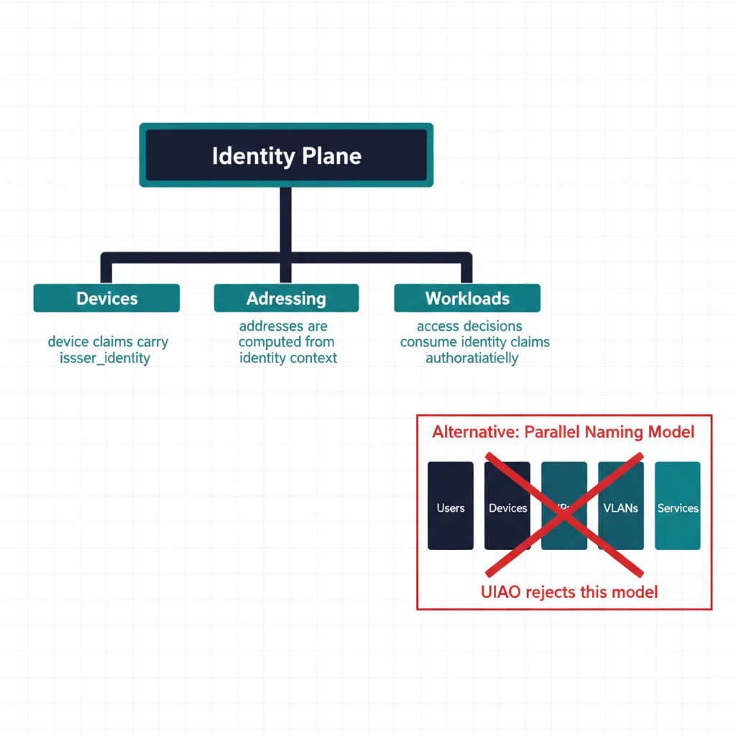
Figure 2: Identity-as-root-namespace tree diagram

4. Continuous verification through drift
CISA’s Optimal column requires continuous verification. UIAO’s drift engine is what makes that operationally tractable. The six drift classes map onto Zero Trust concerns directly:
Drift class | Zero Trust concern
DRIFT-IDENTITY | Identity assertion no longer resolves — a P1 finding routed for governed remediation; the provider’s own enforcement plane denies access, with UIAO as the governing record (ADR-092)
DRIFT-AUTHZ | Action emitted outside the consent envelope — alerts, and suspends autonomous remediation under halt_on_critical; enforcement stays with the provider data plane (ADR-092)
DRIFT-PROVENANCE | Claim chain broken — pillar evidence is no longer trustworthy
DRIFT-SCHEMA | Structural mismatch between declared and observed pillar state
DRIFT-SEMANTIC | Pillar state is structurally valid but semantically stale
DRIFT-SSOT-CONTENTION | A write is directed at a canonically-demoted instance after the SSOT roster has been ratified — the stewardship decision exists and is being bypassed (ADR-074)
Today, schema and provenance drift ship in CI. The runtime detection surface for identity, authorization, and semantic drift is canonical (declared in 16_DriftDetectionStandard.qmd) and partially implemented; the structural pieces that matter most for ZT — provenance envelope, remediation contract, severity model — already ship.

5. Evidence at Advanced/Optimal maturity
Advanced and Optimal maturity require evidence that is:
- Continuous — emitted as state changes, not periodically.
- Cross-pillar — single evidence record covers identity + device + workload context.
- Reproducible — re-executable by an assessor without operator coordination.
UIAO’s evidence chain delivers (2) and (3) today. Cross-pillar evidence is structural: every claim carries the full provenance envelope, so the evidence bundle inherently spans pillars. Reproducibility is structural per ADR-006: same canon, same inputs → byte-identical bundle.
Continuous emission (property 1) is target state. The provenance envelope and bundle lifecycle support continuous capture; the gap is end-to-end wiring across every adapter. Adapters that ship continuous capture today already exhibit the property; the program-level objective is to bring all adapters to that maturity rather than to invent a new mechanism.

6. The boundary problem (GCC-Moderate)
Federal Zero Trust programs in GCC-Moderate hit an additional structural constraint: many of the platform-emitted signals that commercial Microsoft 365 customers use for ZT analytics are silently unavailable in GCC-Moderate (Endpoint Analytics, Device Health Attestation, Network Fence, ARC Server Monitoring). See the Boundary Impact Model and the GCC-Moderate Boundary Problem Statement.
UIAO addresses the boundary structurally rather than waiting for platform fixes:
- Boundary probe confirms which features actually function on each side of the boundary, producing structured capability disposition.
- In-boundary telemetry adapters emit canonical claims with explicit source_classification: derived for signals substituting unavailable commercial features.
- Compensating enforcement adapters provide agency-side enforcement for controls platform features cannot deliver.
- ATO documentation treats the boundary as a first-class governed object, not as implicit assumption.
Per ADR-059, the substrate also recognizes named Commercial exceptions (Amazon Connect Contact Center, SailPoint Non-Employee Risk Management) that operate FedRAMP Moderate on AWS GovCloud — each encoded as a discrete enum value in the gcc-boundary schema and added in lockstep with its authorizing ADR. The substrate’s posture is that boundary exceptions are governed, not glossed over. The compliance pillar’s full treatment of this territory — boundary volumes, evidence and ConMon packaging, and the network enforcement substrate — is the OrgComp — Federal Organization Compliance series. The boundary landscape has since widened beyond GCC-Moderate: ADR-129 added the commercial-general boundary (non-federal commercial regimes, with the SOC 2 pack registered active under it) and ADR-133 added state-local (GovRAMP reciprocity) — the same governed-boundary pattern, applied to new regimes.
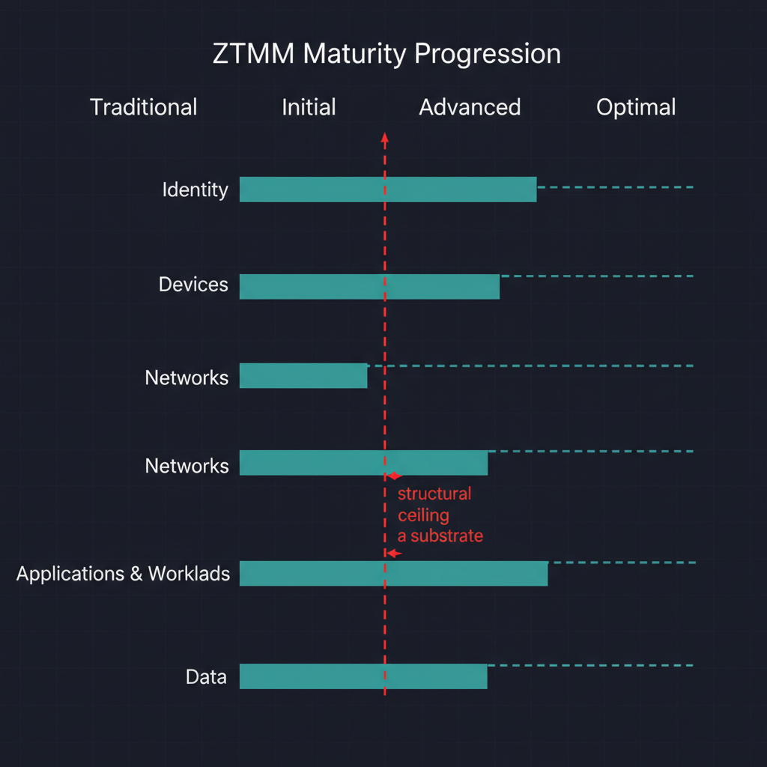
Figure 3: ZTMM maturity progression chart

7. Pillar-by-pillar maturity outlook
Pillar | UIAO-anchored substrate posture
Identity | Identity-as-root-namespace per ADR-008 ships today; identity-plane SSOT enforced via schema gates
Devices | Device claims via provenance envelope ships; cross-pillar correlation ships; per-device runtime drift is TARGET
Networks | Addressing plane SSOT ships; identity-derived addressing is canonical and partially shipped
Applications & Workloads | Adapter taxonomy + KSI mapping ships; workload-side enforcement runtime is library-only (UIAO_111)
Data | Provenance envelope ships; deterministic evidence chain ships; continuous event-time capture is TARGET
For each pillar the substrate’s structural floor is in place; the gap to Optimal is engineering at the runtime layer, not architectural redesign.

8. What an agency can do this quarter
Concrete adoption posture, ordered:
- Inventory which pillar evidence is reproducible today. For each ZTMM pillar, can you re-run the evidence pipeline without operator coordination? Where the answer is no, that is the substrate adoption boundary.
- Bring one adapter under the canonical taxonomy. Pick the highest-leverage tool in any pillar; declare it in the modernization or conformance registry; emit its findings into OSCAL alongside the existing attestation evidence.
- Run uiao substrate walk in CI. Schema and provenance drift findings are immediate; remediating them is the cheapest possible lift toward Advanced maturity.
- Model the boundary explicitly. If the agency operates in GCC-Moderate, instantiate the boundary impact model with the four impact dimensions; treat platform feature gaps as governed findings rather than implicit constraints.
None of these requires a year-long program. Each is a structural step that compounds.

9. Honest limits
- ZTMM Optimal requires continuous, automated, cross-pillar policy evaluation. UIAO ships the substrate that makes this tractable; it does not ship every per-pillar runtime today.
- Identity, authorization, and semantic drift are detected at runtime only by adapters that have implemented the runtime conformance contract. Coverage is growing, not complete.
- The boundary impact model is structural; the operational work of inventorying boundary impacts and authoring compensating mechanisms is per-agency.
- “Continuous verification through drift” (§4) is evidence and posture continuity, not session or token continuity. The latter — sub-second revocation on a risk signal — depends on Entra Continuous Access Evaluation (CAE) fidelity, which is inferred degraded inside GCC-Moderate; see FINDING-006 for the tracked gap and the compensating controls it recommends.

10. Conclusion
CISA’s ZTMM is a destination model. UIAO’s contribution is the substrate that makes the destination structurally reachable: SSOT for cross-pillar truth, drift taxonomy for continuous verification, provenance envelope for reproducible evidence, and boundary impact modeling for the federal constraints (GCC-Moderate especially) that no per-pillar tool can address alone.
Agencies adopting UIAO are not buying a Zero Trust product. They are adopting the operating system that makes their existing pillar tooling produce ZT-grade evidence — and the architectural foundation for every runtime extension that follows.

