Microsoft Zero Trust Assessment and CISA SCuBA — How They Relate
  - Two read-only posture assessments, where they overlap, and how to use them together
Michael Stratton
2026-06-01
Table of contents

 Problem, solution, ask
Problem. Agencies run two free, read-only assessments of their Microsoft cloud — CISA ScubaGear (a compliance question, driven by BOD 25-01) and Microsoft’s Zero Trust Assessment (a maturity question) — and routinely ask whether they need both, or drop one because “it covers identity.”
Solution. They are complementary, not redundant: they intersect almost entirely on Entra identity and barely anywhere else. SCuBA holds Exchange, Teams, and Power Platform baselines the Zero Trust Assessment never touches; the Zero Trust Assessment covers Intune devices, Azure infrastructure, and Purview data that SCuBA does not assess. Run both, and reconcile at the control level (NIST 800-53 / FedRAMP Moderate), not tool to tool.
Ask. Keep ScubaGear for BOD 25-01, add the Zero Trust Assessment for breadth, line both up against a common control spine, treat all output as Controlled and keep it in-boundary — and run uiao zta overlap against your own report to replace this paper’s illustrative split with your tenant’s.

Executive summary
Two free, read-only assessment tools evaluate the security posture of a Microsoft cloud tenant, and agencies routinely ask whether they need both:
- CISA SCuBA / ScubaGear — checks Microsoft 365 against CISA’s Secure Cloud Business Applications baselines. It answers a compliance question: is our M365 configuration aligned with the federal baseline? (relevant to BOD 25-01).
- Microsoft Zero Trust Assessment — checks the broader Microsoft cloud (Entra, Intune, Azure, Purview) against Microsoft’s Secure Future Initiative and the Zero Trust pillars. It answers a maturity question: how close is our whole environment to Zero Trust?
They are complementary, not redundant. They intersect almost entirely on one surface — Entra identity — and barely overlap anywhere else. Roughly half of the Zero Trust Assessment’s checks fall in an area SCuBA also covers (nearly all of it identity), with meaningful non-overlap on each side: SCuBA has baselines the Zero Trust Assessment never touches (Exchange, Teams, Power Platform), and the Zero Trust Assessment covers whole domains SCuBA does not assess at all (Intune devices, Azure networking and infrastructure, Microsoft Purview data). And even where they share a surface, the Zero Trust Assessment is far more granular than SCuBA’s prescriptive baseline. (A specific illustrative split, with its provenance and caveats, appears in the table below.)
Recommendation: run both. Use ScubaGear to demonstrate and maintain federal-baseline compliance for M365 workloads; use the Zero Trust Assessment to drive broader Zero Trust maturity across identity, devices, network, and data. Reconcile their findings at the control level (e.g., NIST 800-53 / the FedRAMP Moderate baseline) rather than expecting one tool’s output to substitute for the other’s.
 Note
The figures in this paper are illustrative, computed from Microsoft’s public demo report. Your tenant’s split comes from running the assessment on your own environment. Assessment output is sensitive — treat it as Controlled and keep it inside your authorization boundary.

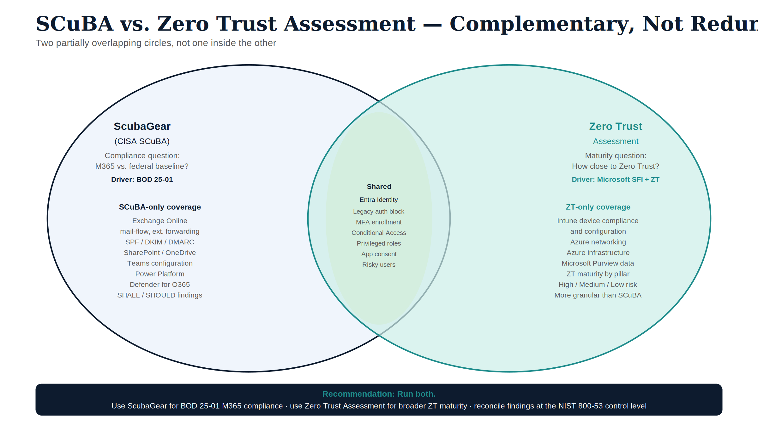
Figure 1: SCuBA vs. Zero Trust Assessment — complementary coverage areas

The two tools at a glance
 | ScubaGear (CISA SCuBA) | Zero Trust Assessment (Microsoft)
Question it answers | Compliance with a federal baseline | Maturity toward Zero Trust
Authoring body | CISA SCuBA baselines | Microsoft (SFI + ZT pillars; cites NIST/CISA/CIS)
Primary driver | BOD 25-01 | Microsoft hardening guidance
Scope | M365 workloads: Entra, Exchange Online, Defender for O365, SharePoint/OneDrive, Teams, Power Platform, Power BI | Entra, Intune (devices), Azure, Purview — organized by Zero Trust pillars
How it runs | PowerShell + Graph/product APIs + policy evaluation | PowerShell + Graph
Output | HTML report + JSON, per product | HTML report + JSON, by pillar
Finding identifier | Policy ID, e.g. MS.AAD.1.1v1 | Numeric / GUID TestId
Severity model | Criticality: SHALL / SHOULD | Risk: High / Medium / Low
Both are read-only | Yes | Yes

Where they overlap, where they don’t
Think of two partially overlapping circles, not one inside the other:
SCuBA-only (ScubaGear covers, ZT does not) | Shared surface (both) | ZT-only (ZT covers, SCuBA does not)
Exchange Online mail-flow, external forwarding, SPF/DKIM/DMARC | Entra identity: legacy auth, MFA, Conditional Access, privileged-role config, risky users, app consent | Intune device compliance & configuration
Defender for Office 365 (anti-phishing, Safe Links/Attachments) |  | Azure RBAC, networking, DDoS/firewall
Microsoft Teams policies |  | Microsoft Purview labels / DLP / RMS
Power Platform governance & DLP |  | Global Secure Access
Illustrative split of the Zero Trust Assessment’s checks (Microsoft sample tenant, 295 checks):
Bucket | Checks | Share
Shared surface (a SCuBA baseline covers the area) | 140 | ~47%
ZT-only (no SCuBA baseline exists) | 155 | ~53%
By pillar, the shared surface is almost entirely Identity; Devices, Network, and Infrastructure are essentially all ZT-only, and the Data pillar is mostly ZT-only (Microsoft Purview).

Two caveats that matter more than the percentage
- “Shared surface” is not “duplicate checks.” SCuBA’s Entra (aad) baseline is on the order of 30 prescriptive policies at ScubaGear v1.8.0 — MS.AAD enumerates MS.AAD.1.1v1 through MS.AAD.7.9v1, with 5.5/5.6/5.7v1 added 11 May 2026 and a high-risk Entra AI-agent policy added 22 Jun 2026, so pin a policy-set version rather than a count; the Zero Trust Assessment has many more identity checks. So shared means same area, not same check — only a subset (legacy auth, MFA, Conditional Access basics, privileged-role hygiene, risky users, app consent) have a true one-to-one counterpart. The rest is the Zero Trust Assessment going deeper than the federal baseline.
- The inverse gap. SCuBA’s Exchange, Defender-for-O365, Teams, and Power Platform baselines have essentially no Zero Trust Assessment counterpart. Dropping ScubaGear because “the Zero Trust Assessment covers identity” would leave those M365 workloads unassessed against the federal baseline.

What this means for your agency
- Keep ScubaGear for BOD 25-01. It is the tool aligned to the federal M365 baseline, including the workloads (Exchange, Teams, Power Platform) the Zero Trust Assessment doesn’t touch.
- Add the Zero Trust Assessment for breadth and maturity. It extends coverage to devices (Intune), Azure infrastructure, network, and data — and risk-ranks findings to help prioritize.
- Reconcile at the control level. Because the two use different identifiers and frameworks, line their findings up against a common spine — the specific tenant setting and/or NIST 800-53 (and, for federal systems, the FedRAMP Moderate baseline) — rather than trying to match tool outputs directly. The operational form of exactly this reconciliation (SCuBA policy ID → NIST control → typed task, held as data) is Vol VII Book 02 of the Federal Organization Compliance series. One federal caveat on the maturity side: in a GCC-Moderate tenant, ZTMM maturity in the Identity, Devices, and Networks pillars is structurally capped near Initial without agency-built analytics — see the B.1 boundary model §4.
- Treat all output as Controlled. Both reports are effectively a map of where the tenant is weak; keep them in-boundary and remediate through normal change-control.

Producing your own figures
The UIAO toolkit can ingest a Zero Trust Assessment report and emit this overlap split for your tenant, alongside a prioritized remediation playbook:
uiao zta overlap --input .\ZeroTrustAssessmentReport.html # shared vs ZT-only for your tenant
uiao zta remediate --input .\ZeroTrustAssessmentReport.html -o . # per-finding fix guidance
See the Zero Trust Assessment Dashboard guide for the full workflow. UIAO treats both ScubaGear and the Zero Trust Assessment as evidence sources it incorporates — not competitors — and reconciles their findings in a common, control-mapped evidence layer.

