Book_01 — The Authentication Inheritance Problem
  - What Microsoft Provides at the Authentication Layer — and the Environmental Problem Only You Can Solve

Book_01 — The Authentication Inheritance Problem
 Note
SQL Server’s Windows Authentication was an act of good engineering, not negligence. This book makes the case for replacement without making the case that what came before was foolish — a precise account of what Windows Authentication is, why it worked, and why it must now end. (UIAO_135 §1.2, ADR-068)

Figure 1: Before: three-party Kerberos flow from SQL Client through Domain Controller to SQL Server — and what that architecture cannot provide.

Figure 2: Before: the three-step Kerberos exchange and what the KDC knows versus what it cannot know about the connecting principal.

Figure 3: Before: the four security controls Kerberos cannot satisfy — Conditional Access, phishing-resistant MFA, device compliance, and sign-in risk visibility.

Figure 4: The Kerberos session lifecycle — UML sequence diagram tracing the full AS-REQ / TGT / TGS-REQ / service ticket / AP-REQ / AP-REP exchange, plus the NTLM silent fallback.

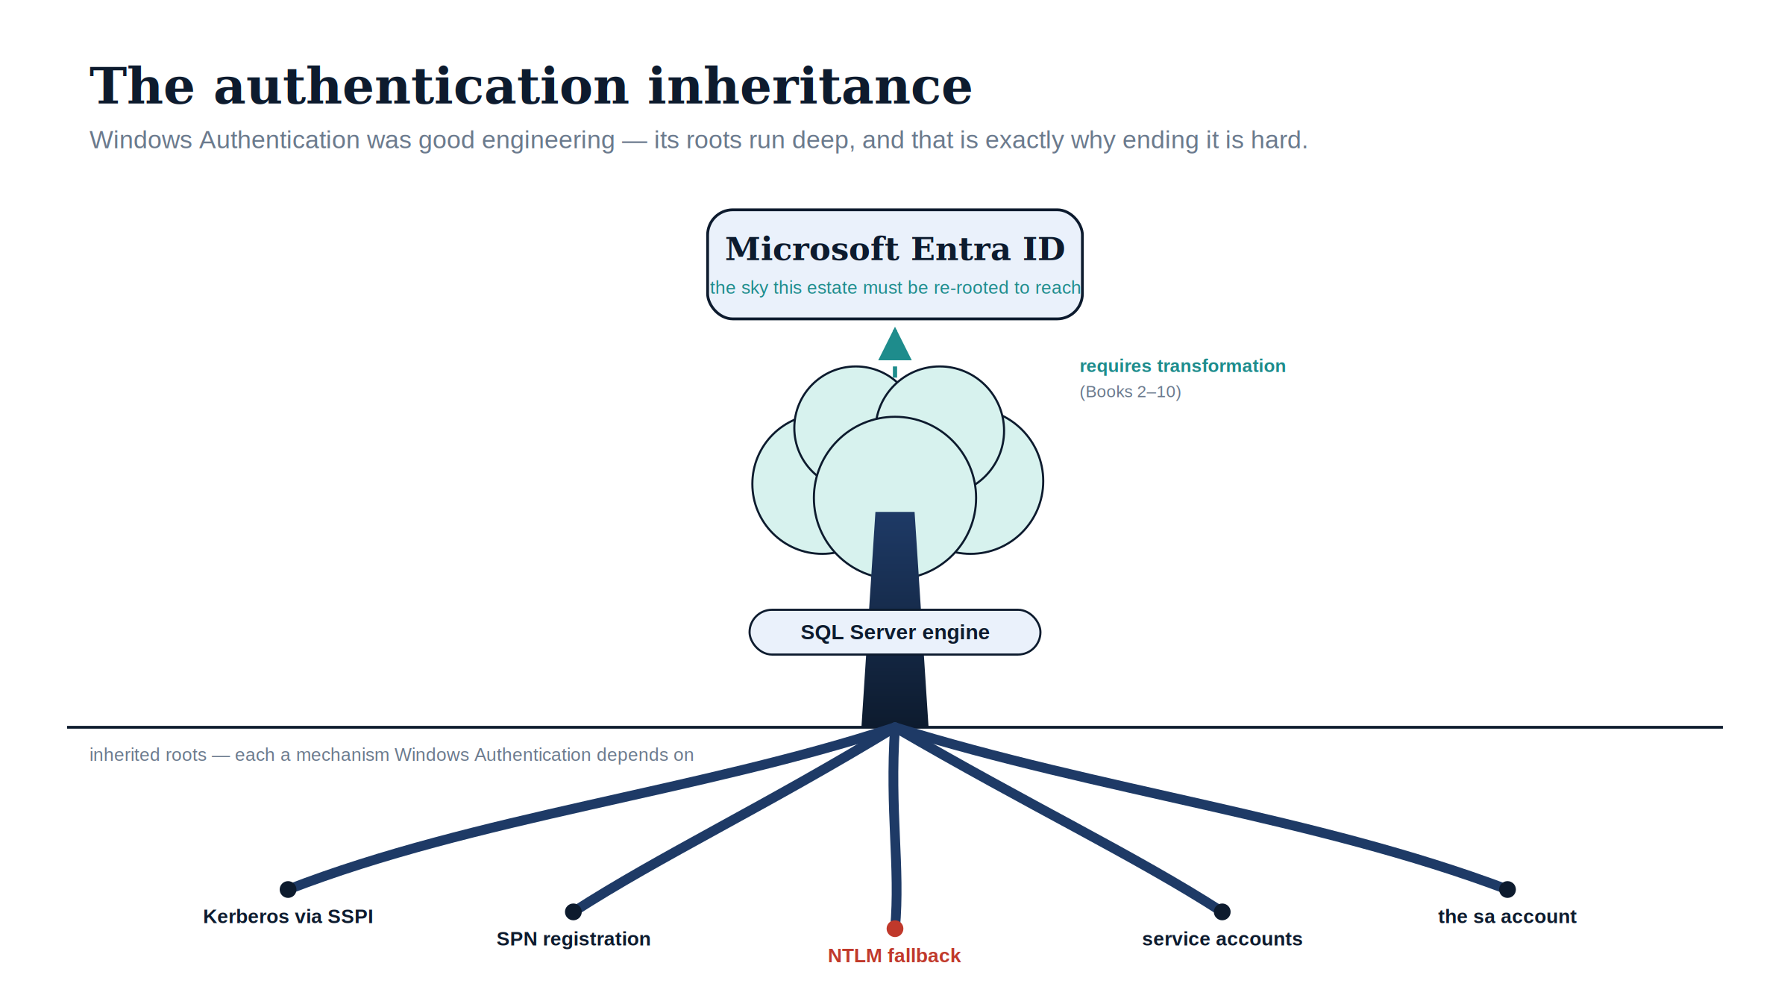
Figure 5: Windows Authentication’s mechanisms are the deep roots of the SQL Server estate — which is exactly why reaching the Entra identity plane requires re-rooting, not a switch.

 Download this book
Book_01-bundle.docx — every chapter of this book concatenated into one Word document. Regenerated on every site deploy.

Chapters
Continue the series
Index · Next: Book 02 — The Estate Itself →

What Windows Authentication Actually Is

Chapter 1 — What Windows Authentication Actually Is
The inheritance, named precisely, before the case for replacing it.
In this chapter
How SQL Server delegates authentication to the Windows security subsystem through Kerberos and SSPI, why a missing SPN silently drops a connection to NTLM, what the service account and the sa account each contribute to the picture, and why this whole architecture was genuinely good engineering for the world it was designed for.

The Kerberos Foundation
SQL Server in Windows Authentication mode delegates authentication entirely to the Windows security subsystem. It does not implement its own password verification, its own cryptographic challenge-response, or its own session token model. When a client opens a connection with Integrated Security=True, the driver passes control to the Security Support Provider Interface — SSPI.
The SSPI layer examines the available authentication protocols and determines whether Kerberos is negotiable for the target server. If it is, SSPI requests a Kerberos service ticket from the Key Distribution Center — the domain controller’s Kerberos service — scoped to the SQL Server’s Service Principal Name. That ticket is presented to the SQL Server engine.
The engine validates the ticket’s cryptographic signature using the session key derived from the service account’s credentials, extracts the Kerberos principal, and maps it to a SQL Server login. No password has traversed the network. No credential has been stored in any application configuration file. The authentication is mutual: the client proves its identity to the server, and the server to the client, both through the shared authority of the domain’s KDC. This is genuinely good security architecture, and it is important to say so plainly before explaining why it must be replaced.
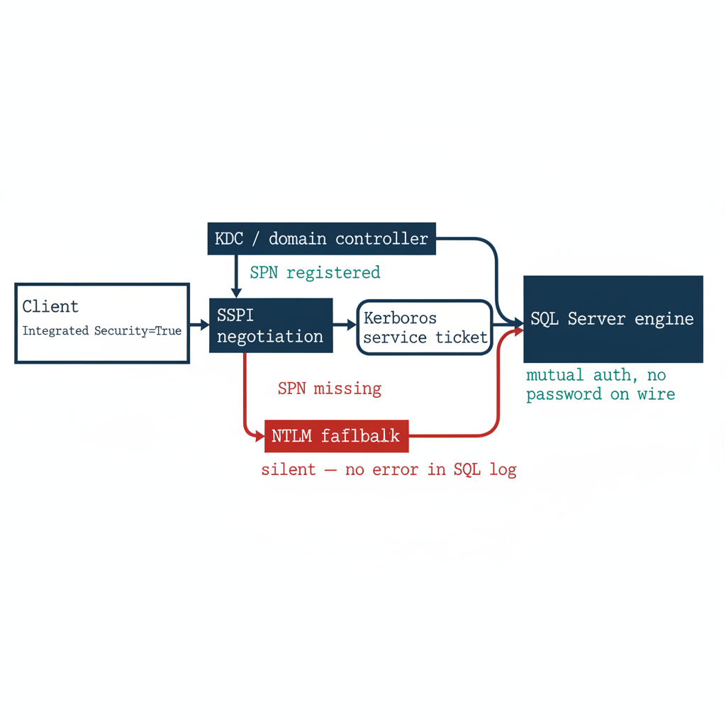
Figure 1: How SQL Server delegates authentication to Kerberos through SSPI, with silent NTLM fallback when the SPN is missing
The SPN must be registered against the service account running the SQL Server engine process. The format for a SQL Server instance is MSSQLSvc/hostname.domain.com:port, and the registration binds the service account’s long-term key — its password hash in the AD domain — to the service name, so the KDC can generate a valid ticket when a client requests one.
Without a correctly registered SPN, the KDC cannot issue a service ticket for the SQL Server endpoint. The SSPI layer on the client, having failed to negotiate Kerberos, silently falls back to the next available protocol. In most Windows environments, that next protocol is NTLM.
This silent fallback is the first and most consequential fault in the inheritance. It is invisible at the application layer, it produces no error in the SQL Server error log under default configuration, and it means that environments which believe with complete confidence that they are running Kerberos for their SQL Server connections are, in a significant fraction of those connections, running NTLM. The fraction can be measured — Spec3-D1.8 (Get-SQLServerAuthAudit.ps1) is the instrument — but it cannot be known without measurement, and most federal environments have not measured it.

The NTLM Fallback
NTLM is not a failure state that was tolerated by accident. In the early history of Windows networking, NTLM was the primary authentication protocol for all Windows workgroup and domain connections. When Kerberos was introduced in Windows 2000 as the preferred domain protocol, NTLM was retained as a compatibility fallback for scenarios where Kerberos was not negotiable — cross-domain connections without trust, connections from non-domain-joined clients, connections to servers the KDC could not locate.
SQL Server inherited this behavior without modification: SSPI negotiates the best available protocol, Kerberos first and NTLM second. For most workloads in most federal environments of the early 2000s and 2010s, this was perfectly adequate. NTLM provided authentication that was sufficient for the threat model of a perimeter-defended network where every client and server was a domain member.
The problem with NTLM is not that it was wrong for its time. The problem is that it does not scale to a modern zero-trust posture, and that posture is now a requirement of this program’s FedRAMP-Moderate boundary, not an aspiration.
NTLM is a challenge-response protocol that embeds the entire authentication exchange within the connection negotiation itself. The server sends a challenge; the client responds with a hash of its credential and the challenge; the server validates the response. There is no token issued at the conclusion of this exchange, and no session assertion that can be presented to a third party for validation.
There is, therefore, no mechanism by which a Conditional Access policy engine — which lives in the Azure identity plane, outside the SQL Server connection path entirely — can observe the NTLM exchange, evaluate it against policy conditions such as device compliance or sign-in risk, and either permit or deny it. NTLM authentication succeeds or fails at the protocol layer, between client and server, and produces no artifact the Azure identity plane can observe, record, or control. (ADR-068)

The Service Account
The SQL Server engine process runs under a service account. That account is the identity the engine presents when it makes network connections — when it accesses file shares, communicates with other instances via linked servers, or forwards log data to a monitoring sink. In federal environments, that account has historically taken one of three forms.
The first is a domain service account: a named Active Directory user with a non-expiring password, typically named something like svc-sqlengine-prod, with a password set at installation and changed infrequently or not at all. The second is a Group Managed Service Account (gMSA): a domain account whose password is managed automatically by Active Directory, rotated every 30 days, and never known to any human. The gMSA pattern is strictly better than the named account from a credential-hygiene perspective, but it is still AD-anchored — when the domain is removed from the architecture, the gMSA loses its governance foundation.
The third form is the NT SERVICE\MSSQLSERVER virtual account, a Windows-local account that uses the computer’s domain account for network authentication. This pattern is also AD-anchored, because it is the domain-joined computer account that provides the Kerberos credential for network connections.
In every one of these patterns, Active Directory is the identity authority for the engine process. The engine’s ability to authenticate to any network resource depends on AD. When the directory modernization program removes AD as the authoritative identity source, the service account pattern loses its foundation, and the engine must acquire a new identity — the system-assigned Managed Identity that Arc provides for the host. That transition is the subject of Book 04.

The sa Account
Alongside Windows Authentication, SQL Server has always supported a second mode: SQL Authentication, which uses credentials stored in SQL Server’s own master database rather than in Active Directory. The sa account — system administrator — is the built-in SQL Authentication login present on every instance at installation.
In a well-governed environment, sa is disabled, renamed, or both; its password is long and random; and it is never used for routine operations. In practice, many federal environments carry active sa accounts as emergency-access mechanisms, often with passwords set at installation and never rotated, on the logic that if AD becomes unavailable, sa provides a path back into the instance.
This is understandable logic, but it produces a serious posture problem. SQL Authentication, unlike Windows Authentication, produces no Entra ID sign-in events. A connection using SQL Authentication is invisible to the Azure identity plane: there is no Conditional Access policy that can intercept it, no Defender for Identity signal, no sign-in risk assessment. SQL Authentication is a completely opaque path from the perspective of the modern identity plane, and the sa account, if active, is the most dangerous entry point on the instance. Its handling is one of the decisions ADR-091 formalizes.

Why This Was Correct
The full picture — Kerberos negotiation via SSPI, SPN registration against the service account, NTLM fallback, domain service accounts and gMSAs, SQL Authentication as a local fallback — is a coherent and defensible architecture.
In a fully domain-joined world with a working KDC, correctly registered SPNs, and a client population consisting entirely of domain members, Windows Authentication was centrally managed through Active Directory, non-repudiable at the Kerberos ticket level, and resistant to credential theft in the network path. It required no infrastructure beyond the domain controller that already existed for every other authentication purpose in the environment.
It was not a security compromise. It was the application of the existing, well-understood Windows security substrate to the SQL Server authentication problem, and for the world that substrate was designed for, it was the right answer. The problem is not the design. The problem is that the world it was designed for — every client domain-joined, every server domain-joined, the perimeter as the security boundary, no cloud identity plane — no longer exists and cannot be made to exist again. (UIAO_135 §1.2)
Division of labor
Microsoft provides: Entra ID as the replacement authentication plane; Arc Managed Identity for the engine process; OAuth 2.0 token validation in SQL Server 2022; NTLM auditing and enforcement controls; Conditional Access policy enforcement.
What only you can provide: the complete estate inventory; the per-instance SPN audit that surfaces silent NTLM fallback; the service-account-to-Managed-Identity mapping; the sequencing plan that coordinates authentication migration with domain consolidation.

What Book 01 establishes — Chapter 1
SQL Server Windows Authentication delegates entirely to the Windows security subsystem: Kerberos via SSPI when an SPN is registered, silent NTLM fallback when it is not. The engine process and the sa account are both anchored to authorities — Active Directory and master respectively — that the modernization program removes or renders invisible to the Azure identity plane. None of this was a mistake. It was correct engineering for a fully domain-joined world that no longer exists.

Why the Inheritance Must End

Chapter 2 — Why the Inheritance Must End
Three drivers, each as well-reasoned as the original design, and their dependency structure.
In this chapter
The three forces that now require replacing Windows Authentication for SQL Server — the NTLM elimination the program has committed to, the zero-trust requirement that puts the Azure identity plane in the authentication path, and the service-account credential problem created by the broader directory modernization — and why their dependency structure dictates the order of the entire series.

That replacement is now necessary, and the reasons are as well-reasoned as the original design choices were. The NTLM elimination the program has committed to, the zero-trust requirement that Conditional Access policies sit in the authentication path for all human access, and the collapse of the domain-joined world as the universal substrate for federal computing are not organizational preferences. They are architectural inevitabilities driven by Microsoft’s progressive NTLM defaults, UIAO_135 §1.2, and the federal zero-trust mandate that governs this program’s boundary — OMB M-22-09 (the Federal Zero Trust Strategy), operationalized in this boundary as phishing-resistant MFA and Conditional Access (AC-17, IA-2).
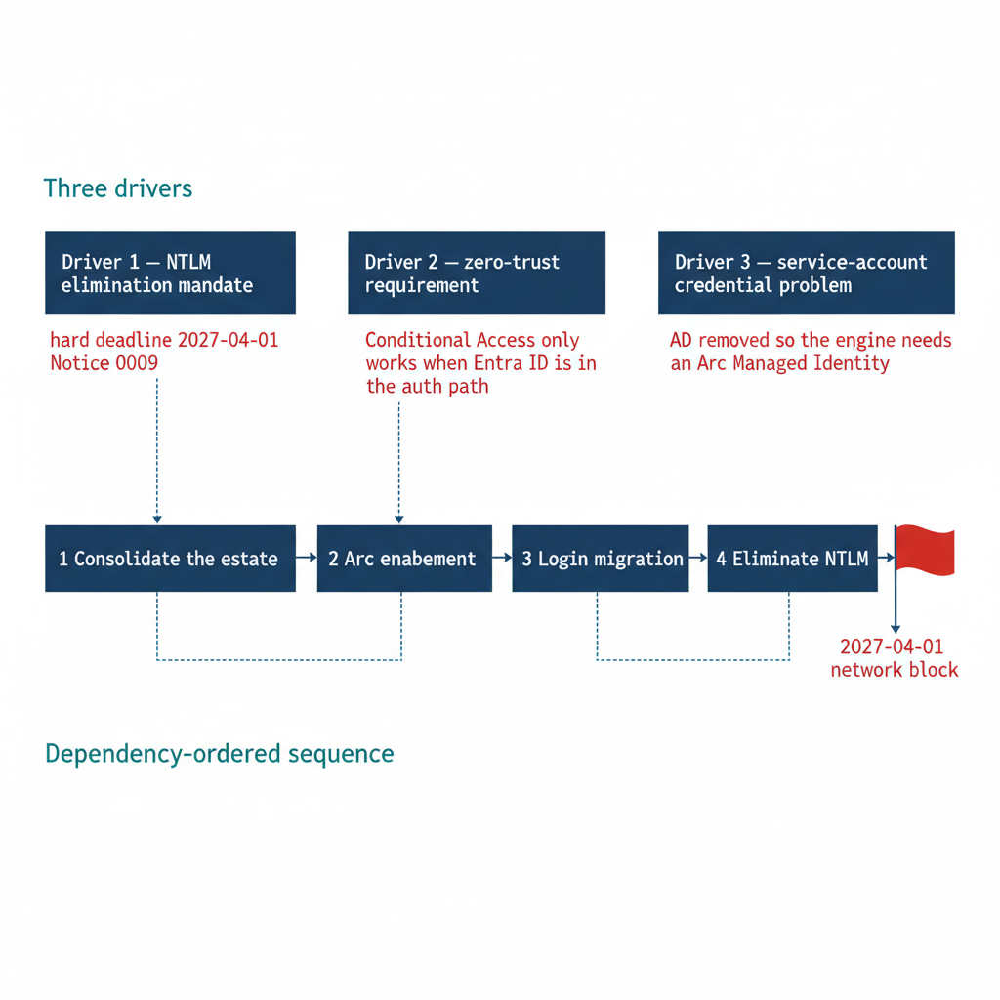
Figure 1: The three drivers requiring the end of Windows Authentication, and the dependency-ordered sequence they impose

Driver One — The NTLM Elimination Commitment
The first driver is a decision this program has made and recorded: ADR-068 (Kerberos / NTLM Elimination), accepted 2026-05-13, commits the program to eliminating NTLM. The external driver is real but gradual: Microsoft formally deprecated NTLM in June 2024 and is disabling it by default — not removing it — across successive Windows releases, from enhanced auditing in Windows Server 2025 / Windows 11 24H2, to the BlockNTLMv1SSO enforcement default arriving via Windows Update in October 2026, to network NTLM off by default in the next major Windows Server release (~2027/2028). Microsoft has not published a fixed calendar date for that final step. The program treats these milestones as risk indicators and eliminates NTLM as operational readiness allows, staying ahead of vendor defaults rather than chasing a fixed date. ADR-068 distinguishes NTLMv1 from NTLMv2 because they present different risk profiles and require different timelines, but both are eliminated.
NTLMv1 is the first to go. Under ADR-068’s phased plan it is disabled in Phase B — the “block-where-safe” phase — by default immediately upon completion of the Phase A assessment, with the implementation plan targeting 2026-Q3, well ahead of the NTLMv2 deadline. The block is implemented through the “Network Security: LAN Manager Authentication Level” Group Policy, set to “Send NTLMv2 response only; refuse LM and NTLM.” Once that policy is in force, any connection attempt that still requires LM or NTLMv1 is refused inside the Windows security subsystem — the Local Security Authority (LSA) negotiates only NTLMv2 and rejects the weaker protocols. A SQL Server connection that generates NTLMv1 traffic — which would require a very old client or a misconfigured application — fails at that point, before the engine ever evaluates the login. (ADR-068)
NTLMv2 carries a longer runway, but ADR-068 Phase C disables NTLM at the LSA layer across the estate as operational readiness allows — the program’s own elimination step, timed to complete ahead of Microsoft’s progressive NTLM defaults. Any SQL Server connection that relies on NTLMv2 — because an SPN is missing, because the client cannot negotiate Kerberos, because the connection crosses a trust boundary, or because the host has already been migrated to a non-domain-joined state — will face increasing friction as Microsoft tightens defaults, and will fail once Phase C is applied.
The migration itself must occur before Phase C is applied. The timeline needed to execute the consolidation, the Arc deployment, the login migration, and the application connection-string migration must maintain forward momentum to keep pace with the vendor default-disable trajectory. (ADR-068)

Driver Two — The Zero-Trust Requirement
The second driver is architectural: the zero-trust posture mandated for this program’s FedRAMP-Moderate boundary by OMB M-22-09 (the Federal Zero Trust Strategy), and operationalized through AC-17 and IA-2, cannot be implemented without the Azure identity plane in the authentication path for SQL Server connections.
Conditional Access policies enforce device compliance, network-location restrictions, MFA completion, and sign-in risk thresholds by intercepting the token issuance request that occurs when a principal authenticates to Entra ID. If the authentication protocol is Kerberos or NTLM, there is no token issuance request. The authentication completes entirely within the Windows security subsystem, and the Azure identity plane is not in the path at any point.
A database administrator connecting to a production SQL Server from an unmanaged personal device, from a network outside the program’s named locations, or with an elevated sign-in risk signal cannot be blocked by a Conditional Access policy if the authentication protocol is Kerberos or NTLM. The policy has no visibility and no leverage point.
Entra ID authentication for SQL Server changes this entirely. When a principal authenticates using an Entra ID-issued OAuth 2.0 access token, the token issuance request passes through the Entra ID authentication service, which evaluates all applicable Conditional Access policies before the token is issued.
If a policy requires MFA and the principal has not completed it, the token is denied and the connection never opens. If a policy requires a compliant device and the client is not registered or is out of compliance, the token is denied. If the sign-in risk level is elevated — an anonymous IP, or an account flagged by Entra ID Protection — the token is denied or a remediation challenge is triggered. In every case, the Conditional Access policy has real enforcement leverage, because the token it controls is the credential SQL Server accepts. This is the zero-trust identity anchoring the program requires — the phishing-resistant, Conditional-Access-conditioned access that OMB M-22-09 mandates and that AC-17 / IA-2 operationalize for this boundary. (OMB M-22-09; AC-17, IA-2; ADR-008, ADR-068)
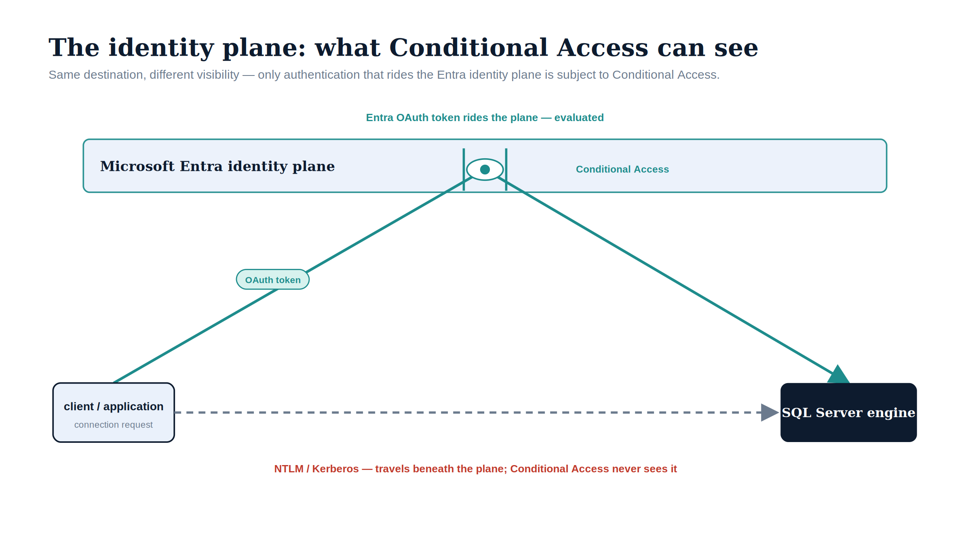
Figure 2: Only authentication that rides the Entra identity plane is visible to Conditional Access; NTLM and Kerberos pass beneath it, unseen.

Driver Three — The Service Account Credential Problem
The third driver is a consequence of the broader directory modernization this series is embedded within. The OrgPath substrate and UIAO_135 collectively describe a transformation in which Active Directory is removed as the authoritative identity source for this program’s environment.
When that transformation completes, the AD service accounts and gMSAs that currently authorize the SQL Server engine process for network access lose their governance foundation. They are objects in a directory that no longer exists as an authoritative identity source. The engine must acquire a new identity before that removal occurs.
The only credential-free, cloud-native identity available for an on-premises server in this architecture is the system-assigned Managed Identity that the Azure Arc Connected Machine agent provides. Arc deployment is therefore not an optional enhancement for SQL Server hosts; it is a prerequisite for the service-account migration the engine requires before the directory modernization can complete.
The sequencing implication follows directly from the dependency structure of these three drivers — and, before any of them, from the consolidation decision of Book 02. You assess and consolidate the estate first, so effort is spent only on instances that survive; then Arc enablement; then the login migration; then NTLM elimination. That order is the architecture of this series. (ADR-002, UIAO_135 Transformation #7)
Division of labor
Microsoft provides: NTLM deprecation and enforcement controls; Conditional Access for token-based authentication enforcement; the Arc Managed Identity that replaces AD-anchored service accounts; the platform-level NTLM elimination timeline.
What only you can provide: the program sequencing that stays ahead of Microsoft’s progressive NTLM defaults; the per-instance NTLM exposure measurement; the program that coordinates three interdependent drivers — NTLM elimination, zero trust, service-account re-rooting — across your specific estate.

What Book 01 establishes — Chapter 2
Three independent drivers require ending the Windows Authentication inheritance: the program’s NTLM elimination commitment (ADR-068), a zero-trust posture mandated by OMB M-22-09 and operationalized through AC-17 / IA-2 that only works when the Azure identity plane is in the authentication path (OMB M-22-09; ADR-008), and a service-account credential problem created by AD’s removal that only an Arc Managed Identity can solve (ADR-002). Their dependency structure — consolidate, then Arc, then migrate logins, then eliminate NTLM — sets the order of the books that follow.

Book_02 — The Estate Itself
  - What Microsoft Discovers About Your Estate — and What Only a Full Inventory Reveals

Book_02 — The Estate Itself
Note
You do not migrate the estate in the shape you discover it. After twenty years across an Active Directory forest, the SQL Server estate is larger and more tangled than any team’s mental model of it — and a significant fraction of it should not survive the transformation at all. This book establishes the consolidation assessment that classifies every instance retain, consolidate, or retire before any login is touched. (ADR-091 §1)

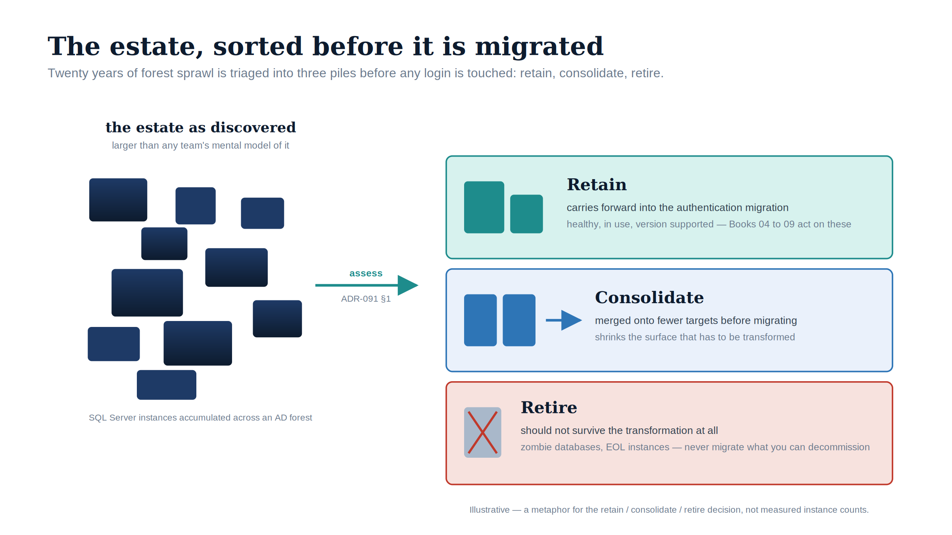
Figure 1: You do not migrate the estate in the shape you discover it: assessment triages twenty years of forest sprawl into retain, consolidate, and retire before any login is touched.

Download this book
Book_02-bundle.docx — every chapter of this book concatenated into one Word document. Regenerated on every site deploy.

Chapters
Continue the series
← Previous: Book 01 — The Authentication Inheritance Problem · Index · Next: Book 03 — Discovery →

The Shape of Twenty Years

Chapter 1 — The Shape of Twenty Years
Why the estate you must transform is not the estate anyone remembers building.
In this chapter
The three forms of sprawl that accumulate in a SQL Server estate over two decades across an Active Directory forest — instance sprawl, database sprawl, and forest entanglement — and why an authentication transformation that begins before this sprawl is assessed will migrate the authentication of servers that should not survive the transformation at all.

The previous book named the inheritance and the three drivers that require ending it. This book confronts a precondition that most authentication narratives skip entirely: you cannot migrate the authentication of an estate you have not first measured and rationalized. After twenty years across an Active Directory forest, the SQL Server estate is larger, older, and more entangled than any single team’s mental model of it — and a meaningful fraction of it should not survive the transformation in its current shape.
The order matters because effort is finite and each release narrows the window. Migrating the logins of an instance to Entra ID, only to retire that instance three months later, is wasted work that also delays the instances that most need attention. ADR-091 §1 makes the sequencing normative: the consolidation assessment classifies every instance retain, consolidate, or retire before any login is touched.

Instance Sprawl
A SQL Server estate does not grow by design. It grows by accretion. A development instance becomes a production instance because a project shipped and nobody rebuilt it on the production tier. A test instance set up for a vendor evaluation is never decommissioned. An application installer silently provisions a SQL Server Express instance on an application server, and that instance accumulates real data for years without ever appearing on a DBA team’s inventory.
The result, in a mature federal environment, is a population of instances spanning every SQL Server version released across two decades — 2008, 2012, 2014, 2016, 2017, 2019, and 2022 — in every edition, from Express on a workstation to Enterprise on a clustered host. Several of those versions are out of support and receive no security updates. The licensing posture is equally heterogeneous: a mix of Standard and Enterprise cores, some covered by Software Assurance and some not, with no single authority that can state how many cores the estate actually consumes.
Instance sprawl is the first thing the assessment must quantify, because the count of instances — and especially the count of unknown instances — determines the true scope of the transformation. An estate that the DBA team believes contains forty instances and the discovery sweep reveals to contain a hundred and ten is not forty instances behind schedule; it is operating on a scope estimate that is wrong by a factor of nearly three.
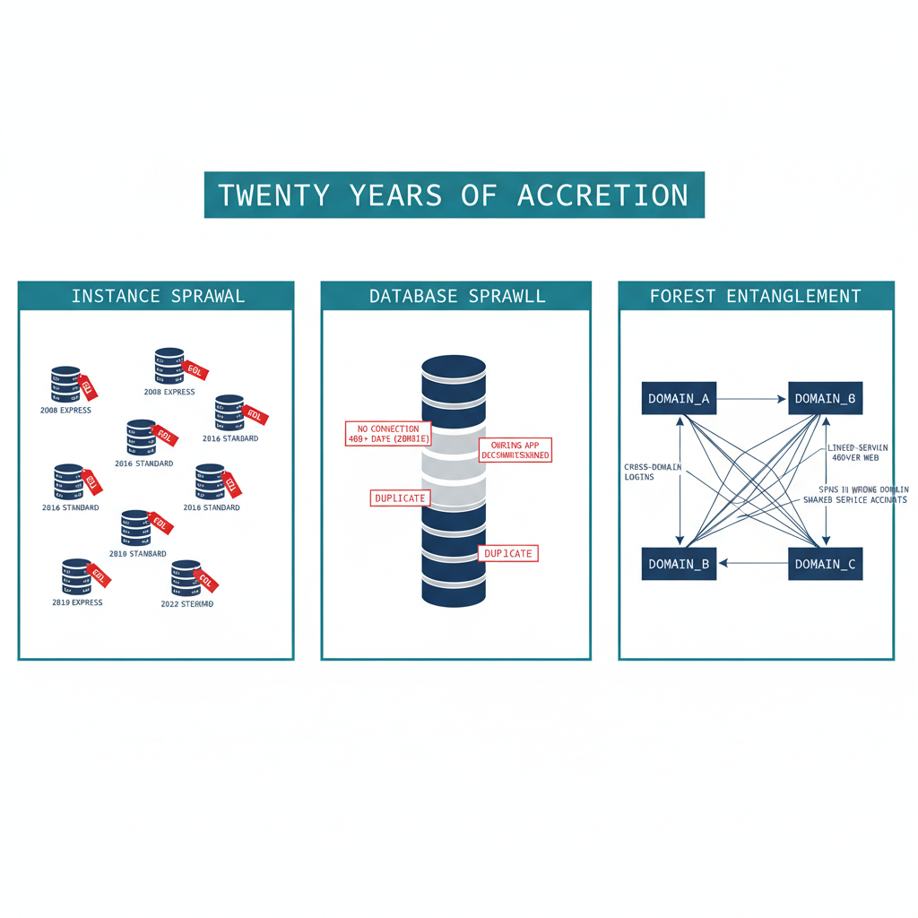
Figure 1: The three forms of sprawl that accumulate in a SQL Server estate over twenty years across an AD forest

Database Sprawl
Beneath the instances lies a second layer of accretion: the databases themselves. An instance that has run for fifteen years carries databases nobody can confidently account for. Some are orphaned — the application that created them has been decommissioned, but the database was never dropped because no one was certain it was safe to do so. Some are zombies — they have received no connection in over a year, yet they consume storage, appear in backup jobs, and lengthen every maintenance window. Some are near-duplicates, the residue of a migration that copied a database to a new name and never removed the original.
Database sprawl matters to the authentication transformation for a specific reason. Every database is a potential source of logins, and every login is a unit of migration work. A zombie database may map a long-forgotten SQL Authentication service account that still has a valid password and still appears, to a discovery script, as an active credential requiring migration. The fastest way to reduce the migration surface is not to migrate faster — it is to retire the databases and instances that should not be migrated at all.
Zombie detection is therefore not a housekeeping nicety; it is migration-scope reduction. A database with no connections in four hundred days, no recent backups consumed for a restore, and an owning application that the application portfolio lists as retired is a database whose logins should never enter the migration pipeline.

Forest Entanglement
The third form of sprawl is the one that makes the SQL Server transformation genuinely harder than a single-domain migration: the estate is entangled with the Active Directory forest it grew up in. Instances are spread across multiple domains connected by trusts. Logins on one instance resolve to security principals in a different domain. Linked-server definitions form a web of cross-instance dependencies that crosses domain boundaries, and the service accounts running the engine processes are drawn from several domains with no consistent naming or governance.
This entanglement is precisely what the directory modernization removes the foundation for. When Active Directory ceases to be the authoritative identity source, every cross-domain login, every SPN registered in a domain that is being collapsed, and every shared service account becomes a dependency that must be resolved — not merely re-pointed. Consolidation is the moment when that resolution is cheapest, because collapsing many instances into fewer modern targets is also the moment to collapse the cross-domain identity sprawl into Entra-backed identity.
The shape of twenty years, then, is three overlapping problems: too many instances, too many databases, and too many forest-spanning dependencies between them. The chapters that follow describe how to measure each, and how to turn the measurement into the retain / consolidate / retire decision that gates everything in Books 03 through 10.
Division of labor
Microsoft provides: Arc-based SQL Server discovery for enrolled hosts; Azure Resource Graph inventory; Defender for SQL assessments; Azure Migrate and MAP for migration assessment.
What only you can provide: discovery of instances Arc cannot reach — unenrolled, firewalled, cross-domain, vendor-installed, Express-edition instances on application servers; the utilization and ownership determination for every discovered instance; the retire/consolidate/retain decision that gates authentication migration.

What Book 02 establishes — Chapter 1
A twenty-year SQL Server estate exhibits three overlapping forms of sprawl: instance sprawl (many unknown instances across many versions and editions, several out of support), database sprawl (orphaned and zombie databases that inflate the migration surface), and forest entanglement (cross-domain logins, linked-server webs, and shared service accounts). The authentication transformation must not begin until this sprawl is assessed, because a significant fraction of the estate should be retired or consolidated rather than migrated. (ADR-091 §1)

The Estate Inventory

Chapter 2 — The Estate Inventory
Finding the instances and databases that no inventory already records.
In this chapter
What a complete estate inventory must capture before consolidation can begin, the discovery instruments that find the instances no one remembers — network and Active Directory sweeps, the SPN registration trail, and Microsoft’s migration-assessment tooling — and why estate discovery is a broader exercise than the authentication audit that Book 03 describes.

A consolidation assessment begins with an inventory, and the defining characteristic of a twenty-year estate is that the inventory does not already exist in complete form. The instances a DBA team manages deliberately are known. The instances that matter most to the assessment are the ones nobody is managing — and those must be discovered, not retrieved from a list.
This is the point at which estate discovery diverges from the authentication audit of Book 03. The Spec3-D1.8 audit measures the authentication posture of instances that are already known: their login types, their authentication mode, their SPN status, their Arc eligibility. Estate discovery runs earlier and casts wider. Its job is to establish the denominator — the complete set of instances and databases that exist — so that the authentication audit has something complete to measure.
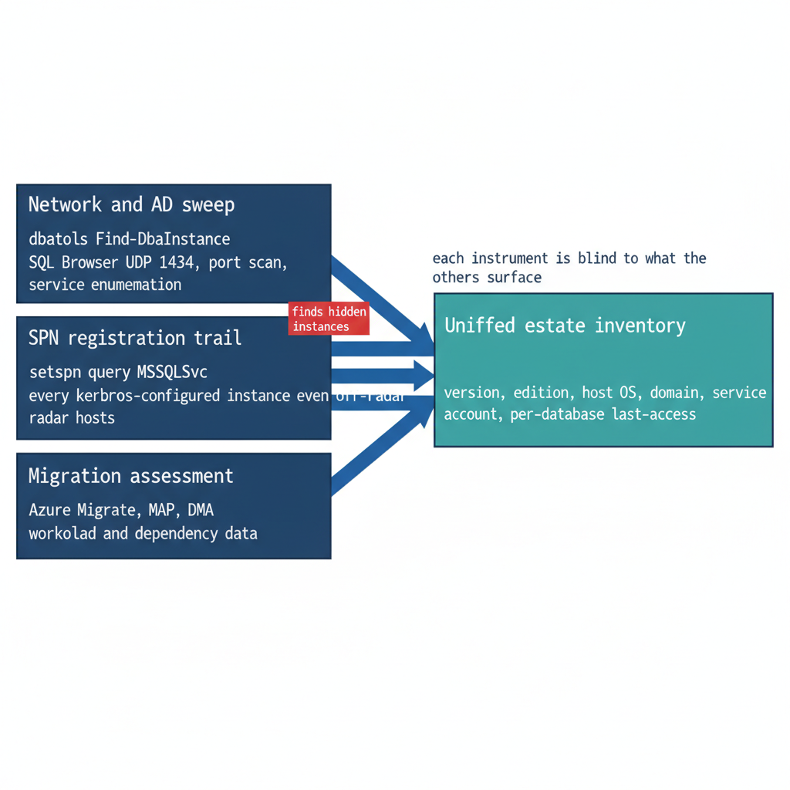
Figure 1: Three independent discovery instruments, each surfacing instances the others miss, converging on one estate inventory

What the Inventory Must Capture
An estate inventory sufficient to drive a consolidation decision captures, for every instance it can find, a consistent set of facts. The version, edition, and build number establish the support and licensing posture. The host operating system version establishes the Arc and upgrade envelope. The domain-join state and the owning domain establish the forest-entanglement picture. The service-account identity and its source domain establish the credential dependencies. And, for every database on the instance, the size, the last-access timestamp, the recovery model, and the owning application establish the utilization and zombie picture that Chapter 3 turns into a rationalization decision.
The inventory is not a point-in-time spreadsheet. Like the authentication audit it precedes, it is designed to be re-run, because instances appear and disappear across a multi-month assessment, and the consolidation plan must track a moving estate rather than a single snapshot.

Discovery Instruments
No single instrument finds every instance, because instances hide in different ways. A complete sweep combines several, each blind to what the others surface.
A network and directory sweep finds instances by listening for them. The SQL Server Browser service responds on UDP 1434, instances listen on TCP 1433 and dynamic ports, and Active Directory itself records instances indirectly. The open-source PowerShell module dbatools provides Find-DbaInstance, which combines these signals — service-principal-name lookups, SQL Browser responses, port scans, and Windows service enumeration — into a single discovery pass across a network range or an Active Directory domain. It is the most direct way to surface instances that no inventory records.
The SPN registration trail is a second, independent signal. Because every instance that successfully negotiates Kerberos must register an MSSQLSvc service principal name, a forest-wide query for those SPNs (setspn -Q MSSQLSvc/*, or the equivalent directory query) enumerates every instance that was ever configured for Kerberos — including instances on hosts that are otherwise off the radar. The SPN trail also feeds directly into the authentication audit, because a registered SPN that points at a decommissioned host, or an instance generating Kerberos traffic with no corresponding SPN, are both findings the later books act on.
Microsoft’s migration-assessment tooling is the third instrument, and it captures what the first two cannot: workload and dependency data. Azure Migrate, with its dependency-analysis capability, and the Microsoft Assessment and Planning (MAP) Toolkit, enumerate instances and their resource consumption at fleet scale. The Data Migration Assistant (DMA) assesses individual databases for compatibility and feature blockers against a target version. These instruments are pedagogically useful here for what they reveal about the estate, independent of any decision to use Azure as a migration target — the dependency map and the version-compatibility findings are inputs to the consolidation decision regardless of where the consolidated estate ultimately lands.

Why a Canonical Estate-Discovery Spec Does Not Yet Exist
The discovery instruments named above are real and well-understood, but they are not yet bound into a canonical UIAO discovery specification the way Spec3-D1.8, Spec3-D1.9, and Spec3-D1.10 bind the authentication, application, and certificate audits. ADR-091 §1 names this as an explicit gap: the estate-consolidation inventory that produces the retain / consolidate / retire classification has no Spec3-D1.x instrument of its own. Authoring that instrument — a discovery script whose output feeds the same CCM-BIR ingestion pipeline as the authentication audit — is identified in the ADR-091 implementation plan as Phase 0, the prerequisite to everything the later books describe.
Until that specification exists, the consolidation assessment is conducted with the general-purpose instruments above and recorded as a deliberate program artifact rather than a canonical telemetry record. Naming the gap is itself part of the assessment’s value: an estate transformation that proceeds on an incomplete inventory will discover its missing instances at the worst possible moment, which is exactly the failure mode the discipline of this book exists to prevent.
Division of labor
Microsoft provides: Find-DbaInstance / Azure Migrate MAP / DMA as discovery instruments; the MSSQLSvc SPN trail in AD as an estate-presence indicator; Azure Migrate assessment tooling.
What only you can provide: the multi-instrument discovery coordination — no single tool covers every instance; the Spec3-D1.x estate-discovery instrument that ADR-091 §1 identifies as not yet authored; the inventory that gates the authentication audit in Book 03.

What Book 02 establishes — Chapter 2
A consolidation assessment begins with a complete inventory the estate does not already possess. Discovery combines a network and directory sweep (dbatools Find-DbaInstance), the forest-wide MSSQLSvc SPN trail, and Microsoft’s migration-assessment tooling (Azure Migrate, MAP, DMA) — each blind to what the others surface. This is broader than the Book 03 authentication audit and must precede it. No canonical Spec3-D1.x estate-discovery instrument exists yet; ADR-091 §1 names authoring it as Phase 0.

Rationalization — Utilization, Versions, and Dependencies

Chapter 3 — Rationalization: Utilization, Versions, and Dependencies
Turning a complete inventory into a defensible judgment about what each instance is worth.
In this chapter
The three analytical lenses that convert a raw inventory into a rationalization judgment — utilization and zombie detection, version and end-of-life posture, and dependency mapping — and why the dependency map in particular determines which instances can be consolidated and which are load-bearing in ways that are invisible until they are mapped.

An inventory establishes what exists. Rationalization establishes what each item is worth keeping. The assessment applies three lenses to every instance and every database the inventory surfaced, and the combined picture drives the retain / consolidate / retire decision that Chapter 4 formalizes.
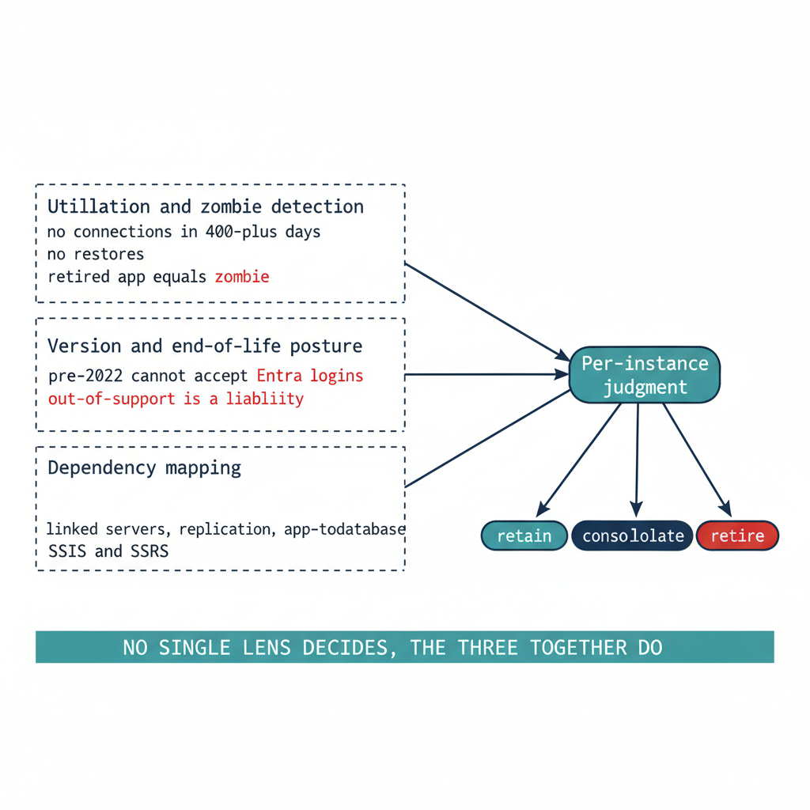
Figure 1: Three rationalization lenses converging on a defensible per-instance judgment

Utilization and Zombie Detection
The first lens is utilization. An instance consumes CPU, memory, storage, and a licensing entitlement whether or not anyone is using it, and a twenty-year estate contains instances that consume all four while serving no current workload.
Utilization analysis rightsizes the survivors and identifies the candidates for retirement. For each instance, the assessment captures sustained and peak resource consumption, connection counts, and the workload profile — read-heavy reporting, transactional, batch, or idle. For each database, it captures the last-access timestamp, the recent query workload, and the backup-restore history.
A database with no connections in over a year, no restores consumed, and a retired owning application is a zombie, and zombies are the cleanest retirement candidates in the estate. Retiring them is the single most effective way to reduce the authentication migration surface, because every login they carry — including long-forgotten SQL Authentication service accounts with still-valid passwords — is removed from the migration pipeline before it ever enters it.
Utilization data also rightsizes the consolidation targets. An instance running at four percent of a sixteen-core Enterprise license is not a retain candidate at its current size; it is a consolidation source whose workload belongs on a shared modern target, freeing the license and the host.

Version and End-of-Life Posture
The second lens is version posture, and it interacts directly with the authentication transformation. The FROM EXTERNAL PROVIDER login syntax that the entire transformation depends upon requires SQL Server 2022. An instance on any earlier version — 2019, 2017, 2016, or the out-of-support 2012 and 2008 — cannot accept Entra ID logins regardless of any other change, a constraint Book 03 formalizes as the Category 3 classification.
This makes version posture a primary input to the consolidation decision rather than a secondary one. An out-of-support instance on SQL Server 2012 is simultaneously a security-update liability, a licensing question, and an instance that cannot be migrated to Entra ID authentication without an engine upgrade. For most such instances, the right answer is not “upgrade in place to 2022 and then migrate” — it is “consolidate the surviving workload onto a modern target and retire the old engine.” The version lens and the utilization lens converge on the same conclusion for the bulk of the aged estate: collapse it onto fewer modern instances rather than carrying each old engine forward.
The licensing posture rides alongside the version posture. Consolidation that reduces the instance count also reduces the core-license consumption, and an estate that can state its true core count before consolidation can quantify the licensing dividend that consolidation produces.

Dependency Mapping
The third lens is the one that most often overturns a naive consolidation plan: dependency mapping. An instance that appears idle by connection count may be the silent target of a linked-server chain, a replication topology, an SSIS package, or a cross-database query that runs once a quarter and matters enormously when it runs.
Dependency mapping traces these relationships before any instance is moved. Linked-server definitions (sys.servers, sys.linked_logins) reveal the cross-instance — and frequently cross-domain — web that forest entanglement produced. Application-to-database mapping, drawn from connection telemetry and the application portfolio, reveals which databases are load-bearing for which systems. The SQL Server Agent job inventory, the replication configuration, and the SSIS/SSRS/SSAS footprint reveal the integration surface that a consolidation must preserve. Azure Migrate’s dependency analysis and the Data Migration Assistant’s compatibility findings supplement the in-engine views with workload-level dependency and feature-blocker data.
The dependency map is also the bridge to Book 08. The upstream applications that consume SQL Server — many of them LDAP-bound — are precisely the systems whose dependencies the map records, and the application-chain migration of Book 08 acts on the same relationships the rationalization lens surfaces here. An instance cannot be classified retire if a load-bearing application still depends on it, and the dependency map is what makes that judgment defensible rather than hopeful.

The Combined Picture
No single lens produces the rationalization decision. An instance that is lightly utilized but load-bearing for a quarterly process is not a retirement candidate. An out-of-support instance with heavy utilization is an urgent consolidation target, not a leave-alone. A zombie database on an otherwise healthy instance is a local retirement that shrinks the migration surface without touching the host. The three lenses together produce, for each instance and each database, a defensible judgment — and that judgment is the input to the decision Chapter 4 records.
Division of labor
Microsoft provides: utilization telemetry via Defender for SQL and Azure Monitor; end-of-life version documentation; DMA for upgrade-path assessment; Application Discovery and Assessment for dependency mapping.
What only you can provide: the zombie database determination — utilization data alone does not establish whether a database is still needed; the linked-server dependency map; the per-instance rationalization judgment that combines all three lenses into a defensible classification.

What Book 02 establishes — Chapter 3
Rationalization applies three lenses to the inventory: utilization and zombie detection (which retires idle instances and zombie databases, shrinking the migration surface), version and end-of-life posture (which interacts directly with the SQL Server 2022 requirement for Entra ID logins and usually argues for consolidation over in-place upgrade), and dependency mapping (which reveals the linked-server, replication, and application relationships that determine what can actually be consolidated). The three together produce the per-instance judgment that drives the retain / consolidate / retire decision.

The Retain, Consolidate, Retire Decision

Chapter 4 — The Retain, Consolidate, Retire Decision
The gate that determines which instances enter the authentication migration at all.
In this chapter
How the three rationalization lenses resolve into a single per-instance classification — retain, consolidate-into-target, or retire — the target-state options that absorb consolidated workloads, the constraints that prevent consolidation, and why this decision is the moment to collapse the forest-spanning identity sprawl into Entra-backed identity. (ADR-091 §1)

The assessment now resolves to a decision. Every instance the inventory surfaced and the rationalization lenses evaluated is assigned one of three classifications, and that classification governs whether the instance enters the authentication migration that Books 03 through 10 describe. ADR-091 §1 makes the classification a normative prerequisite: engine-layer authentication migration is performed only on instances classified retain or on the consolidation targets that absorb consolidated workloads. Instances classified retire or consolidate-into-target (source) are not migrated — they are decommissioned or collapsed.

The Three Classifications
A retain instance survives the transformation roughly in place. It carries current, load-bearing workload; it is on a supported version or has a clear in-place upgrade path to SQL Server 2022; and its dependencies do not argue for collapsing it into something larger. A retain instance proceeds directly into the Book 03 authentication audit and the Arc-eligibility classification.
A consolidate-into-target instance does not survive as an instance, but its workload does. The databases it carries are migrated onto a modern consolidation target, and the source instance is then retired. This is the classification for the large middle of an aged estate: lightly utilized instances, out-of-support engines whose workload is still needed, and instances whose only real function is to host one or two databases that belong on a shared platform. The migration work for these instances happens at the database-and-workload level; the authentication migration is performed on the target, not the source.
A retire instance does not survive at all, and neither does its workload. Zombie instances, instances whose every database is a zombie, and instances whose owning applications are decommissioned are retired outright. No login on a retire instance ever enters the migration pipeline — which is the entire point of running this assessment before the migration rather than after it.
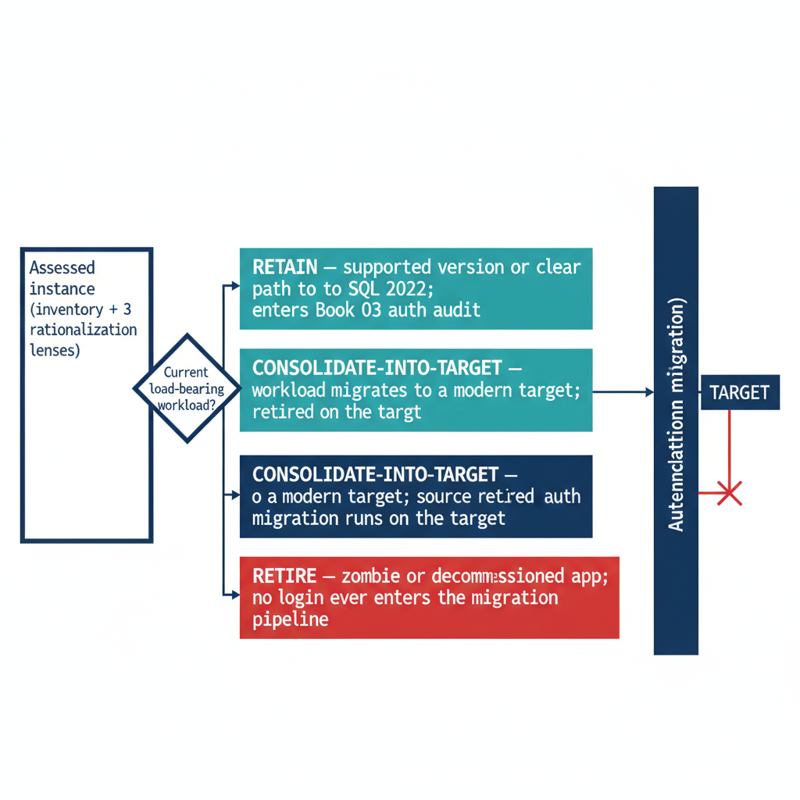
Figure 1: The retain / consolidate / retire decision and how it gates entry into the authentication migration

Target-State Options
A consolidation target is the platform that absorbs consolidated workloads, and the assessment chooses among a small set of options based on the workload profile and the program’s boundary posture. Collapsing many instances onto fewer modern SQL Server 2022 instances — through instance stacking or database consolidation onto a shared engine — is the most direct path and keeps the workload on infrastructure the program already operates. Azure SQL Managed Instance offers a near-full-compatibility platform-as-a-service target for workloads that can move to a managed surface, eliminating the host and much of the patching burden. Azure SQL Database and elastic pools suit workloads that have been modernized to the database-scoped feature set.
The target choice interacts with the rest of the series. A consolidation onto SQL Server 2022 on an Arc-enabled host is exactly the Category 1 starting position that Book 03 describes and Book 05 migrates. A consolidation onto Azure SQL Managed Instance changes the authentication story in detail — the Managed Instance is natively Entra-integrated — but not in principle, because the destination is still Entra ID-only authentication. The point of naming the target during the assessment is that the authentication migration is then performed once, on the target, in its final shape, rather than twice.

What Cannot Be Consolidated
Not every instance that looks like a consolidation candidate can actually be consolidated, and the assessment must record the constraints honestly. Collation conflicts between databases that must coexist on a shared instance can block stacking. Version-locked vendor applications that certify only against a specific SQL Server version cannot be moved to a newer engine without losing vendor support. Compliance-isolation requirements — a database whose data classification mandates physical or logical separation — can prevent co-residency regardless of technical compatibility. And cross-database or cross-instance dependencies that the dependency map surfaced can make two instances a single indivisible unit that must move together or not at all.
Each of these constraints converts an apparent consolidate candidate into either a constrained-consolidation case (move it, but onto a dedicated rather than shared target) or a retain case (leave it in place and migrate its authentication where it sits). Recording the constraint is what makes the consolidation plan executable rather than aspirational.

The Identity Dividend
Consolidation and the authentication transformation are mutually reinforcing, and the assessment is the moment to realize the connection. Collapsing many instances across multiple domains into fewer modern targets is also the moment to collapse the forest-spanning identity sprawl that Chapter 1 described. The cross-domain logins, the orphaned SPNs registered in domains being decommissioned, and the shared service accounts drawn from several domains do not need to be re-pointed instance by instance if the instances carrying them are being retired or consolidated. They are resolved once, at the target, into Entra-backed identity.
This is why the consolidation decision gates the authentication migration rather than running alongside it. The retain instances and the consolidation targets are the surface on which Books 03 through 10 operate; everything classified retire or consolidate-source falls away before that work begins, and the forest entanglement falls away with it. ADR-091 §1 records this ordering as canon: assess and consolidate first, so the authentication transformation is spent only on the estate that survives.
Division of labor
Microsoft provides: Azure SQL Managed Instance and Azure SQL Database as cloud consolidation targets; SQL Server 2022 with Arc as the on-premises retain target; Azure Database Migration Service for the migration itself.
What only you can provide: the retain/consolidate/retire classification for every instance; the target selection per consolidation group; the sequencing that collapses forest-spanning identity sprawl into Entra-backed identity before authentication migration begins.

What Book 02 establishes — Chapter 4
Every assessed instance is classified retain, consolidate-into-target, or retire, and only retain instances and consolidation targets enter the authentication migration. Targets are chosen from SQL Server 2022 on Arc-enabled hosts, Azure SQL Managed Instance, or Azure SQL Database, with the choice made during the assessment so authentication is migrated once, in final shape. Collation conflicts, version-locked vendor apps, compliance isolation, and indivisible dependency clusters constrain what can consolidate. Consolidation is the moment to collapse forest-spanning identity sprawl into Entra-backed identity — which is why ADR-091 §1 makes this decision the gate for everything that follows.

Book_03 — Discovery: The Authentication Audit
  - What Microsoft’s Tools Measure — and the Cross-Estate Classification Only You Can Produce

Book_03 — Discovery: The Authentication Audit
Note
Where Book 02 measured the estate to decide what survives, this book measures the authentication posture of what remains. Spec3-D1.8 is the instrument, the Arc-eligibility classification is its most consequential output, and the CCM-BIR record — not a spreadsheet — is its deliverable. (Spec3-D1.8, ADR-068 Phase A)

Download this book
Book_03-bundle.docx — every chapter of this book concatenated into one Word document. Regenerated on every site deploy.

Chapters
Continue the series
← Previous: Book 02 — The Estate Itself · Index · Next: Book 04 — Arc as the Identity Bridge →

Get-SQLServerAuthAudit.ps1 — What It Measures and Why

Chapter 1 — Get-SQLServerAuthAudit.ps1: What It Measures and Why
The instrument that turns the surviving estate into a structured, drift-aware authentication record.
In this chapter
What Get-SQLServerAuthAudit.ps1 enumerates across the surviving estate, how it reads the authentication-mode configuration and classifies every login by type, how it captures the engine service-account identity and SPN registration, the three-category Arc-eligibility classification that drives migration sequencing, and why the script’s output feeds the CCM-BIR pipeline rather than a spreadsheet.

This audit runs only on the instances Book 02 classified as retain or consolidation-target — the rationalization decision has already removed the zombies and retirees from scope before a single line of enumeration runs.
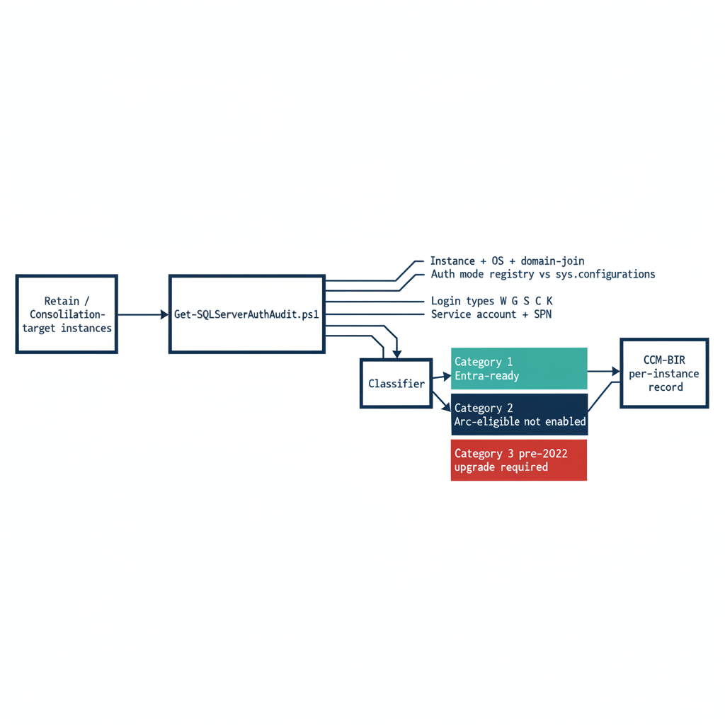
Figure 1: How Get-SQLServerAuthAudit.ps1 enumerates each surviving instance and assigns one of three Arc-eligibility categories before emitting a per-instance CCM-BIR record

Scope of the Enumeration
Get-SQLServerAuthAudit.ps1 performs a structured enumeration of the SQL Server estate across all hosts in the program’s management scope. For each host it identifies every SQL Server instance — named instances and the default instance — along with the version, edition, and build number.
The host operating system version is captured because it determines the Arc capability envelope. Windows Server 2019 and 2022 support the Connected Machine agent, and therefore support Arc-based Managed Identity for the SQL Server engine process. They do not, however, support the AADLoginForWindows OS-level Entra login extension, which requires Windows Server 2025. Windows Server 2025 supports both capabilities.
That distinction matters for migration sequencing, and the audit captures it explicitly. The domain-join status of the host is recorded alongside it: a host already migrated to a non-domain-joined state under the ADR-002 server transformation occupies a different starting position than a domain-joined host, and the per-instance output must reflect that.
Arc-enablement status — whether the Connected Machine agent is installed and the system-assigned Managed Identity is available — is the single most consequential classification output for migration prioritization. (Spec3-D1.8)

Authentication Mode Configuration
For each instance the script reads the authentication-mode configuration. SQL Server supports two modes: Windows Authentication Only and Mixed Mode. In Windows Authentication Only mode, SQL Authentication logins are rejected at the connection level — no SQL Authentication credential is accepted regardless of whether a matching login exists in master. In Mixed Mode, both Windows Authentication and SQL Authentication are accepted.
The mode is stored in the Windows registry at HKLM:\SOFTWARE\Microsoft\Microsoft SQL Server\[InstanceName]\MSSQLServer\LoginMode: a value of 1 indicates Windows Authentication Only, and a value of 2 indicates Mixed Mode.
The audit reads this value directly and also cross-references it against the sys.configurations view within the instance. Discrepancies between the registry value and the running configuration can occur after a manual reconfiguration without a service restart. Any discrepancy is flagged as an anomaly requiring resolution before the migration can proceed.

Login Type Classification
The script connects to each instance and queries the sys.server_principals system view to enumerate all logins. Each login is classified by type: Windows logins derived from individual AD user accounts (type W, mapped by SID to an AD user object); Windows logins derived from AD security groups (type G, mapped by SID to an AD group object); SQL Authentication logins with credentials stored in master (type S); certificate-mapped logins (type C); and asymmetric key-mapped logins (type K).
The count and identity of each type is reported per instance. The presence of active SQL Authentication logins — type S — is a critical finding, because these logins are invisible to the Azure identity plane.
Such logins must be either migrated to Entra ID equivalents — type E, FROM EXTERNAL PROVIDER logins created in Book 04 — or formally excepted with documented justification before Transformation #7 can be declared closed.
The sa account’s status is separately flagged: enabled, disabled, or renamed. An enabled sa account with a non-rotated password is the highest-priority remediation finding in the audit output.

Service Account Identity and SPN Registration
The script captures the identity of the Windows service account running the SQL Server engine process — the MSSQLSERVER service or its named-instance equivalent — by querying the service configuration. This identifies whether the engine runs as a domain service account, a gMSA, the NT SERVICE\MSSQLSERVER virtual account, or another identity.
It then queries Active Directory — using the Get-ADServiceAccount and setspn equivalents — to determine whether the correct SPN is registered for the service account and the instance endpoint.
The SPN check is one of the most operationally valuable outputs of the audit. SPN misconfiguration is the primary cause of NTLM fallback, and it is not visible without deliberately querying AD for it.
An instance with a missing or incorrect SPN is generating NTLM traffic for every connection that expects Kerberos — and in most cases, the application teams generating those connections do not know it. (Spec3-D1.8, ADR-068)

The Arc-Eligibility Output
The most consequential output of the audit is the Arc-eligibility classification it assigns to every instance. Every instance falls into one of three categories.
Category 1 is Arc-eligible and Entra-auth-ready today: the server is already running the Connected Machine agent, the Azure extension for SQL Server has been deployed, the system-assigned Managed Identity is available for the engine process, and the SQL Server version is 2022 or later. A Category 1 instance can have its Entra ID logins created and its login migration begun immediately — it requires no further infrastructure work before Book 04’s migration pattern can be applied.
Category 2 is Arc-eligible but not yet enabled: the host meets all the prerequisites for Arc enablement — Windows Server 2019 or later, network connectivity to the Azure Arc endpoint, SQL Server 2022 — but the Connected Machine agent has not been installed. A Category 2 instance requires Arc deployment as the prerequisite action before login migration can begin.
Category 3 is not yet Arc-eligible. Either the SQL Server version is pre-2022 — 2019, 2017, or earlier — which means the engine cannot accept FROM EXTERNAL PROVIDER logins regardless of Arc status, or the host has a configuration that prevents Arc enrollment.
A Category 3 instance requires a SQL Server version upgrade as the gate before any Entra-auth migration can occur, and that upgrade timeline must be factored into the overall program sequencing ahead of Microsoft’s progressive NTLM defaults.

The CCM-BIR Telemetry Sink
The audit script’s output is not a standalone deliverable — it is the input to the CCM-BIR ingestion pipeline. This is the architectural characteristic that distinguishes Spec3-D1.8 from a conventional discovery script.
The CCM-BIR — Continuous Compliance Monitoring, Boundary Identity Record — is the program-level tracking system for SQL Server authentication state at the instance level. Each time the audit runs — and it is designed to run continuously, on a schedule, against the full estate — it produces a structured record per instance that the CCM-BIR pipeline ingests.
That pipeline computes the current authentication posture of the instance, compares it to the previous record, and flags any drift: a new SQL Authentication login that appeared since the last scan, an instance that has reverted from Entra-only authentication back to Mixed Mode, a new linked-server definition that uses NTLM passthrough.
Drift events in the CCM-BIR are not informational — they are compliance violations that trigger the program’s remediation workflow. The output mandated by ADR-068 is a CCM-BIR record per instance, not a spreadsheet delivered to a program manager. (ADR-068, Spec3-D1.8)
Division of labor
Microsoft provides: sys.dm_exec_connections with auth_scheme; sys.server_principals for login enumeration; the Windows registry LoginMode value; Windows event log NTLM auditing.
What only you can provide: Spec3-D1.8 (Get-SQLServerAuthAudit.ps1) — the cross-estate enumeration and Arc-eligibility classification that DMVs alone do not produce; the CCM-BIR integration that makes the output a drift-aware compliance record rather than a point-in-time spreadsheet.

What Book 03 establishes — Chapter 1
Get-SQLServerAuthAudit.ps1 (Spec3-D1.8) enumerates the surviving estate — instances, version and OS, domain-join status, authentication mode, login types, and engine service-account and SPN posture — and assigns every instance a three-category Arc-eligibility classification: Entra-ready today (Category 1), Arc-eligible but not enabled (Category 2), or version-upgrade-required (Category 3). Its output is not a spreadsheet but a per-instance CCM-BIR record that establishes a continuous, drift-aware authentication baseline under ADR-068.

Reading the Audit — Classification and Triage

Chapter 2 — Reading the Audit: Classification and Triage
From a per-instance category to a defensible migration order — and the one distinction that prevents the program’s most common mistake.
In this chapter
How to interpret each of the three Arc-eligibility categories the audit assigns, how the audit output should drive triage and prioritization within each category, and the architectural distinction between SQL Server engine Entra authentication and server OS Entra login capability — the Layer 1 versus Layer 2 separation that lets engine migration proceed on a host that is still domain-joined.

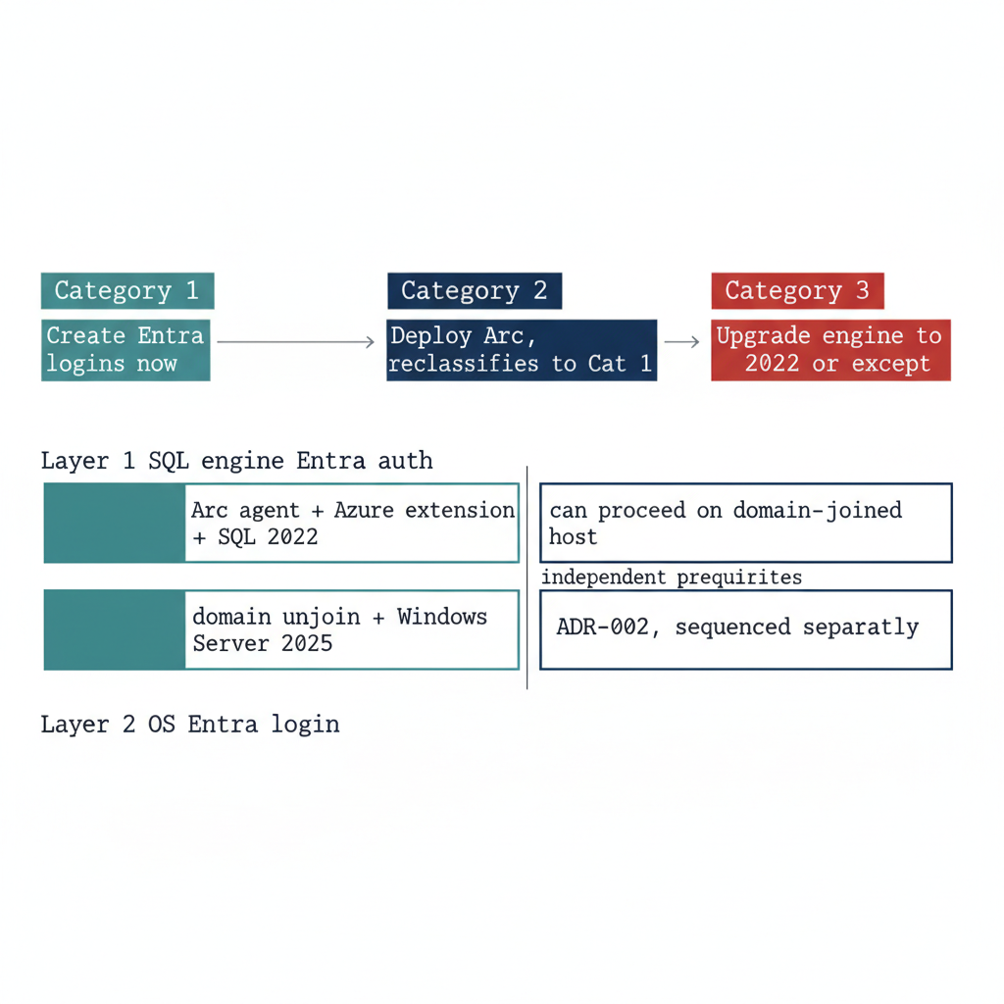
Figure 1: How the three audit categories map to triage actions, and how the SQL-engine Entra-auth layer is independent of the OS-level Entra login layer governed by ADR-002

Interpreting Category 1: Entra-Auth-Ready
A Category 1 classification is the program’s best starting position. It means the infrastructure prerequisites for Entra ID authentication are already in place — the Arc agent is running, the Azure extension for SQL Server is deployed, and the engine is running on SQL Server 2022.
The Managed Identity for the server is available, and the SQL Server extension has registered the instance with the Arc data services plane. Nothing in the infrastructure stack remains to be built.
The migration work for a Category 1 instance therefore begins with the login inventory from the audit: how many Windows logins exist, what AD groups are mapped to SQL Server roles, and whether any SQL Authentication logins need to be addressed before or alongside the Windows login migration. The specific migration steps are documented in Book 04.
The point here is that the audit has done its job for a Category 1 instance when it delivers a precise login inventory. The infrastructure work is already done, and the migration can proceed without any further prerequisites.

Interpreting Category 2: Arc-Eligible but Not Enabled
A Category 2 instance requires an Arc deployment action before login migration can begin. The audit output for such an instance should be used to prioritize that deployment.
Instances with a large number of Windows logins, active SQL Authentication logins, or missing SPN registrations — and therefore NTLM-generating connections — are higher priority for Arc deployment than instances with simple, well-configured Windows Authentication.
The Arc deployment itself is not a SQL Server change. It is a server-level action that installs the Connected Machine agent and the SQL Server extension. Book 03 describes the Arc deployment sequence in detail.
Once Arc deployment is complete and the SQL Server extension confirms the Managed Identity is available, the instance re-classifies from Category 2 to Category 1 on the next audit run, and the login migration can begin.

Interpreting Category 3: Version Upgrade Required
A Category 3 instance is the most operationally complex. A pre-2022 instance cannot accept FROM EXTERNAL PROVIDER logins regardless of any other configuration change.
The CREATE LOGIN [user@tenant] FROM EXTERNAL PROVIDER syntax was introduced in SQL Server 2022 as part of the Azure extension for SQL Server integration. Earlier versions do not support the syntax at all — it produces a parse error.
A Category 3 instance therefore has two possible paths: upgrade the SQL Server engine to 2022 and then proceed through the Category 2 pathway, or document a formal exception with a sunset date for the instance.
A Category 3 instance that cannot be upgraded to SQL Server 2022 as dependencies are remediated will face increasing friction as Microsoft tightens NTLM defaults, regardless of exception status. The NTLM block, when applied, is network-level and does not distinguish between instances that are excepted from the transformation and instances that are not.
The version-upgrade timeline for Category 3 instances must be integrated into the ADR-091 migration plan as an explicit dependency.

The SQL Engine vs. OS Entra Auth Distinction
One of the most important clarifications the audit output must carry — and that the teams reading it must internalize — is the architectural distinction between SQL Server engine Entra authentication and server OS Entra ID login capability. These are two separate capabilities with separate prerequisites, and confusing them is the most common misunderstanding this program will encounter.
SQL Server engine Entra authentication — Layer 1, the capability described in this series — requires the Arc Connected Machine agent, the Azure extension for SQL Server, and SQL Server 2022. It does not require the server to be domain-unjoined, and it does not require Windows Server 2025.
A domain-joined Windows Server 2019 host running SQL Server 2022 with Arc installed can have Entra ID-backed SQL Server logins today, while the server itself remains domain-joined and continues to authenticate OS-level users via Kerberos to the domain controller.
Server OS Entra ID login capability — Layer 2, the ability for administrators to RDP into the server using Entra ID credentials instead of domain credentials — is a separate transformation governed by ADR-002. It requires domain unjoin and Windows Server 2025 with Desktop Experience.
The two capabilities are related — both are part of UIAO_135 Transformation #7 — but they are sequenced independently, and the SQL Server engine migration can and should proceed first.
This sequencing point must be explicit in every instance of audit output that classifies a server as “not yet domain-unjoined.” The correct interpretation is not “SQL Server migration blocked” but “OS-level Entra login not yet available; SQL engine migration can proceed.” (ADR-002)
Division of labor
Microsoft provides: the Arc-eligibility prerequisites — Windows Server 2019+, SQL Server 2022, Connected Machine agent — and the capability envelope each category defines.
What only you can provide: the per-instance triage that maps Arc-eligibility category to action sequence; the critical clarification that SQL-engine Entra authentication (Layer 1) does not depend on OS-level domain unjoin (Layer 2) and must never be blocked waiting for it.

What Book 03 establishes — Chapter 2
The three Arc-eligibility categories map directly to triage actions: a Category 1 instance migrates now from its login inventory, a Category 2 instance is prioritized for Arc deployment and then re-classifies to Category 1, and a Category 3 instance must be upgraded to SQL Server 2022 or formally excepted, with upgrade timing tracked ahead of Microsoft’s progressive NTLM defaults. The decisive clarification is the Layer 1 versus Layer 2 distinction: SQL engine Entra authentication depends only on Arc, the Azure extension, and SQL Server 2022 — it can proceed on a still-domain-joined host, independent of the ADR-002 OS-level Entra login transformation.

Book_04 — Arc as the Identity Bridge
  - What Arc Provides to the SQL Server Engine — and the Deployment Sequence Only You Can Build

Book_04 — Arc as the Identity Bridge
Note
Without Arc, the SQL Server engine has no cloud-native identity; without that identity, there is no Managed Identity to replace the AD service account and no mechanism to accept Entra ID-issued tokens. This book explains exactly what Arc does and does not change — and why SQL engine Entra auth (Layer 1) must not be blocked on the domain unjoin that OS-level Entra login (Layer 2) requires. (ADR-002)

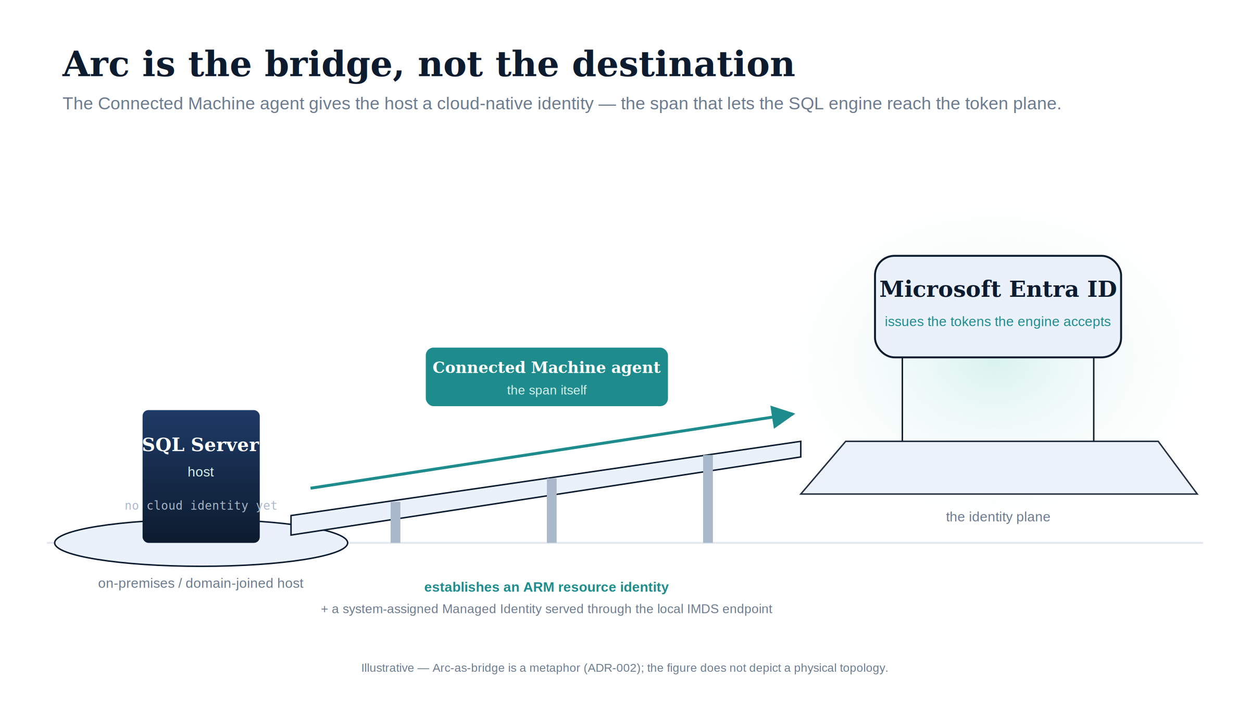
Figure 1: Arc is the bridge, not the destination: the Connected Machine agent gives the host the cloud-native identity that lets the SQL engine reach the Entra token plane.

Download this book
Book_04-bundle.docx — every chapter of this book concatenated into one Word document. Regenerated on every site deploy.

Chapters
Continue the series
← Previous: Book 03 — Discovery · Index · Next: Book 05 — The Login Migration →

What Arc Provides to SQL Server

Chapter 1 — What Arc Provides to SQL Server
Arc is not an end state — it is the bridge that gives the SQL Server engine a cloud-native identity.
In this chapter
What the Connected Machine agent and its ARM resource identity actually establish, how the system-assigned Managed Identity provides a credential-free token through the local IMDS endpoint, the architecturally independent two-layer distinction between SQL-engine Entra authentication and OS-level Entra login, how the Managed Identity replaces the AD-anchored service account, why Arc’s Managed Identity is preferred over a gMSA, a vault-stored service-principal secret, or certificate-based authentication, and — just as important — what Arc deliberately does not change.

When most people encounter Microsoft Azure Arc in a cloud modernization program, they encounter it as a management capability. Arc lets you see on-premises servers in the Azure portal, apply Azure Policy to them, and manage them through Azure Resource Manager. That is accurate, but it understates the architectural significance of Arc for this specific transformation.
Arc does something more fundamental for SQL Server on-premises: it gives the server — and by extension, the SQL Server engine process — a cloud-native identity. Without that identity, the SQL Server engine has no credential that the Azure identity plane can issue, validate, or condition.
Without that identity, there is no Managed Identity to replace the AD service account, and no mechanism for the engine to authenticate to Azure Key Vault, forward logs to Azure Monitor, or accept Entra ID-issued OAuth 2.0 tokens from clients. Arc is the enablement layer for everything that follows in this series. (ADR-002, UIAO_135 Transformation #7)
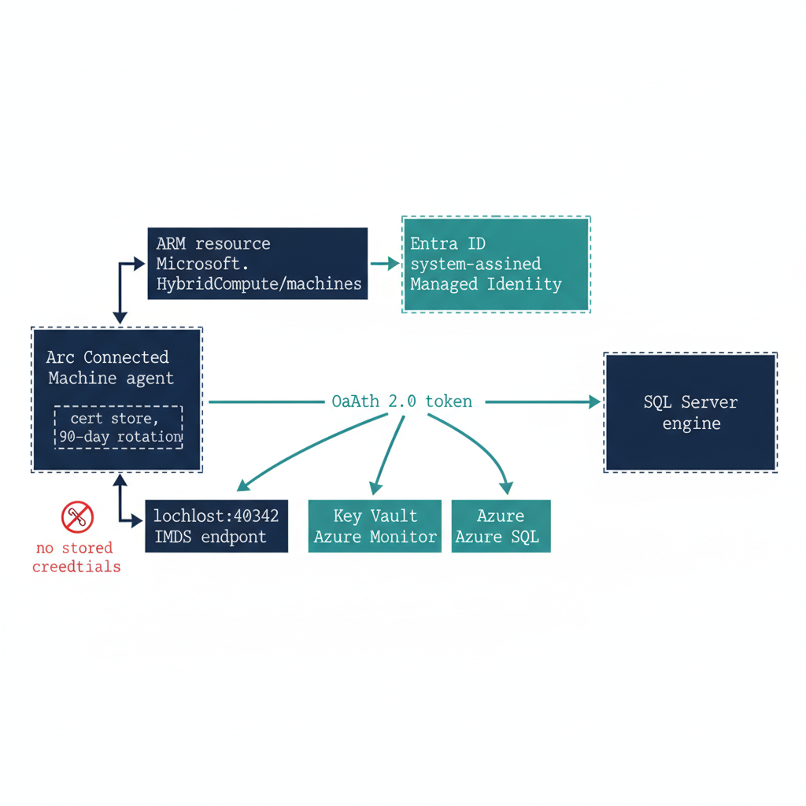
Figure 1: How the Connected Machine agent establishes an ARM resource identity that anchors the system-assigned Managed Identity served through the local IMDS endpoint

The Arc Agent and the ARM Resource Identity
When the Microsoft Azure Connected Machine agent is installed on a server, that server acquires a resource identity in Azure Resource Manager. This is not a figurative identity or a management label. It is a first-class ARM resource, of type Microsoft.HybridCompute/machines, with a resource ID, a subscription scope, a resource group, and a set of ARM resource properties.
The ARM resource identity is what makes the server visible in the Azure portal, manageable through Azure Policy, and addressable by Azure Resource Manager API calls. More importantly for this series, it is the basis for the system-assigned Managed Identity.
The system-assigned Managed Identity is automatically created when the Arc agent is installed and the server resource is registered in ARM. The Managed Identity is an Entra ID service principal whose lifecycle is bound to the server resource. When the server resource exists in ARM, the Managed Identity exists in Entra ID; when the server is deregistered from Arc, the Managed Identity is deleted.
The Managed Identity’s credential — the private key for the identity’s certificate — is stored in the Arc agent’s local certificate store on the server and is rotated automatically by the Arc agent every 90 days. No human administrator ever sees the private key. No process has access to it except the Arc agent itself and the Windows security subsystem components the Arc agent uses to request tokens.
When any process on the server requests a token from the Arc agent’s local IMDS endpoint — http://localhost:40342/metadata/identity/oauth2/token — the Arc agent uses the Managed Identity certificate to authenticate to Entra ID and return a token. The token can be scoped to any Azure resource for which the Managed Identity has been granted access: Azure Key Vault, Azure SQL, Azure Storage, Azure Monitor, or any other service that accepts Entra ID-issued OAuth 2.0 tokens.

The Two-Layer Distinction
Arc enables two distinct Entra ID capabilities for SQL Server, and they are architecturally independent. This is the most commonly misunderstood aspect of the SQL Server identity transformation, and it must be stated precisely before any migration planning begins.
Failure to understand the distinction leads to incorrect sequencing assumptions — either blocking SQL engine migration on OS-level work that is not a prerequisite, or attempting OS-level Entra login without the domain unjoin it requires.
Layer 1 is SQL Server engine Entra authentication, which is the subject of this series. When the Azure extension for SQL Server is deployed on an Arc-enabled server running SQL Server 2022, the engine can be configured to accept Entra ID-issued OAuth 2.0 access tokens as the authentication credential for SQL Server logins.
Clients connect using CREATE LOGIN [user@tenant.onmicrosoft.com] FROM EXTERNAL PROVIDER logins, present an Entra ID access token scoped to the SQL Server’s Azure resource audience, and the engine validates the token against Entra ID’s public key infrastructure. This capability does not require the server to be domain-unjoined. It does not require Windows Server 2025.
It requires three things: the Arc Connected Machine agent installed and registered, the SQL Server 2022 engine, and the Azure extension for SQL Server deployed. A domain-joined Windows Server 2019 host with Arc installed and SQL Server 2022 running is fully capable of Layer 1 today.
Layer 2 is server OS Entra ID login capability, implemented via the AADLoginForWindows extension. This capability allows administrators to authenticate to the server’s operating system using Entra ID credentials — to RDP into the server using their Entra credentials instead of domain credentials. It is governed by ADR-002 and is part of the server infrastructure transformation, not the SQL Server authentication transformation.
It requires domain unjoin — the server must be removed from the Active Directory domain — and it requires Windows Server 2025 with Desktop Experience. This is a more disruptive change than Layer 1: domain unjoin affects every service on the server that depends on AD membership, requires coordination with every team that manages the server, and has implications for DNS, Group Policy, and certificate enrollment that must be planned carefully.
The sequencing guidance is clear. Layer 1 can and should be completed before Layer 2 begins. SQL Server engine authentication can be migrated to Entra ID while the server remains domain-joined, providing transformation progress and security improvement without incurring the operational risk of domain unjoin. (ADR-002)
 Important
Do not block SQL Server engine Entra authentication migration (Layer 1) on domain unjoin (a Layer 2 prerequisite). These are independent sequencing tracks. Layer 1 can proceed on domain-joined servers. Layer 2 is a separate transformation with separate prerequisites. This distinction must be communicated explicitly to every DBA team and infrastructure team involved in the migration. Incorrect sequencing assumptions are the most common cause of unnecessary delays in SQL Server Entra auth migration. (ADR-002, UIAO_135 Transformation #7)

The Managed Identity as Service Account Replacement
The SQL Server engine process typically runs as NT SERVICE\MSSQLSERVER on most standard installations, or as a domain service account or gMSA on installations where the default virtual account was changed. When the Arc agent is installed and the Azure extension for SQL Server is configured, the engine can use the server’s system-assigned Managed Identity to authenticate to Azure services.
The SQL Server extension registers the Managed Identity with the Azure SQL Arc resource plane and configures the engine’s use of the Managed Identity for specific Azure-service interactions. Key Vault secrets, Azure Monitor log forwarding via the Azure Monitor agent, and Azure Arc data services all authenticate via the Managed Identity rather than via stored credentials.
This does not immediately change how the SQL Server engine authenticates to the Windows operating system. The engine still runs as NT SERVICE\MSSQLSERVER for local process purposes. What changes is the engine’s Azure-plane identity: Azure resources see the Managed Identity rather than a service account credential.
The service account migration for SQL Server is thus Arc-first. Deploy Arc, deploy the SQL Server extension, and the engine’s Azure identity is established without any credential management or credential rotation risk.

Why Arc and Not the Alternatives
A skeptical reviewer will ask the fair question directly: why Arc, and not one of the identity mechanisms the organization already operates? The answer is not that Arc is fashionable — it is that every alternative either re-anchors on the very directory the program is retiring, or reintroduces the stored credential the transformation exists to eliminate.
A group Managed Service Account or domain service account is the incumbent, and it works — for as long as Active Directory remains the authoritative identity source. It does not. Driver Three of Book 01 is precisely that AD is removed as the authority for this boundary; binding the engine’s new identity to a gMSA would anchor it to the thing being decommissioned, which is circular. A service principal with a client secret — whether the secret sits on disk or in Azure Key Vault — solves the AD-anchoring problem but reintroduces a stored, rotatable credential, and a bootstrapping one: the engine must authenticate to the vault before it can read the secret, so a root credential lands on the server regardless. That is the credential-management and rotation risk the program is trying to retire, not relocate.
Certificate-based authentication is viable, and is in fact the program’s chosen posture — but as the interim one. ADR-068 and ADR-091 §4 authorize Certificate-Based Authentication specifically for the pre-2022 exception long-tail that cannot reach Kerberos or Entra OAuth as dependencies are remediated; it still requires certificate lifecycle management, which is why it carries the ADCS-to-Cloud-PKI dependency (UIAO_135 §3.3, “Not Yet Defined”). It is a bridge, not a destination.
The Arc system-assigned Managed Identity is the only option that is simultaneously cloud-native and credential-free from the operator’s perspective: the certificate lives in the Arc agent’s local store, rotates automatically every 90 days, is never visible to any human, and its lifecycle is bound to the ARM resource rather than to a directory the program is removing. No secret to vault, no rotation to schedule, no AD object to preserve. That is why Arc wins — not by assertion, but because it is the one mechanism that survives the removal of AD without recreating a managed secret. (ADR-002, ADR-068, ADR-091)

What Arc Does Not Do
It is equally important to be precise about what Arc does not change, because the scope of Arc’s effect on SQL Server is frequently overstated in both directions. Arc does not change how SQL Server authenticates connections from domain-joined clients.
A domain-joined Windows client connecting to a SQL Server instance on an Arc-enabled server using Integrated Security=True still uses Kerberos or NTLM — the same protocol negotiation described in Book 01. The Arc agent has no effect on the SQL Server engine’s SSPI-based authentication of Windows-integrated connections, and Arc installation alone produces no Entra ID sign-in events for SQL Server connections.
Arc does not move any login from the Windows type to the External Provider type. Arc does not disable Windows Authentication or Mixed Mode. Arc does not affect the SPN registration status for the instance. Arc is the enablement layer; it provides the capability for Entra ID authentication without activating it.
The login migration described in Book 04 is what actually changes the authentication behavior for SQL Server connections — Arc merely makes that migration possible. Understanding this distinction is essential for communicating the transformation scope to stakeholders: Arc deployment is a necessary prerequisite, but it is not the transformation itself.
Division of labor
Microsoft provides: the Connected Machine agent; the system-assigned Managed Identity; the Azure extension for SQL Server; Defender for SQL; Azure Monitor integration; the IMDS endpoint for credential-free token acquisition.
What only you can provide: the deployment sequence across your estate; the Layer 1 / Layer 2 distinction communicated to every stakeholder so SQL-engine Entra auth is not blocked on OS-level domain unjoin; the governance model for Managed Identities after enrollment.

What Book 04 establishes — Chapter 1
The Connected Machine agent gives a server a first-class ARM resource identity, and that identity anchors a system-assigned Managed Identity — a credential-free Entra ID service principal whose certificate is rotated automatically and never exposed to any human, served as an OAuth 2.0 token through the local IMDS endpoint. Arc enables two architecturally independent layers: Layer 1 SQL-engine Entra authentication (the subject of this series, available today on domain-joined SQL Server 2022 hosts) and Layer 2 OS-level Entra login (a separate, more disruptive transformation requiring domain unjoin). Layer 1 must never be blocked on Layer 2. Arc replaces the AD-anchored service account at the Azure plane and provides the capability for Entra authentication — but it does not itself activate it. Arc is preferred over the alternatives — a gMSA (re-anchors on the AD being retired), a vault-stored service-principal secret (reintroduces a stored bootstrap credential), or certificate-based authentication (the ADR-068 interim exception posture, not the steady state) — because its Managed Identity is the one credential-free, cloud-native option that survives the removal of AD.

Arc Deployment Sequencing for SQL Server Hosts

Chapter 2 — Arc Deployment Sequencing for SQL Server Hosts
The ordered prerequisites that turn a domain-joined SQL Server host into an Arc-enabled, identity-ready instance.
In this chapter
The connectivity prerequisites that Arc enrollment demands inside a GCC-Moderate boundary, why the Azure extension for SQL Server is a distinct installation with its own version validation, and the IMDS token check that confirms the system-assigned Managed Identity is genuinely available before any login migration begins.

Arc deployment is a sequence, not a single act. Each step has a prerequisite that the prior step satisfies, and skipping ahead produces failures that are easy to misdiagnose as migration problems when they are in fact enrollment problems. The order is connectivity first, then the SQL Server extension, then a verification that the Managed Identity is actually present and answering.
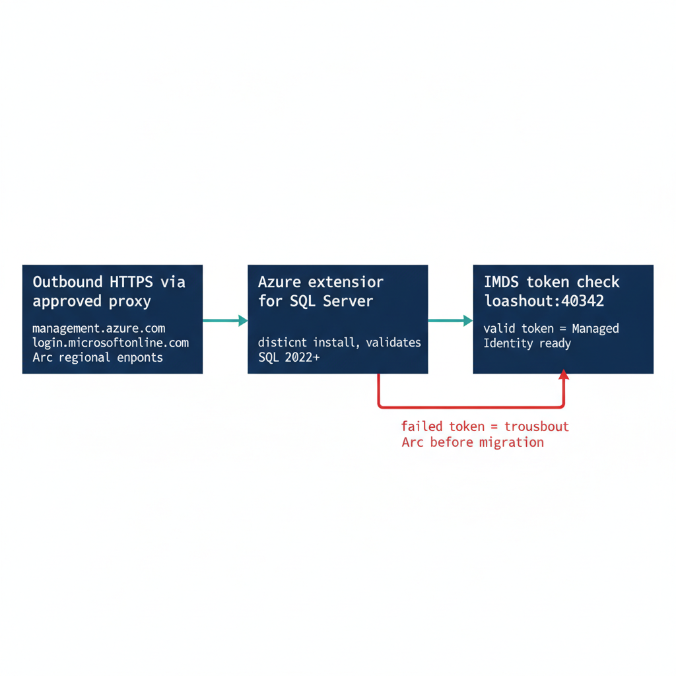
Figure 1: The ordered Arc deployment sequence from outbound HTTPS connectivity verification through extension install to IMDS token confirmation

Prerequisites for Arc Enrollment
The Connected Machine agent requires outbound HTTPS connectivity from the server to the Azure Arc endpoints — management.azure.com, login.microsoftonline.com, and the Arc-specific regional endpoints. In a GCC-Moderate boundary, this connectivity must be routed through the program’s approved network egress path.
Direct internet egress from a production SQL Server host is not acceptable under the boundary’s network posture. The Arc agent supports proxy configuration for HTTPS traffic, and the proxy address must be provided at installation time.
Connectivity verification — confirming that the server can reach all required Arc endpoints through the approved proxy — is the first prerequisite check before Arc deployment begins. An agent that cannot reach its endpoints will fail to register its ARM resource, and without that resource there is no Managed Identity to verify later.

The Azure Extension for SQL Server
The Azure extension for SQL Server is a distinct installation from the Connected Machine agent and must be deployed after the agent is enrolled. It is installed via Azure Policy assignment — the recommended approach for fleet-wide deployment — or via the Azure portal or CLI for individual servers.
The extension performs additional validation at installation time. It verifies the SQL Server version, where 2022 or later is required for Entra auth capability; it registers the SQL Server instance with the Arc SQL resource plane; and it configures the Managed Identity access for the engine process.
The Spec3-D1.8 audit’s Arc-eligibility classification — Category 1 versus Category 2 versus Category 3 — is the primary input for prioritizing Arc deployment across the estate. Category 2 instances are the immediate deployment targets, and the audit’s login inventory and NTLM risk signals within Category 2 are used to order those deployments by remediation urgency. (Spec3-D1.8, ADR-002)

Verification of Managed Identity Availability
After the Connected Machine agent is installed and the Azure extension for SQL Server is deployed, the program must verify that the system-assigned Managed Identity is available before proceeding to the login migration. This verification is not optional — it is the gate between enrollment and migration.
The verification check calls the local IMDS endpoint on the server — http://localhost:40342/metadata/identity/oauth2/token?api-version=2019-11-01&resource=https://management.azure.com/ — and confirms that the Arc agent returns a valid access token.
A successful token response confirms three things at once: that the Managed Identity is enrolled in Entra ID, that the Arc agent is functioning, and that the server’s ARM resource is in a healthy state. A failed token response at this stage requires Arc troubleshooting before the SQL Server migration can proceed.
The Spec3-D1.8 audit’s Arc-eligibility classification is updated on each run to reflect the current Managed Identity availability state, so the CCM-BIR record for the instance reflects this verification outcome in near-real-time.
Division of labor
Microsoft provides: the Arc enrollment process; the Azure extension for SQL Server installation; the IMDS token endpoint; the Spec3-D1.8 Arc-eligibility classification as the prioritization input.
What only you can provide: outbound HTTPS connectivity verification through the GCC-Moderate egress proxy; the per-host deployment sequence that respects linked-server dependency order; the IMDS token test that serves as the gate authorizing login migration.

What Book 04 establishes — Chapter 2
Arc deployment for a SQL Server host proceeds in a strict order: first verify outbound HTTPS connectivity to the Arc endpoints through the program’s approved GCC-Moderate egress proxy, then install the Azure extension for SQL Server — a distinct installation that validates the SQL Server 2022+ version and registers the instance with the Arc SQL resource plane — and finally confirm the system-assigned Managed Identity is live by requesting a token from the local IMDS endpoint. A successful IMDS token response is the gate that authorizes login migration; a failure is an enrollment problem to resolve before migration begins. The Spec3-D1.8 audit drives prioritization and records the verification outcome in near-real-time.

Book_05 — The Login Migration: Windows Principals to Entra Logins
  - What Microsoft’s Login Syntax Enables — and the Principal Mapping Only You Can Resolve

Book_05 — The Login Migration: Windows Principals to Entra Logins
Note
Everything in Books 01 through 04 is prerequisite; everything in Books 06 through 09 is consequence. This book is the migration itself — performed only on the instances Book 02 classified retain or target, using the three-phase parallel-run pattern that ADR-091 makes normative. (ADR-091)

Figure 1: During: two client types simultaneously active — legacy Kerberos/NTLM and migrated Entra token — sharing one SQL Server.

Figure 2: During: the three-phase parallel-run pattern — Add the Entra login, validate it against real traffic for 30 days, then retire the Windows login.

Figure 3: During: the three costs every unmigrated login carries — CA blind spot, NTLM exposure, and vendor pressure tightening with each release.

Figure 4: During the login migration, both authentication paths reach the same SQL Server. Legacy connections use Kerberos or NTLM through the domain controller; migrated connections present an Entra token. The parallel-run window keeps both active until every legacy login is validated, disabled, observed for 30 days, and dropped.

Figure 5: Simplified migration state: two client types, two authentication paths, one SQL Server. The hybrid window stays open until every legacy login is migrated.

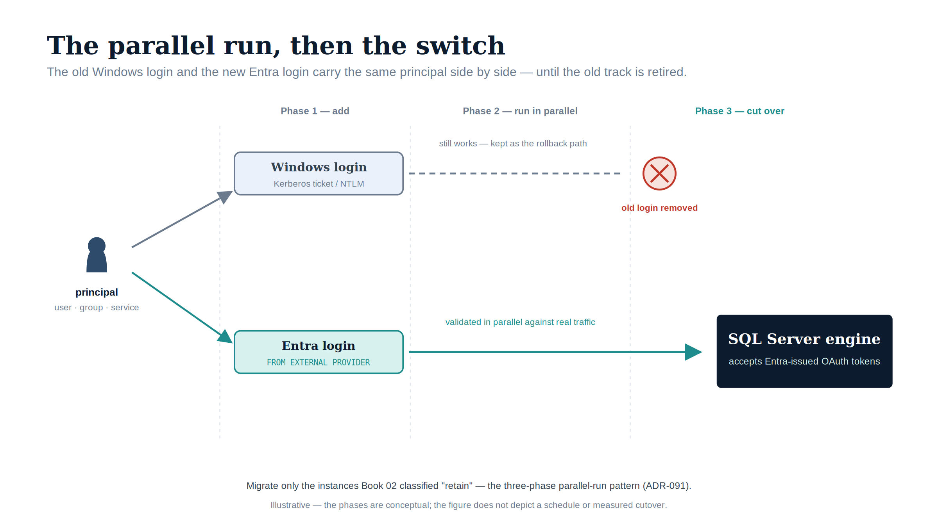
Figure 6: The parallel run, then the switch: the old Windows login and the new Entra login carry the same principal side by side until the legacy track is retired.

Download this book
Book_05-bundle.docx — every chapter of this book concatenated into one Word document. Regenerated on every site deploy.

Chapters
Continue the series
← Previous: Book 04 — Arc as the Identity Bridge · Index · Next: Book 06 — Eliminating NTLM at the SQL Layer →

Three Principal Types — User, Group, Service Principal

Chapter 1 — Three Principal Types — User, Group, Service Principal
The moment the engine stops accepting Kerberos and NTLM and starts accepting Entra-issued tokens.
In this chapter
The FROM EXTERNAL PROVIDER syntax that creates type-E logins validated by token at connect time, the three principal types those logins map to — Entra user, Entra security group, and Entra service principal — and the three-phase parallel-run pattern that creates and validates the new logins before disabling the old ones. (ADR-091 §2)

This is the technical heart of the series. The login migration is the moment where the SQL Server engine stops accepting the authentication artifacts of the old world — AD-issued Kerberos service tickets, NTLM challenge-response exchanges, Windows Integrated Security — and starts accepting the artifacts of the new world: Entra ID-issued OAuth 2.0 access tokens, validated against Entra’s public key infrastructure.
Those tokens carry claims about the principal’s identity, group memberships, device compliance state, and MFA completion. Everything in Books 01 through 04 is prerequisite; everything in Books 06 through 10 is consequence. This chapter is the migration itself, and ADR-091 §2 records the canonical sequence it follows.
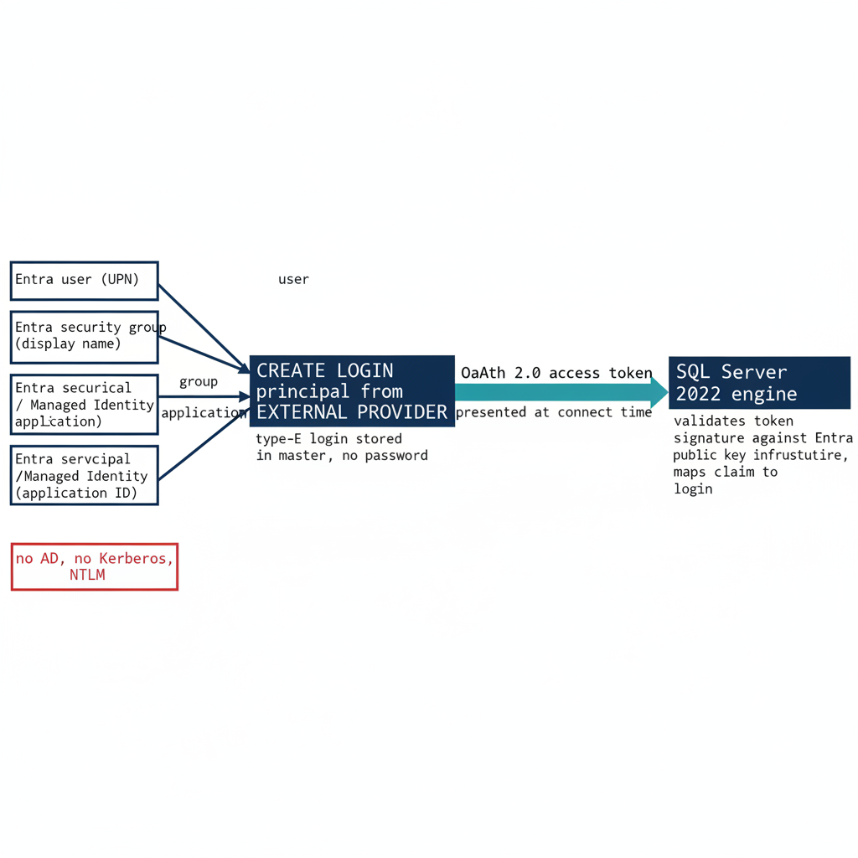
Figure 1: The three Entra principal types mapping through FROM EXTERNAL PROVIDER to type-E logins validated by token at connect time

The FROM EXTERNAL PROVIDER Syntax
SQL Server 2022 introduces a new login creation syntax that is the foundation for the entire migration: CREATE LOGIN [principal] FROM EXTERNAL PROVIDER. This statement maps an Entra ID principal — identified by its user principal name for users, its display name for groups, or its application ID for service principals — to a SQL Server login without any Active Directory involvement at login creation time.
The login is stored in the master database as a type-E login, an external principal. It has no password stored in SQL Server. Authentication for a type-E login is performed by the client presenting a valid Entra ID OAuth 2.0 access token, scoped to the SQL Server’s Azure resource audience, at connection time.
The engine validates the token’s cryptographic signature against Entra ID’s public key infrastructure, extracts the claims from the token payload, and maps the principal identity in those claims to the corresponding FROM EXTERNAL PROVIDER login in master. If the mapping succeeds and the login is enabled, the connection is accepted, and the principal is granted the permissions associated with the login and any database user roles.
The syntax requires that the Azure extension for SQL Server is installed on the host — which provides the Managed Identity and the Entra ID token validation infrastructure — and that the instance has been registered with the Azure Arc SQL resource plane (ADR-002). The CREATE LOGIN statement itself does not call out to Entra ID at execution time. It stores the principal identifier in master and relies on token validation at connection time.
This means the login can be created even if the principal does not yet exist in Entra ID, though a connection attempt with a non-existent principal will fail at token issuance — Entra will not issue a token for a principal that does not exist. The best practice is to verify that the Entra principal exists before creating the SQL Server login, to avoid orphaned type-E logins in master that map to deleted or renamed Entra principals.

Type 1 — Entra User Login
The Entra user login is for human database administrators and developers. The migration pattern for a Windows login derived from an individual AD user account — CREATE LOGIN [DOMAIN\username] FROM WINDOWS — is to create a corresponding type-E login for the same principal’s Entra UPN: CREATE LOGIN [username@tenant.onmicrosoft.com] FROM EXTERNAL PROVIDER.
The user’s UPN in Entra ID may differ from their SAM account name in AD, particularly in environments where UPN synchronization has not been standardized. The audit must capture the UPN-to-SAMAccountName mapping for all Windows logins before the migration begins, so that the Entra principal is correctly identified for each type-E login. After the login is created, the user authenticates to Entra ID using their normal credentials — password plus MFA, FIDO2, or Windows Hello for Business depending on the Conditional Access policy targeting. Entra issues an access token scoped to the SQL Server resource audience, carrying the user’s UPN and object ID as claims; the engine validates the token and maps the UPN to the type-E login.
Multi-factor authentication enforcement is handled entirely by the Conditional Access policy targeting the user and the SQL Server application registration. The SQL Server engine itself does not implement MFA logic and has no awareness of whether MFA was completed. This is the correct architectural division of responsibility: the Conditional Access policy in the Entra ID plane enforces the MFA requirement before the token is issued, and the engine trusts the token because it was issued by the Entra ID service the engine trusts (ADR-008).
If MFA was not completed, the Conditional Access policy denies the token request, and the SQL Server connection never opens. There is no SQL Server-level MFA prompt and no SQL Server-level MFA bypass. The Conditional Access policy also evaluates device compliance, network location through Named Locations, and sign-in risk level before issuing the token. All of these controls apply to SQL Server connections using type-E logins, and none of them apply to connections using Windows Authentication or NTLM. (ADR-008)

Type 2 — Entra Group Login
A SQL Server login can be created for an Entra ID security group rather than an individual user: CREATE LOGIN [GroupDisplayName] FROM EXTERNAL PROVIDER. When a user whose Entra access token includes a claim asserting membership in the named group connects to SQL Server, the engine maps the group claim to the group login and grants the user the permissions associated with that login.
This is the group-based access control pattern familiar from AD group-based SQL Server access, but it operates entirely through Entra ID group membership and OAuth 2.0 claims rather than through AD SID resolution and Kerberos PAC group membership. The shift from SID-and-PAC to claim is the whole difference between the old plane and the new one.
The significance of group-based type-E logins for this program is substantial. An Entra dynamic security group — a group whose membership is defined by a membership rule rather than by manual assignment — whose rule references OrgPath extensionAttributes can drive SQL Server access without any manual DBA provisioning action. The DBA team for an organizational boundary is the set of users whose OrgPath attributes match the dynamic group’s membership rule, and that set is computed continuously by Entra ID’s group membership engine as OrgPath values change with HR data (ADR-036).
A user who joins the DBA team gains SQL Server access when their OrgPath attributes are updated to reflect the new role — without any DBA issuing a CREATE USER statement. A user who leaves loses access when those attributes are updated — without any DBA issuing a DROP USER. The dynamic group is the policy; OrgPath is the data; Entra ID is the engine; and SQL Server consumes the result. This is the architectural connection between the OrgPath Narrative and this series, now expressed at the SQL Server engineering layer. (ADR-036)

Type 3 — Entra Service Principal Login
For application service accounts and automated processes that connect to SQL Server — ETL pipelines, reporting services, API backends, monitoring agents — the migration pattern replaces the SQL Authentication service account, a type-S login with a stored password, with an Entra service principal login: CREATE LOGIN [ApplicationDisplayName] FROM EXTERNAL PROVIDER, where the display name corresponds to the Entra ID application registration for the connecting application.
The application authenticates to Entra ID using its client credentials — which should be a client certificate rather than a client secret, or preferably no credential at all if the application runs on an Azure resource or an Arc-enabled server with a Managed Identity. The Managed Identity authenticates to Entra ID without any credential, obtains an access token scoped to the SQL Server resource audience, and presents that token at connection time.
The service principal pattern eliminates the SQL Authentication service account entirely: no username and password in connection strings, no credential rotation process, no risk of credential exposure in configuration files, log outputs, or code repositories. For applications running on Arc-enabled servers, the Managed Identity is available at the IMDS endpoint, and the Azure.Identity SDK’s DefaultAzureCredential chain will automatically use it (ADR-004).
For applications running in Azure virtual machines, Azure Container Instances, or Azure App Service, the platform-provided Managed Identity is used. For applications that cannot use a Managed Identity and must use a service principal with a credential, a client certificate is preferred over a client secret, and the certificate must be stored in Azure Key Vault rather than in any file system location. (ADR-004)

The Parallel-Run Migration Pattern
Existing Windows logins must not be dropped until their Entra equivalents have been validated. The migration follows the three-phase parallel-run pattern that ADR-091 §2 makes required for production instances, ensuring no access is disrupted during the transition. In Phase 1, type-E equivalents are created for every migrating login. For each Windows login — whether derived from an individual AD user account or an AD security group — a corresponding FROM EXTERNAL PROVIDER login is created using the Entra principal that corresponds to the AD principal.
The Entra-to-AD principal mapping must be verified before each login creation, and any principal for which no Entra equivalent can be confirmed is flagged as a blocking finding requiring resolution before the login can be created. This mapping verification is the most operationally intensive part of the migration: the Spec3-D1.8 audit output provides the AD principal inventory, and the Entra ID directory provides the UPN and group display name data needed for the mapping.
In Phase 2, each type-E login is validated by executing a test authentication using the real Entra credential for the corresponding principal. The test authentication must succeed before any legacy login is modified. In Phase 3, legacy Windows and SQL Authentication logins are disabled — not dropped — after successful validation of their Entra equivalents. The disabled logins are retained for a 30-day observation window during which connection monitoring confirms that no application or user still depends on them.
After the 30-day window, the disabled logins are dropped, and the type-E logins become the sole authentication mechanism for those principals. ADR-091 §2 permits non-production instances to compress the observation window with documented owner sign-off, but the create-validate-disable-observe-drop sequence itself is the canonical pattern, and the next chapter records the four further decisions ADR-091 makes around it.
Division of labor
Microsoft provides: the FROM EXTERNAL PROVIDER syntax in SQL Server 2022; the three principal type mappings — user, group, service principal; the Azure.Identity SDK DefaultAzureCredential chain; Conditional Access enforcement on the token before it reaches SQL Server.
What only you can provide: the Entra-to-AD principal mapping for every Windows login being migrated; the OrgPath dynamic group design that drives SQL Server access without manual DBA action (ADR-036); the parallel-run sequence — create, validate, disable, observe, drop — that prevents access disruption during migration.

What Book 05 establishes — Chapter 1
The FROM EXTERNAL PROVIDER syntax creates type-E logins that carry no password and authenticate by Entra-issued OAuth 2.0 token validated at connect time. The three principal types are the Entra user (UPN-mapped, MFA enforced by Conditional Access in the Entra plane, ADR-008), the Entra security group (OrgPath-driven dynamic groups provision access without DBA action, ADR-036), and the Entra service principal or Managed Identity (no credential in connection strings, ADR-004). The canonical migration is the three-phase parallel run ADR-091 §2 requires: create, validate, then disable — not drop — the legacy login, observe for 30 days, and only then drop it.

What ADR-091 Decides

Chapter 2 — What ADR-091 Decides
The five governance positions that turn the migration pattern into enforceable canon.
In this chapter
The five decisions ADR-091 records — that consolidation gates auth migration, that the parallel-run sequence is required, that SQL Authentication is eliminated and sa disabled and renamed, that pre-2022 instances are upgrade-or-except with a Certificate-Based Authentication interim posture, and that the CCM-BIR per-instance record is the closure artifact. (ADR-091 §1–§5)

The migration pattern in Chapter 1 covers the core engineering case — Windows logins migrated to type-E logins through FROM EXTERNAL PROVIDER — but a pattern alone leaves a set of governance positions that a narrative is not the instrument to settle. Those positions require an architecture decision record, and that record is ADR-091, accepted in PROPOSED status on 2026-06-02 as the engine-layer companion to ADR-068 (protocol layer) and ADR-002 (server and OS layer).
An early draft of this series referred to a “forthcoming ADR-090.” That number was independently taken by an unrelated substrate high-availability decision on the same date, so the engine-layer SQL Server authentication decision is recorded as ADR-091. It does not defer these questions: it answers all five, in operational sequence, and this chapter presents each as ADR-091 records it.
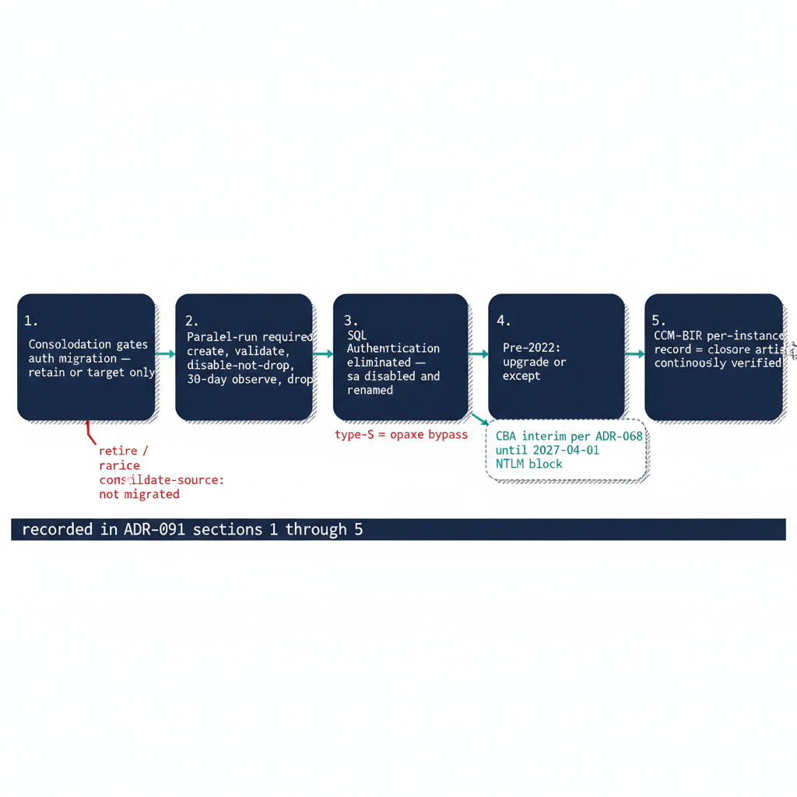
Figure 1: The five ADR-091 decisions arranged as the operational sequence that governs engine-layer auth migration

Decision 1 — Consolidation Precedes and Gates Auth Migration
ADR-091 §1 records the first and ordering decision: the estate consolidation assessment precedes and gates the engine-layer authentication migration. The SQL Server estate that has accumulated across an Active Directory forest over twenty years is not migrated in the shape it is discovered in. Before any instance is migrated to Entra ID authentication, the consolidation assessment must classify it as retain, consolidate-into-target, or retire.
Engine-layer auth migration is performed only on instances classified retain or on the consolidation targets that absorb consolidated workloads. Instances classified retire or consolidate-into-target as a source are not migrated — they are decommissioned or collapsed, and migrating their logins to Entra ID first would be wasted effort. This is the decision Book 02 established at the assessment layer; ADR-091 §1 makes it the normative prerequisite to everything in this book.
The Arc-eligibility classification from Spec3-D1.8 — Category 1, 2, or 3 — is layered on top of the consolidation classification, not before it. Consolidation and auth transformation are mutually reinforcing: collapsing many instances across multiple domains into fewer modern SQL Server 2022 targets, or into Azure SQL Managed Instance or Arc-enabled SQL, is the natural moment to retire cross-domain login sprawl, orphaned SPNs, and shared service accounts into Entra-backed identity.

Decision 2 — The Parallel-Run Sequence Is Required
ADR-091 §2 records that the canonical login migration is a three-phase parallel run, and that it is required for production instances. For every instance classified retain or target, Windows logins — type-U users and type-G groups — and SQL Authentication service-account logins, type-S, are migrated to Entra ID external-provider logins across the three principal types Chapter 1 described. The letters are the values of sys.server_principals.type, not mnemonics: S SQL login, U Windows login, G Windows group, E external (Entra) login. There is no type W — a discovery query written against one returns zero rows and reports a clean instance, which is how a typo becomes a false attestation of closure.
Phase 1 creates a type-E equivalent for every migrating login, with the Entra-to-AD principal mapping verified before each CREATE LOGIN and any unconfirmable principal raised as a blocking finding. Phase 2 exercises each type-E login with a real Entra-credentialed test authentication, which must succeed before the corresponding legacy login is touched. Phase 3 disables the legacy logins — not drops them — after their Entra equivalents validate, retains them for a 30-day observation window during which monitoring confirms no residual dependency, then drops them.
The earlier draft framed this sequence as something a governance record “must decide” between required, recommended, and discretionary. ADR-091 §2 settles it: the parallel run is required for production, and non-production instances may compress the observation window only with documented owner sign-off. Disable-and-observe makes every cutover reversible inside the window, so no principal is locked out by a mapping that turned out wrong.

Decision 3 — SQL Authentication Eliminated; sa Disabled and Renamed
ADR-091 §3 records the disposition of SQL Authentication. Every active type-S login on a retain or target instance is migrated to a type-E service-principal or Managed-Identity login, or carries a documented exception under §4 with a named compensating control and a sunset date. SQL Authentication produces no Entra ID sign-in events and is invisible to Conditional Access and Defender for Identity; it is not an acceptable steady-state credential.
This is the position the earlier draft left open — whether every SQL Authentication login must migrate, or whether some type-S logins could be retained with justification. ADR-091 §3 closes it toward elimination, allowing only the §4 documented-exception path rather than open-ended retention.
The built-in sa account is disabled and renamed on every production instance. Emergency-access recovery, if retained, is documented as a break-glass procedure with its own monitoring, not as an active sa login. An enabled sa account with a non-rotated password is the highest-priority remediation finding in the Spec3-D1.8 audit. A single active sa or type-S login defeats the entire Conditional Access perimeter, because it authenticates outside the Entra ID plane — the perimeter is binary, covering all connections or none.

Decision 4 — Pre-2022 Instances Are Upgrade-or-Except
ADR-091 §4 records the exception path for instances that cannot accept type-E logins. CREATE LOGIN ... FROM EXTERNAL PROVIDER requires SQL Server 2022 plus the Azure extension for SQL Server on an Arc-enabled host, so a pre-2022 Category 3 instance cannot accept external-provider logins regardless of Arc status.
A Category 3 instance classified retain has two paths: upgrade the engine to SQL Server 2022 and then proceed through the Category 2-to-Category 1 pathway, or file a documented exception with a sunset date. ADR-091 §4 notes that most Category 3 instances should be consolidation retire or consolidate-into-target candidates under §1 rather than upgrade candidates. The exception process requires the inability-to-migrate reason, the compensating control, the maximum exception duration, and explicit acknowledgement that the NTLM block, when applied, is network-level and does not honor engine-layer exception status.
Where a connection cannot reach Kerberos or Entra OAuth before that deadline, Certificate-Based Authentication is the authorized interim posture per ADR-068. That makes the certificate-authority dependency — the ADCS-to-Cloud-PKI transformation, classified Not Yet Defined in UIAO_135 §3.3 — a hard dependency for the exception long-tail. The earlier draft asked what evidence an exception requires, what its maximum duration is, and what happens if an instance is still excepted at the deadline; §4 records all three, with the CBA interim posture as the answer for connections that physically cannot reach the modern planes in time.

Decision 5 — The CCM-BIR Record Is the Closure Artifact
ADR-091 §5 records the closure condition. Transformation #7 is closed for an instance when its CCM-BIR record simultaneously shows LoginMode = 1 (Windows Authentication Only), zero active type-S logins outside the exception registry, zero active type-U or type-G logins, sa disabled and renamed, the Arc Connected Machine agent enrolled and healthy, the Azure extension for SQL Server deployed with the Managed Identity active, and — for human principals — Conditional Access MFA enforcement satisfied for SQL Server resource sign-ins over a defined validation period.
The earlier draft observed that without a defined evidence artifact there was no enforceable completion criterion. ADR-091 §5 supplies exactly that field set: the specific values that, populated correctly, constitute proof that the instance has completed the transformation. “Done” stops being a subjective claim and becomes a queryable posture.
Closure is continuously verified, not a point-in-time claim. Spec3-D1.8 runs on a recurring schedule, and CCM-BIR drift events — LoginMode reverting to Mixed Mode, a new type-S, type-U, or type-G login appearing, the Arc agent going offline — are compliance violations that trigger the remediation workflow. With all five positions recorded, the migration pattern of Chapter 1 becomes enforceable canon rather than operational best practice, and the books that follow operate against a defined closure artifact rather than a moving target.
Division of labor
Microsoft provides: the authentication mechanism — type-E logins, token validation; the continuous audit instrument (Spec3-D1.8); the CCM-BIR drift-detection infrastructure.
What only you can provide: the five operational decisions ADR-091 records — consolidation gate, parallel-run sequence, SQL Authentication elimination, pre-2022 exception posture, and CCM-BIR closure artifact. Microsoft provides the plane; ADR-091 is the program’s flight plan.

What Book 05 establishes — Chapter 2
ADR-091 records five positions in operational sequence. §1: the consolidation assessment of Book 02 gates auth migration — only retain instances and consolidation targets are migrated. §2: the three-phase parallel run (create, validate, disable-not-drop, 30-day observe, drop) is required for production. §3: SQL Authentication is eliminated and sa disabled and renamed on every production instance. §4: pre-2022 instances upgrade or file a sunset-dated exception, with Certificate-Based Authentication as the ADR-068 interim posture for connections that cannot yet reach the modern authentication planes. §5: the CCM-BIR per-instance record is the continuously-verified closure artifact for Transformation #7. The forthcoming “ADR-090” the early draft awaited is authored — it is ADR-091, and it has decided.

Book_06 — Eliminating NTLM at the SQL Layer
  - What Microsoft’s Enforcement Controls Block — and the Pattern Classification Only You Can Apply

Book_06 — Eliminating NTLM at the SQL Layer
Note
SQL Server is one of the most common sources of NTLM traffic in a federal environment, and the reasons are more varied than most DBA teams expect. This book traces ADR-068’s three phases — assess, block-where-safe, eliminate — as they apply to the SQL Server workload, ahead of Microsoft’s progressive NTLM default-disable. (ADR-068)

Download this book
Book_06-bundle.docx — every chapter of this book concatenated into one Word document. Regenerated on every site deploy.

Chapters
Continue the series
← Previous: Book 05 — The Login Migration · Index · Next: Book 07 — Access Control →

NTLMv1, NTLMv2, and the Patterns That Generate NTLM

Chapter 1 — NTLMv1, NTLMv2, and the Patterns That Generate NTLM
NTLM is a protocol, not a setting — so eliminating it means naming every connection pattern that produces it.
In this chapter
Why NTLMv1 is blocked early — in ADR-068’s Phase B, by default upon completion of the Phase A assessment (targeted 2026-Q3) — through the LAN Manager Authentication Level policy, while NTLMv2 is phased out as dependencies are remediated ahead of Microsoft’s progressive NTLM defaults, and the four distinct SQL Server connection patterns that generate NTLM traffic — a missing or incorrect SPN, cross-site connections where the KDC is unreachable, linked-server passthrough authentication, and non-domain-joined application hosts created by the server transformation.

NTLM is a protocol, not a configuration setting, and that distinction governs everything in this book. There is no single switch to flip and no single Group Policy change that removes NTLM from SQL Server connections. Eliminating NTLM at the SQL layer requires identifying every connection pattern that generates NTLM traffic, and there are more such patterns than most database teams expect.
The most obvious is the missing-SPN case described in Book 01, where Kerberos negotiation fails because no SPN is registered and SSPI falls back to NTLM. But other patterns exist: cross-site connections, linked-server definitions using passthrough authentication, and application connections from hosts that have already been migrated to a non-domain-joined state. Each pattern has a different root cause and a different remediation path, and none of them can be addressed until it has been detected. (ADR-068)
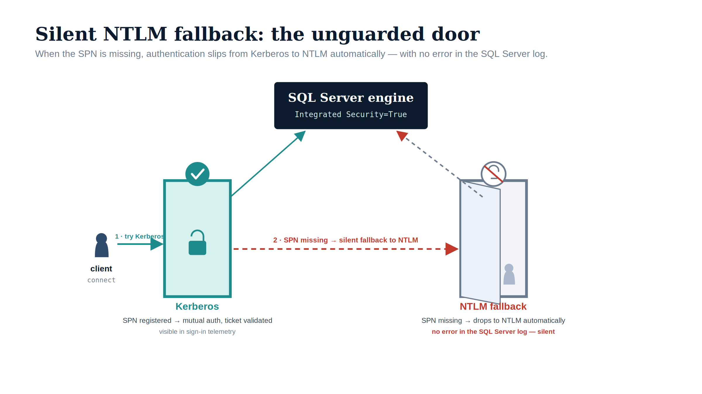
Figure 1: Silent NTLM fallback: when the SPN is missing, the connection slips through the unguarded NTLM door — with no error in the SQL Server log.

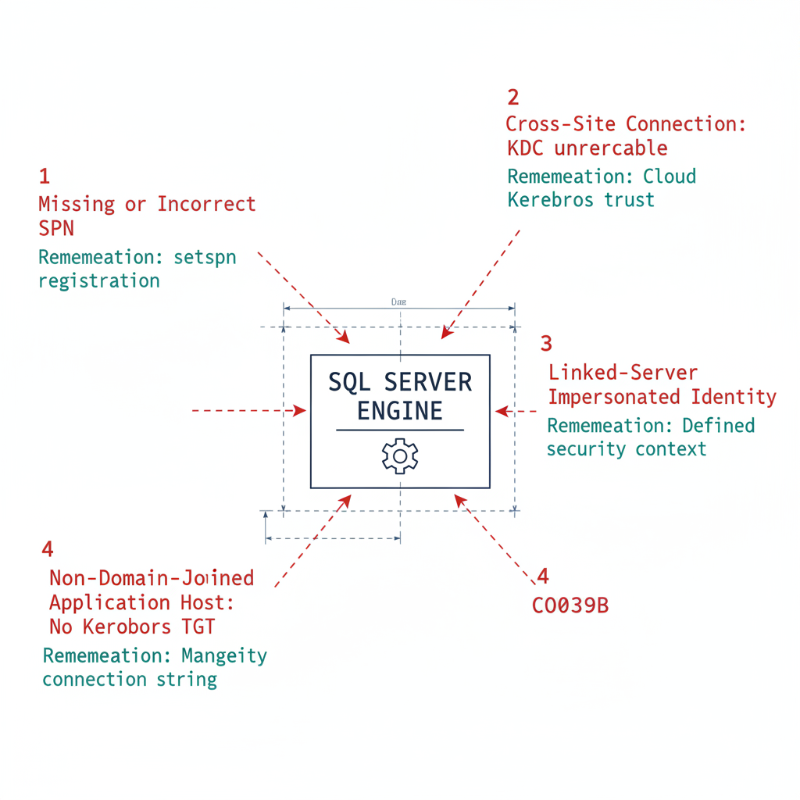
Figure 2: The four SQL Server connection patterns that generate NTLM traffic, each with its distinct root cause and remediation path

NTLMv1: Blocked First, in Phase B
NTLMv1 is the older of the two NTLM variants, and it carries well-documented cryptographic weaknesses that make it unsuitable for any authenticated environment. The NTLMv1 challenge-response uses an MD4 hash of the user’s password as the response key, which is vulnerable to pass-the-hash attacks.
An attacker who captures the NTLMv1 response can mount an offline dictionary attack against the MD4 hash, and can replay the captured hash to authenticate as the victim without ever learning the plaintext password. NTLMv1 also provides no session signing, so a network attacker positioned between the client and the server can modify data in transit without detection.
ADR-068 blocks NTLMv1 in its Phase B “block-where-safe” stage — by default immediately upon completion of the Phase A assessment, with the implementation plan targeting 2026-Q3 — implemented through Group Policy. The “Network Security: LAN Manager Authentication Level” policy is set to “Send NTLMv2 response only; refuse LM and NTLM.” Once that policy is in force, any connection attempt that generates LM or NTLMv1 authentication traffic is refused inside the Windows security subsystem — the Local Security Authority (LSA) negotiates only NTLMv2, and the server rejects the weaker protocols. This puts the program slightly ahead of Microsoft’s own NTLMv1 enforcement, which flips the BlockNTLMv1SSO default from Audit to Enforce via Windows Update in October 2026 for devices without an explicit policy; the program’s Group Policy makes the block deterministic rather than waiting for the platform default. (ADR-068)
In a modern SQL Server environment, NTLMv1 should not appear in any connection. SQL Server clients and servers running on Windows Server 2016 or later, with default security configuration, do not generate NTLMv1 traffic. It surfaces only in environments with very old clients — Windows 7 and earlier — or with applications that have explicitly configured LM or NTLM rather than NTLMv2 as the authentication protocol.
If the Spec3-D1.8 audit or the Phase A network-traffic analysis reveals NTLMv1 in SQL Server connection traffic, it is a critical finding that requires immediate remediation regardless of the broader migration timeline. NTLMv1 in a production SQL Server connection stream is a significant security vulnerability and a compliance violation under ADR-068, and it cannot be treated as a routine migration item.

NTLMv2: The Elimination Phase
NTLMv2 is the current NTLM variant, and it addresses the cryptographic weaknesses of its predecessor. It uses HMAC-MD5 rather than MD4, incorporates a client challenge in addition to the server challenge to prevent replay attacks, and supports session signing. NTLMv2 is the variant that most SQL Server NTLM traffic in a modern federal environment will be generating.
Unlike NTLMv1, NTLMv2 is not removed in Phase B. ADR-068 restricts it via Group Policy to documented exception groups during Phase B, but full disablement waits for the elimination phase — Phase C — which is applied as operational readiness allows. The phased timeline exists to give programs the operational space to identify and remediate NTLMv2-generating connection patterns before the block is applied.
That space narrows with each release as Microsoft tightens defaults, and the program must maintain forward momentum. ADR-068’s elimination phase applies domain-wide NTLM restrictions program-wide — the program’s own NTLM-elimination step, timed to complete ahead of Microsoft’s progressive default-disable. SQL Server NTLMv2 connections must be migrated either to Kerberos as an interim posture — using Cloud Kerberos trust per ADR-068 (Cloud Kerberos trust) — or to Entra ID OAuth 2.0 authentication as the final destination. (ADR-068)

Pattern One: Missing or Incorrect SPN
The most common cause of NTLM fallback in SQL Server connections is a missing or incorrect SPN registration. When a client opens a connection using Windows Integrated Security, SSPI checks whether a valid SPN exists for the SQL Server endpoint. If the SPN is missing from the service account’s AD object, SSPI cannot negotiate Kerberos and falls back to NTLM.
The SPN must take the form MSSQLSvc/hostname.domain.com:port and must be registered on the service account that the SQL Server engine process runs under. Named instances use the named-instance format, MSSQLSvc/hostname.domain.com:instancename, in addition to the port format.
If the service account has been changed without updating the SPN registration — a common occurrence during service-account migration — the SPN may exist but be registered on the wrong account, which produces the same NTLM fallback. SPN remediation is straightforward: setspn -S MSSQLSvc/hostname.domain.com:port serviceaccount. The Spec3-D1.8 audit captures SPN registration status for every instance, and any instance with a missing or incorrect SPN is a discovery-phase finding that can be remediated independently of the broader login migration.

Pattern Two: Cross-Site Connections
SQL Server connections that originate from a client in one Active Directory site and target a server in a different AD site can generate NTLM traffic if the client cannot reach the KDC in the server’s site. Kerberos requires the client to obtain a service ticket from the KDC that is authoritative for the server’s service-account domain.
If the client’s network path to the server-site KDC is blocked or unreliable, SSPI falls back to NTLM. In a distributed federal environment with multiple AD sites across geographic locations and network boundaries, this pattern is not uncommon.
Cross-site NTLM is detectable from the Phase A audit output by correlating connection source and destination network topology. If the source host and the destination SQL Server host are in different AD sites, and the connection is generating NTLM traffic, the likely cause is KDC accessibility from the source site. The remediation is either to ensure KDC reachability from all client sites — adjusting firewall rules for Kerberos traffic on UDP and TCP port 88 — or to implement Cloud Kerberos trust, which satisfies Kerberos authentication through the Azure cloud KDC rather than the on-premises AD site KDC, per ADR-068 (Cloud Kerberos trust).

Pattern Three: Linked-Server Passthrough Authentication
Linked-server definitions in SQL Server — which allow one instance to query another using OPENQUERY or four-part name syntax — frequently use Windows passthrough authentication as the mechanism for the linked-server connection. In the passthrough model, the originating instance impersonates the connecting client’s Windows identity and presents that identity to the target SQL Server using NTLM.
This happens because the originating server, acting as an intermediary, typically cannot negotiate Kerberos for the impersonated identity without Kerberos delegation configured. Kerberos constrained delegation for linked-server passthrough is a known pattern but requires specific AD configuration; in its absence, linked-server passthrough generates NTLM traffic.
Linked-server NTLM is particularly insidious because it often appears in monitoring as “internal” database traffic and is not always visible in standard SQL Server connection audits. It requires examination of the sys.linked_logins and sys.servers views as well as network-traffic analysis between instances. Any linked-server definition that uses passthrough authentication must be identified during discovery and migrated to a defined security context — a specific login or Managed Identity — during the restriction phase.

Pattern Four: Non-Domain-Joined Application Hosts
Any application running on a host that has been migrated to a non-domain-joined state — as part of the ADR-002 server transformation — but still connecting to SQL Server using Windows Integrated Security will generate NTLM traffic. A non-domain-joined host has no Kerberos TGT from the KDC and cannot negotiate Kerberos for SQL Server connections. SSPI falls back to NTLM using local credentials when the application host is in a workgroup.
This pattern becomes more prevalent as the ADR-002 server migration progresses. As more application servers are domain-unjoined, the applications running on them that still use Windows Integrated Security become new NTLM sources. This is a strong operational argument for completing the SQL Server connection-string migration in parallel with, or before, the domain unjoin of application hosts.
An application host that has been domain-unjoined and whose connection string uses Managed Identity authentication generates no NTLM traffic and is fully compliant with both ADR-002 and ADR-068. An application host that has been domain-unjoined but whose connection string still uses Windows Integrated Security is now an NTLM source that did not exist before the domain unjoin. (ADR-002, ADR-068)
Division of labor
Microsoft provides: the LAN Manager Authentication Level policy for NTLMv1 blocking; Windows event log NTLM auditing (events 4624 and 4625); Defender for Identity NTLM signals; the product deprecation timeline.
What only you can provide: the four connection-pattern classification across your estate — missing SPN, cross-site KDC unreachability, linked-server passthrough, ADR-002 domain-unjoin interaction; the SPN corrections, KDC routing fixes, linked-server migrations, and connection-string updates that each pattern class requires.

What Book 06 establishes — Chapter 1
NTLM is a protocol, not a setting, so there is no single switch that removes it from SQL Server connections. NTLMv1 is blocked early — in ADR-068’s Phase B, through the LAN Manager Authentication Level policy — and should never appear in a modern estate; NTLMv2 is restricted to exception groups in Phase B and fully blocked at the Phase C elimination step, applied ahead of Microsoft’s progressive NTLM default-disable (ADR-068). Four connection patterns generate NTLM at the SQL layer — a missing or incorrect SPN, cross-site connections where the KDC is unreachable, linked-server passthrough authentication, and non-domain-joined application hosts created by the ADR-002 transformation — and each must be detected before it can be remediated.

The Three Phases of NTLM Elimination for SQL Server

Chapter 2 — The Three Phases of NTLM Elimination for SQL Server
Discover, restrict, eliminate — the same phase structure ADR-068 applies program-wide, applied specifically to SQL Server workloads.
In this chapter
How ADR-068’s three-phase structure applies to SQL Server: Phase A discovery using Spec3-D1.8 alongside Windows event-log NTLM analysis, Phase B restriction that converts NTLM connections to Kerberos and migrates the remaining patterns, and Phase C elimination applied ahead of Microsoft’s progressive NTLM default-disable — and why an instance migrated to Entra ID logins is immune to that block because it was never generating NTLM in the first place.

ADR-068 structures NTLM elimination into three phases — discover, restrict, eliminate — and this chapter applies that structure specifically to SQL Server workloads. The phases are sequential, and the elimination phase is applied as operational readiness allows — ahead of Microsoft’s progressive NTLM default-disable, not waiting for a fixed calendar date.
Once the elimination phase is applied, any SQL Server connection that requires NTLM will fail at the LSA layer — inside the host’s Windows security subsystem, where the Local Security Authority (LSA) enforces the policy. The SQL Server engine will not receive an authenticated connection; the NTLM exchange is rejected by the LSA before the engine evaluates the login. SQL Server NTLM elimination is therefore not decoupled from the broader ADR-068 posture. Every NTLM-generating connection pattern must be resolved before the elimination phase, not after. (ADR-068)
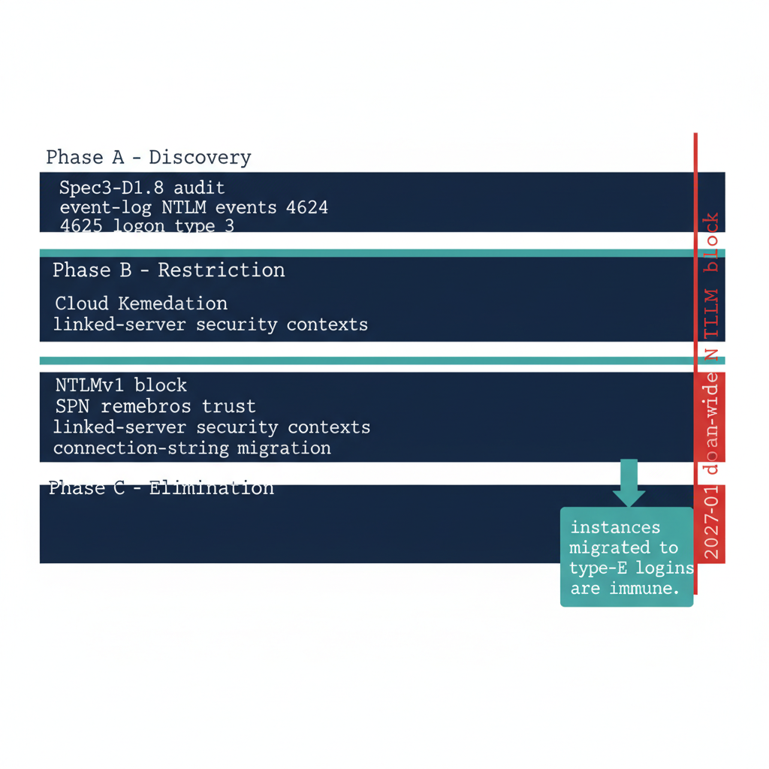
Figure 1: The three NTLM-elimination phases for SQL Server — discover, restrict, eliminate — sequenced ahead of Microsoft’s progressive NTLM defaults

Phase A — Discovery
The discovery phase is ADR-068’s first phase, and for SQL Server its primary instrument is Spec3-D1.8. The Phase A output for SQL Server includes the full instance inventory with Arc-eligibility classifications, the login-type inventory, the SPN registration status for every instance, and the service-account identity for each engine process.
Network-traffic analysis supplements the script output by capturing actual NTLM authentication events in the Windows event log. The relevant events are Event IDs 4624 and 4625 — logon success and failure — with logon type 3, the network logon type, and authentication package NTLM, filtered to events where the target server is a SQL Server host.
The combination of the audit-script output and the event-log analysis produces a complete picture of NTLM-generating SQL Server connection patterns across the estate. That Phase A output is ingested by CCM-BIR as the baseline record from which all subsequent phases measure progress.

Phase B — Restriction
The restriction phase applies controls that reduce NTLM traffic without eliminating it entirely. The restrictions create pressure on connection patterns to migrate while preserving operational continuity. The primary Phase B control for SQL Server is NTLMv1 blocking, combined with Kerberos remediation for the missing-SPN cases.
SPN registration is corrected for all instances with missing or incorrect SPNs, converting those connections from NTLM to Kerberos. Cloud Kerberos trust is deployed per ADR-068 (Cloud Kerberos trust) for cross-site connection patterns where on-premises KDC reachability cannot be guaranteed. Linked-server definitions using passthrough authentication are migrated to defined security contexts. Application connection strings on recently domain-unjoined hosts are migrated to Managed Identity or service-principal authentication.
After Phase B, the only remaining NTLM-generating SQL Server connections should be those that require the elimination phase’s block to remove. These are typically applications that cannot be modified before Phase C is applied, which become exception cases requiring formal exception documentation per ADR-068. (ADR-068)

Phase C — Elimination
The elimination phase disables NTLM across the estate. Group Policy pushed domain-wide restricts NTLM authentication at the LSA layer on every host, and any connection that cannot negotiate an alternative protocol fails. For SQL Server, Phase C is only safe to implement after the login migration of Book 04 has been completed for every instance in the estate.
An instance whose connections have been migrated to Entra ID OAuth 2.0 tokens generates no NTLM traffic at all. The SQL Server engine does not use NTLM or Kerberos for type-E login connections. An instance that has completed the login migration is therefore immune to Phase C — it was not generating NTLM before the block, and it is not affected by the block after.
The sequencing imperative is clear: complete the SQL Server login migration before Phase C is applied. Phase C applies as dependencies are remediated, and the SQL Server login migration must be complete for every production instance in the estate before that step is taken. (ADR-068)
Division of labor
Microsoft provides: the NTLM enforcement controls for each phase; Windows event log analysis instrumentation; the 2027/2028 platform-level network block that arrives regardless.
What only you can provide: the discovery/restriction/elimination phase sequencing; the instance-by-instance rollout with defined rollback procedures; the login migration that must be complete before Phase C is applied — because the block does not wait for unresolved dependencies.

What Book 06 establishes — Chapter 2
ADR-068 elimination runs in three phases for SQL Server. Discovery uses Spec3-D1.8 plus Windows event-log analysis of NTLM events 4624 and 4625 at logon type 3 to baseline every NTLM-generating pattern. Restriction blocks NTLMv1, remediates SPNs, deploys Cloud Kerberos trust, migrates linked-server security contexts, and updates connection strings on domain-unjoined hosts. Elimination applies the domain-wide NTLM block as dependencies are remediated, ahead of Microsoft’s progressive NTLM default-disable — and any instance migrated to type-E Entra ID logins is immune, because it never generated NTLM to begin with.

Book_07 — Access Control: Groups, Roles, and the Entra Perimeter
  - What Microsoft’s Group Model Provides — and the Access Classification Only You Can Design

Book_07 — Access Control: Groups, Roles, and the Entra Perimeter
Note
The migration changes the identity authority for SQL Server’s groups from Active Directory to Entra ID, but it does not eliminate group-based access control — it transforms the group lifecycle. Where an AD group required a helpdesk ticket, an OrgPath-driven dynamic Entra group updates itself as HR data changes. The governance dividend is Conditional Access as the outer perimeter. (ADR-036, ADR-067, ADR-037)

Download this book
Book_07-bundle.docx — every chapter of this book concatenated into one Word document. Regenerated on every site deploy.

Chapters
Continue the series
← Previous: Book 06 — Eliminating NTLM at the SQL Layer · Index · Next: Book 08 — The Application Chain →

AD Group Types and the Entra Perimeter
OrgPath examples in this chapter predate Hybrid-C+Path
The dynamic-group rule examples below use the retired Model A/B form — the whole OrgPath as one composite string in a single slot. ADR-078 replaced that with named facets (extensionAttribute1 is the region facet), and ADR-127 moved the derived canonical path to extensionAttribute15. A subtree rule reads (user.extensionAttribute15 -startsWith "Region=NCR|Department=Finance|") — anchored at Region=, because the derived path is composed region, department, division in that order, and with the trailing delimiter, which is mandatory. A rule for “all of Finance, in every region” is not a subtree at all: it is the facet predicate (user.extensionAttribute2 -eq "Finance").
The examples are retained as written because the pattern they teach — OU-derived groups become dynamic groups keyed on organizational attributes — is unchanged. Do not copy the slot numbers or value shapes; the authoritative map is codebook.yaml.

Chapter 1 — AD Group Types and the Entra Perimeter
The group-based access model survives the migration; its lifecycle and its outer boundary do not.
In this chapter
How the four canonical AD-to-Entra group types of the ADR-067 rationalization framework map onto SQL Server roles, why an OrgPath-driven dynamic security group replaces the helpdesk-ticket membership model, how the mail-enabled security group splits into two Entra objects, why Conditional Access becomes a binary outer perimeter that covers every type-E SQL Server connection and none of the Windows ones, and why that binary is a governed steady state rather than a false dichotomy — with compensating controls accommodated as time-bound exceptions, not co-equal destinations.

The access control model for SQL Server has historically lived entirely inside SQL Server: server-level roles, database-level roles, and the AD security groups mapped to them. The migration from AD-backed Windows logins to Entra-backed type-E logins changes the identity authority for those groups from Active Directory to Microsoft Entra ID, but it does not eliminate the group-based pattern itself.
What changes is the group lifecycle. Where an AD security group required a helpdesk ticket to add or remove a member, an Entra dynamic security group whose membership rule references OrgPath attributes updates itself continuously as HR data changes. The DBA manual cycle — grant access, verify access, revoke access — is replaced by an attribute-driven policy that requires no DBA action for routine changes.
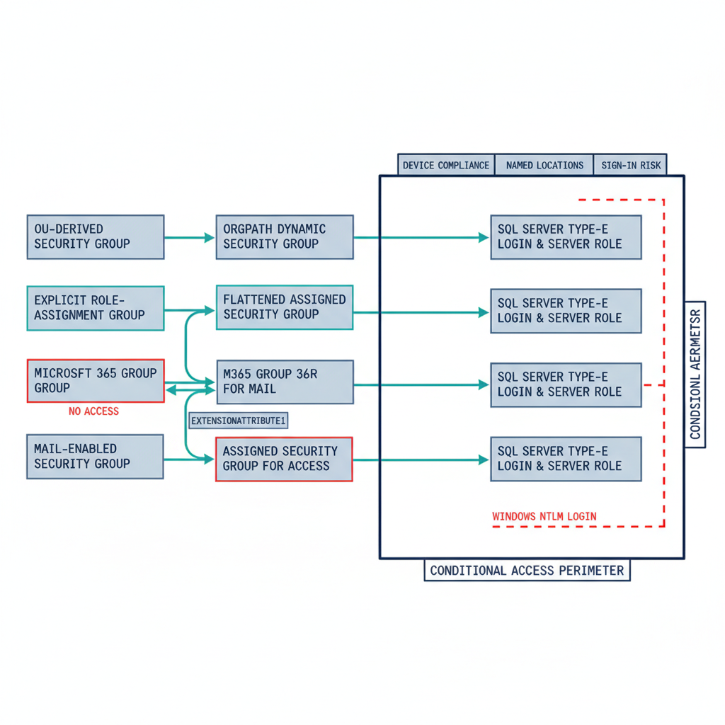
Figure 1: The four ADR-067 group types mapping to Entra group targets and SQL Server type-E logins, with Conditional Access as the binary outer perimeter
ADR-067 classifies every migrating AD security group into exactly one of four canonical types, each with a defined Entra target and transformation pattern. The remainder of this chapter walks those four types, maps each to its SQL Server consequence, and then turns to the perimeter the completed migration enables. (ADR-036, ADR-067, ADR-037)

Type 1 — OU-Derived Security Groups Become OrgPath Dynamic Groups
The first ADR-067 type is the security group used for OU-derived access: groups that exist because users in a given organizational unit needed access to a SQL Server database or server role. In the AD world these are typically named for the unit they serve — OU-DEPT-DBA-PROD — and members are added by organizational position.
ADR-067 maps this type to the dynamic-group pattern that ADR-036 defines. In Entra ID these become dynamic security groups whose membership rule references OrgPath attributes, expressing the organizational logic that was previously encoded in the group name and maintained by hand. A rule such as (user.extensionAttribute5 -eq "ORG/DEPT/TEAM") -and (user.jobTitle -contains "DBA") admits any principal whose OrgPath attribute matches and whose title contains “DBA,” automatically and continuously.
OrgPath attribute values are populated by the OrgPath Narrative’s HR-data synchronization pipeline; they are not manually managed. Migrating a Type 1 group therefore requires two things: confirming the OrgPath attribute infrastructure is in place — a dependency on the OrgPath Narrative — and authoring the dynamic membership rule that correctly expresses the original group’s organizational logic. (ADR-036)

Type 2 — Explicit Role-Assignment Groups
Type 2 groups exist specifically to grant a named role or permission on SQL Server — PROD-SQL-SYSADMIN, DB-REPORTING-READONLY. They carry no organizational-derivation logic; members are added explicitly because they need the specific permission. In Entra ID these become flat assigned security groups: no dynamic rule, membership managed by direct assignment, and — per ADR-067 — flattened, with no nested transitive groups carried over.
The difference from the AD equivalent is in the maintenance model. Modifying membership of an assigned Entra security group requires an Entra role assignment — User Administrator scope, or a delegated role within an Administrative Unit per ADR-037 — rather than a helpdesk ticket to an AD administrator. That is the governance improvement.
The migration itself is operationally straightforward: create the Entra security group, populate it with the AD group’s members, create the SQL Server type-E login for the Entra group, and validate. The process is simple; the improvement is in the ongoing model, which Chapter 2 shows depends on the Administrative Unit being provisioned first. (ADR-037)

Type 3 — Distribution Lists for SQL Server Agent Notifications
Type 3 groups are not access control groups at all — they are routing artifacts. SQL Server Agent jobs can send completion and failure notifications to an email address, and many environments have used AD distribution lists, mail-enabled groups with security disabled, as the target.
In Entra ID, ADR-067 maps a distribution list to a Microsoft 365 Group with securityEnabled: false — mail-only, and explicitly never used for access control. Migrating a Type 3 group is an email-routing migration, not a SQL Server access control migration. The SQL Server Agent operator definition that holds the notification address must be updated to reference the new M365 Group’s email.
No SQL Server login is created for a Type 3 group, because it carries no access role. The ADR-067 classification makes this exclusion explicit: distribution lists are removed from the login migration and handled on the mail-routing path instead. (ADR-067)

Type 4 — Mail-Enabled Security Groups Split in Two
Type 4 is the most complex case: a single group that is both a security group, used for SQL Server access, and mail-enabled, used for Agent notifications. ADR-067 specifies a two-object pattern. The one mail-enabled security group is split into an M365 Group for mail routing — taking the email address and the distribution membership — and an assigned Entra security group for access — taking the security membership and the SQL Server role.
The two objects are correlated by an OrgPath extension attribute so the organizational relationship between them is preserved and a future engagement can re-correlate them. The SQL Server login is created against the security group; the Agent operator is pointed at the M365 Group’s email.
The operational result is identical to the original — the right people get access, the right people get job notifications — but the model is cleaner, because the access group and the mail group now have independent lifecycles. ADR-067 accepts the cost: the split doubles the migration object count for this class, and every split is recorded in the migration audit with its correlation attribute. (ADR-067)

Conditional Access as the Outer Perimeter
The architectural dividend of completing the access control migration is that Conditional Access — a Microsoft Entra capability, not a SQL Server feature — becomes the outer perimeter for all SQL Server access. When every login is a type-E login backed by an Entra principal, every connection attempt requires an Entra access token, and every token request passes through Conditional Access evaluation before the token is issued.
A DBA connecting from a device that is not registered in Entra ID, or registered but out of compliance with the device policy, receives a token denial; the connection never opens. A DBA connecting from a network address outside the program’s Named Locations is denied. A DBA whose sign-in risk is elevated to “high” by Entra ID Protection — an unusual location, or a credential flagged in a breach report — is denied or challenged for remediation.
None of these controls exist in the Windows Authentication model, and none apply to a type-U or type-G login backed by an AD principal. The perimeter is binary: it covers all connections or it covers none, because a single Windows-backed login is a bypass path around every Conditional Access control. This is the zero-trust posture the program’s boundary requires, with continuous verification replacing the perimeter trust of the domain-joined world. (ADR-091)

The Binary Perimeter Is Not a False Binary
A reviewer is right to interrogate the word binary, and the claim deserves a precise defense. The assertion is not that no other control can touch a surviving Windows or SQL-Authentication login — it is that no other control delivers the same assurance, which is why ADR-091 §4 treats every such login as a time-bound exception rather than a co-equal steady state.
The compensating controls a skeptical panel will raise are real and worth naming. A privileged-access workstation (PAW) or Azure Bastion constrains where an administrative connection originates. Network segmentation and host firewalls constrain which hosts can reach the instance. Just-in-time elevation through Privileged Identity Management, and credential vaulting through a privileged-access-management (PAM) system, constrain when a standing credential is live and who can check it out. Each reduces the exposure of a Windows-backed login, and each is appropriate during the migration window.
What none of them provides is identity-conditioned, continuous, per-connection evaluation. A bastion host authorizes the jump, but the SQL connection that leaves it still authenticates with Kerberos or NTLM beneath the Entra plane — the device-compliance state, the sign-in-risk signal, and the MFA freshness that Conditional Access evaluates at token issuance, on every connection are invisible to it. Network controls are perimeter controls: they do not travel with the identity, they do not re-evaluate as risk changes mid-session, and the credential itself stays outside the Entra plane, where Defender for Identity cannot correlate it. A PAM vault still hands out a credential that, once retrieved, authenticates without any of those checks.
This is why ADR-091 §4 does not forbid the compensating-control posture — it governs it. A login that cannot yet move to the Entra plane is permitted only as a documented exception carrying the inability-to-migrate reason, a named compensating control, and a sunset date; where a connection genuinely cannot reach Kerberos or Entra OAuth as dependencies are remediated, Certificate-Based Authentication is the authorized interim posture per ADR-068. Compensating controls are the governed bridge across the migration window, not an equivalent destination. The steady state remains binary because the assurance the program’s boundary requires — OMB M-22-09 phishing-resistant, Conditional-Access-conditioned access, operationalized through AC-17 and IA-2 — is achievable only when the credential SQL Server accepts is the Entra token the policy controls. (ADR-091, ADR-068)
Division of labor
Microsoft provides: Entra ID security groups; Entra Connect sync for AD group projection; the dynamic group membership engine; Conditional Access as the binary outer perimeter once every login is Entra-backed.
What only you can provide: the ADR-067 four-type classification for every migrating AD group; the OrgPath-driven dynamic group design; the two-object split for mail-enabled security groups; the compensating-control documentation for any login that cannot yet reach the Entra plane (ADR-068 CBA as interim posture).

What Book 07 establishes — Chapter 1
The ADR-067 rationalization framework classifies every migrating AD security group into one of four canonical types: OU-derived groups become OrgPath-driven dynamic security groups (ADR-036); explicit role-assignment groups become flattened assigned security groups; distribution lists become mail-only Microsoft 365 Groups with no access role; and mail-enabled security groups split into a two-object pattern — an M365 Group for mail plus an assigned security group for access, correlated by an OrgPath attribute. The access-bearing types map to SQL Server type-E logins, and once every login is Entra-backed, Conditional Access becomes a binary outer perimeter — device compliance, Named Locations, and sign-in risk — that a single surviving Windows login would entirely bypass. That binary is the steady-state target, not a false dichotomy: ADR-091 §4 accommodates compensating controls (PAW/bastion, segmentation, JIT, PAM) only as documented, sunset-dated exceptions, with Certificate-Based Authentication as the authorized interim posture for connections that cannot yet reach the Entra plane (ADR-068).

Administrative Unit Delegation for SQL Server DBA Teams

Chapter 2 — Administrative Unit Delegation for SQL Server DBA Teams
Scoped authority over the groups that control SQL access, without tenant-wide rights.
In this chapter
How the Entra Administrative Unit provides the scoped delegation a DBA team needs to manage the Entra groups behind SQL Server access without holding tenant-wide identity rights, why the AU boundary should be aligned to OrgPath so the delegation boundary and the access boundary stay coherent, and why provisioning the AU is a prerequisite for the explicit role-assignment group migration of Chapter 1.

Chapter 1 left an open question. The explicit role-assignment groups — the Type 2 groups that grant named SQL Server roles — move their maintenance model from a helpdesk ticket against Active Directory to an Entra role assignment. But granting a DBA team lead tenant-wide User Administrator rights to manage a handful of SQL access groups would trade one governance problem for a worse one. The Administrative Unit is the mechanism that resolves it.
The Entra Administrative Unit, governed by ADR-037, is a management boundary that scopes a role assignment to a subset of Entra objects rather than the whole tenant. A DBA team’s AU contains the Entra security groups mapped to the SQL Server roles within that team’s scope of ownership, and a role assignment — User Administrator scoped to that AU — lets the team lead add and remove members of those groups and nothing else. (ADR-037)
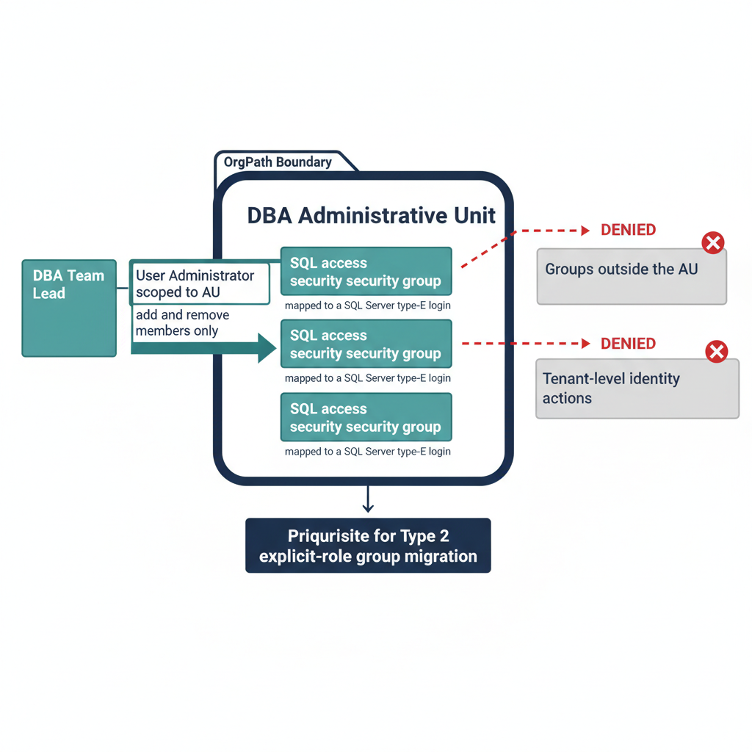
Figure 1: An OrgPath-aligned Administrative Unit scoping DBA delegation to the SQL access groups it owns, with tenant-wide actions denied
The value of the AU is precisely that it confers no other power. The role-eligible assignment scoped to the DBA AU carries no ability to modify groups outside the AU and no ability to perform any tenant-level identity action. Least privilege stops being an aspiration the DBA team is trusted to honor and becomes a boundary the directory enforces.

Aligning the AU Boundary to OrgPath
The SQL Server DBA AU boundary should be aligned to OrgPath. The AU contains the groups whose dynamic membership rules or explicit assignments correspond to the organizational boundary the DBA team owns, so the delegation boundary and the access boundary describe the same scope rather than drifting apart.
If a DBA team owns a specific application portfolio, its AU contains the groups governing access to the SQL Server instances that support that portfolio. If the team is organized geographically, the AU corresponds to the geographic OrgPath dimension. Either way, the AU is drawn from the same OrgPath model that drives the dynamic groups of Chapter 1, not invented as a separate management construct.
This alignment is what keeps the model coherent. The DBA team that manages access to a set of SQL Server instances also manages the Entra groups that control that access, and those groups are scoped to the AU that matches the team’s organizational position. The authority a team holds and the systems it is responsible for are, by construction, the same set. ADR-037 enforces this through its cross-canon integrity checks, which reject an AU whose referenced groups or OrgPath values do not resolve to live canon. (ADR-037)

AU Provisioning as a Migration Prerequisite
Administrative Unit provisioning for DBA teams is not an optional refinement layered on after the group migration; it is a prerequisite for the Type 2 explicit role-assignment migration described in Chapter 1. A Type 2 group can only be managed under appropriate delegation after the AU is provisioned and the scoped role assignment is in place.
The sequencing follows from that dependency. The AU is created and confirmed restricted — ADR-037 pins the restricted-management invariant so the AU cannot be created in a form that lets a Global Admin bypass the division-level delegation. The scoped role assignment is then established for the DBA team lead. Only then can the explicit role-assignment groups be created, populated, and bound to their SQL Server type-E logins under the delegated authority rather than under tenant-wide rights.
Provisioning the AU before the groups it will hold also avoids a transitional window in which the new Entra groups exist but can only be managed by a tenant-wide administrator — the precise concentration of privilege the whole exercise is meant to remove. The AU comes first; the Type 2 groups land inside an already-scoped boundary. (ADR-037)
Division of labor
Microsoft provides: the Administrative Unit object and scoped role assignment mechanism; the Groups Administrator role scopable to AU; the audit log for AU-scoped administrative actions.
What only you can provide: the AU structure design aligned to OrgPath (so the delegation boundary and the access boundary describe the same scope); the scoped delegation for DBA teams; the provisioning sequence — AU before groups — that eliminates the tenant-wide privilege window.

What Book 07 establishes — Chapter 2
The Entra Administrative Unit (ADR-037) gives DBA teams scoped authority over the Entra security groups that control SQL Server access without tenant-wide User Administrator rights: a role assignment scoped to the AU lets a team lead manage members of the groups inside it and nothing else. The AU boundary should be aligned to OrgPath so the delegation boundary and the access boundary describe the same scope, and ADR-037’s restricted-management invariant and cross-canon integrity checks keep that alignment enforced. Provisioning the AU is a prerequisite for the Chapter 1 explicit role-assignment group migration — the AU and its scoped delegation must exist before those groups can be managed under least privilege rather than tenant-wide rights.

Book_08 — The Application Chain: LDAP-Bound and SQL-Consuming Applications
  - What Microsoft’s Application Identity Model Provides — and the Chain Inventory Only You Can Build

Book_08 — The Application Chain: LDAP-Bound and SQL-Consuming Applications
Note
An upstream application that has migrated its user authentication to Entra ID but still uses a SQL Authentication service account to reach the database has not completed its transformation. The application chain must be addressed as a complete authentication path, not as independent layers. (ADR-069, Spec3-D1.9)

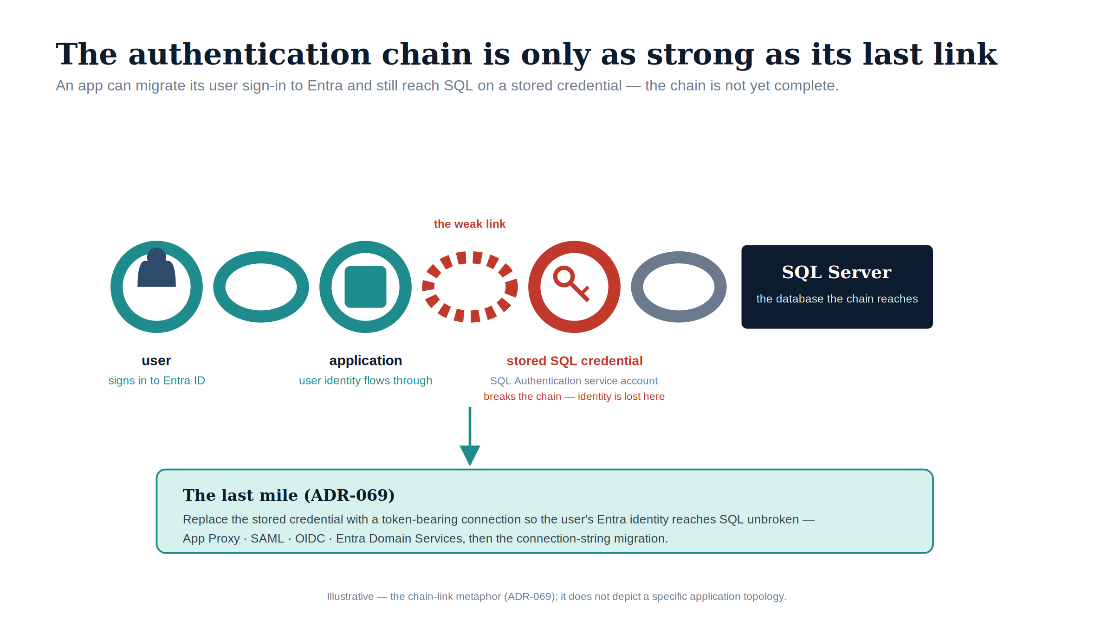
Figure 1: The authentication chain is only as strong as its last link: an app can migrate its user sign-in to Entra and still reach SQL on a stored credential, leaving the chain incomplete.

Download this book
Book_08-bundle.docx — every chapter of this book concatenated into one Word document. Regenerated on every site deploy.

Chapters
Continue the series
← Previous: Book 07 — Access Control · Index · Next: Book 09 — The Transformed Posture →

The Four-Class Pattern Applied to SQL-Consuming Applications

Chapter 1 — The Four-Class Pattern Applied to SQL-Consuming Applications
The application is the other half of the authentication chain — and it has its own AD dependency to remove.
In this chapter
Why SQL Server’s authentication transformation is incomplete until the upstream applications that consume it are addressed, how ADR-069’s four-class taxonomy categorizes those applications by modernization capability, what each class means for both the user-authentication track and the SQL-connection track, and how Spec3-D1.9 produces the per-application classification data that drives the triage.

SQL Server does not exist in isolation. In every federal environment of meaningful size, it is the data layer downstream of a middleware tier — web application servers, API backends, reporting services, ETL pipelines, and legacy integration systems. Those middleware applications carry their own authentication architecture, and in many federal environments that architecture includes LDAP binding: the application binds to Active Directory as a directory authority, queries group membership or user attributes, and treats AD as its authorization source.
The same AD dependency that must be removed from SQL Server’s authentication layer must also be removed from those upstream applications, and the removal must be coordinated. An application that has migrated its user authentication to Entra ID OIDC but still uses a SQL Authentication service account to reach SQL Server has not completed its transformation. The application chain must be addressed as a complete authentication path — user to application to database — not as independent layers.
ADR-069 (LDAP-Dependent Application Migration), accepted 2026-05-13, provides the four-class taxonomy for categorizing upstream applications by modernization capability, in a strict preference order: Class 3 (OIDC) preferred, then Class 2 (SAML), then Class 1 (App Proxy), then Class 4 (Entra Domain Services) as the last resort. Spec3-D1.9 (Get-LDAPBindAccountInventory.ps1) is the discovery instrument that produces the per-application classification data this chapter depends on. (ADR-069, Spec3-D1.9)
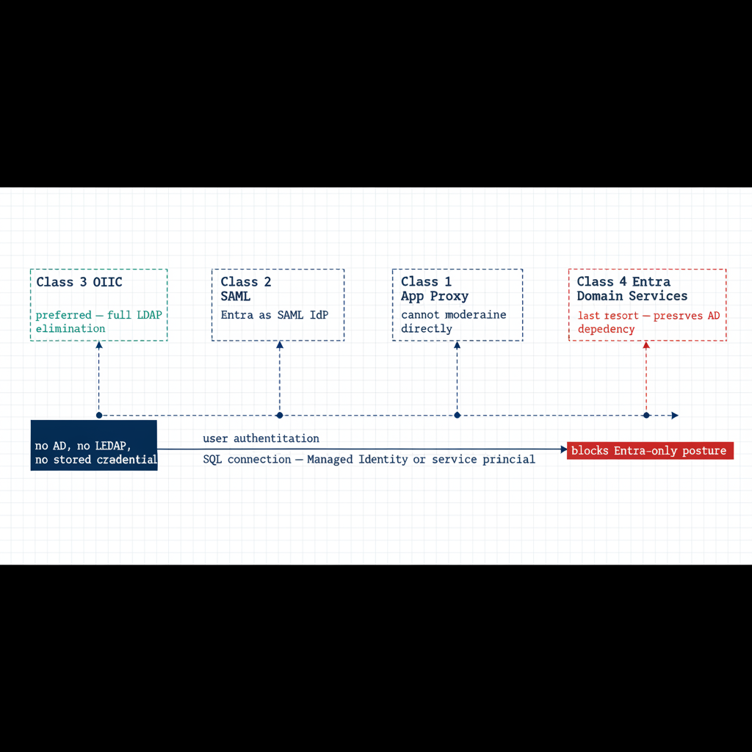
Figure 1: The four application classes in ADR-069 preference order and the two migration tracks each one carries

Class 1 — App Proxy: Cannot Be Modernized Directly
Class 1 applications cannot modify their authentication mechanism. They bind to LDAP for user authentication, and the dependency is architectural — embedded in unmaintainable code, supplied by a vendor with no modern auth option, or frozen by a regulatory certification that prevents code modification. For SQL Server, Class 1 applications typically connect using an AD service-account credential stored in a connection string or configuration file.
The Class 1 migration pattern has two independent tracks. The user-authentication track deploys Entra Application Proxy in front of the application: the App Proxy connector fronts the application’s user authentication behavior without modifying the application itself. The SQL-connection track migrates the application’s database credential from a SQL Authentication service account to a service principal or Managed Identity — a change made in the connection string or configuration, not in code, and independent of the user-authentication track. Both tracks must complete before the application’s contribution to the SQL Server transformation is fulfilled. (ADR-069)

Class 2 — SAML: Federated Identity but Not OIDC
Class 2 applications support SAML federation but not OIDC. SAML 2.0 is an XML-based federation protocol that predates OIDC and is common in federal environments because many enterprise applications implemented SAML support before OIDC was standardized. For Class 2 applications, Entra ID becomes the SAML Identity Provider per ADR-051. The user’s authentication is modernized — they authenticate to Entra ID using their Entra credentials, Entra issues a SAML assertion, and the application validates the assertion and grants access — but the protocol is SAML, not OIDC.
The SQL-connection track for Class 2 follows the same pattern as Class 1: the connection string migrates from SQL Authentication or Windows Integrated Security to Managed Identity or service-principal authentication. The user-authentication modernization and the SQL-connection migration are separate tracks and can be sequenced independently. ADR-069 places Class 2 second to Class 3 because SAML eliminates the LDAP dependency rather than proxying through it, yet ranks below OIDC because it does not provide the full capability set of a modern identity protocol. (ADR-069, ADR-051)

Class 3 — OIDC: The Preferred Destination
Class 3 is the preferred migration destination in ADR-069’s ordering. An OIDC-capable application can migrate fully to Entra ID as its identity provider, eliminating the LDAP dependency entirely. The application redirects the user to the Entra ID authorization endpoint, the user authenticates with Entra credentials, Entra issues an ID token and an access token, and the application uses the claims in those tokens for identity and authorization. No LDAP bind occurs, and no AD query occurs.
The application’s SQL Server connection also uses Managed Identity or service-principal authentication, with no stored credential. The end-to-end chain for a Class 3 application reaching SQL Server is direct: the user authenticates to Entra ID via OIDC, the application uses its Managed Identity to authenticate the SQL connection, SQL Server validates the Managed Identity token through the Arc-provided token-validation infrastructure, and the connection is established. There is no AD in this path, no LDAP, no NTLM or Kerberos, and no stored credential. This is the target architecture. (ADR-069)

Class 4 — Entra Domain Services: Last Resort
Class 4 applications cannot be modernized to any modern authentication protocol. They require actual LDAP and Kerberos from a domain controller — not a proxy, not a federation, but a real AD-compatible domain with DNS SRV records, LDAP on port 389, and Kerberos on port 88. For these applications, Entra Domain Services provides a Microsoft-managed PaaS domain that presents an AD-compatible interface — LDAP, Kerberos, NTLM — while being backed by Entra ID rather than a customer-managed domain controller. ADR-069 places Class 4 last because it preserves the AD dependency rather than eliminating it.
For SQL Server, Class 4 carries a specific implication. An instance hosting databases for a Class 4 application cannot complete the full authentication transformation until that application is upgraded to a higher class or sunset. An instance that still accepts Windows Authentication logins because a Class 4 application cannot use Entra ID authentication is blocked from the Entra-only posture that UIAO_135 Transformation #7 requires. Class 4 applications must be inventoried against their SQL Server dependencies, and each instance with a Class 4 upstream application must carry a documented exception with a sunset date. (ADR-069)

Spec3-D1.9 as the Classification Triage Tool
The Get-LDAPBindAccountInventory.ps1 script (Spec3-D1.9) is the instrument that produces the per-application classification data needed to execute the four-class triage. For each application in its enumeration scope, the script captures the LDAP bind account — the AD service account used for directory queries — and the SQL Server connection target, meaning the instance and database the application connects to.
It also captures the authentication mechanism for that SQL connection (Windows Integrated Security, SQL Authentication, or already-migrated Managed Identity or service principal) and the signals that map to each class: SAML metadata URLs, OIDC discovery-endpoint registration, or vendor documentation indicating modernization capability. The output is a per-application record with a recommended class assignment and the detection signals that support it.
That record is the input to the ADR-069 migration triage and to the instance-level migration planning in Book 04. The two audit scripts must be correlated to produce a complete picture: Spec3-D1.8 enumerates SQL Server instances, and Spec3-D1.9 enumerates the upstream applications. Only when both are joined does each SQL Server instance reveal its full authentication chain — every application that depends on it, and the class each one falls into. (Spec3-D1.9, ADR-069)
Division of labor
Microsoft provides: OIDC/SAML federation (Class 3/2); Azure App Proxy (Class 1); Entra Domain Services (Class 4 last resort); Spec3-D1.9 (Get-AppChainAudit.ps1) as the application discovery instrument.
What only you can provide: the per-application four-class classification across your estate; the two-track migration coordination — user authentication track plus SQL connection track — for each class; the correlation of Spec3-D1.9 application data with Spec3-D1.8 instance data to reveal the complete authentication chain.

What Book 08 establishes — Chapter 1
SQL Server’s authentication transformation is incomplete until the upstream applications that consume it are addressed as a full chain — user to application to database. ADR-069’s four-class taxonomy ranks those applications by modernization capability: Class 3 (OIDC, full LDAP elimination) preferred, then Class 2 (SAML, Entra as IdP per ADR-051), then Class 1 (App Proxy, cannot modernize directly), then Class 4 (Entra Domain Services, last resort, which preserves the AD dependency and blocks the host instance from Entra-only posture). Every class carries two independent tracks — user authentication and the SQL connection — and Spec3-D1.9 produces the per-application classification data that drives the triage.

Connection String Migration — The Last Mile

Chapter 2 — Connection String Migration: The Last Mile
The simplest change in the entire program, and the most gate-controlled.
In this chapter
The connection-string change that ends the application-chain migration — from Integrated Security or SQL Authentication to Entra ID authentication keywords — the gate conditions that must hold before it can be executed, and how the Azure.Identity SDK’s DefaultAzureCredential chain lets a .NET application use one credential code path across production and development without modification.

The final step in the application-chain migration is the SQL Server connection-string change. It is the moment the engine sees the Entra ID identity plane in the application connection rather than a SQL Authentication credential or a Windows Integrated Security token. Technically it is the simplest step in the entire migration. Operationally it is the most gate-controlled, and the two facts together are why it is treated as a distinct step rather than folded into the work that precedes it.
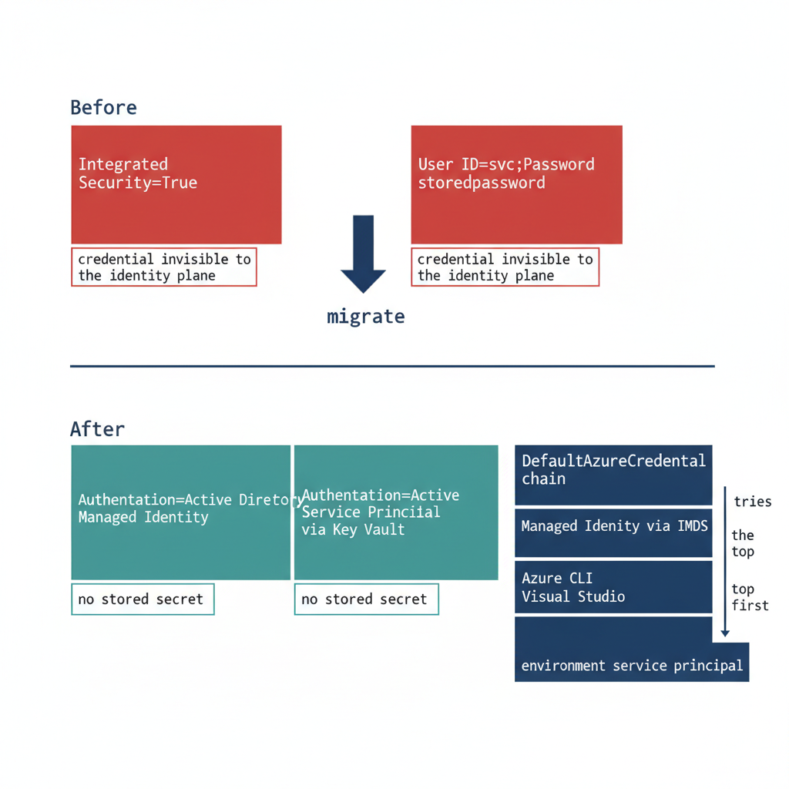
Figure 1: The connection-string change that removes the stored credential, and the DefaultAzureCredential chain behind it

The Connection String Change
For an application using Windows Integrated Security — Data Source=sqlserver;Initial Catalog=database;Integrated Security=True — the connection string changes to use Entra ID authentication. For an application running on an Arc-enabled server with a system-assigned Managed Identity, it becomes Data Source=sqlserver;Initial Catalog=database;Authentication=Active Directory Managed Identity. The keyword tells the driver to acquire a token from the local Managed Identity rather than negotiate a Windows credential.
For an application using a service principal with a client credential, the string uses Authentication=Active Directory Service Principal, with the client ID and credential supplied through an Azure Key Vault reference rather than inline. For SQL Authentication connections — User ID=serviceaccount;Password=storedpassword — migrating to Managed Identity or service principal eliminates the credential from the connection string entirely. In every case the stored secret is removed, which is the point: the connection no longer carries a credential the identity plane cannot see.

The Gate Conditions
The change is the simplest step technically, but it cannot be executed on demand. Three conditions must hold first. The Entra ID login must already exist on the target SQL Server instance — the FROM EXTERNAL PROVIDER login created in the work Book 04 covers — because a connection string that names an Entra identity with no corresponding login on the instance fails at connection time.
The application’s service principal or Managed Identity must have been granted the appropriate SQL Server database role, so that authentication succeeds and authorization follows. And the change must have been tested in a non-production environment whose Arc and SQL Server extension configuration matches production, because token acquisition and validation depend on that infrastructure being present and correctly configured. A connection-string change that works against a developer’s laptop but has never been exercised against a production-equivalent Arc and extension stack is not a tested change. Only when all three gates are satisfied is the production cutover safe to perform.

The Azure.Identity SDK and DefaultAzureCredential
For .NET applications — a large fraction of the federal application estate — the Azure.Identity SDK provides the DefaultAzureCredential class, which implements an ordered credential chain. It attempts Managed Identity first, using the local IMDS endpoint when running on an Arc-enabled server, an Azure VM, or another Azure-hosted platform, then falls back to Azure CLI credentials, then Visual Studio credentials, then environment-variable-based service-principal credentials.
The value of the chain is that a single credential code path works unchanged across environments. In production the application resolves its Managed Identity; in a developer’s local environment it resolves Azure CLI credentials; no code differs between them. The SQL connection uses a SqlConnection with the Authentication=Active Directory Default keyword — available in Microsoft.Data.SqlClient 2.0 and later — or sets the AccessToken property from the DefaultAzureCredential token directly.
The Authentication=Active Directory Default keyword is the preferred approach for new connection-string configurations, because it delegates credential resolution to the DefaultAzureCredential chain automatically. The result is that the connection-string change is a net reduction in complexity for .NET applications: one keyword replaces an entire credential-management system. This is the workload-identity model ADR-004 establishes — the application authenticates as itself through a Managed Identity, with no human credential and no stored secret anywhere in the path. (ADR-004)
Division of labor
Microsoft provides: the Authentication= keyword options — Active Directory Managed Identity, Service Principal, Default; the Azure.Identity SDK DefaultAzureCredential chain; Azure Key Vault for interim credential management.
What only you can provide: the connection-string inventory across every application that connects to SQL Server; the per-connection-string owner assignment; the migration tracking; the pre-cutover testing that validates each updated string against its target instance before the NTLM block is applied.

What Book 08 establishes — Chapter 2
The connection-string change is the last mile of the application-chain migration: Integrated Security or SQL Authentication becomes Authentication=Active Directory Managed Identity, Service Principal, or Default, and the stored credential disappears. It is the simplest step technically but the most gate-controlled — it requires the Entra ID login to exist on the instance, the identity to hold the right database role, and a tested change in a production-equivalent non-production environment. For .NET, the Azure.Identity SDK’s DefaultAzureCredential chain and the Authentication=Active Directory Default keyword collapse credential management to a single keyword, realizing the workload-identity model of ADR-004.

Book_09 — The Transformed Posture: Continuous Governance and the 2027 Milestone
  - The Transformed Posture and What Keeps It — Continuous Verification in a World of Progressive Vendor Constraints

Book_09 — The Transformed Posture: Continuous Governance and the 2027 Milestone
Note
A transformation that achieves a completed state and then stops monitoring is a transformation that will regress. The transformed posture is not a permanent state achieved by a one-time action — it is an ongoing condition maintained by continuous monitoring, automated drift detection, and a governance process that treats regression as a compliance violation. (ADR-068 Phase C, UIAO_135 Transformation #7)

Figure 1: After: three-step token flow — authenticate to Entra ID with MFA, receive a signed OAuth 2.0 token, present it to SQL Server. No domain controller, no Kerberos, no NTLM.

Figure 2: After: the claims the OAuth 2.0 token carries — identity claims (upn, oid, groups, exp) and context claims (amr, acr, deviceid, compliant, ipaddr) — and why each matters to SQL Server.

Figure 3: After: the four security capabilities unlocked by the token posture — Conditional Access full coverage, phishing-resistant MFA, complete audit trail, and OrgPath-driven SQL access.

Figure 4: The OAuth 2.0 token session lifecycle — UML sequence diagram tracing auth+MFA through Conditional Access evaluation, token issuance, SQL validation, and silent token refresh.

Figure 5: The transformed posture: no domain controller in the authentication path, no Kerberos, no NTLM, no Windows logins. Every connection presents an Entra-issued OAuth 2.0 token carrying identity, MFA method, device compliance, and group membership. The SQL Server validates the token signature, maps claims to a type-E login, and the Entra identity plane has a sign-in record for every authentication event.

Figure 6: Simplified view of the transformed posture: three steps — authenticate to Entra ID with MFA, receive a signed token, present it to SQL Server. No domain controller, no Kerberos, no NTLM.

Download this book
Book_09-bundle.docx — every chapter of this book concatenated into one Word document. Regenerated on every site deploy.

Chapters
Continue the series
← Previous: Book 08 — The Application Chain · Index · Next: Book 10 — Certificate Authority →

The Closure Condition for UIAO_135 Transformation #7

Chapter 1 — The Closure Condition for UIAO_135 Transformation #7
Transformations do not complete — they achieve a posture, and a posture is something you keep proving.
In this chapter
The five conditions that must be simultaneously satisfied for Transformation #7 to be closed across the estate, why the continuous audit rather than a one-time scan is the verification instrument, how the CCM-BIR record per instance captures the satisfying state, what drift detection looks for, and how Defender for SQL adds a behavioral telemetry layer on top of the structural monitoring.

A transformation that achieves a completed state and then stops monitoring is a transformation that will regress. A SQL Server instance migrated to Entra ID-only authentication can be reconfigured to Mixed Mode by any administrator with sufficient permission. New SQL Authentication logins can be created. New Windows logins can be created if the instance remains domain-joined. The transformed posture is not a permanent state achieved through a one-time action — it is an ongoing condition maintained by continuous monitoring, automated drift detection, and a governance process that treats regression as a compliance violation rather than an operational preference. (ADR-068 Phase C, UIAO_135 Transformation #7)
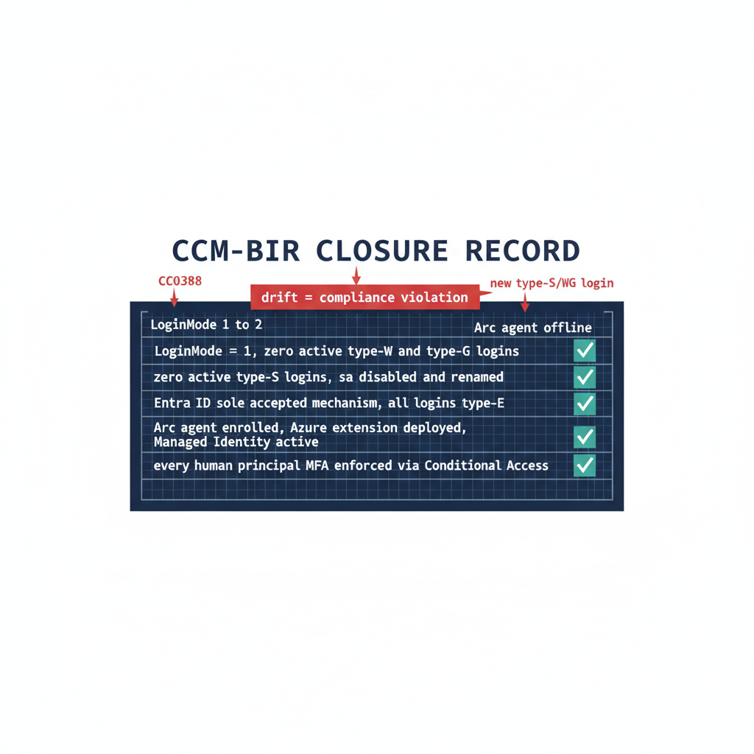
Figure 1: The five closure conditions for Transformation #7 expressed as a single verified CCM-BIR record per instance

The Five Closure Conditions
UIAO_135 §1.2 defines Transformation #7 as complete when five conditions are simultaneously satisfied across all production SQL Server instances in the estate. The first is that Windows Authentication is eliminated as an accepted login mechanism. No production instance is configured for Mixed Mode — all instances run in Windows Authentication Only mode, but with no active Windows-backed logins in master. The operational verification is the authentication mode registry value (LoginMode = 1) together with a query of sys.server_principals confirming zero type-U and type-G logins that are not in a disabled state.
The second condition is that SQL Authentication is eliminated. No SQL Authentication logins — type-S logins — exist on any production instance other than those carrying documented exception status, and the sa account is disabled on every instance. The operational verification is a sys.server_principals query for type-S logins, cross-referenced against the exception registry the program maintains. The third condition is that Entra ID authentication is the sole accepted mechanism. This is the positive statement of the first two: all active logins on all instances are type-E logins, and every connection produces an Entra ID sign-in event.
The fourth condition is that the engine process runs with a Managed Identity. The Arc Connected Machine agent is installed, the system-assigned Managed Identity is active, and the Azure extension for SQL Server is deployed on every production host. The fifth condition is that every human principal authenticates with MFA enforced by Conditional Access. This is verified through Entra ID sign-in logs and Conditional Access policy reports — every sign-in event for a SQL Server resource should show MFA satisfied and Conditional Access grant controls met. (UIAO_135 §1.2, ADR-091 §5)

The Continuous Audit as the Verification Instrument
Spec3-D1.8 in continuous monitoring mode — running on a recurring schedule against the full estate rather than as a point-in-time scan — is the primary instrument for verifying that all five closure conditions remain satisfied over time. The CCM-BIR record per instance, updated on each audit run, is the structured evidence artifact that captures the current state of each condition for each instance. ADR-091 §5 defines the field set that record carries. (Spec3-D1.8, ADR-091 §5)
A CCM-BIR record that shows LoginMode = 1, zero active type-S logins, zero active type-U logins, zero active type-G logins, the sa account disabled and renamed, the Arc agent enrolled, the SQL extension deployed, and the Managed Identity active is a record that satisfies all five closure conditions for that instance. When all production instances carry satisfying CCM-BIR records, Transformation #7 is verifiably closed for the estate. The continuous audit ensures closure is not a point-in-time claim — it is an ongoing verification. (ADR-091 §5)

Drift Detection
Drift detection in the CCM-BIR pipeline identifies conditions that would constitute regression before they become compliance violations. A drift event for SQL Server authentication takes one of several forms. An instance whose LoginMode value changes from 1 to 2 — Windows Authentication Only to Mixed Mode — indicates that someone has enabled Mixed Mode without authorization. A new type-S login appearing in sys.server_principals that was not present on the previous audit run indicates that a SQL Authentication login has been created.
A new type-U or type-G login appearing on an instance that was previously in the Entra-only posture is the same class of regression for Windows-backed identity. And an Arc agent going offline, or the SQL extension becoming unavailable, would interrupt the Managed Identity-based engine authentication. Each drift event triggers the program’s remediation workflow. ADR-091 §5 records these same events — LoginMode reverting to Mixed Mode, a new type-S/U/G login appearing, the Arc agent going offline — as compliance violations, not advisory signals.
The program’s NTLM elimination strategy is not about hitting a fixed block date — it is about driving all production instance CCM-BIR records to the satisfied state and keeping them there continuously. Migration activity should conclude with enough margin for the continuous audit to confirm the satisfying posture across a full validation period before Phase C is applied. (ADR-068 Phase C and ADR-091 §5)

Defender for SQL as the Behavioral Telemetry Layer
Microsoft Defender for SQL provides the behavioral anomaly detection layer that complements the CCM-BIR structural compliance monitoring. CCM-BIR monitors the configuration state of each instance — is the LoginMode correct, are the login types correct. Defender for SQL monitors the behavioral patterns of connections to each instance: who is connecting, from where, at what times, using what authentication mechanisms, and whether those patterns deviate from the established baseline.
In the transformed posture, Defender for SQL operates against a baseline of Entra ID-only connections. Every connection produces an Entra ID sign-in event; every anomalous connection — from an unusual source IP, at an unusual time, with an elevated sign-in risk signal — is surfaced by Defender for SQL and by Entra ID Protection. Any NTLM or Kerberos authentication event in Defender for SQL telemetry, which should be zero in the transformed posture, is an immediate alert.
An NTLM event means one of three things: an instance has regressed to Mixed Mode, which CCM-BIR should already have detected; an instance was not included in the original audit scope, a discovery gap; or a novel connection pattern has appeared that the migration plan did not anticipate. All three require investigation. The combination of CCM-BIR structural monitoring and Defender for SQL behavioral monitoring is the two-layer governance instrument that maintains the transformed posture continuously after the migration is complete.
Division of labor
Microsoft provides: Spec3-D1.8 on a schedule for CCM-BIR structural monitoring; Defender for SQL behavioral monitoring; the five-condition verification capability; the Entra ID sign-in log as evidence.
What only you can provide: the program that drives all five closure conditions to simultaneous satisfaction across every production instance; the drift-detection response process that treats every CCM-BIR event as a compliance violation; the continuous monitoring instruments in production before the migration is declared done.

What Book 09 establishes — Chapter 1
Transformation #7 is closed when five conditions hold simultaneously across every production instance: Windows Authentication eliminated (LoginMode = 1, no active type-U/G logins), SQL Authentication eliminated (sa disabled, no active type-S outside the exception registry), Entra ID the sole mechanism, the engine running under a Managed Identity, and every human principal MFA-enforced via Conditional Access. The continuous audit (Spec3-D1.8 on a schedule) is the verification instrument, the satisfying CCM-BIR record per ADR-091 §5 is the evidence, drift detection catches regression before it becomes a violation, and Defender for SQL adds a behavioral layer over the structural monitoring.

The 2027 Milestone — What Done Looks Like

Chapter 2 — The 2027 Milestone: What Done Looks Like
The evidence is not a binder you assemble — it is the live output of the monitoring you never turn off.
In this chapter
The six evidence artifact sets that close Transformation #7 — and why each is a live output of the continuous monitoring infrastructure rather than a point-in-time document — followed by the correct reading of the program’s NTLM elimination strategy: not a fixed cutover date, but a posture maintained through continuous verification ahead of Microsoft’s progressive NTLM defaults.

The evidence artifacts required to close Transformation #7 in UIAO_135 are not a collection of documents produced at a single point in time — they are the live outputs of the continuous monitoring infrastructure described in Chapter 1. A closure claim is only as strong as the monitoring that keeps producing the evidence after the claim is made. This chapter names the artifacts, then places the program’s NTLM elimination strategy in its proper operational context: continuous verification ahead of Microsoft’s progressive NTLM defaults, not a fixed cutover date. (UIAO_135 §1.2, ADR-068 Phase C)
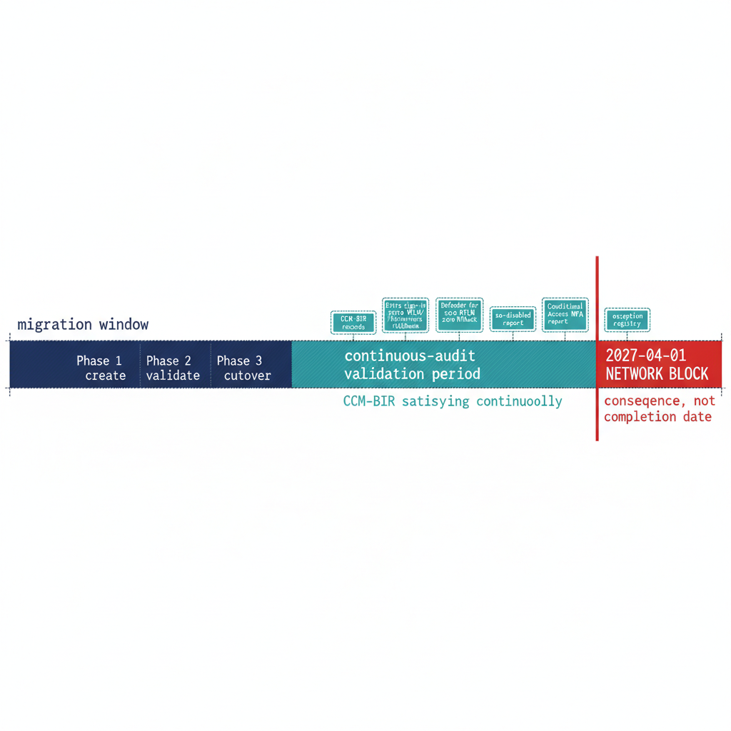
Figure 1: The migration window followed by the continuous-audit validation period — completing migration ahead of vendor defaults, not at a fixed cutover date

The Evidence Artifacts as Live Outputs
The closure claim for Transformation #7 must be supported by six artifact sets, and each is a continuously regenerated output rather than a static deliverable. The first is the CCM-BIR record set: a record for every production SQL Server instance in the estate, each showing Entra-only authentication mode, zero active SQL Authentication logins, zero active Windows-backed logins, the Arc agent enrolled and healthy, and the SQL extension deployed. ADR-091 §5 defines the field set these records carry, and the continuous audit keeps them current rather than freezing them at the moment of the claim. (ADR-091 §5)
The second is the Entra ID sign-in log set, showing zero failed token requests attributable to NTLM or Kerberos fallback for SQL Server resource audience tokens over a defined validation period preceding the closure claim. The third is the Defender for SQL telemetry, showing zero NTLM authentication events over that same validation period — the behavioral confirmation that complements the structural CCM-BIR view. These two artifacts together demonstrate that the transformed posture holds not only in configuration but in observed connection behavior.
The fourth is the sa account status report, showing the sa account disabled on all instances. The fifth is the Conditional Access policy compliance report, showing MFA enforcement satisfied for one hundred percent of SQL Server resource sign-ins by human principals over the validation period. The sixth is the exception registry, showing every currently excepted instance with documented justification, a sunset date, and its own CCM-BIR tracking record. When all six artifact sets are simultaneously satisfying, and the monitoring infrastructure confirms they have been satisfying for the validation period, Transformation #7 is closed. That is what done looks like — not a checkbox, but a demonstrated, continuously verified, evidence-backed posture. (UIAO_135 §1.2, ADR-091 §5)

Vendor Defaults: Progressive Warnings, Not a Hard Cutover
The program’s NTLM elimination strategy is sometimes misread as a race to a single fixed date. It is not. Microsoft’s progressive NTLM defaults — enhanced auditing in Windows Server 2025 / Windows 11 24H2, the BlockNTLMv1SSO enforcement default arriving via Windows Update in October 2026, and network NTLM off by default in the next major Windows Server release — raise the cost of delay with each release. The program’s elimination posture is designed to stay ahead of that vendor default-disable trajectory, not to wait for a hard cutover.
Read as progressive vendor pressure rather than a single deadline, the schedule organizes differently. Migration activity — the three-phase parallel-run, the cutover, the sa disablement, the type-S elimination — should conclude with enough margin for the continuous audit to confirm the satisfying posture across a full validation period before Phase C is applied. The final months of the migration program are reserved for validation, not for last-minute migration, because a posture confirmed only at the edge of the window is a posture nobody has had time to prove.
This framing also gives the exception long-tail its proper weight. An instance that cannot reach Kerberos or Entra OAuth as dependencies are remediated must carry a documented exception with Certificate-Based Authentication as the authorized interim posture, and that exception’s sunset date must be reconciled against the vendor default-disable trajectory rather than against any internal milestone. When the migration is complete, the audit has validated the posture continuously, and the six artifact sets are live and satisfying, the Phase C block arrives as a non-event — which is exactly what done is supposed to feel like. (ADR-068 Phase C and ADR-091 §5)
Division of labor
Microsoft provides: the six evidence artifact categories — CCM-BIR records, Entra sign-in logs, Defender for SQL telemetry, sa-disabled report, Conditional Access MFA report, exception registry; the progressive NTLM default-disable that raises the cost of delay with each release.
What only you can provide: migration completion with sufficient margin for continuous-audit validation before Phase C is applied; the exception registry with Certificate-Based Authentication as the authorized interim posture; the documented sunset dates for every exception that must resolve ahead of the vendor default-disable trajectory.

What Book 09 establishes — Chapter 2
The six evidence artifact sets that close Transformation #7 — CCM-BIR records, Entra sign-in logs showing zero NTLM/Kerberos fallback, Defender for SQL zero-NTLM telemetry, the sa-disabled report, the Conditional Access MFA report, and the exception registry — are live outputs of the continuous monitoring infrastructure, satisfying across a defined validation period rather than assembled once. The program’s NTLM elimination strategy keeps pace with Microsoft’s progressive default-disable trajectory: migration concludes with margin, the final period is reserved for continuous-audit validation, and Phase C is applied as a non-event.

Book_10 — Certificate Authority: From ADCS to Cloud PKI
  - What Microsoft’s Cloud PKI Provides — and the Certificate Migration Only You Can Sequence

Book_10 — Certificate Authority: From ADCS to Cloud PKI
 Warning
This book documents a “Not Yet Defined” gap from UIAO_135 §3.3. The content is analytical and motivational — it identifies the dependencies, names the gap, and describes what the as-yet-unwritten ADCS-migration ADR must address. Spec3-D1.10 (Get-CertBasedAuthAudit.ps1) is the discovery instrument. Do not cite this book as normative governance for ADCS-migration decisions.

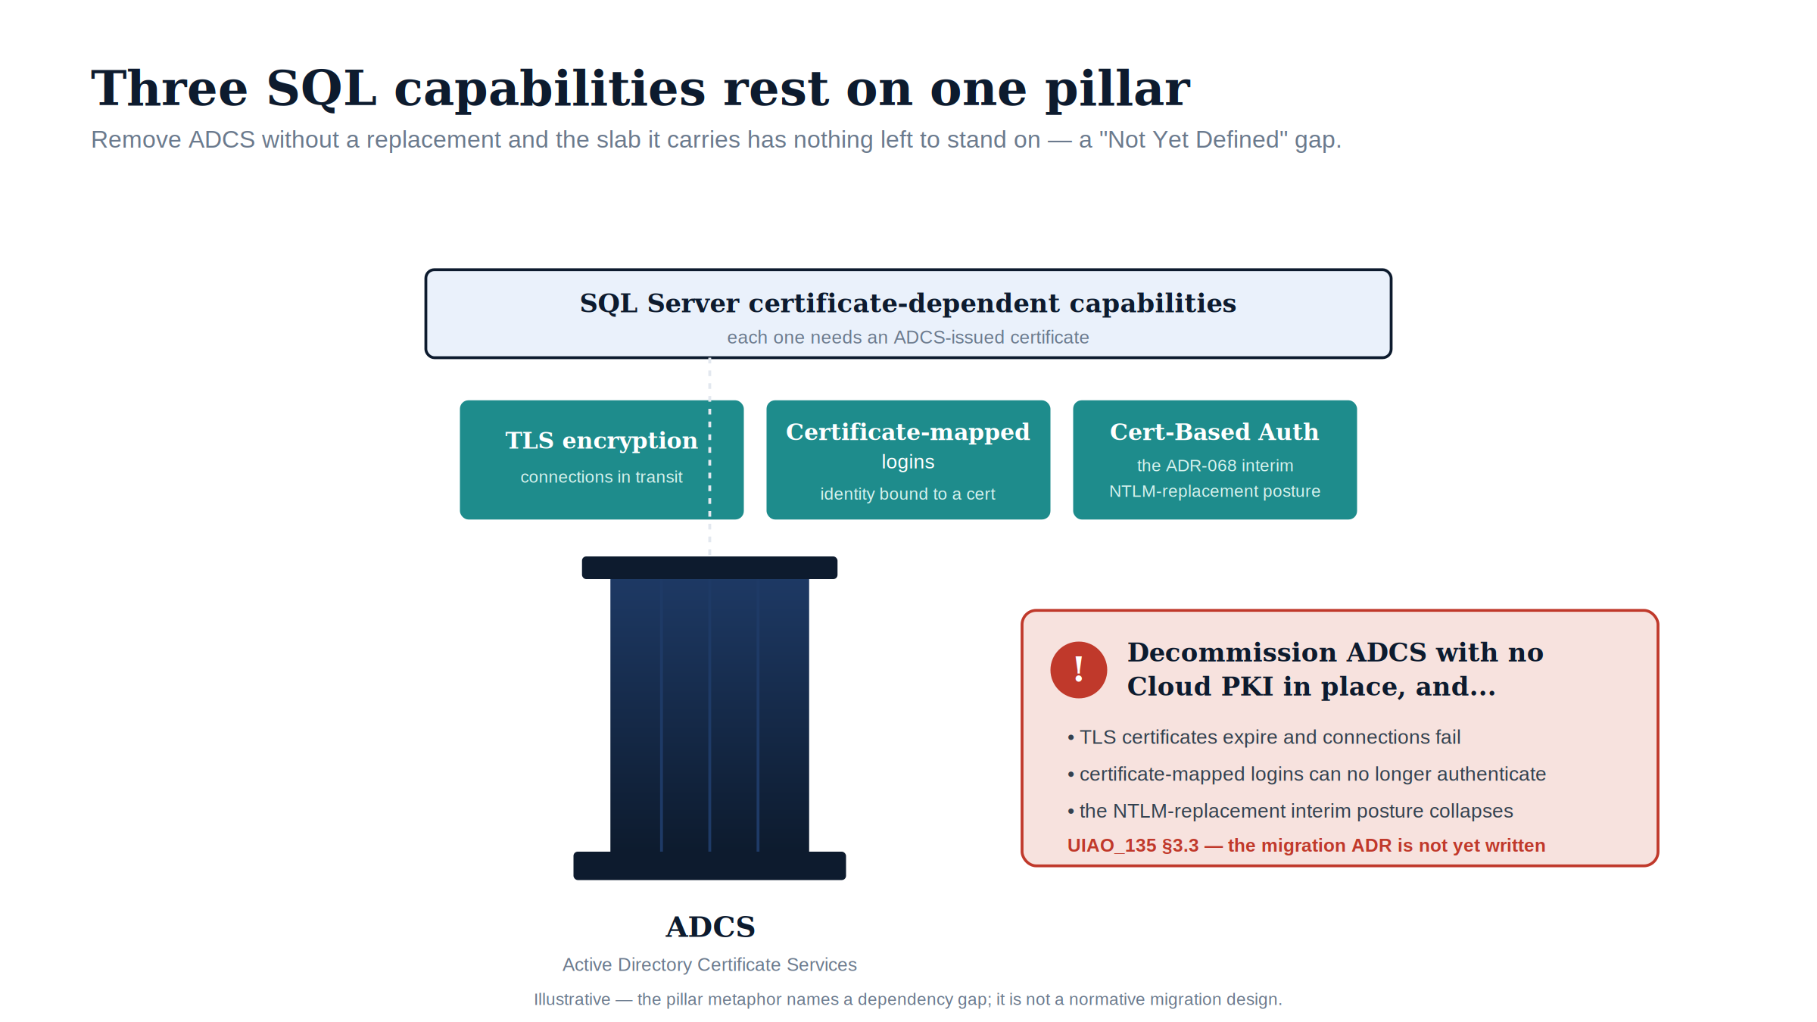
Figure 1: Three SQL Server capabilities rest on the single ADCS pillar; decommission it without a Cloud PKI replacement and the slab they sit on has nothing left to stand on — a “Not Yet Defined” gap.

Download this book
Book_10-bundle.docx — every chapter of this book concatenated into one Word document. Regenerated on every site deploy.

Chapters
Continue the series
← Previous: Book 09 — The Transformed Posture · Index

Where SQL Server Touches ADCS

Chapter 1 — Where SQL Server Touches ADCS
The certificate dependencies a decommission plan cannot see, named before any decommission plan exists.
In this chapter
The three distinct SQL Server capabilities that depend on ADCS-issued certificates — TLS encryption of client connections, certificate-mapped logins, and Certificate-Based Authentication as the authorized NTLM-replacement interim posture — why each one breaks if ADCS is decommissioned before it is migrated, and why this book documents a transformation for which no normative ADR has yet been authored.

UIAO_135 §3.3 identifies the Active Directory Certificate Services to Cloud PKI transformation as “Not Yet Defined.” As the series opening established, that label means the destination may be known but the normative canon governing how to reach it has not been authored. For most of this series, the missing record has been the substrate ADR; for Book 10, the gap is more fundamental still. No architecture decision record governs the certificate authority transformation at all.
There is no ADR equivalent to point to. The transformation is identified as necessary in UIAO_135, the discovery instrument exists, but the normative decision about the replacement CA, the enrollment mechanism, and the sequencing of ADCS decommission has not been made. This book is therefore analytical and motivational rather than prescriptive. It documents why the certificate gap matters specifically for SQL Server, and it cites no normative ADCS-migration ADR because none exists. (UIAO_135 §3.3)
It matters specifically because SQL Server has certificate dependencies that are not visible to most of the teams that will plan the ADCS decommission. Three distinct capabilities depend on ADCS-issued certificates: TLS encryption of client connections, certificate-mapped SQL Server logins, and Certificate-Based Authentication as the authorized NTLM replacement for connections that cannot reach Kerberos or Entra OAuth before the deadline. Spec3-D1.10 (Get-CertBasedAuthAudit.ps1) is the instrument for discovering them. (Spec3-D1.10)
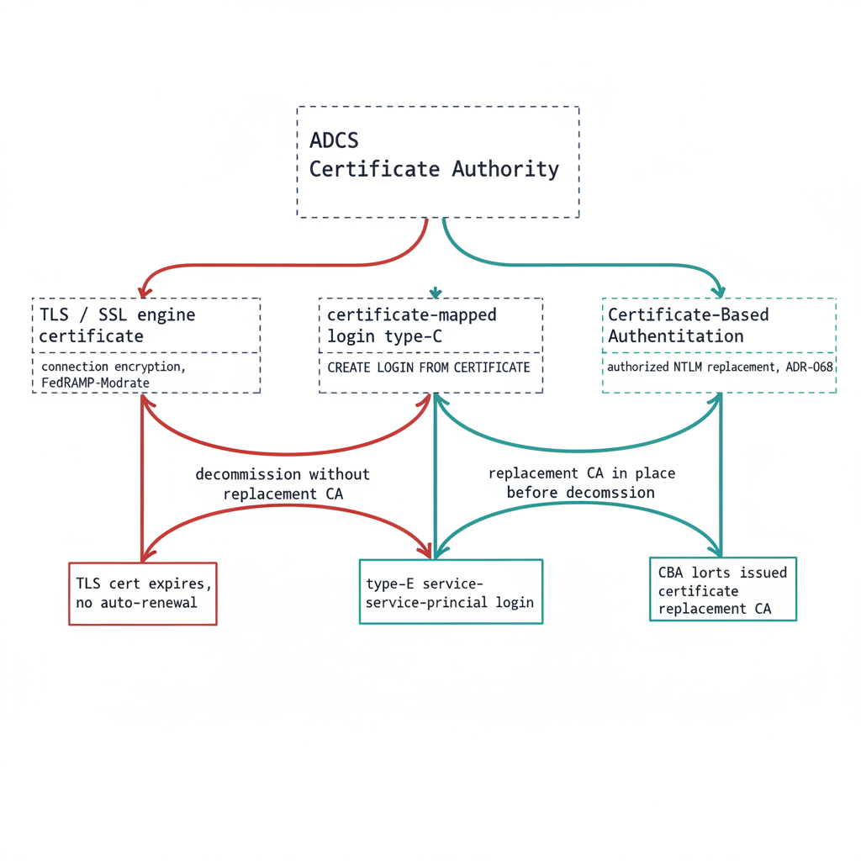
Figure 1: The three SQL Server certificate dependencies on ADCS and what each one loses when the certificate authority is decommissioned without a replacement in place

SQL Server TLS/SSL Certificates
The first and most commonly recognized SQL Server certificate dependency is the TLS certificate the engine presents for encryption of client connections. When SQL Server is configured to use TLS encryption — which is required under this program’s FedRAMP-Moderate posture — it presents a server certificate to connecting clients as part of the TLS handshake.
In most federal environments, that certificate is issued by the organization’s ADCS infrastructure. The administrator submitted a request to the ADCS Certificate Authority, the CA issued a certificate carrying the SQL Server’s hostname as the Subject Alternative Name, and the certificate was installed in the instance’s certificate store and bound through SQL Server Configuration Manager. The certificate has an expiration date.
When ADCS is decommissioned, that certificate will not be renewed automatically — there is no CA left to issue the renewal. If the TLS certificate expires after ADCS decommission, clients configured to validate the server certificate, which is the correct security posture, will reject the connection with a certificate validation error. The encryption that FedRAMP-Moderate requires becomes the thing that breaks the connection.
The Spec3-D1.10 audit captures the TLS certificate for every instance in scope: the subject, the SAN, the issuing CA, and the expiration date. Any instance whose TLS certificate is ADCS-issued is a dependency the migration plan must address. The replacement certificate must come from the new CA — whether Microsoft Cloud PKI or an alternative — and must be installed and bound before the ADCS-issued certificate expires or before ADCS goes offline, whichever comes first. (Spec3-D1.10)

Certificate-Mapped SQL Server Logins
The second dependency is less commonly known. SQL Server supports a login type — the type-C login — that maps an X.509 certificate to a SQL Server login using the CREATE LOGIN [name] FROM CERTIFICATE [cert_name] syntax. When a client connects with a certificate-mapped login, it presents its certificate as the authentication credential. SQL Server validates the certificate’s signature against the certificate object stored in master, and on success accepts the connection with the associated login’s permissions.
Certificate-mapped logins are uncommon in standard deployments, but they appear in specific scenarios: service accounts using certificate-based rather than password-based authentication, SQL Server integration with PKI-based authentication systems, and legacy configurations for Service Broker endpoints. Each is the kind of arrangement that survives quietly across an estate for years without anyone documenting it.
If a certificate-mapped login exists on a production instance and the certificate backing it was issued by ADCS, that login will fail when ADCS is decommissioned and the certificate expires. The preferred migration path is to replace certificate-mapped logins with type-E service-principal logins backed by Entra ID authentication, as described in Book 05. The Spec3-D1.10 audit captures every certificate-mapped login and the issuing CA of its associated certificate, providing the inventory the migration needs. (Spec3-D1.10)

CBA as the NTLM Replacement Interim Posture
The third dependency is the most consequential for the NTLM elimination timeline. ADR-068 (Certificate-Based Authentication) designates CBA as the authorized replacement for NTLM connections that cannot be migrated to Kerberos or Entra ID OAuth 2.0 tokens within the required timeline. CBA allows a client to authenticate with an X.509 client certificate rather than a password or Kerberos ticket — a strong mechanism that is not subject to the NTLM protocol weaknesses Book 01 described. (ADR-068)
For connections that cannot reach Entra ID auth as dependencies are remediated — Category 3 instances still pre-2022, or applications still in the deferred class — CBA is the authorized interim posture. The connection authenticates by certificate rather than NTLM, satisfying the program’s NTLM-elimination commitment (recorded in ADR-068) without requiring the full Entra ID migration that pre-2022 instances cannot complete. It is the bridge that keeps an un-migratable connection compliant.
The problem is that CBA certificates must be issued by a CA. If the plan is to deploy CBA as the NTLM-replacement posture for connections that cannot yet reach Entra auth, and ADCS is being decommissioned, the replacement CA must already be in place and issuing CBA certificates before ADCS goes offline. The interim posture has its own certificate dependency, and that dependency points at the same authority the program intends to remove.

The Sequencing Dependency
The three dependencies converge on a single sequencing question. TLS certificates must be re-issued before they expire; certificate-mapped logins must be migrated to type-E before their backing certificates lapse; and CBA, the very mechanism ADR-068 relies on to cover connections that cannot meet the deadline, must have a CA issuing its certificates before ADCS is retired.
If the ADCS decommission timeline runs earlier than the replacement-CA and CBA-deployment timeline, the program loses the interim posture ADR-068 depends on at precisely the moment it is most needed — connections that could not migrate to Entra auth in time would have no compliant fallback. The sequencing of ADCS decommission against the program’s NTLM elimination strategy is therefore a critical dependency, and it is one the as-yet-unwritten ADCS-migration ADR must explicitly address before any decommission date is set. (UIAO_135 §3.3, ADR-068)
Division of labor
Microsoft provides: Microsoft Cloud PKI (Intune Suite) as the ADCS replacement; certificate issuance via SCEP and EST; Intune-based trust chain deployment to enrolled endpoints; the Arc agent certificate for host authentication to the Azure control plane.
What only you can provide: the TrustServerCertificate=True connection-string audit that must be resolved before certificate validation is enforced; the migration sequence from ADCS-issued to Cloud PKI–issued SQL Server certificates; the coordination of PKI migration timing with the SQL Server authentication migration — the new certificate must be in place and trusted by clients before the ADCS hierarchy is retired.

What Book 10 establishes — Chapter 1
SQL Server touches ADCS in three places that a decommission plan rarely sees: the TLS certificate the engine presents for FedRAMP-Moderate connection encryption, type-C certificate-mapped logins, and Certificate-Based Authentication as the ADR-068 authorized NTLM-replacement interim posture. Spec3-D1.10 (Get-CertBasedAuthAudit.ps1) is the discovery instrument for all three. Because UIAO_135 §3.3 marks the ADCS-to-Cloud-PKI transformation “Not Yet Defined” and no normative ADR governs it, this book is analytical rather than prescriptive — its central finding is that the sequencing of ADCS decommission against the program’s NTLM elimination strategy is a critical dependency the as-yet-unwritten ADCS-migration ADR must resolve.

Book_11 — The Platform Question: Database Consolidation Toward SSOT
  - What the Authentication Transformation Reveals About the Database Platform Layer

Book_11 — The Platform Question: Database Consolidation Toward SSOT
Note
Books 01 through 10 answered the authentication question. This book asks what the estate looks like when the authentication answer exposes the platform question underneath it. Every SQL Server instance that survived the migration is a re-authenticated silo. The SSOT goal requires examining whether those silos should persist — or consolidate into one authoritative database platform. (UIAO_135 §1.2)

Status — Draft
This book extends the SQL Server Identity Transformation series into database platform modernization. It is DRAFT v0.1, published for review alongside the companion authentication narrative. Platform consolidation decisions documented here are analytical — they do not carry normative ADR weight until the relevant ADRs are proposed and accepted.

Download this book
Book_11-bundle.docx — every chapter of this book concatenated into one Word document. Regenerated on every site deploy.

Chapters
Continue the series
← Previous: Book 10 — PKI Migration and the Certificate Dependencies · Index

The Fragmentation Cost — SQL Server Sprawl as an Anti-SSOT Pattern

Chapter 1 — The Fragmentation Cost: SQL Server Sprawl as an Anti-SSOT Pattern
The authentication migration re-authenticates the silos. It does not dissolve them. Dissolving them is the platform question.
In this chapter
Why SQL Server sprawl — dozens of independently licensed, independently administered instances each holding a fragment of agency data — is structurally incompatible with the SSOT goal that UIAO’s architecture pursues. The SSOT case is not that SQL Server is a bad database; it is that having thirty of them produces thirty shadow sources of truth. The chapter closes with the decision framework for the two federal consolidation targets: PostgreSQL and Oracle.

Figure 1: The authentication transformation re-authenticates forty silos. SSOT consolidation dissolves them into one authoritative database platform.

The Authentication Transformation Reveals What It Does Not Fix
Books 01 through 10 described one transformation: moving the SQL Server estate from Windows Authentication to Microsoft Entra ID. At the end of that transformation, every retained instance is re-authenticated. The Kerberos ticket is gone, the NTLM fallback is gone, the service account tied to the domain is gone, and in its place is an OAuth 2.0 token validated by the Conditional Access Engine before it reaches the engine. That transformation is real and significant.
What it does not change is the topology. The estate that emerged from Windows Authentication mode with forty instances enters Entra ID authentication mode with forty instances. Each instance is an independently provisioned server, an independently administered schema, an independently held copy of data that overlaps — in ways nobody has fully mapped — with data held by the other thirty-nine. The authentication transformation made each of those forty instances more secure. It did not reduce the number. (UIAO_135 §1.2)
SSOT — Single Source of Truth — is not a security posture. It is an architectural property. A system has SSOT for a given data domain when there is exactly one authoritative origin for that data, and every consumer reads from it. An estate with forty SQL Server instances almost certainly does not have SSOT for any significant data domain, because each instance is a candidate source for the data it holds, and the question of which instance is authoritative when they disagree is either unresolved or resolved informally. Informal resolution of data authority is the administrative expression of the absence of SSOT.

What Sprawl Does to Data Authority
SQL Server sprawl accumulated through a mechanism that was sensible at each step and disastrous in aggregate. A new application needed a database. The application team provisioned a SQL Server instance — or shared one that was already running. They loaded their schema. They populated the data. If the data overlapped with data held by another instance, the overlap was noted and deferred, because resolving it would have required coordinating with another team, and the application needed to ship. Over two decades, that deferred coordination accumulated into an estate where the same concept — an employee, a contractor, an asset, an authorization — is represented in multiple databases, with no formally designated authority between them.
The result is that data consumers who need the authoritative version of any frequently-represented concept cannot find it by reading the database topology. They must either know which instance is authoritative by institutional knowledge, or make a judgment about which version to use, or query multiple instances and reconcile. All three of these are fragile. Institutional knowledge does not survive staff turnover. Judgment introduces inconsistency. Multi-instance reconciliation is expensive and still does not resolve authority — it only surfaces the disagreement.
UIAO’s architecture pursues SSOT as an organizing principle because fragmented authority is the administrative precondition for the governance failures the architecture is designed to prevent. OrgPath establishes SSOT for identity and organizational relationships. HRIT establishes SSOT for workforce position records. KYC establishes SSOT for citizen verification. These SSOT constructs are meaningful only if the data they govern is actually held in one authoritative place. An OrgPath-driven access model that derives group membership from an authoritative directory loses its authority the moment a shadow copy of that directory data is held in a separate SQL Server instance that is administered independently and may diverge. (ADR-035, ADR-051)

The SSOT Case Against SQL Server Sprawl
The case against SQL Server sprawl is not a case against SQL Server. SQL Server 2022 is a technically capable platform. The case is against multiplicty. Each additional SQL Server instance in the estate:
First, subdivides data authority. Every instance that holds data overlapping with another instance creates a potential authority conflict. The authentication transformation identifies which instances to retain; it does not resolve which of the retained instances holds the authoritative copy of any given data element.
Second, multiplies administrative surface. Each instance requires licensing, patching, backup, monitoring, and access administration. The authentication transformation reduces the per-instance credential surface by eliminating Windows logins and SQL logins. It does not reduce the instance count, and the administrative surface of a large estate remains proportional to the instance count regardless of the authentication mode.
Third, resists SSOT architecture. An OrgPath-derived access model that reads group membership from Entra ID can drive SQL Server security through FROM EXTERNAL PROVIDER logins. But if forty SQL Server instances each independently implement access control, the governance model for all forty must be designed, deployed, and kept synchronized. One authoritative database that all forty applications read reduces that problem from a forty-instance governance problem to a one-instance governance problem.
Fourth, accumulates licensing cost. SQL Server’s per-core licensing model charges for each instance independently. An estate with forty instances running at low average utilization pays forty instance-worth of licensing for work that could, in many cases, be consolidated onto far fewer instances — or onto an open-source platform without per-core licensing cost.

The Consolidation Decision Framework
The authentication transformation produced a classification for each SQL Server instance: retire, consolidate, or retain. The consolidation path — instances that were collapsed onto a target — was handled within the SQL Server estate. The retain path — instances that were individually migrated — produced a set of instances that are now properly authenticated but individually administered.
The platform question asks a further question about the retain group: should these instances remain on SQL Server, or should they migrate to a different database platform as part of a consolidation toward a single authoritative database? This is not a question the authentication transformation resolves. It is a question that the authentication transformation makes possible to ask clearly, because for the first time the estate is inventoried, rationalized, and documented.
Two federal consolidation targets have meaningful vendor support, FedRAMP-authorized paths, and relevance to the Red Hat/OpenShift environment that characterizes this agency’s AWS footprint.
The first is PostgreSQL. PostgreSQL is an open-source relational database with a feature set that closely parallels SQL Server in the areas most relevant to federal agency workloads: transactional integrity, schema-based access control, stored procedures (PL/pgSQL), replication, partitioning, and JSON document storage. It has multiple FedRAMP-authorized hosting paths — Amazon RDS for PostgreSQL, Amazon Aurora PostgreSQL, Azure Database for PostgreSQL, Crunchy Data PostgreSQL on OpenShift — and it is the primary database target for agencies operating on Red Hat OpenShift in AWS GovCloud. Microsoft, AWS, and Red Hat each publish official SQL Server-to-PostgreSQL migration documentation. Book 12 covers the PostgreSQL path in detail.
The second is Oracle Database. Oracle is a commercially licensed relational database with the deepest federal government footprint of any enterprise database platform. Agencies that have significant PL/SQL-based application logic, multi-tier partitioning, or Oracle-specific workloads — Exadata performance profiles, Oracle Text, Spatial, or Real Application Clusters — have a different consolidation calculus than agencies whose SQL Server workloads are schema-and-procedure applications. Oracle Database 19c runs on Red Hat OpenShift Virtualization, Oracle Cloud Infrastructure has FedRAMP High JAB authorization, and Oracle’s US Government Cloud provides an authorized consolidation target for agencies that choose Oracle as their single platform. Book 13 covers the Oracle path in detail.
The choice between PostgreSQL and Oracle is not a universal recommendation — it is an agency-specific decision that depends on the application inventory, the existing Oracle footprint if any, the licensing position, and the operational model. What both paths share is the destination: one authoritative database platform, as close to SSOT as the agency’s data governance work can bring it, rather than forty independently licensed, independently administered instances that re-authenticate cleanly but fragment authority as completely as they did before.
Division of labor
Microsoft and the platform vendors provide: the SQL Server 2022 authentication plane that makes the migration possible; the rationalization tools (Azure Migrate, DMA, Defender for SQL) that classify the estate; the migration toolchains (Azure DMS, AWS DMS + SCT, Red Hat MTA) that convert schemas and data; the authorized FedRAMP hosting paths on PostgreSQL and Oracle targets.
What only you can provide: the authority decision — which data domain is governed by which instance, and which instance is authoritative when instances disagree; the application inventory that determines whether workloads can migrate to PostgreSQL or require Oracle; the governance program that keeps one authoritative database authoritative over time rather than allowing new shadow copies to accumulate.

What Book 11 establishes — Chapter 1
SQL Server sprawl is structurally incompatible with SSOT because each instance is a candidate authority for the data it holds, and candidate authority without designation is fragmented authority. The authentication transformation re-authenticates the silos; dissolving them requires a platform decision. Two federal consolidation targets — PostgreSQL and Oracle — have FedRAMP-authorized paths, Red Hat/OpenShift relevance, and official migration toolchains from Microsoft, AWS, and Red Hat. The chapters that follow examine each in detail.

PostgreSQL in the Federal Stack — The Primary Consolidation Target

Chapter 2 — PostgreSQL in the Federal Stack: The Primary Consolidation Target
PostgreSQL is not the smallest database; it is the one the federal ecosystem has converged on. The FedRAMP paths, the Red Hat partnership, and three vendor migration toolchains all point the same direction.
In this chapter
Why PostgreSQL is the primary consolidation target for federal agencies operating on Red Hat OpenShift in AWS GovCloud: the four FedRAMP-authorized hosting paths, the Crunchy Data PostgreSQL Operator certified for Red Hat OpenShift, the three official SQL Server-to-PostgreSQL migration toolchains from Microsoft (SSMA), AWS (DMS + SCT), and Red Hat (MTA), and the SSOT-relevant capabilities — logical replication, Row-Level Security, JSONB, and Foreign Data Wrappers — that PostgreSQL brings to the consolidation argument.

Figure 1: PostgreSQL federal hosting paths and vendor migration toolchains — from SQL Server assessment through schema conversion, data replication, and application code modernization.

Why the Federal Ecosystem Converged on PostgreSQL
PostgreSQL did not become the dominant federal open-source database by being the most marketed. It became the dominant choice because it is the one that solved the right set of problems for federal workloads: transactional correctness with SQL standard compliance, a privilege model that maps cleanly to schema-based access control, stored procedure support in PL/pgSQL that handles the majority of PL/T-SQL logic with manageable translation effort, and an extension architecture that has produced FedRAMP-relevant capabilities including PostGIS (geospatial), pgaudit (comprehensive audit logging), and pg_cron (scheduled jobs without external schedulers).
More relevant to this agency’s environment, PostgreSQL has the strongest certified operator presence on Red Hat OpenShift of any enterprise database. The Crunchy Data PostgreSQL Operator is listed in the Red Hat Ecosystem Catalog, certified for OpenShift, and available through OperatorHub. The Crunchy PostgreSQL for OpenShift product provides a Kubernetes-native PostgreSQL deployment with high availability, point-in-time recovery, connection pooling via pgBouncer, and automated backup — all managed through Kubernetes custom resources rather than manual DBA procedures. This is the PostgreSQL deployment model for OpenShift-first agencies, and it is the one that aligns with ROSA GovCloud for federally compliant hosting.
The second reason is licensing. SQL Server’s per-core licensing model is among the most expensive in the enterprise database market. An agency consolidating forty SQL Server instances onto one PostgreSQL cluster eliminates per-core licensing cost across the retired and consolidated instances. PostgreSQL is open source under the PostgreSQL License, and the commercial support models from Crunchy Data, EDB (EnterpriseDB), and Amazon eliminate the common objection that open-source databases lack enterprise support in federal procurement contexts. EDB Postgres Advanced Server in particular offers Oracle compatibility extensions — a feature relevant to agencies with legacy Oracle-derived stored procedures.

The Four FedRAMP-Authorized Hosting Paths
Federal agencies do not deploy software; they deploy authorized software on authorized infrastructure. PostgreSQL has four meaningful FedRAMP-authorized hosting paths for federal agencies, each with different operational models.
Amazon RDS for PostgreSQL is the managed PostgreSQL service on AWS and is available in AWS GovCloud (US). RDS handles engine patching, automated backups, Multi-AZ high availability, and read replicas through the AWS Console or IaC tooling. For agencies whose workloads do not require Kubernetes-native database management, RDS provides the lowest administrative overhead PostgreSQL path in AWS GovCloud. Amazon RDS for PostgreSQL is included in the AWS FedRAMP-authorized boundary. (AWS GovCloud User Guide)
Amazon Aurora PostgreSQL is AWS’s cloud-native PostgreSQL-compatible database engine. Aurora is PostgreSQL-compatible at the protocol level but uses a purpose-built distributed storage layer that provides faster crash recovery, up to fifteen read replicas, and a serverless capacity mode. Aurora PostgreSQL is the target platform for the AWS SQL Server to Aurora PostgreSQL Migration Playbook — the most detailed SQL Server migration guide AWS publishes, covering the AWS Database Migration Service and AWS Schema Conversion Tool end-to-end. Aurora is FedRAMP-authorized in AWS GovCloud.
Babelfish for Aurora PostgreSQL is a separate option worth naming. Babelfish is an AWS extension for Aurora PostgreSQL that allows Aurora to accept T-SQL queries and TDS protocol connections — the wire protocol that SQL Server clients use. This means that applications connecting to SQL Server with SQL Server connection strings can connect to Babelfish for Aurora PostgreSQL with minimal or no application code changes. Babelfish does not support every T-SQL feature, and complex stored procedures may require refactoring, but for agencies with a large inventory of T-SQL client applications, Babelfish provides a migration path that minimizes application-layer changes while moving off SQL Server licensing. AWS published official guidance for migrating SQL Server to Babelfish for Aurora PostgreSQL with minimal downtime using AWS DMS. (AWS Blog, Database category)
Crunchy Data PostgreSQL on Red Hat OpenShift / ROSA GovCloud is the fourth path and the one most aligned with this agency’s Red Hat/OpenShift footprint. ROSA — Red Hat OpenShift Service on AWS — is available in AWS GovCloud and received FedRAMP In-Process designation. The Crunchy PostgreSQL Operator deployed on ROSA GovCloud provides a Kubernetes-native PostgreSQL instance with the same operational model as all other OpenShift workloads: Helm or Operator Lifecycle Manager deployment, Kubernetes-native backup/restore through pgBackRest, and declarative configuration through custom resources. This is the consolidation target that aligns database operations with the existing OpenShift platform model rather than introducing a second operational paradigm for database management alongside the Kubernetes workload paradigm.
Azure Database for PostgreSQL is Microsoft’s managed PostgreSQL service. For agencies in a GCC Moderate Microsoft environment who are already using Azure services, Azure Database for PostgreSQL — Flexible Server provides PostgreSQL as a managed PaaS within the Microsoft boundary. This path is relevant for agencies where the database must remain co-located with other Azure workloads for data sovereignty or network topology reasons.

The Three Migration Toolchains
Three vendors publish official SQL Server-to-PostgreSQL migration documentation relevant to this agency’s environment. Each covers the same conceptual migration — schema conversion, data migration, and application update — with different tooling.
Microsoft’s SQL Server Migration Assistant (SSMA) for PostgreSQL is the official Microsoft tool for migrating SQL Server databases to PostgreSQL. SSMA performs schema conversion — translating SQL Server DDL (table definitions, indexes, constraints) and stored procedure logic (T-SQL to PL/pgSQL) — with an assessment report that categorizes conversion items by automated vs. manual effort. Microsoft publishes SSMA as a free download with official documentation on Microsoft Learn. SSMA is the right tool to run first in any SQL Server-to-PostgreSQL migration because it produces the assessment that scopes the manual conversion work. The SSMA assessment output is the input to the migration planning phase. (Microsoft Learn: Azure Database Migration Guide — learn.microsoft.com/en-us/data-migration/)
AWS Database Migration Service (DMS) and Schema Conversion Tool (SCT) are the AWS tools for heterogeneous database migration. AWS SCT converts the database schema — tables, indexes, stored procedures — with an automatic conversion rating and a list of items requiring manual remediation. AWS DMS performs the data migration from the source SQL Server to the target PostgreSQL instance, supporting both one-time full-load migration and ongoing replication using Change Data Capture (CDC) for minimal-downtime migrations. AWS publishes the SQL Server to Aurora PostgreSQL Migration Playbook — a dedicated migration guide covering both tools from initial assessment through cutover — as well as a step-by-step guide for DMS Schema Conversion. The DMS CDC approach enables a parallel-run migration pattern analogous to the Book 05 login migration parallel run: the source SQL Server remains live while DMS continuously replicates changes to the PostgreSQL target, and cutover happens as a planned application-layer switch. (AWS Documentation: docs.aws.amazon.com/dms/latest/sql-server-to-aurora-postgresql-migration-playbook/)
Red Hat Migration Toolkit for Applications (MTA) addresses the application modernization side of the migration rather than the database schema side. MTA analyzes application code to identify dependencies on platform-specific APIs — including SQL Server-specific JDBC drivers, connection strings, and T-SQL client patterns — and produces a remediation report with refactoring guidance. For agencies migrating to PostgreSQL on OpenShift, MTA is the companion to SSMA or SCT: SSMA/SCT migrates the database; MTA migrates the application code that talked to the old database. Red Hat publishes MTA documentation at docs.redhat.com. (Red Hat Documentation: Migration Toolkit for Applications 7.1)
The three tools are not mutually exclusive. A full migration engagement on the OpenShift/ROSA GovCloud path would typically run SSMA (for the schema assessment), SCT (for the schema conversion targeting Aurora PostgreSQL or Crunchy PostgreSQL), DMS CDC (for the data replication), and MTA (for the application code analysis) in combination.

SSOT-Relevant PostgreSQL Capabilities
PostgreSQL’s value for the SSOT argument rests on specific capabilities that SQL Server also provides in some form but that PostgreSQL exposes in ways more compatible with a consolidation architecture.
Logical Replication allows a PostgreSQL instance to publish changes to specific tables as a logical stream that other PostgreSQL instances — or Kafka, or application consumers — can subscribe to. For agencies consolidating data from multiple source databases into one authoritative PostgreSQL instance, logical replication provides the mechanism: each source database replicates its authoritative data domain to the consolidated instance without requiring the source to be taken offline. The consolidated instance accumulates the authoritative views from all contributing sources into a single schema. Logical replication is built into PostgreSQL and requires no additional licensing.
Row-Level Security (RLS) allows PostgreSQL to enforce access policies at the row level based on session variables — the same mechanism UIAO’s OrgPath model uses to drive access at the group level, but applied to individual rows within a table. An OrgPath-derived security group assigned to a database role, combined with RLS policies that filter rows based on that role’s organizational scope, produces a single database table that returns different row sets to different principals based on their organizational position — without requiring separate tables or separate instances for each organizational unit. RLS eliminates one of the most common justifications for running separate database instances per organizational unit.
JSONB is PostgreSQL’s binary JSON column type with full indexing support. Agencies that have accumulated semi-structured data — configuration records, audit events, notification payloads — in separate NoSQL stores alongside their SQL Server instances can consolidate that data into PostgreSQL JSONB columns without losing query capability. A JSONB column with a GIN index supports full-text search, existence checks, and path-expression queries that compete with dedicated document stores for the semi-structured workloads most federal agencies run. JSONB reduces the argument for maintaining separate MongoDB or Elasticsearch instances alongside the primary database.
Foreign Data Wrappers (FDW) allow a PostgreSQL instance to query external data sources — including other PostgreSQL instances, Oracle databases, SQL Server instances, and flat files — through a standard SQL interface as if those sources were local tables. FDW is not a replacement for data migration; a row read through FDW is not authoritatively held in the PostgreSQL instance. But FDW provides the mechanism to expose consolidated views of partially migrated estates — presenting data from multiple sources through one SQL endpoint while migration proceeds in phases. The postgres_fdw extension connects PostgreSQL to PostgreSQL; oracle_fdw connects to Oracle; tds_fdw connects to SQL Server through the TDS protocol.
Schema-Based Tenancy is not a single PostgreSQL feature but a pattern that PostgreSQL’s role and schema model supports more naturally than SQL Server’s database-per-tenant model. A single PostgreSQL instance can host hundreds of schemas, each with independent table definitions, owned by dedicated roles, accessed through connection strings that specify the schema search path. This is the architectural basis for running many logical databases through one physical PostgreSQL instance — the database consolidation that Chapter 1 described as the SSOT destination.

The Parallel Run Pattern for Platform Migration
The parallel-run pattern that Book 05 described for login migration applies at the platform level too. A SQL Server instance does not need to be decommissioned before the PostgreSQL target is serving production traffic. The migration proceeds in three phases analogous to the login migration three phases.
Phase 1 establishes the PostgreSQL target: schema converted via SSMA or SCT, data loaded via DMS full-load, and DMS CDC started to keep the PostgreSQL instance current with changes on the SQL Server source. The PostgreSQL instance is brought up and tested against real SQL traffic in a read-only or validation role before any application is redirected.
Phase 2 runs both databases in parallel. Applications are redirected one by one to the PostgreSQL target, with the SQL Server instance remaining live as the rollback path. DMS CDC continues to replicate changes from SQL Server to PostgreSQL so the PostgreSQL instance does not lag behind. Each redirected application is observed over a defined validation period — analogous to the thirty-day validation window in the login migration — before the redirect is considered settled.
Phase 3 cuts over when all applications have been redirected and the validation period has elapsed for each. The SQL Server instance’s DMS CDC feed is stopped. The SQL Server instance is placed in read-only mode. After a final validation that the PostgreSQL instance is receiving all production write traffic, the SQL Server instance is decommissioned.
This pattern keeps the SQL Server instance alive as a rollback path throughout the migration, which is the same discipline Book 05 applied to the login migration. The old path survives until the new path is validated, then it is removed. Never drop before you observe.
Division of labor
Microsoft provides: SSMA for PostgreSQL (free, schema assessment and conversion); Azure Database Migration Service (managed migration to Azure Database for PostgreSQL); official migration guide documentation at learn.microsoft.com/en-us/data-migration/.
AWS provides: AWS Schema Conversion Tool (SCT) for SQL Server to PostgreSQL schema conversion; AWS Database Migration Service (DMS) with CDC for minimal-downtime data replication; the SQL Server to Aurora PostgreSQL Migration Playbook; Babelfish for Aurora PostgreSQL for T-SQL-compatible migration; ROSA GovCloud as the FedRAMP-aligned Red Hat OpenShift environment.
Red Hat provides: the Crunchy Data PostgreSQL Operator certified for OpenShift; Migration Toolkit for Applications (MTA) for application code analysis; ROSA GovCloud for FedRAMP-aligned OpenShift hosting.
What only you can provide: the data authority decision — which tables in the PostgreSQL target are the authoritative source for each data domain, and which SQL Server instances they replace; the application inventory that determines which workloads can use the DMS CDC migration path and which require manual schema remediation; the validation period design that defines what “PostgreSQL is working correctly” means for each redirected application before the SQL Server rollback path is retired.

What Book 11 establishes — Chapter 2
PostgreSQL is the primary federal consolidation target for agencies operating on Red Hat OpenShift in AWS GovCloud. Four FedRAMP-authorized paths exist: Amazon RDS for PostgreSQL, Amazon Aurora PostgreSQL (with Babelfish for T-SQL-compatible migration), Crunchy Data on ROSA GovCloud, and Azure Database for PostgreSQL. Three vendor toolchains — Microsoft SSMA, AWS DMS + SCT, and Red Hat MTA — each address different parts of the migration. PostgreSQL’s logical replication, Row-Level Security, JSONB, Foreign Data Wrappers, and schema-based tenancy capabilities provide the architectural basis for a one-database SSOT consolidation. The platform migration follows the same parallel-run pattern as the login migration: establish the target, validate in parallel, cut over only after the validation period is complete.

Oracle as the Enterprise Alternative — When the Calculus Is Different

Chapter 3 — Oracle as the Enterprise Alternative: When the Calculus Is Different
PostgreSQL is the right answer for most SQL Server consolidations. Oracle is the right answer when the estate already has Oracle in it, when the PL/SQL corpus is too large to translate, or when the federal procurement path runs through an OCI GovCloud boundary.
In this chapter
The conditions under which Oracle Database is the correct consolidation target rather than PostgreSQL: the PL/SQL translation asymmetry, the existing Oracle footprint that makes a second platform the actual consolidation (not PostgreSQL), the Red Hat OpenShift Virtualization path for Oracle 19c, Oracle Cloud Infrastructure FedRAMP High authorization, Oracle Autonomous Database for managed consolidation, and the SQL Server-to-Oracle migration path for agencies where Oracle is already the primary enterprise platform.

Figure 1: Oracle deployment paths for federal agencies — OpenShift Virtualization for on-premises or ROSA, OCI US Government Cloud for FedRAMP High authorized managed consolidation.

The Decision Is Not Universal
Chapter 2 made the case for PostgreSQL as the primary federal consolidation target. That case is strong for agencies whose database estate is SQL Server and whose operating environment is Red Hat OpenShift on AWS GovCloud. But the case rests on an assumption: that the agency does not already have a significant Oracle footprint.
Many federal agencies do. Oracle has been the dominant enterprise database in federal government for decades. Agencies that standardized on Oracle for their financial management systems, human resources systems, or case management platforms did so with vendor support, GSA schedule contracts, and FedRAMP-authorized Oracle Cloud paths. For those agencies, the consolidation question is not “should we add PostgreSQL” — it is “should we consolidate the SQL Server instances onto Oracle, which we already operate, rather than introducing a third platform.”
This is the condition under which Oracle is the correct answer: when Oracle is already present and the consolidation goal is reducing the number of platforms, not selecting the theoretically optimal platform. An agency that consolidates forty SQL Server instances onto one PostgreSQL cluster and still runs an Oracle estate has not consolidated — it has added a PostgreSQL cluster to an already-mixed environment. The platform consolidation goal requires honest accounting of what is already running.

The PL/SQL Translation Asymmetry
PostgreSQL’s PL/pgSQL is functionally similar to T-SQL in most respects, and the AWS Schema Conversion Tool and Microsoft SSMA both automate a significant portion of the T-SQL-to-PL/pgSQL conversion. But T-SQL-to-PL/SQL conversion — SQL Server stored procedure logic translated to Oracle’s PL/SQL — can in some cases be less laborious than T-SQL-to-PL/pgSQL, because Oracle’s PL/SQL and SQL Server’s T-SQL share historical lineage in ways that PostgreSQL’s PL/pgSQL does not fully inherit.
More relevantly: if the agency has existing Oracle Database Administrators with PL/SQL expertise, migrating SQL Server workloads to Oracle adds those workloads to an environment the DBA team already operates. Migrating to PostgreSQL adds those workloads to a new environment the DBA team must learn to operate. The learning cost is real, particularly in a federal agency where DBA staff are full-time-equivalent positions with defined hiring and training timelines rather than contractors who can be retooled quickly.
This is not a knock on PostgreSQL. It is an acknowledgment that the total cost of platform consolidation includes operational continuity, not just licensing and tooling. An agency whose Oracle DBA team has thirty years of collective PL/SQL expertise has a consolidation cost that PostgreSQL will not eliminate by being technically superior.

Oracle Database 19c on Red Hat OpenShift Virtualization
The intersection of Oracle and Red Hat OpenShift is not theoretical. Red Hat published a reference architecture — Oracle Database 19c on Red Hat OpenShift Virtualization: Performance Validation — documenting the deployment of Oracle Database 19c workloads on OpenShift Virtualization with comprehensive performance benchmarks. OpenShift Virtualization is the KubeVirt-based virtual machine capability in OpenShift that allows traditional VM workloads — including Oracle, which cannot run in a standard Linux container due to its dependency on kernel parameters and file system layout — to run alongside containerized workloads on the same OpenShift cluster.
This matters for this agency’s footprint because it means Oracle Database can run on OpenShift without requiring a separate VMware or bare-metal environment outside the OpenShift platform. An agency that has migrated to ROSA GovCloud does not have to maintain a separate Oracle VM fleet outside OpenShift; it can run Oracle 19c as an OpenShift Virtualization VM, managed through the same Kubernetes control plane that manages its containerized workloads.
The Oracle Database Operator for Kubernetes — the Kubernetes operator that Oracle maintains for deploying and managing Oracle databases — supports both Oracle Database in containers (Oracle Database Free and XE) and Oracle Database in VMs via OpenShift Virtualization. For production Oracle workloads that require the full Oracle Database Enterprise Edition feature set, the OpenShift Virtualization path with Oracle 19c is the supported deployment model on OpenShift.
Oracle has announced support for Red Hat OpenShift 4.21 on Oracle Database Appliance (ODA) — Oracle’s engineered system for Oracle Database. This extends the Red Hat/Oracle integration to Oracle’s purpose-built hardware, enabling agencies that operate ODA to run OpenShift workloads on the same appliance that runs their Oracle database. (Oracle Blog: Announcing Red Hat OpenShift services on Oracle Database Appliance)

Oracle Cloud Infrastructure FedRAMP Authorization
Oracle Cloud Infrastructure (OCI) — Oracle’s public cloud platform — holds FedRAMP High JAB authorization for its US Government Cloud. OCI US Government Cloud provides Oracle Database as a managed cloud service in a FedRAMP High boundary, which covers agencies operating at the Moderate and High impact levels. Oracle’s US Government Cloud is distinct from Oracle’s commercial cloud; it is operated in geographically separate facilities with dedicated infrastructure for federal workloads.
Oracle Autonomous Database is available in OCI US Government Cloud with FedRAMP authorization. Autonomous Database is Oracle’s fully managed, self-tuning, self-patching database service that removes DBA administrative burden from patching, backup, performance tuning, and high availability configuration — performing those operations autonomously. For agencies that want Oracle’s SQL and PL/SQL compatibility combined with a managed operational model comparable to Amazon RDS, Autonomous Database in OCI US Government Cloud provides that path. Oracle’s Database Migration service is also available in OCI US Government Cloud, providing the migration toolchain for moving workloads from SQL Server or other sources into Oracle on OCI.
Agencies whose existing Oracle contracts run through the Oracle US Government Cloud already have the procurement vehicle for Autonomous Database consolidation. The consolidation case is straightforward: move SQL Server workloads whose data is logically related to existing Oracle workloads into Oracle Autonomous Database, reducing the instance count and eliminating SQL Server licensing for those workloads.

The SQL Server-to-Oracle Migration Path
Microsoft’s migration documentation hub at learn.microsoft.com/en-us/data-migration/ covers SQL Server migration to Azure SQL targets but not directly to Oracle. For SQL Server-to-Oracle migrations, the relevant tools come from Oracle and from AWS.
Oracle’s SQL Developer Migration Workbench provides schema conversion from SQL Server to Oracle — translating SQL Server DDL and T-SQL stored procedures to Oracle DDL and PL/SQL. Oracle SQL Developer is a free tool; the Migration Workbench is included. For data migration, Oracle offers Oracle Data Pump (for Oracle-to-Oracle) and Oracle Database Migration Service in OCI for cloud-hosted migrations.
AWS Database Migration Service supports SQL Server as a source and Oracle as a target, providing the same CDC-based minimal-downtime migration approach that the SQL Server-to-PostgreSQL playbook uses. For agencies migrating SQL Server workloads to Oracle on OCI, AWS DMS can serve as the data migration engine for the SQL Server source even if the Oracle target is not on AWS — using DMS with a source endpoint pointing to the on-premises or GovCloud SQL Server instance.
Red Hat’s Migration Toolkit for Applications (MTA) applies to the application code layer regardless of the target database — it identifies SQL Server-specific connection patterns, JDBC driver dependencies, and T-SQL client assumptions in application code that must be updated whether the target is PostgreSQL or Oracle.

Comparing the Two Paths
Both PostgreSQL and Oracle satisfy the fundamental consolidation goal: reducing the number of database instances, concentrating data authority, and moving toward SSOT. The choice between them is agency-specific. A few considerations organize the decision:
Existing Oracle footprint. Agencies with a significant Oracle estate should seriously evaluate Oracle as the consolidation target before committing to PostgreSQL, because consolidation onto Oracle reduces the total number of platforms while PostgreSQL introduces a new one.
PL/SQL complexity and DBA expertise. Agencies whose SQL Server stored procedure logic is complex and whose DBA teams have Oracle experience should favor Oracle. Agencies whose SQL Server logic is CRUD-heavy with moderate stored procedure use and whose teams are cloud-native rather than Oracle-credentialed should favor PostgreSQL.
Licensing philosophy. Agencies with Oracle site licenses that cover Autonomous Database workloads have already paid for Oracle; the incremental cost of adding SQL Server workloads to Oracle is low. Agencies without Oracle licensing will find PostgreSQL’s open-source model significantly less expensive, even accounting for Crunchy Data or EDB commercial support costs.
OpenShift deployment model. Both Oracle 19c on OpenShift Virtualization and Crunchy PostgreSQL Operator on OpenShift run on the same ROSA GovCloud environment. The deployment model is different — VMs for Oracle, Kubernetes pods for PostgreSQL — but both are manageable within the OpenShift platform. The operational preference for Kubernetes-native vs. VM-based workloads is an organizational decision.
Migration toolchain availability. The PostgreSQL migration toolchain — Microsoft SSMA, AWS SCT, AWS DMS — is more mature, more thoroughly documented, and more widely used for SQL Server-to-PostgreSQL migrations than the SQL Server-to-Oracle toolchain. This is a practical advantage for agencies that need to move quickly through migration planning.
Neither path is wrong. Both are correct for different agencies. The SSOT goal is the same either way: one authoritative database platform, one data authority model, one operational team with one set of skills, one licensing position — instead of forty SQL Server instances that re-authenticate cleanly but fragment authority as completely as they did before.
Division of labor
Oracle provides: Oracle Database 19c on Red Hat OpenShift Virtualization (reference architecture); Oracle Autonomous Database in OCI US Government Cloud (FedRAMP High authorized); Oracle Database Migration Service in OCI GovCloud; Oracle SQL Developer Migration Workbench for SQL Server-to-Oracle schema conversion; Oracle Database Operator for Kubernetes; Oracle Cloud Infrastructure US Government Cloud.
Red Hat provides: OpenShift Virtualization for Oracle 19c VM deployment on OpenShift; Red Hat OpenShift 4.21 on Oracle Database Appliance; Migration Toolkit for Applications for application code analysis regardless of target database.
What only you can provide: the honest inventory of what Oracle is already running in the agency — because the consolidation goal is fewer platforms, and adding PostgreSQL alongside existing Oracle does not consolidate; the PL/SQL complexity assessment that determines whether migration to Oracle PL/SQL or PostgreSQL PL/pgSQL is the lower-effort path; the DBA skill assessment that determines which platform the existing operations team can support without a full hiring and training cycle.

What Book 11 establishes — Chapter 3
Oracle is the correct SQL Server consolidation target for agencies with existing Oracle estates, significant PL/SQL complexity, or Oracle-credentialed DBA teams. Oracle Database 19c runs on Red Hat OpenShift Virtualization; Oracle Autonomous Database runs in OCI US Government Cloud with FedRAMP High authorization; Oracle Database Migration Service in OCI GovCloud provides the migration path; and Red Hat’s MTA handles the application code layer regardless of target. The choice between PostgreSQL and Oracle is agency-specific; the goal — one authoritative database platform closer to SSOT — is the same.

The Decision Under a Forcing Function — Choices and Recommendations

Chapter 4 — The Decision Under a Forcing Function: Choices and Recommendations
Microsoft is not asking whether the estate changes. Three pressures decide the timing. What remains genuinely the agency’s to decide is the destination — and that decision is profile-specific, not universal.
In this chapter
Why the platform decision is now a forced-timeline decision rather than a discretionary one; the three pressures — version end-of-support, Extended Security Updates gated behind Azure Arc, and NTLM deprecation — that set the clock; the precise separation between what is forced and what is chosen; the three destinations the agency can choose among; and a profile-driven recommendation matrix that maps an estate to a path without pretending there is a single right answer.

Microsoft Is Not Asking
The first three chapters of this book presented the platform question as if it were a discretionary architectural improvement — a thing a well-run agency could pursue once the authentication transformation exposed the sprawl underneath. That framing is incomplete. The platform question has a clock on it, and the clock is set by Microsoft, not by the agency.
This does not mean Microsoft is forcing a specific destination. It is not. What Microsoft is forcing is the obsolescence of the starting point — the fully domain-joined, Active-Directory-anchored, Windows-Authentication SQL Server estate that Book 01 described as good engineering for a world that no longer exists. Three independent pressures are retiring that starting point on overlapping timelines, and an agency that does not decide where it is going will find the decision made for it by attrition: instances falling out of support, patches no longer flowing, and connections breaking as protocol defaults tighten.
The honest framing for leadership is therefore neither “Microsoft is forcing us onto Azure” nor “we can take our time.” It is this: the floor is moving on a schedule we do not control, the direction of travel off that floor is genuinely ours to choose, and the cost of choosing nothing is to be carried by the current rather than to navigate it.

The Three Forcing Functions
The first pressure is version end-of-support. Each SQL Server version carries roughly a decade of support — five years mainstream, five years extended — after which security updates stop entirely. An out-of-support engine is not merely unfashionable; it is an instance that receives no fixes for newly discovered vulnerabilities, fails the security-update controls that every federal authorization-to-operate depends on, and accrues audit findings that compound until the instance is remediated or excepted. End-of-support forces a version decision: upgrade the engine, or leave the version behind. It does not, by itself, force Arc or a re-platform — but it starts the clock that the other two pressures run on.
The second pressure is Extended Security Updates gated behind Azure Arc. When a version passes end-of-support but cannot yet be upgraded, Extended Security Updates keep critical patches flowing for a bounded additional window. The decisive detail is the delivery mechanism: the streamlined, pay-as-you-go ESU path is delivered and billed through Azure Arc. The agency enables the instance with Arc, and the updates attach and bill through that Arc resource; Microsoft has further made ESUs free for instances migrated to or enabled by Azure. A traditional volume-license ESU path still exists for agencies that do not want Arc, but it is the narrower, time-boxed, upfront-purchase option. The practical effect is that the longer an agency stays on an out-of-support version, the more Arc enablement becomes the path of least resistance to staying patched — a soft force toward the cloud-management plane, applied through the patch-delivery channel rather than through any single mandate.
The third pressure is NTLM deprecation, and it is the one most likely to surprise an agency that believes it is already secure. Microsoft is actively deprecating NTLM and hardening Windows defaults toward Kerberos. SQL Server’s silent NTLM fallback — the behavior Book 01 named as the first and most consequential fault in the inheritance, where a missing SPN drops a connection from Kerberos to NTLM with no error in the SQL log — becomes a liability the moment NTLM is blocked network-wide. A network-level NTLM block does not distinguish between instances that are excepted from the transformation and instances that are not; it breaks the connection regardless. This pressure forces a move off Windows Authentication’s NTLM fallback toward Kerberos and, ultimately, Microsoft Entra token authentication. It is independent of version and independent of Arc — it lands on the authentication layer directly, on the schedule of the progressive NTLM elimination strategy. (ADR-068)
None of the three is a single flag-day switch. Together they converge into a posture where “stay fully on-premises, AD-anchored, never touch Arc, keep Windows Authentication” is not impossible but progressively untenable — more expensive, less supported, and more exposed with every passing support window.

What Is Forced and What Is Chosen
The most important clarification this chapter can offer is the line between the part of the decision that Microsoft has made and the part that remains the agency’s. Conflating the two produces either fatalism — “we have no choice, Microsoft is dictating our architecture” — or denial — “we can wait this out.” Both are wrong, and both are expensive.
What is forced is the authentication-layer change. The estate must move off NTLM and off Windows Authentication’s silent fallback; it must move off end-of-support engine versions, by upgrade or by departure; and if it stays on an out-of-support version, Arc enablement becomes the practical mechanism for continued Extended Security Updates. These are not architectural preferences. They are the consequences of the three forcing functions, and they arrive whether or not the agency has a platform strategy.
What is chosen is the platform-layer destination. Whether a re-authenticated instance remains on SQL Server, consolidates onto PostgreSQL, or consolidates onto Oracle is not dictated by any of the three pressures. How far the agency pushes toward Single Source of Truth — re-authenticating the silos in place versus dissolving them into one authoritative database — is a governance decision the forcing functions make possible to ask clearly but do not answer. And the sequencing of which instances move first, within the forced windows, is the agency’s program to run.
The forced part is sequenced before the chosen part, and this ordering is not negotiable in the other direction. The authentication audit and estate rationalization (Books 02 and 03) come first because they produce the inventory — which instances exist, which are authoritative, which silently fall back to NTLM — that every platform choice depends on. An agency cannot intelligently decide whether to re-platform an instance it has not yet inventoried and classified. The forcing functions, in this sense, do the agency a backhanded favor: they compel the assessment that the platform decision was always going to require.

The Three Destinations
Every retained instance lands at one of three destinations, and all three satisfy the forced requirement — authentication that is observable and conditionable in the identity plane. They differ in effort, in licensing, and in how far they advance the consolidation goal.
The first destination is to stay on SQL Server. The instance is upgraded to SQL Server 2022 if it is not already, Arc-enabled, and migrated from Windows Authentication to Microsoft Entra token authentication through the FROM EXTERNAL PROVIDER login path that Books 04 through 06 describe. This is the lowest-effort destination: the forced work is the whole job, and no schema conversion or application rewrite is required. It does not advance the SSOT goal — forty re-authenticated instances are still forty silos — and it continues SQL Server’s per-core licensing. It is the right destination when sprawl is low, the timeline is tight, and the workloads depend on SQL-specific features.
The second destination is to consolidate onto PostgreSQL, the primary federal re-platform target that Chapter 2 detailed. For an agency operating on Red Hat OpenShift in AWS GovCloud, this means the Crunchy Data PostgreSQL Operator on ROSA GovCloud, with Amazon RDS, Aurora (optionally with Babelfish for T-SQL compatibility), and Azure Database for PostgreSQL as the other authorized paths. This destination is high-effort — it requires schema and T-SQL-to-PL/pgSQL conversion via SSMA or the AWS Schema Conversion Tool, data migration via AWS DMS, and application-code remediation via Red Hat’s Migration Toolkit for Applications — but it eliminates SQL Server licensing and brings the consolidation primitives (logical replication, Row-Level Security, JSONB, Foreign Data Wrappers, schema-based tenancy) that make a one-authoritative-database SSOT architecture achievable. On Azure Database for PostgreSQL the authentication is Entra-native; on self-managed Crunchy/ROSA the governance hook is OrgPath-derived database roles combined with Row-Level Security.
The third destination is to consolidate onto Oracle, the enterprise alternative that Chapter 3 examined. Oracle Database 19c runs on Red Hat OpenShift Virtualization as a KubeVirt VM alongside containerized workloads, and Oracle Autonomous Database runs in OCI US Government Cloud under FedRAMP High authorization. This destination is high-effort in the same way PostgreSQL is, but its calculus is different: it is the correct answer specifically when the agency already operates a significant Oracle estate, carries a large or complex PL/SQL corpus, or fields an Oracle-credentialed DBA team. For such an agency, consolidating SQL Server workloads onto Oracle reduces the number of platforms, whereas introducing PostgreSQL alongside an existing Oracle estate would add one.

The Decision Matrix
The choice among the three is profile-specific. There is no destination that is correct for every agency, and a recommendation that pretended otherwise would be worse than useless — it would be wrong for some fraction of the agencies that followed it. The matrix below maps an estate profile to a recommended path; the reasoning behind each is drawn from the criteria Chapters 2 and 3 established.
An agency with a low instance count, well-configured Windows Authentication, a tight timeline, and SQL-specific feature dependencies should stay on SQL Server 2022 with Entra. The forced work — upgrade, Arc-enable, migrate logins — is the entirety of the job, and the sprawl does not justify the cost and risk of a re-platform.
An agency that is OpenShift-first on ROSA GovCloud, has no significant Oracle estate, has stated a licensing-exit goal, and runs predominantly CRUD-heavy workloads should consolidate onto PostgreSQL. Crunchy on ROSA aligns database operations with the existing OpenShift platform model rather than introducing a second operational paradigm, eliminates per-core licensing, and rides the most mature SQL-Server-to-target migration toolchain available.
An agency with a significant existing Oracle estate, a large and complex PL/SQL corpus, an Oracle-credentialed DBA team, and an Oracle site license already paid for should consolidate onto Oracle. Here the consolidation goal — fewer platforms — points to Oracle precisely because Oracle is already present; PL/SQL translation effort and DBA operational continuity reinforce the choice.
An agency facing high sprawl with SSOT consolidation as an explicit goal and an uncertain Oracle position should treat PostgreSQL as the default re-platform target, evaluating Oracle only if an Oracle estate already exists. PostgreSQL’s consolidation primitives and toolchain maturity make it the lower-risk path to one authoritative database when no incumbent enterprise platform tips the scale.
And an agency whose data must remain co-located with Azure workloads for data-sovereignty or network-topology reasons should choose either to stay on SQL Server or to consolidate onto Azure Database for PostgreSQL, both of which keep the data inside the Microsoft GCC-Moderate boundary while still meeting the forced authentication requirement.
The matrix applies per data domain, not per agency. The realistic outcome for a large estate is a blend: a handful of SQL Server 2022 instances retained on Entra for SQL-specific workloads, the long tail consolidated onto PostgreSQL, and Oracle-adjacent data folded into the existing Oracle estate. The goal is not a single vendor — it is fewer authoritative platforms than the forty-instance sprawl the agency started with.
Division of labor
Microsoft and the platform vendors provide: the Entra authentication plane and Arc Managed Identity that satisfy the forced requirement; the estate-rationalization tooling (Azure Migrate, Data Migration Assistant, Defender for SQL); the migration toolchains (Microsoft SSMA, AWS Schema Conversion Tool and DMS, Oracle SQL Developer Migration Workbench, Red Hat MTA); and the FedRAMP-authorized hosting targets on every destination.
What only you can provide: the recognition that the timeline is forced even though the destination is chosen; the data-authority decision that designates which instance is authoritative for each domain; the application and PL/SQL inventory that decides whether a workload re-platforms cheaply or must be retained; the licensing and DBA-skills assessment that chooses between PostgreSQL and Oracle; and the program sequencing that stays ahead of Microsoft’s version, ESU, and NTLM clocks rather than behind them.

What Book 11 establishes — Chapter 4
The platform decision is now a forced-timeline decision. Three independent pressures — version end-of-support, Extended Security Updates gated behind Azure Arc, and NTLM deprecation (ADR-068) — are retiring the AD-anchored, Windows-Authentication starting point on overlapping schedules the agency does not set. What is forced is the authentication-layer move off NTLM and off end-of-support versions, with Arc as the practical ESU path; what is chosen is the platform destination — stay on SQL Server 2022 with Entra, consolidate onto PostgreSQL, or consolidate onto Oracle. The forced work is sequenced first because it produces the inventory the platform choice depends on. The recommendation is profile-driven and applies per data domain: there is no universal winner, only the destination that fits the estate, the licensing position, and the operating model — and the realistic outcome is a blend that lands on fewer authoritative platforms than the sprawl it replaces.

Continue
← Chapter 3 — Oracle as the Enterprise Alternative · The one-page decision brief · Book 11 index

OrgPath × SQL Server — The Integration Bridge
  - How the OrgPath governance substrate powers the SQL Server identity transformation, and the order in which to read the two series

OrgPath × SQL Server — The Integration Bridge
Status — Draft bridge between two draft anchors
Both endpoints of this bridge are pre-acceptance. The SQL Server Identity Transformation series is DRAFT v0.1 and its governing decision ADR-091 is PROPOSED; the UIAO OrgPath series is the explanatory companion to substrate canon (ADR-035–ADR-040, ADR-048). Treat the integration patterns here as the seam these two series share, not as accepted normative governance, until ADR-091 is accepted and both series are reviewed against it.

The two reading sequences on this portal that most often get read in isolation are siblings. The UIAO OrgPath series builds a governance substrate; the SQL Server Identity Transformation series consumes it. Read apart, each is complete. Read together, they describe a single movement: an Active Directory forest’s organizational structure becomes a set of Entra ID attributes, and those attributes become the access-control authority for a SQL Server estate that no longer trusts the domain. This page names the seams where the two meet, corrects the one place the relationship is most often described wrongly, and proposes the order to read them in.

The substrate and the consumer
OrgPath is the organizational coordinate system Microsoft’s identity stack does not supply on its own. The OrgPath series develops it across seventeen documents, beginning with what the native stack provides and ending with the synthesis; the implementation itself — populating the Entra ID attribute lineage from HR data — is the subject of OrgPath Book 04, “Implementing OrgTree and OrgPath.” Everything downstream depends on Book 04 being done.
The SQL Server series consumes that coordinate system at exactly one structural point: access control. SQL Book 07, “AD Group Types and the Entra Perimeter,” is where a migrated SQL Server stops being governed by AD security groups maintained through helpdesk tickets and starts being governed by Entra dynamic security groups whose membership is computed from OrgPath attributes. The dependency direction is therefore fixed: the OrgPath attribute infrastructure must precede the SQL dynamic-group access work, not the reverse.

The five seams
# | Seam | SQL side | OrgPath / canon side
1 | Dynamic-group access | Book 07 — OU-derived groups become OrgPath dynamic groups | ADR-036 dynamic-group model; ADR-078 facet schema; dynamic-groups.yaml
2 | DBA delegation | Book 07 Ch 2 — Administrative Unit delegation | ADR-037 Administrative Unit provisioning
3 | Migration sequencing | Book 02 consolidation + ADR-091 §1 gate | OrgPath Book 04 coverage maturity
4 | Conditional Access perimeter | Book 07 — the binary outer perimeter | OrgPath-derived groups + CA (ADR-008)
5 | Closure & drift | ADR-091 §5 — CCM-BIR closure artifact | OrgPath drift engine (ADR-040, UIAO_163)

Seam 1 — Dynamic-group access (the one most often described wrongly)
This is the load-bearing seam, and it is worth stating its mechanism precisely, because it is easy to get wrong. OrgPath is not a single packed string stored in one attribute. It is a multi-facet schema (ADR-078) materialized across several Entra extensionAttribute slots — region, department, division, clearance, account-type, and the rest — and a dynamic-group rule is composed from per-facet predicates, not from a string comparison against a whole path. The canonical rules are not hand-authored New-MgGroup calls; they are rendered by the dynamic-group library from src/uiao/canon/data/orgpath/dynamic-groups.yaml against the active per-facet Codebook (UIAO_151), under ADR-036 and ADR-084. SQL Book 07’s worked example — a single-facet rule that admits a principal whose OrgPath attribute matches and whose title contains “DBA” — is an illustrative slice of that general model, not the whole of it. Any integration artifact that hardcodes a single extensionAttribute holding a path=... string is describing a shortcut the substrate does not take.

Seam 2 — DBA delegation
Once SQL access rides on Entra groups, the people who manage those groups need a scope. SQL Book 07 Chapter 2 puts DBA-team membership management inside an Administrative Unit so a DBA can manage the SQL groups for their branch and nothing else. That Administrative Unit is the OrgPath-shaped delegation surface ADR-037 provisions — the same branch structure that drives the dynamic-group rules also bounds who may edit them.

Seam 3 — Migration sequencing
ADR-091 §1 makes estate consolidation a gate in front of engine-layer auth migration: an instance is migrated only after it is classified retain or consolidation-target (SQL Book 02). OrgPath coverage is the second gate on the same instances. A business unit whose OrgPath attributes are not yet populated cannot have its SQL access expressed as dynamic groups, so migration waves follow both the consolidation classification and OrgPath coverage maturity. The series do not assert calendar dates for this; ADR-091’s own plan is anchored to the program’s progressive NTLM elimination strategy, not to fixed quarters.

Seam 4 — Conditional Access perimeter
Book 07 closes on the architectural dividend: once every SQL login is a type-E login backed by an Entra principal, Conditional Access becomes a binary outer perimeter — device compliance, Named Locations, sign-in risk — that a single surviving Windows login would bypass entirely. The principals that perimeter evaluates are the OrgPath-derived groups; the CA design that governs them is the same one the OrgPath series develops as the cloud successor to GPO logon restrictions (OrgPath Book 15). The two series describe one perimeter from two sides.

Seam 5 — Closure and drift
ADR-091 §5 defines the CCM-BIR per-instance record as the closure artifact for Transformation #7 — LoginMode = 1, zero type-S/W/G logins, sa disabled, Arc + Managed Identity healthy, CA-MFA satisfied — and makes closure continuously verified, not a point-in-time claim. That continuous posture is where the substrate’s own drift discipline (ADR-040, UIAO_163) closes the loop: an OrgPath drift on a SQL-governing dynamic group is not a cosmetic event, it is a change in who can reach the database, and it surfaces as a Transformation #7 compliance signal rather than disappearing into manual group management.

Recommended reading order
The two series interleave; reading either straight through leaves the seam implicit. This order makes the dependency explicit.
Step | Read | Why here
1 | OrgPath Books 01–04 | Understand the substrate and build it (Book 04 is the attribute-population prerequisite)
2 | SQL Books 01–03 | The authentication inheritance, estate consolidation, and the discovery audit
3 | SQL Books 04–06 | The Arc identity bridge, the login migration, NTLM elimination at the SQL layer
4 | SQL Book 07 ←→ OrgPath Book 04 | The seam — dynamic-group access and the Conditional Access perimeter consume the substrate from step 1
5 | SQL Books 08–10 | The upstream application chain, the transformed steady state, and the ADCS → Cloud PKI dependency
6 | OrgPath Book 15 | The substrate synthesis as a capstone, now that you have seen a consumer end-to-end

What this bridge deliberately does not claim
For the avoidance of doubt, and because earlier external syntheses of this relationship got these details wrong:
- It does not claim OrgPath lives in a single extensionAttribute as a packed path string. OrgPath is a per-facet schema (ADR-078) across multiple attributes, and rules are composed from per-facet predicates (ADR-036).
- It does not prescribe hand-authored New-MgGroup commands as the way to create SQL access groups. The canonical groups are rendered from dynamic-groups.yaml against the Codebook and extended by governed PR.
- It does not assign fixed calendar-quarter milestones to the integration. Sequencing is gated by consolidation classification and OrgPath coverage, aligned to the program’s NTLM elimination strategy as dependencies are remediated.

Companion canon
- ADR-091 — SQL Server Engine Authentication Transformation (the engine-layer decision the SQL series motivates; PROPOSED).
- ADR-036 — Dynamic Group Provisioning (the OrgPath-driven Entra security-group model SQL Book 07 consumes).
- ADR-037 — Administrative Unit Provisioning (the delegation surface for DBA group management).
- ADR-078 — OrgPath Attribute Schema (the multi-facet attribute model).
- ADR-040 / UIAO_163 — the drift engine that makes OrgPath-on-SQL changes a compliance signal.
- UIAO_135 §3.2 — Transformation #7 (the gap ADR-091 closes).

The Forcing Function — Agency Choices & Recommendations
  - Microsoft is changing the SQL Server identity floor on a timeline you do not control. This page names the three pressures forcing the change, the three destinations available, and a profile-driven recommendation matrix — no universal winner.

The Forcing Function — Agency Choices & Recommendations
The question is no longer whether the SQL Server estate changes. Microsoft is moving the identity floor underneath it — retiring the protocols and versions the estate was built on — on a timeline the agency does not set. This page is the decision layer over the eleven-book series: it names the pressures forcing the change, separates what is forced from what is a choice, lays the three destinations side by side, and maps an agency profile to a recommended path.
It is deliberately neutral. There is no universal winner — only a destination that fits a given estate, licensing position, and operating model. The reasoning behind each cell lives in the books; this page names the decision.
Status — Draft
This brief is DRAFT v0.1, the decision companion to Book 11 and to ADR-091 (SQL Server Engine Authentication Transformation, PROPOSED). The external facts it cites — version lifecycle dates, Extended Security Update terms, and the NTLM deprecation timeline — are Microsoft program facts that shift; verify each against the Microsoft Lifecycle and “Extended Security Updates enabled by Azure Arc” documentation before committing a date to a plan. Treat the recommendation matrix as analytical, not normative, until ADR-091 is accepted.

Why now — the three forcing functions
Three independent pressures are converging. None of them, on its own, is a flag-day switch; together they make “stay fully on-premises, Active-Directory- anchored, never touch Arc, keep Windows Authentication” progressively untenable rather than impossible.
# | Forcing function | What it is | What it forces
1 | Version end-of-support | Each SQL Server version carries roughly five years of mainstream + five years of extended support (~10 years), after which security updates stop. | A version upgrade — not Arc by itself. An out-of-support engine receives no patches and becomes an audit and ATO liability.
2 | ESU gated behind Azure Arc | Past end-of-support, Extended Security Updates (ESU) keep critical patches flowing. The streamlined, pay-as-you-go ESU path is delivered and billed through Azure Arc; ESUs are offered free for instances migrated to / enabled by Azure. | Arc enablement as the practical price of staying patched on an out-of-support version. A traditional volume-license ESU path still exists without Arc, but it is the harder, time-boxed option.
3 | NTLM deprecation | Microsoft is actively deprecating NTLM and hardening defaults toward Kerberos. SQL Server’s silent NTLM fallback (Book 01) breaks when NTLM is blocked network-wide, and the block does not distinguish excepted instances from the rest. (ADR-068) | A move off Windows Authentication’s NTLM fallback toward Kerberos and ultimately Microsoft Entra token authentication — independent of version or Arc.

Note
These three are not one decision. Version end-of-support forces a version move; ESU-via-Arc forces Arc enablement if you stay on an out-of-support version; NTLM deprecation forces an authentication move. An estate can be hit by all three at once, on different instances, on different clocks.

What is forced — and what is a choice
The single most important distinction on this page. Conflating the two is what makes the program feel like a Microsoft mandate with no agency. It is not.
Forced vs. chosen
Forced (the floor moves regardless of what you decide):
- Move off NTLM and off Windows Authentication’s silent NTLM fallback.
- Move off end-of-support engine versions — patch or leave the version.
- If you stay on an out-of-support version, Arc enablement becomes the practical path to keep receiving Extended Security Updates.
Chosen (yours to decide, and the subject of the matrix below):
- Where you land — stay on SQL Server, or consolidate onto PostgreSQL or Oracle.
- How far you consolidate — re-authenticate the silos in place, or dissolve them toward a single authoritative database (the SSOT goal of Book 11).
- Your timeline within the forced windows — which instances move first.

The forced part is an authentication-layer change; the chosen part is a platform-layer change. They are sequenced, not simultaneous — and the authentication work comes first regardless of the destination, because it is what produces the rationalized estate inventory that scopes any platform move (Book 03, Book 11 Chapter 1).

Your three destinations
Every retained instance ends up at one of three destinations. All three satisfy the forced requirement — auth that is observable and conditionable in the identity plane. They differ in effort, licensing, and how far they advance the SSOT goal.
Dimension | A · Stay on SQL Server | B · Consolidate to PostgreSQL | C · Consolidate to Oracle
What it is | SQL Server 2022, Arc-enabled, Windows Auth → Microsoft Entra token auth | Re-platform onto PostgreSQL (Crunchy Data on Red Hat OpenShift / ROSA GovCloud, RDS/Aurora, or Azure DB for PostgreSQL) | Re-platform onto Oracle (19c on OpenShift Virtualization, or Autonomous DB in OCI US Gov Cloud)
Auth model | Entra OAuth 2.0 token (FROM EXTERNAL PROVIDER), Conditional Access | Entra-native on Azure DB for PostgreSQL; OrgPath roles + Row-Level Security elsewhere | Oracle auth integrated to the chosen identity plane
Engine effort | Low — upgrade to 2022, Arc-enable, migrate logins (Books 03–06) | High — schema + T-SQL→PL/pgSQL conversion (SSMA / AWS SCT+DMS), app changes (Red Hat MTA) | High — T-SQL→PL/SQL conversion (Oracle SQL Developer), app changes (MTA)
Licensing | Continues SQL Server per-core licensing | Eliminates SQL Server licensing; open-source + commercial support (Crunchy/EDB) | Oracle licensing — low incremental cost only if an Oracle site license already exists
FedRAMP path | GCC-Moderate (Entra) / Arc | RDS, Aurora, Crunchy on ROSA GovCloud, Azure DB for PostgreSQL | OCI US Gov Cloud (FedRAMP High), OpenShift Virtualization
SSOT advance | None — re-authenticates the silos, does not dissolve them | High — logical replication, RLS, JSONB, FDW toward one authoritative DB | High — consolidation onto an existing Oracle authority
Best fit when | Sprawl is low; timeline is tight; SQL-specific features in use | OpenShift-first; no significant Oracle estate; licensing exit is a goal | Significant existing Oracle estate; heavy PL/SQL corpus; Oracle-credentialed DBAs

Tip
Destinations B and C are not a way to escape the forced authentication work — they relocate it. You still do the Book 03 audit and rationalization first; the re-platform is what you do with the instances you choose not to retain on SQL Server.

The recommendation matrix
There is no universal recommendation — the right destination is a function of the estate. Read down to the first profile that matches; the criteria are drawn from Book 11 Chapters 2 and 3.
If the agency profile is… | Recommended destination | Why
Low instance count, well-configured Windows Auth, tight timeline, SQL-specific features in use | A · Stay on SQL Server 2022 + Entra | The forced work (upgrade, Arc, Entra logins) is the whole job; re-platform cost is not justified by the sprawl.
OpenShift-first footprint (ROSA GovCloud), no significant Oracle estate, licensing exit is a stated goal, CRUD-heavy workloads | B · PostgreSQL | Crunchy on ROSA aligns DB ops with the existing OpenShift model; eliminates per-core licensing; mature SSMA/SCT/DMS toolchain.
Significant existing Oracle estate, large/complex PL/SQL corpus, Oracle-credentialed DBA team, Oracle site license already paid | C · Oracle | Consolidating onto Oracle reduces platform count; adding PostgreSQL alongside Oracle would add one. PL/SQL + DBA continuity favor Oracle.
High sprawl (dozens of overlapping instances), SSOT consolidation is the explicit goal, mixed/uncertain Oracle position | B · PostgreSQL (default re-platform) | PostgreSQL’s logical replication, RLS, JSONB, FDW, and schema-tenancy are the SSOT consolidation primitives; the toolchain is the most mature. Evaluate C only if an Oracle estate already exists.
Database must remain co-located with Azure workloads (data sovereignty / network topology) | A or B via Azure DB for PostgreSQL | Keeps the data inside the Microsoft GCC-Moderate boundary while still meeting the consolidation goal.

Note
Two estates, two answers is normal. The matrix applies per data domain, not per agency. A realistic outcome is a blend: retain a handful of SQL Server 2022 instances on Entra (A) for SQL-specific workloads, consolidate the long tail onto PostgreSQL (B), and fold Oracle-adjacent data into the existing Oracle estate (C). The goal is fewer authoritative platforms — not a single vendor.

Decision sequence
- Audit & rationalize first (Book 02–03). Inventory every instance, surface silent NTLM fallback, and classify each instance retire / consolidate / retain. This is forced work and it produces the inventory every later choice depends on.
- Do the forced authentication move on the retain set (Books 04–06): Arc- enable, stand up Entra logins alongside Windows logins, cut over, retire the old logins. The two auth modes coexist during the parallel run.
- Then make the platform choice per data domain using the matrix above. Re-platform (B/C) follows the same parallel-run discipline — establish the target, validate in parallel, cut over only after the validation window. Never drop before you observe.
Division of labor
Microsoft and the platform vendors provide: the Entra authentication plane and Arc Managed Identity that satisfy the forced requirement; the rationalization tools (Azure Migrate, DMA, Defender for SQL); the migration toolchains (SSMA, AWS SCT+DMS, Oracle SQL Developer, Red Hat MTA); and the FedRAMP-authorized hosting targets.
What only you can provide: the data-authority decision — which instance is authoritative for each domain; the application and PL/SQL inventory that decides whether a workload can re-platform cheaply or must be retained; the licensing and DBA-skills assessment that picks B vs. C; and the program sequencing that stays ahead of Microsoft’s version, ESU, and NTLM clocks.

Read next
- Book 11 — The Platform Question — the full platform analysis.
  - Chapter 1 — The Fragmentation Cost (the SSOT case)
  - Chapter 2 — PostgreSQL in the Federal Stack (destination B)
  - Chapter 3 — Oracle as the Enterprise Alternative (destination C)
  - Chapter 4 — The Decision Under a Forcing Function (the narrative form of this brief)
- Division of Labor — Microsoft vs. You — what the platform provides vs. what only the program can solve, across all eleven books.
- Series index — the full reading sequence.

Division of Labor — Microsoft vs. You
  - What the platform provides across all ten books, and what only the program can solve

Division of Labor
The organizing principle of this series is a clean separation: Microsoft has built an exceptional cloud identity platform, and it solves the engine problem precisely. What it does not — and cannot — solve is the environmental problem: the twenty-year estate you built on a foundation it is now asking you to replace.
Every book in the series returns to this division. This page puts it in one place.
Note
This matrix summarizes the division of labor documented in each book’s Division of labor callout. Read alongside the books, not instead of them — the table names the problem; the books explain why it is a problem and how to solve it.

The Matrix
Book | Topic | Microsoft provides | What only you can provide
01 | Authentication inheritance | Entra ID as the replacement authentication plane; Arc Managed Identity for the engine; OAuth 2.0 token validation in SQL Server 2022; NTLM auditing and enforcement controls; Conditional Access. | The complete estate inventory; the per-instance SPN audit that surfaces silent NTLM fallback; the service-account-to-Managed-Identity mapping; the sequencing plan that coordinates authentication migration with domain consolidation.
01 | Why the inheritance must end | NTLM deprecation and enforcement controls; Conditional Access for token-based authentication; the Arc Managed Identity that replaces AD-anchored service accounts; the platform-level NTLM elimination timeline. | The program sequencing that stays ahead of Microsoft’s progressive NTLM defaults; the per-instance NTLM exposure measurement; the program that coordinates three interdependent drivers — NTLM elimination, zero trust, service-account re-rooting — across your specific estate.
02 | The shape of the estate | Arc-based SQL Server discovery for enrolled hosts; Azure Resource Graph inventory; Defender for SQL assessments; Azure Migrate and MAP for migration assessment. | Discovery of instances Arc cannot reach — unenrolled, firewalled, cross-domain, vendor-installed, Express-edition instances on application servers; the utilization and ownership determination for every discovered instance; the retire/consolidate/retain decision that gates authentication migration.
02 | Estate inventory | Find-DbaInstance / Azure Migrate MAP / DMA as discovery instruments; the MSSQLSvc SPN trail in AD as an estate-presence indicator; Azure Migrate assessment tooling. | The multi-instrument discovery coordination — no single tool covers every instance; the Spec3-D1.x estate-discovery instrument that ADR-091 §1 identifies as not yet authored; the inventory that gates the authentication audit.
02 | Rationalization | Utilization telemetry via Defender for SQL and Azure Monitor; end-of-life version documentation; DMA for upgrade-path assessment; Application Discovery and Assessment for dependency mapping. | The zombie database determination — utilization data alone does not establish whether a database is still needed; the linked-server dependency map; the per-instance rationalization judgment that combines all three lenses.
02 | Retain / consolidate / retire | Azure SQL Managed Instance and Azure SQL Database as cloud consolidation targets; SQL Server 2022 with Arc as the on-premises retain target; Azure Database Migration Service for the migration. | The retain/consolidate/retire classification for every instance; the target selection per consolidation group; the sequencing that collapses forest-spanning identity sprawl into Entra-backed identity before authentication migration begins.
03 | Authentication audit | sys.dm_exec_connections with auth_scheme; sys.server_principals for login enumeration; the Windows registry LoginMode value; Windows event log NTLM auditing. | Spec3-D1.8 (Get-SQLServerAuthAudit.ps1) — the cross-estate enumeration and Arc-eligibility classification that DMVs alone do not produce; the CCM-BIR integration that makes the output a drift-aware compliance record rather than a point-in-time spreadsheet.
03 | Audit triage | The Arc-eligibility prerequisites — Windows Server 2019+, SQL Server 2022, Connected Machine agent — and the capability envelope each category defines. | The per-instance triage that maps Arc-eligibility category to action sequence; the critical clarification that SQL-engine Entra authentication (Layer 1) does not depend on OS-level domain unjoin (Layer 2) and must never be blocked waiting for it.
04 | What Arc provides | The Connected Machine agent; the system-assigned Managed Identity; the Azure extension for SQL Server; Defender for SQL; Azure Monitor integration; the IMDS endpoint for credential-free token acquisition. | The deployment sequence across your estate; the Layer 1 / Layer 2 distinction communicated to every stakeholder so SQL-engine Entra auth is not blocked on OS-level domain unjoin; the governance model for Managed Identities after enrollment.
04 | Arc deployment sequencing | The Arc enrollment process; the Azure extension for SQL Server installation; the IMDS token endpoint; the Spec3-D1.8 Arc-eligibility classification as the prioritization input. | Outbound HTTPS connectivity verification through the GCC-Moderate egress proxy; the per-host deployment sequence that respects linked-server dependency order; the IMDS token test that serves as the gate authorizing login migration.
05 | Login migration — principal types | The FROM EXTERNAL PROVIDER syntax in SQL Server 2022; the three principal type mappings — user, group, service principal; the Azure.Identity SDK DefaultAzureCredential chain; Conditional Access enforcement on the token before it reaches SQL Server. | The Entra-to-AD principal mapping for every Windows login being migrated; the OrgPath dynamic group design that drives SQL Server access without manual DBA action; the parallel-run sequence — create, validate, disable, observe, drop — that prevents access disruption.
05 | ADR-091 decisions | The authentication mechanism — type-E logins, token validation; the continuous audit instrument (Spec3-D1.8); the CCM-BIR drift-detection infrastructure. | The five operational decisions ADR-091 records — consolidation gate, parallel-run sequence, SQL Authentication elimination, pre-2022 exception posture, and CCM-BIR closure artifact. Microsoft provides the plane; ADR-091 is the program’s flight plan.
06 | NTLM patterns | The LAN Manager Authentication Level policy for NTLMv1 blocking; Windows event log NTLM auditing (events 4624 and 4625); Defender for Identity NTLM signals; the product deprecation timeline. | The four connection-pattern classification across your estate — missing SPN, cross-site KDC unreachability, linked-server passthrough, ADR-002 domain-unjoin interaction; the SPN corrections, KDC routing fixes, linked-server migrations, and connection-string updates each pattern class requires.
06 | NTLM elimination phases | The NTLM enforcement controls for each phase; Windows event log analysis instrumentation; the progressive platform-level network block that tightens with each release. | The discovery/restriction/elimination phase sequencing; the instance-by-instance rollout with defined rollback procedures; the login migration that must be complete before Phase C is applied.
07 | Group migration | Entra ID security groups; Entra Connect sync for AD group projection; the dynamic group membership engine; Conditional Access as the binary outer perimeter once every login is Entra-backed. | The ADR-067 four-type classification for every migrating AD group; the OrgPath-driven dynamic group design; the two-object split for mail-enabled security groups; compensating-control documentation for any login that cannot yet reach the Entra plane.
07 | AU delegation | The Administrative Unit object and scoped role assignment mechanism; the Groups Administrator role scopable to AU; the audit log for AU-scoped administrative actions. | The AU structure design aligned to OrgPath (so the delegation boundary and the access boundary describe the same scope); the scoped delegation for DBA teams; the provisioning sequence — AU before groups — that eliminates the tenant-wide privilege window.
08 | Application chain | OIDC/SAML federation (Class 3/2); Azure App Proxy (Class 1); Entra Domain Services (Class 4 last resort); Spec3-D1.9 (Get-AppChainAudit.ps1) as the application discovery instrument. | The per-application four-class classification across your estate; the two-track migration coordination — user authentication track plus SQL connection track — for each class; the correlation of Spec3-D1.9 application data with Spec3-D1.8 instance data to reveal the complete authentication chain.
08 | Connection string migration | The Authentication= keyword options — Active Directory Managed Identity, Service Principal, Default; the Azure.Identity SDK DefaultAzureCredential chain; Azure Key Vault for interim credential management. | The connection-string inventory across every application that connects to SQL Server; the per-connection-string owner assignment; the migration tracking; the pre-cutover testing that validates each updated string against its target instance before the NTLM block is applied.
09 | Closure condition | Spec3-D1.8 on a schedule for CCM-BIR structural monitoring; Defender for SQL behavioral monitoring; the five-condition verification capability; the Entra ID sign-in log as evidence. | The program that drives all five closure conditions to simultaneous satisfaction across every production instance; the drift-detection response process that treats every CCM-BIR event as a compliance violation; the continuous monitoring instruments in production before the migration is declared done.
09 | Vendor defaults and posture | The six evidence artifact categories — CCM-BIR records, Entra sign-in logs, Defender for SQL telemetry, sa-disabled report, Conditional Access MFA report, exception registry; Microsoft’s progressive NTLM default-disable trajectory (each release raises the cost of NTLM reliance). | Migration completion with sufficient margin for continuous-audit validation before Phase C is applied; the exception registry with Certificate-Based Authentication as the authorized interim posture; the documented sunset dates for every exception reviewed against the vendor default-disable trajectory.
10 | PKI and certificate migration | Microsoft Cloud PKI (Intune Suite) as the ADCS replacement; certificate issuance via SCEP and EST; Intune-based trust chain deployment to enrolled endpoints; the Arc agent certificate for host authentication. | The TrustServerCertificate=True connection-string audit that must be resolved before certificate validation is enforced; the migration sequence from ADCS-issued to Cloud PKI–issued SQL Server certificates; the coordination of PKI migration timing with the SQL Server authentication migration — the new certificate must be in place and trusted by clients before the ADCS hierarchy is retired.

The Through-Line
Reading the What only you can provide column top to bottom produces a program:
- Build the true inventory — not the Arc-discovered one, the complete one.
- Decide what survives — retire the zombies, consolidate the stragglers, only then migrate what remains.
- Measure the authentication posture of what survives — classify every instance, classify every NTLM finding by pattern.
- Deploy Arc in dependency order — verify the IMDS token before declaring a host ready for login migration.
- Map every AD principal to its Entra equivalent — users, groups, service accounts, each with a different migration path.
- Migrate logins in parallel — create, validate, disable, observe, drop. Never drop before you observe.
- Eliminate NTLM by pattern — SPN fixes first, connection-string updates second, domain-topology fixes last (they wait on the consolidation program).
- Classify every AD group and every application in the chain — both have four types, each type has a different path.
- Inventory every connection string — the last mile is also the most operationally intensive.
- Verify the closure conditions continuously — the posture is not declared, it is measured. Phase C must arrive as a non-event.
- Migrate the PKI before you retire ADCS — the certificate dependencies are invisible until they break.
Microsoft provides a platform capable of all of this. The program is what drives the estate through it.

