SQL Server Identity Transformation
From Windows Authentication to cloud identity — a ten-book reading sequence on transforming the SQL Server estate

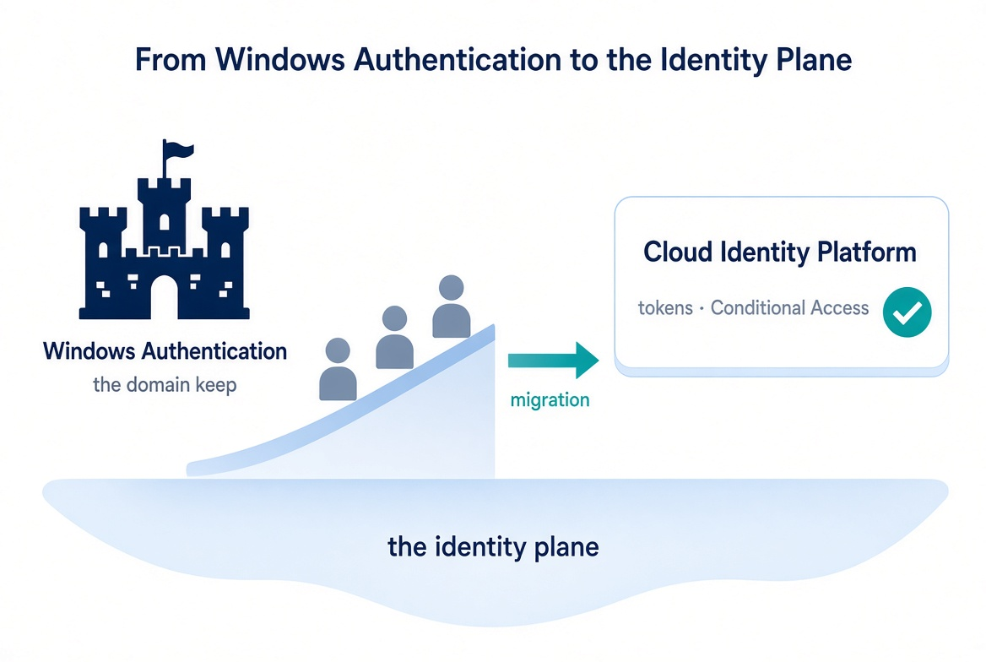

Status
This is a cleaned multi-chapter narrative. It is written as an engineering argument, not a runbook. Treat the patterns as guidance that must be validated against the specific estate.

The destination
Windows Authentication and SQL Authentication are eliminated and replaced with cloud identity authentication for SQL Server 2022 and later. Authentication is enforced through OAuth 2.0 tokens, a managed identity for the engine process, and multi-factor authentication for every human principal.

Reading sequence shape
Book 01 names the inheritance: SQL Server’s Windows Authentication was good engineering for its world, not negligence. Book 02 confronts the precondition that most authentication narratives skip: you cannot migrate the authentication of an estate you have not first assessed and consolidated. Books 03 through 06 trace the migration itself. Books 07 and 08 follow the transformation outward. Book 09 describes the transformed steady-state, and Book 10 addresses the certificate-authority dependency.

The transformation in three diagrams

Before — the domain is the trust boundary
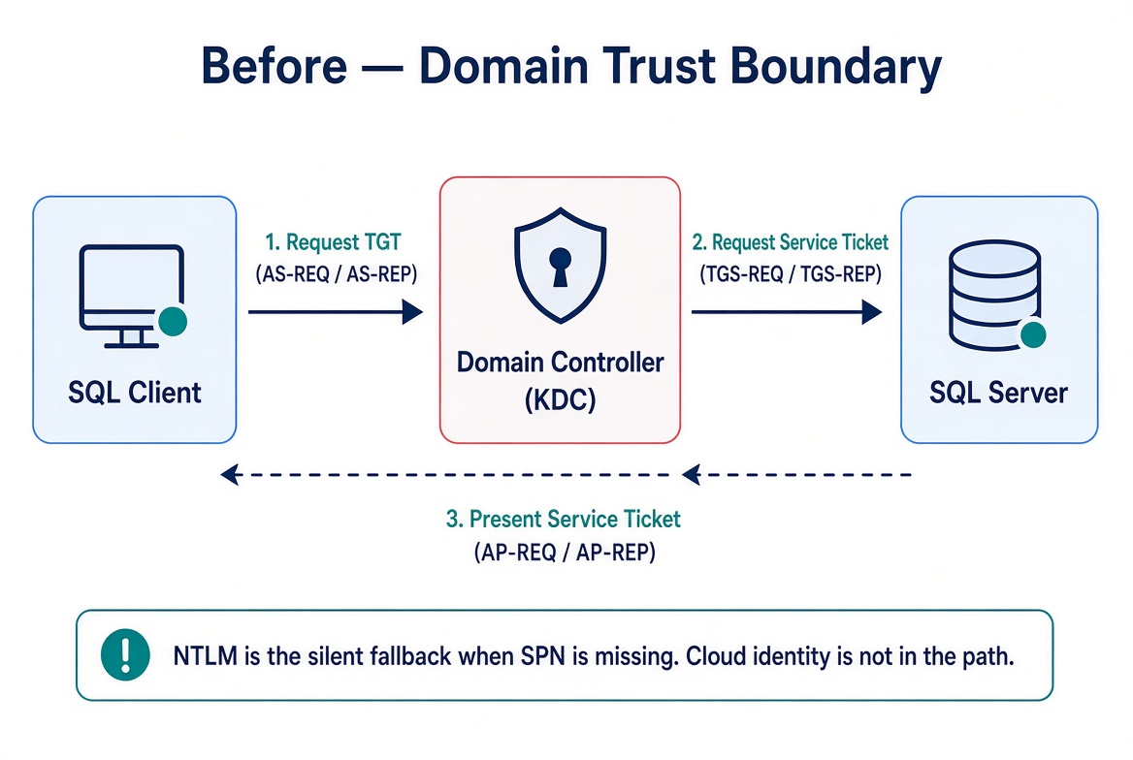
Every party is domain-joined. The domain controller is the authentication authority. Kerberos is the protocol. NTLM is the silent fallback when the service principal name is missing. The cloud identity plane is not in the path.

During — both paths live simultaneously
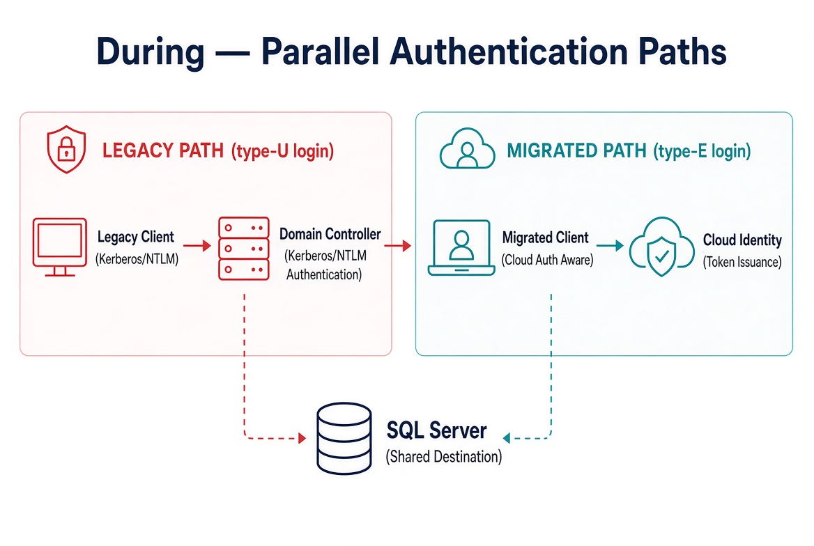
Legacy clients still use Kerberos or fall back to NTLM. Migrated clients authenticate to the cloud identity platform and present a token. The SQL Server accepts both during the parallel-run window.

After — no domain controller in the authentication path
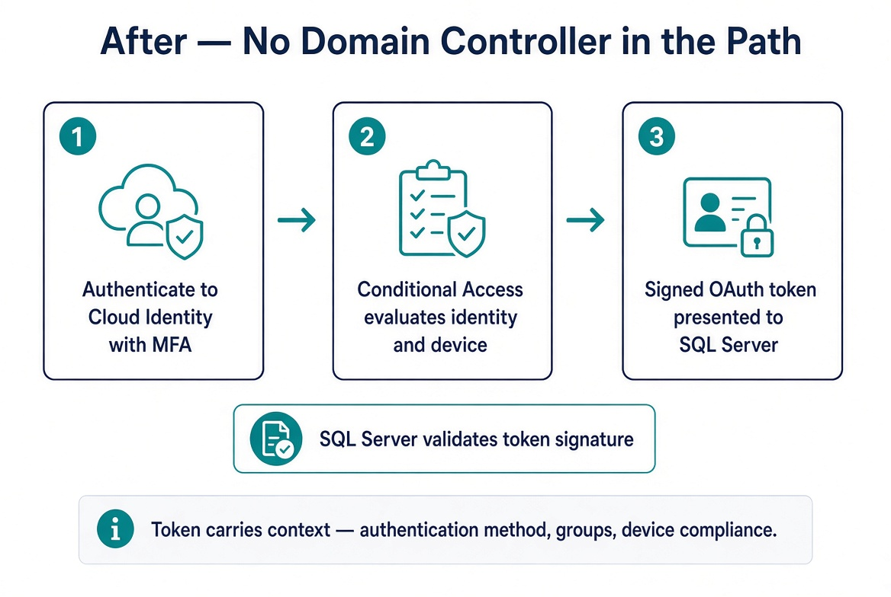
The client authenticates to the cloud identity platform with multi-factor authentication. Conditional Access evaluates identity and device. An OAuth 2.0 token is issued. The SQL Server validates the token.

Reading sequence
Book | Title | Focus
01 | The Authentication Inheritance Problem | What Windows Authentication actually is, and why it must end
02 | The Estate Itself | Assess and consolidate before you touch authentication
03 | The Authentication Audit | What is actually using Windows Authentication, SQL Authentication, and NTLM
04 | The Identity Bridge | Hybrid-management attachment and managed identity for the engine
05 | Login Migration | Parallel-run of Windows and cloud-identity logins
06 | NTLM Elimination | Silent fallback, service principal name repair, and protocol restriction
07 | Access Control | Dynamic groups and administrative-unit delegation
08 | The Upstream Application Chain | Applications that depend on Windows Authentication or LDAP
09 | Transformed Steady State | The destination and the milestone
10 | Certificate-Authority Dependency | The layer the other steps depend on but rarely name

Audience
Database engineers who execute the login migrations, infrastructure architects responsible for estate consolidation, security engineers who own Conditional Access design, and program leadership who must understand the scope of the engine-layer decision. The series assumes familiarity with SQL Server administration and Active Directory security concepts.

Cleaned extraction for project use. No internal branding or document identifiers.

