UIAO Governance OS — Whitepaper
  - How deterministic governance replaces attestation-based compliance
Michael Stratton
2026-06-01
Table of contents

UIAO Governance OS

How deterministic governance replaces attestation-based compliance
 Problem, solution, ask
Problem. Two decades of federal modernization built compliance attestation — point-in-time reports, screenshot evidence, narrative SSPs that age out the moment they are signed. Fragmented identity context, uncorrelated telemetry, and point-in-time evidence leave agencies compliant on attestation day and structurally drifting every day after.
Solution. The Governance OS: a canon-anchored substrate with three structural principles — a single source of truth under src/uiao/canon/, evidence that cites the canon document and version it derives from, and drift as an explicit, classed, deterministically scored signal. Every artifact an assessor receives can be regenerated without operator coordination.
Ask. Adopt it incrementally: install the uiao package and run uiao substrate walk, author a substrate manifest against the agency’s canon, bring one adapter under the class × mission-class taxonomy so it emits OSCAL alongside the existing attestation, then expand coverage and retire attestation evidence as substrate evidence reaches parity (§9).

Executive summary
Federal modernization programs have spent two decades building compliance attestation — point-in-time reports, screenshot-based evidence, and narrative SSPs that age out the moment they are signed. UIAO inverts that model. The Governance OS is a canon-anchored substrate that makes identity, policy, and compliance reproducibly verifiable: every artifact the substrate produces traces back to a numbered canon document, every finding carries a deterministic class and severity, and every evidence bundle can be re-executed by an assessor without operator coordination.
This whitepaper explains the substrate’s three operating principles, the shipped surface, and what an authorizing official can expect from a UIAO-anchored ATO package today.
The companion executive brief is Governance OS Overview. This whitepaper is the long-form synthesis: deeper rationale, more concrete substrate detail, and the case for treating governance as an operating system rather than as a reporting layer. Within the Org-family pillars, governance is OrgPath’s territory — the narrative treatment of the same synthesis is the OrgPath narrative series, whose Book 15 — The Complete OrgPath Narrative tells the Governance OS story end to end; the modernization surfaces referenced in §3 are curated at the OrgMod hub. This whitepaper names the engine; the OrgComp series’ own Vol X — Governance Substrate Integration Overview documents the identical substrate from the opposite side, deliberately without naming it — see §3 and §8 below for how the two fit together.
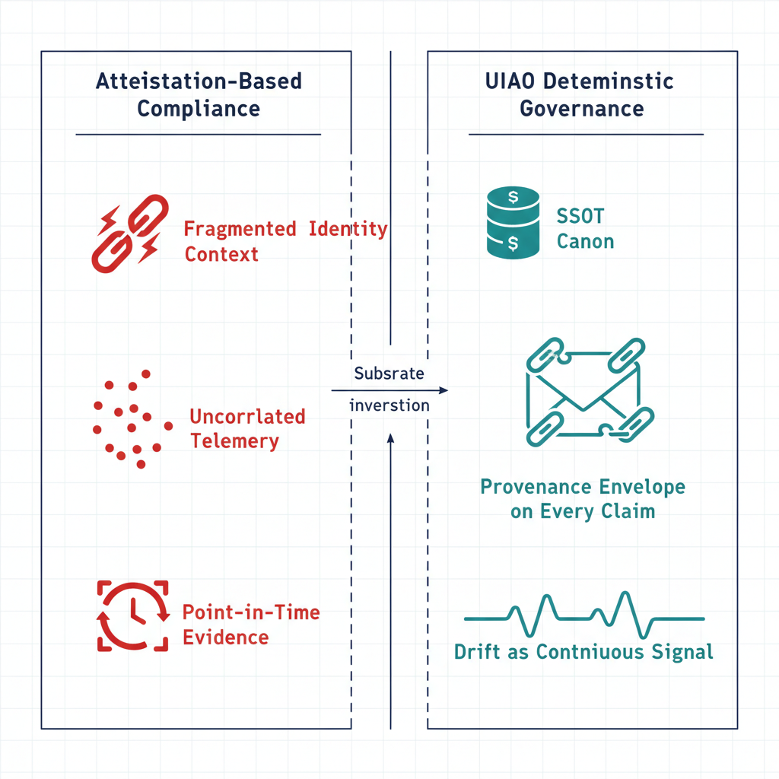
Figure 1: Attestation versus deterministic governance comparison diagram

1. The attestation failure mode
Three observable patterns produce the modernization-and-compliance gap that agencies repeatedly hit:
Pattern 1 — fragmented identity context. ICAM, Zero Trust analytics, and compliance reporting consume identity claims from different sources with different freshness assumptions. The same user may be “current” in one view and “stale” in another at the same moment.
Pattern 2 — uncorrelated telemetry. Security telemetry, configuration state, and access decisions are emitted by different planes with no shared provenance. Correlating them into a single control narrative is a periodic, manual exercise.
Pattern 3 — point-in-time evidence. SSPs, POA&Ms, and 3PAO evidence packages capture a snapshot at the moment of assembly. Between assemblies, drift is invisible to the package, and re-assembly is a re-engineered exercise rather than a deterministic regeneration.
The result: agencies are technically compliant on the day of attestation and structurally drifting every day after. The Governance OS is the operating-system-level response to that pattern.

2. The three operating principles
UIAO declares three substrate-wide principles in substrate-manifest.yaml (UIAO_200). Each is a structural property, not a procedural commitment.
Principle 1 — Single Source of Truth (SSOT). Every claim has exactly one canonical origin under src/uiao/canon/. All other representations are pointers, not copies. SSOT is enforced through importlib.resources reads at runtime — code that bypasses canon to maintain a parallel state is a DRIFT-PROVENANCE finding, not a permitted optimization.
Principle 2 — Canon-anchored evidence. Every artifact the substrate produces — SSP, POA&M, KSI dashboard entries, Component Definitions, adapter findings — cites the canon document ID and version it derives from. Evidence carries lineage as structured data, not as narrative.
Principle 3 — Drift is explicit. The six-class drift taxonomy (DRIFT-SCHEMA, DRIFT-SEMANTIC, DRIFT-PROVENANCE, DRIFT-AUTHZ, DRIFT-IDENTITY, DRIFT-SSOT-CONTENTION per ADR-074) names the failure modes, assigns deterministic severity, and emits remediation contracts. Drift is a signal, not an exception.
These three principles compose: SSOT defines what canon is, evidence anchoring binds artifacts to canon, and drift detection enforces both properties at every CI run and every adapter execution.

3. The substrate that ships today
The principles are not aspirational. The Governance OS already enforces them through a concrete CLI/CI surface declared in AGENTS.md and the substrate-manifest:
Surface | Mechanism | Maturity
Schema-first canon | Forty JSON schemas under src/uiao/schemas/, validated by schema-validation.yml and metadata-validator.yml | SHIPPED
Substrate walker | uiao substrate walk / uiao substrate drift — emits DRIFT-SCHEMA and DRIFT-PROVENANCE per substrate-drift.yml | SHIPPED
Adapter taxonomy | class × mission-class per UIAO_003, registered in two registries, validated by adapter-conformance.yml | SHIPPED
OSCAL evidence | SSP, POA&M, KSI, Component Definition generators with deterministic regeneration per ADR-006 | SHIPPED
Runtime drift (semantic / authz / identity) | Defined in 16_DriftDetectionStandard.qmd; evaluators ship in src/uiao/freshness/ and the identity JML/LocPath modules | PARTIALLY IMPLEMENTED
Continuous event-time evidence capture | Defined in 15_ProvenanceProfile.qmd | TARGET
The four shipped rows are the substrate’s structural floor. They run on every PR, gate every merge, and produce reproducible evidence today. The remaining rows are the runtime extension of the same principles — partially implemented or target-state — and they reuse the canonical taxonomy and provenance envelope rather than introducing parallel concepts.
This substrate is what the OrgComp series binds to, without naming it. Vol X of the Federal Organization Compliance series maps that series’ FedRAMP/NIST closures onto seven regime-agnostic “surface slots” — Identity, Addressing, Network, Telemetry, Endpoint, Security, Continuity — and states its own naming discipline directly: “this volume names no governance product. It speaks of the governance substrate, the conformance layer, the surface slots, and the evidence contract — the functions, not a brand.” That discipline is not a gap in Vol X; it is the OrgComp series independently demonstrating this whitepaper’s own §8 claim — that the substrate is not a vendor product, but a general instrument any conformant engine can score. Where this whitepaper says “UIAO,” Vol X says “the governance substrate that scores it”; both sentences describe the same shipped surface.
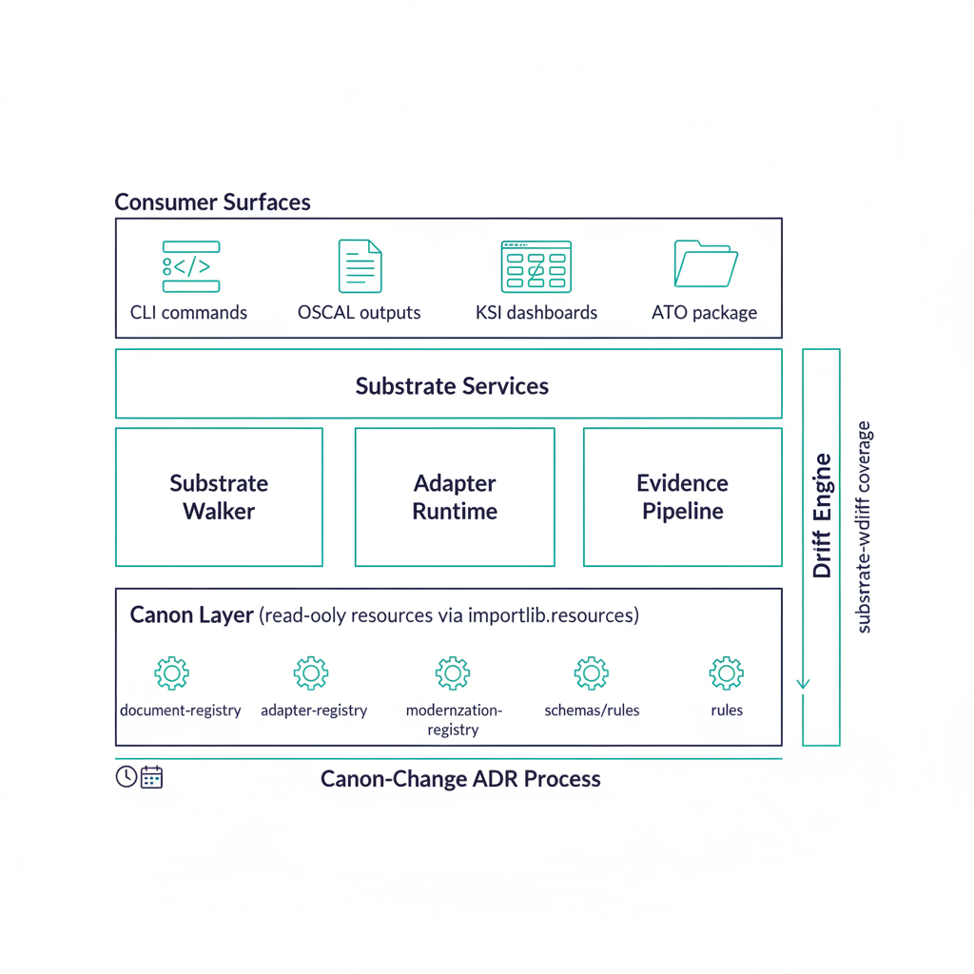
Figure 2: UIAO substrate stack diagram positioned as an operating system

4. Why “operating system,” not “framework”
The naming is deliberate. A framework is something an application consumes; an operating system is something an application runs on. UIAO’s substrate provides a bounded process model for every adapter and CI gate, a single scheduler for canonical change (the canon-change ADR process), and a stable read interface to canon (importlib.resources.files("uiao.canon")) — properties that let independent adapter authors, review surfaces, and deployment regimes build on the same substrate without each requiring its own governance machinery. Since ADR-092, canon names this posture Active Governance: an active reconciliation control plane that observes, reconciles, and actuates through a graduated L0–L4 ladder (federal default ceiling L3, human-approved actuation) while never becoming the in-path enforcer.

4.1 Worked example: one control, telemetry to OSCAL
Sections 3, 6, and 7 describe the evidence chain, the canon-anchored claim shape, and the ATO package properties separately. Tracing a single control end to end through all four pipeline stages makes the abstraction concrete.
Take KSI-IA-02 (phishing-resistant multi-factor authentication for GCC access), one of the KSI rules shipped in src/uiao/rules/ksi/iam/.
 Identifier namespace
KSI-IA-02 is a UIAO-internal rule identifier, named after the NIST SP 800-53 IA-2 control family. It is not a FedRAMP 20x Key Security Indicator. FedRAMP publishes ten KSI families — CED, CMT, CNA, IAM, INR, MLA, PIY, RPL, SCR, SVC — whose suffixes are mnemonic rather than numeric; the FedRAMP indicator for phishing-resistant MFA is KSI-IAM-APM. UIAO rules map to FedRAMP KSIs through src/uiao/rules/ksi/uiao-control-to-ksi-mapping.yaml; the two namespaces are deliberately distinct and must not be read as the same identifier.

Stage 1 — telemetry capture. The Entra adapter (evidence_sources: entra_id, graph_api per the KSI’s own declaration) polls Conditional Access policy state and per-user authentication-method registration on its configured interval, observing whether MFA is enforced and which method satisfies it (FIDO2, certificate-based auth, or a weaker, non-phishing-resistant factor).
Stage 2 — claim normalization. The raw Graph response is wrapped in the canonical provenance envelope. The shape below is illustrative — it shows the fields the envelope carries, not a captured record:
{
"claim_id": "clm-<uuid>",
"control_id": "KSI-IA-02",
"issuer_identity": "<entra-object-id>",
"source_classification": "authoritative",
"extraction_timestamp": "<ISO-8601 timestamp>",
"lineage_hash": "sha256:<hash of the source Graph record>",
"assertion": "phishing_resistant_mfa_required: true"
}
Stage 3 — bundle assembly and seal. Every KSI-IA-02 claim captured in the reporting interval is assembled into an evidence bundle. Per ADR-006, each claim already carries a SHA-256 of its source record; the bundle hash is computed over the per-claim hashes and the bundle is sealed:
{
"bundle_id": "bnd-<uuid>",
"control_id": "KSI-IA-02",
"claims": ["clm-<uuid-1>", "clm-<uuid-2>", "..."],
"bundle_hash": "sha256:<hash over the per-claim hashes>",
"canon_version": "<substrate-manifest version at capture time>",
"sealed_at": "<ISO-8601 timestamp>"
}
Stage 4 — OSCAL emission. The sealed bundle drives an OSCAL Assessment Result entry (and, where the control maps to a system component, a Component Definition) keyed to KSI-IA-02, ready to feed the KSI dashboard, the SSP control narrative, and — if the pass criterion fails — a POA&M item. Because the same canon version processing the same inputs always produces a byte-identical bundle (ADR-006), an assessor can re-run the pipeline months later and verify the bundle hash matches, without needing the original operator available to explain how the evidence was assembled.
That is the whole substrate, for one control: a poll, a hash, a seal, and a citation — repeated across every KSI rule the agency has brought under adapter coverage.

5. The three-layer rule model
UIAO separates rule authoring into three layers — canon, policy, runtime — each with its own change cadence and review surface (see Three-Layer Rule Model). The whitepaper-level point is operational: an agency adopting the Governance OS does not have to renegotiate every layer to make a change. Adding a new modernization adapter is a policy-and-runtime PR; amending a control’s meaning is a canon-change ADR. The blast radius of each change is bounded by the layer it touches.
This is the architectural reason UIAO scales across many concurrent modernization programs: the canon is small and stable, the policy mappings are large and registry-managed, and the runtime is the only layer that has to keep up with vendor product change.

6. The evidence chain
Evidence flows through a four-stage pipeline (see Evidence Chain):
telemetry capture → claim normalization → bundle assembly+seal → OSCAL emission
Two operational properties matter for an authorizing official:
Independent re-execution. Per ADR-006, the same canon version processing the same inputs always produces a byte-identical evidence bundle. A 3PAO can re-run the assembly months after the original audit and verify the bundle hash matches. The evidence does not depend on the operator being available.
Tamper-evident lineage. Each claim carries a SHA-256 of its source record at extraction. The bundle hash is computed over the per-claim hashes. Any modification anywhere in the chain breaks the bundle hash — a property assessors can verify with a hash check rather than a re-audit.

7. What an ATO package looks like
A UIAO-anchored ATO package presents the AO with five concrete properties that an attestation-based package cannot:
- Per-plane control narrative — six-plane decomposition from Six-Plane Architecture rather than a perimeter-centric one.
- Canon citation per control — every policy intent points to a numbered canon document, not to a paragraph in a Word file.
- Drift findings scoped per plane and per layer — DRIFT-* findings identify exactly which plane and which layer require remediation.
- Reproducible evidence bundles — the AO can re-run uiao substrate walk and the OSCAL pipeline without coordinating with the operator.
- Boundary impacts modeled as first-class objects — GCC-Moderate feature gaps appear as named boundary findings per the Boundary Impact Model, not as footnotes in control narratives.

8. What this is not
Three honest limits:
- It is not a replacement for the underlying control catalog. UIAO maps to NIST 800-53, FedRAMP CR26, and CISA ZTMM — it does not redefine the controls.
- It is not a runtime enforcement engine for every drift class today. Schema and provenance drift ship in CI; semantic, authorization, and identity drift detection at runtime is partially implemented and still maturing toward full coverage.
- It is not a vendor product. The substrate ships as the uiao Python package; agencies host it. There is no SaaS dependency in the canon layer. §3 above names the OrgComp series as the independent, product-neutral demonstration of this claim — a second corpus, bound to the same substrate, that never names it either.
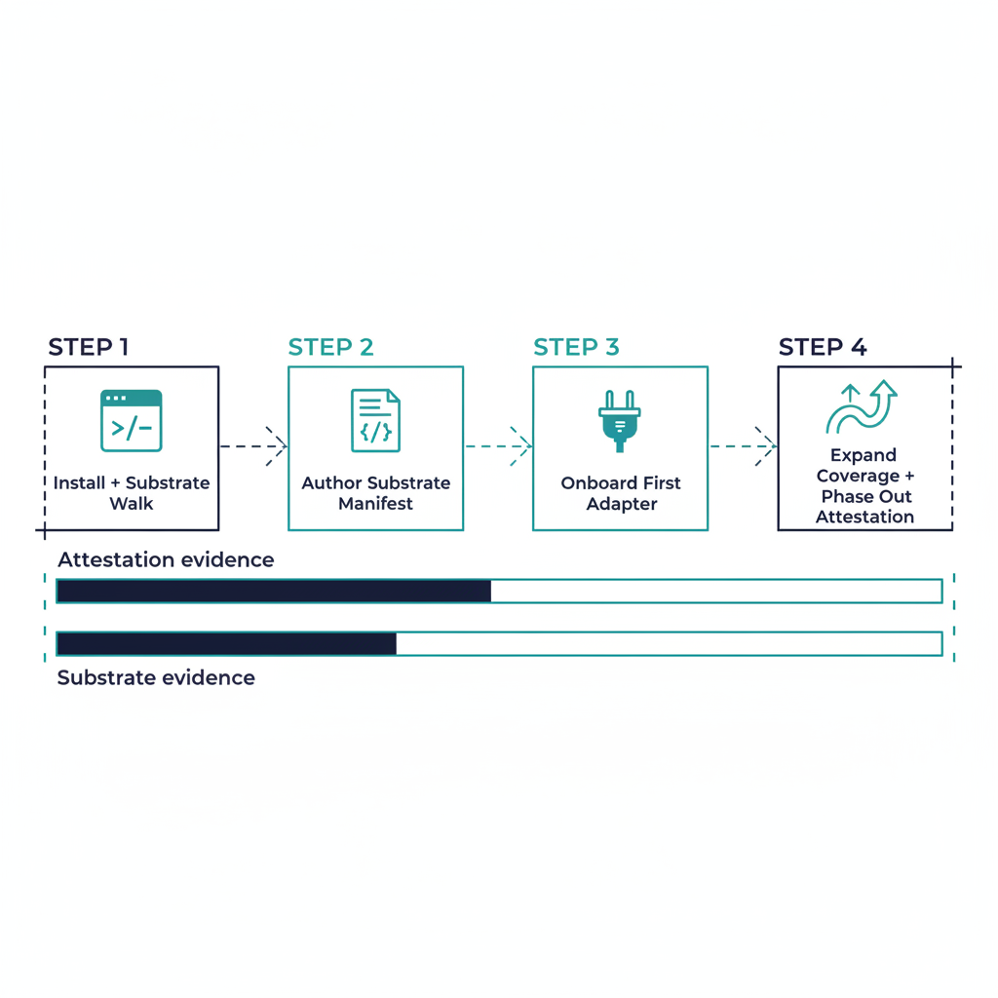
Figure 3: Incremental adoption ramp diagram

9. Adoption posture
An agency adopting the Governance OS does not have to rebuild its control narrative from scratch. The minimum viable adoption is:
- Install the uiao package; run uiao substrate walk on the local tree to validate the substrate is healthy.
- Author a substrate-manifest pointing at the agency’s canon (start with the modules already in scope).
- Bring one adapter under the class × mission-class taxonomy and register it; let it emit OSCAL evidence into the existing ATO package alongside the legacy attestation.
- Expand adapter coverage; phase out attestation evidence as substrate-emitted evidence reaches parity.
The substrate is designed for this incremental adoption — there is no big-bang. Phase 1 of the customer-documents ROADMAP is itself an example: each brief and explainer was ratified into the substrate one PR at a time, with the substrate walker keeping the prior shipped surface intact.

10. Conclusion
The Governance OS is the operational answer to the question “how do we keep canon, evidence, and runtime tied together as the substrate evolves?” The answer is: declare canon once, anchor evidence to it, detect drift explicitly, and run the whole thing as an OS rather than as a reporting layer.
What ships today is enough to anchor real ATO packages. What is target state extends the same model to runtime drift and continuous event-time evidence. The structural floor is in place; the rest is engineering on the same canonical foundation.

