AD to Entra ID — The Structural Migration Problem
  - Why the governance gap between AD and Entra ID is structural, not technical
Michael Stratton
2026-04-01
Table of contents

 Problem, solution, ask
Problem. Active Directory’s OU hierarchy is the agency’s governance model — delegation boundaries, GPO inheritance, administrative scope. Entra ID flattens all of it, Microsoft’s roadmap is forcing the move, and most agencies never had a clean AD to begin with, so the authority model they must reconstruct exists only as tribal knowledge.
Solution. Treat the migration as governance discovery, normalization, mapping, continuity, and validation — not a tools project. Every AD delegation concept has an explicit Entra counterpart (Administrative Units, PIM, Conditional Access, Entitlement Management) that has to be built as executable canon rather than inherited from a tree. That work is now the OrgTree modernization canon (UIAO_150–184) under the OrgPath pillar.
Ask. Before any Entra Connect setting is touched, commission the discovery of what the current AD actually encodes, and design around the two limits that decide whether the mapping works: AUs cannot nest, and the facets that drive AU membership are AD-mastered for every synced user. Read The Session vs. Telemetry Divide for the architectural mechanism underneath this gap.

The Core Problem
Active Directory’s X.500/LDAP hierarchy isn’t just a technical structure — it’s an organizational model. OUs carry governance: delegation boundaries, GPO inheritance, administrative scope, role-based access, and organizational authority chains. Enterprises and agencies built 20-30 years of operational process on top of that hierarchy.
Entra ID flattened all of it. What remains is objects in a tenant, some groups, and conditional access policies — but the governance model that AD’s tree encoded is gone. Microsoft’s answer has largely been “use administrative units” and “redesign your access model” — which is technically correct but operationally brutal for large organizations.
And agencies reading Microsoft’s roadmap are right: it is clearly moving in one direction. Hybrid is a transitional state, not a destination.

The Actual State of AD in Most Organizations
Most enterprises — federal agencies included — never achieved a clean, well-governed AD. What they actually have is decades of organic growth: regional DCs that were never fully consolidated, OUs that reflect org charts from 2003, GPOs layered on top of GPOs, service accounts nobody remembers creating, and trust relationships that exist because someone needed something to work fast fifteen years ago.
The “centralization” wave that followed didn’t clean it up — it just added a layer on top. The mess is still there, just now behind a load balancer.
And nobody wants to own it. AD became infrastructure that everyone depends on and nobody champions. It just runs. Until it doesn’t.

The Forced Migration Problem
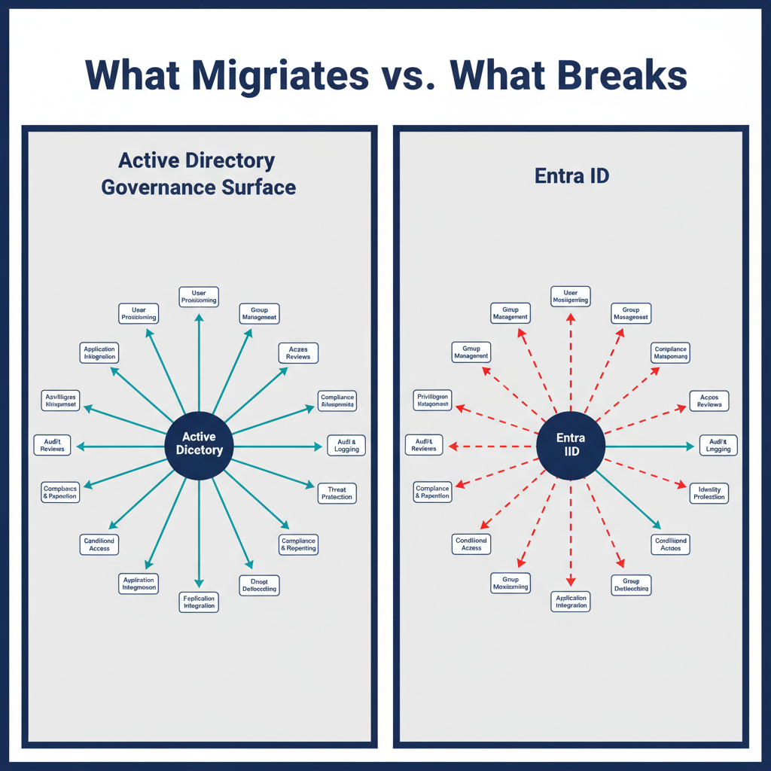
Figure 1: Architecture comparison diagram with two panels: Left panel ’Active Directory…
The worry that Microsoft will force Entra ID on organizations that never got AD right is not paranoia — it’s pattern recognition. Microsoft did this with Exchange → Exchange Online. They did it with Skype for Business → Teams. The pattern is always the same: deprecation notices, then hybrid support windows, then end of support, then the migration is forced. And the organizations that were already clean made the transition reasonably well. The ones that weren’t clean got hurt badly.
The difference with AD → Entra ID is the governance gap is structural, not just technical. An organization can’t script its way out of a flat directory if its entire authority model depended on OU hierarchy. It has to reconstruct the governance model in a new paradigm — Administrative Units, Privileged Identity Management, Conditional Access, Entitlement Management — and that reconstruction requires understanding what was there in the first place. Most organizations don’t have that documentation. It’s tribal knowledge, if it exists at all.

What UIAO Brings to This Problem
What this problem calls for isn’t just a migration tool. It’s a governance discovery, mapping, and reconstruction platform. Specifically:
- Discovery — what governance model the current AD actually encodes, whether it was set up right or not
- Normalization — rationalize the chaos into a clean authority model before the migration, not after
- Mapping — translate X.500/LDAP governance concepts into Entra ID equivalents (Administrative Units, PIM roles, access packages, conditional access policies)
- Continuity — ensure Kerberos-dependent services, SQL, legacy apps, and on-prem systems have a governed transition path, not a cliff
- Validation — prove the governance model survived the migration with evidence
That’s a capability that hospitals, banks, universities, manufacturers, and federal agencies all need. The federal compliance angle (FedRAMP, Zero Trust, OSCAL) is just one vertical of a much broader market.

AD Governance Concepts → Entra ID Equivalents
The reconstruction is not guesswork. Every AD delegation concept has a direct Entra counterpart — but it must be built explicitly rather than inherited structurally.
AD Concept | Entra ID Equivalent | Notes
Organizational Unit (OU) | Administrative Unit (AU) | AU membership is attribute-driven (OrgPath facets), not container-based. AUs cannot nest — an OU tree does not map onto an AU tree, only onto a flat set of attribute-selected AUs
OU-scoped delegation | Entra role scoped to AU | Same role (e.g., User Administrator) — different scope binding
GPO inheritance down OU tree | Intune policy sets targeted at dynamic groups | Group rule replaces OU position
Domain Admin | Global Administrator | PIM-eligible only; never permanently active
Helpdesk delegation on leaf OU | Authentication Administrator scoped to AU | AU membership rule matches org facets
Site-linked GPO (network policy) | Conditional Access + named locations | Token-based, not session/proximity-based
OU read delegation for service accounts | Microsoft Graph scoped API + least-privilege Entra role | Explicit scope; no implicit OU traversal
Security group creation by dept admin | Groups Administrator scoped to department AU | Role + AU together replace OU ACL
Privileged service account OU | Workload Identity Administrator (PIM-gated) | No OU containment; explicit role binding

Two limits decide whether this mapping works
AUs cannot nest. An OU tree does not become an AU tree. It becomes a flat set of AUs whose membership is selected by attribute, so any governance that depended on inheritance down the OU tree has to be re-expressed as an explicit predicate per AU rather than carried by containment.
The facets that drive AU membership are AD-mastered, not cloud-mastered. For a user with onPremisesSyncEnabled = true, Microsoft Graph treats onPremisesExtensionAttributes as read-only — the source of authority is on-premises AD. In a hybrid agency that is every user, so the facet values the AU rules match on are written in AD and reach Entra by directory sync. Two consequences: the migration cannot stamp facets cloud-side for synced users, and every AU membership change inherits a sync-latency hop. Device extensionAttributes are cloud-mastered and are writable, which is why the device plane and the user plane behave differently. See the hybrid-sync trap.

The UIAO Mapping step operationalizes this table: for each delegation record found in Discovery, it produces the AU definition, the membership rule (OrgPath facet predicate), and the role-assignment record needed in Entra. The output is executable canon, not a spreadsheet.

The Strategic Question
The reason this matters is architectural: the federal compliance machinery in UIAO (OSCAL generation, KSI engine, FedRAMP artifacts) is a vertical add-on to the core governance engine, not the other way around. That engine should be clean and universal, with the federal compliance module layered on top.
That inverts how it can feel today, when the federal compliance work is the most visible part of the platform.
UIAO’s core operating principles — Single Source of Truth, canon-anchored evidence, and explicit drift — are stated canonically, once, in UIAO Governance OS — Whitepaper’s “The three operating principles” section; the AD-to-Entra problem described in this paper is one instance of those principles applied to directory governance specifically, not a separate principle set.

What This Means Strategically
UIAO’s Eight Core Concepts aren’t federal-specific. They’re universal identity governance principles that happen to have been first proven in the hardest possible environment — federal civilian compliance. That’s actually the strongest commercial argument for the platform:
“We built this to survive FedRAMP Moderate, BOD 25-01, and Zero Trust mandates for federal agencies. For your enterprise, it’s easier.”
The federal work isn’t a liability in a commercial context — it’s a proof of concept at the highest standard of rigor.

The Architecture Decision This Pointed To
Enterprise directory governance shouldn’t be a separate product that happens to share some ideas with UIAO. It is UIAO’s Eight Core Concepts applied to the enterprise directory governance problem. The federal compliance layer (OSCAL, KSI, FedRAMP) is one vertical. Enterprise directory governance is another. The core engine — SSOT, identity as root namespace, deterministic policy, embedded governance — is the same underneath both.
That means directory governance belongs inside the UIAO framework as a governance domain in its own right — distinct from the data-source adapters (ServiceNow, Entra, Palo Alto) UIAO consumes today, but governed by the same envelope. Rather than standing outside the platform, it brings the directory migration problem under the UIAO governance envelope.
That is the decision the canon has since made. What this paper originally argued for as a direction is now settled architecture: the Org family stands as four named pillars — OrgPath (Governance), OrgComp (Compliance), OrgMod (Modernization), and OrgLink (External Interconnection) — established through ADR-089 and completed by ADR-134. And the directory reconstruction described here is specified as the OrgTree modernization canon (UIAO_150 through UIAO_184): the OrgPath codebook, attribute mapping tables, the delegation matrix, the OU-to-Entra migration runbook, drift detection, and the governance enforcement test suite. The conceptual architecture wasn’t just already there — it has since been built out as operational canon.

The Session vs. Telemetry Divide
The governance gap described above has a deeper architectural root: federal networks were built on session-oriented protocols (Kerberos, GPO, SQL Windows Authentication) that assume client/server proximity, while FedRAMP’s Zero Trust boundary controls assume continuous, stateless, telemetry-driven verification. Those two trust models are not compatible, and the collision between them is what makes AD-to-Entra migrations break in ways that look like bugs but are actually structural mismatch. Nobody wants to own the fix because it means admitting the problem is the entire architecture, not one system. This argument — naming the divide, tracing it to the FedRAMP boundary specifically, and showing how UIAO acts as the architectural bridge between the two models — is developed in full as its own paper: The Session vs. Telemetry Divide — Why Identity Architecture Splits at the FedRAMP Boundary.
 Related
This page makes the structural argument. For the same gap narrowed to the device-policy plane — the five governance capabilities lost when Group Policy moves to Intune/Entra, how the migration is actually progressing, and where OrgPath restores each — see GPO-to-Cloud Governance Gaps.
The series-length treatment of this exact ground is the OrgPath narrative: Book 01 walks the Microsoft identity stack tool by tool (including the flat directory, partial compensation by AUs and dynamic groups, and role-based delegation), Book 02 states what must exist, and Book 03 proposes the governance substrate. The pillar hubs for this territory are OrgPath (governance) and the OrgMod hub (the migration itself).

