UIAO Git Server Interfaces — Windows Server 2025 Deployment
  - Every plane the canonical Git host exposes once Phases 1-14 of the platform build are complete
UIAO Platform Engineering
2026-05-01
Table of contents

UIAO Git Server Interfaces — Windows Server 2025 Deployment
 Problem, solution, ask
Problem. Once a UIAO Git host is built, “what does it talk to, what talks to it, and what governs each conversation” has no single answer. An unenumerated interface surface on a Tier-0 host inside a GCC-Moderate boundary is exactly the gap an assessor finds and a drift engine cannot score.
Solution. An exhaustive inventory of six interface families — client transport, identity and authentication, cloud management plane, governance and telemetry, local management, outbound integrations — for the ADR-041 Option B build (Gitea behind IIS on Windows Server 2025), with every plane mapped to its boundary, authentication model, canon provenance, and NIST SP 800-53 Rev 5 controls. The list is finite, named, and observable; anything outside it is a DRIFT-* finding.
Ask. Adopt this inventory as the authorized-interface baseline for UIAO-GIT01, enforced through the build runbook, the release manifest, and the uiao-git-server conformance adapter — and treat any plane not on it as a finding to close or an ADR to write, never an exception to tolerate. Close the disclosed build-guide currency gap (v1.3 profile cited against v1.5) so the inventory stays anchored to current canon.

 Scope of this whitepaper
This paper enumerates every interface plane the UIAO Git infrastructure exposes once a Windows Server 2025 host has been brought up through the 14-phase runbook in platform-server-build.qmd under the architecture set by ADR-041 — UIAO Git Infrastructure.
Where the build guide answers “how do I install it?”, this paper answers “once it is installed, what does it talk to, what talks to it, and what governs each conversation?” Every interface is mapped to its boundary (GCC-Moderate vs. commercial-FedRAMP exception), its authentication model, its provenance into UIAO canon, and the controls it supports under NIST SP 800-53 Rev 5.
Two architectural options for the substrate-authority Git service are documented in the repository — Option A (IIS + git-http-backend.exe CGI) and Option B (Gitea behind IIS reverse proxy). ADR-041 selects Option B as canon. This whitepaper inventories the Option B interface surface; Option A’s reduced surface is summarized in Appendix B.

Executive summary
The UIAO Git host (UIAO-GIT01) is a single Windows Server 2025 VM that runs Gitea on 127.0.0.1:3000 behind IIS terminating HTTPS on :443. It sits inside the customer’s GCC-Moderate boundary, is domain-joined to the legacy AD forest, is hybrid-registered to the customer’s Entra tenant, enrolls into Azure Arc + Intune for compliance and policy projection, and emits drift telemetry to the UIAO_163 engine. From the outside it looks like one TLS endpoint; from the inside it is a federation of six interface families:
Family | Planes inventoried | Primary consumer
A. Client / operator transport | HTTPS Git Smart-HTTP, Gitea SSH, Gitea Web UI, Gitea REST API v1, Git LFS, optional FastAPI (UIAO API) | UIAO contributors, automation, auditors
B. Identity & authentication | AD LDAPS (:636), Entra OIDC, Kerberos / NTLM (Negotiate), hybrid Entra device join, GPG signed-commit verification | Operators + service principals
C. Cloud management plane | Azure Arc agent, Azure Policy + Guest Configuration, Intune compliance attestation, Azure Monitor Agent, Azure Blob (backup target) | Platform engineering, security operations
D. Governance & telemetry | Server-side Git hooks (pre-receive / update / post-receive), Gitea webhooks, UIAO_163 drift reporter, uiao-git-server conformance adapter, IIS W3C access logs | UIAO governance pipeline + ConMon
E. Local management | PowerShell 7.4 (signed-only via WDAC + AppLocker), Windows PowerShell 5.1 (legacy IIS cmdlets), Gitea CLI, IIS Manager / appcmd, NTFS storage on D:\GitRepos\ and D:\Gitea\ | Tier-0 administrators
F. Outbound integrations | GitHub upstream pull-mirror (api.github.com), PostgreSQL relational backend (pg01.corp.contoso.com:5432; or embedded SQLite on-host in the ADR-041 v1.3 single-host profile), PSGallery / Microsoft-CDN / GitHub-Releases (build only) | Substrate canon ingest, supply chain
Provenance note. The frontmatter above cites platform-server-build.qmd@v1.5, but the ADR-041 v1.3 single-host profile named in Family F (and cited again in §4.5 and §7.2) is itself still anchored to build-guide v1.3 — a known canon-currency gap, disclosed here rather than silently re-cited as current authority (see AGENTS.md’s operating-rules note on Version isolation).
Canonical claim. Every plane in the table above is enforced by the operational PowerShell in platform-server-build.qmd (Phases 0-14), pinned by the binaries in platform-server-v1.2.yaml, and observed by the conformance adapter uiao-git-server. Anything not in this table is not authorized on the host.
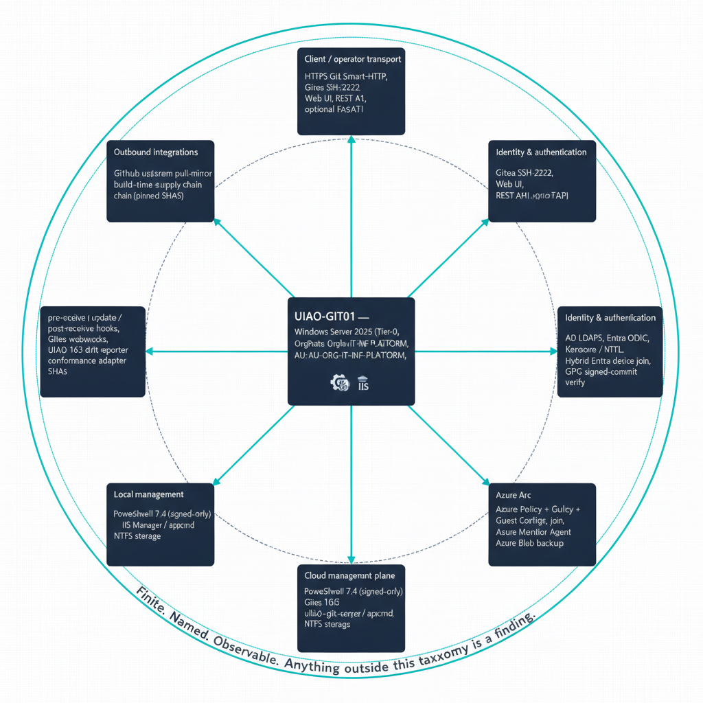
Figure 1: Six interface families radiating from the UIAO-GIT01 host as a hub-and-spoke map

1. Architectural context — what is being deployed

1.1 One host, six interface families
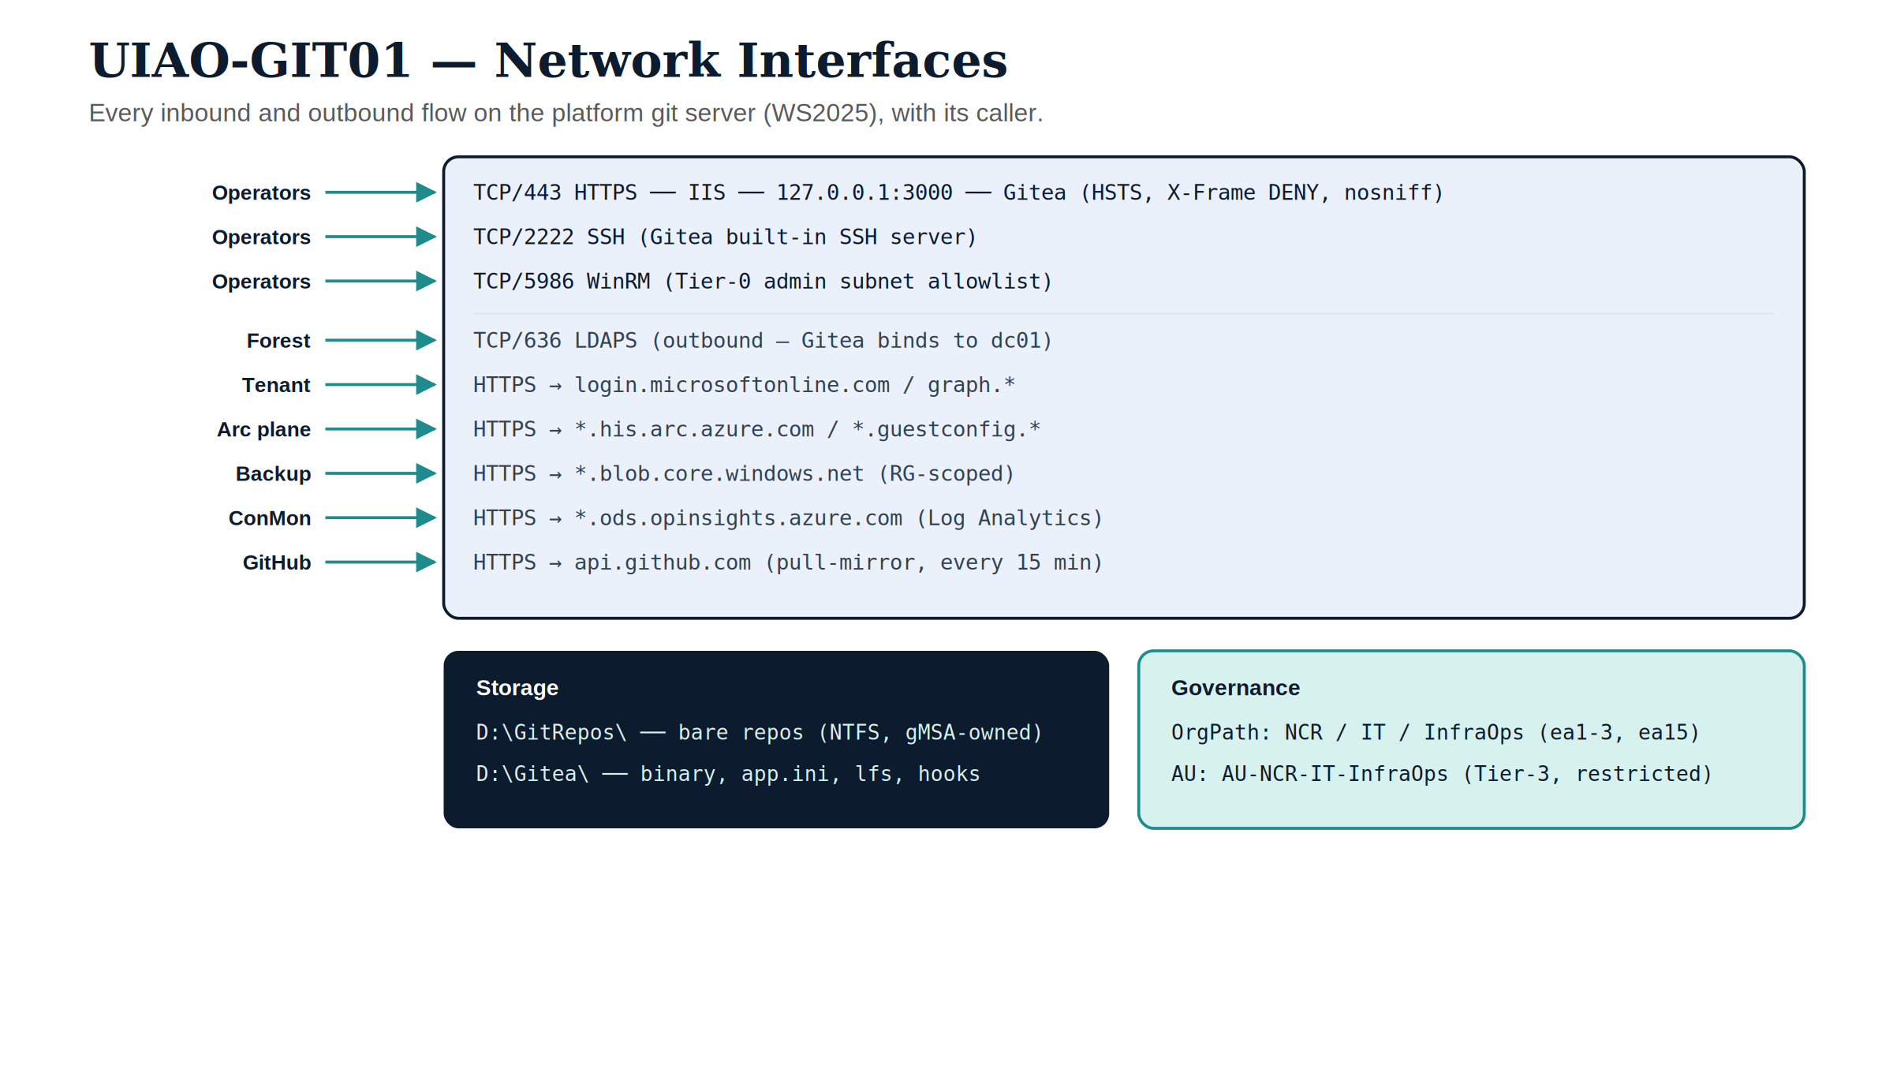
Figure 2: UIAO-GIT01 network interfaces — every inbound and outbound flow with its caller, plus storage and OrgPath/AU governance tags.
The host is Tier-0 by classification — it carries the canon, every plan, every authorization decision, and every drift signal traces back to a commit on it. CIS Level-2, AppLocker (publisher CN=UIAO Canon Signing), WDAC UMCI, Defender for Servers Plan 2, and Intune compliance all apply (see platform-server-build.qmd Phase 13). The interfaces below inherit that posture; nothing on the host is “informally available”.

1.2 Single substrate authority — replication is for DR, not load
Two hosts cannot both be authoritative for the canon — they would diverge. The interface inventory below describes a single-instance service. In the baseline (cold) DR posture, a passive replica exists for the 24-hour-RPO / 4-hour-RTO cold-restore target and shares the interface contract identically, but only the active node terminates client traffic. ADR-090 — Substrate High Availability (accepted 2026-06-02) adds an opt-in hot-standby posture on top of that baseline: a synchronously-replicated standby with split-brain-safe (witness-gated) automatic failover, raising the recovery target to near-zero RPO and single-digit-minutes RTO while preserving the single-logical-authority invariant — exactly one node binds commits at any instant. Horizontal scale, where required, is delegated to the target-surface adapters (Entra, Intune, Arc), not to the substrate authority. This is the same architectural claim asserted by 01-platform-foundation.qmd:25-33.

2. Interface family A — Client and operator transport
The four planes in this family are the only ones ordinary contributors ever see. Three of them (HTTPS, SSH, Web UI) ride the same TLS termination at IIS; the fourth (FastAPI) is an optional service co-resident on the host when the [api] extra is installed.

2.1 HTTPS Git Smart-HTTP — tcp/443
Attribute | Value
Listener | IIS site UIAOReverseProxy, host header git.uiao.corp.contoso.com:443
TLS | Enterprise-CA-issued cert (template WebServerV2), 4096-bit RSA, private key ACL’d to NT SERVICE\gitea and IIS AppPool\UIAOReverseProxy
Backend | http://127.0.0.1:3000 (Gitea), via ARR + URL Rewrite
Headers injected | X-Forwarded-Proto: https, X-Forwarded-For, X-Forwarded-Host
Security headers | Strict-Transport-Security: max-age=31536000; includeSubDomains, X-Content-Type-Options: nosniff, X-Frame-Options: DENY
Body limit | maxAllowedContentLength = 524288000 (500 MB)
Auth | Whatever the user picked — interactive Web SSO via Entra OIDC, or PAT/credential prompt for git push/clone
Audit | IIS W3C extended logs in %SystemDrive%\inetpub\logs\LogFiles\ (read by the conformance adapter)
This is the only plane that talks to the public-facing IP. Gitea is bound to loopback and is unreachable directly. The reverse-proxy rewrite rule is single, catch-all, and stop-processing — there is no static-content fall-through.
Used by: every git clone, git fetch, git push against the canonical mirror; every browser session against the Web UI; every REST-API call against Gitea.

2.2 SSH Git transport — tcp/2222
Gitea ships its own SSH server (DISABLE_SSH = false, SSH_LISTEN_PORT = 2222). It is bound to the host network, advertises host key git.uiao.corp.contoso.com, and authenticates with SSH public keys uploaded by the user through the Web UI or the REST API (POST /api/v1/user/keys). It is not the OpenSSH service — port 22 is not used and the OS-level OpenSSH server feature is not installed.
The SSH plane is functionally equivalent to the HTTPS plane for git operations but bypasses IIS, so it does not appear in the IIS W3C logs. Its audit trail is the Gitea event log (D:\Gitea\log\), which the uiao-git-server adapter reads as a complement to the IIS log.
 Why two transports?
HTTPS terminates at IIS, gets the full security-header treatment, and is routable through the corporate forward proxy. SSH does not honor HTTP proxies, so it is the escape hatch for build agents that cannot speak HTTPS through Kerberos-authenticated proxies. Operators are pushed toward HTTPS by default (Web UI, README, git config --global push URLs); SSH is for automation that needs raw socket access.

2.3 Gitea Web UI — browser, on the same tcp/443
Routed through IIS to Gitea’s HTML surface. Carries:
- Repository browser, blame, raw-file view, diff/PR view
- Issues + pull requests + reviews
- Settings → Webhooks → Git Hooks — the only place where server-side hook bodies are edited from a browser; signed by the Phase 0.6 code-signing cert before deployment
- OAuth2 consumer-app management (organizations can register their own)
- Personal access token (PAT) issuance for the signed-in operator
- Mirror status and forced-resync controls for the GitHub upstream pull-mirror
Anonymous access is disabled (DISABLE_REGISTRATION = true, REQUIRE_SIGNIN_VIEW = true); every page render is bound to an authenticated session.

2.4 Gitea REST API v1 — https://git.uiao.corp.contoso.com/api/v1/
The substrate uses the REST API as the machine-to-machine control plane for Gitea. Everything the Web UI does is also reachable here under the same auth model (PAT, OAuth2 token, or session cookie).
Documented call paths used by the Phase 6-8 build PowerShell:
Endpoint | Method | Phase | Purpose
/api/v1/admin/sources | POST | 6, 7 | Register corp-ad-ldaps and EntraID source-configs
/api/v1/orgs | POST | 8 | Create the uiao organization
/api/v1/repos/migrate | POST | 8 | Configure the GitHub pull-mirror with mirror_interval = 15m0s
/api/v1/orgs/uiao/teams | GET | 14.4 | UIAO_163 reporter compares team list to dynamic-group claims
/api/v1/admin/users | GET | runtime | Audit + drift reporting
/api/v1/repos/{owner}/{repo}/hooks | * | 9 | Webhook fan-out registration
The same REST surface is what UIAO modernization adapters and the CI mirror use; the surface is not customer-extensible — adapters that want new behavior add server-side hooks, not Gitea endpoints.

2.5 Git LFS server — LFS_START_SERVER = true
The Gitea-hosted LFS server runs on the same 127.0.0.1:3000 listener as everything else; its content-addressed chunks live under D:\Gitea\data\lfs\. There is no separate LFS S3/Azure backend — the LFS plane is a first-class part of the substrate authority, with the same backup, ACL, and quota posture as the bare repos in D:\GitRepos\.
The conformance adapter (uiao-git-server) emits LFS bytes-stored as part of the per-poll git-repo-inventory.json record; LFS-quota drift shows up as a CM-8 finding.

2.6 Optional FastAPI plane — uiao.api.app:app via HttpPlatformHandler
Distinct from Gitea. When the [api] optional extra is installed (pip install -e ".[api]"), the FastAPI app at uiao.api.app:app runs under IIS HttpPlatformHandler per deploy/windows-server/web.config. This is the UIAO API, not the Git API; it exposes the substrate-walker, KSI, evidence-graph, and ATO surfaces.
Key contract:
Property | Value | Source
Process | python.exe C:\inetpub\uiao-api\run.py (uvicorn, single worker, loopback) | deploy/windows-server/run.py
Bind | 127.0.0.1:%HTTP_PLATFORM_PORT% (ephemeral) | same
TLS | Terminated at IIS — same enterprise cert as Gitea or a sibling cert | web.config
Auth | windowsAuthentication enabled="true", providers Negotiate, NTLM (Kerberos preferred); anonymous disabled | web.config:67-85
Token forwarding | forwardWindowsAuthToken="true" — Python sees the impersonated principal | web.config:33
Headers | HSTS, X-Frame-Options DENY, X-Content-Type-Options nosniff, X-XSS-Protection, Referrer-Policy, Permissions-Policy, X-Powered-By removed | web.config:120-135
Logging | IIS W3C log is authoritative; uvicorn access_log=False deliberately | run.py:49
The FastAPI plane is off by default — Phase 4 does not install it, and the canonical interface contract (pip install uiao without [api]) ships only the CLI surface. Customers turn it on when they need a REST entry point for non-CLI consumers; the substrate’s own governance pipeline does not depend on it.

3. Interface family B — Identity and authentication

3.1 AD LDAPS — outbound tcp/636 to dc01.corp.contoso.com
Configured as a Gitea source-config named corp-ad-ldaps via the REST API in Phase 6. Bind account is least-privilege (CN=svc-uiao-ldap,OU=ServiceAccounts,...), search base is scoped to the OrgPath-governed Users OU (OU=Users,OU=ORG-IT-INF-PLATFORM,...), and the admin filter is the OrgTree dynamic group OrgTree-IT-INF-PLATFORM-CanonStewards.
This is the operator path for “AD-only” users — anyone whose identity lives in the legacy forest but has not yet been federated to Entra. A successful LDAP bind creates a native Gitea identity on first sign-in; the user’s group memberships are synced on each sign-in.
The host’s own machine account uses Kerberos (separate from this LDAPS bind) for AD domain-join services and Group Policy resolution.

3.2 Entra OIDC — login.microsoftonline.com + graph.microsoft.com
The federated SSO path. Phase 7 registers the app UIAO-Gitea-OIDC in the customer tenant with:
- Sign-in audience: AzureADMyOrg
- Redirect URI: https://git.uiao.corp.contoso.com/user/oauth2/EntraID/callback
- Optional claim: groups in the ID token
- Group-membership claim type: SecurityGroup
Gitea is then configured (also via /api/v1/admin/sources) with:
- provider: openidConnect
- openid_connect_auto_discovery_url: https://login.microsoftonline.com/{tenantId}/v2.0/.well-known/openid-configuration
- scopes: openid profile email groups
The critical property is the groups claim: when an operator signs in, the ID token carries their Entra security-group memberships, and Gitea maps those memberships to its team model on the uiao org via the rules in platform-server-build.qmd §14.3. A joiner/mover/leaver event in the HR feed propagates through the Entra dynamic-group recalculation and arrives as a Gitea permission change within roughly fifteen minutes — no hand-maintained team membership. This is the same Phase 14 OrgTree propagation mechanism §5.3 and §9.2 flag as canonically declared but still under operational validation; the fifteen-minute figure carries that same caveat here.

3.3 Kerberos / NTLM (Negotiate) — for the FastAPI plane
When the optional FastAPI plane is enabled, IIS terminates Windows Authentication via Negotiate (Kerberos preferred, NTLM fallback) and forwards the impersonated token into the Python process. This auth surface does not apply to the Gitea reverse proxy — Gitea handles its own auth via LDAPS or OIDC.

3.4 Hybrid Entra device join — the OrgPath facets and derived path
The host is registered as a device object in the customer’s Entra tenant. That matters for the write path: device extensionAttributes are cloud-mastered and writable through Graph, unlike a synced user’s onPremisesExtensionAttributes, which Graph treats as read-only. The stamps below are therefore direct Graph writes, with no on-premises hop. Two attributes are critical to the governance plane:
- The governance-layer facets in their codebook slots — extensionAttribute1 = NCR (Region), extensionAttribute2 = IT (Department), extensionAttribute3 = InfraOps (Division) — each validated against its own enumeration in the UIAO_151 codebook and the UIAO_158 schema
- extensionAttribute15 — the derived OrgPath (Region=NCR|Department=IT|Division=InfraOps|), recomputed from those facets on every stamp rather than hand-authored (ADR-127)
- Azure Arc resource tags mirror the same OrgPath plus DeviceRole and DeviceTier (Phase 14.1)
These attributes are how the drift engine (UIAO_163) recognizes the host as a first-class OrgTree object rather than an unmanaged appliance.

3.5 GPG — signed-commit verification (gpg.exe on the host)
The Phase 9 pre-receive hook chain calls gpg.exe (from gpg4win 4.3.x, pinned in the release manifest) to validate signatures on canon-bearing commits. The keyring lives under the gMSA’s profile; trust roots are the enterprise PKI’s signing certs plus the explicit operator signing keys uploaded through the Gitea Web UI. Unsigned pushes to main, canon/*, or any path under src/uiao/canon/ are rejected at pre-receive.

3.6 Authentication identity matrix
Caller | Auth path | Where the identity comes from | Bound to
Federated UIAO contributor | Entra OIDC SSO (Web UI), then PAT for git | Entra tenant + group claims | OrgTree-IT-INF-* dynamic groups
Legacy / AD-only contributor | LDAPS bind through Gitea source-config | Forest user object in OrgPath OU | OrgTree-IT-INF-PLATFORM-CanonStewards admin filter
FastAPI plane caller (optional) | IIS Negotiate (Kerberos / NTLM) | Forest user; impersonated to Python | NTFS ACL on whatever resource the API touches
Gitea service itself | gMSA corp\svc-uiao-gitea$ | Forest service account | D:\GitRepos, D:\Gitea, TLS private key
IIS reverse-proxy app pool | IIS AppPool\UIAOReverseProxy | Built-in app-pool identity | TLS private key (Read), nothing else
Backup / Arc plane | Service principal in customer subscription | Tenant SPN, secrets in SecretStore | Storage account + Arc resource scope
GitHub upstream mirror | Read-only (anonymous over HTTPS) | n/a — WhalerMike/uiao is public | n/a

4. Interface family C — Cloud management plane

4.1 Azure Arc — azcmagent connect
Phase 11 onboards the host as an Microsoft.HybridCompute/machines resource named UIAO-GIT01 in the resource group rg-uiao-governance. The agent runs as a Windows service, talks outbound to:
- *.his.arc.azure.com — agent registration + heartbeat
- *.guestconfiguration.azure.com — Azure Policy / Guest Configuration evaluation
- management.azure.com — ARM control plane (resource updates, extension installs)
Arc projection is what makes Azure Policy and Defender for Servers Plan 2 reach the on-prem host. The OrgPath, OrgPathBranch, OrgPathDivision, DeviceRole, and DeviceTier tags are set on the Arc resource so Azure Policy assignments can be scoped via tag expressions instead of resource IDs.

4.2 Azure Policy + Guest Configuration
Inherits the Arc plane. Once the host is Arc-enrolled, Azure Policy assignments scoped to rg-uiao-governance (or to OrgPath tags) project Guest Configuration audits onto the host. The audit results flow back through the Arc agent into the Azure portal and into the UIAO_163 drift engine via the Azure-side payload.

4.3 Intune compliance attestation
Phase 10 publishes a windows10CompliancePolicy named UIAO-GIT-ServerCompliance-v2 and assigns it to the dynamic group OrgTree-IT-INF-PLATFORM-Devices (Phase 14.5). The host’s Intune agent attests the eight required signals (Secure Boot, BitLocker, code integrity, storage encryption, firewall, antivirus, real-time protection, TPM) to *.events.data.microsoft.com; non-compliance opens an SLA ticket through UIAO_167.

4.4 Azure Monitor Agent — Log Analytics forwarding
Installed as the Arc extension AzureMonitorWindowsAgent in Phase 11. Forwards the W3C IIS access log, the Gitea event log, the Windows audit log (Phase 13.e categories: Logon/Logoff, Object Access, Privilege Use, System, Account Management, Policy Change), and the Defender event log to the customer’s Log Analytics workspace at *.ods.opinsights.azure.com / *.oms.opinsights.azure.com. This is the SIEM-feed plane — one Arc extension projects into whatever downstream SIEM the customer has wired to that workspace.

4.5 Azure Blob — backup target
Phase 12’s Backup-UIAOGitea function uploads the nightly gitea dump plus the zipped D:\GitRepos\ to a storage account (stuiaogovernance, container gitea-backups) using the managed identity assigned to the Arc resource, with 30-day retention. This is the default backup path for the full-production (PostgreSQL) profile. Deployments on the single-host SQLite profile sanctioned by ADR-041 v1.3 — and any deployment without reachable Azure Blob (lab, air-gapped) — instead run scripts/deploy/Backup-GiteaDatabase.ps1, which quiesces Gitea, takes a Volume Shadow Copy–consistent snapshot of gitea.db, and ships the timestamped archive to on-prem local + SMB targets under the same 30-day retention.
Both paths satisfy the cold-restore baseline of RPO 24 h / RTO 4 h; deployments that opt into the ADR-090 hot-standby posture (§1.2) raise that to near-zero RPO and single-digit-minutes RTO via split-brain-safe automatic failover. In the full-production profile the blob endpoint is the only outbound “data” path on the host — everything else outbound is control-plane traffic; in the single-host SQLite profile backups stay on-prem (local + SMB targets), so no outbound data path exists at all.

5. Interface family D — Governance and telemetry
This is where the host stops looking like a Git server and starts looking like a UIAO substrate node.

5.1 Server-side Git hooks — pre-receive / update / post-receive
Native to every bare repo under D:\GitRepos\. The bodies are authored in git-server-implementation.qmd §15 (canonical for both Option A and Option B) and apply unchanged to Gitea. They run inside the Gitea process under the gMSA, with their own audit log written to D:\Gitea\log\hooks\.
Hook | Mandatory rule | Source
pre-receive | Reject main pushes unless author ∈ OrgTree-IT-INF-PLATFORM-CanonStewards | §15 Rule 1
pre-receive | Reject any commit containing FOUO / For Official Use Only markings | §15 Rule 2
pre-receive | Validate canon-file YAML frontmatter (document_id, version, status, classification, owner, boundary) | §15 Rule 3
pre-receive | Reject canon files not matching ^UIAO_\d{3}_[\w]+_v\d+\.\d+\.md$ | §15 Rule 4
pre-receive | Reject unsigned .ps1 files under scripts/ (Authenticode + WDAC requirement) | Phase 0.6
update | Enforce branch-naming allowlist: main, develop, feature/*, bugfix/*, hotfix/*, canon/*, release/* | §15
post-receive | Log push + emit repository_dispatch to GitHub Actions for canonical CI mirroring | §15
Each hook is signed with the CN=UIAO Canon Signing certificate before deployment; AppLocker would refuse to execute any unsigned script anyway.

5.2 Gitea webhooks — outbound HTTP fan-out
Configured per repository through the Web UI or /api/v1/repos/{owner}/{repo}/hooks. The substrate uses webhooks for:
- repository_dispatch to GitHub — keeps the public mirror’s CI in sync after a canonical push
- UIAO_163 drift engine — push events emit a payload that the drift reporter consumes alongside the scheduled Arc-agent state
- Quarto rebuild trigger — push events on docs/** paths trigger the Quarto pipeline to regenerate the documentation site
Webhooks are HTTP POST with HMAC-SHA256 signatures; the receiver verifies the signature before acting. Failed webhooks are retried by Gitea with exponential backoff and surface in the Web UI under Settings → Webhooks → Recent Deliveries.

5.3 UIAO_163 drift reporter — scheduled task
Phase 14.4 registers a scheduled task that runs under the Arc service principal (no interactive credentials on the host) — a Phase 14 OrgTree capability that is canonically declared but still under operational validation per the build guide’s own status warning. The task collects:
- Entra device extensionAttribute1 value
- Azure Arc resource OrgPath tag value
- Gitea team list via GET /api/v1/orgs/uiao/teams
- Administrative Unit membership via Graph
- Arc agent lastHeartbeat
…and submits them to UIAO_163 via Submit-DriftReport. The drift engine emits the standard taxonomy: DRIFT-SCHEMA, DRIFT-SEMANTIC, DRIFT-PROVENANCE, DRIFT-AUTHZ, DRIFT-IDENTITY. Non-zero counts open SLA tickets per UIAO_167.

5.4 uiao-git-server conformance adapter
Documented in adapter-specs/uiao-git-server/uiao-git-server.qmd and registered as active in adapter-registry.yaml. Read-only. Emits four evidence files per polling interval:
- git-server-health.json — IIS app-pool state, Gitea service status, git-http-backend responsiveness
- git-tls-inventory.json — TLS certificate inventory with expiry timestamps, chain validity, key algorithm, SAN coverage
- git-repo-inventory.json — repos with size, last-push, branch count, quota state, LFS bytes
- IIS access-audit summaries — per-period request volume, response-code distribution, top-N principal patterns
Maps to NIST controls CA-7 (continuous monitoring), CM-8 (component inventory), AU-2 (event logging), AU-6 (audit review), SI-4 (system monitoring).

5.5 IIS W3C extended logs
The deterministic record of every :443 request — the authenticated principal, the URL, the user-agent, the response code, and the bytes moved. Files land in %SystemDrive%\inetpub\logs\LogFiles\<siteId>\, get rolled daily, and feed both the conformance adapter (§5.4) and the SIEM forwarder (§4.4). Treated as evidence under AU-2 / AU-6.

6. Interface family E — Local management

6.1 PowerShell 7.4 — pwsh (signed-only)
The administrative shell. Execution policy is AllSigned on the user scope; AppLocker (Phase 13.b) and WDAC UMCI (Phase 13.c) refuse to execute any script not signed by CN=UIAO Canon Signing. Every Gitea hook carries #!/usr/bin/env pwsh. PowerShell 5.1 is retained only for Install-WindowsFeature and a small set of legacy IIS cmdlets (WebAdministration); all new automation runs on pwsh.

6.2 Gitea CLI — gitea.exe
Local management surface for the Gitea service:
- gitea service install — the Phase 4 service registration
- gitea dump — the backup primitive (Phase 12)
- gitea admin user * — emergency operator break-glass
- gitea generate secret — JWT / internal-token rotation
Always invoked under the gMSA via Run-As. There is no SSH-into-the-host operator workflow; Tier-0 administration uses the WinRM 5986 surface restricted to the admin subnet (10.1.20.0/24).

6.3 IIS Manager + appcmd + IISAdministration module
The IIS configuration plane. Used at install time (Phase 2 / Phase 5) and during incident response. Read-only access for the conformance adapter is granted via the Web Server (IIS) Tools RSAT group membership on the gMSA.

6.4 Storage — D:\GitRepos\ and D:\Gitea\
The bare-metal interfaces. Every byte the Git substrate cares about lives under one of two roots:
Path | Owner | Contents
D:\GitRepos\ | gMSA corp\svc-uiao-gitea$ (Modify, OI/CI) | Bare repos and their hooks/; the actual Git object store
D:\Gitea\ | gMSA (Modify, OI/CI) | gitea.exe, custom\conf\app.ini, data\, data\lfs\, log\
E:\Backups\Staging\ | Service-account-owned, opt-in | Backup-UIAOGitea staging area before Blob upload
NTFS ACLs are the only authorization boundary inside the host. In the full-production profile, Postgres metadata lives off-host on pg01.corp.contoso.com:5432; in the ADR-041 v1.3 single-host SQLite profile it lives on-host in D:\Gitea\data\gitea.db, under the same gMSA-owned ACL as the rest of D:\Gitea\ (see §7.2).

7. Interface family F — Outbound integrations

7.1 GitHub upstream pull-mirror — api.github.com
Phase 8 configures the canonical WhalerMike/uiao repo as a pull-mirror in Gitea via POST /api/v1/repos/migrate with mirror_interval = 15m0s. Every 15 minutes Gitea pulls from https://github.com/WhalerMike/uiao.git and updates local refs. Authentication is anonymous (the upstream is public); commits are verified by the same hook chain that governs operator pushes.
GitHub is the source of canon ingest; the on-prem Gitea is the source of canon authority. A push to GitHub does not become canon until the pull-mirror has fetched it and the hook chain has accepted it.

7.2 Relational backend — PostgreSQL (full production) or embedded SQLite (single-host profile)
ADR-041 v1.3 (2026-06-20) sanctions two database profiles for Gitea’s metadata (users, teams, OAuth apps, issue/PR state, webhook delivery history):
- Full production (default). The database uiao_gitea on a separate PostgreSQL host, pg01.corp.contoso.com:5432. Connection details (user, password from Microsoft.PowerShell.SecretManagement) live in the [database] section of app.ini. Backup is the responsibility of the database team; the Gitea-side gitea dump includes a logical dump of this database for cold-restore use.
- Single-host SQLite (lab / air-gapped / small-footprint). Gitea’s embedded SQLite backend (DB_TYPE = sqlite3, D:\Gitea\data\gitea.db) on the same host — no separate relational tier and no outbound database connection. Backup is scripts/deploy/Backup-GiteaDatabase.ps1 (VSS-consistent snapshot of gitea.db, shipped to on-prem local + SMB targets, 30-day retention; see §4.5).
Only the full-production profile contributes an outbound plane to this interface family; under the single-host SQLite profile the database is local state under D:\Gitea\ governed by the §6.4 storage posture.

7.3 Build-time supply chain — pinned to platform-server-v1.2.yaml
Every binary the Phase 1-13 PowerShell downloads is pinned to a canonical_url + sha256 in platform-server-v1.2.yaml. Hosts: github.com, objects.githubusercontent.com, download.microsoft.com, aka.ms, dotnetcli.azureedge.net, packages.microsoft.com, www.gpg4win.org, *.powershellgallery.com, timestamp.digicert.com. Internal-mirror operators (§0.5) substitute the canonical URLs with their Artifactory / Azure Artifacts mirror; the SHA-256 stays the same.
This plane is build-only. After cutover, the only outbound “package” path is the GitHub pull-mirror in §7.1; the supply-chain URLs are not on the runtime egress allowlist.

8. Boundary and egress posture
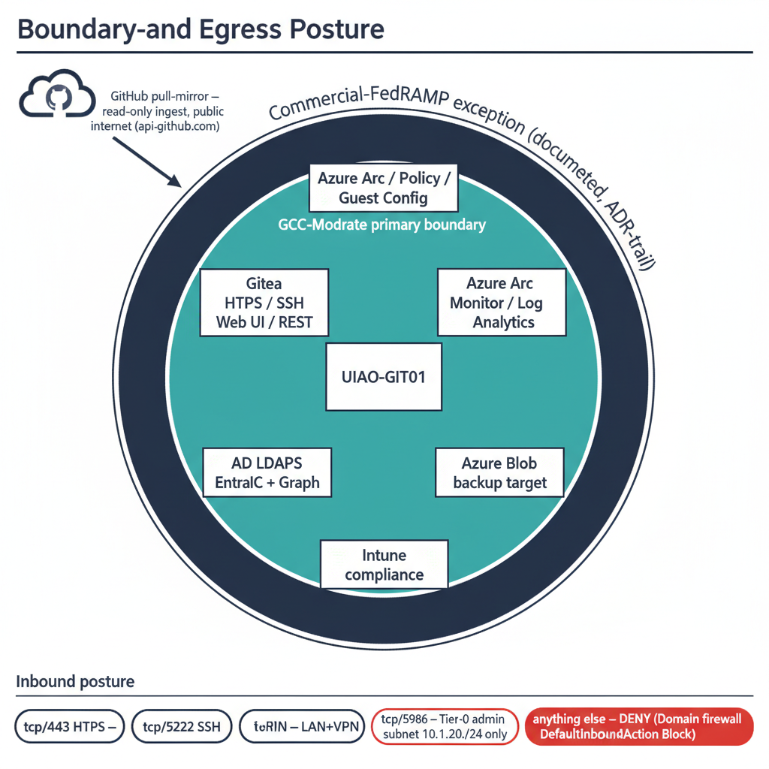
Figure 3: Boundary-and-egress posture: GCC-Moderate inner ring vs commercial-FedRAMP exception outer ring, with inbound-port allowlist

8.1 GCC-Moderate primary; commercial-FedRAMP exception for IaaS
Plane | Boundary | Authority
Gitea HTTPS / SSH / Web UI / REST | GCC-Moderate (on-prem, customer LAN) | ADR-041
AD LDAPS | Customer-internal (forest) | ADR-041
Entra OIDC + Graph | GCC-Moderate (M365 SaaS) | ADR-033, substrate manifest
Intune compliance | GCC-Moderate | UIAO_171
Azure Arc / Policy / Guest Config | Commercial-FedRAMP exception | ADR-041, ADR-059 pattern
Azure Monitor / Log Analytics | Commercial-FedRAMP exception | same
Azure Blob (backup target) | Commercial-FedRAMP exception | same
GitHub pull-mirror | Public internet (read-only ingest) | ADR-041
The Arc / Monitor / Blob set is recorded as a discrete commercial exception in every artifact’s frontmatter; it is not a covert violation of GCC-Moderate, it is a documented exception with an ADR trail and a risk acceptance.

8.2 Egress allowlist (runtime)
Phase 0.5.b enumerates the runtime egress allowlist. The proxy / firewall team configures the corporate forward proxy to permit only those hostnames; everything else is denied by default. The HTTPS_PROXY / HTTP_PROXY / NO_PROXY environment variables on the host are persisted at machine scope (Phase 0.5.c) so Git, PowerShell, and the Arc agent all consume the same proxy.

8.3 Inbound posture — what the public IP is allowed to receive
Port | Protocol | Source allowlist | Purpose
443 | HTTPS | Customer LAN + VPN ranges | Gitea Web UI, REST API, Git Smart-HTTP, optional FastAPI
2222 | SSH | Customer LAN + VPN ranges | Git over SSH (Gitea built-in SSH server)
5986 | WinRM/HTTPS | 10.1.20.0/24 (Tier-0 admin subnet) only | Tier-0 administration
anything else | — | denied by Domain firewall profile (DefaultInboundAction Block) | n/a
There is no inbound from the public internet to the canonical instance. Operator access from outside the LAN goes through the customer’s documented VPN / Privileged Access Workstation path.

9. Governance and control mapping
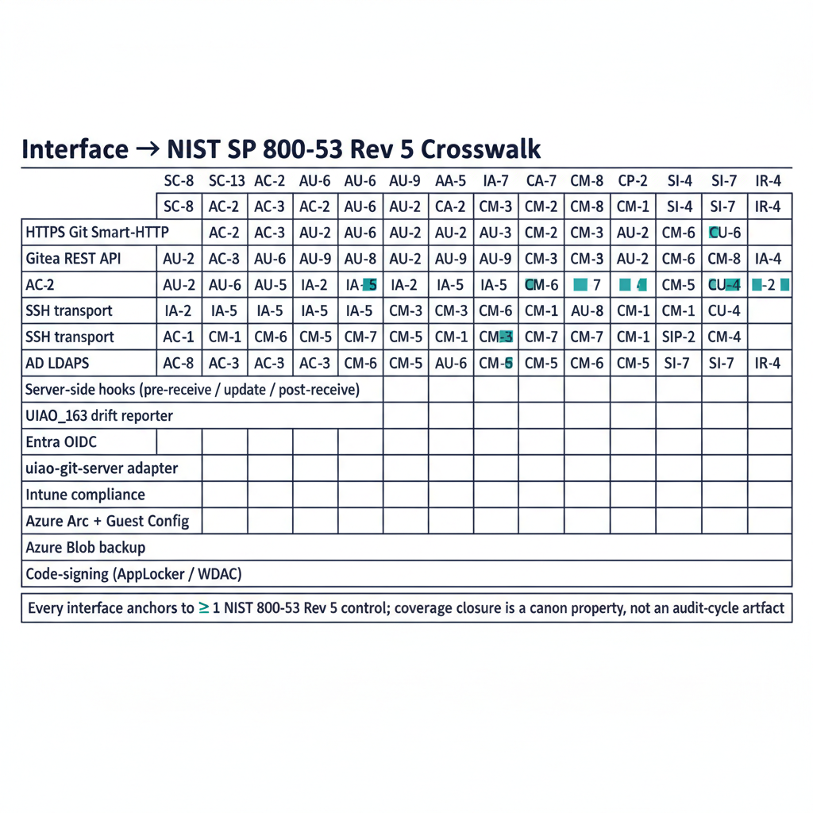
Figure 4: Interface-to-NIST-control crosswalk matrix: each interface plane mapped to its supporting NIST SP 800-53 Rev 5 controls

9.1 NIST SP 800-53 Rev 5 — interface-to-control crosswalk
Interface | Control(s) | Adapter / mechanism
HTTPS Git Smart-HTTP | SC-8, SC-13, AU-2, AU-12 | TLS 1.2+ at IIS, IIS W3C log, uiao-git-server
Gitea REST API | AC-3, AC-6, AU-2 | OIDC + LDAPS auth, IIS W3C log, Gitea audit log
SSH transport | SC-8, AU-2 | Gitea host key + per-user pubkey, Gitea event log
AD LDAPS | IA-2, IA-5 | Least-privilege bind, OrgPath-scoped search base
Entra OIDC | IA-2, IA-8, AC-2 | Group-claim mapping to dynamic groups
Server-side hooks | CM-3, CM-5, SI-7 | Pre-receive validators, signed-commit enforcement
UIAO_163 drift reporter | CM-8, SI-4, IR-4 | Scheduled task, drift taxonomy
uiao-git-server adapter | CA-7, CM-8, AU-2, AU-6, SI-4 | Health, TLS, repo, access-log evidence
Azure Arc + Guest Config | CM-2, CM-6, CM-7 | Azure Policy projection
Intune compliance | CM-6, SI-2, SI-7 | Compliance policy + attestation
Azure Monitor Agent | AU-6, AU-9, SI-4 | Log Analytics forwarding
Azure Blob backup | CP-9, CP-10 | Nightly snapshot + retention
Code-signing (AppLocker / WDAC) | CM-7, SI-7 | Publisher allowlist

9.2 OrgTree governance — who can use which interface
Every interface above is gated by membership in one of three OrgTree dynamic groups, defined in platform-server-build.qmd §14.3 — a Phase 14 OrgTree integration that is canonically declared but still under operational validation per the build guide’s own status warning:
Gitea role | Dynamic group | Membership rule
Owner | OrgTree-NCR-IT-InfraOps-CanonStewards | (user.extensionAttribute2 -eq "IT") and (user.extensionAttribute3 -eq "InfraOps") and (user.extensionAttribute10 -eq "Privileged")
Write | OrgTree-NCR-IT-InfraOps-Contributors | (user.extensionAttribute15 -startsWith "Region=NCR\|Department=IT\|Division=InfraOps\|")
Read | OrgTree-NCR-IT-Users | (user.extensionAttribute15 -startsWith "Region=NCR\|Department=IT\|")
These rules read user facets, and the user plane is written differently from the device plane above: for a synced user the facets are stamped in on-premises AD and reach Entra by directory sync, so a move carries a sync hop before any group recalculates. Microsoft additionally warns against keying dynamic-group rules on attributes that are writable elsewhere — here the mitigation is that the facets have exactly one writer, the governance plane, and drift against it is a finding rather than an accepted edit. See the hybrid-sync trap.
A move in the HR feed propagates through dynamic-group recalculation into a Gitea permission change in roughly fifteen minutes; no hand-maintained team membership exists on the host.

9.3 Key Security Indicators (KSIs)
The KSI library (uiao.rules.ksi) carries the following families that test the Git host’s interface posture as part of every uiao ksi evaluate run:
- KSI-CA-7 family — continuous-monitoring presence and freshness
- KSI-CM-8 family — repo + TLS inventory completeness
- KSI-AU-2 / AU-6 family — IIS W3C log presence + retention
- KSI-SI-4 family — system-monitoring evidence freshness
- KSI-RECIP family (v0.6.0) — reciprocity-record health for the ATO surface (see federal-hrit-productization)
Failure of any KSI in these families opens an SLA ticket through UIAO_167 and gates the next ATO recertification.

10. Disposition relative to other deployment options
ADR-041 evaluated five alternatives before selecting Gitea behind IIS on Windows Server 2025. The interface inventory above changes materially under each:
Option | Interface delta vs. canon
Option A — IIS + git-http-backend.exe CGI (retained for lab use only) | No Web UI, no native LFS, no built-in OIDC, no team/group semantics, no REST API, no webhooks. Auth collapses to IIS Windows Authentication. See Appendix B.
GitHub Enterprise Server (on-prem appliance) | Linux appliance interface (GHES upgrade ladder, GHES REST API instead of Gitea API). Adds vendor licensing surface.
Bitbucket Data Center / GitLab self-managed | Linux-first; adds clustered-DB / Redis / Sidekiq / NGINX / Puma surfaces. Heavier interface footprint without proportional governance value at this scale.
Azure DevOps Services (SaaS) | Excluded by boundary — same reason GitHub SaaS cannot serve as substrate authority. ADO Server (on-prem) is retired post-2020.
Plain bare repos over SSH | No URL-based access-control granularity, no read-operation audit, no LFS unless bolted on, no OIDC. Acceptable for an emergency offline mirror only.
Operators who need to deviate from canon must file a new ADR superseding ADR-041; the conformance adapter (uiao-git-server) currently expects the Option B interface contract and will emit DRIFT-SCHEMA against any non-canonical surface.

11. Closing position
The interface inventory above is finite, named, and observable. That is the architectural claim of ADR-041 and the operational claim of platform-server-build.qmd. Every plane in the six families is either:
- Inbound and gated by IIS, Gitea OIDC/LDAPS, or the firewall subnet allowlist;
- Outbound and pinned to a canonical URL or hostname pattern in the egress allowlist;
- Local and signed, with WDAC + AppLocker refusing anything outside CN=UIAO Canon Signing; or
- Telemetry, observed by the conformance adapter and emitted to the drift engine.
Anything outside that taxonomy is a finding — DRIFT-SCHEMA if the plane appeared without an ADR, DRIFT-PROVENANCE if its provenance into canon cannot be resolved, DRIFT-AUTHZ if its authorization posture diverged from the OrgTree group mapping. The substrate is governed by the closure of this list, not by the absence of incidents.

Appendix A — Provenance and references
Artifact | Path | Role
ADR-041 | src/uiao/canon/adr/adr-041-uiao-git-infrastructure.md | Architectural decision (Option B is canon)
Build runbook | docs/customer-documents/platform/platform-server-build.qmd | Phases 0-14, operational source of truth
Release manifest | src/uiao/canon/release-manifests/platform-server-v1.2.yaml | Binary pins + SHA-256
Conformance adapter spec | docs/customer-documents/adapter-specs/uiao-git-server/uiao-git-server.qmd | Telemetry interface contract
Adapter registry | src/uiao/canon/adapter-registry.yaml | uiao-git-server entry
Option-A reference | docs/customer-documents/platform/git-server-implementation.qmd | Lab build (CGI), source of canonical hook bodies
FastAPI deployment | deploy/windows-server/web.config, run.py | Optional [api] plane
Substrate manifest | src/uiao/canon/substrate-manifest.yaml | Boundary (GCC-Moderate + commercial exceptions)
OrgTree canon | UIAO_151, UIAO_152, UIAO_153, UIAO_154, UIAO_158, UIAO_163, UIAO_167, UIAO_171, UIAO_174 | Group mapping, schema, drift, SLA
Foundational architecture | docs/customer-documents/operational-guides/client-server-to-hybrid-cloud/01-platform-foundation.qmd | “Single substrate authority” claim

Appendix B — Option A interface delta (CGI only)
The non-canonical Option A architecture in git-server-implementation.qmd exposes a strictly smaller interface set. Use this table when inventorying a lab / proof-of-concept host that has not been promoted to Option B.
Interface family | In Option B (canon) | In Option A (lab only)
HTTPS Git Smart-HTTP | ✅ via Gitea behind IIS reverse proxy | ✅ via git-http-backend.exe as IIS CGI handler
SSH transport | ✅ Gitea built-in SSH server on :2222 | ❌ not present
Web UI | ✅ Gitea (issues, PRs, OAuth apps, mirror UI) | ❌ none — Git CLI only
REST API | ✅ Gitea /api/v1/... | ❌ none
LFS | ✅ Gitea built-in (LFS_START_SERVER = true) | ⚠️ requires hand-rolled IIS handler
OIDC / Entra federation | ✅ via Gitea source-config | ❌ collapses to IIS Windows Authentication
AD LDAPS | ✅ via Gitea source-config | ⚠️ AD groups → IIS roles only, no per-repo team mapping
Server-side hooks | ✅ same hook bodies (canonical for both options) | ✅ same hook bodies
Webhooks | ✅ Gitea native, with HMAC signing + retries | ❌ requires custom PowerShell + Task Scheduler
Conformance adapter | ✅ uiao-git-server operates against the Gitea + IIS surface | ⚠️ partial coverage — TLS + IIS log only; no Gitea-specific telemetry
Drift integration (UIAO_163) | ✅ Gitea team list contributes to the drift payload | ⚠️ payload omits team/group state
Any Option A deployment promoted to production requires a new ADR superseding ADR-041; until then it is restricted to lab / PoC scope.

