Flipping 50,000 Devices to Hybrid Join — The Governed and Ungoverned Paths
  - Why “all sign-in activity comes from managed devices” is a near-effortless tenant switch — and a loss ledger if you take the switch without governance
Michael Stratton
2026-06-01
Table of contents

Flipping 50,000 Devices to Hybrid Join — The Governed and Ungoverned Paths
 Problem, solution, ask
Problem. “All sign-in activity comes from managed devices” is scored T3 — a multi-quarter program — yet converting 50,000 domain-joined devices to Entra hybrid join is a two-setting tenant switch. Taken ungoverned, the fleet converts itself and silently spends a loss ledger: duplicate objects, unattributable device-state changes, devices Conditional Access cannot see — with nobody having decided anything.
Solution. The governed path reaches the same end state under UIAO’s active-governance control plane: enter at L1 Observe in report-only mode, sequence OrgPath-scoped waves, and gate every L3 enforcement class on coverage data and AO sign-off, so enforcement never runs ahead of the inventory it depends on.
Ask. Find out whether the ungoverned path is already live (SCP + GPO auto-registration, and since when); run the fleet against the loss ledger in §3 before any Conditional Access policy enforces; and name the wave owner who holds the plan, the sign-offs, and the rollback. The four steps are in the Call to Action.

 In this whitepaper
The federal Zero-Trust baseline carries a control that reads, in full, “All sign-in activity comes from managed devices” — satisfied in practice by requiring compliant or hybrid-joined devices with Conditional Access. On the AD-to-Entra crosswalk that single line is scored T3 — a multi-quarter program gated on device, Intune, and join maturity.
This paper takes one agency-scale instance of that control — “move 50,000 domain-joined Windows devices into Microsoft Entra hybrid join” — and walks it down two paths. The ungoverned path is a near-effortless tenant switch: two settings and the fleet converts itself. The governed path reaches the same end state under UIAO’s active-governance control plane. The gap between them is the subject of this paper, expressed as a loss ledger: what classic AD gave you, what an ungoverned flip silently spends, and what governed reconciliation restores.

 The one sentence this turns on
The mechanism to convert a 50,000-seat estate to hybrid join requires almost no governance — and that is exactly why doing it ungoverned is dangerous. The provider data plane makes the bulk state change effortless; governance is precisely the part the mechanism does not require, so it is the part that gets skipped. — anchored to ADR-092 Active Governance

1. The control being satisfied
The crosswalk scores the control like this:
Control | License | GCC | AD-friction | Tier
All sign-in activity comes from managed devices | P1 | ✅ | 🔴 (Intune + join maturity) | T3
The 🔴 and the T3 are the whole story. The license is already in hand (P1 ships with M365 G5) and the feature is available in government cloud (✅). What makes it a multi-quarter program is not the toggle — it is the 20 years of Active Directory entanglement the toggle sits on top of. The ungoverned path, below, is what it looks like when an organization treats the 🔴 as if it were a 🟢.

2. The ungoverned path — a tenant switch, not 50,000 decisions
Converting an existing AD-domain-joined fleet to Entra hybrid join is, at the mechanism level, a fleet-wide switch — not a per-device project:
- Sync the computer objects. Entra Connect (or Entra Cloud Sync) is almost certainly already syncing your users; extend the scope to synchronize the computer objects.
- Set the Service Connection Point (SCP) once. Either the Entra Connect configuration wizard writes the SCP into AD’s Configuration partition, or you push the “Register domain-joined computers as devices” device-registration policy by GPO. The SCP stamps every domain-joined machine with the tenant ID and a verified domain name — its instructions for where to register.
- The devices register themselves. The built-in Automatic-Device-Join scheduled task fires on the next logon or reboot, the device reaches enterpriseregistration.windows.net / device.login.microsoftonline.com / login.microsoftonline.com (and autologon.microsoftazuread-sso.com for Seamless SSO), an Entra device object is created, and the device receives a Primary Refresh Token (PRT) for cloud SSO. dsregcmd /status then shows AzureAdJoined : YES + DomainJoined : YES.
That is the entire mechanism. One SCP, one GPO, and the whole estate begins flipping state on its own schedule. There is no per-device gate, no ownership check, no organizational-position check, and no reconciliation step anywhere in that path. (Microsoft Learn — plan hybrid join · how-to)
That effortlessness is not a convenience. It is the hazard: the control’s intent — every sign-in comes from a known, owned, managed device — gets converted into 50,000 untracked state changes that no one can subsequently attribute.
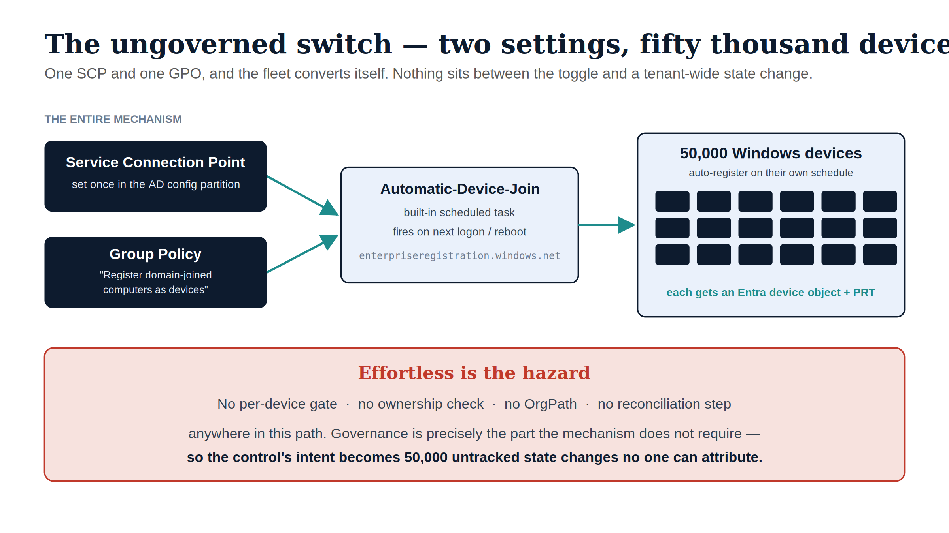
Figure 1: The ungoverned switch — one SCP plus one GPO drives the Automatic-Device-Join task, and 50,000 devices auto-register on their own schedule with no per-device gate, ownership check, OrgPath, or reconciliation step

3. The loss ledger — what “ungoverned” actually spends
Classic AD was a creaky governance system, but it was a governance system: a computer object lived in an OU, had a delegated admin lineage, and was visible to the same console that governed everything else. An ungoverned hybrid-join flip keeps the connectivity benefit (cloud SSO, Conditional Access eligibility) while quietly discarding the governance scaffolding underneath.
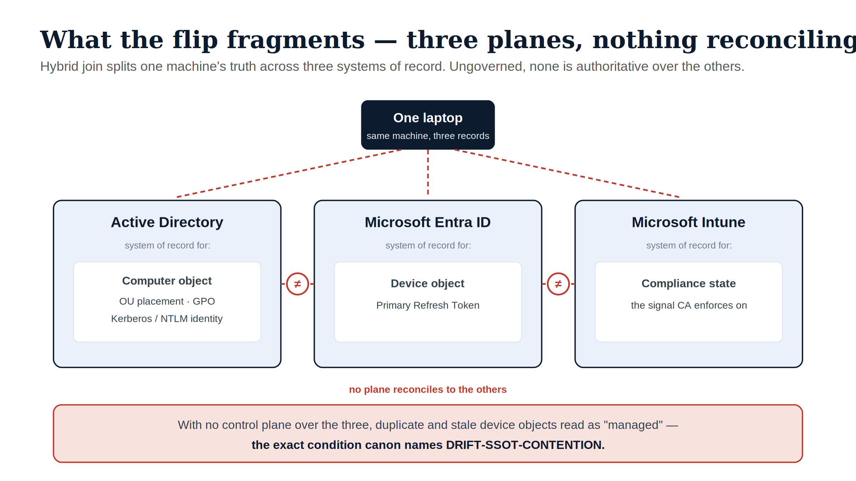
Figure 2: Hybrid join splits one machine’s truth across three systems of record — Active Directory (computer object), Entra ID (device object + PRT), and Intune (compliance state) — with nothing reconciling them, the condition canon names DRIFT-SSOT-CONTENTION
The ledger:
Capability under classic AD | What an ungoverned hybrid-join flip loses | What governed reconciliation restores (canon)
Ownership — each computer object sat in an OU with a delegated admin lineage | New Entra device objects appear with no human-owner mapping and no organizational position; “who owns this device, in what part of the org” is unanswerable at scale | Every governed object carries OrgPath; ownership and scoping compose against it (UIAO_151, ADR-092 §2)
One object per machine — the AD computer object was the single record | Prior Workplace-Join/registered states and stale-but-still-syncing AD objects produce duplicate and phantom device records that read as “managed” | The reconciliation loop detects the divergence as DRIFT-SSOT-CONTENTION and de-duplicates against canon
Scoped, gradual rollout — GPO applied per-OU, in waves | Turning the Conditional Access “require compliant or hybrid joined” policy to enforce before registration has actually completed fleet-wide → tenant-wide lockout | Device-state change is treated as a high-blast-radius operation class: report-only baking, then L3 gated actuation with a human approver (ADR-092 §3–4)
Provenance — changes were at least logged in one directory | Each of 50,000 device-state changes happens with no signed, attributable record of why and under whose authority | Each plan / apply / reconcile step emits signed evidence; an unattributable state is DRIFT-PROVENANCE
Lifecycle — AD had a (creaky) join/leave lifecycle | No retirement story: decommissioned machines linger as stale Entra device objects, inflating the “managed” count indefinitely | Lifecycle is reconciled against canon; stale objects surface for access review rather than accumulating
Single console of record — AD owned the computer object end-to-end | State now spans three planes — AD owns the computer object, Entra owns the device object, Intune owns compliance — with nothing reconciling them | UIAO is the control plane that reconciles all three; providers remain incorporated data planes, not competing sources of truth (ADR-092)
Line-of-sight assumption was explicit | Hybrid join’s hard dependency on reaching a domain controller is left implicit; remote-first / VPN-only users silently rot (password/PIN/TPM failures) until unusable | The DC-reachability constraint is named as a known limit and drives the target state (Entra join) rather than being discovered as an outage
The pattern across every row is the same: the ungoverned flip keeps the runtime benefit and spends the truth-and-accountability layer — the exact conflation UIAO exists to undo.

4. What hybrid join still doesn’t satisfy
Even a flawless 50,000-device hybrid-join rollout does not by itself satisfy “all sign-in activity comes from managed devices.” Hybrid join only covers domain-joined Windows. The control’s denominator is larger:
- macOS / iOS / Android / Linux → need Entra join or Intune MDM enrollment plus a compliance policy — not hybrid join.
- BYOD, contractors, B2B guests → never hybrid-joinable at all.
- Servers, VDI / AVD, shared kiosks, service accounts → each needs its own posture decision.
So the population the assessment is really probing is precisely the slice an ungoverned Windows-only flip renders invisible. Canon’s answer is to make endpoint onboarding a governed, Intune-first discipline across surfaces (ADR-071 Intune-First Asset Onboarding), so the uncovered surface is surfaced as a gap instead of hidden by a green checkmark.

5. The governed path — same end state, under the control plane
The governed path reaches the identical technical outcome — devices hybrid-joined, Conditional Access enforcing managed-device sign-in — but routes the bulk state change through UIAO’s active reconciliation control plane rather than letting the provider data plane convert the fleet unattended. UIAO holds desired state, observes actual state, classifies drift, and reconciles toward intent; Entra and Intune remain the data planes that authenticate and enforce at runtime (ADR-092). Concretely, the same program looks like this:
- Address before you actuate. Every device to be converted carries an OrgPath expressing its organizational position, so the rollout can be scoped, waved, and audited in the same terms as every other plane — not by ad-hoc OU guesswork (UIAO_151).
- Cap the blast radius by class. “Tenant-wide device-state change” and “Conditional Access enforcement change” are exactly the high-blast-radius classes canon caps at L3 — human-approved — permanently. One wrong CA toggle touching 50,000 devices is the textbook case the ceiling exists for.
Rung | Name | Behavior
L0 | Record | Desired state (hybrid-join target, CA intent) recorded in canon.
L1 | Observe | Actual join state collected per device; drift detected. Read-only.
L2 | Advise | Wave plan + report-only CA change-set generated and surfaced; no writes.
L3 | Gated actuation | A human approves each wave; UIAO executes through the provider API. Federal default ceiling.
L4 | Autonomous | Not permitted for this class — high blast radius, L3-capped.

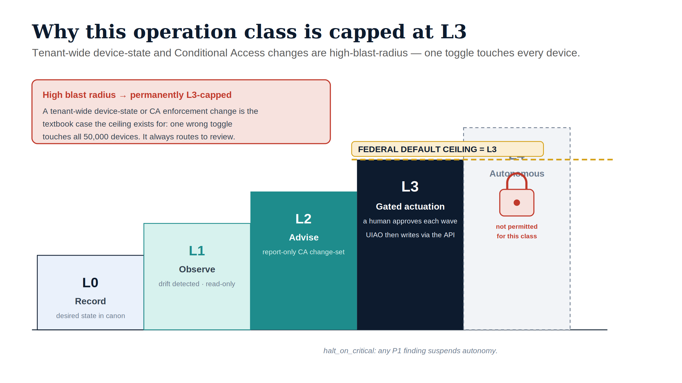
Figure 3: The L0–L4 actuation ladder with the federal default ceiling at L3; tenant-wide device-state and Conditional Access changes are high-blast-radius and permanently L3-capped, so L4 autonomy is locked for this operation class
- Execute the wave through plan() / apply(), not ad hoc scripts. The CLI entry point for adapter operations is uiao adapter run entra (a Typer command in src/uiao/cli/adapter.py that dispatches into the Entra adapter family under src/uiao/adapters/). The OrgPath-scoped wave itself is computed and executed by that family’s EntraDynamicGroupAdapter: its plan(observed) method is pure — it diffs the canonical dynamic-group library (the wave’s declared target state, keyed to the OrgPath-bound extensionAttribute slot) against the tenant’s observed group state and returns a list of FacetOperation records, one per group whose membership rule needs to be created or updated, without making a single Graph call. That diff is what L1 Observe and L2 Advise are, concretely. apply(operations, dry_run=True) — dry_run=True is the method’s default — is the report-only execution of that plan: every operation is evaluated and recorded as would-send, and nothing reaches Graph. Promotion to dry_run=False is a separate, explicit call an operator makes per wave after review — the code-level shape of the L3 gate above. One class of operation never crosses that gate regardless of dry_run: operations in governance_review_ops (today, the phantom-group verb, flagged for removal) are always skipped by apply() whether dry_run is True or False — a standing human-sign-off set that promoting a wave out of dry-run cannot silently sweep past. (ADR-084 §C4–C5)
- Bake the enforcement. Conditional Access runs report-only first; the control plane reconciles “registered and compliant” coverage against the OrgPath-scoped target population before any wave flips CA to enforce — so the lockout failure mode in §3 cannot occur silently.
- Reconcile duplicates and lifecycle. Phantom/stale device objects are classified as drift (ADR-074) and resolved against canon, not left to inflate the managed-device count.
- Emit evidence an AO can sign. Every wave produces signed plan / apply / reconcile evidence. The accreditation sentence is not “it enforces managed-device sign-in” but “this operation class is at L3, gated, with dry-run record and rollback” — a sentence an authorizing official can put their name to.
- Cover the whole denominator. Non-Windows, BYOD, and guest surfaces are driven through Intune-first onboarding (ADR-071) so the control is satisfied for its real population, not just the Windows slice.
The end state is the same as the ungoverned flip. The difference is that every one of the 50,000 changes is owned, addressable, attributable, reversible, and accredited — the loss ledger of §3 is paid down rather than run up.

6. The two paths side by side
§2 named the exact provider mechanism that flips the fleet unattended — SCP, GPO, the Automatic-Device-Join scheduled task, dsregcmd /status. §5 names the equivalent governed mechanism at the same level of specificity — EntraDynamicGroupAdapter.plan() computing the wave’s operations, apply(dry_run=True) as the default report-only execution, an explicit dry_run=False promotion as the L3 gate, and governance_review_ops as the operations that stay human-gated no matter what. Both are real code paths in this repository, not aspirational description. Same end state; the entire difference is what stands between the plan and the write.
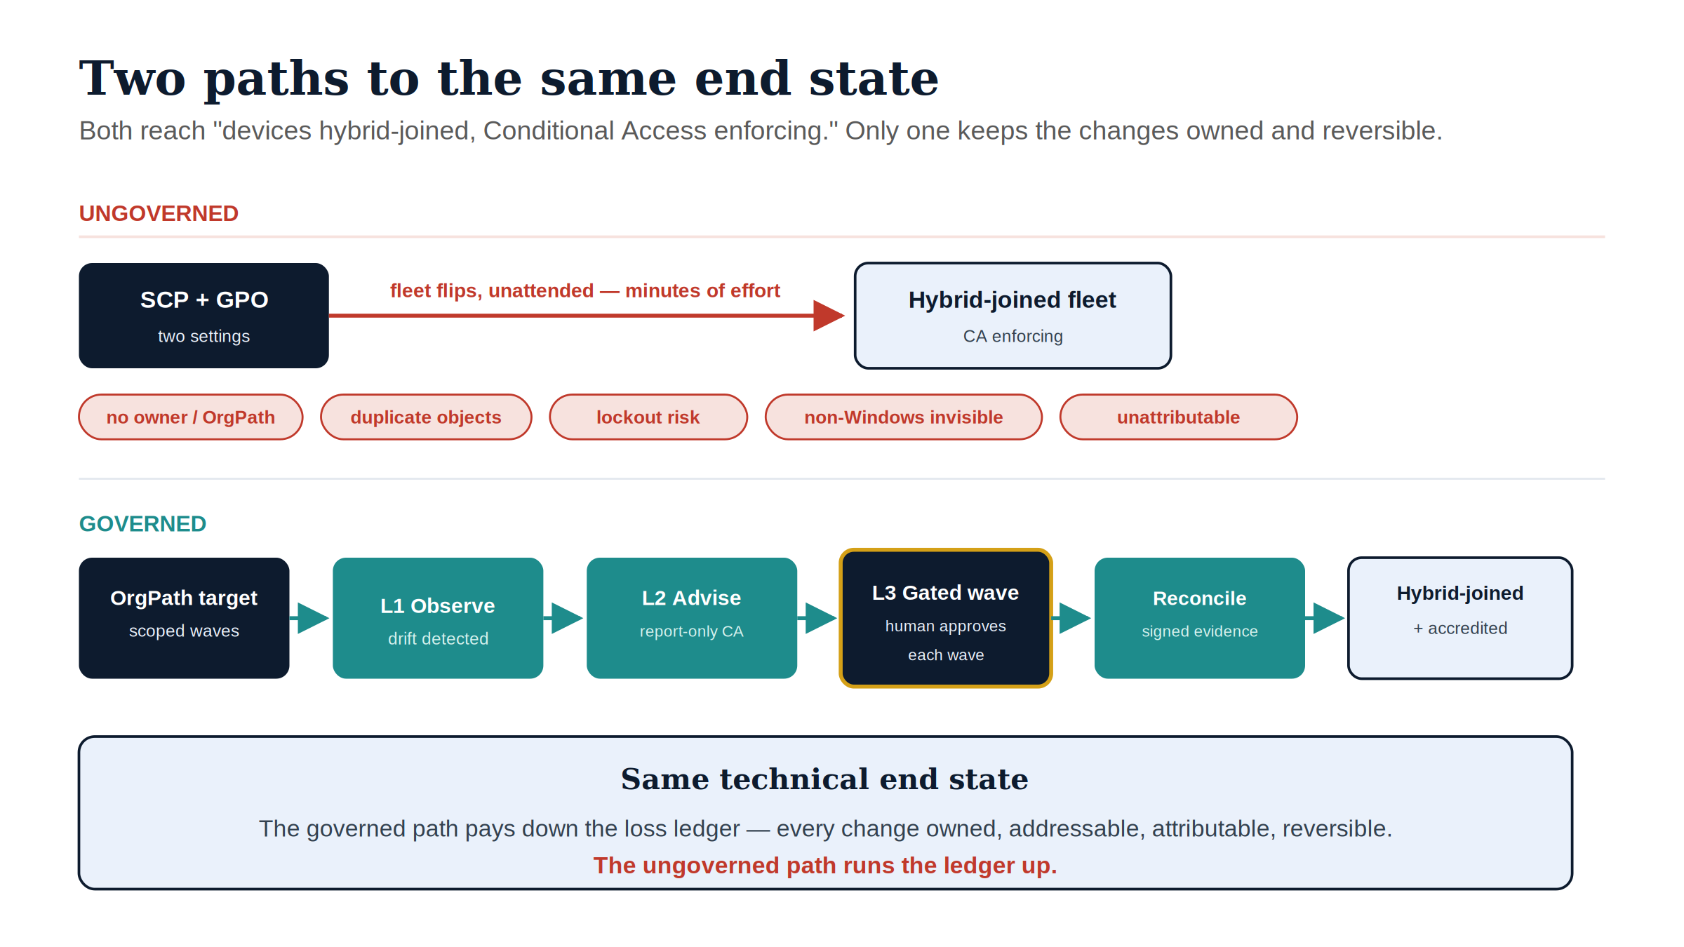
Figure 4: Both paths reach the same end state — devices hybrid-joined with Conditional Access enforcing — but the ungoverned flip spends the loss ledger while the governed wave pipeline pays it down

Dimension | Ungoverned flip | Governed reconciliation
Effort to start | Two settings (SCP + GPO) | A program, scoped by OrgPath waves
Who decides, per device | No one — auto-registration | Canon target + human-approved waves
Pre-enforcement safety | CA can lock out the fleet | Report-only baked against coverage first
Duplicate / stale objects | Accumulate as phantom “managed” devices | Classified as drift, reconciled to canon
Non-Windows / BYOD / guests | Invisible — false green | Surfaced as gap; Intune-first onboarding
Accountability | 50,000 unattributable changes | Signed plan/apply/reconcile evidence
AO sign-off | “It’s enabled” | “This class is L3-gated, dry-run, rollback-capable”
Reversibility | No rollback plane | Rollback-capable, evidence-backed

7. How this maps to UIAO canon
Claim in this paper | Canon anchor | Note
The control is a multi-quarter program, not a toggle | crosswalk T3 row | The 🔴 / T3 score is the starting point this paper expands.
Governance is the part the mechanism doesn’t require | ADR-092 §1 | AD conflated truth with the in-path enforcer; the data plane makes bulk change effortless and ungoverned.
Every governed device carries OrgPath; decisions compose against it | UIAO_151, ADR-092 §2 | OrgPath is an addressing attribute, not a token; scoping/AU/CA/Intune compose against it.
Tenant-wide device/CA change is L3-capped | ADR-092 §3–4 | High-blast-radius classes are permanently human-gated at the federal L3 ceiling.
The wave’s plan/apply mechanism, and its permanent human-review set | ADR-084 §C4–C5 | EntraDynamicGroupAdapter.plan() / apply(dry_run=...) and governance_review_ops are the code-level shape of the L1/L2/L3 rungs above.
Duplicate/stale device objects are drift | ADR-074 | DRIFT-SSOT-CONTENTION — structurally valid state directed at a record that should no longer be authoritative.
Unattributable state changes are a provenance gap | ADR-040 | DRIFT-PROVENANCE — activity that cannot be traced to a declared, authorized source.
Whole-denominator coverage via endpoint onboarding | ADR-071 | Intune-first asset onboarding across surfaces, not Windows-only.
Control-plane / data-plane separation as the spine | ADR-092 | This paper is one worked operation inside that larger arc (the Modernization Journey whitepaper tells it end to end).

Provenance
The Entra hybrid-join mechanism in §2 is summarized from Microsoft Learn (linked inline) and is provider behavior, not a UIAO canon claim. The loss ledger (§3) and the governed path (§5) are reconciled to canon as tabulated in §7. Draft staged 2026-06-08 for review; published to the site as a Draft-status work.

Sources
- Microsoft Entra hybrid join — concept
- Plan your hybrid join deployment
- How to configure hybrid join
- Companion crosswalk: Entra Security Baseline — A Federal AD-to-Entra Crosswalk (the T3 row this paper expands).
- Companion narrative: Modernization Journey — the control-plane/data-plane arc this paper sits inside.
- Series treatment of the device plane: OrgPath narrative Book 05 — OrgPath and Microsoft Intune (the dynamic device-group library and compliance/CA bridge the governed path assumes), curated with the rest of the modernization surfaces at the OrgMod hub.

Call to Action
The two paths in §6 reach the same technical end state. The only question this paper actually poses is which one your agency is already on — and whether anyone decided that on purpose.
Four steps before the next tenant switch
- Check whether the ungoverned path is already live. Confirm whether hybrid-join auto-registration (SCP + GPO) is enabled in your tenant today, and if so, since when. A control that “shipped itself” the moment the settings were flipped is drift, not policy — it needs to be found before it can be governed.
- Inventory before you enforce. Run the ungoverned fleet against the loss ledger in §3 — count the duplicate objects, the unattributable device-state changes, the non-Windows/BYOD devices Conditional Access can’t see. This inventory is the input to every later wave, not a formality.
- Enter at L1 Observe, report-only, before any CA policy can lock out the fleet. The governed path in §5 exists precisely so enforcement never runs ahead of coverage data. Skipping straight to L3 is how a well-intentioned rollout becomes an outage.
- Assign the wave owner. Someone needs to own the OrgPath-scoped wave plan, the AO sign-off on each L3-gated class, and the rollback path. If no one owns it, the tenant setting is the plan — which is the failure mode this paper describes.

This is a single control, not a program — which is exactly why it’s worth getting right before the next 50,000-device decision arrives on a shorter deadline.

