Next Generation DNS
  - How DNS evolved from a name-lookup service into the application surface, the security enforcement plane, and the identity substrate of the hybrid multi-cloud enterprise — and what federal agencies must do to govern it
Michael Stratton
2026-06-01
Table of contents

Next Generation DNS
 Problem, solution, ask
Problem. DNS has quietly become the application surface, the security enforcement plane, and the PKI and identity substrate of the hybrid multi-cloud enterprise — and agencies still run it as a commodity utility across five independent platforms (AD DNS/NIOS, Route 53, Azure Private DNS, Cloud DNS, NSX-T). The result is split-brain DNS that breaks private connectivity, SaaS endpoint selection, certificate trust, and Layer 7 zero-trust policy at once — surfacing as certificate errors and access denials, never as DNS errors.
Solution. One policy plane — Infoblox Universal DDI — propagating DNS, DHCP, and IPAM state to all five surfaces, with Cisco Catalyst SD-WAN’s redirect-dns pointed at it rather than around it, and a reference architecture (Part 10) that concentrates the operational risk in five configuration decisions.
Ask. Before the next SD-WAN or DDI change: audit every branch’s redirect-dns target, verify the forwarding-chain order in the running configuration, inventory AD DNS records before decommissioning any domain controller, confirm the sovereign-cloud (GCC/DoD) INR gap with the program office, and take Appendix B’s open questions to Infoblox and Cisco directly. The five steps are in the Call to Action.

 In this whitepaper
DNS was designed in 1983 to answer one question: what is the IP address for this hostname? Four decades later, it answers a much larger set of questions — and federal agencies that treat DNS as a commodity network utility are systematically underestimating how much of their security posture, application availability, certificate trust chain, and identity infrastructure now depends on DNS being correct, consistent, and governed.
This paper makes ten arguments, one per part. Taken together, they describe a discipline that has quietly become the most consequential ungoverned surface in the federal enterprise:
- Every major cloud provider and on-premises virtualization platform ships its own independent DNS service. The aggregate result is a fragmented DNS landscape that no single team manages end-to-end.
- When DNS is fragmented, a class of failure called split-brain DNS emerges: the same query resolves to different answers depending on where it originates. This breaks private IP addressing, public SaaS endpoint selection, and security policy enforcement simultaneously.
- DNS is not a single record type — it is a protocol with more than fifty standardized record types, at least fifteen of which are directly relevant to federal security, certificate governance, email authentication, and application-aware routing. A/AAAA/CNAME are the floor, not the ceiling. SRV, CAA, TLSA, SSHFP, SPF, DKIM, DMARC, HTTPS/SVCB, and DNSSEC types each carry their own split-brain failure modes.
- Active Directory has served as the hidden DNS substrate for on-premises federal networks for twenty years. As Microsoft deprecates AD and agencies migrate to Entra ID, the DNS records AD maintained — service locators, Kerberos targets, LDAP endpoints — do not migrate automatically. This creates a category of DNS orphaning that is not yet widely understood.
- As Kerberos is replaced by token-based authentication, DNS does not become less important — it becomes more so. Token audience claims reference FQDNs. Certificate Subject Alternative Names reference FQDNs. OCSP validation endpoints are FQDNs. A split-brain DNS condition in a token/PKI environment produces certificate validation failures that are significantly harder to diagnose than Kerberos authentication failures.
- As agencies transition from Layer 4 session networking to Layer 7 application networking — service meshes, API gateways, zero trust proxies — DNS subdomains become the definition of the application surface. A wildcard DNS entry (*.api.agency.gov) now describes a namespace of applications, not a single host. DNS management is application surface management.
- Infoblox Universal DDI is the industry’s most complete answer to this governance problem. Its IPAM, DNS, and DHCP management capabilities span on-premises NIOS, all three major CSPs, and edge providers — and its security feature set (RPZ, DNSSEC, BloxOne Threat Defense) applies policy consistently across every surface it manages.
- Cisco Catalyst SD-WAN — the only Microsoft-certified INR partner — intercepts DNS at the branch in ways that can silently bypass the Infoblox policy plane if not correctly configured. This interaction is undocumented by either vendor.
- Federal agencies operating in GCC Moderate, GCC High, or DoD sovereign cloud environments cannot use Microsoft INR. The Infoblox DDI architecture is unchanged; only the SD-WAN telemetry loop is absent.
- For the per-CSP implementation of the architecture this paper argues for — landing-zone-level Infoblox DDI build-out on Azure, AWS, GCP, OCI, and VMware with a governed ServiceNow front door — see the companion Volume VIII — Multi-Cloud DDI Landing-Zone Automation of the Federal Organization Compliance series. The architecture-level foundation — Infoblox as the SDN-aware IPAM control plane inside a federal cloud landing zone, with the NIST 800-53 control mappings and FedRAMP evidence this paper deliberately does not carry — is Vol I Book 01 (Cloud Landing Zone, IPAM, FedRAMP) of the same series. This paper owns the argument; those volumes own the build and the control closure.
- A complete reference architecture unifying all of the above — ten-part governance model, record type surface, AD DNS departure, cert-DNS surface, Layer 7 application namespace, Infoblox DDI management plane, and SD-WAN interception chain — does not exist in any vendor publication. It is synthesized here from first principles, vendor documentation, and RFC-level behavior.

For decision makers: read this page first
This paper’s argument in one pass, without the record-type taxonomy first: DNS fragmentation across five independent platforms — on-premises AD DNS/NIOS, AWS Route 53, Azure Private DNS, GCP Cloud DNS, and VMware NSX-T — produces split-brain DNS, the same query resolving to different answers depending on where it originates. That is not a lookup-utility inconvenience; it now breaks private connectivity, SaaS endpoint selection, certificate/PKI trust, and Layer 7 zero trust policy simultaneously. Infoblox Universal DDI is the structural fix: one policy plane that propagates DNS, DHCP, and IPAM state to all five surfaces at once, so consistency is answered by the control plane instead of by manual audit.
Five things every decision maker needs to understand:
- Split-brain DNS is a structural property of independent per-CSP DNS, not a bug to patch. Runbooks and audits cannot keep pace with the change rate across five systems with five different APIs and consistency models (Part 2).
- DNS is now a security and PKI dependency, not just a lookup utility. Certificate validation, OCSP/CRL reachability, token audience claims, and zero trust FQDN-based policy all silently fail under split-brain DNS — and the failure surfaces as a certificate error or an access denial, not a DNS error (Parts 5–6).
- Cisco Catalyst SD-WAN can silently bypass the Infoblox policy plane. The redirect-dns destination configured at the branch determines whether Universal DDI’s RPZ, DNSSEC, and IPAM policy apply at all — misconfigure it and every branch query becomes invisible to the governance layer (Part 8).
- Federal sovereign cloud tenants — GCC Moderate, GCC High, DoD — cannot use Microsoft’s INR telemetry loop at all. The Infoblox DDI architecture is unaffected, but any plan that treats INR as a fallback is planning around a gap that does not close (Part 9).
- Five configuration decisions carry essentially all of this paper’s operational risk: the redirect-dns target, the forwarding chain order, per-CSP conditional forwarding ownership, AD DNS record inventory before decommissioning, and OCSP/CRL reachability from every origin. They are laid out, with nothing else required to act on them, in Part 10.2.

Scope boundary — Cisco Catalyst SD-WAN only
The SD-WAN DNS interception analysis in Part 8 (Cisco Catalyst SD-WAN DNS Interception) addresses exclusively Cisco Catalyst SD-WAN (IOS XE SD-WAN ≥ 20.4/17.4), which as of the Microsoft Learn INR documentation (updated 2026-03-10) is the only SD-WAN vendor listed in the INR “Currently enabled solutions” table. No other SD-WAN vendor is covered.

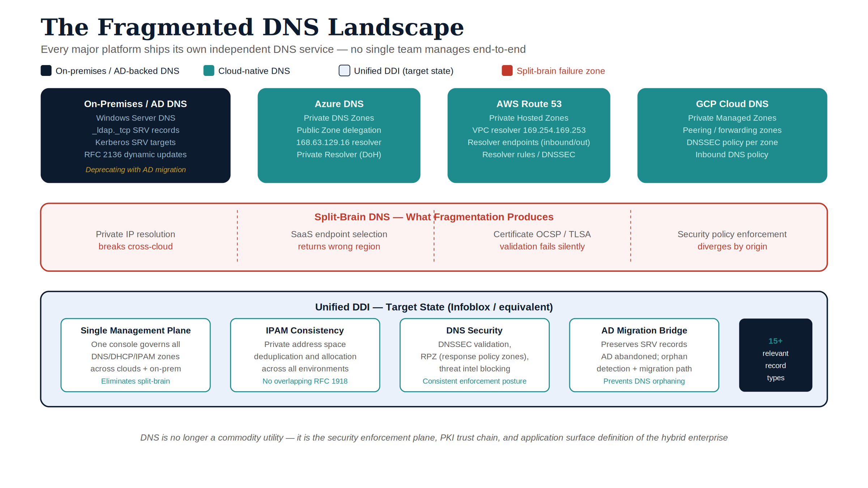
Figure 1: The fragmented DNS landscape — every major platform ships its own independent DNS service

Part 1 — DNS in the Modern Hybrid Multi-Cloud Enterprise

1.1 What DNS was designed to do
The Domain Name System was specified in RFC 1034 and RFC 1035 in November 1987, obsoleting the November 1983 originals (RFC 882, RFC 883 and RFC 973). Its purpose was straightforward: allow humans to use memorable hostnames (www.example.com) instead of numeric IP addresses (93.184.216.34), and give network operators a distributed, hierarchical database to publish those mappings. DNS resolved names to addresses. That was the whole job.
The protocol was designed for a world where every networked device had one IP address, every service lived on a known host, and the boundary between “inside” and “outside” a network was a physical wire. The recursive resolver in a university computer center forwarded queries to authoritative name servers on the internet; those servers answered; the answer was cached and served to local clients. The model was elegant, scalable, and sufficient for its era.
That era ended.

1.2 What DNS has become
In a modern federal hybrid multi-cloud environment, DNS performs a list of functions its designers did not anticipate:
Private address publication. Cloud platforms publish RFC 1918 addresses for private endpoints, internal load balancers, and inter-service communication through DNS. These addresses are meaningless — and unreachable — from outside the network boundary where they were assigned. DNS must answer differently depending on where the query comes from.
Public SaaS endpoint selection. Services like Microsoft 365 use DNS to direct clients to the correct cloud environment. A GCC Moderate tenant must resolve outlook.office365.com to GCC endpoints, not commercial endpoints. The DNS answer determines which data sovereignty boundary the traffic crosses.
Security policy enforcement. DNS is now a control plane for threat prevention. Response Policy Zones (RPZ) block malicious domains before a connection is established. DNS Firewall rules in AWS Route 53, Azure DNS, and GCP Cloud DNS filter traffic at the resolution layer. Infoblox BloxOne Threat Defense uses DNS to detect data exfiltration, command-and-control communications, and domain generation algorithm (DGA) activity.
Certificate validation. Online Certificate Status Protocol (OCSP) responders and Certificate Revocation List (CRL) distribution points are DNS names. A certificate’s validity chain includes DNS lookups that must succeed and resolve consistently for the chain to verify.
Service identity. In a zero trust architecture, the FQDN is the service identity — not the IP address. A service mesh routes traffic to payments.internal.agency.gov, not to 10.0.42.17. The IP is ephemeral; the FQDN is the stable identity that policy, certificates, and audit logs reference.
Application surface definition. Wildcard DNS entries define namespaces of applications. *.api.agency.gov is not a single host — it is a surface declaration that any subdomain of api.agency.gov is a valid application endpoint. API gateways, WAF rules, certificate SANs, and zero trust policies are written against this surface.
DNS is no longer a name-lookup utility. It is the identity substrate, the security enforcement plane, and the application surface definition layer of the modern enterprise. Governing it is not an IT operations task — it is a strategic security and architecture task.

1.3 The hybrid multi-cloud DNS landscape
Federal agencies do not choose to manage DNS in five places. The fragmentation is an emergent property of how cloud platforms were adopted. Each platform ships its own DNS service because DNS is the connective tissue of everything else the platform does. Decoupling DNS from the cloud platform requires deliberate architectural work that the platform’s default experience does not encourage.
The result, for most federal agencies today, is a DNS estate that spans:
- On-premises: Active Directory-integrated DNS (Windows Server DNS managed by AD) and/or Infoblox NIOS
- AWS: Amazon Route 53 (public and private hosted zones) with Route 53 Resolver for hybrid forwarding
- Azure: Azure Private DNS zones linked to virtual networks, fronted by Azure DNS Private Resolver
- GCP: Google Cloud DNS with private zones and DNS peering
- VMware NSX-T: NSX-T DNS Service per logical segment, layered over vSphere DNS and AD integration
Each of these operates independently. Each has its own console, its own API, its own zone model, and its own behavior under failure. None of them was designed to share policy with the others.
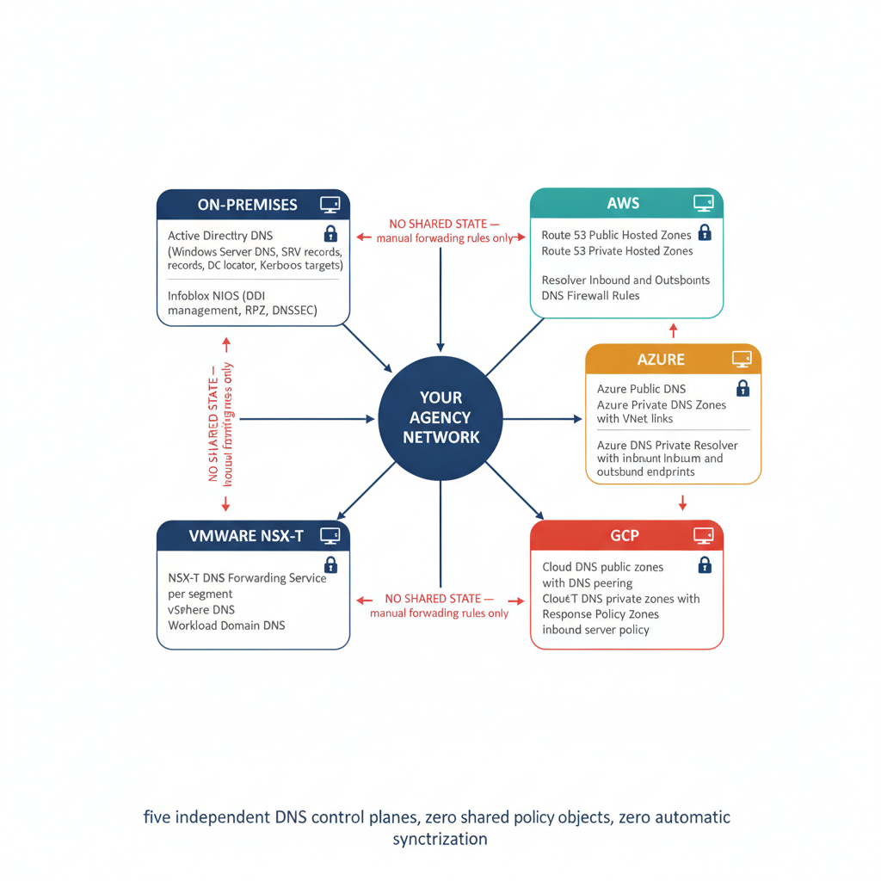
Figure 2: The hybrid multi-cloud DNS landscape: each platform operates an independent DNS system — on-premises AD DNS and NIOS, AWS Route 53, Azure Private DNS, GCP Cloud DNS, and VMware NSX-T DNS — none of which was designed to share state with the others

1.4 How each platform implements DNS
Understanding why unified management is necessary requires understanding what each platform’s DNS service actually does — and where its behavior diverges from the others.
AWS Route 53 operates as both a public authoritative DNS service and a private resolver infrastructure. Public hosted zones are authoritative for internet-visible domains. Private hosted zones are authoritative for names that should resolve only within a VPC. The Route 53 Resolver provides inbound endpoints (for on-premises queries entering AWS) and outbound endpoints (for AWS-originating queries leaving to on-premises or other CSPs). Outbound Resolver rules define which namespaces are forwarded where. Route 53 Resolver DNS Firewall applies domain-level block/allow rules to outbound queries. Each of these components — hosted zones, Resolver, DNS Firewall rules — is configured independently in the AWS console or CLI.
Azure Private DNS zones are sovereign: they do not exist in a global hierarchy. They are linked to virtual networks via DNS zone links, and resolution of a private zone’s records is available only to VMs in a linked VNet. Azure DNS Private Resolver provides inbound and outbound endpoints — the inbound endpoint accepts queries from on-premises or other networks, the outbound endpoint forwards queries to designated servers. Forwarding rulesets on the outbound endpoint define per-namespace forwarding rules. Private endpoint FQDNs (such as storageaccount.blob.core.windows.net) resolve to RFC 1918 addresses only when the query arrives via an inbound endpoint linked to a VNet that has the private endpoint. The same query from outside that path resolves to a public IP. This is the structural root of the Azure split-brain problem.
GCP Cloud DNS private zones are associated with VPC networks. Resolution is handled by the metadata server at 169.254.169.254 within the VPC — a well-known RFC 3927 link-local address that Google’s hypervisor intercepts. DNS peering allows a private zone in one VPC to be visible to another. An inbound server policy adds a regional forwarding endpoint that accepts queries from on-premises or other networks. GCP Cloud DNS supports Response Policy Zones (functionally equivalent to Infoblox RPZ) for DNS-layer security enforcement — an important distinction from Azure, which has no equivalent native RPZ mechanism.
VMware NSX-T DNS Service operates at the logical segment level. The NSX-T DNS Service is a gateway-level forwarder deployed on the Tier-1 or Tier-0 gateway; it intercepts DNS queries from workloads on managed segments and forwards them to designated upstream resolvers. Multiple DNS service profiles can be configured, each pointing to different forwarders for different namespaces. This creates a DNS topology where the resolver a workload uses is determined by which NSX-T segment it lives on — behavior that is entirely opaque from the perspective of the on-premises DNS console. vSphere clusters that are AD-joined use AD DNS directly; NSX-T managed workloads may or may not, depending on how the DNS service profile is configured.

1.5 The management burden of independence
Managing these five DNS systems independently requires five distinct skill sets, five separate operational playbooks, and five separate security posture reviews. When a new private endpoint is provisioned in Azure, the engineer provisioning it must also update the Azure Private DNS zone link, the Azure DNS Private Resolver forwarding ruleset, the Route 53 outbound resolver rule (if AWS workloads need to reach the endpoint), and the Infoblox NIOS conditional forwarding configuration (if on-premises workloads need to reach it). The provisioning step is one action; the DNS synchronization it requires is four more, on four different consoles, with four different syntaxes.
No organization has a team that owns all five of those operations simultaneously. The natural ownership boundary is: cloud team owns CSP DNS, network team owns NIOS, Windows team owns AD DNS. The DNS that crosses those ownership boundaries — the forwarding rules that connect them — typically falls into the gap between all three teams.

Part 2 — Split-Brain DNS: The Structural Problem
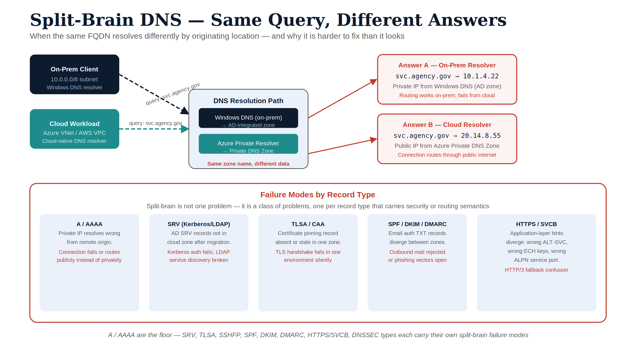
Figure 3: Split-brain DNS — same query, different answers by originating location

2.1 What split-brain DNS is
Split-brain DNS is the condition where a DNS query for the same name returns different answers depending on where the query originates. The name is correct — it maps to the right host in both cases — but the two answers point to different addresses, and the difference in address determines whether the traffic reaches its intended destination.
Split-brain is not a bug. It is often an intentional design: the same public FQDN resolves to an RFC 1918 address for internal callers and a public IP for external callers. That is a legitimate and common pattern. The problem arises when the two views are inconsistent in ways that are not intentional — when the internal view is stale, when the external view is incorrect for some callers but not others, or when a security policy (RPZ block, DNS Firewall rule) applies in one view but not the other.
In a hybrid multi-cloud environment managed with independent per-CSP DNS, unintentional split-brain is structurally guaranteed. The independent DNS systems diverge because they have no mechanism to stay consistent.

2.2 Private IP split-brain: the cross-cloud case
The clearest example of private IP split-brain is the Azure Private Endpoint case. When an Azure Storage account is configured with a private endpoint, Azure creates a DNS record in the privatelink.blob.core.windows.net private zone that resolves the storage account’s FQDN to a VNet-scoped RFC 1918 address — say 10.1.0.4. Within the VNet, any query for storageaccount.blob.core.windows.net resolves to 10.1.0.4. Traffic stays on the private network.
For an EC2 instance in AWS to reach the same storage account via its private endpoint, the Route 53 outbound resolver must have a forwarding rule for privatelink.blob.core.windows.net that directs queries to the Azure DNS Private Resolver inbound endpoint. If that rule exists and is current, the EC2 instance resolves the private endpoint correctly. If the rule is absent or outdated, Route 53 falls through to public recursive resolution, the storage account resolves to a public IP, and the EC2 instance either connects over the public internet (bypassing private endpoint security controls) or is blocked by the storage account’s network access rules.
The failure is intermittent because the public FQDN resolves successfully — just to the wrong address. The application layer sees a connection; the network layer completes it. The fact that the traffic is not taking the intended private path is invisible without explicit DNS query logging and traffic flow analysis.
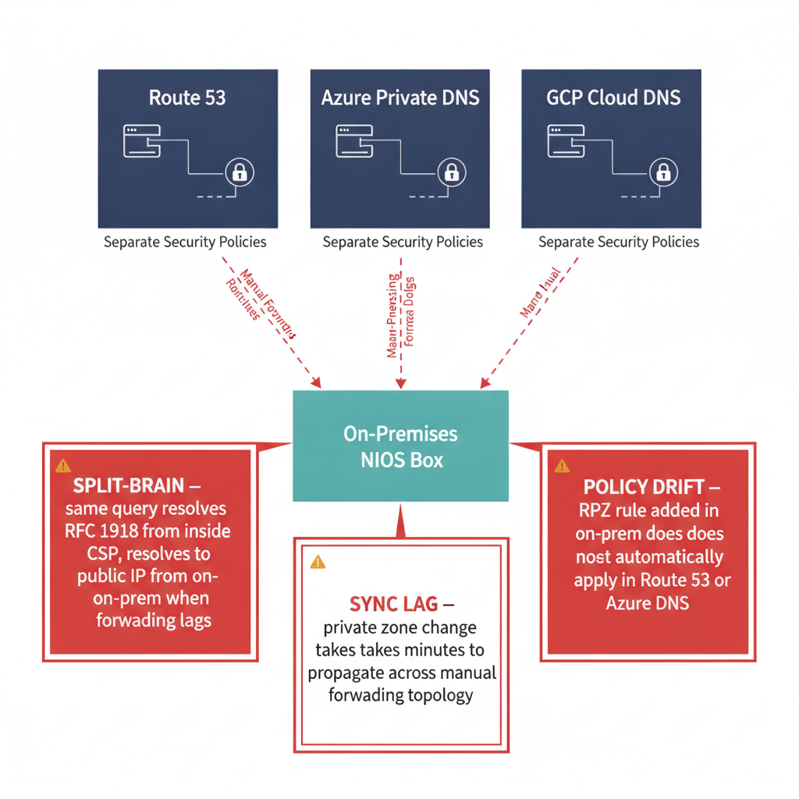
Figure 4: Split-brain DNS in two scenarios: private IP cross-cloud (EC2 to Azure private endpoint resolves differently by query origin) and public SaaS endpoint selection (M365 resolves to commercial vs. GCC endpoints depending on DNS configuration)

2.3 Public SaaS split-brain: Microsoft 365 and sovereign cloud
Microsoft 365 presents a different form of split-brain that is particularly consequential for federal agencies. M365 uses DNS to route clients to the correct service endpoint — commercial, GCC Moderate, GCC High, or DoD. The FQDNs are identical across environments (e.g., outlook.office365.com); the DNS answers that clients receive determine which infrastructure they connect to.
For a GCC Moderate tenant, M365 traffic must resolve to GCC endpoints. This is enforced by DNS: Microsoft publishes different IP ranges for GCC vs. commercial, and the expectation is that agency DNS infrastructure resolves M365 FQDNs to the correct range. In practice, the agency’s DNS forwarders typically resolve M365 FQDNs via public recursive resolution, which returns the anycast IP closest to the resolver — not necessarily the GCC endpoint.
The result is that M365 DNS resolution for GCC tenants is often implicitly correct (because Microsoft routes GCC tenants to GCC endpoints at the application layer even if the client connects via a commercial IP) — but it is not explicitly governed. When configuration changes, network path changes, or conditional access policies enforce GCC-specific IP restrictions, the implicit behavior breaks and the failure surfaces as authentication failures or access denials that appear to have nothing to do with DNS.
Governing M365 endpoint selection via DNS — configuring conditional forwarding or DNS policies that explicitly route M365 namespaces to the correct endpoints — is the correct answer, and it requires a DNS management plane that covers both on-premises resolvers and the cloud DNS services that branch users reach first.

2.4 Security policy split-brain: the invisible gap
DNS security policy — Response Policy Zones, DNS Firewall rules, block lists — enforces at the resolver. If a malicious domain is blocked in Infoblox NIOS but not in Route 53 DNS Firewall, workloads on EC2 instances that use Route 53 as their resolver are unprotected. If an RPZ block is applied in GCP Cloud DNS Response Policy Zones but not in Azure, Azure-hosted workloads are unprotected.
The per-CSP model produces a security posture that is the intersection of all five DNS security policies — meaning it is only as strong as the weakest system. Because policy replication across five independent DNS systems is manual, the intersection is never exactly equal. The systems diverge over time as each is updated independently.
This is not merely a compliance gap. DNS-layer threat detection is one of the most effective early-warning mechanisms for supply chain compromise, ransomware pre-positioning, and data exfiltration — precisely because malicious actors rely on DNS for command-and-control and staging infrastructure. A DNS security policy that applies only to queries that reach NIOS provides no protection for the majority of cloud-native queries that never touch NIOS.

2.5 Why process discipline cannot fix a structural problem
The standard response to split-brain DNS in a per-CSP model is process: write a runbook, require engineers to update all five DNS systems when any DNS change is made, and audit compliance. This response fails for three reasons.
First, the failure mode is silent. When a Route 53 forwarding rule is not updated after an Azure private endpoint changes IP, no alarm fires. The divergence accumulates quietly until a workload that happens to query from AWS fails — and the failure looks like a network problem, not a DNS problem.
Second, the change surface is too large. Every private endpoint provisioning, every IP address reassignment, every new workload deployment has DNS implications across all five systems. In a large federal estate with dozens of teams provisioning cloud resources, the rate of DNS changes exceeds any manual synchronization process’s ability to keep up.
Third, the five systems have different APIs, different rate limits, different propagation delays, and different consistency models. Even a fully automated synchronization process must solve the ordering and conflict-resolution problems that arise when the five systems update at different speeds.
The only structural fix is a unified control plane that holds the authoritative policy objects and propagates them to all five surfaces simultaneously — so that the question of whether Route 53 has the current forwarding rules is answered by the control plane, not by manual audit.

Part 3 — The Modern DNS Record Catalog: Types, Security Integration, and Application-Aware Routing
DNS is a protocol with more than fifty standardized record types, and at least fifteen of them are directly relevant to federal hybrid multi-cloud security, certificate governance, application-aware routing, and threat defense — address and alias records, service discovery (SRV/NAPTR), certificate governance (CAA/TLSA/SSHFP/SMIMEA), email authentication (SPF/DKIM/DMARC/BIMI/MTA-STS), modern service binding (HTTPS/SVCB), and the full DNSSEC record family (DNSKEY/DS/RRSIG/NSEC3/CDS/CDNSKEY). A security-integration matrix cross-references all nineteen record types against DNSSEC dependency, CA/PKI integration, split-brain impact, threat-defense relevance, and application-aware routing — a single table a practitioner can use to reason about any record type’s governance requirements. That catalog and matrix have been moved into their own reference document so they can be bookmarked and searched independently of this paper’s argument.
For the full record-type catalog, including the security-integration matrix, see DNS Record Types and Universal DDI Ecosystem Integrations — Reference Companion.

Part 4 — The Active Directory DNS Departure

4.1 What Active Directory DNS actually does
For twenty years, Active Directory has been the DNS server for most federal on-premises networks — not as an architectural choice but as a consequence of how AD works. When a Windows domain is deployed, the domain name (e.g., agency.gov or agency.local) becomes a DNS zone, and the domain controllers become the authoritative DNS servers for that zone. Every domain-joined device queries AD DNS for everything — not just domain-specific lookups, but all recursive resolution. AD DNS is the default resolver for every workstation, server, and network-joined device in the enterprise.
The DNS records AD maintains are not just name-to-address mappings. AD DNS is the backbone of Windows authentication and directory service discovery:
SRV records for Kerberos. _kerberos._tcp.agency.gov is a DNS SRV record that points clients to Kerberos KDCs. Every Kerberos authentication starts with a DNS query for this record. If it is missing or wrong, Kerberos fails.
SRV records for LDAP. _ldap._tcp.agency.gov points clients to domain controllers for LDAP queries — group membership, policy application, user attribute lookup. Every AD-aware application queries this record.
DC locator records. Domain controllers register a family of SRV and A records that allow clients to find the nearest DC by site, by service, and by capability. These records are dynamically maintained by the Netlogon service on every DC. They are not static; they change when DCs are decommissioned, when AD sites are reconfigured, or when DC services change.
DFS namespace records. Distributed File System namespaces are published via DNS. File share access for roaming profiles, home drives, and shared storage all depend on DNS records that AD maintains.
GPO application. Group Policy Objects are applied to machines in a domain. The policy application process begins with an LDAP query for the DC, which begins with a DNS query for the LDAP SRV record. GPO does not function if AD DNS is not functioning.
The operational implication: AD DNS is not a service that runs alongside the enterprise. It is the service that everything else depends on. When AD DNS is unavailable, authentication fails, policy fails, file access fails, and every Windows-integrated application fails simultaneously.

4.2 Microsoft’s deprecation trajectory
Microsoft has been systematically reducing the role of Active Directory in its modern identity architecture. The trajectory is clear:
- Entra ID (Azure AD) replaces AD as the identity plane for cloud and modern applications. Entra ID is not AD — it has no LDAP endpoint, no Kerberos KDC (in the traditional sense), no Group Policy, and no SRV records.
- Entra hybrid join connects AD-joined devices to Entra ID, but the device is still fundamentally AD-dependent for its core operations.
- Entra-only join removes the AD dependency entirely. An Entra-only joined device authenticates via token, not Kerberos. It does not query AD DNS for SRV records. It does not require a domain controller to be reachable.
- Microsoft’s published guidance for new deployments consistently recommends Entra-only join, cloud-only identities, and Entra ID as the primary identity provider — with AD described as a legacy dependency to be eliminated over time.
The UIAO SQL Server Identity Transformation series documents this trajectory in the context of database authentication. The pattern is universal: every place that AD authentication is used is a deprecation candidate, and every deprecation exposes a DNS dependency that was previously invisible.

4.3 What happens to DNS when AD goes away
When an agency begins decommissioning domain controllers and migrating to Entra-only identities, the DNS records that AD maintained do not migrate automatically. They are not exported, not converted, and not reprovisioned in a replacement DNS server unless someone explicitly plans for it. The records simply stop being maintained — and when the last DC is decommissioned, they disappear.
The applications that depended on those records are not notified. They continue to query DNS for records that no longer exist. Kerberos-dependent applications fail. LDAP-dependent applications fail. Any application that used AD DNS as its recursive resolver and relied on the AD-managed conditional forwarding rules to reach on-premises services now queries a resolver that may not have those forwarding rules configured.
Figure 5: The Active Directory DNS departure: what AD DNS provides today across six record families, what happens to each when AD is deprecated without explicit DNS governance, and what must be reprovisioned in a replacement DNS system before decommissioning begins
The agencies most at risk are those that have already begun Entra migration but have not yet established a DNS governance program outside of AD. They are consuming AD DNS without recognizing that it is the thread holding together their hybrid DNS topology — and when that thread is cut, the topology collapses.

4.4 What must be reprovisioned before AD leaves
A DNS governance program that runs alongside AD deprecation must explicitly account for every DNS record category that AD currently maintains:
- Kerberos and LDAP SRV records must be reprovisioned in the replacement DNS system for any service that will continue to use them during a transition period. If Kerberos is being replaced by token authentication in parallel, the SRV records can be allowed to expire — but the timeline must be coordinated, not accidental.
- DC locator records must be maintained in the replacement DNS system until every workload that queries for them has been migrated to Entra-only authentication.
- Conditional forwarding rules must be inventoried, exported, and reprovisioned in the replacement DNS platform. This is the most commonly missed step: AD DNS conditional forwarding is configured in the DNS Manager GUI and is not easily exported. Many agencies have no record of what conditional forwarding rules their AD DNS servers maintain.
- The DNS namespace itself — the internal domain (agency.gov or agency.local) — must be reprovisioned as a zone in the replacement DNS system. Infoblox NIOS is the natural landing point for this zone, but the zone must be explicitly created and populated, not assumed.

Part 5 — Kerberos to Tokens: The Certificate-DNS Surface Problem

5.1 How Kerberos uses DNS
Kerberos authentication has a deep and often underappreciated dependency on DNS. When a client authenticates to a service using Kerberos, the process begins with a DNS lookup:
- The client queries DNS for the KDC SRV record (_kerberos._tcp.<realm>) to find the Key Distribution Center.
- The client requests a Ticket-Granting Ticket (TGT) from the KDC.
- The client requests a service ticket for the target service, identified by its Service Principal Name (SPN).
- The SPN includes the FQDN of the target service. The KDC validates the SPN against the service account registered in AD.
- The client presents the service ticket. The service validates it by resolving the SPN back to an IP and confirming it matches the connection.
Every step that involves an FQDN is a DNS dependency. If the KDC SRV record is wrong, authentication fails at step 1. If the service’s FQDN does not resolve to the server’s IP, the service ticket validation fails at step 5. If split-brain DNS causes the client and the server to resolve the same FQDN to different IPs, the service ticket is valid but the connection target doesn’t match — authentication fails at step 5 in a way that is extremely difficult to diagnose without knowing to look at DNS.

5.2 How Entra ID tokens replace Kerberos — and why DNS still matters
Entra ID replaces Kerberos with OAuth 2.0 / OpenID Connect token-based authentication. A client authenticates to Entra ID (via a browser redirect, device code flow, or client credential grant), receives an access token, and presents that token to the target service. The target service validates the token’s signature, issuer, and audience claims against Entra ID’s public key infrastructure — not against a KDC.
This sounds like DNS is no longer involved. It is not. The OAuth flow introduces a different DNS surface:
Authorization endpoints. The client must reach login.microsoftonline.com (commercial) or login.microsoftonline.us (GCC/DoD). These FQDNs must resolve correctly and consistently. If split-brain DNS routes a GCC tenant’s authentication traffic to the commercial login endpoint, authentication fails.
Token audience claims. An access token’s aud (audience) claim contains the FQDN or application ID of the target service. For a custom agency application, the audience is the FQDN registered in the app’s Entra registration — e.g., api.agency.gov. The service validates that the token audience matches its own registered identifier. If the service’s FQDN has been changed (DNS rename, namespace migration) but the token audience claim has not, validation fails.
Certificate Subject Alternative Names. Modern applications use TLS everywhere. Every TLS certificate is issued for specific FQDNs, listed as Subject Alternative Names (SANs). A certificate issued for api.agency.gov is valid only for that FQDN and any wildcards explicitly included (e.g., *.api.agency.gov). If DNS resolves api.agency.gov to the correct server but the server presents a certificate that does not include that FQDN as a SAN, the TLS handshake fails.
OCSP and CRL endpoints. Certificate validity is checked against OCSP responders and CRL distribution points embedded in the certificate. Both are DNS names. If the OCSP responder’s FQDN does not resolve — or resolves to the wrong IP, or resolves differently from different network locations — certificate validation fails or falls back to a degraded mode.

5.3 The certificate split-brain problem
The certificate-DNS intersection produces a specific form of split-brain that is more difficult to diagnose than the private IP form because it manifests as a certificate error, not a DNS error.
Consider a federal agency that has deployed a service at payments.agency.gov. The service has a TLS certificate with payments.agency.gov as a SAN, issued by the agency’s PKI. The OCSP responder for that PKI is at ocsp.pki.agency.gov.
In the hybrid multi-cloud model, payments.agency.gov is a private zone record — it resolves to an RFC 1918 address from inside the network, and either does not resolve or resolves to a public IP from outside. The OCSP responder at ocsp.pki.agency.gov must be reachable from any network location that is validating the certificate — including cloud workloads in AWS and Azure that might call the service.
If ocsp.pki.agency.gov is a private-only record in AD DNS, it does not resolve from AWS EC2 instances unless the Route 53 outbound resolver has a forwarding rule for pki.agency.gov. If that forwarding rule is absent, the EC2 instance cannot reach the OCSP responder, certificate validation fails with an OCSP unreachable error, and the TLS handshake either fails (if the client enforces OCSP) or succeeds with a revocation warning (if the client is configured to soft-fail on OCSP unreachability).
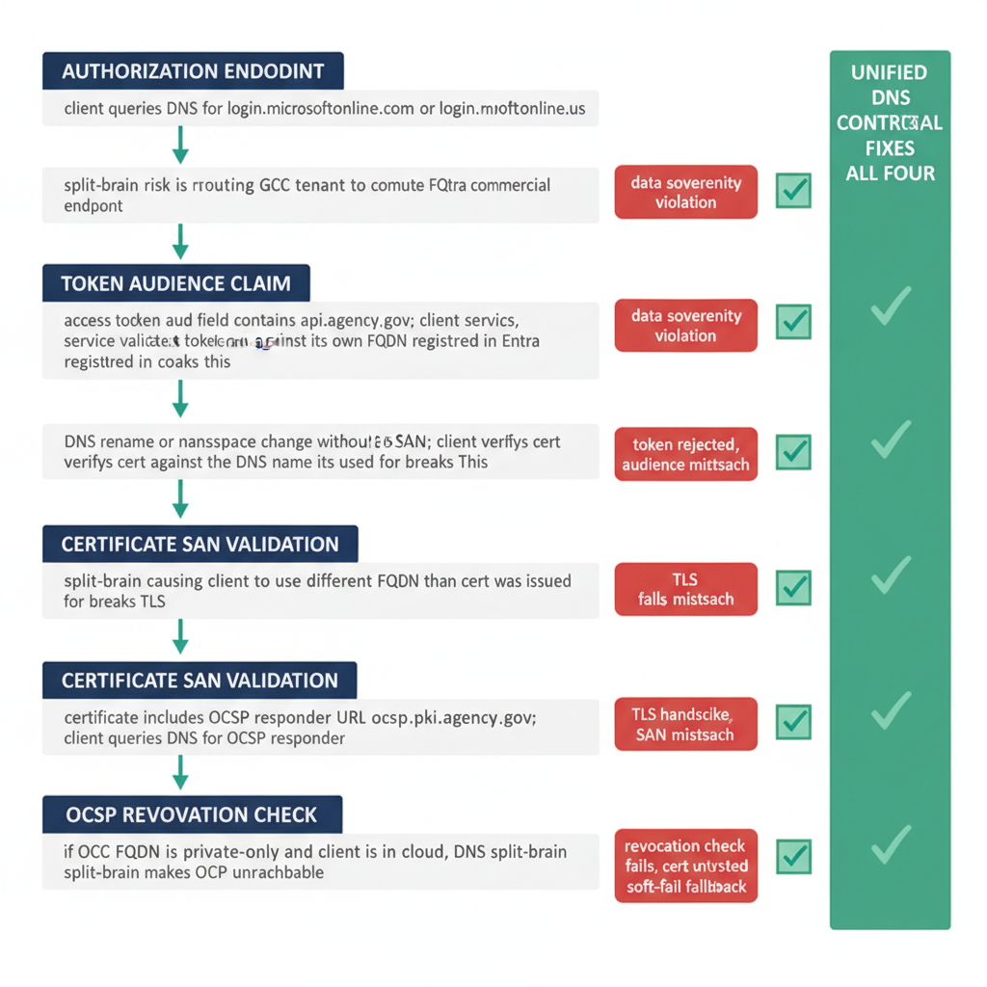
Figure 6: The certificate-DNS surface in a token-based authentication environment: how DNS governs the authorization endpoint, the token audience claim, the certificate SAN, and the OCSP validation path — and how split-brain DNS breaks each layer independently
This failure is invisible in the DNS logs because the DNS query fails at the forwarder level — no response is returned — and the client interprets the failure as an OCSP unreachability event, not as a DNS failure. The incident ticket is opened against PKI, not against DNS. The root cause — an absent forwarding rule in Route 53 — may not be discovered for days.

5.4 The implication: DNS correctness is a PKI trust prerequisite
The logical conclusion is that PKI trust in a hybrid multi-cloud environment is a dependent of DNS correctness. A certificate that is issued correctly, by a trusted CA, for the right FQDN, and has not been revoked, can still fail to be trusted if the DNS fabric that supports its validation chain has split-brain conditions.
This means that the security case for unified DNS governance is not only about network path correctness (Part 2) and threat enforcement (Part 3). It is also about PKI integrity. An agency cannot claim to have a functioning PKI trust chain in a hybrid multi-cloud environment unless DNS resolution is consistent from every network location — on-premises, in every CSP, and at every branch.

5.5 Geographic certificate scoping and the DNS namespace
A related challenge emerges when agencies deploy applications across geographically distributed regions and need to scope certificate trust to specific geographic boundaries — for data residency, sovereignty compliance, or risk containment purposes.
The question of mid-label wildcards. It is natural to ask whether a certificate for application.*.agency.gov could serve this purpose, allowing the * to match region names (eastus, westus, etc.). The answer is: this was technically ambiguous for a brief historical window, is now formally prohibited for all public certificates, and does not work on any modern TLS client.
The history in brief: - RFC 2818 (2000) — the original HTTPS specification described wildcard matching as applying to “component fragments,” language ambiguous enough that some implementations allowed mid-label matching (application.*.agency.gov matching application.eastus.agency.gov) - RFC 6125 (2011) — clarified that wildcards SHOULD apply only in the leftmost label; mid-label matching SHOULD NOT be supported - CA/Browser Forum Baseline Requirements (2012) — prohibited public CAs from issuing certificates containing mid-label wildcards; any such certificate is non-compliant and browsers reject it - RFC 9525 (2023) — codified MUST NOT; mid-label wildcards are now formally prohibited in all conformant TLS implementations - Current client behavior — OpenSSL, BoringSSL (Chrome/Android), NSS (Firefox), SChannel (Windows/Edge) all reject mid-label wildcards at validation time; application.*.agency.gov will fail TLS handshake on every modern client
How geographic scoping is actually done. The correct pattern uses the DNS namespace structure and leftmost-position wildcards:
DNS layer: Publish per-region specific A records for application instances (app.eastus.agency.gov, app.westus.agency.gov), and optionally leftmost-position wildcard records for region namespaces (*.eastus.agency.gov, *.westus.agency.gov). These are DNS wildcards conforming to RFC 1034 — the * is in the leftmost label position.
Certificate layer: Use multi-SAN wildcard certificates, with one SAN per region: *.eastus.agency.gov and *.westus.agency.gov as separate Subject Alternative Names in a single certificate. This is current practice, widely deployed, and fully supported. The blast radius is wider than a per-region certificate — a compromised private key exposes all regions covered by the SANs — which is the principal operational trade-off.
Trust boundary layer: The strongest geographic scoping mechanism is Name Constraints on intermediate CA certificates. An agency that operates a subordinate CA for each geographic region can issue certificates from Agency-EastUS-Intermediate with a Name Constraints extension permitted: eastus.agency.gov. Any certificate issued by that intermediate CA is cryptographically constrained to names within the permitted subtree — a browser or TLS client will reject a certificate from Agency-EastUS-Intermediate that claims to cover westus.agency.gov, even if the certificate itself is otherwise valid. This is the only mechanism that provides cryptographic (rather than procedural) geographic enforcement.
The three-layer geographic trust architecture:
Layer | Mechanism | Enforcement | Split-Brain Risk
DNS namespace | *.eastus.agency.gov zone | DNS resolution | High — zone must be consistent on all surfaces
Certificate SANs | Multi-SAN cert: *.eastus.agency.gov, *.westus.agency.gov | TLS handshake SAN matching | Medium — cert is issued once; DNS must resolve to correct region
Name Constraints | Intermediate CA with permitted: eastus.agency.gov | Cryptographic — client enforces | Low — the constraint is in the cert, not DNS
The DNS layer is where split-brain re-enters this picture: even if the certificate is correctly scoped to eastus.agency.gov, a split-brain DNS condition that causes a client in Azure West US to receive the East US endpoint address means the client connects to the wrong region — the certificate validates (it covers the FQDN), but the data sovereignty boundary has been crossed silently. Correct geographic enforcement requires DNS consistency, not just correct certificate scoping.

Part 6 — Layer 7 Networking and DNS as the Application Surface

6.1 Session networking versus application networking
For most of the internet’s history, network policy was written in terms of Layer 4 constructs: IP addresses and ports. A firewall rule said “allow 10.0.0.5:443 to reach 10.1.0.12:8443”. A load balancer forwarded connections by destination IP and port. A VPN policy granted access to a subnet (10.2.0.0/24). The service identity was the IP address, and IP addresses were relatively stable.
This model works when the number of services is small, the service topology is static, and the policy granularity of IP:port is sufficient. It breaks down in the cloud-native and zero trust era for three reasons:
First, IP addresses are ephemeral. Cloud workloads are created and destroyed continuously. A Kubernetes pod runs on 10.0.5.42 today and 10.0.7.18 tomorrow. Writing firewall policy against IP addresses requires continuous policy updates that cannot keep pace with infrastructure change.
Second, IP addresses are insufficient policy identifiers. Two workloads on the same IP address (different ports) may have entirely different security postures. An IP-based policy that allows port 443 does not distinguish between an agency’s API gateway and a compromised container that has been moved to the same IP.
Third, IP-based policy does not compose across cloud boundaries. The 10.0.0.0/8 RFC 1918 space is used by every CSP and on-premises network simultaneously. A policy written for 10.1.0.0/16 in AWS is meaningless in Azure where the same CIDR block is assigned to a different VNet.

6.2 FQDN as the stable service identity
Application-layer networking resolves these problems by using the FQDN as the stable service identity. A zero trust policy says “allow payments-service to call ledger-api.finance.agency.gov on port 443” — regardless of what IP address ledger-api.finance.agency.gov resolves to at any given moment. A service mesh routes traffic to payments.internal and manages the load-balancing, retry, and circuit-breaking logic based on that FQDN, not on individual pod IPs. An API gateway validates the Host: header against a registered FQDN list before routing the request.
The FQDN is stable; the IP is not. Policy, audit logs, certificates, and access controls all reference the FQDN. The IP is a runtime detail that DNS resolves on demand.
This architectural shift has a profound implication for DNS: DNS is no longer a name-lookup utility that supports networking. DNS is now the registry of service identities. The FQDN in DNS is the canonical reference for a service. If DNS is inconsistent — if the same FQDN resolves differently from different locations — then the service identity itself is inconsistent, and policy, certificates, and access controls that reference that identity may behave differently depending on where the caller is located.

6.3 Wildcard DNS and the application surface
As agencies adopt application-layer networking, a new DNS pattern has emerged: the wildcard subdomain as application surface definition.
A wildcard DNS entry (*.api.agency.gov) matches any subdomain of api.agency.gov. This is not a new DNS feature — wildcards have been defined since RFC 1034 — but their use has expanded dramatically in the application-layer networking era because they are the natural mechanism for publishing namespaces of applications:
- payments.api.agency.gov — the payments API endpoint
- grants.api.agency.gov — the grants management API
- identity.api.agency.gov — the identity service API
- documents.api.agency.gov — the document management API
All of these can be published with a single wildcard entry pointing to an API gateway’s IP address (or CNAME to a load balancer). The gateway inspects the Host: header to route the request to the correct backend. From a DNS perspective, the entire application surface is defined by one record.
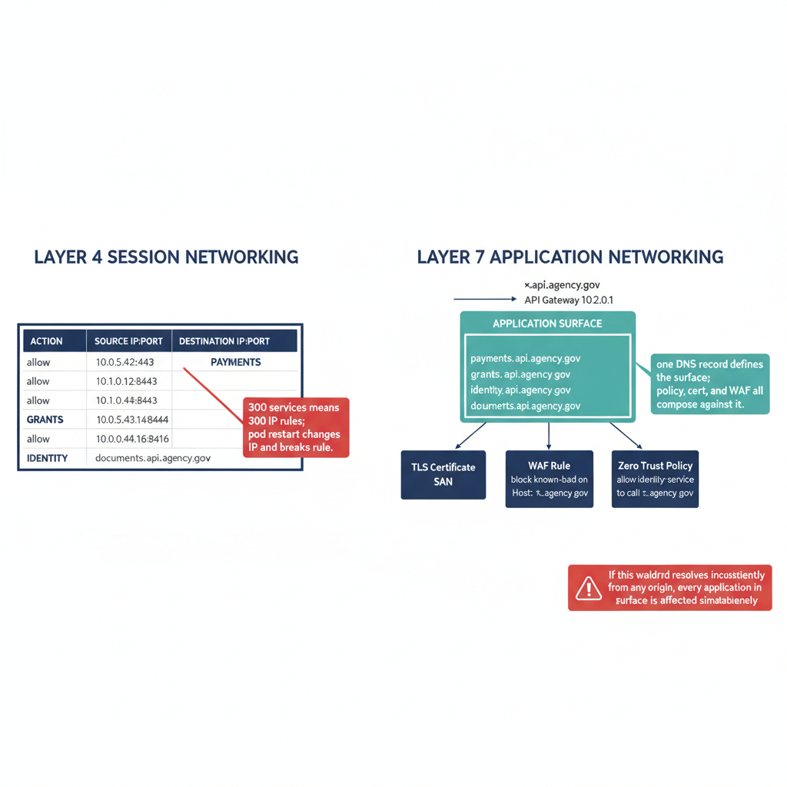
Figure 7: Layer 4 versus Layer 7 networking: IP-port policy gives way to FQDN-based service identity — and wildcard DNS subdomains become the declaration of the application surface, governing not just routing but TLS certificates, WAF rules, and zero trust policy simultaneously

6.4 What wildcard DNS means for governance
The wildcard pattern amplifies the consequences of DNS misconfiguration. If *.api.agency.gov is a wildcard that resolves to the API gateway, and that wildcard record is inconsistent across the five DNS systems — correct in NIOS but absent in Route 53, so cloud workloads in AWS cannot call any *.api.agency.gov endpoint — the failure is not one broken service, it is the entire application surface. Every API behind the gateway fails from AWS-hosted callers simultaneously.
The certificate consequence is equivalent. A wildcard certificate issued for *.api.agency.gov is valid for every subdomain in that namespace. The PKI team issues one certificate; the application team deploys dozens of services under it. If DNS resolution of *.api.agency.gov is split-brain, the certificate is simultaneously valid (for callers whose DNS is correct) and untrusted (for callers whose DNS is wrong) — a failure mode that cannot be diagnosed by examining the certificate itself, only by examining DNS resolution.

6.5 The IPAM implication
IP Address Management was historically the management of IP address assignments — tracking which IP address was assigned to which device, ensuring no conflicts, and automating DHCP configuration. In the Layer 4 era, IPAM and DNS were tightly coupled: an IP assignment produced a DNS A record, and a DNS A record implied an IP assignment.
In the Layer 7 era, this coupling weakens in one direction and strengthens in another. The IP address is less important as a policy identifier — an application is identified by FQDN, not by IP. But DNS management becomes more important because the FQDN namespace is the canonical application registry.
The implication: IPAM systems that track only IP assignments are incomplete. The full picture requires tracking the FQDN namespace — which FQDNs are registered, which wildcard namespaces are active, which subdomains are in use, and which certificates are bound to which namespaces. This is the DNS side of IPAM, and it is the side that has not been consistently governed in the per-CSP model.
Infoblox Universal DDI’s IPAM module tracks both IP assignments and DNS records across all managed surfaces. This makes it the only currently available platform that can answer the question “what is the complete FQDN namespace of our hybrid multi-cloud estate?” from a single console.

6.6 Geographic namespace and the application surface boundary
As agencies deploy applications across multiple geographic regions — for performance, redundancy, data residency, or sovereignty — the DNS namespace must encode regional identity. The correct pattern is a hierarchical geographic namespace: {app}.{region}.agency.gov, where {region} is a stable label such as eastus, westus, or govcloud-east.
This namespace is populated with specific A records per application per region (payroll.eastus.agency.gov, payroll.westus.agency.gov) and optionally with leftmost-label wildcard records per region namespace (*.eastus.agency.gov, *.westus.agency.gov). These wildcard records are RFC 1034-compliant — the * occupies the leftmost label position.
The geographic namespace creates a new dimension of split-brain risk: geographic split-brain. In a per-CSP model, the AWS private zone in US-East might correctly resolve payroll.eastus.agency.gov, while the Azure private zone in US-West lacks the record entirely. A user whose DNS query is forwarded to the Azure resolver receives NXDOMAIN for a name that exists on AWS. The failure is not a different IP address (classic split-brain) but a missing record — which produces a different failure signature and may not trigger the same alerting thresholds.
Geographic split-brain also creates data residency violations that appear as application behavior. If payroll.eastus.agency.gov (which should route to the east datacenter) resolves to the west datacenter IP address on a client whose DNS forwarder has a stale or incorrect entry, payroll data crosses a geographic boundary that policy prohibits — with no network-layer indication that anything went wrong. The TLS connection succeeds; the certificate validates; the application responds. Only the data location is wrong.
Governing a geographic namespace requires that the same authoritative source of truth publish consistent records for *.eastus.agency.gov and *.westus.agency.gov across every DNS surface where clients may query. This is precisely the consistency problem that per-CSP DNS cannot solve and unified DDI management directly addresses.

Part 7 — Infoblox Universal DDI: The Federal Answer
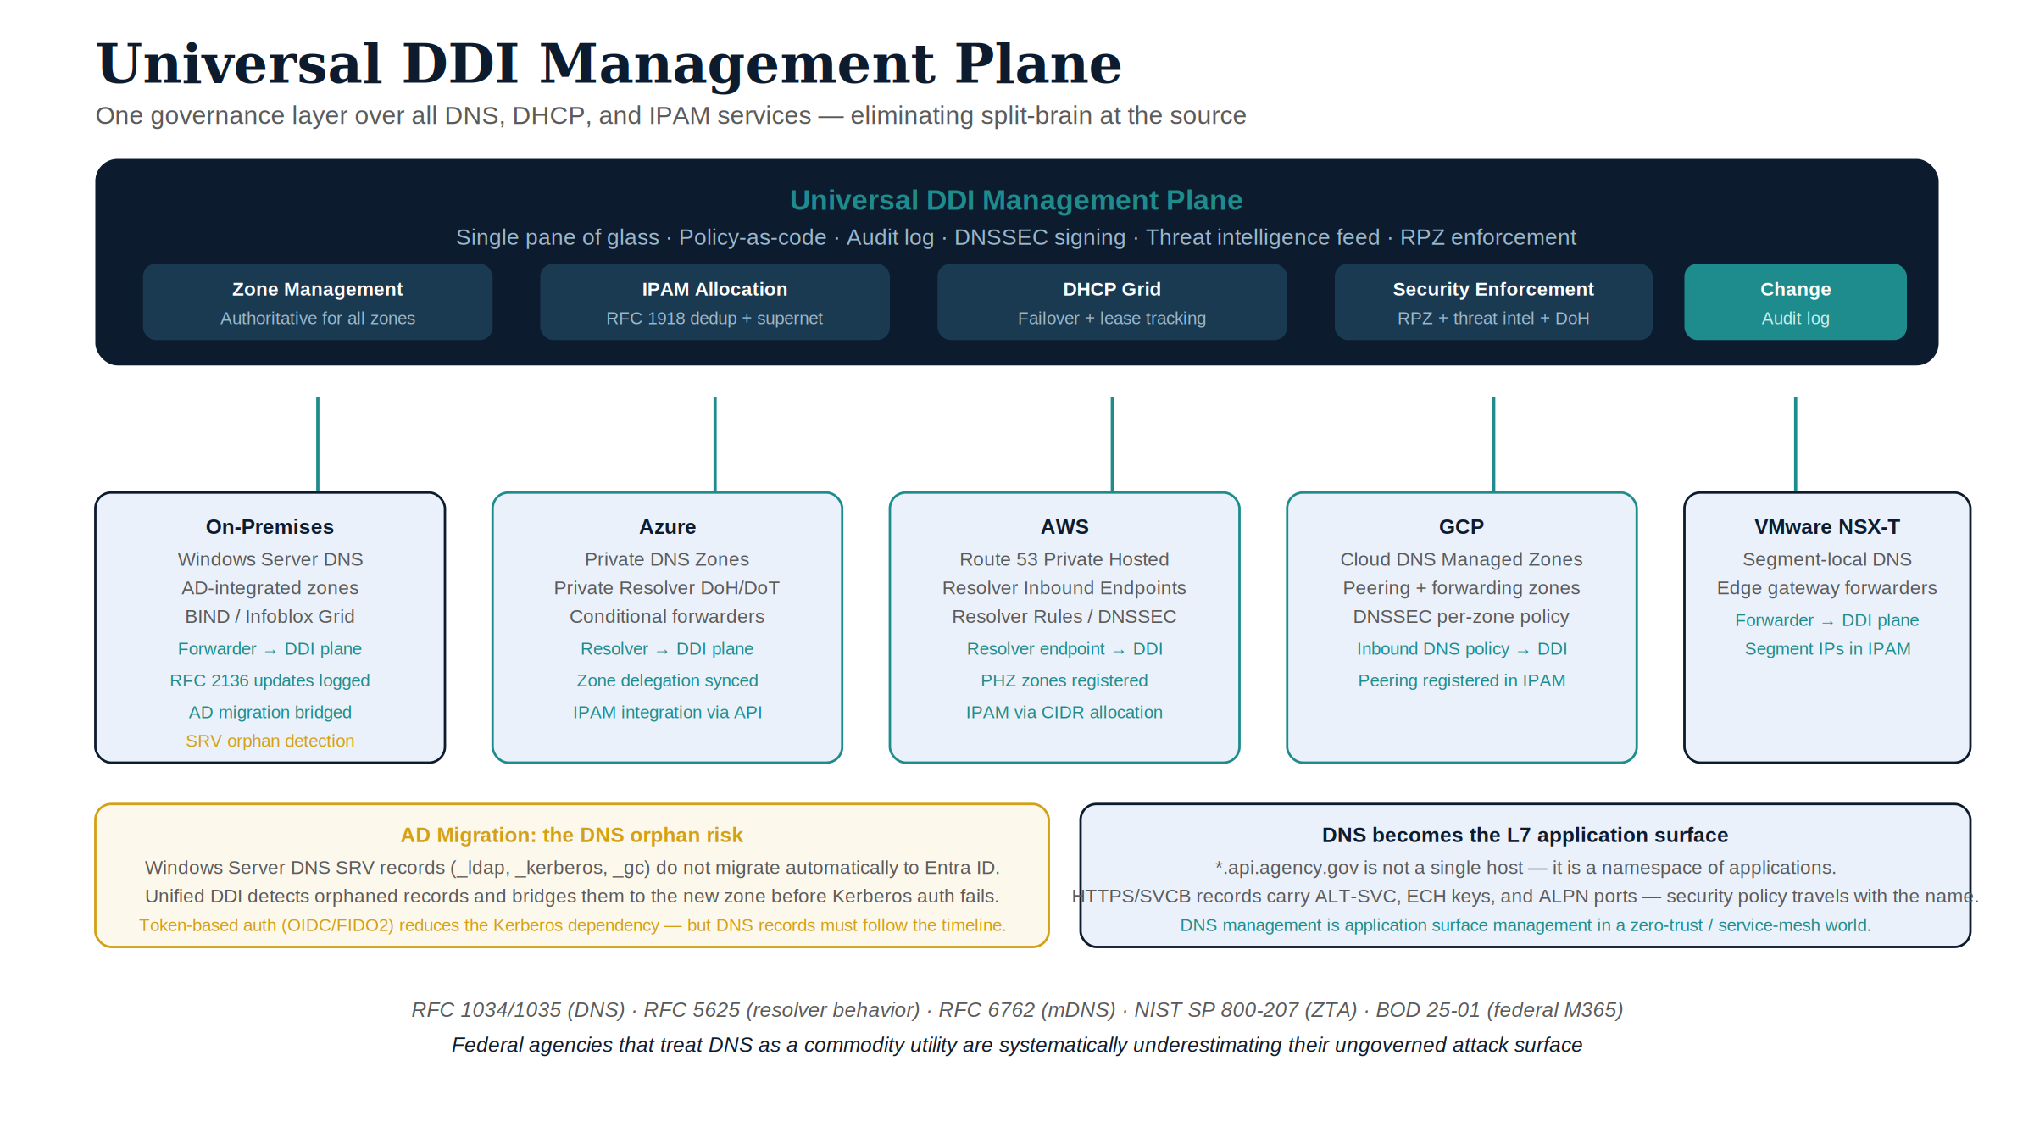
Figure 8: Universal DDI management plane — one governance layer over all DNS, DHCP, and IPAM services

7.1 What DDI is
DDI stands for DNS, DHCP, and IP Address Management — the three interrelated network services that govern how devices get addresses, how those addresses are published in DNS, and how the name space is managed as a whole. Historically, these three services were managed separately: DNS on one server, DHCP on another, IPAM as a spreadsheet. Infoblox built the first integrated DDI platform to manage all three as a unified discipline.
The integration matters because the three services are not independent:
- DHCP assigns an IP address. That assignment should automatically create a DNS A record and a PTR (reverse lookup) record.
- DNS hosts those records. When the DHCP lease expires, the DNS records should be removed automatically.
- IPAM tracks the overall address space — which subnets are allocated, which addresses are in use, which are available — and feeds that information back into DHCP scope configuration.
When the three services are managed independently, these relationships must be maintained manually. IP addresses are assigned by DHCP, DNS records are created by hand, and IPAM is updated by spreadsheet — with the inevitable result that the three are inconsistent. An IP address that DHCP has reclaimed and reassigned still has an old DNS A record pointing at it. A new service has a DHCP reservation but no DNS entry. IPAM shows addresses as available that DNS records still reference.
Unified DDI eliminates this class of inconsistency by making the three services a single managed object.

7.2 Infoblox NIOS: on-premises DDI
Infoblox NIOS (Network Identity Operating System) is Infoblox’s on-premises DDI platform, deployable as a physical appliance, a virtual appliance (vNIOS), or a container. NIOS operates as a Grid — a cluster of appliances that share a replicated database and present a unified management interface. The Grid architecture provides high availability: any Grid member can serve DNS and DHCP queries, and the database is replicated across all members in near real-time.
NIOS-X is the newer cloud-native variant. Where classic NIOS runs as a virtual appliance, NIOS-X is containerized and deployable in Kubernetes environments, including cloud-native infrastructure in AWS, Azure, and GCP. NIOS-X participates in the same Universal DDI management plane and is particularly relevant for agencies that are expanding Grid coverage into cloud environments without running full virtual appliance stacks per VPC.
Key NIOS capabilities relevant to the hybrid multi-cloud context:
DNS authoritative and recursive resolution. NIOS can serve as both the authoritative server for internal zones (replacing AD DNS) and the recursive resolver for all client queries. In the recursive role, NIOS intercepts all DNS queries before they reach public resolvers or CSP resolvers, enabling policy enforcement on every query.
Response Policy Zones (RPZ). RPZ is a DNS-layer security mechanism that intercepts queries for domains in a block list and returns a policy response (NXDOMAIN, NODATA, or a specific address) before the query is forwarded. Infoblox maintains threat intelligence feeds that are automatically ingested into RPZ, providing DNS-layer protection against malware, phishing, and command-and-control infrastructure without requiring endpoint agents.
DNSSEC. NIOS implements full DNSSEC validation and signing. As a validating resolver, it verifies the cryptographic signatures on DNS responses received from authoritative servers, protecting clients from DNS spoofing and cache poisoning attacks. As a signing authority, it signs the zones it is authoritative for, enabling downstream validation.
Conditional forwarding. NIOS maintains a forwarding configuration that maps DNS namespaces to upstream resolvers. This is the mechanism by which on-premises clients reach per-CSP private DNS zones: NIOS forwards queries for privatelink.blob.core.windows.net to the Azure DNS Private Resolver, queries for *.compute.internal to the GCP Cloud DNS resolver, and queries for Route 53 private hosted zones to the Route 53 Resolver inbound endpoint. In the per-CSP model, these forwarding rules must be maintained manually. In Universal DDI, they are managed through a single interface.
Grid replication and WAN latency. The NIOS Grid replicates its database across all Grid members. This replication is subject to the same WAN physics that govern any distributed system: propagation delay is fixed by distance (approximately 5 ms per 1,000 km, one-way), and that floor cannot be reduced by any networking technique. A Grid spanning a coast-to-coast enterprise is therefore replicating across a propagation floor of roughly 25–30 ms round-trip minimum — meaning DNS record updates made at the Grid Primary reach remote Grid Members with a physical minimum latency of that magnitude before any congestion or routing overhead is added. Infoblox’s Grid tolerates this by allowing each member to serve authoritatively from its local database copy, accepting bounded staleness in exchange for local performance. In practice, the operational implication is: DNS record changes propagate to all Grid members within seconds under normal WAN conditions, but agencies should not rely on millisecond convergence for time-critical security operations in WAN-distributed Grids. The BloxOne SaaS plane provides a single authoritative source of truth that is not subject to Grid replication latency between remote sites.

7.3 DHCP: the full governance surface
DHCP (Dynamic Host Configuration Protocol) is the most widely deployed network service that most engineers think about least. Every device on a managed network — workstation, server, printer, IoT sensor, mobile device, VDI session — acquires its IP address, default gateway, DNS server, and domain search suffix through DHCP. In a hybrid multi-cloud environment, DHCP failures are invisible until they cascade into connectivity outages whose root cause is not DNS, not routing, but address assignment.
Infoblox NIOS DHCP is a full enterprise DHCP server integrated with IPAM and DNS. The governance surface it manages is larger than the “IP address” abstraction suggests.
Scopes, ranges, and exclusions. A DHCP scope defines the address range available for dynamic assignment within a subnet. Exclusion ranges carve out addresses that are assigned statically (servers, printers, infrastructure). Reservations bind a specific MAC address or client identifier to a specific IP address, providing the benefits of static assignment without the overhead of manual DNS record management — because the reservation triggers automatic A and PTR record creation just like a dynamic lease. Infoblox NIOS tracks all three (scope, exclusion, reservation) as a unified IPAM object, which means the IPAM view always reflects what is actually assigned, not what was last updated in a spreadsheet.
DHCP options: the configuration broadcast. Every DHCP response carries option fields that tell the client how to configure itself. The options most relevant to hybrid multi-cloud DNS governance:
Option | Name | Function | Governance implication
6 | DNS Servers | Which resolvers to use | Must point to Infoblox/NIOS, not per-CSP resolvers
15 | Domain Name | Default search domain | Must match authoritative zone; wrong value causes unresolved FQDNs
119 | Domain Search List | Ordered list of search suffixes | Complex multi-domain environments; stale entries cause resolution to wrong zone
43 | Vendor-Specific | Vendor-specific config (PXE, phones) | Often carries IP Phone server addresses; must be consistent across sites
60 | Vendor Class ID | Client identifies vendor class | Allows DHCP to return different option sets per device type (PXE vs. phone vs. workstation)
82 | Relay Agent Info | Added by DHCP relay (router) | Circuit-ID and remote-ID identify the physical switch port; used for IPAM attribution and security logging
252 | WPAD (Proxy Auto-Discovery) | Web proxy configuration URL | Carries the WPAD script location; incorrect value bypasses proxy; security-relevant
Option 6 is the highest-consequence option in a hybrid DDI context: if DHCP distributes the wrong DNS server address — or if multiple DHCP servers in different parts of the estate are distributing different option-6 values — clients resolve DNS through different resolvers and the RPZ, DNSSEC, and forwarding policy is unevenly applied. In the per-CSP model, cloud DHCP services (AWS VPC DHCP options sets, Azure DHCP) each distribute their own option-6 values pointing to their own resolvers. Unifying this across the estate requires pushing consistent option-6 values through all DHCP surfaces — which Infoblox Universal DDI manages through its DHCP policy model.
DHCP fingerprinting. NIOS analyzes the sequence and content of DHCP options presented by a requesting client to identify the operating system, device type, and vendor class. Windows clients, macOS clients, Linux hosts, Cisco IP phones, printers, and IoT devices each send characteristic option patterns. DHCP fingerprinting enables: (1) policy decisions by device class (different lease times, option sets, VLAN assignments per device type); (2) rogue device detection (a device fingerprinting as a Cisco phone on a workstation VLAN is anomalous); (3) visibility into device population without requiring an MDM enrollment — DHCP fingerprinting is passive.
DHCP failover and the Grid. NIOS DHCP supports two high-availability modes: (1) DHCP failover pairs — two NIOS members configured as primary and secondary with synchronized lease state; if the primary fails, the secondary takes over without loss of lease continuity; (2) Grid DHCP redundancy — multiple Grid members serve overlapping address ranges with the Grid database as the shared lease store. In a distributed environment, the WAN latency physics described in §7.2 apply to lease synchronization: a DHCP failover pair separated by a WAN with a 50 ms round-trip will have a lease-state propagation latency of at least that magnitude. Infoblox handles this with a split-scope model for sites with unreliable WAN: each site serves a fraction of the total address pool locally, ensuring that a WAN outage does not prevent new device connectivity in either location.
Dynamic DNS update (DDNS). The most operationally critical integration between DHCP and DNS is the Dynamic DNS update: when a DHCP lease is assigned, NIOS automatically creates an A record and a PTR record for the leased address; when the lease expires or is released, those records are removed. This automation is what keeps DNS accurate in environments where device addresses change. Without DDNS, DNS becomes a stale map of where things used to be. NIOS implements DDNS using two methods: (1) direct internal update — NIOS-as-DHCP updates NIOS-as-DNS directly within the Grid (zero latency, atomic, the default for integrated deployments); (2) RFC 2136 dynamic update — NIOS sends a signed DNS UPDATE message to an external DNS server (used when the DNS server is Windows Server DNS or another non-NIOS server). In Universal DDI, cloud-sourced addresses (from AWS VPC IP assignment, Azure NIC allocation, etc.) are also published as DNS records through API integration, extending DDNS semantics to cloud-native workloads.
DHCP lease analytics and security audit trail. Every DHCP lease event — assignment, renewal, expiry, release, decline — is logged with timestamp, client MAC address, hostname, leased address, and option fingerprint. This log is the primary mechanism for answering the question “what device had IP address X at time T?” — a question that arises constantly in security investigations. In a per-CSP model, DHCP logs are scattered across AWS VPC flow logs, Azure DHCP diagnostics, NIOS syslog, and Windows DHCP event logs, each in a different format with a different retention policy. In Universal DDI, the lease history is in one place, queryable with a unified interface, and available to SIEM integrations through a consistent API.
DHCP for IPv6. DHCPv6 (RFC 8415, which obsoletes RFC 3315 and RFC 3633) carries the same governance surface as DHCPv4 with additional complexity from stateless address autoconfiguration (SLAAC). In a dual-stack federal environment, NIOS manages both DHCPv4 scopes and DHCPv6 prefix delegation, and DDNS creates both A and AAAA records on lease assignment. OMB M-21-07 requires IPv6 in federal environments; DHCP governance for IPv6 is frequently the unfinished half of compliance programs that have addressed IPv4.
DHCP in cloud environments. AWS VPCs, Azure VNets, and GCP VPCs each run their own DHCP services that cannot be replaced by an external DHCP server. Infoblox’s integration approach for cloud DHCP is not to replace the per-CSP DHCP service but to: (1) ingest cloud DHCP lease events via API, publishing them into the IPAM model; (2) push DHCP option values (including option 6 DNS server addresses) through each CSP’s DHCP options mechanism (AWS DHCP Option Sets, Azure custom DNS server configuration, GCP DNS server policy), ensuring clients in cloud environments receive the same resolver addresses as on-premises clients; (3) track cloud-native IP allocations in IPAM, providing a unified address map across the hybrid estate.

7.4 Universal DDI (formerly BloxOne DDI): the SaaS management plane
Universal DDI — Infoblox’s current name for the SaaS-delivered DDI platform formerly marketed as BloxOne DDI — is delivered through lightweight software agents (formerly BloxOne Endpoints) deployed on-premises or in cloud environments; they phone home to the SaaS plane, which provides centralized management, policy enforcement, and analytics across all endpoints. Older Infoblox documentation and licensing SKUs still use the BloxOne name for the same components.
Universal DDI is the management layer that spans both NIOS (on-premises) and the SaaS-delivered deployments (the former BloxOne class), together with native integrations into per-CSP DNS services. As of the November 2025 / January 2026 feature release, Universal DDI manages:
Surface | Integration type
Infoblox NIOS (on-premises) | Native Grid management
Infoblox NIOS-X | Native
Microsoft Windows Server DNS | Agent-based
Amazon Route 53 | API integration
Microsoft Azure DNS | API integration (noted limitations)
Google Cloud DNS | API integration
Cloudflare DNS | API integration (added late 2025)
Akamai DNS | API integration (added late 2025)
The April 2026 release extended the suite further: an early-access Universal DDI Management program, DDI integration for SASE, secondary-zone visibility for Microsoft DNS servers, DHCP split ranges, host-object sync, and NIOS-X support on the Trinzic X6 appliance — the management-plane consolidation trajectory this part describes is accelerating, not stabilizing.
The integration model is overlay management: Universal DDI does not replace per-CSP DNS services. Route 53 still serves Route 53 zones; Azure Private DNS still serves Azure private zones. What Universal DDI provides is a single policy object that is propagated to all managed surfaces simultaneously, and a single console where the state of all surfaces is visible.
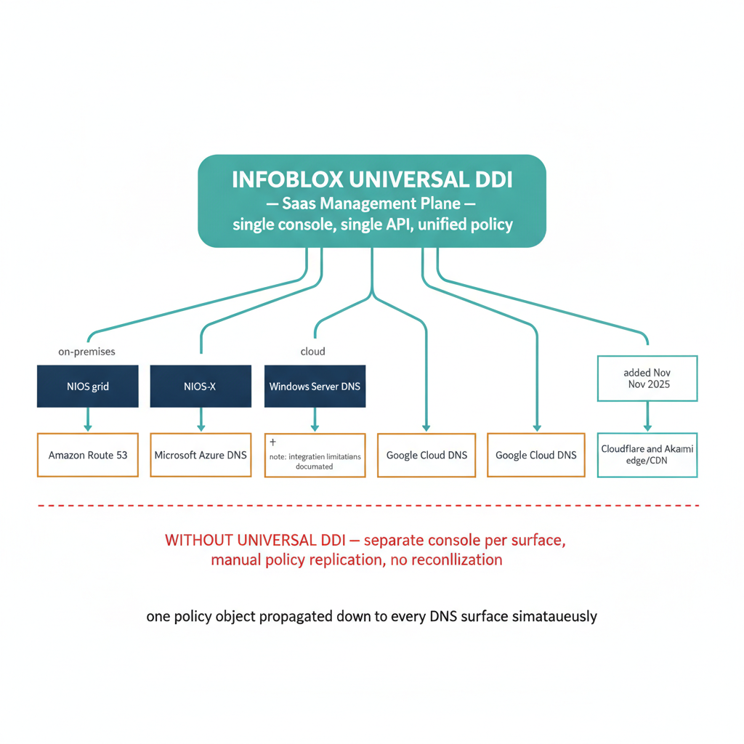
Figure 9: Infoblox Universal DDI capability map: the full feature set spanning NIOS on-premises, BloxOne SaaS endpoints, Universal DDI overlay management, and BloxOne Threat Defense — showing how each capability layer addresses a distinct governance problem
BloxOne Endpoint is the lightweight agent component of BloxOne DDI. Installed on endpoints — physical workstations, cloud instances, remote workers’ laptops — BloxOne Endpoint intercepts all DNS queries from the device, applies local policy (RPZ, threat feeds), and forwards to the BloxOne SaaS plane for analytics. This is significant in a zero trust context: it extends DNS policy enforcement to the endpoint, ensuring that a device that has bypassed the corporate resolver (because it is on a hotel Wi-Fi network, for example) still receives threat protection and still has its queries logged centrally. Endpoint-level DNS enforcement closes the largest gap in resolver-based DNS security: the user who is not on the corporate network.
Cloud Services Portal (CSP) is the web console for all BloxOne services. It provides a single pane of glass across Universal DDI (the renamed BloxOne DDI), BloxOne Threat Defense, and the per-CSP overlay integrations. Role-based access control in the CSP can be scoped to specific services, regions, or object types, enabling delegation models appropriate for large agencies where different teams own different parts of the address space.

7.5 Infoblox platform services: ecosystem, automation, and discovery
Beyond DDI core and BloxOne, the Infoblox platform integrates with the broader security and IT-operations ecosystem: REST/WAPI and CSP APIs (with official Terraform and Ansible support) make IPAM, DNS, and DHCP scriptable and composable with infrastructure-as-code workflows; Network Insight performs active and passive device discovery and rogue-DHCP detection; a catalog of pre-built Ecosystem Exchange integrations connects Infoblox to Splunk, ServiceNow, Palo Alto Networks NGFW, CrowdStrike Falcon, Cisco ISE, Microsoft Sentinel, and Qualys/Tenable — letting DNS’s early-warning signal reach SIEM, SOAR, and EDR workflows before a malicious connection is ever established; and Grid/BloxOne audit trail with change-control approval workflows maps directly to NIST SP 800-53 CM controls. This material — including the full partner-by-partner ecosystem-integration table — has been moved into its own reference document so it can be bookmarked independently of this paper’s argument.
For the full ecosystem-integration table, see DNS Record Types and Universal DDI Ecosystem Integrations — Reference Companion.

7.6 BloxOne Threat Defense: DNS as the security enforcement plane
BloxOne Threat Defense is Infoblox’s DNS security service. Its core function is using DNS as the earliest point of detection in the kill chain — intercepting malicious activity before network connections are established, before file downloads occur, before exploits are executed.
Threat Intelligence Data Exchange (TIDE). TIDE is Infoblox’s threat intelligence platform. It aggregates indicators of compromise (IoCs) from multiple sources — Infoblox’s own research team, commercial threat feeds, open-source threat intelligence, and customer-contributed data — and normalizes them into a searchable, API-accessible data set. TIDE feeds are automatically ingested into BloxOne Threat Defense RPZ rules and into Infoblox NIOS RPZ configurations. Federal agencies with their own threat intelligence feeds can contribute to TIDE and receive enriched, deduplicated intelligence back — turning DNS telemetry into a bidirectional threat intelligence loop.
DNS tunneling detection. DNS tunneling encodes data in DNS query and response labels, allowing an attacker to exfiltrate data through a corporate DNS resolver that allows external queries. Detection is based on multiple signals: unusually long query labels (a tunneling query might encode aGVsbG8gd29ybGQ=.exfil.attacker.com, where the first label is base64-encoded exfiltrated data), high query frequency to a single domain, high entropy in query labels, and the use of uncommon record types (TXT, NULL) that are not typical of normal application traffic. BloxOne Threat Defense classifies tunneling traffic with a confidence score and can automatically block, alert, or redirect traffic matching tunnel signatures.
Domain Generation Algorithm (DGA) detection. Malware families that use DGA generate thousands of algorithmically created domain names, querying each one hoping that the attacker has registered one of them as the current C2 endpoint. DGA domains have characteristic statistical properties — high entropy, consonant clusters, lengths inconsistent with human-readable names. BloxOne Threat Defense applies machine learning models trained on known DGA families to classify new queries and flag DGA activity before the C2 connection is established.
Lookalike domain detection. Attackers register domains that are visually similar to legitimate targets — rnyagency.gov (r+n reads as m), agency-gov.com, агеncy.gov (Cyrillic а). BloxOne Threat Defense maintains a lookalike detection model seeded with the agency’s authoritative domain list and flags queries to known-lookalike domains as phishing preparation indicators.
SOC Insights. SOC Insights is an AI-driven prioritization layer within BloxOne Threat Defense. It aggregates DNS threat events across the estate, correlates them with DHCP lease data (identifying the specific endpoint and user behind each suspicious query), and presents a ranked list of security events requiring investigation. The correlation between DNS signals and DHCP history is what allows “this IP queried a C2 domain” to become “this workstation, assigned to this user, queried a C2 domain at this time” — the attribution chain that SOC analysts need to triage and escalate.
The TIDE → RPZ → NIOS pipeline for federal environments. In a NIOS-on-premises federal deployment, the BloxOne Threat Defense detection pipeline connects to NIOS through RPZ: threat intelligence from TIDE is translated into RPZ policy objects and pushed to NIOS Grid members. This means that threat feeds from the SaaS-delivered BloxOne Threat Defense reach on-premises resolvers that may be in air-gapped or limited-internet environments, as long as TIDE can push RPZ updates to a Grid member that is reachable. Federal agencies with GCC Moderate or GCC High restrictions should verify the network path from Infoblox’s TIDE delivery endpoints to on-premises NIOS Grid members as part of their architecture assessment.

7.7 Network Discovery and IPAM governance
For federal agencies, IPAM is not optional infrastructure — it is a FISMA and FedRAMP compliance requirement. NIST SP 800-53 CM-8 (Information System Component Inventory) requires a comprehensive inventory of all IT components, updated continuously. For IP-connected devices, the IP address inventory maintained by IPAM is the most current and automated form of that component inventory available.
Active discovery. Infoblox Network Insight performs SNMP polling, ICMP probing, and port scanning to discover devices. It queries network infrastructure (routers, switches) for ARP tables and MAC address tables, correlating MAC-to-IP bindings with DHCP lease history to build a device population map that reflects current state rather than last-provisioned state.
Passive discovery. NIOS in the recursive resolver role observes every DNS query made by every client on the network. The source IP of each query is an asset assertion: that IP address has a device that is active and resolving DNS. Passive observation does not require any active scan or agent, making it the least intrusive discovery mechanism and the one most likely to find devices that block active scans (ICS sensors, legacy embedded systems, IoT devices).
Cloud IPAM and address space management. Each CSP’s address space is managed through a different tool (AWS IPAM, Azure IPAM, GCP IPAM). In a multi-cloud environment, these produce isolated islands of address knowledge. Universal DDI imports the address allocation data from each CSP via API, presenting the entire RFC 1918 address space — on-premises and cloud — as a unified hierarchy. This is necessary for: (1) detecting address overlap (two VPCs with the same 10.x.x.0/24 that are being peered or connected via transit gateway); (2) planning new subnet allocations without collisions; (3) compliance reporting (what is the full inventory of IP-connected assets in my hybrid estate?).
IPAM and the zero trust inventory requirement. Zero trust architectures require continuous, authoritative knowledge of every device on the network — its address, its identity, its compliance state. IPAM provides the address layer of that inventory. When integrated with the ecosystem (CMDB for asset attributes, MDM for device compliance, DHCP fingerprinting for device class), IPAM becomes the join table between “IP address” and “identity” — the lookup that turns a network observable (IP address seen in a log) into a managed, identifiable asset.

7.8 Why federal agencies need to get ahead of this now
Federal agencies face a convergence of forces that makes DNS governance urgent rather than optional:
The Zero Trust mandate. CISA’s Zero Trust Maturity Model and OMB M-22-09 require agencies to move toward identity-based access controls that reference service identities by FQDN, not by IP address. Zero trust network access (ZTNA) implementations use DNS as the service registry. An agency cannot implement a zero trust architecture on a fragmented DNS foundation — because the service identities that zero trust policy references are DNS names, and if those names are inconsistent across the estate, the policy is inconsistent too.
The AD deprecation timeline. Microsoft’s direction is unambiguous: Entra-only join is the future, AD is the legacy. Agencies that are in the middle of AD deprecation — or that will begin it in the next two to three years — must have a DNS governance program in place before the last DC is decommissioned. Starting after the DC is gone means recovering from DNS orphaning under operational pressure.
The hybrid multi-cloud expansion. Federal agencies are not consolidating to a single cloud — they are expanding across multiple CSPs, often driven by FedRAMP authorization timelines, mission system requirements, and data classification constraints. Each new CSP addition adds another independent DNS system. The management burden grows with each addition, and the number of split-brain conditions grows combinatorially with the number of independent DNS systems.
The PKI modernization timeline. Federal PKI is modernizing — migrating from RSA-2048 to ECDSA, from SHA-1 to SHA-256, from legacy CRL distribution to OCSP. Each of these migrations changes DNS records: new OCSP responder FQDNs, new CRL distribution point FQDNs, new intermediate CA FQDNs. In a unified DNS management plane, these changes propagate automatically. In the per-CSP model, each change requires manual updates across five DNS systems.
The Layer 7 transition. Agencies deploying zero trust network access, API gateways, and service mesh architectures are implicitly adopting FQDN-based service identity. Once that transition is underway, the consequence of DNS inconsistency is not “some workloads reach the wrong IP” — it is “zero trust policy is unenforced for callers whose DNS is inconsistent.”
The DHCP option-6 attack surface. A rogue DHCP server distributing a malicious DNS resolver in option-6 can redirect every client on a subnet through an attacker-controlled resolver, bypassing all RPZ and threat defense controls in one step. This attack vector is not hypothetical — it is a documented technique in red team playbooks and has been observed in federal network incidents. Unified DHCP governance, with rogue DHCP detection and option-6 consistency enforcement, closes this attack surface.
The management-plane authorization gap has just closed. On 2026-07-22, Infoblox Government Cloud achieved FedRAMP Moderate certification, delivering Universal DDI Management, NIOS-X Servers, and Universal Asset Insights through AWS GovCloud (US). Agencies that previously had to run the SaaS management plane described in §7.4 outside an authorized boundary — or defer adopting it until an authorization existed — no longer have that constraint as a reason to wait. The architecture this paper argues for is now authorizable, not just directionally correct.

Part 8 — Cisco Catalyst SD-WAN DNS Interception

8.1 The gap in vendor documentation
Neither Infoblox nor Cisco has published documentation explaining how Cisco Catalyst SD-WAN DNS interception interacts with the Infoblox DDI resolution chain. The Infoblox Universal DDI product page contains a single generic bullet — “Optimize SD-WAN” — with no technical detail. The Cisco INR blog covers URL categorization and traffic steering at a marketing level.

8.2 How Cisco Catalyst SD-WAN intercepts DNS
Cisco Catalyst SD-WAN (IOS XE SD-WAN ≥ 20.4/17.4) implements DNS interception through its redirect-dns data policy feature. When a branch device sends a DNS query, the SD-WAN edge router intercepts the query — regardless of its configured resolver — and redirects it to a policy-designated DNS server. The originating workstation receives a response indistinguishable from a native response.
The interception determines whether Infoblox DDI policy is applied:
Correct path:
Branch User → SD-WAN edge (intercept) → BloxOne Endpoint
→ BloxOne DDI (RPZ, DNSSEC, IPAM policy)
→ Per-CSP private resolver
Bypassed path:
Branch User → SD-WAN edge (intercept) → Cisco Umbrella
→ Public recursive resolution
[Infoblox DDI policy plane is bypassed entirely]
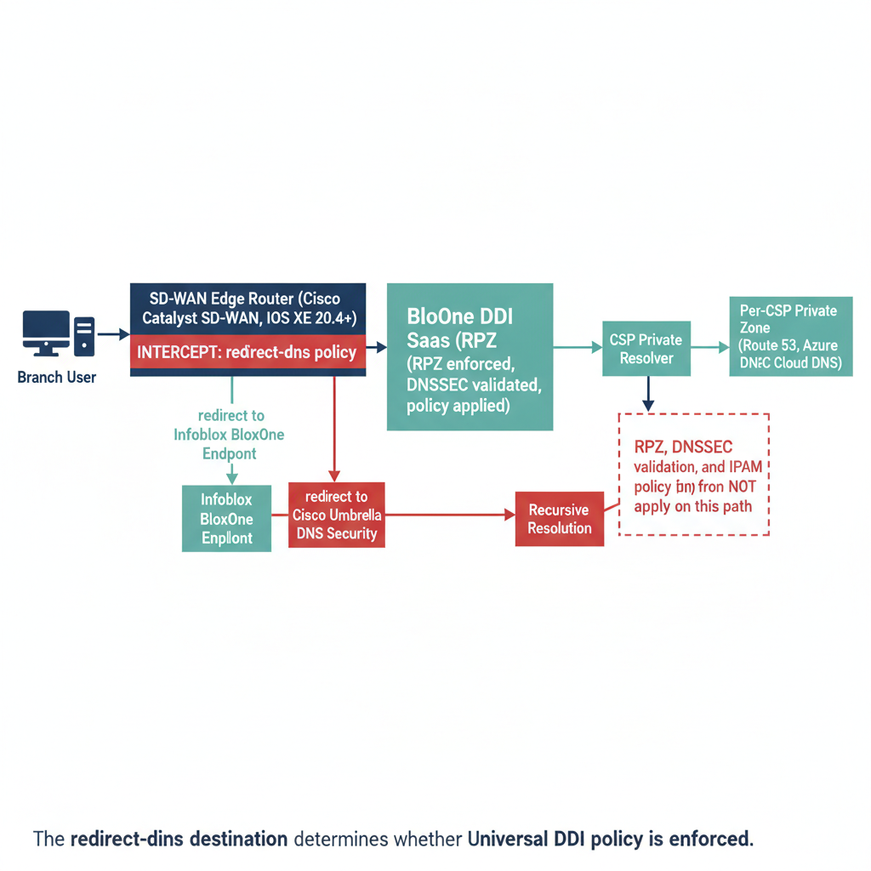
Figure 10: The Cisco Catalyst SD-WAN DNS interception chain: query origin, SD-WAN intercept point, and which path reaches Infoblox BloxOne DDI policy enforcement versus which path bypasses it entirely
If redirect-dns forwards to Cisco Umbrella, the Infoblox DDI policy plane is bypassed for every branch query. From the Infoblox console, those queries are invisible: no log entry, no RPZ evaluation, no DNSSEC validation.

8.3 DNSSEC validation and the forwarder position problem
DNSSEC validation requires the validating resolver to sit at the first recursive position in the chain. When redirect-dns sends queries to Umbrella and Umbrella performs recursive resolution, DNSSEC validation has occurred at Umbrella — not within the agency’s control plane. For compliance postures that require DNSSEC validation within the agency’s own infrastructure, a Umbrella-first configuration is non-compliant.
Correct configuration: redirect-dns must point to the local Infoblox BloxOne Endpoint. Umbrella, if used for DNS security, must be a downstream forwarder within the BloxOne DDI chain — not the primary redirect target.

8.4 INR telemetry and DNS interaction
Cisco Catalyst SD-WAN’s INR integration collects telemetry at the traffic-flow level, not the DNS query level. DNS interception and INR are independent mechanisms. However, if redirect-dns routes to Umbrella, and Umbrella returns a different M365 anycast IP than Infoblox would have returned (due to different ECS subnet tagging), the INR telemetry Microsoft receives reflects the Umbrella-selected endpoint. In a split deployment, Microsoft’s routing recommendations may be suboptimal for the portion of traffic resolved through Infoblox.

Part 9 — The Federal Sovereign Cloud Gap

9.1 INR is WW Commercial only
Microsoft 365 Informed Network Routing (INR) is restricted to WW Commercial cloud tenants. Microsoft Learn (updated 2026-03-10) states verbatim:
“Microsoft 365 informed network routing supports tenants in WW Commercial cloud but not the GCC Moderate, GCC High, DoD, Germany, or China clouds.”
Cisco Catalyst SD-WAN (IOS XE SD-WAN ≥ 20.4/17.4) is the only SD-WAN vendor in Microsoft’s INR “Currently enabled solutions” table. The INR integration is real and valuable — but it is architecturally irrelevant to any federal agency operating in a sovereign cloud environment.
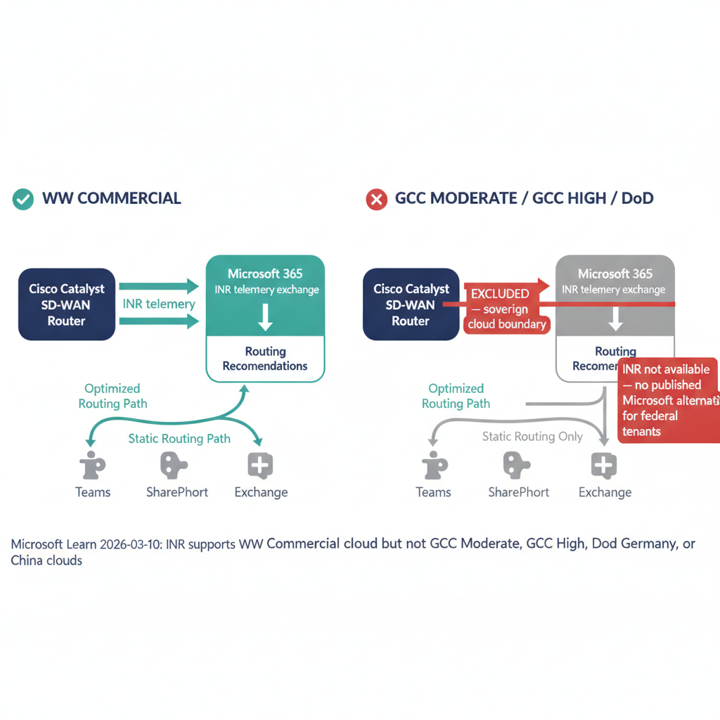
Figure 11: Federal sovereign cloud INR exclusion: Cisco Catalyst SD-WAN INR applies only to WW Commercial tenants — GCC Moderate, GCC High, and DoD are explicitly excluded, and no published alternative achieves equivalent M365 traffic optimization for federal customers

9.2 What federal agencies use instead
The absence of INR does not eliminate SD-WAN value for federal agencies. Available mechanisms:
Direct internet breakout with DSCP marking identifies M365-destined traffic by Microsoft’s published IP ranges and routes it via direct breakout, bypassing MPLS backhaul. This is the primary M365 optimization pattern recommended in Microsoft’s network connectivity principles and is fully available in sovereign cloud environments.
Application-aware routing measures real-time path quality (latency, jitter, packet loss) and selects the best SD-WAN tunnel. Without INR, the selection uses locally observed metrics rather than Microsoft-provided telemetry — operationally sound, with an incremental gap.
Infoblox DDI operates identically in federal sovereign cloud environments. DNS resolution, RPZ enforcement, DNSSEC validation, and IPAM management are unaffected by INR availability. The redirect-dns configuration guidance in Part 8 applies unchanged.
The federal implementation reference for this combination — FedRAMP boundary partitioning of the SD-WAN planes, the FedRAMP 20x KSI evidence contracts, the greenfield deployment sequence, and the machine-enforced contract fixture that encodes the INR unavailability itself (FINDING-001, tests/fixtures/contract/m365/informed-network-routing-unavailable-gcc-moderate.yaml) — is maintained in Vol I Book 05, Appendix A of the Federal Organization Compliance series. This paper owns the resolution-chain analysis (Parts 8–9); the appendix owns the federal build-out.

Part 10 — Reference Architecture

10.1 The end-to-end resolution flow
This reference architecture synthesizes the components addressed in Parts 1–9 into a complete DNS governance model for a hybrid multi-cloud federal environment. It encompasses on-premises AD DNS transition, multi-cloud private DNS forwarding, Cisco Catalyst SD-WAN branch interception, and the federal sovereign cloud boundary.
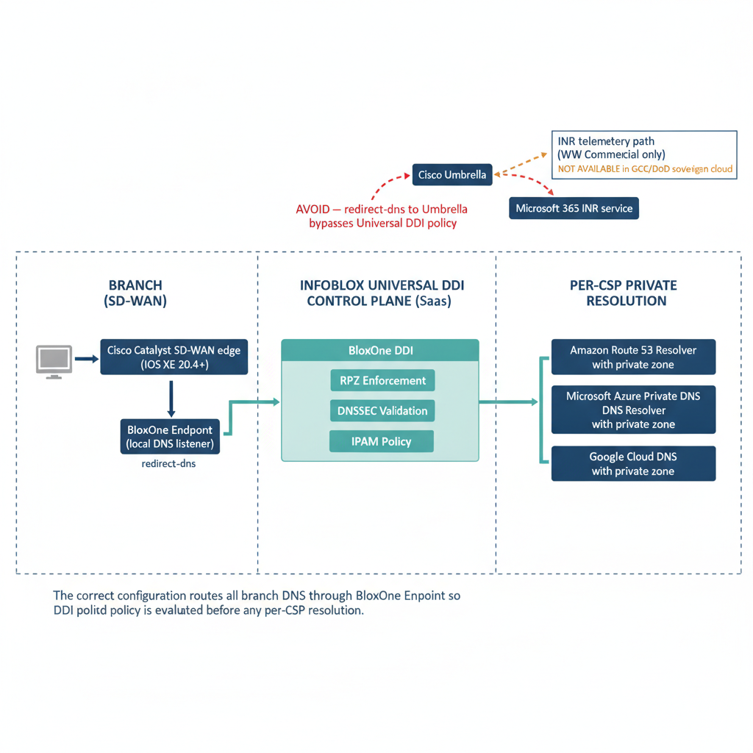
Figure 12: End-to-end reference architecture: Cisco Catalyst SD-WAN branch to Infoblox Universal DDI to per-CSP private zones — the complete DNS resolution flow that neither Infoblox nor Cisco has published

10.2 The five critical configuration decisions
Decision 1 — redirect-dns destination. Cisco Catalyst SD-WAN redirect-dns must designate the local Infoblox BloxOne Endpoint as the redirect target. Any other target bypasses Universal DDI for branch queries.
Decision 2 — forwarding chain order. Umbrella, if used, must be downstream of BloxOne DDI in the forwarding chain — not an upstream redirect target. Correct sequence: BloxOne Endpoint → BloxOne DDI (policy) → Umbrella (optional) → recursive.
Decision 3 — per-CSP conditional forwarding. Universal DDI must hold authoritative forwarding rules for all private namespaces across all CSPs and VMware segments. Rules maintained only in NIOS and not in Universal DDI leave BloxOne Endpoint branches without private resolution capability.
Decision 4 — AD DNS record inventory before deprecation. Before any DC is decommissioned, all SRV records, conditional forwarding rules, and namespace authorizations maintained by AD DNS must be inventoried and reprovisioned in NIOS or Universal DDI. This step is irreversible to skip — the records cannot be recovered from a decommissioned DC.
Decision 5 — OCSP and CRL reachability from all origins. PKI validation endpoints must be resolvable from every network origin — on-premises, every CSP, every branch. OCSP FQDNs that are private-only in AD DNS must be published in Universal DDI with forwarding rules that make them reachable from cloud-originating queries.

10.3 Deployment comparison: Commercial versus federal
Component | WW Commercial | GCC Moderate / GCC High / DoD
Infoblox Universal DDI | ✅ Full | ✅ Full
BloxOne Endpoint at SD-WAN branch | ✅ | ✅
Cisco Catalyst SD-WAN redirect-dns | ✅ | ✅
RPZ / DNSSEC via Universal DDI | ✅ | ✅
AD DNS record migration to NIOS | ✅ Required | ✅ Required
OCSP/CRL reachability from cloud | ✅ | ✅
Wildcard DNS application surface governance | ✅ | ✅
Layer 7 FQDN-based policy support | ✅ | ✅
Cisco SD-WAN INR telemetry loop | ✅ Available | ❌ Excluded
M365 optimization via DSCP / direct breakout | ✅ | ✅ (primary mechanism)

Appendix A — Source Inventory
Source | Quality | Key claim supported
Infoblox Multi-Cloud Solutions | Primary vendor | Siloed DNS / split-brain problem statement
Infoblox Universal DDI Product Page | Primary vendor | Management plane surface coverage
Infoblox Federal Solutions Page | Primary vendor | Federal marketing and government hybrid-cloud claim
Infoblox Innovations Blog, Nov 2025 – Jan 2026 | Vendor blog | Cloudflare / Akamai integration additions
Infoblox Security Blog — Unified Interception Point | Vendor blog | Single management plane
Network World — Infoblox Universal DDI Nov 2025 | Trade press | Independent confirmation of edge integrations
Infoblox Government Cloud Achieves FedRAMP Moderate Certification (2026-07-22) | Primary vendor | Universal DDI Management + NIOS-X + Universal Asset Insights authorized in AWS GovCloud (US)
Microsoft Learn — INR CPE Documentation | Primary (Microsoft) | Cisco-only INR table; GCC/DoD exclusion (2026-03-10)
Cisco Blog — INR First Vendor | Vendor blog | INR integration context
Cisco Blog — INR Teams/SharePoint | Vendor blog | 20.4.x starting version
RFC 1034 / RFC 1035 | IETF | DNS specification and wildcard behavior
RFC 5625 | IETF | DNS forwarder behavior in policy chain
NIST SP 800-207 | NIST | Zero Trust Architecture — FQDN as service identity
Cisco — Redirect DNS in Cisco Catalyst SD-WAN Service-Side VPNs | Primary vendor | §8.2 redirect-dns mechanics: data policy match/action syntax, NAT dependency, restrictions (IPv4-only, UDP-only, no overlay-tunnel source) — confirms the interception model in the text
Infoblox — Limitations of Azure DNS Integration | Primary vendor | §7.4 “noted limitations” footnote: no Azure DNS tag support, no non-simple routing policy records, NS/SOA/MNAME sync constraints — answers Appendix B Q2
Infoblox — Managing Endpoint | Primary vendor | Current-gen Infoblox Endpoint architecture: DoT on TCP/443 to a loopback stub resolver (127.0.0.1, or 127.0.0.2 on macOS) — informs but does not fully resolve Appendix B Q1
Infoblox DDI-for-SD-WAN PDF (docs.infoblox.com/space/BloxOneCloud/2096169083) | Primary vendor | Citation error, corrected 2026-07-27: this URL is reachable but is Cisco Catalyst SD-WAN Credentials, a Universal Asset Insights (device-discovery) credential-setup page — unrelated to DNS/DDI resolution behavior. It does not support any claim in this paper and should not have been cited as a DDI-for-SD-WAN source.

Appendix B — Open Questions for Vendor Engagement
- Infoblox: Does BloxOne Endpoint support transparent DNS proxy mode compatible with Cisco Catalyst SD-WAN redirect-dns? Or must the workstation explicitly configure BloxOne Endpoint as its resolver? — Partially informed 2026-07-27: Managing Endpoint describes Infoblox Endpoint as a loopback stub resolver (device queries 127.0.0.1/127.0.0.2 on port 53, agent forwards over DoT/443) rather than a network-addressable proxy. That architecture is not obviously the target of a network-level redirect-dns redirect, which points at an IP address — still needs vendor confirmation.
- Infoblox: What are the specific Azure DNS integration limitations in docs.infoblox.com? Do they affect private endpoint FQDN resolution or conditional forwarding for Azure-managed namespaces? — Answered 2026-07-27 for the limitation list: see Limitations of Azure DNS Integration (no Azure DNS tags, no non-simple routing policy records, NS/SOA/MNAME sync constraints). The page does not address private-endpoint FQDN resolution or conditional forwarding specifically — that half of the question is still open.
- Infoblox: Does Universal DDI IPAM track wildcard DNS records and subdomain namespace occupancy, or only host-level A/AAAA records?
- Cisco: When redirect-dns redirects a query to a BloxOne Endpoint, does the source IP presented to BloxOne Endpoint reflect the originating workstation (for ECS subnet selection) or the SD-WAN edge router?
- Microsoft: Is there a roadmap for INR in GCC Moderate or GCC High? Is there an alternative telemetry mechanism for sovereign cloud customers?
- Microsoft: What is the recommended DNS governance approach for agencies mid-way through AD deprecation with an Infoblox DDI deployment? Is there a published migration guide for AD DNS → NIOS → Universal DDI?

Document status
This whitepaper is DRAFT v0.5 (2026-08-03 — the Part 3 DNS record catalog and the Part 7.5 ecosystem-integration table were split out into a standalone reference companion, DNS Record Types and Universal DDI Ecosystem Integrations, and a “For decision makers” executive digest was added near the top of this page so Part 10.2’s five configuration decisions are reachable without reading the taxonomy first; no external claims were re-verified in that revision). External claims were last re-verified 2026-07-27 — the INR sovereign-cloud restriction is unchanged on Microsoft Learn, the April 2026 Infoblox release is reflected in §7.4, and the 2026-07-22 Infoblox Government Cloud FedRAMP Moderate certification is now reflected in §7.8. The two Appendix A sources originally marked unreachable were re-checked on 2026-07-27: both return only a bare page title to a plain HTTP fetch (Infoblox’s docs portal and Cisco’s guide are both JS-rendered and require a real browser), but both render full content in a browser. The Cisco redirect-dns guide is now cited directly and grounds §8.2. The Infoblox URL turned out to be a Universal Asset Insights credential-setup page unrelated to DNS/DDI behavior — that citation was a research-time error and has been replaced in Appendix A with two on-topic Infoblox sources (Azure DNS integration limitations, current Endpoint architecture) found while re-verifying. Appendix B Q2 is now substantially answered; Q1 and Q4 are better informed but still open, and Q3/Q5/Q6 remain fully open. Vendor technical review is still recommended, but the “unreachable source” gate itself is closed. Parts 4 (AD DNS departure), 5 (Kerberos → token / certificate DNS surface), and 6 (Layer 7 wildcard DNS) are synthesized from first principles, RFC behavior, and Microsoft product documentation — not from Infoblox or Cisco publications, which do not address these topics. The SD-WAN interception chain analysis in Part 8 is similarly synthesized. Before customer distribution, resolve the remaining open Appendix B questions and obtain sources in Appendix A and obtain Infoblox and Cisco technical review.

Call to Action
Part 10.2’s five configuration decisions are where most of this paper’s risk concentrates — get the redirect-dns destination and forwarding order wrong, and the rest of the reference architecture doesn’t matter.
Five steps before the next SD-WAN or Universal DDI change
- Audit the current redirect-dns destination at every branch. Decision 1 (§10.2) is the single most common configuration error — any target other than the local BloxOne Endpoint bypasses Universal DDI policy entirely, silently.
- Verify the forwarding chain order, not just its presence. Umbrella, if used, must sit downstream of BloxOne DDI (Decision 2). Confirm this in the running config, not the design document.
- Inventory AD DNS records before touching a domain controller. Decision 4 is irreversible to skip — SRV records and conditional-forwarding rules cannot be recovered from a decommissioned DC. This inventory has to happen before decommissioning, not during.
- Check the sovereign-cloud boundary before promising INR telemetry. If any part of the estate is GCC/DoD, Cisco’s INR loop (Part 9) is unavailable regardless of SD-WAN version — confirm this with the program office before it’s designed into a briefing.
- Take Appendix B’s open questions to the vendors, not around them. Three of six are still open as of this draft. Engaging Infoblox and Cisco directly on transparent-proxy mode, per-CSP forwarding coverage, and the INR sovereign-cloud roadmap is faster than working around unconfirmed behavior.

This paper is still Draft — that describes what’s verified, not a reason to wait. The five decisions above are actionable today regardless of which Appendix B questions remain open.

