Modernization Journey
  - From Mainframe to FedRAMP 20x — what forty years of federal architecture cost, and which mandates actually bind the agency
Michael Stratton
2026-09-09
Table of contents

Modernization Journey
 Problem, solution, ask
Problem. Forty years of federal architecture — the mainframe, decentralization, the security era, the breaking point — conflated the system of record with the in-path enforcer, first in the mainframe and then in Active Directory. Today’s estates run session-based identity over hairpinned WANs across four environments, and the cost shows up as duplicate payments and unreconcilable records, not slow screens. The commercial sector made this transition in 2015–2020; the agency’s own clocks — M-22-09, BOD 25-01, CA-7 under A-130 — have already run.
Solution. Rebuild the foundation around one structural move — separate truth from enforcement, as NIST SP 800-207 and OMB M-22-09 require — and the five principles that follow: a single source of truth, application-aware networking, token-based identity, active governance, and fewer synchronous round-trips; with a PassTicket/Identity Propagation token bridge for the mainframe.
Ask. Six steps this quarter: inventory the actual architecture, run a physics-based latency audit before the next migration decision, assign an owner to each principle, put the agency’s own deadlines on the calendar, pilot the mainframe token bridge on one low-risk transaction class, and hand this paper unchanged to the CIO/CISO, network, identity, and mainframe teams. The full list is in the Call to Action.

Executive Summary
 One narrative, one paper
Version 2.1 (2026-09-09) consolidates two earlier editions of this same forty-year arc into a single paper and applies a review pass. Federal requirements are cited to NIST, OMB, CISA and FedRAMP. Named products appear as concrete illustrations of a role — an identity provider, a DDI platform, an SD-WAN fabric — and any equivalent in the same role substitutes cleanly; the architecture does not depend on the specific names. The canon-anchored edition contributed the closing provenance appendix, which maps Act 4’s claims to the UIAO ADRs behind them — it sits after the Call to Action and is separable, so the paper can still be handed on without a platform commitment attached.

Provenance
The “your agency” narrative running through this paper — twelve regional offices, the named employee Jane Smith, the named systems and environments — is a composite illustration, a narrative synthesis of a common federal agency modernization arc. It is not a documented case study of any specific agency.

Federal agency IT architecture has evolved through four historical eras — stark mainframe centralization, distributed decentralization, security-driven complexity, and cloud-forced fragmentation — without ever replacing the single source of truth the mainframe originally provided. The result: regional identity domains that never reconciled, duplicate payments, records that cannot be traced to an authoritative source, and a session-based authentication model (Kerberos/Active Directory) that breaks under the physics of distance and the security architecture layered on top of it.
This is not a technology gap. It is an architecture gap, and it is well understood: commercial industries — banking, healthcare, manufacturing — hit and solved this same problem between roughly 2014 and 2022. The physics is fixed: bandwidth does not reduce latency, and no amount of infrastructure spend changes the propagation floor of light through fiber. What changes the outcome is architecture — separating the system of record from the in-path enforcer, making the network application-aware rather than packet-aware, replacing session-based identity with token-based identity, governing infrastructure actively rather than assessing it periodically, and reducing the number of synchronous round-trips an application makes to its data, including at the mainframe boundary itself.
The agency-side deadlines are already behind us. OMB M-22-09 set government-wide zero-trust targets whose milestones came due in FY24; CISA BOD 25-01 binds agencies directly for Microsoft 365 secure configuration; and NIST SP 800-53 CA-7 with OMB Circular A-130 has required continuous monitoring of the agency’s own authorized systems all along. What FedRAMP 20x adds is direction of travel rather than a new agency deadline: it obligates cloud service providers, and it establishes that machine-readable, continuously-verified evidence is what federal authorization now means. Agency ATOs are where that standard lands next, and an architecture that cannot emit evidence continuously will meet it badly. The path forward is five principles, each traced to a specific NIST, OMB, CISA, or FedRAMP requirement. Concrete next steps are laid out in the Call to Action at the end of this document.
For decision makers: read this page first
This document tells the story of how a federal agency’s IT architecture evolved across forty years — and why the architecture that served it well through 2010 is now working against its mission. The first three acts are history. The fourth act is the path forward. Federal requirements are cited to NIST, OMB, CISA, or FedRAMP, and where a requirement binds someone other than the agency this paper says so. Named products appear as concrete illustrations of a role — an identity provider, a DDI platform, an SD-WAN fabric — and any equivalent in that role substitutes cleanly.
The core problem is not a technology shortage. Federal agencies have invested heavily in security tools, network capacity, and cloud migration. The problem is that the foundational services beneath those investments — the network, the directory, the address management, the access control model — were designed for a world that no longer exists.
Five things every decision maker needs to understand:
- High bandwidth does not mean low latency. Large private circuits connecting field offices to regional data centers provide guaranteed bandwidth. They do not change the physics of distance.
- The federal government is five to ten years behind the commercial sector on this transition. Major banks, healthcare networks, and manufacturers hit these same breaking points between 2015 and 2020 and modernized. The path is known. The delay has a cost measured in program integrity, not just performance.
- DNS, DHCP, and IP address management were not designed to be security controls — but they now are. Zero Trust policy is written against named services rather than addresses, so name resolution becomes a policy surface; where enforcement is still expressed as IP or CIDR ranges, the address-management system is what makes those ranges meaningful and current. Either way the device and address inventory federal compliance requires is produced by DDI, not surveyed alongside it.
- VPN is not Zero Trust. A VPN tunnel extends trust to everyone inside it. A compromised endpoint inside the tunnel has the same access as a trusted administrator. You cannot fully implement Zero Trust while VPN is the primary access mechanism.
- The cost of not modernizing is not abstract. Duplicate payments, records that cannot be reconciled, benefits issued against data that cannot be traced to an authoritative source — these are the downstream consequences of accumulated architectural debt.

 The one sentence the whole story turns on
Every era conflates the system of record with the in-path enforcer — the mainframe first, then Active Directory. NIST SP 800-207 and OMB M-22-09 require agencies to separate these roles: a governance layer holds and reconciles authoritative state; identity providers, network enforcement points, and data platforms remain the runtime data planes beneath it.

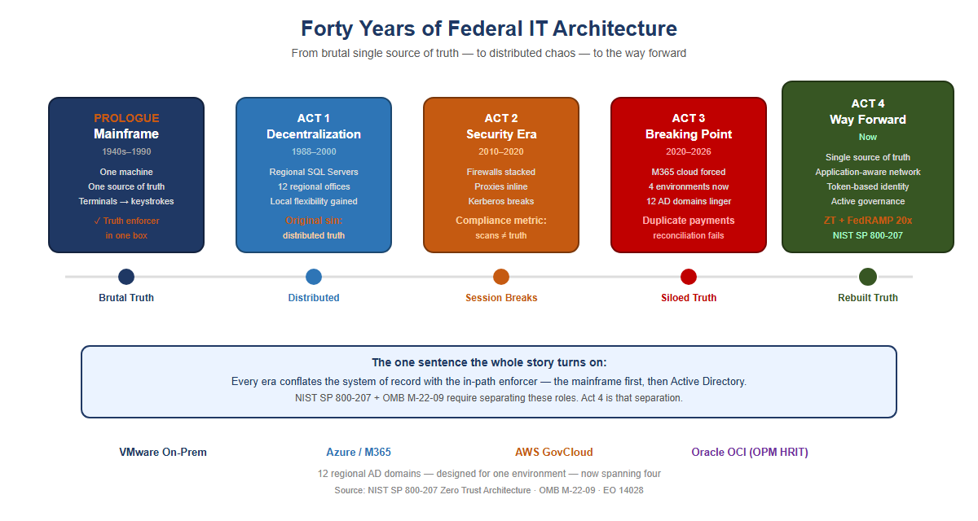
Figure 1: Forty years of federal IT architecture in one view — from the mainframe’s stark single source of truth, through decentralization, the security era, and the breaking point, to the way forward

Prologue — The Mainframe Era (1940s–1990s)
Your agency’s entire operation ran on mainframes. IBM systems, mostly. One massive computer in a locked room. Everything happened there: all the data, all the logic, all the state.
Users didn’t have computers. They had terminals — green screens, keyboards. A terminal was a dumb device that sent keystrokes to the mainframe and received screen refreshes back. Text-based, synchronous, simple.
The model was starkly elegant: one source of truth. The mainframe was the truth. When you asked “how many people received benefits this month,” there was one answer, and it came from one place. No ambiguity. No regional variations. No hidden discrepancies.
Security was implicit. If you weren’t sitting at a terminal physically connected to that mainframe room, you couldn’t access anything. The network was the security perimeter. Control physical access, and you controlled everything.
And crucially: the machine that held the truth was the same machine that enforced access to it. Truth and enforcement lived in one box. Remember that; it is the seed of everything that follows.
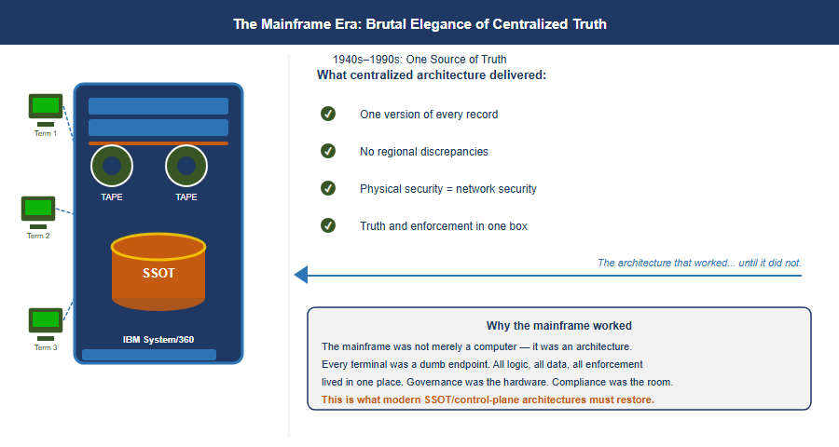
Figure 2: The Mainframe Era: stark elegance of centralized truth — an IBM System/360 with three terminals wired to a single SSOT database cylinder, plus the four benefits centralized architecture delivered

Act 1 — The Great Decentralization (Late 1980s–2000)
By the late 1980s, the entire world was rejecting the mainframe model — not because mainframes stopped working, but because the economics broke and the technology changed.
Minicomputers had already proven you didn’t need one godlike machine. Then PCs arrived. Networks got faster. The vision became irresistible: put a SQL Server in every region. Put applications in every office. Spread programming expertise to the edges. Let local teams build solutions for their local problems — because they understood those problems better than Washington ever could.
For your agency, this was revolutionary. Twelve regional offices could each have their own database administrators, their own application developers, their own tools tailored to how their states and territories worked.
But here is where the architecture broke.
With the mainframe, there was one source of truth. One database. One version of the record. The moment you put SQL Servers in twelve regions, you lost that. Now California had its own database. Massachusetts had its own. New York had its own. And they didn’t always talk to each other — or they did, but inconsistently. Regional systems evolved their own schemas, their own business logic, their own definitions of what a “benefit” even meant.
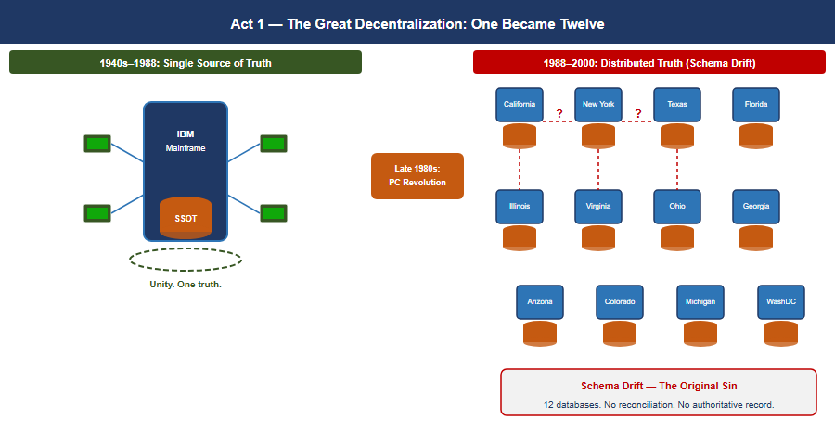
Figure 3: Act 1 — The Great Decentralization: one mainframe became twelve regional databases, with schema drift appearing between adjacent silos and the original sin of distributed truth called out below
The vision of distributed intelligence was real and good. But it came at a cost: distributed truth. And nobody replaced the single source of truth that the mainframe had given you.
That became the original sin — the moment the architecture started to drift.
It is worth being precise about what was lost, because the usual telling gets it backwards. Active Directory was never the system of record for identity. HR was. AD became the de facto authority only because nothing upstream was authoritative enough to reconcile against: with twelve regional databases and no arbiter among them, the directory that every system happened to query became the truth by default. That is the thread Principle 1 picks up — not “replace AD with something better”, but give the estate an upstream authority it never had, so the directory can go back to being an enforcement surface instead of an accidental system of record. The regional variations that seemed like flexibility in 1993 would calcify into incompatible silos by 2020.

Act 2 — When Security Ate the Architecture (2000s–2020)
Around 2010, your agency started consolidating compute. Simultaneously — and this is the critical inflection — cybersecurity became a board-level imperative. Not just “have a firewall.” Defense-in-depth. Layered security. Multiple inspection points.
But here is the problem: the tools chosen to enforce security were fundamentally incompatible with the session-based client-server model your entire infrastructure depended on.
Load balancers became inline proxies. Intrusion detection systems were inserted into the traffic path. Multiple NAT sessions. Firewalls stacked on firewalls. Every packet from a field office to a regional data center had to traverse security devices designed to break sessions — to inspect, decrypt, re-encrypt, verify, block.
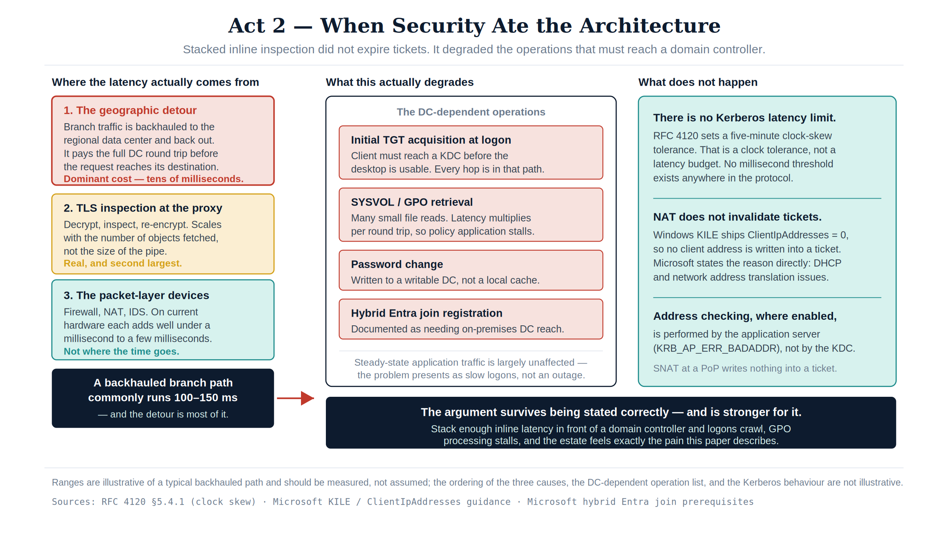
Figure 4: Act 2 — When Security Ate the Architecture: the geographic detour, not the inline devices, is where the latency comes from, and the added round-trip cost lands on the four operations that must reach a domain controller
Active Directory Kerberos tickets have a lifespan — a default TGT lives ten hours with seven-day renewal, and service tickets 600 minutes. They are not bound to a network path. Windows KILE ships ClientIpAddresses = 0, so client addresses are not written into the ticket at all, and Microsoft’s stated reason is verbatim “because of Dynamic Host Configuration Protocol and network address translation issues” — tolerating a changed source address is a design property of the deployed protocol. Where RFC 4120’s optional caddr field is populated, it carries addresses the client supplies in the AS-REQ rather than the source IP the KDC observes, and the check is performed by the application server (KRB_AP_ERR_BADADDR), not by the KDC on a TGS-REQ. SNAT at a PoP writes nothing into a ticket, and Kerberos FAST (RFC 6113) is pre-authentication armouring, unrelated to source-IP binding.
What distance actually costs is narrower, and the argument is stronger for being stated correctly: the DC-dependent operations. Initial TGT acquisition at logon, SYSVOL/GPO retrieval, password changes, and hybrid Entra join registration all require reaching a domain controller, and Microsoft documents the last of these as needing line-of-sight to an on-premises DC. Stack enough inline latency in front of those and logons crawl, GPO processing stalls, and the estate feels exactly the pain this paper describes — without any ticket being invalidated by NAT.
The physics that cannot be negotiated: Portland to Washington is approximately 3,800 km great-circle. Real fiber routes are not straight; a routing factor of 20–40% puts the actual glass path at roughly 4,500–5,300 km. At 200,000 km/second — the speed of light through glass fiber — that sets an unavoidable propagation floor of 23–26 ms one-way, 45–53 ms round-trip, before any queue delay, security inspection, or application processing. Active Directory has no millisecond latency requirement — the widely-quoted five-minute Kerberos figure is clock-skew tolerance, not a latency budget — but the DC-dependent operations are the ones that feel this distance: initial TGT acquisition at logon, SYSVOL/GPO retrieval, password changes, and hybrid Entra join registration, each of which Microsoft documents as requiring line-of-sight to an on-premises domain controller. No amount of bandwidth changes this. Bandwidth is volume. Latency is distance. You cannot buy your way out of geography.

Asymmetric routing: the second session killer
Latency kills sessions by exceeding protocol timeouts. A second mechanism, equally destructive and entirely independent of latency, operated simultaneously: asymmetric routing. It occurs when the outbound path of a session and the return path traverse different physical or logical routes through stateful network devices. A stateful firewall maintains a session table keyed on the five-tuple. When a SYN packet arrives, the device creates an entry expecting the SYN-ACK to return through it. When the SYN-ACK returns via a different path, that second device sees a SYN-ACK with no corresponding session entry — it drops it as unsolicited. The TCP three-way handshake never completes.
Asymmetric routing vs. latency: independent killers that compound. Latency kills sessions by exceeding protocol timeouts. Asymmetric routing kills sessions by preventing TCP from completing its three-way handshake at all — even with perfect, sub-millisecond latency on both paths. In environments where both conditions exist simultaneously — the federal standard — they compound.
How SD-WAN overlay eliminates asymmetric routing: The SD-WAN overlay tunnel is established between two edge devices as a single logical connection. Inside the tunnel, individual packets may physically traverse any available path. But at the application layer, both directions of every session enter and exit the same SD-WAN edge device. The stateful inspection happens at the tunnel endpoint, which sees both directions. Asymmetric physical routing below the tunnel is structurally removed.

Act 3 — The Breaking Point (2020–2026)
Then M365 happened. Microsoft forced the issue. Your agency migrated to Microsoft 365 — Exchange Online, Teams, SharePoint. Suddenly your email and collaboration lived in Azure, managed by Microsoft, unreachable by your session-based authentication model.
And here is the critical moment: the agency still had twelve regional Active Directory domains. Still had the OU tree structure designed for when compute lived regionally. Still had MPLS circuits connecting field offices to regional data centers that were increasingly just logical boundaries, not physical anchors.
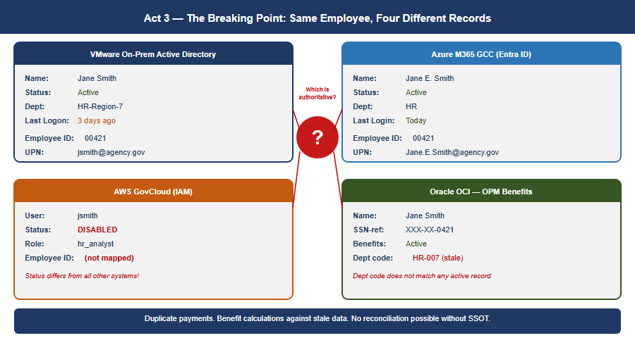
Figure 5: Act 3 — The Breaking Point: the same employee, Jane Smith, shows four contradictory records across VMware on-prem AD, Azure M365 GCC, AWS GovCloud IAM, and Oracle OCI HR-Benefits platform, converging on a red question mark asking which is authoritative
Now a field office in Portland authenticates to a regional DC physically in Washington. An application running on VMware queries a service in AWS. Email lives in Azure. The session-based contract — the assumption that client and server are talking synchronously over a trusted link — is fracturing across three environments and an upcoming fourth.
The hard realization. The bulk of mission compute still runs on VMware on-premises. Red Hat workloads are moving to AWS GovCloud. Email and collaboration are in Azure. A government-wide HR platform on Oracle OCI is the next boundary arriving. Identity is still in twelve regional AD domains designed for a world where all four of those environments were the same room. The infrastructure could do things but could not verify them across that boundary. With program integrity now a national imperative, that is no longer acceptable.
Meanwhile, the regional variations that started in Act 1 had calcified into institutional silos. California’s benefit calculation differed from Massachusetts’s. Regional databases had evolved incompatible schemas. And because single source of truth had never been restored, nobody could see the discrepancies. The fragmentation that made the system agile in 1995 had become the hiding place for systemic error — duplicate payments across states, records that should have been closed years ago, reconciliations nobody could complete.

The Physics Argument Decision Makers Have Not Heard
When a decision maker hears “the MPLS hairpin is causing latency problems,” the response is almost always: “add a Direct Internet Access circuit at the branch.” DIA eliminates the geographic hairpin. That improvement is real.
And then leadership will conclude that the network problem is solved. It is not. DIA is a pipe. It is a better-positioned pipe than the MPLS circuit it supplements, but it is still a single, unintelligent pipe with no visibility into what is happening on it, no ability to respond when it degrades, and no way to know whether it is actually the best available path to your destination.
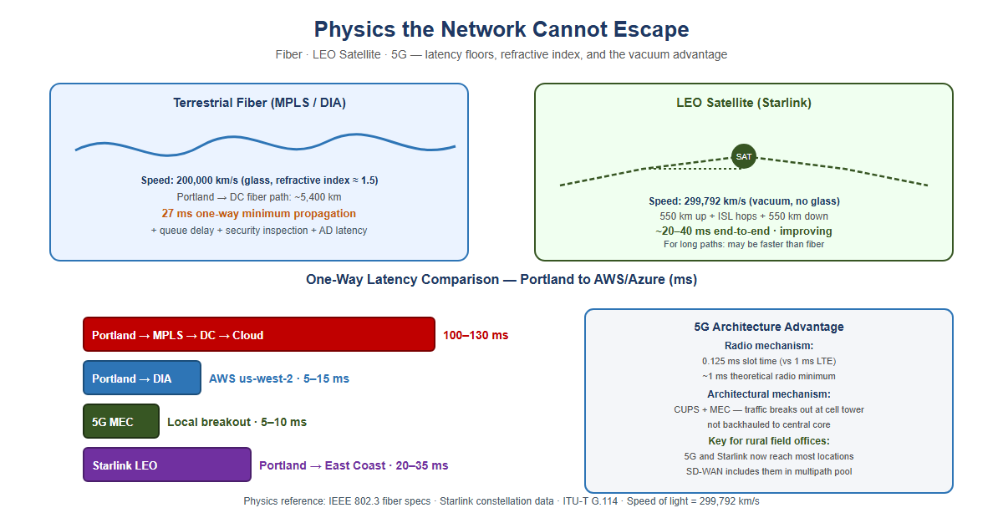
Figure 6: Physics the network cannot escape: terrestrial fiber at 200,000 km/s and 27ms one-way propagation versus LEO satellite at the vacuum speed of light, with a one-way latency comparison bar chart across MPLS, DIA, 5G MEC, and Starlink paths, and the 5G architectural advantage explained on the right

Why satellite latency is no longer what you remember
The satellite internet that federal IT professionals evaluated and rejected for decades was geostationary (GEO) — satellites parked at 35,786 km altitude. The physics are unforgiving: approximately 238 ms of one-way propagation delay. No enterprise application tolerates this gracefully. That ruling does not apply to LEO.
Starlink and similar Low Earth Orbit constellations operate at approximately 550 km altitude. Current practical end-to-end latency: 20–40 ms and improving. That places LEO satellite in the same competitive range as broadband DIA circuits.
The vacuum advantage: Light travels through optical fiber at approximately 200,000 km/second — two-thirds the speed of light in vacuum, due to the refractive index of glass. Light travels through the vacuum of space at 299,792 km/second. Vacuum is 50% faster, which means that over the same physical path length the signal arrives in two-thirds the time — about 33% sooner. (Speed and time are inverses; it is an easy sentence to get backwards.) This is not a technology gap that better fiber will close. It is physics.
For the longest domestic paths — Pacific Northwest to mid-Atlantic — the terrestrial fiber route may traverse 4,500 km or more of physical cable. The LEO vacuum path traverses 550 km up, geometrically direct inter-satellite laser link hops through space, and 550 km down at propagation speed 50% higher than fiber. Under the right conditions the satellite path is not a compromise — it is the physics-optimal path.

5G: lower latency through architecture, not just physics
5G reduces latency through two distinct mechanisms.
The radio mechanism: 5G’s scalable numerology shortens the slot as subcarrier spacing rises — 0.5 ms at the 30 kHz spacing typical of mid-band sub-6 GHz deployments, and 0.125 ms only at the 120 kHz spacing used in mmWave — against a fixed 1 ms slot in LTE. Practical mid-band sub-6 GHz 5G achieves 5–10 ms across the air interface.
The architectural mechanism: 5G’s Control and User Plane Separation (CUPS) and Multi-access Edge Computing (MEC) allow traffic to break out of the carrier’s network locally — at the cell tower or a nearby edge node — rather than backhauling to a central core. This is particularly significant for federal field offices in locations where broadband ISP options are limited.

What Application-Aware Networking Actually Means
The phrase “application-aware networking” appears in policy documents and vendor briefings without ever being explained in plain terms. Here is the plain version.
Your current network sees a packet. Specifically, it sees: source IP address, destination IP address, source port, destination port, protocol. It has no idea who sent the packet, what application it belongs to, whether the user is who they claim to be, whether the device is managed and compliant, or whether the data being accessed is the data policy says they should access. It sees a packet. It checks a rule. It allows or denies.
Application-aware networking sees a transaction. Specifically, it sees: a specific employee, on a managed government laptop that passed compliance check this morning, running Microsoft Teams, requesting a SharePoint document classified as internal, from an office location that is consistent with their normal work pattern, at a time of day that is expected, to access a file that their role and organizational attributes authorize them to access. The network enforces policy against the full context of the transaction — not against a packet.
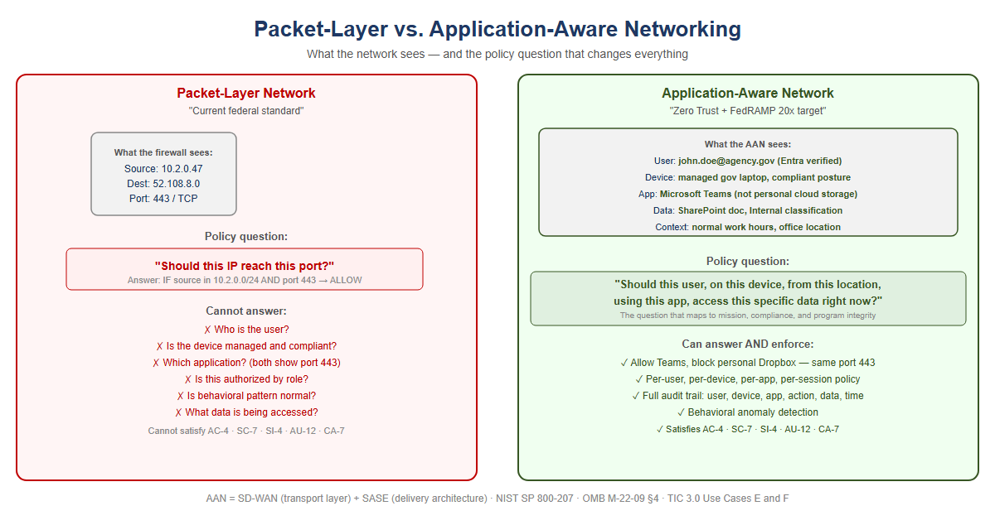
Figure 7: Packet-layer network versus application-aware network: the packet-layer side can only answer ‘should this IP reach this port?’ and lists six questions it cannot answer, while the application-aware side answers the full transaction-context policy question and lists what it can enforce

What SD-WAN overlay does with new transports
The overlay treats 5G and LEO satellite exactly the same way it treats MPLS and broadband DIA: as transports to probe continuously, measure precisely, and steer traffic across based on what is performing best for each application class at each moment. The agency does not need to decide in advance that Starlink is better than DIA for Teams calls. The overlay makes that determination empirically, in real time, and changes it when conditions change.

SD-WAN Active-Active Multipath
An SD-WAN overlay runs continuous, simultaneous probes on every available transport using sub-second probe intervals. The probes measure three things on each path independently: latency, jitter, and packet loss. When a path degrades, the overlay knows within seconds.
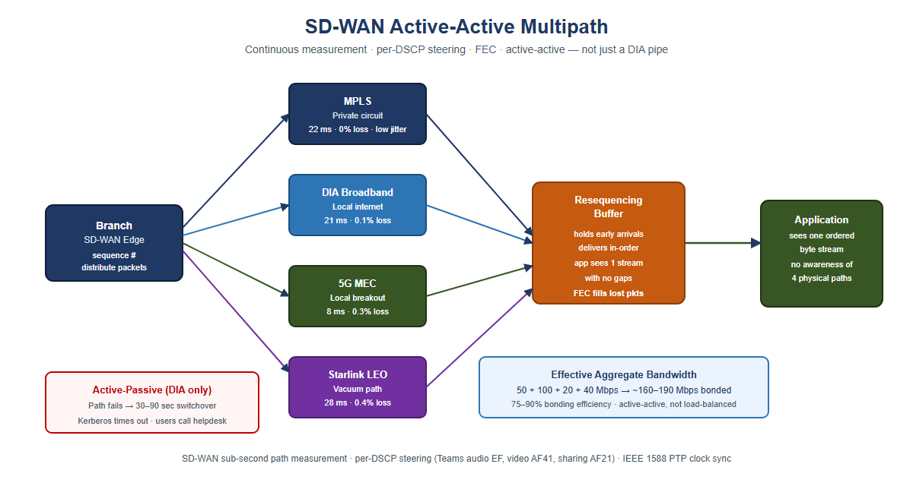
Figure 8: SD-WAN active-active multipath: a branch edge distributes sequenced packets across MPLS, DIA broadband, 5G MEC, and Starlink LEO simultaneously into a resequencing buffer with FEC, delivering one ordered byte stream to the application, versus an active-passive DIA-only fallback with a 30-90 second switchover

Forward Error Correction: recovering toward the physics floor
Forward Error Correction (FEC) sends redundant data alongside the primary transmission. The receiver can reconstruct a lost packet from the redundant data without any retransmission. The application experiences only the propagation delay — the physics floor — with no retransmission penalty. FEC does not make the signal travel faster. It removes the latency tax that lossy paths impose on top of the physics minimum.

Active-active vs. active-passive: the failover that is not a failover
Traditional WAN design is active-passive: MPLS is the primary circuit, DIA broadband is the standby. During switchover — typically 30–90 seconds — authentication sessions time out. VPN tunnels drop. Users re-authenticate.
Active-active multipath carries traffic on all available paths simultaneously, all the time. When a path fails or degrades, the remaining paths absorb its load within milliseconds. A Kerberos ticket exchange that is mid-flight when a path fails is retransmitted automatically. Under active-passive failover, the client times out after several seconds — this is the “logon takes 45 seconds” symptom field offices report. Under active-active multipath, the request was already distributed across multiple paths. The user experiences a 50 ms pause rather than a 30-second timeout.

Why “DIA to M365 will solve it” is half the answer
Capability | DIA Circuit Only | SD-WAN Intelligent Overlay
Eliminates MPLS geographic hairpin to cloud | Yes | Yes
Visibility into path quality (latency, jitter, loss) | None | Continuous, per-transport
Responds to path degradation before users notice | None | Sub-second reweighting
Splits a single conversation across multiple paths simultaneously | One path only | Active-active multipath with resequencing
Aggregates bandwidth from all transports | One path only | Bonded capacity = sum of all paths
Routes audio, video, and data streams of one call to different paths | None | Per-stream application steering
Fails over within milliseconds without dropping sessions | 30–90 second switchover | Seamless — all paths already active
Uses 5G local breakout when faster than wireline | None | Measured and included in multipath pool
Uses LEO satellite vacuum path when faster than fiber | None | Measured and included in multipath pool
Applies FEC to recover toward physics minimum on lossy paths | None | Per-transport FEC
Provides audit trail of path decisions (TIC 3.0 / AU-12) | None | Every decision is a logged event

What the commercial world figured out — and when
Current Federal Practice | When Commercial Moved On | What Replaced It | Why
MPLS for all branch connectivity | 2014–2018 | SD-WAN on broadband + LTE | Cost, flexibility, local breakout
Central internet breakout through DC | 2016–2019 | Local internet breakout at branch | Cloud apps do not need to go through DC
VPN as primary remote access | 2019–2021 | ZTNA / SASE overlay | Per-app access replaces per-network trust
Windows DNS / per-site DNS servers | 2017–2020 | Unified DDI (InfoBlox, BlueCat) | DNS became a security control surface
DHCP as invisible per-site utility | 2017–2020 | IPAM as inventory and compliance evidence | Zero Trust requires authoritative device inventory
Network-layer firewall as primary security | 2018–2022 | Application-layer enforcement (SASE, ZTNA) | Packets carry no useful identity or intent
Session-based application authentication | 2015–2019 | Token-based (OAuth 2.0 / OIDC) | Sessions break across WAN; tokens are stateless
This is not a forecast. Every item in this table is a completed transition in the commercial sector. The federal government is executing these transitions now under obligations commercial enterprises never carried — EO 14028, OMB M-22-09, and CISA BOD 25-01 — each of which binds agencies directly. (TIC 3.0 is guidance rather than a mandate, and FedRAMP 20x binds cloud service providers, not agencies; both are treated that way later in this paper.) That makes the federal transition harder, not easier. The path is known. The delay has a cost.

Why Direct Internet Access Alone Does Not Satisfy NIST Controls
When agencies present DIA as a modernization achievement, they have solved a connectivity problem. They have not solved a compliance problem. DIA is a transit service — a pipe to the internet. It satisfies exactly one federal requirement: it provides network connectivity to internet-hosted services. Every security control governing what traverses that connectivity must be applied by a separate control stack. The pipe itself contributes nothing to compliance.
NIST Control | What It Requires | What Provides It
AC-4 Information Flow Enforcement | Application-layer enforcement identifying the destination application, not just the destination IP | CASB in SASE stack
SC-7 Boundary Protection | Application-layer inspection; detect C2 on port 443, exfiltration in DNS | SWG / FWaaS in SASE stack
SC-8 Transmission Confidentiality and Integrity | Network-layer encryption | SD-WAN IPsec tunnel — DIA alone encrypts nothing
SI-3 Malware Protection | Inline malware inspection at appropriate locations | SWG with SSL inspection in SASE stack
SI-4 System Monitoring | Application-layer telemetry — user, device, app, data, behavioral pattern | AAN application telemetry
AU-2 / AU-12 Audit Events / Audit Record Generation | User Z on device D accessed application A, performed action V on data type C — not just IP flows | Application-layer logging via AAN
CA-7 Continuous Monitoring | Per-session: identity verified, device posture, access consistent with policy — machine-readable | AAN and SASE stack
The precise relationship: DIA enables compliance; AAN and SASE achieve it. DIA provides the connectivity that makes cloud-hosted services reachable without the MPLS hairpin. It is necessary. It is not sufficient. When an agency presents “we have DIA” as a compliance achievement, the correct technical response is: you have the pipe. Where is the control stack?

Act 4 — The Way Forward: Application-Aware Modernization
You can’t fix this by patching the old model. You can’t bolt Zero Trust onto a Kerberos-in-MPLS architecture. You can’t add more proxies. The only way forward is to rebuild the foundation around one structural move and five principles that follow from it.
The structural move is the one sentence this whole story turns on. Active Directory conflated the directory (truth) with the domain controller (the in-path enforcer). NIST SP 800-207 and OMB M-22-09 require the modern architecture to keep these separate: the governance layer holds and reconciles authoritative state, while identity providers, enforcement points, and data platforms remain the runtime data planes.
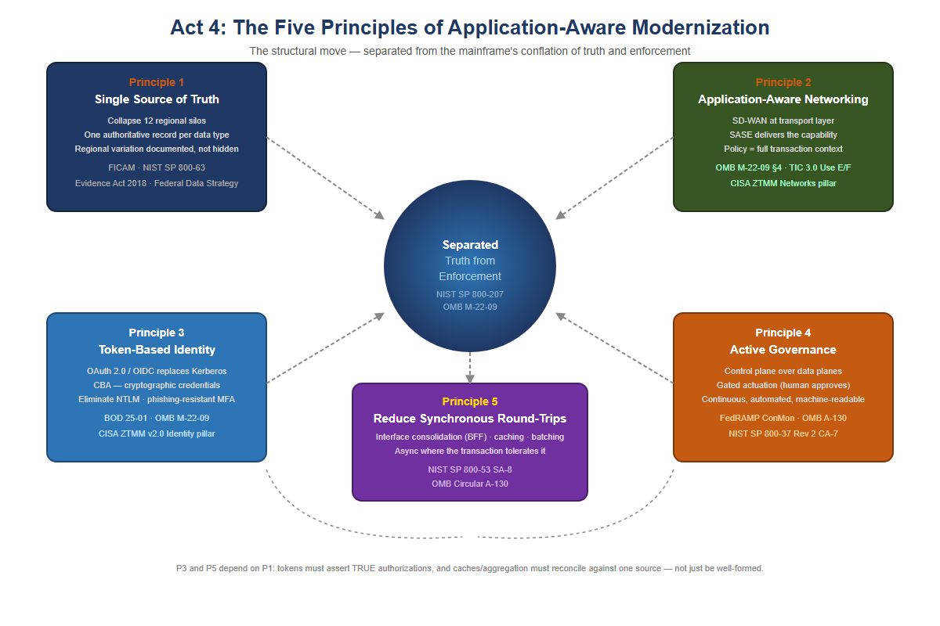
Figure 9: Act 4: the five principles of application-aware modernization, arranged around a central hub reading ‘Separated: Truth from Enforcement’ — Single Source of Truth, Application-Aware Networking, Token-Based Identity, Active Governance, and Reduce Synchronous Round-Trips

Principle 1 — Restore a Single Source of Truth
Every data type the federal government manages must have one authoritative source. Not twelve regional databases with eventual consistency. Not caches that drift. One source, cryptographically verifiable, auditable: you must know where every piece of data came from, who accessed it, when, and why.
For your agency, that means collapsing the twelve regional silos into a unified model — not by erasing regional autonomy, but by making it transparent. If California’s benefit calculation differs from Massachusetts’s, that difference is documented, auditable, and traceable back to policy, not hidden in schema variation.
The Federal Identity, Credential, and Access Management (FICAM) Architecture and NIST SP 800-63 require that every governed object carry a complete, authoritative set of identity attributes derived from authoritative sources such as HR systems and device management platforms. The Evidence Act (2018) and the Federal Data Strategy push in the same direction — toward data that is authoritative, traceable and usable as evidence — though neither mandates a single system of record per data type with documented lineage. That is this paper’s inference from them, and it is stated here as such; the binding requirements closest to it are NIST SP 800-53 CM-8 (system component inventory) and SI-12 (information management and retention).
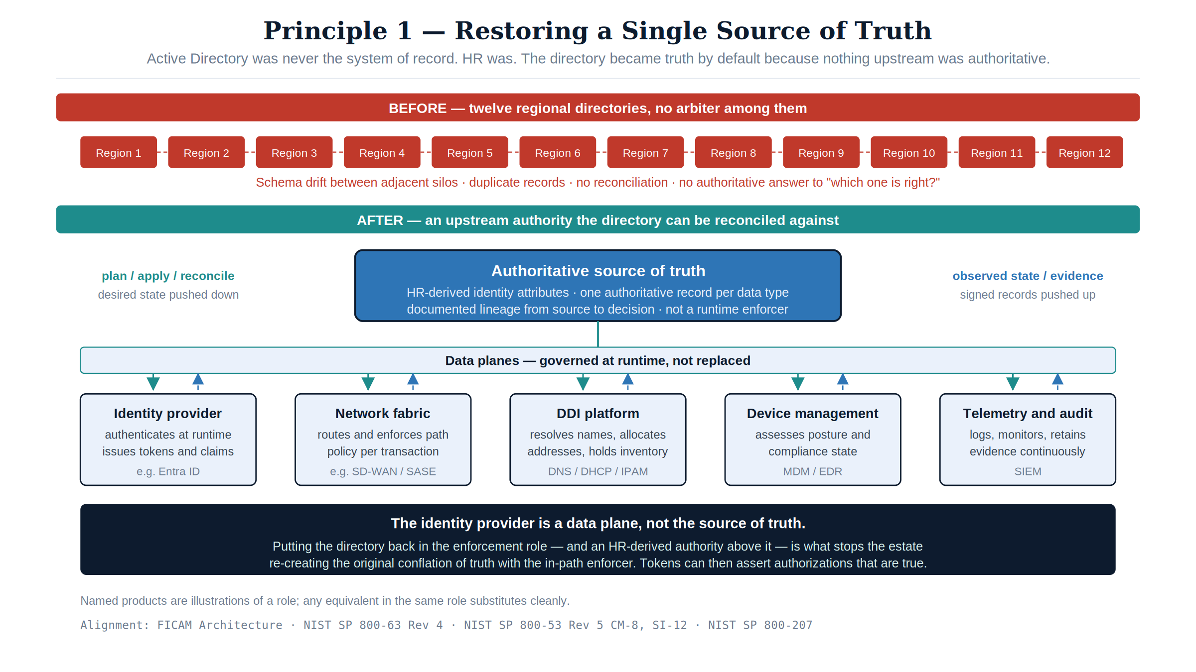
Figure 10: Principle 1 — SSOT restoration: twelve unreconciled regional directories give way to an HR-derived authoritative source above five governed data planes, with the identity provider shown as a data plane rather than as truth

Principle 2 — Application-Aware Networking and Cybersecurity
You can’t enforce security at the network layer anymore. The network is the Internet now. The only way to know whether a transaction is legitimate is to understand what the application is doing: Is this user authorized to access this data? Is the data being accessed the data policy says they should access? Is the request from a compliant device, from a location that makes sense?
That is application-aware networking. NIST SP 800-207’s seven zero trust tenets require exactly this: all communication secured regardless of network location; access determined per-session with least privilege; integrity and behavior monitored continuously. OMB M-22-09 §4 requires agencies to implement network visibility and traffic inspection that operates at the application layer, not the IP/port layer. TIC 3.0 publishes four use cases — Traditional TIC, Branch Office (v1.0, April 2021), Remote User (v2.2, July 2025) and Cloud (v1.2, July 2025). The Branch Office and Remote User cases describe application-layer visibility at the policy enforcement point, but TIC 3.0 is guidance rather than a mandate and prescribes no specific product class.
Application-Aware Networking framework alignment:
- SD-WAN is AAN at the transport layer. SD-WAN achieves application awareness through DPI or FQDN/signature-based identification, then applies per-application path selection dynamically based on real-time path quality measurement. SD-WAN alone does not enforce access control based on user identity or device posture. That requires SASE.
- SASE is the delivery architecture that completes AAN. SASE converges SD-WAN with cloud-delivered security services — CASB, FWaaS, ZTNA, SWG — at the network edge. It brings user identity (from the IdP via SAML/OIDC), device posture (from MDM/EDR), application identity (from DPI), and data classification (from CASB) into a single enforcement point distributed geographically near the user.
- CISA ZTMM maps AAN to the Networks pillar maturity progression. Traditional: all decisions at IP/port layer, no application visibility. Initial: basic application identification. Advanced: application-aware routing and enforcement — the posture this paper recommends as the production default. Optimal: fully dynamic, identity-driven, application-aware policy with continuous behavioral monitoring.

Principle 3 — Move From Session-Based to Token-Based Identity
Active Directory Kerberos assumes clients and servers are in the same room. Tokens assume they are strangers on the Internet.
A token is a cryptographically signed assertion: this user is who they claim to be; this device is compliant; this request is authorized; timestamp now; signature here. The server validates it offline, without trusting the network.
Kerberos service-ticket validation is also offline — the application server decrypts the ticket with its own key and calls no domain controller, as Act 2 established. The difference is not validation, it is issuance topology and where policy is evaluated. A Kerberos ticket is issued by a KDC the client must reach at logon, on the agency’s network, and it carries no device or authorization context to evaluate. A token is issued by an identity provider reachable from anywhere over HTTPS, and the policy decision — device compliance, location, risk, scope — is evaluated at issuance and travels inside the assertion.
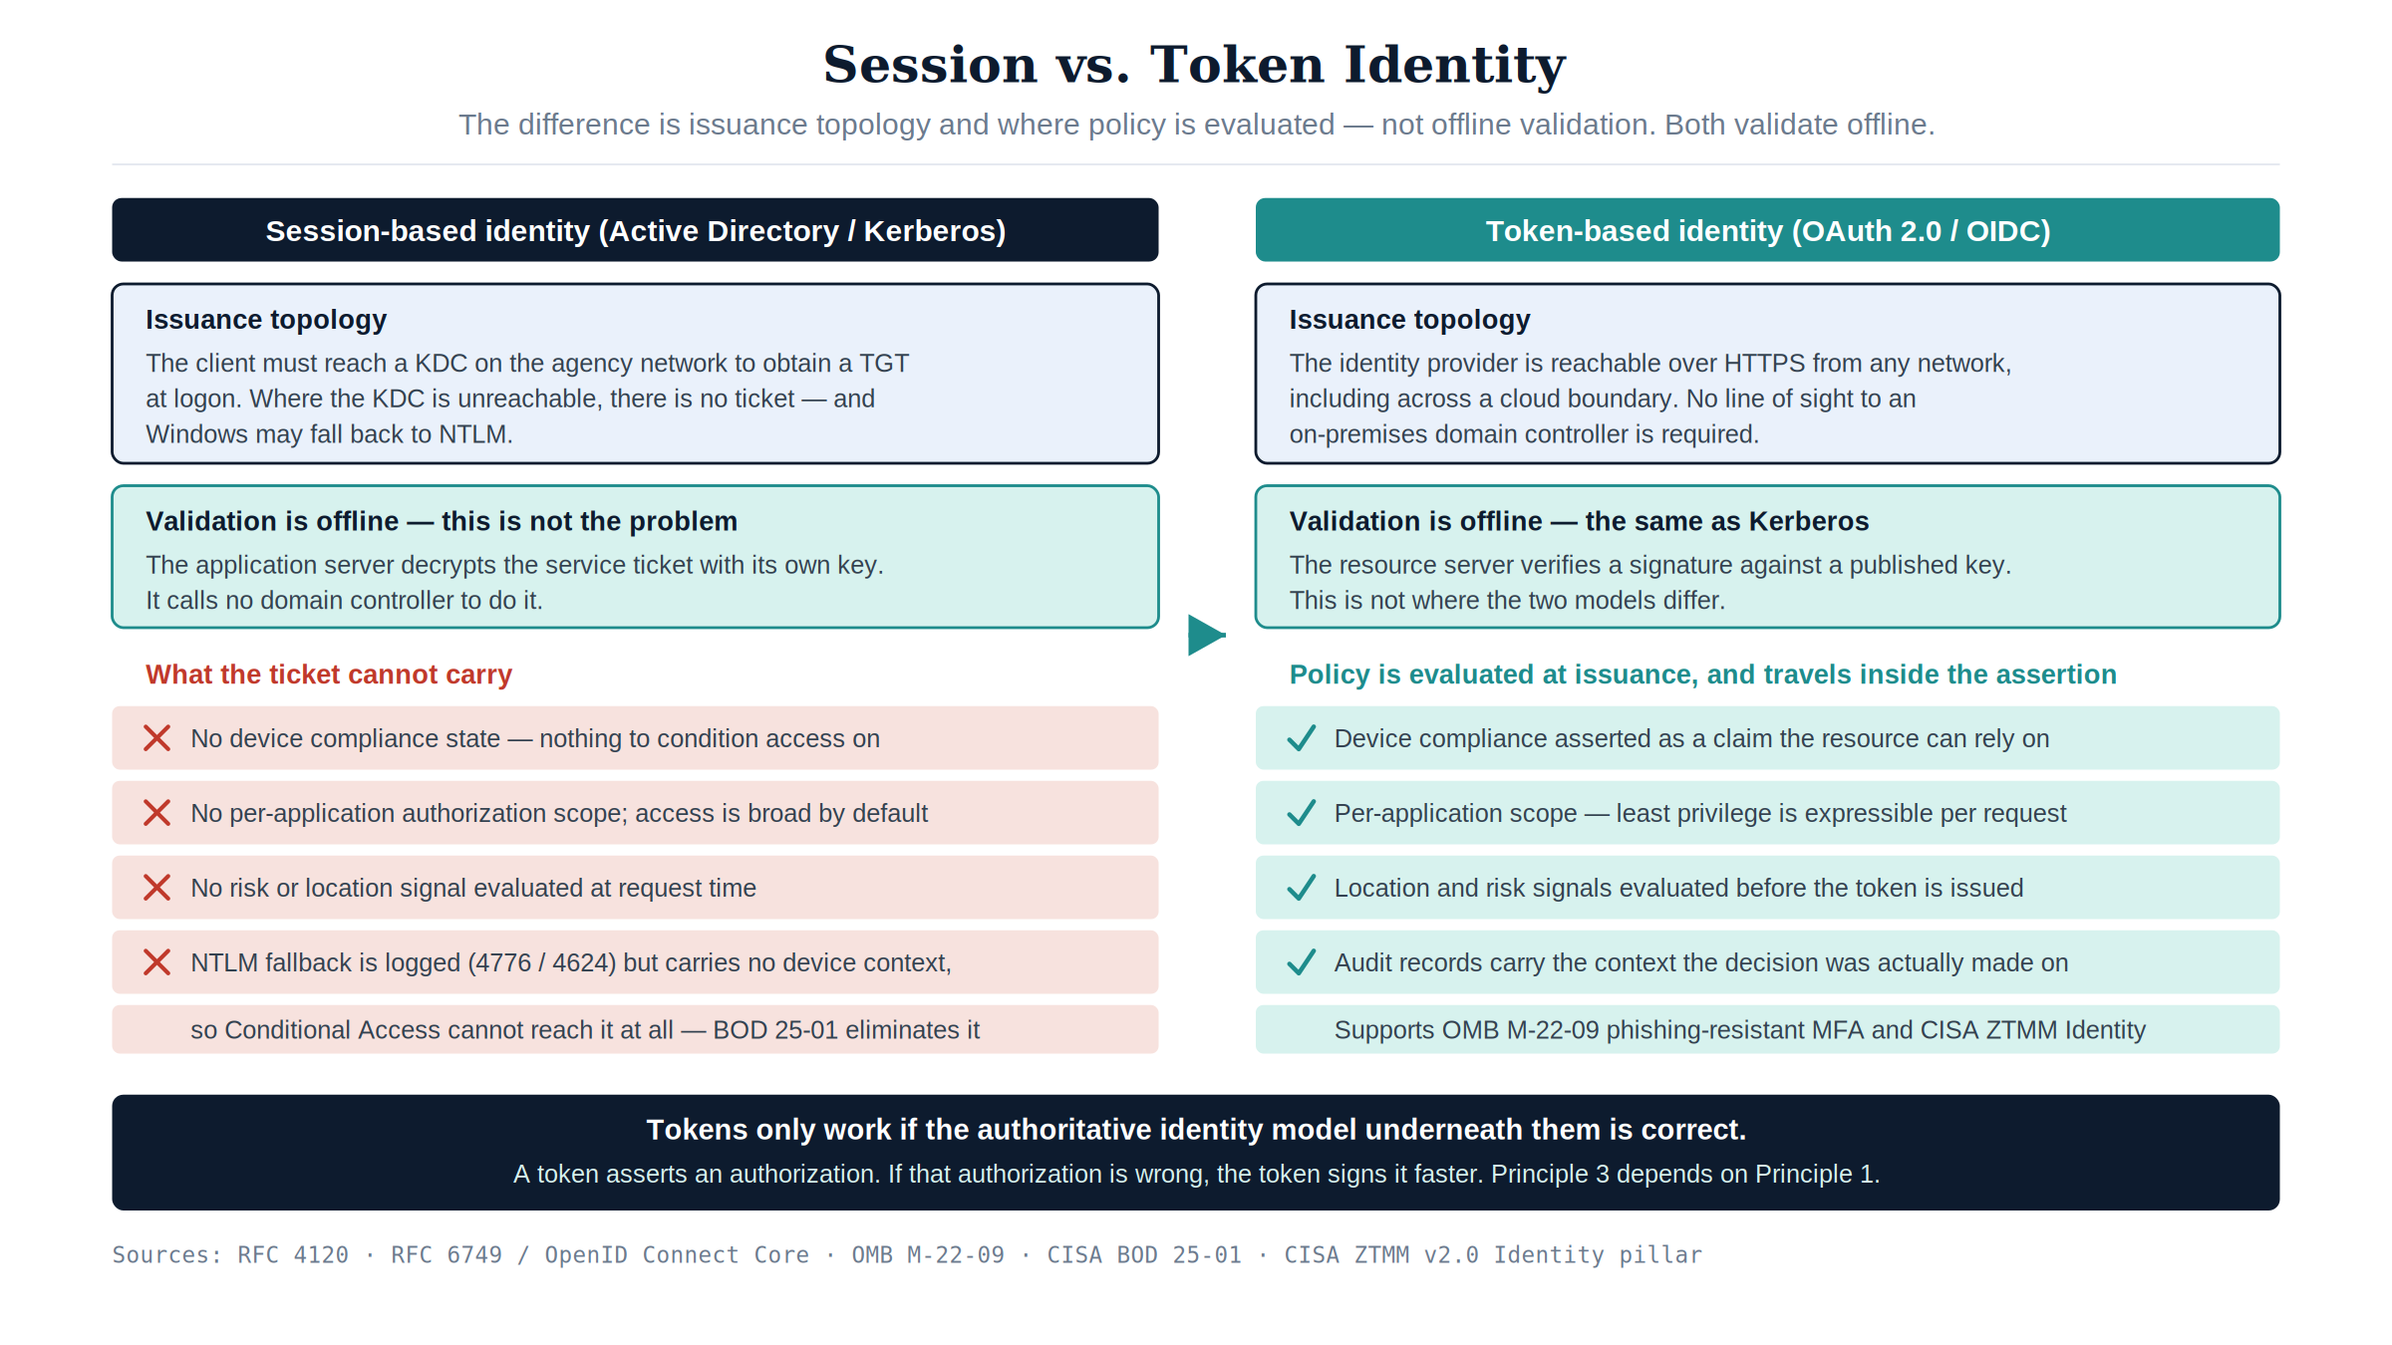
Figure 11: Principle 3 — Session vs. token identity: both models validate offline, and the real difference is issuance topology and where policy is evaluated
Entra ID, Conditional Access, and device-compliance policies are the token-based equivalents of what AD used to do. BOD 25-01 mandates SCuBA secure configuration baselines for Microsoft 365 that require modern authentication throughout. OMB M-22-09 requires phishing-resistant MFA government-wide. The CISA Zero Trust Maturity Model v2.0 Identity pillar calls for phishing-resistant MFA at Advanced and Optimal; certificate-based authentication is one way to get there, not a named requirement. NTLM has no zero-trust story — not because it is invisible (events 4776 and 4624 log it perfectly well) but because it carries no device or session context: an NTLM authentication cannot be conditioned on device compliance, location, or risk, so it is unreachable by Conditional Access and cannot participate in a per-transaction access decision at all.
Tokens only work if the authoritative identity model is correct. If you don’t know what a user is actually authorized to do — if that is still encoded in twelve regional OU trees with no authoritative HR-derived source — tokens won’t save you. You will just be signing broken authorizations very efficiently. That is why Principle 3 depends on Principle 1: the token must assert an authorization that is true rather than merely well-formed.

FedRAMP 20x Consolidated Rules — What Changed, and Who It Binds
FedRAMP published its Consolidated Rules for 2026 on June 25, 2026, establishing the most significant shift in federal cloud authorization since FedRAMP’s inception. The core change: periodic evidence assembly is replaced by continuously-verified, machine-readable Key Security Indicators (KSIs).
Who this actually binds
FedRAMP 20x obligates cloud service providers, not agencies. The Consolidated Rules define a Persistent FedRAMP Assessment (FRD-PFA) as “follow-on assessments of a cloud service offering focused on Key Security Indicators, coordinated by the provider”; a Provider (FRD-PRV) is “the cloud service provider responsible for a cloud service offering”; and All Necessary Parties (FRD-ANP) places the agency on the other side of the transaction as “any agency customer who is using the cloud service offering”. An agency’s own AD domains, SD-WAN fabric, DDI grid, and mainframe are not a certified cloud service offering, and nobody will demand JSON KSI evidence for them on January 1, 2027.
Read the dates below as a procurement and supply-chain clock — they govern the cloud services the agency buys and the evidence those providers will start handing over. Read the architecture argument as direction of travel: FedRAMP has now defined what federal authorization means, and agency ATOs under NIST SP 800-53 CA-7 and OMB Circular A-130 are where that definition lands next. The agency’s own binding deadlines are OMB M-22-09 (milestones due FY24, already passed), BOD 25-01 for Microsoft 365, and the continuous-monitoring obligations already inside its existing ATOs.
If you want to test this before acting on it, ask your FedRAMP/ATO office which systems in this paper carry a 20x obligation. The expected answer is none.

What the modernization does buy is the capacity to answer a continuous-evidence question at all — whoever ends up asking it:
Continuous-evidence capability | What the modern architecture provides
Continuous, automated verification rather than periodic sampling | SD-WAN probes every transport continuously; SASE logs every session; DDI logs every DNS query
Machine-readable evidence (JSON) | SD-WAN telemetry APIs, SIEM structured exports, DDI platform APIs — all native JSON
Infrastructure-as-code guardrails | Terraform for DDI, IaC for SASE policy, GitOps for network config — guardrails enforced at commit
No manual evidence assembly for assessments | The control plane’s continuous observation IS the evidence — not a report prepared for an assessor
CM-8 inventory that is current by construction | Address, name, and workload records emitted by the system that allocates them, not re-surveyed annually
AU-2/AU-12 provenance for every transaction | Session and resolution records carry the identity and device context the decision was made on
These are CA-7, CM-8 and AU-12 capabilities the agency already owes on its own systems. That they also happen to be the shape FedRAMP now demands of providers is corroboration that the direction is right — not a deadline the agency is under.
Key dates — the provider clock the agency buys against:
- July 28, 2026: FedRAMP Ready submissions cease — no new Ready pathway submissions accepted
- August 3, 2026: Class A pipeline opens
- August 31, 2026: Class B and C pipelines open
- January 1, 2027: Consolidated Rules mandatory for all certified cloud service offerings — provider ConMon evidence must meet the machine-readable KSI format
- June 11, 2027: No new Rev5 certifications accepted
Important
The alignment, stated precisely: a control plane that holds desired state, observes actual state, classifies drift, and reconciles toward intent — generating structured JSON records of every observation and action — produces exactly the kind of evidence FedRAMP now requires of providers, and exactly what CA-7 continuous monitoring asks of the agency for its own systems. It does not make the agency’s infrastructure “FedRAMP 20x compliant”: that status belongs to certified cloud service offerings. It makes the agency able to answer the continuous-evidence question on its own estate, which is the obligation it actually carries.

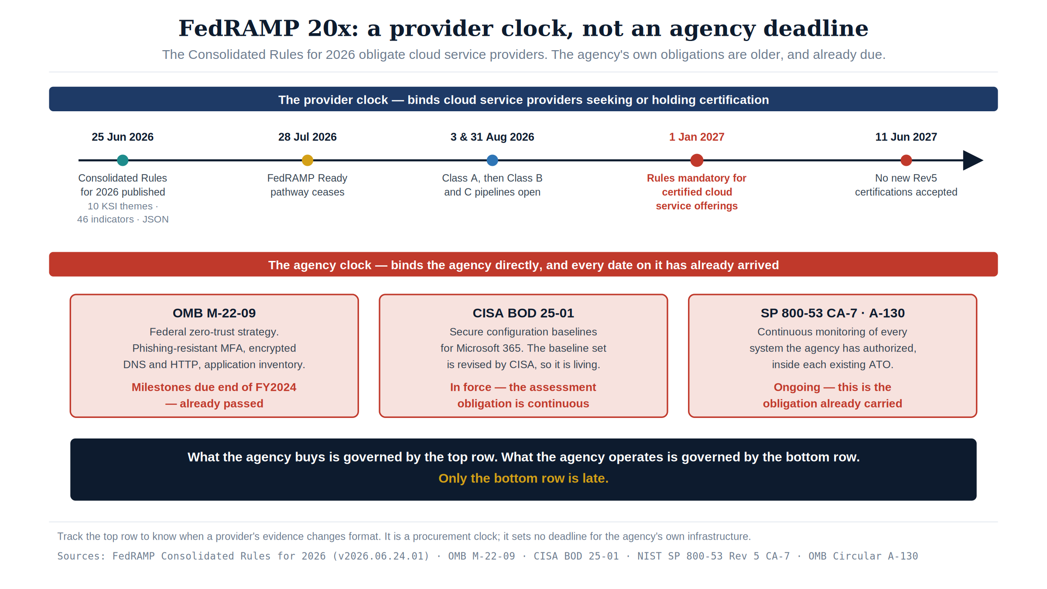
Figure 12: The FedRAMP 20x provider clock — Consolidated Rules publication, the Class A/B/C pipeline openings, and the January 2027 date on which the rules become mandatory for certified cloud service offerings — set against the agency’s own, already-passed obligations

Principle 4 — Govern Actively: The Control Plane Over the Data Plane
A governance substrate that embodies these principles is not a passive registry that records desired state and reports divergence. It is an active reconciliation control plane: it holds desired state, observes actual state, classifies drift, and reconciles toward intent — while identity providers, network fabrics, endpoint management platforms, DDI systems, and SIEM platforms remain the data planes that authenticate, route, resolve, and store at runtime.
CISA ZT Stage | Governance Posture | What This Means in Practice
Traditional | Record and observe only | Desired state documented; actual state collected manually. No automated detection or correction.
Initial | Observe and advise | Automated detection of drift from policy. Corrective actions generated and surfaced to operators. No automated writes.
Advanced | Gated actuation | Governance framework generates a corrective action; a human approves before it executes. Dry-run required before production. The posture this paper recommends as the production default — see the note below on why.
Optimal | Autonomous within guardrails | Governance framework closes the loop without human intervention for enumerated low-blast-radius operation classes. High-blast-radius operations remain gated permanently.

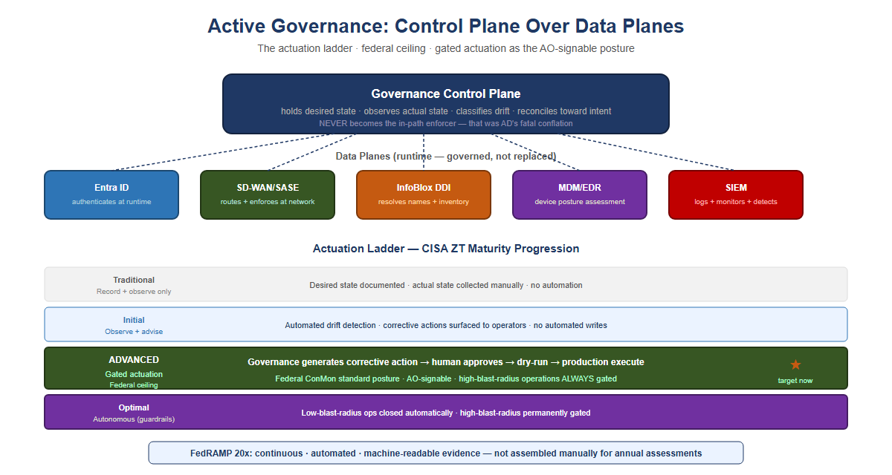
Figure 13: Active Governance: control plane and actuation ladder — a governance control plane over five data planes (Entra ID, SD-WAN/SASE, InfoBlox DDI, MDM/EDR, SIEM), plus the CISA ZT maturity progression from Traditional through Optimal with the federal L3 gated-actuation ceiling marked as the target now
What this means for authorizing officials: no federal mandate names a CISA ZTMM stage as a production requirement — ZTMM is a maturity model, and M-22-09 sets outcomes (phishing-resistant MFA, encrypted DNS and HTTP, application inventory) rather than a stage. Advanced is this paper’s recommendation, and the reason is signability: gated actuation, where the governance framework generates a corrective action and a human approves before it executes, keeps a named human in the accountability chain for every change to an authorized system. That is a posture an Authorizing Official can sign; fully autonomous reconciliation over a Moderate estate generally is not. High-blast-radius operations — tenant-wide role changes, network policy updates that touch thousands of endpoints — remain gated permanently regardless of overall maturity level.

Principle 5 — Reduce Synchronous Round-Trip Count at the Application Layer
Source
This principle’s core argument — bandwidth does not reduce latency, and an application’s compute should remain co-located with its authoritative data until modernization demonstrates distributed readiness — draws directly on an internal architecture position paper on application–data separation and cloud-migration readiness in hybrid environments (July 2026).

Key insight
SD-WAN multipath and token-based identity make a fixed number of round trips faster and more resilient; they do not reduce the number of round trips a chatty, synchronous application makes. A legacy transaction that issues 200 sequential calls to a mainframe 5,400 km away still pays the propagation floor 200 times, regardless of how well the transport and identity layers are engineered.

Every application that depends on frequent synchronous communication with an authoritative data store must reduce the number of network round trips a single business transaction requires, before that application is separated from its data across a distance that imposes a meaningful propagation floor. Where round-trip reduction has not been demonstrated through transaction profiling and performance validation, the application’s compute should remain co-located with its authoritative data.
Principles 1 through 4 govern truth, transport, session survival, and identity. None of them touch application design. A well-architected SD-WAN overlay carrying token-authenticated traffic over active-active multipath still incurs the physics floor once per synchronous call. Only reducing the number of calls — or converting them to a pattern that tolerates distance — actually shrinks the latency budget a transaction consumes.
Round-trip reduction is an application and integration-architecture discipline, not a network purchase:
Technique | Mechanism | Effect on Latency Exposure
Interface consolidation (BFF) | One aggregated call replaces N fine-grained calls | Reduces round-trip count from N× floor to 1× floor per transaction
Async / event-driven processing | Producer does not block on a synchronous reply | Removes floor exposure from the user-facing critical path
Edge caching (read-through) | Serve repeat reads from a local cache | Eliminates the round trip entirely for cache hits
Batching | Multiple operations travel in one exchange | Amortizes the floor across many logical operations
Connection pooling | Handshake cost paid once, reused many times | Removes repeated setup latency, not the data round trip
Stateless transaction conversion | Pseudo-conversational sessions become atomic calls | Removes multi-step server affinity that forces sequential round trips
Principle 5 depends on Principle 1 the same way Principle 3 does: a cache or aggregation layer is only safe to build once there is one authoritative source to cache from and reconcile against. Principle 2’s application-layer visibility (DPI, SASE telemetry) is the natural place to measure round-trip count and transaction chattiness in production, giving Principle 5 an evidence base rather than a guess. Principle 4’s gated actuation should treat “has this workload’s round-trip count been profiled and reduced” as a required check before approving separation of an application from its authoritative data store.

Mainframe Access Modernization: A Token-Based Implementation Path
This section describes an implementation pattern that is already mature and productized — not an open feasibility question. It does not assume knowledge of a specific z/OS estate’s current subsystem versions or RACF configuration; validating configuration against the actual environment is the first implementation step, not an afterthought.

Current state
Mainframe access is natively governed by RACF (Resource Access Control Facility) through the System Authorization Facility (SAF) interface. Interactive access is typically session-bound — 3270 terminal emulation, or z/OS’s own Kerberos implementation (Network Authentication Service) — and CICS/IMS transactions execute within a region that expects a resolved RACF identity for the duration of the unit of work. None of this is token-based in the OAuth/OIDC sense: it is credential- or ticket-based, and tied to an active session in the same way Kerberos in Principle 3 is tied to a domain controller.

How the gateway bridges to RACF
Token-based access to mainframe transactions is not a hypothetical — IBM has shipped it for a decade. z/OS Connect (Enterprise Edition) has validated OAuth 2.0 / OIDC tokens against CICS, IMS, and batch assets since the mid-2010s, and RACF PassTicket itself dates to the 1990s. Commercial banks — exactly the customer base with the least tolerance for standing still — adopted this pattern years ago under PSD2 and open-banking mandates that required OAuth-fronted core banking APIs. The federal gap here is not a technology gap; it is the same adoption lag documented throughout this whitepaper.
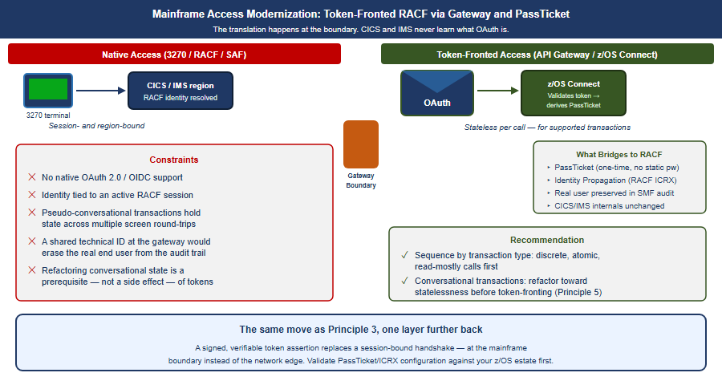
Figure 14: Mainframe access modernization: native 3270/RACF/SAF access on the left versus token-fronted access through an API gateway/z/OS Connect on the right, bridging to RACF via PassTicket and Identity Propagation
The established pattern: an API gateway or z/OS Connect (EE) layer exposes CICS, IMS, or batch assets as REST/JSON services and terminates an OAuth 2.0 / OIDC token issued by the enterprise identity provider (e.g., Entra ID). The gateway validates the token’s signature and claims, then derives a RACF PassTicket — a one-time, algorithmically generated credential (from a shared secret, user ID, application ID, and timestamp) — to authenticate to RACF without storing or transmitting a static password. z/OS Identity Propagation (RACF distributed identity filters / ICRX) maps the external token’s subject into the RACF audit and authorization context, so the transaction is authorized and logged against the real end user rather than a shared technical service ID. This is architecturally the same move as Principle 3 — a signed, verifiable assertion replaces a session-bound handshake — applied one layer further back, at the mainframe boundary instead of the network edge.

What does not change internally
CICS and IMS do not natively understand OAuth tokens, and the underlying transaction engine remains region- and session-bound. Token-based access is a translation at the boundary, not a replacement of the mainframe’s internal security model. Pseudo-conversational transactions that hold state across multiple screen interactions are the harder case: they were designed around a persistent session, and converting them to a stateless, per-request token model is itself a round-trip-reduction and refactoring exercise — the same work Principle 5 already calls for. In practice, token-based mainframe access and round-trip reduction are not two separate modernization tracks; they are the same gateway and the same refactoring effort viewed from two angles.

Recommendation
Treat mainframe token-based access as a byproduct of Principle 5’s interface-consolidation work, not a separate initiative. The same API/gateway layer built to aggregate chatty synchronous calls is the natural point to terminate tokens and bridge to RACF via PassTicket and Identity Propagation. Sequence the work by transaction type: discrete, atomic, read-mostly transactions are the near-term candidates for token-fronted access; pseudo-conversational, multi-step transactions should be refactored toward statelessness first, which is exactly the round-trip reduction Principle 5 already requires. Validate PassTicket and Identity Propagation configuration against the specific z/OS estate before committing a modernization timeline — this assessment is general; the environment’s current CICS/IMS versions, RACF class configuration, and API gateway posture will determine the actual sequencing.

Federal Framework Alignment
The following table maps each concept in this narrative to the federal mandate, standard, or policy that requires or validates it.
Concept / Narrative Claim | Federal Mandate | Standard / Reference
Separate truth from runtime enforcement | EO 14028 (May 2021), OMB M-22-09 | NIST SP 800-207 §2 (Zero Trust tenets)
Single source of truth for identity and data | No direct mandate — inferred from the Evidence Act (2018) and Federal Data Strategy, which are directional, not prescriptive here | NIST SP 800-53 Rev 5 CM-8, SI-12
Authoritative identity attributes from HR / authoritative sources | FICAM Architecture, OMB M-22-09 | NIST SP 800-63 Rev 4 Digital Identity Guidelines (31 Jul 2025)
Application-aware networking; per-transaction policy enforcement | OMB M-22-09 §4, EO 14028 | NIST SP 800-207, TIC 3.0 Branch Office and Remote User use cases
Phishing-resistant MFA / Certificate-Based Authentication | BOD 25-01, OMB M-22-09 | CISA ZTMM v2.0 Identity pillar (Advanced/Optimal)
Eliminate NTLM; move to token-based identity | BOD 25-01 (M365 SCuBA baselines) | CISA ZTMM v2.0 Identity pillar
Device compliance as input to access decisions | OMB M-22-09 §3 | CISA ZTMM v2.0 Devices pillar
SD-WAN local internet breakout; eliminate MPLS hairpin | TIC 3.0 (Trusted Internet Connections) | CISA ZTMM v2.0 Networks pillar
SASE / ZTNA as access model replacing VPN | OMB M-22-09 §4, TIC 3.0 | NIST SP 800-207, CISA ZTMM Networks pillar
DNS resolution integrity (DNSSEC validation, authoritative and recursive) | FedRAMP Moderate SC-20/21 | NIST SP 800-53 Rev 5 SC-20, SC-21
DNS as a threat-blocking control (RPZ, reputation feeds) | Not covered by SC-20/21 — supports SI-4 monitoring and the CISA ZTMM Networks pillar | NIST SP 800-53 Rev 5 SI-4
IP address inventory as compliance evidence (CM-8) | FedRAMP Moderate | NIST SP 800-53 Rev 5 CM-8
Audit provenance: every transaction traceable to authorized source | FedRAMP Moderate AU-2/12 | NIST SP 800-53 Rev 5 AU-2, AU-12
Continuous monitoring of the agency’s own authorized systems | OMB Circular A-130; the agency’s existing ATOs | NIST SP 800-53 Rev 5 CA-7; NIST SP 800-37 Rev 2
Gated actuation as recommended governance posture (Advanced maturity) | No mandate — this paper’s recommendation; supports CA-7 and AU-12 accountability | CISA ZTMM v2.0 Automation and Orchestration pillar (a maturity model, not a requirement)
Machine-readable KSI evidence; no manual evidence assembly | FedRAMP 20x Consolidated Rules — binds cloud service providers, not agencies; relevant to the agency as a purchaser and as direction of travel | FedRAMP 20x JSON evidence format; 46 indicators across 10 KSI themes in the 2026 Consolidated Rules
Reduce synchronous round-trip count before separating an application from authoritative data | OMB Circular A-130 (sound engineering practice); EO 14028 | NIST SP 800-53 Rev 5 SA-8 (Security and Privacy Engineering Principles)
Bridge mainframe RACF/SAF access to token-based identity via API gateway and PassTicket | OMB M-22-09 (modern authentication); BOD 25-01 | NIST SP 800-207; CISA ZTMM v2.0 Identity pillar

Call to Action
This whitepaper describes a well-worn commercial transition your agency has not yet completed, under a federal compliance deadline that is no longer negotiable. The following steps convert the five principles into an execution plan.
Six steps to start this quarter
- Inventory the actual architecture, not the assumed one. Document every regional AD domain, every MPLS circuit, every location where DIA has been installed without a SASE/SD-WAN control stack behind it, and every application that makes synchronous calls across a WAN boundary to a mainframe or legacy data store. Most agencies cannot answer this today — that is the first gap to close.
- Run a physics-based latency audit before the next migration decision. For every workload being considered for cloud migration, measure — do not assume — its round-trip count and the fixed propagation floor of the distance involved. Do not approve a migration until the answer is known.
- Assign an owner to each of the five principles. Single source of truth, application-aware networking, token-based identity, active governance, and round-trip reduction are five separate engineering disciplines with five different natural owners — data governance, network engineering, identity engineering, compliance/ConMon, and application architecture, respectively. None of them will move if nobody owns them.
- Put the agency’s own clocks on the calendar — they are the late ones. OMB M-22-09’s zero-trust milestones came due at the end of FY24 and have passed; CISA BOD 25-01 is in force and continuous for Microsoft 365 secure configuration; and NIST SP 800-53 CA-7 with OMB Circular A-130 already requires continuous monitoring of every system the agency has authorized. Continuous monitoring built after those obligations came due is a remediation project, not a modernization project. Separately, track the provider clock so you know when your vendors’ evidence changes format: FedRAMP Ready ceases 28 July 2026, the Class A/B/C pipelines open 3 and 31 August 2026, the Consolidated Rules become mandatory for certified cloud service offerings on 1 January 2027, and no new Rev5 certifications are accepted after 11 June 2027. Those are procurement dates, not agency deadlines.
- Pilot the mainframe token-bridge pattern on one low-risk transaction class before committing to a timeline. Discrete, atomic, read-mostly transactions are the correct first candidates — not the highest-value or highest-visibility ones. Prove the PassTicket/Identity Propagation pattern against your specific z/OS estate before scheduling the harder, pseudo-conversational transactions.
- Bring this document to the people who can act on it. The CIO/CISO office owns the ATO and continuous-monitoring posture — the CA-7 obligation inside each existing authorization, and the M-22-09 and BOD 25-01 positions; the network team owns Principles 2 and 5; the identity team owns Principle 3; the mainframe and application teams own the token-bridge chapter. This document is written to be handed to all four without modification.

None of this requires a specific vendor decision on day one. It requires an inventory, an owner, and a date. The architecture described in this whitepaper is not aspirational — it is what the commercial sector already runs, and what the agency’s existing authorizations already oblige it to be able to evidence.

Sources
Federal requirements in this paper are cited to the issuing authority below. Dates for FedRAMP and CISA events are the ones carried in this repository’s authority-deadline register, which records the issuing source and the date each was last verified against it; a date in the corpus that disagrees with that register fails a build gate, so the citations here and the dates elsewhere in the corpus cannot drift apart.
Two claims in this paper are deliberately not attributed to a mandate, and say so where they appear: the single-source-of-truth requirement is this paper’s inference from the Evidence Act and the Federal Data Strategy, and Advanced-maturity gated actuation is this paper’s recommendation rather than a posture any federal document requires.

Appendix — Narrative provenance: this arc mapped to UIAO canon
Everything above this appendix stands on its own — federal requirements cited to NIST, OMB, CISA and FedRAMP, and no dependency on anything below. This appendix is separable: it exists for readers who want to know where Act 4’s claims come from in the UIAO substrate, and it can be dropped when the paper is handed to an audience that is not evaluating a platform.
The same arc also circulates as OrgComp Vol I Book 05, which carries the federal control-closure framing (NIST 800-53, FedRAMP 20x KSI, TIC 3.0) and the SD-WAN / INR implementation appendix. That book names no automation engine at all — the OrgComp series is adoptable on its own — so this appendix is the canonical home of the mapping below. The modernization pillar’s curated entry points for the arc are collected at the OrgMod hub.
Acts 1–3 are the agency’s lived history and are not canon claims. Act 4 is anchored — here is the line-by-line provenance, including where earlier framings were corrected to match canon.
Narrative claim | Canon anchor | Reconciliation note
Separate truth from runtime enforcement; AD conflated directory + DC | ADR-092 §1 | Verbatim doctrine; the spine of Act 4.
OrgPath restores addressable truth | UIAO_151, ADR-092 §2 | Corrected: OrgPath is an addressing attribute every object carries, not a “governance primitive,” and not “every token includes an OrgPath.” Decisions compose against it.
Application-aware networking; token-bound per-call transport | ADR-066 | Proposed (amended by ADR-123); generalized by accepted ADR-092. “Session is no longer a canonical concept.”
Vendor products (SD-WAN platform, cloud on-ramp) | ADR-092 §2, Book_17 | Softened: canon names a neutral sdwan-fabric slot, Azure Policy, ISE/ClearPass/Entra RADIUS. Specific platforms are illustrative, incorporated as providers.
Session→token identity; CBA replaces Kerberos | ADR-068, ADR-004 | Canonical. NTLM elimination + CBA + Cloud Kerberos trust.
Active Governance; L0–L4 ladder; federal L3 ceiling | ADR-092 §3–4 | Verbatim; the keystone of the way forward.
Restore single source of truth / provenance | ADR-074, ADR-040 | Canonical, framed as governance / accountability / integrity. Program-integrity stakes are the agency’s real-world motivation, not a UIAO canon claim.

Provenance
Acts 1–3 are a narrative synthesis of an agency modernization arc (mainframe → regional decentralization → security-layer accretion → multi-cloud breaking point); the specific institutional details (twelve regional domains, the named data-center anchors) are the agency’s own and are not asserted as UIAO canon. Act 4 is reconciled to canon as tabulated above. Mapping first staged 2026-06-04; retained here through the 2026-09-09 consolidation of this paper’s two editions.

NIST SP 800-53 Rev. 5, controls CM-8 (System Component Inventory) and SI-12 (Information Management and Retention). https://csrc.nist.gov/pubs/sp/800/53/r5/upd1/final
Microsoft, [MS-KILE]: Kerberos Protocol Extensions. Windows sets ClientIpAddresses to zero so client addresses are not written into tickets, stated to be “because of Dynamic Host Configuration Protocol and network address translation issues” — which is why source-address translation on a network path does not invalidate a ticket. https://learn.microsoft.com/openspecs/windows_protocols/ms-kile/
R. Neuman et al., The Kerberos Network Authentication Service (V5), RFC 4120 (July 2005). The five-minute figure commonly quoted at Kerberos is the maximum tolerable clock skew; the protocol defines no latency bound. Optional address checking uses the caddr field the client supplies, and is enforced by the application server (KRB_AP_ERR_BADADDR), not by the KDC. https://www.rfc-editor.org/rfc/rfc4120
3GPP 5G NR scales slot duration with subcarrier spacing: 1 ms at 15 kHz, 0.5 ms at the 30 kHz spacing typical of mid-band sub-6 GHz deployments, and 0.125 ms at the 120 kHz spacing used in millimetre wave. The 0.125 ms figure is therefore an mmWave number and should not be quoted for a mid-band deployment.
Executive Order 14028, Improving the Nation’s Cybersecurity, 86 FR 26633 (17 May 2021). https://www.federalregister.gov/documents/2021/05/17/2021-10460/improving-the-nations-cybersecurity
OMB Memorandum M-22-09, Moving the U.S. Government Toward Zero Trust Cybersecurity Principles (26 January 2022). The memorandum sets specific outcomes — phishing-resistant MFA, encrypted DNS and HTTP traffic, an application inventory — against milestones due by the end of FY2024. It does not name a CISA Zero Trust Maturity Model stage as a requirement. https://www.whitehouse.gov/wp-content/uploads/2022/01/M-22-09.pdf
CISA Binding Operational Directive 25-01, Implementing Secure Practices for Cloud Services. The directive is in force and its obligation is continuous; the finalized-baseline set and the mandatory policy list are revised by CISA, so confirm the current set at the source rather than from any static snapshot. https://www.cisa.gov/resources-tools/services/bod-25-01-implementing-secure-practices-cloud-services-required-configurations
NIST SP 800-207, Zero Trust Architecture (August 2020). https://csrc.nist.gov/pubs/sp/800/207/final
OMB Memorandum M-22-09, Moving the U.S. Government Toward Zero Trust Cybersecurity Principles (26 January 2022). The memorandum sets specific outcomes — phishing-resistant MFA, encrypted DNS and HTTP traffic, an application inventory — against milestones due by the end of FY2024. It does not name a CISA Zero Trust Maturity Model stage as a requirement. https://www.whitehouse.gov/wp-content/uploads/2022/01/M-22-09.pdf
NTLM authentication is recorded by Windows Security events 4776 (credential validation) and 4624 (logon). The objection to NTLM here is not visibility but the absence of device, location and risk context in the exchange, which is what places it outside a per-transaction access decision.
FedRAMP, Consolidated Rules for 2026, machine-readable ruleset version 2026.06.24.01 (published 24 June 2026). Definitions cited by their FedRAMP Definition identifiers: FRD-PFA (Persistent FedRAMP Assessment), FRD-PRV (Provider), FRD-CSO (Cloud Service Offering), FRD-ANP (All Necessary Parties). A SHA-256-pinned copy is vendored in this repository at src/uiao/canon/compliance/reference/fedramp-cr26/official/. https://github.com/FedRAMP/rules
CISA, Zero Trust Maturity Model, version 2.0 (April 2023). A maturity model describing Traditional, Initial, Advanced and Optimal stages; it does not designate a stage as a federal production requirement. https://www.cisa.gov/zero-trust-maturity-model
Counted from the ruleset in [^cr26]: ten KSI themes (CED, CMT, CNA, IAM, INR, MLA, PIY, RPL, SCR, SVC) carrying forty-six indicators in total. Note that material predating the 2026 Consolidated Rules describes a larger KSI set across more themes; the figures here are the restructured CR26 counts, which is why they differ.
OMB Memorandum M-22-09, Moving the U.S. Government Toward Zero Trust Cybersecurity Principles (26 January 2022). The memorandum sets specific outcomes — phishing-resistant MFA, encrypted DNS and HTTP traffic, an application inventory — against milestones due by the end of FY2024. It does not name a CISA Zero Trust Maturity Model stage as a requirement. https://www.whitehouse.gov/wp-content/uploads/2022/01/M-22-09.pdf
CISA Binding Operational Directive 25-01, Implementing Secure Practices for Cloud Services. The directive is in force and its obligation is continuous; the finalized-baseline set and the mandatory policy list are revised by CISA, so confirm the current set at the source rather than from any static snapshot. https://www.cisa.gov/resources-tools/services/bod-25-01-implementing-secure-practices-cloud-services-required-configurations
NIST SP 800-53 Rev. 5, control CA-7 (Continuous Monitoring), applied through the authorization process in NIST SP 800-37 Rev. 2 and required of agency systems by OMB Circular A-130. https://csrc.nist.gov/pubs/sp/800/53/r5/upd1/final · https://csrc.nist.gov/pubs/sp/800/37/r2/final · https://www.whitehouse.gov/wp-content/uploads/legacy_drupal_files/omb/circulars/A130/a130revised.pdf
FedRAMP, Propelling change: FedRAMP launches Consolidated Rules for 2026 (25 June 2026), for the Ready, Class A/B/C and 1 January 2027 dates; and FedRAMP’s provider-transition guidance for the 11 June 2027 Rev5 cutoff. https://www.fedramp.gov/2026-06-25-propelling-change-fedramp-launches-consolidated-rules-for-2026/ · https://www.fedramp.gov/2026/providers/updating/

