SD-WAN vs. DIA Under TIC 3.0
  - Transport is a physics decision; control is a compliance decision; TIC 3.0 forbids making the first without the second — across fiber, MPLS, LEO satellite, and 5G/6G transports
Michael Stratton
2026-07-01
Table of contents

SD-WAN vs. DIA Under TIC 3.0
 Problem, solution, ask
Problem. Federal network programs keep framing “SD-WAN vs. DIA” as a choice. DIA is a pipe that solves the geographic hairpin; SD-WAN is the control surface that governs pipes. Treated as alternatives, agencies end up with a governed network too slow for voice or a fast network that is a compliance finding — and a bare DIA branch egress sits outside any assessed boundary.
Solution. Transport is a physics decision (fiber, MPLS, LEO, and 5G differ enormously in physics and close exactly one control family, CP-8 diversity); control is a compliance decision (the SD-WAN/SASE governor closes the protection controls); TIC 3.0 is why you cannot stop at the pipe — and the governor is itself attack surface. Part 8 turns that into a five-step order of operations.
Ask. Before the next transport or SD-WAN procurement: run Part 8 against the current portfolio, file the CA-6 authorization-boundary update before cutover rather than after, name an owner for each of the five steps, and hand the physics argument to whoever signs the transport contract. The four steps are in the Call to Action.

 In this whitepaper
Federal network modernization conversations keep framing a decision as “SD-WAN vs. DIA” — as if the two were competing answers to the same question. They are answers to different questions, and agencies that treat them as alternatives end up with one of two failure modes: a governed network that is too slow for voice, or a fast network that is a compliance finding.
This paper makes eight arguments, one per part:
- The versus is false. DIA is a pipe; SD-WAN is the control surface that governs pipes. DIA solves exactly one problem (the geographic hairpin), satisfies none of the confidentiality, integrity, flow-enforcement, boundary, malware, or monitoring controls claimed near it — and, deployed bare, leaves the branch egress outside any assessed boundary.
- DIA exists because of physics, not preference. Light in fiber travels at roughly 200,000 km/s, ITU-T G.114 budgets 150 ms one-way for voice, and no security product shortens a fiber path. Local breakout is the only latency fix that exists; everything else in the stack is there to make that fix lawful and evidenced.
- Every transport is a pipe — and the pipe menu closes exactly one control family. Fiber DIA, MPLS, LEO satellite (Starlink), and 5G differ enormously in physics and not at all in their contribution to the protection controls, which is zero for all four. What transport selection does close is CP-8 Telecommunications Services — specifically its CP-8(2) and CP-8(3) provider- and path-diversity enhancements — which is precisely why you buy four pipes; the priority-of-service and provider-contingency-plan enhancements require separate contractual and provider artifacts (Part 8). 6G will extend the physics menu without changing that conclusion.
- TIC 3.0 is the policy gate — and it cuts both ways. OMB M-19-26 replaced mandatory TIC consolidation with a use-case model: branch traffic may egress locally only when the security-capabilities catalog is satisfied at a distributed policy enforcement point — and only while the agency’s telemetry obligations to CISA are met. The PEP also has a location, and the paper’s own physics argument applies to it.
- SD-WAN is the transport governor — necessary, not sufficient. The overlay contributes circuit-wide IPsec encryption (SC-8), traffic-class separation (SC-6), and application-layer path telemetry (SI-4), plus active-active multipath. The boundary, flow, and malware closures come from the SASE stack above it: SD-WAN alone does not satisfy the TIC 3.0 Branch Office use case.
- The governor is itself attack surface. A controller with agency-wide routing and policy authority, and a fleet of internet-facing edges replacing two hardened egress points, are consequential new exposures — edge-management-plane products are among the most actively exploited categories in federal networks. A paper that credits the governor with eight closures owes the reader the controls that protect the governor.
- The coverage claims are honesty-clause claims, not absolutes. FIPS-validated per-flow TLS closes SC-8 for the flows that negotiate it; the overlay closes it for every flow at once. And the M365 Optimize carve-out that bypasses the overlay also bypasses inline inspection — which the ledger states per control, anchored in SC-7(4)’s documented traffic-flow exceptions, instead of hiding it in one row.
- The decision sequence is knowable. Buy the pipe on measured physics within the acquisition and supply-chain envelope, deploy the governor before production traffic, treat the boundary change as the significant change it is, and let the OrgComp series carry the control-by-control build. This paper owns the argument; the volumes own the build and the control closure.

For decision makers: read this page first
This paper resolves a question that keeps getting asked wrong. “Should we buy SD-WAN or DIA?” is like asking “highway or traffic law?” — one is a road, the other is what makes the road usable at scale. Get the framing right and the rest of the paper is a checklist, not a debate.
Five things worth knowing before you read further:
- “SD-WAN vs. DIA” is a false choice. DIA is the fast internet connection at a field office; SD-WAN is part of what governs it. Buying one does not substitute for the other — agencies that treat them as competing options end up with either a governed network too slow for phone calls, or a fast network that fails an audit.
- The speed problem is physics, not a vendor decision. Data takes measurable time to travel long distances no matter whose equipment carries it. The only real fix is routing internet traffic out locally, near the user, instead of detouring it through a distant data center first. No security product shortens that physical path.
- The compliance problem is policy, not physics. Federal rules now allow that faster, local routing — but only when real security controls sit at the point where traffic leaves the building, and the agency keeps sharing what those controls see with federal monitoring programs. Skip that condition and the speed fix becomes an audit finding instead of a solution.
- The system that provides those controls is itself worth protecting. Centralizing routing and security policy in one governing platform is powerful, but it also becomes the single most attractive target on the network — so the paper insists on securing that platform, not just deploying it.
- The paper ends in a five-step order of operations (Part 8): buy connections based on measured, real-world performance and supply-chain rules; turn on the governing security layer before any real traffic moves onto the new connections; treat the network-boundary change as the formal, reviewable decision it is; handle Microsoft 365 traffic through its own documented exception rather than an ad hoc workaround; and register the supporting technical evidence where the program’s companion volumes track it. Doing these out of order — especially lighting up fast connections before the security layer is live — is the single most common and most costly mistake this paper sees agencies make.

Part 1 — The False Versus
When a modernization proposal says “we will add Direct Internet Access at field offices,” it has answered a connectivity question. When a reviewer asks “SD-WAN or DIA?”, the question itself is malformed — like asking “highway or traffic law?” One is infrastructure; the other is the regime that makes the infrastructure usable at scale.
The OrgComp Executive Summary states the three-step argument every DIA conversation must survive, and this paper adopts it as its frame:
- What DIA solves: exactly one thing — the geographic hairpin. The latency budget is a physics constraint, and local breakout is the only fix. No security product shortens a fiber path.
- What DIA satisfies: none of the protection controls claimed near it. Information-flow enforcement, boundary protection, transmission confidentiality, malware inspection, monitoring, and audit — every protection control invoked around a DIA circuit (SC-7, SC-8, AC-4, SI-3, SI-4, AU-12, CA-7) is satisfied by the SD-WAN, SASE, and TIC 3.0 stack that governs the pipe, never by the pipe. The one control family transport selection does close is CP-8 (Telecommunications Services) — specifically CP-8(2) and CP-8(3) — through diversity — Part 3 returns to it, because it is an argument for the four-pipe menu, not against this claim.
- What bare DIA breaks: the assessed boundary. “Bare” here has a precise meaning, used consistently in this paper: a DIA circuit whose policy enforcement point does not satisfy the applicable TIC 3.0 security-capabilities catalog entries — which leaves that egress outside any boundary the SSP asserts and the assessor has assessed. (No one proposes a field office with a circuit and no firewall; the failure mode is a PEP that exists but does not meet the catalog.) A field office moved from the MPLS/TIC 2.0 hairpin to bare DIA in this sense has lost assessed SC-7 network-boundary protection relative to its starting point: a compliance regression with better latency.
Figure 1: DIA Is a Pipe — the governance stack satisfies the controls, the pipe solves latency
Everything that follows elaborates one of those three steps: Part 2 and Part 3 are step one (the physics), Part 4 is step three (the policy), and Parts 5–7 are step two (the control stack — including the controls that protect the control stack itself).

Part 2 — The Physics That Created DIA
Light travels through optical fiber at approximately 200,000 km/s — two-thirds of its vacuum speed, a consequence of the refractive index of glass. For any physical path between two points there is therefore a minimum latency set purely by distance, before a single switch, firewall, or proxy adds a microsecond. Vol II Book 03 derives this floor for database replication; the same floor governs voice.
Voice makes the floor a compliance number. ITU-T G.114 budgets 150 ms one-way delay for acceptable conversational quality. The OrgComp reference case — a Portland field office hairpinning over MPLS through a Washington-area data center before reaching a West-Coast cloud region — spends 100–130 ms one-way on the detour. That number deserves its own honesty clause, because it is not pure geometry, and the decomposition is the argument:
- Propagation: Portland→Washington great-circle is roughly 3,900 km; the full detour to a West-Coast region roughly doubles it. At 200,000 km/s that is ~20 ms out and ~39 ms for the round trip east-and-back — the irreducible physics term.
- Routing inflation: carrier paths are not great circles; a ~1.5× fiber-route factor over the geodesic is typical, lifting the propagation term toward ~60 ms.
- The inspection stack: the TIC 2.0-era security stack at the hairpin — queuing, serialization, proxy and inspection processing — supplies the remainder, and is frequently the largest term.
The decomposition matters because it makes the prescription precise: local breakout deletes the first two terms, and the distributed PEP re-architects the third — it does not delete inspection, it moves inspection to where the latency budget can afford it. The same office breaking out locally to a nearby cloud region measures 5–15 ms one-way. That difference is geometry plus stack placement; neither is a product feature.
Figure 2: Physics floor: fiber vs. LEO satellite vs. 5G — the latency menu the buyer actually chooses from
Two properties of this problem shape everything downstream:
- Distance is the only latency variable a buyer controls. Direct Internet Access — local breakout — shortens the physical path by eliminating the geographic hairpin. There is no second latency fix, which is why every transport conversation eventually arrives at DIA.
- Carrier topology is not geometry. MPLS routes traffic along paths determined by the carrier’s peering points, not the shortest physical path. A packet from Virginia to Oregon may transit Chicago and Denver because those are where the carrier interconnects. Buying a faster circuit does not straighten the path.
The trap is what leadership concludes next: that adding the DIA circuit solved “the network problem.” It solved the latency problem. Vol I Book 05 is blunt about the remainder: DIA is a better-positioned pipe than the MPLS circuit it supplements, but it is still a single, unintelligent pipe — no visibility into what is happening on it, no ability to respond when it degrades, no way to know whether it is currently the best available path.

Part 3 — The Transport Menu: Fiber, MPLS, LEO, 5G — and 6G
The overlay doctrine of Part 5 only makes sense once the transport menu is seen for what it is: four pipes with radically different physics and — for the protection control families — identical compliance contribution: zero. The table states each latency figure’s measurement basis explicitly, because the paper’s budget (G.114) is one-way and the transports are conventionally quoted on different bases:
The transport menu — physics varies; protection-control contribution does not
Transport | Propagation physics | Path geometry | Reference latency figure (basis stated) | Contribution to protection controls
Fiber DIA (broadband) | ~200,000 km/s in glass | ISP routing; locally short | 5–15 ms one-way, end-to-end Portland → nearby cloud region | None — a pipe
MPLS | Same glass, same speed | Carrier peering topology; often geographically indirect, plus the agency hairpin | 100–130 ms one-way, end-to-end incl. inspection stack Portland → cloud via East-Coast DC (decomposed in Part 2) | None — a pipe with a contract
LEO satellite (Starlink-class) | ~299,792 km/s in vacuum — 50% faster than glass per km | Up 550 km, across the constellation, down | 20–40 ms round-trip, terminal to ground segment, long-haul, improving | None — a pipe
5G (mid-band / MEC) | Radio to the tower, then fiber | CUPS + MEC allow breakout at or near the cell edge | 5–10 ms air interface only — end-to-end adds the wireline segment beyond the MEC breakout | None — a pipe
The one control family the menu itself closes — and only two of its four enhancements. The scoping in that last column is deliberate: transport selection contributes nothing to confidentiality, integrity, flow enforcement, boundary, malware, or monitoring — and it is the only thing that closes the base CP-8 (Telecommunications Services) control and two of its enhancements: CP-8(2) Single Points of Failure and CP-8(3) Separation of Primary and Alternate Providers, genuinely closed by buying dissimilar transports from independent providers over independent paths. The other two enhancements are not satisfied by the transport menu itself: CP-8(1) Priority of Service Provisions is a contractual Telecommunications Service Priority (TSP) / NS-EP artifact that must be written into the acquisition vehicle, not a byproduct of owning diverse transports, and CP-8(4) Provider Contingency Plan requires the provider’s own documented contingency plan, not the buyer’s diversity choice — both route to the acquisition discussion in Part 8. No overlay closes CP-8; provider and path diversity closes CP-8(2) and CP-8(3). That is the compliance statement of this Part’s punchline — four dissimilar pipes are not a convenience, they are the CP-8(2)/CP-8(3) closure — and it is why the table above is a shopping list rather than a beauty contest.
Figure 3: The transport menu — four pipes compared on physics; the protection controls come from the stack, the diversity closes CP-8
Three of these deserve a word beyond the table:
LEO is not the satellite you rejected. The satellite ruling most federal IT professionals carry — unusable latency — was earned by geostationary birds parked at 35,786 km, where physics charges roughly 238 ms one-way before anything else happens. Low Earth Orbit constellations at ~550 km change the geometry entirely, and vacuum propagation beats glass by half again per kilometer: for long-haul paths, the sky can be faster than the ground. Practical round-trip latency of 20–40 ms puts LEO in the same competitive range as broadband DIA — a real transport, not a last resort.
5G is an architecture story, not just a radio story. The radio mechanism is real — 0.5 ms slot duration at mid-band 30 kHz numerology, 0.125 ms at mmWave, versus 1 ms in LTE — but the federally interesting mechanism is Control and User Plane Separation (CUPS) with Multi-access Edge Computing (MEC): user-plane traffic can break out of the carrier network at or near the tower instead of backhauling to a central core. For rural field offices with thin broadband markets, 5G local breakout is often the best-performing DIA on the menu.
6G will extend the menu, not the doctrine. As of this writing, 6G is roadmap, not product: ITU-R’s IMT-2030 framework defines the target usage scenarios, 3GPP’s study work aims at first 6G specifications in the Release 21 timeframe, and commercial deployment expectations cluster around 2030. Two roadmap directions matter for this paper’s argument. First, native non-terrestrial network (NTN) integration — satellite and terrestrial radio as one standardized fabric — will blur the LEO/cellular row boundary in the table above. Second, sub-millisecond air-interface targets do not repeal propagation physics: the speed of light in glass and vacuum still sets the floor for any path long enough to matter. Whatever pipe 6G delivers, it arrives as exactly that — a pipe — and the overlay absorbs it the way it absorbed the last four transports, as one more path to probe, measure, encrypt, and steer. An agency whose compliance architecture is transport-agnostic today does not re-architect for 6G; an agency whose compliance story is welded to one transport does.
The punchline of the menu: transport diversity is a reason for the overlay, not a substitute for it — and it is the CP-8 closure. Four pipes with different failure modes, different loss profiles, and different best-use windows are an availability asset and a compliance closure only if something measures all four continuously and steers per-application — and a liability if a human is expected to do it with static routes.

Part 4 — TIC 3.0: The Policy That Makes DIA Lawful
The Trusted Internet Connections program began as consolidation: force agency traffic through a small number of heavily instrumented TIC access points. That architecture is precisely the geographic hairpin Part 2 condemned — the compliance design and the latency pathology were the same design.
OMB M-19-26 and CISA’s TIC 3.0 guidance replaced mandatory consolidation with a use-case model. Two use cases govern the field-office patterns in this paper, as Vol I Book 06 lays out for agency voice:
- Branch Office: field-office traffic egresses locally over DIA, with the policy enforcement point (PEP) at or near the branch egress — the SD-WAN edge plus SASE services.
- Remote User: teleworker traffic reaches cloud platforms from home networks, with the cloud-delivered SASE PoP as the PEP and ZTNA replacing VPN.
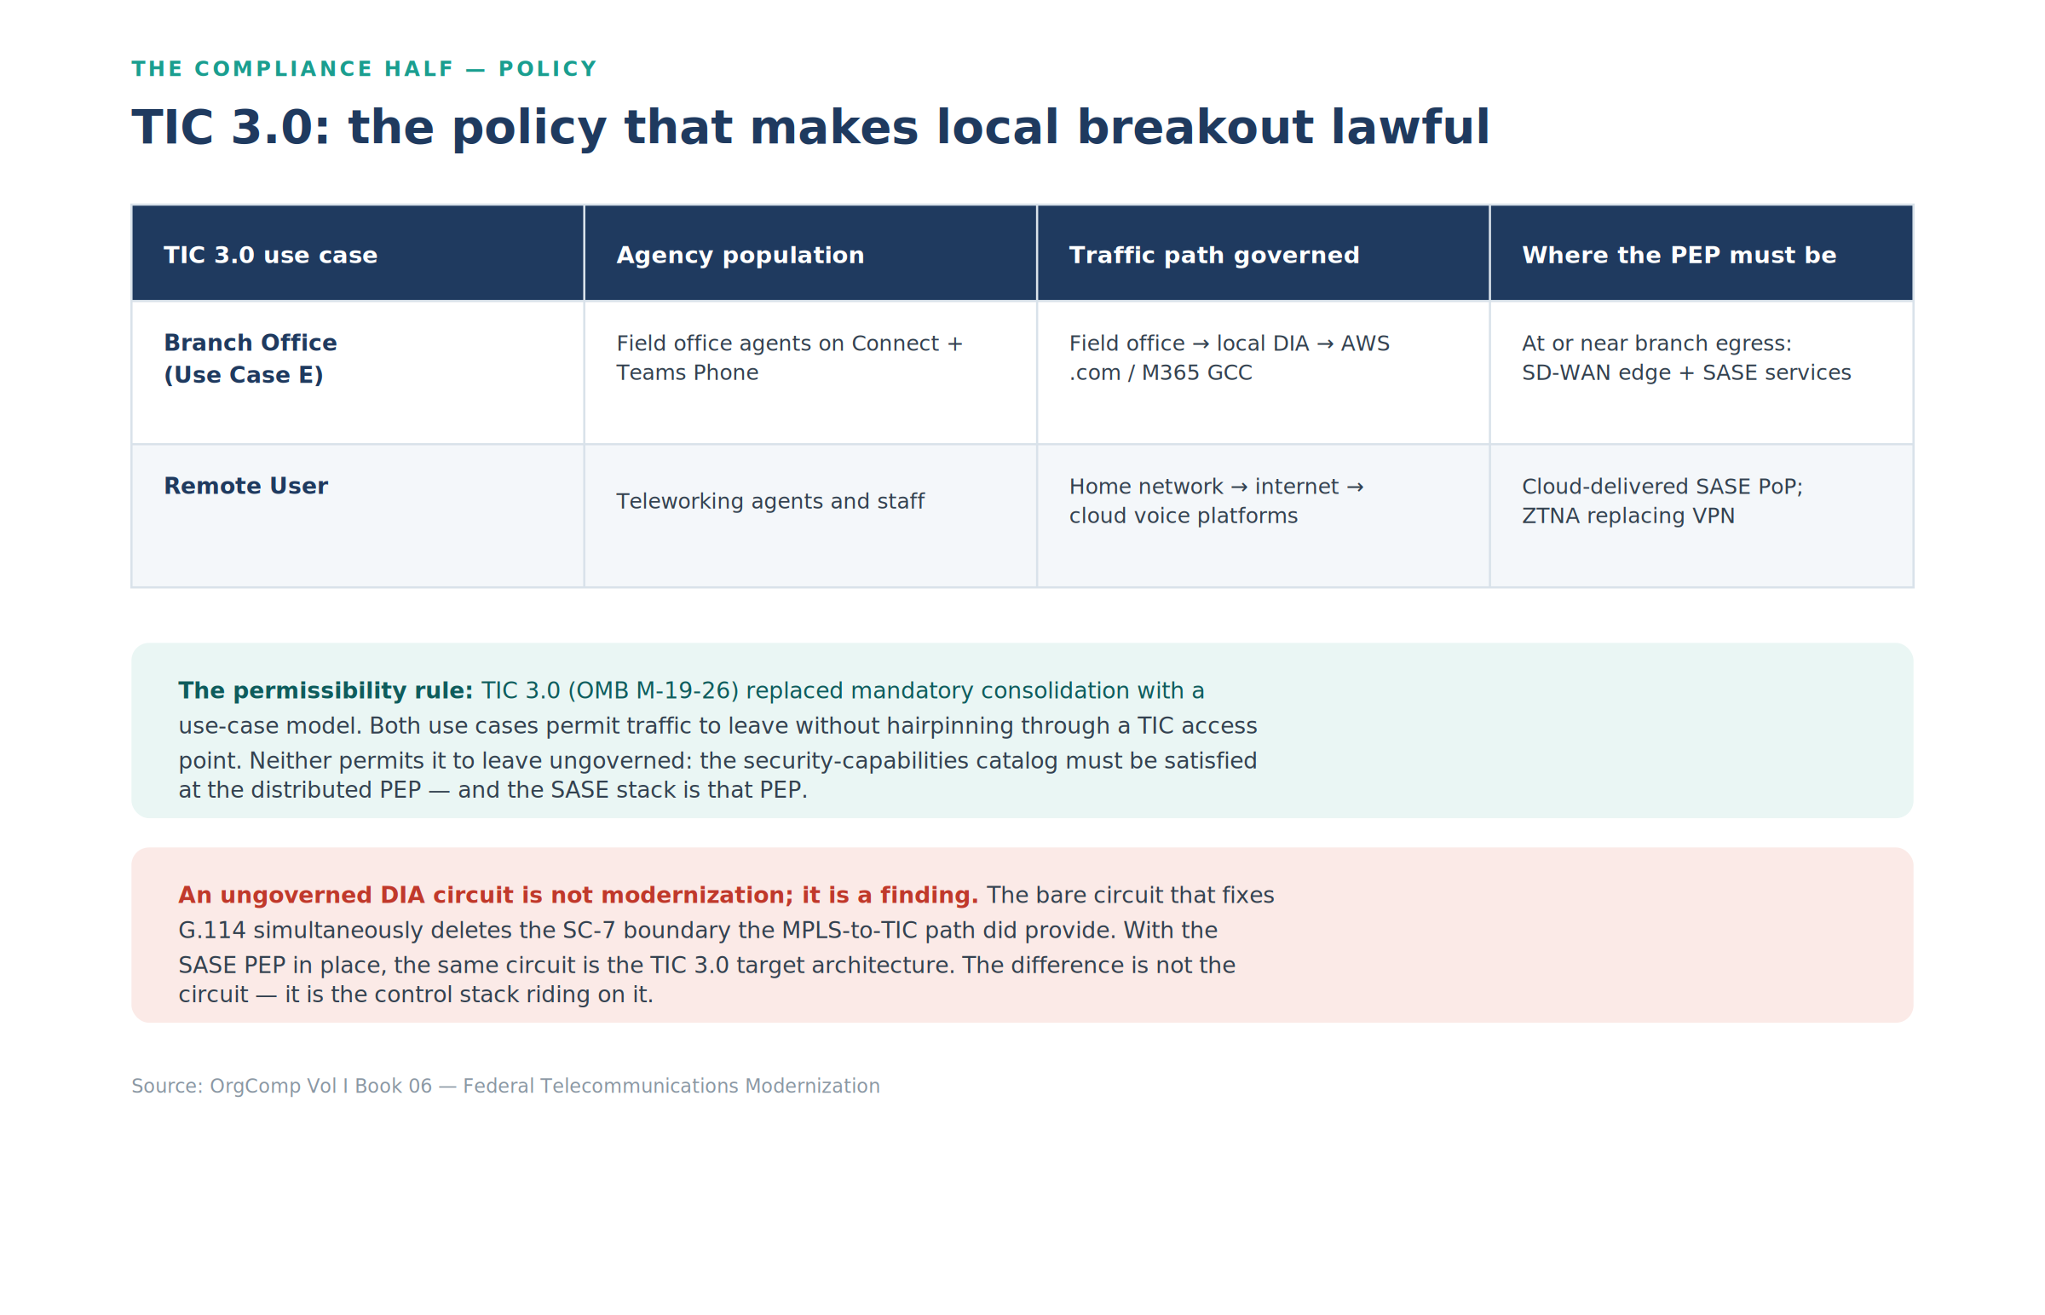
Figure 4: TIC 3.0: the two use cases governing the field-office path and the permissibility rule
The permissibility rule is the entire point: both use cases permit traffic to leave without hairpinning through a TIC access point, and neither permits it to leave ungoverned. The applicable entries of the TIC security capabilities catalog must be satisfied at the distributed PEP, commensurate with the agency’s risk tolerance. TIC 3.0 never asks “SD-WAN or DIA?” — it asks “where is the PEP on this DIA circuit, and which catalog capabilities does it satisfy?” An agency that cannot answer has not modernized; it has opened a finding.
Does an agency need SD-WAN to meet SASE and Zero Trust?
No. The two use cases above answer this directly: Remote User traffic reaches Zero Trust posture with zero SD-WAN in the path — a cloud-delivered SASE PoP as the PEP, ZTNA replacing VPN, done. SD-WAN is not a prerequisite for SASE or for Zero Trust; it is the transport-governance layer this paper’s own title names, and it earns its place for one reason only: Branch Office continuity. A branch’s traffic is high-value, often latency-sensitive, and typically spans multiple circuits at once — SD-WAN adds circuit-wide encryption (SC-8), active-active multipath, and per-class steering that a single teleworker’s cloud-PoP path doesn’t need and a single-circuit branch can’t get any other way. Skip SD-WAN and stay Zero-Trust-compliant if there is no branch circuit to govern; add it back the moment there is one, because that is the specific workload it solves.
CISA’s own June 2026 guidance, The Journey to Zero Trust: Using SASE in a Modern TIC 3.0 Solution, makes the same point from the other direction: it positions SASE as the piece that operationalizes Zero Trust for distributed federal traffic; SD-WAN does not appear in that framing at all, because CISA is describing the access-and-enforcement layer, not the branch-transport layer underneath it.

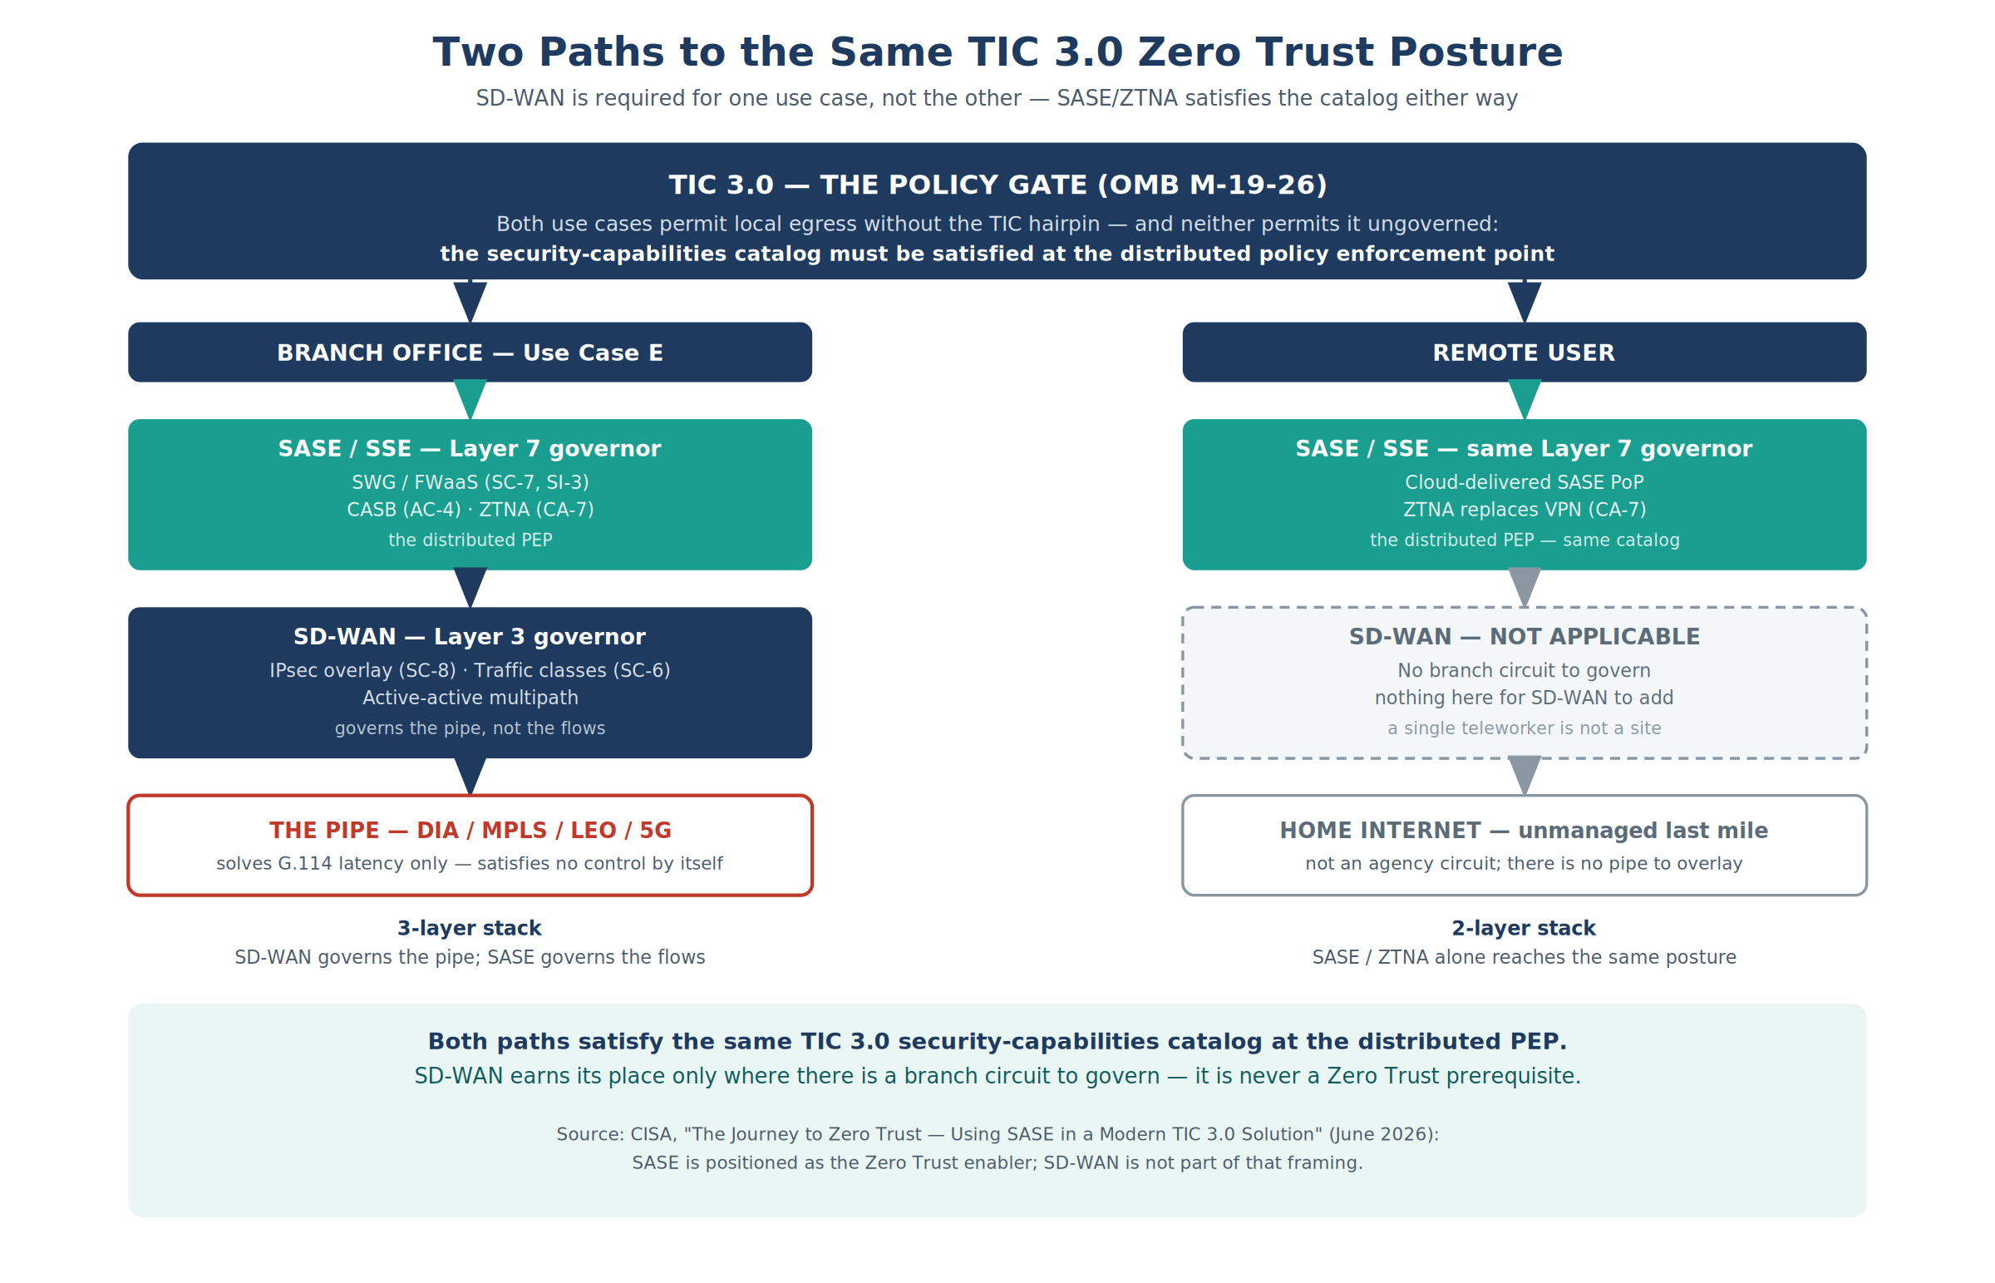
Figure 5: Two paths to the same TIC 3.0 Zero Trust posture — SD-WAN required for Branch Office, not for Remote User

4.1 Can Branch Office reach this without SD-WAN?
Sometimes — with real caveats, not a blanket yes. Part 5 breaks the closure into four pieces: SC-8 circuit-wide encryption, SC-6 traffic-class separation, SI-4/AU-12 application-layer path telemetry, and active-active multipath as the availability property behind all three. Each piece can, in principle, be closed by something other than a dedicated SD-WAN product — but not all of them survive the substitution equally well.
The terminology matters here. Gartner’s original 2019 definition of SASE already bundles SD-WAN in as one of its converged components — SASE is SD-WAN plus the SSE stack (SWG, CASB, ZTNA, FWaaS/NGFW) delivered from the cloud as one service. When this paper (or the industry generally) talks about “SASE without SD-WAN,” what is actually being described is SSE — Gartner’s own name for the security-only subset of SASE with the WAN-edge / transport-governance component removed. A Branch Office that skips SD-WAN is, by definition, running SSE plus something else for the transport leg — not a variant of SASE that happens to lack a component.
Two scenarios where that something-else genuinely does not need to be a standalone SD-WAN product:
- Single-circuit branch — the multipath closure is moot by construction. SD-WAN’s signature capability, active-active steering across paths, has nothing to steer across when there is exactly one circuit. A single-circuit branch can satisfy SC-8 with a plain IPsec or GRE tunnel from the branch router into the SASE PoP, with the SSE stack covering SC-7, AC-4, SI-3, and CA-7 as it would for any site. What this path does not close is CP-8 (NIST SP 800-53’s telecommunications services diversity control): one circuit is one circuit, and no overlay technology manufactures a second path that doesn’t physically exist. That is a documented risk-acceptance an authorizing official can make for a low-criticality site — a real, honest gap, not a control satisfied by another mechanism.
- A converged SASE vendor’s own branch connector. Several SASE/SSE vendors sell a lightweight branch appliance or connector that provides the encrypted tunnel and basic path awareness as part of the same platform as the SSE stack, rather than a separately procured, separately branded “SD-WAN” product. Per Gartner’s own definition above, this is not an exception to “you need SD-WAN” — it is SD-WAN, delivered as a converged capability inside one vendor’s fabric instead of as a distinct SKU. The functional requirement does not disappear; the procurement line item does.
What does not survive the substitution, with or without a branded SD-WAN product in the picture:
- Sub-second, per-flow active-active failover across multiple circuits. Traditional routing-based failover (BGP re-convergence, VRRP/HSRP gateway failover) operates at the whole-circuit level, on a timescale of seconds rather than the sub-second, per-flow failover an SD-WAN control plane provides. A multi-circuit branch that needs real resilience needs something doing this job — hand-built routing can approximate it, at materially worse failover performance.
- Per-application, per-class traffic steering across paths (SC-6). Routing traffic classes across specific circuits at the flow level is a policy-engine function; without one, per-class separation collapses to whatever a static routing table or manual QoS policy can express, which does not scale past a handful of sites and does not adapt to path conditions.
- The automated evidence trail for SI-4/AU-12. SD-WAN’s DPI-plus- steering-log is what turns “traffic was routed somewhere” into a per-flow, application-identified audit record. Hand-built routing does not produce this by default; even where the underlying control is arguably satisfied by manual means, the agency loses the machine-readable evidence Part 7’s compliance ledger depends on and is left assembling audit trails by hand — precisely the failure mode Part 1 argues against for the transport decision generally.
The honest bottom line: a multi-circuit Branch Office that needs genuine resilience always needs something performing SD-WAN’s function — whether procured as a distinct product or absorbed into a converged SASE vendor’s platform, per Gartner’s own definition of what SASE already includes. The clean exceptions are a single-circuit branch, where the correct answer is a documented CP-8 risk-acceptance rather than a claim that the control was closed some other way, and a converged-platform deployment, where the function is still present under a different name. Neither is “Zero Trust without transport governance” — both are transport governance delivered, or explicitly not delivered and named as such, rather than assumed away.

4.2 The other half of the bargain: telemetry to CISA
M-19-26’s trade was not “distributed enforcement for free” — it was distributed enforcement in exchange for visibility. An agency that distributes its egress assumes an obligation to share security telemetry with CISA; in the cloud-era architecture that means reporting patterns per the NCPS Cloud Interface Reference Architecture into CISA’s Cloud Log Aggregation Warehouse (CLAW). Neither CIRA nor CLAW answers “what telemetry is required” — that is CISA’s extensible Visibility Reference Framework (eVRF), which specifies the required telemetry by network vantage point; CIRA and CLAW describe the reporting pattern and the pipeline the telemetry travels once eVRF has said what must be collected. This matters to the compliance ledger in Part 7: agency-side continuous monitoring (CA-7) and the federal telemetry obligation are different artifacts — closing one does not close the other, and a distributed-egress design that cannot feed CLAW has satisfied its SSP and failed the program bargain. Two further mandates frame the telemetry story: OMB M-26-14 (22 May 2026), which rescinded M-21-31, defines the event-logging maturity levels (EL0–EL3) that any AU-12 claim in this paper is actually measured against, and OMB M-22-09 speaks directly to encrypted traffic and the inspection tradeoffs of Section 5.5.

4.3 The PEP has a location — apply Part 2 to it
This paper’s own physics argument applies to the enforcement point. If the Branch Office PEP is realized as a cloud SASE PoP, the flows it governs travel branch → PoP → destination, and the PoP’s location joins the latency budget. The FedRAMP-authorized PoP footprint available to an agency is materially thinner than the vendor’s commercial footprint — and if the nearest authorized PoP to a Portland field office is not near Portland, the agency has traded a TIC hairpin for a SASE hairpin and spent the G.114 budget anyway. The decision rule falls out of Part 2:
- Measure, don’t assume: probe round-trip from each branch to the nearest authorized PoP of each candidate vendor, from the FedRAMP Marketplace’s authorized-services list, not the commercial PoP map.
- If the detour to the authorized PoP consumes the voice budget, the PEP belongs at the branch edge (on-premises SD-WAN + security services at or near the egress) for latency-critical classes, with the cloud PoP governing the classes that can afford it.
- Steer per class, not per site: the Optimize-category discussion of Section 5.5 is the same decision applied to Microsoft’s latency-critical flows.
This is why the OrgComp series calls a bare DIA circuit (Part 1’s precise sense) a step backward: the MPLS hairpin it replaced was slow, but it did pass through an assessed network boundary. Bare DIA has better latency and no network boundary (endpoint- and host-based boundary controls, where present, are unaffected by the transport change). The formal treatment of boundary controls on distributed egress — SC-7, SC-7(7), AC-4 — is anchored in Vol I Book 07 and the Executive Summary’s necessity-anchor table.

Part 5 — SD-WAN: The Governor of Pipes
SD-WAN is the mechanism class that turns the Part 3 menu into one governed transport. Its contributions divide into three control closures no pipe can provide, plus one availability property that changed field-office operations. One scoping sentence up front, because the paper’s title invites the misreading: SD-WAN alone does not satisfy the TIC 3.0 Branch Office use case. The overlay closes SC-8 (circuit-wide), SC-6, and the transport share of SI-4; the boundary, flow-enforcement, and malware capabilities the TIC catalog demands at the PEP come from the SASE stack above it. A reader who buys the title’s SD-WAN and stops has bought the governor’s Layer 3 and skipped its Layer 7 — and still fails the use case. The defensible framing is DIA vs. SASE, with SD-WAN as the transport-governance component.
Figure 6: “SD-WAN vs. DIA” is a category error — the pipe, the two governor layers above it, and the TIC 3.0 gate above all three

5.1 Circuit-wide encryption (SC-8)
The SD-WAN overlay encrypts at the network layer — IPsec tunnels between WAN edges, with AES-256-GCM data-plane encryption on the platforms the OrgComp series references. State the FIPS claim the way an assessor will demand it: FIPS 140-3 validates cryptographic modules, not cipher suites or products, and the validation applies only in the configuration the CMVP certificate describes. The evidence bundle is a named CMVP certificate number, the deployed module version, and configuration evidence that each edge runs in the validated configuration (on several SD-WAN platforms, FIPS mode restricts tunnel types or portions of the data plane — the restriction is part of the evidence, not a footnote). Every packet the overlay carries is encrypted regardless of what application generated it and regardless of whether that application negotiated TLS. Part 7 states precisely what this does and does not claim.

5.2 Traffic-class separation (SC-6)
A pipe carries whatever arrives. The overlay classifies: voice marked and prioritized, bulk transfer kept out of the way of interactive traffic — and, in the database estate, Vol II Book 03’s lean/fat lane separation, where consensus heartbeats and quorum acknowledgments ride a protected class that backup and async-replication streams cannot starve. This is SC-6 (Resource Availability), not SC-5: allocating bandwidth by priority, quota, and unit allocation across classes is a resource-allocation control, and only the overlay has classes to allocate against. SC-5 (Denial-of-Service Protection) targets adversarial DoS attacks specifically — attack-restriction, capacity, bandwidth, and redundancy provisioning, and DoS detection — and this paper names no rate-limiting or DoS-detection mechanism elsewhere that would earn even partial SC-5 credit; closing SC-5 requires a separate, DoS-specific control, not traffic-class separation alone.

5.3 Application-layer path telemetry (SI-4, AU-12, CA-7)
A bare circuit reports link state and byte counts. Flow records see five-tuples. Neither can distinguish authorized use from exfiltration on port 443, and neither records why traffic took the path it took. The overlay’s DPI classifies the application per flow; its steering decisions are logged events; and the SASE stack above it records identity, posture, and action per session. This is the telemetry that feeds the series’ continuous-monitoring evidence pipeline — the machine-readable per-session records that CA-7 expects and that no collector can extract from a pipe that never carried the information. (Two scope notes from Part 4: the telemetry must also reach CLAW to honor the TIC bargain, and M-26-14’s EL tiers — not this paper — define what “logged” means for AU-12.)

5.4 Active-active multipath — the availability property
Traditional WAN design is active-passive: MPLS primary, broadband standby, and a 30–90-second switchover during which VPN tunnels drop, sessions time out, and field offices report the “45-second logon.” Active-active multipath carries traffic on all available paths — MPLS, fiber DIA, 5G, LEO — simultaneously, resequencing at the far edge and absorbing a path failure fast enough that sessions survive it.
Figure 7: SD-WAN active-active multipath: four transports, one application view
State the failover claim with its configuration basis, because the defaults do not deliver it: path-failure detection is BFD hello interval × multiplier, and common default profiles land in the high hundreds of milliseconds to seconds. A user-visible impact in the tens of milliseconds on a protected class generally requires per-packet duplication or forward error correction on that class — which is a bandwidth cost (duplication doubles the protected class’s consumption; FEC adds its coding overhead) that belongs in the design, not in the fine print. The OrgComp reference configuration names the tuned BFD profile and confines duplication/FEC to the voice and interactive classes where the budget justifies it.
Two structural consequences matter beyond user experience. First, asymmetric routing is removed by construction — for overlay-carried flows: both directions of an overlay-encapsulated site-to-site conversation enter and exit the same edge pair, so the stateful-middlebox failure mode — SYN out one path, SYN-ACK back another, handshake never completes — cannot occur above the overlay. Scope the claim honestly: it does not cover locally broken-out internet and Optimize flows (which never enter the overlay), dual-edge sites with independent breakout, or multi-hub ECMP designs — those paths need conventional symmetric-routing discipline.
Second, every path decision is a logged event, which converts multipath from an audit liability (four uncorrelated pipes) into an audit asset (one decision log). Vol I Book 05 develops both, including the corrected Kerberos-under-failover analysis in Vol I Book 03.

5.5 The M365 case — steering around the overlay, on purpose
Microsoft’s network connectivity principles instruct agencies to egress M365 traffic locally, avoid hairpins, and give Optimize-category endpoints (Teams media above all) no inspection, no proxy, no detour. An SD-WAN deployment honoring that guidance — Cloud OnRamp probing the M365 front door across every transport and steering Teams media to the best-measured local path — may carry Optimize flows outside the IPsec overlay entirely.
Figure 8: Microsoft 365 local breakout vs. backhaul — the front door matters more than the destination
For SC-8, that is the per-flow concession of Part 7 made deliberate: Optimize flows carry their own FIPS-validated encryption (TLS; SRTP for media), and the overlay continues to encrypt every flow that does not. But the honesty clause cannot stop at SC-8, because the same carve-out punctures the inspection controls identically: a flow that bypasses the proxy has no SWG inline inspection (SI-3), no visibility into the content of encrypted communications (SI-4(10), satisfied for proxied flows by the SWG’s TLS break-and-inspect and absent by design for Optimize-bypassed flows), no CASB flow enforcement (AC-4), and no application-layer audit record. Records are still generated for those flows, so what degrades is their content — an AU-3 requirement, which AU-12 incorporates by reference: five-tuple plus steering metadata on encrypted media, not “user, device, app, action, data type.”
One case looks like a hard contradiction and is not — but only if the agency does something about it. Tenant-to-tenant exfiltration over an Optimize-categorized path is exactly the case an assessor will construct. The natural answer concedes it: Microsoft’s tenant restrictions v2 is enforced by header injection at an in-path proxy, so a proxy-bypassed flow cannot carry it. That answer is wrong, and worth correcting precisely because it is the intuitive one. Proxy enforcement is the tenant restrictions v1 model. Under v2 it survives as one of three enforcement paths for a single cross-tenant access policy, and it is the weakest of the three — the only one that reaches the authentication plane alone and never the data plane. Microsoft’s setup guidance documents two paths that need no proxy: Windows Group Policy signaling on corporate-owned devices, which carries both authentication-plane and data-plane protection with policy evaluation still in the cloud, and universal tenant restrictions via Global Secure Access, which covers the authentication plane on every platform and the data plane for Microsoft Graph only.
The control therefore does not vanish with the proxy. It moves to the endpoint, where the coverage is better than what the proxy provided. Two limits keep that honest. The Group Policy path covers Office applications, Universal Windows Platform .NET applications and Microsoft Edge — non-Edge browsers and non-Windows devices at an exempted site fall outside it and have to be enumerated rather than assumed away. And the Entra federal crosswalk records Global Secure Access as non-FIPS in GCC Moderate and unavailable in GCC High and DoD, which makes Group Policy signaling the path a FedRAMP Moderate agency can actually rely on rather than one option among equals. Device-side signaling configured and verified is a precondition of the carve-out, not a footnote to it.
The compliant shape of the carve-out is therefore not “the steering log says so” — documentation alone is not a compensating control. It is SC-7(4)’s documented traffic-flow exception discipline: each Optimize-category bypass recorded as a named exception with its supporting mission need, reviewed on a cadence, with the steering log as the enforcement evidence that the exception’s boundaries hold — plus compensating controls where they exist (identity-tier conditional access; tenant allow-listing re-signaled from the endpoint rather than the proxy, per the paragraphs above; endpoint DLP for content controls the network cannot see). Part 7’s ledger carries an explicit “applies to” scoping per control so the exception is visible where an assessor will look for it. Vol I Book 05’s M365 appendix carries the build, including the GCC Moderate caveat that Microsoft’s Informed Network Routing telemetry is unavailable in that cloud and probe-based steering is the implementation.

5.6 The flows the honesty clause names: DNS
Part 7’s honesty clause lists DNS among the flows that ride the circuit bare — and DNS deserves more than a mention, because Protective DNS is a TIC security capability and a mandated federal shared service, and local breakout changes the branch’s resolution story twice. First, every DIA egress must resolve through the agency’s protective resolver (in the OrgComp reference build, the DDI platform’s RPZ with the CISA Protective DNS feed — Vol I Book 01); a branch whose DNS follows the default route to the ISP resolver has opened an unmonitored control channel regardless of how good the overlay is. Second, local breakout breaks split-horizon assumptions: a branch that resolves internal names via the overlay and external names via local breakout needs its resolution policy designed, not inherited. SC-20/SC-21 closure on the branch path is a naming-plane function and lives with the DDI books, but a transport paper that names DNS as a bare flow owes the reader the pointer.

Part 6 — The Governor Is Also Attack Surface
A paper that credits the governor with eight control closures owes the reader the other side of the entry: the governor is the most valuable target on the WAN. Two structural facts drive the risk.
The controller has agency-wide blast radius. An SD-WAN orchestrator holds routing and policy authority over every branch simultaneously; a compromise is not a site incident but an enterprise event. This is not hypothetical risk-register material: edge and management-plane products are among the most actively exploited categories in federal networks, and the canonical SD-WAN example — the Versa Director vulnerability CVE-2024-39717, KEV-listed and attributed with moderate confidence by Lumen Black Lotus Labs to Volt Typhoon activity — is precisely a compromise of the governor, not the pipe. The Ivanti and Fortinet edge-appliance campaigns are the same lesson from adjacent categories.
Distribution multiplies the exposed surface. Moving from roughly two hardened TIC egress points to a couple of hundred internet-facing edge devices is a real increase in initial-access surface and a real loss of a containment chokepoint. The design answer is not to un-distribute; it is to treat the fleet as the security system it is.
The controls an assessor will expect on the governor itself:
The governor’s own ledger — the controls that protect the control plane
Exposure | Controls | Design answer
Orchestrator compromise | AC-17, SC-7, IA-2 | Controller isolated from the data plane; out-of-band management network; ZTNA in front of the orchestrator; no management interface on the internet — the baseline CISA Binding Operational Directive 23-02 (Mitigating the Risk from Internet-Exposed Management Interfaces) sets for routers, switches, firewalls, VPN concentrators, proxies, load-balancers, and OOB management
Edge device identity | IA-3 | Certificate-based device authentication for every edge joining the fabric; no shared enrollment secrets
Fleet key management | SC-12, SC-13, SC-17 | Automated key establishment and rotation across the fleet; PKI-issued identities; documented CMVP module evidence per Section 5.1
Fleet patch and vulnerability posture | SI-2, RA-5 | Patch cadence and authenticated scanning stated for 200 sites, not asserted for one; KEV-listed CVEs on edge platforms treated as clock-started events under CISA Binding Operational Directive 22-01 (Reducing the Significant Risk of Known Exploited Vulnerabilities), which established the KEV catalog and its CVE-specific remediation deadlines
Configuration integrity | CM-3, CM-6, CM-7 | Template-driven configuration with change control; drift detection against the declared baseline; least functionality on every edge
Supply chain | SR-3, SR-5 | Provenance and acquisition controls for the edge fleet and its controller — the same discipline Part 8 applies to transport acquisition
Containment when an edge falls | IR-4 | A written answer to “how do we isolate one branch edge — and the controller — during an incident,” rehearsed, not implied by the topology
Crypto-agility is part of this surface. A recommendation to standardize agency-wide, long-lived IPsec invites the harvest-now-decrypt-later objection, and the answer belongs in the design rather than a future retrofit: post-quantum key establishment for IKEv2 exists in interim form (RFC 8784 pre-shared augmentation; RFC 9370 multiple key exchanges) with ML-KEM standardized in FIPS 203, and CNSA 2.0 under NSM-10 sets the federal transition expectations. The two questions to put to any SD-WAN vendor today: what is the PQ roadmap for the tunnel establishment path, and what is the operational story for rekeying a 200-edge fleet when the answer changes.

Part 7 — The Compliance Ledger
The control-by-control ledger for the field-office path, stated as the OrgComp series registers it. Scope note, stated plainly: this ledger is the pipe-vs-governor comparison, not the system’s full control story. The operational controls a 200-site distributed-PEP design also carries — IA-3, SC-12/SC-13/SC-17, CM-3/CM-6/CM-7, SI-2, RA-5, AC-20, IR-4 — are Part 6’s table; CP-8 is Part 3’s; the RMF change controls are Part 8’s. Closures are anchored per book; this table is a reader’s map, not a claims register.
Figure 9: DIA enables — SASE achieves: the NIST control stack on a governed circuit

The ledger — what the pipe provides, what the governor provides, and where each claim actually applies
NIST SP 800-53 Rev 5 control | Bare DIA provides | Provided on a governed circuit by | Applies to | Inheritance / responsibility | Closure anchored in
SC-8 / SC-8(1) Transmission Confidentiality and Integrity | Nothing — unencrypted at the network layer | SD-WAN IPsec overlay (circuit-wide) | All overlay-carried flows; Optimize exception: bypassing flows rest on their own FIPS-validated TLS/SRTP (the per-flow closure) | Agency-implemented — SD-WAN overlay procured and operated by the agency; not inherited from a CSO by default | Vol I Book 07
SC-7 Boundary Protection | Nothing — egress outside the assessed boundary | SASE SWG/FWaaS at the distributed PEP | All proxied flows; Optimize bypass documented as an SC-7(4) traffic-flow exception with mission justification and periodic review | Shared — inherited from the authorized SASE CSO at the distributed PEP; name the specific CSO and CRM line during acquisition (Part 8) — TBD, no vendor selected in this paper | Vol I Book 07
SC-7(8) Route Traffic to Authenticated Proxy Servers | Nothing | SWG as the authenticated proxy for the routed classes | Proxied classes only — this is the control that makes the proxy claim assessable | Shared — inherited from the authorized SASE CSO; CSO and CRM line TBD at acquisition (Part 8) | Vol I Book 07
AC-4 Information Flow Enforcement | Nothing | SASE CASB — application, tenant, data type, action | Proxied flows; CASB flow enforcement not deliverable on Optimize-bypassed flows. Tenant restrictions v2 is not lost with the proxy — its Windows Group Policy path needs none and reaches the data plane (§5.5) — but it must be signaled from the endpoint and verified | Shared — inherited from the authorized SASE CSO; CSO and CRM line TBD at acquisition (Part 8) | Vol I Book 07
SC-6 Resource Availability | Nothing | SD-WAN traffic classes and per-class path policy — priority, quota, and unit allocation across classes | All overlay-carried flows | Agency-implemented — SD-WAN overlay traffic-class policy configured by the agency | Vol II Book 03
SC-5 Denial-of-Service Protection | Nothing | Not closed by traffic-class separation alone — SC-5 targets adversarial DoS (attack-restriction, capacity/bandwidth/redundancy provisioning, DoS detection); this paper names no rate-limiting or DoS-detection mechanism that would earn even partial credit | Not applicable to this design as described — requires a separate, DoS-specific control | Not applicable | —
SI-3 Malicious Code Protection | Nothing | SWG inline SSL inspection at the nearest PoP | Proxied flows; no inline inspection on Optimize-bypassed flows — compensate with endpoint protection and the SC-7(4) exception record | Shared — inherited from the authorized SASE CSO; CSO and CRM line TBD at acquisition (Part 8) | Vol I Book 06 cross-references
SI-4 / SI-4(10) System Monitoring / Visibility of Encrypted Communications | Link state and byte counts | Overlay DPI + SASE per-session telemetry; SI-4(10) encrypted-traffic visibility satisfied by SWG TLS break-and-inspect | All flows for path/steering telemetry; session-content telemetry, including SI-4(10) visibility, on proxied flows only — absent by design on Optimize-bypassed flows | Agency-implemented (overlay DPI) / Shared (SASE per-session telemetry, incl. SI-4(10)) — CSO and CRM line TBD at acquisition (Part 8) | Vol I Books 05–07
AU-12 Audit Record Generation | IP flow logs | Per-session records: user, device, app, action, data type | Proxied flows; Optimize-bypassed flows yield five-tuple + steering metadata only — measure against M-26-14 maturity levels | Agency-implemented (overlay steering log) / Shared (SASE session records) — CSO and CRM line TBD at acquisition (Part 8) | Vol I Books 05–07
CA-7 Continuous Monitoring | Nothing machine-readable | Per-session evidence into the series’ ConMon pipeline and telemetry to CISA CLAW (Part 4.2 — a distinct artifact) | All flows, at the fidelity each class permits | Agency-implemented — ConMon pipeline; CLAW is a separate federal-reporting obligation, not CSO inheritance | Evidence-fabric books
CP-8 Telecommunications Services (+ CP-8(2), CP-8(3) only) | CP-8(2)/CP-8(3) closed by the transport menu itself — no single point of failure, separation of primary and alternate providers; CP-8(1) priority of service requires contractual TSP/NS-EP provisions and CP-8(4) provider contingency plan requires the provider’s own documented plan — neither satisfied by transport diversity alone | Transport selection and diversity (Part 3) for CP-8(2)/CP-8(3); acquisition vehicle (Part 8) for CP-8(1); provider deliverable (Part 8) for CP-8(4) | The circuit portfolio, not any single circuit | Agency-implemented via the acquisition vehicle (Part 8); CP-8(4) evidence is a provider deliverable, not agency-authored | Part 3 of this paper; acquisition controls in Part 8
The honesty clause. The SC-8 row above is a coverage-completeness claim, not an exclusivity claim, and the series states it that way on purpose. FedRAMP’s Rev 5 data-in-transit guidance (“The Rev. 5 Approach to SC-8, and Protecting Data-in-Transit,” 2023) requires FIPS 140-validated encryption and names no protocol: FIPS-validated TLS closes SC-8 for the flow that negotiates it, physical protection moved to SC-8(5) Protected Distribution System — FedRAMP’s Rev 5 SC-8 guidance glosses this enhancement as a “Controlled Access Area” path, but that is FedRAMP’s own alternative-compliance-path language, not the enhancement’s formal NIST title — and SC-8 is inheritable for traffic that originates and terminates inside an authorized boundary. None of those paths reaches a field-office DIA circuit egressing over the public internet — traffic originates outside every authorized boundary, no Controlled Access Area encloses the internet, and per-flow TLS closure must be demonstrated flow by flow while DNS lookups (Section 5.6), legacy protocols, and misconfigured applications ride the same circuit bare. The overlay’s contribution is uniform coverage of all flows and a single circuit-level attestation; among overlay classes (site-to-site IPsec, ZTNA tunnels, WireGuard-class), SD-WAN is the one that also delivers the SC-6 and SI-4 closures of Part 5. The Executive Summary’s rebuttal box carries the full counter-source treatment, including the “our traffic is M365 and M365 is already encrypted” objection resolved in Section 5.5 — and Section 5.5 extends the same honesty to SI-3, AC-4, and AU-12, where the ledger’s “applies to” column records it.

Part 8 — The Decision Sequence
For a decision maker, the whole paper compresses to an ordered checklist:
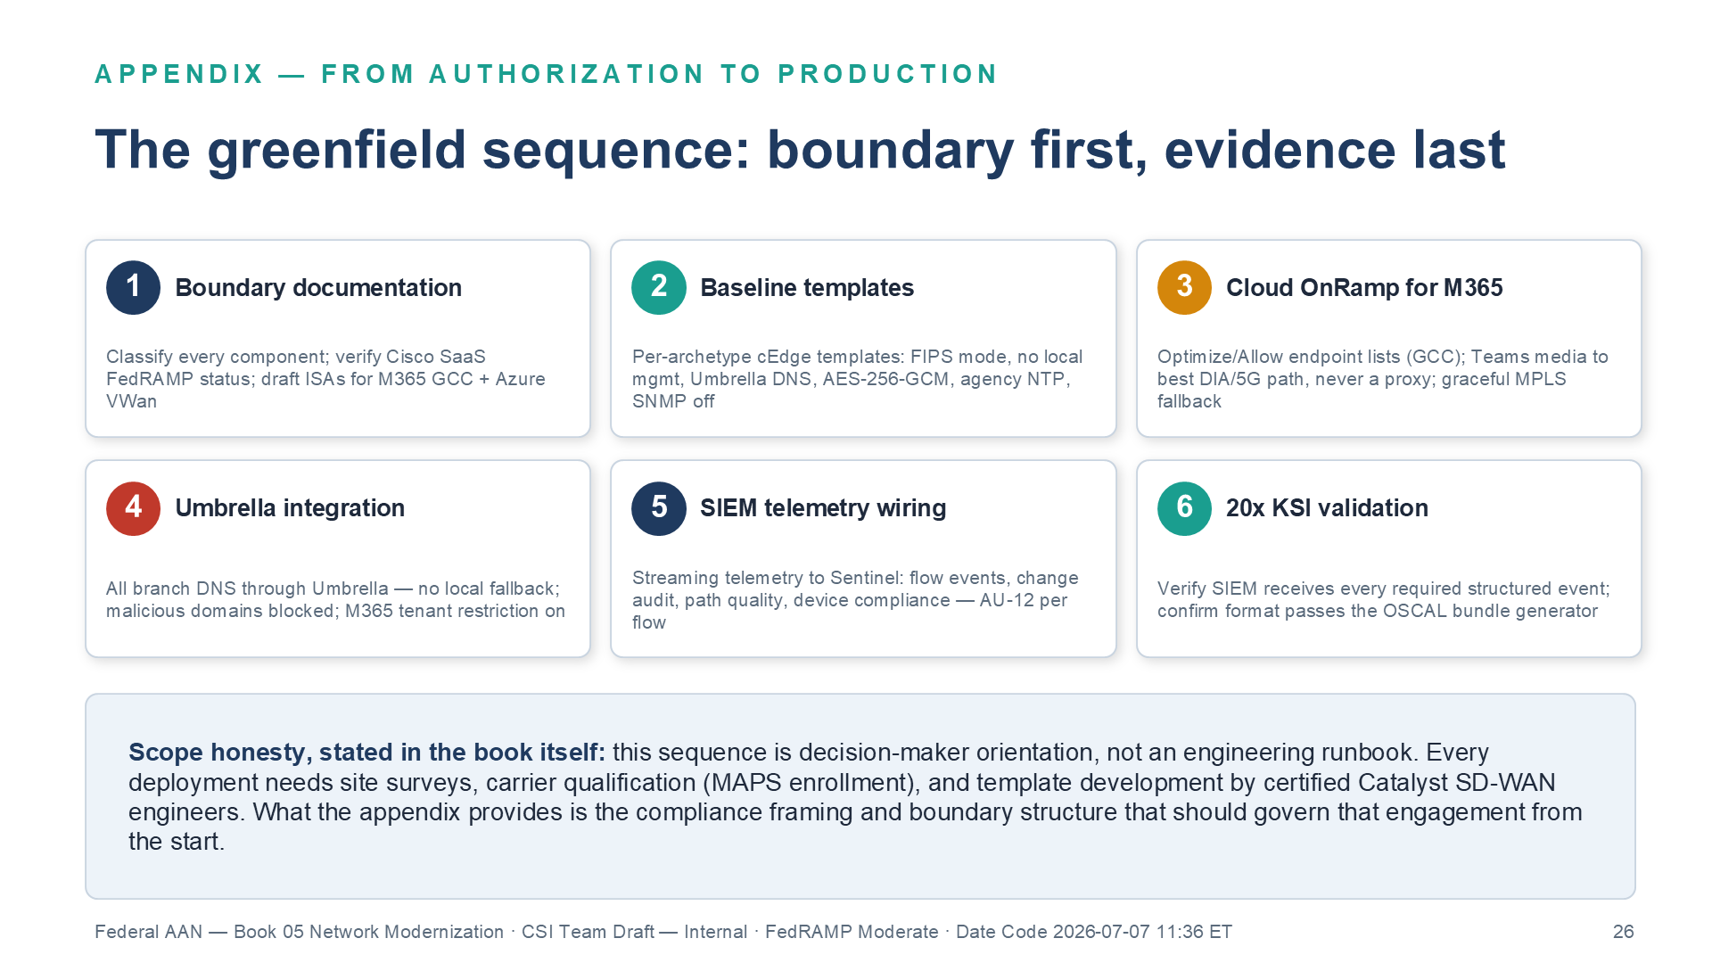
Figure 10: The implementation sequence — boundary first, evidence last
- Buy the pipe on measured physics — within the acquisition and supply-chain envelope. Choose DIA transports — fiber, 5G, LEO, retained MPLS — on measured latency to the destinations that matter (M365 front door, contact-center region, the nearest authorized SASE PoP per Section 4.3), on the G.114 budget, and on the CP-8 diversity the portfolio must deliver. Physics ranks the candidates; the envelope bounds them: Section 889 prohibitions, the agency’s acquisition vehicles (EIS/GSA), SCRM obligations (SR-3, SR-5, SR-6), and — for managed LEO or 5G MEC services — the provider’s authorization status and ownership posture. No transport choice earns protection-control credit; the portfolio’s diversity earns the CP-8(2)/CP-8(3) credit. Two further CP-8 enhancements are decided here, in acquisition, not on the transport menu: CP-8(1) Priority of Service Provisions requires enrolling qualifying circuits in the Telecommunications Service Priority (TSP) program and writing NS-EP priority-restoration provisions into the acquisition vehicle itself — a contract artifact, not a purchasing decision — and CP-8(4) Provider Contingency Plan requires obtaining and retaining the provider’s own documented contingency plan as acquisition evidence; neither is authored or satisfied by the buyer’s diversity choice.
- Deploy the governor before the pipe carries production traffic — and protect the governor. The SD-WAN overlay (encryption, classes, telemetry, multipath) and the SASE stack (SWG, CASB, FWaaS, ZTNA) are where the TIC 3.0 security capabilities live; Part 6’s ledger is the price of admission for operating them. A DIA circuit lit before its PEP exists is a finding with good latency. Vendor selections for both layers are agency-procurement decisions; the OrgComp series names deployed examples of each mechanism class, with alternatives enumerated per layer.
- Treat distributed egress as the significant change it is. Moving branches from the TIC hairpin to distributed egress changes the authorization boundary: SSP and boundary-diagram updates, a security impact analysis, and the CA-6 authorization decision on the change belong before cutover, and the CLAW telemetry path of Section 4.2 belongs in the same package. This is the step that actually gates deployment, and it is missing from most modernization schedules.
- Steer M365 by Microsoft’s categories, and file the exception. Optimize-category traffic egresses locally on its own validated encryption; everything else rides the overlay; each bypass is an SC-7(4)-documented traffic-flow exception with its mission justification, review cadence, and compensating identity-plane controls — with the steering log as enforcement evidence that the exception’s boundaries hold.
- Register the closures where the series anchors them. The control-by-control builds, KSI evidence contracts, and ConMon wiring are owned by the OrgComp volumes: Vol 0 Book 00 for the doctrine and its counter-sources, Vol I Book 05 for transport physics, multipath, and the M365/Cloud OnRamp build, Vol I Book 06 for voice, G.114, and the TIC 3.0 use cases, Vol I Book 07 for the enforcement-substrate closure anchors, and Vol II Book 03 for the physics floor and traffic-class doctrine.
The one-sentence version: physics buys you the pipe, diversity buys you CP-8, the governor buys you the protection controls, TIC 3.0 is why you may not stop at the pipe — and no future transport, 6G included, changes which of those you are allowed to skip: none.

References
Authorities and primary sources asserted in this paper. Verification status for externally sourced claims is tracked in the OrgComp External Verification Register (EV-M091–M096).
- ITU-T Recommendation G.114 — One-way transmission time (the 150 ms one-way budget).
- OMB Memorandum M-19-26 — Update to the Trusted Internet Connections (TIC) Initiative (the use-case model and the telemetry bargain).
- CISA TIC 3.0 core guidance — Program Guidebook, Reference Architecture, Security Capabilities Catalog (current published version), and the Branch Office use case.
- CISA, “The Journey to Zero Trust: Using SASE in a Modern TIC 3.0 Solution” (June 2026) — positions SASE as the Zero Trust enabler for distributed federal traffic; the source behind Part 4’s SD-WAN-optionality callout. Same underlying document already cited via EV-M094’s telemetry verification below; this is its first standalone bibliography entry.
- Gartner, “The Future of Network Security Is in the Cloud” (2019) — coined Secure Access Service Edge (SASE) and defined it as SD-WAN converged with Security Service Edge (SSE) technologies (SWG, CASB, ZTNA, FWaaS/NGFW) delivered primarily as a cloud service; the basis for §4.1’s SASE-vs-SSE terminology distinction (SSE is the security-only subset of SASE with the SD-WAN/transport-governance component removed).
- NCPS Cloud Interface Reference Architecture, Vols. 1–2 — the reporting patterns for agency telemetry to CISA’s Cloud Log Aggregation Warehouse (CLAW).
- CISA extensible Visibility Reference Framework (eVRF) — specifies the telemetry required at each network vantage point; CIRA/CLAW carry it, they do not define it.
- OMB Memorandum M-26-14 — Ensuring Effective and Efficient Agency Logging and Network Visibility (22 May 2026), rescinding M-21-31, Improving the Federal Government’s Investigative and Remediation Capabilities (EL0–EL3 logging maturity).
- OMB Memorandum M-22-09 — Moving the U.S. Government Toward Zero Trust Cybersecurity Principles (encrypted-traffic and inspection posture).
- FedRAMP, “The Rev. 5 Approach to SC-8, and Protecting Data-in-Transit” (fedramp.gov, 2023-07-13).
- NIST SP 800-53 Rev 5 — control text for SC-8 / SC-8(5) (Protected Distribution System), SC-6, SC-5, SC-7(4), SC-7(8), SI-4(10), CP-8 and its enhancements CP-8(1)–CP-8(4), and the Part 6 fleet controls; NIST SP 800-37 Rev 2 — the RMF significant-change discipline behind Part 8 step 3.
- CISA Binding Operational Directive 23-02 — Mitigating the Risk from Internet-Exposed Management Interfaces (Part 6’s “no management interface on the internet” baseline).
- CISA Binding Operational Directive 22-01 — Reducing the Significant Risk of Known Exploited Vulnerabilities (established the KEV catalog and its CVE-specific remediation deadlines).
- Microsoft 365 network connectivity principles and endpoint categories (Microsoft Learn); Set up tenant restrictions v2 — the three enforcement paths and the v1/v2 comparison behind §5.5.
- ITU-R Recommendation M.2160 (IMT-2030 framework); 3GPP Release 20/21 6G study and specification timeline.
- RFC 8784, RFC 9370 — post-quantum interim key establishment for IKEv2; NIST FIPS 203 (ML-KEM); CNSA 2.0 / NSM-10 transition guidance.
- CISA Known Exploited Vulnerabilities catalog — CVE-2024-39717 (Versa Director) and the edge-management-plane exploitation record.
- Lumen Black Lotus Labs — exploitation of CVE-2024-39717 (Versa Director) attributed with moderate confidence to Volt Typhoon activity.
- Section 889, FY2019 NDAA — covered telecommunications equipment and services prohibitions.

Call to Action
Part 8 already compresses this paper to an ordered checklist. What’s still missing from most modernization schedules is a date and an owner for each of its five steps.
Before the next transport or SD-WAN procurement decision
- Run Part 8 as a checklist against your current portfolio, not a future one. For every circuit in flight today, answer step 1 (measured physics within the acquisition envelope) and step 2 (is the governor deployed before the pipe carries production traffic) — in that order.
- File the CA-6 authorization boundary update before cutover, not after. Step 3 is the step most schedules skip. Distributed egress is a significant change; the SSP and security-impact-analysis paperwork belongs before branches move off the TIC hairpin.
- Name the owner for each of the five steps. Acquisition owns step 1’s SCRM/Section 889 envelope and the CP-8 enhancements; network engineering owns steps 2 and 4; the AO/ISSO owns step 3’s authorization decision; the OrgComp volumes (step 5) are the register, not a substitute for an owner.
- Bring the physics argument to the acquisition conversation, not just the network diagram. Part 8’s one-sentence version — physics buys the pipe, diversity buys CP-8, the governor buys the protection controls, TIC 3.0 is why you can’t stop at the pipe — is written to be handed to whoever signs the transport contract.

No future transport class, 6G included, changes which of these four steps is optional. None of them are.

