M365 GCC-Moderate Telemetry & Boundary Assessment
Consolidated, normalized assessment — FedRAMP Moderate only
Document title | M365 GCC-Moderate Telemetry & Boundary Assessment
Version | 1.0 (External)
Date | April 25, 2026
Authorization scope | FedRAMP Moderate only (M365 GCC-Moderate, .com commercial cloud)

0. Scope and Normalization Rules
This document presents a consolidated assessment of Microsoft 365 GCC-Moderate telemetry gaps, synthesized from multiple analytical sources together with operational dashboard-coverage findings. It has been normalized to FedRAMP Moderate only.

What “FedRAMP Moderate only” means in this document
- Target environment: Microsoft 365 GCC-Moderate, which operates in the .com commercial cloud domain under a FedRAMP Moderate authorization boundary.
- Out of scope as an authorization target: GCC-High, DoD, and any other FedRAMP High environment. References to those environments appear only where (a) Microsoft's own documentation enumerates them in a single line that names GCC-Moderate as well, or (b) they serve as a comparator that helps explain how FedRAMP Moderate behaves.
- Documentation purity rule: .us-domain documentation and any GCC-High or DoD-specific page must not be applied to GCC-Moderate (.com) without separate justification. The .com boundary enforces telemetry constraints more strictly than the .us boundary, not less. Importing .us conclusions into .com is therefore an unsafe inference.
- AWS GovCloud is excluded from the primary findings. AWS GovCloud is FedRAMP High plus DoD SRG IL2/4/5 plus ITAR — it is not a Moderate environment. AWS material is acknowledged in Appendix B as a comparator only.

Methodology — the boundary-inference framework
The single most important methodological position taken in this assessment is that absence of an explicit “not available in GCC-Moderate” statement is not evidence of availability. Many telemetry-dependent capabilities are constrained by the FedRAMP Moderate authorization boundary itself, regardless of what any product page says.
The constraining controls are summarized in the table below.
NIST 800-53 control | Constraint applied to outbound telemetry
SI-4 (Information System Monitoring) | Monitoring data must remain within the authorized boundary unless explicitly scoped and authorized for export.
AU-2 / AU-3 (Audit Events / Content of Audit Records) | Audit content shipped off-boundary to commercial multi-tenant analytics may exceed authorized export scope.
SC-7 (Boundary Protection) | Continuous, rich telemetry to multi-tenant analytics services is exactly the cross-boundary flow SC-7 forces agencies to constrain.
Reverse-inference rule. If a feature requires telemetry to flow to Microsoft's commercial multi-tenant processing pipeline, and the FedRAMP Moderate boundary restricts that outbound flow under SI-4, AU-2, AU-3, or SC-7, then the signal is blocked or degraded by architecture — even when no Microsoft product page explicitly says so. This document marks every such finding “Inferred blocked by FedRAMP boundary architecture” rather than asserting documented unavailability.
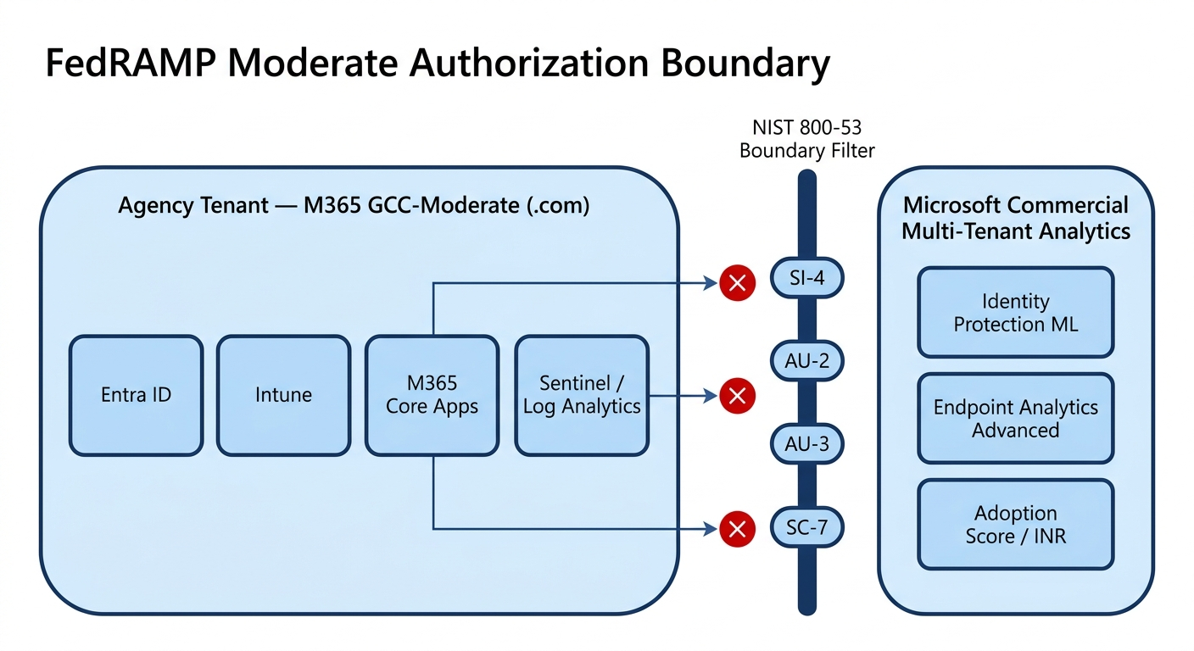
Figure 1. FedRAMP Moderate authorization boundary — the .com agency tenant in scope, the commercial multi-tenant analytics out of scope, and the four NIST 800-53 controls (SI-4, AU-2, AU-3, SC-7) acting as the constraining filter on outbound telemetry.

1. Executive Summary
Position. Microsoft 365 GCC-Moderate provides the same nominal product set as Microsoft 365 commercial, but the FedRAMP Moderate authorization boundary materially constrains the outbound telemetry that drives many of the platform's higher-order analytics. The result is a structural reduction in the fidelity of signals available for Zero Trust decisions, anomaly detection, insider-risk detection, and forensic reconstruction.
Two confirmed-unavailable telemetry-driven capabilities (with direct Microsoft documentation):
- Microsoft Adoption Score — Microsoft's own page states the feature is not available in GCC, GCC High, and DOD tenants. The “GCC” item in that list is GCC-Moderate.
- Microsoft Informed Network Routing (INR) — Microsoft's own page states INR supports tenants in WW Commercial cloud but not the GCC Moderate, GCC High, DoD, Germany, or China clouds.
One disputed but partially-confirmed-unavailable capability:
- Endpoint Analytics — Advanced Analytics tier (Intune) — The Advanced Analytics overview page lists sovereign-cloud support as limited to GCC High and DoD only; GCC-Moderate is not listed. Whether base-tier Endpoint Analytics is available is not explicitly documented.
Capabilities that have GCC-Moderate-specific connection guidance (i.e., are supported, contrary to some earlier conclusions):
- Teams Call Quality Dashboard (CQD) — supported with GCC-specific docs; EUII retention is the operational constraint, not feature absence.
- Microsoft 365 Usage Analytics — supported via the GCC-specific Power BI connector; only the Marketplace template app variant is missing.
Five product areas with no explicit unavailability documentation but architecturally constrained outbound telemetry (inferred blocked):
- Entra ID — Identity Protection ML risk scoring and cross-tenant analytics
- Intune — advanced compliance, app-protection, WUfB, and EPM analytics
- M365 core apps — Office “Optional” diagnostic data, Copilot/AI telemetry, sensitivity-label and DLP behavioral analytics
- Continuous Access Evaluation (CAE) — real-time sub-second revocation paths
- Windows Update for Business reporting — fleet-wide trend and regression telemetry
Compliance posture. Agencies operating in GCC-Moderate can satisfy core logging requirements (CISA BOD 25-01, OMB M-21-31 Tier 3) by exporting raw logs into Sentinel or Log Analytics, but reaching CISA ZTMM Advanced maturity in the Identity, Devices, Networks, Data, and Visibility & Analytics pillars requires building agency-side analytics — Microsoft's commercial ML pipelines cannot be inherited.
The paradox. Agencies may be technically compliant with FedRAMP Moderate yet structurally less observable than commercial enterprises that have full access to Microsoft's commercial telemetry stack. Closing this observability gap is an agency responsibility, not a Microsoft platform feature.
Recommendation summary. Execute the 60-day tactical remediation plan in Section 11. Track gap closure through a telemetry completeness scorecard. Pursue MAS 2026 boundary refinement as the strategic resolution path (Section 12).

2. Confirmed-Unavailable Capabilities (Direct Microsoft Documentation)

2.1 Microsoft Adoption Score
Microsoft documentation | Microsoft Adoption Score report overview — Microsoft 365 admin
URL | https://learn.microsoft.com/en-us/microsoft-365/admin/adoption/adoption-score?view=o365-worldwide
Verbatim text | “This feature isn't available in GCC High, GCC, and DOD tenants.”
Interpretation | “GCC” in this list = GCC-Moderate, per Microsoft's own naming.
Telemetry signals lost. Adoption Score is the entry point for tenant-level behavioral baselines across People Experiences and Technology Experiences:
- People Experiences — Communication patterns (chat-vs-email frequency), Meetings participation, Content Collaboration (cloud links vs. physical attachments), Teamwork, Mobility (multi-platform usage)
- Technology Experiences — Microsoft 365 Apps health (update channel adoption, version telemetry over time), Network Connectivity scores to Microsoft 365, Endpoint readiness baselines
Specific telemetry fields named: AppCrashCount, BlueScreenCount (Endpoint experience overlap), communication ratios such as ChatCount / EmailCount, attachment-vs-cloud-link frequency, and multi-platform mobility flags.

2.2 Microsoft Informed Network Routing (INR)
Microsoft documentation | Microsoft 365 informed network routing (commercial .com page)
Excerpt | INR “supports tenants in WW Commercial cloud but not the GCC Moderate, GCC High, DoD, Germany, or China clouds.”
Status | Confirmed unavailable in GCC-Moderate.
Telemetry signals lost. Real-time path-aware metrics — latency, jitter, packet loss between user locations and Microsoft front doors; per-ISP and per-peering path performance; continuous-feedback dynamic routing optimization. Without INR, agencies cannot use Microsoft's global telemetry to drive M365 path optimization; routing falls back to static or policy-based egress, third-party SD-WAN or SASE telemetry, or local NetFlow, SNMP, or synthetic-probe monitoring.

3. Documentation-Limited Capabilities (Sovereign-Cloud Statement Excludes GCC-Moderate)

3.1 Endpoint Analytics — Advanced Analytics tier
Microsoft documentation | Advanced Analytics overview — Microsoft Intune
URL | https://learn.microsoft.com/en-us/intune/advanced-analytics/
Sovereign-cloud support | “U.S. Government Community Cloud (GCC) High” and “U.S. Department of Defense (DoD)”
GCC-Moderate listing | Not listed. Inferred unavailable.
Supporting doc | Microsoft Intune Government Service overview — Advanced Analytics is listed only under GCC High and DoD support.
Telemetry signals at risk in the Advanced Analytics tier:
- Device performance: startup or boot time (median total and core), Group Policy processing duration, desktop load time, top boot processes by CPU, path, or publisher
- Application reliability: AppCrashCount, hang rates, stability trends per app
- Stop-error restarts and sensor diagnostics
- Battery health
- Work-from-anywhere readiness scoring
- Device performance anomalies — regressions after configuration, policy, or OS changes
- Resource performance: AverageProcessorUsage, TotalPhysicalMemory spikes — the “grey-ware” signal: attacks that don't trigger EDR but do show up as performance outliers
Status note. Whether the base-tier Endpoint Analytics (without “Advanced”) is available in GCC-Moderate is not explicitly addressed. The Endpoint Analytics data-collection page states the feature is “available in all Intune locations in global Azure” but does not enumerate GCC-Moderate. Treat base-tier as available in principle but unverified for GCC-Moderate; treat the Advanced Analytics tier as unavailable.

4. Capabilities That Are Available in GCC-Moderate
This section corrects analyses that incorrectly listed CQD and M365 Usage Analytics as unavailable.

4.1 Teams Call Quality Dashboard (CQD)
Microsoft documentation | Data and reports in CQD; Turn on and use Call Quality Dashboard
URLs | https://learn.microsoft.com/en-us/microsoftteams/cqd-data-and-reports; https://learn.microsoft.com/en-us/microsoftteams/turning-on-and-using-call-quality-dashboard
Status | Available. Documentation does not exclude GCC-Moderate.
Operational constraint | EUII (End-User Identifiable Info: BSSID, public IP, subnet/building mapping) is typically purged after 28 days — a forensic-retention constraint, not a feature-absence constraint.
Modernization note | The legacy CQD portal has been deprecated; the GA pathway is QER v5.0 Power BI templates (M365 Admin announcement, October 2024) plus Real-Time Analytics (RTA) in the Teams admin center.
The “forensic cliff” described elsewhere in this assessment — incidents discovered 45+ days after initial access find the EUII has been purged — applies even though CQD is technically available. This is an operational gap to mitigate via local long-term retention of CQD exports.

4.2 Microsoft 365 Usage Analytics
Microsoft documentation | Connect to GCC data with usage analytics
URL | https://learn.microsoft.com/en-us/microsoft-365/admin/usage-analytics/connect-to-gcc-data-with-usage-analytics?view=o365-worldwide
Status | Available for GCC tenants via the Power BI connector.
Constraint | The Power BI Marketplace template app is not available; agencies download and connect the GCC-specific template manually. Some long-horizon historical pivoting (12+ months, joined to Entra ID department or location attributes via Graph API) is functionally limited.
Net. Treat M365 Usage Analytics as available with manual setup overhead, not unavailable. Cross-product behavioral correlation pivots are reduced in fidelity but are recoverable via Sentinel plus custom Power BI over Log Analytics.

5. Architecturally Constrained Services (Inferred Blocked, No Explicit Documentation)
These five product areas have no Microsoft documentation that explicitly addresses GCC-Moderate availability, but the FedRAMP Moderate boundary architecture (SI-4 / AU-2 / AU-3 / SC-7) blocks or degrades the outbound telemetry their commercial-cloud features depend on.
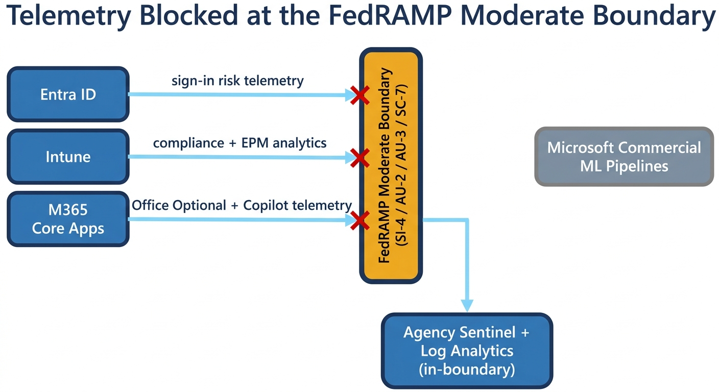
Figure 2. Telemetry blocked at the FedRAMP Moderate boundary — Entra ID, Intune, and M365 core apps each attempt outbound flows to Microsoft's commercial multi-tenant ML and analytics pipelines; the boundary's NIST controls block or degrade the flow, leaving agency-side Sentinel and Log Analytics as the only in-boundary destination.

5.1 Entra ID — Identity Protection, sign-in analytics, cross-tenant collaboration
(A) Commercial telemetry signals required. Per-sign-in evaluation data (device, location, client app, network, sign-in risk, session details); raw sign-in logs with success/failure, IP, user agent, MFA status, CA status; aggregated patterns (impossible travel, atypical client usage); Identity Protection risk detections (leaked credentials, atypical travel, anonymous IP, malware-linked IP, unfamiliar sign-in properties); user-risk and sign-in-risk scores and their evolution over time; B2B and B2B-direct-connect events; cross-tenant access settings evaluations.
(B) Constraining controls. SI-4 (raw user-identifiable sign-in and risk telemetry export to commercial multi-tenant analytics conflicts with in-boundary monitoring requirement); AU-2 / AU-3 (full-fidelity sign-in and risk events shipped off-boundary may exceed authorized audit export); SC-7 (continuous rich telemetry to multi-tenant analytics is exactly the cross-boundary flow SC-7 constrains).
(C) Documentation status. No direct GCC-Moderate (.com) documentation confirms or denies availability. Entra government docs that exist are Azure Government (.us) — not applicable here under the scoping rule.
(D) Workarounds and fidelity loss. Graph API export of sign-in and audit logs into Sentinel or Log Analytics; unified audit log plus KQL queries; custom risk models built on local IP, location, device-ID, and failure-pattern correlation. Fidelity lost: Microsoft's proprietary ML-driven risk scores (no continuously-tuned “atypical travel” or “unfamiliar sign-in properties” models), real-time cross-tenant correlation, and vendor-supplied global threat-intelligence context. Detection-gap order of magnitude: commercial cloud ≈ minutes; GCC-Moderate ≈ hours to days.
(E) Compliance impact. BOD 25-01 core logging is achievable if logs are exported and retained; the directive's “rapid detection and investigation” intent is harder to meet without local analytics. M-22-09 Identity pillar requires continuous identity-behavior monitoring and risk-based access — agencies must implement equivalent risk scoring to credibly claim Advanced maturity in the ZTMM Identity and Visibility & Analytics pillars; Optimal is difficult without equivalent continuous risk scoring.

5.2 Intune — compliance, app protection, Windows Update for Business reporting, Endpoint Privilege Management
(A) Commercial telemetry signals required. Detailed configuration state, health attestation, encryption status, OS version, jailbreak or root detection; continuous compliance evaluation results; app-launch events, app-protection enforcement outcomes (data-transfer blocked, copy/paste/save-as suppressed); WUfB per-device update state, patch success or failure, deferral status, safeguard holds, error codes and timing; EPM elevation requests, approvals, and denials with process metadata (hash, path, publisher).
(B) Constraining controls. SI-4 (continuous device monitoring plus app-level behavior plus elevation events are sensitive monitoring data); AU-2 / AU-3 (policy enforcement and elevation attempts are audit records); SC-7 (telemetry paths constrained to “core management only,” not full analytics).
(C) Documentation status. No direct documentation. Public Intune docs describe data collection in the global Azure commercial environment without explicit GCC-Moderate addressing; Government-specific Intune docs are Azure Government (.us) and out of scope.
(D) Workarounds and fidelity loss. Graph API exports into Log Analytics or Sentinel; built-in Intune reports where present (compliance status, basic update state); custom Power BI over exported device, compliance, and update data. Fidelity lost: less granular and less frequent telemetry, limited behavioral context, reduced cross-correlation with identity and data events.
(E) Compliance impact. BOD 25-01 met if device compliance and update events are logged centrally; loss of fine-grained telemetry reduces investigation speed and precision. M-22-09 Device pillar needs supplementation with OS-level logs to demonstrate posture; ZTMM Devices and Visibility & Analytics push toward Initial or Advanced, not Optimal.

5.3 M365 core apps — Office diagnostic data, Copilot/AI, sensitivity labels, DLP
(A) Commercial telemetry signals required. Office “Optional” diagnostic data (UX telemetry, feature usage, performance, crashes, add-in behavior, document interaction patterns at telemetry level); Copilot and AI prompt-and-response metadata (structure and usage, not necessarily content), interaction patterns, feedback signals; sensitivity-label application and removal events with locations and patterns by user, department, or workload; DLP policy match conditions, content fingerprints, user actions, override or justification metadata, and device, location, or app context.
(B) Constraining controls. SI-4 (Office and Copilot user-behavior telemetry exported to AI or analytics services must be tightly controlled); AU-2 / AU-3 (DLP incidents and label events are audit records, content-sensitive); SC-7 (outbound client telemetry to external analytics endpoints constrained when it carries detailed behavioral or policy-match information).
(C) Documentation status. Confirmed restricted: GCC privacy settings default Office diagnostic data to “Required” only — Optional diagnostic data is suppressed. Copilot and rich DLP analytics: no direct GCC-Moderate documentation; Purview docs mention government support generally but not at full analytics parity.
(D) Workarounds and fidelity loss. Purview audit logs and DLP alerts exported via Graph or Management Activity API; custom label-usage reports from SharePoint, OneDrive, and Exchange metadata plus unified audit log; server-side logs (SharePoint access, Exchange message trace) instead of client-side telemetry. Fidelity lost: fine-grained Office client telemetry, Copilot usage patterns, and behavioral DLP analytics (override behavior, near-misses, behavioral trends).
(E) Compliance impact. BOD 25-01 met for centralized DLP and label-event logging; rich behavioral analytics for “rapid detection” weakened. M-22-09 Data pillar enforcement works but analytics-driven tuning is weaker; ZTMM Data plus Visibility & Analytics typically Advanced at best.

5.4 Continuous Access Evaluation (CAE)
(A) Commercial telemetry signals required. Token issuance, refresh, and revocation events; session state changes (revoked, invalidated); policy-relevant events (password changes, account disablement, device-compliance changes, location changes, high-risk detections); near-real-time event streams between Entra ID and resource services (Exchange, SharePoint, Teams).
(B) Constraining controls. SI-4 (event streams are monitoring); AU-2 / AU-3 (CAE-triggering events are audit events); SC-7 (cross-boundary signaling to non-GCC services constrained).
(C) Documentation status. Inferred degraded. Basic CAE policy enforcement appears available with Entra ID licensing; the real-time signaling fidelity required for sub-minute revocation may be throttled by boundary inspection or proxies. CAE-capable client behavior is signaled in tokens via the xms_cc claim, which agencies can audit to confirm the path is at least negotiated.
(D) Workarounds and fidelity loss. Short access-token lifetimes (60–90 minutes) to limit exposure without CAE; frequent re-authentication and CA re-evaluation; SIEM-triggered Graph API revocation scripts where possible. Fidelity lost: sub-second revocation; higher user friction; slower containment of compromised sessions.
(E) Compliance impact. BOD 25-01 not directly mandating CAE but closely aligned with continuous-enforcement intent. M-22-09 Identity pillar emphasizes continuous verification and rapid revocation — without full CAE, agencies must compensate with shorter token lifetimes and strong monitoring; ZTMM Identity plus Automation & Orchestration are difficult to push to Optimal.

5.5 Windows Update for Business reporting (depth and trend telemetry)
This area overlaps with §5.2 but is treated separately because it has its own asset-visibility consequence under BOD 25-01. Outbound flow to “Commercial Global Service” endpoints for WUfB telemetry is often blocked by boundary firewalls in agency environments. Agencies fall back to local GPO-based reporting or third-party inventory tools. Fidelity lost: real-time fleet-wide patch-compliance scoring; the “asset-visibility” requirement of BOD 25-01 is harder to satisfy.

6. Consolidated Telemetry-Gap Matrix
Each row is a specific telemetry field or metric. Source dashboard, ZTMM mapping, and the four impact dimensions are normalized across the underlying analyses. Where unavailability cannot be confirmed from Microsoft documentation in the GCC-Moderate (.com) context, the row is marked Inferred.
The matrix below is reproduced in landscape orientation on the next page so the nine columns remain legible.

Missing signal | Source | Documented? | ZTMM pillar(s) | ZTMM level | ZT impact | Anomaly detection | Insider risk | Forensics
Communication patterns (ChatCount vs EmailCount) | Adoption Score | Yes | Identity; Visibility & Analytics | Advanced | No “expected communication behavior” baseline for identity verification | No baseline for normal user-interaction volume | Critical — loss of digital-disengagement / flight-risk signal | Low — usage volume rarely the smoking gun
Content collaboration (PhysicalAttachments vs CloudLinks) | Adoption Score | Yes | Data; Visibility & Analytics | Advanced | Inability to enforce or monitor cloud-only collaboration policies | High — regression to legacy methods to bypass DLP | High — users hoarding data via local copies | Moderate — harder to establish intent
Mobility (multi-platform usage patterns) | Adoption Score | Yes | Identity; Devices | Initial → Advanced | Cannot use “unusual platform” as account-takeover signal | Loss of platform-shift anomaly | Moderate — disengagement via specific workstation | Low
Meetings participation telemetry | Adoption Score | Yes | Visibility & Analytics | Advanced | Reduced behavioral context for risk scoring | No baseline for collaboration shifts | Lowers sensitivity to insider behavior changes | Missing participation data for activity reconstruction
Apps Health (update channel, version telemetry) | Adoption Score | Yes | Applications & Workloads; Visibility & Analytics | Advanced | Limits app and version posture as policy input | No outdated-app anomaly trends | Indirect | No version-change history correlated to incidents
Network connectivity scores (per location) | Adoption Score | Yes | Networks; Visibility & Analytics | Advanced → Optimal | Cannot distinguish real outages from path manipulation in access decisions | Hides localized connectivity drops indicating targeted disruption | Insiders degrading or rerouting traffic harder to see | Reduced evidence of when and where network conditions shifted
Endpoint readiness baselines (tenant-wide) | Adoption Score | Yes | Visibility & Analytics | Advanced | No global posture view for ZT policy tuning | No tenant-wide deviation detection | Subtle group-level shifts harder to see | Weakens reconstruction of baseline drift
INR real-time path metrics (latency / jitter / packet-loss) | Microsoft INR | Yes | Networks; Visibility & Analytics | Advanced → Optimal | No “expected path” baseline for path-aware trust | Infinite gap — no native ability to detect BGP hijack, DNS manipulation, MITM | Insiders using unusual paths invisible | Cannot reconstruct routing during incident windows
Device boot performance / GP processing / desktop load | Endpoint Analytics — Advanced | Inferred (sovereign-list excludes Moderate) | Devices; Visibility & Analytics | Advanced → Optimal | Coarse compliance and AV posture only; degradations not risk inputs | Boot-time outliers as weak compromise signal lost | Tools or drivers destabilizing endpoints invisible | Cannot reconstruct device performance around incident
App reliability (AppCrashCount, hang rates, stability) | Endpoint Analytics — Advanced | Inferred | Devices; Applications & Workloads | Advanced → Optimal | Cannot use unstable apps as risk signal | Crash clusters indicating exploit attempts masked | Insiders testing unapproved tools obscured | Cannot correlate app instability with incidents
Resource performance (AverageProcessorUsage, memory spikes) | Endpoint Analytics — Advanced | Inferred | Devices | Advanced → Optimal | “Resource health” cannot drive dynamic access decisions | High — hidden miners or exfil tools bypassing AV go unnoticed | Unauthorized software by power users masked | Loss of CPU and RAM history to correlate with data egress
Stop-error restarts | Endpoint Analytics — Advanced | Inferred | Devices; Visibility & Analytics | Advanced → Optimal | Impairs real-time device-state verification | Loses automated restart-anomaly detection | N/A | Missing restart event correlation
Battery health / Work-from-anywhere readiness | Endpoint Analytics — Advanced | Inferred | Devices | Advanced | Reduced confidence in remote-endpoint trust | Less baseline for remote connectivity patterns | Unusual remote-only patterns obscured | Limited readiness-score history
Device performance anomalies (post-config / policy / OS regression) | Endpoint Analytics — Advanced | Inferred | Devices; Visibility & Analytics | Advanced → Optimal | Weakens continuous device-integrity verification | Core loss of automated regression detection | Targeted policy changes harming subsets of users masked | No anomaly-event timeline
Entra real-time risk scores / Identity Protection | Entra ID | Inferred blocked | Identity; Visibility & Analytics | Advanced → Optimal | Detection delay: minutes (commercial) → hours/days (GCC-M) | ML-driven impossible-travel and atypical-IP detection lost | Low-and-slow spraying invisible | Post-hoc only via log correlation
Cross-tenant access telemetry (B2B, Direct Connect) | Entra ID | Inferred blocked | Identity | Advanced | Less context for cross-tenant risk decisions | Cross-tenant anomaly correlation lost | External-collaboration insider patterns harder to see | Cross-tenant timeline reconstruction limited
Real-time CAE revocation paths (sub-second) | Entra ID + workloads | Inferred blocked | Identity; Automation & Orchestration | Optimal | Token-theft window 60–90 min vs. <15 min commercial | Mid-lifetime hijacks not auto-cut | Compromised sessions persist | Limited to token-expiry timeline
App-protection policy violation analytics | Intune | Inferred blocked | Devices; Applications & Workloads | Advanced | Snapshot compliance only; no real-time violation flag | Sideloaded or shadow apps invisible on BYOD | “Authorized but malicious” elevations masked | No app-protection telemetry for IR
WUfB deployment health trends / per-device error codes | Intune | Inferred blocked | Devices; Visibility & Analytics | Advanced | No real-time fleet patch posture for ZT | 7–14 day reporting lag | Patch state on specific devices opaque | Patch-window-aware forensics weakened
EPM elevation operational analytics (process metadata) | Intune | Inferred blocked | Devices; Identity; Visibility & Analytics | Advanced → Optimal | No elevation-as-risk input in CA | Anomalous elevations not “scored” centrally | Insider elevation patterns invisible | Elevation timeline reconstruction limited
Office “Optional” diagnostic data | M365 core | Confirmed restricted (defaults to Required) | Applications & Workloads; Devices | Advanced | Reduced client-side feature and use telemetry for trust | “Contextual glue” between apps lost | Lateral movement via Office or Teams cross-app navigation invisible | Cannot rewind client-side behavior
Copilot / AI prompt-response telemetry richness | M365 core | Inferred blocked | Applications & Workloads; Visibility & Analytics | Advanced | Limited AI-usage posture | Anomalous AI-usage patterns invisible | AI-mediated data hoarding harder to spot | Limited AI-interaction reconstruction
Sensitivity-label usage analytics | M365 core | Inferred blocked | Data; Visibility & Analytics | Advanced → Optimal | Label-state-aware policies coarser | Bulk label changes / mass decryption signals delayed | Insider label-stripping behavior less visible | Label-history forensic detail reduced
DLP behavioral richness (override, near-miss, fingerprint context) | M365 core | Inferred blocked | Data; Visibility & Analytics | Advanced → Optimal | Static DLP only; no behavior-aware policy | Intent-based detection absent | Override-pattern insider signal lost | Reduced DLP forensic context
Long-term EUII (BSSID, public IP, subnet/building) | Teams CQD | Available, retention-limited (28 days) | Networks | Advanced → Optimal | Trusted-location verification weakened for >28-day-old context | Limits delayed impossible-travel detection in Teams | Low | Critical forensic cliff at 28 days
Cross-product 12+ month historical pivots | M365 Usage Analytics | Available with reduced fidelity | Visibility & Analytics | Advanced | Shorter-window decisions only | “Low and slow” attacks across months hard to visualize | Long-term access-shift detection limited | Severely reduced retrospective breach analysis

7. Cybersecurity Vulnerabilities — MITRE ATT&CK Mapping
Compensating-control honesty: every “compensating control” below assumes the agency has stood up the necessary local analytics. Without that investment, the gap is full.

7.1 Identity and session attacks (Entra ID)
Attack pattern | MITRE TTP | Blocked / degraded signal | Detection gap | Compensating control
Credential stuffing / password spraying | T1110, T1078 | Identity Protection ML risk detections; aggregated sign-in anomaly models | Commercial: minutes. GCC-M: hours to days (periodic SIEM correlation) | CA + MFA + lockout + custom SIEM rules. No ML-driven low-and-slow spraying detection.
Token theft / session hijacking / Pass-the-Cookie | T1550.003, T1550.004, T1528 | Real-time sign-in risk changes; CAE event streams | Commercial: <15 min. GCC-M: up to full token lifetime (60–90 min) | Shorter token lifetimes; strict device compliance; SIEM-triggered Graph revocation.
Impossible travel / location anomalies | T1078, T1090 | Global impossible-travel models, cross-tenant telemetry | Commercial: minutes. GCC-M: hours to days, often missed | Custom geo-correlation in agency SIEM; many do not build this.
MFA fatigue / prompt bombing | T1621 | Behavioral risk models for abnormal MFA prompt frequency | Commercial: minutes (risk-based block). GCC-M: hours to days | FIDO2, number matching, user education. Volume-of-attempts not auto-flagged.

7.2 Device and endpoint attacks (Intune)
Attack pattern | MITRE TTP | Blocked / degraded signal | Detection gap | Compensating control
Privilege escalation (EPM bypass) | T1068 | EPM operational analytics; elevation behavioral telemetry | Commercial: real-time anomaly flagging. GCC-M: 48+ hours via compliance snapshots | Endpoint logs + SIEM correlation; no native equivalent.
Delayed-patch exploitation | T1190 / T1068 | WUfB deployment health trends; regression telemetry | Commercial: hours. GCC-M: 3–7 day gap (weekly manual reports) | Basic compliance reporting present; trend insights missing.
Malicious app sideloading (BYOD) | T1474, T1574.002 | App-protection policy violation analytics | Commercial: real-time. GCC-M: 24–48 hours | Periodic device checks; no real-time signal.

7.3 Data movement (M365 core)
Attack pattern | MITRE TTP | Blocked / degraded signal | Detection gap | Compensating control
Sensitivity-label-bypass exfiltration | T1048.003 | Label usage analytics; rich DLP behavioral context | Commercial: near-real-time. GCC-M: 24–72 hours, basic incident counts only | Static DLP regex rules; no intent-based detection.
Lateral movement via shared links (Teams / OneDrive) | T1021.006, T1534 | Office diagnostic telemetry (anomalous file-access patterns); label analytics | Commercial: minutes–hours. GCC-M: days | Manual audit-log / eDiscovery review; limited correlation.
Persistence via Office macros | T1547.009 | Office diagnostic / crash telemetry flagging anomalous macro execution | Commercial: hours. GCC-M: no equivalent; manual investigation 3–7 days | Manual Purview searches plus endpoint telemetry outside M365.
Persistence via SharePoint OAuth / browser fingerprint | T1098.005 | Rich DLP context: client/browser fingerprint, API access details | Commercial: real-time. GCC-M: limited fingerprint telemetry | Static rules only; adversaries persist via “trusted” browsers.
Automated exfiltration | T1020 | Real-time risk-based DLP triggers | Commercial: minutes. GCC-M: 24+ hours processing latency | Static DLP; intent-aware detection absent.

7.4 Network and session (INR + CAE)
Attack pattern | MITRE TTP | Blocked / degraded signal | Detection gap | Compensating control
Adversary-in-the-middle / BGP hijack / DNS manipulation | T1557, T1565.002 | INR real-time path / latency / jitter telemetry | Commercial: sub-minute. GCC-M: not available | Third-party SD-WAN or SASE; external DNS monitoring.
Session persistence after network change | T1550.001 | CAE real-time revocation | Commercial: seconds–minutes. GCC-M: up to 60 min token lifetime | Shorter tokens; manual revocation; CA without continuous signals.

7.5 Cross-cutting compound chains
Two attack chains become difficult to detect in GCC-Moderate without dedicated agency analytics.
Chain A — T1190 → T1550.001 → T1048.003. Initial access via delayed-patched Intune device + token theft (no CAE, no Entra Identity Protection real-time risk) + exfiltration via label-stripped OneDrive link (no rich DLP). Three blocked telemetries simultaneously. Commercial cloud detection: end-to-end <30 minutes. GCC-Moderate: days to weeks if no compensating analytics exist.
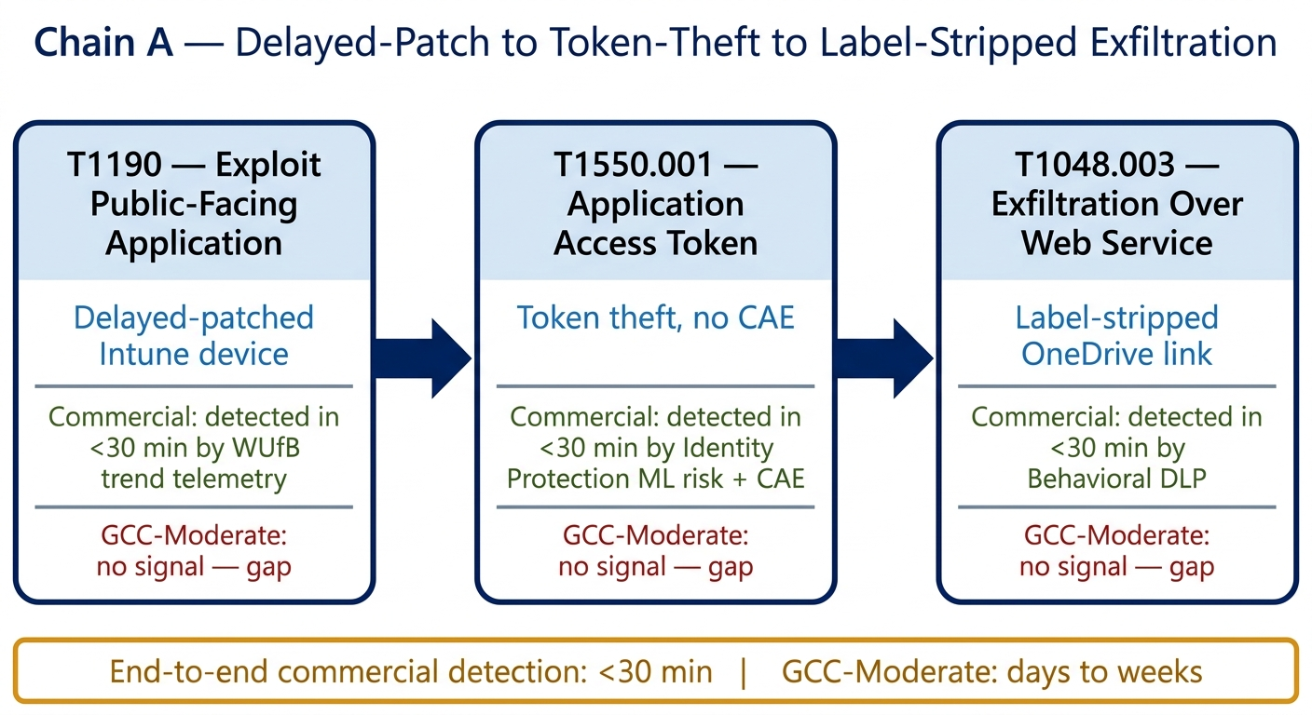
Figure 3. MITRE Chain A — T1190 (initial access via delayed-patched device) → T1550.001 (session-cookie theft persisting past CAE absence) → T1048.003 (label-stripped exfiltration). Each transition is annotated with the telemetry that would catch it in commercial cloud and the gap that hides it in GCC-Moderate.

Chain B — T1110.004 → T1068 → T1557. Credential stuffing (no Entra risk) + privilege escalation on compromised device (no EPM analytics) + MITM via INR-blind routing. Commercial: minutes. GCC-Moderate: undetected until manual investigation.
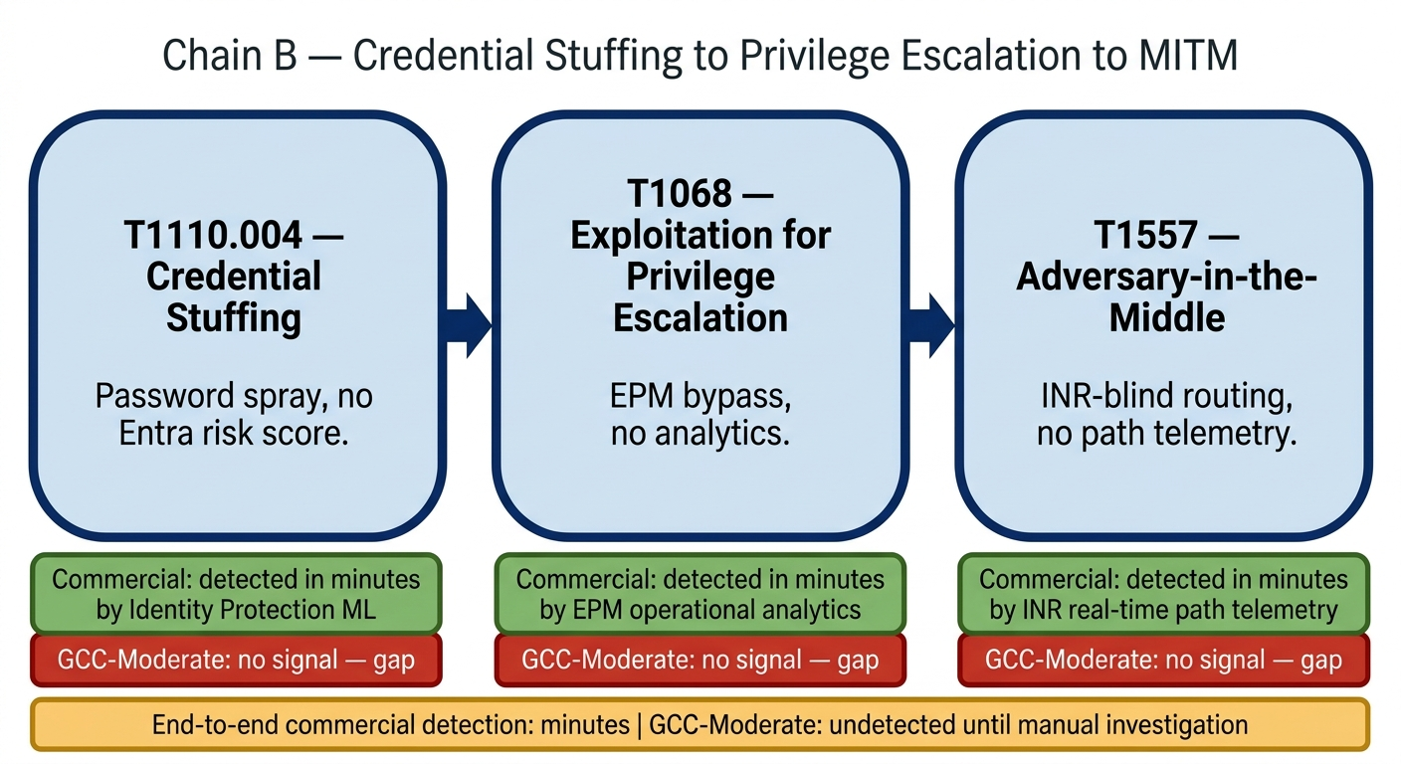
Figure 4. MITRE Chain B — T1110.004 (credential stuffing without Identity Protection ML) → T1068 (privilege escalation without EPM analytics) → T1557 (adversary-in-the-middle without INR path telemetry). The diagram shows where each commercial-cloud detection signal would normally fire and the corresponding gap inside the GCC-Moderate boundary.

“Ghost compromise” scenario — three-step concrete walkthrough:
- Identity. Adversary uses a residential proxy for sign-in; degraded global behavioral signals classify it as low risk.
- Device. Adversary uses BYOD with sideloaded grey-ware; advanced compliance telemetry blocked, device reports compliant.
- Data. Adversary performs low-and-slow exfiltration of sensitivity-labeled data; suppressed Office diagnostic telemetry hides the read-to-bulk-sync behavioral shift.
Net. A nation-state actor can exfiltrate substantial data over weeks without ever crossing a “high” severity threshold, because each individual action stays below the static-rule threshold inside GCC-Moderate.

8. CISA Zero Trust Maturity Model — Pillar-Level Impact
Pillar mapping below is per CISA ZTMM v2.0 (April 2023). All maturity ratings reflect the achievable-without-additional-agency-analytics baseline. Each pillar can typically be lifted one tier (toward Advanced or Optimal) by investing in agency-side Sentinel and Log Analytics plus custom analytics over exported telemetry.
Pillar | Achievable without agency analytics | Gating gap | Achievable with agency analytics | What “Optimal” requires
Identity | Initial | Real-time Identity Protection ML risk + CAE | Advanced | Continuous risk scoring equivalent to Microsoft commercial pipeline
Devices | Initial | Endpoint Analytics Advanced + Intune behavioral analytics | Advanced | Continuous performance and anomaly scoring with automated remediation
Networks | Initial | INR + CQD long-retention EUII | Advanced (with third-party SD-WAN or SASE) | Native M365-integrated dynamic optimization (not available; requires third-party)
Applications & Workloads | Initial → Advanced | Office Optional diagnostic + Copilot telemetry | Advanced | Behavior-aware app monitoring with predictive analytics
Data | Initial → Advanced | Adoption Score collaboration baselines + rich DLP behavioral context | Advanced | Behavior-aware DLP, adaptive policies, rich override-pattern analytics
Visibility & Analytics (cross-cutting) | Initial → Advanced | All of the above | Advanced | UEBA-class baselines plus historical correlation across pillars
Automation & Orchestration (cross-cutting) | Initial | Real-time CAE; automated risk-based response | Advanced | Event-driven automatic response, integrated across pillars
The structural ceiling. Without agency-side analytics, the GCC-Moderate environment caps near Initial maturity in Identity, Devices, and Networks; reaching Advanced requires meaningful agency engineering investment; Optimal in any pillar requires either Microsoft platform changes (e.g., MAS 2026 boundary refinement) or substantial agency-built equivalents to Microsoft commercial ML pipelines.
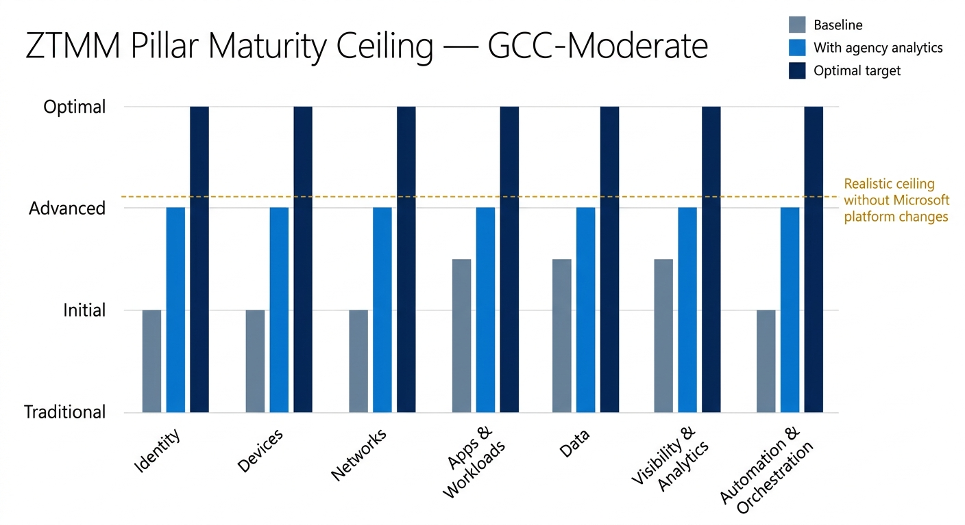
Figure 5. ZTMM pillar maturity ceiling — for each of the seven CISA Zero Trust Maturity Model pillars, three bars showing (a) baseline achievable in GCC-Moderate without agency analytics, (b) achievable with the compensating stack, and (c) the “Optimal” target. The diagram makes the structural ceiling visible: most pillars cap at Initial without agency engineering.

9. Compliance Posture — BOD 25-01, M-22-09, M-21-31
Mandate | Met by GCC-Moderate alone? | Gap | What closes the gap
CISA BOD 25-01 (cloud secure configuration; logging and visibility) | Core logging requirements met if all available logs are exported to Sentinel or Log Analytics with appropriate retention. | Spirit of “rapid detection and investigation” requires analytics fidelity GCC-Moderate cannot natively provide. | Agency-built local analytics, custom KQL or SIEM rules, third-party UEBA.
OMB M-22-09 (Federal Zero Trust Strategy) | Identity pillar continuous-monitoring intent not met without compensating analytics; Network pillar partially blocked by INR absence. | Identity (CAE / Identity Protection); Network (INR); Data (rich DLP behavioral context). | Equivalent agency risk scoring; third-party SASE or SD-WAN; behavior-aware DLP overlay.
OMB M-21-31 (Tier 3 logging) | Met for Tier 1–3 if all categories (Entra non-interactive sign-ins, service-principal sign-ins, MailItemsAccessed, etc.) are enabled and routed. | Tier 3 advanced behavioral analytics interpretation — not unavailability of the underlying logs. | Telemetry completeness scorecard with quarterly verification per Section 11.
NIST SP 800-207 (Zero Trust Architecture) | Architecture is consistent with the model, but PE / PA require continuous trust signals that GCC-Moderate constrains. | Continuous behavioral risk signals to feed the Policy Engine. | Build trust-algorithm overlay in agency SIEM.
Unifying frame: An agency in GCC-Moderate can be technically compliant with FedRAMP yet structurally less observable than a commercial enterprise until it builds its own observability stack on top of the FedRAMP boundary.

10. Operational Findings
The following findings come from operational dashboard-coverage analysis applied to the same GCC-Moderate boundary. They convert the architectural telemetry conclusions above into directly-actionable misconfigurations, scored on a 0–100 dashboard-completeness scale.

10.1 Symptoms catalog
# | Symptom | Severity | Root cause | Detection heuristic
1 | Invisible non-interactive / service-principal / managed-identity sign-in activity | Critical | Entra diagnostic settings do not enable NonInteractiveUserSignInLogs, ServicePrincipalSignInLogs, ManagedIdentitySignInLogs by default. | Query AADNonInteractiveUserSignInLogs in Sentinel — zero results with active SPNs or MIs = not collected.
2 | Exchange mailbox-access blind spot (MailItemsAccessed) | Critical | Pre-2025-Jan CISA Expanded Cloud Logs Playbook, only Audit Premium captured this; now in Standard but must be operationalized. | Query OfficeActivity for Operation == “MailItemsAccessed” over 7d — no results = gap.
3 | Teams media-relay blind spots; CQD/QER pipeline not in Sentinel | High | Teams call quality data flows through CQD or QER, not natively into Sentinel; PSTN and Direct Routing legs sparsely instrumented. | Attempt to query packet-loss, jitter, RTT in Sentinel — not present; only OfficeActivity Teams membership/messaging.
4 | Intune compliance-state lag | High | Diagnostic settings must be manually enabled; evaluation-cycle latency; aggressive DCR filtering of high-volume Win32 detection events removes security-relevant data. | Compare Intune admin-center reports to IntuneDevices table — stale or empty = misconfigured.
5 | Conditional Access evaluation-log incompleteness | High | CA evaluation depends on sign-in log completeness; Entra default 30-day retention without diagnostic settings loses historical CA evaluation. | SigninLogs filtered for ConditionalAccessStatus == “notApplied” to find scope misconfigurations.
6 | Sentinel correlation false-negatives from missing data sources | Critical | Analytic rules joining tables (e.g., SigninLogs ⋈ DeviceEvents) silently miss when a source is not configured. | Run Sentinel health diagnostics; check Usage table for unexpectedly low data volume.
7 | Power Platform activity opacity | Medium | Power Apps / Power Automate / Power BI activity flows through Purview unified audit, not a dedicated Sentinel connector; Dataverse Application Insights requires premium. | Search OfficeActivity for OfficeWorkload in (“PowerApps”, “MicrosoftFlow”, “PowerBI”).
8 | SharePoint search-query telemetry gap | Medium | SearchQueryInitiatedSharePoint previously Premium-only; now in Standard per CISA expansion but requires enablement. | Query for SearchQueryInitiatedSharePoint in OfficeActivity / Purview — zero events = not enabled.
9 | GCC feature-parity drift | High | Microsoft cloud feature availability documents many features as GA in Commercial but Preview or N/A in GCC; releases follow Commercial-first cadence. | Compare deployed GCC feature set against current Commercial feature list quarterly.
10 | Purview Audit retention cliff | Critical | Audit Standard retains 180 days max; Premium extends to 1 year (10-year add-on). E3 / G3 licensing creates a forensic blind spot vs. APT dwell times. | Query audit log >180 days old; if absent on Standard, gap confirmed.

10.2 Dashboard completeness scores
Scoring methodology: Score = (a) percentage of expected telemetry types available × (b) default-enabled × (c) Sentinel-integration path × (d) GCC parity confirmed.
Product | Score | Primary remaining gap
Entra ID (P2) | 75 | NonInteractive, ServicePrincipal, ManagedIdentity logs not on by default
Exchange Online | 70 | MailItemsAccessed newly available in Standard, requires operationalization
SharePoint Online | 65 | SearchQueryInitiatedSharePoint requires enablement
Microsoft Teams | 55 | CQD / QER outside Sentinel; PSTN / Direct Routing telemetry incomplete
Microsoft Intune | 60 | Diagnostic settings manual; Win32-detection event volume forces aggressive filtering
Defender for Endpoint | 85 | Generally well-instrumented; some advanced tables may lag in GCC
Defender for Office 365 | 80 | Some Defender XDR connector data types may have limited GCC support
Defender for Identity | 80 | On-prem sensor required; hybrid gaps
Defender for Cloud Apps | 70 | CloudAppEvents requires Purview unified audit enabled
Purview Audit | 60 | Standard 180-day cliff; Premium needed for forensic-grade depth
Microsoft Sentinel | 75 | Platform audit requires CloudAppEvents via Defender XDR connector
Power Platform (Apps / Automate / BI) | 45 | No native Sentinel connectors; relies on Purview unified audit
Dynamics 365 | 40 | Heavy reliance on Application Insights; limited native security event coverage
Microsoft Stream | 25 | No native Sentinel connector
Windows Autopilot | 30 | No direct Sentinel connector; deployment telemetry siloed in Intune

11. 60-Day Tactical Remediation Plan
This plan combines operational priorities with the architectural telemetry mitigations from the analyses above. It is the operational realization of the conclusion that GCC-Moderate compliance plus observability requires agency engineering, not just license selection.

11.1 Priority 1 — Foundation (Week 1–2)
# | Action | Products | Effort | Symptom addressed
1 | Enable all Entra ID diagnostic-settings log categories — NonInteractiveUserSignInLogs, ServicePrincipalSignInLogs, ManagedIdentitySignInLogs, RiskyUsers, UserRiskEvents, ProvisioningLogs, MicrosoftGraphActivityLogs, NetworkAccessTrafficLogs to Sentinel Log Analytics. | Entra ID | 2–4 h | Symptom 1
2 | Operationalize CISA Expanded Cloud Logs — enable and validate MailItemsAccessed, MailItemsSent, SearchQueryInitiatedSharePoint, SearchQueryInitiatedExchange in Purview Audit Standard; deploy Sentinel analytic rules per CISA playbook. | Exchange / SharePoint / Purview | 1–2 d | Symptoms 2, 8
3 | Configure Intune diagnostic settings with DCRs filtering Win32-detection event volume while preserving security-relevant events. | Intune / Sentinel | 1 d | Symptom 4
4 | Validate via KQL (Section 13.3) — record baseline scorecard. | Sentinel | 0.5 d | Symptom 6

11.2 Priority 2 — Expansion (Week 3–4)
# | Action | Products | Effort
5 | Deploy Teams QER v5.0 Power BI templates; establish baseline call-quality metrics plus alerting thresholds; export EUII for long-term retention to circumvent the 28-day forensic cliff. | Teams | 2–3 d
6 | Deploy Conditional Access analytic rules from the Microsoft Entra Sentinel content hub. | Entra / Sentinel | 0.5 d
7 | Deploy Exchange Online and SharePoint Online security solutions from Sentinel content hub — RBAC delegation changes, transport-rule changes, VIP mailbox monitoring. | Exchange / SharePoint / Sentinel | 1–2 d

11.3 Priority 3 — Depth (Week 5–6)
# | Action
8 | Power Platform monitoring via Purview unified audit — Sentinel rules for suspicious Power Automate flow creation and Power Apps data access.
9 | Begin GCC feature-parity audit; document delta as governance risk-register entries.

11.4 Priority 4 — Maturation (Week 7–8)
# | Action
10 | Build Sentinel Telemetry Completeness Workbook — data-freshness checks across all expected tables.
11 | Dynamics 365 Application Insights prototype for security telemetry.
12 | Establish quarterly GCC Feature Parity Review.
13 | Establish monthly Telemetry Completeness Scorecard for continuous-ATO review.

12. Boundary Modernization Path — TIC 3.0 and MAS 2026
Position taken in this assessment. Modern mandates require telemetry that traditional FedRAMP authorization boundaries inhibit. This creates sustained pressure to modernize boundary implementation — for example, through scope refinement and boundary-shrinking approaches such as MAS 2026 — while maintaining a defined authorization boundary required for compliance under FISMA.

12.1 What the policy stack actually says
Source | Effect on GCC-Moderate boundary
EO 14028 (2021) | Drives Zero Trust adoption; implicitly increases telemetry demand.
OMB M-21-31 | Requires Tier 3 logging — achievable inside the boundary if all categories are enabled.
OMB M-22-09 | Federal Zero Trust Strategy — drives Identity-pillar telemetry demand.
TIC 3.0 | Permits cloud-direct connectivity (vs. legacy MTIPS), enables SASE / ZTNA patterns inside the FedRAMP boundary.
EO 14117 (2024) | Adds restrictions on precise geolocation — tightens, does not loosen, boundary controls.
EO 14144 (Jan 2025) | Strengthens FedRAMP baselines (does not authorize boundary removal).
June 2025 EO | Modernizes FedRAMP, reduces process burden — does not authorize boundary removal.
MAS 2026 | Practical resolution. Narrows boundary scope; allows more commercial-like functionality; explicitly excludes telemetry pipelines from the authorization boundary. The boundary itself remains.

12.2 Operational implication for GCC-Moderate
MAS 2026 scope refinement is the realistic path to recovering some currently-blocked telemetry by removing Microsoft's commercial telemetry pipelines from the agency's authorization scope rather than blocking the data flow at the network boundary. This shifts the conversation from “can the data leave?” to “is the receiving service in scope of my ATO?”

12.3 Escalation channels for boundary-related issues
These channels are GCC-High-scoped in the underlying source guides; the same mechanism applies to GCC-Moderate boundary issues.
Destination | Contact
FedRAMP PMO | info@fedramp.gov; ticket at help.fedramp.gov
Azure Government / Azure FedRAMP escalation | AzFedDoc@microsoft.com
Microsoft 365 GCC FedRAMP escalation | O365FedRAMP@microsoft.com
Realistic timeline expectations: Day 0–1 acknowledgment; Week 1–2 MAS adoption-plan response; Week 3–6 SCN (Significant Change Notification) filing window for boundary-scope refinements.
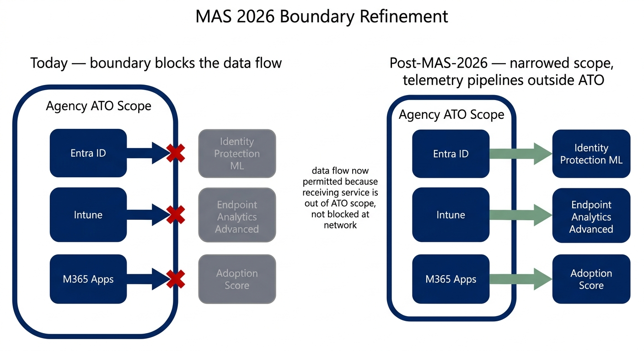
Figure 6. MAS 2026 boundary refinement — before/after diagram. Left panel: today's GCC-Moderate boundary blocks Microsoft commercial telemetry pipelines at the network edge. Right panel: post-MAS-2026 the boundary scope is narrowed so that Microsoft's commercial telemetry services sit outside the agency's ATO scope rather than being blocked by it, allowing the data flow without changing the authorization posture.

13. Workarounds, Compensating Architectures, and Validation

13.1 Workarounds by area
Constraint | Primary workaround | Fidelity loss
Entra Identity Protection ML scoring | Graph API → Sentinel + custom KQL risk rules | No proprietary continuously-tuned ML; less real-time; higher operational burden
Cross-tenant analytics | Manual cross-tenant log correlation in Sentinel | No vendor-supplied global threat intelligence context
Intune behavioral telemetry | Graph API exports + custom Power BI / Sentinel | Snapshot compliance only; no behavioral context
Office Optional diagnostic | Server-side audit (SharePoint access, message trace) | No client-side feature or use telemetry
Copilot / AI telemetry richness | Purview audit logs via Graph or Management Activity API | Basic incident counts only
INR routing optimization | Third-party SD-WAN or SASE | No native M365-integrated routing; agency-side detection of MITM and DNS manipulation only
CAE sub-second revocation | Short token lifetimes (60–90 min) + SIEM-triggered Graph revocation | Up to full token lifetime exposure window
CQD EUII 28-day retention | Scheduled CQD export to Log Analytics with extended retention | Operational overhead; storage cost

13.2 Compensating architecture components (the agency-side stack)
To recover Advanced ZTMM maturity, an agency typically needs:
- Sentinel + Log Analytics workspace with all M365, Entra, and Intune diagnostic settings routed in.
- Defender XDR connector for CloudAppEvents, EmailEvents, DeviceEvents, and identity tables.
- Purview unified audit ingestion for Power Platform and Office activity.
- Custom analytic rules for the gaps the platform doesn't ML-score (impossible travel, MFA fatigue, low-and-slow spraying, behavioral DLP).
- Local risk-scoring overlay that consumes the above to produce a continuous user-risk and device-risk signal feeding the Policy Engine.
- Third-party SD-WAN or SASE for INR-equivalent path telemetry and MITM / DNS-manipulation detection.
- Long-term forensic store (1+ year for general audit, 10 years for high-impact systems) to defeat the 28-day CQD EUII cliff and the 180-day Audit Standard cliff.
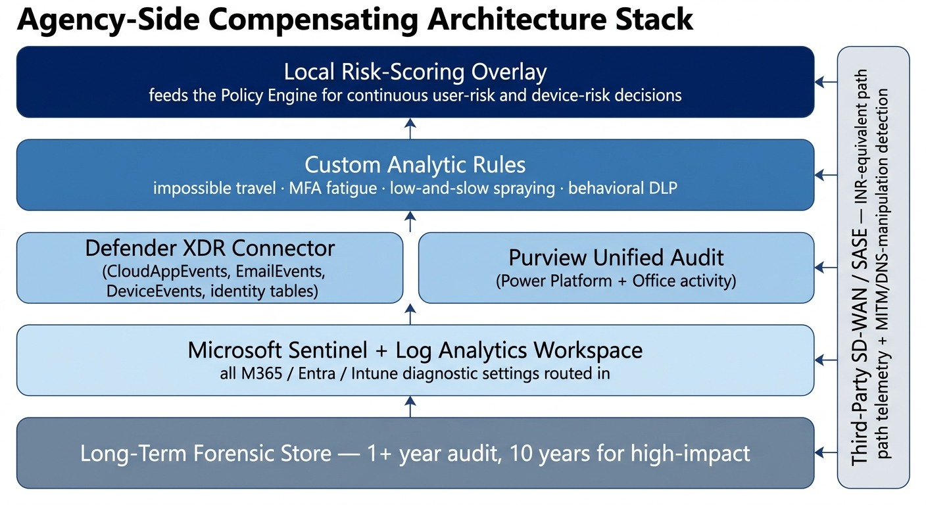
Figure 7. Compensating-architecture stack — the agency-side observability components that together recover Advanced ZTMM maturity. Sentinel and Log Analytics at the base, Defender XDR connector and Purview unified audit feeding it, custom analytic rules and a local risk-scoring overlay above, and third-party SD-WAN or SASE bolted on for the Networks pillar.

13.3 Validation KQL (executable in Sentinel Log Analytics)

13.3.1 — Validate Entra ID diagnostic-setting completeness
union withsource=TableName SigninLogs, AADNonInteractiveUserSignInLogs,
AADServicePrincipalSignInLogs, AADManagedIdentitySignInLogs, AuditLogs,
AADProvisioningLogs, AADRiskyUsers, AADUserRiskEvents
| summarize RecordCount = count(), LastRecord = max(TimeGenerated) by TableName
| order by TableName asc

13.3.2 — Validate CISA Expanded Cloud Logs operationalization (MailItemsAccessed)
OfficeActivity
| where TimeGenerated > ago(7d)
| where Operation == "MailItemsAccessed"
| summarize Count = count(), FirstSeen = min(TimeGenerated), LastSeen = max(TimeGenerated)
| extend Status = iff(Count > 0, "Operational", "NOT DETECTED — Action Required")

13.3.3 — Validate Intune diagnostic-settings ingestion
IntuneOperationalLogs
| where TimeGenerated > ago(7d)
| summarize RecordCount = count(), LastRecord = max(TimeGenerated)
| extend Status = iff(RecordCount > 0, "Ingesting", "NOT DETECTED")

13.3.4 — Master telemetry health check (data volume by table over 24h)
Usage
| where TimeGenerated > ago(1d)
| summarize DataVolumeMB = sum(Quantity) by DataType
| order by DataVolumeMB desc

13.3.5 — CA evaluation completeness — flag policies with high “notApplied” volume
SigninLogs
| where TimeGenerated > ago(7d)
| where ConditionalAccessStatus == "notApplied"
| summarize NotAppliedCount = count() by ConditionalAccessPolicies = tostring(ConditionalAccessPolicies)
| order by NotAppliedCount desc
| take 20

13.3.6 — Power Platform activity in unified audit
OfficeActivity
| where TimeGenerated > ago(30d)
| where OfficeWorkload in ("PowerApps", "MicrosoftFlow", "PowerBI")
| summarize EventCount = count() by OfficeWorkload, Operation
| order by OfficeWorkload, EventCount desc

13.3.7 — Exchange security baseline (RBAC, transport rules, mailbox permissions)
OfficeActivity
| where TimeGenerated > ago(7d)
| where OfficeWorkload == "Exchange"
| where Operation in ("New-ManagementRoleAssignment", "Set-TransportRule", "Set-RemoteDomain", "Add-MailboxPermission")
| project TimeGenerated, UserId, Operation, Parameters = tostring(Parameters)

14. Methodological Notes — Resolved Positions on Disputed Questions
Several questions in scope for this assessment were initially the subject of conflicting analytical conclusions. This section records the position adopted for each, on a most-documented, most-conservative basis.
Question | Resolved position
How many M365 dashboards are unavailable in GCC-Moderate? | Two confirmed unavailable (Adoption Score and INR), one inferred unavailable (Endpoint Analytics Advanced tier). CQD and Usage Analytics are available with operational caveats.
Is Teams CQD available in GCC-Moderate? | Available, with 28-day EUII retention as the operational constraint.
Is M365 Usage Analytics available? | Available via the GCC-specific connector; the Marketplace template app is the only missing variant.
Is the boundary-inference framework (NIST SI-4 / AU-2 / AU-3 / SC-7) valid? | Accepted as methodological, with explicit “Inferred blocked by FedRAMP boundary architecture” labeling rather than asserted unavailability.
Is INR explicitly unavailable? | Yes — confirmed unavailable (verbatim Microsoft text).
Are agencies in BOD 25-01 / M-22-09 violation? | Core requirements achievable with agency-side analytics; not free out of the box. Optimal maturity not achievable without compensating engineering.
Should TTPs and hour-level detection gaps be quantified? | Provided in Section 7 with explicit acknowledgment that detection-gap orders of magnitude are analytical synthesis, not vendor-published numbers.

Conceptual framings used throughout this assessment
- “False negative” — absence of “not available” language is not evidence of availability.
- “Telemetry paradox” — controls meant to protect government data create a shadow zone where advanced attack patterns thrive.
- “Forensic cliff” — the 28-day CQD EUII purge and 180-day Audit Standard retention create incident-discovery dead zones.
- “Digital disengagement” — the missing communication-volume baseline is a flight-risk insider indicator.
- “Grey-ware” — attacks that evade EDR but show as performance outliers, invisible without Endpoint Analytics.
- “Sovereign blind spot compound chain” — multiple gaps combining to enable undetectable nation-state-grade exfiltration.
- “Ghost compromise” — the proxy + BYOD + low-and-slow exfiltration scenario described in §7.5.

15. References

Microsoft documentation (load-bearing for this assessment)
- Microsoft Adoption Score report overview — Microsoft 365 admin — https://learn.microsoft.com/en-us/microsoft-365/admin/adoption/adoption-score?view=o365-worldwide — verbatim “not available in GCC High, GCC, and DOD tenants.”
- Microsoft 365 informed network routing — verbatim “supports tenants in WW Commercial cloud but not the GCC Moderate, GCC High, DoD, Germany, or China clouds.”
- Advanced Analytics overview — Microsoft Intune — https://learn.microsoft.com/en-us/intune/advanced-analytics/
- Microsoft Intune Government Service overview — https://learn.microsoft.com/en-us/intune/intune-service/fundamentals/intune-govt-service-description
- Endpoint analytics data collection — Microsoft Intune — https://learn.microsoft.com/mem/intune/endpoint-analytics/data-collection
- Connect to GCC data with usage analytics — https://learn.microsoft.com/en-us/microsoft-365/admin/usage-analytics/connect-to-gcc-data-with-usage-analytics?view=o365-worldwide
- Data and reports in CQD — https://learn.microsoft.com/en-us/microsoftteams/cqd-data-and-reports
- Turn on and use Call Quality Dashboard — https://learn.microsoft.com/en-us/microsoftteams/turning-on-and-using-call-quality-dashboard
- Configure Microsoft Entra diagnostic settings for activity logs
- Logs available for streaming from Microsoft Entra ID
- Learn about auditing solutions in Microsoft Purview
- Support for data types in Microsoft Sentinel across different clouds
- Privacy controls — overview (Office privacy and GCC defaults to Required diagnostic data) — https://learn.microsoft.com/en-us/deployoffice/privacy/overview-privacy-controls
- Cloud feature availability for commercial and US Government customers

Policy and framework references
- CISA Zero Trust Maturity Model v2.0 (April 2023) — https://www.cisa.gov/sites/default/files/2023-04/zero_trust_maturity_model_v2_508.pdf
- CISA BOD 25-01 (cloud secure configuration)
- OMB M-22-09 (Federal Zero Trust Strategy)
- OMB M-21-31 (Tier 3 logging)
- NIST SP 800-53 — controls SI-4, AU-2, AU-3, SC-7
- NIST SP 800-207 (Zero Trust Architecture)
- EO 14028 (May 2021)
- EO 14117 (2024) — precise-geolocation restrictions
- EO 14144 (Jan 2025) — FedRAMP baseline strengthening
- June 2025 EO — FedRAMP modernization
- CISA — Microsoft Expanded Cloud Logs Implementation Playbook, January 15, 2025

Operational and community references
- Microsoft Community Hub — Microsoft Sentinel Platform: Audit Logs and Where to Find Them (Dec 2025)
- Microsoft Community Hub — How to Ingest Microsoft Intune Logs into Microsoft Sentinel (Apr 2026)
- Charbel Nemnom — Monitor Microsoft Intune with Microsoft Sentinel (Oct 2024)
- MSEndpointMgr — Fine-Tuning Azure Sentinel Log Ingestion for Intune Script Execution (Dec 2024)
- Kevin Kieller (LinkedIn) — Teams Reporting: Evolving but still gaps (Nov 2024)
- M365 Admin — Teams QER v5.0 GA announcement (Oct 2024)
- Real-time telemetry to troubleshoot poor meeting quality (Teams)
- CloudBrothers — Continuous Access Evaluation (xms_cc claim detail)

Appendix A — Glossary (selected)
Abbreviation | Definition
ATO | Authorization to Operate
BEC | Business Email Compromise
BOD | Binding Operational Directive (CISA)
CA | Conditional Access
CAE | Continuous Access Evaluation
CQD | Call Quality Dashboard (Teams)
DCR | Data Collection Rule (Azure Monitor)
EPM | Endpoint Privilege Management (Intune)
EUII | End-User Identifiable Information
GCC | Government Community Cloud
INR | Informed Network Routing (M365)
KQL | Kusto Query Language
MAS | Microsoft Authorization Sponsor (boundary refinement program)
MFA | Multi-Factor Authentication
MITM | Man-in-the-Middle
QER | Quality of Experience Report (Power BI templates for Teams)
RTA | Real-Time Analytics (Teams admin center)
SCN | Significant Change Notification (FedRAMP)
SIEM | Security Information and Event Management
SOC | Security Operations Center
TIC | Trusted Internet Connection
TTP | Tactics, Techniques, and Procedures (MITRE ATT&CK)
UAL | Unified Audit Log (Purview)
UEBA | User and Entity Behavior Analytics
WUfB | Windows Update for Business
XDR | Extended Detection and Response
ZTMM | Zero Trust Maturity Model (CISA)

Appendix B — AWS GovCloud comparator (informational)
AWS GovCloud is FedRAMP High plus DoD SRG IL2/4/5 plus ITAR — not a Moderate environment. The same architectural pattern observed in M365 GCC-Moderate (boundary blocks high-fidelity telemetry from leaving the authorized zone) appears in AWS GovCloud, which reinforces the conclusion that the M365 telemetry gap is a CSP-architecture pattern, not a Microsoft-specific decision.
Comparator points worth retaining:
- AWS Nitro System provides hardware-isolation guarantees that mirror, in different form, the SC-7 boundary protection M365 uses.
- Amazon Location Service is only available in us-gov-west-1 (Cognito dependency); third-party providers transmit query parameters outside GovCloud.
- CloudTrail single-region trails miss global service events from outside us-gov-west-1 — must convert to multi-region.
- FIPS endpoints (iam.us-gov.api.aws) prevent accidental routing through commercial gateways.
- No native VPC Peering or Transit Gateway Peering between GovCloud and commercial accounts.
- OpenTelemetry pipelines must be manually built with FIPS collectors and audit logging.
These observations are reference only for this Moderate-only assessment; they neither apply to M365 GCC-Moderate boundary scope nor are they citable for FedRAMP Moderate compliance arguments.

